Prostheses List Reforms – Consultation Paper Nº 3
  - Prostheses List – A modernised fit-for-purpose listing process

Context for the consultation paper
In the 2021-22 Federal Budget, the Australian Government committed $22 million over four years for the Modernising and Improving the Private Health Insurance Prostheses List Budget measure. Following extensive consultation over recent years, this consultation paper will canvass views on proposed implementation of improvements to the Prostheses List (PL) as announced in the Budget. The Government considers these improvements are necessary to benefit consumers, because a number of reviews of the system have consistently found a high variance in the prices on the PL compared to prices paid in the public hospital system, with a limited ability for market forces to exert a downward pressure that would benefit consumers.
The PL improvements are part of a major multi-year reform to the health technology assessment (HTA) processes within the Department of Health to address capability limitations and position HTA for future needs. Central to the HTA uplift is the development of the Health Products Portal (HPP) which is a single, secure and easy to use platform through which industry can interact with Government to apply, track, pay for and manage listings for regulated and subsidised health-related products and services.
The HPP will provide significant regulatory savings to industry, across a range of categories which build on each other over time to realise cumulative benefits. Once the project is fully implemented, the estimated savings to the pharmaceutical and medical device industry will be around $157 million annually. This estimate is based on digitisation of approximately 8,000 interactions per year between industry and government.
The development of the HPP together with the PL improvements, provide the opportunity for streamlining processes and ensuring the PL, which has been a feature of the Australian health system since 1985, meets consumer expectations.
The PL improvements propose a number of changes to the PL processes to improve transparency, increase consumer protection and address sustainability of the system of reimbursement through private health insurance, including:
• clarification of the purpose, definitions, and scope (criteria for listing) of the PL
• restructured Part A and Part C of the PL with the streamlined grouping structure
• a revised Part B of the PL
• a modernised fit-for-purpose listing pathway process
• disclosing actual prices paid for PL items in the Australian public sector
• comparison of PL prices with the prices in comparable international markets such as Canada, France, New Zealand, Singapore, United Kingdom, and the United States of America
• introducing, as a part of PL application process, a declaration by companies that there will not be extra charges for the products beyond the PL price, with penalties for false declaration, to ensure no out-of-pocket expenses for consumers, and
• other suitable compliance approaches to maintain the integrity of the program.
The PL improvements will benefit private health insurers by lowering prices paid by insurers for medical devices. This benefit will flow to Australians with private health insurance by keeping downward pressure on premiums. Doctors, private hospitals and privately insured patients will benefit through continued access to a comprehensive range of medical devices and certainty about their reimbursement.
Medical device companies will also benefit from the PL streamlined administration with new listing pathways for the PL.

Purpose
A key element of these reforms is to improve the administration of the PL to reduce red tape and ensure that all medical devices are listed on the Prostheses List (PL) in line with health technology assessment guidelines while streamlining the application and listing processes.
The purpose of this paper is to describe the proposed modernised listing pathways. This paper seeks stakeholder comment on these modernised listing pathways which aim to provide a contemporary fit-for-purpose process for the PL which will allow for applications of differing complexity to be dealt with via different pathways. It is expected that implementation of the new pathways will commence from July 2022 in line with the anticipated expansion of the HPP to include the PL application process (replacing the current use of the Prostheses List Management System (PLMS)).
This paper does not explore the following which will be addressed in future Prostheses List Reform Consultation Papers:
- review of any governance arrangements associated with the PL listing process
- expected timeframes and deadlines of applications submitted by sponsors for the suggested new pathway processes
- detailed guidelines for each possible new pathway (including set criteria for each proposed pathway)
- revised cost recovery arrangements to reflect the modernised listing pathways and ensure compliance with the Australian Government Charging Framework.

Approach
This consultation paper builds on the previous reform and review activities, including the reforms under the Australian Government’s 2017 Agreement with the Medical Technology Association of Australia (MTAA Agreement), in particular the work of:
- the Quality of Information and Guidance Industry Working Group (QIG)
- the Revised Benefit Setting and Review Framework Industry Working Group.
Other relevant references include:
- Report of the Senate Standing Committee on Community Affairs – Price regulation associated with the Prostheses List Framework (2017)
- World Health Organization Technical paper: Health technology assessment of medical devices (2011).
This consultation process will inform the development of amendments to relevant policy, information technology and legislation, including the Prostheses List Guide.
Other elements of PL reform are not within the scope of this paper, for example, a proposed new grouping structure for the PL are not considered in this consultation paper. However, whilst the focus of this paper is on describing new listing pathways, implementation of any changes will include consideration of linked reforms, including:
- Deregulation: improving digital administration for the PL as part of the rollout of the HPP
- Governance: reviewing the purpose, functions and membership of the Prostheses List Advisory Committee (PLAC) and its subcommittees (the Clinical Advisory Groups (CAGs) and Panel of Clinical Experts (PoCE)), and any future arrangements for the advisory committee as applicable
- Cost: updating the existing cost recovery arrangements to align with the Australian Government Charging Framework
- Monitoring: improving post-listing monitoring including an enhanced program of utilisation reviews commencing in 2022 and the establishment of a compliance program in 2023 to ensure the integrity of the new arrangements.

Background
The PL is the primary mechanism governing the reimbursement for the medical devices as part of the private health system in Australia.
The PL specifies a set benefit amount for listed prostheses. The PL benefit is payable to appropriately covered privately insured patients that receive a prosthesis as part of treatment, where there is a Medicare benefit payable for the medical service associated with the provision of the prosthesis. The treatment can be delivered in a private or public hospital, or in a hospital-substitute setting.
The Private Health Insurance (Prostheses) Rules (the Prostheses Rules) is a legislative instrument made under the PHI Act, that sets up requirements in relation to provision of minimum price for prostheses. The Schedule to the Prostheses Rules is known as the PL.

The current listing process for the Prostheses List
– an overview
The Minister for Health and Aged Care is responsible under the Private Health Insurance Act 2007 for deciding whether to list a prosthesis on the PL. Figure 1 provides a visual representation of the current PL listing process (whether new, amendment, compression and expansion applications) which takes approximately 25 weeks to complete for an application (refer Prostheses List: Guide to listing and setting benefits for prostheses on how to submit an application).
Prostheses, like all medical devices, are only approved for marketing in Australia if they are found to be of acceptable quality, safety, and efficacy (performance) by the Therapeutic Goods Administration (TGA). Once regulatory approval is obtained from the TGA and an ARTG entry is received, sponsors are able to legally supply the device in Australia.
Under the parallel assessment process, sponsors can submit a new Prostheses List application for the device before they receive an ARTG entry, however, they must provide evidence of a valid application to the TGA as part of the information submitted with the PL application. The PL application will be assessed, but no decision will be made regarding listing the device on PL until a valid ARTG entry is issued by the TGA. The PL application can be deferred for up to 18 months since the date when it was submitted in anticipation of the ARTG entry. If no ARTG entry is issued during this time, the sponsor will need to re-submit the PL application.
When applying for listing on the PL, the sponsor elects whether to request listing in an existing prostheses group, usually at the same benefit, or to apply for a higher benefit.
Applications are then assessed by the department with input from clinical experts from the relevant CAG or the PoCE. The CAGs and PoCE consider the comparative clinical effectiveness of the device compared to similar devices on the PL, and whether the grouping requested by the sponsor is appropriate.
Recommendations made by the CAGs, PoCE and the department are provided to the PLAC who considers all information provided to them, including advice from the Medical Services Advisory Committee (MSAC) if an application requires a full health technology assessment. This advice is then provided to the Minister or the Minister’s delegate who will make a decision on including the product on the PL.
The Department usually receives between 400 and 600 new, amendment, expansion, and compression type of applications for each Prostheses List update (which occurs three times per year). In addition, sponsors submit about the same number of sponsors’ transfers, duplication, or deletion applications for each PL cycle.

Figure 1: Overview of the current PL application process (taken from The Prostheses List: Guide to listing and setting benefits for prostheses)
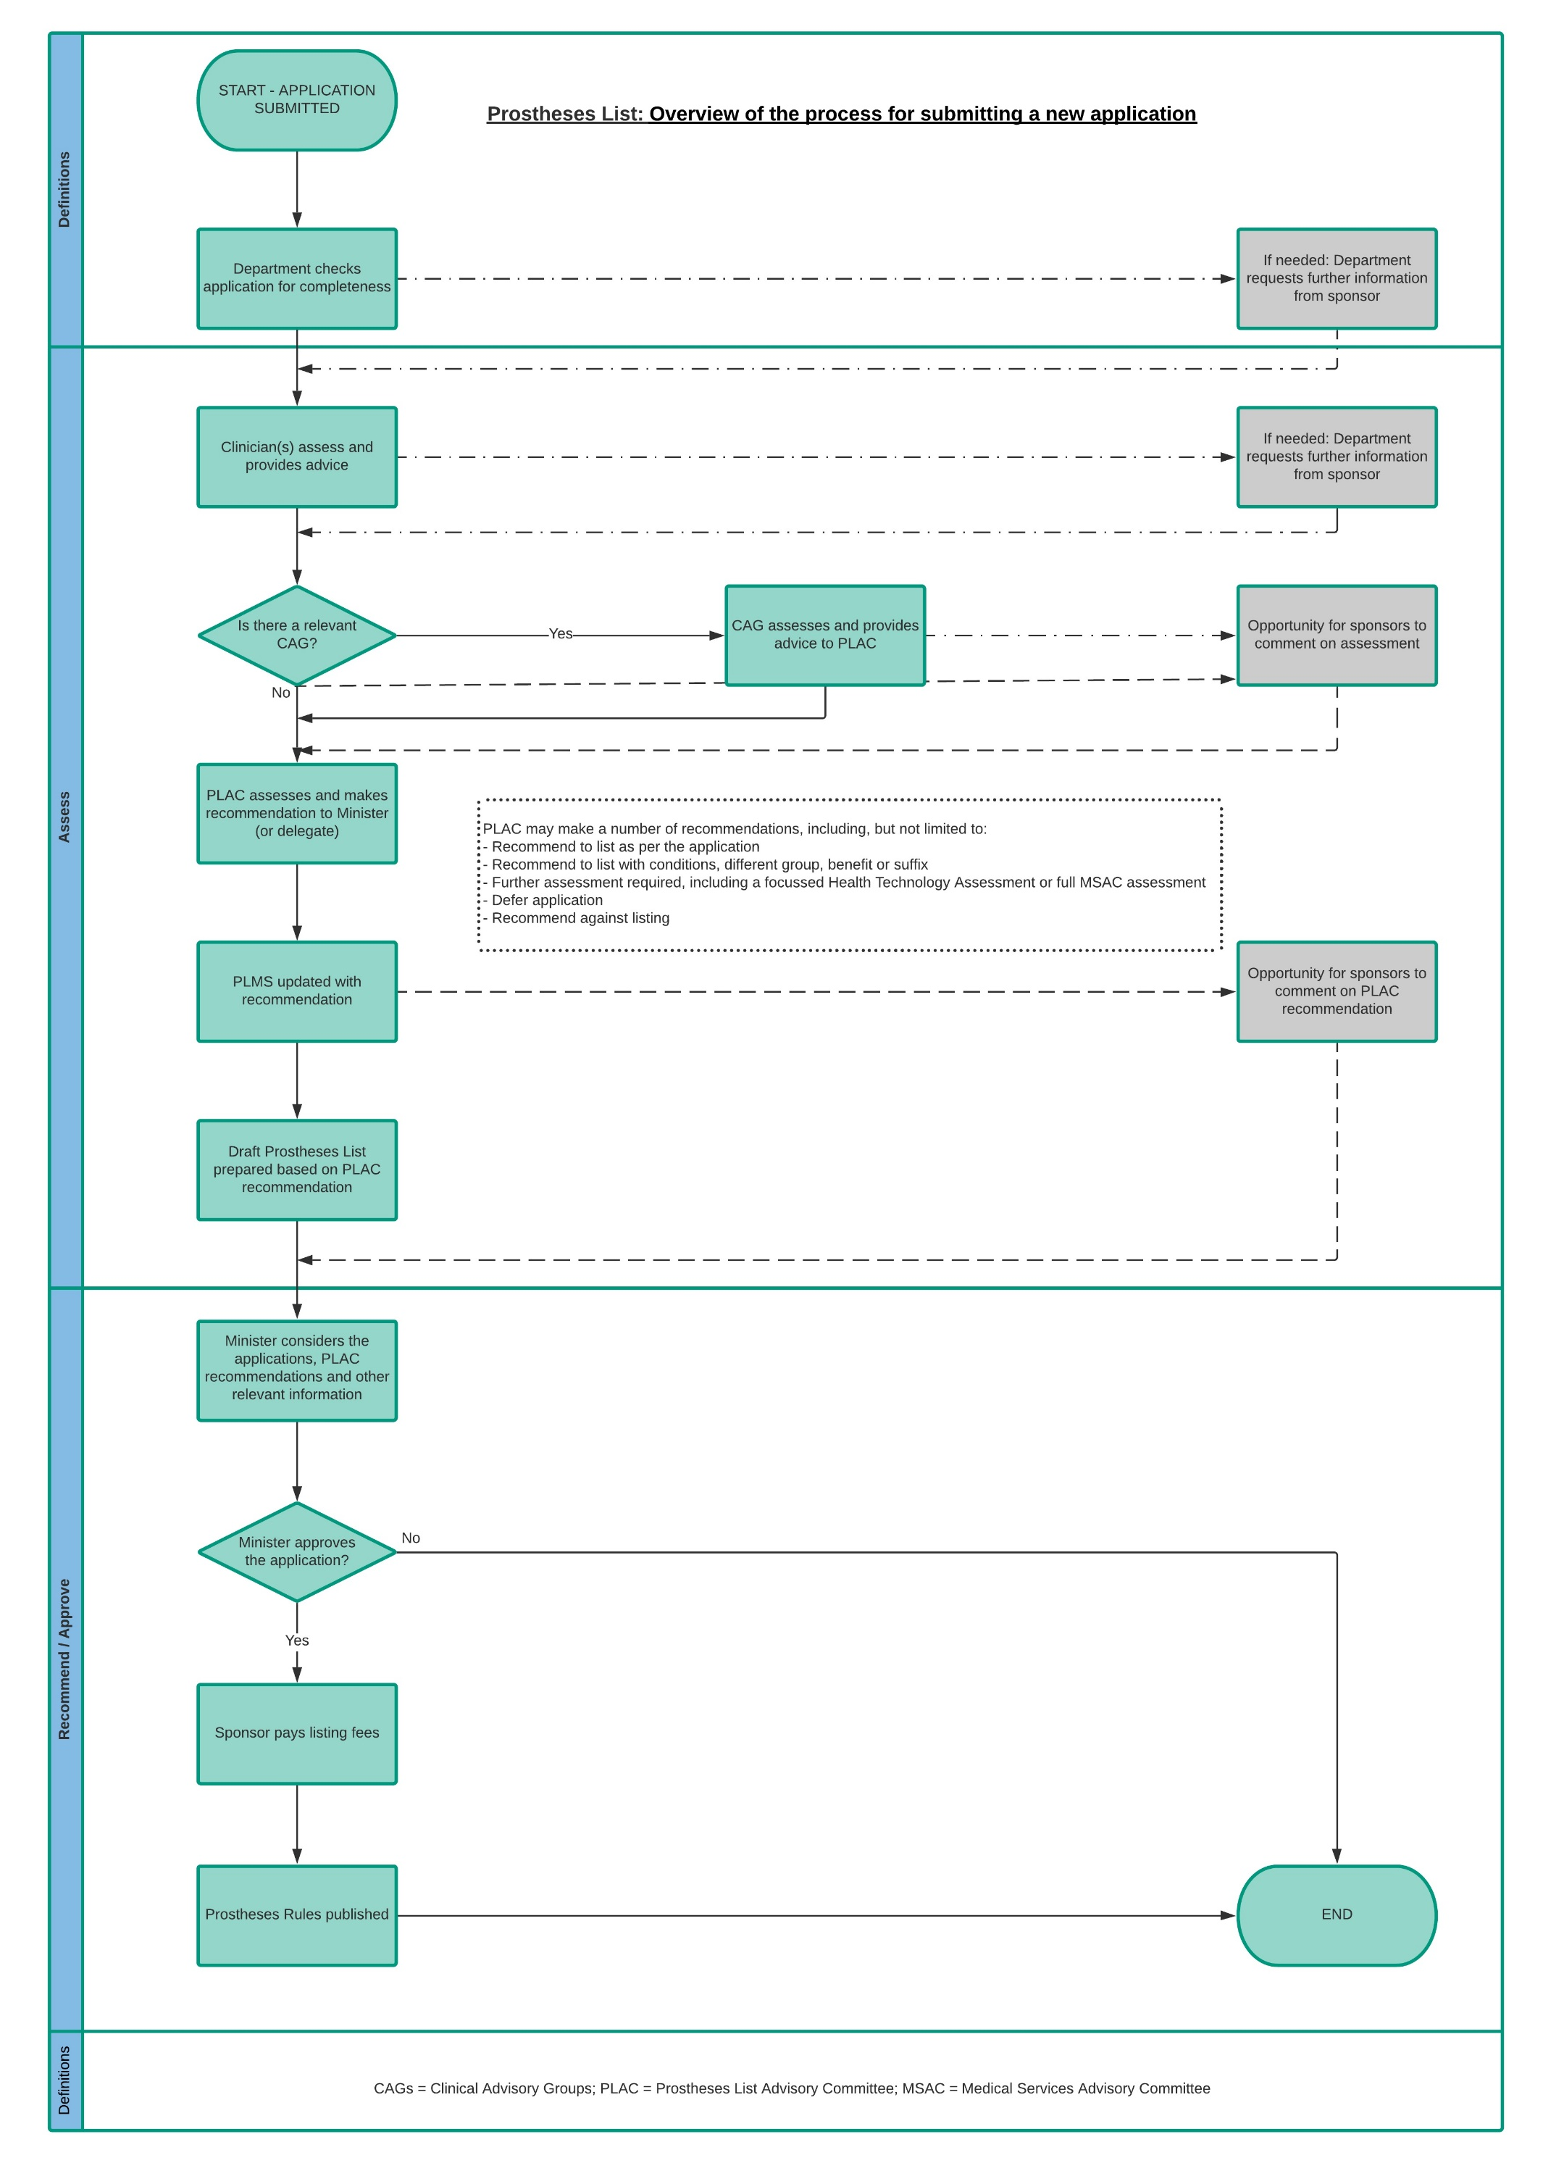
(Taken from The Prostheses List: Guide to listing and setting benefits for prostheses

The case for modernised fit-for-purpose listing pathways
The PL has been in place since 1985 and has been subject to numerous reforms, however, pathways to list an item on the PL have not evolved at the same pace as broader changes for assessing medical technologies in other Australian Government health technology assessment processes.
In 2017 the Government and MTAA entered an agreement to:
- promote the sustainability of privately insured health care through rebalancing the costs of medical devices to privately insured patients, to help keep private health insurance affordable for all Australians
- support a viable, innovative and diverse medical technology sector in Australia and local jobs
- improve the value of private health insurance for consumers by reducing benefits for prostheses on the PL.
As part of this agreement, industry and Government committed to working together to develop appropriate pathways for application and assessment of products including options for improved expedited pathways for some devices.
Under the MTAA Agreement, the Quality of Information and Guidance Industry Working Group (the QIG) was established. This group met six times between July 2018 and February 2020 and included membership from MTAA companies.
The QIG was tasked with overseeing the review and update of the PL Guide and associated PL application forms, and the development of fit-for-purpose HTA pathways for the assessment of applications to the PL.
As part of this process, a consulting company ThinkPlace were engaged to facilitate the QIG meetings and conduct broader consultations on the PL pathways with a range of stakeholders, including device sponsors, private hospitals, private health insurance funds and the Department of Health PL Secretariat. Figure 2 provides some insights into the issues raised by stakeholders as part of this consultation.

Figure 2: Exploring the user experience of the PL listing pathways process (from ThinkPlace consultations)

Sponsors  Applying to list prostheses | Secretariat/  Department  Managing the listing process | CAG Clinicians  Assessing device applications | Private hospitals  Purchasing and billing for devices using the PL | Private Insurance Funds  Reimbursing hospitals for devices using the Prostheses List
Insight 1: Sponsors feel that the Prostheses List evidence requirements and assessment process are not fit for purpose.  Insight 2: Sponsors do not get adequate feedback or explanation about CAG decisions.  Insight 3: Sponsors claim inconsistency of evidence requirements and decision-making from CAGs.  Insight 4: Sponsors do not get timely information and updates. This affects their organisation’s ability to plan ahead.  Insight 5: Inefficiencies and flaws in the listing process result in significant delays and financial losses for sponsors.  Insight 6: While sponsors overall value the digitisation of the assessment process through PLMS, there are usability issues that cause frustration and inefficiencies. | Insight 1: Manual handling of some information by the Department reduces the efficiency of the process and increases the likelihood of errors.  Insight 2: Irrelevant information/very poorly presented provided by some sponsors with applications is unnecessary and likely slows down the assessment process. | Insight 1: Many CAG clinicians lack clarity about their role and the purpose of their assessment particularly in relation to TGA assessment. This makes providing clear advice / feedback to sponsors difficult.  Insight 2: CAG clinicians take into account multiple factors when considering the clinical effectiveness of a device. The factors that need to be considered differ significantly from device to device.  Insight 3: The quality of applications received by CAG clinicians is extremely variable. Poor quality applications include excessive, irrelevant or erroneous information.  Insight 4: The number of applications that some CAG Clinicians must assess every list does not support thorough, quality assessment or communication. | Insight 1: Delays in the list being published and multiple amendments makes it very difficult for private hospitals to be ready for the list effective date.  Insight 2: The format and design of the list creates significant usability issues for private hospitals.  Insight 3: Errors in the list and some coding and naming conventions pose significant financial risk for private hospitals.  Insight 4: Private hospitals experience difficulty managing resourcing when they don’t know publish dates well in advance | Insight 1: Changes and amendments to the list are not adequately communicated to funds and hospitals, which poses significant financial risk.  Insight 2: Funds experience inconsistencies in communications about amendments and errors in the list.  Insight 3: Errors in the list and some coding and naming conventions pose significant financial risk for funds.

Characteristics of a modernised listing process proposed by QIG
The QIG highlighted that any new pathway for listing on the PL should be characterised by:
- clear and specific evidence requirements
- transparent decision making
- efficient use of resources
- predictable timelines
- consistency.

Principles for a modernised listing process
The design of a modern listing process for the PL is based on six core principles:
- One part of the Australian HTA system (consistency, but not duplicative)
- A single departmental portal for Australian Government health technology assessment processes
- Efficient for both applicants and assessors (including the use of digital options to decrease the regulatory burden; cost recovery fees proportionate to the services provided)
- Globally accepted health technology assessment principles underpinning Australian Government process
- Balancing transparency (for consumers, clinicians and payers) and confidentiality (respecting privacy and commercial information)
- Collaborative, not compulsory - The Australian Government cannot compel a medical technology company to seek reimbursement of a device on the PL if it does not wish to do so.

The importance of Health Technology Assessment in the PL listing process
A key feature that must underpin the development of a modern PL listing process is to ensure that it aligns with world-class HTA processes, especially for any new or novel technologies. The World Health Organization (2011) defines HTA as:
…the systematic evaluation of properties, effects, and/or impacts of health technology. Its main purpose is to inform technology-related policy-making in health care, and thus improve the uptake of cost-effective new technologies; prevent the uptake of technologies that are of doubtful value for the health; and slow the uptake of technologies that seem promising but have persistent uncertainties.
Overall, the use of HTA to inform national coverage policies leads to a more explicit and transparent resource-allocation process, improving not only technical or allocative efficiency, but also health equity.
HTA uses scientific evidence to evaluate the quality, safety, efficacy, effectiveness and cost-effectiveness of health services and health technology. Efficient and effective HTA processes are crucial to supporting sustainable management of subsidised health technologies. The below figures outline the characteristics of HTA (Figure 3) and the difference between regulation and HTA (Figure 4) as identified by the World Health Organisation (WHO).

Figure 3: Characteristics of Health Technology Assessment as identified by WHO
Perspective | Efficacy, effectiveness and appropriateness
Orientation | Societal / population health
Method | Systematic critical review, meta-analysis
Criteria | Clinical effectiveness, cost effectiveness, appropriateness
Outcome | Policy / decision / practice
Requirement | Recommendation on complex technologies
Role | Maximise clinical and cost effectiveness
Figure 4: The difference between Regulation (i.e. TGA inclusion) and Health Technology Assessment (i.e. PL listing) as identified by WHO
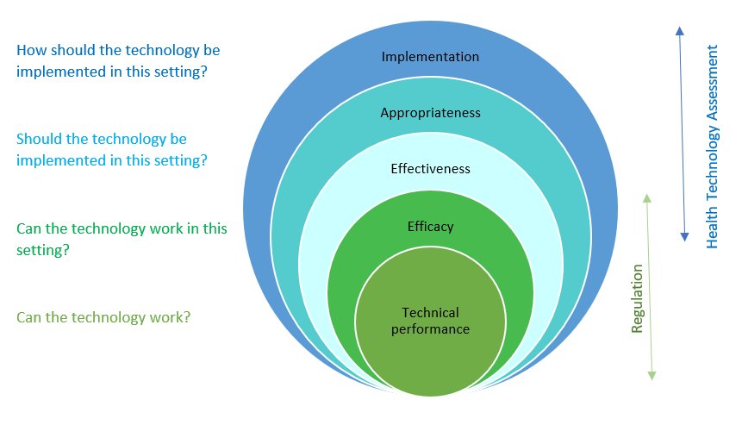
In Australia, several advisory and regulatory bodies provide health technology assessment:
- The Medical Services Advisory Committee (MSAC) assesses the comparative safety, clinical effectiveness and cost-effectiveness of medical technologies and procedures to inform decisions about public funding.
- The Pharmaceutical Benefits Advisory Committee (PBAC) assesses the comparative effectiveness and cost-effectiveness of medicines and vaccines to inform decisions about public funding through the PBS and the NIP.
Consistent application of evidence across Australian Government HTA processes is an important element in ensuring stakeholder confidence in the HTA framework by creating certainty in the processes and their achieved outcome.
A key outcome of the PL listing process is a decision regarding reimbursement. Therefore, it is critical that both comparative clinical and cost-effectiveness are key arbiters for any assessment.
The PL listing process already accommodates the initial HTA, which assesses the reimbursement value at the point of a new technology’s entry into the health system. However, the outcome of the PL is enduring. A regular post-market surveillance system will be established to ensure both applicants and payers can have confidence that a listed device represents value for money throughout the lifecycle of the device. To ensure the PL supports best practice reimbursement (investment) outcomes, the modern listing process will re-introduce rigorous methods for assessing cost-effectiveness, enhance post-market monitoring of reimbursement decisions and clarify processes for delisting (dis-investment) of some devices as required.

A tiered listing process
The concept of a three-tiered approach to the assessment of PL applications for Part A and Part C was introduced by the work undertaken by the QIG. Top level principles are summarised in the Chart below (refer Figure 5).
Figure 5: Three-tiered approach for assessment of PL applications

It is anticipated that each pathway will have specific criteria which sponsors will need to consider while nominating the pathway they believe suits their application, noting that there may be cases where the pathway will change during the assessment.

The assessment of any application will include:
- Eligibility –the device meets the criteria for listing on the PL (medical device or human tissue item) as documented in the Prostheses Rules made under the Private Health Insurance Act 2007.
- Correct pathway nominated – the Department will progress assessment as required and confirm if the sponsor has nominated the correct pathway (wherever possible):
  - applications submitted under the Abbreviated pathway that do not meet the suitability requirements will be rejected (and sponsors will need to submit another application under either Clinical/Focused HTA or Full HTA (MSAC) pathway
  - applications made under Clinical/Focused HTA may be re-directed during the assessment to the Full HTA (MSAC) pathway if required.
- Completeness of application check – the Department will conduct a check on all applications to ensure completeness. Sponsors will be required to provide further information if it is incomplete, but for the applications submitted under the Abbreviated pathway, there will be limited opportunities for sponsors to do so. Information about the requirements for applications submitted under different pathways will be detailed in the PL Guide which will be updated as part of the PL Reforms (and, where relevant, the MSAC Guidelines). It is anticipated that the transition to the HPP will assist in ensuring that applications are as complete as possible before submission.
As noted above, this paper does not explore the review of any governance arrangements associated with the PL listing process which will be addressed in a future Prostheses List Reform Consultation Paper.
To enable flexibility in the process to allow for applications differing in complexity, the evidence requirements and cost recovery fees will be tailored to better reflect each application. Each pathway is explained in more detail below.

Tier 1 – Abbreviated pathway
The Abbreviated pathway is a new concept to the PL listing process and as the name suggests, this pathway is intended to be more efficient, reflecting the nature of the device and information the sponsor provides. The process aims to reduce red-tape for eligible applications and potentially reduce the time for an application to be assessed and the device be listed on the PL.
The Abbreviated pathway is intended to apply when applications meet the following criteria:
- ARTG status – the device must be included in the ARTG – this means that an Abbreviated pathway would not be suitable for a parallel application process
- ‘Me-too’ devices – meaning that the device is the same as a well-established technology already listed on the PL
- Medium or lower risk classification – devices classified by the TGA at Class IIb or lower
- Prostheses List status of comparator – there are substantially similar comparator device(s) listed on the PL
- Grouping and benefit – the device will be listed in the same group as the comparator(s) and will be priced using a cost-minimisation economic analysis
- Application and information provided – the sponsor must provide sufficient information in the application to enable assessment by the Department as there will be little opportunity for consultation between the Department and the Sponsor.
An indicative process for the Abbreviated pathway is provided below in Figure 6, noting once again that this is subject to further consultation and reform work with respect to governance, as well as transition from the PLMS to the HPP.
Figure 6: Abbreviated pathway – indicative process

Tier 2 – Clinical/Focused HTA pathway
A Clinical/Focused HTA pathway will be used for applications that require either a comparative clinical effectiveness assessment or a focused cost-effectiveness assessment.
This pathway is similar to the existing assessment for new, amendment, compression and expansion applications for Part A and Part C with assessments undertaken by expert clinicians and cost-effectiveness assessment by the HTA consultant (where applicable).
This will usually apply for any Class III devices, or devices of a lower risk classification where there are differences with the comparator(s) (e.g. material or design), or if the device is a new/improved technology, and/or where the sponsor requested a new grouping and/or higher benefit for the device.
The Clinical/Focused HTA pathway will include assessments by clinical experts and HTA evaluators, as required.
This “middle” pathway will provide an assessment of applications that are not suitable for the Abbreviated pathway but do not require a comprehensive assessment by the MSAC (Full HTA pathway).
Examples of applications that will be considered under the Clinical/Focused HTA pathway will include:
- any Class III devices
- new technology or devices with significantly different characteristics compared with the devices listed on PL (for example, material or design)
- where the sponsor requests a higher PL benefit than the group benefit on the basis of claimed superior clinical performance or improved characteristics leading to better clinical outcomes
The Focused HTA pathway would not be suitable for amendment applications where the change will lead to the use of the device in the new indications or be associated with new MBS services, hence expanded utilisation through an increase to the eligible population.
An indicative process for the Clinical/Focused HTA Pathway is provided below in Figure 7.
Figure 7: Focused HTA pathway – indicative process
Parallel step: The device is approved for listing in the ARTG (TGA)

* Parallel assessments of applications for inclusion the device in the ARTG and listing it on PL will continue to be available, however, the device will not be listed on the PL (if recommended) until a valid ARTG entry is issued.

Tier 3 – Full HTA pathway
The Full HTA pathway will apply for novel/first in class/breakthrough technology, or a new technology with a significant financial impact on the health system, or where there are no comparators already listed on the PL, and may or may not require the establishment or modification of a MBS item.
These devices will continue to be referred to the MSAC by the Department for a full health technology assessment. MSAC provides advice on the comparative safety, effectiveness, and cost-effectiveness of the medical device for listing on the PL and may also provide advice to Government on the listing of an associated service on the MBS.
An indicative process for the Full HTA pathway is provided below in Figure 8.
Figure 8: Full HTA pathway – indicative process
Parallel step: The device is approved for listing in the ARTG (TGA)

* Parallel assessment of applications for inclusion of the device in the ARTG and PL applications will continue to be available, however, the device will not be listed on the PL (if recommended) until a valid ARTG entry is issued.

** It is expected that MSAC would seek advice from one or more of the following ESC, PLAC or any expert of its choosing.

PL delisting process and transfer of sponsor application
Sponsors may submit deletion and transfer of sponsors applications that will continue being assessed in the manner similar to the existing process (i.e. by verification of the accuracy of information provided by the sponsor and the scope of the application).

Assessment authority recommended delisting
On occasion, the delisting of a device from the PL may be necessary. Notably where the device no longer satisfies the criteria for listing or where there are safety concerns or cancellation or suspension of ARTG entry by the TGA.
The assessment process in these cases is expected to be similar to the listing pathways discussed in this consultation paper.
The Department will write to the sponsor informing them of the consideration and offering them the opportunity for comment.
If the sponsor provides further information or evidence to support continued listing the assessment of the information may undergo abbreviated, or clinical/focussed, or MSAC assessment depending on the nature of issues and information provided.
The recommendation following the assessment will be provided to the Minister or Minister’s delegate. If agreed, the product may be delisted from the PL the next time the Prostheses Rules are made.

Next steps
This paper will be out for consultation until COB 28 February 2022.
As noted in the introduction to this paper, this paper does not explore the following issues:
- review of any governance arrangements associated with the PL listing process
- detailed guidelines for each possible new pathway (including any more detailed criteria for each proposed pathway)
- revised cost recovery arrangements to reflect the modern listing pathways and ensure compliance with the Australian Government Charging Framework.
We ask that stakeholders provide overarching feedback on the three potential new pathways and any ideas they have regarding the above issues via the consultation hub. This feedback will then be used to inform the concepts outlined, noting some concepts may change based on feedback the department receives through this consultation process.

References
Australian Government Department of Health. (2017a). Agreement between the Government and the Medical Technology Association of Australia. www.health.gov.au/resources/publications/agreement-between-the-government-and-the-medical-technology-association-of-australia
Australian Government Department of Health. (2017b). Prostheses List: Guide to listing and setting benefits for prostheses. [www.health.gov.au/resources/publications/prostheses-list-guide]
Australian Government Department of Health. (2020). Options for a revised framework for setting and reviewing benefits for the Prostheses List report. [www.health.gov.au/resources/publications/options-for-a-revised-framework-for-setting-and-reviewing-benefits-for-the-prostheses-list-report]
Commonwealth of Australia. (2017). The Senate. Community Affairs References Committee: Report – Price regulation associated with the Prostheses List Framework. [www.aph.gov.au/Parliamentary_Business/Committees/Senate/Community_Affairs/ProsthesesListFramework/Report]
World Health Organization (WHO). (2011). Health technology assessment of medical devices: WHO medical devices technical series. [www.who.int/publications/i/item/9789241501361]

At the time of writing, the Department is planning changes to the Prostheses Rules, as outlined in Consultation Paper No. 1: Prostheses List – Purpose, Definitions, and Scope.

