Prostheses List Reforms – Consultation Paper No 2(a)

Modernisation of Part B of the Prostheses List

**Context for the consultation paper**

In the 2021-22 Federal Budget, the Australian Government committed $22 million over four years for the *Modernising and Improving the Private Health Insurance Prostheses List* Budget measure. Following extensive consultation over recent years, this consultation paper identifies issues and proposes improvements to Part B (Human tissues).

The PL improvements are part of a major multi-year reform to the health technology assessment (HTA) processes within the Department of Health to address capability limitations and position HTA for future needs. Central to the HTA uplift is the development of the Health Products Portal (HPP) which is a single, secure and easy to use platform through which industry can interact with Government to apply, track, pay for and manage listings for regulated and subsidised health-related products and services.

The HPP will provide significant regulatory savings to industry, across a range of categories which build on each other over time to realise cumulative benefits. Once the project is fully implemented, the estimated savings to the pharmaceutical and medical device industry will be around $157 million annually. This estimate is based on digitisation of approximately 8,000 interactions per year between industry and government.

The development of the HPP, together with the PL improvements, provide the opportunity for streamlining processes and ensuring the PL, which has been a feature of the Australian health system since 1985, meets consumer expectations.

The PL improvements propose a number of changes to the PL processes to improve transparency, increase consumer protection and address sustainability of the system of reimbursement through private health insurance. While this paper focuses on Part B, future consultation papers will discuss the following proposed features:

• restructured Part A and Part C of the PL with the streamlined grouping structure

• disclosing actual prices paid for PL items in the Australian public sector as required information in the application process

• comparison of PL prices with the prices in comparable international markets such as Canada, France, New Zealand, Singapore, United Kingdom, and the United States

• introducing, as a part of PL application process, a declaration by companies that there will not be extra charges for the products beyond the PL price, with penalties for false declaration, to ensure no out-of-pocket expenses for consumers, and

• other suitable compliance approaches to maintain the integrity of the program.

The PL improvements will benefit private health insurers by lowering prices paid by insurers for medical devices. This benefit will flow to Australians with private health insurance by keeping downward pressure on premiums. Doctors, private hospitals and privately insured patients will benefit through continued access to a comprehensive range of medical devices and certainty about their reimbursement.

Medical device companies will also benefit from the PL streamlined administration with new listing pathways for the PL.

# Purpose

The purpose of this paper is to describe the government’s decision, announced at the 2021/22 Budget, to improve the administration of the PL. This paper has a specific focus on Part B of the PL and outlines how to implement improvements across Part B, whilst maintaining access to human tissues products for privately insured Australians.

The proposed changes to Part B of the PL are intended to better align it with the remainder of the PL. As a consequence, the existing grouping structure for Part B would be consolidated and an HTA framework, including the proposed assessment pathways, would apply to Part B.

This consultation paper builds on the work undertaken and commissioned in the previous reform phase (2012-2021).

It is important to note that this consultation paper should be read in conjunction with other consultation papers planned for release. For this reason, consultation on Part B of the PL will occur in two stages (a and b) and makes reference to other consultation papers where relevant. This paper (Consultation paper No 2(a)) provides background on the current situation for Part B of the PL and proposes a new concept for grouping Part B as well as new assessment procedures. The second stage of this paper (Consultation paper No 2(b)) will be released in March 2022.

# Background

## Prostheses cover under private health insurance (PHI)

The Private Health Insurance (Prostheses) Rules is a legislative instrument made under the Private Health Insurance Act 2007. The schedule to the Private Health Insurance (Prostheses) Rules is known as the Prostheses List (PL).

Private health insurers are required to pay benefits for products listed on the PL if the product is provided to a patient, with the right cover, as part of hospital or hospital substitute treatment, and a Medicare benefit is payable for a service associated with the use of the product.

Products currently eligible for the PL include surgically implanted medical devices (Part A), human tissue items (Part B) and other specified items (Part C).

The majority of devices are listed in Part A of the PL. Part B is the next biggest component, with relatively few items listed on Part C. Of the total of 11,600 items on the PL as at 1 July 2021, the breakdown for each Part was as follows:

|  |  |  |
| --- | --- | --- |
| Part | No of items | Proportion of PL |
| A | 10,800 | 92.7% |
| B | 760 | 6.5% |
| C | 90 | 0.8% |

## Overview of Part B

Part B was established in 1985 as part of an arrangement that led to the current PL, the purpose of which is to set benefits payable by private health insurance. An additional informal purpose has evolved whereby the Part B PL Benefits act as a price list for transactions between the public hospital sector and tissue providers.

Applications for listing on Part B are not subject to any Prostheses List application or listing fees, nor are they considered by PLAC or its subcommittees.

Due to the altruistic nature of organ and tissue donation and the prohibition on trade in human tissue and organs, Australian tissue banks have historically operated as not-for-profit entities, although commercial suppliers have more recently begun supplying tissue. The premise for PL benefit setting for human tissue is currently that the benefit paid covers the costs of supplying tissue products with no additional margin or profit to tissue product providers. The Prostheses List – Guide to listing and setting Benefits for prostheses (Feb 2017; ‘the Guide’), states that:

The benefit for a human tissue item is set at an amount that recovers the costs involved in supplying the human tissue to the patient. This includes, but is not limited to: costs of retrieval, processing, storage and transport. Documentation must be provided to support the proposed benefit.

The Guide currently requires Sponsors to provide an annual financial statement and an audited service cost calculation to the Department to support the requested Benefit amount. There are no detailed explanations on how costs should be calculated, and what methods should be used. Consequently, there is variation in the justifications received from different Sponsors for the benefits claimed for apparently similar products.

## Previous reports and reforms

Since the establishment of Part B, the Australian tissue sector has undergone significant change, most notably the adoption of novel processing techniques, and the emergence of commercial providers (many of whom import products from overseas). Much of this has been documented in prior reports, key among which is the 2016 PricewaterhouseCoopers report[1] (PwC 2016) on the Australian tissue sector prepared for the Organ and Tissue Authority. Key relevant findings from this and other reports are summarised below.

### PwC 2016 report on the Australian tissue sector

Three overarching themes of the report were:

* the demand for tissues is not being met locally
* Australian tissue banks are facing viability issues
* the amount of tissue being imported into Australia is increasing as demand is outstripping supply.

Specific to the PL Part B, the report found that:

* Tissue banks use existing prices on the PL to identify ‘what the price should be’ rather than applying the true costs of the service. Consequently, some degree of benchmarking of Benefits already occurs.
* There is little consistency in the methods used to determine ‘cost recovery’ for listing on PL Part B.
* The amendment process for the PL Part B is underutilised by tissue banks.

A key recommendation of the report was for a clear national policy framework and articulation of the following sector principles:

1. Ethical framework
2. Donated tissue supply
3. Exportation of donated tissue
4. Governance and oversight of the sector
5. Transparency, data, reporting accountability
6. Standards of practice
7. Scope of service
8. Clinical purpose
9. Funding arrangements
10. Research and development
11. Role of professional associations.

A National Eye and Tissue Framework is currently under development and is a necessary complement to the proposed Part B reforms.

## Previous government reviews

Although there have been numerous reviews into Government HTA generally, and the PL specifically, issues specific to human tissue products have not been explicitly considered.

The 2007 Report of the Review of the Prostheses Listing Arrangements (the ‘Doyle Report’) made two relevant recommendations:

* Recommendation 8: items currently included on the list that do not meet the criteria for listing as a Prostheses and autologous tissue products should be removed no later than by December 2008
* Recommendation 15: In relation to human tissue:
* The [Department of Health] should carry out a comprehensive review of existing Benefit levels for human tissue items, informed by cost accounting data provided by tissue banks by June 2010.
* The [Department of Health] should ensure it has appropriate clinical expertise available to provide advice to the Minister on the listing of human tissue items.
* In providing advice on items for inclusion on the list and Benefit levels, the [Department of Health] should have regard to the principles that no profit should be derived from trade in human tissue and items involving autologous tissue should not be listed.

Both recommendations note that items involving autologous tissues should not be listed, this is based on the view that such products represent ‘a therapeutic process rather than a manufacturing one’. There is no mention of autologous tissues in the PL Guidance material. Autologous skull flaps and an autologous femoral head remain listed on the PL Part B as of November 2019 (Billing Codes QBB61, RNB02, QBB60, QBB56 and MVS23. See also Appendix B, Technical Document). The appropriate MBS item number for autologous skull flaps is likely to be 40600 – Cranioplasty, reconstructive.

Proposal: That the PL Guide should clarify whether autologous products are eligible for listing and, if ineligible, that skull flaps and an autologous femoral head are removed from the list.

### NHMRC Guidance on organ and tissue donation

The National Health and Medical Research Council (NHMRC) guidelines on “Organ and Tissue Donation after Death, for Transplantation” are under review. The latest guidelines were published in 2007[2]. A more recent issues paper on the exchange and sale of profits derived from human tissue was published in 2011[3]. The issues paper notes that ‘certain commercial practices that derive products from human tissue have become accepted practice (e.g., development of tissue “blocks”) but appear not to be governed by existing legislation and guidelines’.

The Working Group presented ethical values for determining the ethical permissibility of commercialising products derived from human tissue (Box 1); however, they are designed to be used by a Human Research Ethics Committee (HREC) when considering approval for research projects. The applicability of these ethical values to the use of human tissue outside a research setting (i.e., for medical treatment) needs further consideration. Appendix 4 of the NHMRC 2011 Issues Paper (Issues for Further Discussion) notes the need for further consideration by policymakers of non-research commercial practices.

The NHMRC concept of **attenuation**, or distance, is defined in two ways:

* subjectively, when the donor is not concerned about the use of the tissue that he or she has donated
* *objectively*, when a human tissue product has lost significant properties, such as cellular or genomic properties that link the tissue to the donor (NHMRC, 2011).

Box 1 – Values for determining the ethical permissibility of commercialising products derived from human tissues (NHMRC, 2011)

1. Is the tissue product sufficiently attenuated from the donor?
2. Is a community benefit likely to be derived from commercialisation, and will equity of access to that benefit be maintained? For research purposes, this can be assessed by a HREC.
3. If the use of the human tissue product has genomic significance to the individual donor, family or ethnic grouping, will the right to privacy and the obligations to provide information derived from the product and relevant to future health of the donor or his or her relatives or ethnic grouping be met?
4. Would members of the community consider the commercial use of a particular product to be offensive because it commodifies the human body?
5. Does the value of the human tissue product derive from a property that is unique to the individual donor or donor family or ethnic grouping?
6. Is it possible that perverse incentives might arise from the commercial use of the product?

## International perspectives on the tissue sector

Similar changes and trends in the tissue sector are observed internationally as in Australia (as identified by the PwC 2016 report). In particular, across the EU tissue banks are facing viability issues, increased dependence on the import of tissue from the US and increased commercialisation.

Another issue is that there are an increasing number of products that are difficult to classify (i.e., as a tissue, device, or medicine). An example is decellularised tissues (skin, heart valves, bone). In the EU, these could be considered ‘derivatives’ and would therefore fall under EU medical device regulation. However, most EU member states classify such products under cell and tissue regulations, although one regulates demineralised bone as an Advance Tissue Medicinal Product (ATMP), and one as a medical device (European Commission, 2019). In the US, demineralised bone with a carrier agent is classified as a device. The regulatory distinctions are important as human tissue regulation tends to focus on safety from the perspective of disease-transmission risk but tends not to carry the additional regulatory burden of drugs and devices (i.e., pre-marketing authorisation and the need for ‘registration’ studies).

There is a common governance structure being used to separate tissue procurement from tissue processing. For example, in Belgium there is legislation to ensure that Banks for Human Body Material are non-profit; however, commercial companies can obtain licences as intermediate structures that can process, preserve, store and distribute human tissue in collaboration with a Bank for Human Body Material.

Similarly, in the US, SightLife is a non-profit company that partners with organ procurement organisations (OPOs) to collect tissue. It has a related company, CorneaGen, that processes, evaluates and distributes the tissues to cornea surgeons and supplies associated devices. SightLife is the largest eye bank in the world and in 2017 provided more than 35,000 corneas for transplant worldwide, of which approximately 30% were transplanted in the US. This procurement and processing model has been criticised on the basis of:

* Commoditisation: the donated cornea becomes an object of trade and, if the eye bank is profit based, becomes a source of income.
* Inurement: the use of the income or assets of a tax-exempt organisation to directly or indirectly unduly benefit an individual or other person who has a close relationship with the organisation or can exercise significant control over the organisation. Although this is legally prohibited, the authors claim it is occurring in the mixing of for-profit industry with non-profit eye banking (Mannis & Sugar, 2018).

Figure 1 – Traditional eye bank versus SightLife/CorneaGen services for corneal transplant (Moshirfar et al., 2019)

The traditional eye bank versus Sight/CorneaGen services for corneal transplant.

A similar model to SightLife/CorneaGen is replicated in Australia. This occurs through the importation of tissue from the US by commercial providers (currently ConMed and Johnson & Johnson), which both source tissue from the global not-for-profit Musculoskeletal Transplant Foundation (MTF) Biologics. MTF Biologics does not itself collect tissue but, like SightLife, partners with Organ Procurement Organisations. MTF Biologics was established in 1987 by a for-profit company, Osteotech, to secure their supply of tissue, but is independent from Osteotech (Katz, 2005).

This structure is replicated by arrangements in Australia. Australian Biotechnologies is a private provider of tissue processing, storage and distribution services to the Australian tissue sector. The ATDN is a non-profit agency set up for the purpose of tissue procurement for Australian Biotechnologies. It is the single largest provider of items listed on Part B, procuring tissue from both live and deceased donors. Tissues procured by the NSW Tissue Bank and ACT DonateLife are also processed by Australian Biotechnologies. These non-profit agencies remain custodians of the tissue through to allograft use.

Figure 2 – Tissue from three procurement agencies is processed, stored, and distributed by Australian Biotechnologies

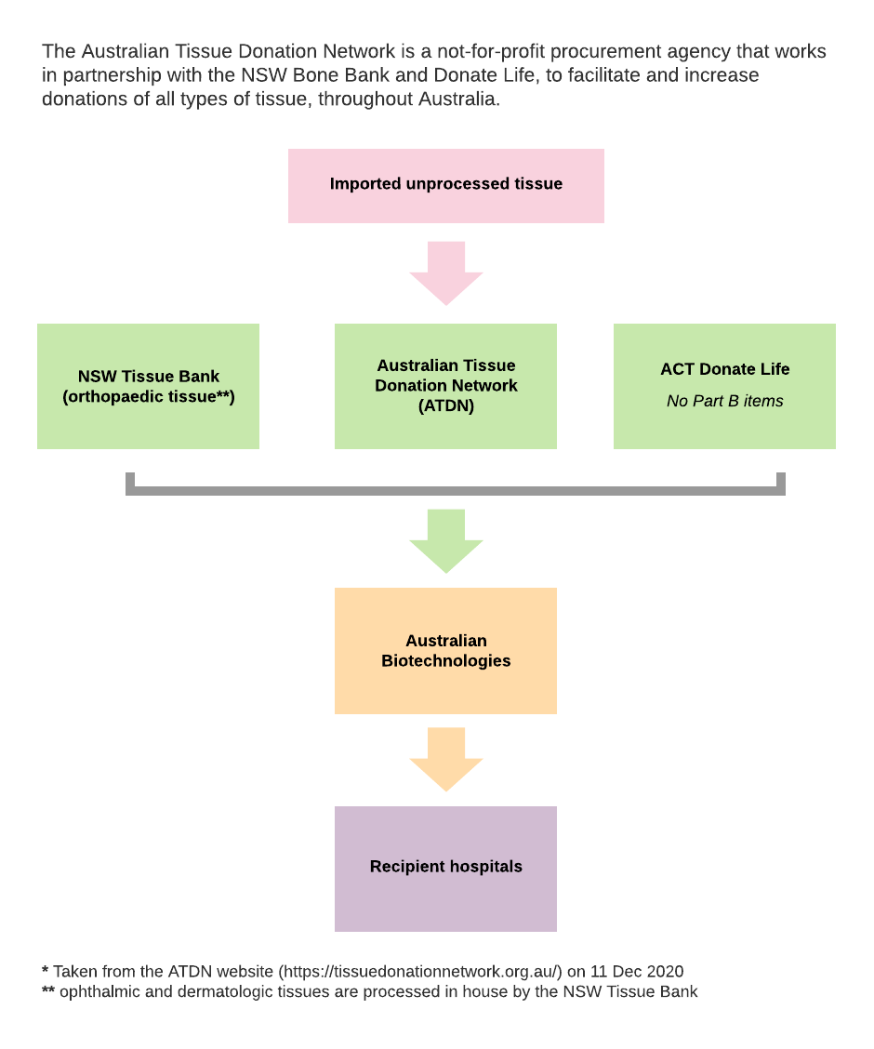

Abbreviation: ATDN, Australian Tissue Donation Network.

A similar model is also used for Australia’s blood supply. The not-for-profit organisation, Australian Red Cross Lifeblood, is responsible for the collection and processing of blood. The non-cellullar, plasma component is then further processed by CSL Behring which is an entirely commercial, multi-national company. A key difference here, though, is the overarching role of the National Blood Authority (NBA) to manage the national blood supply, including setting prices for blood products on the National Product Price List (NPPL). A number of blood products (e.g., immunoglobulin) are also imported from overseas providers. It is worth noting that the NBA typically sets prices for imported products on the NPPL via a tendering process. However, with the recent expansion in the remit of MSAC, the NBA can (and does) seek guidance from MSAC regarding the comparative cost effectiveness of new products seeking listing on the NPPL. It is also worth noting that the prices on the NPPL for blood products derived from blood collected by the Australian Red Cross Lifeblood are ‘list prices’ that do not include the costs to the health system of blood collection, transportation and storage by Lifeblood while these costs are included for fresh blood components including plasma for fractionation. When such costs are included, the price is referred to by the NBA as the ‘fully loaded price’.

Figure 3 – Purchaser – provider arrangements for the Australian blood sector

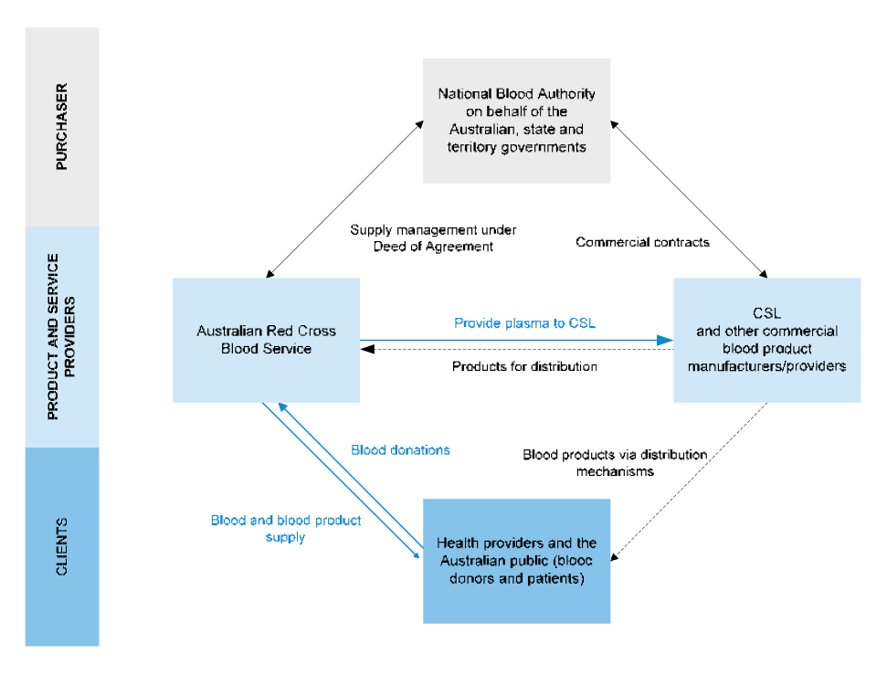

Source: The National Blood Authority's Management of the National Blood Supply performance audit 2011 (available at <https://www.anao.gov.au/work/performance-audit/national-blood-authoritys-management-national-blood-supply>

Abbreviation: CSL, Commonwealth Serum Laboratory.

The price of tissue products varies across European countries and is clearly influenced by economies of scale in tissue processing. For this reason, it is argued that tissue banks need to cooperate to lower the overall costs of maintaining quality, and that the best approach is for banks to be organised on a larger (preferably national) scale, which would lower the number of organisations and systems, leading to reduced overall costs associated with maintenance, overheads and audits (De Kort & Verhagen, 2008). This approach has been adopted in the UK with the establishment of the NHS Blood and Transplant (NHSBT) organisation, which facilitates the collection and processing of approximately 95% of tissue from deceased donors in the UK. The NHSBT is a Special Health Authority established in 2005 by the merger of the UK National Blood Authority and UK Transplant and sponsored by the Department of Health. In at least two EU jurisdictions, Belgium and the Netherlands, a national insurance authority sets human tissue product prices. In Belgium, these are fixed by Ministerial Decree, cover the costs of processing, and are published annually.

## Key issues for the local tissue sector

### Ethical and legislative considerations

Transplantation of human organs and tissues is often considered together. However, there are differences between them such that the clinical and ethical considerations that apply to organ donation do not necessarily apply to tissues.

Table 1 – Key differences between organ and tissue transplants

|  |  |
| --- | --- |
| **Organs** | **Tissues** |
| Usually life-saving | Usually not life-saving but life-enhancing |
| Donor pool is small | Donor pool is larger |
| Time to implantation is usually measured in hours and the organs cannot be preserved for future use | Time to implantation can be measured in days or years, depending on the tissue and the preservation method applied |
| Donor can supply only a small number of recipients | One donor’s tissues can be transplanted into many patients, so donor-selection failures can affect many recipients |
| Cannot be sterilised or exposed to robust decontamination processes | Tissues and cells can often be subject to decontamination and/or sterilisation methodologies |
| Often the only therapeutic option | Alternative treatments usually available |

Source: EDQM (2019)

There is a clear principle that human tissue is prohibited from sale. This is articulated in the WHO Guiding Principles on human cell, tissue and organ transplantation that states:

‘The prohibition on sale or purchase of cells, tissues and organs does not preclude reimbursing reasonable and verifiable expenses incurred by the donor, including loss of income, or paying the costs of recovering, processing, preserving and supplying human cells, tissues or organs for transplantation.’ (World Health Organization, 2010)

Although the WHO principle is enshrined in legislation and Australian ethical guidance and prohibits payments to tissue donors and their families, it does not explicitly cover ‘the manufacture of saleable products from those tissues (Tonti‐Filippini & Zeps, 2011)’. Human-tissue-derived products therefore consist of a non-commercialisable part (human body material) and a commercialisable part (technological processing) (Pirnay et al., 2015).

Organ and tissue legislation is state/territory specific and there are differences in definitions across jurisdictions. Nevertheless, exemptions are specifically made in the legislation of most states and territories for products that have been processed.

The PwC 2016 report noted that the legislation is dated and was established to function when human tissue (like an organ) was transplanted as donated and did not incorporate a processing stage before use. Consequently, legislation has failed to keep up with newer generation products that are derived from human tissues but involve significant processing stages. For example, governance of allografts that are sourced from elsewhere, or are composite products (i.e., are part of a kit or are only partly human derived) is largely unaddressed by existing state regulatory frameworks.

There are risks to an approach in which commercialisation is unrestrained, including charging of unreasonable prices and catering to clinical indications based on commercial rather than public health interests (Pirnay et al., 2015). The 2011 NHMRC Issues Paper is the most applicable document on how to approach these risks but states itself that further consideration is needed with respect to ‘non-research commercial practices’.

The first NHMRC ethical value for determining the ethical permissibility of commercialising products derived from human tissue is whether ‘the tissue product is sufficiently attenuated from the donor?’ Similarly, legislative exemptions to the prohibition on trade are based on the tissue having been processed into a medical product. The extent of processing varies greatly for products listed on Part B and this may impact the extent to which Benefits can be determined based on a ‘cost of supply’ principle alone versus a ‘cost-effectiveness’ principle.

**Proposal:** That further work is undertaken to develop guidance on an ethical framework for human tissue and human tissue products used for medical treatment, possibly in consultation with the NHMRC.

### Implications for private hospitals and private health insurers

There is an increasing trend in expenditure on human tissue items from $6.3 million in 2011-12 to $56.1 million in 2019-20. This is much less than the expenditure of $1.8 billion for Part A in 2019-20 but reflects the entry of commercial sponsors and the changing composition of the list with an increase in the number and utilisation of more highly processed products.

### Implications for the MBS

All items listed on the PL require an appropriate MBS item. This is an important consideration as the growth in Part B PL expenditure reflects a shift from the use of items in ‘transplant-like’ applications to use across a wider variety of clinical applications. There will be many MBS items that have been claimed for the use of human tissue products. However, given that the majority of human tissue products currently on Part B have not been assessed by PLAC, it is likely that the appropriateness of claiming for specific MBS items has not been established.

Establishing the appropriateness of the MBS items linked to a human tissue product would more explicitly link each product to its intended purpose or purposes.

### Implications for sector viability and composition

The PwC 2016 report highlighted the changing nature of the human tissue sector, both in Australia and internationally, as well as issues associated with the financial viability of smaller tissue banks, and the failure of the local sector to meet local demand, resulting in an increasing reliance on imported tissue.

In addition, while the PL is intended to define the Benefits payable by private health insurers for prostheses used as part of an episode of care for privately insured patients, it is clear that the PL Benefits for tissue products on Part B are being used as a ‘price list’ for the supply of tissue products to public hospitals.

Changes to Part B need to acknowledge the interrelationships between public and private hospital sectors and tissue bank viability.

# Proposals to modernise Part B

This paper proposes two initiatives to modernise Part B of the PL:

1. Revised classification structure
2. Introduction of a health technology assessment for human tissue products.

## Concept for Revised classification structure of Part B

**–Note on Source data:**

Relevant details for all items listed on Part B were extracted from the November 2019 PL Part B. Data were not updated from more recent lists. However, the proposed grouping would need to be reconciled with the PL Part B list current at the time of implementation.–

Proposed structure

The example discussed in this section describes how Part B could be aligned with the current structure in Part A. However, readers should note that Part A is currently being restructured and no final decision on the future structure of Part B will be taken until it can be referenced to the new structure in Part A.Therefore, the discussion below is intended to describe the concept for realignment only.

For Part A of the PL, substantially similar products are listed within the same group (where ‘grouping’ refers to the full classification of a prosthesis on the Prostheses List, including category, subcategory, group and subgroup). The same principles have been used to propose groupings for items in Part B with the structure of Part A providing a template.

The four categories of the current PL Part B (cardiothoracic, ophthalmic, orthopaedic, and dermatologic) are retained in the proposed structure although the Part B Dermatologic Category has been renamed Plastic and Reconstructive to align with Part A and to allow for the addition of non-skin products to this category.

There are multiple orthopaedic categories in Part A and therefore the Part B Orthopaedic Category aligns with multiple Part A categories. It is also the most complex category, including the most items (92%) on Part B.  
The proposed grouping structure is presented in ES Table 1.

ES Table 1 Proposed grouping structure for the PL Part B

| Category | Subcategory |  | Group |  | Subgroup |  |
| --- | --- | --- | --- | --- | --- | --- |
| 01 - Cardio-thoracic | 01.01 | Conduit | - | N/A | - | N/A |
| - | 01.02 | Valve | - | N/A | - | N/A |
| - | 01.03 | Patch | 01.03.01 | Valve Patch | - | N/A |
| - | 01.04 | Pericardium | - | N/A | - | N/A |
| 02 - Ophthalmic | 02.01 | Cornea | 02.01.01 | Cornea, Full Thickness | - | N/A |
| - | - | - | 02.01.02 | Cornea, Precut | - | N/A |
| - | - | - | 02.01.03 | Cornea, Patch Graft | - | N/A |
| - | 02.02 | Sclera | 02.02.01 | Sclera | - | N/A |
| 03 - Orthopaedic | 03.01 | Osseous | 03.01.01 | Intact Bone, Whole or Part | 03.01.01.01 | Femoral Head |
| - | - | - | - | - | 03.01.01.02 | Hemipelvis, Whole or Part |
| - | - | - | - | - | 03.01.01.03 | Long Bone, Distal |
| - | - | - | - | - | 03.01.01.04 | Long Bone, Proximal |
| - | - | - | - | - | 03.01.01.05 | Long Bone, Proximal with Soft Tissue |
| - | - | - | - | - | 03.01.01.06 | Long Bone, Shaft |
| - | - | - | - | - | 03.01.01.07 | Patella |
| - | - | - | - | - | 03.01.01.08 | Small Bone |
| - | - | - | - | - | 03.01.01.09 | Whole bone |
| - | - | - | - | - | 03.01.01.010 | Whole Bone with Soft Tissue |
| - | - | - | 03.01.02 | Manufactured, Structural | 03.01.02.01 | Block |
| - | - | - | - | - | 03.01.02.02 | Block, Demineralised |
| - | - | - | - | - | 03.01.02.03 | Block, Custom Shape |
| - | - | - | - | - | 03.01.02.04 | Cube |
| - | - | - | - | - | 03.01.02.05 | Plate, Cortical |
| - | - | - | - | - | 03.01.02.06 | Plug |
| - | - | - | - | - | 03.01.02.07 | Ring |
| - | - | - | - | - | 03.01.02.08 | Segment, Demineralised |
| - | - | - | - | - | 03.01.02.09 | Segment, Preshaped |
| - | - | - | - | - | 03.01.02.010 | Sheet, Cortical |
| - | - | - | - | - | 03.01.02.011 | Spacers, Cervical |
| - | - | - | - | - | 03.01.02.012 | Strip |
| - | - | - | - | - | 03.01.02.013 | Strip, Demineralised |
| - | - | - | - | - | 03.01.02.014 | Strut |
| - | - | - | - | - | 03.01.02.015 | Wedge |
| - | - | - | 03.01.03 | Manufactured, Non-structural | 03.01.03.01 | Granulated Bone |
| - | - | - | - | - | 03.01.03.02 | DBM Granulated |
| - | - | - | - | - | 03.01.03.03 | DBM Fibres |
| - | - | - | - | - | 03.01.03.04 | DBM Preshaped Fibres |
| - | - | - | - | - | 03.01.03.05 | DBM Fibres with Granulated Bone |
| - | - | - | 03.01.04 | Manufactured, Non-structural with Inert Carrier | 03.01.04.01 | DBM Granulated with Inert Carrier |
| - | - | - | - | - | 03.01.04.02 | DBM Fibres with Inert Carrier |
| - | - | - | - | - | 03.01.04.03 | DBM Preshaped Fibres with Inert Carrier |
| - | - | - | - | - | 03.01.04.04 | DBM Fibres with Granulated Bone and Inert Carrier |
| - | 03.02 | Non-osseous | 03.02.01 | Cartilage | 03.02.01.01 | Joint Cartilage, Preshaped |
| - | - | - | - | - | 03.02.01.02 | Meniscus |
| - | - | - | - | - | 03.02.01.03 | Rib Cartilage |
| - | - | - | 03.02.02 | Fascia Lata | 03.02.02.01 | Fascia Lata |
| - | - | - | 03.02.03 | Ligaments | 03.02.03.01 | Ligament, Medial |
| - | - | - | - | - | 03.02.03.02 | Ligament Patch, Spinal |
| - | - | - | 03.02.04 | Tendons | 03.02.04.01 | Achilles Tendon |
| - | - | - | - | - | 03.02.04.02 | Achilles Tendon with Bone |
| - | - | - | - | - | 03.02.04.03 | Achilles Tendon with Preshaped Bone |
| - | - | - | - | - | 03.02.04.04 | Patellar Tendon |
| - | - | - | - | - | 03.02.04.05 | Patellar Tendon with Bone |
| - | - | - | - | - | 03.02.04.06 | Patellar Tendon with Preshaped Bone |
| - | - | - | - | - | 03.02.04.07 | Tendon Patch |
| - | - | - | - | - | 03.02.04.08 | Other Tendon |
| - | - | - | - | - | 03.02.04.09 | Other Tendon with Bone |
| - | - | - | - | - | 03.02.04.010 | Other Tendon with Preshaped Bone |
| 04 – Plastic and Reconstructive | 04.01 | Skin Graft | 04.01.01 | Split Skin | - | N/A |
| - | 04.02 | Biological Scaffold | 04.02.01 | Acellular Dermal Matrix | 04.02.01.01 | Breast Reconstruction |
| - | - | - | - | - | 04.02.01.02 | Joint Repair |
| - | *-* | *-* | 04.03.01 | Amnion | 04.03.01.01 | Ulcers |
| - | *-* | *-* | *-* | *-* | 05.03.01.02 | Burns |
| - | *-* | *-* | *-* | *-* | 05.03.01.03 | Laminectomy* |
| - | *-* | *-* | *-* | *-* | 05.04.01.01 | Tendon Repair |

### Approaches to benchmarking benefits

Although the PL is often used as a ‘price list’ by hospitals for public patients, this is not the intended purpose of the PL. The purpose of the PL is to ensure that privately insured Australians have access to clinically effective prostheses that meet their health care needs. It does this by setting a ‘minimum Benefit’ that private health insurers are required to pay for the prosthesis. The ‘minimum Benefit’ does not need to be the actual cost at which a prosthesis is supplied: Sponsors can supply products at values less than the PL Benefit and it is up to individual suppliers to set the price for their products.

Given this, and the complexity of establishing a true cost-recovery price, there is no expectation that cost-recovery principles will be applied at the level of the individual tissue product to set a Benefit. Indeed, an individual tissue bank or commercial supplier may determine a cost-recovery price by considering the aggregated costs of tissue recovery, processing, preserving, product development, quality assurance and supply distributed across all of the tissue and tissue products supplied by that Sponsor in a year.

The overarching principle that is proposed for benchmarking PL Benefits is that non-attenuated tissue products (i.e., transplant-like) are benchmarked on a ‘cost of supply’ basis while attenuated tissue products, for which commercialisation is more likely to be ethically permissible, have the option to establish a cost-effective price. The proposed approaches are as follows:

* **Tissue products that are non-attenuated (homologous use):** Benchmarked based on existing ‘cost of supply’ using one of two approaches:
* Ceiling approach: where the PL Benefit is benchmarked to the highest value (the maximum) for a grouping of products.
* Upper Quartile approach: where the PL Benefit is benchmarked to a value that sits between the median value and the maximum value for a grouping of products (the median of the upper half of the Benefits).
* **Tissue products that are attenuated (non-homologous use or highly processed):**
* Suitable for an HTA approach: where the benchmarked PL Benefit for a grouping is determined through application of the principles of HTA.

Applying this approach presents difficulties for products supplied by product area, weight or volume, such as granulated bone and ADM. For these products, Benefits per unit supplied tend to decrease with increasing quantities supplied, which is consistent with item Benefits allowing for a flat fee for dispatch. Additional work will be necessary to benchmark such products.

A number of Sponsors make claims regarding superior clinical performance attributed to specific processing methods. The claims identified are for products prepared using the following processes:

* aseptic processing without irradiation
* supercritical carbon dioxide (ScCO2) cleaning
* ScCO2sterilising
* processes that facilitate osteoinductivity (batch tested).

A fixed-Benefit supplement could be established for these processes and incorporated within (or added to) the benchmarked Benefit for each product grouping. Alternatively, an HTA could be undertaken to determine a benchmarked Benefit for each processing method.

Osteoinductivity is determined by batch testing and appears to have face validity with respect to clinical claims. Clarification of the specific criteria used by the Therapeutic Goods Administration (TGA) to establish osteoinductivity should be sought in order to determine whether a supplement should be established or whether an HTA should be undertaken. The remaining claims are more likely to require assessment via an HTA approach.

Freeze drying is an established method of tissue storage which may reduce storage infrastructure and promote equity rather than providing a specific clinical benefit. Although not reflected in current Benefits, freeze drying tissue has a higher cost of supply than freezing. An additional fixed Benefit based on cost of supply is included in the tissue list of the National Institute for Health and Disability Insurance in Belgium for freeze-dried tissue and may be a suitable approach.

## Applying an HTA framework

Unlike applications for listing on Part A or C, applications for listing on Part B are not currently subject to any consideration by the Prostheses List Advisory Committee (PLAC) or its sub-committees. Nor are they subject to PL application or listing fees. Rather than using clinical information as part of an HTA process, the benefit setting process for Part B items is largely based on financial statements (that must be certified by an accountant) to demonstrate the costs attributed to supplying the human tissue product to the patient and confirming the product will be supplied to recover those costs rather than generate a profit. The current process does not require any assessment of either clinical effectiveness or cost effectiveness.

It is therefore proposed to introduce a health technology assessment for human tissue products as part of the listing process for the PL.

### Current application and assessment pathway for Part B of the PL

Unlike applications for listing on Part A or C, applications for listing on Part B are not currently subject to any Prostheses List application or listing fees, nor are they considered by PLAC or its subcommittees. The PL Guide currently requires Sponsors to nominate a comparator and an MBS item and description for requests to list products on Part B. However, no clinical information is requested. Sponsors are required to provide:

* An annual financial statement of the human tissue facility; certified by an accountant.
* An audited service cost calculation showing the costs attributed to supplying the human tissue to the patient, certified by an accountant. Where possible, this should include actual costs, not estimates.
* An image of the item or type of item.
* Information on the actual or projected utilisation of the human tissue item, if available.

This approach presents the following challenges:

* Limited guidance for applicants in terms of how to price their products or the matters to be taken into account by the Department in making decisions (creating uncertainty for applicants).
* Lack of clarity regarding decision-making criteria (generating risk to the Department/Delegate including in relation to compliance with the enabling legislation and administered law considerations).
* No clear grounds on which the Department could challenge/negotiate a proposed price, meaning that the price proposed by the applicant is often accepted.
* Lack of a process for the Department to seek expert advice if needed.

Some information required as part of a Part B application is uninformative for decision making. For example, applicants are required to submit an audited financial statement to demonstrate the not-for-profit nature of the Benefit, but the Statement does not necessarily provide any information about the cost of the tissue for which listing is sought, nor whether any profit is generated from that particular product (as opposed to the profit generated by the organisation more broadly – the latter is to be expected from for-profit enterprises but does not mean that such organisations are generating profit on their tissue products).

### Suitability of proposed application and assessment pathways for Part B products

The three application and assessment pathways proposed for products for Parts A and C of the PL could also be employed for applications to list on Part B – albeit with the adoption of tissue-specific approaches to HTA (see below).

Adoption of the three pathways, together with a proposed re-framing of how human tissue Benefits are defined (see Approaches to Benchmarking), would address all of the challenges identified and listed above.

**Readers should note these three listing pathways are described in Consultation Paper No 3.**

### Regulatory approval of human tissue products by the TGA

The TGA regulates tissue-based products as biologicals. The TGA then further stratifies biologicals into four classes, as set out in Schedule 16 of the Therapeutic Goods Regulations 1990 (Compilation Number 92). Tissues listed on the PL Part B are primarily Class 2 biologicals - only DBM mixed with a synthetic carrier is Class 3:

* **Class 2** – low risk: subject to minimal manipulation and for homologous use
* **Class 3** – medium risk: for homologous use but have been prepared using more than minimal manipulation OR for non-homologous use, regardless of whether they have been prepared using minimal manipulation or more than minimal manipulation.

In obtaining an ARTG listing for a biological, there is an assessment of the quality, safety and efficacy of the product. However, in conducting the current Review, it was clear that the ARTG listings have very limited specificity, with only 17 unique ARTG listings for the 589 items on the Part B list. Indeed, a single ARTG number (277310) is used for 427 orthopaedic items. This lack of ARTG specificity makes it difficult to value (i.e., assign a PL Benefit to) the clinical claims made for specific tissue products or groups of tissue products.

**Proposal:** That the number and nature of ARTG listings for human tissue products is discussed with the TGA to explore the feasibility of greater specificity of ARTG listings for these products.

#### International experience with HTA of human tissue products

Internationally, there are examples of HTAs of human tissue products; for example, NICE in the UK has undertaken the following:

* EpiFix for chronic wounds (Medtech innovation briefing, January 2018)[4]
* Processed nerve allografts to repair peripheral nerve discontinuities (Interventional procedures guidance, November 2017)[5].

In Canada, CADTH has conducted HTAs of tissue products, for example:

* GRAFTJACKET® Regenerative Tissue Matrix: Clinical Evidence and Guidelines for Use[6]
* The Use of Osteochondral Allograft for the Ankle, Knee, and Shoulder: Clinical Effectiveness and Cost-Effectiveness[7]
* Bioinductive Implants for Shoulder Surgery: Clinical Effectiveness, Cost-Effectiveness, and Guidelines[8].

However, the HTA conducted by NICE and CADTH is undertaken for the purpose of clinical advice rather than direct reimbursement decisions. Consequently, while they do consider cost effectiveness, the NICE and CADTH assessments do not set a Benefit or determine a cost-effective price for the products assessed.

MSAC has two human tissue products applications for listing on the PL Part B:

* 1557 - Human tissue (surgical) wound treatments – Laminectomy and tendon repair (AmnioFix, AmnioWrap and AmnioFix Injectable)[9]
* 1608 - Amnion membrane (human tissue) for topical treatment of ophthalmic disorders (caused by disease and/or trauma), and wound dressings for skin burns and ulcers on the craniofacial area, torso, and limbs[10].

At the time of writing this paper, 1608 had been considered by MSAC and 1557 was pending. The existence of the assessments listed above demonstrates that it is possible to undertake an HTA of human tissue products.

### Proposed HTA framework for PL Part B products

#### Future use of HTA for new Part B listings

It is proposed that human tissue products are suitable for the application and assessment pathways that have been proposed elsewhere for prostheses on Parts A and C of the PL Consultation paper No 3 describes these pathways in more detail. It is proposed that the established methods of HTA can be applied to the assessment of tissue products, as long as the level of evidence is commensurate with the nature of the clinical claims made and the Benefits sought for the product.

An illustration of how different tissue products might be assigned to the three assessment pathways is shown in Figure 4.

As for medical devices, it is proposed that the criteria for assessment of tissue products via the different pathways is based on a combination of product characteristics, the Benefit sought, and whether or not claims are made regarding superior clinical performance.

If the product is novel, a TGA Biological Class 3, or there is no existing MBS item, then the assessment could follow the Full HTA Pathway. Otherwise, the triage criteria proposed for Part A and Part C are transferable to human tissue items, although it would need to be agreed that a Class 3 medical device has an equivalent risk level to a Class 3 biological.

**Proposal:** That the application and assessment pathways for human tissue products mirror the three proposed application and assessment pathways (i.e., Abbreviated, Focused HTA, and Full HTA) for medical devices.

**Proposal**: That advice is sought from the TGA regarding whether a Class 3 biological has an equivalent risk level to a Class 3 medical device.

Figure 4 An illustration of how the three proposed PL application and assessment pathways could be used for different types of human tissue products

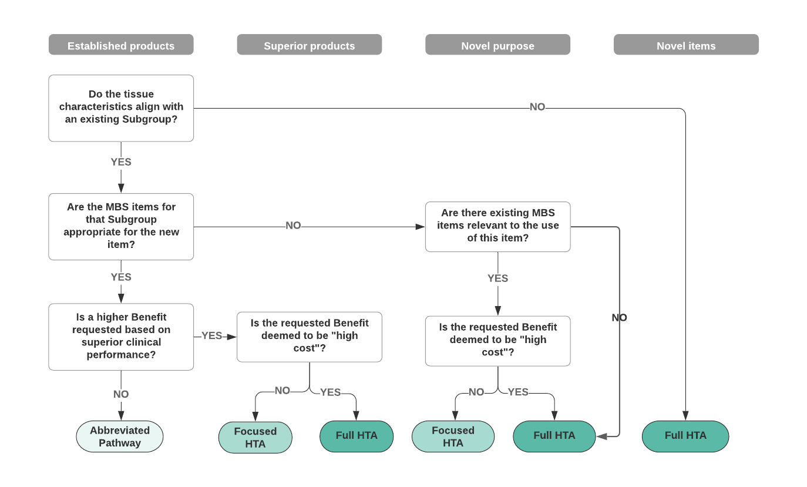

Abbreviations: HTA, Health Technology Assessment; MBS, Medicare Benefits Schedule

Sponsors of human tissue products should be encouraged to make use of registries to collect outcome data to support claims of both safety and performance. Although such data is not comparative, it can provide real-world evidence to support HTA.

#### Eligibility for listing on the PL

To be eligible for listing on the PL, all products are required to nominate one or more applicable MBS items. This criterion applies to Part B as well as to Parts A and C. However, it is possible that some MBS items that have been nominated may be *generally applicable* but not *specifically intended* for human tissue application. Adoption of an HTA framework provides an opportunity to audit and/or define the MBS items associated with the use of human tissue products as they are assessed within an HTA framework. It may be possible to define an explicit set of relevant MBS items for each Part B grouping when they are assessed. The intent would be that PL Benefits should only be paid for products that are used with one or more of those MBS items. If an applicant subsequently requests a broadening of the use of a tissue product (different MBS items), then the assessment could follow a Focussed HTA Pathway (which could extend the proposed MBS items to all products in the subgroup).

**Proposal:** That Part B products undergoing HTA assessment have an agreed list of appropriate MBS items assigned to them to enable their use to be restricted to specific clinical indications.

#### Established tissue products

Established tissue products are those for which precedents already exist on the PL – either in terms of the source of tissue and/or the processing method. It is anticipated that for the majority of such products seeking listing on Part B, there would be an appropriate comparator already listed on Part B.

If such products are seeking the same Benefit as the relevant grouping for which they are applying, and no claims of superior performance are being made beyond what has already been accepted and acknowledged via the relevant Processing Supplement, then the Department would only need to accept that the product was ‘substantially similar’ to its comparator. No additional clinical evidence would be required, and such products could be assessed via the Abbreviated Pathway. However, reliance on the Abbreviated Pathway for the assessment of tissue products does assume that prior assessments by the TGA of safety and efficacy are sufficient for the purpose of determining the PL Benefit.

**Proposal:** That there is a clear understanding of the nature of the assessments undertaken by the TGA for different groupings of tissue products, before the Abbreviated Pathway is used to determine Benefits for tissue products.

Identification of a direct comparator on the PL is necessary for the Abbreviated Pathway of the HTA framework, and the assumption of the framework being trialled for Part A and C is that the comparator would be in the same Part of the PL. The same assumption is made here for Part B listings.

The updated PL Guide may need to specifically state whether the comparator must come from the same Part of the PL for which listing is being sought, where a product is to be assessed via the Abbreviated Pathway. If a product seeking a listing on Part B has its comparator in Part A, then it is assumed that the product would need to undergo HTA.

#### Superior performance

If claims of superior clinical performance are made for a tissue product and a Benefit is sought that is higher than the Defined Benefit, then the product would be suitable for an HTA Pathway. The Focussed HTA Pathway might be appropriate if a Sponsor seeks a Benefit that incorporates a higher Processing Supplement for an existing product type e.g., due to an innovation in processing methods. These products could undergo either focussed or full HTA depending on the whether the product is ‘high cost’.

A full economic evaluation may not be required. If it can be demonstrated that products developed with the new process are at least as safe and effective as products developed with an established method, then the focus of the economic evaluation would be to define an appropriate Processing Supplement for the new process. It is possible that this type of analysis could be undertaken as a focused HTA.

#### Tissue products with a novel purpose

Products may also be eligible for the Focussed HTA Pathway where they are requesting different MBS items from the existing grouping (i.e., broadening of the uses for the tissue product). The outcome of the focused HTA could be that the additional proposed MBS items are applied to all products in an existing grouping. These products could undergo either focussed or full HTA depending on the whether the product is ‘high cost’.

Any products for which a new MBS item is required would be required to undergo the Full HTA Pathway.

It is expected that all tissue products developed for a clinical purpose or purposes that differ from the source tissue (i.e., not like-for-like replacement) undergo HTA assessment.

#### Novel tissue products

Novel tissue products do not have precedents on the PL. In all instances, HTA methods could be used, and clinical evidence would be required to support clinical claims made for the product and to determine an appropriate PL Benefit.

The type of evidence required to support clinical claims would not be materially different to the evidence required to support the listing of products on Parts A or C of the PL. A full HTA (including an economic evaluation) is likely to be required. As per the MSAC Technical Guidelines, the economic evaluation would take the perspective of the health system, would include all direct costs associated with a procedure (including, but not limited to, the cost of supply of the tissue product), and would express cost effectiveness in terms of an Incremental Cost-Effectiveness Ratio (ICER). It would be expected that such economic evaluations would identify a ‘maximum price’ below which the amount paid for the tissue product (as a PL Benefit) would represent a cost-effective price for the product.

It is proposed that all tissue products that are used as a non-like replacement (regardless of processing) or are a hybrid of a medical device and a tissue product, undergo HTA. It is worth noting that hybrid human tissue products are already listed on Part B, and some Part B products are designed to be used in combination with Part A products – for example:

* bone pastes and putties (DBM) are used in joint replacements and revisions and to fill spinal fusion cages
* ADM is used with breast implants listed on Part A.

#### Legal, social and ethical considerations as part of HTA

HTA is multidisciplinary, uses explicit methods and seeks to determine the value of a health technology. Critically, that value includes intended and unintended consequences and can cover many dimensions including clinical effectiveness, safety, costs and economic implications, ethical, social, cultural and legal issues, organisational and environmental aspects, as well as wider implications for the patient, relatives, caregivers, and the population[11]. HTA of human tissue products may need to give a greater weight to ethical, social, cultural and legal issues than tends to be undertaken when seeking reimbursement for other medical technologies in Australia.

No guidance for considering these dimensions in the context of human tissue products was identified in the literature review. However, there is guidance on these domains more broadly, in particular in the EuNetHTA core model,[12] which is a methodological framework for the production and sharing of standardised HTA information. This model is referenced extensively in the current draft MSAC Guidelines where these domains are discussed.

Additional guidance could be developed to address tissue-specific questions when conducting HTA by adopting and adapting specific aspects of the EuNetHTA core model. In particular, some questions in the ethical domain may need to be adapted to include consideration of both the donor and the recipient. For example, in the ethical domain, the following question is asked: ‘does the technology invade the sphere of privacy of the patient/user?’ However, this may need to be broader to also consider the privacy of the donor. Development of additional guidance for assessing human tissue products should also consider the NHMRC ethical guidance and could map HTA core model issues to the questions posed in Box 1.

Some additional requirements around informed consent for the recipient and the ability to trace the tissue between donor and recipient may also need to be considered, either within specific assessments or as a broader policy context.

# List of proposals in this paper and next step for consultation

This paper has laid out the current issues for Part B of the PL and made a number of proposals:

**Proposal:** That the PL Guide should clarify whether autologous products are eligible for listing and, if ineligible, that skull flaps and an autologous femoral head are removed from the list.

**Proposal:** That further work is undertaken to develop guidance on an ethical framework for human tissue and human tissue products used for medical treatment, possibly in consultation with the NHMRC.

**Proposal:** That the number and nature of ARTG listings for human tissue products is discussed with the TGA to explore the feasibility of greater specificity of ARTG listings for these products.

**Proposal:** That the application and assessment pathways for human tissue products mirror the three proposed application and assessment pathways (i.e., Abbreviated, Focused HTA, and Full HTA) for medical devices.

**Proposal**: That advice is sought from the TGA regarding whether a Class 3 biological has an equivalent risk level to a Class 3 medical device.

**Proposal:** That Part B products undergoing HTA assessment have an agreed list of appropriate MBS items assigned to them to enable their use to be restricted to specific clinical indications.

**Proposal:** That there is a clear understanding of the nature of the assessments undertaken by the TGA for different groupings of tissue products, before the Abbreviated Pathway is used to determine Benefits for tissue products

The ideas and proposals in this paper are provided to stakeholders for consideration. The second stage of consultation (Consultation Paper No 2(b)) will be released in March 2022. This second stage will pose specific questions for consultation. However, if stakeholders would like to comment in response to Consultation paper No 2(a), comments should be made via the consultation hub.

1. Available at <https://donatelife.gov.au/about-us/corporate-information/government-reports>
2. <https://www.nhmrc.gov.au/about-us/publications/organ-and-tissue-donation-after-death-transplantation>
3. [https://webarchive.nla.gov.au/awa/20170820051437/https://www.nhmrc.gov.au/guidelines-publications/e103](https://webarchive.nla.gov.au/awa/20170820051437/https:/www.nhmrc.gov.au/guidelines-publications/e103)
4. <https://www.nice.org.uk/advice/mib139>
5. <https://www.nice.org.uk/guidance/ipg597>
6. <https://www.cadth.ca/sites/default/files/pdf/htis/GRAFTJACKET%20Regenerative%20Tissue%20Matrix%20Clinical%20Evidence%20and%20Guidelines%20for%20Use.pdf>
7. <https://www.cadth.ca/use-osteochondral-allograft-ankle-knee-and-shoulder-clinical-effectiveness-and-cost-effectiveness>
8. <https://www.cadth.ca/bioinductive-implants-shoulder-surgery-clinical-effectiveness-cost-effectiveness-and-guidelines>
9. <http://www.msac.gov.au/internet/msac/publishing.nsf/Content/1557-public>
10. <http://www.msac.gov.au/internet/msac/publishing.nsf/Content/1608-public>
11. <http://htaglossary.net/health-technology-assessment>
12. <https://eunethta.eu/hta-core-model/>