Stoma Appliance Scheme Schedule Review 2024

Public Consultation Summary

## Contents

Contents 2

Background 3

Consultation Outcomes 3

Recommendation 1: Eligibility 4

Recommendation 2: Maximum quantities 5

Recommendation 3: Group 9 products 5

Recommendation 4: Product pricing 6

Other Issues 6

Next Steps 7

## Background

The Department of Health and Aged Care (the department) is undertaking a comprehensive review of the Stoma Appliance Scheme (SAS) Schedule. The aim of the SAS Schedule Review (the Review) is to make sure all the products listed are clinically effective, correctly priced, and cost-effective.

The independent Stoma Product Assessment Panel (SPAP) and the department developed 4 recommendations for changes to the SAS and the SAS Schedule. These recommendations are the result of consideration of current issues with the SAS Schedule, stakeholder feedback on the SAS Schedule and a report by an external consultant (HealthConsult).

1. The SAS should maintain its focus on stomas originating from the urinary and gastrointestinal tract for the removal of waste. The current eligibility criteria should not expand to cover non-gastrointestinal stomas and stomas not for the removal of waste.
2. Review the current maximum quantity restrictions on all products to ensure these are in line with clinical requirements.
3. Group 9 (accessory products) should be split into 2 groups to differentiate between products that are necessary to manage a stoma and those that are discretionary. Products considered to be discretionary should have higher evidence requirements for listing and stricter maximum quantities and restrictions.
4. Maintain the current benchmark and premium pricing model for most products on the SAS Schedule and consider a price increase for products as well as regular pricing reviews.

We undertook a national consultation from 2 September 2024 to 6 October 2024 to seek stakeholder views on these proposed changes.

The [Consultation Paper](https://www.health.gov.au/resources/publications/stoma-appliance-scheme-schedule-review-consultation-paper-2024) provides more details of the SAS Schedule Review and the consultation.

## Consultation Outcomes

438 participants took part in the consultation including ostomates and carers of ostomates, stomal therapy nurses (STNs) and other key SAS stakeholders, including:

* SAS administrators
  + Australian Council of Stoma Associations
  + Stoma association employees
  + Services Australia
* Product sponsors
  + Stoma Industry Association (SIA)
  + Omnigon Pty Ltd
* Health consumer/professional organisations
  + Crohn’s and Colitis Australia
  + One in 5000 Foundation
  + Colorectal Surgical Society of Australia and New Zealand.

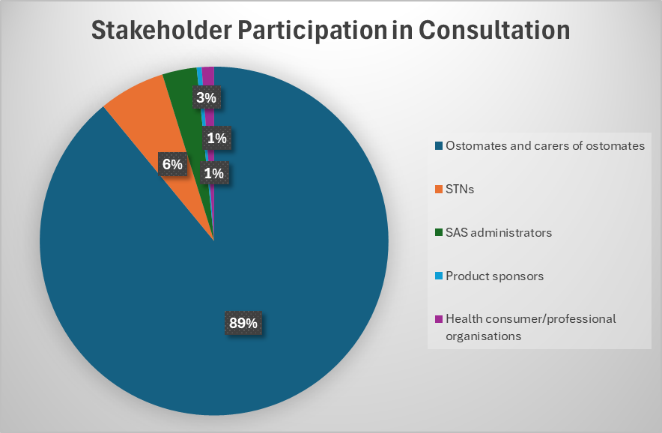

### Recommendation 1: Eligibility

**The SAS should maintain its focus on stomas originating from the urinary and gastrointestinal tract for the removal of waste. The current eligibility criteria should not expand to cover non-gastrointestinal stomas and stomas not for the removal of waste.**

#### Key feedback regarding Recommendation 1

* We heard strong feedback from all categories of stakeholders that the SAS should maintain its focus on stomas originating from the urinary or gastrointestinal tract for the removal of waste.
* Many ostomates gave personal reasons for supporting this recommendation such as the positive impact the SAS has on their lives and the cost that would be incurred by ostomates if they had to purchase stoma products independently.
* Other reasons given for not expanding SAS eligibility included:
  + concerns about a reduced focus,
  + the potential negative impact on the delivery of current services, and
  + the importance of preserving the original intent of the program.
* Many respondents did not make specific suggestions about other conditions to be included in the SAS eligibility. The most important consideration for them was that no ostomates were excluded.
* The clinicians who responded regarding the expansion of the SAS did not have a consensus view on what other conditions to include in the SAS eligibility.
* The consultation asked specifically about the continued inclusion of patients with neo‑anus openings. Many respondents were unfamiliar with this condition but wanted to ensure these patients were appropriately supported.
* The consultation feedback did not provide a strong case for expanding the SAS eligibility to include other stoma types.

### Recommendation 2: Maximum quantities

**Review the current maximum quantity restrictions on all products to ensure these are in line with clinical requirements.**

#### Key feedback regarding Recommendation 2

* We found several common themes emerge from the responses to this recommendation. These themes included:
* For some products the maximum quantity does not align with current clinical recommendations. For example, for products listed in subgroup 1c (Convex Baseplates), clinical advice is that the bag could require changing up to 3 times per day, but the current maximum quantity for most products in this subgroup is 60 per month.
* In situations where 2 products are used together (or example seals and certain types of bags) the maximum quantities do not always align for the 2 products, resulting in requests for additional supplies.
* Some products that are required to be changed daily have a maximum quantity of 30 per month (or 360 per year).
* New ostomates often require extra products, above the maximum quantity, as they are changing their appliances more frequently and trying to find the best product for their needs.
* In addition to these themes, it became apparent that some ostomates are unaware of existing SAS processes such as being able to access additional supplies for clinical reasons or the option to orders 2 months’ supply at one time.

### Recommendation 3: Group 9 products

**Group 9 (accessory products) should be split into 2 groups to differentiate between products that are necessary to manage a stoma and those that are discretionary. Products considered to be discretionary should have higher evidence requirements for listing and stricter maximum quantities and restrictions.**

#### Key feedback regarding Recommendation 3

* We heard that respondents were generally supportive of Group 9 being divided into 2 proposed categories: ‘clinically necessary’ and ‘discretionary’.
* However, there was no consensus on the proposed allocation of products to each category. Common feedback from ostomates was that there is no ‘normal’ in stoma management, so imposing additional restrictions on some products could disadvantage some ostomates.
* STN respondents provided feedback regarding the clinical use of some Group 9 products including some categories of products that are no longer used in clinical practice as technology has been superseded by other products.
* STN respondents also highlighted the potential increase in workload if more restrictions were introduced.

### Recommendation 4: Product pricing

**Maintain the current benchmark and premium pricing model for most products on the SAS Schedule and consider a price increase for products as well as regular pricing reviews.**

#### Key feedback regarding Recommendation 4

* We heard most respondents are generally supportive of the current benchmark/  
  premium pricing model for products on the SAS schedule as well as regular pricing reviews.
* There were mixed views about tendering for Group 9 products with the main concern being tendering may reduce the quality and range of product options available to them.
* We also noted some respondents do not have visibility of product pricing or an understanding of how the pricing model works, and their main concern was whether the pricing model supported their access to the products they need to manage their stoma.
* SIA also made some specific requests on behalf of product sponsors, including:
* A once-off ‘price correction’ to account for 12 years of fixed prices.
* The resumption of annual indexation, as was in place for the SAS pre‑2013.
* A new process, whereby every 2 years product suppliers can request a review of prices for specific products based on evidence to support the price review.
* Improved transparency in product pricing and listing processes including:
  + - opportunities to consult with the Chair of the SPAP,
    - clear requirements for clinical evidence to support price premiums, and
    - a mechanism to request for price increases beyond annual indexation.

### Other Issues

* We also asked respondents to comment on any aspect of the SAS not covered by the consultation paper. From the large number of responses to this question we have identified the following themes.

*Value of the SAS*

* Many respondents provided positive feedback and gratitude for the SAS noting it provides ‘life changing’ access to a wide range of fully subsidised stoma products and appliances for all Australian ostomates.
* Respondents value the wide range of products available on the SAS as there is no ‘one size fits all’ approach to ostomy care.
* Respondents were very appreciative of the services provided by stoma associations.

*STNs*

* Respondents acknowledged that STNs play an essential, specialised role in providing advice, education and helping ostomates select the right products to manage their stomas.
* There was widespread concern regarding the number and accessibility of STNs across the country.

*Distribution*

* Concerns were raised regarding the heavy reliance on a volunteer workforce in many associations.
* There was concern regarding inequities in the current system, as some ostomates must pay postage and others can pick their orders up at their local association at no cost.

*Composition of the SPAP*

* The SPAP is an independent panel that assesses stoma products for listing on the SAS Schedule.
* There was support for expansion of the SPAP to include:
* increased consumer representation on SPAP, potentially including an ostomate with a urostomy
* broader STN representation including STNs that work in different clinical settings, communities and with different stoma types, and
* a clinician with expertise in urostomies.

*Improved education and communication about the SAS*

* Based on some of the responses to the consultation, it was evident there is a need for increased information sharing and education for ostomates about SAS processes including:
* changes to products on the SAS Schedule (Group 9 changes, deletions of existing products etc)
* how to access additional supplies.
* Some SAS documentation is not consumer-friendly and could be provided in a different format to make it more accessible for ostomates. Examples include information in the SAS Schedule and the SAS Operational Guidelines.

## Next Steps

Through this consultation, we have heard a consensus among stakeholders that the SAS in its current form is highly valued. However, there are also opportunities to improve the SAS.

The SPAP has considered the responses of this consultation and will present its recommendations to Government for consideration. Depending on the scope of the recommendations, any changes to the SAS and SAS Schedule will be a decision for either the Minister for Health and Aged Care’s delegate in the department, the Minister or Cabinet.

In the interim, the SPAP and the department are working together to address some concerns and issues that can be managed via administrative changes. This includes improving SAS documentation to better meet the needs of ostomates and other stakeholders.

The department will continue to keep stakeholders informed of the reform process and will provide opportunities for engagement wherever practical.

For more information about the SAS: [Stoma Appliance Scheme | Australian Government Department of Health and Aged Care](https://www.health.gov.au/our-work/stoma-appliance-scheme)