Consultation Guide

The Health Legislation Amendment (Data-matching) Bill 2019 and associated Regulations

Introduction
While the vast majority of Medicare providers do the right thing, the Department of Health (the Department) has a responsibility to protect the integrity of the Medicare health payments system through prevention, identification and treatment of fraudulent and incorrect claiming. In order to better detect fraud and incorrect claiming the Department proposes improved data matching and sharing arrangements through changes to legislation.
The proposed Health Legislation Amendment (Data-matching) Bill 2019 (the Bill) will amend the National Health Act 1953 and the Health Insurance Act 1973 to enable a scheme of data matching for permitted Medicare compliance purposes. The legislative package also includes the Health Legislation Amendment (Permitted Information Disclosure) Regulations 2019 (the Regulations).
This consultation guide is published to assist health practitioners, members of the public, peak bodies and professional associations to scrutinise the proposed legislation and participate in the consultation process.
The legislative package is not final. The Department welcomes comment regarding all aspects of the proposed changes and this feedback will inform the final form of the legislative package introduced to Parliament. Feedback and comments can be provided to the Department via the consultation page at https://consultations.health.gov.au/ by 11 October 2019.

Why are the changes being proposed?
To ensure the sustainability of Medicare into the future, it is critical to protect the integrity of its payment systems. In 2018-19, the Australian Government spent $37.1 billion on Medicare and other health services funded by the Department of Veterans’ Affairs (DVA). If only one half of a percent of Medicare payments are fraudulently, incorrectly or inappropriately billed, around $180 million of health benefits would be lost that could have otherwise contributed to essential health services for Australians.
Currently, the Department uses a combination of tip-offs and data analysis of existing Medicare datasets to detect fraud and incorrect claiming. While tip-offs will continue to be a highly valuable source of information, the Department is limited in its ability to analyse Medicare data to identify non-compliance. Improved data-matching capabilities supported by the proposed legislative changes will assist the Department to more efficiently and accurately detect fraud, incorrect or inappropriate claiming to ensure a greater percentage of incorrectly paid benefits are identified and recovered.

What is Medicare compliance?
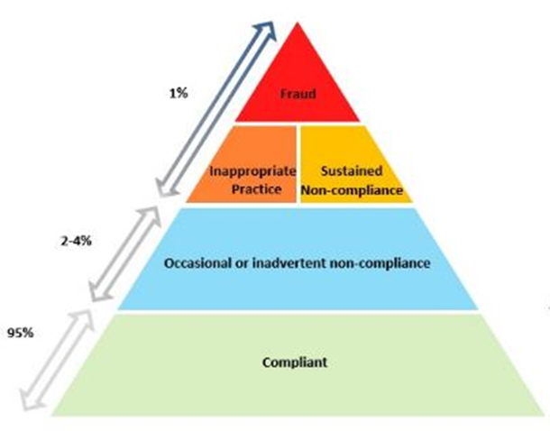
Figure 1 - Health provider compliance pyramid
The Department has a strong and well-established Medicare compliance program that protects Australia’s health payments system through the prevention, identification and treatment of incorrect claiming, inappropriate practice and fraud by health care providers and suppliers.
The Department currently conducts compliance activities that are proportionate to the type of non-compliance identified (Figure 1). These activities include:
- audits where sustained or opportunistic non-compliance is identified;
- targeted letter campaigns where unintentional non-compliance is identified;
- professional review where inappropriate practice is identified;
- investigations of suspected fraudulent activity and prosecution of fraud through the Commonwealth Director of Public Prosecutions; and
- the recovery of debts that have been identified as a result of incorrectly claimed benefits.
The Department continues to improve Medicare compliance arrangements by:
- consulting with professional bodies and stakeholder groups on its compliance strategies and activities;
- using data analytics to better target compliance activities; and
- providing education support resources for health professionals.

The Medicare compliance process is a prescriptive process that incorporates procedural fairness and review rights. Officers performing provider compliance functions within the Department must follow particular processes in sequential order that affords an opportunity for providers to respond.

The proposed data-matching and sharing arrangements do not expand the powers of the Department to conduct compliance activities. Nor do they change the approach taken by the Department in conducting its compliance activities.

The changes focus only on improving the Department’s ability to match and share data for the purposes of identifying fraud and incorrect or inappropriate claiming. The proposed changes will not authorise the automation of compliance outcomes or raising of debts, and the Department’s compliance officers will continue to follow prescribed and/or legislated compliance processes.

The scope of proposed legislative changes
The legislation package will amend existing legislation to introduce a scheme of data matching with the following features:
- The Bill enables the matching of specific data-sets with other prescribed Australian Government agencies for the following legislated, permitted Medicare compliance purposes:
- identifying whether a person may have engaged in Medicare fraud or incorrect claiming;
- recovering overpayments of benefits due to fraud or incorrect claiming under a Medicare program;
- detecting or investigating contraventions of a law in relation to Medicare;
- detecting or investigating whether a healthcare provider may have engaged in inappropriate practice;
- analysing services and benefits for the purposes above; and
- educating healthcare providers about Medicare program requirements.

- Currently, section 135AA of the National Health Act 1953 and associated National Health (Privacy) Rules 2018 (the Privacy Rules) only permit matching of Medicare Benefits Schedule (MBS) and Pharmaceutical Benefits Scheme (PBS) data in narrow circumstances. The proposed legislation will exclude data matching from this restriction when the matching is undertaken for specified Medicare compliance purposes.

- The Regulations will enable the disclosure and sharing of certain information with prescribed government entities to assist them in performing their functions.

- Disclosure of certain information to Australian Government agencies for the purposes of matching data on behalf of the Chief Executive Medicare will be authorised for legislated, permitted Medicare compliance purposes.

- Data matching for Medicare compliance purposes using data from the MBS and PBS,DVA, the Department of Home Affairs (Home Affairs), the Australian Health Practitioner Regulation Agency (AHPRA) and the Therapeutic Goods Administration (TGA). Private Health Insurers (PHIs) may also provide data to the Department on a voluntary basis, though Medicare data will not be permitted to be provided to PHIs.

The changes will not allow the Department to access My Health Record data for the purposes of its Medicare compliance activities.

For further information on what is in and out of scope refer to Figure 2 below.
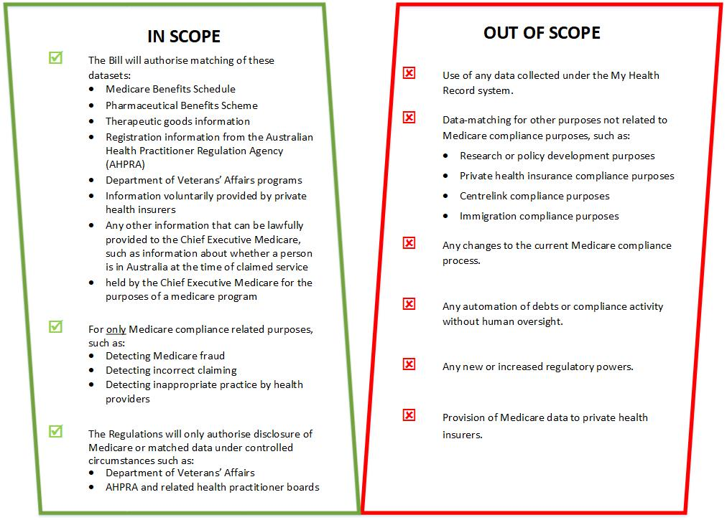
Figure 2 - Data-matching scheme: In scope and out of scope
The legislation will allow both the matching of MBS and PBS datasets and the matching of these data sets with other external datasets (Figure 3 and Figure 4).
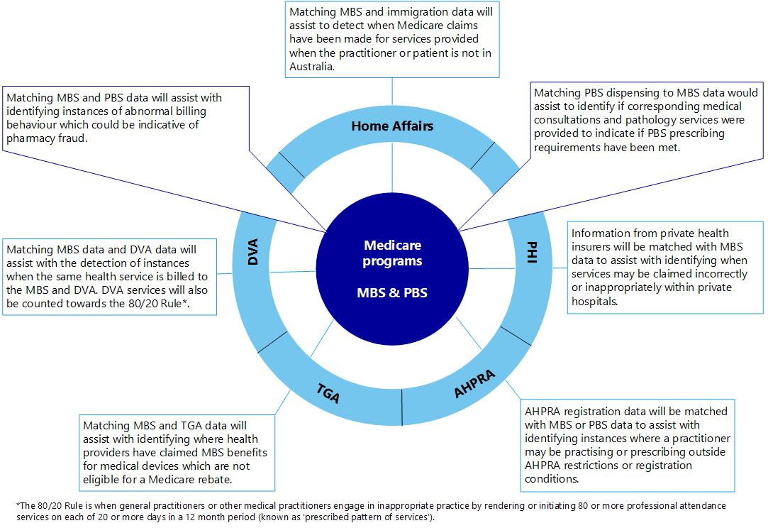
Figure 3 - Datasets proposed to be used for matching
Matched Datasets | Matching Method | Current Capability | Benefit
MBS data and PBS data | Matching PBS dispensing data to MBS data would assist to identify whether corresponding medical consultations and pathology services were provided and indicate whether PBS requirements are being met.  Positive identification of claiming patterns outside the norm may be an indicator of fraud or inappropriate dispensing. | Currently, the Department relies on tip-offs and has limitations to the extent it can see if a patient who has high cost drugs dispensed has had any prior relevant MBS consultations.  The Department is currently limited in its ability to analyse the relationship between MBS services and the claiming of PBS benefits. | Patient safety, recovery of incorrect or fraudulent claims, possible referral to responsible regulator or DPP, accurate health data demonstrating legitimate use of PBS benefits.
MBS data and immigration data | Matching dates of claims made by providers to records confirming the provider or patient was overseas would assist in identifying instances where a provider may have fraudulently claimed Medicare benefits for services which were not validly provided. | Currently, the Department relies on tip-offs and is not able to see whether practitioners billing MBS claims are in Australia at that time. | Recovery of fraudulent claims and prosecution, potential removal of future Medicare privileges.
MBS data and DVA data | Matching dates of claims for the same provider and patient, to assist in identifying instances where a provider is claiming both Medicare and DVA benefits for the same service when only entitled to claim one. | Currently, the Department has limited visibility of whether there has been a simultaneous claim made with DVA for a service where an MBS claim was made. | Recovery of incorrect claims.
MBS data and TGA data | TGA provides information to Health about medical devices and the practitioners using them, to be matched with MBS data, to assist with identifying instances where providers may be claiming MBS benefits for the use of medical devices which do not attract a benefit. | Currently, TGA is unable to provide this information to the Chief Executive Medicare routinely and it is not matched. | Patient safety, recovery of incorrect claims, possible referral to responsible regulator.
MBS data and private health data | Private health insurers may voluntarily provide information to Health about anomalous claims with data that goes beyond what is routinely held as a result of Medicare claims. This additional information will assist Health to identify fraudulent or incorrect billing. | Currently, private health insurers are prevented from providing certain information to the Department. Private health insurers collect more information than what is logged with MBS claims, including details such as the start and end times of a surgical procedure. | Recovery of incorrect or fraudulent claims.

Figure 4 - Examples of matching for compliance purposes

How the privacy of individuals will continue to be protected
The Bill deems any breaches of any part of the new legislative provisions in relation to an individual to be considered as a breach of the Privacy Act 1988 (Privacy Act), thus ensuring that the scheme is subjected to the same protections and enforcement as the Privacy Act.
The Office of the Australian Information Commissioner is responsible for the privacy functions provided by the Privacy Act and other laws. The Bill further expands the Information Commissioner’s assessment powers to enable the Information Commissioner to have oversight in relation to the data matching scheme.
The Department has commissioned an independent Privacy Impact Assessment to identify the impact the proposed changes might have on the privacy of individuals. In response to recommendations, privacy safeguards have been included within the Bill that require the Department to put in place a range of measures to improve governance arrangements and ensure appropriate privacy protections.
To ensure effective governance, the Bill requires the Chief Executive Medicare to establish and maintain systems and processes to:
- ensure the information matched is reasonably necessary for identified purposes;
- have record-keeping requirements;
- ensure the information used for matching is accurate, up-to-date and complete;
- ensure the timely destruction of information that is not in use; and
- maintain a public register of matching activity.
To ensure these systems and processes are fit for purpose, there is also a legislative requirement to consult with the Information Commissioner on these arrangements.
The Information Commissioner has also issued the Guidelines on data matching in Australian Government administration (the Guidelines), which provide guidance to government agencies on best practice in undertaking data matching activities. While the Guidelines are voluntary, the Department has committed to adopt these for routine data matching enabled under the Bill and for future data matching Medicare compliance activities.
The Guidelines require the Department to develop data matching protocols and technical standard reports that can be reviewed by the Information Commissioner, as well as other notification activities in addition to the governance requirements legislated under the Bill.

Regulations
The Department also proposes Regulations to allow the disclosure of certain information, including information resulting from data matching, to prescribed Australian Government agencies and regulatory authorities, in specified circumstances.
The Regulations enable information disclosure to DVA, AHPRA and the Health Professional Boards and related health practitioner regulation bodies.
DVA would also be a prescribed authority to allow the Department to disclose information relevant for DVA’s legislative functions, including program management purposes.
The Regulations also make AHPRA and the Health Professional Boards and related health practitioner regulation bodies “prescribed bodies” to receive information so that they are able to undertake investigative and disciplinary action to fulfil their role of public protection.

Stakeholder Questions
The Department welcomes feedback on the proposed legislation from all interested parties. The Department will consider all submissions when formulating the final form of the Bill that will be introduced to Parliament. In developing your submission, you may wish to consider the following questions:
- Do you have concerns about this legislation with regard to privacy protections, the Privacy Act 1988 or the role of the Australian Information Commissioner?

- Are there any additional agencies and entities that should be listed for potential disclosure of MBS and/or PBS information, or notification of compliance outcomes for public interest reasons?

- Are there any other data sources that would be appropriate to match with MBS and/or PBS data for Medicare compliance purposes?

- Are there any additional safety and quality concerns in the health system that could be addressed through access to other data?

- Should there be any other compliance purposes that should be permitted under the proposed legislation?

- Are there adequate transparency and accountability mechanisms built in to the framework?

In the context of this guide, the use of the term Medicare refers to Medicare programs including Medicare Benefits Schedule, the Pharmaceutical Benefits Scheme, the Child Dental Benefits Schedule and other health incentive payment schemes.

