Data submission user guide for voluntary Private Hospital Financial Return

Contents

Identity and Access Management (IAM) Portal 5

Log on to the Identity and Access Management (IAM) portal 5

Change your password 7

Criteria for your new password 8

Setting up password challenge questions 8

Reset forgotten password 9

Data Submission Portal (DSP) 11

Logging onto the DSP 11

Uploading a file 13

Logging out 15

This User Guide assumes that you have already contacted the department and have obtained a username and temporary password for an account which enables access the Data Submission Portal. If you do not have a username and password please contact [hcp@health.gov.au](mailto:hcp@health.gov.au) (or ring 02 6289 8058) and request an account by giving the following details:

Name of data submitter:

Provider number of facility:

Provider (facility) name:

Email for validation reports:

If you submit data for more than one hospital and require this to be set up, please provide the provider ID for all facilities.

This portal is the same portal hospitals use to submit the PHDB data monthly to the department. The portal can also be used as a drop box to upload hospital financial information. Please follow instructions as normal, once file has been uploaded, email the [hcp@health.gov.au](mailto:hcp@health.gov.au) inbox or [private.hospitals@health.gov.au](mailto:private.hospitals@health.gov.au).

# Identity and Access Management (IAM) Portal

**This process will allow you to change your password, set or modify your challenge questions and update your personal details.**

To set up a new password for your account you will need to access the Identity and Access Management (IAM) portal.

Your username and temporary password are required to access this page. You should have received these in emails from the Department of Health.

## Log on to the Identity and Access Management (IAM) portal

**Step 1:** Access the [Identity and Access Management (IAM) portal](https://login.healthdata.gov.au/my.policy) at or click on the link provided in the Welcome email notification.

**Step 2:** Sometimes you may see the screen below depending on your browser settings. If so, click the ‘click here’ link.

Error screen 
Text says 
Your session could not be established 
to open a new session please click here 

**Step 3:** Indicate your agreement with the terms and conditions by clicking on the ‘Accept’

Login page 
Text in image 
 This system is for use by authorised users only. The right is reserved to monitor usage as necessary in accordance with relevant legislation and applicable policies. Unauthorised or improper use of this system may result in disciplinary action and/or civil or criminal penalties. By continuing to use this system you indicate your awareness of, and agreement to, these terms and conditions of use. DO NOT proceed with logon if you do not agree to the conditions stated in this notice.

with the options 
ACCEPT 
DECLINE

**Step 4:** Enter the username and temporary password you received in the email notification

Picture of the login.healthdata.gov.au page.
username
Password


Once you are logged on, the homepage will appear where you will be able to perform a number of different activities including changing your password.

## Change your password

**Step 1:** Select the ‘My Information’ tab from the IAM Portal

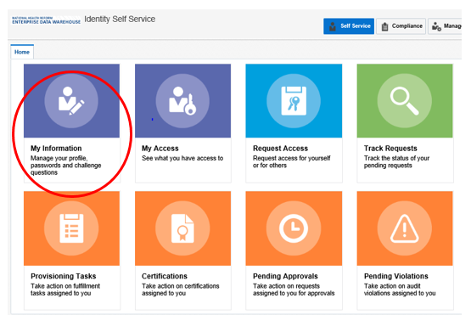

**Step 2:** Enter your temporary/old password into the ‘Old Password’ field and your new password in the listed fields. Once you have completed all three fields click ‘Apply’.

Change password page 
Old password
New password
Confirm New password

## Criteria for your new password

Passwords must:

* contain at least 2 alphabetic character(s)
* be at least 10 character(s) long
* contain at least 1 lowercase letter(s)
* contain at least 1 numeric character(s)
* contain at least 1 uppercase letter(s)
* start with an alphabetic character

Passwords must not:

* match or contain first name
* match or contain last name
* match or contain Username

## Setting up password challenge questions

**The setting of challenge questions is triggered whenever a new account holder logs into their account for the first time. The challenge questions can also be updated at any time through the Identity and Access Management (IAM) portal. These questions are used to check the user’s identity whenever a password reset is requested.**

**Step 1**: Select the ‘My Information’ tab from the IAM Portal

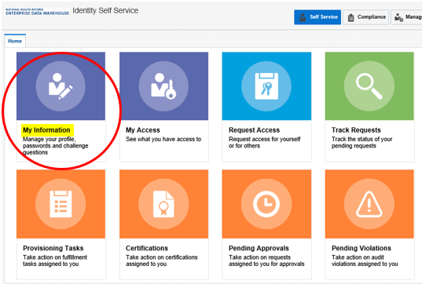

**Step 2:** Select the ‘Challenge Questions’ sub tab from the ‘My Information’ page.

Challenge questions page.
Question 1 Answer 1 
Question 2 Answer 2
Question 3 Answer 3
Question 4 Answer 4   
Question 5 Answer 5 
Question 6  Answer 6 

**Step 3:** Select questions you would like to use as your three challenge questions using the drop-down boxes.

**Step 4:** Enter the answer for each chosen question into the boxes provided.

**Step 5:** Complete all questions and responses then click ‘Apply’. A popup will appear to confirm that challenge questions have been successfully set.

## Reset forgotten password

If you ever forget your password, you are able to do a reset by entering the answers to your challenge questions, follow these steps.

**Step 1:** Navigate to [Forgotten Password](https://identity.healthdata.gov.au/identity/faces/forgotpassword?backUrl=https://identity.healthdata.gov.au/identity)

**Step 2:** Enter your username in the space provided and then click **Next**.

Forgotten password page
Enter your username 


**Step 3:** The following window will appear where you can enter the answers to your challenge questions which were set up when first setting your password.

Answer your challenge questions
What is your mothers maiden name?
what is the city of your birth?
what is  your favourite colour?


**Step 4:** Once you have filled in answers to each challenge question click the “Submit” button

**Step 5:** Once submitted an email should be sent to your email account assigning a random password which you can then use to log in.

Once you have received your temporary password, it is recommended that you change it to something more memorable to reduce the need for a future password reset.

If you have forgotten the answers or never set your security challenge questions then you will have to request a manual password reset by emailing [hcp@health.gov.au](mailto:hcp@health.gov.au) providing your username and letting us know that you require a password reset.

# Data Submission Portal (DSP)

## Logging onto the DSP

**Step 1:** Navigate to the [Data submission Portal](https://mftportal.data.health.gov.au/VLPorta)

**Step 2:** You may see the screen below depending on your browser settings. If so, click on the ‘click here’ link.

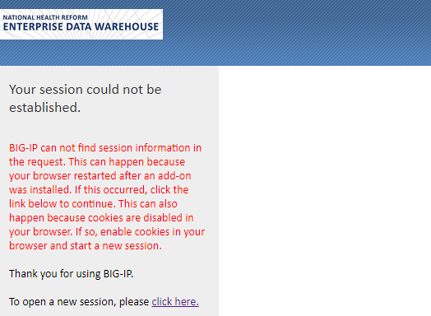

**Step 3:** Indicate your agreement with the terms and conditions by clicking on the ‘Accept’ icon

This system is for use by authorised users only. The right is reserved to monitor usage as necessary in accordance with relevant legislation and applicable policies. Unauthorised or improper use of this system may result in disciplinary action and/or civil or criminal penalties. By continuing to use this system you indicate your awareness of, and agreement to, these terms and conditions of use. DO NOT proceed with logon if you do not agree to the conditions stated in this notice.
Accept or 
Decline

**Step 4:** Enter your Username and Password and click ‘Logon’.

Please note: your Username must be entered in lowercase

Secure logon page
username 
Password


After successfully logging into the Data Submission Portal you will arrive at this page:

Welcome to the VersaLex web portal.

  --  select "Manual File Transfer" for ad hoc file transfers
  --  select "File Transfer History" to view transfer results within your HTTP user mailbox or an associated primary mailbox
  --  select "VersaLex Web Portal Help" to view general help documentation for the portal


Please contact the system administrator with any questions.

**Please note:**

The standard browser ‘forward’ and ‘back’ buttons should not be used when navigating within and between the portal base pages. Instead use the menu in the left pane to navigate between the pages. The standard browser ‘refresh’ button should also not be used. Instead use the refresh button or icon provided on the portal view page.

## Uploading a file

Server Download Directory
upload files
home > outbox
Files below 

**Step 1:** To upload your files, select the ‘Manual File Transfer’ link from the menu, as shown below. If you see an error message after clicking the link, please click the ‘Manual File Transfer’ link again.

**Step 2:** In the Server Upload Directory panel, ensure that ‘./inbox’ is selected from the dropdown box.

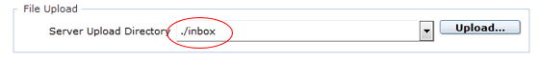

**Step 3:** Click on the ‘Upload button’ to upload files. A security warning may pop up, if this happens, tick the option to ‘Always trust content from this publisher’ and then click ‘Yes’. (This warning message should only appear the first time you launch the DSP from your browser).

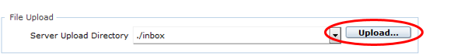

**Step 4:** A Windows File Explorer window will be displayed (as shown below). Navigate to and select the file you wish to upload and Click on the ‘Open’ button

Windows File Explorer window
the ‘Open’ button circled

**Please note**: The DSP will accept both zipped and unzipped files.

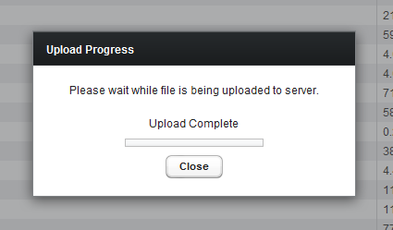

**Step 5** An ‘Upload Progress’ window will appear on your screen updating you on the progress of the upload. Once your file(s) have been uploaded the text “Upload Complete” should appear in the window. Note that the ‘progress bar’ in the window will appear as below once completed. Click the ‘Close’ button to close the window.

Once you have uploaded your file to the DSP, you will receive an email confirming its upload. Please email the department and let them know you have uploaded the file and we will take care of it on our end.

Please note that when submitting the Private Hospital Financial Return for FY2024, you will receive a validation error message. You can ignore this error message. Your file has been submitted and can be retrieved by the department.

## Logging out

**Once you have finished using the DSP click the ‘Log Out’ button on the left to log out.**

**If you leave your session inactive for more than a few minutes during use the system will log you out automatically.**