National Allied Health Workforce Strategy – Consultation Hub Landing Page

Process for developing the Strategy
In 2023 Robyn Kruk AO prepared the Independent review of overseas health practitioner regulatory settings Final Report. The report recommended governments collaborate through Health Ministers to develop a National Allied Health Workforce Strategy (the Strategy). The Strategy will facilitate future workforce planning and support effective multi-disciplinary workforce models and integrated care. The Australian Government and state and territory governments accepted the recommendation.
The Health Workforce Taskforce, a subcommittee under the Health Chief Executives Forum and the Health Ministers Meeting, considers matters relating to the Australian health workforce. Members are drawn from all jurisdictions and will oversee the Strategy’s development. Once Health Workforce Taskforce has endorsed the Strategy, it will be progressed to Health Chief Executives and Health Ministers for endorsement.

The aim of this project is to deliver a national, cross-sectoral Strategy that will outline how to address current and future allied health workforce issues in Australia over a 10-year horizon. The purpose is to enable long term workforce planning to ensure the supply of allied health professionals better matches existing and predicted need. The Strategy will acknowledge and embed other major cross cutting health reforms within it.

Development of the Strategy is occurring through the stages outlined in Table 1. Some of these stages occur in parallel.

Table 1: Stages for development of the National Allied Health Workforce Strategy
Stage |  | Timeframes
GATHERING  EVIDENCE | Progressing an environmental scan and literature review with a focus on:  - Overarching factors and reforms influencing workforce supply, demand and safety and quality  - Existing policies, strategies and models of care and cross-cutting health reforms  - Gaps in data collection  - An analysis of allied health workforce issues by sector (such as, but not limited to, public health, primary care, disability, aged care, mental health, education). | January 2024 – June 2024
CONSOLIDATING EVIDENCE | Using the results of the environmental scan and literature review to:  - Identify and draw out commonalities across sectors; and  - Identify sector-specific or emerging issues. | May 2024 – October 2024
 | Conducting stakeholder consultations to confirm and build on the findings of the environmental scan and literature review.
DRAFTING STRATEGY | Drafting a Strategy that outlines key findings and recommendations or actions for governments to take forward. | July 2024 – December 2024
STRATEGY ENDORSEMENT | Final Strategy tabled with Health Workforce Taskforce, Health Chief Executives and Health Ministers for endorsement. | Early 2025

There are other projects being done through Health Workforce Taskforce that complement the Strategy. One of these projects is considering detailed workforce modelling for allied health and other health professionals. As such, workforce modelling is not in scope for the Strategy. Governments are collaborating through Health Workforce Taskforce to ensure the Strategy is aligned with other complementary projects.

Implementation planning will occur once the Strategy is complete.

Overview of consultation approach
In line with the approach for the medical and nursing strategies, there are five key principles that will guide stakeholder engagement approaches to support the Strategy’s development. The five principles set the standards for consistent, open and respectful working relationships. The principles have been tested against, and are consistent with, current stakeholder engagement standards and practices across the public and private sectors, locally and internationally.

- Purposeful: begin every engagement with a clear understanding of what we want to achieve
- Drive engagement according to the objectives of the Strategy and the broader government priorities.
- Understand the need to engage and agree on what success looks like, to support focused and meaningful engagement.
- Plan communication and manage expectations, to help build lasting goodwill with stakeholders participating in the process and develop an understanding about their capacity to engage.

- Inclusive: identify our stakeholders and make it easy for them to engage
- Identify and enable the participation of those people and organisations that contribute to, influence, or are affected by implementation of the Strategy. This includes those that may be harder to reach for reasons such as language, culture, age or disability. It also includes other professionals who work alongside allied health professionals.
- Provide stakeholders with the information they need to engage and contribute in a meaningful way.

- Timely: involve stakeholders early and agree on when and how to engage
- Clearly identify and explain the engagement process. This includes meeting schedules, and response times for information requests or feedback.

- Transparent: open in our engagement and set clear expectations
- Provide information to enable stakeholders to participate in engagement in a meaningful way; this will help foster a culture of sharing information.

- Respectful: acknowledge and respect the expertise, perspective, and needs of stakeholders
- Take care to be open to alternative views and to listen as well as speak, recognising that engagement is a two-way process.
- Respect our stakeholders’ expertise and appreciate the benefits of mutual learning.
- Recognise the different communication needs and preferences of stakeholders and endeavour to meet these wherever possible.
- Recognise our stakeholders’ objectives, environment, and level of influence.
The stakeholder engagement model at Figure 1 will be used to inform conduct of stakeholder engagement activities in relation to development of the Strategy. The five-step process is structured to support thorough planning, preparation, action and evaluation of every engagement activity. The process is a dynamic and ongoing cycle, which supports a comprehensive approach to engagement.

The way in which this process is applied in relation to the Strategy will be driven by the purpose, level and type of engagement undertaken.
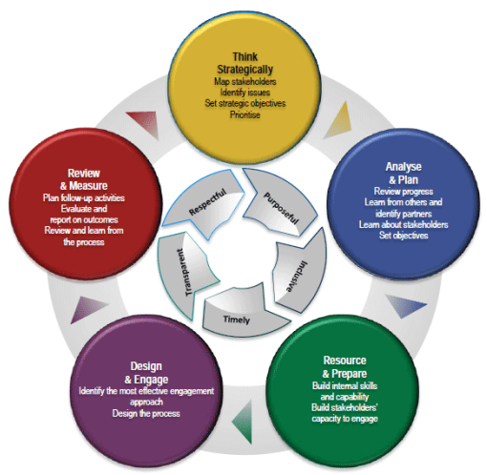
Figure 1: Stakeholder engagement model for the National Allied Health Workforce Strategy

There will be multiple methods of consultation on the Strategy. An overview of the methods to be used and the timeframe for these opportunities is outlined in Table 2. Consultations that are open to all stakeholders are shaded green, while targeted consultations are shaded orange.
Table 2: Summary of consultation approaches for the National Allied Health Workforce Strategy
Consultation approach and purpose | May | June | July | August | September | October
Consultation Hub – Round 1
To seek feedback on the purpose and scope of the Strategy
Stakeholder workshops and webinars
Targeted consultations with allied health leaders
Targeted consultations with allied health peak bodies on draft Strategy
Consultation Hub – Round 2
To summarise the issues to be raised in the Strategy and identify potential actions to address these issues

How to provide input
We welcome your input to the Strategy’s development.
This survey provides the opportunity to respond to the draft outline of the National Allied Health Workforce Strategy.
If you would like to contact us about the consultation process, please email caho@health.gov.au
If you’d like to receive updates on the progress of the Strategy, please subscribe to allied health sector updates via the department’s website.

Other documents to review
- Consultation Hub paper: Draft outline of the National Allied Health Workforce Strategy
- Consultation Hub survey: the draft outline of the National Allied Health Workforce Strategy

https://www.health.gov.au/resources/publications/stakeholder-engagement-framework?language=en

