COAG Health council logo

**Have your say on a national obesity strategy**

Overweight and obesity is a significant issue in Australia. It affects a person’s health and wellbeing, and their social and economic opportunities. It also impacts our communities, society and the economy.

We can help to reduce overweight and obesity in Australia through a national obesity strategy. The strategy will guide government action over the next 10 years.

A national obesity strategy will identify opportunities to create benefits for many people and sectors. It will:

* scale up or leverage current efforts to reduce overweight and obesity in our communities
* be innovative and bold
* involve working together
* fill gaps
* focus on influencing the environments around us to better support healthy weight. These can be social, cultural, physical, economic and commercial factors.

The ideas of individuals and organisations gathered through the *Senate Select Committee Inquiry into the Obesity Epidemic in Australia* (2018) and the *National Obesity Summit* (2019), along with evidence and practice reviews, have been used to draft options for what a national obesity strategy might include.

It’s time to have your say about these ideas and share what you think will encourage and enable a healthy weight for all Australians.

## How to have your say

To share your views and ideas:

* Complete the online survey. There is a long and shorter survey to choose from.
* Participate in a community consultation session.
* Participate in the national consultation webinar.
* Host a consultation session.

**The consultation closes at 11:59 pm, Sunday 15 December 2019.**

Visit [consultations.health.gov.au/population-health-and-sport-division/national-obesity-strategy](https://consultations.health.gov.au/population-health-and-sport-division/national-obesity-strategy/) to find out more about the consultation process and community forums.

# The situation - overweight and obesity in Australia

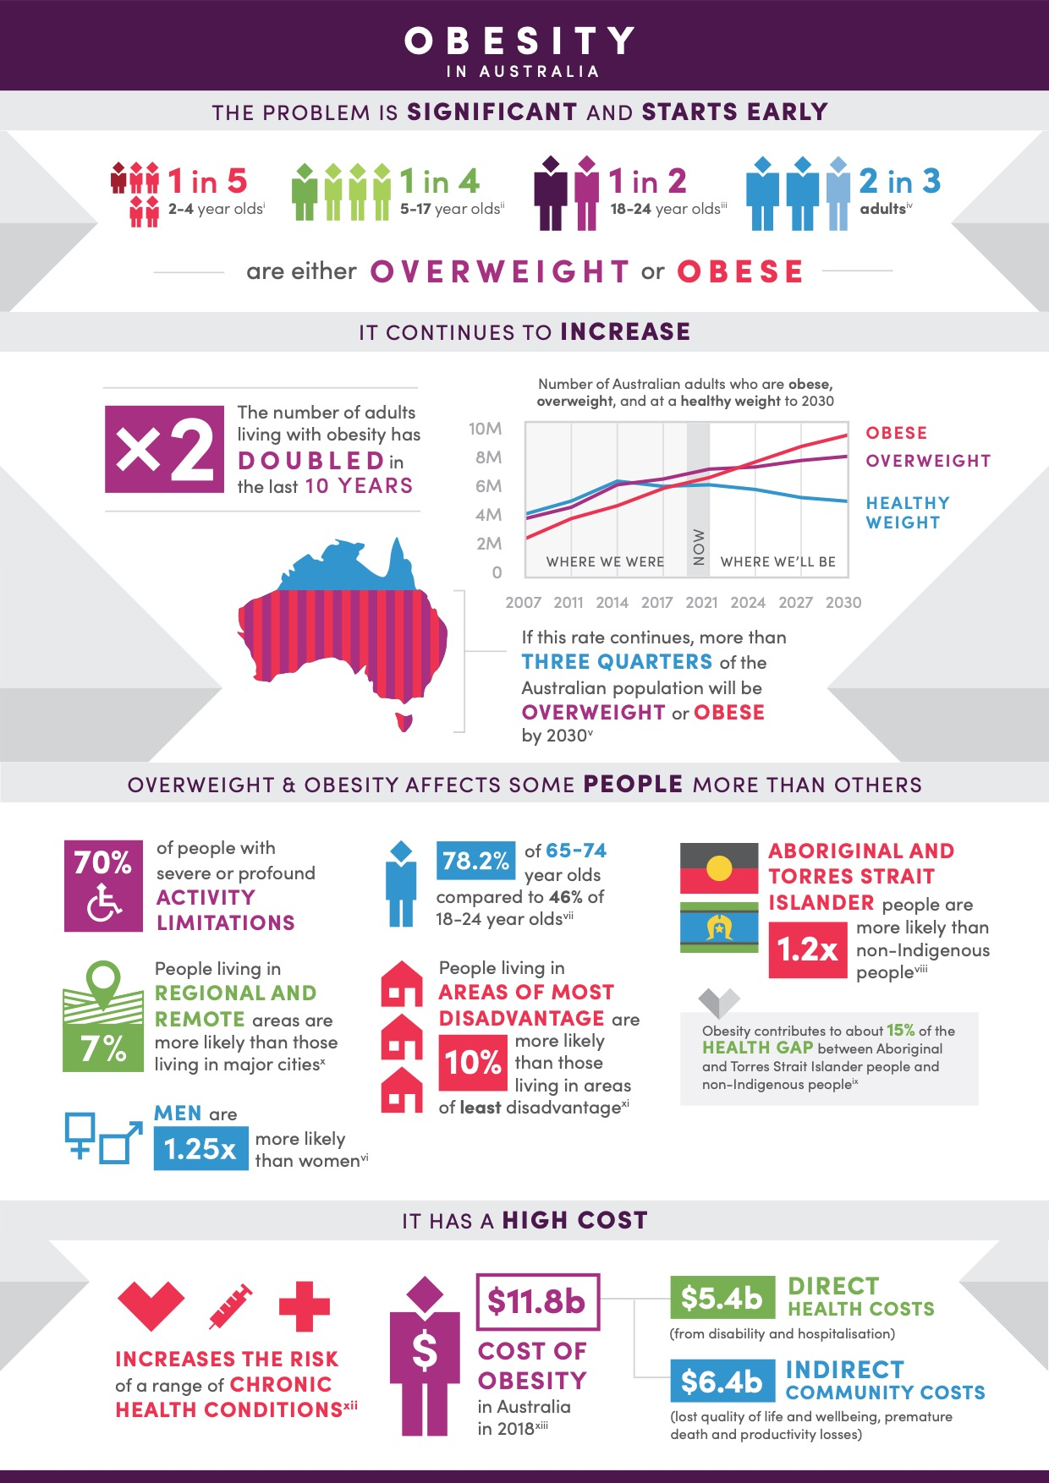

For references, go the consultation hub at [consultations.health.gov.au/population-health-and-sport-division/national-obesity-strategy](http://consultations.health.gov.au/population-health-and-sport-division/national-obesity-strategy).

# Causes of increasing overweight and obesity in Australia

Overweight and obesity is a complex issue with many causes. Our individual choices are shaped by what is available to us, the environments we live in, and our own perceptions and community norms of what is a healthy lifestyle.

###### We have easy access to unhealthy food and drinks

Unhealthy food and drinks are available almost everywhere and are made appealing through marketing and price promotions. They make up over 30% of the Australian diet for children and adults1. Most of the 30,000 packaged foods stocked in an average Australian supermarket are highly processed and unhealthy2.

###### We do less physical activity

People use cars more to get around and have more access to screens, which means they stay still for longer periods. In Australia, driving to work is much more common than walking or riding (69% compared to 5%)3.

###### Choices are not equal for everyone

Some people have even less opportunity to make healthy food choices and be physically active. Healthier food or drinks may not be as available as processed products or they may not be able to afford the cost of healthier food. This includes people experiencing social disadvantage or who live in rural and remote areas.

###### Cultural or historical impacts

For Aboriginal and Torres Strait Islander people, the drivers of overweight and obesity are even more complex. We cannot ignore the impacts of trauma across generations on health, or the positive influence of culture on health and wellbeing.

Continued action is needed now and into the future to address and prevent this major health and societal challenge. Transformative change is possible, and Australia is well placed to lead the way.

# About the proposed national obesity strategy

A national obesity strategy is a way to identify actions for government to lead and do, at the local, regional and national level. This will require strong partnerships across many sectors such as transport, employment, health, social services, education, infrastructure, agriculture, retail, manufacturing, trade and finance.

Government, industry and the community working more collaboratively together will help enhance effort and create many benefits. These benefits will not just improve our health, but will also support our communities.

Prevention is the focus of this national effort, as we know it works. Prevention actions benefit everyone, by helping to make the healthy option the easiest option.

###### What has worked well in your community to promote healthy and active lifestyles?

1 Australian Bureau of Statistics. Australian Health Survey: Nutrition First Results - Foods and Nutrients, 2011–12. Canberra: ABS. 2014 2 National Health and Medical Research Council. 2013. Australian Dietary Guidelines. Canberra. NHMRC (Pg 67)

3 Australian Bureau of Statistics. 2016 Census of Population and Housing. ABS. 2017

# The components of a national obesity strategy

## Proposed vision

A community and environment that encourages and enables healthy weight for all Australians.

What is your vision for healthier weight in our communities?

## Proposed principles

**Five (5) proposed principles** will help to guide development of a national obesity strategy and implementation of its priorities. These include.



People-first

Equity

Collective and sustained action

Evidence-based

Sustainable development

## Focus of the proposed strategy

The strategy will focus on:

* **Government leadership for a whole-of-society response**

A national obesity strategy will guide sustained preventive action over the next 10 years to reduce overweight and obesity in Australia. The strategy will unify people who can impact change. It will create partnerships and promote teamwork. It will identify what governments can do, and how the community and other key stakeholders such as non-government organisations and the private sector contribute.

* **Prevention**

Primary and secondary preventive actions promote and support healthy eating, regular physical activity and the healthiest weight for all. This includes actions to address environmental and social factors and actions to support individuals, families and communities.

**Primary prevention reduces the likelihood of developing a disease or disorder.**

**Secondary prevention interrupts, prevents or minimises the progress of a disease or disorder at an early stage.**

This graphic shows how the focus of the national obesity strategy is on primary and secondary prevention, including promotion, prevention and early intervention. However, it does not focus on tertiary prevention, treatment or rehabilitation, which will be considered as part of other national strategies which are currently under development. 

# Strategies to reduce overweight and obesity in Australia

**Four (4) priority areas** are proposed to help reduce overweight and obesity in Australia. Action in each of these areas is guided by key strategies and sub-strategies.

## 

## 1. Supporting children and families: starting early to support healthy weight throughout life

Children deserve a healthy start to life. The path to overweight and obesity can start even before birth. Proposed strategies include:

* **Support for parents-to-be and new parents**
* healthy habits before, during pregnancy and after birth
* breastfeeding
* healthy infant development guidance
* **Enabling parents to encourage lifelong healthy habits for children and young people**
* healthy child development guidance
* families supported to buy, prepare and enjoy healthy food and drinks
* families supported to use recreation facilities and role model being active
* social support options for adolescents to be active for life
* appropriate family-focused weight management programs
* **Enabling places where children play and learn to promote healthy behaviours**
* supportive policies, practices, leadership, curriculum and programs in schools and early childhood education and care
* communities and facilities that enable being active and active travel
* school attendance

###### Which of these ideas would best support children and families to maintain a healthy weight?

**What stops children from eating healthy and doing more physical activity?**

**What else could help children and families to eat healthy and do more physical activity?**

## 

## 2. Mobilising people and communities: using knowledge, strengths and community connections to enable healthy weight

Empowered individuals and communities can make positive decisions about their health and their environment. Proposed strategies include:

* **Building people’s knowledge and skills to enable healthy habits and social norms**
* information, education and skill-building aligned with national guidelines
* co-designed programs and social marketing to support people and specific communities at greater risk of being an unhealthy weight
* **Support for local communities, groups and organisations to lead initiatives that respond to local need**
* capacity building for leadership, innovation, collective impact and sharing across communities
* informed decisions about sport and event sponsorship options
* **Weight management interventions for those at risk of becoming overweight**
* appropriate weight management programs accessible to all
* co-designed behaviour change programs to support specific communities with greater prevalence of being an unhealthy weight
* reduced weight stigma
* **Support for health and social services to prioritise the prevention of obesity-related chronic disease**
* health and non-health sectors working together
* health and social services that identify unhealthy weight gain and refer clients to services and programs
* social policies to increase employment, social protection and living conditions
* **Healthy behaviours promoted in places where people learn, work and receive healthcare**
* supportive policies, practices, buildings, environments and programs in workplaces, healthcare facilities and tertiary institutions

###### Which of these ideas would best create healthy, active communities that support people to be a healthy weight?

**What can stop people from being a healthy weight throughout their life?**

**What else could help people to eat healthy and do more physical activity?**

## 

## 3. Enabling active living: supporting a way of life that helps people move more throughout the day

Places, spaces and facilities can empower, motivate and inspire individuals and communities to be active. Proposed strategies include:

* **Investing in connected active places and spaces in urban, regional and rural areas**
* safe people-friendly spaces with infrastructure to encourage people to be active
* safe active travel facilities, options and policies through urban and regional planning and design
* green spaces and natural environments
* **Motivating and inspiring participation in regular physical activity by people of all ages and abilities**
* fun, local and social active living programs and events
* co-developed interventions with specific communities at greater risk of being an unhealthy weight
* low-cost access to infrastructure, facilities and spaces that support people being active
* social marketing to build understanding and confidence to be active

**Which of these ideas would best support you and your family to be active in your community?**

**What stops you and your family from living a more active life?**

**What else can be done in your community to make being active easier**

## 

## 4. Building a healthier and more resilient food system: producing and promoting healthier food with little impact on the environment

A resilient food system means having the capacity to produce enough healthy and culturally appropriate food to meet people’s needs now, and into the future. Proposed strategies include:

* **Ensuring our food system favours the production, processing and manufacture of healthy and sustainable products**
* **Increasing the availability of healthier, more sustainable food and drinks in the places we live and work**
* **Making processed food and drinks healthier and more sustainable**
* **Ensuring availability and affordability of good quality, culturally appropriate, healthy food and drinks in communities that are currently worse off**
* interventions with specific communities at greater risk of limited access to healthy food and drinks
* housing support for better food preparation and storage
* partnerships with large supermarkets to make healthy food and drinks cheaper
* **Reducing exposure to unhealthy food and drinks marketing and promotion**
* reduced advertising in public spaces, on television and online
* reduced sponsorship associated with sport and events
* **Increasing the availability and accessibility of information to help people choose healthier options at the time of purchasing food or drinks**
* nutrition and environmental impact labelling on packaged products
* menu labelling for ready-to-eat food and drinks
* promotional placement of healthy food and drinks in supermarkets
* **Look at ways of changing the price of food and drinks to shift consumer purchases towards healthier options**
* make healthy food and drinks more affordable
* reduce the appeal of unhealthy food and drinks

###### Which of these ideas would best support you and your family to choose healthier food and drinks?

**What stops you and your family from eating more healthily?**

**What else can be done to make choosing healthier food and drinks easier?**

**Enablers that support change**

**Four (4) enablers** will help to ensure national action on overweight and obesity is effective. Action in each of these areas is guided by key strategies and sub-strategies.

## lead the way

Collective commitment and action for obesity prevention and health equity across governments.

**Why?**

Strong government leadership can drive effective system change and foster partnerships to deliver better outcomes at the national, state/territory, regional and local levels.

## better use of data

Knowledge, data and evidence shared and used to develop policies and programs and make sure collective actions are effective.

**Why?**

Strengthening evidence and data systems helps to guide investment, assess impact, improve

outcomes, and continue to grow the evidence base.

## build the workforce

An engaged, empowered and skilled workforce that can better support individuals and influence community actions and environments.

**Why?**

A cross-sector workforce that understands their contribution and influence on the drivers of unhealthy weight can better respond to the diverse needs of the Australian community and support positive health outcomes for all.

## invest for delivery

Adequately funded sustainable prevention interventions, and economic policies and trade agreements that positively impact on obesity rates, communities and the environment.

**Why?**

Investment in obesity prevention should match the high burden of overweight and obesity on the

Australian community. Increasing the proportion of funds directed to prevention can ensure sustained, long term preventative actions.

# Implementation and reporting

All governments will work together to implement the strategy. To guide implementation and keep governments accountable to the priorities, a monitoring and evaluation framework will be put in place.

This will help to bring the strategy to life. This might include:

* indicators to show progress towards implementing the strategy
* outcome measures aligned with priority areas
* targets

**What do you think is most important to ensure national action on overweight and obesity is effective?**

The COAG Health Council will be responsible for strategy implementation, monitoring and progress reporting. They will be supported by their advisory councils and a cross-portfolio committee to implement the strategies. Governments will also work with partners across the community.

Information gathered during these consultations will help to inform a national obesity strategy to be considered by COAG Health Council later in 2020.

**For more information and to complete the survey visit** **consultations.health.gov.au/populations-health-and-sport-division/national-obesity-strategy.**