National Women’s Health Strategy 2020-2030 - CONSULTATION Draft
October 2018

Contents
Contents…………………. 1
About the Strategy 2
The Strategy in context 3
Women’s health at a glance 4
Priority populations among women and girls in Australia 5
A life course approach 6
What we want to achieve 7
Strategy blueprint 8
Policy principles and Strategy objectives 9
Principle 1 - Gender equity 9
Principle 2 - Health equity between women 9
Principle 3 - A life course approach to health 9
Principle 4 - A focus on prevention 10
Principle 5 - A strong and emerging evidence base 10
Priority areas…… 11
Priority 1 – Mental health and wellbeing 12
Priority 2 – Chronic disease and preventive health 15
Priority 3 – Sexual and reproductive health 18
Priority 4 – Conditions where women are overrepresented 21
Priority 5 – Healthy ageing 23
Investing in research 25
Strengthening Partnerships 27
Achieving progress 28
Expectations for the future 28
Next steps 28
Appendix A Related policy and strategy documents 29
Appendix B Text Alternatives 30
Text description of Figure 1: Overview of the strategic policy context for women’s health 30
National Women’s Health Strategy 2020-2030 30
Key risks 30
Statements from consultation participants 31
Appendix C References 32

About the Strategy
The health of our nation depends on the combined and individual health of Australians. Recognising that women’s experiences of mental and physical illness are different from men’s is essential for developing services that are effective in addressing the health needs of both men and women.
In March 2018, the Minister for Health, the Hon Greg Hunt MP, announced the development of a National Women’s Health Strategy 2020-2030 (the Strategy), focusing on the health needs of women and girls in Australia over the medium term. This Strategy builds on the existing National Women’s Health Policy 2010, with a focus on priority areas for action to improve health outcomes for Australian women and girls over the coming decade.
With the National Women’s Health Policy 2010 as its foundation, the consultation draft of the Strategy has been developed through the commissioning of an Evidence Review – The current state of women’s health in Australia, to consider the latest evidence in relation to women’s health; and has drawn on the input and opinions of leading health experts from across Australia through a consultative National Women’s Health Forum held at Parliament House on 8 August 2018.
The resulting Strategy aims to drive continuing improvement in the health and wellbeing of all women in Australia, particularly those at greatest risk of poor health. It sets specific actions to help address the health issues that affect Australian women and girls throughout their lives and works to address inequalities between the health outcomes of males and females, and between population groups of women and girls.
The Strategy works in tandem with the National Men’s Health Strategy 2020-2030. The aim of these strategies is to acknowledge the different biological and societal factors that impact women’s and men’s health and wellbeing, and to strengthen and improve national approaches for both.
Specifically, this Strategy accounts for changes in the policy environment since 2010 and identifies the current gaps and emerging issues in women’s health in Australia. It aims to inform targeted action at the national and jurisdictional levels to address the priority health needs of Australian women and girls.
When describing the needs of lesbian, gay, bisexual, transgender, intersex and queer Australians, the Strategy adopts the acronym LGBTIQ. It acknowledges, however, that this acronym does not describe a single category of people but rather a community of overlapping but distinct groups. Where the acronym LGBTIQ is used, it is with recognition of the diverse needs it represents.
The Strategy has the dual aim to build on recent improvements in women’s health and target emerging and persistent challenges. Building on the vision and objectives of the National Women’s Health Policy 2010, the Strategy will chart a path for substantial improvements in the health of Australian women and girls over the coming decade.

The Strategy in context
The National Women’s Health Strategy is aligned with several complementary national and jurisdictional policy and strategy documents and shares many of the underlying principles of these documents. This Strategy builds on this existing work and is designed to provide a gender-specific approach to activities already underway and to guide the development of new and innovative policies and approaches aimed at addressing the specific health needs of women and girls in Australia. A list of complementary national strategic documents is provided in Appendix A.
Specifically, this Strategy:
- Builds on the National Women’s Health Policy 2010 by aligning the Policy principles and priorities with strategic objectives for action to meet the health needs of women and girls in Australia over the next decade
- Complements the priorities and approach taken in the National Men’s Health Strategy 2020-2030
- Recognises gender-specific strategies and policies developed at a jurisdictional level
- Supports broader national health strategies that are non-disease specific and, where possible, disease-specific action plans and policies
- Acknowledges relevant cross-sector strategies and policies

Figure 1: Overview of the strategic policy context for women’s health
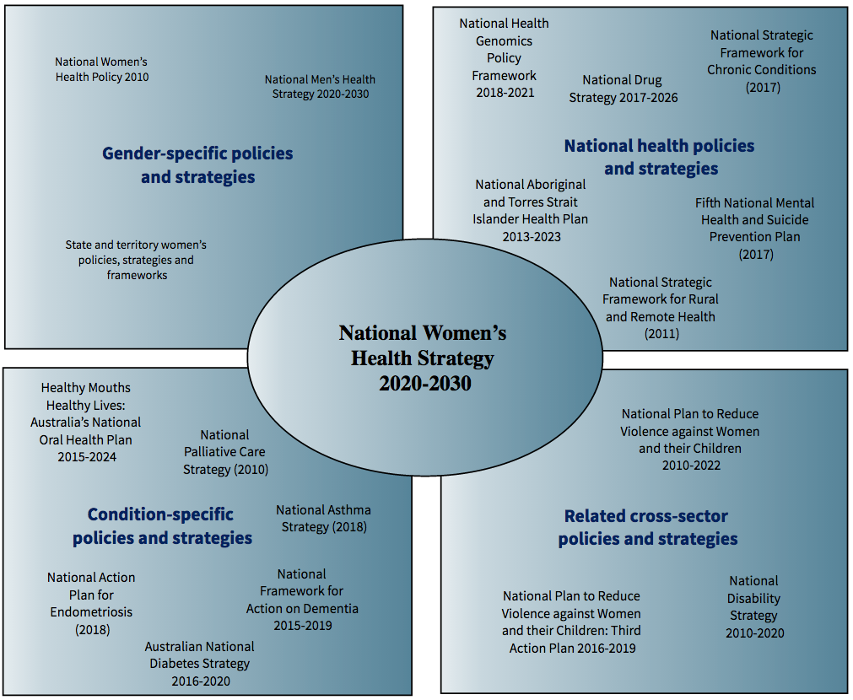
Text alternative for Figure 1: Overview of the strategic policy context for women’s health.

Women’s health at a glance
A snapshot of key health risks for women and girls in Australia.
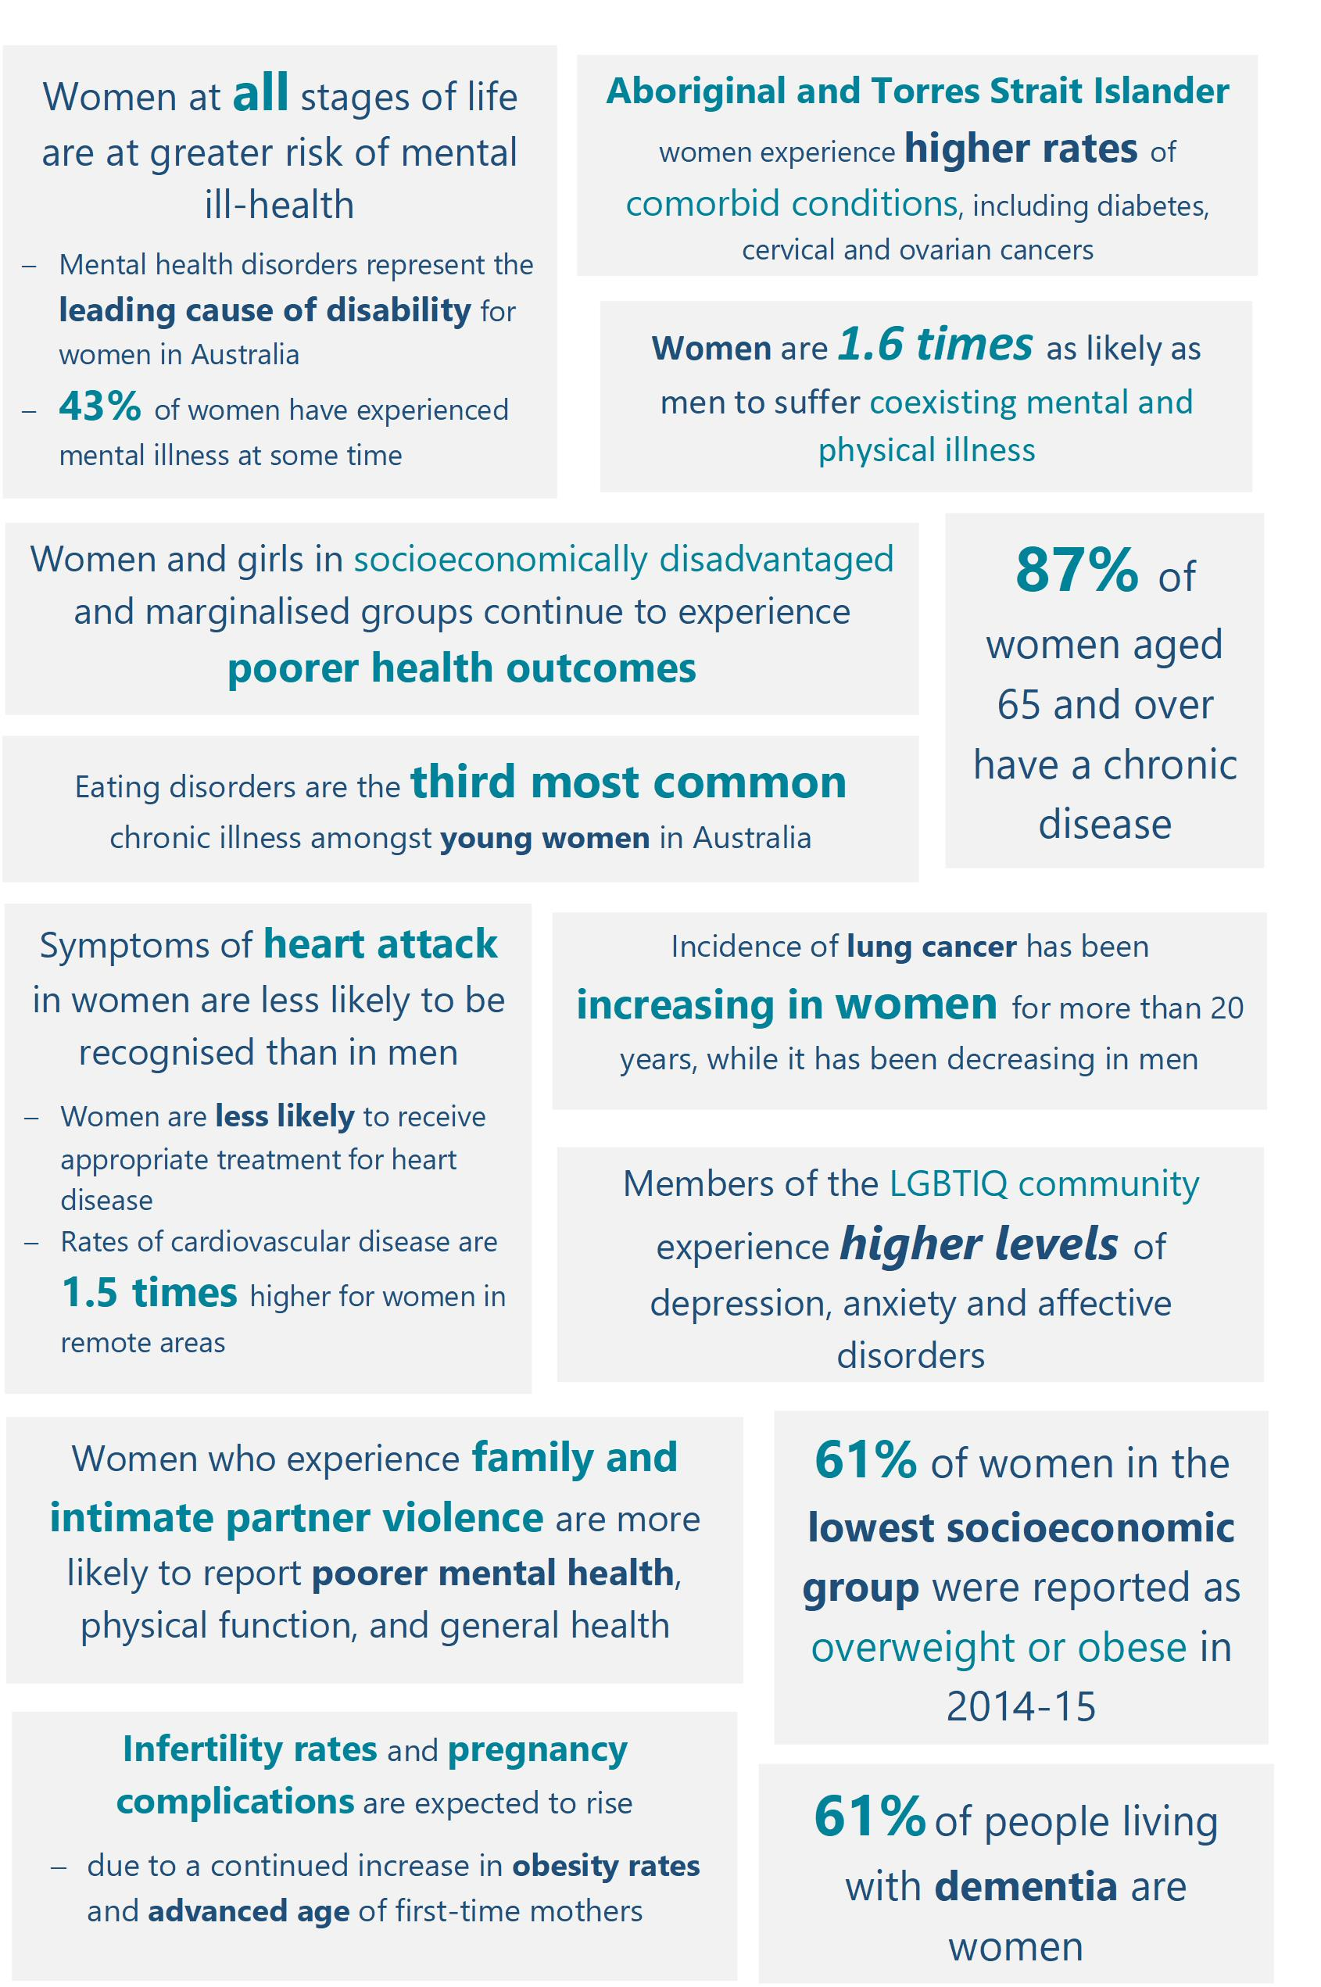
Text alternative for key risks

Priority populations among women and girls in Australia
Women and girls in Australia are diverse in age, social and economic circumstances, as well as culture, language, education, beliefs and a range of other factors that influence health behaviours and outcomes. Overall the health and wellbeing of women in Australia is good. Australia's 12 million females (in 2016) experience varying health outcomes across population characteristics like Indigenous status, remoteness, socioeconomic disadvantage and age. Females also experience different health outcomes than males. Diversity among women and girls can have a material impact on exposure to risk factors, access to education and health services, burden of disease and overall health outcomes.
While there have been improvements in the lives and health of women and girls in Australia over the last decade, many women remain disadvantaged, with greater health needs, lower access to quality health care and poorer health outcomes.
Addressing these inequities in health care, between and within population groups, is a key focus of this Strategy. The following figure represents priority populations that are the focus of this Strategy.

Figure 2: Priority Populations for the National Women’s Health Strategy
Aboriginal & Torres Strait Islander women & girls | Pregnant women & their children | Culturally & linguistically diverse women & girls* | Members of the LGBTIQ community** | Women & girls from low socio-economic backgrounds*** | Women & girls from rural & remote areas | Women & girls living with disability & their carers | Women & girls affected by the criminal justice system
* This includes migrants, asylum seekers and their children
** This includes female-identifying individuals and individuals assigned female at birth and may include transgender men and women, intersex, non-binary and gender diverse people
*** This includes homeless women and girls
Health inequities and risk factors are evident across these population groups, for example:
- Aboriginal and Torres Strait Islander women born in 2010–2012, life expectancy was estimated to be 9.5 years lower than non-Indigenous women (73.7 years compared with 83.1)
- Women and girls who experience poverty, social and/or geographical isolation are at increased risk of health problems related to limited access to quality health care
- Women from a non-English speaking background experience language and cultural barriers in accessing health facilities, services and information particularly in mental health areas
- Members of the LGBTIQ community can experience discrimination and stigma which impacts on both their health and health care access, with an increased risk of mental, sexual and chronic illness
- Women and girls with disabilities and their carers, have higher risk of poor mental health, early onset of chronic conditions and social and economic disadvantage than the general population
- Key factors that impact on women affected by the criminal justice system are poor mental health, alcohol and substance abuse and histories of early victimisation, particularly child and/or family violence
- Behavioural risk factors such as tobacco smoking and alcohol consumption during pregnancy impact on pregnancy outcomes and infant health
An emerging potential priority group are women veterans of Australia’s armed services (army, navy, air force and police).
Through targeted health policy design, education and service delivery focusing on the particular needs and circumstances of Aboriginal and Torres Strait Islander women and priority groups of women and girls within the population, there is substantial scope to improve health equity among all women and girls and across the whole population.

A life course approach
A life course approach to health care recognises that women and girls can experience a range of diverse health needs and risks across their lifespan. To increase the effectiveness of health education, intervention and service delivery, there needs to be a focus on the multiple areas and intervention points across the life course where women’s health could be improved. Health care policy, planning and service delivery must be adapted to both suit the needs of women and girls and to the best health outcomes into the future.
Awareness and education campaigns, health services delivery and research investments need to be age appropriate, gender-sensitive and integrated to respond to women’s changing mental and physical health needs. This Strategy proposes a comprehensive approach to improving women’s health across the life course. The changing health needs and risks, and leading causes of total burden of disease across each stage in women’s lives, are highlighted in Figure 3.

Figure 3: Health focus and burden of disease across the life course
Girls | Adolescent women | Adult women | Older women
Early development of healthy lifestyles and help-seeking behaviours are critical to establishing good health habits for life  Poor mental and physical health at this point means long-term risks for women and children | Vulnerable years for health risks, poor mental health, preconception health and lifelong health behaviours  Peer influence, cultural pressures and societal messaging can adversely impact health | Healthy lifestyles and help-seeking behaviours are significantly influenced by sociodemographic factors and habits developed during childhood and adolescence  Women are at increased risk of experiencing mental ill-health during pregnancy and the year following childbirth | Older women, who carry a significant burden of disease, represent an increasing part of the Australian population as life expectancy increases
Birth to 5 years:  ‘Other’ mental disorders (including sleep disorders and separation anxiety), gastrointestinal infections and asthma are the leading causes of total burden of disease  5 to 14 years:  Asthma, anxiety and depressive disorders are the leading causes of burden in young girls | 15 to 24 years:  Anxiety disorders, depressive disorders and asthma continue to lead the cause of disease burden  Suicide/self-inflicted injuries and motor vehicle accidents are the leading causes of death  Young women are at greater risk of experiencing violence, particularly women inexperienced in relationships or in a relationship where there is a substantial age gap between partners | 25 to 44 years:  Anxiety and depressive disorders are leading non-fatal disease burden  Burden due to intimate partner violence was highest among women aged 40 to 44 years  Suicide/self-inflicted injuries and breast cancer are the leading causes of fatal burden  45 to 64 years:  Musculoskeletal and back pain problems, anxiety disorders, breast, lung and bowel cancers, and coronary heart disease are the leading causes of total burden | 65 to 74 years:  Musculoskeletal and back pain and problems along with osteoarthritis and rheumatoid arthritis are the leading causes of non-fatal burden  Lung and breast cancers alongside coronary heart disease are the leading causes of fatal burden  75 years and older:  Dementia and coronary heart disease, hearing and vision disorders and musculoskeletal conditions, increasingly account for the total burden of disease

What we want to achieve
Through consultations on the development of the Strategy to date, a number of themes have emerged as necessary factors to enable successful improvement in the health outcomes of women and girls in Australia. These themes are reflected in the following selection of statements from consultation participants, and have been considered in the development of the approach for the Strategy, as outlined in the Strategy blueprint.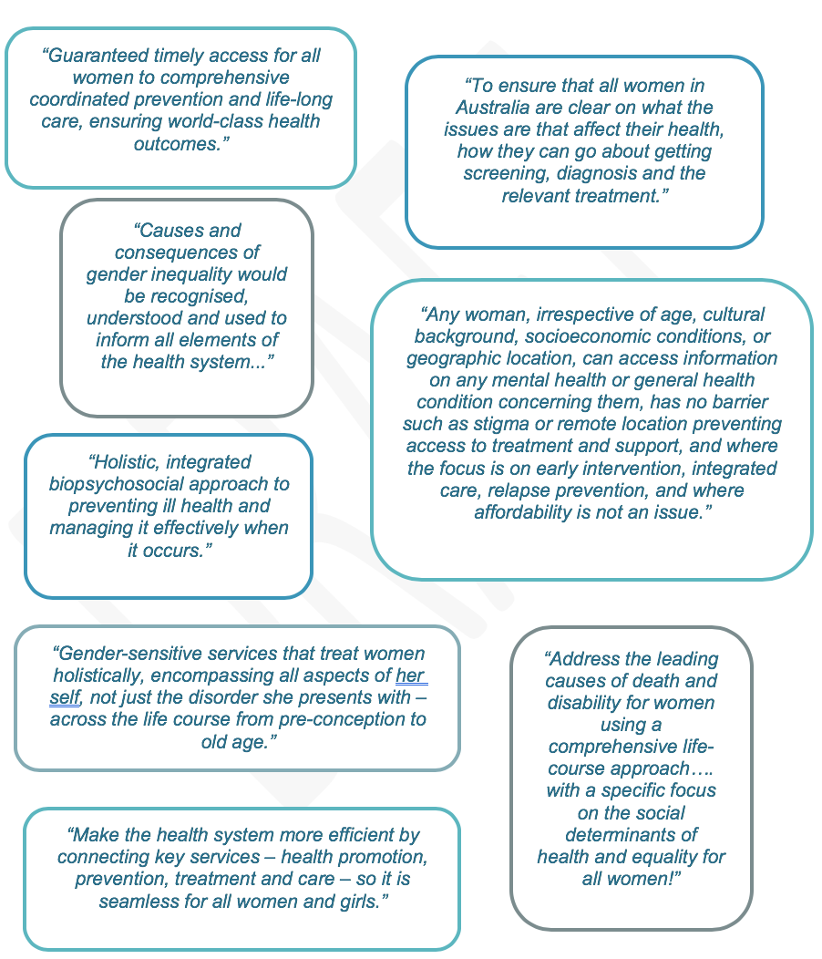
Text Alternative of statements

Strategy blueprint
Purpose

Continue to improve the health and wellbeing of all women and girls in Australia, providing appropriate, accessible and equitable care, especially for those at greatest risk of poor health.

Policy principles | Strategy objectives
- Gender equity | Highlight the significance of gender as a key determinant of women’s health and wellbeing and support “women’s health in women’s hands” to strengthen gender-sensitised services and women’s and girls’ engagement with the health system
- Health equity between women | Acknowledge the different health needs of priority populations and target those women’s population groups where the worst health outcomes are experienced
- A life course approach to health | Develop health initiatives that focus on healthy lifestyles and target risk factors across the life course, to support women’s health from preconception through to old age
- A focus on prevention | Invest in positive prevention and early intervention from childhood, with a focus on holistic person-centred care
- A strong and emerging evidence base | Support effective and collaborative research, data collection, monitoring, evaluation and knowledge transfer to advance the evidence base on women’s health

Priority areas
Mental health and wellbeing | Chronic disease and preventive health | Sexual and reproductive health | Overrepresented conditions | Healthy ageing
Enhance gender-specific mental health education & awareness  Focus on earlier intervention, integration & access to care  Invest in service delivery for priority populations  Embed practices to reduce stigma associated with mental ill-health | Increase awareness of chronic disease symptoms & risk factors in women & embed a prevention-focused life course approach  Tailor health services to meet the needs of women & girls  Invest in targeted prevention & management of chronic conditions affecting women & girls | Increase health promotion activity to enhance & support preconception & perinatal health  Support enhanced access to maternal & perinatal health care services  Increase access to sexual & reproductive health care information & services for priority populations | Co-design & deliver safe & accessible services for women experiencing family, intimate partner and sexual violence  Promote positive relationships & address impacts of family and sexual violence  Adopt a multi-faceted approach to support women & girls with eating disorders | Adopt a life course approach to healthy ageing for women  Address key risk factors that reduce quality of life for ageing women  Better manage the impact of an ageing female population

Investing in research | Strengthening partnerships | Achieving progress

Policy principles and Strategy objectives
The principles identified for the National Women’s Health Policy 2010 provided a framework for improving the health and wellbeing of all women and girls in Australia, with equal health outcomes for population groups of women at risk of poor health. This Strategy builds on the same themes, with nuanced Strategy objectives to reflect changes and emerging health needs since the development of the Policy in 2010.
The five Policy principles and Strategy objectives are detailed below.

Principle 1 - Gender equity

Objective
Highlight the significance of gender as a key determinant of women’s health and wellbeing and support “women’s health in women’s hands” to strengthen gender-sensitised services and women’s and girls’ engagement with the health system
- Improve equality and accessibility to improve health outcomes
- Use a gender-sensitised lens to tailor programs, interventions and initiatives to improve engagement, increase equity and combat biases related to sex and gender in the health system

Principle 2 - Health equity between women

Objective
Acknowledge the different health needs of priority populations and target those women’s population groups where the worst health outcomes are experienced
- Deliver equitable access to timely, appropriate and affordable care for women and girls in their own communities
- Focus on the social, cultural and commercial determinants of health to understand the needs of varying subpopulations and to deliver culturally safe and responsive care
- Provide ongoing support for quality services that directly target priority populations, with reduced institutional and interpersonal discrimination in the health system

Principle 3 - A life course approach to health

Objective
Develop health initiatives that focus on healthy lifestyles and target risk factors across the life course, to support women’s health from preconception through to old age
- Recognise that healthy ageing begins when an individual is well
- Strengthen the focus on prevention and self-care
- Invest in health literacy, health promotion and disease prevention in early childhood, particularly to prevent cross-cutting risk factors such as early excess weight gain
- Emphasise genomics and family history to tailor health care provision

Principle 4 - A focus on prevention

Objective
Invest in positive prevention and early intervention from childhood, with a focus on holistic person-centred care

- Acknowledge that focusing on the individual as a whole is key to effective health care
- Engage individuals to create a culture that empowers all Australians to strive for better health and wellbeing
- Underpin service access improvement with investment in a skilled workforce and supporting technology
- Shift from a purely medical model to a blended medical and psychosocial model, to consider an individual’s context and to personalise health care

Principle 5 - A strong and emerging evidence base

Objective
Support effective and collaborative research, data collection, monitoring, evaluation and knowledge transfer to advance the evidence base on women’s health
- Focus on the collection of more detailed and nuanced data, particularly among underrepresented population groups and less prevalent conditions
- Engage in and promote innovative and non-traditional ways of gathering data alongside quantitative and scientific study
- Align Australia’s health research investment with the priority health issues affecting women and girls
- Concentrate effort to strengthen research translation across jurisdictions and subject areas
- Recognise and adapt to the changing needs of women and girls in Australia, particularly as health technologies and information systems become increasingly sophisticated

Priority areas
There are five priority areas that identify the actions that will deliver a multifaceted approach to improving the health outcomes for women and girls in Australia. Each of these priority areas contributes towards the overall purpose and objectives of the Strategy.
The actions under each priority area aim to highlight key areas of intervention to improve the health of women and girls in Australia.
The five priority areas are:
- Mental health and wellbeing
- Chronic disease and preventive health
- Sexual and reproductive health
- Conditions where women are overrepresented
- Healthy ageing
These priority areas are inter-related and the Strategy recognises the intersections between them. For example, mental health is considered a chronic condition, but given its prevalence as a health issue both among priority populations and also across the life course of women and girls in Australia, it receives specific attention as a separate priority area. Similarly, healthy ageing can only be achieved if health improvements are made in all of the priority areas.
Each priority is of equal importance and will require the cooperation of multiple parties. Attention must be paid to all five in order to achieve real progress and achieve holistic reductions in the impact and burden of disease.
The integration of the priorities is modelled in Figure 4.
Figure 4: Priorities for the National Women’s Health Strategy 2020-2030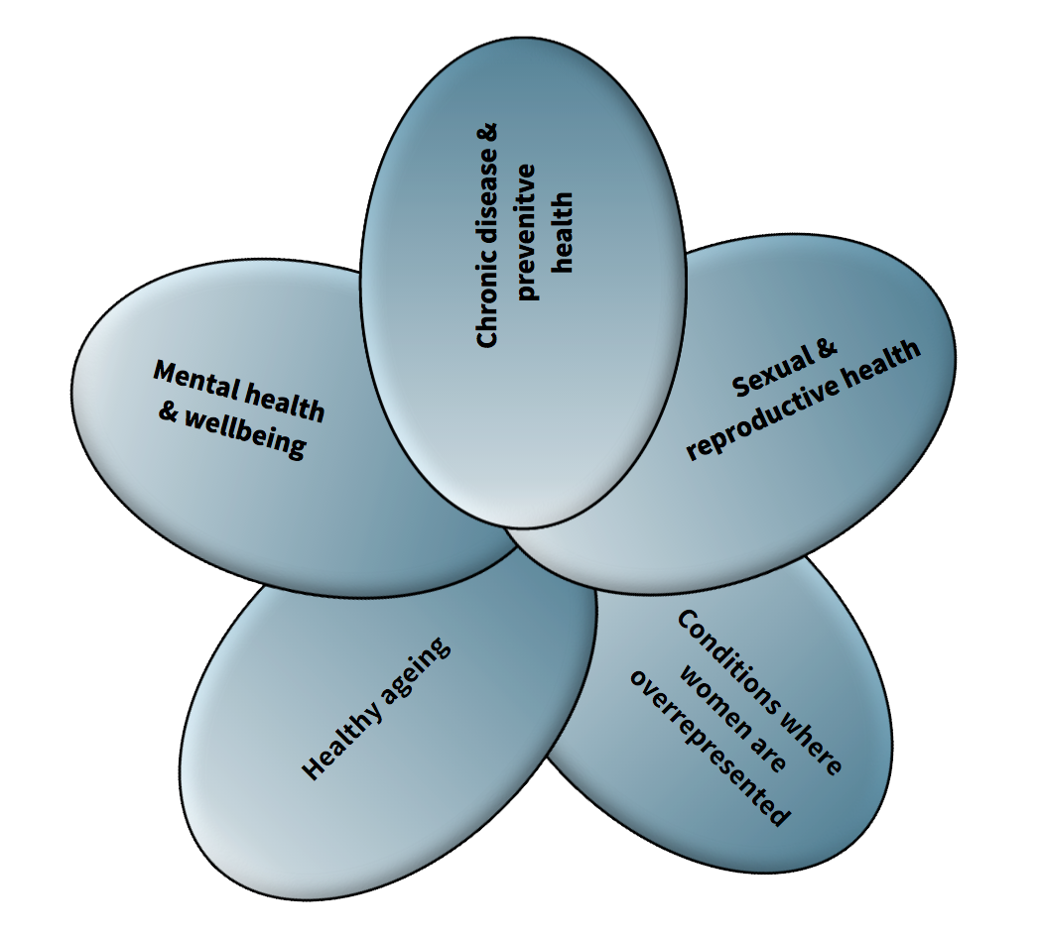

Priority 1 – Mental health and wellbeing

What’s working well
Since the National Women’s Health Policy was released in 2010, there has been an increasing awareness throughout Australia about common mental health conditions and some reduction of stigma. The prevalence of common mental disorders including anxiety and depression has been stable over the last decade, with a rate of 1 in 5 women.

What needs more attention
Federal and state and territory governments have identified mental health as a policy priority, and access to mental health services has risen, but there seems to be little progress in reducing the burden of mental illness in Australia over the last two decades.
Women experienced higher rates of mental disorders than men (22 per cent vs 18 per cent), particularly anxiety (17.9 per cent vs 10.8 per cent) and affective or mood disorders (7.1 per cent vs 5.3 per cent).

Priorities and actions
There are four key priorities for mental health and wellbeing.

Enhance gender-specific mental health education and awareness
Action | Detail
Collaborate with existing early learning institutions and schools to strengthen early education and promote opportunities to screen young girls and adolescents who may be at high-risk | Promote access to resources for parents and for school students to learn more about mental health.  Support provision of resources for early years centres and for school curriculums to include a gendered focus on building resilience, managing anxiety, and resolving conflict through social media.
Equip primary and secondary school educators, as well as physical and mental healthcare staff in these environments, to recognise the factors that influence mental health in young girls and adolescents | Provide resources, guidance, support and information regarding referral pathways to:  - students and their families  - adolescents in out-of-home care or living with a disability  - foster families and carers  - Aboriginal education assistants in schools with a high indigenous population
Provide resources, guidance and support to women, healthcare professionals and education providers about the impact of childhood trauma, bullying, relationship breakdown, financial distress, unemployment, chronic conditions and substance use across the life course | Acknowledge the longer-term societal influences that impact mental health, such as systemic forms of discrimination and inequality.  Support middle aged and older women dealing with mental health issues.

Support the development of media and community awareness materials covering a range of mental health conditions affecting women and girls across the priority populations | Education and awareness materials and campaigns need to be tailored for each cohort across the community, with time taken to work with these groups to investigate and co-design the specific messages required for each group at a local level.  Utilise the existing health prevention and promotion infrastructure at the local level to support implementation.

- Focus on earlier intervention, integration and access to mental health care
Action | Detail
Invest in an expansion of community mental health services to focus on early intervention and integration of services | - Equip Primary Health Networks to coordinate services and plan future workforce capacity based on projected demand.  - Continue work to refine referral pathways, improve screening and diagnosis tools and align federal and state health policy to better integrate national and state-based services.  Promote and support early intervention through referrals to community health services.
Develop additional targeted programs to address the specific mental health care needs of women and girls | Increase specific services for young women and girls (0-18) that recognise and respond to early childhood experiences such as trauma or adolescent experiences such as body image and eating disorders.  - Invest in developing appropriate programs to target eating disorders in adolescent women.  - Emphasise prevention and early intervention in mental health and wellbeing, focusing on perinatal mental health.  - Recognise and monitor the specific mental health needs of women veterans of Australia’s armed services.
Deliver a system that provides universal access to people in mental health crisis. | - Facilitate access to rapid response high quality services for women and girls experiencing suicidal crisis, including immediate after-care and crisis support.  - Include freely accessible, digital or phone-based suicide prevention information sources and applications, which enhance system navigation from prevention services, through immediate after-care and crisis support.
Integrate physical and mental health care in recognition that poor mental health is a major risk factor for poor physical health (and vice versa) | - Ensure women and girls being treated for mental health conditions have their physical health regularly assessed.  - Women and girls with chronic conditions should also be assessed regularly for mental health issues.

- Invest in service delivery for priority populations
Action | Detail
Focus on access to mental health support services for groups with lower access and greater need | - Tailor services and messaging to respond to the cultural determinants of health  - Develop specific strategies to target and reduce mental ill health among priority populations  - Fill gaps for key populations, for example 0-12 and 25+ categories of young people who are not served by existing services.
Expand existing services for lower prevalence high impact conditions | - Invest in services for bipolar disorder and schizophrenia  - Equip Primary Health Networks to coordinate services and support lower prevalence conditions through development of capability protocols and clinical governance models.
Support innovative initiatives to develop a new generation of mental health services through co-design with adolescents and young women | - Build engagement among this priority population.

- Embed practices to reduce stigma associated with mental ill-health
Action | Detail
Promote positive mental health messaging through mobile and digital channels, to combat stigma and misinformation that affects women and girls | Messaging should highlight the importance of giving the end-user a voice, in particular the lived-experience voice – ordinary women and girls should be advocates for their peers.  Use these diverse voices to reflect diverse experiences on a variety of forms of mental ill-health, including lesser-understood conditions.  - Acknowledge and address the role of trauma in mental ill-health.
Educate the Australian community on the use of appropriate, non-stigmatising language around mental health | Use a co-design approach to identify language preferences.  Advertise online resources for organisations and institutions to adopt similarly responsible language.  Continue working to normalise everyday conversations around suicide.
Invest in continuing education and awareness-raising for health professionals to embed inclusive practices in the health system | Focus on the needs of transgender, intersex, non-binary and gender-diverse Australians.  Consider specific actions to reduce harm and improve engagement with the health system.

Priority 2 – Chronic disease and preventive health

What’s working well
Outcomes for chronic disease, such as cardiovascular disease, have been broadly improving over the last half century due to medical advancements, reduction in risk factors and increasing accessibility of services.
Despite increases in some diagnosis rates, death rates from many cancers have also been decreasing, due to screening to detect early cancers and substantial improvements in diagnosis and treatment.

What needs more attention
A large proportion of the burden of disease in Australia is preventable. In the period leading to 2030, there is a need to increase prevention and early detection of factors that greatly affect the development of chronic diseases.
It is important to support this through continued efforts to develop policies which address the needs of groups of women at increased risk of chronic conditions. The risk factors causing the most burden were tobacco use, high body mass, alcohol use, physical inactivity and high blood pressure.
Tobacco use and alcohol consumption has been broadly declining, however tobacco smoking remains the leading preventable cause of death and disease in Australia and a leading risk factor for many chronic conditions. Rates of overweight and obesity are increasing for all women, particularly in younger generations. Physical inactivity is also associated with other risk factors such as high blood pressure and high cholesterol.
Symptoms of heart attack in women are less likely to be recognised than in men, and women are less likely to receive appropriate treatment for heart disease.
Breast cervical and ovarian cancers represent significant total burden of disease in Australian women. Cervical cancer is much less common among women in Australia but, along with breast cancer, is an important target for screening.
There are substantial inequalities between sub-groups of Australian women for most risk factors, and particularly for smoking reduction. There remain substantial inequalities between Aboriginal and Torres Strait Islander women and non-Indigenous women for most chronic conditions, and women in socioeconomically disadvantaged and marginalised groups continue to experience poorer health outcomes.

Priorities and actions
There are three key priorities for chronic disease and preventive health.
- Increase awareness of chronic disease symptoms and risk factors for women and embed a prevention-focused life course approach in policy and practice
Action | Detail
Develop and deliver an education campaign that raises awareness of the characteristics across a woman’s lifespan which impact risk of chronic disease and multimorbidity | Target messaging about prevention of chronic disease risk factors for young girls and adolescent women.  Increase awareness of lesser known risk factors, such as stress and childhood trauma and promote the creation of lifestyles that promote long-term wellbeing.  Education should support system navigation and self-management, facilitated by regular access to health system gateways such as clinics, GPs and pharmacists.
Develop and publicise an authoritative ‘map’ of risk factors and chronic condition intervention points across women's lifespans, from childhood to older age | Articulate the impact of different events over the life course (such as adverse events, relationship breakdowns, and childbirth) to identify care pathways within the health system.  Identify opportunities to streamline access to health care.

- Tailor health services to meet the needs of women and girls
Action | Detail
Apply a gendered approach to tailor programs, interventions and initiatives to women, with the aim of increasing health literacy to enable self-advocacy and empowerment of women | Celebrate healthy and diverse female role models and encourage health services that tap into a strengths-based engagement strategy.  Develop platforms and programs for peer support among women with chronic disease, encouraging women to share information, stories and support.
Ensure health policy development for women supports priority populations | Connect with services to address social determinants of health, including education, welfare, employment and participation.  Target women's population groups where the worst health outcomes are experienced, including Aboriginal and Torres Strait Islander women and women in rural, regional and remote locations, homeless women, previously incarcerated women, migrants and refugees, members of the military and LGBTIQ communities.
Allocate specific, sustainable funding for women’s health programs and services | Design services through wider consultation with the women who access (or should access) them to best meet their diverse needs while focusing on holistic person-centred care.  Pursue needs-based funding arrangements and strategies to address the higher burden of chronic conditions and risk factors experienced by Aboriginal and Torres Strait Islander women and girls.
Support educational, advocacy and support networks, providing information on available services and helping women and girls navigate the health system | Highlight existing clinical and education tools that clarify care pathways for women and girls with any stage of chronic disease progression.  Support women impacted by the psychosocial impacts of cancer recurrence, through linkage to ongoing care and peer support systems.

- Invest in targeted prevention and management of chronic conditions affecting women and girls
Action | Detail
Support the development of healthy habits through family and institutional settings to reverse rising rates of overweight and obesity in women and girls | Pursue cross-government and service sector partnerships to:  - embed nutrition education in all schools  - promote active school travel for all children  - advocate for support for healthier food choices
Develop and deliver a national campaign to promote awareness of the different risks for and symptoms of cardiovascular disease in women | Specifically promote awareness of the different symptoms of heart attack in women and the appropriate treatment for cardiovascular disease.  Develop a national approach for screening and medication of rheumatic heart disease.
Enhance access to cancer screening services and early intervention for women in rural and remote areas or from lower socioeconomic quintiles | Support the continued use of mobile cancer screening services.  Recognise that, currently, there is no early detection test for some female cancers.

Priority 3 – Sexual and reproductive health

What’s working well
The successful National Human Papillomavirus (HPV) Vaccination Program has led to a rapid and significant decline in genital warts and is expected to reduce the rates of HPV-related cancers in the coming years, such as cervical cancer.
The notification rates of sexually transmissible infections (especially chlamydia and gonorrhoea) continued to rise in Australian women over the last decade, in particular among young women aged under 30 years, Aboriginal and Torres Strait Islander women, and women living in remote and very remote areas (noting that rising notification rates may indicate screening and diagnosis rates, not exclusively an increase in incidence).

What needs more attention
Australian women are giving birth later in life and are increasingly overweight or obese, both of which significantly increase risk factors and complications during the pregnancy and throughout the woman’s later life. The average age of first-time mothers has increased from 28.1 years in 2005 to 28.9 years in 2015, and almost half of mothers are overweight or obese at their first antenatal visit. One in ten women still smoke during pregnancy and 40 per cent of Australian mothers drink at least some alcohol during pregnancy.
Given the increasing prevalence of obesity and advanced maternal age in Australia, it is expected that the infertility rate, number of caesarean sections and incidence of pregnancy complications, especially gestational diabetes and hypertensive disorders during pregnancy, will continue to increase in the next decade.
The perinatal period (from conception to the end of the first year after birth) has also been identified as a time of greater vulnerability for the development of depression and anxiety, with up to one in ten women (nine per cent) experiencing antenatal depression, and one in seven women (16 per cent) experiencing postnatal depression.
While a large proportion of women use a contraceptive method, the rate of failed contraception resulting in unintended pregnancy is high in Australia, and the uptake of long-acting reversible contraception has been low.
There is limited evidence on national estimates of the prevalence of polycystic ovarian syndrome and endometriosis, especially the change over time. Hysterectomy rates declined over the last decade, but the rate was still high, at around one in three women.

Priorities and actions
There are three key priorities for sexual and reproductive health.
- Increase health promotion activity to enhance and support preconception and perinatal health
Action | Detail
Promote the importance of good preconception health, particularly regarding nutrition and lifestyle, and target all women who are planning a pregnancy | Increase awareness of gestational diabetes as an indicator of Type 2 diabetes later in life and support affected women to make healthy life choices.  Map family history and previous health experiences for preconception and newly pregnant women to manage risks to women and their babies.
Engage with existing whole-of-life preventive health campaigns to promote awareness of the link between excess weight gain from a young age and infertility and ill health during pregnancy | Support health care services involved in preconception and perinatal health care to promote healthy habits in women of reproductive age to lower pregnancy and infertility risks.
Tailor service delivery and communication messages to ensure cultural safety in maternal and perinatal care for all women | Design campaigns and programs which celebrate positive and relatable mother figures and role models across priority populations.

- Support enhanced access to maternal and perinatal health care services
Action | Detail
Support primary healthcare services (including GPs and Primary Health Networks) to complete all pre-pregnancy activity and genomics screening, alongside existing sexual and reproductive health services | Encourage primary healthcare services to leverage perinatal healthcare interactions with pregnant women to provide support and referral to appropriate services to address other physical and/or mental health conditions.
Create clear pathways for women to access relevant services to prevent or minimise the impact of the reoccurrence of pre-existing conditions, as well as plan for subsequent pregnancies | Equip GPs to address and support pre-existing conditions both previously known and discovered during the first pregnancy  Include follow up post-partum care pathways to identify at-risk women and to prevent chronic disease.
Improve access to mental health services throughout preconception and perinatal stages. Engage with health care practitioners to promote and utilise the Mental Health Care in the Perinatal Period: Australian Clinical Practice Guideline | Provide mental health support for women with sub-fertility, infertility or women going through IVF.  Increase support for women at risk of experiencing perinatal mental ill-health and encourage mothers to seek help and social support.  Break down the stigma surrounding postnatal depression and other mental ill-health experienced in the perinatal period.
Tailor awareness campaigns to address late presentation to antenatal care for migrant and culturally and linguistically diverse women | Include peer education
Set sustainable national accreditation criteria, measurements and standards for maternal and perinatal care | Collaborate with peak bodies to work towards consistent national implementation of best practice guidelines.  Enhance workforce capability through training to upskill GPs, nurses and midwives through peer support networks.

- Increase access to sexual and reproductive health care information and services for priority populations
Action | Detail
Improve access to information, self-education and self-management tools to encourage self-informing and help-seeking behaviours in relation to women’s sexual and reproductive health | Develop interactive tools (phone-based applications, web-based tools and symptom checkers) to increase women’s sexual and reproductive health literacy and promote health-seeking behaviour.  Promote these tools to health professionals and health networks to facilitate information sharing and to raise awareness of their application.
Remove barriers to support equitable access to timely, appropriate and affordable care for all women, including culturally sensitive and safe care | Improve access to sexual and reproductive health information and services that offer options to women to empower choice and control in decision-making about their bodies, including contraception and unplanned pregnancies.  Expand family planning services for marginalised groups, including Aboriginal and Torres Strait Islander women, women with disability, health care card holders, migrants and migrant populations, and incarcerated women.
Strengthen access pathways to sexual and reproductive health services across the country, particularly in rural and remote areas | Ensure strong referral pathways between primary care services and specialised services and practitioners.  Increase access to services for conditions such as polycystic ovarian syndrome, endometriosis, premature and early menopause, prolapse, incontinence, sub-fertility and infertility.  Increase access to government-funded health services that offer sexual and reproductive health services.

Priority 4 – Conditions where women are overrepresented

Family and intimate partner violence and sexual violence
In a 2016 national survey, about one in six (17 per cent or 1.6 million) women had experienced physical and/or sexual violence by a current or previous partner since age 15, and almost one in four (23 per cent or 2.2 million) women had experienced emotional abuse by a current or previous partner. Of these women, more than half (54 per cent) experienced more than one incident of violence, and the rate of violence is higher in pregnant women.
Women who experience intimate partner violence and/or sexual violence are more likely to report poorer mental health, physical function, and general health, as well as higher levels of bodily pain. Some groups of women are also more vulnerable to family and intimate partner violence and sexual violence, particularly young women, pregnant women, Aboriginal and Torres Strait Islander women, women with disabilities, and women experiencing financial hardships and lack of social supports.

Eating disorders
Evidence shows that young women are more likely to suffer from eating disorders and negative body image than men. One in 100 adolescent girls develops anorexia nervosa, while five in 100 develop bulimia nervosa. Anorexia nervosa has the highest mortality rate of any psychiatric disorder, with approximately 15-20 per cent dying within 20 years.

Priorities and actions
There are three key priorities for conditions where women are overrepresented.
- Co-design and deliver safe and accessible services for women experiencing family, intimate partner and/or sexual violence
Action | Detail
Provide immediate crisis intervention support as well as longer-term advocacy, support, education and training for women experiencing family, intimate partner and/or sexual violence | Involve affected women (and their families) in the design and redevelopment of these services to ensure that services are matching the needs of their users.  Embed inclusive practices in the system to ensure services are culturally safe and appropriate, taking account of vulnerability experienced by women escaping family and/or intimate partner violence.
Continue to develop and invest in freely accessible, digital information sources and applications and 24-hour phonelines, which can connect women who have difficulty accessing physical services due to their circumstances | These digital information sources and applications should always include mechanisms that facilitate an immediate exit.  Link services for survivors of family, intimate partner and/or sexual violence closely to mental health support services, as recovery is strongly linked to experiences of mental ill-health.
Educate the broader health workforce about indicators that a woman or her children may be experiencing family and/or sexual violence | Equip the workforce, particularly GPs and community health organisations with tools to provide support and links to services while ensuring safety as a priority.  Consider specific actions to reduce harm and improve engagement with the health system, including: mother and child-only clinic appointments and flexible arrangements for health service access.

- Promote positive relationships and address impacts of family and/or sexual violence
Action | Detail
Promote peer education of adolescent girls and boys to raise awareness and educate both genders about acceptable and unacceptable behaviours in relationships | Promote this message through mobile and digital channels, to combat stigma, isolation and misinformation that affects all Australians, but particularly women and girls.
Raise awareness of the need to change men’s behaviours and attitudes towards women, alongside awareness of family, intimate partner and sexual violence and the pathways to support | This messaging should highlight the importance of giving the end-user a voice, in particular the lived-experience voice – ordinary women and girls should be advocates for their peers.  Where possible, use these diverse voices to reflect different experiences on a variety of forms of family and/or sexual violence.
Empower women to speak up about their experiences of sexual violence by creating safe environments to enable disclosure and ongoing support | Provide pathway options which can be provided to women to ensure they are given choice to control their journey of recovery after sexual assault.

- Adopt a multi-faceted approach to support women and girls with eating disorders
Action | Detail
Provide schools with easily accessible information about available services for students at risk of developing eating disorders | Develop and deliver resources to be used in family and institutional settings to raise awareness of the risk factors and symptoms of eating disorders.  Continue to develop and promote freely accessible, digital prevention information and support resources and applications.
Deliver a system that provides universal access to rapid response high quality services for women with eating disorders | Replicate best practice approach eating disorder strategies to inform a consistent and collaborative national approach.  Support existing community-based models for prevention and early intervention.

Priority 5 – Healthy ageing
Healthy ageing and its associated concepts (successful ageing, positive ageing, ageing well and ageing productively) have been developed over the years as a response to changing population demographics. Healthy ageing is defined as ‘the process of developing and maintaining functional ability that enables wellbeing in older age’.

What’s working well
Australian women are living longer, healthier lives, with more women in all age groups from 65 years and above experiencing ‘excellent’ or ‘very good’ health, and less disability, than in previous decades.
There have been significant advances in medical science, which reduce the impact of some major conditions (e.g. premature deaths from heart disease), but also increase the likelihood of more people living longer with multiple conditions (multimorbidity and disabilities).

What needs more attention
While women are living longer, the life expectancy of Aboriginal and Torres Strait Islander women is about 10 years less than non-Indigenous women.
With increasing age, women are likely to experience multiple chronic conditions simultaneously.
The health system as a whole will be under increasing pressure due to the increasing complexity of older women’s health, including the prevalence of multimorbidities. Further, women face the increasing risk of dementia as they age, which remains incurable.
Sociodemographic inequalities affect all aspects of healthy ageing, including rates of access to dental services for women without private health insurance, with low income or living in remote areas.

Priorities and actions
There are three key priorities for healthy ageing.
- Adopt a life course approach to healthy ageing for women
Action | Detail
Build awareness that healthy ageing starts with young Australian women and girls to embed a preventive and health promotion approach throughout life | Engage with individuals, education institutions and healthcare providers to reinforce that ‘healthy ageing begins early’ and is the ongoing aim of healthy lifestyles and habits.
Acknowledge the need for targeted conversations relating to healthy ageing at different points in the life course and across priority populations | Through all stages of the life course, it is important to reduce stigma and normalise the conversation about ageing as well as support whole-of-life preventative approaches that embrace wellness and self-care.

- Address key risk factors that reduce quality of life for ageing women
Action | Detail
Monitor emerging patterns of multimorbidities in older women and tackle the risk factors that cut across conditions | Educate Australians on the role of frailty as an emerging indicator of poor health in women.  Target the high-risk ratio for neurodegenerative disorders in older Aboriginal and Torres Strait Islander women.  Address the increase in homelessness experienced by older Australian women.
Target risk factors for dementia across the life course | Promote screening of all women at clinically indicated ages for risk factors for dementia including cardiovascular risk.
Coronary disease and conditions arising from shared risk factors | Promote screening of all women at clinically indicated ages for cardiovascular risk.
Enhance prevention efforts to reduce the risk of falls and fractures | Ensure implementation of falls and fracture prevention strategies in health services and community and residential aged care services.
Address conditions that impact on the non-fatal burden of disease | Improve access to dental services for priority populations.  Improve access to audiology advice and hearing devices.  Improve access to services to reduce vision loss.
Promote awareness around incontinence | - Specifically, target communication strategies to promote the National Continence Program, and mechanisms to enable the discreet public disposal of continence products.

- Better manage the impact of an ageing female population
Action | Detail
Build capability within the health system to identify and effectively manage the increasing complexity of older women’s health | - Acknowledge the amplification of trauma that occurs at end of life and support trauma-informed aged care services.  - Incentivise GPs and other health care providers to undertake relevant health checks at 45+ and 70+ years.  - Educate GPs and pharmacists to raise awareness of ‘doctor shopping’ and work to improve take-up of Home Medication Reviews.
Recognise loneliness experienced by older Australians as a key issue and encourage increased physical and social interactions for older Australians | - Continue investment in key health promotion and social support initiatives.
Acknowledge the role of carers and provide resources and social support through multiple sources, including peer support platforms | - Recognise the particular circumstances and health needs arising for women providing intergenerational care within families and networks.

Investing in research
Investing in research is critical for successful delivery of the priorities and actions outlined in this Strategy. Due to the strength, collaborative will and specialised knowledge of its research community, Australia is well placed to lead and develop research into improving health outcomes for women and girls, both nationally and internationally.
An initial Commonwealth investment of $18 million through the Medical Research Future Fund will support research focusing on significant health challenges that affect Australian women including breast cancer, maternal health, immunisation rates and cardiovascular disease - a leading cause of death in Australian women. This funding will support priorities specifically identified in the Strategy.
Additional Commonwealth investments totalling $200 million through the National Health and Medical Research Council and the Medical Research Future Fund, will also support the priorities and actions outlined in this Strategy. These projects will aim to find solutions to a wide range of health challenges, including cancer, cardiovascular disease, stillbirths and mental health; and will support research into specific conditions such as improved care for premature babies, arthritis and osteoporosis, treatment for depression and anxiety in young people and improved health for older Aboriginal and Torres Strait Islander people.

What will be different?
The research opportunities offered by the National Health and Medical Research Council and the funds made available through the Medical Research Future Fund will offer significant scope to make immediate and longer-term improvements in health outcomes for women and girls both in Australia and internationally. Research techniques will be collaborative and innovative, and will include the development of novel diagnostics and therapies and research translation, and will be supported by discerning, effective use of clinical trials. Investing in research is needed to:
- Strengthen and diversify research and data collection across identified health priorities for women and girls
Action | Detail
Map the gap between current needs and available services to understand the scope of mental health services for women and girls and where integration across the health system is needed | - Draw on existing longitudinal studies to deepen the understanding of long-term trends in mental health.  - Use non-traditional data collection methods including qualitative, ethnographic and narrative, to understand the effect of social determinants of health and the lived experience of women and girls with mental ill-health.
Invest in more timely data collection, translation and research for under-researched groups and conditions affecting women and girls, particularly focusing on the priority populations | - Include eating disorders in the National Survey of Mental Health and Wellbeing to obtain nuanced national estimates of the prevalence of eating disorders.  - Commission research into perinatal health and mental health  - Commission to understand the life-long impacts of childhood trauma, including family and sexual violence.  - Include intersex Australians and national population-level data for the LGBTIQ community.  - Commission research as appropriate into mental and physical health needs of women veterans.

Fill gaps in research, ensuring there are up-to-date figures for prevalence and measures for underreported conditions, such as chronic pain | - Make better use of existing health promotion, public health research and evaluation evidence to drive future actions.
Support targeted research into sex- and gender differences in profiling for non-communicable diseases | - Consider implications and hormonal influence for treatment and secondary prevention.
Disaggregate data for sexual and reproductive health conditions | - Support research to understand comorbidities and linkages between violence and sexual and reproductive health, including the link between STIs and family violence.
Increase data and research relating to the risk factors affecting pregnancy and pregnancy complications | - Commission research on maternal anxiety, stillbirth and obesity during pregnancy.  - Support research which examines the impacts of infertility treatment outcomes on mental health and productivity.
Commission further research into the role and impact of menopause | - Examine the impact of early or medically-induced menopause on mental and physical health as well as the overall impact of menopause on work.  - Consider research into women’s experiences of menopause alongside its economic impact.
Support research into the short and long-term impacts of family and intimate partner violence and develop targeted strategies to support those affected | - Support the work of research centres such as Australia’s National Research Organisation for Women’s Safety (ANROWS) to undertake ongoing research into the long-term health effects of violence and sexual abuse on women and children and the translation of research into practice.  - Disaggregate existing and future data and research to provide a more nuanced understanding about the intersection of family and intimate partner violence with all aspects of women and children’s lives.  - Support existing research into the prevalence and measures of violence experienced by underreported population groups to ensure adequate services are available.
Invest in research to better understand the pathogenesis of dementia in women | - Develop resources for the prevention of dementia across the life course, as well as ongoing research to improve diagnosis, treatment and care options for women living with dementia.  - Develop strategies to reduce dementia risk and slow the progression of the disease

- Build research capacity and capability in women’s health
Action | Detail
Increase and support the number of research-focused clinicians working to solve health problems specific to women and girls | - Through the Medical Research Future Fund, create more career development fellowships, research translation and practitioner fellowships and investigator grants, that are targeted towards women’s health.  - Create pathways to engage and support more female researchers in women’s health.

Strengthening Partnerships
The achievement of the overall goal and supporting objectives of the Strategy will require strong and continued collaboration between the health sector, governments, women and girls, their families, carers and advocates. Working with and alongside governments and policymakers, professionals from across the health and advocacy sectors must partner to oversee the actions named in this document.
Implementation partners will include organisations from across various sectors, operating at local, state, territory and national levels. Dependent on the priority and action, partners may be required to work in direct collaboration or in parallel. Partners need to include education providers and peak bodies; primary, secondary and tertiary healthcare providers; general practice, allied health and specialist colleges and representative bodies; researchers; advocates; industry groups; industry partners; the media; and policymakers and governments.
By using this Strategy, all partners will be able to better focus their attention to key areas where they are best placed to provide additional support and ensure their investment is appropriately directed.
Above all, action must be driven and owned by women – proactive participation and increased engagement in prevention, self-care and health care will drive the most rapid improvements in health outcomes for all women and girls in Australia.

Achieving progress
To ensure the effectiveness of the Strategy in fulfilling its objectives, the following is proposed:
- Establish an Implementation Steering Group to facilitate and drive implementation of the National Women’s Health Strategy; and
- Conduct a five-year review, with twelve-month and three-year development checks, to assess progress made in each of the priorities.
In addition, regular reporting on health outcomes for women will enable the community to appreciate the extent to which the actions are contributing to its ultimate goal of improving the health and wellbeing of Australian women and girls. Regular reporting will enable the community to appreciate the extent to which the actions are contributing to its goal of improving the health and wellbeing of all women and girls in Australia.

Expectations for the future
In five years’ time, we would expect to see a marked improvement against the objectives of the Strategy, with indication of progress against the overarching goal of improving the health and wellbeing of all women and girls in Australia, providing appropriate, accessible and equitable care, especially for those at greatest risk of poor health.

Next steps
Further work is required to operationalise each of the priorities in the National Women’s Health Strategy. It is proposed that an Implementation Steering Group:
- coordinate the effort to develop an interventional timeline to prioritise the actions
- identify the sector area responsible for driving implementation of each action, including key implementation partners
- where appropriate, identify and agree on targets and outcome measures
- determine how to progress implementation to achieve the overall objectives of the Strategy

- Related policy and strategy documents
The following list indicates some of the key documents that inform the Women’s Health Strategy, and to which it refers:
- Fifth National Mental Health and Suicide Prevention Plan (2017) and Implementation Plan (2017)
- Australian National Diabetes Strategy 2016-2020
- Healthy Mouths Healthy Lives: Australia’s National Oral Health Plan 2015 - 2024
- Healthy, Safe and Thriving: National Strategic Framework for Child and Youth Health (2015)
- National Aboriginal and Torres Strait Islander Health Plan 2013-2023
- National Action Plan for Endometriosis (2018)
- National Ageing and Aged Care Strategy for people from culturally and linguistically diverse (CALD) backgrounds (2015)
- National Asthma Strategy (2018)
- National Cultural Respect Framework for Aboriginal and Torres Strait Islander Health 2016-2026
- National Digital Health Strategy (2018)
- National Disability Strategy 2010-2020
- National Drug Strategy 2017-2026
- National Framework for Action on Dementia 2015-2019
- National Framework for Communicable Disease Control (2014)
- National Framework for Health Services for Aboriginal and Torres Strait Islander Children and Families (2016)
- National Framework for Universal Child and Family Health Services (2011)
- National Health Genomics Policy Framework 2018-2021
- National Medicines Policy (2000)
- National Palliative Care Strategy (2010)
- National Plan to Reduce Violence against Women and their Children 2010-2022
- National Plan to Reduce Violence against Women and their Children: Third Action Plan 2016-2019
- National Strategic Framework for Chronic Conditions (2017)
- National Strategic Framework for Rural and Remote Health (2011)
- National Women's Health Policy 2010 – 2030
- State and territory gender-based strategies, policies and frameworks
It is also directly aligned with its companion document, the National Men’s Health Strategy 2020-2030.
- Text Alternatives

Text description of Figure 1: Overview of the strategic policy context for women’s health

National Women’s Health Strategy 2020-2030

Gender-specific policies and strategies
- National Women’s Health Policy 2010
- National Men’s Health Strategy 2020-2030
- State and territory women’s policies, strategies and frameworks

National health policies and strategies
- National Health Genomics Policy Framework 2018-2021
- National Drug Strategy 2017-2026
- National Strategic Framework for Chronic Conditions (2017)
- National Aboriginal and Torres Strait Islander Health Plan 2013-2023
- Fifth National Mental Health and Suicide Prevention Plan (2017)
- National Strategic Framework for Rural and Remote Health (2011)

Condition-specific policies and strategies
- Healthy Mouths Healthy Lives: Australia’s National Oral Plan 2015-2024
- National Palliative Care Strategy (2010)
- National Asthma Strategy (2018)
- National Action Plan for Endometriosis (2018)
- Australian National Diabetes Strategy 2016-2020
- National Framework for Action on Dementia 2015-2019

Related cross-sector policies and strategies
- National Plan to Reduce Violence against Women and their Children 2010-2022
- National Plan to Reduce Violence against Women and their Children: Third Action Plan 2016-2019
- National Disability Strategy 2010-2020
Return to Figure 1: Overview of the strategic policy context for women’s health

Key risks
Women at all stages of life are at greater risk of mental ill-health.
- Mental health disorders represent the leading cause of disability for women in Australia
- 43% of women have experienced mental illness at some time.
Aboriginal and Torres Strait Islander women experience higher rates of comorbid conditions, including diabetes, cervical and ovarian cancers.
Women are 1.6 times as likely as men to suffer coexisting mental and physical illness.
Women and girls in socioeconomically disadvantaged and marginalised groups continue to experience poorer health outcomes.
87% of women aged 65 and over have a chronic disease.
Eating disorders are the third most common chronic illness amongst young women in Australia.
Symptoms of heart attack in women are less likely to be recognised than in men.
- Women are less likely to receive appropriate treatment for heart disease
- Rates of cardiovascular disease are 1.5 times higher for women in remote areas.
Incidence of lung cancer has been increasing in women for more than 20 years, while it has been decreasing in men.
Members of the LGBTIQ community experience higher levels of depression, anxiety and affective disorders.
Women who experience family and intimate partner violence are more likely to report poorer mental health, physical function and general health.
61% of women in the lowest socioeconomic group were reported as overweight or obese in 2014-15.
Infertility rates and pregnancy complications are expected to rise due to a continued increase in obesity rates and advanced age of first-time mothers.
61% of people living with dementia are women.
Return to Women’s health at a glance.

Statements from consultation participants
“Guaranteed timely access for all women to comprehensive coordinated prevention and life-long care, ensuring world-class health outcomes.”
“To ensure that all women in Australia are clear on what the issues are that affect their health, how they can go about getting screening, diagnosis and the relevant treatment.”
“Causes and consequences of gender inequality would be recognised, understood and used to inform all elements of the health system...”
“Any woman, irrespective of age, cultural background, socioeconomic conditions, or geographic location, can access information on any mental health or general health condition concerning them, has no barrier such as stigma or remote location preventing access to treatment and support, and where the focus is on early intervention, integrated care, relapse prevention, and where affordability is not an issue.”
“Holistic, integrated biopsychosocial approach to preventing ill health and managing it effectively when it occurs.”
“Gender-sensitive services that treat women holistically, encompassing all aspects of her self, not just the disorder she presents with – across the life course from pre-conception to old age.”
“Address the leading causes of death and disability for women using a comprehensive life-course approach…. with a specific focus on the social determinants of health and equality for all women!”
“Make the health system more efficient by connecting key services – health promotion, prevention, treatment and care – so it is seamless for all women and girls.”
Return to What we want to achieve.

- References

Australian Institute of Health and Welfare. Australia’s mothers and babies 2015—in brief. Perinatal statistics series no. 33. Cat no. PER 91. Canberra: AIHW, 2017.
Australian Institute of Health and Welfare. Australian Burden of Disease Study: Impact and causes of illness and death in Australia 2011. Australian Burden of Disease Study series no. 3. BOD 4. Canberra: AIHW, 2016.
Australian Bureau of Statistics. National Survey of Mental Health and Wellbeing 2007. Canberra: ABS, 2007.
Leonard W, Pitts M, Mitchell A, et al. Private lives 2: The second national survey of the health and wellbeing of gay, lesbian, bisexual and transgender (GLBT) Australians. Melbourne: The Australian Research Centre in Sex, Health & Society, La Trobe University, 2012.
Duggan M. Investing in women’s mental health: Strengthening the foundations for women, families and the Australian economy. Australian Health Policy Collaboration Issues paper No. 2016-02. Melbourne: Australian Health Policy Collaboration, 2016.
Australian Institute of Health and Welfare. Trends in cardiovascular deaths. Bulletin No. 141. Cat. No. AUS 216. Canberra: AIHW, 2018.
Australian Institute of Health and Welfare. Family, domestic and sexual violence in Australia 2018. Cat. no. FDV 2. Canberra: AIHW, 2018.
Australian Institute of Health and Welfare. Life expectancy and disability in Australia: expected years living with and without disability. Canberra: AIHW, 2017.
Australian Institute of Health and Welfare. Australia's Health 2018. Canberra: AIHW, 2018.
Migration Council Australia. The health outcomes of migrants: a literature review. Smith L, 2015 http://migrationcouncil.org.au/wp-content/uploads/2016/06/2015_Smith.pdf (accessed September 2018).
Barmaky S, Lee A. LGBTIQ peoples’ experiences of and barriers to healthcare. Vector; 26 October 2017.
VicHealth. Disability and health inequalities in Australia: Research summary, 2012. www.vichealth.vic.gov.au/publications (accessed September 2018).
Corrective Services NSW. Women as offenders, women as victims. The role of corrections in supporting women with histories of sexual abuse. NSW, 2014.
Australian Institute of Health and Welfare. Australia’s mothers and babies 2015—in brief. Perinatal statistics series no. 33. Cat no. PER 91. Canberra: AIHW, 2017.
Australian Institute of Health and Welfare. Australian Burden of Disease Study: Impact and causes of illness and death in Australia 2011. Australian Burden of Disease Study series no. 3. BOD 4. Canberra: AIHW, 2016.
Australian Institute of Health and Welfare. Family, domestic and sexual violence in Australia 2018. Cat. no. FDV 2. Canberra: AIHW, 2018.
Ayre J, Lum On M, Webster K, Gourley M, L M. Examination of the burden of disease of intimate partner violence against women in 2011: Final report. Sydney: ANROWS, 2016.
Australian Bureau of Statistics. Life Tables, States, Territories and Australia, 2014-2016. Canberra: ABS, 2017.
Australian Institute of Health and Welfare. Perinatal Depression: Data from the 2010 Australian National Infant Feeding Survey. Information Paper, Cat. No. PHE 161. Canberra: AIHW, 2012.
Harvey SB, Deady M, Wang MJ, et al. Is the prevalence of mental illness increasing in Australia? Evidence from national health surveys and administrative data, 2001-2014. Med J Aust 2017; 206(11): 490-3.
Australian Bureau of Statistics. National Survey of Mental Health and Wellbeing 2007. Canberra: ABS, 2007.
Australian Institute of Health and Welfare. Cancer in Australia 2017. Cancer series no.101.Cat. no. CAN 100. Canberra: AIHW, 2017.
Australian Institute of Health and Welfare. Australian Burden of Disease Study: Impact and causes of illness and death in Australia 2011. Australian Burden of Disease Study series no. 3. BOD 4. Canberra: AIHW, 2016.
Australian Institute of Health and Welfare. Australia's Health 2018. Canberra: AIHW, 2018.
Australian Institute of Health and Welfare. Australia's Health 2018. Canberra: AIHW, 2018.
Brown WJ, Bauman AE, Bull FC, NW B. Development of evidence-based physical activity recommendations for adults (18-64 years). Report prepared for the Department of Health. Canberra: Department of Health, 2012.
Khan E, Brieger D, Amerena J, et al. Differences in management and outcomes for men and women with ST-elevation myocardial infarction. Med J Aust, 2018.
Australian Institute of Health and Welfare. Cancer in Australia 2017. Cancer series no.101.Cat. no. CAN 100. Canberra: AIHW, 2017.
Australian Institute of Health and Welfare. National Drug Strategy Household Survey 2016: detailed findings. Drug statistics series no. 31. Cat. no. PHE 214. Canberra: AIHW, 2017.
Australian Institute of Health and Welfare. Cervical screening in Australia 2014–2015. Cancer series no. 105. Cat. no. CAN 104. Canberra: AIHW, 2017.
Kirby Institute. HIV, viral hepatitis and sexually transmissible infections in Australia: annual surveillance report. Sydney: Kirby Institute, UNSW Sydney, 2017.
Australian Institute of Health and Welfare. Australia’s mothers and babies 2015—in brief. Perinatal statistics series no. 33. Cat no. PER 91. Canberra: AIHW, 2017.
Australian Institute of Health and Welfare. Australia’s mothers and babies 2015—in brief. Perinatal statistics series no. 33. Cat no. PER 91. Canberra: AIHW, 2017.
O'Keeffe LM, Kearney PM, McCarthy FP, et al. Prevalence and predictors of alcohol use during pregnancy: findings from international multicentre cohort studies. BMJ Open 2015; 5(7): e006323.
Beyondblue. Perinatal depression. 2018. https://healthyfamilies.beyondblue.org.au/pregnancy-and-new-parents/maternal-mental-health-and-wellbeing/depression (accessed September 2018).
Hill EL, Graham ML, Shelley JM. Hysterectomy trends in Australia--between 2000/01 and 2004/05. Aust N Z J Obstet Gynaecol 2010; 50(2): 153-8.
Australian Bureau of Statistics. Personal Safety Survey. Canberra: ABS, 2016.
Australian Bureau of Statistics. Personal Safety Survey. Canberra: ABS, 2016.
Loxton D, Dolja-Gore X, Anderson AE, Townsend N. Intimate partner violence adversely impacts health over 16 years and across generations: A longitudinal cohort study. PLoS One 2017; 12(6): e0178138.
Loxton D, Dolja-Gore X, Anderson AE, Townsend N. Intimate partner violence adversely impacts health over 16 years and across generations: A longitudinal cohort study. PLoS One, 2017; 12(6): e0178138.
Australian Bureau of Statistics. Personal Safety Survey. Canberra: ABS, 2016.
Department of Health. National Eating Disorders Collaboration, 2014. http://www.health.gov.au/internet/main/publishing.nsf/content/mental-nedc (accessed September 2018).
Department of Health. National Eating Disorders Collaboration, 2014. http://www.health.gov.au/internet/main/publishing.nsf/content/mental-nedc (accessed September 2018).
The Royal Australian College of General Practitioners. Guidelines for preventive activities in general practice. 9th edn. East Melbourne, Vic: RACGP, 2016.
Australian Bureau of Statistics. National Health Survey: First Results 2014-15. Cat No. 4364.0.55.001. Canberra: ABS, 2015.
Australian Institute of Health and Welfare. Australian Burden of Disease Study: Impact and causes of illness and death in Australia 2011. Australian Burden of Disease Study series no. 3. BOD 4. Canberra: AIHW, 2016.
Welfare AIoHa. Mortality and life expectancy of Indigenous Australians: 2008 to 2012. Cat. no. IHW 140. In: Welfare AIoHa, editor. Canberra: AIHW, 2014.
Barnett K, Mercer SW, Norbury M, Watt G, Wyke S, Guthrie B. Epidemiology of multimorbidity and implications for health care, research, and medical education: a cross-sectional study. Lancet, 2012; 380(9836): 7.
Livingston G, Sommerlad A, Orgeta V, et al. Dementia prevention, intervention, and care. Lancet, 2017; 390(10113): 62.
Department of Health. $18 million for medical research to improve women’s health. 8 August 2018. <health.gov.au/internet/ministers/publishing.nsf/Content/health-mediarel-yr2018-hunt104.htm>
Department of Health. $200 million for medical research to overcome health challenges. 13 August 2018. <health.gov.au/internet/ministers/publishing.nsf/Content/health-mediarel-yr2018-hunt109.htm>

