Part 1 – Vertical retail packaging
Health warning 7.1.1 | Health warning 7.1.2
Front outer surface  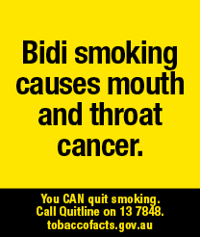 | Front outer surface  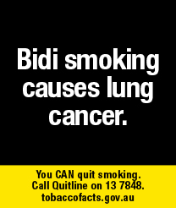
Health warning 7.1.3 | Health warning 7.1.4
Front outer surface  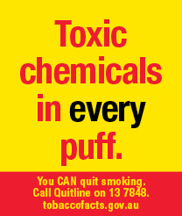 | Front outer surface  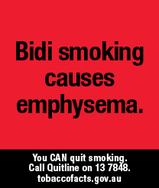
Health warning 7.1.5
Front outer surface
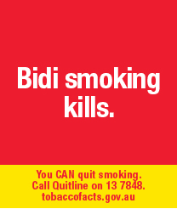

Part 2 - Horizontal retail packaging
Health warning 7.2.1
Front outer surface
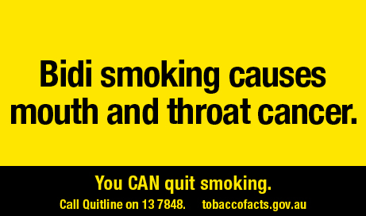
Health warning 7.2.2
Front outer surface
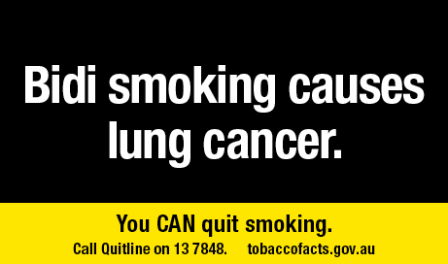
Health warning 7.2.3
Front outer surface
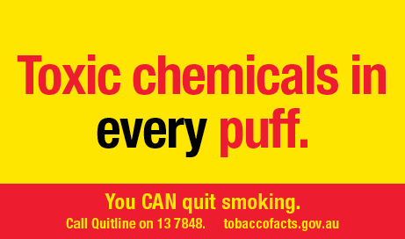

Part 2 - Horizontal retail packaging
Health warning 7.2.4
Front outer surface
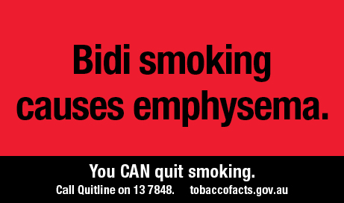
Health warning 7.2.5
Front outer surface
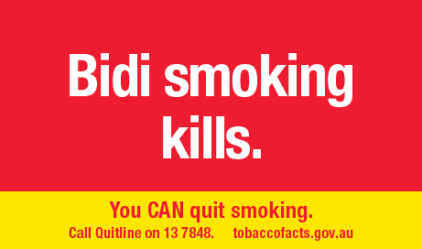

Part 3 - Square retail packaging, and square images used on other retail packaging
Health warning 7.3.1 | Health warning 7.3.2
Front outer surface  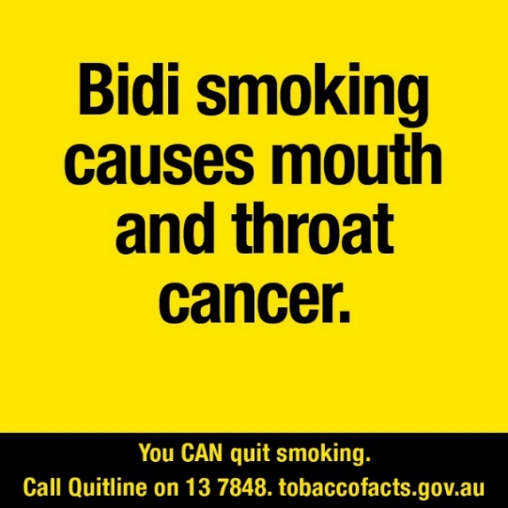 | Front outer surface  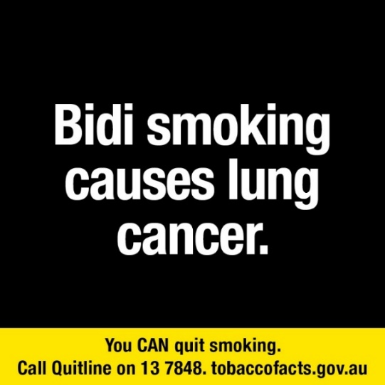
Health warning 7.3.3 | Health warning 7.3.4
Front outer surface  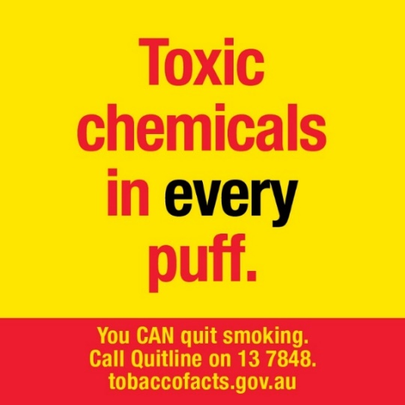 | Front outer surface  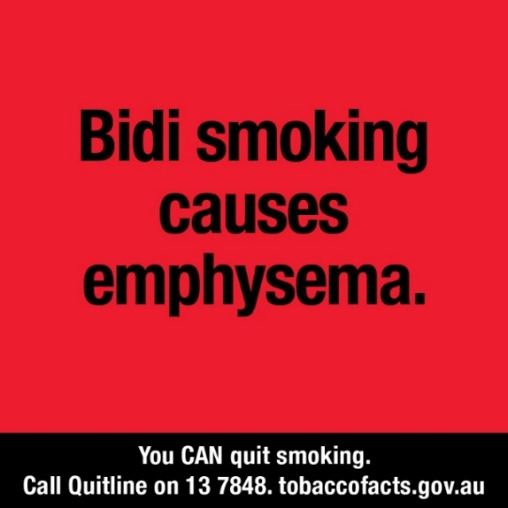
Health warning 7.3.5
Front outer surface
