Part 1 – Vertical retail packaging
Health warning 6.1.1
Front outer surface  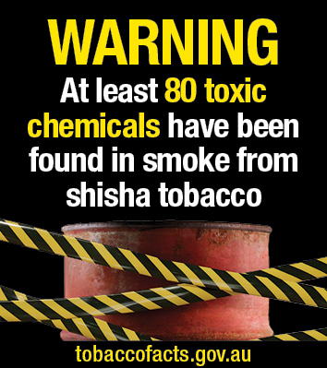 | Back outer surface  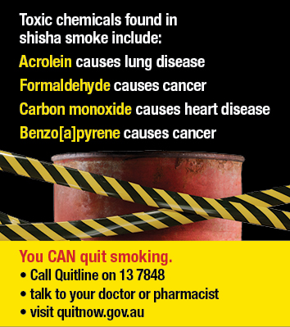 | Side outer surface  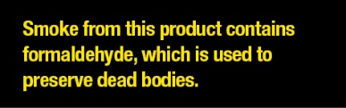
Health warning 6.1.2
Front outer surface  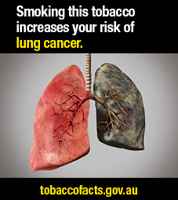 | Back outer surface | Side outer surface  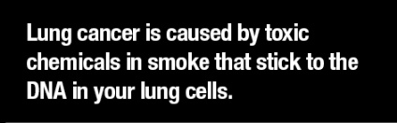
Health warning 6.1.3
Front outer surface  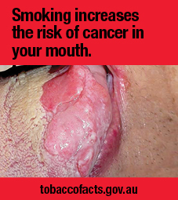 | Back outer surface  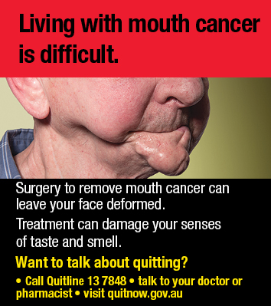 | Side outer surface  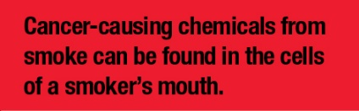

Part 1 – Vertical retail packaging
Health warning 6.1.4
Front outer surface  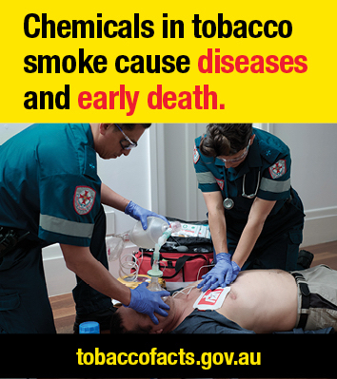 | Back outer surface  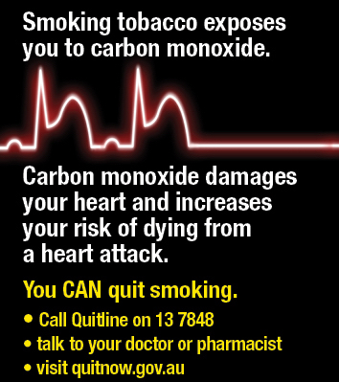 | Side outer surface  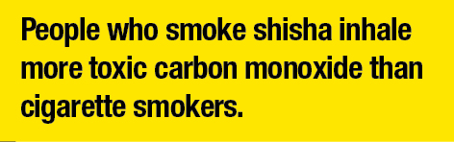
Health warning 6.1.5
Front outer surface  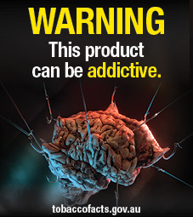 | Back outer surface  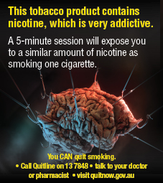 | Side outer surface  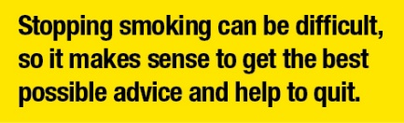

Part 2 - Horizontal retail packaging
Health warning 6.2.1
Front outer surface  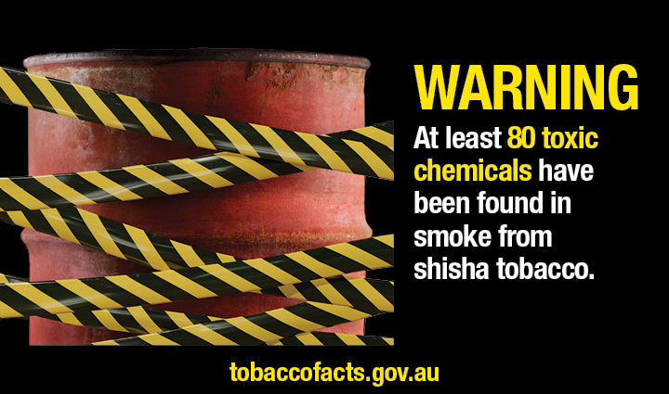 | Side outer surface/hidden flap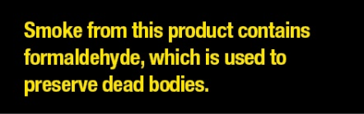
Back outer surface
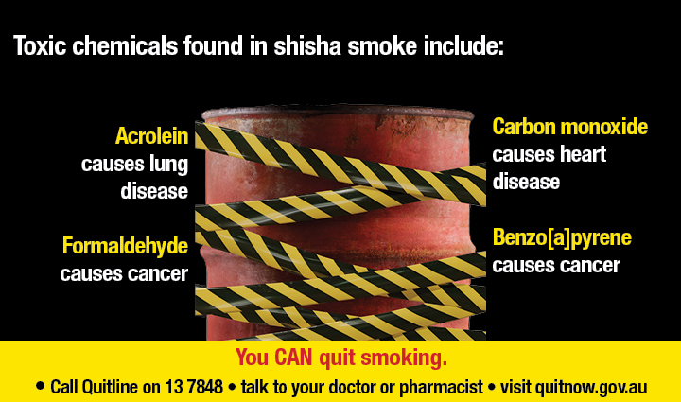
Health warning 6.2.2
Front outer surface  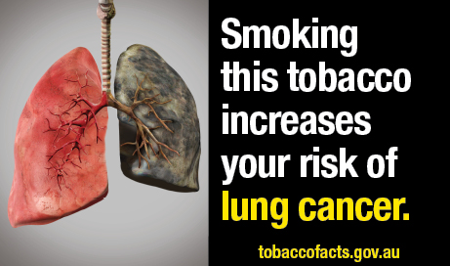 | Side outer surface/hidden flap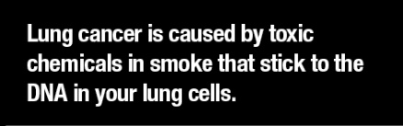
Back outer surface
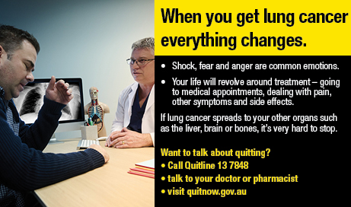

Part 2 - Horizontal retail packaging
Health warning 6.2.3
Front outer surface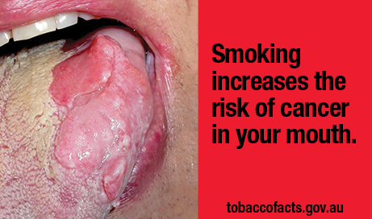 | Side outer surface/hidden flap  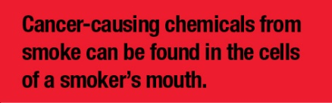
Back outer surface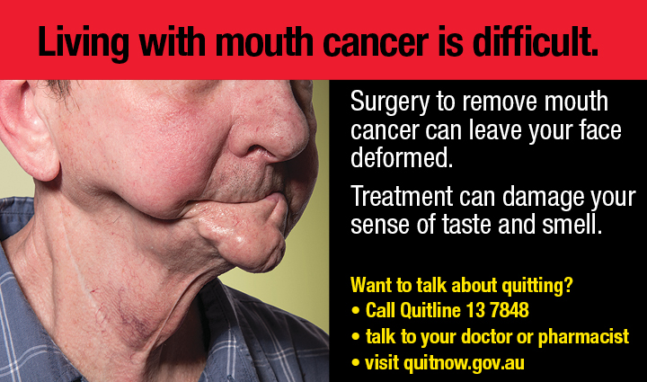
Health warning 6.2.4
Front outer surface  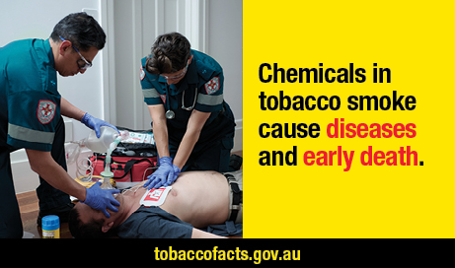 | Side outer surface/hidden flap
Back outer surface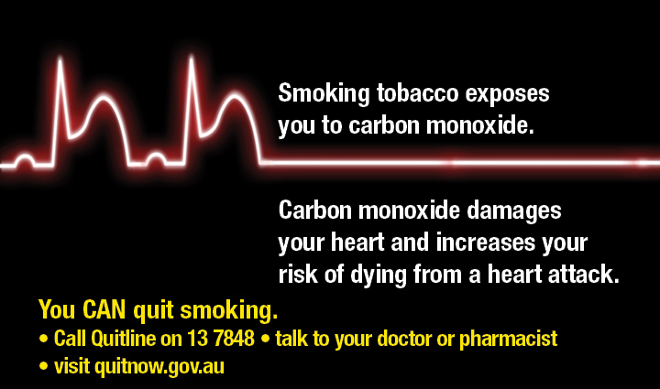

Part 2 - Horizontal retail packaging
Health warning 6.2.5
Front outer surface | Side outer surface/hidden flap 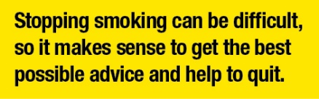
Back outer surface 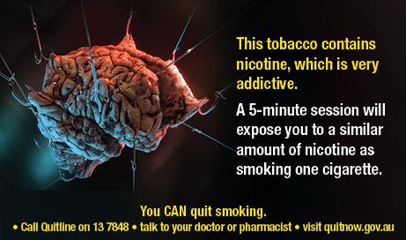

Part 3 - Square retail packaging, and square images used on other retail packaging
Health warning 6.3.1
Front outer surface  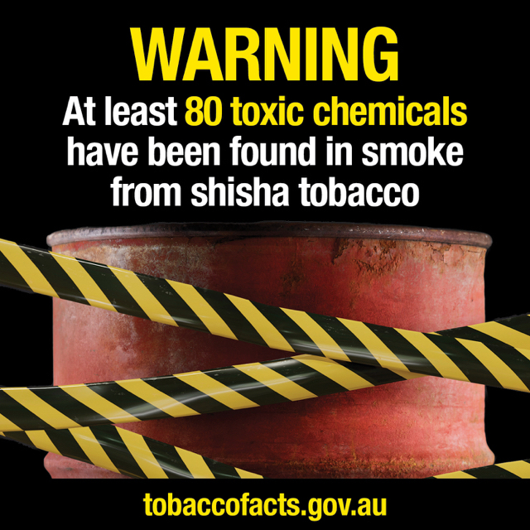 | Back outer surface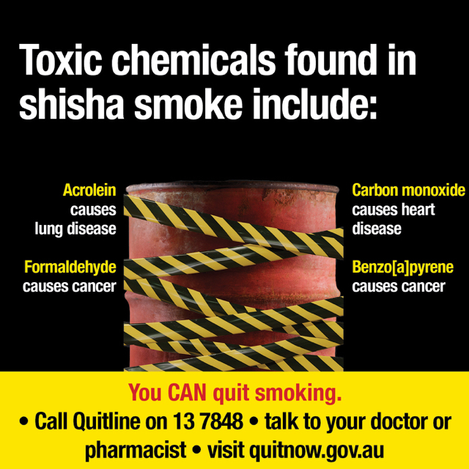
Side outer surface/hidden flap
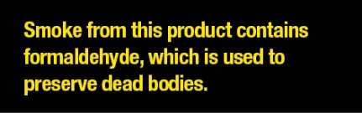
Health warning 6.3.2
Front outer surface  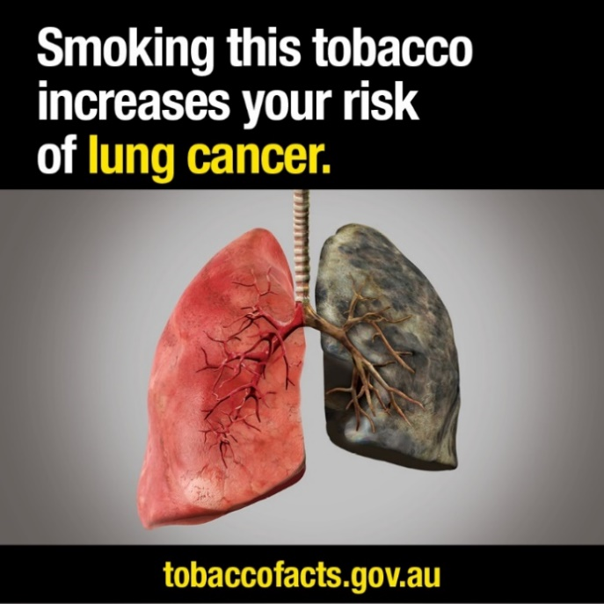 | Back outer surface  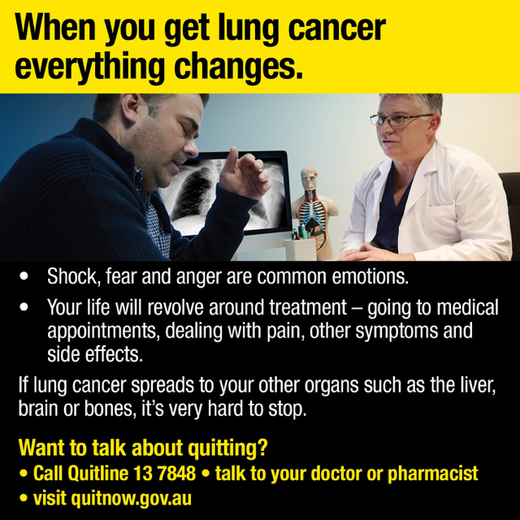
Side outer surface/hidden flap
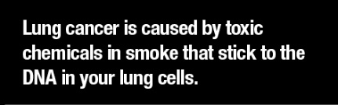

Part 3 - Square retail packaging, and square images used on other retail packaging
Health warning 6.3.3
Front outer surface  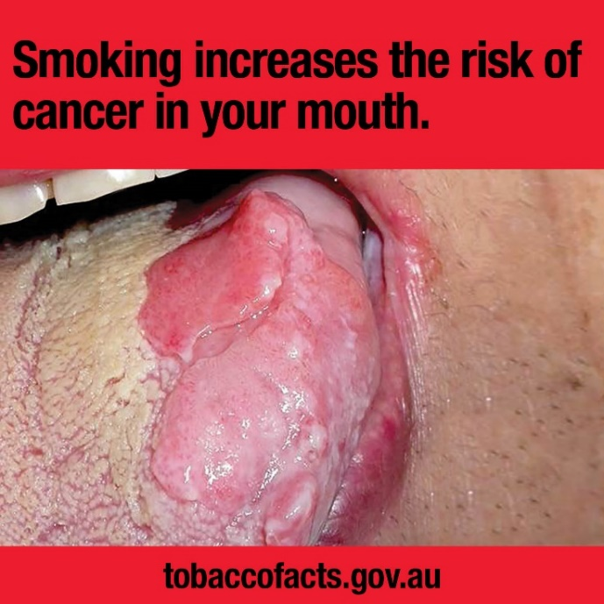 | Back outer surface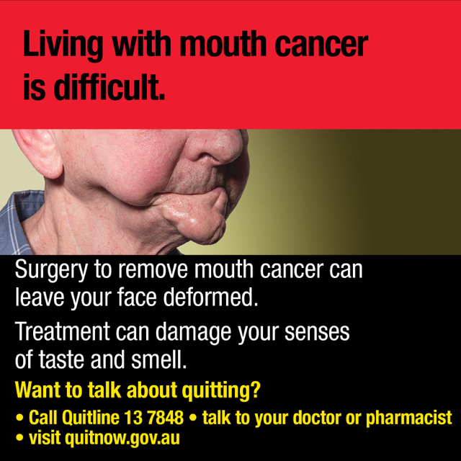
Side outer surface/hidden flap
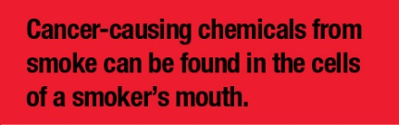
Health warning 6.3.4
Front outer surface  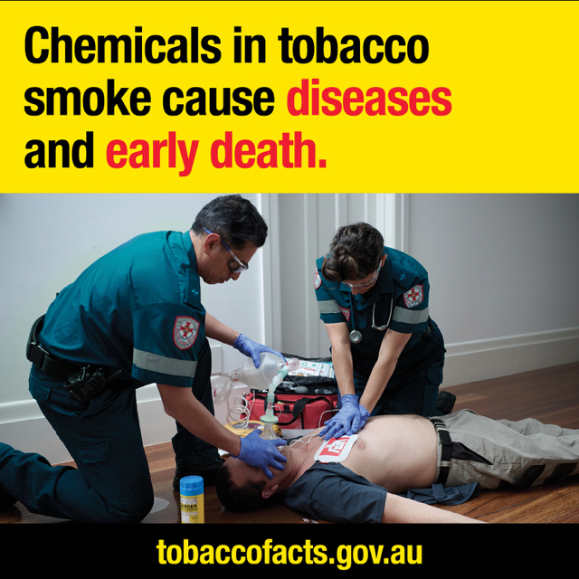 | Back outer surface  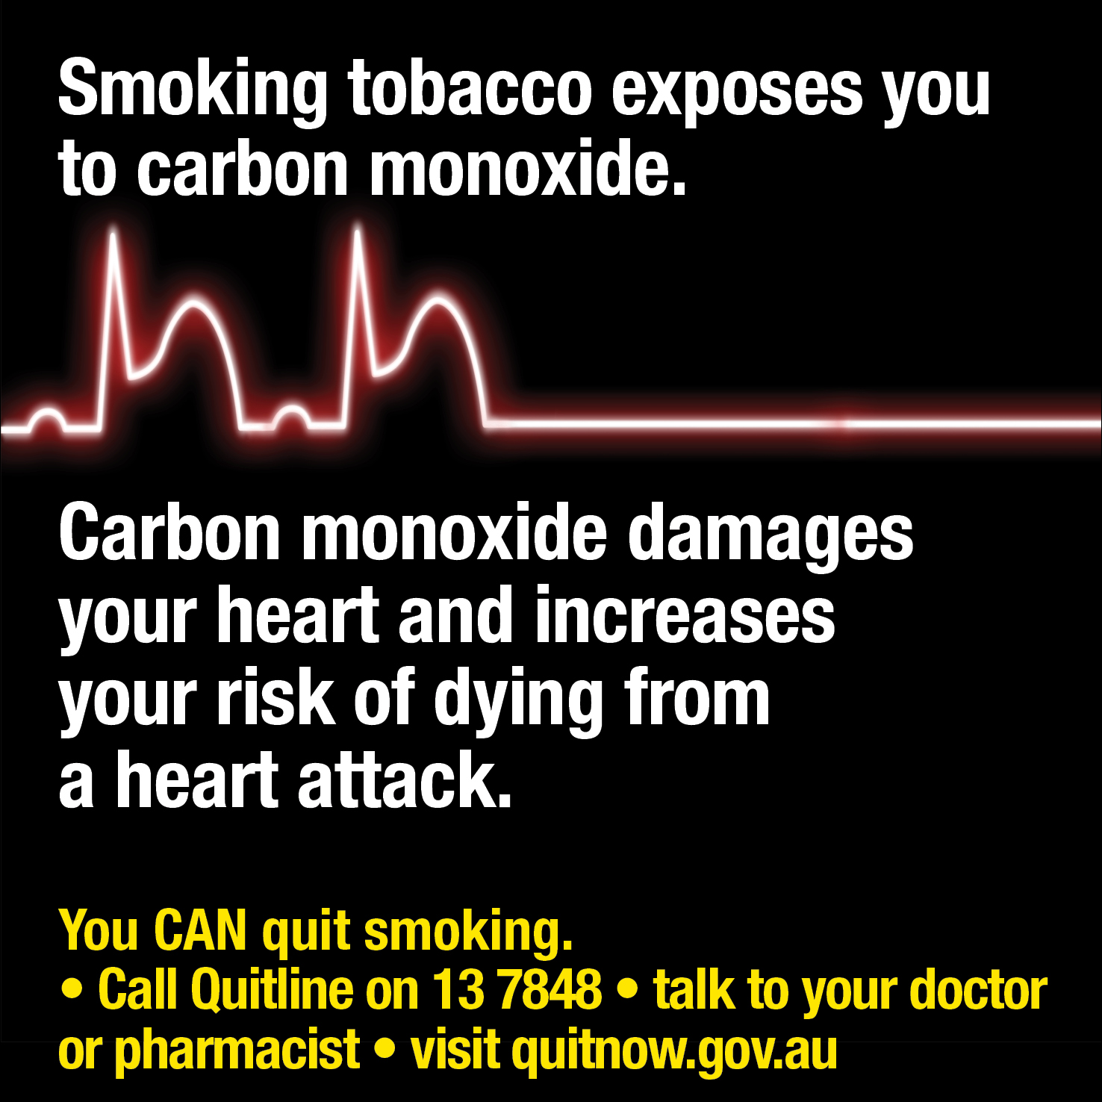
Side outer surface/hidden flap
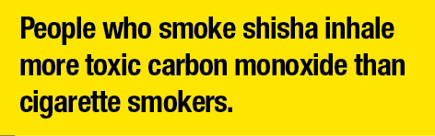

Part 3 - Square retail packaging, and square images used on other retail packaging
Health warning 6.3.5
Front outer surface  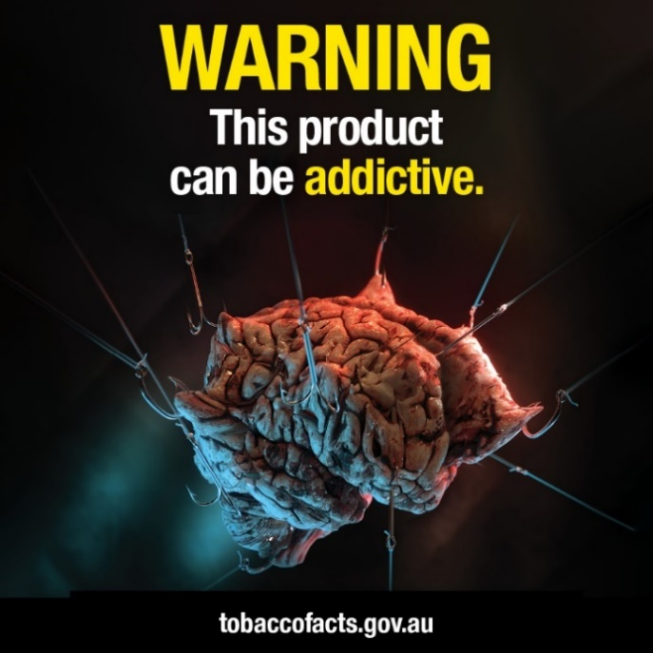 | Back outer surface  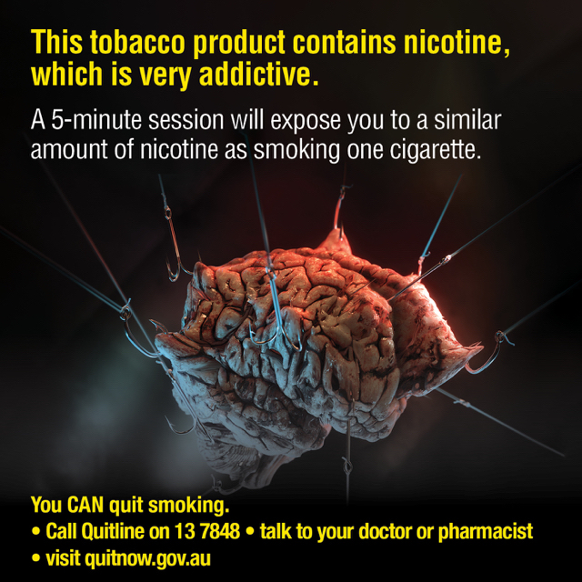
Side outer surface/hidden flap
