Part 1 – Vertical retail packaging
Health warning 5.1.1
Front outer surface  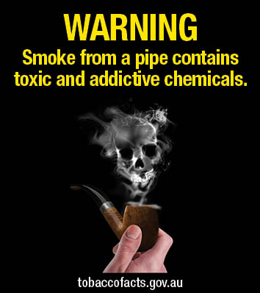 | Back outer surface  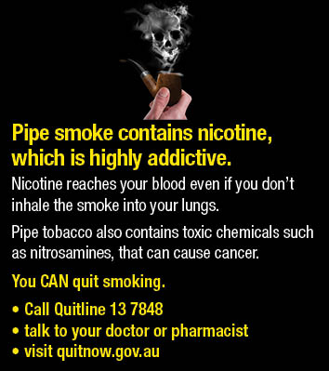 | Side outer surface/hidden flap  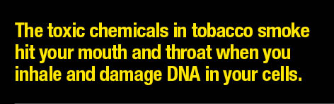
Health warning 5.1.2
Front outer surface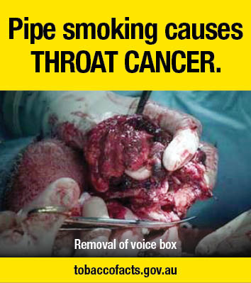 | Back outer surface  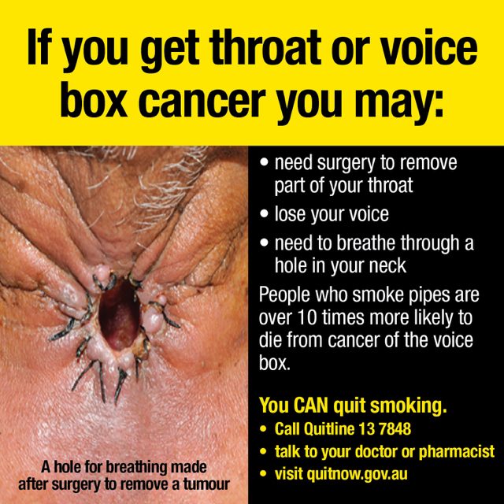 | Side outer surface/hidden flap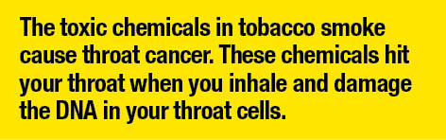
Health warning 5.1.3
Front outer surface  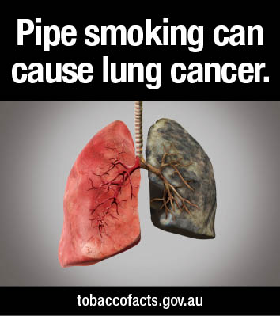 | Back outer surface | Side outer surface/hidden flap  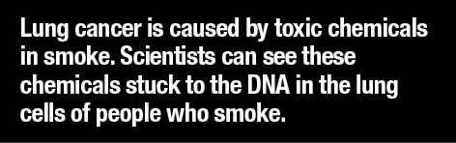
Part 1 – Vertical retail packaging
Health warning 5.1.4
Front outer surface  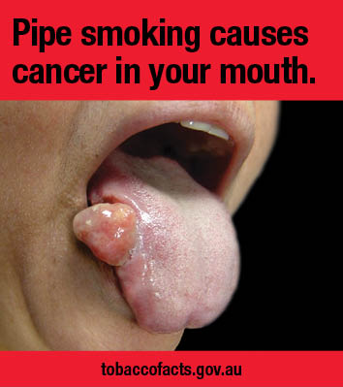 | Back outer surface  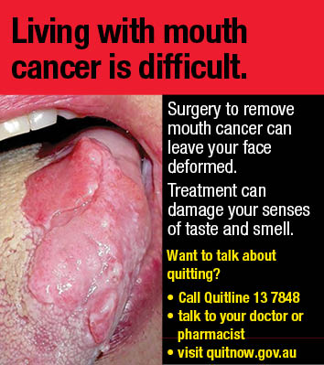 | Side outer surface/hidden flap  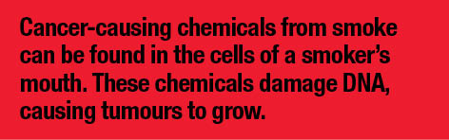
Health warning 5.1.5
Front outer surface  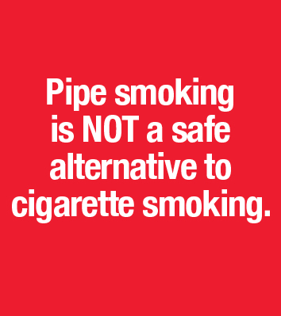 | Back outer surface  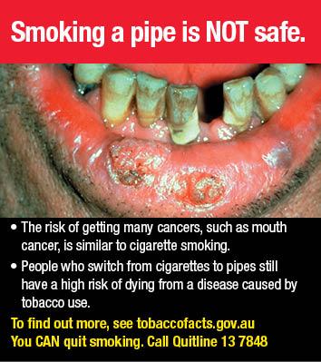 | Side outer surface/hidden flap  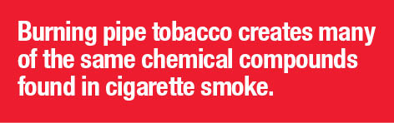

Part 2 - Horizontal retail packaging
Health warning 5.2.1
Front outer surface  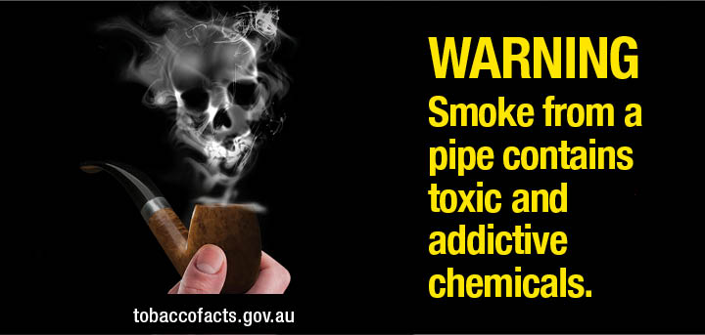 | Side outer surface/hidden flap
Back outer surface
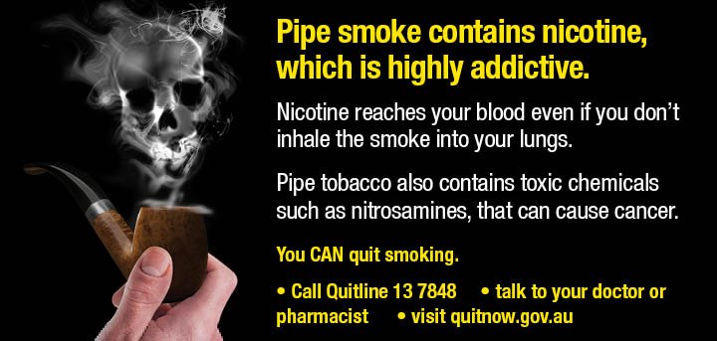
Health warning 5.2.2
Front outer surface  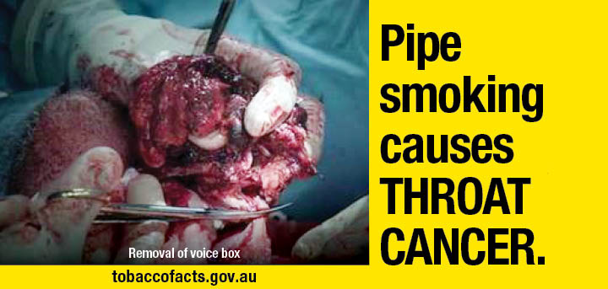 | Side outer surface/hidden flap
Back outer surface
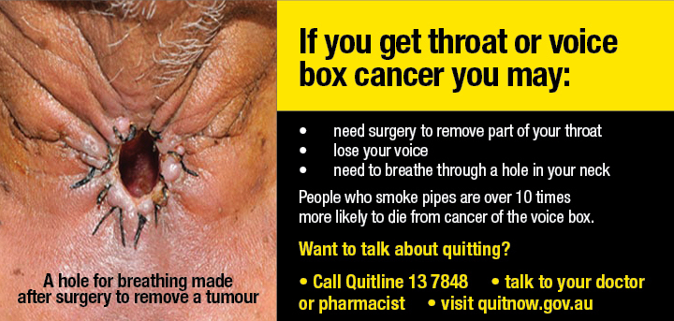

Part 2 - Horizontal retail packaging
Health warning 5.2.3
Front outer surface  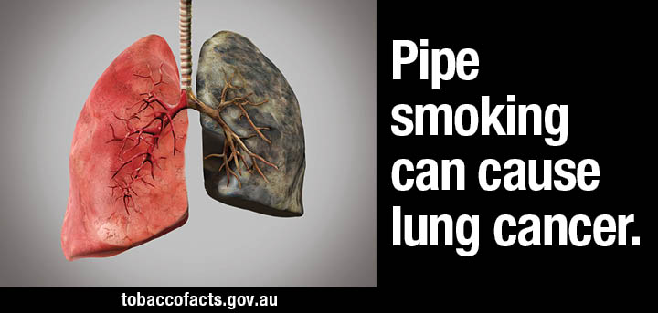 | Side outer surface/hidden flap
Back outer surface
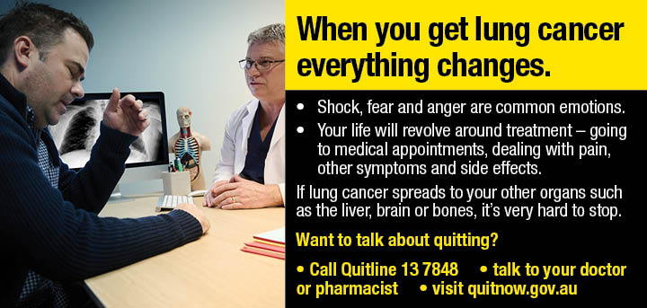
Health warning 5.2.4
Front outer surface  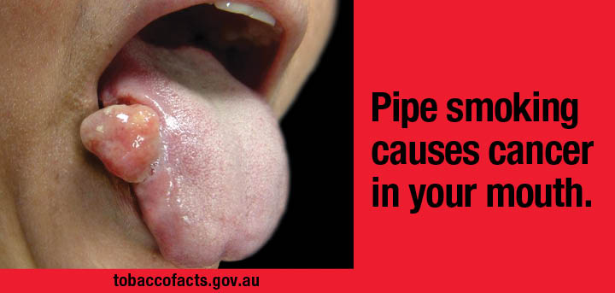 | Side outer surface/hidden flap
Back outer surface
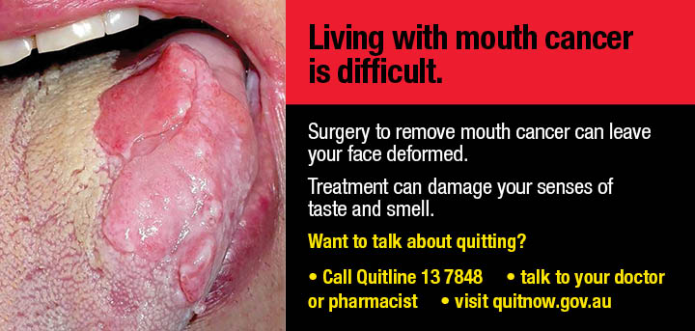

Part 2 - Horizontal retail packaging
Health warning 5.2.5
Front outer surface  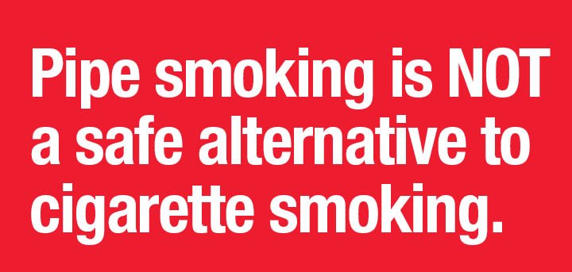 | Side outer surface/hidden flap
Back outer surface
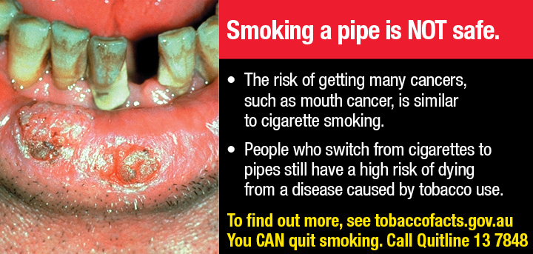

Part 3 - Square retail packaging, and square images used on other retail packaging
Health warning 5.3.1
Front outer surface  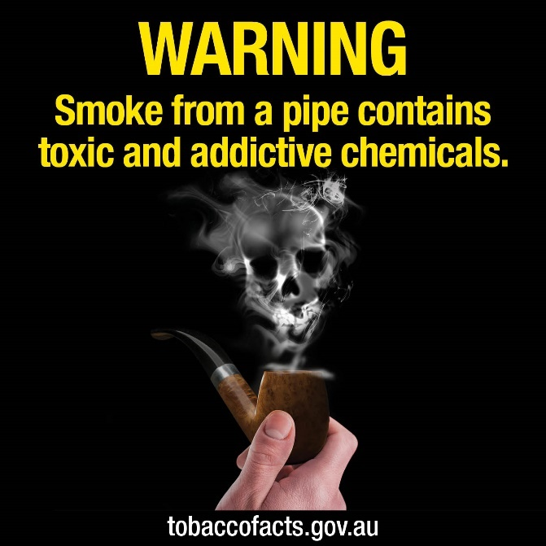 | Back outer surface  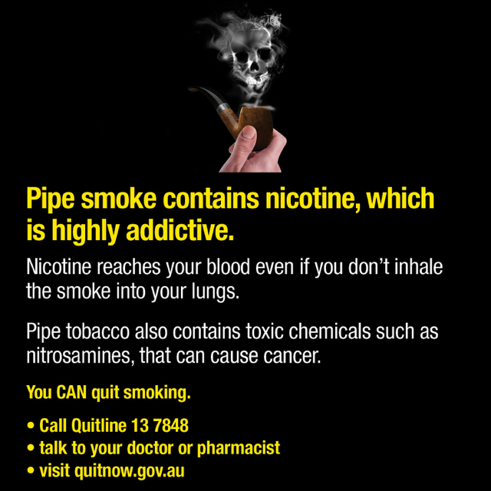
Side outer surface/hidden flap
Health warning 5.3.2
Front outer surface  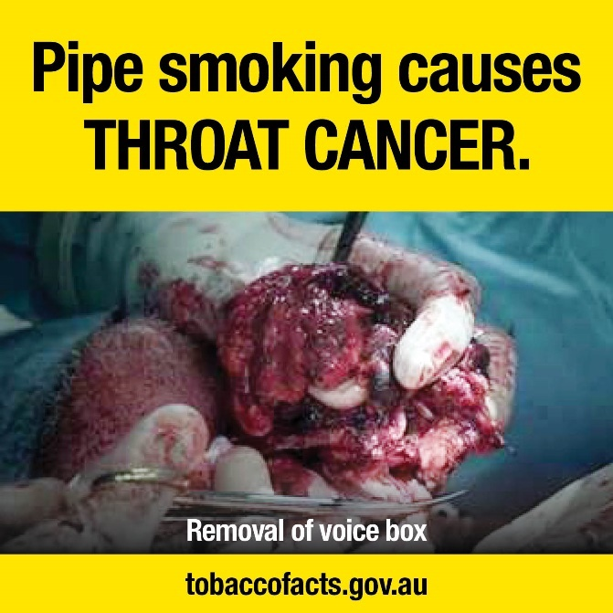 | Back outer surface  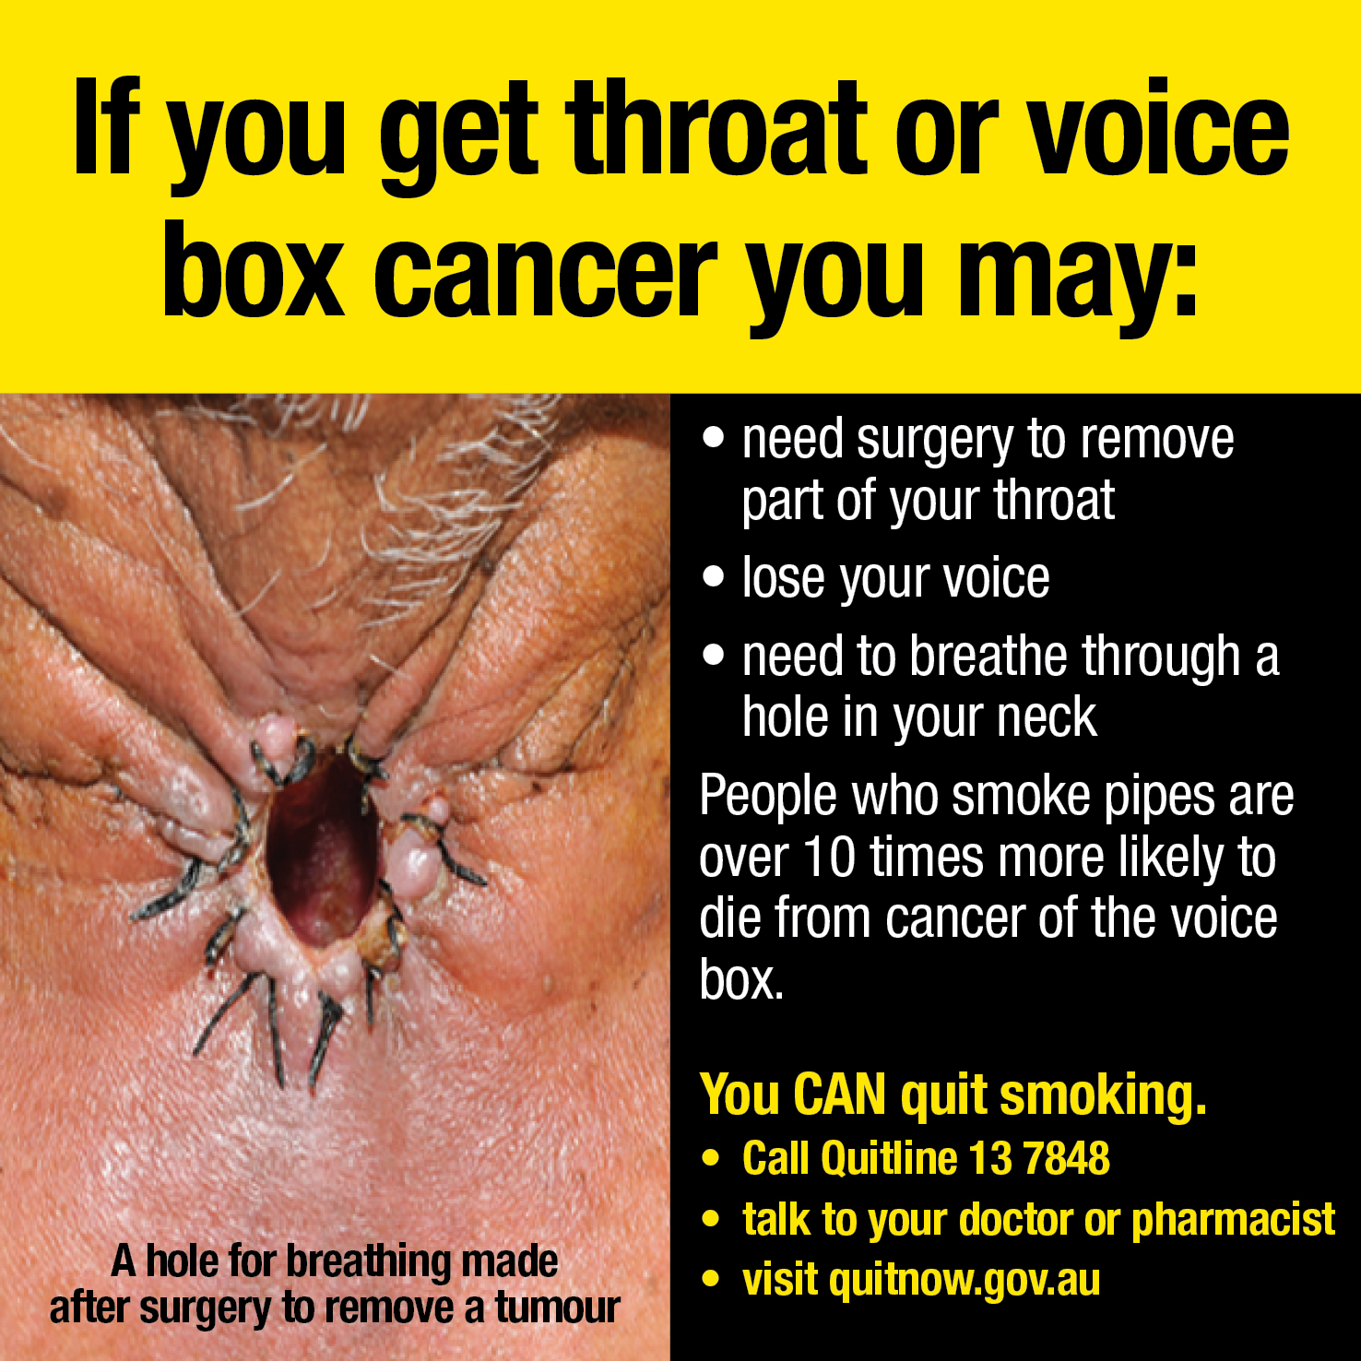
Side outer surface/hidden flap
Part 3 - Square retail packaging, and square images used on other retail packaging
Health warning 5.3.3
Front outer surface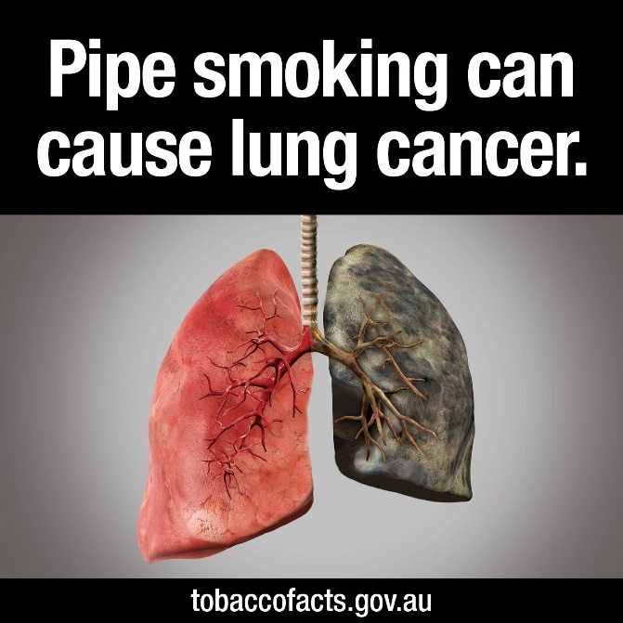 | Back outer surface
Side outer surface/hidden flap
Health warning 5.3.4
Front outer surface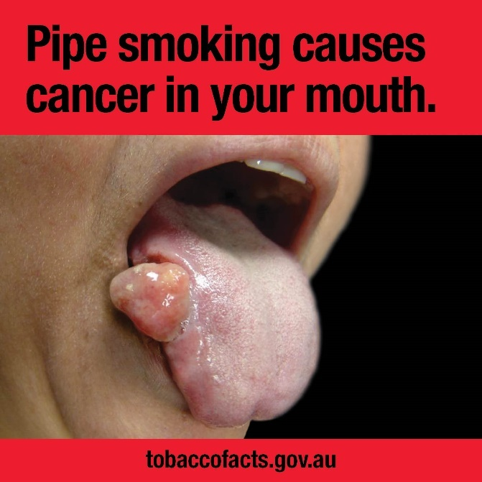 | Back outer surface 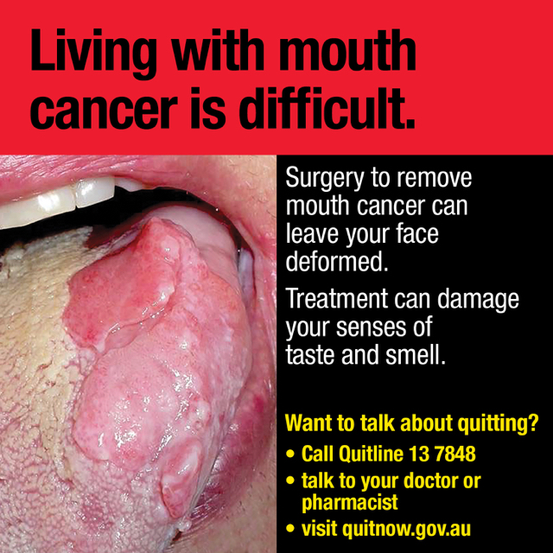
Side outer surface/hidden flap

Part 3 - Square retail packaging, and square images used on other retail packaging
Health warning 5.3.5
Front outer surface  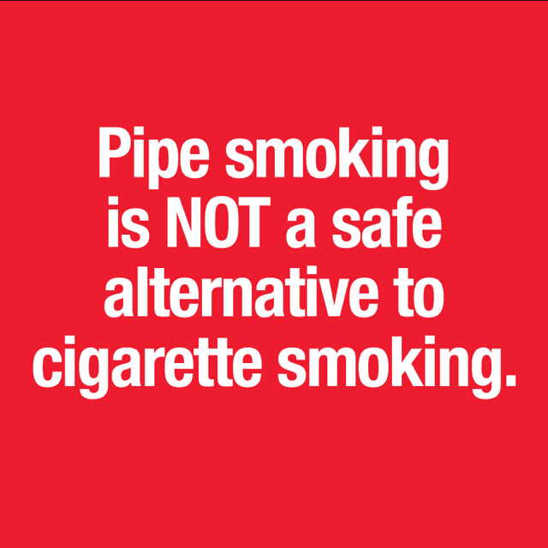 | Back outer surface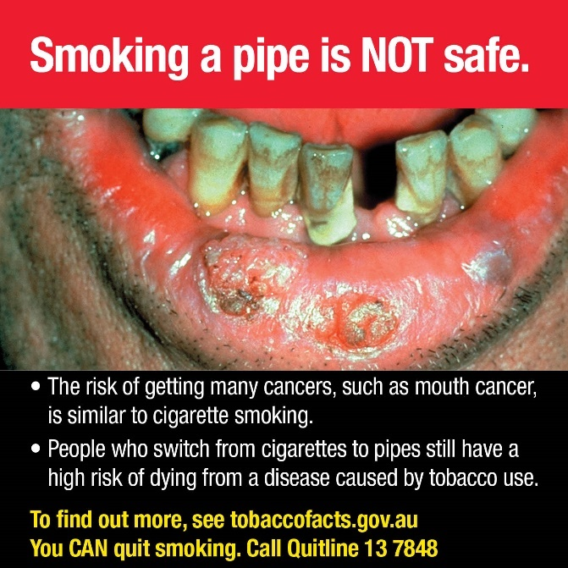
Side outer surface/hidden flap

