Part 1 – Vertical retail packaging
Health warning 4.1.1
Front outer surface  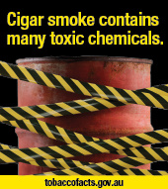 | Back outer surface  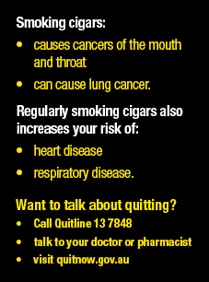
Health warning 4.1.2
Front outer surface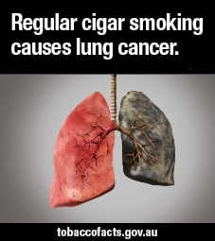 | Back outer surface

Part 1 – Vertical retail packaging
Health warning 4.1.3
Front outer surface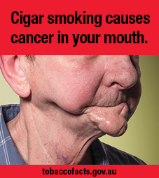 | Back outer surface  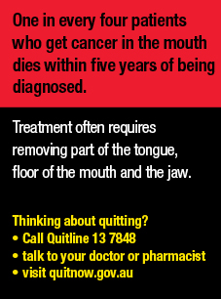
Health warning 4.1.4
Front outer surface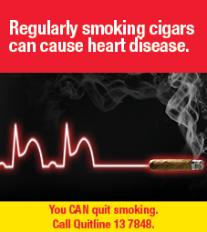 | Back outer surface  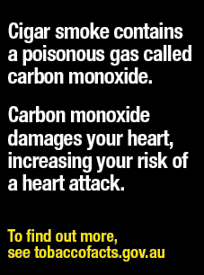

Part 1 – Vertical retail packaging
Health warning 4.1.5
Front outer surface 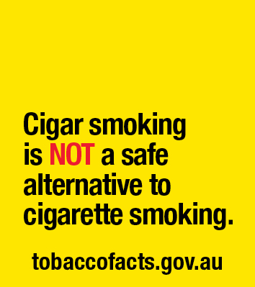 | Back outer surface  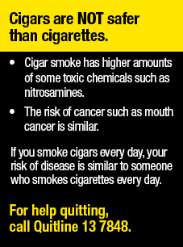

Part 2 - Horizontal retail packaging
Health warning 4.2.1
Front outer surface  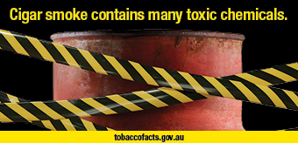 | Back outer surface  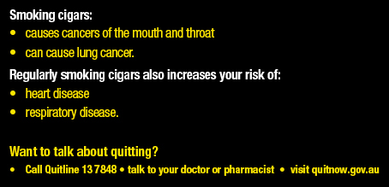
Health warning 4.2.2
Front outer surface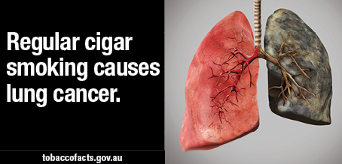 | Back outer surface
Health warning 4.2.3
Front outer surface  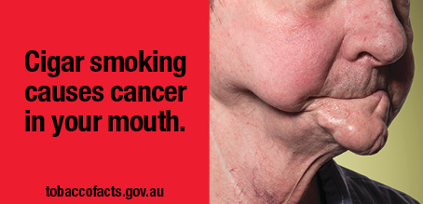 |  | Back outer surface  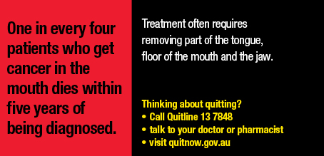

Part 2 - Horizontal retail packaging
Health warning 4.2.4
Front outer surface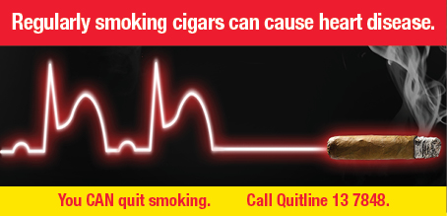 | Back outer surface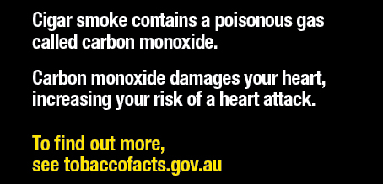
Health warning 4.2.5
Front outer surface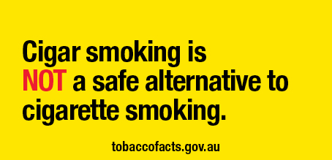 | Back outer surface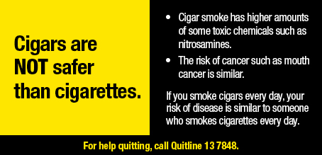

Part 3 – Square retail packaging, and square images used on other retail packaging
Health warning 4.3.1
Front outer surface  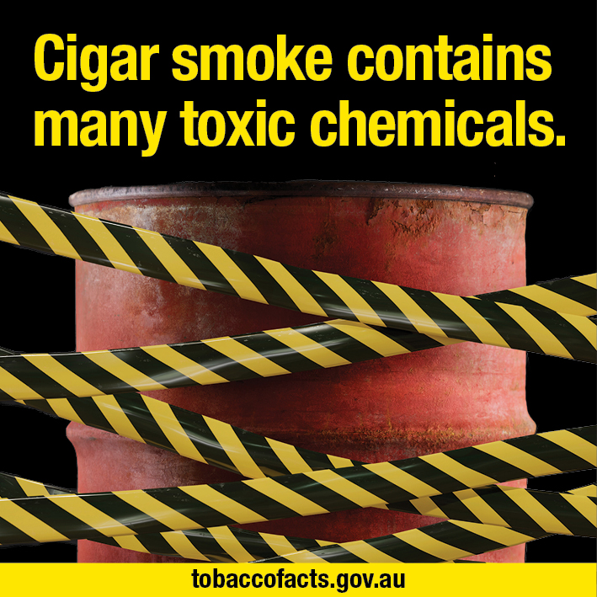 | Back outer surface  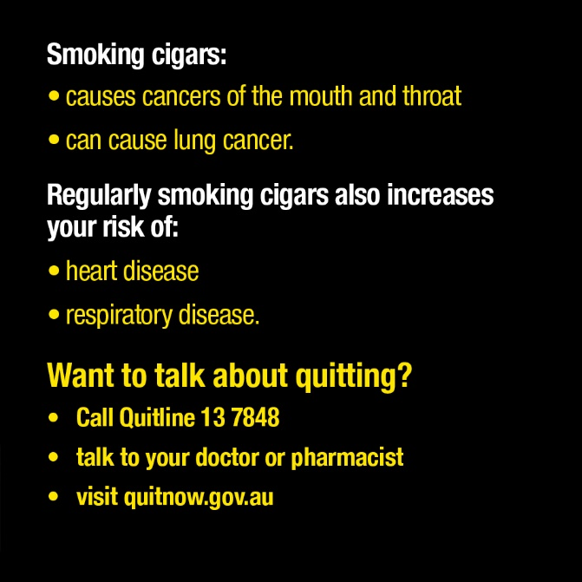
Health warning 4.3.2
Front outer surface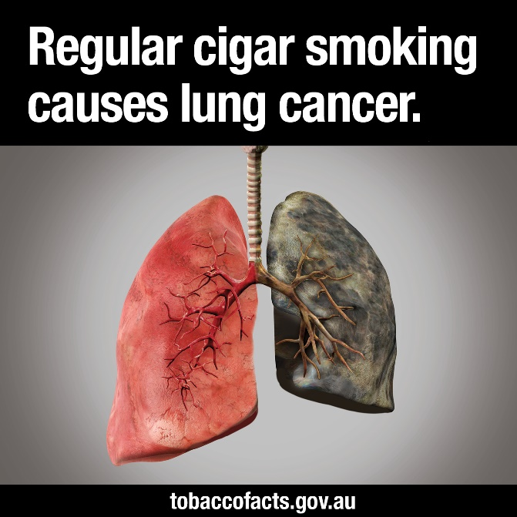 | Back outer surface

Part 3 – Square retail packaging, and square images used on other retail packaging
Health warning 4.3.3
Front outer surface 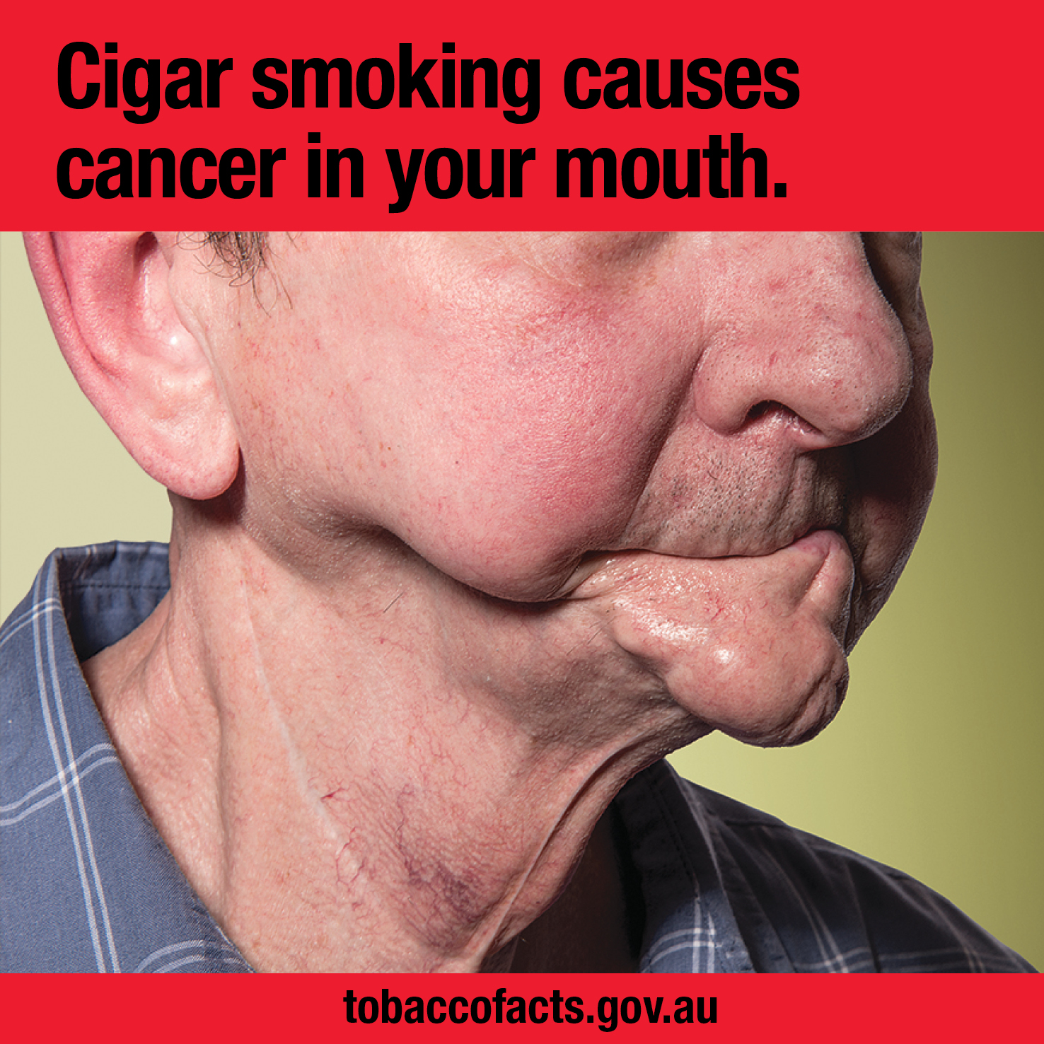 | Back outer surface
Health warning 4.3.4
Front outer surface 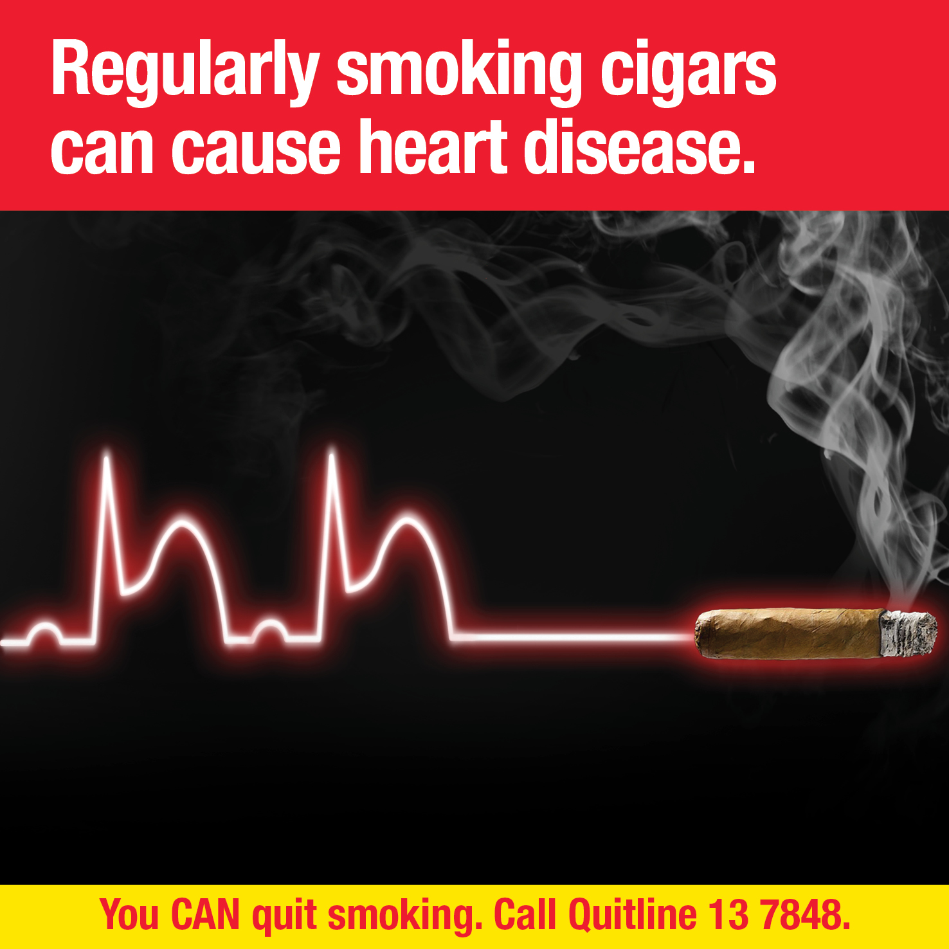 | Back outer surface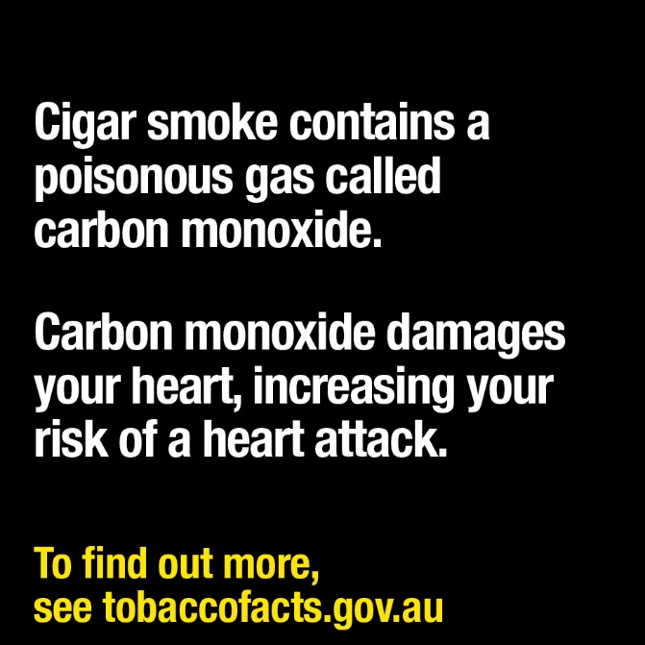

Part 3 – Square retail packaging, and square images used on other retail packaging
Health warning 4.3.5
Front outer surface 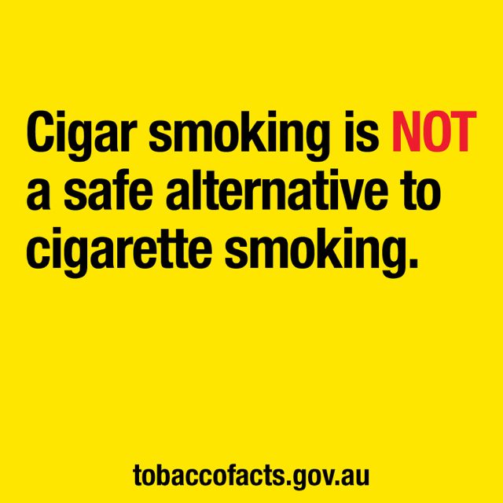 | Back outer surface