Part 1 – Vertical retail packaging
Health warning 2.1.1
Front outer surface  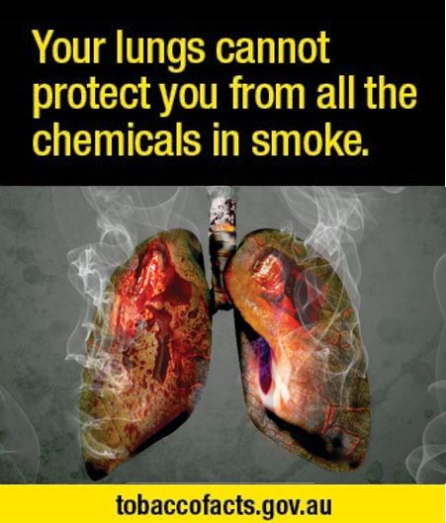 | Back outer surface  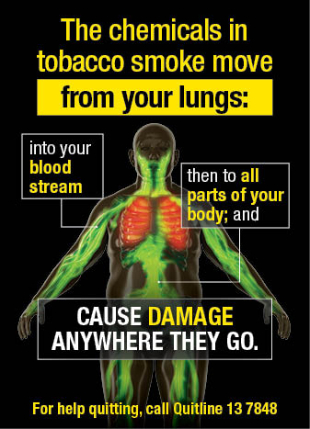 | Side outer surface/hidden flap  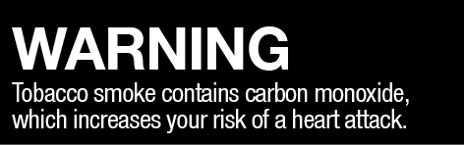
Health warning 2.1.2
Front outer surface | Back outer surface  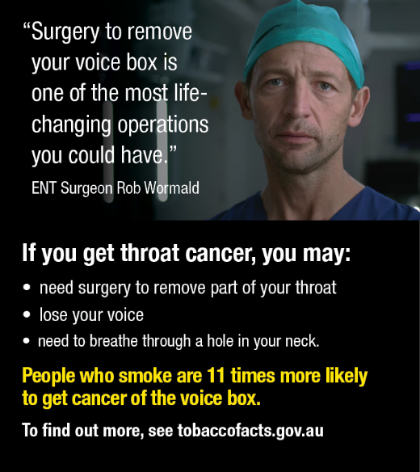 | Side outer surface/hidden flap  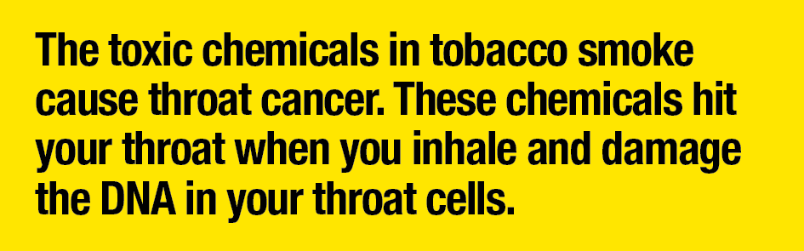

Part 1 – Vertical retail packaging
Health warning 2.1.3
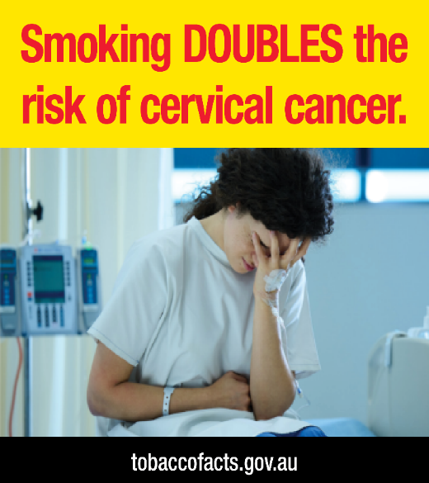  Front outer surface | Back outer surface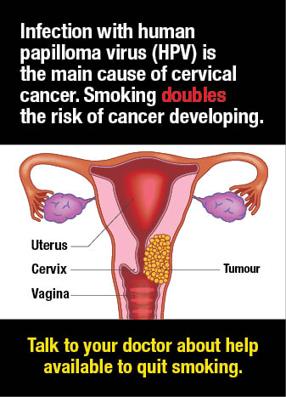 | Side outer surface/hidden flap  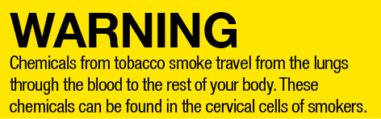
Health warning 2.1.4
Front outer surface | Back outer surface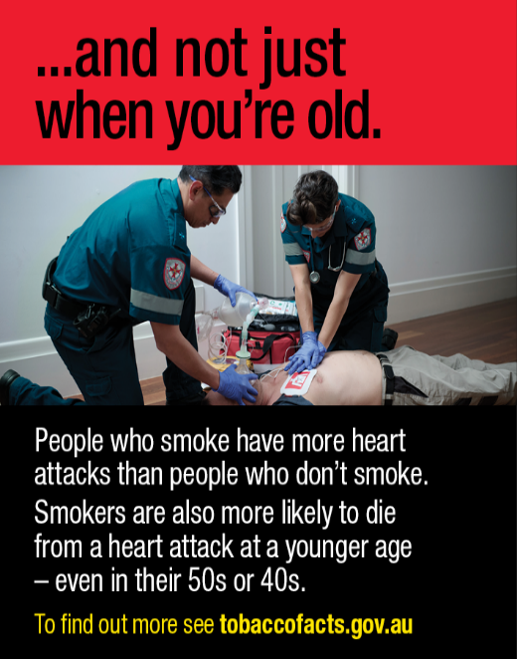 |  | Side outer surface/hidden flap  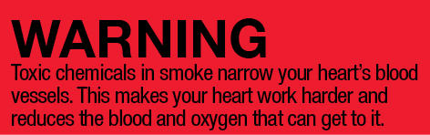

Part 1 – Vertical retail packaging
Health warning 2.1.5
Front outer surface | Back outer surface  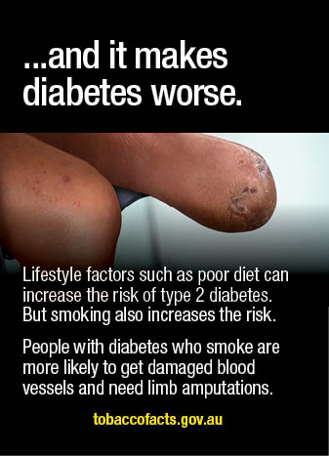 | Side outer surface/hidden flap  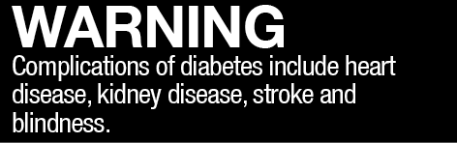
Health warning 2.1.6
Front outer surface  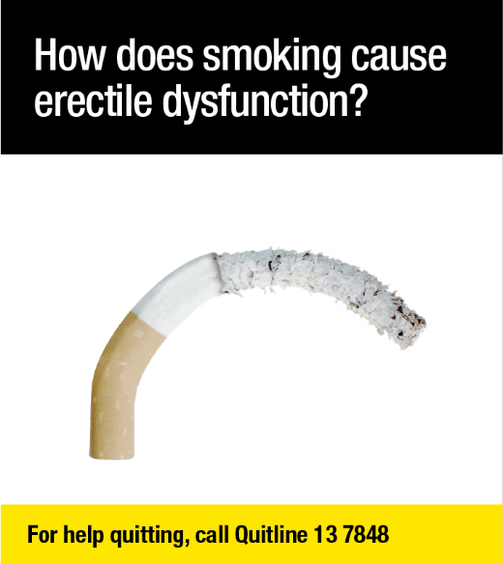 | Back outer surface  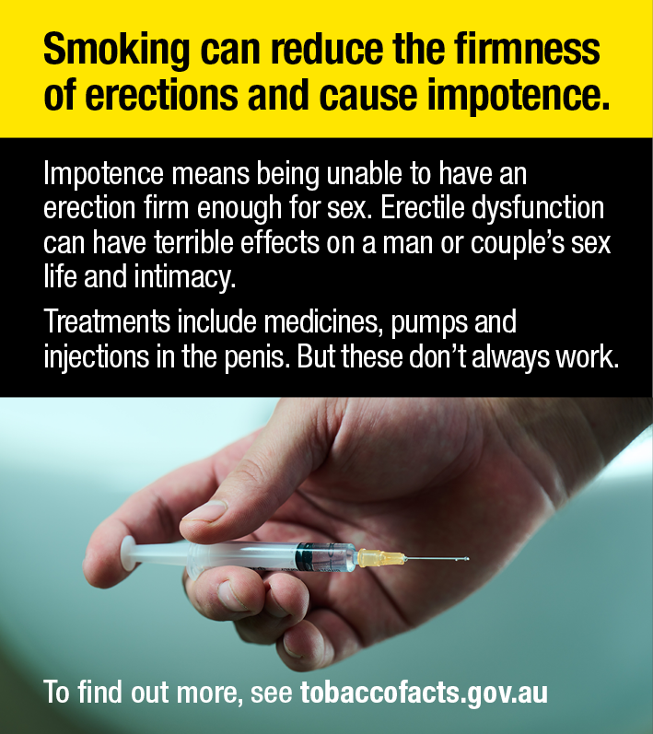 | Side outer surface/hidden flap  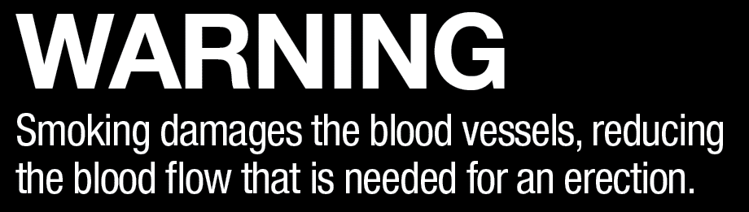

Part 1 – Vertical retail packaging
Health warning 2.1.7
Front outer surface  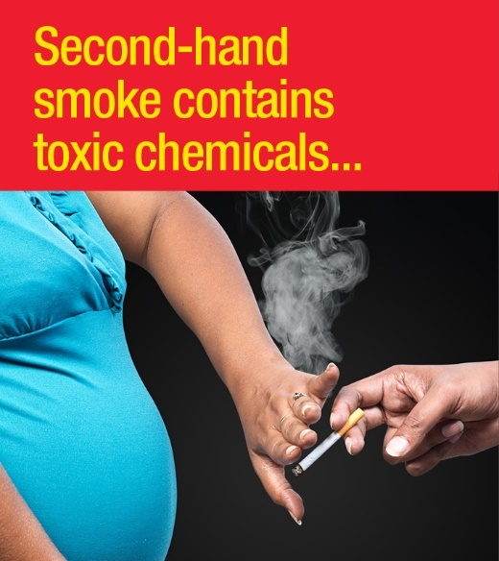 | Back outer surface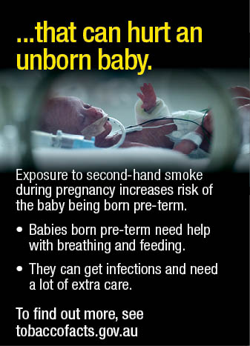 | Side outer surface/hidden flap  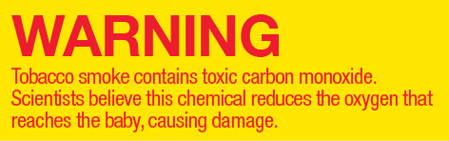
Health warning 2.1.8
Front outer surface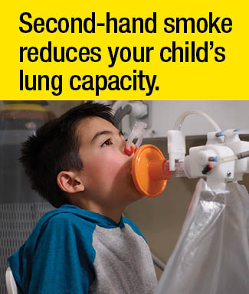 | Back outer surface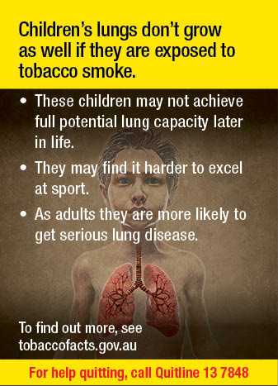 | Side outer surface/hidden flap  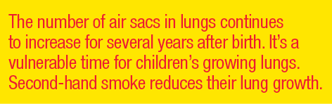

Part 1 – Vertical retail packaging
Health warning 2.1.9
Front outer surface  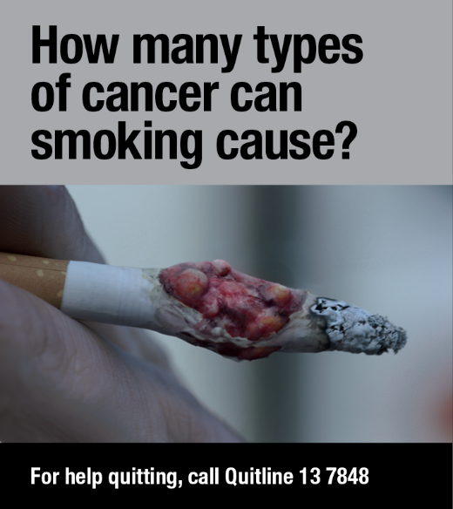 | Back outer surface  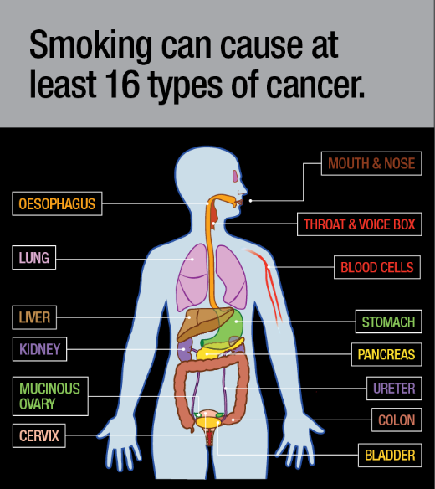 | Side outer surface/hidden flap  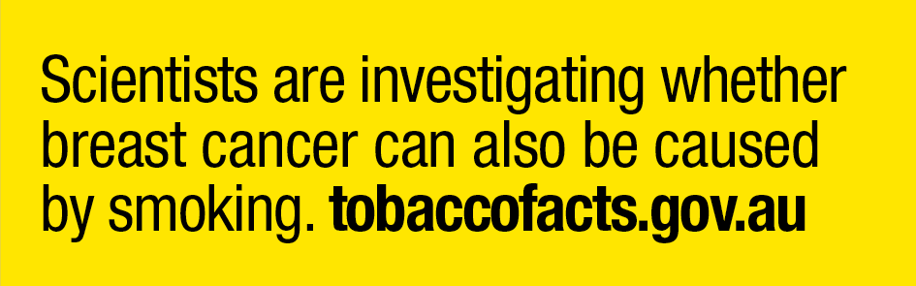
Health warning 2.1.10
Front outer surface | Back outer surface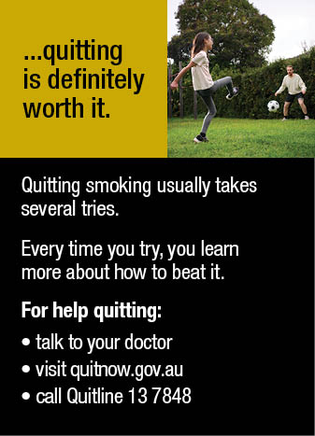 | Side outer surface/hidden flap

Part 2 - Horizontal retail packaging
Health warning 2.2.1
Front outer surface  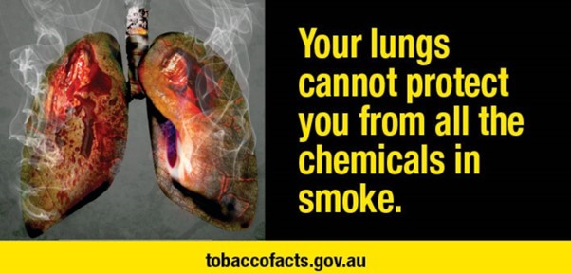 | Side outer surface/hidden flap
Back outer surface
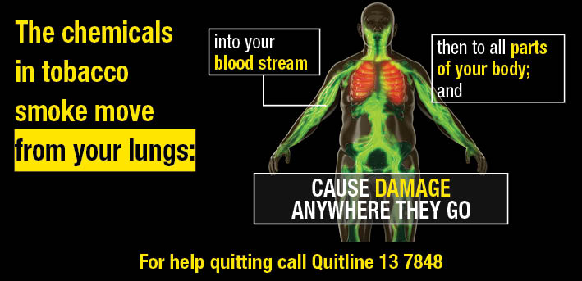
Health warning 2.2.2
Front outer surface  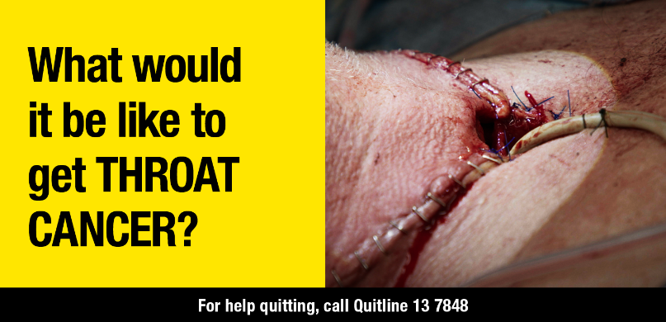 | Side outer surface/hidden flap
Back outer surface
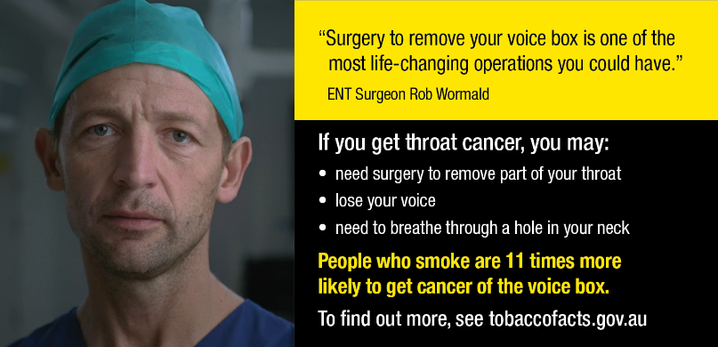

Part 2 - Horizontal retail packaging
Health warning 2.2.3
Front outer surface | Side outer surface/hidden flap
Back outer surface
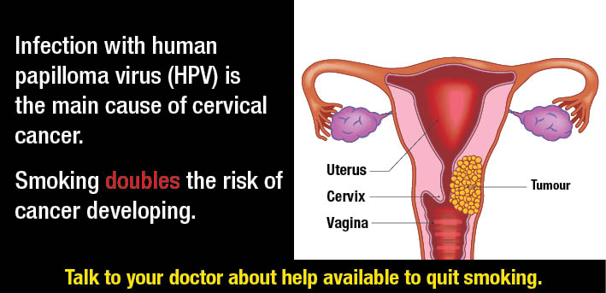
Health warning 2.2.4
Front outer surface | Side outer surface/hidden flap
Back outer surface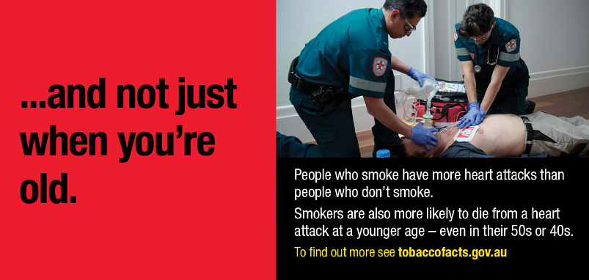
Part 2 - Horizontal retail packaging
Health warning 2.2.5
Front outer surface  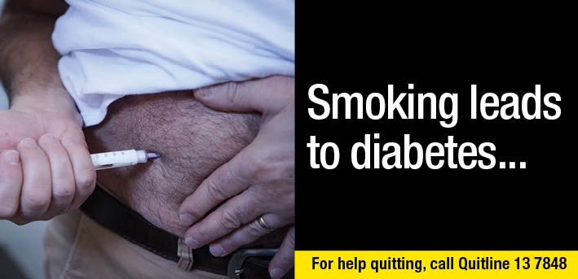 | Side outer surface/hidden flap
Back outer surface
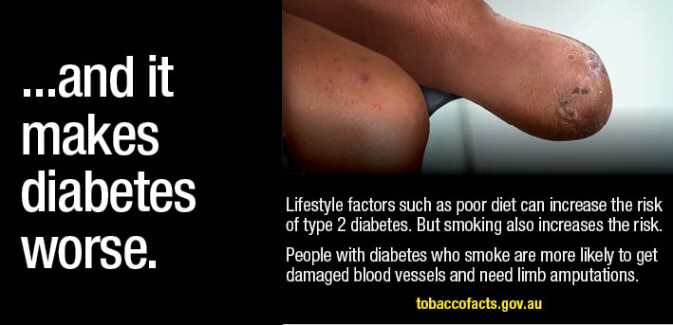
Health warning 2.2.6
Front outer surface  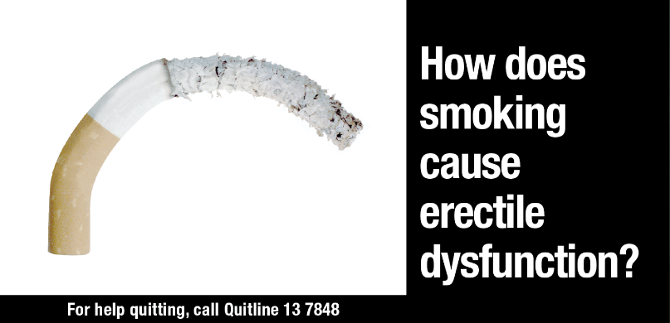 | Side outer surface/hidden flap  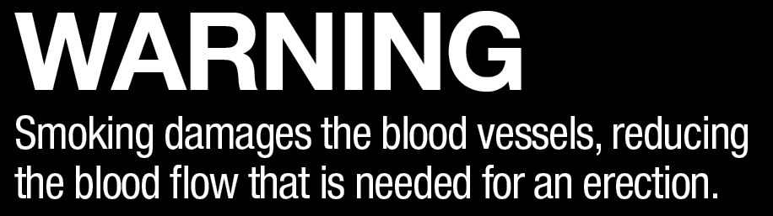
Back outer surface
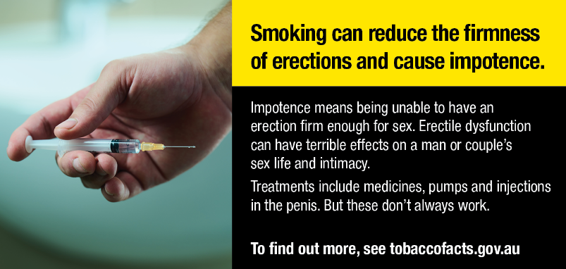

Part 2 - Horizontal retail packaging
Health warning 2.2.7
Front outer surface  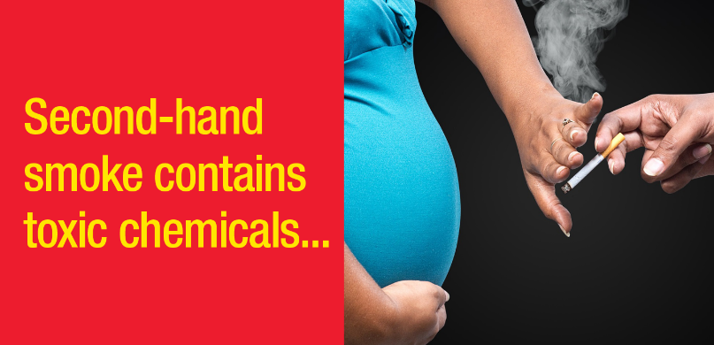 | Side outer surface/hidden flap
Back outer surface
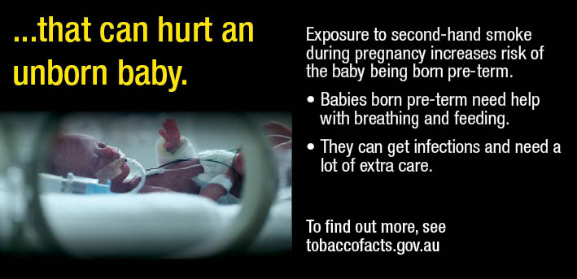
Health warning 2.2.8
Front outer surface  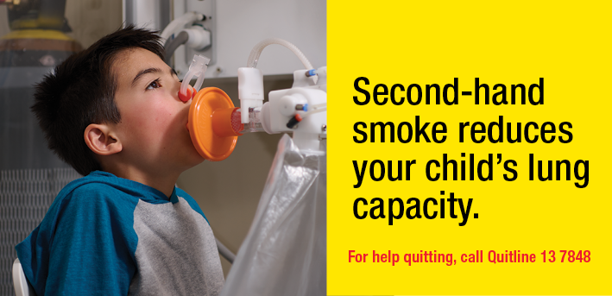 | Side outer surface/hidden flap
Back outer surface
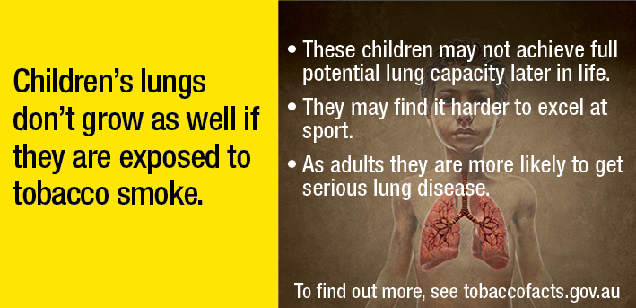

Part 2 - Horizontal retail packaging
Health warning 2.2.9
Front outer surface  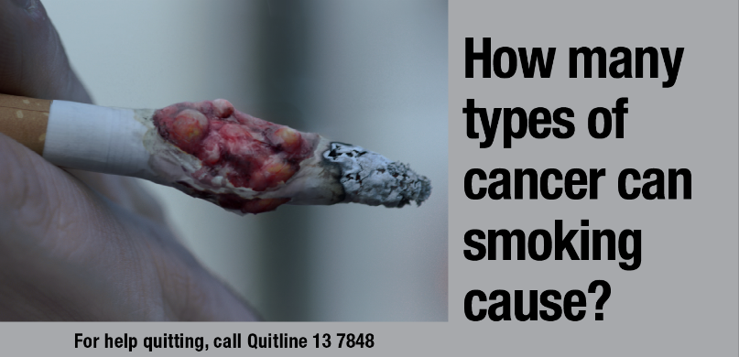 | Side outer surface/hidden flap
Back outer surface
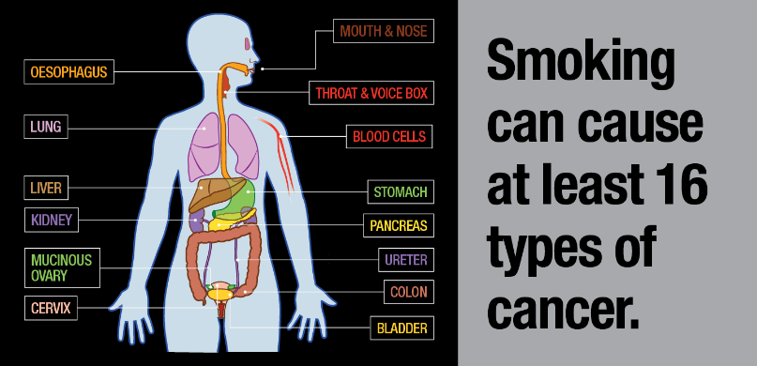
Health warning 2.2.10
Front outer surface | Side outer surface/hidden flap
Back outer surface
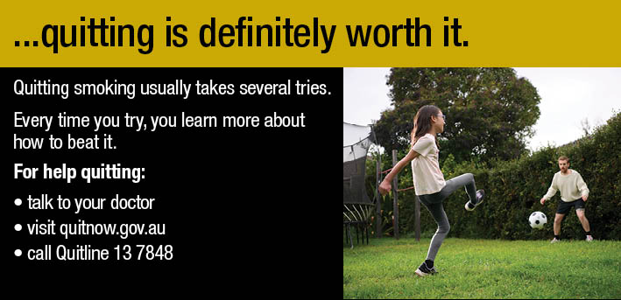

Part 3 - Square retail packaging, and square images used on other retail packaging
Health warning 2.3.1
Front outer surface  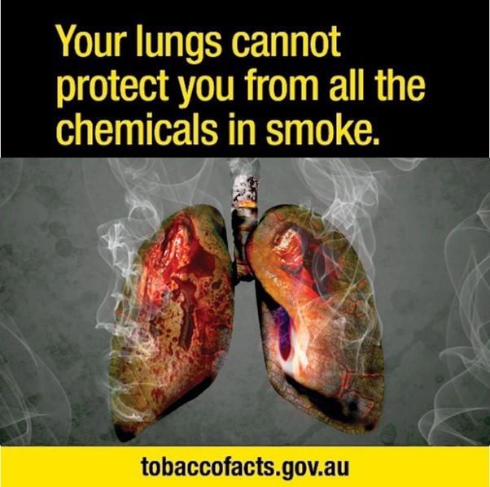 | Back outer surface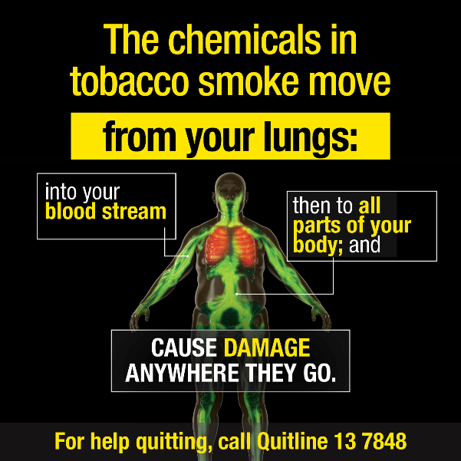
Side outer surface/hidden flap
Health warning 2.3.2
Front outer surface  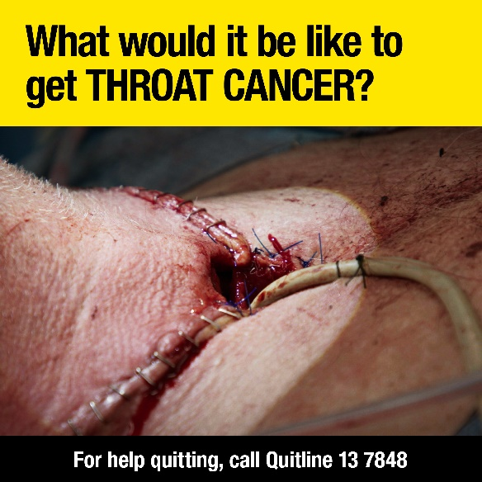 | Back outer surface  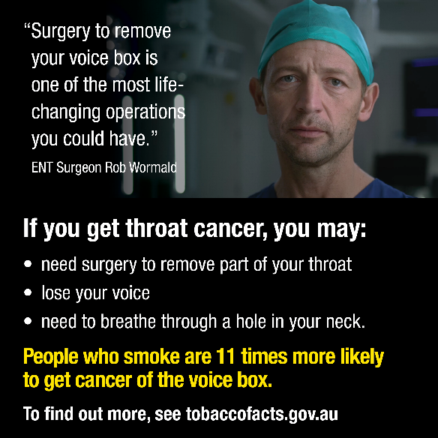
Side outer surface/hidden flap

Part 3 - Square retail packaging, and square images used on other retail packaging
Health warning 2.3.3
Front outer surface | Back outer surface
Side outer surface/hidden flap
Health warning 2.3.4
Front outer surface | Back outer surface
Side outer surface/hidden flap

Part 3 - Square retail packaging, and square images used on other retail packaging
Health warning 2.3.5
Front outer surface | Back outer surface
Side outer surface/hidden flap
Health warning 2.3.6
Front outer surface | Back outer surface
Side outer surface/hidden flap

Part 3 - Square retail packaging, and square images used on other retail packaging
Health warning 2.3.7
Front outer surface | Back outer surface
Side outer surface/hidden flap
Health warning 2.3.8
Front outer surface | Back outer surface
Side outer surface/hidden flap

Part 3 - Square retail packaging, and square images used on other retail packaging
Health warning 2.3.9
Front outer surface | Back outer surface
Side outer surface/hidden flap
Health warning 2.3.10
Front outer surface | Back outer surface
Side outer surface/hidden flap

