Health warning 1.1 (Quarter 1)
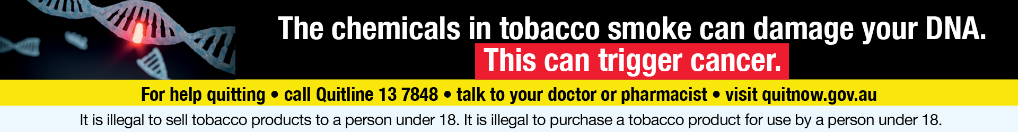
Health warning 1.2 (Quarter 2)
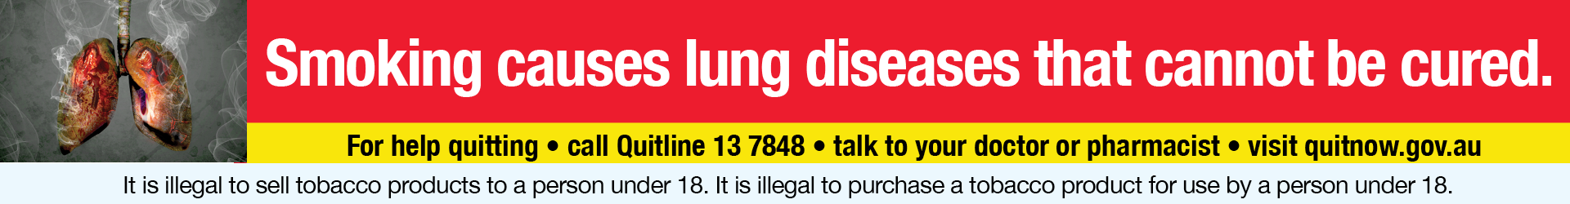
Health warning.1.3 (Quarter 3)
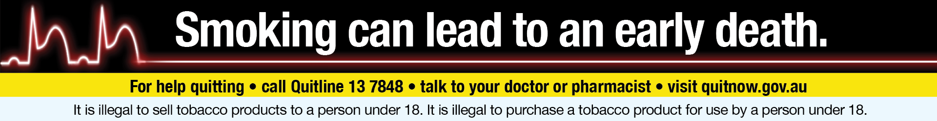
Health warning 1.4 (Quarter 4)

