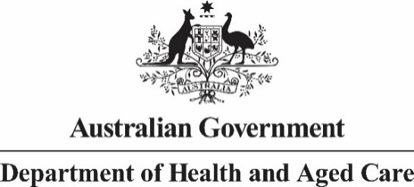

Privacy Notice

Exposure Draft of Public Health (Tobacco and Other Products) Legislation - APP 5 Notice
Who is collecting your personal information? | Your personal information is being collected by the Department of Health and Aged Care (the Department).
What information is being collected? | This information being collected includes your:  - Name  - Email address  - Location  - Organisation name and type of organisation  - Financial interests  - Personal views and experiences
Why we collect this information | We collect personal information for the purpose of informing the finalisation of policy development for the Australian Government’s proposed tobacco control reforms, including whether the exposure draft can be implemented and administered in a manner that is consistent with the Government’s intent.
How does the Department collect this information? | We will collect your personal information when you register to participate in the consultation through the Consultation Hub. We may also collect some personal information through the consultation process, after the point of registration.
What would happen if the Department did not collect your personal information? | If you do not or are unable to provide your personal information, the Department may be unable to accept your submission.
Who will the Department disclose your personal information to? | We will disclose your information to:  - the entity engaged to undertake analysis of the submissions, Allen + Clarke Consulting  - anyone you’ve agreed we can share it with  - anyone the law requires or authorises us to share it with.
How we handle personal information | Your submission, either in whole or in part, may be published on the Department’s website www.health.gov.au after the consultation closes. However, the Department retains the right to not publish submissions at its discretion and will not place on the website or make available to the public submissions that contain offensive or defamatory comments or which are outside the scope of the consultation.  Your name will not be published with your submission unless you give the Department permission to do so. In addition, the Department will remove all other personally identifying information (such as personal email addresses, telephone numbers and home addresses) from submissions prior to publication. The Department will not release any submissions (or parts of submissions) which contain information which you ask us to treat us confidential unless we subsequently receive your consent to do so.
How we handle sensitive information | Sensitive information is personal information that includes information or an opinion about an individual’s:  - racial or ethnic origin  - political opinions or associations  - religious or philosophical beliefs  - trade union membership or associations  - sexual orientation or practices  - criminal record  - health or genetic information  - some aspects of biometric information.  Although the Department is not routinely requesting sensitive information through this consultation, the Department understands that some of the matters discussed in submissions may include details of a sensitive nature.  By making a submission containing your sensitive information, you consent to the Department collecting that information. We will use it for the purposes stated in ‘Why we collect this information’.
Overseas disclosure of your personal information | Submissions which have been published on the Department’s website can be accessed by the general public, including people overseas.  Ordinarily, where the Department discloses personal information to an overseas recipient, APP 8.1 requires the Department to take reasonable steps to ensure that the overseas recipients do not breach the APPs. However, if you consent to the publication of your submission, APP 8.1 will not apply to this disclosure and the Department will not be accountable under the Privacy Act 1988 (Cth) for any subsequent use or disclosure of the submission by an overseas recipient, and you will not be able to seek redress under that Act.
Access to and correction of your personal information | The Department’s privacy policy contains information about how you may access and seek correction of personal information about you that is held by the Department.
Privacy complaints | The Department’s privacy policy contains information about how you may complain about a breach of the APPs or the Australian Government Agencies Privacy Code. The privacy policy also explains how the Department will manage your complaint.  You can read the Department’s privacy policy here. You can obtain a copy of the APP privacy policy by contacting the Department using the contact details set out at the end of this notice.
Consent | By providing your information to us, you consent to the Department collecting that information for the purposes stated in ‘Why we collect this information’.
Contact details | If you wish to contact the Department about a privacy-related matter, including questions about this notice, please contact the Department’s Privacy Officer by one of the following methods:  - Post  Privacy Officer  Department of Health and Aged Care  23 Furzer Street  WODEN ACT 2606  - Email  privacy@health.gov.au  - Telephone  02 6289 1555

