AURA 2019
  - Third Australian report on antimicrobial use and resistance in human health

Published by the Australian Commission on Safety and Quality in Health Care
Level 5, 255 Elizabeth Street, Sydney NSW 2000
Phone: (02) 9126 3600
Fax: (02) 9126 3613
Email: AURA@safetyandquality.gov.au
Website: https://www.safetyandquality.gov.au/antimicrobial-use-and-resistance-in-australia/
ISBN: 978-1-925948-00-4
© Australian Commission on Safety and Quality in Health Care 2019
All material and work produced by the Australian Commission on Safety and Quality in Health Care (the Commission) is protected by copyright. The Commission reserves the right to set out the terms and conditions for the use of such material.
As far as practicable, material for which the copyright is owned by a third party will be clearly labelled. The Australian Commission on Safety and Quality in Health Care has made all reasonable efforts to ensure that this material has been reproduced in this publication with the full consent of the copyright owners.
With the exception of any material protected by a trademark, any content provided by third parties, and where otherwise noted, all material presented in this publication is licensed under a Creative Commons Attribution-NonCommercial-NoDerivatives 4.0 International Licence.
Enquiries regarding the licence and any use of this publication are welcome and can be sent to AURA@safetyandquality.gov.au
The Commission’s preference is that you attribute this publication (and any material sourced from it) using the following citation:
Australian Commission on Safety and Quality in Health Care (ACSQHC). AURA 2019: third Australian report on antimicrobial use and resistance in human health. Sydney: ACSQHC; 2019.
An online version of this report can be accessed at the AURA homepage.
Acknowledgements
The Commission acknowledges the significant contribution of data on antimicrobial use and antimicrobial resistance to the AURA Surveillance System through the program partners – the Australian Group on Antimicrobial Resistance, the National Antimicrobial Prescribing Survey, the National Antimicrobial Utilisation Surveillance Program and Queensland Health as the provider of the OrgTRx system (used as the platform for the Australian Passive AMR Surveillance system).
Disclaimer
The content of this document is published in good faith by the Australian Commission on Safety and Quality in Health Care (the Commission) for information purposes. The document is not intended to provide guidance on particular healthcare choices. You should contact your healthcare provider on particular healthcare choices.
This document includes the views or recommendations of its authors and third parties. Publication of this document by the Commission does not necessarily reflect the views of the Commission, or indicate a commitment to a particular course of action. The Commission does not accept any legal liability for any injury, loss or damage incurred by the use of, or reliance on, this document.

Contents
Summary xv
AURA Surveillance System and the Australian Commission on Safety and Quality in Health Care xv
AURA provides essential information to improve AU and reduce AMR xv
AURA improves each year xvi
Antimicrobial use and the inappropriate use of antimicrobials xvi
In hospitals, antibiotic use is increasing, but inappropriate prescribing levels remain steady xvi
In primary care, antibiotic use is decreasing xvii
In aged care homes, levels of inappropriate AU and rates of AMR are high xvii
Specific areas for improvement xviii
Antimicrobial resistance xviii
AMR is increasing for some organisms xix
The National Alert System for Critical Antimicrobial Resistances is providing important and timely information to support clinical decision making xix
In some cases, Australian rates of AMR are higher than in Europe xx
Future developments for the AURA Surveillance System xx
Chapter 1: Introduction 1
1.1 Background 1
About the Commission 2
About the Antimicrobial Use and Resistance in Australia Surveillance System 2
1.2 Australian healthcare system: governance and context 6
1.3 Importance of antimicrobial resistance 7
1.4 Importance of surveillance 7
1.5 AURA 2019 report 8
References 9
Chapter 2: Data sources and methods 11
2.1 Types of data and information collected under the Antimicrobial Use and Resistance in Australia Surveillance System 11
2.2 Sources of data for antimicrobial use and appropriateness of prescribing 15
2.3 Sources of data for antimicrobial resistance 16
2.4 Considerations for interpreting the data 17
Denominator data 17
Antimicrobial resistance 18
Antimicrobial use 18
2.5 Data governance 18
References 20
Chapter 3: Antimicrobial use and appropriateness 21
3.1 Antimicrobial use in hospitals 22
Volume of use in hospitals 24
Appropriateness of prescribing in hospitals 53
3.2 Commentary – acute hospitals 65
Overall antimicrobial use 65
Appropriateness of prescribing 69
3.3 Developments and future plans – acute hospitals 71
3.4 Antimicrobial use in the community 71
Antibiotic dispensing: Pharmaceutical Benefits Scheme and Repatriation Pharmaceutical Benefits Scheme 71
Antibiotic prescribing in general practice: NPS MedicineInsight program 78
Appropriateness of prescribing: NPS MedicineInsight program 85
Antimicrobial use in aged care homes: Aged Care National Antimicrobial Prescribing Survey 88
International comparisons 93
Commentary – overall antimicrobial use in the community 95
3.5 Developments and future plans – community antimicrobial use 96
3.6 Overall use and appropriateness in the acute and community sectors 96
References 99
Chapter 4: Antimicrobial resistance 103
4.1 Introduction 103
Priority organisms for surveillance 103
Data on priority organisms 104
4.2 Acinetobacter baumannii complex 114
Health impact 114
Treatment 114
Types and impact of resistance 114
Key findings: national 114
Key findings: states and territories 116
4.3 Enterobacterales 116
Health impact 116
Treatment 117
Types and impact of resistance 117
Key findings: national 118
Key findings: states and territories 123
National trends 125
Additional findings from targeted surveillance 126
4.4 Enterococcus species 129
Health impact 129
Treatment 130
Types and impact of resistance 130
Key findings: national 130
Key findings: states and territories 134
Additional findings from targeted surveillance 138
4.5 Mycobacterium tuberculosis 140
Health impact 140
Treatment 140
Types and impact of resistance 140
Key findings: national 141
Key findings: states and territories 142
National trends 142
4.6 Neisseria gonorrhoeae 143
Health impact 143
Treatment 144
Types and impact of resistance 144
Key findings: national 144
Key findings: states and territories 146
National trends 147
4.7 Neisseria meningitidis 148
Health impact 148
Treatment 148
Types and impact of resistance 148
Key findings: national 148
National trends 150
4.8 Pseudomonas aeruginosa 151
Health impact 151
Treatment 151
Types and impact of resistance 151
Key findings: national 151
4.9 Salmonella species 153
Health impact 153
Treatment 153
Types and impact of resistance 154
Key findings: national 154
4.10 Shigella species 155
Health impact 155
Treatment 155
Types and impact of resistance 155
Key findings: national 156
4.11 Staphylococcus aureus 156
Health impact 156
Treatment 157
Types and impact of resistance 157
Key findings: national 157
Key findings: states and territories 165
4.12 Streptococcus agalactiae 167
Health impact 167
Treatment 167
Types and impact of resistance 168
Key findings: national 168
4.13 Streptococcus pneumoniae 168
Health impact 168
Treatment 169
Types and impact of resistance 169
Key findings: national 169
4.14 Streptococcus pyogenes 171
Health impact 171
Treatment 171
Types and impact of resistance 172
Key findings: national 172
References 174
Chapter 5: National Alert System for Critical Antimicrobial Resistances (CARAlert) 175
5.1 Overview of the CARAlert system 175
5.2 Results from CARAlert 2017–18 176
Critical antimicrobial resistances overall 176
Critical antimicrobial resistances by state and territory 190
Critical antimicrobial resistances by age group 192
Critical antimicrobial resistances by specimen type 195
Critical antimicrobial resistances by facility type 197
Carbapenemase-producing Enterobacterales type by state and territory 199
Carbapenemase-producing Enterobacterales by organism 201
Other critical antimicrobial resistance types 204
5.3 Commentary 204
5.4 Developments and future plans 205
References 206
Chapter 6: Focus areas 208
6.1 Amoxicillin–clavulanic acid and cefalexin prescribing 209
Frequency of prescribing 209
Indications for prescribing and compliance with guidelines 209
Reducing the use of amoxicillin–clavulanic acid and cefalexin 210
6.2 Chronic obstructive pulmonary disease 212
Reasons for inappropriate prescribing 212
Complexity of following treatment guidelines 213
Improving prescribing for chronic obstructive pulmonary disease 213
6.3 Aged care homes 214
Antimicrobial use in aged care homes 214
Antibiotic resistance in aged care homes 214
6.4 International comparisons of antimicrobial resistance 215
Fluoroquinolones and third-generation cephalosporins 216
Piperacillin–tazobactam 221
Methicillin and vancomycin 223
References 226
Chapter 7: Conclusions and future developments 228
7.1 Conclusions from AURA findings 229
7.2 Future developments for the AURA Surveillance System and future AURA reports 231
Appendix 1: Data source description 233
A1.1 Data sources for antimicrobial use 233
National Antimicrobial Prescribing Survey 233
National Antimicrobial Utilisation Surveillance Program 236
Pharmaceutical Benefits Scheme and Repatriation Pharmaceutical Benefits Scheme 238
NPS MedicineWise MedicineInsight program 240
A1.2 Data sources for antimicrobial resistance 242
Australian Group on Antimicrobial Resistance 242
National Neisseria Network 243
National Notifiable Diseases Surveillance System 244
Australian Passive AMR Surveillance 245
Sullivan Nicolaides Pathology 247
National Alert System for Critical Antimicrobial Resistances 248
References 249
Appendix 2: Priority organisms 252
Appendix 3: Terminology 255
A3.1 Abbreviations 255
A3.2 Common terms 257
References 260
Appendix 4: Key messages 262
Chapter 1: Introduction 262
Chapter 2: Data sources and methods 262
Chapter 3: Antimicrobial use and appropriateness 262
Hospitals 262
Community 263
Chapter 4: Antimicrobial resistance 264
Chapter 5: National Alert System for Critical Antimicrobial Resistances (CARAlert) 265
Chapter 6: Focus areas 266
Amoxicillin–clavulanic acid and cefalexin prescribing 266
Chronic obstructive pulmonary disease 266
Aged care homes 266
International comparisons in antimicrobial resistance 266
Chapter 7: Conclusions and future developments 267

Summary
The Antimicrobial Use and Resistance in Australia (AURA) Surveillance System provides data and information to support Australia’s strategic response to one of the most significant challenges facing health care around the world: antimicrobial resistance (AMR).
AMR reduces the range of antimicrobials available to treat infections, and increases morbidity and mortality associated with infections caused by multidrug-resistant organisms. AMR is well established as a priority for action due to its serious and growing impact on human health.

AURA Surveillance System and the Australian Commission on Safety and Quality in Health Care
AURA was established in 2014 by the Australian Commission on Safety and Quality in Health Care (the Commission) to provide a nationally coordinated system for surveillance of AMR and antimicrobial use (AU) for human health. This work has been funded by the Australian Government Department of Health and, more recently, with contributions from the states and territories.
The AURA Surveillance System collects data from hospital and community settings to provide a comprehensive national and regional picture of AU and AMR. The AURA National Coordination Unit (NCU) has led a process to progressively increase the breadth and volume of data collected for AU and AMR. Increases in geographic coverage have been achieved, with resistance data now available from the public sector in all states and the Australian Capital Territory, and from a number of private sector laboratories in Queensland. The AURA Surveillance System has also increased its coverage of hospitals and aged care homes providing data on AU and appropriateness of use, with a doubling of the number of hospitals and aged care homes participating in the National Antimicrobial Utilisation Surveillance Program (NAUSP), the National Antimicrobial Prescribing Survey (NAPS) and the Aged Care National Antimicrobial Prescribing Survey (AC NAPS) since 2014. These changes have resulted in increased representativeness of the data, which better supports the analysis of these data for trends over time.
Data from the AURA Surveillance System directly support the NSQHS Standards, and the work of clinicians, public and private sector hospitals, aged care homes and primary healthcare providers to prevent and control AMR to benefit patients and the community.
The Preventing and Controlling Healthcare-Associated Infection Standard is one of eight National Safety and Quality Health Service (NSQHS) Standards (second edition). Since 2011, this standard has required health service organisations to monitor patterns of AU and AMR, and use this information to guide antimicrobial stewardship (AMS), support infection prevention and control programs, and prevent and control AMR.

AURA provides essential information to improve AU and reduce AMR
Surveillance of AU and AMR increases understanding of the burden of AMR in Australia, and the volume and appropriateness of AU. In conjunction with implementation of the NSQHS Standards and implementation of Australia’s National Antimicrobial Resistance Strategy, AURA data inform and support national, state and territory, and local strategies to improve AU, prevent and contain AMR, and improve patient outcomes by providing Australia-specific data. These strategies include the development or revision of antimicrobial prescribing guidelines, and public health actions, such as education campaigns. The information can be used at a policy level to drive change, and by clinicians at a patient-care level to support more effective prescribing.

AURA improves each year
AURA 2019 is the third in a series of national reports. It includes national data from 2016 and 2017, and 2018 data on critical antimicrobial resistances (CARs). Cumulatively, these AURA data allow the identification and tracking of national trends in AU and AMR, and monitoring of the effect of changes in policy and clinical practice.
Compared with previous reports, AURA 2019 uses a greater range and volume of surveillance data drawn from two new systems: the National Alert System for Critical Antimicrobial Resistances (CARAlert) and the Australian Passive AMR Surveillance (APAS) system. AURA 2019 provides more detail than previous reports about the key AU and AMR issues for Australia, with a broader range of data on the most frequently used antimicrobials. Increased participation by clinicians, hospitals, aged care homes and primary care providers in the surveillance of AU and appropriateness of prescribing gives enhanced confidence in the data and conclusions.

Antimicrobial use and the inappropriate use of antimicrobials

In hospitals, antibiotic use is increasing, but inappropriate prescribing levels remain steady
In 2017, total-hospital antibiotic use in hospitals that participated in NAUSP increased for the first time since 2013. The usage rate increased from 932.8 defined daily doses (DDDs) per 1,000 occupied bed days (OBDs) in 2016 to 956.8 DDDs per 1,000 OBDs in 2017. Understanding this change and identifying interventions to avoid further increases in AU will be an area of focus for the hospital sector.
The overall rate of inappropriate prescribing in hospitals that participated in NAPS has been static since 2013. In 2017, 23.5% of prescriptions assessed were found to be inappropriate. Encouragingly, AMS programs in Australia have led to improvements in key performance indicators such as documentation of indication and duration of surgical prophylaxis. However, the static rate of inappropriate prescribing requires further attention. Although monitoring appropriateness is a key strategy to help evaluate performance, it is important that health service organisations use the surveillance data to identify local areas for improvement and to take action.
The five most commonly used antibiotics in NAUSP contributor hospitals in 2017 were amoxicillin–clavulanic acid, cefazolin, flucloxacillin, doxycycline and amoxicillin. Cefalexin and amoxicillin–clavulanic acid had the highest rates of inappropriate prescribing in NAPS contributor hospitals, indicating that agents with high rates of use often have high rates of inappropriate prescribing.
The most common indications for prescribing of antimicrobials in NAPS contributor hospitals were surgical prophylaxis, community-acquired pneumonia, medical prophylaxis, urinary tract infections and sepsis. The proportion of prescriptions for surgical prophylaxis that extended beyond the recommended 24 hours dropped in NAPS contributor hospitals from 41.1% in 2013 to 30.5% in 2017.
The AURA NCU has identified and promoted improvements in prescribing, such as for surgical prophylaxis, and will continue to develop strategies and resources for implementation in collaboration with clinicians, the states and territories, and the private sector.

In primary care, antibiotic use is decreasing
The rate of antibiotic dispensing under the Pharmaceutical Benefits Scheme (PBS) and the Repatriation Pharmaceutical Benefits Scheme (RPBS) declined in 2016 and further declined in 2017, following steady increases between 2013 and 2015. This is the first downward trend in community antibiotic dispensing since the late 1990s.
Although these trends are encouraging, the high rates of AU in Australia remain a serious public health issue. In 2017, 41.5% (n = 10,215,109) of the Australian population had at least one systemic antibiotic dispensed under the PBS/RPBS.
Australia remains in the top 25% of countries with the highest community AU, compared with European countries and Canada.
The most commonly dispensed antibiotics under the PBS/RPBS continue to be cefalexin, amoxicillin and amoxicillin–clavulanic acid.
In participating NPS MedicineWise MedicineInsight practices, the rate of systemic antibiotic prescribing has steadily declined since 2010. However, antibiotics continue to be overprescribed compared with guideline recommendations. In participating MedicineInsight practices, there was an absolute reduction of 5.7% from 2015 for patients prescribed systemic antibiotics.
While the decline in overall prescribing rates is a positive step, inappropriate prescribing practices persist. A large percentage of patients from participating MedicineInsight practices were prescribed antibiotics for conditions for which there is no evidence of benefit, including influenza (52.2% of patients with this condition recorded) and acute bronchitis (92.4% of patients with this condition recorded).
Because a large proportion of antimicrobials are used in primary care settings, improving prescribing in primary care continues to be a priority. The AURA NCU will continue to collaborate with clinicians, NPS MedicineWise and the Australian Government Department of Health to identify and support areas of focus to improve prescribing practice in the primary care sector.

In aged care homes, levels of inappropriate AU and rates of AMR are high
Monitoring AU and AMR in aged care homes is important because multidrug-resistant organisms are well established in this setting. In addition, many residents move in and out of hospital on a regular basis.
Aged care homes in Australia have high levels of both unnecessary antimicrobial prescribing and inappropriate AU. Almost 1 in 10 residents of aged care homes that participated in AC NAPS was prescribed at least one antimicrobial; one-third of prescriptions (33.1%) were for topical antimicrobials. Antimicrobials were often used for unconfirmed infections in aged care homes that participated in AC NAPS: more than half of antimicrobial prescriptions were for residents who had no signs or symptoms of infection.
There are also high levels of infection and colonisation with multidrug-resistant organisms among residents of Australian aged care homes, which further supports the need for appropriate antimicrobial prescribing in this setting.
Aged care homes need enhanced infection prevention and control, and antimicrobial stewardship efforts to improve the safety of care provided to residents and reduce AMR. The Commission will be working with the Aged Care Quality and Safety Commission to provide AU and AMR data, and collaborate on the development of these strategies.

Specific areas for improvement

Prescribing for chronic obstructive pulmonary disease needs improvement
There is a long-term trend in hospitals of high levels of inappropriate prescribing of antibiotics for the exacerbation of chronic obstructive pulmonary disease (COPD), a common condition for which broad-spectrum, rather than narrow-spectrum, antibiotics are prescribed.
Targeted strategies and guidelines, involving collaboration between clinicians involved in AMS and specialists managing patients with COPD, are needed to improve the appropriateness of antibiotic prescribing for treatment of COPD in hospitals.

Amoxicillin–clavulanic acid and cefalexin prescribing is often inappropriate
Broad-spectrum antibiotics, such as amoxicillin–clavulanic acid and cefalexin, have greater potential to promote the development of AMR than narrow-spectrum antibiotics. They are prescribed in high volumes in both community and hospital settings. Prescribing of these agents is often inappropriate, particularly for sinusitis, and lower respiratory tract, urinary tract, and skin and soft tissue infections.
For cefalexin, the most common reasons for inappropriate prescribing in hospitals were the wrong dose (27.2%) and the wrong duration (32.6%). For amoxicillin–clavulanic acid, the most common reason was that the spectrum was too broad for the indication being treated (63.0%). NPS MedicineWise MedicineInsight data show that many prescriptions for these agents were not consistent with recommendations for first-line treatment.
Strategies to promote symptom management, in place of inappropriate antibiotic prescribing, and increase the use of narrower-spectrum antibiotics, will be particular areas of focus for AURA, to promote reductions in inappropriate prescribing of these agents.

Antimicrobial resistance
AURA 2019 includes data and analyses on patterns and trends in resistance in priority organisms to key antimicrobials in acute care, aged care homes and the community.

AMR is increasing for some organisms
National rates of resistance for many priority organisms have not changed substantially from those reported in 2016 and 2017. However, there have been several notable increases in AMR:
In Escherichia coli, resistances to common agents used for treatment continue to increase. Resistance to ceftriaxone, ciprofloxacin and other fluoroquinolones has continued to rise in isolates from community-onset infections, despite restriction of access to these agents on the PBS. These changes in resistance may result in increasing treatment failures and greater reliance on last-line treatments such as carbapenems
In Enterococcus faecium, the overall rates of vancomycin resistance are declining nationally, although the absolute number of isolates with vancomycin resistance continues to increase
In Neisseria gonorrhoeae, rates of azithromycin resistance initially remained low, with a slight upward trend from 2012 to 2015. There has been a sharp upward trend since 2015, and 9.3% of isolates were resistant in 2017. The total number of notifiable cases also continues to increase
In Neisseria meningitidis, the number of notifiable cases increased, and reduced susceptibility to benzylpenicillin reached almost 45% in 2017. Resistance to benzylpenicillin is now almost 6%, which may impact on treatment guidelines
In Salmonella, ciprofloxacin resistance in typhoidal species (Salmonella Typhi and Salmonella Paratyphi) exceeded 60% in 2017, confirming that ciprofloxacin should no longer be relied on for empirical treatment. These high rates are in part due to recent changes to susceptibility testing breakpoints, resulting from a review of efficacy for strains with low-level resistance
In Staphylococcus aureus, patterns of methicillin resistance continue to evolve. Clones that were previously dominant are being replaced by other clones, and community-associated methicillin-resistant S. aureus has become highly prevalent in remote and very remote regions compared with urban areas. This will require a renewed focus on infection prevention and control, and increased collaboration with clinicians, in both community and acute settings, and greater adherence to prescribing guidelines.
The enhanced data available to clinicians, health service organisations and the community sector will support better understanding of local resistance issues and foster the development of targeted and effective responses.

The National Alert System for Critical Antimicrobial Resistances is providing important and timely information to support clinical decision making
In 2016, the Commission established CARAlert to combine the information on CARs that laboratories currently provide to clinicians with a system to inform health service program and system managers.
CARAlert raises awareness with clinicians and system managers of potential resistance issues requiring response at the local and jurisdictional levels. CARAlert supplements state and territory data for which timely local surveillance of a number of CARs is not yet established. Successful control by Queensland Health of a local outbreak of OXA-48-like E. coli in May–July 2017 highlighted the value of timely surveillance data and a rapid outbreak response.
Data and analyses from CARAlert and APAS provide a national picture of CARs and multidrug-resistant organisms across both healthcare and aged care settings; this has not previously been available. The information also supports the development of actions to implement the National Antimicrobial Resistance Strategy 2015–2019.
In 2018, carbapenemase-producing Enterobacterales (CPE) were the most commonly reported CAR. In particular, CARs reported from aged care were predominantly CPE or daptomycin-nonsusceptible S. aureus. Of CARs reported from bloodstream specimens, 81% were CPE. Oral therapies may not be available for many of these infections, and hospital-based intravenous therapy is now the only treatment option.
The emergence of sporadic cases of ceftriaxone-nonsusceptible N. gonorrhoeae (no isolates in 2017 and six isolates in 2018) indicates the need for ongoing surveillance of this CAR. The data available through CARAlert and local surveillance systems, where available, will support clinicians, enable targeted prevention and control programs, and inform treatment guidelines.

In some cases, Australian rates of AMR are higher than in Europe
Internationally, rates of resistance to fluoroquinolones in E. coli and Klebsiella pneumoniae increased between 2015 and 2017. Although resistance rates in Australia remain low compared with rates in most European countries, fluoroquinolone resistance rates have increased compared with some countries. This requires particular focus to reduce potentially significant future impacts.
Rates of resistance in key gram-positive pathogens are also moderate to high in Australia compared with European countries. The prevalence of vancomycin resistance in E. faecium remains higher in Australia than in any European country, even though rates have levelled off in recent years. The Commission is currently reviewing the need for targeted strategies for vancomycin-resistant enterococci.

Future developments for the AURA Surveillance System
AURA 2019 data provide increased capacity to identify patterns and trends in resistance in the priority organisms for Australia in acute care, aged care homes and the community. This information enables better defined responses to specific resistance in specific settings.
The AURA NCU will undertake further consultation with clinical and technical experts to provide this information in the most accessible form. Key areas of focus for the AURA NCU in 2020 will be to support the relevant lead organisations in aged care and the primary care sector, and clinicians and carers, to understand the reasons for inappropriate prescribing and improve prescribing practice.

Chapter 1: Introduction
Key messages
- Antimicrobial resistance (AMR) is a risk to patient safety because it reduces the range of antimicrobials available to treat infections. It also increases morbidity and mortality associated with infections caused by multidrug-resistant organisms. AMR may limit future capacity to perform medical procedures such as organ transplantation, cancer chemotherapy, diabetes management and major surgery, because of a lack of effective antimicrobials.
- The Australian Commission on Safety and Quality in Health Care established the Antimicrobial Use and Resistance in Australia (AURA) Surveillance System in 2014. This has enabled national coordination of data collection and analyses, and an enhanced understanding of antimicrobial use (AU) and AMR across Australia, including local and national patterns and trends over time.
- Comprehensive, coordinated and effective surveillance of AMR and AU enables effective strategies to be developed to prevent and control AMR.
- AURA 2019 is the third report of its type on AMR and AU in Australia. It includes data about organisms that have been determined to be a priority for Australia, the volume of AU, the appropriateness of antimicrobial prescribing, key emerging issues for AMR, and a comparison of Australia’s situation with other countries.
Antimicrobial resistance (AMR) is one of the most significant challenges internationally to the provision of safe, high-quality health services. This chapter provides context and background to the importance of AMR as a healthcare issue, along with information about the Australian strategic policy context and the contribution of the Antimicrobial Use and Resistance in Australia (AURA) Surveillance System to the response to AMR.

1.1 Background
Effective surveillance and monitoring are essential to determine the burden of AMR, and to inform response, prevention and control strategies.
The Australian Commission on Safety and Quality in Health Care (the Commission) was engaged by the Australian Government Department of Health in 2013 to establish a nationally coordinated system for surveillance of AMR and antimicrobial use (AU) for human health. At that time, a small number of AMR surveillance programs were operating independently, with varying levels of geographic representativeness, but there was no nationally integrated approach to surveillance. In addition, minimal data were available on AU, which is a key driver of AMR.
The establishment of the AURA Surveillance System provided the opportunity and means for a comprehensive, nationally coordinated approach to AMR surveillance, and for integrating data on the volume and appropriateness of AU. The Commission collaborated with the existing surveillance programs, the states and territories, and private health service organisations to develop the national system and provide strategic direction to the development of AURA.

About the Commission
Australian governments and health service organisations are committed to improving the safety and quality of health care, and the Commission is central to this process. In 2006, the Council of Australian Governments (COAG) established the Commission to lead and coordinate national improvements in the safety and quality of health care. The Commission’s permanent status was confirmed under the National Health and Hospitals Network Act 2011, and its role was codified in the National Health Reform Act 2011. The Commission’s governance structure is determined by these Acts. The Commission commenced as an independent statutory authority on 1 July 2011, funded jointly by the Australian Government and state and territory governments on a cost-sharing basis.
The Commission’s purpose is to lead and coordinate national improvements in the safety and quality of health care. This contributes to better health outcomes and experiences for all patients and consumers, and improved value and sustainability in the health system. Within this overarching purpose, the Commission aims to ensure that people are kept safe when they receive health care and that they receive the care they should.
The Commission works in partnership with patients, consumers, clinicians, managers, policymakers and healthcare organisations to achieve a sustainable, safe and high-quality health system.

National Safety and Quality Health Service Standards
To protect the public from harm and improve the quality of health service provision, the Commission developed the National Safety and Quality Health Service (NSQHS) Standards^{1,2} in collaboration with the states and territories, clinical experts, patients and carers. The NSQHS Standards provide a quality assurance mechanism that tests whether relevant systems are in place to ensure that expected standards of safety and quality are met. They provide a nationally consistent statement about the standard of care that consumers can expect from their health service organisations.
There are eight NSQHS Standards, which cover clinical governance, partnering with consumers, preventing and controlling healthcare-associated infection, medication safety, comprehensive care, communicating for safety, blood management, and recognising and responding to acute deterioration.
The Preventing and Controlling Healthcare-Associated Infection Standard requires health service organisations to monitor patterns of AMR and AU, and use this information to guide antimicrobial stewardship (AMS) practices and meet infection control requirements. Data from the AURA Surveillance System directly support this standard. The Commission has developed a number of national programs that focus on prevention and control of healthcare-associated infection, and quality improvement through AMS activities.

About the Antimicrobial Use and Resistance in Australia Surveillance System
The AURA Surveillance System provides essential information to inform strategies for preventing and containing AMR in human health, and improve AU across the acute and community healthcare settings. Funding for AURA is provided by the Australian Government Department of Health, and state and territory health departments.
The role of the AURA Surveillance System is described in Box 1.1. The Commission’s AURA National Coordination Unit (NCU) developed the system after consulting stakeholders about the requirements for an effective national system and reviewing the capacity of existing surveillance systems. The system was implemented by partnering with existing AMR and AU surveillance programs, and establishing additional programs, as required. Contracts were established with several partners to specify data requirements, and enable development of a comprehensive picture of patterns and trends in AU and AMR. Collaboration continues with a range of stakeholders to build and improve surveillance infrastructure, and to coordinate data collection, analysis and reporting on AMR and AU.
Box 1.1: Role of the Antimicrobial Use and Resistance in Australia Surveillance System
The Antimicrobial Use and Resistance in Australia Surveillance System:
- Implements coordinated, effective and integrated surveillance and reporting of antimicrobial use (AU) and antimicrobial resistance (AMR) in Australia
- Continues to improve quality, coverage and utility of data collections on AU and AMR
- Provides increasingly detailed analysis across data collections, including analysis of relationships between AU and AMR, at a system level
- Provides systematic, coordinated and centralised national reporting on AU and AMR
- Ensures currency of data collections through the systematic and timely identification of the emergence of critical antimicrobial resistances
- Provides a means for rapidly consulting and communicating with states, territories and a range of stakeholders to further improve the system and its reporting capabilities, and to continue to inform strategies for AMR prevention and control, and antimicrobial stewardship.

Improvements to the AURA Surveillance System
Where gaps in surveillance were identified, new systems have been established. These include the National Alert System for Critical Antimicrobial Resistances (CARAlert) and the Australian Passive AMR Surveillance (APAS) system.
The Commission established CARAlert in 2016. CARAlert combines the information on critical antimicrobial resistances (CARs) that laboratories currently provide to clinicians with a system to inform health service program and system managers. This allows timely responses at the local and state and territory levels, if required, which supplement local data and response systems.
The Commission established APAS in 2015 with the support of Queensland Health, which enabled access to the OrgTRx system as the information technology infrastructure. APAS collects information provided by laboratories to clinicians, and analyses and reports on de-identified patient-level AMR data contributed by 10 public and private pathology services across Australia. These laboratories detect AMR in isolates referred from public and private hospitals, aged care homes and community settings. Initially, data were captured from January 2015 from all contributing laboratories; historical data have now also been incorporated from four of these laboratories. Each of these laboratories has variable population coverage, ranging from all public facilities in Western Australia to most public facilities in Tasmania. APAS includes more than 50 million AMR records from 2006 to 2018.
The Commission continues to take a systematic approach to improving data representativeness, collection, analytics and accessibility by identifying gaps and targeting those areas for expansion. The AURA NCU also consults with stakeholders about additional reports and analyses that would be useful. AURA publications since 2014 have reported on increasingly comprehensive and complex aspects of AU and AMR in public and private hospital, aged care and community settings across Australia. These improvements inform strategies and programs to prevent and contain AMR. Data from AURA, and commentary on analyses of these data, have been provided to clinicians, policy and program developers, health service managers and executives, state and territory governments, and the Australian Government to inform policy and clinical practice. The Commission also uses AURA data to identify priorities for quality improvement programs, and develop resources for infection control and prevention, and AMS.

Alignment with national strategies
The AURA Surveillance System addresses the human health aspects of One Health objectives. In 2015, the Australian Government released Australia’s first strategy on AMR, the National Antimicrobial Resistance Strategy 2015–2019³, which outlined the framework to address AMR using a One Health approach. The implementation plan for the strategy was released in 2016.⁴ The strategy aligns with the World Health Organization (WHO) Global Action Plan on Antimicrobial Resistance⁵, which was also released in 2015 and endorsed at the United Nations General Assembly high-level meeting on AMR in 2016.⁶ The National Antimicrobial Resistance Strategy will be reviewed and the next AMR strategy developed during 2019.
The AURA Surveillance System and the NSQHS Standards2 (particularly the Preventing and Controlling Healthcare-Associated Infection Standard) support safe and effective health care, and the following objectives of the national strategy:
Objective 1 – Increase awareness and understanding of AMR, its implications and actions to combat it, through effective communication, education and training
Objective 2 – Implement effective AMS practices across human health and animal care settings to ensure the appropriate and judicious prescribing, dispensing and administering of antimicrobials
Objective 3 – Develop nationally coordinated One Health surveillance of AMR and AU
Objective 4 – Improve infection prevention and control measures across human health and animal care settings to help prevent infections and the spread of resistance.
The AURA Surveillance System will also support the Commission’s contribution to the Australian Government Department of Health five-year National Action Plan for Health Security with regard to AMR in human health and real-time surveillance. The 2018 WHO Report on Joint External Evaluation of Australia’s core capacities against the International Health Regulations 2005 indicated that Australia has developed a comprehensive system of capabilities and functions to prepare, detect and respond to health security threats such as AMR.⁷ The Commission will continue to contribute to national initiatives using data from the AURA Surveillance System.

Partners and contributors
The AURA NCU continues to work with the AURA Surveillance System foundation partners to ensure both continuity and growth in the scope and representativeness of data. These partners are:
Australian Group on Antimicrobial Resistance
National Antimicrobial Prescribing Survey
National Antimicrobial Utilisation Surveillance Program
Queensland Health OrgTRx system, which is the base for APAS
In addition, data and reports are brought together by the AURA NCU from:
The National Neisseria Network, on Neisseria gonorrhoeae and N. meningitidis
The National Notifiable Diseases Surveillance System, on Mycobacterium tuberculosis
The Pharmaceutical Benefits Scheme (PBS) and the Repatriation Pharmaceutical Benefits Scheme (RPBS)
The NPS MedicineWise MedicineInsight program
Sullivan Nicolaides Pathology, on rates of AMR from the community and private hospital settings
CARAlert, on priority organisms with resistance to last-line antimicrobials (see Chapter 5 for more information about CARAlert).
Each of the partner programs provides valuable data on AU and AMR that cover selected organisms or antimicrobials from the community and hospitals. The programs use a range of methods, sampling techniques and sources, and have largely been set up to provide data at the local or state and territory levels for specific purposes. The coverage, capture and content of these data have varied over time. However, each of these programs operates within the framework of AURA to provide an integrated and coordinated picture of AU and AMR in Australia that continues to improve as a result of increased participation and representativeness. Important functions of the AURA Surveillance System include coordinating data from across the public and private hospital, aged care and primary care settings, and engaging with providers to help them use the AURA data and reports to improve clinical practice, and prevent and contain AMR.
Important functions of the Antimicrobial Use and Resistance in Australia (AURA) Surveillance System include providing strategic direction; coordinating data from across the public and private hospital, aged care and primary care settings; and engaging with providers to help them use the AURA data and reports to improve clinical practice, and prevent and contain antimicrobial resistance.

AURA data and reporting
Several detailed reports on AMR and AU have been published by the AURA NCU since 2014, in addition to two comprehensive national reports on data from the AURA Surveillance System that are referred to as AURA 2016⁸ and AURA 2017.⁹ The patterns and trends identified in AURA reports guide improvements in infection control, AMS and antimicrobial prescribing practices. The key findings of these publications are incorporated in this report. The full publications are available on the Commission’s website.¹⁰
The AURA Surveillance System has created capacity to compare AU and AMR in Australia with data from some other countries, as described in Chapters 3 and 6. These types of comparisons are important for benchmarking. Comparable data on the volume of AU in the community are only available from European countries and Canada. However, national data on appropriateness of AU in those settings, which is a feature of AURA, are not yet available for any other countries or regions. Resistance rates for selected pathogens can only be compared with European countries at present, as Europe is the only region that regularly releases comparable data.
It is not yet possible to contribute AURA Surveillance System data to the WHO Global Antimicrobial Resistance Surveillance System (GLASS). Reasons for this include the voluntary contribution of data to AURA by pathology laboratories and other health service organisations, the arrangements for confirmation of resistances by reference laboratories, and the inability of most AURA partners to capture unit record and denominator data to meet the data specification requirements of GLASS. A phased approach to contributing data to GLASS is currently being considered.

1.2 Australian healthcare system: governance and context
Governance of the Australian healthcare system is a shared responsibility of the Australian Government and state and territory governments. Their roles include funding, policy development, regulation and service delivery.¹¹ The governance role is facilitated by the COAG Health Council and its advisory body, the Australian Health Ministers’ Advisory Council (AHMAC).
AHMAC provides a mechanism for the Australian Government, the New Zealand Government, and state and territory governments to discuss matters of mutual interest concerning health policy, services and programs. AHMAC is responsible for advising the COAG Health Council on strategic issues relating to the coordination of health services across Australia, and operates as a national forum for planning, information sharing and innovation.
The Australian healthcare system is multifaceted. Services are provided by both the public and private sectors, and in institutional and community settings. Healthcare providers include individual clinicians such as doctors, nurses and allied health professionals, and organisational entities such as hospitals, primary care services, and government and non-government agencies.
State and territory governments license and regulate private hospitals that are owned by the private sector. Ownership is primarily limited to large for-profit and not-for-profit organisations, and also includes large diagnostic services.
The Australian, state and territory governments each contribute funding to public hospitals. Public hospitals are managed by state and territory governments through Local Hospital Networks and Local Health Districts. There are currently 136 of these networks in Australia – 122 are geographically based and 14 are statewide or territory-wide networks.
A range of other services, including population health programs, community health services, health and medical research, and Aboriginal and Torres Strait Islander health services, are funded and delivered by combinations of the Australian Government and state and territory governments. The role of local government in health service delivery varies between states and territories.
Medicare is the Australian Government–funded universal health insurance scheme that provides access to free or subsidised healthcare services for the Australian population. It provides free hospital services for public patients in public hospitals, subsidises private patients for hospital services, and provides benefits for out-of-hospital medical services such as consultations with general practitioners (GPs) or specialists. The Australian Government also funds Primary Health Networks. GPs are significant providers of health care in community settings, and the majority of antimicrobial prescriptions in community settings are written by GPs.
The Australian Government’s PBS and RPBS provide subsidised access to a wide range of medicines for all Australians. Under the PBS/RPBS, patient contributions towards medication costs at pharmacies are capped, and there is a Safety Net scheme to protect people with high medication needs.

1.3 Importance of antimicrobial resistance
AMR occurs when a microorganism develops resistance to an antimicrobial that was previously an effective treatment. As a result, infections caused by the resistant organism may need to be treated with other antimicrobials, which may have more severe side effects, be more expensive or take longer to work. In some severe cases, resistant organisms may not be able to be treated by currently available antimicrobials.
International evidence consistently demonstrates the growing effect that AMR is having on human health, and studies confirm that increasing numbers of infections in health service organisations and in the community are caused by resistant pathogens.¹² The Organisation for Economic Co-operation and Development (OECD) has estimated that an average of 290 people die each year in Australia due to infections from eight resistant bacteria. Between 2015 and 2050, it is estimated that 10,430 people will die as a result of AMR.¹²
Estimating the economic impact of AMR is complicated by the limited availability of data that allow comparative analyses. Most analyses of the costs of AMR in Australia are based on international data, such as the data produced by the OECD. The most recent OECD estimate is that, between 2015 and 2050, AMR will cost the health systems of the United States, Canada and Australia combined approximately $74 billion in United States dollar purchasing power parity.¹³ The safety of medical procedures will be affected across all countries surveyed by the OECD – between 44,000 and 439,000 additional postoperative infections will occur due to reduced effectiveness of antimicrobials.¹³

1.4 Importance of surveillance
Comprehensive and coordinated surveillance is a critical requirement of efforts to control AMR. The information generated through the AURA Surveillance System informs and supports national, state and territory, and local strategies to prevent and contain AMR. Successive international and Australian reports on AMR have identified the effective coordination of national surveillance as a foundation for reducing the adverse effects of AMR. Slowing the rate of increase in resistance, preparing for and responding to new and emerging threats, and ensuring that antimicrobials are used appropriately are all components of the Commission’s work, informed by AURA Surveillance System data, to ensure the safety and quality of health care in Australia. Broader health system benefits will also be gained through reduced length of stay in hospitals and overall improvements in bed capacity.
Use of surveillance data can result in earlier detection of, and response to, CARs and may reduce overall population impact in an outbreak. The Commission’s leadership in developing an AMR outbreak response model, in collaboration with states and territories and the Australian Government Department of Health, will be supported by AURA Surveillance System data.
More timely access to relevant data on AMR and AU will more effectively inform policy decisions, such as development or revision of antimicrobial prescribing guidelines. It will also help identify priorities for public health action, such as education campaigns or regulatory measures. For example, the AURA NCU has worked with the developers of Therapeutic Guidelines: Antibiotic to provide a range of AURA Surveillance System data to inform review of antimicrobial treatment protocols.
A lack of surveillance, or poor or ineffective reporting, can lead to misdirected and inefficient policies and programs, along with poor use of resources through inappropriate or ineffective therapies. Importantly, these deficits can also lead to increased morbidity and mortality for patients.
Reporting the information gained from an effective surveillance program to policymakers and clinicians will have positive effects at all levels of the health system. At a policy level, programs will be better targeted at the areas of greatest need, improving their effect and efficiency. At a patient care level, information that is robust and accessible may contribute to more effective prescribing, creating the potential for better health outcomes and reducing healthcare costs.
Reporting the information gained from an effective surveillance program to policymakers and clinicians will have positive effects at all levels of the health system.

1.5 AURA 2019 report
AURA 2019 is the third national AURA report. It builds on the first and second national reports from 2016 and 2017 by providing a more comprehensive picture of AU and AMR rates, patterns and trends, using a greater range and volume of surveillance data.
Data and analyses from CARAlert and APAS provide a national picture of CARs and multidrug-resistant organisms across both the healthcare setting and the aged care setting, which has not previously been available. This information also supports the development of actions to implement the National Antimicrobial Resistance Strategy.
AURA 2019 provides more detail than previous reports about the key AMR issues for Australia, with a broader range of data on the most frequently used antimicrobials and a designated group of priority organisms. The report includes data and analyses on patterns and trends:
For antimicrobial prescribing and dispensing in hospitals and the community
For the appropriateness of antimicrobial prescribing
For resistance in priority organisms to key antimicrobials in acute care, aged care homes and the community
To provide evidence to inform state and territory AMR prevention and containment strategies.
AURA 2019 highlights some issues for AU and AMR in Australia, and reflects on some comparisons with other countries that were included in AURA 2016 and AURA 2017.
The Commission continues to expand the range of surveillance to cover all elements of the AURA framework (see Figure 2.1 in Chapter 2), and provide an increasingly comprehensive understanding of AU and AMR in Australia.
This report integrates data from a wide range of programs and organisations, and reflects participation from all states and territories, and the private sector. Details on the data sources and methods for individual collections are included in Chapter 2 and Appendix 1.
The Commission continues to engage new participants and partners to strengthen the integrity and utility of the AURA Surveillance System. The AURA NCU will work with each of the partner programs, the states and territories, the Australian Government, the private sector and clinicians to ensure that participation continues to grow, and that data are increasingly consistent and comparable. Data will also be analysed from medical, scientific and epidemiological perspectives to inform response strategies. The Commission’s governance arrangements, clinician networks, and relationships with consumers and governments will enable information to be reported in formats that will be most useful to these diverse audiences.
The Commission thanks each of the organisations and networks that contribute to the AURA Surveillance System and to the report, and encourages greater participation and use of the surveillance data by all those involved in health service delivery.

References
1. Australian Commission on Safety and Quality in Health Care. National Safety and Quality Health Service Standards. Sydney: ACSQHC; 2012 (accessed Jan 2019).
2. Australian Commission on Safety and Quality in Health Care. National Safety and Quality Health Service Standards. Sydney: ACSQHC; 2017 (accessed Jan 2019).
3. Australian Government Department of Health, Australian Government Department of Agriculture. Responding to the threat of antimicrobial resistance: Australia’s first National Antimicrobial Resistance Strategy 2015–2019. Canberra: Australian Government Department of Health; 2015 (accessed Jan 2019).
4. Australian Government Department of Health, Australian Government Department of Agriculture and Water Resources. Implementation plan: Australia’s first National Antimicrobial Resistance Strategy 2015–2019. Canberra: Australian Government Department of Health; 2016 (accessed Jan 2019).
5. World Health Organization. Global action plan on antimicrobial resistance. Geneva: WHO; 2015 (accessed Jan 2019).
6. United Nations. Political declaration of the high-level meeting of the General Assembly on antimicrobial resistance. New York: United Nations General Assembly; 2016 (accessed Jan 2019).
7. World Health Organization. Joint external evaluation of IHR core capacities of Australia. Geneva: WHO; 2018. (WHO/WHE/CPI/REP/2018.8.) (accessed Jan 2019).
8. Australian Commission on Safety and Quality in Health Care. AURA 2016: first Australian report on antimicrobial use and resistance in human health. Sydney: ACSQHC; 2016 (accessed Jan 2019).
9. Australian Commission on Safety and Quality in Health Care. AURA 2017: second Australian report on antimicrobial use and resistance in human health. Sydney: ACSQHC; 2017 (accessed Jan 2019).
10. Australian Commission on Safety and Quality in Health Care. AURA report and resources. Sydney: ACSQHC; 2019 [cited 2019 Jan 30].
11. Australian Institute of Health and Welfare. Australia’s health 2018. Canberra: AIHW; 2018. (AIHW Cat. No. AUS 221.) (accessed Jan 2019).
12. Organisation for Economic Co-operation and Development. Stemming the superbug tide: just a few dollars more. Paris: OECD Publishing; 2018.
13. O’Neill J. Antimicrobial resistance: tackling a crisis for the health and wealth of nations. London: Review on Antimicrobial Resistance; 2014 (accessed Jan 2019).

Chapter 2: Data sources and methods
Key messages
- The Australian Commission on Safety and Quality in Health Care (the Commission) continues to manage the Antimicrobial Use and Resistance in Australia (AURA) Surveillance System following its establishment in 2014. The AURA Surveillance System captures data on antimicrobial use (AU) and antimicrobial resistance (AMR) from hospital and community settings using both passive and targeted systems.
- Data on AU and its appropriateness are sourced from the National Antimicrobial Prescribing Survey, the National Antimicrobial Utilisation Surveillance Program, the NPS MedicineWise MedicineInsight program and the Pharmaceutical Benefits Scheme/Repatriation Pharmaceutical Benefits Scheme.
- Data on AMR are sourced from the Australian Group on Antimicrobial Resistance, Australian Passive AMR Surveillance (based on the Queensland Health OrgTRx system), the National Neisseria Network, the National Notifiable Diseases Surveillance System, Sullivan Nicolaides Pathology and the National Alert System for Critical Antimicrobial Resistances.
The Australian Commission on Safety and Quality in Health Care (the Commission) has a longstanding and well-established approach to working collaboratively with the states and territories, clinicians, the private sector, consumers and a range of stakeholders to improve the safety and quality of health care. The Commission’s Antimicrobial Use and Resistance in Australia (AURA) National Coordination Unit (NCU) has used this approach to establish and develop the AURA Surveillance System as a voluntary system, with no requirement for organisations to participate or provide data.
The AURA NCU continues to work in collaboration with multiple organisations and programs to specify the data and information required from them, and to coordinate all elements of the AURA Surveillance System and achieve effective performance.
The strategy for the AURA Surveillance System is to progressively increase participation in each of the surveillance components to maximise geographic coverage, as well as coverage of the community and acute sectors, and both the private and public sectors. The collection methods, analyses and understanding of any limitations when using the data will also continue to be refined. Effective coordination, timely analysis and accurate reporting by the Commission continue to inform strategies for local, state and territory, and national health systems. Opportunities to enhance the AURA Surveillance System continue to be identified to improve the prevention and control of antimicrobial resistance (AMR).
This chapter describes the types and sources of data used in the AURA Surveillance System.

2.1 Types of data and information collected under the Antimicrobial Use and Resistance in Australia Surveillance System
The framework for, and the components of, the AURA Surveillance System are shown in Figure 2.1, along with their data sources. This report includes data mainly from 2016 and 2017. However, 2015 data from the NPS MedicineWise MedicineInsight program on antibiotic use (AU) in the community are also included, as well as 2018 data from the National Alert System for Critical Antimicrobial Resistances (CARAlert) and analyses of Pharmaceutical Benefits Scheme data from 2013 to 2017.
AURA uses a combination of passive and targeted surveillance to achieve comprehensive and effective surveillance, and to support timely and appropriate response strategies. Passive surveillance is the use of data that are already collected for other purposes, to identify patterns and trends in AMR and AU. Targeted surveillance is where the primary purpose of collecting data is to identify trends and patterns in AMR and AU.
As shown in Figure 2.1, surveillance data are collected for the hospital and community sectors. Table 2.1 summarises the data sources, the type of surveillance undertaken, the types of data sourced, and the settings and coverage of data included in AURA 2019.
Further detail on the data sources for this report, including details of collection methods, are in Appendix 1.
Figure 2.1: Antimicrobial Use and Resistance in Australia (AURA) Surveillance System
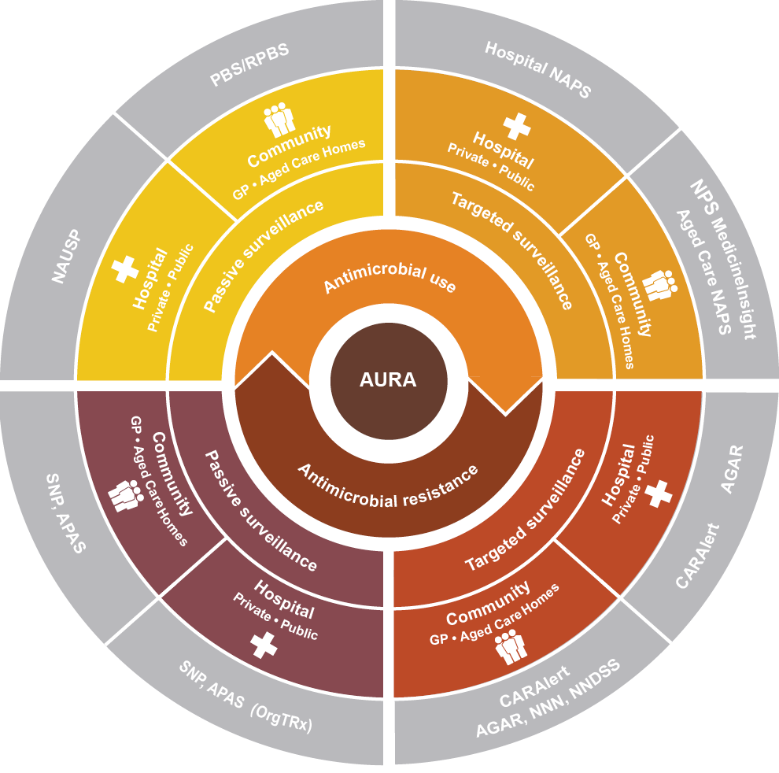
AGAR = Australian Group on Antimicrobial Resistance; APAS = Australian Passive AMR Surveillance; CARAlert = National Alert System for Critical Antimicrobial Resistances; NAPS = National Antimicrobial Prescribing Survey; NAUSP = National Antimicrobial Utilisation Surveillance Program; NNDSS = National Notifiable Diseases Surveillance System; NNN = National Neisseria Network; PBS = Pharmaceutical Benefits Scheme; RPBS = Repatriation Pharmaceutical Benefits Scheme; SNP = Sullivan Nicolaides Pathology
Table 2.1: Data sources for the AURA 2019 report
Subject and type of surveillance | Data source | Type of data | Setting | Coverage
- Antimicrobial use  - Targeted  - Community | MedicineInsight | Appropriateness of prescribing, prescribing patterns | Australian general practices | - All states and territories  - 2015: 535 general practices, 3,196,155 patients  - 2016: 543 general practices, 3,649,131 patients  - 2017: 545 general practices, 4,090,261 patients
 | Aged Care National Antimicrobial Prescribing Survey | Appropriateness of prescribing, prescribing volume, infections | Australian aged care homes and multi-purpose services | - All states, no territories  - 2016: 287 facilities  - 2017: 292 facilities
- Antimicrobial use  - Targeted  - Hospital | Hospital National Antimicrobial Prescribing Survey | Appropriateness of prescribing, prescribing volume | Australian public and private hospitals | - All states and territories, public and private hospitals  - 2016: 325 hospitals (229 public, 91 private)*  - 2017: 314 hospitals (228 public, 86 private)
 | Surgical National Antimicrobial Prescribing Survey | Appropriateness of prescribing, prescribing volume | Australian public and private hospitals | - All states and territories, public and private hospitals  - 2017: 106 hospitals (56 public, 50 private)
- Antimicrobial use  - Passive  - Community | Pharmaceutical Benefits Scheme and Repatriation Pharmaceutical Benefits Scheme | Dispensed volume, trends | Australian general practices and community health services | - National  - 2016: 27,324,648 prescriptions for all antibiotics  - 2017: 26,553,451 prescriptions for all antibiotics
- Antimicrobial use  - Passive  - Hospital | National Antimicrobial Utilisation Surveillance Program | Dispensed volume | Australian public and private hospitals | - All states and territories, public and private hospitals  - 2016: 169 hospitals (143 public, 26 private), including all Principal Referral Hospitals  - 2017: 191 hospitals (155 public, 36 private), including all Principal Referral Hospitals
- Antimicrobial resistance  - Targeted  - Community | Australian Group on Antimicrobial Resistance | Rates of resistance, 30-day all-cause mortality | Australian public and private hospitals (community onset) | - All states and territories  - 2016: 28 laboratories servicing 32 hospitals and their communities  - 2017: 29 laboratories servicing 36 hospitals and their communities
 | CARAlert | Rates of resistance for priority organisms | Australian general practices, aged care homes, community health services and hospital non-admitted care services | - National  - 28 confirming laboratories
 | National Notifiable Diseases Surveillance System | Rates of resistance and trends for Mycobacterium tuberculosis | Australian general practices, community health services and hospital non-admitted care services | - National  - 5 reference laboratories
 | National Neisseria Network | Rates of resistance and trends for Neisseria gonorrhoeae and N. meningitidis | Australian general practices, community health services and hospital non-admitted care services | - National  - 9 reference laboratories
- Antimicrobial resistance  - Targeted  - Hospital | Australian Group on Antimicrobial Resistance | Rates of resistance, 30-day all-cause mortality | Australian public and private hospitals (hospital onset) | - National  - 2016: 28 laboratories servicing 32 hospitals  - 2017: 29 laboratories servicing 36 hospitals
 | CARAlert | Rates of resistance for priority organisms | Australian public and private hospitals | - National  - 28 confirming laboratories
- Antimicrobial resistance  - Passive  - Community | Australian Passive AMR Surveillance | Rates of resistance | Community and aged care homes | Each of the laboratory services provides access to a range of resistance testing for primary care and non-admitted hospital patients. Laboratories estimated that testing for the community sector represents 30–85% of their workload
 | Sullivan Nicolaides Pathology | Rates of resistance | Community and aged care homes | Queensland and northern New South Wales
- Antimicrobial resistance  - Passive  - Hospital | Australian Passive AMR Surveillance | Rates of resistance | Australian Capital Territory, New South Wales, Queensland, South Australia, Tasmania, Victoria, Western Australia | All Queensland public hospitals; Mater Pathology Brisbane (selected private hospitals, Queensland); all public hospitals and private hospitals in South Australia; selected public hospitals and health services in the Australian Capital Territory, New South Wales, Tasmania, Victoria and Western Australia
 | Sullivan Nicolaides Pathology | Rates of resistance | Queensland and northern New South Wales | Queensland and northern New South Wales
AMR = antimicrobial resistance; CARAlert = National Alert System for Critical Antimicrobial Resistances
* For the 2016 Hospital National Antimicrobial Prescribing Survey (NAPS) report, analyses were included for 320 hospitals (229 public and 91 private) that contributed data during the data collection period of 1 March 2016 to 2 February 2017.¹ In 2017, the Hospital NAPS data collection period was the calendar year 1 January 2017 to 31 December 2017. The National Centre for Antimicrobial Stewardship reanalysed data for 2016 and 2017 for the 2017 Hospital NAPS report, based on the calendar year in which the data were collected; the analyses included 325 hospitals that contributed data between 1 January 2016 and 31 December 2016 (234 public and 91 private).²

2.2 Sources of data for antimicrobial use and appropriateness of prescribing
Chapter 3 describes patterns and trends in AU and appropriateness of prescribing, based on data collected by four programs:
1. National Antimicrobial Prescribing Survey (NAPS)
NAPS is a voluntary online audit performed annually by hospitals and aged care homes to assess antimicrobial prescribing practices and appropriateness of prescribing. National data are reported annually. Participating hospitals and aged care homes can interrogate their own data and undertake benchmarking using the audit tool. The methodology for the Hospital NAPS has varied each year since 2013 when the audit was piloted, so results are not directly comparable from year to year.
2. National Antimicrobial Utilisation Surveillance Program (NAUSP)
NAUSP is a voluntary continuous data collection program conducted by hospitals using their dispensing systems to monitor the volume of AU. Participating hospitals can interrogate data and generate reports on local practice at any time. NAUSP analyses and reports on AU data six-monthly for states and territories, and hospital peer groups; this further supports opportunities for benchmarking. National reports are currently prepared every two years.
3. NPS MedicineWise MedicineInsight program
MedicineInsight is a large general practice dataset, originally established to support quality improvement in Australian primary care and post-market surveillance of medicines. MedicineInsight consists of monthly longitudinal, de-identified, whole-of-practice data extracted from the clinical information systems of consenting general practices across Australia. The program aims to support quality improvement by providing local data to general practices. The data can be benchmarked at local, regional and national levels. Participating practices are offered customised quality improvement activities that support alignment with best practice and identify key areas for improvement.
4. Pharmaceutical Benefits Scheme (PBS) and Repatriation Pharmaceutical Benefits Scheme (RPBS)
Data on antimicrobials dispensed under the PBS and RPBS are analysed for AURA reports. For AURA 2019, PBS data were obtained from the Australian Government Department of Human Services and the Drug Utilisation Sub Committee, which hold historical PBS data.
The AURA NCU has established effective relationships with each of these programs and organisations to specify the data to be included in the surveillance as part of AURA. Together, these data sources reflect AU and the appropriateness of prescribing in public and private hospitals, and in the community across Australia. Publishing these data and analyses, and working with the states and territories to highlight trends and patterns of use, will inform local, and state and territory antimicrobial stewardship programs, and direct more effective strategies to improve prescribing.

2.3 Sources of data for antimicrobial resistance
Chapter 4 describes rates of resistance for priority organisms and trends over time, based on data collected by six programs:
1. Australian Group on Antimicrobial Resistance (AGAR)
AGAR collects, analyses and reports on data on priority organisms, including Enterobacterales, Enterococcus species, Staphylococcus aureus, Pseudomonas aeruginosa and Acinetobacter species. Data are reported nationally for three AGAR programs every year, both individually and in an amalgam report prepared by the AURA NCU in collaboration with AGAR.
2. National Alert System for Critical Antimicrobial Resistances (CARAlert)
CARAlert collects surveillance data on nationally agreed priority organisms that are resistant to last-line antimicrobial agents, and provides timely information to states and territories to support response action.
3. Australian Passive AMR Surveillance (APAS)
APAS was established in collaboration with Queensland Health, and uses the OrgTRx system to collect, analyse and report on AMR data from hospitals and private pathology services. Participants include Pathology Queensland; ACT Pathology (Australian Capital Territory); Monash Health (Victoria); New South Wales (NSW) Health Pathology laboratories that provide services to the Hunter New England, Illawarra Shoalhaven, Mid North Coast, Northern NSW, South Eastern Sydney, South Western Sydney and Sydney Local Health Districts, and the Sydney Children’s Hospitals Network (Randwick); SA Pathology (South Australia); Royal Hobart Hospital (Tasmania); PathWest Laboratory Medicine (Western Australia); and Mater Pathology Brisbane (Queensland). APAS participants have access to their own data at any time and can run reports within the system to better understand local patterns of resistance. The Commission has been working with all state and territory health authorities and several private pathology services to achieve nationwide participation in APAS and enhance national surveillance coverage.
4. National Neisseria Network (NNN)
The NNN conducts the national laboratory surveillance programs for Neisseria gonorrhoeae and N. meningitidis. Data from the NNN programs are published in the journal Communicable Diseases Intelligence.
5. National Notifiable Diseases Surveillance System (NNDSS)
The NNDSS collects data on Mycobacterium tuberculosis. Data are published in the journal Communicable Diseases Intelligence. The Australian Mycobacterium Reference Laboratory Network provides antimicrobial susceptibility data on M. tuberculosis isolates to state and territory public health units for inclusion in the NNDSS.
6. Sullivan Nicolaides Pathology (SNP)
SNP collects data on organisms in the community, acute facilities and aged care homes in Queensland and northern NSW. SNP has worked collaboratively with the AURA NCU to provide AMR reports since the AURA Surveillance System began.

2.4 Considerations for interpreting the data
The AURA Surveillance System continues to expand the breadth of AMR and AU surveillance data for the hospital and community sectors. Although the AURA reports have improved access to a range of data not previously available, such as resistance data for populations across Australia, several considerations should be noted in interpreting the data. Further information on data sources and interpretation is available in Appendix 1.
With the continued maturation of datasets available through AURA, long-term trend analyses are available for some programs, including NAUSP and APAS. However, there are not yet enough longitudinal data to perform time-series analyses for all components of AURA. Comparisons across years can be made within this report, but continual enhancements and changes to the data sources may affect comparisons between different reports.
The AURA NCU continues to work with health service organisations, and states and territories to expand the range of data provided, but participation in the AURA Surveillance System remains voluntary.

Denominator data
Denominator data are not available for all the AURA partner programs for several reasons, and the most appropriate choice of denominator depends on the intended purpose of the analyses. For example, estimates of the proportion resistant for each species are used to determine the probability of failure with primary treatment and inform guidelines about primary therapeutic choices, whereas estimates of the burden of resistance, overall and by syndrome, are used to determine the extent of the problem.
In hospitals, laboratory information systems and patient information systems are usually separate. Laboratory information systems, PBS data and general practice desktop software each collect specific data from various sources, and important privacy considerations relate to any proposal for data linkage. Similarly, the PBS database is separate from the Medicare Benefits Schedule database, with the same privacy considerations related to data linkage. As a result, the AURA NCU considers each data request and analysis based on individual requirements and in consultation with the program leads, and includes the most appropriate assumptions and qualifications with the results of analyses.
Finally, the populations served by individual hospitals, networks and laboratories cannot be precisely defined. A Principal Referral Hospital may provide a full range of services to a reasonably well-defined geographical catchment population of around 1 million people, but may also provide more highly specialised services to an entire state. Similarly, a population of 5 million people in the community may be served by five laboratory services, with the populations served by each laboratory being quite different.

Antimicrobial resistance
AMR data have continued to expand across all components of AURA, particularly throughout 2018. Data from the community sector, including aged care homes, are more limited, and the AURA NCU will focus on this sector to increase the volume and breadth of resistance data captured for future AURA reports.
Passive surveillance data on AMR in public and private hospitals are gathered by APAS through voluntary agreements with Local Hospital Networks and Local Health Districts or the states and territories, and selected private sector pathology services. For 2016 and 2017, the coverage is as shown in Table 2.1, and has now grown to more than 50 million records.
There are also variations in testing practice. For example, many hospital patients have susceptibility testing performed if a specimen is accessible. In contrast, few community patients have susceptibility testing performed, even if a specimen is accessible.

Antimicrobial use
Prescribing data presented in this report are an indication of the volume and appropriateness of prescribing. Prescribing data can differ from dispensing data because not all prescriptions are dispensed.
The proportion of prescriptions written in the community that are captured by the PBS and RPBS is estimated³ to be more than 90%, although the exact percentage is not known. The PBS and RPBS also capture public hospital outpatient and discharge prescriptions in all states and territories except NSW. The PBS and RPBS do not capture data on private prescriptions, or from the majority of Aboriginal and Torres Strait Islander health services.
Both NAPS and NAUSP rely on voluntary contribution of data through agreements with the states and territories, and the private sector. The number of contributors to each program has steadily increased each year.
The NPS MedicineWise MedicineInsight program also relies on voluntary participation and submission of data from general practices. The proportion of participating practices in each state and territory varies as a result of non-random sampling, and comparisons between different states and territories should be interpreted carefully.
Enhancements to the MedicineInsight data warehouse since AURA 2017 may result in variations in the number of conditions and prescriptions identified in this report compared with AURA 2017. Comparisons of data between years should therefore only be made within this report.

2.5 Data governance
The Commission’s Data Governance Framework provides guidance on data acquisition, maintenance, sharing and permissions, reporting and publication.
The framework provides the basis for developing and implementing data management policies, and provides guidance for all the data collections managed and coordinated by the Commission, including the AURA Surveillance System. The framework covers:
Key data governance concepts, including collection, handling and reporting of data in compliance with legislative, regulatory and policy requirements
Commission structures and roles to support good data management practices
Key data management principles
An overview of policies, guidelines and procedures, including integrated data management.
The AURA Surveillance System has established protocols to ensure the integrity and security of the data it uses, as part of its partnership approach and contracting arrangements. These arrangements also ensure that data conform to appropriate standards of data management and quality, and that data are used in accordance with appropriate approvals.
The entities that manage the data collections are the data custodians, and are responsible for:
Approving access to, and use of, data collections
Ensuring that data collections are protected from unauthorised access, alteration or loss
Advising data users on use of the data, including any caveats
Ensuring compliance with relevant legislation and policies regarding administration, quality assurance, and data access and release.
The data collections and systems that now form the AURA Surveillance System were originally established for different purposes, such as health service quality improvement, research or statistical analysis.
The Commission’s data governance arrangements apply to all data requested, collected or funded by the Commission. As a result, each AURA data custodian is required to ensure that data management policies, guidelines and procedures are in place for data collection, including for:
Data governance
Data development
Data acquisition, storage and management
Data security
Data quality management
Data processing
Data disclosure and reporting
Metadata management.
The Commission continues to work with each of its partners and contracted suppliers of data and reports to improve standardisation of data definitions, comparability of data items, development of new data items and analytical methodologies. The Commission will also continue to identify opportunities to reduce duplication of, and effort associated with, data systems and provision of data by health services, and to increase the utility of the systems.

References
1. National Centre for Antimicrobial Stewardship, Australian Commission on Safety and Quality in Health Care. Antimicrobial prescribing practice in Australian hospitals: results of the 2016 Hospital National Antimicrobial Prescribing Survey. Sydney: ACSQHC; 2018 (accessed Jan 2019).
2. National Centre for Antimicrobial Stewardship, Australian Commission on Safety and Quality in Health Care. Antimicrobial prescribing practice in Australian hospitals: results of the 2017 Hospital National Antimicrobial Prescribing Survey. Sydney: ACSQHC; 2018 (accessed Jan 2019).
3. Drug Utilisation Sub Committee (DUSC). Antibiotics: PBS/RPBS utilisation, Oct 2014 and Feb 2015. Canberra: Australian Government Department of Health; 2015 [updated 2015 May 29; cited 2019 Jan 30].

Chapter 3: Antimicrobial use and appropriateness
Key messages
Hospitals
- In 2017, total-hospital antibiotic use in hospitals that participated in the National Antimicrobial Utilisation Surveillance Program (NAUSP) increased for the first time since 2013. The usage rate increased from 932.8 defined daily doses (DDDs) per 1,000 occupied bed days (OBDs) in 2016 to 956.8 DDDs per 1,000 OBDs in 2017.
- Antibiotic use in NAUSP contributor hospitals varied among states and territories, and among peer groups.
- Consistent with findings from 2015, the five most commonly used antibiotics in NAUSP contributor hospitals in 2017 were amoxicillin–clavulanic acid, cefazolin, flucloxacillin, doxycycline and amoxicillin.
- A national shortage of piperacillin–tazobactam in 2017 had a considerable impact on patterns of antibiotic use in NAUSP contributor hospitals, including increased use of cephalosporins.
- The overall rate of inappropriate prescribing in hospitals that participated in the National Antimicrobial Prescribing Survey (NAPS) has been static since 2013. In 2017, 23.5% of prescriptions assessed were found to be inappropriate.
- In 2017, the most common indications for prescribing antimicrobials in NAPS contributor hospitals were surgical prophylaxis, community-acquired pneumonia, medical prophylaxis, urinary tract infections and sepsis.
- The proportion of prescriptions for surgical prophylaxis that extended beyond the recommended 24 hours dropped in NAPS contributor hospitals from 41.1% in 2013 to 30.5% in 2017.
- Cefalexin and amoxicillin–clavulanic acid had the highest rates of inappropriate prescribing in NAPS contributor hospitals.
- Eight of the top 10 most used antimicrobials in NAPS and NAUSP contributor hospitals were also included in the top 10 antimicrobials with the highest rates of inappropriate prescribing.
Community: primary care
- In 2017, 41.5% (n = 10,215,109) of the Australian population had at least one systemic antibiotic dispensed under the Pharmaceutical Benefits Scheme (PBS) or the Repatriation Pharmaceutical Benefits Scheme (RPBS).
- After a steady increase in the rate of antibiotic dispensing under the PBS/RPBS between 2013 and 2015, there was a decline in 2016, and a further decline in 2017.
- The mostly commonly supplied antibiotics under the PBS/RPBS continue to be cefalexin, amoxicillin and amoxicillin–clavulanic acid.
- In patients aged less than 65 years, the highest rate of dispensing was for children aged 2–4 years.
- Approximately 50% of all antibiotic prescriptions were ordered with repeats; of those repeats, approximately half were filled within 10 days of the original prescription.
- The rate of systemic antibiotic prescribing in participating MedicineInsight practices has steadily declined since 2010. However, antibiotics continue to be overprescribed compared with guideline recommendations.
- In 2017, 26% of patients from participating MedicineInsight practices were prescribed systemic antibiotics.
- A large percentage of patients from participating MedicineInsight practices were prescribed antibiotics for conditions for which there is no evidence of benefit, including influenza (52.2% of patients with this condition recorded) and acute bronchitis (92.4% of patients with this condition recorded).
- Differences in prescribing by participating MedicineInsight practices were found among age groups. Children aged 0–4 years were most commonly prescribed amoxicillin, and people aged 90–94 years were most commonly prescribed cefalexin and ciprofloxacin. The most common indications for cefalexin prescribing were skin/wound infections and urinary tract infections.
Community: aged care homes
- Almost one in 10 residents of aged care homes that participated in the Aged Care National Antimicrobial Prescribing Survey (AC NAPS) was prescribed at least one antimicrobial.
- There is a high rate of use of antimicrobials for unconfirmed infections in aged care homes that participated in the AC NAPS. More than half of antimicrobial prescriptions were for residents who had no signs or symptoms of infection.
- Approximately one-quarter of prescriptions in 2016 and 2017 in aged care homes that participated in the AC NAPS did not include the reason for prescribing antimicrobials.
- In 2016 and 2017, approximately one-third of antimicrobial prescriptions in aged care homes that participated in the AC NAPS were for topical use.
Antimicrobial use (AU) promotes antimicrobial resistance (AMR) in both individuals and the community. Surveillance of AU and appropriateness of prescribing is essential to inform AMR prevention and containment strategies.
This chapter provides analysis of data on AU, dispensing and appropriateness of prescribing in public and private hospitals, and in the community.

3.1 Antimicrobial use in hospitals
Two long-term surveillance programs provide data to the Antimicrobial Use and Resistance in Australia (AURA) Surveillance System on the volume of antimicrobials dispensed, and the appropriateness of antimicrobial prescribing, in Australian public and private hospitals. These are the National Antimicrobial Utilisation Surveillance Program (NAUSP), which is conducted by SA Health, and the National Antimicrobial Prescribing Survey (NAPS), which is conducted by the National Centre for Antimicrobial Stewardship (NCAS). Together, these programs help health service organisations to monitor the quantity and quality of their AU, and identify focus areas for their antimicrobial stewardship (AMS) programs. This assists them to meet the requirements of the Preventing and Controlling Healthcare-Associated Infection Standard of the National Safety and Quality Health Service (NSQHS) Standards. Both NAPS and NAUSP have been enhanced since they were incorporated into the AURA Surveillance System to increase geographic and peer group representativeness of hospitals that contribute data, and to streamline data collection and analysis processes.
Highlights of analyses of data on the volume of AU from the 2016 NAUSP report¹ and from the 2017 NAUSP data collection have been summarised for AURA 2019. Adult acute-care hospitals contribute to NAUSP on a voluntary basis. In 2016, 169 acute-care hospitals (143 public and 26 private) participated in NAUSP across Australia. In 2017, 191 acute-care hospitals (155 public and 36 private) participated in NAUSP. All states and territories, all Principal Referral Hospitals, and more than two-thirds of Public Acute Group A and Public Acute Group B Hospitals were represented in the program in both years.²
AURA 2019 includes historical comparisons of data between and within states and territories, and comparisons of usage rates between hospital peer groups for selected classes of antimicrobials. Rates are expressed as defined daily doses (DDDs) per 1,000 occupied bed days (OBDs). Appendix 3 provides further information on DDDs. Hospitals are classified into peer groups according to the November 2015 criteria of the Australian Institute of Health and Welfare.²
For AURA 2019, antibiotic usage data from 29 Queensland public hospitals are not included in NAUSP longitudinal trend analyses because of inconsistent application of surveillance definitions between 2013 and 2017. As a consequence, previously published national total-hospital antibiotic usage trend data are not comparable with data in AURA 2019. A process is under way to obtain and reanalyse Queensland antibiotic usage data, and to publish updated Queensland and national antibiotic usage trend data.
Highlights of analyses of data on appropriateness of antimicrobial prescribing in Australian hospitals presented in the 2016³ and 2017⁴ Hospital NAPS reports have been summarised for AURA 2019. There were 325 public and private hospital participants in the 2016 Hospital NAPS, and 314 participants in the 2017 Hospital NAPS. Principal Referral Hospitals were well represented in both years, as were Public Acute Group A and Public Acute Group B Hospitals. Participation by Private Acute Group A and Private Acute Group C Hospitals was static between 2016 and 2017.
Some confusion can arise between the terms antimicrobial, antibacterial and antibiotic. Antimicrobials are all antibiotics, antifungals, antivirals and antiparasitic agents. The terms antibacterial and antibiotic have the same meaning. In this chapter, the term antibiotic will be used to refer to antibacterials; the term antimicrobial will be used unless the data being discussed relate specifically to antibiotics.
From information to action
Queensland Statewide Antimicrobial Stewardship Program
The Queensland Statewide Antimicrobial Stewardship Program (QSAMSP) supports antimicrobial stewardship (AMS) activities in four Hospital and Health Services (HHSs) in regional and remote Queensland. The program provides telephone support from an antimicrobial stewardship pharmacist and an infectious diseases physician, and partners with HHSs to improve procedures and governance relating to antimicrobial use. The QSAMSP also provides education programs for the state and supports the Queensland Antimicrobial Resistance Strategy Steering Committee.
The HHSs have AMS committees and report to their executive on issues relating to antimicrobial resistance. The AMS committees set the strategic direction, and the QSAMSP assists with implementation.
A QSAMSP audit in conjunction with one of the regional health services identified four main categories that accounted for most infectious admissions: respiratory tract infections, skin and soft tissue infections, urinary tract infections, and septicaemia.
Further audits were carried out with hospital staff from the facilities in the HHSs, where prescribing was assessed using a locally adapted version of the National Antimicrobial Prescribing Survey criteria. Appropriateness of prescribing varied widely between facilities, but was significantly lower for respiratory tract infections than for the other three categories (57%; inter-facility range 31–80%).
Based on these results, the QSAMSP has partnered with local clinicians to develop an online, mobile device–accessible portal for prescribing guidelines. Respiratory tract infection will be the first condition to be covered by this technology. Further audits are planned to assess the impact of the guidelines on prescribing appropriateness, and the guideline portal will be expanded to cover the other common infectious diagnostic groups.

Volume of use in hospitals

Total annual usage rates
NAUSP participation rates have steadily increased since 2013 (Table 3.1), which increases the representativeness and value of the data. Facilities from all states and territories contribute to NAUSP.
Table 3.1: NAUSP participation by public hospitals (by peer group) and private hospitals, 2013–2017
Year ending | Total number | Principal Referral Hospitals | Public Acute Group A Hospitals | Public Acute Group B Hospitals | Public Acute Group C Hospitals | All private hospitals | Specialist Women’s Hospitals
2013 | 118 | 29 | 42 | 24 | 4 | 16 | 2
2014 | 145 | 29 | 53 | 32 | 10 | 18 | 3
2015 | 157 | 30 | 55 | 36 | 13 | 19 | 4
2016 | 169 | 30 | 56 | 37 | 16 | 26 | 4
2017 | 191 | 30 | 58 | 37 | 26 | 36 | 4
Notes:
1. The number of hospitals shown in each group may vary from those in previous reports as a result of new contributors providing retrospective data, some contributors being excluded from some annual cohorts while data anomalies were corrected, and three hospitals that closed between 2013 and 2017.
2. The total numbers include Specialist Women’s Hospitals and unassigned hospitals, as some newly opened hospitals that contribute data may not have been assigned an Australian Institute of Health and Welfare peer category.
3. The total number of Australian facilities enrolled in NAUSP each year may exceed the figures in this table because not all sites meet the criteria for inclusion in the analyses. Some hospitals participate in NAUSP but have not had their data included in annual reports because of insufficient data, data validity issues or inability to supply data. The figures in the table represent the facilities for which data were included in the analyses.
Source: NAUSP
The total-hospital antibiotic usage rate increased from 932.8 DDDs per 1,000 OBDs in 2016 to 956.8 DDDs per 1,000 OBDs in 2017. This is the first increase in total-hospital antibiotic use since 2013 (Figure 3.1), but there has been an overall downward trend since 2010.
Figure 3.1: Annual total-hospital aggregate antibiotic usage rate (DDD/1,000 OBD) in NAUSP contributor hospitals, 2007–2017
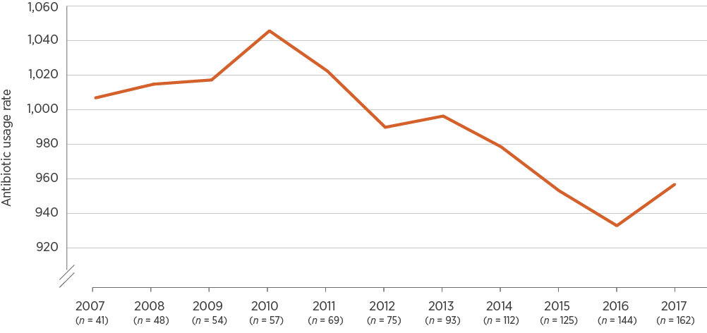
DDD/1,000 OBD = defined daily doses per 1,000 occupied bed days; n = number of facilities participating that year
Note: Data for 29 Queensland public hospitals are not included because of inconsistent application of surveillance definitions from 2013 to 2017.
Source: NAUSP⁵
In 2017, there were notable increases in use of third- and fourth-generation cephalosporins (7.8% and 63.3%, respectively), carbapenems (3.7%) and first-generation cephalosporins (2.8%). Approximately 45% of the total increase in AU in 2017 was attributable to third- and fourth-generation cephalosporins, presumably due to the piperacillin–tazobactam shortage that year.
There were also increases in the ‘other’ category, mostly accounted for by the alimentary antibiotics rifaximin and fidaxomicin. Rifaximin was included in NAUSP from March 2017. The historical trend of increasing use of the tetracycline class continued in 2017, with a further 11.3% rise compared with 2016 (Figure 3.2).
After consistent downward trends in previous years, use of a number of classes was stable, or increased only slightly, in 2017. The agents for which there were decreases compared with 2016 included fluoroquinolones, β-lactamase inhibitor combinations, macrolides, nitroimidazoles, aminoglycosides and glycopeptides (Figures 3.2 and 3.3).
Twenty antibiotics accounted for 93% of all use in 2017 (Figure 3.4). The top five most used antibiotics – amoxicillin–clavulanic acid, cefazolin, flucloxacillin, doxycycline and amoxicillin – have not changed since 2015. These five antibiotics accounted for almost 50% of all use in NAUSP contributor hospitals in 2017.
Figure 3.2: Annual antibiotic usage rates (DDD/1,000 OBD) in NAUSP contributor hospitals, by class, 2007–2017
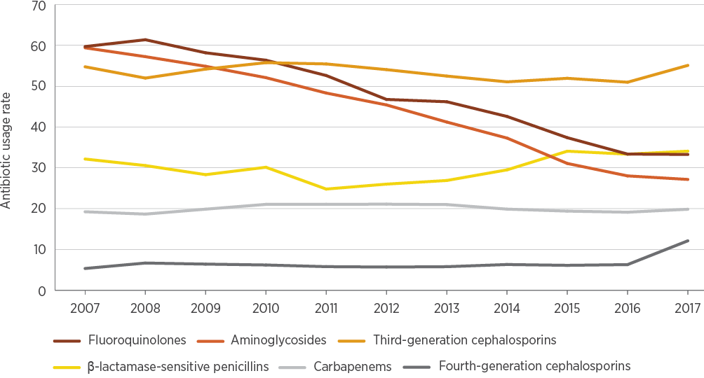
DDD/1,000 OBD = defined daily doses per 1,000 occupied bed days
Note: Data for 29 Queensland public hospitals are not included because of inconsistent application of surveillance definitions from 2013 to 2017.
Source: NAUSP⁵
Figure 3.3: Annual antibiotic usage rates (DDD/1,000 OBD) in NAUSP contributor hospitals, by class, 2007–2017
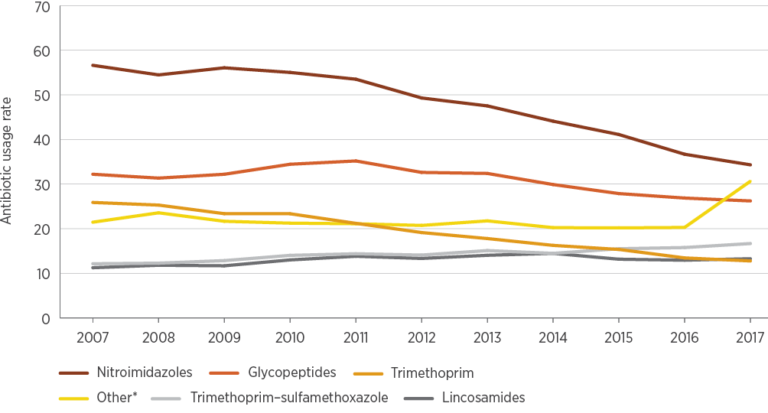
DDD/1,000 OBD = defined daily doses per 1,000 occupied bed days
* Refers to alimentary antibiotics (rifaximin and fidaxomicin), amphenicols (chloramphenicol), monobactams, nitrofurans (nitrofurantoin), linezolid, daptomycin, fosfomycin, ceftaroline, ceftolozane–tazobactam, polymyxins (colistin and polymyxin B), rifamycins (rifampicin), second-generation cephalosporins, steroids (fusidic acid), streptogramins (pristinamycin) and streptomycin
Note: Data for 29 Queensland public hospitals are not included because of inconsistent application of surveillance definitions from 2013 to 2017.
Source: NAUSP⁵
Figure 3.4: Top 20 antibiotics as a percentage of all antibiotics used in NAUSP contributor hospitals, 2017
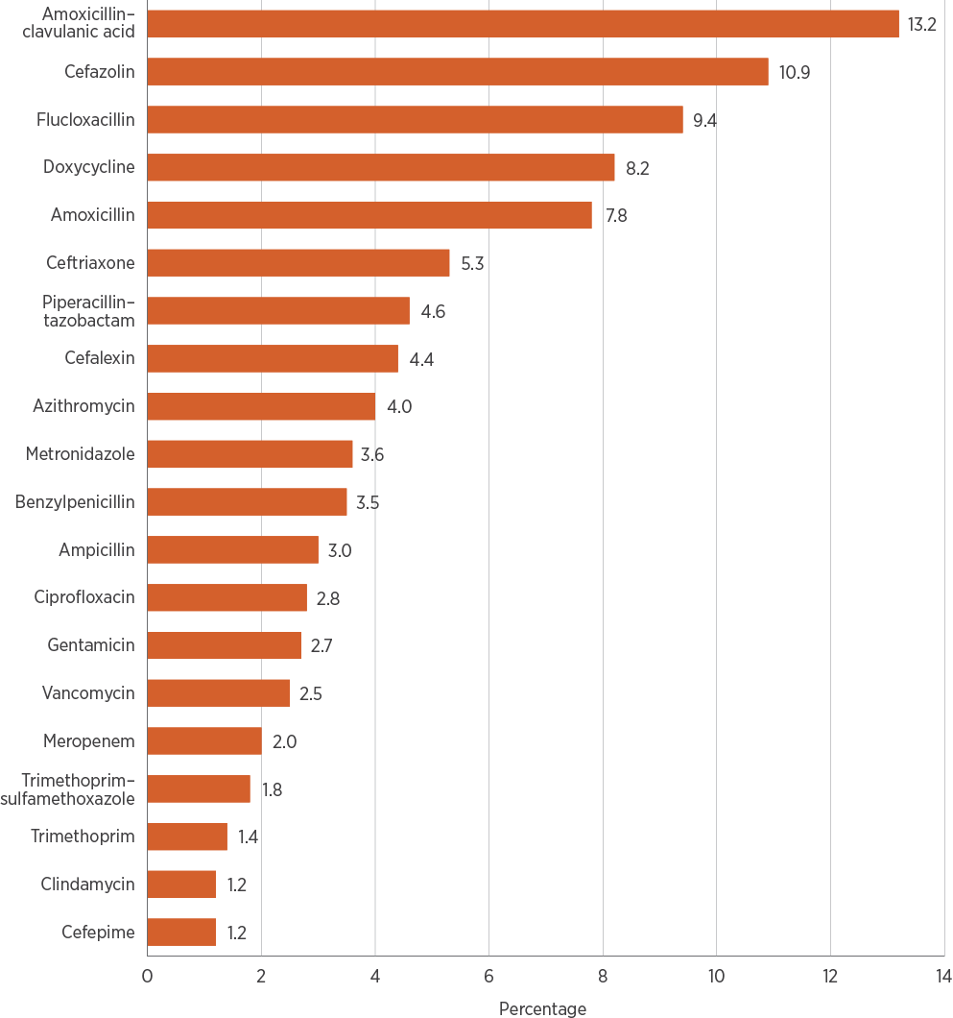
Note: The World Health Organization refers to amoxicillin–clavulanic acid as amoxicillin and beta-lactamase inhibitor, and piperacillin–tazobactam as piperacillin and beta-lactamase inhibitor. These agents are referred to as amoxicillin–clavulanic acid and piperacillin–tazobactam throughout this chapter for consistency with, and relevance to, the Australian context.
Source: NAUSP⁵
Roxithromycin and clarithromycin were not included in the top 20 antibiotics used in 2017; they were replaced by ampicillin and cefepime. This may be because roxithromycin is no longer recommended in Therapeutic Guidelines: Antibiotic⁶, and clarithromycin has been replaced by doxycycline for many indications. Roxithromycin was in 18th place in 2015 and 19th place in 2014. The worldwide piperacillin–tazobactam shortage may explain many other changes in use in 2017.⁷
The top 10 antimicrobials reported in NAPS and NAUSP are almost the same, but with different proportions (Table 3.2). This can be explained by the different methodologies and measurement purposes (qualitative versus quantitative) of NAPS and NAUSP. Although NAPS collects both qualitative and quantitative data, it is a point prevalence survey, which limits its use for quantitative analysis.
Cefazolin was the most frequently prescribed antimicrobial from NAPS (12.0% of prescriptions) and the second most frequently used antimicrobial from NAUSP (10.9%). Ceftriaxone comprised 9.7% of prescriptions from NAPS but only 5.3% of antimicrobials used. Amoxicillin–clavulanic acid was the third most frequently prescribed antimicrobial (6.6%) but the most frequently used (13.2%).
Table 3.2: Most frequently prescribed and used antimicrobials, reported by NAPS and NAUSP contributor hospitals, 2017
Rank | Most frequently prescribed (NAPS) | Highest use (NAUSP)
1 | Cefazolin (12.0%) | Amoxicillin–clavulanic acid (13.2%)
2 | Ceftriaxone (9.7%) | Cefazolin (10.9%)
3 | Amoxicillin–clavulanic acid (6.6%) | Flucloxacillin (9.4%)
4 | Metronidazole (6.1%) | Doxycycline (8.2%)
5 | Doxycycline (5.4%) | Amoxicillin (7.8%)
6 | Cefalexin (5.2%) | Ceftriaxone (5.3%)
7 | Piperacillin–tazobactam (4.5%) | Piperacillin–tazobactam (4.6%)
8 | Flucloxacillin (4.4%) | Cefalexin (4.4%)
9 | Benzylpenicillin (3.3%) | Azithromycin (4.0%)
10 | Amoxicillin (3.1%) | Metronidazole (3.6%)
Note: NAPS is a point prevalence survey and NAUSP measures cumulative volume.
Sources: NAPS⁴; NAUSP⁵
Intravenous amoxicillin–clavulanic acid was registered for use in Australia in 2017. Amoxicillin–clavulanic acid represented 13.2% of total antibiotic use in 2017, and intravenous use accounted for 3.4% of amoxicillin–clavulanic acid use.
The top five most used antibiotics in hospitals – amoxicillin–clavulanic acid, cefazolin, flucloxacillin, doxycycline and amoxicillin – have not changed since 2015. These five antibiotics accounted for almost 50% of all use in NAUSP contributor hospitals in 2017.
Box 3.1 shows NAUSP data on antifungal use in hospitals.
Box 3.1: Antifungal use in hospitals
As part of developing strategies to prevent and contain antimicrobial resistance, the role of antifungals must be considered. Antifungals are widely used for the treatment of systemic fungal infections, particularly in high-risk immunocompromised patients, such as those with severe haematological or oncological conditions, or HIV infection. Intravenous formulations of antifungals are more commonly used in this population. Antifungals can also be used for prophylaxis in people who are immunosuppressed; oral formulations are more common for this indication.
Like all antimicrobials, antifungals can be prescribed inappropriately to varying degrees. Common reasons include using an antifungal when the patient is only colonised with Candida, prescribing echinocandins for a clinically stable patient with azole-susceptible Candida, and dosing without considering the pharmacokinetic and pharmacodynamic profile of the agent.¹
The use of antifungals has increased over time, along with the increasing numbers of people who are immunocompromised and at risk of invasive fungal infections.² Studies suggest that antifungal exposure and suboptimal dosing are linked to antifungal resistance, especially for Candida.² The number of patients with multiple fungal infections is also increasing, which can further affect antifungal use.³
In recognition of the growing concern about antifungal resistance, AURA 2019 includes this preliminary overview of antifungals. The National Antimicrobial Utilisation Surveillance Program (NAUSP) collects data on a number of systemic antifungals, although not all hospitals provide these data yet. Despite being on the published NAUSP inclusion list for some time, antifungal surveillance is not yet being undertaken in some large Australian hospitals.
AURA 2019 includes 86 NAUSP Principal Referral and Public Acute Group A contributor hospitals. This is the first AURA report to include antifungal data.
The total-hospital antifungal usage rate was 39.1 defined daily doses (DDDs) per 1,000 occupied bed days (OBDs) in 2017. Antifungal usage rates differed slightly between states and territories (Figure A). Usage rates in haematology/oncology departments and intensive care units were greater than total-hospital usage rates (Figure B), reflecting the acuity of patients seen in these specialty units. Although a smaller number of hospitals contributed to the specialty group analysis, the data provide a picture of the high use of antifungals in these units. NAUSP continues to engage with hospitals to promote submission of antifungal data to improve surveillance and allow monitoring of trends over time.
Figure C shows differences between antifungal usage rates for selected antifungals across Principal Referral Hospitals. Fluconazole had the highest use among these hospitals, most likely because it is generally well tolerated and has a wide therapeutic range against common yeasts, and comparatively lower toxicity and substantive drug interactions.^{4,5} It is also the preferred antifungal for Candida albicans, which is the most common cause of invasive yeast infection.⁶
Increased surveillance of antifungal use, coupled with antimicrobial stewardship efforts targeting antifungals, may improve safety and patient outcomes, and reduce costs (antifungal agents are usually expensive). Use of antifungal agents can have significant adverse effects⁷, and appropriate reductions in use may reduce these side effects. Work needs to continue to highlight antifungal stewardship as an important issue for Australian hospitals.
Figure A: Overall antifungal usage rates (DDD/1,000 OBD) in NAUSP contributor hospitals, by state and territory, 2017
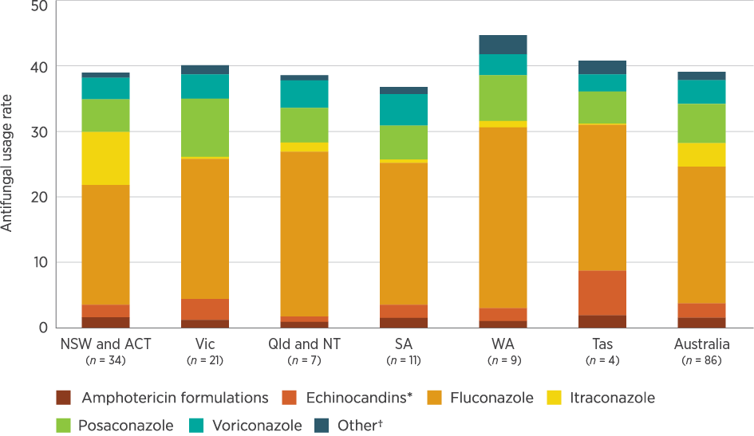
DDD/1,000 OBD = defined daily doses per 1,000 occupied bed days
* Echinocandin rates are aggregated rates for anidulafungin, caspofungin and micafungin
† Refers to flucytosine, griseofulvin, isavuconazole, ketoconazole and terbinafine
Source: NAUSP
Figure B: Antifungal usage rates (DDD/1,000 OBD) in NAUSP contributor hospitals, by specialty, 2016–17
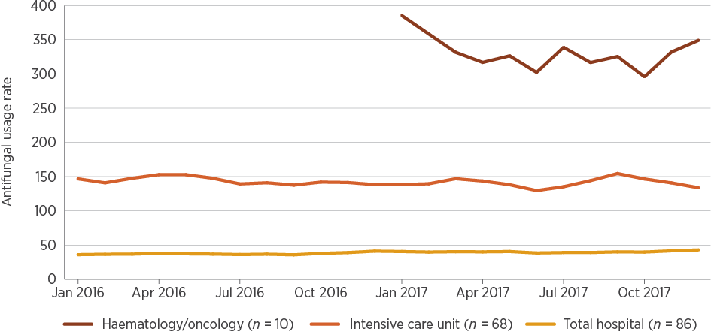
DDD/1,000 OBD = defined daily doses per 1,000 occupied bed days Note: Numbers of contributing hospitals differ for each specialty.
Source: NAUSP
Figure C: Annual total-hospital antifungal usage rates (DDD/1,000 OBD) in Principal Referral Hospitals, 2017
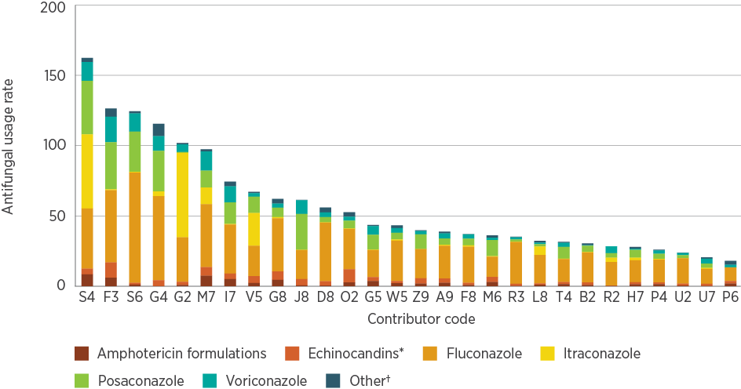
DDD/1,000 OBD = defined daily doses per 1,000 occupied bed days
* Echinocandin rates are aggregated rates for anidulafungin, caspofungin and micafungin
† Refers to amphotericin B, amphotericin lipid complex, amphotericin liposomal, flucytosine, griseofulvin, isavuconazole, ketoconazole and terbinafine
Source: NAUSP
References
1. Valerio M, Rodriguez-Gonzalez CG, Muñoz P, Caliz B, Sanjurjo M, Bouza E, et al. Evaluation of antifungal use in a tertiary care institution: antifungal stewardship urgently needed. J Antimicrob Chemother 2014;69(7):1993–9.
2. Hamdy RF, Zaoutis TE, Seo SK. Antifungal stewardship considerations for adults and pediatrics. Virulence 2016;8(6):658–72.
3. Micallef C, Ashiru-Oredope D, Hansraj S, Denning DW, Agrawal SG, Manuel RJ, et al. An investigation of antifungal stewardship programmes in England. J Med Microbiol 2017;66(11):1581–9.
4. Lewis RE. Current concepts in antifungal pharmacology. Mayo Clin Proc 2011;86(8):805–17.
5. Chau MM, Kong DC, van Hal SJ, Urbancic K, Trubiano JA, Cassumbhoy M, et al. Consensus guidelines for optimising antifungal drug delivery and monitoring to avoid toxicity and improve outcomes in patients with haematological malignancy, 2014. Intern Med J 2014;44(12b):1364–88.
6. Kauffman CA. Management of candidemia and invasive candidiasis in adults. UpToDate; 2018 [updated 2018 Nov 26; cited 2019 Feb 19].
7. Urbancic KF, Thursky K, Kong DC, Johnson PD, Slavin MA. Antifungal stewardship: developments in the field. Curr Opin Infect Dis 2018;31(6):490–8.

Antibiotic usage rates by state and territory
In 2017, states and territories varied in their aggregate usage rates and ratios of antibiotic classes (Figure 3.5). As in 2015, Tasmania had the highest usage rate of 1,098 DDDs per 1,000 OBDs, and Western Australia (WA) had the lowest usage rate of 861 DDDs per 1,000 OBDs – a difference of 237 DDDs per 1,000 OBDs (Table 3.3). Although Tasmania had the highest rate of use, the ratio of narrow-spectrum antibiotics to broader-spectrum antibiotics was higher. For example, use of third-generation cephalosporins in Tasmania (54.81 DDDs per 1,000 OBDs) was below the national average of 56.10 DDDs per 1,000 OBDs (Figure 3.5). A higher ratio of narrow-spectrum antibiotics, especially used in combination, to broader-spectrum antibiotics can indicate more appropriate use of antimicrobials, which is why it is important to interpret total usage rates with caution.
Figures 3.6–3.9 show the varying patterns of antibiotic use between states and territories for carbapenems, cephalosporins, penicillin–β-lactamase inhibitor combinations and fluoroquinolones. These classes and agents have been selected because of the implications of their use for AMR.
The primary carbapenem used in Australia is meropenem. Use varies by state and territory, and is generally restricted in hospitals to limit the progression of carbapenem resistance. Carbapenem use is more common in Principal Referral Hospitals than in other hospital peer groups. Common indications for meropenem use in Australia include infections with multidrug-resistant organisms and extended-spectrum β-lactamase (ESBL)-producing organisms. Meropenem may also be used to treat Burkholderia pseudomallei infections, which are largely confined to health services north of the Tropic of Capricorn. Infections caused by multidrug-resistant organisms such as carbapenemase-producing Enterobacterales are more commonly encountered in hospitals, whereas ESBL-producing organisms occur with high frequency in both community- and hospital-onset infections.^{8,9}
Figure 3.5: Overall antibiotic usage rates (DDD/1,000 OBD) in NAUSP contributor hospitals, by state and territory, 2017
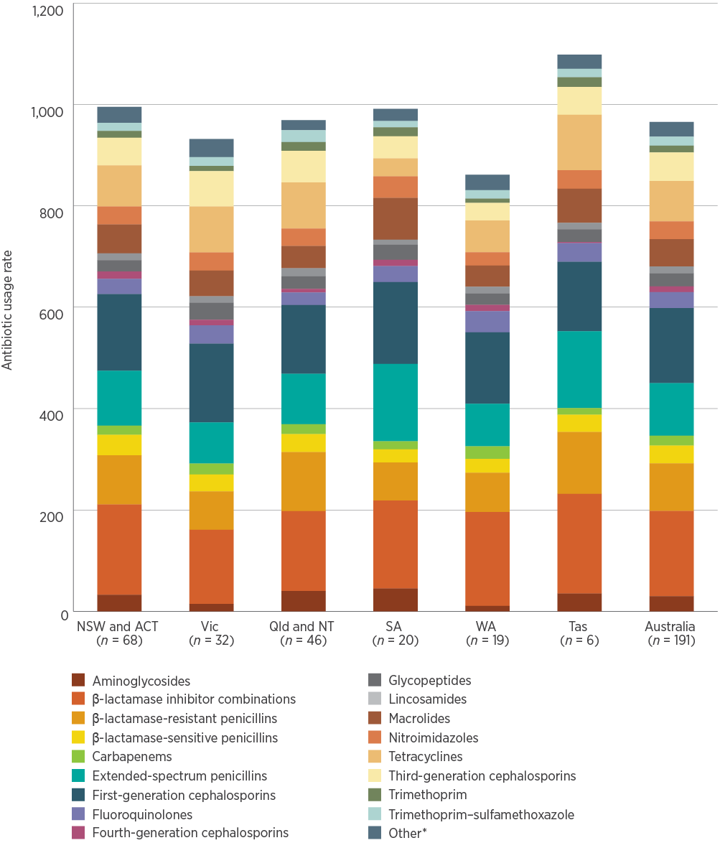
DDD/1,000 OBD = defined daily doses per 1,000 occupied bed days
* Refers to alimentary antibiotics (rifaximin and fidaxomicin), amphenicols (chloramphenicol), monobactams, nitrofurans (nitrofurantoin), linezolid, daptomycin, fosfomycin, ceftaroline, ceftolozane–tazobactam, polymyxins (colistin and polymyxin B), rifamycins (rifampicin), second-generation cephalosporins, steroids (fusidic acid), streptogramins (pristinamycin) and streptomycin
Note: Numbers of hospitals include public hospitals, private hospitals and Specialist Women’s Hospitals.
Source: NAUSP⁵
Table 3.3: Antibiotic usage rates in NAUSP contributor hospitals, by state and territory, and peer group, 2017
State or territory | Hospitals contrib-uting to NAUSP (number) | All-  hospitals rate* | All-hospitals range* | Principal Referral Hospitals rate* | Public Acute Group A Hospitals rate* | Public Acute Group B Hospitals rate* | Public Acute Group C Hospitals rate* | Private hospitals rate*
NSW and ACT | 68 | 995.1 | 349–1,944 | 997.1  (n = 12) | 986.3  (n = 22) | 1,156.5  (n = 15) | 1,059.7  (n = 12) | 804.4  (n = 7)
Vic | 32 | 931.7 | 257–1,186 | 996.1  (n = 6) | 976.7  (n = 13) | 862.8  (n = 7) | nd | 750.6  (n = 5)
Qld and NT | 46 | 969.0 | 220–1,886 | 951.1  (n = 6) | 1,113.3  (n = 14) | 1,071.0  (n = 8) | 1,194.0  (n = 7) | 724.0  (n = 11)
SA | 20 | 991.3 | 537–1,281 | 1,124.2  (n < 5) | 1,142.0  (n < 5) | 678.5  (n < 5) | 647.9  (n < 5) | 839.5  (n = 7)
WA | 19 | 861.5 | 439–1,251 | 1,060.2  (n < 5) | 659.8  (n = 5) | 979.7  (n < 5) | 530.7  (n < 5) | 826.3  (n < 5)
Tas | 6 | 1,098.3 | 781–1,490 | nd | 1,302.6  (n < 5) | nd | nd | 791.1  (n < 5)
Australia | 191 | 965.3 | 220–1,944 | 1,005.5  (n = 30) | 1,001.3  (n = 58) | 1,019.2  (n = 37) | 889.2  (n = 26) | 782.1  (n = 36)
nd = no data (either a small sample size or no contributors)
* Rate in defined daily doses per 1,000 occupied bed days
Note: Rates are presented as an aggregate for all hospitals within each category. Data for Specialist Women’s Hospitals are included in the all-hospitals rate and range data. Private hospitals are combined because of small numbers contributing to NAUSP. In future, it may be possible to provide data for Private Acute Groups A, B and C Hospitals separately.
Source: NAUSP⁵
Carbapenem resistance in Enterobacterales has emerged in Australia, primarily as a result of production of transmissible carbapenemases.⁸
Carbapenem use is commonly above 20 DDDs per 1,000 OBDs in WA and Victoria, and is lower in other states and territories (Figure 3.6).
Ceftriaxone, a third-generation cephalosporin, is commonly used for severe community-acquired pneumonia, infections for which gentamicin is contraindicated, and infections in people with penicillin allergy. Cephalosporin use – particularly third-generation cephalosporins such as ceftriaxone – is associated with the amplification of ESBLs and other resistance patterns.
Figure 3.6: Carbapenem usage rates (DDD/1,000 OBD) in NAUSP contributor hospitals, by state and territory, 2013–2017 (3-month moving average)
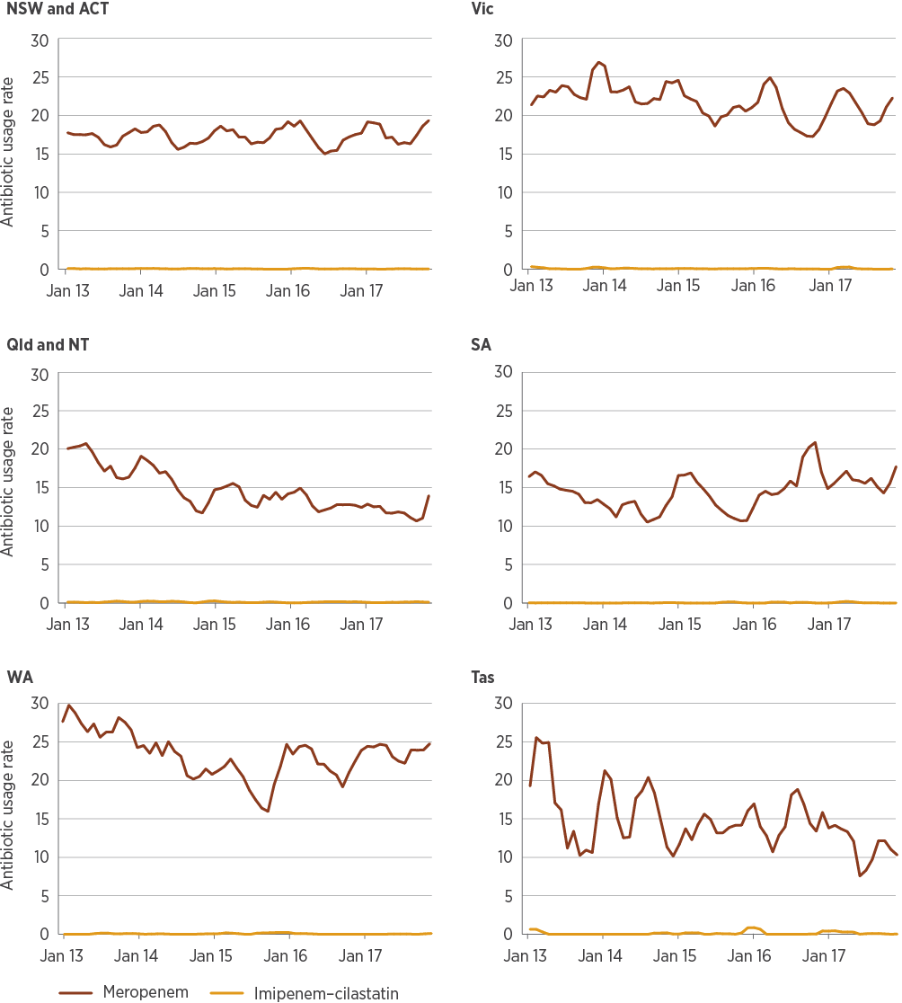
DDD/1,000 OBD = defined daily doses per 1,000 occupied bed days
Note: Trend analysis for 29 Queensland public hospitals uses historically consistent surveillance definitions for 2017.
Source: NAUSP⁵
Ceftriaxone continues to show a pattern of seasonal use, reflecting its role in the treatment of lower respiratory tract infections. However, cephalosporin use showed marked changes in 2017 that did not follow this pattern, primarily explained by the national piperacillin–tazobactam shortage that year.⁷ Use of cephalosporins other than ceftriaxone, predominantly cefepime, increased in all states and territories. Increased ceftriaxone use was mainly seen in Queensland and the Northern Territory (NT), and WA (Figure 3.7). This may be explained by preferences in other states and territories for use of intravenous amoxicillin–clavulanic acid, rather than ceftriaxone.
Figure 3.7: Third- and fourth-generation cephalosporin usage rates (DDD/1,000 OBD) in NAUSP contributor hospitals, by state and territory, 2013–2017 (3-month moving average)
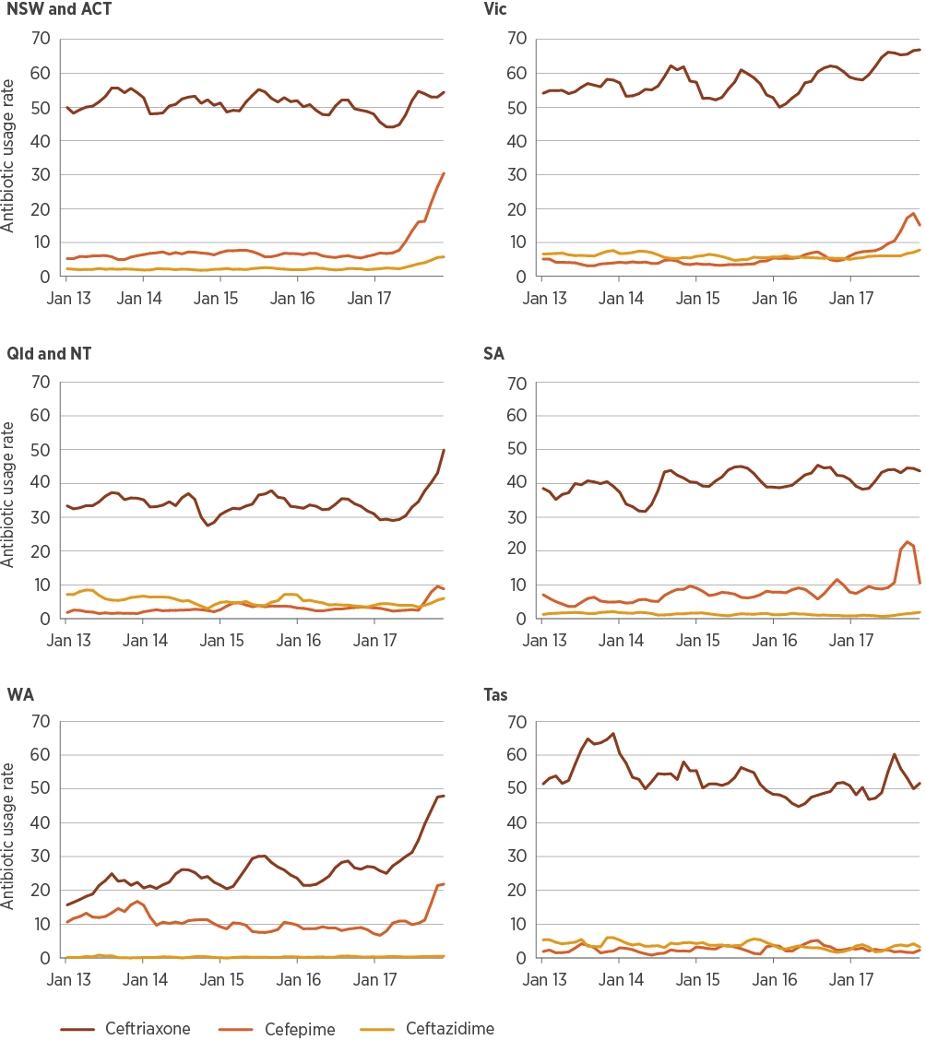
DDD/1,000 OBD = defined daily doses per 1,000 occupied bed days
Notes: Trend analysis for 29 Queensland public hospitals uses historically consistent surveillance definitions for 2017. Cefotaxime was not included because usage rates were very low.
Source: NAUSP⁵
Changing patterns of use of penicillin–β-lactamase inhibitors in 2017, including piperacillin–tazobactam and amoxicillin–clavulanic acid, are mainly accounted for by changes in prescriber behaviour in response to the national shortage of piperacillin–tazobactam (Figure 3.8).
Figure 3.8: Penicillin–β-lactamase inhibitor combination usage rates (DDD/1,000 OBD) in NAUSP contributor hospitals, by state and territory, 2013–2017 (3-month moving average)
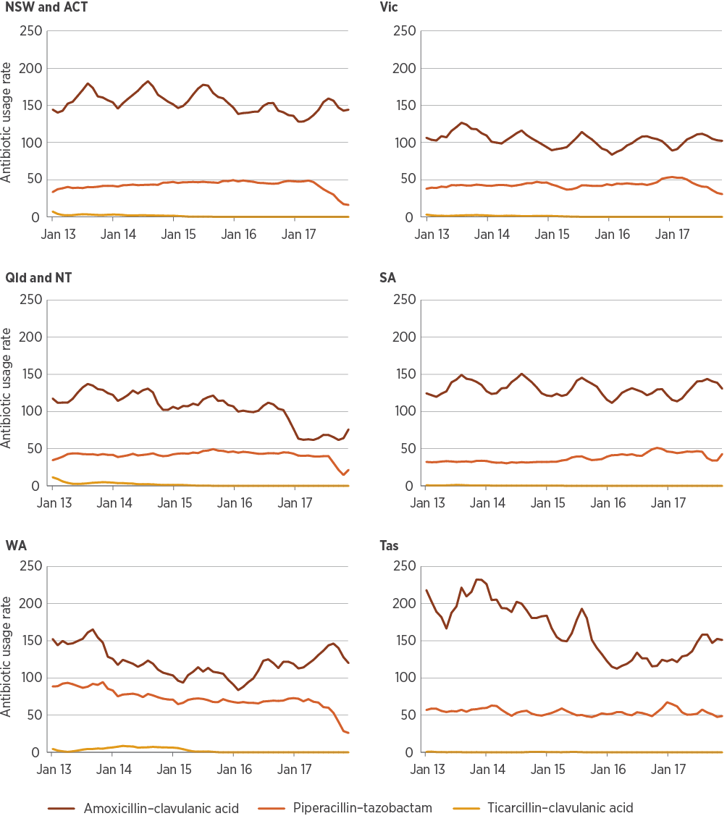
DDD/1,000 OBD = defined daily doses per 1,000 occupied bed days
Note: Trend analysis for 29 Queensland public hospitals uses historically consistent surveillance definitions for 2017.
Source: NAUSP⁵
Cephalosporin use – particularly third-generation cephalosporins such as ceftriaxone – is associated with the amplification of extended-spectrum β-lactamases and other resistance patterns.
The main fluoroquinolone used in Australia is ciprofloxacin. Supply issues with norfloxacin in 2017¹⁰ meant that ciprofloxacin was used preferentially for many indications. Inappropriate ciprofloxacin use is concerning, because of its role in development of gram-negative resistance and healthcare-associated infections such as epidemic Clostridium difficile.
Inappropriate ciprofloxacin use is concerning, because of its role in development of gram-negative resistance and healthcare-associated infections such as epidemic Clostridium difficile.
Moxifloxacin has specific uses, including treatment of pneumonia in people with immediate penicillin hypersensitivity or in multidrug-resistant tuberculosis. Moxifloxacin use is generally low across Australia. Use in WA may be higher than in other states and territories as a result of differences in indications (for example, multidrug-resistant tuberculosis) or state-specific prescribing practices (such as for pneumonia) (Figure 3.9).
Figure 3.9: Fluoroquinolone usage rates (DDD/1,000 OBD) in NAUSP contributor hospitals, by state and territory, 2013–2017 (3-month moving average)
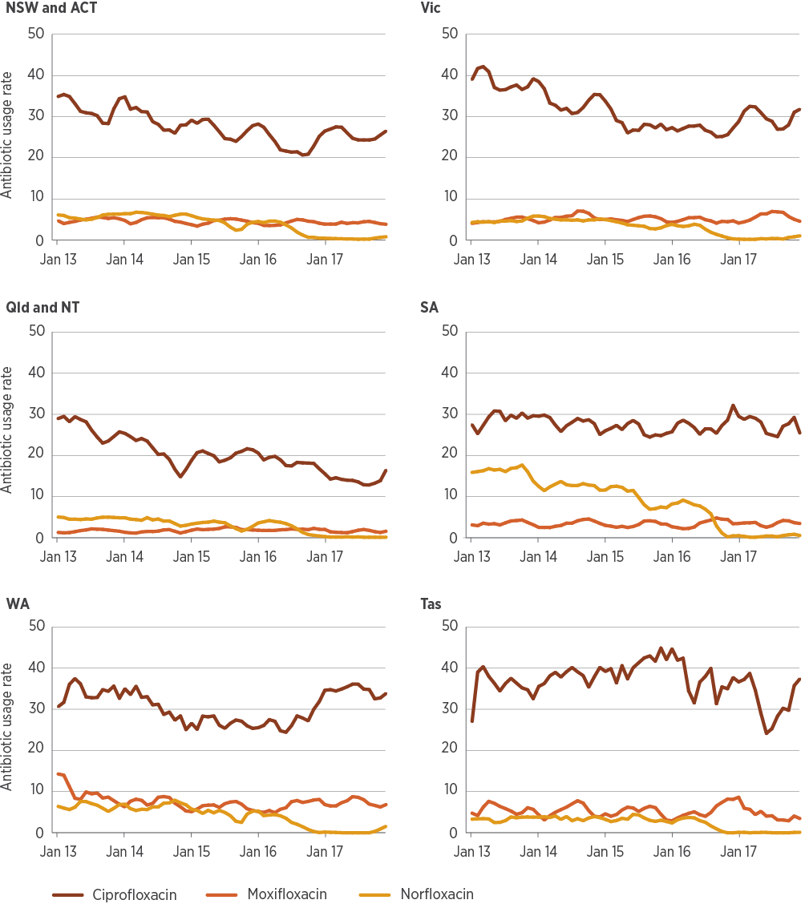
DDD/1,000 OBD = defined daily doses per 1,000 occupied bed days
Note: Trend analysis for 29 Queensland public hospitals uses historically consistent surveillance definitions for 2017.
Source: NAUSP⁵
From information to action
Using data from the National Antimicrobial Utilisation Surveillance Program to target Antimicrobial Stewardship interventions at Royal Darwin Hospital
Royal Darwin Hospital faces unique challenges for antimicrobial stewardship (AMS). It is located in the wet tropics and is the most northerly Principal Referral Hospital in Australia.
Antimicrobial use in tropical areas is different from that in temperate locations. Infections due to community strains of methicillin-resistant Staphylococcus aureus (MRSA) are common, and unusual bacteria such as Burkholderia pseudomallei (causing melioidosis) and community-acquired Acinetobacter baumannii are seen as likely causes of pneumonia during the wet season.
Sepsis is a frequent presentation at Royal Darwin Hospital, and patients tend to be younger and have more comorbidities than elsewhere in Australia. Rapidly progressive illness is common. Sepsis is a major cause of death worldwide, and delays in diagnosis and management of patients with sepsis are associated with high morbidity and mortality.
Analysing and acting on National Antimicrobial Utilisation Surveillance Program data
The National Antimicrobial Utilisation Surveillance Program (NAUSP) team provided a tailored report on antibiotic use in hospitals in the tropical region of Australia (above the Tropic of Capricorn) to determine usage rates per occupied bed day (OBD). This allowed a detailed, site-specific comparison of antibiotic use.
Total-hospital antibiotic use at Royal Darwin Hospital was among the highest per OBD for the cohort of NAUSP hospitals in tropical locations. Use of third-generation cephalosporins, extended-spectrum β-lactamase combinations, carbapenems and glycopeptides was higher in Royal Darwin Hospital than in most other tropical hospitals.
In response to the NAUSP data, the Top End Health Service AMS Program held a grand-round meeting focused on the difference in antibiotic use and comparison of antibiograms between tropical sites. The service introduced electronic approval of antimicrobial prescriptions, prescribing advice specific to the Top End and AMS ward rounds six days per week. An electronic system was used to identify patients who were prescribed antimicrobials that did not match the treatment indication, incorrect doses for renal/hepatic function, or agents that did not match microbiology results.
If the AMS team deemed a prescription inappropriate, this was reported to the prescribing team, and details of the feedback were entered into a rolling-audit database. A log of all recommendations was provided to individual consultants each year, to highlight areas where there was potential for their team to improve prescribing.
Reviewing results
Total antibiotic use at Royal Darwin Hospital has decreased in comparison to its peers since September 2014, when the targeted AMS program was progressively implemented. Figure A demonstrates the high level of use relative to peers before the AMS program, and Figure B shows an improvement after its implementation.
Figure A: Total-hospital antibiotic usage rates (DDD/1,000 OBD), NAUSP contributor hospitals above the Tropic of Capricorn, 2014
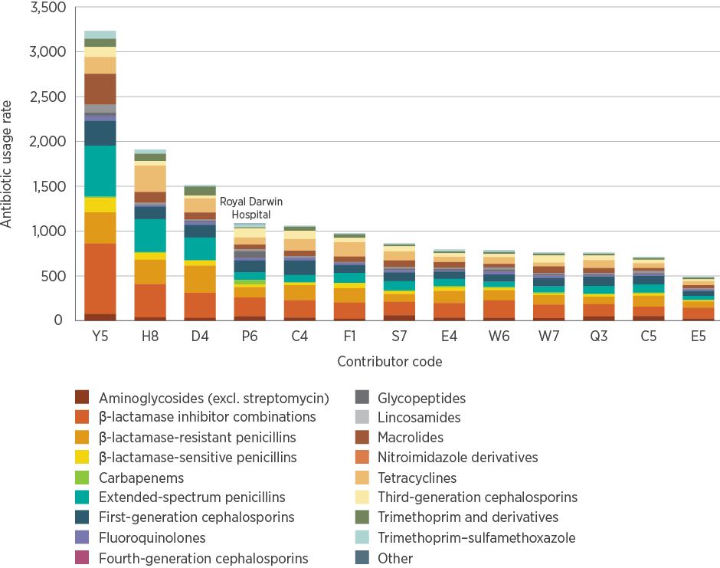
DDD/1,000 OBD = defined daily doses per 1,000 occupied bed days
Figure B: Total-hospital antibiotic usage rates (DDD/1,000 OBD), NAUSP contributor hospitals above the Tropic of Capricorn, 2017
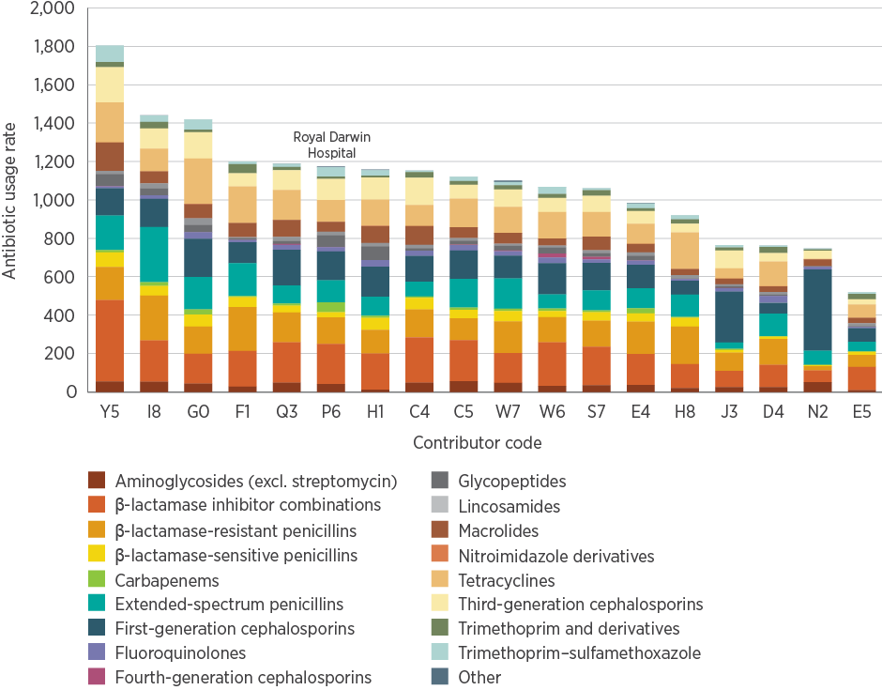
DDD/1,000 OBD = defined daily doses per 1,000 occupied bed days
Although change has been gradual, a trend is emerging towards reduced use of broad-spectrum β-lactamase inhibitor combinations, carbapenems, glycopeptides and third-generation cephalosporins. At Royal Darwin Hospital, use of many of these agents has decreased to the lowest on record per OBD.
Trends in antimicrobial use take time to emerge. Antimicrobial use in the Top End is seasonal, with significant swings between the wet (November to April) and dry (May to October) seasons. The NAUSP data provided not only a rate of antibiotic use per OBD but also a moving-average use, which helps interpret usage swings with season changes.
The ability to track antibiotic use with NAUSP proved most useful following one of the Top End Health Service’s major interventions for AMS – the introduction of a locally developed, open-source, electronic advice and approval application for antimicrobials known as TEAMS (Top End AntiMicrobial Stewardship).
Because TEAMS was developed with strong consultation with prescribers, uptake was high. It is believed that the implementation of TEAMS led to the reduction in ceftriaxone use shown in Figure C.
The moving average of ceftriaxone use provided by NAUSP allows comparison of seasonal high and low points. The average dry-season low point for ceftriaxone use fell significantly from 74.9 DDDs per 1,000 OBDs in 2017 to 63.3 DDDs per 1,000 OBDs in 2018.
Prescribing practices take time to change. AMS programs require evidence – such as the data and peer benchmarks produced by NAUSP – to demonstrate opportunities for improvement to prescribers, monitor change over time and measure the effectiveness of interventions to improve prescribing.
The 2017 enhancements to the NAUSP portal enable contributors to make comparisons between hospital divisions. This provides AMS programs with a mechanism for intra-hospital benchmarking and targeting of improvement programs.
Figure C: Total-hospital moving average of ceftriaxone use (DDD/1,000 OBD), Royal Darwin Hospital, September 2013 to September 2018
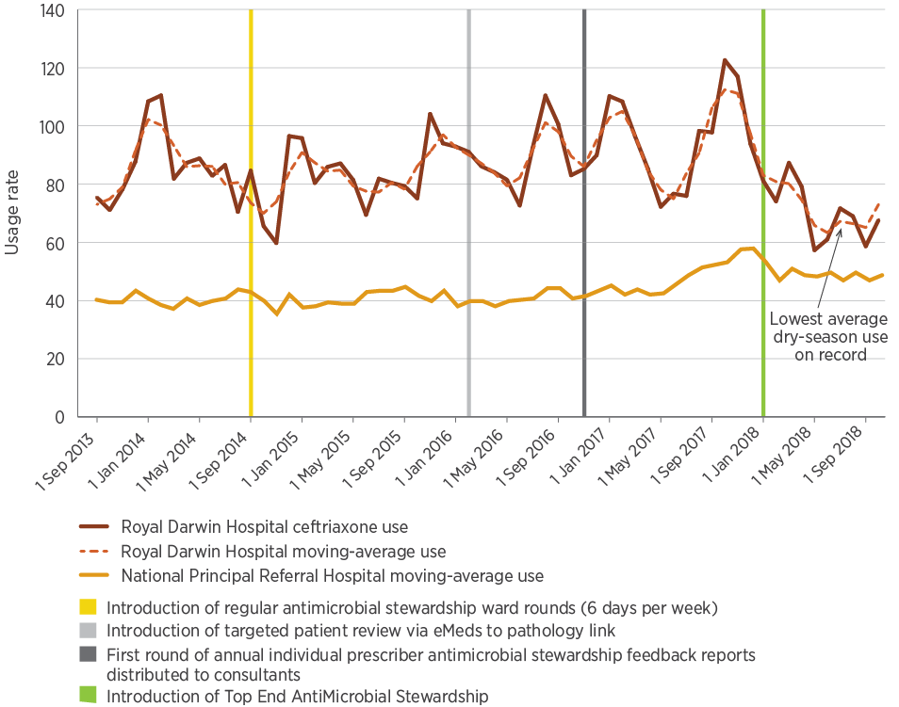
DDD/1,000 OBD = defined daily doses per 1,000 occupied bed days

Antibiotic use by hospital peer group
Figures 3.10–3.14 show antibiotic usage rates by hospital peer group for carbapenems, cephalosporins, piperacillin–tazobactam and fluoroquinolones. Classifying hospital data by peer group allows each hospital to compare its data with similar hospitals, identify variations in use and highlight areas for improvement. Private hospitals were included with public hospitals of similar size and patient mix for the analyses. Data from four Specialist Women’s Hospitals were not included in these analyses because of low numbers.
The effects of the 2017 piperacillin–tazobactam shortage are evident in these data, with a decrease in piperacillin–tazobactam use (Figure 3.13) and increases in use of other classes during that period. The effect was most pronounced in Principal Referral and Public Acute Group A Hospitals. These hospitals care for a larger proportion of patients who might be immunosuppressed, require intensive or high-dependency care, and be more likely to require broader-spectrum agents such as piperacillin–tazobactam. Meropenem use increased in all Principal Referral Hospitals, which indicates that this peer group most likely compensated for the piperacillin–tazobactam shortage with meropenem (Figure 3.10). Third-generation cephalosporin use also increased across all peer groups in response to the shortage (Figure 3.12).
The effects of the 2017 piperacillin–tazobactam shortage are evident in these data, with a decrease in piperacillin–tazobactam use and increases in other classes to compensate.
Carbapenem and piperacillin–tazobactam use differ by peer group: use was higher in Principal Referral Hospitals than in Public Acute Group C Hospitals. This disparity in use is not replicated for third-generation cephalosporins, possibly because of high use of this class of antibiotic for community-onset respiratory and abdominal infections that occur very commonly, irrespective of hospital acuity or size.
There was a large increase in cefepime use in Public Acute Group B and C Hospitals between 2016 and 2017. This is notable, as these institutions are likely to have lower burdens of comorbidities and healthcare-acquired infections, and are less likely to care for immunosuppressed and high-dependency patients who are more likely to require broader-spectrum agents such as cefepime.
Fluoroquinolone use (mostly ciprofloxacin) shows a different pattern, with less overall variation between peer groups and differences in trends over time (Figure 3.14). There was a notable increase in use in Public Acute Group B and C Hospitals in 2017.
Figure 3.10: Carbapenem usage rates (DDD/1,000 OBD) in NAUSP contributor hospitals, by selected peer groups, 2013–2017 (3-month moving average)
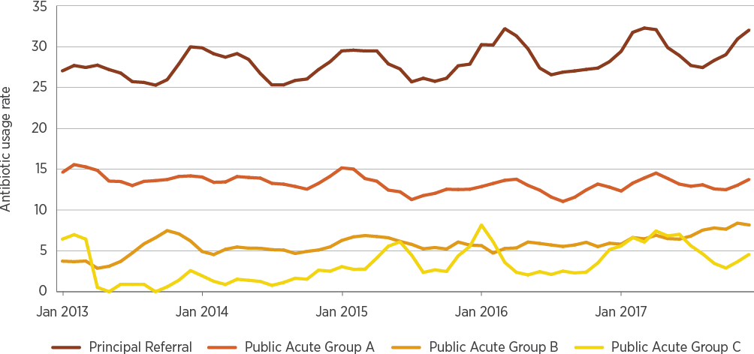
DDD/1,000 OBD = defined daily doses per 1,000 occupied bed days
Notes:
1. Carbapenems include meropenem, ertapenem and imipenem–cilastatin.
2. Data for 29 Queensland public hospitals are not included because of inconsistent application of surveillance definitions from 2013 to 2017.
Source: NAUSP⁵
Figure 3.11: First-generation cephalosporin usage rates (DDD/1,000 OBD) in NAUSP contributor hospitals, by selected peer groups, 2013–2017 (3-month moving average)
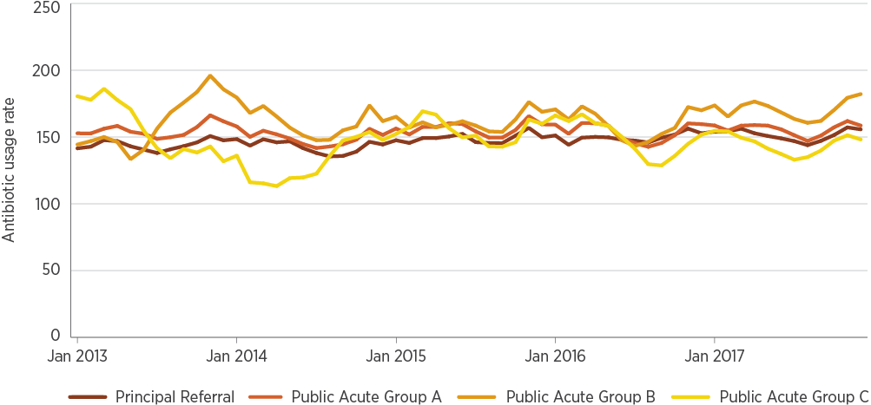
DDD/1,000 OBD = defined daily doses per 1,000 occupied bed days
Notes:
1. First-generation cephalosporins include cefalexin, cefazolin and cefalothin.
2. Data for 29 Queensland public hospitals are not included because of inconsistent application of surveillance definitions from 2013 to 2017.
Source: NAUSP⁵
Figure 3.12: Third- and fourth-generation cephalosporin usage rates (DDD/1,000 OBD) in NAUSP contributor hospitals, by selected peer groups, 2013–2017 (3-month moving average)
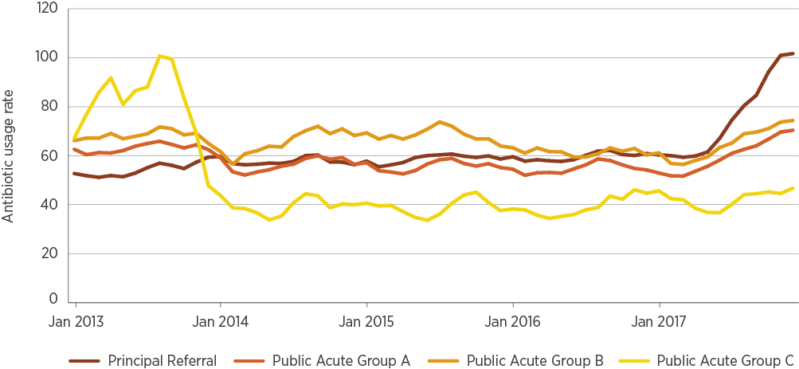
DDD/1,000 OBD = defined daily doses per 1,000 occupied bed days
Notes:
1. Third- and fourth-generation cephalosporins include ceftriaxone, ceftazidime, cefotaxime and cefepime.
2. Data for 29 Queensland public hospitals are not included because of inconsistent application of surveillance definitions from 2013 to 2017.
Source: NAUSP⁵
Figure 3.13: Piperacillin–tazobactam usage rates (DDD/1,000 OBD) in NAUSP contributor hospitals, by selected peer groups, 2013–2017 (3-month moving average)
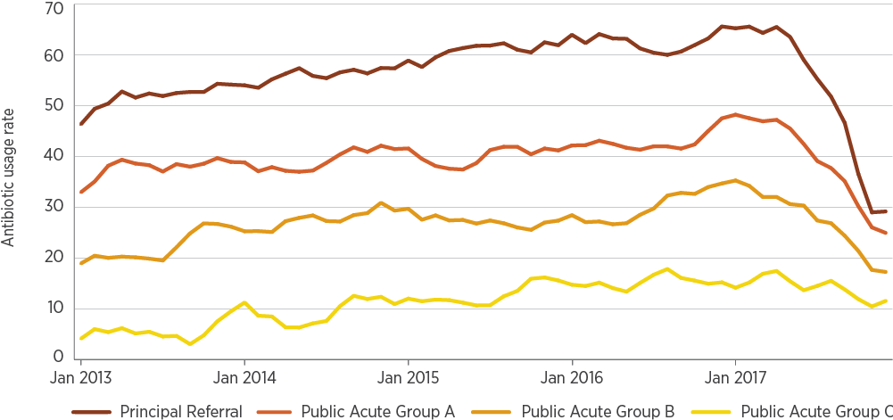
DDD/1,000 OBD = defined daily doses per 1,000 occupied bed days
Note: Data for 29 Queensland public hospitals are not included because of inconsistent application of surveillance definitions from 2013 to 2017.
Source: NAUSP⁵
Figure 3.14: Fluoroquinolone usage rates (DDD/1,000 OBD) in NAUSP contributor hospitals, by selected peer groups, 2013–2017 (3-month moving average)
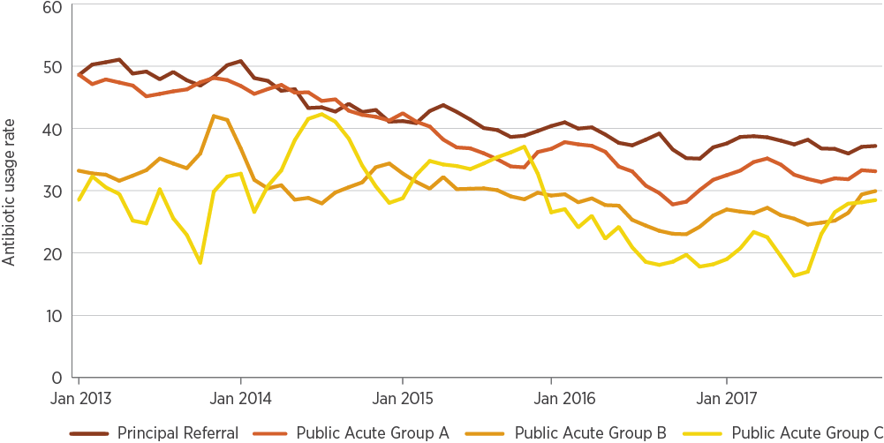
DDD/1,000 OBD = defined daily doses per 1,000 occupied bed days
Notes:
1. Fluoroquinolones include ciprofloxacin, moxifloxacin and norfloxacin.
2. Data for 29 Queensland public hospitals are not included because of inconsistent application of surveillance definitions from 2013 to 2017.
Source: NAUSP⁵
From information to action
Impact of the piperacillin–tazobactam shortage on acquisition of vancomycin-resistant enterococci and multidrug-resistant Staphylococcus aureus at John Hunter Hospital
In late 2017, Australia experienced a nationwide shortage of piperacillin–tazobactam. Piperacillin–tazobactam is often used for indications that are not supported by Therapeutic Guidelines: Antibiotic, such as:
- On an empirical basis for abdominal infections, for which surgical source control is the most critical factor
- In skin and soft tissue infections, in which gram-positive bacteria are the predominant causative pathogens
- In lower respiratory tract infections, for which the gram-negative spectrum of piperacillin–tazobactam is mostly unnecessary.
To manage the piperacillin–tazobactam shortage, John Hunter Hospital, a Principal Referral Hospital in New South Wales, promoted intravenous amoxicillin–clavulanic acid as an alternative agent. Amoxicillin–clavulanic acid is considered narrower in spectrum than piperacillin–tazobactam. Intravenous amoxicillin–clavulanic acid was registered for use in Australia in 2017.
Piperacillin–tazobactam use, and acquisition of vancomycin-resistant enterococci (VRE) and methicillin-resistant Staphylococcus aureus (MRSA) were assessed for two periods: October 2016 to September 2017 (the 12 months before the piperacillin–tazobactam shortage) and November 2017 to October 2018 (after the shortage commenced). Piperacillin–tazobactam use decreased from a mean of 44 defined daily doses (DDDs) per 1,000 occupied bed days (OBDs) in the pre-shortage period to 5 DDDs per 1,000 OBDs after the shortage commenced. Piperacillin–tazobactam was replaced largely with intravenous amoxicillin–clavulanic acid, use of which increased from 4 to 33 DDDs per 1,000 OBDs. In absolute terms, new hospital-onset acquisitions of VRE fell by 47% from the pre-shortage baseline of 191 events, and hospital-onset MRSA acquisitions fell by 42% from the pre-shortage baseline of 53 events.
Reductions in VRE and MRSA acquisition and infection occurred in close association with the sustained shortage of piperacillin–tazobactam. Importantly, the hospital avoided replacing piperacillin–tazobactam therapy with broad-spectrum agents such as meropenem, and overall use of broad-spectrum agents declined during the shortage. The new pattern of antimicrobial use was not associated with changes in Clostridium difficile infection rates. A new universal cleaning wipe was introduced sequentially across all wards from February 2018, but this was some months after the change in VRE incidence was detected, and no other significant changes to hospital practice were described during the study period.
This study supports the premise that reducing overall broad-spectrum antimicrobial use in hospitals is a key strategy to control multidrug-resistant organisms, and shows that there is scope for reducing use of broad-spectrum antimicrobials such as piperacillin–tazobactam.
Figure A: Methicillin-resistant Staphylococcus aureus (MRSA) and vancomycin-resistant enterococci (VRE) acquisitions with changes to piperacillin–tazobactam use (DDD/1,000 OBD)
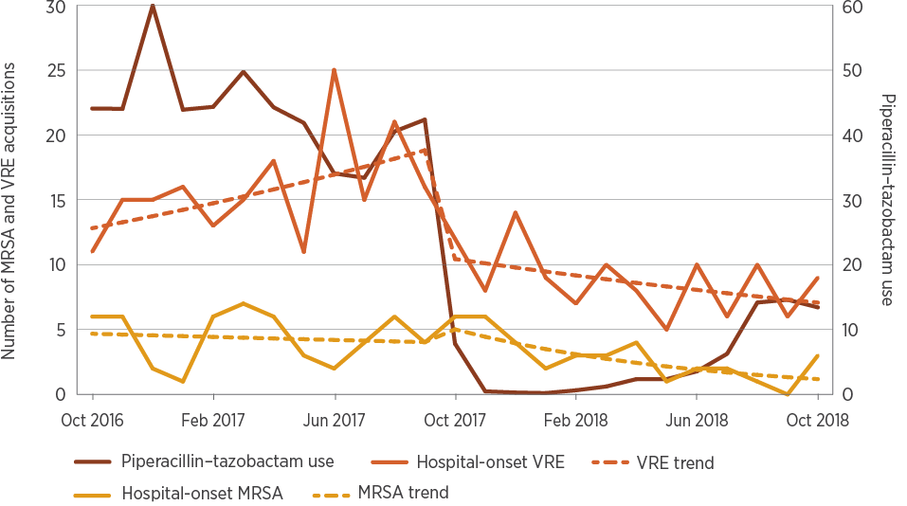
DDD/1,000 OBD = defined daily doses per 1,000 occupied bed days
Source: Ferguson JK, Kozierowski K, Munnoch SA, Oldmeadow C, Chiu S. Reduction in MRSA and VRE colonisation and infection associated with sustained reduction in broad spectrum antibiotic usage at a large tertiary hospital [article submitted to Medical Journal of Australia, January 2019].
Public Acute Group B Hospitals had the highest use of first-generation cephalosporins such as cefazolin (Figure 3.11). Cefazolin was the most frequently used agent of this class. Cefazolin is commonly used in surgical prophylaxis, as well as in skin, soft tissue and joint infections.
Antibiotic use varies substantially within and between public and private hospital peer groups. Among Principal Referral Hospitals, usage rates ranged from 707 DDDs per 1,000 OBDs to 1,378 DDDs per 1,000 OBDs in 2017 (Figure 3.15).
The main reasons for this variation are differences in casemix of Principal Referral Hospitals, differences in local resistance patterns and local prescribing variations. The variation was even more pronounced in the Public Acute Group A Hospitals (Figure 3.16), and Private Acute Group A, B and C Hospitals (Figure 3.17).
Figure 3.15: Annual total-hospital antibiotic usage rates (DDD/1,000 OBD) in Principal Referral Hospitals contributing to NAUSP, 2017
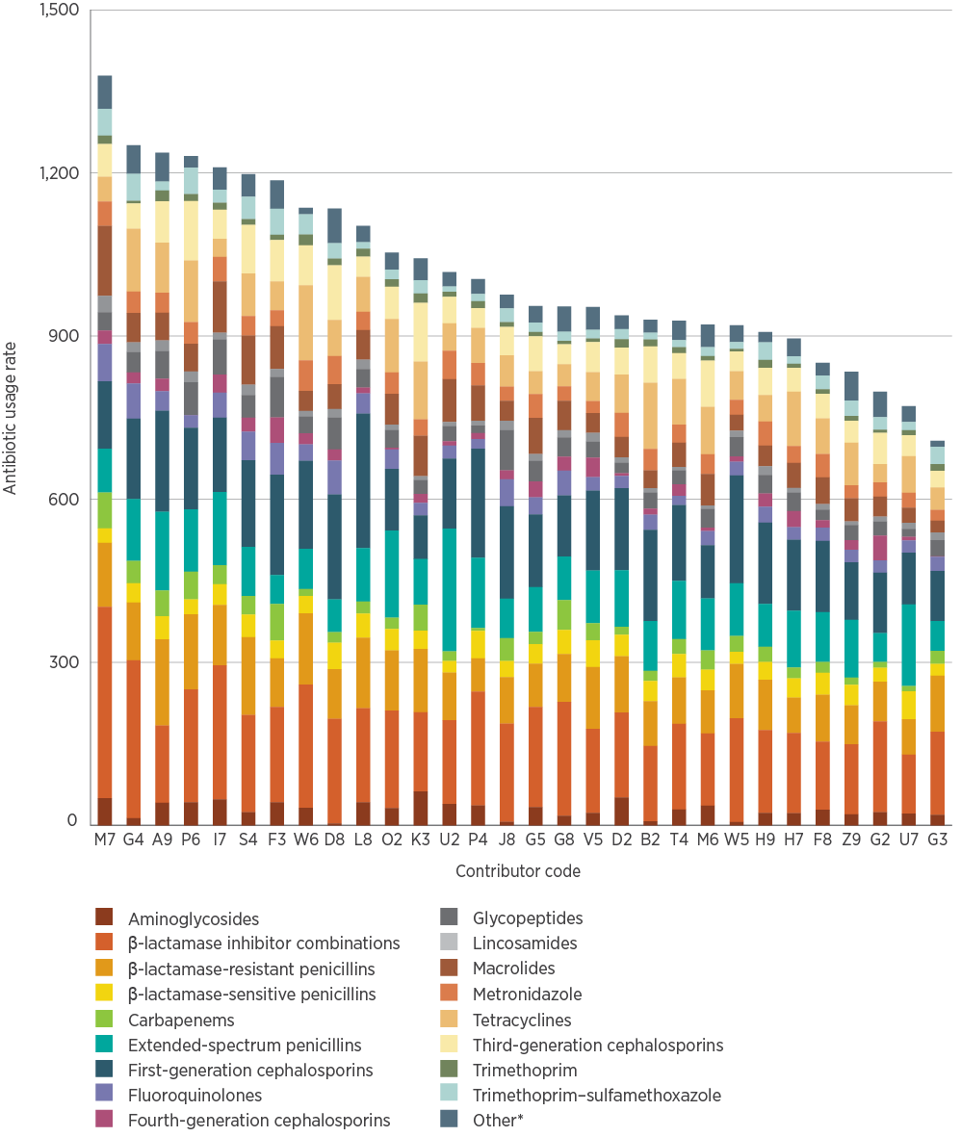
DDD/1,000 OBD = defined daily doses per 1,000 occupied bed days
* Refers to alimentary antibiotics (rifaximin and fidaxomicin), amphenicols (chloramphenicol), monobactams, nitrofurans (nitrofurantoin), linezolid, daptomycin, fosfomycin, ceftaroline, ceftolozane–tazobactam, polymyxins (colistin and polymyxin B), rifamycins (rifampicin), second-generation cephalosporins, steroids (fusidic acid), streptogramins (pristinamycin) and streptomycin
Source: NAUSP⁵
Figure 3.16: Annual total-hospital antibiotic usage rate (DDD/1,000 OBD) in Public Acute Group A hospitals contributing to NAUSP, 2017
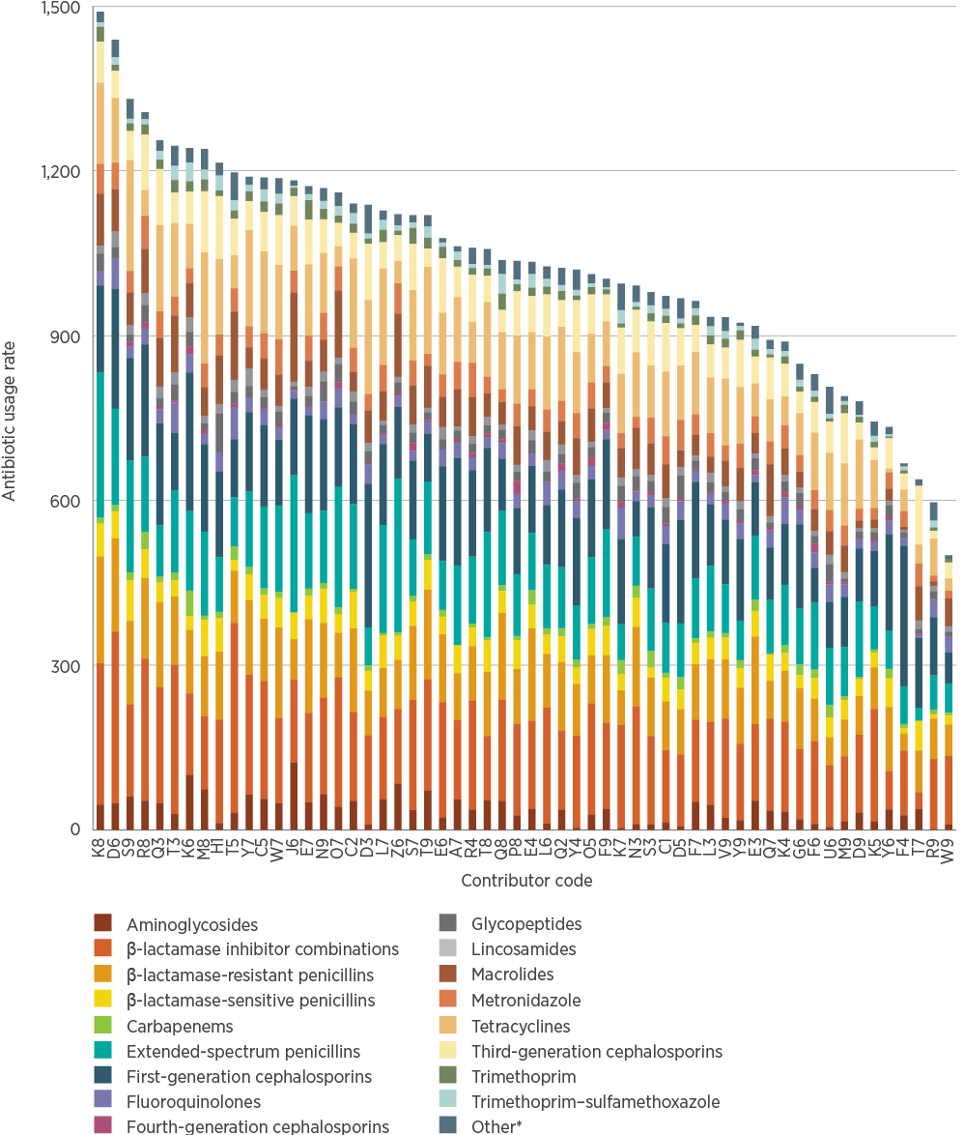
DDD/1,000 OBD = defined daily doses per 1,000 occupied bed days
* Refers to alimentary antibiotics (rifaximin and fidaxomicin), amphenicols (chloramphenicol), monobactams, nitrofurans (nitrofurantoin), linezolid, daptomycin, fosfomycin, ceftaroline, ceftolozane–tazobactam, polymyxins (colistin and polymyxin B), rifamycins (rifampicin), second-generation cephalosporins, steroids (fusidic acid), streptogramins (pristinamycin) and streptomycin
Source: NAUSP⁵
Figure 3.17: Annual total-hospital antibiotic usage rate (DDD/1,000 OBD) in private hospitals contributing to NAUSP, by peer group, 2017
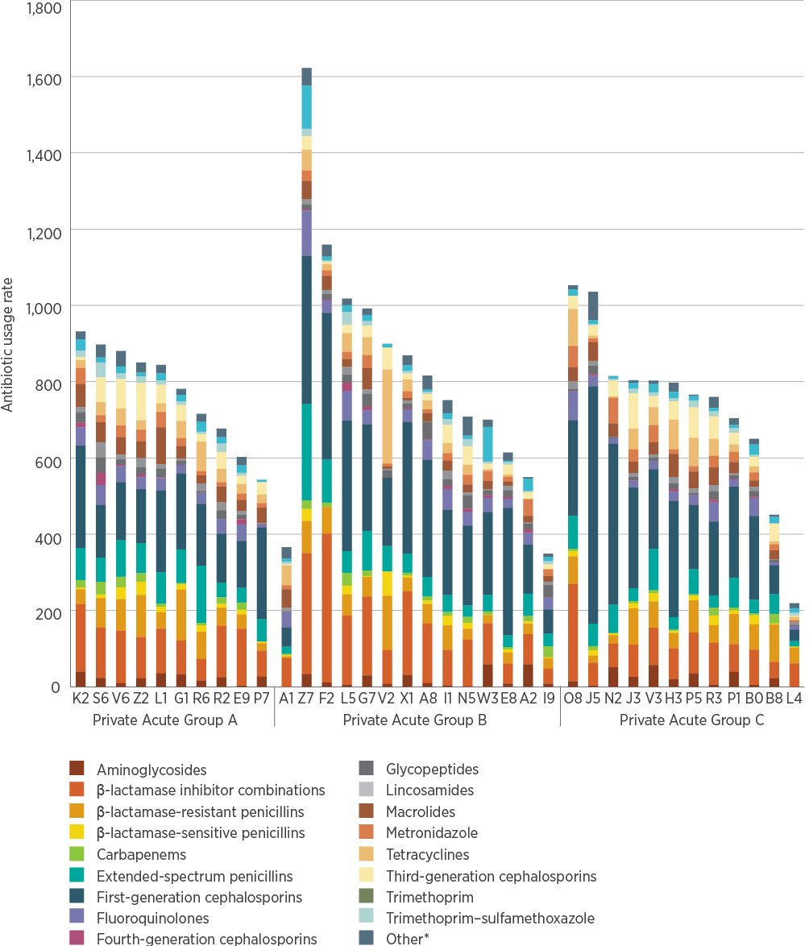
DDD/1,000 OBD = defined daily doses per 1,000 occupied bed days
* Refers to alimentary antibiotics (rifaximin and fidaxomicin), amphenicols (chloramphenicol), monobactams, nitrofurans (nitrofurantoin), linezolid, daptomycin, fosfomycin, ceftaroline, ceftolozane–tazobactam, polymyxins (colistin and polymyxin B), rifamycins (rifampicin), second-generation cephalosporins, steroids (fusidic acid), streptogramins (pristinamycin) and streptomycin
Source: NAUSP⁵

Appropriateness of prescribing in hospitals
Australian hospitals undertake targeted surveillance of the appropriateness of antimicrobial prescribing using the Hospital NAPS and Surgical NAPS.
Participation in the Hospital NAPS steadily increased from 2013 to 2017, and the number of prescriptions and hospitals for which data were submitted more than doubled (Table 3.4). This is a positive outcome for the AURA Surveillance System because it increases the representativeness of the data. All facilities that performed either a hospital-wide point prevalence survey, a repeat point prevalence survey or a randomised sample are included in the analyses.
The cohort of participating hospitals changed over the period from 2013 to 2017.
In 2017, almost one-third (32.7%) of the 21,034 prescriptions that were assessable did not comply with guidelines. In addition, almost one-quarter (23.5%) of the 24,987 prescriptions that were assessable were classified as inappropriate. Results for the key indicators of appropriateness of antimicrobial prescribing included (Table 3.5):
Improvement in documentation of indication from 70.5% to 77.7%
Improvement in documentation of review or stop date from 34.8% (in 2015) to 40.5%
Reduction in the proportion of surgical prophylaxis given for more than 24 hours from 41.1% to 30.5%
Decline in compliance with Therapeutic Guidelines: Antibiotic or local guidelines from 72.1% to 67.3%
Static rate of overall appropriateness of prescribing of approximately 76% each year.
From 2013 to 2017, appropriateness of prescribing improved in some measures – for example, documentation of indication increased from 70.5% to 77.7%.
Table 3.4: Participation in NAPS, 2013–2017
Year | Prescriptions (n) | Patients (n) | Facilities (n)
2013 | 12,800 | 7,700 | 151
2014 | 19,994 | 12,634 | 248
2015 | 22,021 | 14,389 | 281
2016* | 25,661 | 17,040 | 325
2017 | 26,277 | 17,366 | 314
* The data in Table 3.4 for 2016 are different from those reported in the 2016 Hospital NAPS report. This is because the data collection period changed to calendar years from 2017 to align with other antimicrobial usage reports.
Source: Hospital NAPS^{4,11}
Table 3.5: Results for key Hospital NAPS indicators, 2013–2017
Key indicator | Category | Percentage of total prescriptions 2013 | Percentage of total prescriptions 2014 | Percentage of total prescriptions 2015 | Percentage of total prescriptions 2016 | Percentage of total prescriptions 2017
Indication documented in medical notes (best practice >95%) | n/a | 70.5 | 74.6 | 71.9 | 75.5 | 77.7
Review or stop date documented (best practice >95%) | n/a | n/a | n/a | 34.8 | 38.0 | 40.5
Surgical prophylaxis given for >24 hours (best practice <5%)* | n/a | 41.1 | 36.1 | 26.9 | 30.0 | 30.5
Compliance with guidelines | Compliant with Therapeutic Guidelines: Antibiotic or local guidelines† | 58.6 (72.1) | 56.9 (70.5) | 55.6 (70.0) | 52.1 (66.0) | 54.0 (67.3)
 | Noncompliant† | 22.7 (27.9) | 23.8 (29.5) | 23.8 (30.0) | 26.9 (34.0) | 26.2 (32.7)
 | Directed therapy | n/a | 9.5 | 12.0 | 12.7 | 12.6
 | No guideline available | 12.0 | 5.3 | 3.7 | 4.0 | 3.3
 | Not assessable | 6.6 | 4.5 | 5.0 | 4.4 | 3.9
Appropriateness | Appropriate: optimal and adequate§ | 70.8 (75.8) | 72.1 (75.7) | 72.3 (76.4) | 72.2 (76.2) | 72.9 (76.5)
 | Inappropriate: suboptimal and inadequate§ | 22.6 (24.2) | 23.2 (24.3) | 22.3 (23.6) | 22.5 (23.8) | 22.4 (23.5)
 | Not assessable | 6.6 | 4.7 | 5.4 | 5.3 | 4.7
n/a = not applicable
* Where surgical prophylaxis was selected as the indication (n = 3,397 in 2017)
† Figures in brackets represent the percentage of prescriptions for which compliance was assessable (21,034 prescriptions in 2017). These exclude prescriptions determined to be ‘directed therapy’, ‘not available’ or ‘not assessable’ (5,193 prescriptions in 2017).
§ Figures in brackets represent the percentage of prescriptions for which appropriateness was assessable (24,987 prescriptions in 2017). These exclude prescriptions determined to be ‘not assessable’ (2,193 prescriptions in 2017).
Note: For the purposes of this report, and to facilitate data analysis in the future, all historical and current Hospital NAPS data have been reanalysed by calendar year. When comparing the graphs and figures with previous Hospital NAPS reports, there may be some minor differences in the reporting of historical data.
Source: Hospital NAPS⁴
Several factors may influence these changes in compliance with guidelines or appropriateness over time. These include changes in the characteristics of hospitals participating in the audit, and the result of sustained audit and action on the results.
It is interesting to note that compliance with guidelines decreased, but overall appropriateness remained static. One possible explanation is that the nature of the prescription is affected by increasing AMR in clinical care settings. A prescription can be assessed as appropriate but not compliant with guidelines if a patient has a risk factor or personal history of AMR requiring broader therapy than is recommended in guidelines. Another explanation may be differences in assessing what constitutes a reasonable prescriber choice – a prescriber may select a treatment for a patient that is not compliant with guidelines but is clinically justifiable, and would be assessed as appropriate. Finally, the range of contributing facilities may account for this pattern – the increase in appropriateness in longer-term contributors may be offset by new contributors with lower rates of compliance and appropriateness.
In 2017, almost one-third (32.7%) of the 21,034 prescriptions that were assessable did not comply with guidelines. In addition, almost one-quarter (23.5%) of the 24,987 prescriptions that were assessable were classified as inappropriate.
The 2016³ and 2017⁴ Hospital NAPS reports show that the antimicrobials with the highest rates of inappropriate prescribing were cephalosporins (such as cefalexin, cefazolin and ceftriaxone) and amoxicillin–clavulanic acid (Figure 3.18; Table 3.6). These were also among the most commonly prescribed antibiotics: cefazolin (12%), ceftriaxone (9.7%), amoxicillin–clavulanic acid (6.6%), metronidazole (6.1%) and doxycycline (5.4%). Consistent with previous Hospital NAPS results, rates of appropriateness were higher for narrow-spectrum agents such as flucloxacillin, benzylpenicillin and trimethoprim.⁴ Eight of the top 10 antimicrobials used, as reported by NAPS and NAUSP, were also included in the top 10 antimicrobials with the highest rates of inappropriate use. Agents with high use often have high rates of inappropriate use.
Table 3.6: Appropriateness of prescribing for the 20 most commonly prescribed antimicrobials in public and private hospitals contributing to NAPS, 2017
Antimicrobial | Appropriate (%) | Inappropriate (%) | Not assessable (%)
Valaciclovir | 92.1 | 2.8 | 5.0
Trimethoprim–sulfamethoxazole | 87.2 | 6.8 | 6.0
Vancomycin | 84.8 | 12.4 | 2.8
Flucloxacillin | 84.3 | 13.6 | 2.1
Benzylpenicillin | 83.9 | 14.3 | 1.7
Meropenem | 83.1 | 12.9 | 4.0
Nystatin | 82.8 | 10.1 | 7.1
Trimethoprim | 79.6 | 18.0 | 2.4
Gentamicin | 79.3 | 17.9 | 2.8
Piperacillin–tazobactam | 76.1 | 20.4 | 3.5
Doxycycline | 74.1 | 20.7 | 5.2
Ciprofloxacin | 72.6 | 20.3 | 7.1
Azithromycin | 70.6 | 25.4 | 4.0
Amoxicillin | 69.3 | 25.7 | 5.0
Cefazolin | 69.2 | 28.9 | 1.9
Ceftriaxone | 68.5 | 28.1 | 3.3
Metronidazole | 67.9 | 27.3 | 4.8
Clotrimazole | 66.6 | 20.0 | 13.4
Amoxicillin–clavulanic acid | 63.7 | 29.4 | 6.8
Cefalexin | 50.4 | 43.3 | 6.4

Figure 3.18: Appropriateness of prescribing for the 20 most commonly prescribed antimicrobials in public and private hospitals contributing to NAPS, 2017
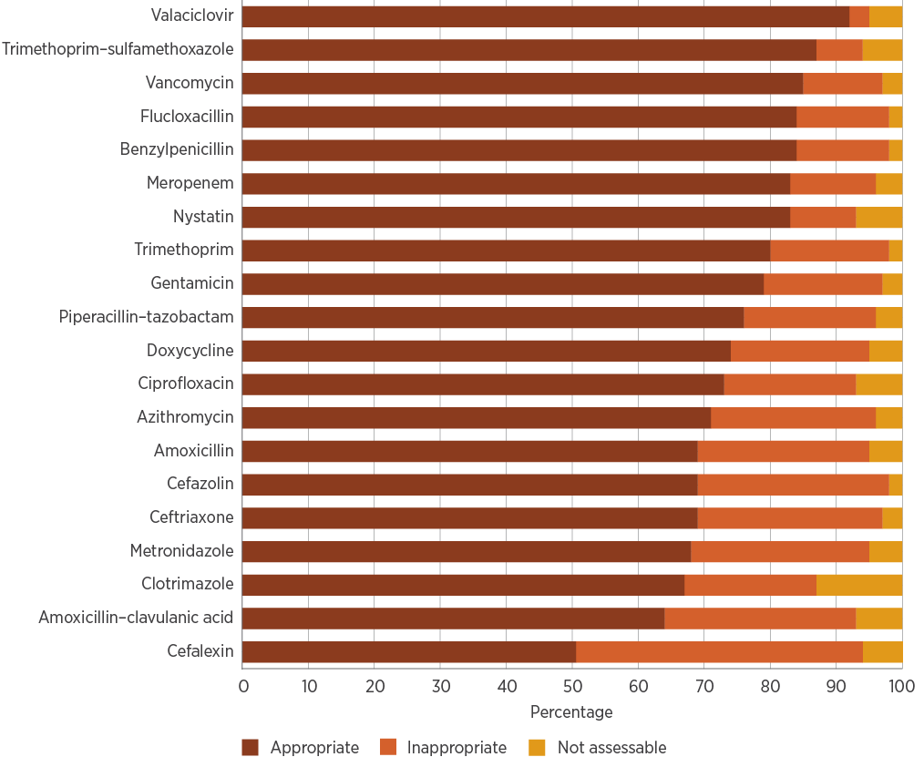
Source: Hospital NAPS⁴
The most common indications for antimicrobial use remained the same from 2013 to 2017 (Figure 3.19; Table 3.7). Surgical prophylaxis was the most common reason for a patient to receive an antimicrobial prescription during their hospital stay. This proportion decreased to 13.0% in 2017, after peaking at 15.6% in 2015. The decrease may be due to a reduction in prescriptions related to surgical prophylaxis being audited or a relative increase in the other prescribing indications. Prescribing for community-acquired pneumonia has gradually increased, as part of the overall percentage, from 2013, rising to 12.5% in 2017 (Figure 3.19; Table 3.7).
Table 3.7: The 20 most common indications for prescribing in public and private hospitals contributing to NAPS, 2013–2017
Indication | 2013 (%) | 2014 (%) | 2015 (%) | 2016 (%) | 2017 (%)
Surgical prophylaxis | 12.0 | 12.5 | 15.6 | 14.3 | 13.0
Pneumonia: community acquired | 10.6 | 12.2 | 11.1 | 11.9 | 12.5
Medical prophylaxis | 8.6 | 7.1 | 7.2 | 7.3 | 7.3
Urinary tract infection | 6.7 | 7.4 | 6.4 | 6.1 | 6.4
Sepsis | 5.5 | 6.1 | 5.6 | 5.6 | 5.8
Cellulitis/erysipelas | 4.1 | 4.6 | 4.2 | 4.3 | 4.2
COPD: infective exacerbation | 3.7 | 4.0 | 3.7 | 3.6 | 3.7
Pneumonia: hospital acquired | 2.8 | 2.4 | 2.5 | 2.7 | 2.6
Cutaneous and mucosal candidiasis | 2.6 | 2.4 | 3.4 | 3.8 | 3.4
Pneumonia: aspiration | 2.4 | 2.1 | 1.9 | 2.0 | 2.1
Wound infection: surgical | 2.2 | 2.0 | 1.8 | 1.8 | 2.0
Abscess: skin and soft tissue | 2.2 | 1.9 | 1.9 | 1.9 | 1.8
Trauma (including wound) | 1.6 | 1.7 | 1.6 | 1.5 | 1.5
Febrile neutropenia | 1.4 | 1.6 | 1.3 | 1.5 | 1.2
Osteomyelitis | 1.4 | 1.4 | 1.3 | 1.3 | 1.4
Diverticulitis | 1.2 | 1.4 | 1.5 | 1.3 | 1.6
Appendicitis | 1.2 | 1.0 | 0.9 | 1.0 | 1.0
Peritonitis | 1.1 | 0.8 | 1.1 | 1.0 | 1.2
Diabetic infection (including foot) | 0.9 | 1.0 | 1.0 | 1.0 | 1.0
Pyelonephritis | 0.7 | 1.0 | 0.9 | 0.9 | 1.1

Figure 3.19: The 20 most common indications for prescribing in public and private hospitals contributing to NAPS, 2013–2017
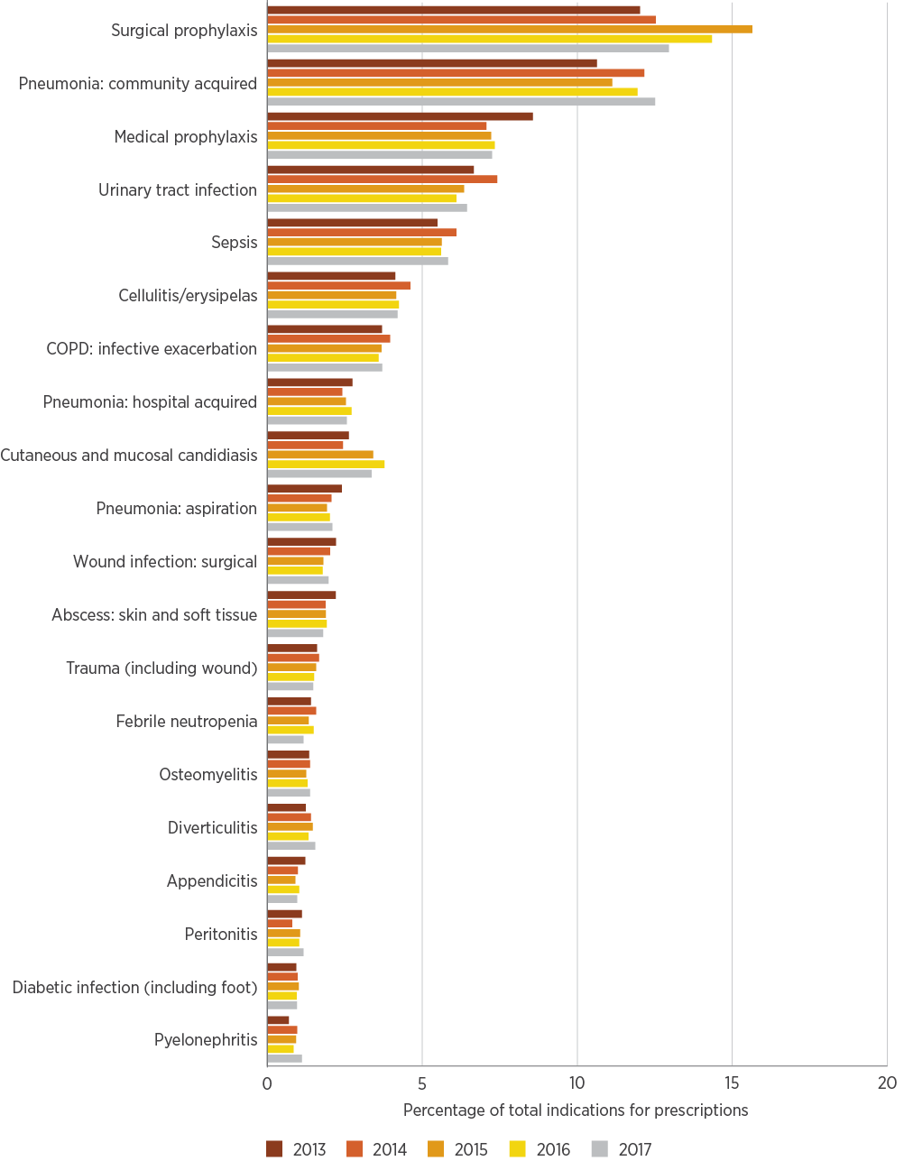
COPD = chronic obstructive pulmonary disease
Source: Hospital NAPS⁴
The reasons for inappropriate prescribing were varied. Reasons included spectrum too broad (21.9% of prescriptions assessed as inappropriate), incorrect dose or frequency (20.1%) and antimicrobial not required (17.5%). The proportion of prescriptions assessed as having an incorrect duration rose from 17.8% in 2015 to 20.3% in 2016, but dropped to 16.5% in 2017.
In 2017, 30.5% of surgical prophylaxis prescriptions for hospital patients extended 24 hours or more beyond the time of surgery (Table 3.5). This is despite guidelines recommending surgical prophylaxis durations of up to 24 hours. Prescriptions were also assessed as inappropriate if:
The spectrum of the antimicrobial was too broad or too narrow (more often too broad) for the causative organisms known to cause surgical site infections
They were inconsistent with guidelines, with no indication of patient characteristics that would require variation
The wrong dose was prescribed.
In 2017, 30.5% of surgical prophylaxis prescriptions for hospital patients extended 24 hours or more beyond the time of surgery, despite guidelines recommending durations of up to 24 hours.
Of the 20 most common indications for prescribing antimicrobials in 2017 (Figure 3.20; Table 3.8), the conditions for which the highest proportions of prescriptions were assessed as inappropriate were surgical prophylaxis (40.3%), infective exacerbation of chronic obstructive pulmonary disease (COPD) (37.8%) and trauma (29.3%). The indications with the highest rates of appropriateness were medical prophylaxis (88.2%), appendicitis (87.0%), peritonitis (86.6%), osteomyelitis (86.5%) and sepsis (86.4%). Of the antimicrobials indicated for sepsis, 12.1% were assessed as inappropriate; this is particularly concerning given the importance of appropriate antibiotic use in sepsis.
Respiratory tract infections as a group include infective exacerbation of COPD, community-acquired pneumonia, aspiration pneumonia and hospital-acquired pneumonia. These indications have below-average levels of appropriate prescribing. Infective exacerbation of COPD is notable in this regard, but contributes a lower rate of inappropriate prescribing overall than community-acquired pneumonia, which is more common.
Respiratory tract infections as a group have below-average levels of appropriate prescribing.
In 2017, 26.2% of prescriptions were reported as being noncompliant with either local guidelines or Therapeutic Guidelines: Antibiotic. There has been no improvement in this indicator over time (Table 3.5).
Figure 3.20: Appropriateness of prescribing for the 20 most common indications in hospitals, 2017
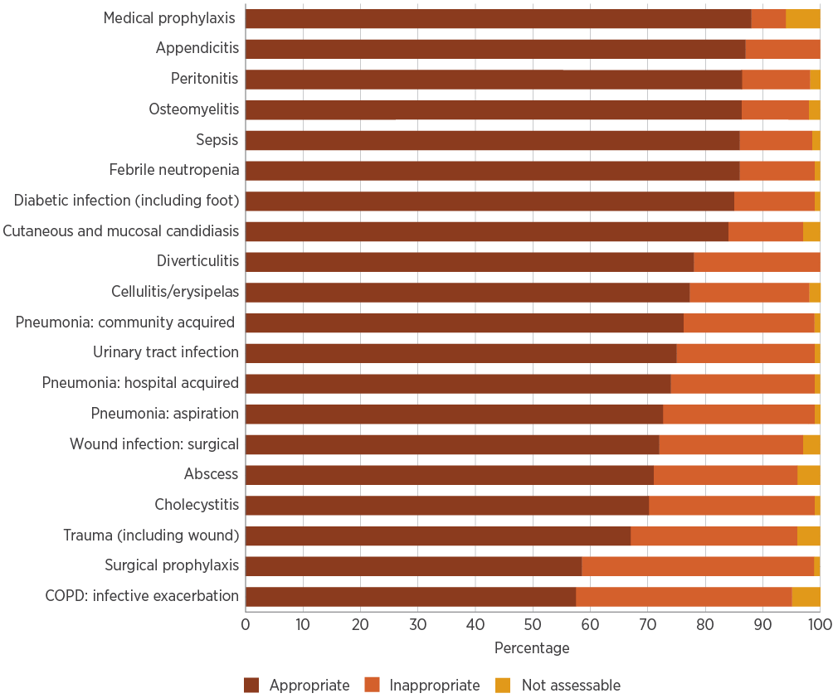
COPD = chronic obstructive pulmonary disease
Source: Hospital NAPS⁴
Table 3.8: Appropriateness of prescribing for the 20 most common indications in hospitals, 2017
Condition | Appropriate (%) | Inappropriate (%) | Not assessable (%)
Medical prophylaxis | 88.2 | 6.1 | 5.7
Appendicitis | 87.0 | 13.0 | 0.0
Peritonitis | 86.6 | 11.7 | 1.6
Osteomyelitis | 86.5 | 11.3 | 2.2
Sepsis | 86.4 | 12.1 | 1.5
Febrile neutropenia | 86.3 | 12.7 | 1.0
Diabetic infection (including foot) | 85.0 | 14.2 | 0.8
Cutaneous and mucosal candidiasis | 84.3 | 12.7 | 3.1
Diverticulitis | 78.1 | 21.7 | 0.2
Cellulitis/erysipelas | 77.8 | 20.5 | 1.7
Pneumonia: community acquired | 76.7 | 22.6 | 0.6
Urinary tract infection | 74.7 | 23.9 | 1.4
Pneumonia: hospital acquired | 73.9 | 25.2 | 0.9
Pneumonia: aspiration | 72.1 | 26.4 | 1.4
Wound infection: surgical | 71.9 | 25.0 | 3.1
Abscess | 71.1 | 24.6 | 4.2
Cholecystitis | 70.4 | 28.9 | 0.8
Trauma (including wound) | 66.6 | 29.3 | 4.1
Surgical prophylaxis | 58.3 | 40.3 | 1.4
COPD: infective exacerbation | 57.5 | 37.8 | 4.7
Source: Hospital NAPS⁴

Appropriateness of prescribing in hospitals: Surgical National Antimicrobial Prescribing Survey
The Surgical NAPS is an audit tool that allows facilities to review their use of procedural and post-procedural surgical antimicrobial prophylaxis. Procedural prophylaxis is defined as any antimicrobial administered either immediately before or during the procedure for purposes of prophylaxis. Post-procedural antimicrobial prophylaxis is defined as any antimicrobial given immediately after the surgical procedure for the purposes of surgical prophylaxis. The Surgical NAPS uses antimicrobial use beyond 48 hours as a marker for prolonged post-procedural prophylaxis, whereas the Hospital NAPS uses 24 hours. This is because, in many cases, the administration time for antimicrobials used for procedural surgical prophylaxis is not recorded, so duration can only be determined on the basis of calendar days as opposed to exact durations of therapy.
In the 2017 Surgical NAPS, 7,183 procedural episodes and 6,428 post-procedural episodes were assessed. Cardiac surgery had the highest rate of inappropriate antimicrobial prescribing (Figure 3.21; Table 3.9), but the number of cardiac surgery episodes (156) was low compared with orthopaedic surgery (1,701 episodes).
In 2017, procedural prophylaxis was deemed inappropriate for 2,443 surgical episodes (34.0%). The proportion of inappropriateness was higher for surgical episodes in which procedural antimicrobials had been prescribed than for surgical episodes in which procedural antimicrobials had not been prescribed when they were indicated.
A total of 127 doses of procedural antimicrobials were administered topically; of these, only 6.3% were assessed as appropriate. For procedural surgical episodes that were deemed to require antimicrobials, the most common reasons for inappropriateness were incorrect timing (n = 988; 44.6%), incorrect dosage (n = 487; 26.9%) and spectrum too broad (n = 248; 13.7%).
In 2017, procedural prophylaxis was deemed inappropriate for 2,443 surgical episodes (34.0%). Post-procedural prophylaxis was deemed inappropriate for 1,239 surgical episodes (19.3%).
Post-procedural prophylaxis was assessed as inappropriate for 1,239 surgical episodes (19.3%). A total of 2,075 episodes (32.3%) had at least one post-procedural antimicrobial prescribed for prophylaxis, of which 1,218 episodes (58.7%) involved a prescription with an element that was deemed inappropriate. The craft groups with the highest rate of inappropriateness for post-procedural surgical prophylaxis were breast surgery (95.3%), dentoalveolar surgery (88.7%) and gynaecological surgery (87.5%). For post-procedural surgical episodes that were deemed to require antimicrobials, the most common reasons for inappropriateness were incorrect duration (n = 347; 59.6%), incorrect dose or frequency (n = 198; 34.0%) and spectrum too broad (n = 59; 10.1%).
There was a large difference between public and private hospitals in the duration of post-procedural surgical prophylaxis. Antimicrobials were prescribed for longer than 48 hours in 37.9% (n = 470) of public hospital prescriptions and 27.6% (n = 320) of private hospital prescriptions. Post-procedural prophylaxis delivered by non-intravenous routes (oral, ocular, topical and enteral) had a median of six to seven days of therapy. This emphasises the importance of reviewing all surgical prophylaxis, not just agents that are intravenously administered. The post-procedural antimicrobials with the highest rates of inappropriateness were dicloxacillin (92.9%; n = 14), trimethoprim (90.9%; n = 22) and amoxicillin (88.6%; n = 44).
Figure 3.21: Appropriateness of prescribing for total surgical procedures (procedural and post-procedural), Surgical NAPS contributor hospitals, 2017
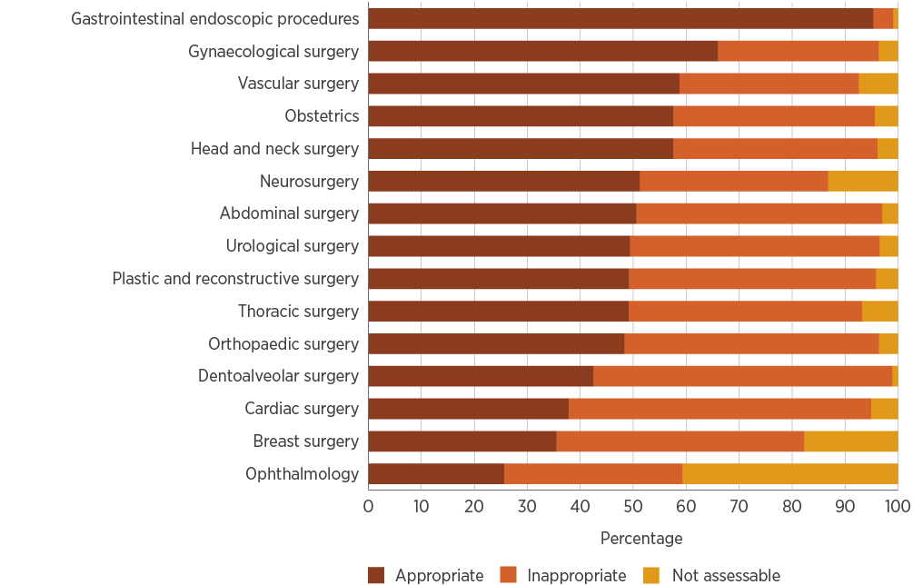
Source: NCAS¹²
Table 3.9: Appropriateness of prescribing for surgical procedures, Surgical NAPS contributor hospitals, 2017
Procedure | Appropriate (%) | Inappropriate (%) | Not assessable (%)
Gastrointestinal endoscopic procedures | 95.3 | 3.8 | 0.9
Gynaecological surgery | 66.0 | 30.3 | 3.7
Vascular surgery | 58.7 | 33.9 | 7.4
Obstetrics | 57.6 | 38.0 | 4.4
Head and neck surgery | 57.5 | 38.6 | 3.9
Neurosurgery | 51.2 | 35.6 | 13.2
Abdominal surgery | 50.6 | 46.4 | 3.0
Urological surgery | 49.4 | 47.1 | 3.5
Plastic and reconstructive surgery | 49.2 | 46.6 | 4.2
Thoracic surgery | 49.1 | 44.1 | 6.8
Orthopaedic surgery | 48.3 | 48.1 | 3.6
Dentoalveolar surgery | 42.5 | 56.4 | 1.1
Cardiac surgery | 37.8 | 57.1 | 5.1
Breast surgery | 35.5 | 46.8 | 17.7
Ophthalmology | 25.6 | 33.7 | 40.7

3.2 Commentary – acute hospitals

Overall antimicrobial use
In 2017, hospital antibiotic use increased slightly, on a DDD/1,000 OBD basis, after three years of sustained decline. However, there has been an overall downward trend in hospital antibiotic use since 2010. The increase in 2017 may be the result of factors such as antibiotic shortages, including the piperacillin–tazobactam shortage in 2017, and changes in the hospitals contributing data.
The piperacillin–tazobactam shortage in 2017 demonstrated the impact that external factors can have on prescribing. The full flow-on effects from this shortage for AMR in Australia are not yet known.
It appears that the shortage has expedited the introduction of intravenous amoxicillin–clavulanic acid in Australia, which is not recommended in the 2014 version of Therapeutic Guidelines: Antibiotic. However, it is understood that many facilities updated their local guidelines to reflect the appropriate use of intravenous amoxicillin–clavulanic acid. The preferential use of this agent by some states and territories led to striking differences in ceftriaxone use in 2017, which highlights the importance of national guidelines for appropriate prescribing practice. Some variation is expected between states and territories, due to differences in the epidemiology of infections.
From information to action
Using quality improvement methods to tackle surgical antibiotic prophylaxis
The New South Wales (NSW) Clinical Excellence Commission’s Antimicrobial Stewardship Expert Advisory Committee identified an opportunity to improve prescribing of antibiotics for surgical prophylaxis after a review of results from repeated Hospital National Antimicrobial Prescribing Surveys. A multidisciplinary working party was established to develop a suite of resources to support appropriate prescribing of antibiotics for surgical prophylaxis and improve patient safety. In February 2018, a process map, cause and effect diagram (Figure A) and driver diagram (Figure B) were developed to identify barriers and enablers to appropriate prescribing of antibiotics for surgical prophylaxis, and generate ideas for change. These resources are intended to be adapted to the local setting.
To test these resources, the Clinical Excellence Commission partnered with two Public Acute Group A Hospitals in NSW to conduct improvement projects. Each hospital formed a multidisciplinary project team and was trained in the Model for Improvement.¹ Both hospitals had historical audit data on indicators for surgical antibiotic prophylaxis. Based on these data, the selected focus for improvement was antibiotic prophylaxis for caesarean sections (Hospitals A and B) and cholecystectomies (Hospital B). To assess the impact of changes in practice, the proportion of patients who received appropriate surgical antibiotic prophylaxis (appropriate antibiotic choice, dose and timing) was measured over one year. A target of five patient records were audited weekly at each hospital. Changes were tested using plan–do–study–act (PDSA) cycles aligned with the Model for Improvement. The study was run at different times at the two sites: Hospital A started in January 2018 and Hospital B in March 2018.
Baseline data from Hospital A indicated that antibiotic choice, dose and duration for surgical prophylaxis were appropriate for caesarean sections. Documentation of timing of incision and antibiotic administration was poor, and was missing in 47% (14/30) of patient records at baseline (weeks 1–5). This made it difficult to determine whether the timing of antibiotic administration was appropriate. When documentation was complete and appropriateness of antibiotic timing could be assessed, data revealed that timing was suboptimal, so this became the key focus for improvement at Hospital A.
Baseline data from Hospital B identified that antibiotic choice for surgical prophylaxis was appropriate for both caesarean sections and cholecystectomies. Incorrect antibiotic dosing, and poor documentation of timing of incision and antibiotic administration were recognised as the key areas for improvement at Hospital B. Around 8% (8/104) of surgical prophylaxis prescriptions for the focus procedures were for longer than 24 hours; this is marginally higher than the best-practice target of 5% or less, and was therefore considered a lower priority.
To tackle the issues identified, primary drivers for change included improved documentation and communication, clinician engagement and education, standardisation, and knowledge of guidelines. The project team at each hospital developed change ideas to address these issues using PDSA cycles, including:
- Multidisciplinary education to address myths and gaps in knowledge
- Creation of a prompt to document incision time, antibiotic choice, antibiotic dose and administration time; the prompt took the form of a stamp on the anaesthetic record, as the facilities did not have electronic medical records
- Review of antibiotic products (agents and strengths) kept in theatre imprest (for example, introduction of 2-gram vials of cefazolin).
Hospital A improved from 11% (3/27) of patients receiving timely perioperative antibiotics in weeks 1–5 to 40% (12/30) in weeks 33–37. This process measure also improved in Hospital B, from 29% (6/21) in weeks 1–5 to 75% (15/20) in weeks 23–27. The proportion of patients who received the correct antibiotic dose also increased during the same period in Hospital B, from 62% (13/21) to 90% (18/20). Data collection for both hospitals continues as new change ideas are tested.
Using small samples of data (5 to 10 patient records weekly) collected on an ongoing basis is an effective component of quality improvement methodology. It can show whether changes being tested are leading to an improvement, while also providing a sustainable audit method. This small sample is acceptable for measuring quality improvement; it is not appropriate for a research project.
A suite of resources to support a surgical antibiotic prophylaxis improvement project is available from the NSW Clinical Excellence Commission.²
Figure A: Cause-and-effect diagram for inappropriate surgical antibiotic prophylaxis
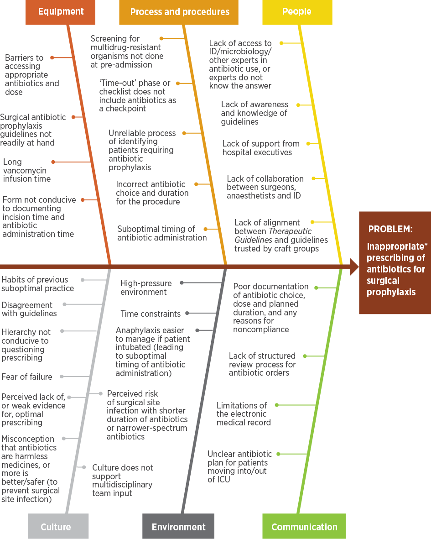
ICU = intensive care unit; ID = infectious diseases * Inappropriate in relation to choice of antibiotic, dose, route, timing of administration or duration Source: NSW Clinical Excellence Commission3
Figure B: Driver diagram for surgical antibiotic prophylaxis
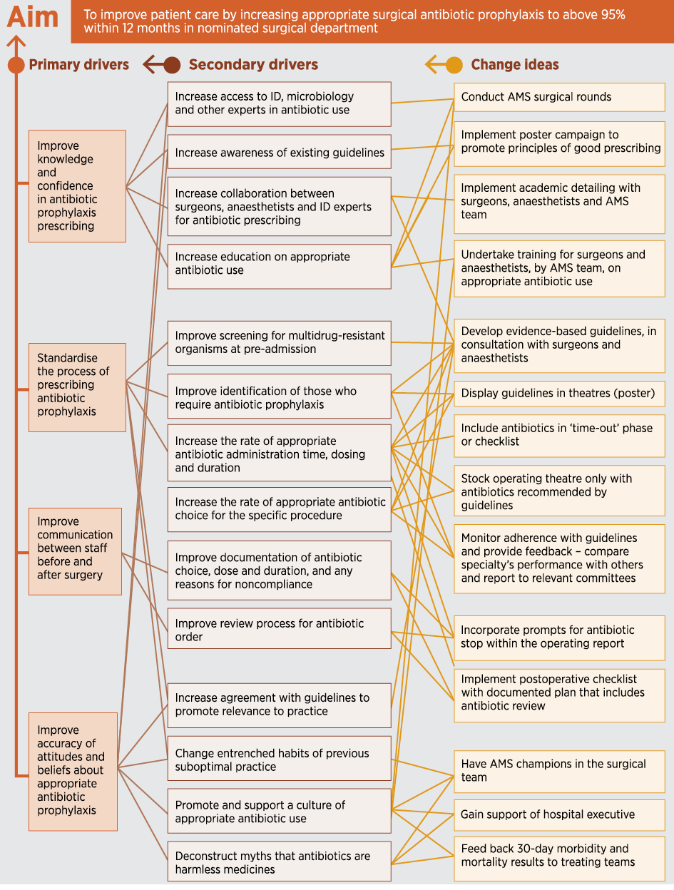
AMS = antimicrobial stewardship; ID = infectious diseases Source: NSW Clinical Excellence Commission³
References
1. Institute for Healthcare Improvement (US). How to improve. Boston (MA): Institute for Healthcare Improvement; 2019 [cited 2019 Jan 16].
2. NSW Clinical Excellence Commission. Surgical antibiotic prophylaxis. Sydney: NSW Clinical Excellence Commission; 2019 [cited 2019 Jan 16].
3. NSW Clinical Excellence Commission. Surgical antibiotic prophylaxis: quality improvement tools. Sydney: NSW Clinical Excellence Commission; 2019 [cited 2019 Jan 16].
The piperacillin–tazobactam shortage in 2017 demonstrated the impact that external factors can have on prescribing. The full flow-on effects from this shortage for antimicrobial resistance in Australia are not yet known.
Variation among states and territories in use of antibiotic classes was also apparent; the reasons are not clear. Differences in epidemiology or resistance patterns are unlikely to fully explain this finding. Behavioural and cultural characteristics of prescribers have been identified as important reasons for variations in antibiotic selection and use.¹³ Variation in practices between facilities creates challenges for trainee medical staff who move between facilities on regular rotations, and may also move across states and territories. AMS education programs that are robust and facility-specific can support consistent and appropriate prescribing, and improve practice.

Appropriateness of prescribing
Between 2013 and 2017, several key quality indicators of antimicrobial prescribing improved among Hospital NAPS contributors. These included increases in the rate of documentation of indication for prescribing antimicrobials in participating hospitals, and in the rate of documentation of an antimicrobial review or stop date. In 2017, in response to these improvements in the quality of documentation, fewer prescriptions were deemed to be not assessable.
The relatively stable levels of appropriate prescribing and guideline compliance nationally may mask local changes in prescribing appropriateness reported by state and territory stakeholders. This reaffirms the importance of individual institutions monitoring their own trends over time, as required by the Preventing and Controlling Healthcare-Associated Infection Standard. Institutional prescribing behaviour change takes time. It is likely that hospitals with more mature AMS programs have made greater gains in compliance and appropriateness than hospitals with new or less well developed AMS programs. However, improvements under mature AMS programs with consistent NAPS participation are difficult to identify in national aggregate data.
Historically, the Hospital NAPS has shown a large proportion of inappropriate prescribing for many indications involving unrestricted antibiotics, such as oral cefalexin and amoxicillin–clavulanic acid, and intravenous therapies such as cefazolin.⁴ To achieve real improvements for these commonly used antibiotics, dedicated activities are required to change prescribing practice. The reasons for inappropriate prescribing vary, and must be considered critically, based on desired outcomes for improvement at the local level. Reasons for variation may include lack of guideline awareness, difficulties in accessing guidelines and clinician preference.
Prescriptions for broad-spectrum antibiotics are common targets for AMS programs because of concerns about the impact on development of AMR. However, these prescriptions account for only 21.9% of inappropriate prescriptions. Other practices affecting inappropriateness include incorrect doses or frequencies, which occurs at similar levels to ‘spectrum too broad’, closely followed by prescription of antimicrobials that are not indicated. Incorrect duration decreased from 20.3% in 2016 to 16.5% in 2017. Reduction in inappropriate duration is probably a reflection of more prudent use of antimicrobials in hospitals. Targeting changes in the duration of antimicrobials within one prescribing episode may not necessarily have a large impact on all prescriptions reported for the Hospital NAPS. However, duration changes may be very important, particularly if interventions target conditions that have high levels of use of broad-spectrum antibiotics.

Surgical prophylaxis
Data from both the Hospital NAPS and the Surgical NAPS demonstrate that surgical prophylaxis should remain a target area for improvement. In the Hospital NAPS, although there has been a downward trend between 2013 and 2017 in the rate of prescribing of antimicrobials for surgical prophylaxis for longer than 24 hours, the rate is still well above the best-practice target of less than 5%. In 2017, 30.5% of antimicrobial prescriptions for surgical prophylaxis were for longer than 24 hours. Because surgical prophylaxis remains the most common indication for prescribing antimicrobials (13% of all antimicrobial prescriptions) and has the highest proportion of inappropriate prescribing in hospitals, these results are cause for concern and attention.
The Surgical NAPS results provided more detail on prescribing of surgical prophylaxis. Procedural surgical prophylaxis was deemed to be inappropriate in 34% of cases, and the most common reason was incorrect timing of antibiotics (44.6% of prescriptions that were deemed inappropriate). Post-procedural surgical prophylaxis was deemed to be inappropriate in 19.3% of cases, and the most common reason was prolonged duration of therapy (59.6% of prescriptions that were deemed inappropriate). Generally, topical antibiotics were also poorly prescribed for surgical prophylaxis, whether procedurally or post-procedurally. Tailored quality improvement approaches are required to address variations in volume and appropriateness of prescribing for surgical prophylaxis.

Respiratory infections
Prescribing for respiratory infections continues to feature as an area of inappropriate prescribing in the Hospital NAPS. However, it is important to consider both the frequency of the indication and its rate of inappropriateness when determining areas to target for improvement interventions.
For example, in 2017, community-acquired pneumonia was the second most common reason for prescribing antimicrobials (12.5% of prescriptions), and 22.5% of these prescriptions were assessed as inappropriate. COPD was the seventh most common reason for prescribing antimicrobials (3.7% of prescriptions), and 37.8% of these prescriptions were assessed as inappropriate. Although community-acquired pneumonia had a lower proportion of inappropriate prescribing, the impact on the total proportion of inappropriate prescribing is higher. This is because the point prevalence of community-acquired pneumonia (2.8%) is double that of infective exacerbation of COPD (1.4%). In 2016–17, there were 100,000 admissions to Australian hospitals for ‘pneumonia, unspecified’ and 86,000 admissions for COPD (with and without infections). This means that interventions to improve prescribing practice should consider the total burden of inappropriate prescribing in terms of both the number of patients and the rate of inappropriate prescribing.
Interventions to improve prescribing practice should consider the total burden of inappropriate prescribing in terms of both the number of patients and the rate of inappropriate prescribing.

3.3 Developments and future plans – acute hospitals
Maintenance of hospital AU surveillance programs is required to monitor further changes over time, in both volume and appropriateness of AU, and in response to variations in supply.
As electronic medication management is implemented in more hospitals across Australia, both NAPS and NAUSP are expanding their capacity to support collection of AU data from these systems.
The AURA National Coordination Unit (NCU) continues to work with NCAS and NAUSP to improve the representativeness of contributors in terms of peer groups and geographic areas. The AURA NCU will also explore improved metrics and undertake detailed analysis to better understand variation in quantitative AU, and assessment of trends in long-term NAPS and NAUSP contributors.
The AURA NCU has been collaborating with the Royal Australasian College of Surgeons, the Australian and New Zealand College of Anaesthetists, the Australian College of Perioperative Nurses, the Australian Private Hospitals Association, NCAS, and state and territory health departments to develop resources and strategies to improve surgical antibiotic prophylaxis. A suite of new resources was published in 2018, and work will continue in 2019.
The use of antimicrobials in respiratory prescribing is a priority area for improvement (see Chapter 6). The AURA NCU will seek to work with relevant clinical specialist groups in 2019 to develop resources and strategies to increase the appropriateness of prescribing for these conditions.
As Australian AMS systems continue to develop and respond to data on AU and AMR, variations in AU may be better understood by implementing different approaches to stratification, such as the World Health Organization Access, Watch and Reserve (AWaRe) categories. This would strengthen understanding of changes and improvements in AU. Focusing on total AU may mask other specific changes that indicate positive AMS outcomes, such as increased use of narrow-spectrum, first-line antibiotics.

3.4 Antimicrobial use in the community
Data on AU in primary care include dispensing data that are sourced from the Pharmaceutical Benefits Scheme (PBS) and the Repatriation Pharmaceutical Benefits Scheme (RPBS). Previous AURA reports may describe antibiotics dispensed as antibiotics ‘supplied’.
Data from NPS MedicineWise describe prescribing patterns from participating NPS MedicineInsight practices.
For aged care homes, data are sourced from the Aged Care National Antimicrobial Prescribing Survey (AC NAPS).

Antibiotic dispensing: Pharmaceutical Benefits Scheme and Repatriation Pharmaceutical Benefits Scheme
The principal source of prescribing data in the community in Australia is the PBS/RPBS. Data on all antibiotic prescriptions dispensed under the PBS/RPBS are recorded in a national database. The PBS/RPBS data are believed to capture more than 90% of all antibiotic prescriptions dispensed in the community, although this estimate has not been updated for some years.
Information on community prescribing that is not available from the PBS/RPBS includes the number of private prescriptions (which are not subsidised by the PBS/RPBS), and the reason or treatment indication for the prescription.
For AURA 2019, five years of PBS/RPBS data from 1 January 2013 to 31 December 2017 were analysed to assess trends. Data include the standard collection of data for the Anatomical Therapeutic Chemical (ATC) Class J01 (systemic antibiotics), which are usually presented internationally. In addition, analyses for AURA 2019 include the following ATC classes of antibiotics:
A02: Drugs for acid related disorders
A07: Antidiarrheals, intestine antiinflammatory/antiinfective agents
D06: Antibiotics and chemotherapeutics for dermatological use
S01: Ophthalmologicals
S02: Otologicals
S03: Ophthalmological and otological preparations.
These additional classes ensure that data on important agents, such as topical fluoroquinolones, were captured to better reflect antibiotic exposure in the community and resistance selection pressure.

Prescription volume
In 2017, 41.5% (n = 10,215,109) of the Australian population had at least one antibiotic dispensed under the PBS/RPBS. Until 2016, non-J01 antibiotics comprised 8–9% of all prescriptions dispensed (Table 3.10). In 2016, chloramphenicol eye drops were rescheduled and became available over the counter without a prescription, resulting in a substantial drop in the total volume of non-J01 prescriptions.
In 2017, 41.5% (n = 10,215,109) of the Australian population had at least one antibiotic dispensed under the PBS/RPBS.
Table 3.10: Volume of PBS/RPBS antibiotic prescriptions dispensed, 2013–2017
Year | All antimicrobials (n) | J01 antimicrobials (n) | Non-J01 antimicrobials (n) | Non-J01 antimicrobials (%)
2013 | 27,957,297 | 25,451,142 | 2,506,155 | 9.0
2014 | 28,822,257 | 26,403,441 | 2,418,816 | 8.4
2015 | 29,264,932 | 26,813,587 | 2,451,345 | 8.4
2016 | 27,324,648 | 26,926,933 | 397,715 | 1.5
2017 | 26,553,451 | 25,924,324 | 629,127 | 2.4
Source: Gadzhanova, Roughead¹⁴
After a steady increase between 2013 and 2015 in the crude and age-adjusted rates of dispensing, there was a decline in 2016, and a further decline in 2017 (Figure 3.22). This is the first downturn in community antibiotic dispensing since the late 1990s. In 2017, the age-adjusted rate of the number of PBS/RPBS prescriptions per 1,000 inhabitants was 13.1% lower than the peak in 2015.
Figure 3.22: Number of PBS/RPBS antibiotic prescriptions dispensed per 1,000 inhabitants, crude and age-standardised rates, 2013–2017
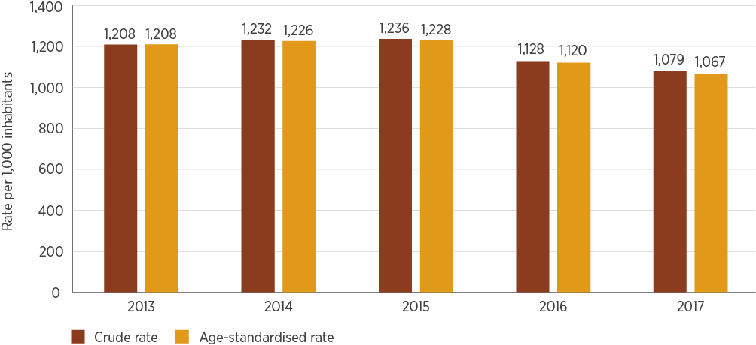
Source: Gadzhanova, Roughead¹⁴
After a steady increase in community dispensing rates between 2013 and 2015, there was a decline in 2016, and a further decline in 2017. This is the first downturn in community antibiotic use since the late 1990s.
Rates of supply of antibiotics vary between states and territories (Figure 3.23). The lower rates in the NT probably reflect other sources of supply of antibiotics, particularly Aboriginal and Torres Strait Islander health services, which are not included in the PBS/RPBS data. Approximately 30% of the NT population is Aboriginal or Torres Strait Islander, compared with approximately 5% or less in other states and territories.¹⁵
The volume of prescriptions is also available as DDDs per 1,000 inhabitants per day for J01-class agents. A downward trend in the volume of prescriptions dispensed was seen between 2015 and 2017 (Figure 3.24).
Figure 3.23: Age-standardised rate of the number of PBS/RPBS antibiotic prescriptions dispensed per 1,000 inhabitants, by state and territory, 2013–2017
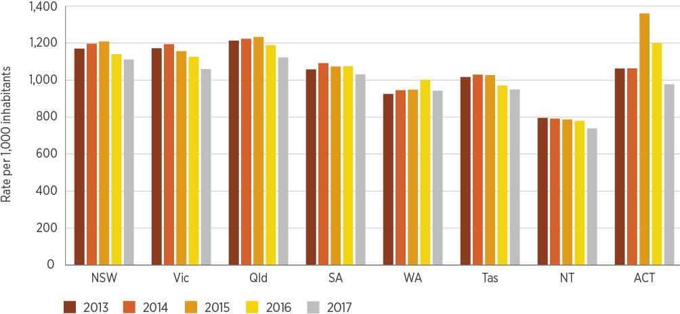
Source: Gadzhanova, Roughead¹⁴
Figure 3.24: Quantity of antibiotics dispensed under the PBS/RPBS (DDD/1,000 inhabitants/day), 2013–2017
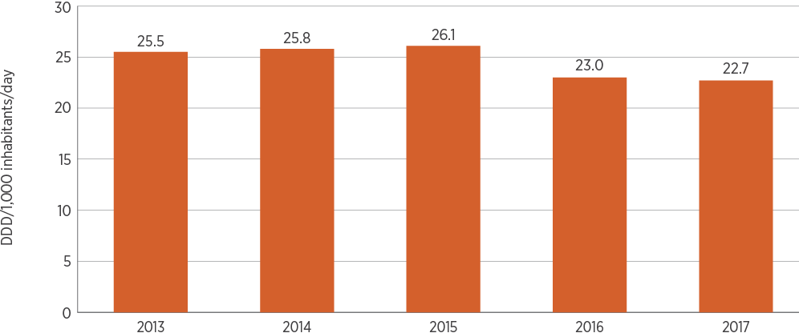
DDD = defined daily doses
Source: Gadzhanova, Roughead¹⁴
Dispensing rates vary by local area (Statistical Area Level 3 – SA3; Table 3.11). In some states and territories, the rates are influenced by the availability of other sources of supply of antibiotics, such as Aboriginal and Torres Strait Islander health services. Another noticeable feature is that the area with the lowest dispensing rate is often near to, or contiguous with, the area with the highest dispensing rate. This suggests that local physician preference is a major influence on antibiotic use.
Table 3.11: Highest and lowest antibiotic dispensing rates per 1,000 inhabitants, by Statistical Area Level 3, five-year average, 2013–2017
State or territory | Lowest SA3 region | Rate | Highest SA3 region | Rate
NSW | Hawkesbury | 557 | Richmond–Windsor | 2,158
Vic | Maryborough–Pyrenees | 812 | Melton–Bacchus Marsh | 1,772
Qld | Far North | 327 | Beenleigh | 1,893
SA | Barossa | 860 | Playford | 1,598
WA | Kimberley | 386 | Canning | 1,373
Tas | Central Highlands | 347 | Brighton | 1,598
NT | East Arnhem* | 180 | Darwin City | 1,283
ACT | North Canberra | 883 | Tuggeranong | 1,687
* Rate probably influenced by the availability of other sources of supply of antibiotics, such as Aboriginal and Torres Strait Islander health services
Source: Gadzhanova, Roughead¹⁴
As in previous years, the three most common antibiotics dispensed in 2017 were cefalexin, amoxicillin and amoxicillin–clavulanic acid (Figure 3.25). These agents accounted for more than 50% of all prescriptions dispensed. The three most common antibiotic types dispensed (based on DDDs per 1,000 inhabitants per day and antibiotic class) are penicillins with extended spectrum (mainly amoxicillin), β-lactamase inhibitor combinations (amoxicillin–clavulanic acid) and tetracyclines (mainly doxycycline). These are followed by first-generation cephalosporins (cefalexin) (Figure 3.26). There is seasonal variation in rates of dispensing of amoxicillin and amoxicillin–clavulanic acid, both of which are higher in winter. However, there is no seasonal variation in rates of dispensing of cefalexin (data not shown).
Usage rates for different age groups differ substantially (Figure 3.27). In 2017, the rate was highest in the 2–4-year age group, and for those aged over 65 years. This was recently highlighted in the Third Australian Atlas of Healthcare Variation 2018¹⁶, which describes in more detail the variation in rates of prescribing for children aged 9 years and under across the country.
Figure 3.25: The 10 most commonly dispensed antibiotics under the PBS/RPBS, by percentage of all antibiotic prescriptions, 2017
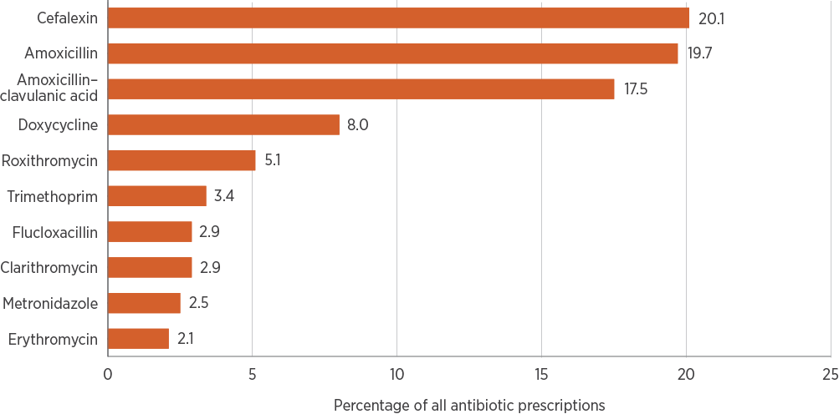
Source: Gadzhanova, Roughead¹⁴
Figure 3.26: Antibiotics dispensed under the PBS/RPBS (DDD/1,000 inhabitants/day), by class of systemic antibiotic (J01), 2015–2017
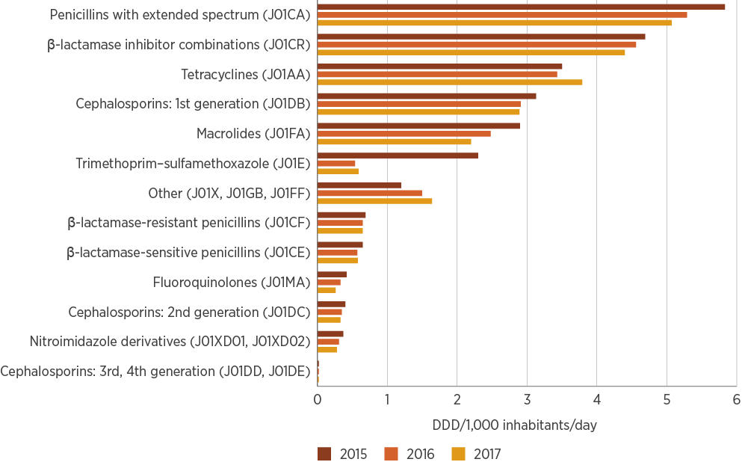
DDD = defined daily doses
Source: Gadzhanova, Roughead¹⁴
Figure 3.27: Number of PBS/RPBS prescriptions dispensed per 1,000 inhabitants, all antibiotics, by patient age group, 2017
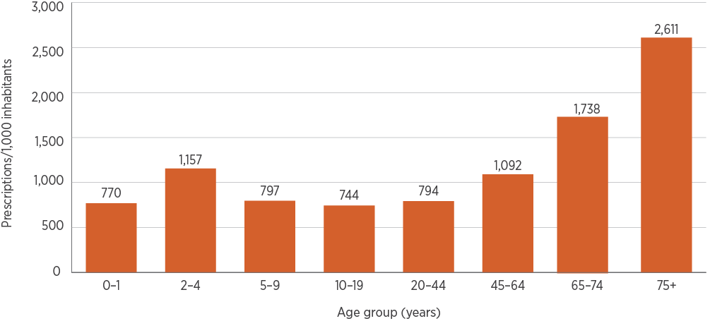
Source: Gadzhanova, Roughead¹⁴
Many antibiotic pack sizes are adequate for treating minor infections in the community. However, a high proportion of antibiotic prescriptions presented for dispensing were ordered with repeats (Table 3.12). The high rate of repeats for roxithromycin reflects the small pack size relative to the dosing regimen that is usually prescribed.
Repeat prescriptions filled within 10 days usually indicate a continuation of the original course of treatment. Repeat prescriptions dispensed after 10 days may indicate an interruption of the original duration and increased potential for inappropriate use.
Table 3.12: Percentage of PBS/RPBS antibiotic prescriptions ordered with repeats and repeats dispensed within 10 days, top 10 antibiotics dispensed, 2017
Antibiotic | Percentage of prescriptions ordered with repeats | Percentage of original prescriptions with repeats for which the first repeat was ordered less than 10 days from the original prescription
Cefalexin | 42.3 | 52.3
Amoxicillin | 28.6 | 51.0
Amoxicillin–clavulanic acid | 55.0 | 62.5
Doxycycline | 45.2 | 33.8
Roxithromycin | 54.6 | 70.9
Trimethoprim | 32.2 | 42.5
Clarithromycin | 46.9 | 57.6
Metronidazole | 30.4 | 48.1
Erythromycin | 39.3 | 39.9
Note: Less than 10 days was chosen for analysis because most pack sizes provide treatment for 5–10 days.
Source: Gadzhanova, Roughead¹⁴

Antibiotic prescribing in general practice: NPS MedicineInsight program
MedicineInsight is a large general practice dataset managed by NPS MedicineWise. It collects longitudinal de-identified clinical data from participating general practices. The data include information on patterns of prescribing, as well as the demographic characteristics and risk factors of patients prescribed systemic antimicrobials.
AURA 2019 includes MedicineInsight data for 2015–2017. In 2017, data were contributed by 545 general practice sites (10 more than in 2015) for 4,090,261 patients. Analyses of trends for the period 2010–2017 are included, where available.
Antibiotics include the standard collection of ATC Class J01 (systemic antibiotics). Rates presented are the number of patients in the MedicineInsight data who received one or more antibiotic prescriptions, per 100 patients.
In 2017, 26% of MedicineInsight patients (1,062,696 of 4,090,261) were prescribed systemic antibiotics – an absolute reduction of 5.7% compared with 2015 (Figure 3.28).
Figure 3.28: Percentage of patients prescribed one or more systemic antibiotics, NPS MedicineInsight practices, 2015–2017
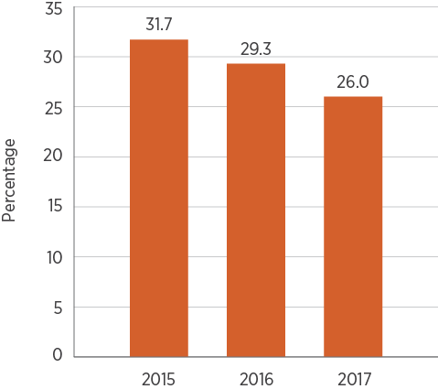
Notes: Number of practices was 535 in 2015, 543 in 2016 and 545 in 2017. The number of denominator patients may change each year.
Source: NPS MedicineWise¹⁷
In 2017, 26% of NPS MedicineInsight patients were prescribed systemic antibiotics – an absolute reduction of 5.7% compared with 2015.
Among NPS MedicineInsight practices, more people aged 90–94 years were prescribed systemic antibiotics than any other age group (39.7 per 100 patients). In patients aged less than 65 years, the highest rate was for children aged 0–4 years (29.5 per 100 patients) (Figure 3.29). The prescribing rate for females was 27.9 per 100 patients, compared with 23.8 per 100 patients for males. These patterns have remained the same since 2015.
Among Aboriginal and Torres Strait Islander patients, 29.2 per 100 patients were prescribed an antibiotic, compared with 27.7 per 100 patients for non-Indigenous patients. In absolute terms, the proportion of Aboriginal and Torres Strait Islander patients prescribed an antibiotic in 2017 was 3.2% higher (29.2%) than for all patients combined (26%). Among patients with no record of their Aboriginal and Torres Strait Islander status, 20.8 per 100 patients were prescribed at least one antibiotic in 2017.
Figure 3.29: Number of patients prescribed one or more J01 antibiotics, per 100 patients, by age group, NPS MedicineInsight practices, 2017
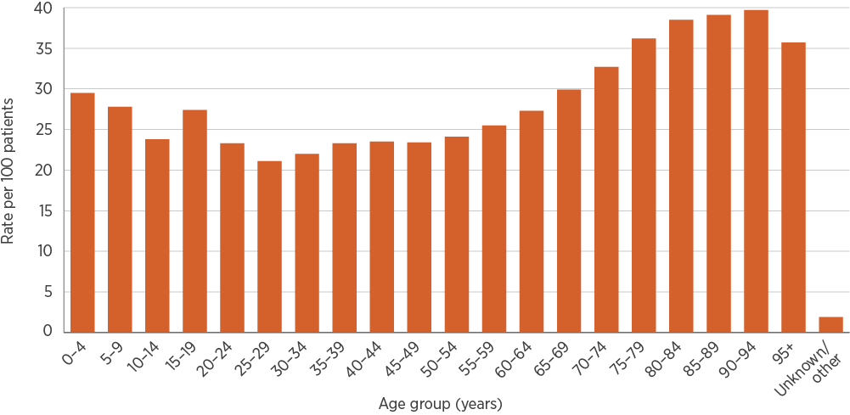
Note: Number of practices in 2017 was 545.
Source: NPS MedicineWise¹⁷
Aboriginal and Torres Strait Islander people continue to be under-identified in many Australian health-related data collections¹⁸, which may influence the reported rate of prescribing by Aboriginal and Torres Strait Islander status. Aboriginal and Torres Strait Islander patients have higher levels of morbidity and mortality than non-Indigenous Australians. They are also at higher risk of serious complications following infection, and therefore have a lower threshold for antimicrobial prescribing.¹⁹
Improving the identification and reporting of Aboriginal and Torres Strait Islander status is essential for surveillance of antimicrobial prescribing to allow quality improvement activities that support appropriate antimicrobial prescribing for, and use by, Aboriginal and Torres Strait Islander patients.
Socioeconomic differences are measured using the Socio-Economic Indexes for Areas (SEIFA). The rate of prescribing per 100 patients was 26.3 among people living within the most disadvantaged SEIFA decile and 25.5 among the least disadvantaged SEIFA decile in 2017.
Differences were observed in antibiotic prescribing between people living in major cities of Australia (26.5 per 100 patients) and people in very remote areas (21 per 100 patients). However, remote areas of Australia are under-represented in participating MedicineInsight practices. People living in rural and remote areas tend to have higher levels of disease and poorer health outcomes.²⁰
Differences in antibiotic prescribing rates among MedicineInsight practices were also observed between states and territories. The Australian Capital Territory had the highest antibiotic prescribing rate (31 per 100 patients), followed by South Australia (27.6 per 100 patients), New South Wales (27.3 per 100 patients), Queensland (26.7 per 100 patients), Tasmania (25.1 per 100 patients), WA (24.8 per 100 patients) and Victoria (24.5 per 100 patients). The lowest rate of prescribing was in the NT (21.3 per 100 patients). These differences across states and territories should be interpreted with caution because of non-random sampling and varying levels of participation in the MedicineInsight program. However, it is promising to see that all states and territories have shown a decline in prescribing rates since 2015, with the greatest decline in Victoria.
Further detailed information on prescribing for Aboriginal and Torres Strait Islander people, socioeconomic and remoteness differences, and differences between MedicineInsight practices can be found in AURA 2019: Supplementary data.

Antibiotic prescribing trends among NPS MedicineInsight practices
Between January 2010 and December 2017, the rate of systemic antibiotic prescriptions (originals and repeats) per 100 general practitioner (GP) consultations in participating MedicineInsight practices steadily declined, from 29.5% to 18.2%. Monthly variations were observed and were consistent with seasonal variation – the number of prescriptions per 100 GP visits increased during the winter months (Figure 3.30). Six of these systemic antibiotics showed the same seasonal prescribing variation. Cefalexin did not share this pattern, probably because it is not recommended as a first-line treatment for respiratory infections. A different but consistent seasonal variation was observed for cefalexin with more prescriptions in the summer period (Figure 3.30).
Between January 2010 and October 2017, the rate of systemic antibiotic prescriptions (originals and repeats) per 100 general practitioner consultations in participating MedicineInsight practices steadily declined, from 29.5% to 18.2%.
Figure 3.30: Rate of general practitioner PBS/RPBS prescriptions for J01 systemic antibiotics (originals and repeats) per 100 visits, NPS MedicineInsight practices, January 2010 to December 2017
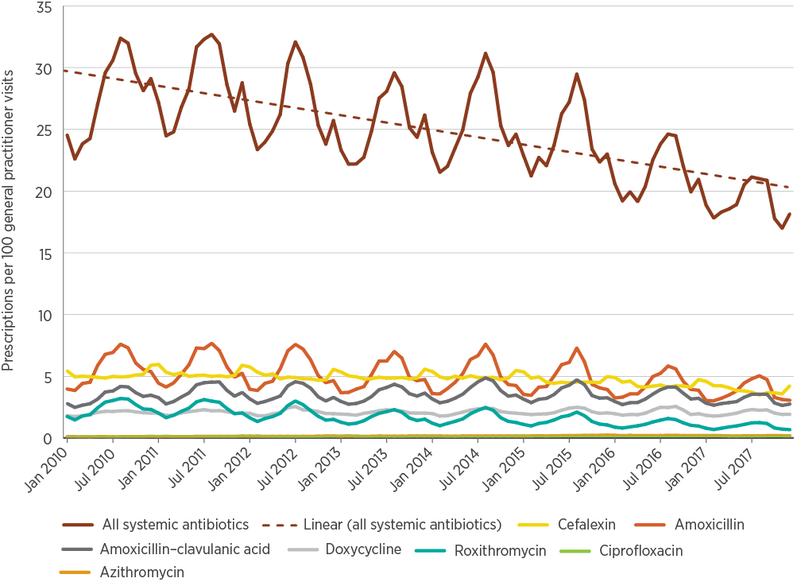
Source: NPS MedicineWise¹⁷

Patterns of prescribing
Since 2015, there have been no improvements in the percentage of prescriptions for which an indication for prescribing is recorded among participating practices. Of antibiotics prescribed, only 33.4% had an explicit recorded reason for the prescription; 36.5% did not have a reason for prescription, but were associated with a reason for the encounter and/or a diagnosis on the same day as the prescription. Of prescriptions for which a reason for prescription was recorded or identified, the highest proportion of prescribing was indicated for ‘skin/wound infections’ (13%), followed by acute upper respiratory tract infections (URTIs) (12.6%) and ‘other infection’ (10.8%). A total of 30% of prescriptions could not be associated with any indication recorded on the same day as the prescription in fields collected by MedicineInsight. Table 3.13 summarises patterns of GP prescribing for seven selected antibiotics.
In 2017, of the seven selected antibiotics, amoxicillin was the most frequently prescribed (8.0%), followed by cefalexin (6.7%), amoxicillin–clavulanic acid (4.8%), doxycycline (2.6%), roxithromycin (1.7%), azithromycin (0.8%) and ciprofloxacin (0.5%). This order has remained the same since 2015.
Differences in prescribing were found across patient age groups, with children aged 0–4 years most commonly prescribed amoxicillin (17.6 per 100 patients). People aged 90–94 years were most commonly prescribed cefalexin (18.8 per 100 patients) and ciprofloxacin (2.1 per 100 patients). The most common indications for cefalexin prescribing were skin/wound infections (31.8%) and urinary tract infections (UTIs) (21.4%) (Table 3.13).
It is encouraging that, compared with 2015, the overall rate of prescribing for antibiotics that have restricted benefits (ciprofloxacin and azithromycin) has not increased. However, a large proportion of azithromycin use may not be measured in this dataset because conditions such as chlamydia and gonorrhoea are primarily treated in the sexual health clinic setting, which uses a different data reporting system.
The 2017 data show changes in the prescribing patterns for ciprofloxacin. The most common indication for ciprofloxacin prescribing was not evident, because it was described as ‘other infection’ (33.2%). UTI was the third most common indication for prescribing ciprofloxacin in 2017 (12.8%); it was the fifth most common indication (5.5%) in 2015. The increase is of particular concern because greater use of ciprofloxacin is likely to increase the number of ciprofloxacin-resistant urinary pathogens.²¹ This is a difficult clinical problem because very limited oral therapeutic options are available for UTIs apart from ciprofloxacin. Ciprofloxacin should be reserved for treatment of infections that are resistant to other antibiotics and when alternative antibiotics are not available.⁶
Table 3.13: Patterns of general practitioner prescribing for seven antibiotics, NPS MedicineInsight practices, 2017
Antibiotic | Patients issued a prescription (PBS/RPBS or private) (%)* | Most common indication (%)† | Patient age group with highest rate§ of prescribing (years) | Prescriptions (PBS/RPBS or private) ordered with repeats (%) | Prescriptions ordered as private (%)
Amoxicillin | 8.0 | - URTI (acute) (25.8)  - Otitis media (14.5)  - Other LRTI (10.4)  - Sinusitis (acute/chronic) (9.5) | 0–4 | 19.9 | 0.8
Cefalexin | 6.7 | - Skin/wound infection (31.8)  - UTI (21.4)  - Other infection (10.9)  - Other relevant problems (9.2) | 90–94 | 28.8 | 0.6
Amoxicillin–clavulanic acid | 4.8 | - Sinusitis (acute/chronic) (14.0)  - URTI (acute) (11.5)  - Other LRTI (9.0)  - Skin/wound infection (8.9) | 80–84 | 35.2 | 1.0
Doxycycline | 2.6 | - Acne (13.1)  - Other LRTI (12.1)  - Travel (11.6)  - Sinusitis (acute/chronic) (10.3) | 75–79 | 55.5 | 13.9
Roxithromycin | 1.7 | - URTI (acute) (27.7)  - Other LRTI (15.9)  - Bronchitis (10.6)  - Sinusitis (acute/chronic) (9.0) | 80–84 | 34.0 | 0.4
Azithromycin | 0.8 | - Chlamydia infection (21.2)  - Other infection (18.5)  - Travel (10.7)  - Other relevant problems (9.2) | 20–24 | 19.7 | 47.5
Ciprofloxacin | 0.5 | - Other infection (33.2)  - Otitis media (14.2)  - UTI (12.8)  - Skin/wound infection (8.9) | 90–94 | 31.6 | 52.5
LRTI = lower respiratory tract infection; URTI = upper respiratory tract infection; UTI = urinary tract infection
* Percentage of MedicineInsight patients who visited a general practitioner at least once between 1 January 2016 and 31 December 2017, and had one or more prescriptions in 2017 for the specified antibiotic
† 70% of prescriptions could be associated with an indication. Indications for prescribing were described using the ‘reason for prescription’ field in the first instance. If an explicit recorded reason for the prescription was missing, an association was assumed between the antibiotic prescribed and a reason for the encounter and/or a diagnosis recorded on the same day as the prescription.
§ Number of patients in the MedicineInsight data prescribed one or more antibiotic prescriptions, per 100 patients
Source: NPS MedicineWise¹⁷
Urinary tract infection was the third most common indication for prescribing ciprofloxacin in 2017 (12.8%) in NPS MedicineInsight practices; it was the fifth most common indication (5.5%) in 2015. This increase is of particular concern because greater use of ciprofloxacin is likely to increase the number of ciprofloxacin-resistant urinary pathogens.
In Australia, prescriptions may be subsidised by the PBS or ordered as private. Prescribers may order prescriptions as private for many reasons, including prescribing an antibiotic for an indication that is not subsidised by the PBS/RPBS or prescribing a quantity that exceeds the PBS/RPBS limit.
Nearly half (47.5%) of all azithromycin prescriptions, 52.5% of ciprofloxacin prescriptions and 13.9% of doxycycline prescriptions were ordered as private. Compared with 2015, the proportion of these three antibiotics being prescribed as private has increased. The greatest increase was for ciprofloxacin (up 6%). The remaining antibiotics were mostly prescribed on the PBS/RPBS.
The proportion of prescriptions issued with a repeat varied between antibiotics. This is expected, as some indications may appropriately require repeats. For example, treatment of acne using doxycycline requires longer time frames. However, common infections almost never require repeat prescriptions, and there is evidence to support a recommendation for shorter antibiotic courses.²²
Prescribing software often defaults to the maximum number of repeats allowable on the PBS. The potential impact of this, and alternative approaches to prescribing software defaults, are currently being reviewed.

Appropriateness of prescribing: NPS MedicineInsight program
The proportion of patients prescribed antibiotics for eight selected conditions is outlined in Table 3.14. These conditions were selected because they are often seen in the primary care setting and, other than UTIs, are conditions for which antibiotics are not routinely recommended in guidelines. Among these conditions, most antibiotic prescribing was for acute URTIs (39.5%), followed by UTIs (13%) and sinusitis (12%). The percentage of patients prescribed systemic antibiotics for these conditions has changed little since 2015, with the exception of prescribing for acute URTIs (which decreased from 70.2% in 2015 to 62.3% in 2017) and influenza (57.4% to 52.2%).
In the context of Therapeutic Guidelines: Antibiotic recommendations, antibiotics continue to be overprescribed in Australia. Antibiotic prescribing is generally not recommended for the conditions listed in Table 3.14, with some exceptions.⁶ Of particular concern is antibiotic prescribing for acute bronchitis and influenza, for which antibiotics are never recommended. A remarkable 92% of patients aged 18–75 years with acute bronchitis and more than half of patients with influenza were prescribed an antibiotic. Prescribing of antibiotics may be recommended in 19–40% of patients with acute tonsillitis²³, but 94% of MedicineInsight patients with acute tonsillitis were prescribed an antibiotic. Although direct comparisons should be made with caution, it is clear that antibiotics are being overprescribed for these conditions.
Of particular concern is antibiotic prescribing for acute bronchitis and influenza, for which antibiotics are never recommended. A remarkable 92% of patients aged 18–75 years with acute bronchitis and more than half of patients with influenza were prescribed an antibiotic.
Despite these patterns, there has been some decrease in the percentage of prescribing for acute URTIs (down 8%) and influenza (down 5%) since 2015.
GPs prescribe antimicrobials for many reasons, including limited time, poor doctor–patient communication, diagnostic uncertainty and patient expectations. Other reasons include GP attitudes and beliefs about AMR – GPs may not view antimicrobial prescribing in the primary care setting as a major contributor to the development of AMR, or consider that their individual prescribing may contribute to AMR compared with other settings, such as hospital or veterinary prescribing.²⁴ However, although AMR is found more frequently in hospitals, and the intensity of antimicrobial use is much greater in hospitals, most antimicrobial use occurs in the community setting.
GPs play a crucial role in reducing the use of antimicrobials and AMR, and strategies should continue to be implemented to support reduced antimicrobial prescribing. Strategies include audit and feedback activities, delayed prescribing, community education and shared decision making. These are all important measures to help improve antimicrobial prescribing in primary care, and recognise the important role that GPs have in reducing AMR.²⁵
Table 3.14: Number and percentage of patients prescribed systemic antibiotics by general practitioners for selected conditions, NPS MedicineInsight practices, 2015 and 2017
Condition | Patients | 2015 No. | 2015 % | 2015 95% CI | 2017 No. | 2017 % | 2017 95% CI | Recommended  new cases to be  managed with  antibiotics^{23*}: Range (%)*
Acute bronchitis | Aged 18–75 years prescribed antibiotics | 37,362 | 94.5 | 93.5–95.6 | 36,004 | 92.4 | 91.1–93.7 | 0
Acute otitis media | Older than 2 years prescribed antibiotics | 49,293 | 94.3 | 93.4–95.2 | 48,209 | 92.2 | 91.4–93.1 | 20–31
 | And prescribed TG-recommended amoxicillin | 33,277 | 63.6 | 62.0–65.3 | 32,561 | 62.3 | 60.8–63.7 | 20–31
Acute tonsillitis | Older than 1 year prescribed antibiotics | 54,701 | 95.7 | 94.8–96.6 | 59,297 | 94.0 | 92.8–95.1 | 19–40
 | And prescribed TG-recommended penicillin V | 27,382 | 47.9 | 42.7–53.1 | 32,011 | 50.7 | 47.3–54.2 | 19–40
Influenza | Older than 1 year prescribed antibiotics | 12,521 | 57.4 | 55.7–59.0 | 20,184 | 52.2 | 51.1–53.2 | 0
Pneumonia | Aged 18–65 years prescribed antibiotics | 48,962 | 95.1 | 93.7–96.5 | 48,220 | 94.1 | 92.9–95.2 | nd
 | And prescribed TG-recommended antibiotic (for mild CAP – amoxicillin or doxycycline) | 27,407 | 53.2 | 51.7–54.8 | 28,758 | 56.1 | 54.3–57.9 | 100
Sinusitis (acute/chronic) | Older than 18 years prescribed antibiotics | 66,827 | 92.9 | 91.5–94.4 | 72,175 | 91.3 | 90.2–92.4 | 0.5–8
 | And prescribed TG-recommended amoxicillin | 28,680 | 39.9 | 37.9–41.9 | 30,961 | 39.2 | 37.7–40.7 | 0.5–8
Acute URTI | Older than 1 year prescribed antibiotics | 234,715 | 70.2 | 68.9–71.5 | 236,905 | 62.3 | 61.1–63.5 | nd
UTI | Females older than 18 years prescribed antibiotics | 68,400 | 94.7 | 94.2–95.2 | 78,986 | 92.9 | 91.5–94.3 | nd
 | And prescribed TG-recommended trimethoprim | 33,267 | 46.0 | 44.8–47.3 | 38,157 | 44.9 | 43.4–46.4 | nd
CAP = community-acquired pneumonia; CI = confidence interval; nd = no data; TG = Therapeutic Guidelines: Antibiotic; URTI = upper respiratory tract infection; UTI = urinary tract infection
* Mean percentage of new cases to be managed with antibiotics, based on guideline recommendations, where available²³
† NPS MedicineWise develops algorithms to identify specific conditions and measures of interest in the MedicineInsight database, based on commonly accepted definitions. These definitions may differ slightly from McCullough et al.²³
Note: Number of practices was 535 in 2015 and 545 in 2017.
Source: NPS MedicineWise¹⁷; McCullough et al.²³
From information to action
General Practice National Antimicrobial Prescribing Survey
In 2017, the National Centre for Antimicrobial Stewardship developed a pilot General Practice National Antimicrobial Prescribing Survey (GP NAPS) to explore the feasibility of adapting the NAPS methodology to the primary care setting. Eleven metropolitan and regional general practices from four Australian states took part in the project. The pilot comprised data from 550 patients, generating 572 antibiotic prescriptions. The project was funded by the Australian Government.
A customised audit tool was created, allowing assessors to review compliance of antimicrobial prescribing with national guidelines, such as Therapeutic Guidelines: Antibiotic¹, and the appropriateness of individual antimicrobial prescriptions. Assessing the appropriateness of each prescription allows review of situations in which a prescription may not comply with guidelines but may be clinically justified based on information in the patient’s medical record. During the pilot, prescribing feedback reports were developed in conjunction with general practitioners (GPs) to inform clinician- and practice-level quality improvement activities.
Detailed analyses of the data from contributing general practices identified several opportunities for improvement. There was high use of cefalexin for skin and soft tissue infection, but flucloxacillin/dicloxacillin is the recommended antibiotic for these infections; in general, cefalexin is reserved for patients with a penicillin allergy. There was also high use of amoxicillin–clavulanic acid for respiratory tract infections, which is unnecessary. This antibiotic is not recommended for community-acquired respiratory infection, except as second-line therapy after failure of amoxicillin. Compared with amoxicillin, amoxicillin–clavulanic acid is a broad-spectrum agent that is generally less well tolerated by patients.¹
Participating GPs identified the lack of integrated decision support in electronic prescribing software programs as a factor in the inappropriate prescribing of antimicrobials. Currently, manufacturers’ product information is usually embedded in the available electronic prescribing software. However, manufacturers’ recommendations on antimicrobial dosing and treatment duration are frequently inconsistent with national guidelines.²
Participating GPs found auditing and feedback at the local level valuable. The concept of creating automated reports with de-identified benchmarking was well received, allowing practices and individual GPs to compare prescribing patterns, identify areas for improvement and learn from practices with high levels of appropriate prescribing.
The GP NAPS pilot identified several interventions with the potential to improve prescribing behaviour and enhance antimicrobial stewardship in general practice. These include:
- A standardised approach for all GP prescribing software programs to document the prescription indication in the electronic medical record, include the intended treatment duration on each prescription and specify the exact quantity required for the course of the prescription
- Improved access, and promotion of adherence, to Therapeutic Guidelines: Antibiotic
- The ability to review, during the electronic prescribing process, the maximum number of repeat prescriptions that are automatically generated for antibiotic prescriptions dispensed under the Pharmaceutical Benefits Scheme
- The potential to revise standard antibiotic pack sizes to reduce excess quantities for treatment of common indications.
References
1. Antibiotic Expert Groups. Therapeutic guidelines: antibiotic. Melbourne: Therapeutic Guidelines Limited; 2014.
2. Day RO, Snowden L. Where to find information about drugs. Aust Prescr 2016;39(3):88–95.

Antimicrobial use in aged care homes: Aged Care National Antimicrobial Prescribing Survey
Aged care homes play an important role in the care of older members of the community in Australia, as well as some younger people who require residential care. In addition, multi-purpose services located in all states and the NT provide integrated health and aged care services for small regional and remote communities where a standalone aged care home or hospital would not be viable. Aged care homes are recognised nationally and internationally as an important community setting for monitoring AMR and AU. This is because of the significant prevalence of infections and colonisation caused by antimicrobial-resistant organisms in residents.²⁶⁻²⁹ High levels of inappropriate antimicrobial prescribing and use in aged care homes are also well documented.³⁰⁻³²
Residents of aged care homes are susceptible to infections for a variety of reasons, including advanced age, multiple comorbidities, poor functional status, compromised immune status, prosthetic devices and the use of invasive devices such as urinary tract catheters. Aged care homes are also a close living environment, with frequent contact with potentially colonised or infected staff or other residents. Some aged care home residents also have multiple or prolonged hospitalisations.
The Aged Care National Antimicrobial Prescribing Survey (AC NAPS) is a standardised surveillance tool that can be used to monitor the prevalence of infections and AU. NCAS contributes NAPS data to the AURA Surveillance System. All Australian aged care homes and multi-purpose services are eligible to participate in AC NAPS, and participation is mostly voluntary. From 2017, all aged care homes operated by the Victorian Government are required to participate in AC NAPS as part of the VICNISS Infection Control Indicator Program.³³
AC NAPS was piloted in 2015, and has subsequently been conducted each year. Highlights of analyses of data from the 2016 and 2017 surveys are presented in this report; more extensive information on the results of each survey is available in other reports published by NCAS and the Australian Commission on Safety and Quality in Health Care (the Commission).^{31,32}
In 2017, 292 aged care homes participated in AC NAPS; 287 participated in 2016. In both years, all states, remoteness areas and organisation types were represented; there were no participants from either the Australian Capital Territory or the NT. Approximately two-thirds of participating aged care homes were located in Victoria in both 2016 and 2017. In 2017, more than 40% of participating aged care homes were classified as inner regional, and 68.2% were state government operated. Of the 12,307 residents audited in 2017, most resided in not-for-profit (46.6%) and government-operated (45.5%) aged care homes. There were variations in sample size and characteristics, and changes in indicators for some states, remoteness areas and organisation types between the two surveys (Table 3.15).
In 2017, 2.8% (n = 349) of residents were reported to have a total of 360 suspected infections on the survey day, compared with 3.1% in 2016 (Table 3.16). Overall in 2017, 39.4% (n = 142) of suspected infections met the McGeer et al. infection definitions (Table 3.17).³⁴ In the 48 hours before the survey day, a microbiological specimen was taken for 6.6% (n = 23) of these residents. Almost half of those specimens (n = 11; 47.8%) were urine samples.
There was minimal change in the proportion of residents who were prescribed at least one antimicrobial: 8.8% in 2017 and 9.9% in 2016. In 2017, 1,087 residents were prescribed a total of 1,231 antimicrobials (Table 3.16). The start date was unknown for 4.3% (n = 53) of antimicrobial prescriptions in 2017, compared with 3.8% (n = 57) in 2016. In 2017, 27% (n = 332) of antimicrobial prescriptions started more than six months before the survey day, compared with 30.1% in 2016.
For the quality indicators ‘indication documented’ and ‘review or stop date documented’, there were small changes overall from 2016 to 2017, and there were variations between states, remoteness areas and organisation types (Table 3.15).
Table 3.15: Key quality indicators for antimicrobial prescriptions, by state, remoteness area and organisation type, AC NAPS contributors, 2016 and 2017
Category | Sub-category | Number of prescriptions (n), 2016 | Number of prescriptions (n), 2017 | Indication documented (%), 2016 | Indication documented (%), 2017 | Review or stop date (%), 2016 | Review or stop date (%), 2017
State | NSW | 237 | 136 | 77.6 | 67.6 | 46.0 | 41.9
 | Vic | 656 | 639 | 73.3 | 71.5 | 37.8 | 40.4
 | Qld | 276 | 147 | 77.9 | 87.8 | 35.1 | 44.9
 | SA | 92 | 155 | 70.7 | 79.4 | 50.0 | 61.3
 | WA | 184 | 139 | 72.3 | 88.5 | 47.3 | 43.2
 | Tas | 48 | 15 | 68.8 | 100.0 | 45.8 | 73.3
Remote-ness area | Major cities | 777 | 543 | 75.4 | 81.2 | 42.2 | 51.0
 | Inner regional | 475 | 482 | 70.5 | 77.2 | 39.6 | 43.8
 | Outer regional | 208 | 171 | 76.9 | 63.7 | 37.5 | 29.8
 | Remote | 27 | 35 | 92.6 | 48.6 | 33.3 | 22.9
 | Very remote | 6 | 0 | 83.3 | n/a | 100.0 | n/a
Organisation type | Not for profit | 816 | 548 | 74.4 | 82.5 | 40.4 | 49.5
 | Government | 563 | 629 | 71.0 | 70.1 | 39.4 | 39.3
 | Private | 114 | 54 | 91.2 | 85.2 | 50.0 | 53.7
Total |  | 1,493 | 1,231 | 74.4 | 76.3 | 40.8 | 44.4
n/a = not applicable
Source: 2017 Aged Care NAPS³²
Table 3.16: Prevalence of infections and antimicrobial use among residents, AC NAPS contributors, 2016 and 2017
Resident category | 2016 (N = 13,398), Number | 2016 (N = 13,398), Percentage | 2016 (N = 13,398), 95% CI | 2017 (N = 12,307), Number | 2017 (N = 12,307), Percentage | 2017 (N = 12,307), 95% CI | P value
Residents with signs and/or symptoms of a suspected infection | 417 | 3.1 | 2.8–3.4 | 349 | 2.8 | 2.5–3.1 | 0.08
Residents prescribed at least one antimicrobial | 1,321 | 9.9 | 9.4–10.4 | 1,087 | 8.8 | 8.3–9.3 | <0.01
CI = confidence interval
Source: 2017 Aged Care NAPS³²
Table 3.17: Number and percentage of residents with signs and/or symptoms of a suspected infection, by body system, AC NAPS contributors, 2017
Body system | Number of suspected infections | Aged care home–associated suspected infections*, Number | Aged care home–associated suspected infections*, Percentage | Suspected infections that met McGeer et al. definition, Number | Suspected infections that met McGeer et al. definition, Percentage
Respiratory tract | 132 | 92 | 69.7 | 69 | 52.3
Skin, soft tissue | 117 | 90 | 76.3 | 50 | 42.4
Urinary tract | 74 | 56 | 73.7 | 1 | 1.3
Eye | 19 | 16 | 84.2 | 16 | 84.2
Oral | 9 | 6 | 66.7 | 6 | 66.7
Gastrointestinal | 1 | 0 | 0.0 | 0 | 0.0
Other | 8 | 5 | 62.5 | 0 | 0.0
Total | 360 | 265 | 73.6 | 142 | 39.4
* Aged care home–associated infections were those for which the resident’s signs and/or symptoms started at least two calendar days after admission or readmission into the home.
Source: 2017 Aged Care NAPS³²

Most commonly prescribed antimicrobials reported by AC NAPS contributors
In 2017, the five most commonly prescribed antimicrobials were clotrimazole (n = 256; 20.8%), cefalexin (n = 239; 19.4%), amoxicillin (n = 75; 6.1%), trimethoprim (n = 71; 5.8%) and amoxicillin–clavulanic acid (n = 71; 5.8%). Compared with 2016, the order varied and amoxicillin replaced topical chloramphenicol.
In 2017, most antimicrobial prescriptions were for either oral (n = 794; 64.5%) or topical (n = 407; 33.1%) administration. The five most commonly prescribed topical antimicrobials in 2017 were clotrimazole (n = 248; 60.9%), chloramphenicol (n = 66; 16.2%), gramicidin–neomycin–nystatin (Kenacomb®; n = 26; 6.4%), miconazole (n = 25; 6.1%) and mupirocin (n = 10; 2.5%).

Common indications for prescribing antimicrobials reported by AC NAPS contributors
Of all known indications for prescribing antimicrobials in 2017, 71.1% (n = 875) were for treatment, compared with 74.8% (n = 1,117) in 2016. Of these treatment indications, the most commonly reported were chest infections and lower respiratory tract infections (14.1%, n = 158 in 2016; 14.1%, n = 123 in 2017). In both 2016 and 2017, cystitis was the most common reason for prescribing antimicrobials for prophylactic use (n = 104; 29.2%).

Infection signs and symptoms reported by AC NAPS contributors
For the purposes of AC NAPS, prescriptions for antimicrobials are assessed as appropriate when they are for patients who have signs or symptoms that meet internationally accepted surveillance criteria, known as the McGeer et al. criteria.³⁴ In 2017, just under half (n = 513; 44.8%) of antimicrobial prescriptions were for residents who had signs and/or symptoms of a suspected infection in the week before the antimicrobial start date (Table 3.18). A total of 40% of these infections were classified as aged care home associated, and only 18.4% (n = 211) met the McGeer et al. infection criteria. In 2016, 36.5% of antimicrobial prescriptions were for residents who had signs and/or symptoms of a suspected infection that met the McGeer et al. infection criteria in the week before the antimicrobial start date. It is not known why there was such a large change between 2016 and 2017 in classification of infections; there was no change in the criteria.
In aged care homes that contributed to the Aged Care National Prescribing Survey in 2017, only 18.4% of prescriptions were for residents with infection signs or symptoms that met internationally accepted surveillance criteria.
In 2017, compliance with the McGeer et al. infection criteria was highest for eye infections (n = 34; 46.6%) and respiratory infections (n = 62; 29.1%) (Table 3.18).
The following results from the 2017 AC NAPS are of particular concern, because of potential ongoing safety risks for residents of aged care homes and multi-purpose services:
More than half of the antimicrobial prescriptions (55.2%) were for residents with no signs and/or symptoms of a suspected infection in the week before the antimicrobial start date
Only 18.4% of prescriptions were for residents with infection signs and/or symptoms that met internationally accepted surveillance criteria, which is half the number that met the criteria in 2016
The start date was more than six months before the survey day for 26.9% of antimicrobial prescriptions
The indication for starting an antimicrobial was not documented for 23.7% of prescriptions
The antimicrobial review or stop date was not documented for 55.6% of prescriptions
One-third (33.1%) of antimicrobial prescriptions were for topical use.
Table 3.18: Number and percentage of antimicrobial prescriptions for which infection signs and/or symptoms were recorded and McGeer et al. criteria were met, by body system, AC NAPS contributors, 2017
Body system | Number of prescriptions | With signs and symptoms of infection, n (%) | Aged care home–associated suspected infections*, n (%) | Infections that met McGeer et al. criteria, n (%)
Skin, soft tissue | 424 | 170 (40.1) | 155 (36.6) | 82 (19.3)
Urinary tract | 323 | 114 (35.3) | 99 (30.7) | 17 (5.3)
Respiratory tract | 213 | 150 (70.4) | 129 (60.6) | 62 (29.1)
Other body system | 86 | 29 (33.7) | 27 (31.4) | 11 (12.8)
Eye | 73 | 38 (52.1) | 36 (49.3) | 34 (46.6)
Oral | 17 | 9 (52.9) | 10 (58.8) | 3 (17.6)
Gastrointestinal tract | 10 | 3 (30.0) | 2 (20.0) | 2 (20.0)
Total | 1,146 | 513 (44.8) | 458 (40.0) | 211 (18.4)
* Aged care home–associated infections were those for which the resident’s signs and/or symptoms started at least two calendar days after admission or readmission into the home.
Note: Excludes prescriptions for medical prophylaxis and unknown indications. There may have been infection signs and/or symptoms from more than one body system for some prescriptions.
Source: 2017 Aged Care NAPS³²
The results of the 2017 AC NAPS have been widely disseminated for consideration in the context of the new Aged Care Quality Standards³⁵, against which aged care homes will be assessed from 1 July 2019. These standards will require aged care homes to demonstrate practices to promote appropriate antibiotic prescribing and use to support optimal care, and reduce the risk of increasing AMR. Transition to the new Aged Care Quality Standards started from 1 July 2018.

International comparisons
Data for AU in the community that may be used for comparison purposes are available from the European Surveillance of Antimicrobial Consumption Network (ESAC-Net) and the Canadian Antimicrobial Resistance Surveillance System (CARSS).
Although Australia has seen a decline in AU in the community since 2015, Australia remains in the top quarter of countries for AU, as measured by DDDs per 1,000 inhabitants, compared with European countries and Canada (Figure 3.31).
Australian AU continues to be above the average of these countries, particularly compared with Scandinavian countries, the Baltic states and the Netherlands, which are often seen as benchmark countries for AU and AMR.
Australia remains in the top quarter of countries for antimicrobial use, as measured by defined daily doses per 1,000 inhabitants, compared with European countries and Canada.
Figure 3.31: International comparison of community use of systemic antimicrobials (J01) (DDD/1,000 inhabitants/day), 2017
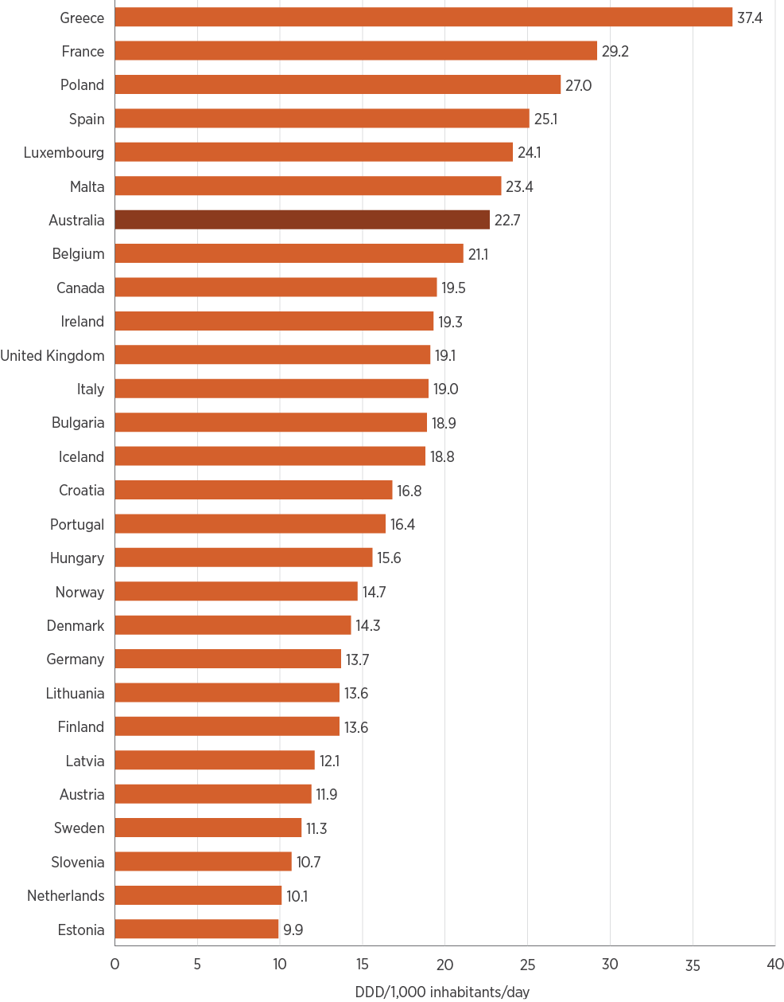
DDD = defined daily doses Note: Data were unavailable for the Czech Republic, Slovakia and Liechtenstein.
Source: ESAC-Net (Europe)³⁶; CARSS (Canada)³⁷; AURA (Australia)

Commentary – overall antimicrobial use in the community
Using PBS/RPBS dispensing data and MedicineInsight prescribing data as a measurement for AU, it is promising to see that, overall, AU in the Australian community has declined since 2015, although it remains high compared with European countries and Canada. However, there were no improvements in aged care homes that participated in AC NAPS; the proportion of aged care home residents prescribed antimicrobials increased slightly from 2016 to 2017.
Variation in AU between age groups was observed in both the PBS/RPBS dispensing data and MedicineInsight prescribing data. Children under 5 years of age have the highest rates of dispensing among people less than 65 years of age.
Some variation in the patterns of AU was seen between the PBS/RPBS data and NPS MedicineInsight data, as would be expected, as a result of differences in the type of data available. PBS/RPBS data include prescriptions generated by a broad range of prescribers, including GPs, specialist doctors, non-medical prescribers and hospitals. MedicineInsight data relate only to prescribing by general practices that have voluntarily joined the program.
Both PBS/RPBS and MedicineInsight data showed variation in AU between states and territories, and a decline in antibiotic dispensing and prescribing rates in all states and territories.
Amoxicillin, cefalexin and amoxicillin–clavulanic acid continue to be the three most commonly used antibiotics in the community, across the PBS/RPBS and MedicineInsight datasets included for analysis. These three antibiotics are among the top five reported antimicrobials in AC NAPS.
The inappropriate prescribing of amoxicillin for URTIs in general practice may be contributing to the high use of amoxicillin. Respiratory tract infections (which include URTIs) were also the third most common indication for prescribing in aged care homes.
Prescribing of cefalexin was most common for older people in MedicineInsight data, and the most commonly recorded indication for prescribing cefalexin was skin/wound infections. These types of infections were the most commonly reported in aged care homes, which may also explain the high use of cefalexin in aged care.
No indication was recorded for approximately 25% of prescriptions in AC NAPS and 30% of prescriptions in MedicineInsight data. Understanding the reason for an antimicrobial being prescribed is key to monitoring appropriateness and undertaking quality improvement activities.
The aged care home setting is of particular importance for appropriate AU and AMR control because of the high levels of prescribing. Data presented in Chapter 4 show that, for some organisms, rates of AMR in aged care homes were as high as, or higher than, rates in hospitals. The rate of AMR, in combination with the inappropriate AU identified by AC NAPS, reinforces the potential for aged care homes to amplify AMR in Australia.

3.5 Developments and future plans – community antimicrobial use
The Commission will support the Australian Government Department of Health, and the Australian Strategic and Technical Advisory Group on AMR in the review of antibiotic listings on the PBS/RPBS to promote appropriate prescribing. This may include examining access to repeat prescriptions for antibiotics for which there is evidence of a high volume of repeat prescriptions being filled after 10 days and inappropriate use. Potential changes include changes to prescribing software so that the default option for antibiotic prescriptions is ‘no repeats’, and alignment of the dispensed amount of antibiotic with the recommended duration of therapy to avoid leftover doses.²⁵
The Commission will continue to promote the appropriate use of antimicrobials in aged care homes, and the use of tools such as AC NAPS to monitor AU and inform strategies to improve care for residents. The Commission will also collaborate with the Australian Government Department of Health and the Aged Care Quality and Safety Commission to support implementation of the infection prevention and control and AMS requirements of the new Aged Care Quality Standards. This work will include targeted strategies to promote effective infection control and AMS programs in aged care homes to improve the quality and safety of care for residents.
Targeted strategies will be developed in collaboration with experts in primary care, respiratory medicine and AMS to improve the appropriateness of antibiotic prescribing for respiratory conditions.
Participation in programs that monitor appropriateness of AU in aged care homes and general practice will also be encouraged. Data from these programs are essential to inform quality improvement programs and change prescribing practice.

3.6 Overall use and appropriateness in the acute and community sectors
The analyses presented in AURA 2019 show that a number of aspects of AU are similar in acute hospital and community settings. In both settings, there are continuing high rates of unnecessary and inappropriate AU. The changing patterns of AMR, particularly the increases in methicillin resistance in Staphylococcus aureus and fluoroquinolone non-susceptibility in Escherichia coli in community settings (described in Chapter 4), highlight the importance of promoting appropriate AU to address AMR in Australia.
The data highlight several areas for targeting of improvement interventions, including:
The most frequently prescribed antimicrobials
The antimicrobials that are most frequently prescribed inappropriately
Documentation of the reason for prescribing
The indications for which antimicrobials are most frequently inappropriately prescribed (respiratory and skin conditions).
Six of the top 10 antibiotics (cefalexin, amoxicillin, amoxicillin–clavulanic acid, doxycycline, flucloxacillin and metronidazole) dispensed under the PBS/RPBS are also in the top 10 antibiotics used in hospitals that contribute to NAPS and NAUSP. These six agents account for 46.5% of AU reported by NAUSP and 70.7% of AU under the PBS/RPBS. These antibiotics are not usually high-priority agents for AMS programs, whose focus has traditionally been on broad-spectrum, intravenous, expensive antimicrobials. However, because these six antibiotics account for a large proportion of AU in both the acute hospital and community sectors, they should be prioritised for improvement interventions.
High usage of antimicrobial agents is often associated with high rates of inappropriate use. Eight of the top 10 antimicrobials used in hospitals that contribute to NAPS and NAUSP are also included in the top 10 antimicrobials with the highest rates of inappropriate use in hospitals. The indications for which antimicrobials are most frequently inappropriately prescribed in hospitals and the community are respiratory conditions; there is also a high rate of inappropriate prescribing of antimicrobials for skin conditions in aged care homes.
Inappropriate prescribing is further explored in Chapter 6, with particular reference to amoxicillin–clavulanic acid and cefalexin, and respiratory and skin conditions.
The Preventing and Controlling Healthcare-Associated Infection Standard has criteria relating to AMS, as do the new Aged Care Quality Standards. The Commission will work with stakeholders that provide hospital, aged care and primary health services to promote these criteria and the prioritisation of interventions to reduce inappropriate prescribing of selected antimicrobials to improve the care of patients with respiratory conditions.
The indications for which antimicrobials are most frequently inappropriately prescribed in hospitals and the community are respiratory conditions; there is also a high rate of inappropriate prescribing of antimicrobials for skin conditions in aged care homes.
From information to action
Developing healthcare- and community-onset antibiograms by approximating epidemiology and resistance
Organisms that cause healthcare-acquired infections can differ substantially from those that cause community-acquired infections. However, these differences may not be seen in cumulative antibiograms that combine all samples of similar specimen type, regardless of the place of onset of the infection. This is partly due to difficulty in applying the onset definitions when data on date of admission are not readily available, as is the case for cumulative antibiogram data. However, it is important to monitor differences in resistance patterns between healthcare-acquired and community-acquired infections to ensure that treatment guidelines are always appropriate at the local level.
To help understand this epidemiological difference, an Australian tertiary facility requested its pathology provider to differentiate the local antibiogram based on patient setting – that is, whether the patient was from the emergency department (ED) or inpatient areas. The specimens collected from the ED were used as a proxy for the community setting. Other than this difference, the facility followed the requirements in the Specification for a Hospital Cumulative Antibiogram developed by the Australian Commission on Safety and Quality in Health Care. The findings showed differences between the two settings in resistance patterns and the relative contributions of species.
For blood culture isolates, differences in antibiograms between inpatient and ED settings included:
- Staphylococcus aureus flucloxacillin susceptibility – 88% in inpatient isolates and 95% in ED isolates
- Escherichia coli piperacillin–tazobactam susceptibility – 89% in inpatient isolates and 98% in ED isolates
- E. coli cotrimoxazole susceptibility – 78% in inpatient isolates and 67% in ED isolates.
In addition, yeast comprised 5% of all inpatient bloodstream infections, whereas it is a relatively uncommon finding in the community setting.
For urine isolates, differences in antibiograms included:
- E. coli as the dominant pathogen in the ED, falling substantially in the inpatient setting
- Gentamicin susceptibility – more than 95% for most organisms in the ED, but 84% for Pseudomonas spp. in inpatients
- E. coli cefalexin susceptibility – 82% in inpatient isolates and 93% in ED isolates.
The organism group including Enterobacter spp., Serratia spp., Morganella morganii and Citrobacter freundii contributed 11% of all urine isolates in the inpatient setting versus 7% in the ED setting.
The differences in the relative contributions of different species in each setting are shown for blood culture isolates (Figures A and B) and urine isolates (Figure C).
Although this methodology is not a comprehensive approach, it does reflect healthcare-acquired versus community-acquired epidemiology, and demonstrates differences that may be a better surrogate than current methods, with minimal change in resource requirements. These data have now been used by the hospital to develop specific treatment guidelines for inpatients and patients in EDs. The data are monitored annually and local guidelines are adjusted accordingly.
Figure A: Percentage of blood culture isolates in inpatient and emergency department settings, gram-positive organisms
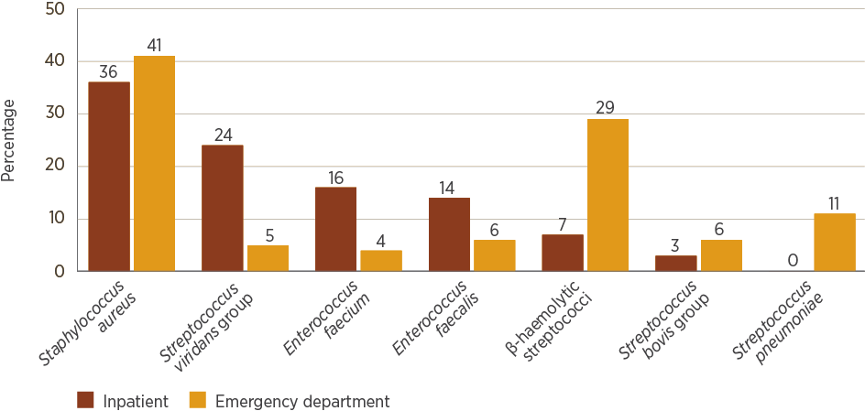
Note: Excludes coagulase-negative staphylococci
Figure B: Percentage of blood culture isolates in inpatient and emergency department settings, gram-negative organisms
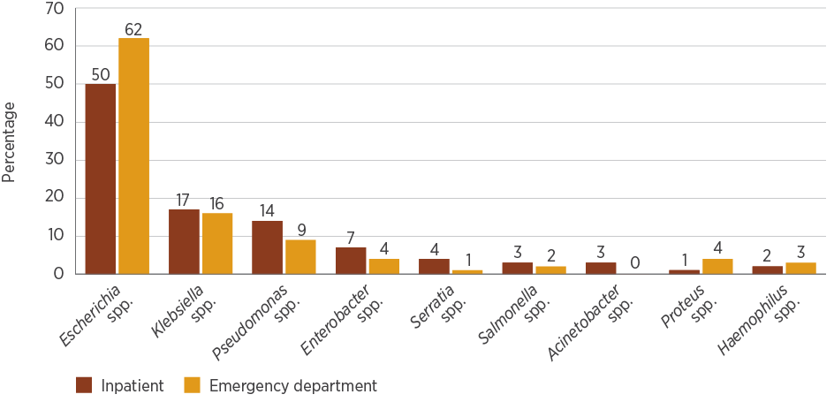
Figure C: Percentage of urine culture isolates in inpatient and emergency department settings
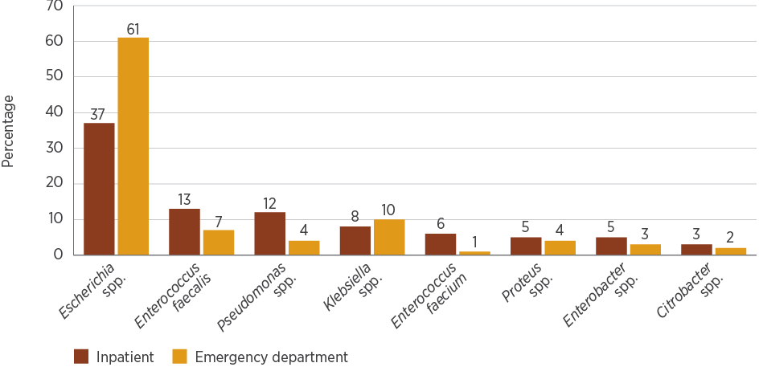
Note: Excludes coagulase-negative staphylococci

References
1. SA Health, Australian Commission on Safety and Quality in Health Care. Antimicrobial use in Australian hospitals: 2016 annual report of the National Antimicrobial Utilisation Surveillance Program. Sydney: ACSQHC; 2018 (accessed Feb 2019).
2. Australian Institute of Health and Welfare. Australian hospital peer groups. Canberra: AIHW; 2015. (AIHW Cat. No. HSE 170; Health Services Series No. 66.)
3. National Centre for Antimicrobial Stewardship, Australian Commission on Safety and Quality in Health Care. Antimicrobial prescribing practice in Australian hospitals: results of the 2016 Hospital National Antimicrobial Prescribing Survey. Sydney: ACSQHC; 2018 (accessed Feb 2019).
4. National Centre for Antimicrobial Stewardship, Australian Commission on Safety and Quality in Health Care. Antimicrobial prescribing practice in Australian hospitals: results of the 2017 Hospital National Antimicrobial Prescribing Survey [PDF, 2.7MB]. Sydney: ACSQHC; 2018 (accessed Feb 2019).
5. National Antimicrobial Utilisation Surveillance Program (NAUSP). Antimicrobial use in Australian hospitals data for 2017 (unpublished).
6. Antibiotic Expert Groups. Therapeutic guidelines: antibiotic. Melbourne: Therapeutic Guidelines Limited; 2014.
7. NSW Clinical Excellence Commission. Intravenous piperacillin–tazobactam: disruption to supply. Sydney: NSW CEC; 2017. (Safety Notice 012/17.)
8. Australian Commission on Safety and Quality in Health Care. CARAlert summary report 1 April 2018 – 30 September 2018. Sydney: ACSQHC; 2018.
9. Coombs G, Bell JM, Daley D, Collignon P, Cooley L, Gottlieb T, et al. Australian Group on Antimicrobial Resistance Sepsis Outcomes Programs: 2017 report. Sydney: Australian Commission on Safety and Quality in Health Care; 2019.
10. Miller AC. AMA advocacy on medicine shortages. Canberra: Australian Medical Association; 2018 [updated 2018 Dec 6; cited 2019 Mar 5].
11. Australian Commission on Safety and Quality in Health Care. AURA 2017: second Australian report on antimicrobial use and resistance in human health. Sydney: ACSQHC; 2017 (accessed Feb 2019).
12. National Centre for Antimicrobial Stewardship. Surgical prophylaxis prescribing in Australia: results of the 2017 Surgical National Antimicrobial Prescribing Survey (unpublished).
13. Broom A, Broom J, Kirby E. Cultures of resistance? A Bourdieusian analysis of doctors’ antibiotic prescribing. Soc Sci Med 2014;110:81–8.
14. Gadzhanova S, Roughead E. Analysis of 2013–2017 Pharmaceutical Benefits Scheme (PBS) data for the National Report on Antimicrobial Use and Resistance (unpublished).
15. Australian Bureau of Statistics. Estimates of Aboriginal and Torres Strait Islander Australians, June 2016. Canberra: ABS; 2018 [cited 2019 Jan 24].
16. Australian Commission on Safety and Quality in Health Care. The third Australian atlas of healthcare variation 2018. Sydney: ACSQHC; 2018 (accessed Feb 2019).
17. NPS MedicineWise. MedicineInsight data analyses for AURA 2019, November 2018 (unpublished).
18. Australian Institute of Health and Welfare. National best practice guidelines for collecting Indigenous status in health data sets. Canberra: AIHW; 2010 (accessed Dec 2018).
19. Murray R. Prescribing issues for Aboriginal people. Aust Prescr 2003;26:55–7.
20. Australian Institute of Health and Welfare. Rural and remote health. Canberra: AIHW; 2017 (accessed Feb 2019).
21. Stewardson AJ, Vervoort J, Adriaenssens N, Coenen S, Godycki-Cwirko M, Kowalczyk A, et al. Effect of outpatient antibiotics for urinary tract infections on antimicrobial resistance among commensal Enterobacteriaceae: a multinational prospective cohort study. Clin Microbiol Infect 2018;24(9):972–9.
22. Wilson HL, Daveson K, Del Mar CB. Optimal antimicrobial duration for common bacterial infections. Aust Prescr 2019;42(1):5–9.
23. McCullough AR, Pollack AJ, Plejdrup Hansen M, Glasziou PP, Looke DF, Britt HC, et al. Antibiotics for acute respiratory infections in general practice: comparison of prescribing rates with guideline recommendations. Med J Aust 2017;207(2):65–9.
24. Fletcher-Lartey S, Yee M, Gaarslev C, Khan R. Why do general practitioners prescribe antibiotics for upper respiratory tract infections to meet patient expectations: a mixed methods study. BMJ Open 2016;6(10):e012244.
25. Del Mar CB, Scott AM, Glasziou PP, Hoffmann T, van Driel ML, Beller E, et al. Reducing antibiotic prescribing in Australian general practice: time for a national strategy. Med J Aust 2017;207(9):401–6.
26. Suetens C, Latour K, Kärki T, Ricchizzi E, Kinross P, Moro ML, et al. Prevalence of healthcare-associated infections, estimated incidence and composite antimicrobial resistance index in acute care hospitals and long-term care facilities: results from two European point prevalence surveys, 2016 to 2017. Euro Surveill 2018;23(46):pii=1800516.
27. Smith M, Atkins S, Worth L, Richards M, Bennett N. Infections and antimicrobial use in Australian residential aged care facilities: a comparison between local and international prevalence and practices. Aust Health Rev 2013;37(4):529–34.
28. Coombs G, Bell JM, Daley D, Collignon P, Cooley L, Gottlieb T, et al. Australian Group on Antimicrobial Resistance Sepsis Outcomes Programs: 2016 report [PDF, 2.6MB]. Sydney: Australian Commission on Safety and Quality in Health Care; 2018 (accessed Feb 2019).
29. Australian Commission on Safety and Quality in Health Care. Australian Passive Antimicrobial Resistance Surveillance: first report – multi-resistant organisms. Sydney: ACSQHC; 2018 (accessed Feb 2019).
30. Centers for Disease Control and Prevention. The core elements of antibiotic stewardship for nursing homes. Atlanta (GA): CDC; 2015 (accessed Feb 2019).
31. National Centre for Antimicrobial Stewardship, Australian Commission on Safety and Quality in Health Care. Aged Care National Antimicrobial Prescribing Survey 2016. Sydney: ACSQHC; 2017. (accessed Feb 2019).
32. National Centre for Antimicrobial Stewardship, Australian Commission on Safety and Quality in Health Care. Antimicrobial prescribing and infections in Australian aged care homes: results of the 2017 Aged Care National Antimicrobial Prescribing Survey. Sydney: ACSQHC; 2018 (accessed Feb 2019).
33. Victorian Healthcare Associated Infection Surveillance Coordinating Centre. VICNISS eBulletin June 2017. Melbourne: VICNISS; 2017 [cited 2019 Jan 24].
34. Stone ND, Ashraf MS, Calder J, Crnich CJ, Crossley K, Drinka PJ, et al. Surveillance definitions of infections in long-term care facilities: revisiting the McGeer criteria. Infect Control Hosp Epidemiol 2012;33(10):965–77.
35. Aged Care Quality and Safety Commission. Aged Care Quality Standards. Sydney: ACQSC; 2019 (accessed Feb 2019).
36. European Centre for Disease Prevention and Control. ESAC-Net interactive database. Rates by country. Stockholm: ECDC; 2018 [cited 2019 Jan 25].
37. Public Health Agency of Canada. Canadian Antimicrobial Resistance Surveillance System: update 2018. Ottawa: Canadian Government; 2018.

Chapter 4: Antimicrobial resistance
Key messages
- National rates of resistance for many priority organisms have not changed substantially from those reported in AURA 2016 and AURA 2017. However, several notable upswings in resistance are important to consider in the context of infection prevention and control, and antimicrobial prescribing.
- In Escherichia coli, resistances to common agents used for treatment continue to increase. Resistance to ciprofloxacin and other fluoroquinolones has continued to rise in isolates from community-onset infections, despite restriction of access to these agents on the Pharmaceutical Benefits Scheme. These changes in resistance may mean increasing treatment failures and greater reliance on last-line treatments such as carbapenems.
- In Enterococcus faecium, when all specimens are considered, the overall rate of vancomycin resistance is declining nationally, although the absolute number of isolates with vancomycin resistance continues to increase.
- In Neisseria gonorrhoeae, rates of azithromycin resistance initially remained low, with a slight upward trend from 2012 to 2015. There has been a sharp upward trend since 2015, with resistance in 2017 now at 9.3%. The total number of notifiable cases also continues to increase.
- In Neisseria meningitidis, the number of notifiable cases increased, and reduced susceptibility to benzylpenicillin reached almost 45% in 2017. Resistance to benzylpenicillin is now almost 6%, which may affect treatment guidelines.
- In Salmonella, ciprofloxacin resistance in typhoidal species (Salmonella Typhi and Salmonella Paratyphi) exceeded 60% in 2017, confirming that ciprofloxacin should no longer be relied on for empirical treatment. These high rates are partly because of recent changes to susceptibility testing breakpoints.
- In Staphylococcus aureus, patterns of methicillin resistance continue to evolve. Clones that were previously dominant are being replaced by other clones, and community-associated methicillin-resistant S. aureus has become prominent in remote and very remote regions. This requires a renewed focus on infection prevention and control in community and acute settings.
This chapter provides analyses of data collected through the passive and targeted components of the Antimicrobial Use and Resistance in Australia (AURA) Surveillance System from hospitals, aged care homes and the community. The results have been compiled for each of the 13 priority organisms in AURA.

4.1 Introduction
Antimicrobial-resistant bacteria and their resistance genes can spread readily between people. This can happen in the community, primary care services, hospitals and aged care homes. It can happen rapidly, and can often go unnoticed. The spread of these bacteria can significantly affect the community, patients, health services and the health system. Therefore, it is critical that resistant bacteria with the highest risk of causing harm to humans are identified and monitored through enhanced surveillance, and managed appropriately.

Priority organisms for surveillance
To focus Australia’s antimicrobial resistance (AMR) surveillance efforts, the Australian Commission on Safety and Quality in Health Care (the Commission) developed a list of organisms and key antimicrobials that are high priorities for AMR strategies in Australia. Key experts involved in the AURA project advised on the development of this list.
The Commission coordinates surveillance of these organisms across several programs that are now part of AURA. AURA 2016 provided data on these organisms for the first time at a national level. AURA 2019 provides additional data to improve understanding of rates of resistance, as well as commentary on some related outcome measures and an assessment of trends over time (when enough data are available). The Commission continues to direct, coordinate and report on this enhanced surveillance to support improvements in Australia’s capacity to prevent and contain AMR.
The priority organisms list (Appendix 2) comprises four sets of organisms. AURA reports on organisms in sets 1, 2 and 4, when enough data are available:
Acinetobacter baumannii
Enterobacterales
Enterococcus species
Mycobacterium tuberculosis
Neisseria gonorrhoeae
Neisseria meningitidis
Pseudomonas aeruginosa
Salmonella species
Shigella species
Staphylococcus aureus
Streptococcus agalactiae
Streptococcus pneumoniae
Streptococcus pyogenes.
Sets 3 and 4 include organisms for which surveillance capacity needs to be further developed, and organisms that have been identified for monitoring for potential inclusion in future surveillance activity.
The Commission will continue to review and update the priority organisms list as new data become available.

Data on priority organisms
This report includes data from:
The Australian Passive AMR Surveillance (APAS) system (using the infrastructure of the Queensland Health OrgTRx system), which collects data from public hospitals and health services across New South Wales (NSW), Victoria, Queensland, South Australia (SA), Western Australia (WA), Tasmania and the Australian Capital Territory (ACT), as well as some private hospitals in Queensland
The Sullivan Nicolaides Pathology information system, which collects data from its own laboratories in Queensland and northern NSW; these laboratories service private hospitals, community-based services and aged care homes
The Australian Group on Antimicrobial Resistance (AGAR), which collects data on minimum inhibitory concentrations (MICs) of antimicrobials from laboratories across Australia for selected organism groups, as well as some demographic and outcome data, and undertakes further characterisation of strains
The National Neisseria Network, which collects data and undertakes confirmatory susceptibility testing for all N. gonorrhoeae and N. meningitidis cases across Australia
The National Notifiable Diseases Surveillance System (NNDSS), which collects susceptibility testing data for all confirmed M. tuberculosis cases across Australia.
Additional tables with more detailed information are provided in AURA 2019: Supplementary data. Also see Appendix 1 for an overview of each data source program and a link to its website for further information.
The Commission’s coordinating role will ensure that the AURA Surveillance System monitors changes in the nature of AMR for each organism. The Commission will include this information in regular reporting.
Table 4.1 provides a summary of the data sources for each organism, and Table 4.2 summarises the priority organisms and their AMR prevalence. Table 4.2 shows some changes in the prevalence of resistance in some organisms from 2014 to 2017. Increases were noted in ciprofloxacin-resistant Escherichia coli, benzylpenicillin-resistant N. meningitidis and azithromycin-resistant N. gonorrhoeae. Reports of N. gonorrhoeae with reduced susceptibility to ceftriaxone decreased.
Table 4.1: Data sources for priority organisms included in this report
Section of report | Organism | Data source
4.2 | Acinetobacter baumannii | AGAR, APAS, SNP
4.3 | Enterobacterales | AGAR, APAS, SNP
4.4 | Enterococcus faecalis and E. faecium | AGAR, APAS, SNP
4.5 | Mycobacterium tuberculosis | NNDSS
4.6 | Neisseria gonorrhoeae | NNN
4.7 | Neisseria meningitidis | NNN
4.8 | Pseudomonas aeruginosa | AGAR, APAS, SNP
4.9 | Salmonella species | AGAR, APAS, SNP
4.10 | Shigella species | APAS, SNP
4.11 | Staphylococcus aureus | AGAR, APAS, SNP
4.12 | Streptococcus agalactiae | APAS, SNP
4.13 | Streptococcus pneumoniae | APAS, SNP
4.14 | Streptococcus pyogenes | APAS, SNP

AGAR = Australian Group on Antimicrobial Resistance – 32 national public and private hospitals in 2016 and 36 in 2017; APAS = Australian Passive AMR Surveillance – public hospitals and health services nationally (except the NT), one private pathology service in Qld and several private hospitals in SA; NNDSS = National Notifiable Diseases Surveillance System – national hospitals and community health services; NNN = National Neisseria Network – national hospitals and community health services; SNP = Sullivan Nicolaides Pathology – Qld and northern NSW communities, private hospitals and aged care homes
Table 4.2: Summary of antimicrobial resistance for high-priority organisms, 2014–2017
Organism | Main types of infection | Most common setting | Important antimicrobials for treatment | % resistant, 2014 | % resistant, 2015 | % resistant, 2016 | % resistant, 2017
Acinetobacter baumannii | Ventilator-associated pneumonia, severe burn infections | Intensive care units, burn units | Ciprofloxacin/norfloxacin | 7.4 | 5.3 | 6.5 | 4.2
 |  |  | Gentamicin | 3.0 | 1.9 | 5.0 | 3.2
 |  |  | Meropenem | 4.0 | 2.8 | 5.0 | 2.8
 |  |  | Trimethoprim–sulfamethoxazole | 7.9 | 5.3 | 9.0 | 6.4
Enterobacter cloacae complex | Urinary tract infections, biliary tract infections, other intra-abdominal infections, septicaemia | Hospitals | Cefepime | 3.1 | 4.2 | 1.6 | 7.2
 |  |  | Ceftriaxone/cefotaxime | 22.6–28.5 | 21.3–31.5 | 24.5–28.3 | 26.9–29.6
 |  |  | Ciprofloxacin/norfloxacin | 5.1–5.7 | 3.5–6.1 | 2.5–6.2 | 3.7–7.2
 |  |  | Gentamicin | 5.9–7.3 | 7.7–8.6 | 4.5–6.9 | 5.9–6.9
 |  |  | Meropenem | 1.0–2.8 | 1.7–2.3 | 1.2–1.2 | 1.2–1.3
 |  |  | Nitrofurantoin (urine) | 49.3 | 52.2 | 38.2 | 34.8
 |  |  | Piperacillin–tazobactam | 22.4–23.7 | 20.9–28.8 | 28.3–28.5 | 27.8–36.9
 |  |  | Trimethoprim (urine) | 21.0 | 20.3 | 19.6 | 19.0
 |  |  | Trimethoprim–sulfamethoxazole (non-urine) | 17.4 | 15.0 | 14.6 | 16.3
 |  |  | Multidrug-resistant* | 7.3 | 9.2 | 6.7 | 9.9
Enterococcus faecalis | Urinary tract infections, biliary tract infections, other intra-abdominal infections, septicaemia, endocarditis | Community, hospitals | Ampicillin/amoxicillin | 0.1–0.9 | 0.2–0.8 | 0.4–1.1 | 0.4–0.8
 |  |  | Ciprofloxacin/norfloxacin (urine) | 9.1 | 17.2 | 20.1 | 13.4
 |  |  | Linezolid | 0.3–0.5 | 0.6–2.1 | 0.4–1.1 | 0.5–0.7
 |  |  | Nitrofurantoin (urine) | 0.2 | 0.4 | 0.2 | 0.3
 |  |  | Teicoplanin | 0.0–0.1 | 0.0–<0.1 | 0.0–0.1 | 0.0–0.4
 |  |  | Vancomycin | 0.3–0.4 | 0.2–0.4 | 0.3–0.6 | 0.3–0.5
Enterococcus faecium | Urinary tract infections, biliary tract infections, other intra-abdominal infections, septicaemia | Hospitals | Ampicillin/amoxicillin | 84.0–95.6 | 85.7–95.8 | 87.0–96.2 | 89.1–96.8
 |  |  | Linezolid | 0.3–0.7 | 0.2–1.0 | 0.1–0.5 | 0.3–1.1
 |  |  | Teicoplanin | 3.6–16.5 | 9.3–16.1 | 10.8–21.1 | 11.6–21.4
 |  |  | Vancomycin | 46.9–51.4 | 47.7–54.7 | 45.2–46.9 | 39.3–46.8
Escherichia coli | Urinary tract infections, biliary tract infections, other intra-abdominal infections, septicaemia | Community, hospitals | Amoxicillin–clavulanic acid | 9.5–15.2 | 10.4–16.5 | 10.7–15.6 | 13.5–16.7
 |  |  | Ampicillin/amoxicillin | 42.1–51.4 | 44.0–52.1 | 44.3–52.5 | 45.3–53.0
 |  |  | Cefalexin (urine) | 8.0 | 7.1 | 7.4 | 8.0
 |  |  | Cefazolin | 15.8–20.3 | 16.8–21.4 | 16.9–22.3 | 18.1–22.5
 |  |  | Ceftriaxone/cefotaxime | 5.8–7.9 | 6.4–9.4 | 7.2–9.7 | 7.8–10.4
 |  |  | Ciprofloxacin/norfloxacin | 6.5–9.0 | 7.1–10.8 | 8.5–10.5 | 10.0–12.3
 |  |  | Gentamicin | 4.4–7.3 | 4.7–7.2 | 4.9–7.1 | 5.2–8.0
 |  |  | Meropenem | 0.0–0.0 | 0.0–0.1 | 0.0–0.0 | 0.0–0.0
 |  |  | Nitrofurantoin (urine) | 1.1 | 1.3 | 1.2 | 1.1
 |  |  | Piperacillin–tazobactam | 4.6–5.3 | 5.2–5.2 | 5.2–5.8 | 5.3–6.2
 |  |  | Trimethoprim (urine) | 20.7 | 22.0 | 22.8 | 24.1
 |  |  | Trimethoprim–sulfamethoxazole (non-urine) | 27.4 | 28.3 | 28.0 | 28.9
 |  |  | Multidrug-resistant* | 22.8 | 25.7 | 26.7 | 26.5
Klebsiella pneumoniae | Urinary tract infections, biliary tract infections, other intra-abdominal infections, septicaemia | Community | Amoxicillin–clavulanic acid | 4.8–6.6 | 4.9–6.0 | 4.3–5.6 | 6.2–6.9
 |  |  | Cefazolin | 6.9–10.3 | 7.3–8.4 | 7.1–9.4 | 7.6–11.6
 |  |  | Ceftriaxone/cefotaxime | 4.9–6.9 | 5.1–5.4 | 4.4–5.5 | 5.4–7.3
 |  |  | Ciprofloxacin/norfloxacin | 5.1–5.3 | 4.5–4.9 | 4.2–4.7 | 6.0–7.0
 |  |  | Gentamicin | 3.3–4.7 | 3.1–3.9 | 2.6–3.5 | 2.9–4.1
 |  |  | Piperacillin–tazobactam | 7.1–7.7 | 5.3–8.3 | 7.1–7.8 | 7.7–8.2
 |  |  | Meropenem | 0.1–0.4 | 0.2–0.4 | 0.2–0.6 | 0.2–0.6
 |  |  | Trimethoprim (urine) | 12.5 | 12.5 | 11.7 | 12.7
 |  |  | Trimethoprim–sulfamethoxazole (non-urine) | 14.4 | 11.2 | 12.2 | 12.3
 |  |  | Multidrug-resistant* | 12.1 | 10.8 | 11.1 | 11.7
Mycobacterium tuberculosis | Pulmonary tuberculosis, extrapulmonary tuberculosis | Community | Ethambutol | 1.2 | 0.9 | 1.5 | 0.7
 |  |  | Isoniazid | 8.5 | 10.7 | 9.4 | 8.9
 |  |  | Pyrazinamide | 2.1 | 2.7 | 2.1 | 1.5
 |  |  | Rifampicin | 2.4 | 3.8 | 2.8 | 2.2
 |  |  | Multidrug-resistant† | 1.7 | 3.0 | 2.4 | 2.0
Neisseria gonorrhoeae | Gonorrhoea | Community | Azithromycin | 2.5 | 2.6 | 5.0 | 9.3
 |  |  | Benzylpenicillin | 28.5 | 22.5 | 32.5 | 26.1
 |  |  | Ceftriaxone (decreased susceptibility) | 5.4 | 1.8 | 1.7 | 1.1
 |  |  | Ciprofloxacin | 36.4 | 27.2 | 30.0 | 27.5
Neisseria meningitidis | Septicaemia, meningitis | Community | Benzylpenicillin (decreased susceptibility) | 15.8 | 25.6 | 44.4 | 44.9
 |  |  | Ceftriaxone | 0.0 | 0.0 | 0.0 | 0.0
 |  |  | Ciprofloxacin | 0.0 | 0.0 | 0.0 | 0.7
 |  |  | Rifampicin | 2.1 | 0.9 | 0.0 | 0.4
Pseudomonas aeruginosa | Urinary tract infections, septicaemia, burn infections, cystic fibrosis exacerbations | Community, hospitals | Ceftazidime | 4.4 | 4.6 | 5.1 | 5.1
 |  |  | Ciprofloxacin | 5.9 | 6.2 | 5.7 | 6.4
 |  |  | Gentamicin | 5.3 | 5.0 | 5.7 | 5.7
 |  |  | Meropenem | 3.9 | 4.0 | 3.6 | 3.9
 |  |  | Piperacillin–tazobactam | 7.8 | 6.8 | 5.9 | 6.1
Salmonella species (non-typhoidal) | Gastroenteritis, septicaemia | Community | Ampicillin/amoxicillin | 3.8–7.8 | 2.8–7.2 | 5.1–7.7 | 6.7–8.1
 |  |  | Ceftriaxone/cefotaxime | 0.0–1.5 | 0.5–1.4 | 0.4–0.9 | 0.8–0.9
 |  |  | Ciprofloxacin | 0.0–2.7 | 0.9–4.6 | 0.0–2.2 | 1.0–2.4
 |  |  | Trimethoprim–sulfamethoxazole | 2.6–3.1 | 0.7–4.3 | 1.9–5.4 | 2.2–4.4
Salmonella Typhi/Paratyphi | Typhoid fever (septicaemia) | Community | Ampicillin/amoxicillin | 6.3 | 5.0 | 7.9 | 12.1
 |  |  | Ceftriaxone/cefotaxime | 0.0 | 1.3 | 0.0 | 0.0
 |  |  | Ciprofloxacin | 35.6 | 46.7 | 43.5 | 66.2
 |  |  | Trimethoprim–sulfamethoxazole | 4.5 | 3.9 | 4.1 | 11.5
Shigella flexneri | Bacillary dysentery | Community | Ampicillin/amoxicillin | 64.5 | 72.7 | 84.0 | 91.2
 |  |  | Ceftriaxone/cefotaxime | 0.0 | 0.0 | 4.0 | 1.4
 |  |  | Ciprofloxacin | 13.6 | 0.0 | 15.8 | 9.5
 |  |  | Trimethoprim–sulfamethoxazole | 34.4 | 38.1 | 33.3 | 24.2
Shigella sonnei | Bacillary dysentery | Community | Ampicillin/amoxicillin | 12.0 | 13.3 | 48.3 | 32.7
 |  |  | Ceftriaxone/cefotaxime | 3.9 | 3.5 | 5.7 | 0.6
 |  |  | Ciprofloxacin | 20.4 | 12.6 | 15.2 | 6.7
 |  |  | Trimethoprim–sulfamethoxazole | 76.3 | 55.2 | 67.9 | 70.3
Staphylococcus aureus | Skin, wound and soft tissue infections; bone and joint infections; device-related infections; pneumonia; septicaemia; endocarditis | Community, hospitals | Benzylpenicillin | 83.5–88.3 | 83.5–87.8 | 83.2–87.5 | 83.5–87.1
 |  |  | Clindamycin | 11.9–14.6 | 11.5–14.9 | 11.0–14.8 | 11.7–14.7
 |  |  | Erythromycin (and other macrolides) | 17.3–18.7 | 16.3–17.1 | 16.1–16.7 | 16.3–16.6
 |  |  | Oxacillin (methicillin) | 18.4–21.2 | 16.9–21.8 | 17.4–22.4 | 17.5–22.6
 |  |  | Tetracycline (and doxycycline) | 3.9–5.9 | 4.0–5.1 | 3.9–4.7 | 3.7–4.8
 |  |  | Trimethoprim–sulfamethoxazole | 2.9–4.2 | 2.6–3.0 | 3.1–3.3 | 3.1–3.3
Staphylococcus aureus (methicillin-resistant) | Skin, wound and soft tissue infections; bone and joint infections; device-related infections; pneumonia; septicaemia; endocarditis | Community, hospitals | Ciprofloxacin | 24.9–44.5 | 25.5–42.5 | 24.0–42.2 | 23.0–46.3
 |  |  | Clindamycin | 23.1–29.5 | 23.8–31.1 | 18.9–29.5 | 21.8–29.9
 |  |  | Daptomycin | 0.5–0.5 | 0.5–0.6 | 0.3–0.3 | 0.3–0.4
 |  |  | Erythromycin (and other macrolides) | 29.6–46.6 | 29.5–44.4 | 26.9–42.6 | 25.5–41.3
 |  |  | Fusidic acid | 4.2–4.7 | 4.5–5.0 | 3.6–4.3 | 3.4–3.5
 |  |  | Gentamicin | 6.5–12.6 | 7.9–14.3 | 8.9–17.0 | 9.0–18.3
 |  |  | Linezolid | 0.1–0.2 | 0.0–0.1 | 0.0–0.0 | 0.1–0.2
 |  |  | Rifampicin | 0.6–0.9 | 0.8–1.6 | 0.6–1.1 | 0.6–1.5
 |  |  | Trimethoprim–sulfamethoxazole | 7.0–12.8 | 6.6–10.4 | 6.6–9.7 | 6.4–9.7
 |  |  | Tetracycline (and doxycycline) | 9.7–18.1 | 10.2–22.5 | 9.7–19.8 | 9.3–18.9
 |  |  | Vancomycin | 0.0 | 0.0 | 0.0 | 0.0
Streptococcus agalactiae | Skin and soft tissue infections, urinary tract infections, bone and joint infections, newborn septicaemia and meningitis | Community | Benzylpenicillin | 0.0 | 0.1 | 0.1 | 0.0
 |  |  | Clindamycin | 24.6 | 23.4 | 25.1 | 29.4
 |  |  | Erythromycin (and other macrolides) | 21.6 | 25.4 | 28.0 | 30.7
 |  |  | Trimethoprim | 17.2 | 13.9 | 11.3 | 8.8
Streptococcus pneumoniae | Otitis media, sinusitis, acute exacerbation of chronic obstructive pulmonary disease, pneumonia, meningitis, septicaemia | Community | Benzylpenicillin (outside the central nervous system) | 2.6–4.1 | 4.7–4.7 | 4.0–6.0 | 3.5–3.9
 |  |  | Ceftriaxone (and cefotaxime) | 0.0–0.0 | 0.0–0.4 | 0.8–1.5 | 0.8–1.0
 |  |  | Clindamycin | 18.6 | 18.8 | 17.1–18.2 | 12.2–19.3
 |  |  | Erythromycin (and other macrolides) | 13.1–26.2 | 12.5–23.4 | 16.7–24.1 | 17.4–24.6
 |  |  | Trimethoprim–sulfamethoxazole | 29.2 | 6.7–25.0 | 17.1–25.0 | 2.4–24.4
 |  |  | Tetracycline (and doxycycline) | 27.7 | 22.3 | 20.2–22.9 | 11.9–21.9
Streptococcus pyogenes | Skin and soft tissue infections, bone and joint infections, necrotising fasciitis, septicaemia | Community | Benzylpenicillin | 0.0 | 0.0 | 0.0 | 0.0
 |  |  | Clindamycin | 3.7 | 3.0 | 3.6 | 4.1
 |  |  | Erythromycin (and other macrolides) | 3.5 | 3.4 | 4.4 | 4.9
 |  |  | Trimethoprim–sulfamethoxazole | 1.2 | 0.8 | 0.8 | 1.1

* Multi-drug resistance is defined as non-susceptibility to at least one agent in three or more antimicrobial categories as defined by Magiorakos.¹
† Resistance to at least isoniazid and rifampicin
Notes:
1. Percentages for 2014 and 2015 may have changed from previous reports as more data have become available.
2. A number range is shown where different specimen sources were analysed. If only one specimen source or all specimen sources were analysed, there is no range.

Notes on data sources
APAS reports data for antimicrobials for which at least 75% of isolates were tested using either the European Committee on Antimicrobial Susceptibility Testing (EUCAST), Clinical and Laboratory Standards Institute (CLSI) or the calibrated dichotomous sensitivity (CDS) method, and for which at least 30 strains were tested. In 2016, Victoria and WA used CLSI; the ACT changed from CLSI to EUCAST; Queensland, SA and Tasmania used EUCAST; and NSW used CLSI, CDS and EUCAST. In 2017, Victoria changed from CLSI to EUCAST.
Sullivan Nicolaides Pathology reports data for antimicrobials for which at least 75% of isolates were tested using the EUCAST interpretive criteria, and at least 30 strains were tested.
For S. pneumoniae, there were insufficient data to report the prevalence of resistance for strains causing meningitis.
AGAR reports national data using EUCAST interpretive criteria.
The NNDSS reports data from the Australian Mycobacterium Reference Laboratory Network (AMRLN). All AMRLN laboratories that provide data to the NNDSS now use the same commercial broth system for susceptibility testing of M. tuberculosis, but different susceptibility testing methods have been used in the past in some laboratories. For reporting historical trend data, the results of other methods have been assumed to be equivalent. All laboratories in the AMRLN test every isolate against the four first-line agents (isoniazid, rifampicin, ethambutol and pyrazinamide). Tests against additional antimycobacterial agents are conducted when 1) resistance to isoniazid and rifampicin is detected, 2) resistance to two or more first-line agents is detected, and 3) patients experience severe adverse reactions to first-line agents. Resistance is currently determined using CLSI interpretive criteria.
The National Neisseria Network reports data on Neisseria infections. Most cases of gonococcal infection are now diagnosed using nucleic acid techniques, and specimens for culture are not collected. Because current susceptibility testing methods depend on obtaining a culture of the organism, only a minority of cases undergo susceptibility testing.

4.2 Acinetobacter baumannii complex
This section describes the health impact and treatment of A. baumannii complex, and the types, impact and rates of resistance in this species complex.

Health impact
The A. baumannii complex is a group of environmental organisms that cause infections in patients with compromised physical barriers and immunity. The most common infections caused by this species complex are ventilator-associated pneumonia and severe burn infections. The species complex can cause sustained outbreaks in certain clinical settings, such as intensive care and burn units.

Treatment
Because of the organisms’ pattern of intrinsic resistances to many antimicrobial classes, the preferred agents to treat serious A. baumannii complex infections are carbapenems.

Types and impact of resistance
The members of A. baumannii complex have a high propensity for developing resistance to multiple antimicrobial agents, including broad-spectrum agents such as carbapenems. Sometimes, they are susceptible only to potentially toxic antimicrobials, such as colistin. Even this agent is a problem because of hetero-resistance (strains that naturally harbour resistant subpopulations), which requires combination treatment with other antimicrobials.

Key findings: national
Rates of resistance to key antimicrobial agents remained low in 2016 and 2017 (Figure 4.1) – often less than 5%. Resistance rates were higher in hospitals than in the community (Figure 4.2), which might be attributable to more resistant strains being established in some hospital units. The temporary increase in the rate of meropenem resistance in 2016 can be attributed at least in part to an outbreak (now contained) of a strain harbouring OXA-23 in a single contributing institution.
Figure 4.1: Acinetobacter baumannii complex resistance, 2016–17
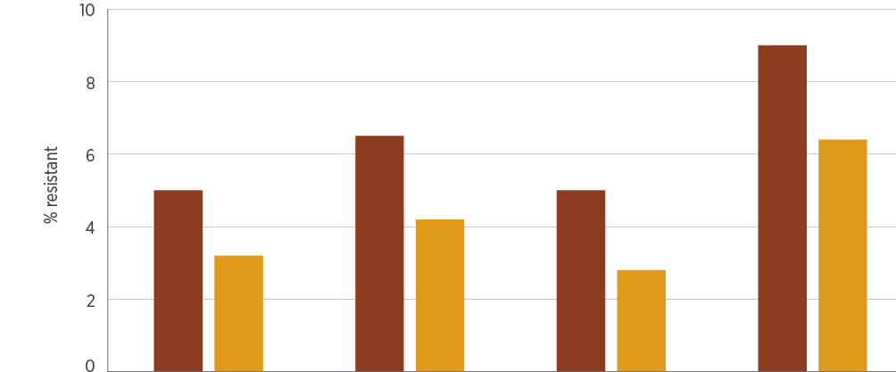
Year | Gentamicin | Ciprofloxacin  /norfloxacin | Meropenem | Trimethoprim–  sulfamethoxazole
2016, % | 5.0 | 6.5 | 5.0 | 9.0
2017, % | 3.2 | 4.2 | 2.8 | 6.4
2016, n | 1,212 | 1,161 | 976 | 970
2017, n | 1,266 | 1,194 | 1,063 | 1,093

Sources: AGAR (national); APAS (NSW, Vic, Qld, SA, WA, Tas, ACT); SNP (Qld, northern NSW)
Figure 4.2: Acinetobacter baumannii complex resistance, by clinical setting, 2016–17
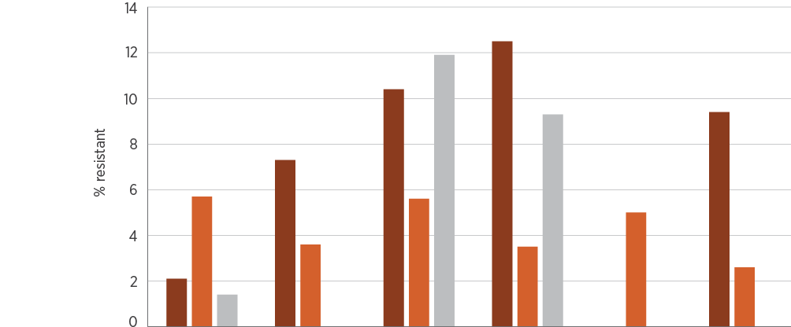
Setting | 2016 | 2017 | 2016 | 2017 | 2016 | 2017
 | Gentamicin |  | Ciprofloxacin  /norfloxacin |  | Meropenem
Private hospitals, % | 2.1 | 7.3 | 10.4 | 12.5 | nd | 9.4
Public hospitals, % | 5.7 | 3.6 | 5.6 | 3.5 | 5.0 | 2.6
Community, % | 1.4 | 0.0 | 11.9 | 9.3 | nd | nd
Private hospitals, n | 48 | 41 | 48 | 40 | nd | 32
Public hospitals, n | 1,025 | 1,063 | 987 | 1,008 | 976 | 994
Community, n | 139 | 124 | 126 | 108 | nd | nd

nd = no data (either not tested or tested against an inadequate number of isolates)
Sources: AGAR and APAS (public hospitals); AGAR, APAS (Qld, SA) and SNP (private hospitals); APAS and SNP (community)

Key findings: states and territories
Rates of resistance to the three key agents (ciprofloxacin/norfloxacin, gentamicin and meropenem) tended to be higher in WA than in other states and territories. There was notable variation in rates of resistance to ciprofloxacin between states and territories, although, overall, resistance rates were low (<10%) (see AURA 2019: Supplementary data).

4.3 Enterobacterales
This section describes the health impact and treatment of Enterobacterales, and the types, impact and rates of resistance in this bacterial group.
Recent taxonomic studies have narrowed the definition of the family Enterobacteriaceae. Some previous members of this family are now included in other families within the order Enterobacterales, and this term will now be used across AURA publications, including AURA 2019.²

Health impact
The order Enterobacterales is a large group of related bacteria. Many of its members are associated with infections in humans. Of these, E. coli and Klebsiella pneumoniae are the most common and important species, and cause both community- and hospital-associated infections. Enterobacter cloacae complex is a common pathogen group in hospital care. The Enterobacterales also include Salmonella and Shigella species; these are reported on separately in Sections 4.9 and 4.10.
E. coli, K. pneumoniae and E. cloacae complex are associated with a variety of infections, including urinary tract infections, biliary tract infections, other intra-abdominal infections (including those following surgery, and often mixed with other pathogens) and septicaemia. E. coli is the most common cause of urinary tract infection and septicaemia in the community and in otherwise healthy people. Less frequently, the three species are a cause of bacteraemia from intravascular lines and meningitis.

Treatment
The aminoglycosides (especially gentamicin) are recommended for empirical use, pending the results of culture and susceptibility testing. β-lactam agents, including those combined with β-lactamase inhibitors, are preferred for treatment of infections caused by these species when prolonged treatment or a switch from parenteral to oral therapy is considered. In Australia, fluoroquinolones are recommended only for strains that are resistant to other classes of antimicrobials. In addition to β-lactams, trimethoprim is recommended for treatment of lower urinary tract infections.

Types and impact of resistance
The most common resistance mechanisms in Enterobacterales are β-lactamases. The acquired TEM-1 β-lactamase has become so common worldwide that it is found in at least half of the strains isolated from humans in the community in Australia, making these strains resistant to ampicillin and amoxicillin. Both K. pneumoniae and E. cloacae complex contain intrinsic β-lactamases that make them naturally resistant to ampicillin/amoxicillin. In addition, the intrinsic β-lactamase of E. cloacae complex makes this species resistant to first-generation cephalosporins such as cefazolin and cefalexin, and the enzyme can be easily upregulated to make the species resistant to third-generation cephalosporins such as ceftriaxone, cefotaxime and ceftazidime. The β-lactam/β-lactamase inhibitor combinations amoxicillin–clavulanic acid and piperacillin–tazobactam are the usual treatments for TEM-1-producing E. coli and K. pneumoniae, along with third-generation cephalosporins.
The acquired β-lactamases of greatest interest are the extended-spectrum β-lactamases (ESBLs), the plasmid-borne AmpC enzymes (pAmpCs) and the carbapenemases. ESBLs and pAmpCs render Enterobacterales resistant to third-generation cephalosporins, and carbapenemases confer resistance to carbapenems and almost all other β-lactams. Carbapenemase-producing Enterobacterales are almost always highly multidrug-resistant.
Other resistance mechanisms in Enterobacterales that have a clinical impact include the aminoglycoside-modifying enzymes, which render strains resistant to gentamicin and tobramycin (but susceptible to amikacin), and the ribosomal methylases, which confer resistance to gentamicin, tobramycin and amikacin. Resistance to fluoroquinolones is usually through mutations at the target sites (the topoisomerases), but, recently, plasmid-borne resistance has emerged. Resistance to trimethoprim–sulfamethoxazole is common and occurs through several mechanisms.
E. coli, K. pneumoniae and E. cloacae complex are noted for their capacity to acquire and transmit resistance genes among themselves and to some other genera through horizontal gene transfer. In addition, this family has specialised mechanisms (integrons) for capturing and accumulating resistance genes, giving them great capacity to become multidrug-resistant. The number of agents available for treatment of highly multidrug-resistant strains is limited, and all these agents have greater toxicity than the β-lactams.

Key findings: national
As observed in previous survey years, in 2016–17 there were no substantial differences in resistances between specimen sources for any of the three reported species. Resistance to ampicillin (and therefore amoxicillin) remains the most common resistance in E. coli, while being intrinsic in K. pneumoniae and E. cloacae complex. Resistance to amoxicillin–clavulanic acid increased from 11–16% in 2016 to 14–17% of E. coli in 2017 (Figure 4.3), but remains less than 10% for K. pneumoniae (Figure 4.5). Resistance to cefazolin and trimethoprim (with or without sulfamethoxazole) was common in E. coli, but less so in K. pneumoniae. Resistance to third-generation cephalosporins (ceftriaxone or cefotaxime) was found in 7–10% of E. coli in 2016 and 8–10% in 2017; the rates in K. pneumoniae were 4–6% in 2016 and 5–7% in 2017. In E. cloacae complex, ceftriaxone/cefotaxime resistance was found in 24–30% (Figure 4.7), mostly resulting from stably derepressed mutants of its intrinsic cephalosporinase. The lower resistance rate to cefepime in this species (2% in 2016; 7% in 2017) is an indication of the proportion of this complex that harbours ESBLs. Fluoroquinolone (ciprofloxacin or norfloxacin) resistance was detected in 9–11% of E. coli in 2016 and 10–12% in 2017. The rates in K. pneumoniae were 4–5% in 2016 and 6–7% in 2017, and in E. cloacae complex 3–6% in 2016 and 4–7% in 2017. Resistance to carbapenems (meropenem) was less than 0.1% in E. coli, less than 0.5% in K. pneumoniae, but 1% in E. cloacae complex (Figures 4.3, 4.5 and 4.7).
Rates of resistance were somewhat lower in the community than in hospitals for most agents with available data. There were no major differences between rates in public versus private hospitals. Rates in aged care homes were often as high as, or higher than, rates in hospitals (Figures 4.4, 4.6 and 4.8).
Figure 4.3: Escherichia coli acquired resistance, by specimen source, 2016–17
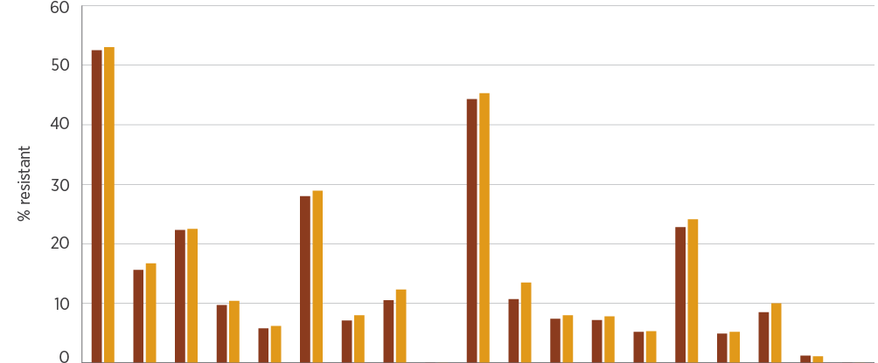
Year | AMP | AMC | CZL | CTR | PTZ | SXT | GEN | FQs | MER | AMP | AMC | CLX | CTR | PTZ | TMP | GEN | FQs | NIT | MER
 | Blood |  |  |  |  |  |  |  |  | Urine
2016, % | 52.5 | 15.6 | 22.3 | 9.7 | 5.8 | 28.0 | 7.1 | 10.5 | 0.0 | 44.3 | 10.7 | 7.4 | 7.2 | 5.2 | 22.8 | 4.9 | 8.5 | 1.2 | 0.0
2017, % | 53.0 | 16.7 | 22.5 | 10.4 | 6.2 | 28.9 | 8.0 | 12.3 | 0.0 | 45.3 | 13.5 | 8.0 | 7.8 | 5.3 | 24.1 | 5.2 | 10.0 | 1.1 | 0.0

AMC = amoxicillin–clavulanic acid; AMP = ampicillin; CLX = cefalexin; CTR = ceftriaxone/cefotaxime; CZL = cefazolin; FQs = ciprofloxacin/norfloxacin; GEN = gentamicin; MER = meropenem; NIT = nitrofurantoin; PTZ = piperacillin–tazobactam; SXT = trimethoprim–sulfamethoxazole; TMP = trimethoprim
Sources: AGAR (national); APAS (NSW, Vic, Qld, SA, WA, Tas, ACT); SNP (Qld, northern NSW)
Figure 4.4: Escherichia coli acquired resistance, by clinical setting, 2016–17
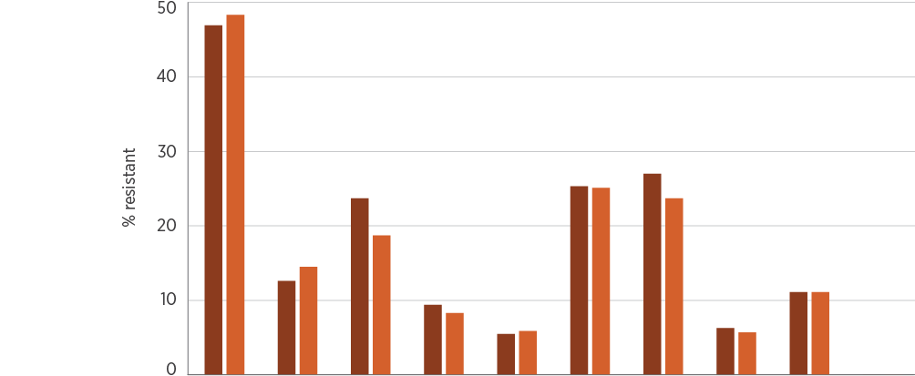
Setting | AMP | AMC | CZL | CTR | PTZ | TMP | SXT | GEN | FQs | MER
Private hospitals, % | 46.9 | 12.6 | 23.7 | 9.4 | 5.5 | 25.3 | 27.0 | 6.3 | 11.1 | 0.0
Public hospitals, % | 48.3 | 14.5 | 18.7 | 8.3 | 5.9 | 25.1 | 23.7 | 5.7 | 11.1 | 0.0
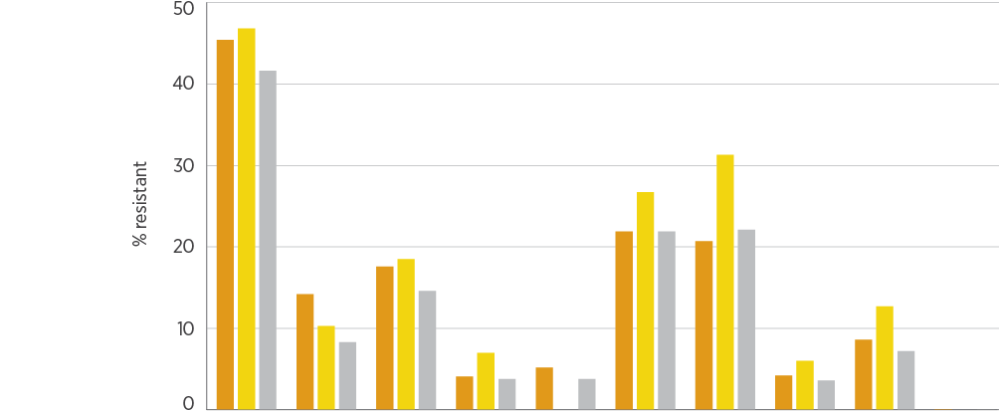
Setting | AMP | AMC | CZL | CTR | PTZ | TMP | SXT | GEN | FQs | MER
Multi-purpose services, % | 45.4 | 14.2 | 17.6 | 4.1 | 5.2 | 21.9 | 20.7 | 4.2 | 8.6 | 0.1
Aged care homes, % | 46.8 | 10.3 | 18.5 | 7.0 | nd | 26.7 | 31.3 | 6.0 | 12.7 | nd
Community, % | 41.6 | 8.3 | 14.6 | 3.8 | 3.8 | 21.9 | 22.1 | 3.6 | 7.2 | 0.0
AMC = amoxicillin–clavulanic acid; AMP = ampicillin; CTR = ceftriaxone/cefotaxime; CZL = cefazolin; FQs = ciprofloxacin/norfloxacin; GEN = gentamicin; MER = meropenem; nd = no data (either not tested or tested against an inadequate number of isolates); PTZ = piperacillin–tazobactam; SXT = trimethoprim–sulfamethoxazole; TMP = trimethoprim Note: For clarity of presentation, data for 2016 and 2017 have been combined. Raw data for the individual years are available in AURA 2019: Supplementary data.
Sources: AGAR and APAS (public hospitals); AGAR, APAS (Qld, SA) and SNP (private hospitals); APAS and SNP (community and aged care homes); APAS (multi-purpose services)
Figure 4.5: Klebsiella pneumoniae acquired resistance, by specimen source, 2016–17
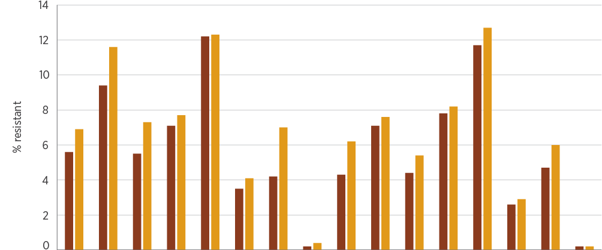
Year | AMC | CZL | CTR | PTZ | SXT | GEN | FQs | MER | AMC | CZL | CTR | PTZ | TMP | GEN | FQs | MER
 | Blood |  |  |  |  |  |  |  | Urine
2016, % | 5.6 | 9.4 | 5.5 | 7.1 | 12.2 | 3.5 | 4.2 | 0.2 | 4.3 | 7.1 | 4.4 | 7.8 | 11.7 | 2.6 | 4.7 | 0.2
2017, % | 6.9 | 11.6 | 7.3 | 7.7 | 12.3 | 4.1 | 7.0 | 0.4 | 6.2 | 7.6 | 5.4 | 8.2 | 12.7 | 2.9 | 6.0 | 0.2

AMC = amoxicillin–clavulanic acid; CTR = ceftriaxone/cefotaxime; CZL = cefazolin; FQs = ciprofloxacin/norfloxacin; GEN = gentamicin; MER = meropenem; PTZ = piperacillin–tazobactam; SXT = trimethoprim–sulfamethoxazole; TMP = trimethoprim
Sources: AGAR (national); APAS (NSW, Vic, Qld, SA, WA, Tas, ACT); SNP (Qld, northern NSW)
Figure 4.6: Klebsiella pneumoniae acquired resistance, by clinical setting, 2016–17
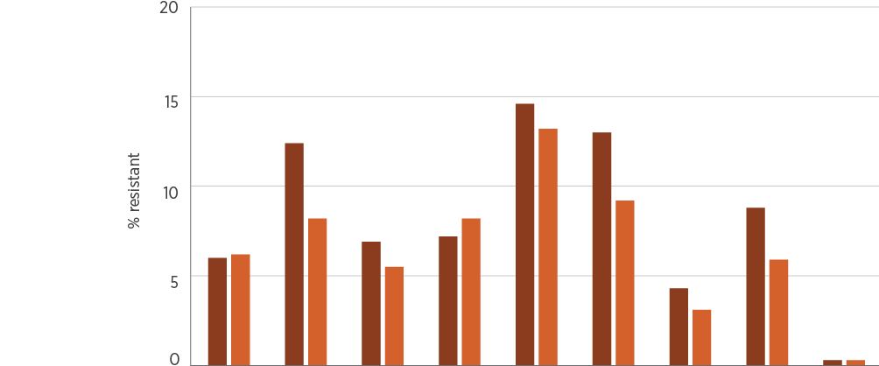
Setting | AMC | CZL | CTR | PTZ | TMP | SXT | GEN | FQs | MER
Private hospitals, % | 6.0 | 12.4 | 6.9 | 7.2 | 14.6 | 13.0 | 4.3 | 8.8 | 0.3
Public hospitals, % | 6.2 | 8.2 | 5.5 | 8.2 | 13.2 | 9.2 | 3.1 | 5.9 | 0.3
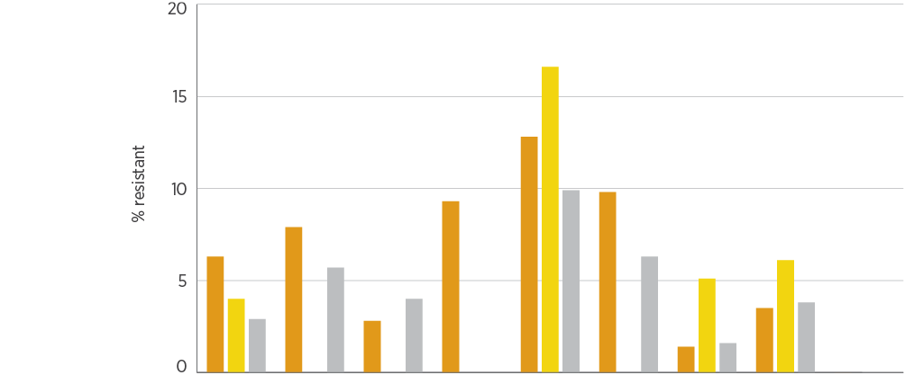
Setting | AMC | CZL | CTR | PTZ | TMP | SXT | GEN | FQs | MER
Multi-purpose services, % | 6.3 | 7.9 | 2.8 | 9.3 | 12.8 | 9.8 | 1.4 | 3.5 | 0.0
Aged care homes, % | 4.0 | nd | nd | nd | 16.6 | nd | 5.1 | 6.1 | nd
Community, % | 2.9 | 5.7 | 4.0 | nd | 9.9 | 6.3 | 1.6 | 3.8 | nd

AMC = amoxicillin–clavulanic acid; CTR = ceftriaxone/cefotaxime; CZL = cefazolin; FQs = ciprofloxacin/norfloxacin; GEN = gentamicin; MER = meropenem; nd = no data (either not tested or tested against an inadequate number of isolates); PTZ = piperacillin–tazobactam; SXT = trimethoprim–sulfamethoxazole; TMP = trimethoprim Note: For clarity of presentation, data for 2016 and 2017 have been combined. Raw data for the individual years are available in AURA 2019: Supplementary data.
Sources: AGAR and APAS (public hospitals); AGAR, APAS (Qld, SA) and SNP (private hospitals); APAS and SNP (community and aged care homes); APAS (multi-purpose services)
Figure 4.7: Enterobacter cloacae complex acquired resistance, by specimen source, 2016–17
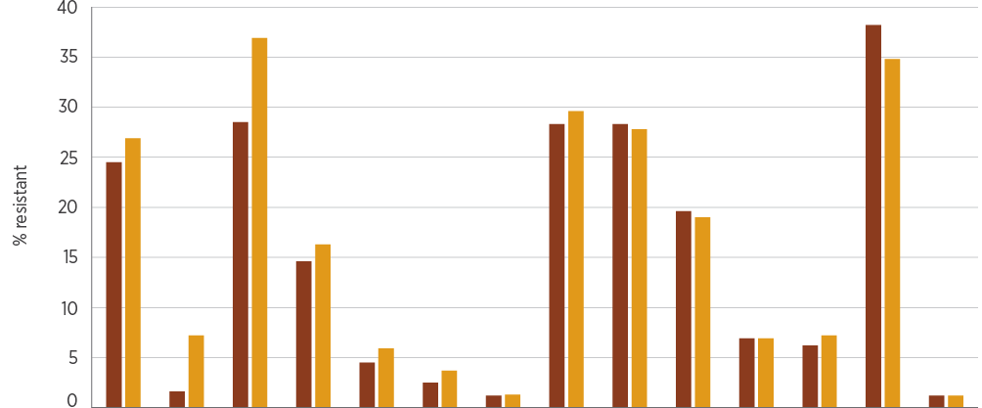
Year | CTR | CPM | PTZ | SXT | GEN | FQs | MER | CTR | PTZ | TMP | GEN | FQs | NIT | MER
 | Blood |  |  |  |  |  |  | Urine
2016, % | 24.5 | 1.6 | 28.5 | 14.6 | 4.5 | 2.5 | 1.2 | 28.3 | 28.3 | 19.6 | 6.9 | 6.2 | 38.2 | 1.2
2017, % | 26.9 | 7.2 | 36.9 | 16.3 | 5.9 | 3.7 | 1.3 | 29.6 | 27.8 | 19.0 | 6.9 | 7.2 | 34.8 | 1.2

CPM = cefepime; CTR = ceftriaxone/cefotaxime; FQs = ciprofloxacin/norfloxacin; GEN = gentamicin; MER = meropenem; NIT = nitrofurantoin; PTZ = piperacillin–tazobactam; SXT = trimethoprim–sulfamethoxazole; TMP = trimethoprim
Sources: AGAR (national); APAS (NSW, Vic, Qld, SA, WA, Tas, ACT); SNP (Qld, northern NSW)
Figure 4.8: Enterobacter cloacae complex acquired resistance, by clinical setting, 2016–17
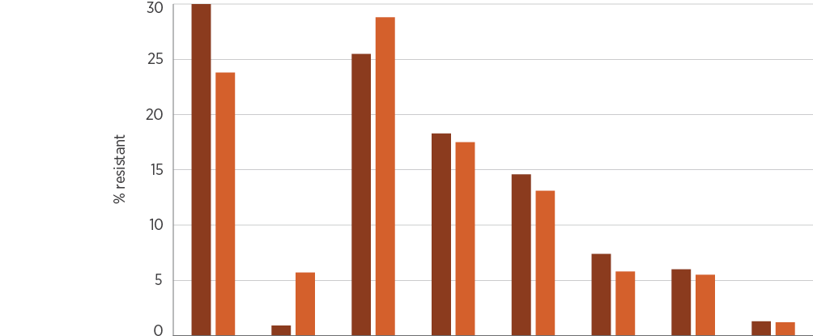
Setting | CTR | CPM | PTZ | TMP | SXT | GEN | FQs | MER
Private hospitals, % | 30.0 | 0.9 | 25.5 | 18.3 | 14.6 | 7.4 | 6.0 | 1.3
Public hospitals, % | 23.8 | 5.7 | 28.8 | 17.5 | 13.1 | 5.8 | 5.5 | 1.2
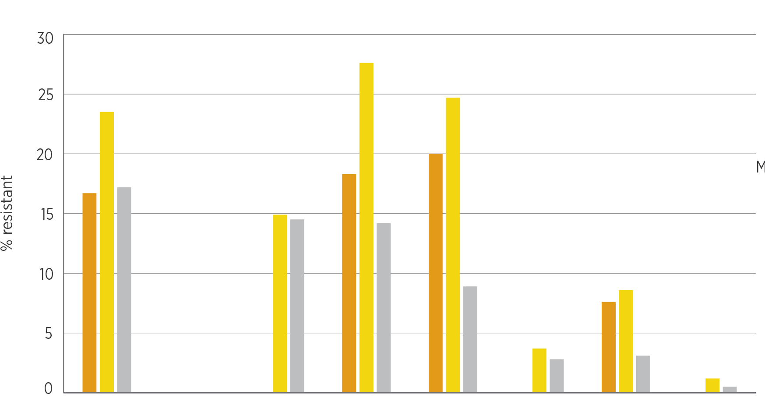
Setting | CTR | CPM | PTZ | TMP | SXT | GEN | FQs | MER
Multi-purpose services, % | 16.7 | nd | nd | 18.3 | 20.0 | 0.0 | 7.6 | 0.0
Aged care homes, % | 23.5 | nd | 14.9 | 27.6 | 24.7 | 3.7 | 8.6 | 1.2
Community, % | 17.2 | nd | 14.5 | 14.2 | 8.9 | 2.8 | 3.1 | 0.5

CPM = cefepime; CTR = ceftriaxone/cefotaxime; FQs = ciprofloxacin/norfloxacin; GEN = gentamicin; MER = meropenem; nd = no data (either not tested or tested against an inadequate number of isolates); PTZ = piperacillin–tazobactam; SXT = trimethoprim–sulfamethoxazole; TMP = trimethoprim Note: For clarity of presentation, data for 2016 and 2017 have been combined. Raw data for the individual years are available in AURA 2019: Supplementary data.
Sources: AGAR and APAS (public hospitals); AGAR, APAS (Qld, SA) and SNP (private hospitals); APAS and SNP (community and aged care homes); APAS (multi-purpose services)

Key findings: states and territories
Data on resistance were analysed by AURA in blood culture isolates from across the states and territories through the AGAR program. The resistance rates to all antimicrobials tested can be found in AURA 2019: Supplementary data. There were some notable differences between the states and territories in the prevalence of some important resistances (Figure 4.9).
For E. coli, acquired resistance to ceftriaxone ranged from 6.0% in Tasmania to 15.3% in NSW in 2016, and from 4.2% in SA to 14.1% in Victoria in 2017. Acquired resistance to gentamicin ranged from 4.2% in Tasmania to 11.8% in WA in 2016, and from 3.4% in Tasmania to 13.3% in the ACT in 2017. Non-susceptibility to ciprofloxacin ranged from 11.1% in the Northern Territory (NT) to 19.5% in NSW in 2016, and from 6.9% in Tasmania to 20.9% in Victoria in 2017 (Figure 4.9).
Overall, Tasmania had lower rates of resistance in E. coli to the three indicator agents (ceftriaxone, gentamicin and ciprofloxacin) in 2016 and 2017 than other states and territories. The reasons for this are unclear and warrant further investigation.
For K. pneumoniae, in 2017, acquired resistance to gentamicin ranged from 2.4% in Queensland to 10.2% in Victoria, and acquired resistance to ceftriaxone ranged from 3.3% in Queensland to 19.8% in Victoria. Acquired resistance to ciprofloxacin ranged from 0.0% in Tasmania to 21.8% in Victoria (Figure 4.9).
Overall, Tasmania had lower rates of resistance in Escherichia coli to the three indicator agents in 2016 and 2017 than other states and territories. The reasons for this are unclear and warrant further investigation.
Figure 4.9: Escherichia coli and Klebsiella pneumoniae acquired resistance (blood culture isolates), by state and territory, 2016–17
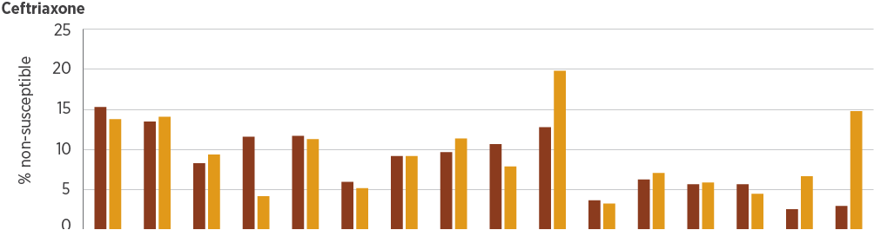
Year | NSW | Vic | Qld | SA | WA | Tas | NT | ACT | NSW | Vic | Qld | SA | WA | Tas | NT | ACT
 | E. coli |  |  |  |  |  |  |  | K. pneumoniae
2016, % | 15.3 | 13.5 | 8.3 | 11.6 | 11.7 | 6.0 | 9.2 | 9.7 | 10.7 | 12.8 | 3.7 | 6.3 | 5.7 | 5.7 | 2.6 | 3.0
2017, % | 13.8 | 14.1 | 9.4 | 4.2 | 11.3 | 5.2 | 9.2 | 11.4 | 7.9 | 19.8 | 3.3 | 7.1 | 5.9 | 4.5 | 6.7 | 14.8
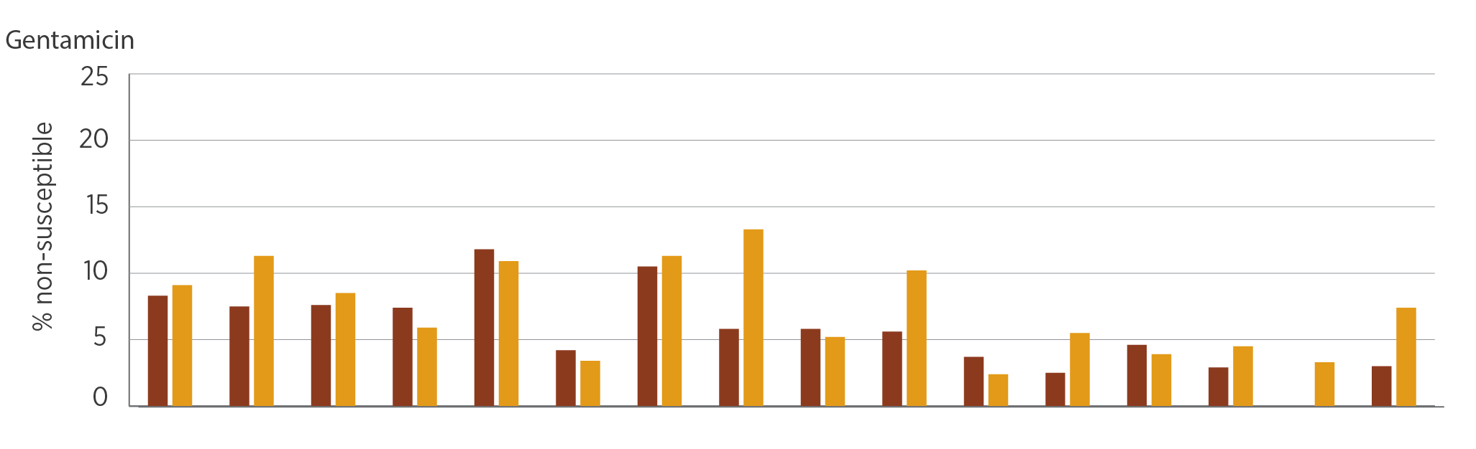
Year | NSW | Vic | Qld | SA | WA | Tas | NT | ACT | NSW | Vic | Qld | SA | WA | Tas | NT | ACT
 | E. coli |  |  |  |  |  |  |  | K. pneumoniae
2016, % | 8.3 | 7.5 | 7.6 | 7.4 | 11.8 | 4.2 | 10.5 | 5.8 | 5.8 | 5.6 | 3.7 | 2.5 | 4.6 | 2.9 | 0.0 | 3.0
2017, % | 9.1 | 11.3 | 8.5 | 5.9 | 10.9 | 3.4 | 11.3 | 13.3 | 5.2 | 10.2 | 2.4 | 5.5 | 3.9 | 4.5 | 3.3 | 7.4
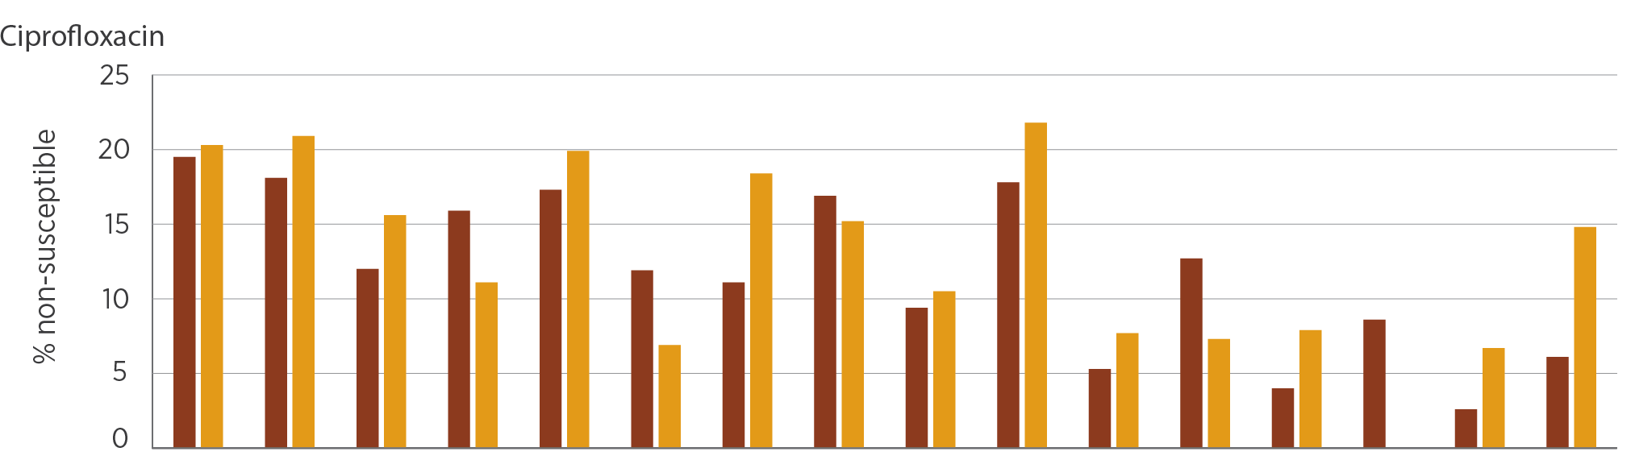
Year | NSW | Vic | Qld | SA | WA | Tas | NT | ACT | NSW | Vic | Qld | SA | WA | Tas | NT | ACT
 | E. coli |  |  |  |  |  |  |  | K. pneumoniae
2016, % | 19.5 | 18.1 | 12.0 | 15.9 | 17.3 | 11.9 | 11.1 | 16.9 | 9.4 | 17.8 | 5.3 | 12.7 | 4.0 | 8.6 | 2.6 | 6.1
2017, % | 20.3 | 20.9 | 15.6 | 11.1 | 19.9 | 6.9 | 18.4 | 15.2 | 10.5 | 21.8 | 7.7 | 7.3 | 7.9 | 0.0 | 6.7 | 14.8

Source: AGAR (national)

National trends
From AGAR data, acquired resistance of E. coli to key anti-gram-negative antimicrobial agents showed a steady increase over the five-year period 2013–2017 (Figure 4.10).
Figure 4.10: Trends in acquired resistance of Escherichia coli to key antimicrobials (blood cultures isolates), 2013–2017
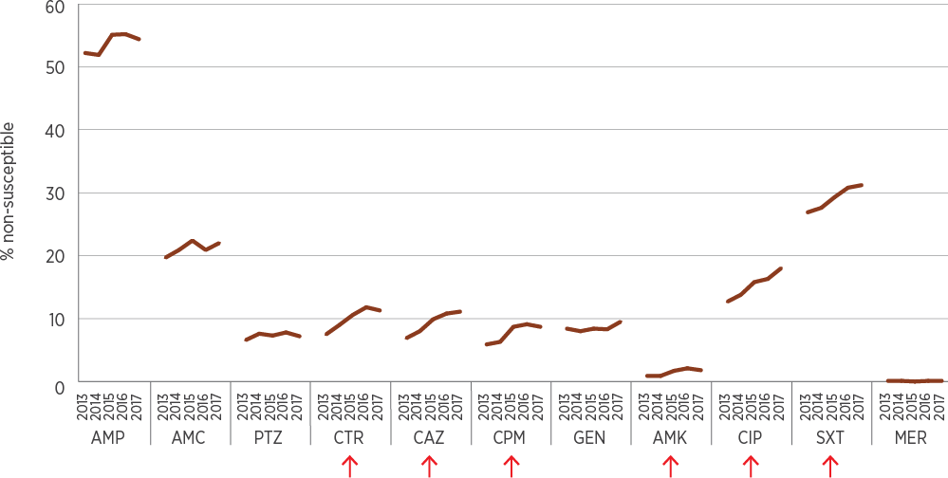
AMC = amoxicillin–clavulanic acid (2:1 ratio); AMK = amikacin; AMP = ampicillin; CAZ = ceftazidime; CIP = ciprofloxacin; CPM = cefepime; CTR = ceftriaxone; GEN = gentamicin; MER = meropenem; PTZ = piperacillin–tazobactam; SXT = trimethoprim–sulfamethoxazole
Note: Arrows indicate antimicrobial agents with a significant increase (P < 0.01, chi-square test for trend) in resistance over the period 2013–2017.
Source: AGAR (national)
Resistance to fluoroquinolones is increasing in E. coli, despite no increase in the use of this antibiotic class in the community (where access is restricted) or in hospitals. APAS data show substantial increases in fluoroquinolone non-susceptibility in E. coli in all remoteness areas for 2015–2017 (Figure 4.11).
The likely impact of these changes in resistance is:
Increasing treatment failures of empirical therapy in community-onset urinary tract infections and septicaemia
Increasing treatment failures, in combination regimens, used for the treatment of complicated intra-abdominal infections
Greater reliance on ‘last-line’ treatments such as carbapenems.
Acquired resistance of Escherichia coli to key anti-gram-negative antimicrobial agents showed a steady increase over the five-year period 2013–2017.
Figure 4.11: Percentage of fluoroquinolone-nonsusceptible Escherichia coli by remoteness area, 2015–2017
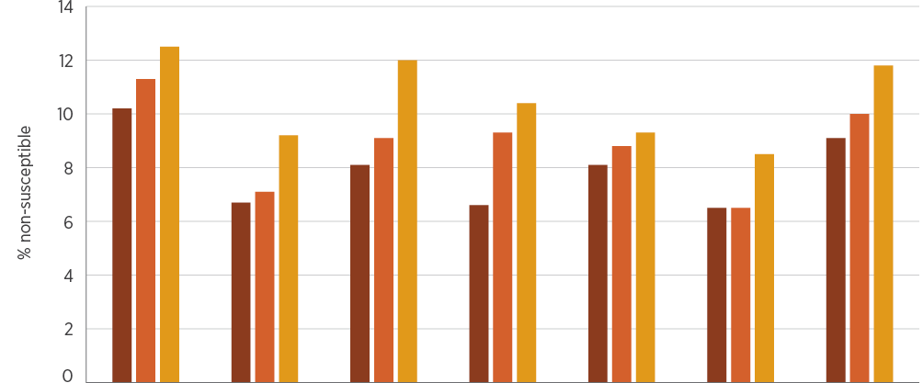
Year | Major cities | Inner regional | Outer regional | Remote | Very remote | Unknown | All remoteness areas
2015, % | 10.2 | 6.7 | 8.1 | 6.6 | 8.1 | 6.5 | 9.1
2016, % | 11.3 | 7.1 | 9.1 | 9.3 | 8.8 | 6.5 | 10.0
2017, % | 12.5 | 9.2 | 12.0 | 10.4 | 9.3 | 8.5 | 11.8
2015, n | 54,606 | 14,327 | 8,384 | 1,936 | 995 | 5,840 | 86,088
2016, n | 63,700 | 16,364 | 8,805 | 1,935 | 695 | 6,766 | 98,265
2017, n | 66,443 | 11,789 | 7,116 | 1,875 | 633 | 4,093 | 91,949

Note: Fluoroquinolone refers to ciprofloxacin or norfloxacin.
Source: APAS (national, excluding NT)

Additional findings from targeted surveillance
AGAR also captured data on 30-day all-cause mortality (Tables 4.3 and 4.4). Unless otherwise stated, these findings apply to all species of Enterobacterales detected.
Both E. coli and E. cloacae complex had significantly higher 30-day all-cause mortality in 2017 for hospital-onset than for community-onset bacteraemia. The effect of ESBLs (E. coli and K. pneumoniae) on 30-day all-cause mortality was small or absent. All-cause mortality rates were higher in hospital-onset sepsis than in community-onset sepsis, most likely because of greater comorbidities in hospitalised patients.
Table 4.3: Onset setting and 30-day all-cause mortality for the three most commonly isolated Enterobacterales species (blood culture isolates), 2016–17
Species | Year | Community, n | Community mortality, % (n) | Hospital, n | Hospital mortality, % (n) | Total, n | Total mortality, % (n)
Escherichia coli | 2016 | 1,986 | 10.1 (200) | 474 | 17.3 (82) | 2,460 | 11.5 (282)
 | 2017 | 2,286 | 9.4 (214) | 546 | 13.2 (72) | 2,832 | 10.1 (286)
Klebsiella pneumoniae | 2016 | 415 | 11.3 (47) | 193 | 14.5 (28) | 608 | 12.3 (75)
 | 2017 | 482 | 12.4 (60) | 224 | 15.6 (35) | 706 | 13.5 (95)
Enterobacter cloacae complex | 2016 | 148 | 16.2 (24) | 144 | 11.8 (17) | 292 | 14.0 (41)
 | 2017 | 169 | 8.3 (14) | 145 | 19.3 (28) | 314 | 13.4 (42)
All Enterobacterales | 2016 | 3,157 | 11.2 (353) | 1,071 | 16.5 (177) | 4,228 | 12.5 (530)
 | 2017 | 3,603 | 10.6 (383) | 1,173 | 14.6 (171) | 4,776 | 11.6 (554)

Source: AGAR (national)
Table 4.4: Onset setting and 30-day all-cause mortality for the two most commonly isolated Enterobacterales species (blood culture isolates), by extended-spectrum β-lactamase phenotype and multi-drug resistance, 2016–17
Species | Year | ESBL phenotype | Community, n | Community mortality, % (n) | Hospital, n | Hospital mortality, % (n) | Total, n | Total mortality, % (n)
Escherichia coli | 2016 | Total | 1,983 | 10.1 (200) | 472 | 17.4 (82) | 2,455 | 11.5 (282)
 |  | Non-ESBL | 1,743 | 9.8 (171) | 407 | 17.0 (69) | 2,150 | 11.2 (240)
 |  | ESBL | 240 | 12.1 (29) | 65 | 20.0 (13) | 305 | 13.8 (42)
 | 2017 | Total | 2,266 | 9.4 (214) | 526 | 13.7 (72) | 2,792 | 10.2 (286)
 |  | Non-ESBL | 2,009 | 9.3 (186) | 429 | 13.3 (57) | 2,438 | 10.0 (243)
 |  | ESBL | 257 | 10.9 (28) | 97 | 15.5 (15) | 354 | 12.1 (43)
Klebsiella pneumoniae | 2016 | Total | 414 | 11.4 (47) | 193 | 14.5 (28) | 607 | 12.4 (75)
 |  | Non-ESBL | 383 | 12.0 (46) | 166 | 15.7 (26) | 549 | 13.1 (72)
 |  | ESBL | 31 | 3.2 (1) | 27 | 7.4 (2) | 58 | 5.2 (3)
 | 2017 | Total | 475 | 12.2 (58) | 217 | 15.7 (34) | 692 | 13.3 (92)
 |  | Non-ESBL | 441 | 12.0 (53) | 175 | 16.0 (28) | 616 | 13.1 (81)
 |  | ESBL | 34 | 14.7 (5) | 42 | 14.3 (6) | 76 | 14.5 (11)

ESBL = extended-spectrum β-lactamase
Source: AGAR (national)
Data for gram-negative bacteria can be found on the AURA³ and AGAR websites.⁴
The proportions of E. coli and K. pneumoniae strains that are resistant to ceftriaxone and/or ceftazidime (MIC > 1 mg/L; ESBL phenotype), and variations between states and territories are shown in Figure 4.12. Considerable variation was noted between species, and between states and territories in 2016–17. Victoria had a 32% increase in K. pneumoniae with ESBL phenotype in one year.
Figure 4.12: Percentage of Escherichia coli and Klebsiella pneumoniae with extended-spectrum β-lactamase (ESBL) phenotype, by state and territory and nationally, 2016–17
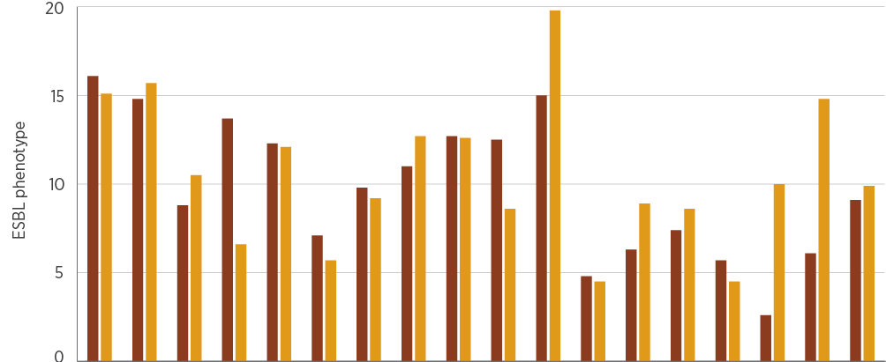
Year | NSW | Vic | Qld | SA | WA | Tas | NT | ACT | Aus | NSW | Vic | Qld | SA | WA | Tas | NT | ACT | Aus
 | E. coli |  |  |  |  |  |  |  |  | K. pneumoniae
2016, % | 16.1 | 14.8 | 8.8 | 13.7 | 12.3 | 7.1 | 9.8 | 11.0 | 12.7 | 12.5 | 15.0 | 4.8 | 6.3 | 7.4 | 5.7 | 2.6 | 6.1 | 9.1
2017, % | 15.1 | 15.7 | 10.5 | 6.6 | 12.1 | 5.7 | 9.2 | 12.7 | 12.6 | 8.6 | 19.8 | 4.5 | 8.9 | 8.6 | 4.5 | 10.0 | 14.8 | 9.9
2016, n | 992 | 709 | 811 | 431 | 677 | 168 | 153 | 154 | 4,095 | 224 | 180 | 189 | 79 | 175 | 35 | 38 | 33 | 953
2017, n | 1,170 | 794 | 858 | 289 | 771 | 174 | 141 | 158 | 4,355 | 267 | 197 | 246 | 56 | 152 | 22 | 30 | 27 | 997

Note: ESBL phenotype refers to strains that are resistant to ceftriaxone and/or ceftazidime (MIC > 1 mg/L).
Source: AGAR (national)

4.4 Enterococcus species
This section describes the health impact and treatment of Enterococcus species, and the types, impact and rates of resistance in these species.

Health impact
Enterococcus species are opportunistic pathogens that cause a variety of infections in patients whose physical barriers are compromised through surgery or invasive devices. They rarely cause disease in healthy people, but may cause infections in vulnerable people, such as the very elderly or people who are immunosuppressed.
The most common clinical syndromes associated with enterococcal septicaemia are intra-abdominal and urinary tract infections. Enterococci are a cause of urinary tract infection in patients with catheters or structural abnormalities of the urinary tract. They are also associated with other intestinal organisms in many intra-abdominal infections, especially those of the biliary tract (particularly E. faecium). These infections can be complicated by septicaemia. E. faecalis is also a less common, but important, cause of endocarditis.

Treatment
Enterococci are naturally resistant to a range of common antimicrobial classes, including anti-staphylococcal penicillins, cephalosporins, macrolides and lincosamides. Amoxicillin administered orally is the most common treatment for minor infections. More serious infections are treated with intravenous ampicillin or amoxicillin; for endocarditis, one of these agents is often combined with low-dose gentamicin. Vancomycin is used instead of ampicillin/amoxicillin for serious infections in patients who are allergic to penicillins.

Types and impact of resistance
Ampicillin resistance has emerged worldwide at high levels in E. faecium during the past 20 years, including in Australia. This has led to increased use of vancomycin for treatment. More recently, vancomycin-resistant enterococci (VRE) have also emerged, most notably in E. faecium, but also in E. faecalis. The gene complexes responsible are of two main types: vanA and vanB. In Australia, unlike in most other countries, VRE have been dominated until recently by the vanB, rather than the vanA, genotype. VRE require treatment with agents that are usually reserved, such as teicoplanin or daptomycin.

Key findings: national
Rates of resistance to key antimicrobials in E. faecalis were very low. In 2016–17, less than 1% of isolates from blood (n = 1,076 in 2016; n = 1,089 in 2017), urine (n = 11,576 in 2016; n = 12,731 in 2017) and other sites (n = 2,545 in 2016; n = 2,597 in 2017) were resistant to ampicillin, nitrofurantoin, vancomycin or linezolid (Figure 4.13). Rates of resistance showed some differences by clinical setting (Figure 4.14).
Figure 4.13: Enterococcus faecalis resistance, by specimen source, 2016–17
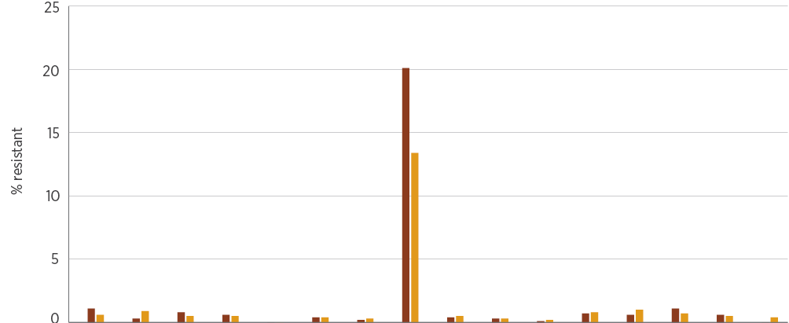
Year | AMP | NIT | LNZ | VAN | TEI | AMP | NIT | CIP/  NOR | LNZ | VAN | TEI | AMP | NIT | LNZ | VAN | TEI
 | Blood |  |  |  |  | Urine |  |  |  |  |  | Other
2016, % | 1.1 | 0.3 | 0.8 | 0.6 | 0.0 | 0.4 | 0.2 | 20.1 | 0.4 | 0.3 | 0.1 | 0.7 | 0.6 | 1.1 | 0.6 | 0.0
2017, % | 0.6 | 0.9 | 0.5 | 0.5 | 0.0 | 0.4 | 0.3 | 13.4 | 0.5 | 0.3 | 0.2 | 0.8 | 1.0 | 0.7 | 0.5 | 0.4
2016, n | 1,076 | 376 | 779 | 1,071 | 377 | 11,576 | 11,470 | 2,824 | 5,428 | 10,690 | 5,344 | 2,545 | 518 | 1,566 | 2,455 | 521
2017, n | 1,089 | 342 | 743 | 1,081 | 344 | 12,731 | 12,173 | 3,738 | 5,757 | 11,420 | 5,315 | 2,597 | 505 | 1,663 | 2,482 | 502

AMP = ampicillin; CIP/NOR = ciprofloxacin/norfloxacin; LNZ = linezolid; NIT = nitrofurantoin; TEI = teicoplanin; VAN = vancomycin
Sources: AGAR (national); APAS (NSW, Vic, Qld, SA, WA, Tas, ACT); SNP (Qld, northern NSW)
Figure 4.14: Enterococcus faecalis resistance, by clinical setting, 2016–17
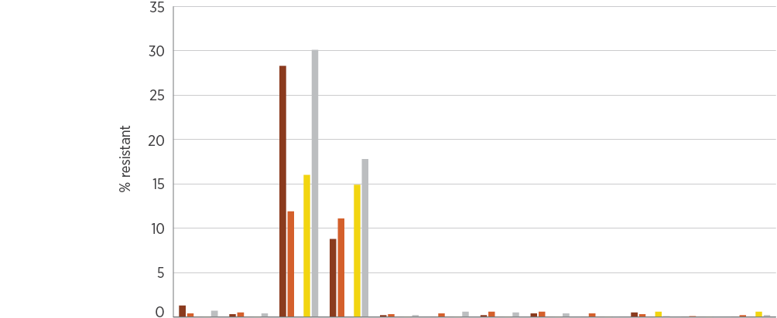
Setting | 2016 | 2017 | 2016 | 2017 | 2016 | 2017 | 2016 | 2017 | 2016 | 2017 | 2016 | 2017
 | AMP |  | CIP/NOR |  | NIT |  | LNZ |  | VAN |  | TEI
Private hospitals, % | 1.3 | 0.3 | 28.3 | 8.8 | 0.2 | 0.0 | 0.2 | 0.4 | 0.0 | 0.5 | 0.0 | 0.0
Public hospitals, % | 0.4 | 0.5 | 11.9 | 11.1 | 0.3 | 0.4 | 0.6 | 0.6 | 0.4 | 0.3 | 0.1 | 0.2
Multi-purpose services, % | 0.0 | 0.0 | nd | nd | 0.0 | 0.0 | 0.0 | 0.0 | 0.0 | 0.0 | 0.0 | 0.0
Aged care homes, % | 0.0 | 0.0 | 16.0 | 14.9 | 0.0 | 0.0 | 0.0 | 0.0 | 0.0 | 0.6 | 0.0 | 0.6
Community, % | 0.7 | 0.4 | 30.1 | 17.8 | 0.2 | 0.6 | 0.5 | 0.4 | 0.0 | 0.1 | 0.0 | 0.2

AMP = ampicillin; CIP/NOR = ciprofloxacin/norfloxacin; LNZ = linezolid; nd = no data (either not tested or tested against an inadequate number of isolates); NIT = nitrofurantoin; TEI = teicoplanin; VAN = vancomycin
Sources: AGAR and APAS (public hospitals); AGAR, APAS (Qld, SA) and SNP (private hospitals); APAS and SNP (community and aged care homes); APAS (multi-purpose services)
In contrast, rates of resistance in E. faecium to ampicillin, ciprofloxacin/norfloxacin and vancomycin were high (Figures 4.15 and 4.16). Linezolid resistance was rare. Specimen source did not substantially influence rates of resistance (Figure 4.15). There was some variation in the rates of vancomycin resistance in E. faecium, depending on the setting (Figure 4.16).
Figure 4.15: Enterococcus faecium resistance, by specimen source, 2016–17
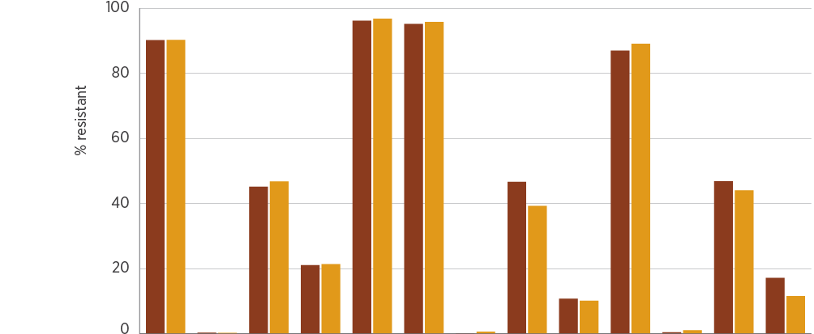
Year | AMP | LNZ | VAN | TEI | AMP | CIP/NOR | LNZ | VAN | TEI | AMP | LNZ | VAN | TEI
 | Blood |  |  |  | Urine |  |  |  |  | Other
2016, % | 90.2 | 0.4 | 45.2 | 21.1 | 96.2 | 95.2 | 0.1 | 46.7 | 10.8 | 87.0 | 0.5 | 46.9 | 17.2
2017, % | 90.3 | 0.3 | 46.8 | 21.4 | 96.8 | 95.8 | 0.7 | 39.3 | 10.2 | 89.1 | 1.1 | 44.1 | 11.6
2016, n | 533 | 511 | 546 | 204 | 2,150 | 480 | 1,361 | 2,157 | 581 | 1,031 | 962 | 1,080 | 279
2017, n | 639 | 625 | 652 | 266 | 2,626 | 640 | 1,707 | 2,657 | 801 | 1,168 | 1,137 | 1,220 | 276

AMP = ampicillin; CIP/NOR = ciprofloxacin/norfloxacin; LNZ = linezolid; TEI = teicoplanin; VAN = vancomycin
Sources: AGAR (national); APAS (NSW, Vic, Qld, SA, WA, Tas, ACT); SNP (Qld, northern NSW)
Figure 4.16: Enterococcus faecium resistance, by clinical setting, 2016–17
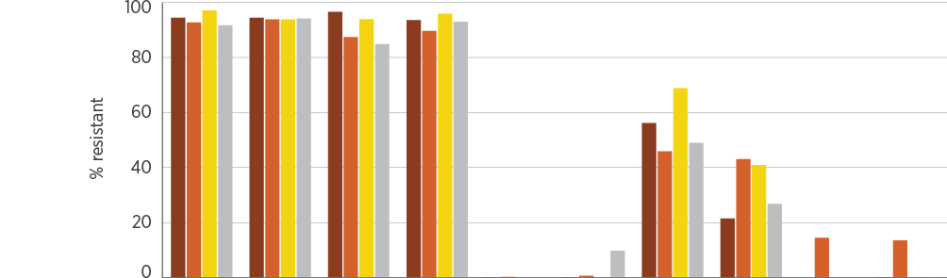
Settings | 2016 | 2017 | 2016 | 2017 | 2016 | 2017 | 2016 | 2017 | 2016 | 2017
 | AMP |  | CIP/NOR |  | LNZ |  | VAN |  | TEI
Private hospitals, % | 94.4 | 94.4 | 96.6 | 93.6 | 0.0 | 0.0 | 56.2 | 21.5 | nd | 0.0
Public hospitals, % | 92.7 | 93.8 | 87.4 | 89.6 | 0.3 | 0.7 | 45.9 | 43.1 | 14.5 | 13.5
Aged care homes, % | 97.1 | 93.8 | 93.9 | 95.9 | nd | nd | 68.8 | 40.9 | nd | nd
Community, % | 91.7 | 94.2 | 84.8 | 93.0 | nd | 9.8 | 49.0 | 26.8 | nd | 0.0

AMP = ampicillin; CIP/NOR = ciprofloxacin/norfloxacin; LNZ = linezolid; nd = no data (either not tested or tested against an inadequate number of isolates); TEI = teicoplanin; VAN = vancomycin Note: Multi-purpose services are excluded because of an insufficient number of isolates from this setting (<30).
Sources: AGAR and APAS (public hospitals); AGAR, APAS (Qld, SA) and SNP (private hospitals); APAS and SNP (community and aged care homes)
There is evidence that the overall rates of vancomycin resistance in E. faecium are declining nationally when all specimens are considered together. However, the absolute numbers of vancomycin-resistant isolates continue to increase. In 2017, the total number of clinical specimens of vancomycin-nonsusceptible E. faecium (VRE) increased by 17% in the APAS system, while vancomycin-susceptible isolates increased by 29%. This accounts for the change in the proportion of vancomycin non-susceptibility in E. faecium.
Data from APAS reveal a downward trend in vancomycin non-susceptibility in all remoteness areas during the period 2015–2017 (Figure 4.17).
The overall rates of vancomycin resistance in Enterococcus faecium are declining nationally; however, the absolute numbers of vancomycin-resistant isolates continue to increase.
Figure 4.17: Percentage of vancomycin-nonsusceptible Enterococcus faecium by remoteness area, 2015–2017
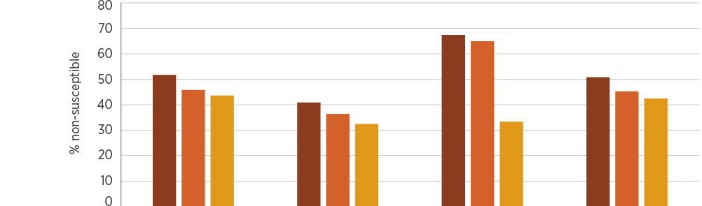
Year | Major cities | Inner regional | Outer regional | All remoteness areas
2015, % | 51.7 | 40.8 | 67.4 | 50.8
2016, % | 45.8 | 36.4 | 64.9 | 45.2
2017, % | 43.6 | 32.4 | 33.3 | 42.4
2015, n | 2,247 | 292 | 46 | 2,585
2016, n | 2,801 | 269 | 37 | 3,107
2017, n | 3,359 | 339 | 63 | 3,761

Source: APAS (public hospitals)

Key findings: states and territories
The percentages of Enterococcus species that were resistant to key antimicrobials are shown in Tables 4.5 and 4.6. In E. faecium, there are significant differences in vancomycin resistance between states.
Table 4.5: Percentage of Enterococcus faecalis resistance (blood culture isolates), by state and territory, 2016–17
Antimicrobial | Year | NSW | Vic | Qld | SA | WA | Tas | NT | ACT | Australia, % (no. tested)
Ampicillin | 2016 | 0.0 | 0.0 | 0.0 | 2.0 | 0.0 | 0.0 | 0.0 | 0.0 | 0.2 (592)
 | 2017 | 0.0 | 0.0 | 1.0 | 0.0 | 0.0 | 0.0 | 0.0 | 0.0 | 0.2 (601)
Vancomycin | 2016 | 0.0 | 0.8 | 0.0 | 1.9 | 0.0 | 0.0 | 0.0 | 0.0 | 0.3 (592)
 | 2017 | 0.0 | 1.7 | 0.0 | 0.0 | 0.0 | 0.0 | 0.0 | 0.0 | 0.3 (601)
Teicoplanin | 2016 | 0.0 | 0.0 | 0.0 | 0.0 | 0.0 | 0.0 | 0.0 | 0.0 | 0.0 (592)
 | 2017 | 0.0 | 0.0 | 0.0 | 0.0 | 0.0 | 0.0 | 0.0 | 0.0 | 0.0 (601)
Ciprofloxacin | 2016 | 7.2 | 11.5 | 8.2 | 3.9 | 8.0 | 21.4 | 0.0 | 12.1 | 8.8 (559)
 | 2017 | 7.0 | 13.6 | 16.8 | 9.7 | 5.5 | 6.3 | 20.0 | nd | 10.3 (546)
Nitrofurantoin | 2016 | 0.0 | 0.0 | 0.0 | 0.0 | 0.0 | 0.0 | 0.0 | 0.0 | 0.0 (591)
 | 2017 | 0.0 | 0.8 | 0.0 | 0.0 | 0.0 | 0.0 | 0.0 | 0.0 | 0.2 (595)
Linezolid | 2016 | 0.0 | 0.0 | 2.0 | 0.0 | 0.0 | 0.0 | 0.0 | 0.0 | 0.3 (591)
 | 2017 | 0.0 | 0.0 | 0.0 | 0.0 | 0.0 | 0.0 | 0.0 | 0.0 | 0.0 (601)
Total number of isolates tested | 2016 | 152 | 130 | 100 | 52 | 87 | 27 | 7 | 40 | 595
 | 2017 | 187 | 119 | 102 | 31 | 94 | 31 | 10 | 28 | 602

nd = no data (tested against an inadequate number of isolates)
Notes:
1. Resistance was determined using European Committee on Antimicrobial Susceptibility Testing interpretive criteria.
2. Not all antimicrobial agents were reported for all isolates.
Source: AGAR (national)
Table 4.6: Percentage of Enterococcus faecium resistance (blood culture isolates), by state and territory, 2016–17
Antimicrobial | Year | NSW | Vic | Qld | SA | WA | Tas | NT | ACT | Australia, % (no. tested)
Ampicillin | 2016 | 91.9 | 89.0 | 90.7 | 97.7 | 92.6 | 85.7 | nd | 90.9 | 91.5 (412)
 | 2017 | 89.2 | 92.5 | 95.6 | 85.7 | 81.0 | 88.2 | nd | 95.5 | 89.6 (481)
Vancomycin | 2016 | 47.6 | 62.4 | 30.2 | 46.5 | 14.8 | 42.9 | nd | 68.2 | 46.5 (413)
 | 2017 | 51.5 | 64.2 | 33.3 | 57.1 | 14.3 | 29.4 | nd | 27.3 | 47.0 (481)
Teicoplanin | 2016 | 38.7 | 13.8 | 2.3 | 0.0 | 9.3 | 0.0 | nd | 40.9 | 18.9 (413)
 | 2017 | 45.5 | 17.9 | 13.3 | 17.9 | 4.8 | 5.9 | nd | 27.3 | 24.9 (481)
Linezolid | 2016 | 0.0 | 0.0 | 0.0 | 0.0 | 0.0 | 0.0 | nd | 0.0 | 0.0 (408)
 | 2017 | 0.0 | 0.0 | 0.0 | 0.0 | 0.0 | 0.0 | nd | 0.0 | 0.0 (481)
Total number of isolates tested | 2016 | 124 | 109 | 43 | 43 | 54 | 14 | 4 | 22 | 413
 | 2017 | 167 | 134 | 45 | 28 | 63 | 17 | 5 | 22 | 481

nd = no data (tested against an inadequate number of isolates)
Notes:
1 Resistance was determined using European Committee on Antimicrobial Susceptibility Testing interpretive criteria.
2. Not all antimicrobial agents were reported for all isolates.
Source: AGAR (national)
Vancomycin-resistant E. faecium is the main AMR issue for Enterococcus species. The main type of vancomycin-resistant E. faecium circulating in Australia is the vanB type; however, in 2017, the vanA type was as prevalent as vanB (Figure 4.18). In NSW and the ACT, the vanA type is now predominant in blood culture isolates.
Figure 4.18: Enterococcus faecium genotype (blood culture isolates), by state and territory and nationally, 2016–17
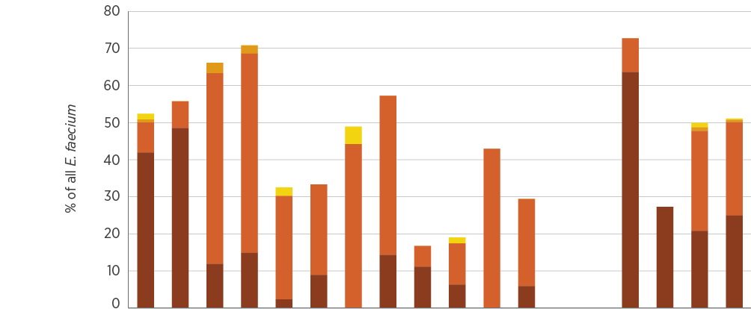
Genotype | 2016 | 2017 | 2016 | 2017 | 2016 | 2017 | 2016 | 2017 | 2016 | 2017 | 2016 | 2017 | 2016 | 2017 | 2016 | 2017 | 2016 | 2017
 | NSW |  | Vic |  | Qld |  | SA |  | WA |  | Tas |  | NT |  | ACT |  | Australia
vanA | 41.9 | 48.5 | 11.9 | 14.9 | 2.3 | 8.9 | 0.0 | 14.3 | 11.1 | 6.3 | 0.0 | 5.9 | nd | nd | 63.6 | 27.3 | 20.8 | 24.9
vanB | 8.1 | 7.2 | 51.4 | 53.7 | 27.9 | 24.4 | 44.2 | 42.9 | 5.6 | 11.1 | 42.9 | 23.5 | nd | nd | 9.1 | 0.0 | 26.9 | 25.2
vanA and vanB | 0.8 | 0.0 | 2.8 | 2.2 | 0.0 | 0.0 | 0.0 | 0.0 | 0.0 | 0.0 | 0.0 | 0.0 | nd | nd | 0.0 | 0.0 | 1.0 | 0.6
Not determined | 1.6 | 0.0 | 0.0 | 0.0 | 2.3 | 0.0 | 4.7 | 0.0 | 0.0 | 1.6 | 0.0 | 0.0 | nd | nd | 0.0 | 0.0 | 1.2 | 0.4

nd = no data (tested against an inadequate number of isolates)
Notes:
1. Total number of isolates: n = 413 in 2016; n = 481 in 2017.
2. For NT, number of isolates: n = 4 in 2016 (3 vanB, 1 not vanA or vanB); n = 5 in 2017 (3 vanB, 1 not vanA or vanB, 1 not determined).
Source: AGAR (national)
Data from the AGAR program show that the overall rate of vancomycin resistance has not changed significantly since 2014, in contrast to the national picture found in APAS data. The reason for this difference is not clear, and will be discussed further with the states and territories. Over this time, there has been a growth of vanA and a decline of vanB genotypes. Of note is the small proportion of strains with vanA or vanB genes that tested as ‘susceptible’ in the routine susceptibility test. These strains highlight the problem of a hidden reservoir of resistance gene complexes (Figure 4.19).
Figure 4.19: Enterococcus faecium genotype and vancomycin susceptibility (blood culture isolates), 2013–2017
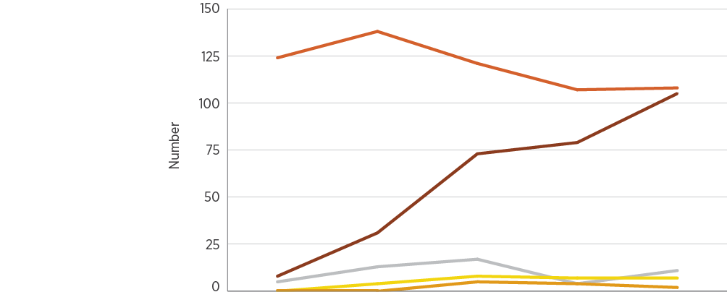
Genotype | 2013 | 2014 | 2015 | 2016 | 2017
vanA, vancomycin-resistant | 8 | 31 | 73 | 79 | 105
vanB, vancomycin-resistant | 124 | 138 | 121 | 107 | 108
vanA + vanB, vancomycin-resistant | 0 | 0 | 5 | 4 | 2
vanA, vancomycin-susceptible | 0 | 4 | 8 | 7 | 7
vanB, vancomycin-susceptible | 5 | 13 | 17 | 4 | 11
Total, n | 137 | 186 | 224 | 201 | 233
Source: AGAR (national)

Additional findings from targeted surveillance
Data from AGAR are available for 30-day all-cause mortality. The all-cause mortality at 30 days was significantly higher for E. faecium infections than for E. faecalis infections, possibly as a result of greater comorbidities in patients with E. faecium infections. Vancomycin resistance in E. faecium appeared to have an even greater association with 30-day mortality than vancomycin susceptibility in E. faecium (Table 4.7).
Table 4.7: Onset setting and 30-day all-cause mortality for infections with Enterococcus (blood culture isolates), 2016–17
Species | Year | Community, n | Community mortality, % (n) | Hospital, n | Hospital mortality, % (n) | Total, n | Total mortality, % (n)
Enterococcus faecalis | 2016 | 336 | 10.4 (35) | 161 | 18.0 (29) | 497 | 12.9 (64)
 | 2017 | 345 | 14.2 (49) | 145 | 14.5 (21) | 490 | 14.3 (70)
Enterococcus faecium | 2016 | 96 | 21.9 (21) | 283 | 29.0 (82) | 379 | 27.2 (103)
 | 2017 | 117 | 29.9 (35) | 298 | 26.8 (80) | 415 | 27.7 (115)
Vancomycin-susceptible E. faecium | 2016 | 57 | 21.1 (12) | 141 | 27.7 (39) | 198 | 25.8 (51)
 | 2017 | 78 | 33.3 (26) | 134 | 22.4 (30) | 212 | 26.4 (56)
Vancomycin-resistant E. faecium | 2016 | 39 | 23.1 (9) | 142 | 30.3 (43) | 181 | 28.7 (52)
 | 2017 | 39 | 23.1 (9) | 164 | 30.5 (50) | 203 | 29.1 (59)

Source: AGAR (national)
E. faecium isolates were typed using whole genome sequencing. Different multi-locus sequence types have become established in different states and territories, consistent with rapid local or regional spread rather than national spread (Figure 4.20). This emphasises the importance of local infection control practices in containment and spread of VRE strains.
Figure 4.20: Distribution of Enterococcus faecium sequence types (blood culture isolates), by state and territory, 2016–17
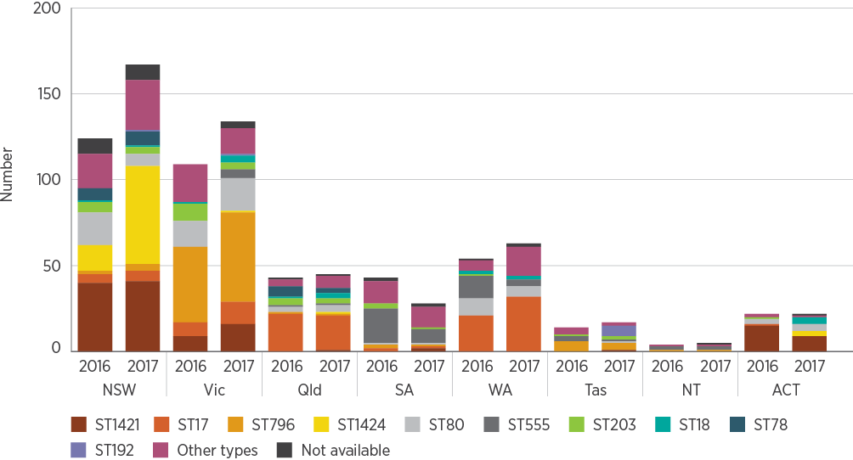
Source: AGAR (national)
Four sequence types – ST17, ST796, ST1421 (M-type 1) and ST80 – accounted for 58% of all E. faecium in Australia in 2016. In 2017, ST1424 (M-type 3) replaced ST80. However, ST1421 and ST796 harboured the greatest proportion of van genes. Sequence type ST1421 harboured vanA genes, while ST796 harboured vanB genes (Figure 4.21). This accounts for different VE teicoplanin susceptibility patterns seen by state and territory in AGAR national reports. ST1424 increased in 2017 compared with 2016. In 2016, this sequence type was found in NSW, but in 2017 it was detected in all states and territories except the NT and WA.
Figure 4.21: Enterococcus faecium multi-locus sequence types harbouring vanA and/or vanB genes, 2016–17
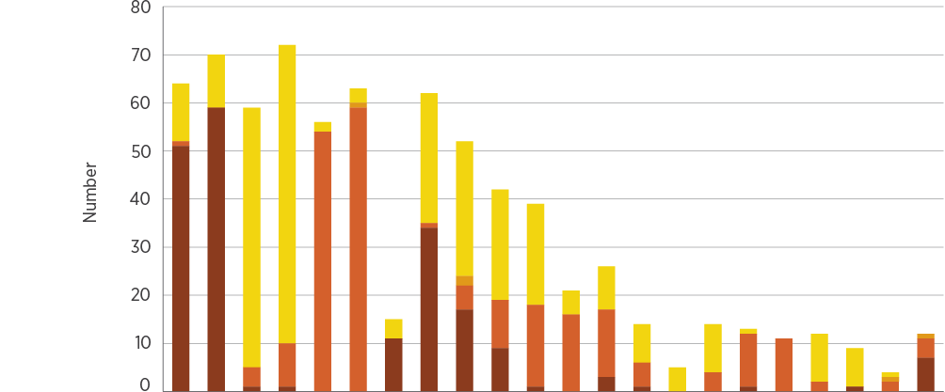
Genotype | 2016 | 2017 | 2016 | 2017 | 2016 | 2017 | 2016 | 2017 | 2016 | 2017 | 2016 | 2017 | 2016 | 2017 | 2016 | 2017 | 2016 | 2017 | 2016 | 2017 | 2016 | 2017
 | ST1421 |  | ST17 |  | ST796 |  | ST1424 |  | ST80 |  | ST555 |  | ST203 |  | ST18 |  | ST78 |  | ST262 |  | Other types
vanA | 51 | 59 | 1 | 1 | 0 | 0 | 11 | 34 | 17 | 9 | 1 | 0 | 3 | 1 | 0 | 0 | 1 | 0 | 0 | 1 | 0 | 7
vanB | 1 | 0 | 4 | 9 | 54 | 59 | 0 | 1 | 5 | 10 | 17 | 16 | 14 | 5 | 0 | 4 | 11 | 11 | 2 | 0 | 2 | 4
vanA and vanB | 0 | 0 | 0 | 0 | 0 | 1 | 0 | 0 | 2 | 0 | 0 | 0 | 0 | 0 | 0 | 0 | 0 | 0 | 0 | 0 | 1 | 1
Not vanA or vanB | 12 | 11 | 54 | 62 | 2 | 3 | 4 | 27 | 28 | 23 | 21 | 5 | 9 | 8 | 5 | 10 | 1 | 0 | 10 | 8 | 1 | 0

Source: AGAR (national)
Full data from AGAR surveys of Enterococcus species can be found on the AGAR website.⁴
Different sequence types of Enterococcus faecium have become established in different states and territories, consistent with rapid local or regional spread. This emphasises the importance of local infection control practices in containment and spread of vancomycin-resistant strains.

4.5 Mycobacterium tuberculosis
This section describes the health impact and treatment of M. tuberculosis, and the types, impact and rates of resistance in this species.

Health impact
M. tuberculosis is the bacterium that causes tuberculosis, which has a variety of clinical manifestations, but most commonly presents as lung disease. Once acquired, M. tuberculosis can remain quiescent in the body for many years (even decades) as latent tuberculosis. When the body’s defences wane, it reactivates and causes active disease. Tuberculosis is a major public health issue in many countries. Australia is fortunate in having one of the lowest rates of tuberculosis in the world; however, continued vigilance is required to maintain or improve this low rate. About 85% of all notified cases in Australia occur in people born overseas, who have mostly migrated from high-prevalence countries.

Treatment
M. tuberculosis is not susceptible to most conventional antibacterial agents. Instead, it requires treatment with specially designed antimycobacterial agents. Four of these – isoniazid, rifampicin, ethambutol and pyrazinamide – are the first-line agents and comprise the standard oral treatment regimen for tuberculosis caused by fully susceptible strains. When the strain is susceptible, isoniazid is considered the mainstay of therapy. Combinations of antimycobacterial agents are always required for treatment because resistance to any of them can emerge during treatment. Treatment is required for a minimum of six months.

Types and impact of resistance
Because such a high proportion of Australian cases occur in people born overseas, changes in antimicrobial susceptibility observed in Australia reflect patterns of resistance in these other countries. The most common forms of resistance worldwide are resistance to isoniazid and rifampicin. When strains are resistant to one or both of these agents, other antimycobacterial agents are added to, or substituted into, the treatment combination. For most of these additional agents, side effects are more likely or more severe. Longer courses of treatment are needed for resistant strains.
Strains that are resistant to isoniazid and rifampicin, with or without resistance to the other two first-line agents, are considered to be multidrug-resistant tuberculosis (MDR-TB). If these strains are also resistant to fluoroquinolones and at least one injectable agent (amikacin, capreomycin, kanamycin), they are considered to be extremely drug-resistant tuberculosis (XDR-TB). Treatment success is significantly lower, and costs are significantly higher, for MDR-TB, and even more so for XDR-TB.

Key findings: national
In 2016, 1,364 cases of tuberculosis were notified nationally (5.6 cases per 100,000 population). In 2017, 1,434 cases were notified (5.8 cases per 100,000 population).⁵ Of these, 1,031 cases in 2016 and 1,056 cases in 2017 had positive laboratory cultures and susceptibility test results. Overall rates of resistance to the four first-line agents and selected additional agents are shown in Figure 4.22.
Figure 4.22: Mycobacterium tuberculosis resistance to individual first-line agents and selected additional agents, 2016–17
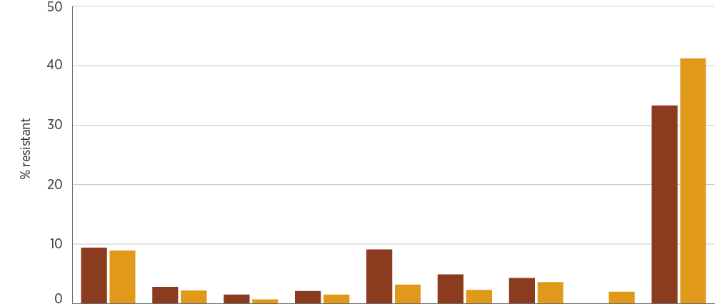
Year | INH | RIF | EMB | PZA | FLQ | KAN | CAP | AMK | INN
2016, % | 9.4 | 2.8 | 1.5 | 2.1 | 9.1 | 4.9 | 4.3 | 0.0 | 33.3
2017, % | 8.9 | 2.2 | 0.7 | 1.5 | 3.2 | 2.3 | 3.6 | 2.0 | 41.2
2016, n | 1,016 | 1,031 | 1,016 | 955 | 55 | 41 | 47 | 48 | 48
2017, n | 1,033 | 1,056 | 1,030 | 998 | 63 | 44 | 56 | 51 | 51

AMK = amikacin; CAP = capreomycin; EMB = ethambutol; FLQ = fluoroquinolones; INH = isoniazid; INN = ethionamide; KAN = kanamycin; PZA = pyrazinamide; RIF = rifampicin
Notes:
1. First-line agents (INH, RIF, EMB, PZA) were tested against (almost) all strains. Selected additional agents (FLQ, KAN, CAP, AMK, INN) were tested against isolates with resistance to first-line agents or from patients with severe adverse reactions to first-line agents.
2. Fluoroquinolones tested were ciprofloxacin, ofloxacin, moxifloxacin or levofloxacin.
Source: NNDSS (national)

Key findings: states and territories
There was some variation in resistance rates to first-line agents across the states and territories in 2016 and 2017 (Figure 4.23 and AURA 2019: Supplementary data). Although resistance rates appear higher in Tasmania, this is based on few isolates from that state (8 for 2016 and 10 for 2017).
Figure 4.23: Mycobacterium tuberculosis resistance to first-line agents, by state and territory, 2016–17
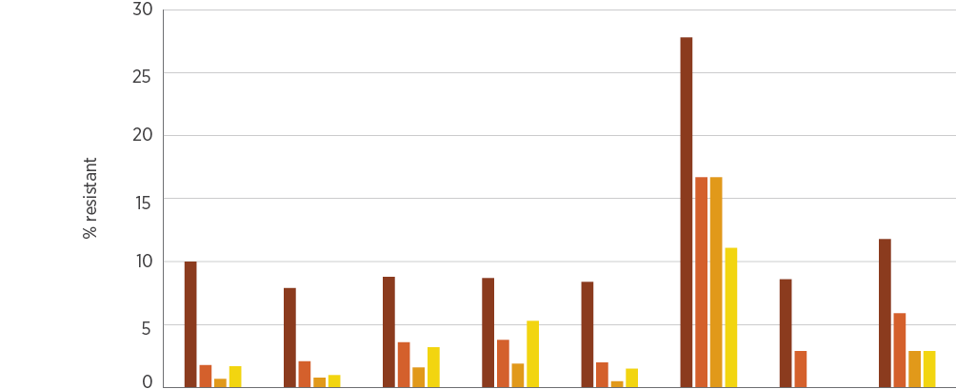
Agent | NSW | Vic | Qld | SA | WA | Tas | NT | ACT
Total, n | 738 | 635 | 332 | 105 | 203 | 18 | 36 | 34
Isoniazid, % | 10.0 | 7.9 | 8.8 | 8.7 | 8.4 | 27.8 | 8.6 | 11.8
Rifampicin, % | 1.8 | 2.1 | 3.6 | 3.8 | 2.0 | 16.7 | 2.9 | 5.9
Ethambutol, % | 0.7 | 0.8 | 1.6 | 1.9 | 0.5 | 16.7 | 0.0 | 2.9
Pyrazinamide, % | 1.7 | 1.0 | 3.2 | 5.3 | 1.5 | 11.1 | 0.0 | 2.9

Note: For clarity of presentation, data for 2016 and 2017 have been combined. Raw data for the individual years are available in AURA 2019: Supplementary data.
Source: NNDSS (national)

National trends
Overall, rates of resistance have not changed significantly during the past decade. There was a small increase in the percentage of MDR-TB strains (resistance to at least isoniazid and rifampicin) between 2014 and 2015, but this has since declined (Figure 4.24). XDR-TB strains remain rare, with no reports in 2016–17.
Figure 4.24: Resistance and multidrug-resistance patterns in Mycobacterium tuberculosis, 2007–2017
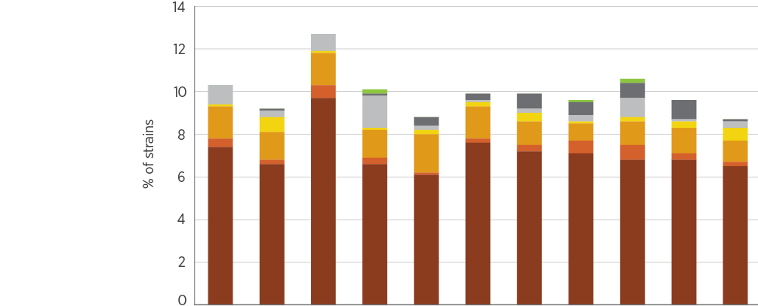
Agent | 2007 | 2008 | 2009 | 2010 | 2011 | 2012 | 2013 | 2014 | 2015 | 2016 | 2017
Strains tested, n | 809 | 942 | 974 | 1,033 | 1,058 | 985 | 938 | 1,035 | 975 | 1,035 | 1,066
Isoniazid only, % | 7.4 | 6.6 | 9.7 | 6.6 | 6.1 | 7.6 | 7.2 | 7.1 | 6.8 | 6.8 | 6.5
Rifampicin only, % | 0.4 | 0.2 | 0.6 | 0.3 | 0.1 | 0.2 | 0.3 | 0.6 | 0.7 | 0.3 | 0.2
Isoniazid + rifampicin*, % | 1.5 | 1.3 | 1.5 | 1.3 | 1.8 | 1.5 | 1.1 | 0.8 | 1.1 | 1.2 | 1.0
Isoniazid + rifampicin + ethambutol*, % | 0.1 | 0.7 | 0.1 | 0.1 | 0.2 | 0.2 | 0.4 | 0.1 | 0.2 | 0.3 | 0.6
Isoniazid + rifampicin + pyrazinamide*, % | 0.9 | 0.3 | 0.8 | 1.5 | 0.2 | 0.1 | 0.2 | 0.3 | 0.9 | 0.1 | 0.3
Isoniazid + rifampicin + ethambutol + pyrazinamide*, % | 0.0 | 0.1 | 0.0 | 0.1 | 0.4 | 0.3 | 0.7 | 0.6 | 0.7 | 0.9 | 0.1
XDR-TB, % | 0.0 | 0.0 | 0.0 | 0.2 | 0.0 | 0.0 | 0.0 | 0.1 | 0.2 | 0.0 | 0.0

XDR-TB = extremely drug-resistant tuberculosis
* Multidrug-resistant tuberculosis strains
Source: NNDSS (public and private hospitals and health services)

4.6 Neisseria gonorrhoeae
This section describes the health impact and treatment of N. gonorrhoeae, and the types, impact and rates of resistance in this species.

Health impact
N. gonorrhoeae causes gonorrhoea, an infection that is largely sexually transmitted, and most commonly manifests as urethritis in men and cervicitis in women. Many infections in women are asymptomatic, but, in some women, the infection ascends to the uterus and fallopian tubes, which can cause infertility if not treated promptly. Women who become infected in late pregnancy can spread the infection to the newborn at the time of delivery. With the advent of nucleic acid testing for gonococcal infection, most cases are now diagnosed using these techniques, and specimens for culture are not collected. Only a minority of cases undergo susceptibility testing, which depends on obtaining a culture of the organism.

Treatment
Most gonorrhoea is treated empirically, and treatment does not depend on the results of culture and susceptibility testing. The most important reason for this is that immediate empirical treatment is the most effective tool for preventing further transmission. Thus, treatment is based on standard treatment protocols, which are guided by the prevalence of resistances determined in national surveillance programs.
The most important agent for treating gonorrhoea is the third-generation cephalosporin ceftriaxone. This is effective as a single dose in uncomplicated infections such as urethritis or cervicitis. Ceftriaxone has superseded penicillin and ciprofloxacin for first-line treatment, because resistance to these latter agents has emerged. Since 2014, azithromycin, an antimicrobial agent, was added to ceftriaxone for combination therapy for gonococcal disease to contain the emergence of ceftriaxone resistance.

Types and impact of resistance
Resistance to ceftriaxone is an emerging concern globally. Failures of ceftriaxone treatment have been documented in Australia in strains that have reduced susceptibility to it (that is, MICs above those of the wild type).

Key findings: national
In 2016, 23,872 cases of gonococcal infection were notified nationally (a rate of 98.7 per 100,000 population).⁵ Of these cases, 6,378 had positive laboratory cultures that were submitted for susceptibility testing.⁶ In 2017, 28,378 cases were notified (a rate of 115.4 per 100,000 population); of these cases, 7,835 had positive laboratory cultures submitted for susceptibility testing. Most other cases would have been diagnosed without culture, using nucleic acid testing.
Overall rates of resistance to the main agents used for treatment are shown in Figure 4.25. In these and subsequent data, all ceftriaxone percentages refer to decreased susceptibility, rather than full resistance.
In 2017, resistance to azithromycin (MIC ≥ 1.0 mg/L) was found in 9.3% of N. gonorrhoeae isolates nationally, which is approximately double the proportion reported in 2016 (5.0%) and more than three times the proportion reported in 2015 (2.6%). The combined impact of the absolute increase in notifiable cases in 2017 and the increased proportion of azithromycin resistance indicates a possible five-fold increase in total resistant cases in the community.
Figure 4.25: Neisseria gonorrhoeae resistance, 2015–2017
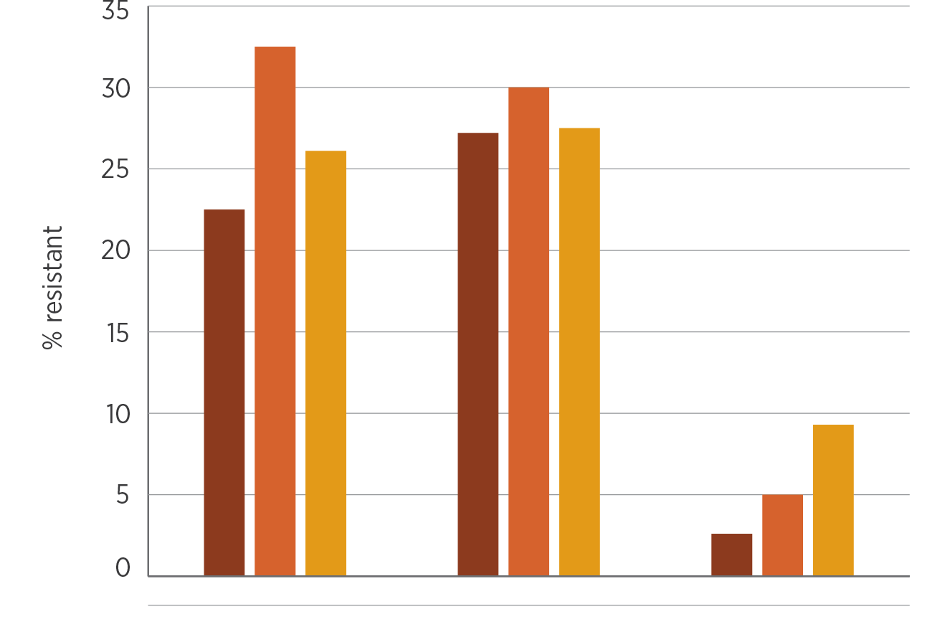
Year | Benzylpenicillin | Ciprofloxacin | Azithromycin
2015 (n=5,411) | 22.5 | 27.2 | 2.6
2016 (n=6,378) | 32.5 | 30.0 | 5.0
2017 (n=7,835) | 26.1 | 27.5 | 9.3

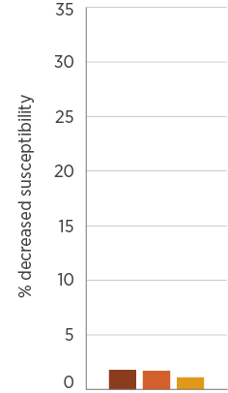
Year | Ceftriaxone
2015 | 1.8
2016 | 1.7
2017 | 1.1
Note: Decreased susceptibility to ceftriaxone is defined as a minimum inhibitory concentration above that of the wild type; wild-type strains have no acquired resistance mechanisms.
Source: NNN (public and private hospitals, and health services)

Key findings: states and territories
There was some variation in resistance rates to first-line agents across states and territories in both 2016 and 2017 (Figure 4.26). Most noticeable are the low rates of resistance in the remote areas of the NT and WA. A high proportion of the population in these parts of the country are Aboriginal and Torres Strait Islander people. Rates of decreased susceptibility to ceftriaxone were 1.1% in 2017, which is lower than reported in 2016 (1.7%).⁶ Azithromycin resistance in three states (NSW, Victoria and Queensland) increased more than 2.5-fold in 2017. The reasons for variation in resistance between states and territories may warrant further review.
Figure 4.26: Neisseria gonorrhoeae resistance, by state and territory, 2016–17
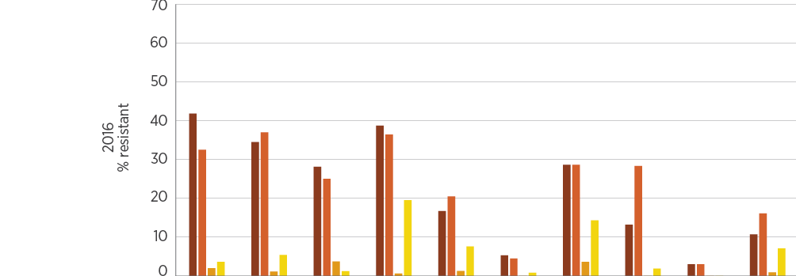
Agent | NSW | Vic | Qld | SA | WA (non-remote) | WA  remote | Tas | NT (non-remote) | NT  remote | ACT
Isolates, n | 2,268 | 1,734 | 865 | 349 | 672 | 132 | 28 | 53 | 165 | 112
Benzylpenicillin, % | 41.8 | 34.5 | 28.1 | 38.7 | 16.7 | 5.3 | 28.6 | 13.2 | 3.0 | 10.7
Ciprofloxacin, % | 32.5 | 37.0 | 25.0 | 36.4 | 20.5 | 4.5 | 28.6 | 28.3 | 3.0 | 16.1
Ceftriaxone (decreased susceptibility), % | 2.0 | 1.1 | 3.7 | 0.6 | 1.3 | 0.0 | 3.6 | 0.0 | 0.0 | 0.9
Azithromycin, % | 3.6 | 5.4 | 1.2 | 19.5 | 7.6 | 0.8 | 14.3 | 1.9 | 0.0 | 7.1
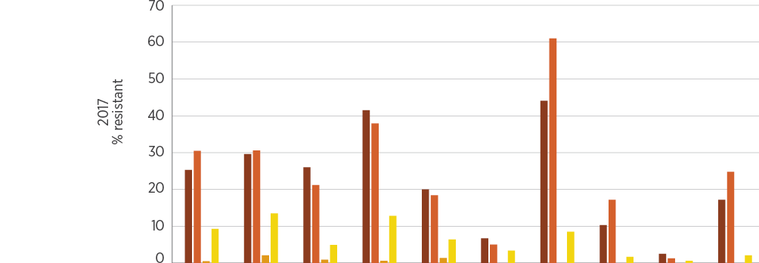
Agent | NSW | Vic | Qld | SA | WA (non-remote) | WA (remote) | Tas | NT (non-remote) | NT (remote) | ACT
Isolates, n | 2,806 | 2,258 | 1,249 | 359 | 624 | 119 | 59 | 58 | 158 | 145
Benzylpenicillin, % | 25.3 | 29.6 | 26.0 | 41.5 | 20.0 | 6.7 | 44.1 | 10.3 | 2.5 | 17.2
Ciprofloxacin, % | 30.5 | 30.6 | 21.2 | 37.9 | 18.4 | 5.0 | 61.0 | 17.2 | 1.3 | 24.8
Ceftriaxone (decreased susceptibility), % | 0.5 | 2.1 | 0.9 | 0.6 | 1.4 | 0.0 | 0.0 | 0.0 | 0.0 | 0.0
Azithromycin, % | 9.3 | 13.5 | 4.9 | 12.8 | 6.4 | 3.4 | 8.5 | 1.7 | 0.6 | 2.1
Note: Decreased susceptibility to ceftriaxone is defined as a minimum inhibitory concentration above that of the wild type; wild-type strains have no acquired resistance mechanisms.
Source: NNN (national)

National trends
In the past 17 years, resistance rates to the four first-line agents have evolved in different ways (Figure 4.27). Resistance to benzylpenicillin and ciprofloxacin trended upwards from 2003 to 2008, then declined somewhat, to stabilise at about 30%; however, this is not low enough to consider reintroducing these agents into standard treatment protocols. By 2015, there was early evidence of a downward trend. Rates of reduced susceptibility to ceftriaxone are low; reduced susceptibility increased until 2013 but appears to now be in decline.
Figure 4.27: Trends in resistance and multidrug-resistance patterns, and decreased susceptibility to ceftriaxone, in Neisseria gonorrhoeae, 2000–2017
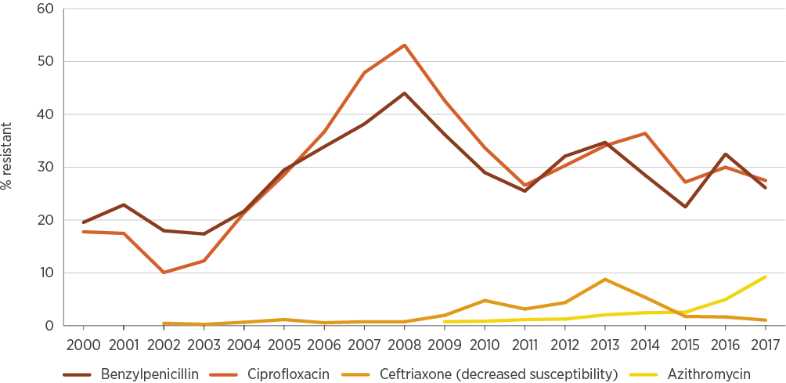
Note: Decreased susceptibility to ceftriaxone is defined as a minimum inhibitory concentration above that of the wild type; wild-type strains have no acquired resistance mechanisms.
Source: NNN (public and private hospitals, and health services)
Detailed reports of susceptibility data on N. gonorrhoeae from 1995 to 2017 can be found in the Australian Gonococcal Surveillance Programme annual reports.⁶
In 2017, resistance to azithromycin was found in 9.3% of Neisseria gonorrhoeae isolates nationally, which is about double the proportion reported in 2016 (5.0%) and more than three times the proportion reported in 2015 (2.6%).

4.7 Neisseria meningitidis
This section describes the health impact and treatment of N. meningitidis, and the types, impact and rates of resistance in this species.

Health impact
N. meningitidis can cause septicaemia and meningitis, known as invasive meningococcal disease. Although this is a very uncommon infection in Australia as a result of the advent of vaccines that provide immunity to some strains, it is considered a medical emergency because it can progress rapidly to serious disease and death. Invasive meningococcal disease can be associated with outbreaks in environments in which there is close prolonged contact, especially in the household. N. meningitidis is also rarely associated with localised disease, such as conjunctivitis, arthritis or pneumonia.

Treatment
Because invasive meningococcal disease is potentially life-threatening, most invasive infection is treated empirically (pending the results of blood cultures and, when necessary, testing of cerebrospinal fluid). The most important antimicrobials for treatment are ceftriaxone (or cefotaxime) and benzylpenicillin. Close contacts of patients with invasive meningococcal disease are given antimicrobial prophylaxis to prevent infection by clearing nasopharyngeal colonisation. The most important antimicrobials for prophylaxis are rifampicin, ciprofloxacin and ceftriaxone.

Types and impact of resistance
There is currently no international consensus on the definition of reduced susceptibility or resistance to benzylpenicillin in N. meningitidis. In most test systems, wild-type strains (that is, strains with no acquired resistance mechanism) have MICs of ≤0.25 mg/L.
Resistance to benzylpenicillin and ceftriaxone has been slow to develop in Australia. Non-wild-type strains that have reduced susceptibility to these two agents are now found regularly, but are not yet associated with treatment failure. Occasional strains are found with resistance to rifampicin or reduced susceptibility to ciprofloxacin.

Key findings: national
In 2016, 252 cases of meningococcal infection were notified nationally (a rate of 1.0 per 100,000 population).⁵ From these cases, 189 isolates were submitted for susceptibility testing. In 2017, 380 cases of meningococcal infection were notified nationally (a rate of 1.5 per 100,000 population).⁵ From these cases, 274 were submitted for susceptibility testing. Figure 4.28 shows the national rates of resistance to the four key agents used for treatment or prophylaxis.
There continues to be an upswing in the rates of reduced susceptibility and resistance to benzylpenicillin (44.9% in 2017), while ceftriaxone is so far unaffected.
Although the proportion of strains with reduced susceptibility was similar in 2016 and 2017, an overall increase in notifiable cases may account for a 51% increase in cases with reduced susceptibility in 2017.
Figure 4.28: Neisseria meningitidis resistance, 2015–2017
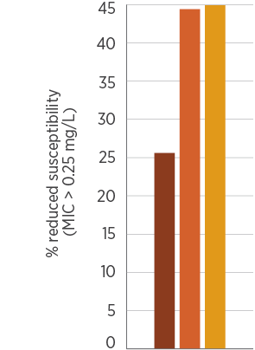
Year | Benzylpenicillin
2015 (n = 117) | 25.6
2016 (n = 189) | 44.4
2017 (n = 274) | 44.9
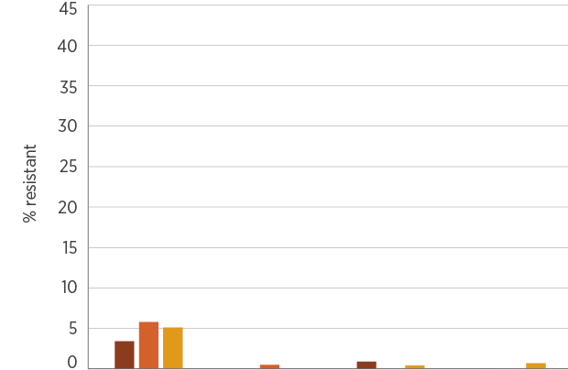
Year | Benzylpenicillin | Ceftriaxone | Rifampicin | Ciprofloxacin
2015 | 3.4 | 0.0 | 0.9 | 0.0
2016 | 5.8 | 0.5 | 0.0 | 0.0
2017 | 5.1 | 0.0 | 0.4 | 0.7
MIC = minimum inhibitory concentration
Notes:
1. Reduced susceptibility or resistance to benzylpenicillin: in most test systems, wild-type strains (i.e. with no acquired resistance mechanism) have MICs of ≤0.25 mg/L.
2. Resistance to benzylpenicillin is defined as an MIC of ≥1 mg/L.
Source: NNN (public and private hospitals, and health services)

National trends
In the past 18 years, there has been little change in the (very low or zero) rates of resistance to any of the four key agents, except for benzylpenicillin (Figure 4.29). For benzylpenicillin, in this context, resistance is defined as an MIC of ≥1 mg/L. In contrast, rates of reduced susceptibility to benzylpenicillin (defined in this report as strains with an MIC > 0.25 mg/L) have shown a slow but steady increase to 45% in 2016 and 2017 (Figure 4.30).
Detailed reports of susceptibility data for N. meningitidis from 1997 to 2017 can be found in the Australian Meningococcal Surveillance Programme annual reports.⁷
Figure 4.29: Trends in resistance in Neisseria meningitidis, 2000–2017
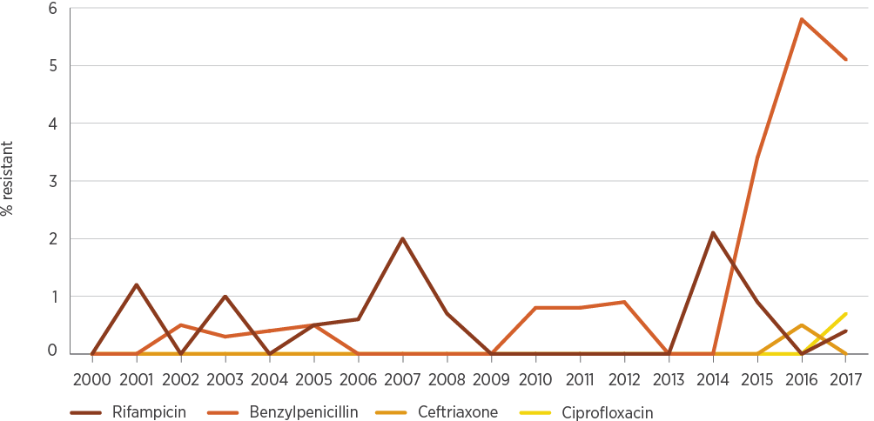
Note: Resistance to benzylpenicillin is defined as a minimum inhibitory concentration of ≥1 mg/L.
Source: NNN (public and private hospitals, and health services)
Figure 4.30: Trends in benzylpenicillin reduced susceptibility in Neisseria meningitidis, 2006–2017
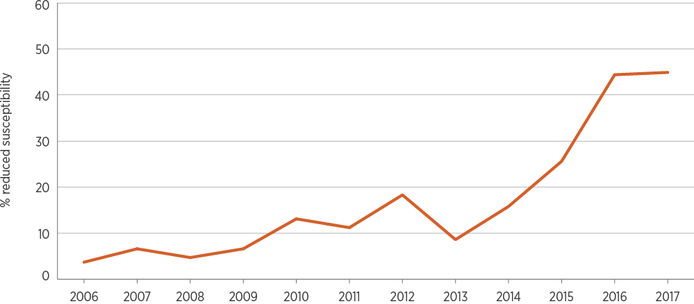
Note: Reduced susceptibility is defined as a minimum inhibitory concentration of >0.25 mg/L.
Source: NNN (public and private hospitals, and health services)

4.8 Pseudomonas aeruginosa
This section describes the health impact and treatment of P. aeruginosa, and the types, impact and rates of resistance in this species.

Health impact
P. aeruginosa is an opportunistic, nosocomial pathogen that primarily affects hospitalised or immunocompromised patients. It is a ubiquitous organism found in moist environments. It is naturally resistant to many chemicals, including most common antimicrobials and some antiseptics. As a consequence, it frequently causes infections in patients who are receiving antimicrobial treatments for other purposes.
P. aeruginosa can cause urinary tract infection in patients with catheters or structural abnormalities of the urinary tract. It is also associated with burn and other wound infections, and has a strong propensity to cause chronic persistent airway infection in patients with cystic fibrosis. P. aeruginosa also causes septicaemia, especially in neutropenic patients.

Treatment
P. aeruginosa is susceptible to only a limited range of antimicrobials:
Specialised β-lactams such as piperacillin (with or without tazobactam), ceftazidime and meropenem
Aminoglycosides such as gentamicin and tobramycin
Some fluoroquinolones, such as ciprofloxacin.
Urinary tract infections can often be managed with oral fluoroquinolones. More serious infections must be treated with β-lactams, which may be used in combination with aminoglycosides for the most serious infections. The effective β-lactams and aminoglycosides can only be administered intravenously.

Types and impact of resistance
P. aeruginosa is intrinsically resistant to many antimicrobial classes because of the presence of several efflux pumps in its cell wall and cell membrane. Upregulation of these efflux pumps results in resistance to the limited range of effective agents; P. aeruginosa is well known for its capacity to become resistant during treatment. It also has the capacity to become resistant to β-lactams through porin loss and the acquisition of β-lactamases. Multidrug-resistant strains with acquired resistance to two or three of the effective antimicrobial classes will require other treatments, such as the potentially toxic antimicrobial colistin.

Key findings: national
Resistance of P. aeruginosa to key antimicrobial agents is shown in Figure 4.31. Rates of resistance were substantially higher in public hospitals than in private hospitals (Figure 4.32), possibly due in part to the influence of isolates from patients with cystic fibrosis who are managed in the public sector. These patients have isolates with higher rates of resistance to all effective agents because they are likely to have been treated multiple times for acute infective exacerbations of cystic fibrosis lung disease.
Figure 4.31: Pseudomonas aeruginosa resistance, 2016–17
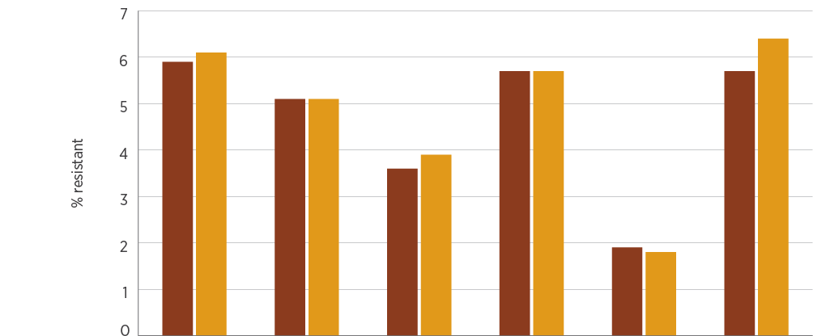
Year | PTZ | CAZ | MER | GEN | TOB | CIP
2016, % | 5.9 | 5.1 | 3.6 | 5.7 | 1.9 | 5.7
2017, % | 6.1 | 5.1 | 3.9 | 5.7 | 1.8 | 6.4
2016, n | 43,911 | 42,710 | 35,610 | 44,967 | 36,192 | 39,095
2017, n | 45,961 | 42,983 | 36,564 | 46,252 | 38,162 | 40,801
CAZ = ceftazidime; CIP = ciprofloxacin; GEN = gentamicin; MER = meropenem; PTZ = piperacillin–tazobactam; TOB = tobramycin
Sources: AGAR (national); APAS (NSW, Vic, Qld, SA, WA, Tas, ACT); SNP (Qld, northern NSW)
Figure 4.32: Pseudomonas aeruginosa resistance, by clinical setting, 2016–17
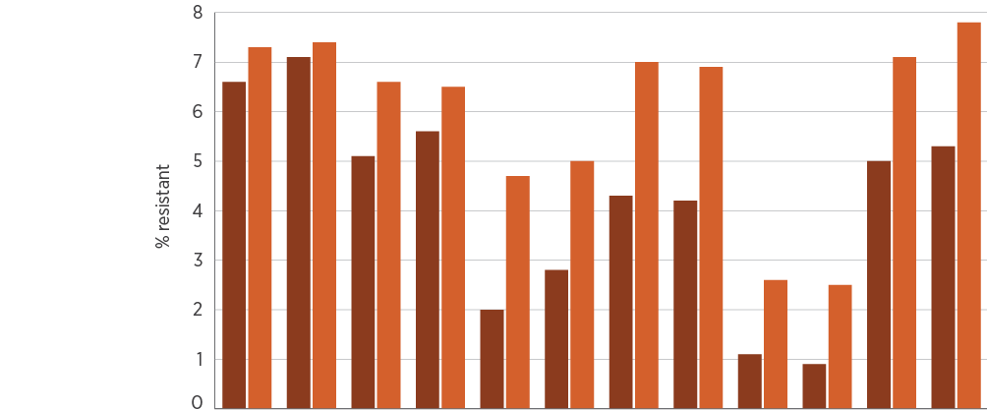
Setting | 2016 | 2017 | 2016 | 2017 | 2016 | 2017 | 2016 | 2017 | 2016 | 2017 | 2016 | 2017
 | PTZ |  | CAZ |  | MER |  | GEN |  | TOB |  | CIP
Private hospitals, % | 6.6 | 7.1 | 5.1 | 5.6 | 2.0 | 2.8 | 4.3 | 4.2 | 1.1 | 0.9 | 5.0 | 5.3
Public hospitals, % | 7.3 | 7.4 | 6.6 | 6.5 | 4.7 | 5.0 | 7.0 | 6.9 | 2.6 | 2.5 | 7.1 | 7.8
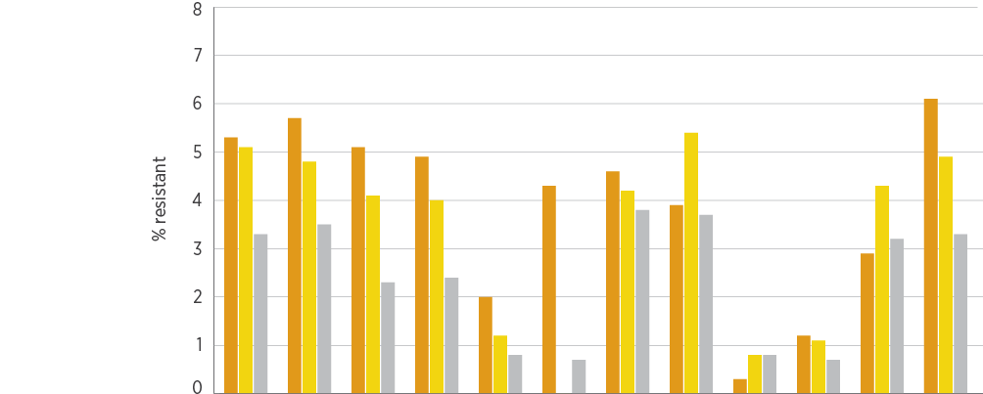
Setting | 2016 | 2017 | 2016 | 2017 | 2016 | 2017 | 2016 | 2017 | 2016 | 2017 | 2016 | 2017
 | PTZ |  | CAZ |  | MER |  | GEN |  | TOB |  | CIP
Multi-purpose services, % | 5.3 | 5.7 | 5.1 | 4.9 | 2.0 | 4.3 | 4.6 | 3.9 | 0.3 | 1.2 | 2.9 | 6.1
Aged care homes, % | 5.1 | 4.8 | 4.1 | 4.0 | 1.2 | 0.0 | 4.2 | 5.4 | 0.8 | 1.1 | 4.3 | 4.9
Community, % | 3.3 | 3.5 | 2.3 | 2.4 | 0.8 | 0.7 | 3.8 | 3.7 | 0.8 | 0.7 | 3.2 | 3.3
CAZ = ceftazidime; CIP = ciprofloxacin; GEN = gentamicin; MER = meropenem; PTZ = piperacillin–tazobactam; TOB = tobramycin
Sources: AGAR and APAS (public hospitals); AGAR, APAS (Qld, SA) and SNP (private hospitals); APAS and SNP (community and aged care homes); APAS (multi-purpose services)

4.9 Salmonella species
This section describes the health impact and treatment of Salmonella species, and the types, impact and rates of resistance in these species.

Health impact
Salmonella species are important causes of bacterial gastroenteritis. Most cases are acquired through foodborne transmission. Occasionally, gastroenteritis is complicated by septicaemia, although this is usually self-limiting. Two serotypes, Salmonella Typhi and Salmonella Paratyphi (together called ‘typhoidal Salmonella’), cause a distinct syndrome called enteric fever, in which the organism is always invasive (causing septicaemia), and causes considerable morbidity and mortality if untreated. Salmonella gastroenteritis is endemic in Australia, but almost all cases of enteric fever are seen in returning overseas travellers.

Treatment
Salmonella gastroenteritis is self-limiting. Antimicrobial therapy is generally contraindicated because it does not affect the course of the disease and will prolong intestinal carriage of the organism after disease resolution, increasing the risk of transmission. Antimicrobial therapy is indicated in patients with severe disease or septicaemia (typhoidal Salmonella infection, in particular), and patients who have prosthetic vascular grafts. Ciprofloxacin, azithromycin and ceftriaxone are the standard treatments.

Types and impact of resistance
Resistance to older treatment agents, such as ampicillin and chloramphenicol, has been seen for many years. So far, resistance to the newer agents has only been a problem with ciprofloxacin and other fluoroquinolones, such as norfloxacin. This has resulted in the definition of fluoroquinolone resistance recently being reassessed.

Key findings: national
In non-typhoidal Salmonella species, rates of resistance were low for ampicillin, and very low for ceftriaxone and the fluoroquinolones (Figure 4.33). In contrast, rates of resistance to the fluoroquinolone ciprofloxacin in typhoidal Salmonella species were above 60% in 2017 for blood isolates (Figure 4.34). These high rates reflect (in part) recent changes to breakpoints after extensive review by organisations responsible for susceptibility testing standards.
High rates of resistance in typhoidal Salmonella species are partly because of recent changes to susceptibility testing breakpoints.
Figure 4.33: Non-typhoidal Salmonella species resistance, by specimen source, 2016–17
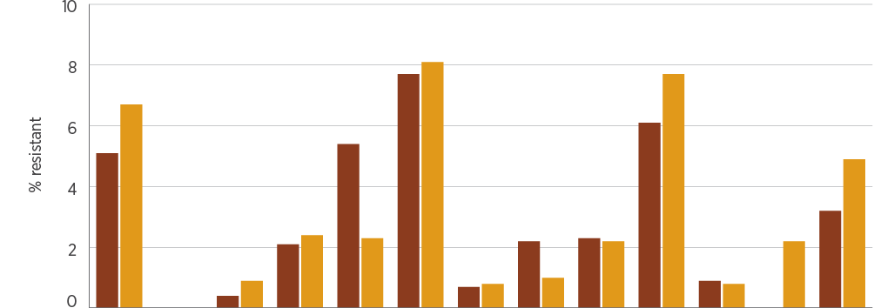
Year | AMP | AZI | CTR | CIP | SXT | AMP | CTR | CIP | SXT | AMP | CTR | CIP | TMP
 | Blood |  |  |  |  | Faeces |  |  |  | Other
2016, % | 5.1 | 0.0 | 0.4 | 2.1 | 5.4 | 7.7 | 0.7 | 2.2 | 2.3 | 6.1 | 0.9 | 0.0 | 3.2
2017, % | 6.7 | 0.0 | 0.9 | 2.4 | 2.3 | 8.1 | 0.8 | 1.0 | 2.2 | 7.7 | 0.8 | 2.2 | 4.9
2016, n | 235 | 4 | 235 | 190 | 221 | 3,457 | 1,901 | 1,801 | 3,433 | 165 | 106 | 83 | 156
2017, n | 225 | 15 | 225 | 165 | 217 | 3,366 | 2,068 | 1,555 | 3,369 | 183 | 118 | 89 | 162

AMP = ampicillin; AZI = azithromycin; CTR = ceftriaxone; CIP = ciprofloxacin; SXT = trimethoprim–sulfamethoxazole; TMP = trimethoprim
Sources: AGAR (national); APAS (NSW, Vic, Qld, SA, WA, Tas, ACT); SNP (Qld, northern NSW)
Figure 4.34: Typhoidal Salmonella species resistance (blood culture isolates), 2016–17
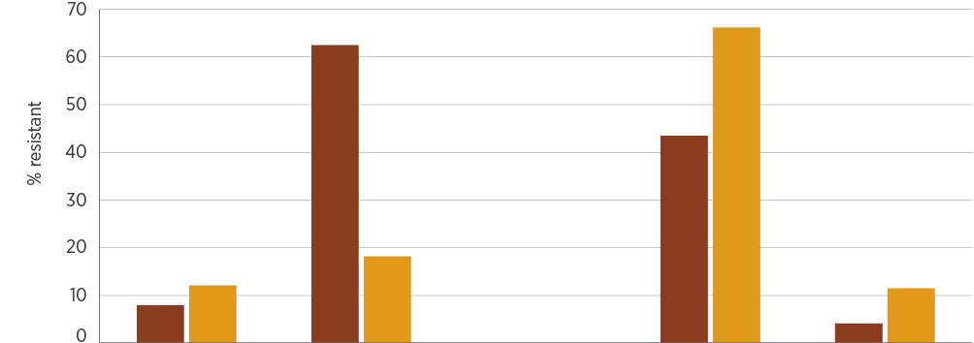
Year | Ampicillin | Azithromycin | Ceftriaxone | Ciprofloxacin | Trimethoprim–sulfamethoxazole
2016, % | 7.9 | 62.5 | 0.0 | 43.5 | 4.1
2017, % | 12.1 | 18.2 | 0.0 | 66.2 | 11.5
2016, n | 76 | 8 | 76 | 62 | 73
2017, n | 99 | 11 | 99 | 74 | 96

Sources: AGAR (national); APAS (NSW, Vic, Qld, SA, WA, Tas, ACT); SNP (Qld, northern NSW)

4.10 Shigella species
This section describes the health impact and treatment of Shigella species, and the types, impact and rates of resistance in these species.

Health impact
Shigella species are an uncommon but important cause of gastroenteritis. Genetically, they are almost identical to E. coli, and have a similar capacity to acquire multiple antimicrobial resistances. They also have the capacity to cause outbreaks if there is a common source(s) that infects people, or through person-to-person transmission.

Treatment
Treatment is usually administered when the infection is confirmed to be caused by Shigella. The main aim of treatment is to prevent transmission of the organism, rather than to treat symptoms. The antimicrobials of choice are fluoroquinolones (ciprofloxacin and norfloxacin) and trimethoprim–sulfamethoxazole.

Types and impact of resistance
Resistance, including multi-drug resistance to conventional treatments, is well documented in other countries. Azithromycin is considered a suitable option for infections caused by strains that are resistant to standard treatments.

Key findings: national
Resistance to ampicillin was common in S. flexneri. The prevalence of resistance to ciprofloxacin and ceftriaxone was very low (Figure 4.35). The presence of any resistance to ciprofloxacin in Australia is of concern, given the capacity of this organism to cause outbreaks.
Figure 4.35: Shigella species resistance (faecal isolates), 2016–17
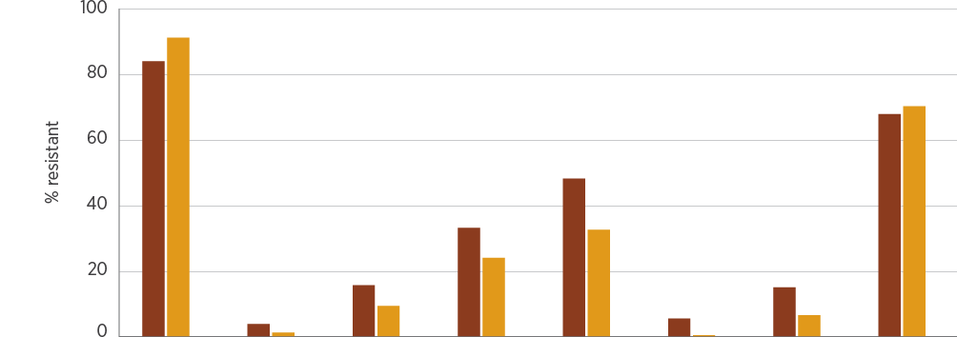
Year | Ampicillin | Ceftriaxone | Ciprofloxacin | SXT | Ampicillin | Ceftriaxone | Ciprofloxacin | SXT
 | S. flexneri |  |  |  | S. sonnei
2016, % | 84.0 | 4.0 | 15.8 | 33.3 | 48.3 | 5.7 | 15.2 | 67.9
2017, % | 91.2 | 1.4 | 9.5 | 24.2 | 32.7 | 0.6 | 6.7 | 70.3
2016, n | 25 | 25 | 19 | 30 | 143 | 105 | 105 | 137
2017, n | 159 | 143 | 148 | 161 | 217 | 179 | 179 | 219

SXT = trimethoprim–sulfamethoxazole
Sources: APAS (NSW, Vic, Qld, SA, WA, Tas, ACT); SNP (Qld, northern NSW)

4.11 Staphylococcus aureus
This section describes the health impact and treatment of S. aureus, and the types, impact and rates of resistance in this species.

Health impact
S. aureus is a common human pathogen that causes a wide variety of infections. Infections may be minor, such as boils, impetigo and wound infections; moderate, such as cellulitis; or serious, such as bone and joint infections, pneumonia, endocarditis and septicaemia. Infections associated with bacteraemia (positive blood cultures) have a 30-day crude mortality of 15–30%. S. aureus is also a common cause of healthcare-associated infections, especially surgical site infections, intravascular line infections with bacteraemia, and infections of prosthetic devices.
According to AGAR data, the overall 30-day all-cause mortality rate for S. aureus bacteraemia was 16.7% in 2016 and 14.8% in 2017.^{8,9} Thirty-day all-cause mortality was lowest with methicillin-susceptible strains, higher for community-associated bacteraemia, and highest for hospital-associated bacteraemia. Common clinical manifestations of staphylococcal bacteraemia were skin and skin structure infections, bone and joint infections, and device-related infections. With the exception of right-sided endocarditis, all infections are more common in males.

Treatment
Many staphylococcal skin infections can be managed without antimicrobial therapy, but moderate and serious infections require treatment. The preferred agent for ‘susceptible’ strains is flucloxacillin (or dicloxacillin), which can be replaced with first-generation cephalosporins such as cefazolin or cefalexin in penicillin-allergic patients.

Types and impact of resistance
Around 85–90% of S. aureus strains in the community are resistant to penicillin; this has been the case for decades. Healthcare-associated strains that are resistant to flucloxacillin and first-generation cephalosporins, commonly called methicillin-resistant S. aureus (MRSA), emerged in the 1970s and are now common in many parts of Australia. These healthcare-associated clones are multidrug-resistant and require treatment with reserve antimicrobials such as vancomycin, rifampicin and fusidic acid. Community-associated clones of MRSA are distinct from healthcare-associated clones and emerged in the 1980s. These clones are usually not multidrug-resistant, and moderate infections may be treated with trimethoprim–sulfamethoxazole or clindamycin. All serious MRSA infections require initial treatment with vancomycin. Resistance to vancomycin appears to be uncommon, but is difficult to detect in the diagnostic laboratory. There are very few alternative treatments to vancomycin.

Key findings: national
Overall, more than 83–87% of S. aureus isolates were resistant to benzylpenicillin in 2016–17 (Figure 4.36). Oxacillin (methicillin) resistance was stable at 17–22% in isolates from blood and other specimens. There was little difference in rates of resistance between different clinical settings, apart from oxacillin resistance, which was highest in aged care homes and multi-purpose services, suggesting that these are important reservoirs for MRSA (Figure 4.37).
Figure 4.36: Staphylococcus aureus resistance, by specimen source, 2016–17
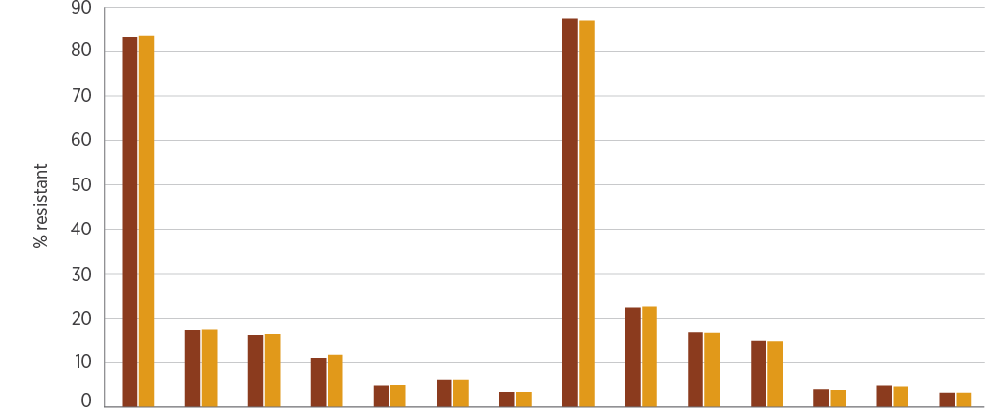
Year | PEN | OXA | ERY | CLN | TET | CIP | SXT | PEN | OXA | ERY | CLN | TET | CIP | SXT
 | Blood |  |  |  |  |  |  | Other
2016, % | 83.2 | 17.4 | 16.1 | 11.0 | 4.7 | 6.2 | 3.3 | 87.5 | 22.4 | 16.7 | 14.8 | 3.9 | 4.7 | 3.1
2017, % | 83.5 | 17.5 | 16.3 | 11.7 | 4.8 | 6.2 | 3.3 | 87.1 | 22.6 | 16.6 | 14.7 | 3.7 | 4.5 | 3.1

CIP = ciprofloxacin; CLN = clindamycin; ERY = erythromycin; OXA = oxacillin; PEN = penicillin; SXT = trimethoprim–sulfamethoxazole; TET = tetracyclines
Sources: AGAR (national), APAS (NSW, Vic, Qld, SA, WA, Tas, ACT); SNP (Qld, northern NSW)
Figure 4.37: Staphylococcus aureus resistance, by clinical setting, 2016–17
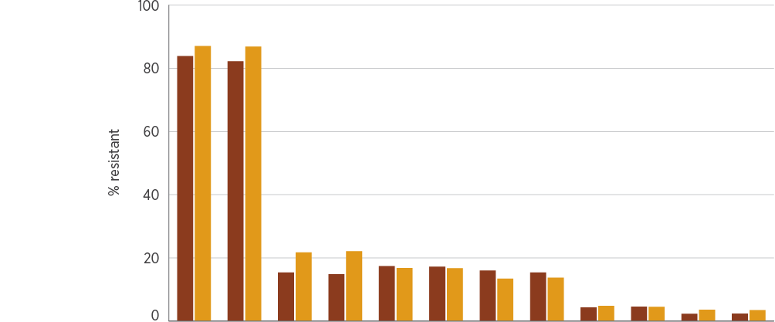
Setting | 2016 | 2017 | 2016 | 2017 | 2016 | 2017 | 2016 | 2017 | 2016 | 2017 | 2016 | 2017
 | PEN |  | OXA |  | ERY |  | CLN |  | TET |  | SXT
Private hospitals, % | 83.8 | 82.2 | 15.4 | 14.8 | 17.4 | 17.2 | 16.0 | 15.4 | 4.3 | 4.6 | 2.3 | 2.4
Public hospitals, % | 87.0 | 86.8 | 21.7 | 22.1 | 16.8 | 16.7 | 13.4 | 13.7 | 4.8 | 4.5 | 3.6 | 3.5
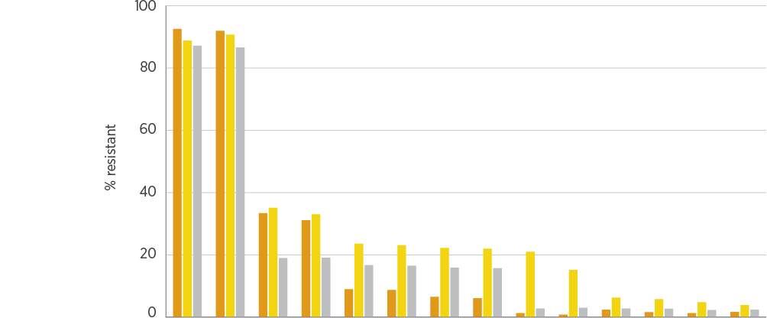
Setting | 2016 | 2017 | 2016 | 2017 | 2016 | 2017 | 2016 | 2017 | 2016 | 2017 | 2016 | 2017 | 2016 | 2017
 | PEN |  | OXA |  | ERY |  | CLN |  | CIP |  | TET |  | SXT
Multi-purpose services, % | 92.5 | 91.9 | 33.4 | 31.1 | 9.0 | 8.7 | 6.5 | 6.1 | 1.3 | 0.8 | 2.4 | 1.6 | 1.3 | 1.7
Aged care homes, % | 88.8 | 90.7 | 35.1 | 33.0 | 23.6 | 23.1 | 22.2 | 22.0 | 21.0 | 15.2 | 6.3 | 5.8 | 4.8 | 3.9
Community, % | 87.1 | 86.6 | 19.0 | 19.1 | 16.7 | 16.5 | 15.9 | 15.7 | 2.8 | 3.0 | 2.8 | 2.7 | 2.3 | 2.4

CIP = ciprofloxacin; CLN = clindamycin; ERY = erythromycin; OXA = oxacillin; PEN = penicillin; SXT = trimethoprim–sulfamethoxazole; TET = tetracyclines
Sources: AGAR and APAS (public hospitals); AGAR, APAS (Qld, SA) and SNP (private hospitals); APAS and SNP (community and aged care homes); APAS (multi-purpose services)
Analyses of APAS data indicate that oxacillin (methicillin) resistance is currently more prevalent in isolates from outer regional, remote and very remote areas of Australia than in major cities and inner regional areas (Figure 4.38).
Figure 4.38: Percentage of methicillin-resistant Staphylococcus aureus by remoteness area, 2015–2017
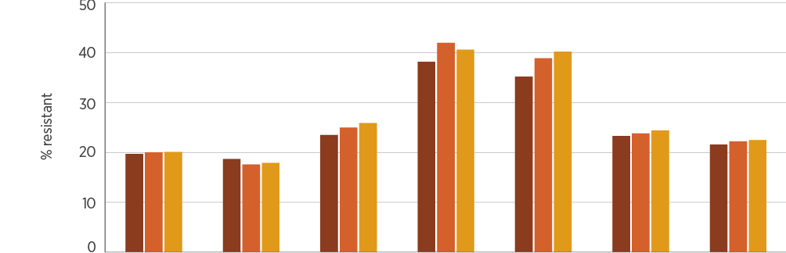
Year | Major cities | Inner regional | Outer regional | Remote | Very remote | Unknown | All remoteness areas
2015, % | 19.7 | 18.7 | 23.5 | 38.2 | 35.2 | 23.3 | 21.6
2016, % | 20.0 | 17.6 | 25.0 | 42.0 | 38.9 | 23.8 | 22.2
2017, % | 20.1 | 17.9 | 25.9 | 40.6 | 40.2 | 24.4 | 22.5
2015, n | 58,837 | 14,303 | 9,820 | 4,105 | 4,078 | 7,335 | 98,478
2016, n | 63,566 | 15,176 | 10,907 | 4,654 | 4,908 | 6,810 | 106,021
2017, n | 65,867 | 15,758 | 11,549 | 4,896 | 4,771 | 6,686 | 109,527

Source: APAS (national, excluding NT)
Oxacillin (methicillin) resistance was highest in aged care homes and multi-purpose services, suggesting that these are important reservoirs for methicillin-resistant Staphylococcus aureus.
Resistance to ciprofloxacin and erythromycin was high in MRSA, especially in blood isolates. A small number of MRSA strains exhibited resistance to linezolid and daptomycin (Figure 4.39). There were noticeable differences in resistance to ciprofloxacin, erythromycin and gentamicin in MRSA strains between clinical settings (Figure 4.40), possibly related to variation in the distribution of healthcare-associated clones compared with community-associated clones (Figures 4.41 and 4.42).
Figure 4.39: Methicillin-resistant Staphylococcus aureus resistance to non-β-lactam agents, by specimen source, 2016–17
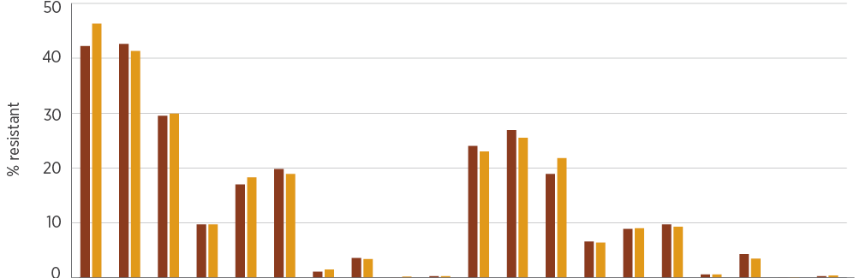
Year | CIP | ERY | CLN | SXT | GEN | TET | RIF | FUS | LNZ | DAP | CIP | ERY | CLN | SXT | GEN | TET | RIF | FUS | LNZ | DAP
 | Blood |  |  |  |  |  |  |  |  |  | Other
2016, % | 42.2 | 42.6 | 29.5 | 9.7 | 17.0 | 19.8 | 1.1 | 3.6 | 0.0 | 0.3 | 24.0 | 26.9 | 18.9 | 6.6 | 8.9 | 9.7 | 0.6 | 4.3 | 0.0 | 0.3
2017, % | 46.3 | 41.3 | 29.9 | 9.7 | 18.3 | 18.9 | 1.5 | 3.4 | 0.2 | 0.3 | 23.0 | 25.5 | 21.8 | 6.4 | 9.0 | 9.3 | 0.6 | 3.5 | 0.1 | 0.4
CIP = ciprofloxacin; CLN = clindamycin; DAP = daptomycin; ERY = erythromycin; FUS = fusidic acid; GEN = gentamicin; LNZ = linezolid; RIF = rifampicin; SXT = trimethoprim–sulfamethoxazole; TET = tetracyclines
Sources: AGAR (national); APAS (NSW, Qld, SA, Tas, ACT); SNP (Qld, northern NSW)
Healthcare-associated clones of MRSA had high rates of resistance to ciprofloxacin, erythromycin and clindamycin, and moderate levels of resistance to trimethoprim–sulfamethoxazole and gentamicin (Figure 4.41). Rates of resistance to other ‘anti-MRSA’ agents were low. In particular, aged care homes had high rates of MRSA that was resistant to ciprofloxacin and erythromycin (Figure 4.40), a pattern most closely associated with the EMRSA-15 clone. Rates of resistance to ciprofloxacin, erythromycin and clindamycin were much lower in community-associated clones than in healthcare-associated clones (Figure 4.42).
Figure 4.40: Methicillin-resistant Staphylococcus aureus resistance to non-β-lactam agents, by clinical setting, 2016–17
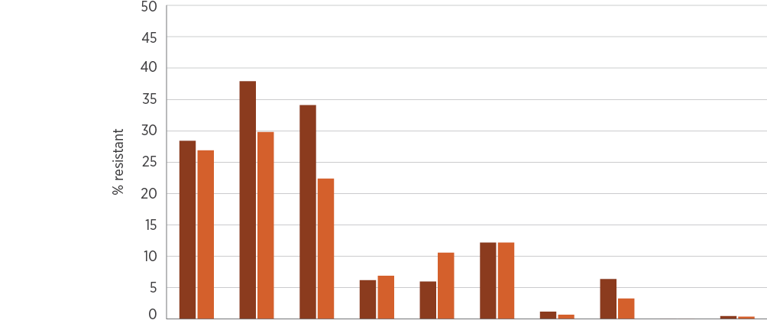
Setting | CIP | ERY | CLN | SXT | GEN | TET | RIF | FUS | LNZ | DAP
Private hospitals, % | 28.4 | 37.9 | 34.1 | 6.2 | 6.0 | 12.2 | 1.2 | 6.4 | 0.0 | 0.5
Public hospitals, % | 26.9 | 29.8 | 22.4 | 6.9 | 10.6 | 12.2 | 0.7 | 3.3 | 0.0 | 0.4
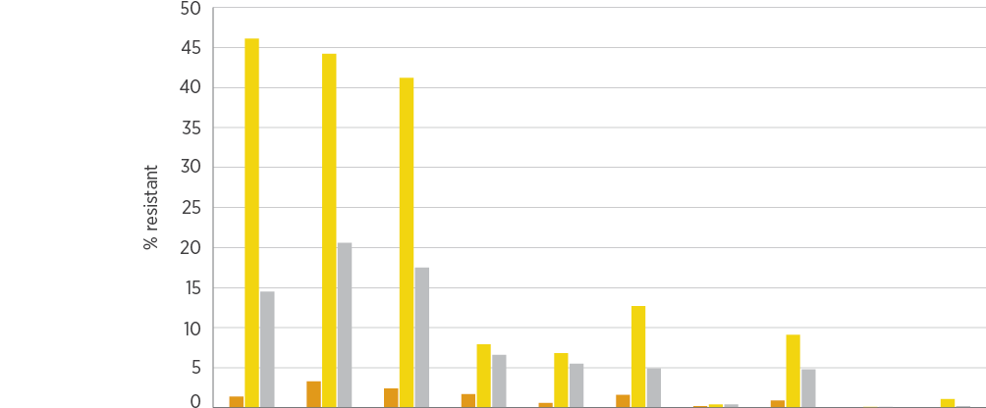
Setting | CIP | ERY | CLN | SXT | GEN | TET | RIF | FUS | LNZ | DAP
Multi-purpose services, % | 1.4 | 3.3 | 2.4 | 1.7 | 0.6 | 1.6 | 0.2 | 0.9 | nd | nd
Aged care homes, % | 46.1 | 44.2 | 41.2 | 7.9 | 6.8 | 12.7 | 0.4 | 9.1 | 0.1 | 1.1
Community, % | 14.5 | 20.6 | 17.5 | 6.6 | 5.5 | 4.9 | 0.4 | 4.8 | 0.1 | 0.2
CIP = ciprofloxacin; CLN = clindamycin; DAP = daptomycin; ERY = erythromycin; FUS = fusidic acid; GEN = gentamicin; LNZ = linezolid; nd = no data (either not tested or tested against an inadequate number of isolates); RIF = rifampicin; SXT = trimethoprim–sulfamethoxazole; TET = tetracyclines
Note: For clarity of presentation, data for 2016 and 2017 have been combined. Raw data for the individual years are available in AURA 2019: Supplementary data.
Sources: AGAR and APAS (NSW, Qld, SA, Tas, ACT) (public hospitals); AGAR, APAS (Qld, SA) and SNP (private hospitals); APAS and SNP (community and aged care homes); APAS (multi-purpose services)
Figure 4.41: Resistance to other antimicrobials of healthcare-associated clones of methicillin-resistant Staphylococcus aureus (blood culture isolates), 2015–2017
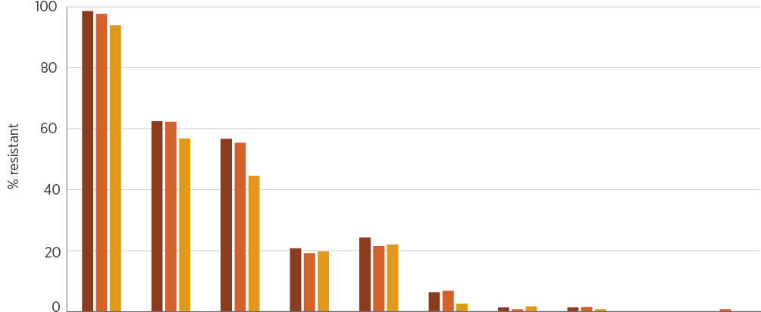
Year | CIP | ERY | CLN | SXT | GEN | RIF | FUS | DAP | LNZ | VAN
2015, % | 98.6 | 62.5 | 56.7 | 20.8 | 24.3 | 6.3 | 1.4 | 1.4 | 0.0 | 0.0
2016, % | 97.7 | 62.3 | 55.4 | 19.2 | 21.5 | 6.9 | 0.8 | 1.5 | 0.0 | 0.8
2017, % | 94.0 | 56.8 | 44.6 | 19.7 | 22.0 | 2.6 | 1.7 | 0.8 | 0.0 | 0.0
2015, n | 144 | 144 | 120 | 144 | 144 | 143 | 144 | 144 | 144 | 144
2016, n | 130 | 130 | 101 | 130 | 130 | 130 | 130 | 130 | 130 | 130
2017, n | 117 | 118 | 92 | 117 | 118 | 117 | 118 | 118 | 118 | 118

CIP = ciprofloxacin; CLN = clindamycin; DAP = daptomycin; ERY = erythromycin; FUS = fusidic acid; GEN = gentamicin; LNZ = linezolid; RIF = rifampicin; SXT = trimethoprim–sulfamethoxazole; VAN = vancomycin
Source: AGAR (national)
Figure 4.42: Resistance to other antimicrobials of community-associated clones of methicillin-resistant Staphylococcus aureus (blood culture isolates), 2015–2017
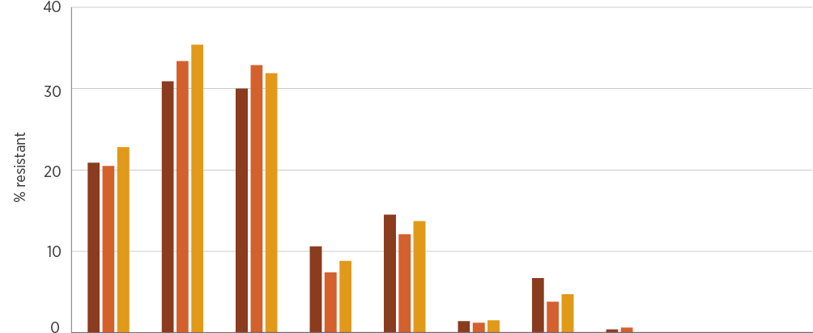
Year | CIP | ERY | CLN | SXT | GEN | RIF | FUS | DAP | LNZ | VAN
2015, % | 20.9 | 30.9 | 30.0 | 10.6 | 14.5 | 1.4 | 6.7 | 0.4 | 0.0 | 0.0
2016, % | 20.5 | 33.4 | 32.9 | 7.4 | 12.1 | 1.2 | 3.8 | 0.6 | 0.0 | 0.0
2017, % | 22.8 | 35.4 | 31.9 | 8.8 | 13.7 | 1.5 | 4.7 | 0.0 | 0.0 | 0.0
2015, n | 282 | 282 | 243 | 282 | 282 | 280 | 282 | 282 | 282 | 282
2016, n | 337 | 338 | 292 | 338 | 338 | 336 | 338 | 338 | 338 | 338
2017, n | 342 | 342 | 310 | 341 | 342 | 340 | 342 | 343 | 343 | 342

CIP = ciprofloxacin; CLN = clindamycin; DAP = daptomycin; ERY = erythromycin; FUS = fusidic acid; GEN = gentamicin; LNZ = linezolid; RIF = rifampicin; SXT = trimethoprim–sulfamethoxazole; VAN = vancomycin
Source: AGAR (national)
Table 4.8 shows the multi-locus sequence types of MRSA clones across Australia. Community-associated clones now dominate in staphylococcal bacteraemia. This may be related, in part, to the continued decline of ST239, the multidrug-resistant healthcare-associated clone that was dominant in the eastern states and SA for more than 30 years. The dominant healthcare-associated clone is now EMRSA-15, which has a large reservoir in aged care homes.
Community-associated MRSA clones continue to expand nationally, especially ST93, which is now the most common clone found in sepsis.
Table 4.8: Methicillin-resistant Staphylococcus aureus clones (blood culture isolates), 2016–17
MRSA clone type | Clone | Clonal complex | 2016, % of MRSA (n) | 2017, % of MRSA (n)
Healthcare associated | ST22-IV (EMRSA-15) | 22 | 20.5 (96) | 19.5 (90)*
 | ST239-III (Aus 2/3 EMRSA) | 8 | 6.2 (29) | 5.4 (25)†
 | ST5-II | 5 | nc (1) | nc (3)
 | ST8-II | 8 | nc (1) | nc (0)
 | Total |  | 27.1 (127) | 25.5 (118)
Community associated | ST93-IV (Qld CA-MRSA) | Singleton | 21.8 (102) | 24.5 (113)†
 | ST5-IV | 5 | 10.9 (51) | 8.4 (39)†
 | ST45-V (WA84 MRSA) | 45 | 9.0 (42) | 9.5 (44)
 | ST1-IV (WA1 MRSA) | 1 | 9.6 (45) | 7.4 (34)§
 | ST78-IV (WA2 MRSA) | 78 | 3.4 (16) | 3.5 (16)*
 | ST30-IV (SWP MRSA) | 30 | 3.8 (18) | 2.2 (10)
 | ST97-IV | n/a | nc (6) | nc (8)
 | ST8-IV | 8 | nc (3) | 2.2 (10)†
 | ST5-V | 5 | nc (1) | nc (8)
 | ST953-IV | n/a | nc (3) | nc (6)
 | ST188-IV | n/a | nc (4) | nc (4)
 | ST6-IV | n/a | nc (1) | nc (7)†
 | ST72-IV | n/a | nc (4) | nc (2)
 | ST762-IV | 1 | nc (1) | nc (4)
 | ST59-V | n/a | nc (0) | nc (4)
 | ST22-IV (PVL-positive) | n/a | nc (0) | nc (4)
 | Other clones | n/a | 9.4 (44) | 6.7 (31)
 | Total |  | 72.9 (341) | 74.5 (344)
MRSA = methicillin-resistant Staphylococcus aureus; n/a = not applicable; nc = not calculated (<10 isolates; insufficient numbers to calculate percentage); PVL = Panton–Valentine leucocidin; slv = single locus variant(s)
* Includes three slv
† Includes one slv
§ Includes two slv
Note: Total numbers of MRSA blood culture isolates were 468 in 2016 and 462 in 2017.
Source: AGAR (national)

Key findings: states and territories
State and territory data are available from the AGAR targeted surveillance program on blood culture isolates. The prevalence and types of MRSA differ significantly between states and territories. In 2017, overall rates ranged from 9.5% in the ACT to 44.4% in the NT (Figure 4.43 and AURA 2019: Supplementary data). Community-associated MRSA clones dominated in all states and territories except Tasmania. Multi-locus sequence type analysis revealed a great diversity of clones across the states and territories (Figure 4.44). The increase in the proportion of ST93 clones observed in blood culture isolates in 2017 was predominantly in Queensland and WA. In the NT, rates of MRSA exceeded 40% in blood culture isolates.
Figure 4.43: Methicillin-resistant Staphylococcus aureus as a percentage of all S. aureus blood culture isolates, by state and territory, 2016–17
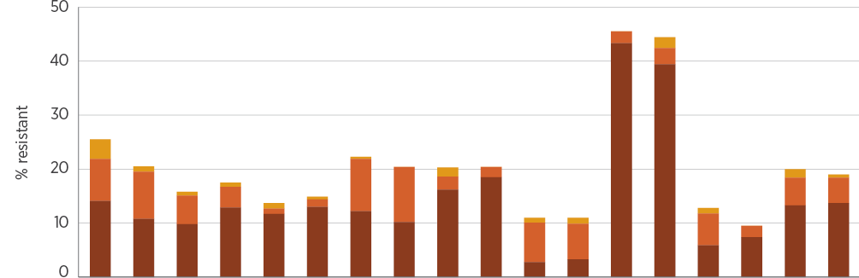
Isolate | 2016 | 2017 | 2016 | 2017 | 2016 | 2017 | 2016 | 2017 | 2016 | 2017 | 2016 | 2017 | 2016 | 2017 | 2016 | 2017 | 2016 | 2017
 | NSW |  | Vic |  | Qld |  | SA |  | WA |  | Tas |  | NT |  | ACT |  | Australia
CA, % | 14.1 | 10.8 | 9.8 | 12.9 | 11.7 | 13.0 | 12.2 | 10.2 | 16.2 | 18.5 | 2.8 | 3.3 | 43.3 | 39.4 | 5.9 | 7.4 | 13.3 | 13.7
HA, % | 7.8 | 8.7 | 5.3 | 3.8 | 1.0 | 1.4 | 9.7 | 10.2 | 2.4 | 1.9 | 7.3 | 6.6 | 2.2 | 3.0 | 5.9 | 2.1 | 5.1 | 4.7
na, % | 3.6 | 1.0 | 0.7 | 0.8 | 1.0 | 0.5 | 0.4 | 0.0 | 1.7 | 0.0 | 0.9 | 1.1 | 0.0 | 2.0 | 1.0 | 0.0 | 1.6 | 0.6
CA, n | 90 | 73 | 41 | 47 | 58 | 72 | 34 | 17 | 67 | 86 | 3 | 3 | 39 | 39 | 6 | 7 | 338 | 344
HA, n | 50 | 59 | 22 | 14 | 5 | 8 | 27 | 17 | 10 | 9 | 8 | 6 | 2 | 3 | 6 | 2 | 130 | 118
na, n | 23 | 7 | 3 | 3 | 5 | 3 | 1 | 0 | 7 | 0 | 1 | 1 | 0 | 2 | 1 | 0 | 41 | 16

CA = community associated; HA = healthcare associated; na = isolate not available for typing
Source: AGAR (national)
Figure 4.44: Distribution of methicillin-resistant Staphylococcus aureus clones (blood culture isolates), by state and territory, 2016–17
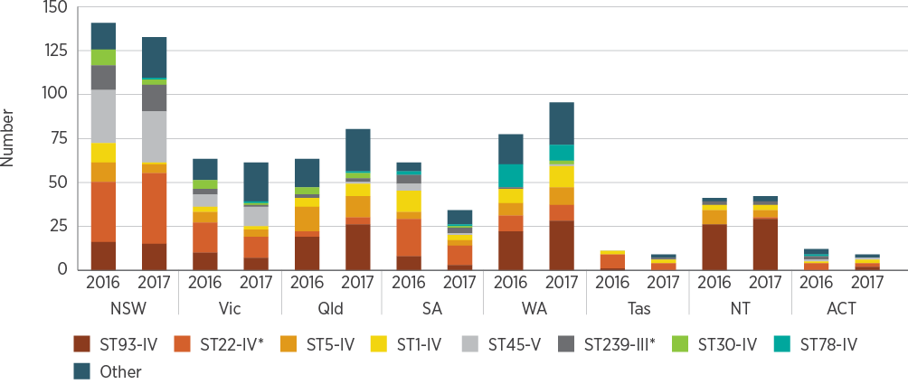
* Healthcare-associated clones
Source: AGAR (national)
The overall 30-day all-cause mortality rate was 16.7% in 2016 and 14.8% in 2017, and the rate was higher in hospital-onset bacteraemia than in community-onset bacteraemia (Table 4.9). Thirty-day all-cause mortality was lowest with methicillin-susceptible strains, somewhat higher for bacteraemia caused by community-associated MRSA clones, and highest for bacteraemia caused by hospital-associated MRSA clones.
Full data from AGAR surveys of S. aureus can be found on the AGAR website.⁴
Table 4.9: Onset setting and 30-day all-cause mortality for infections with Staphylococcus aureus (blood culture isolates), 2016–17
Staphylococcus aureus strain | Year | Community, n | Community mortality, % (n) | Hospital, n | Hospital mortality, % (n) | Total, n | Total mortality, % (n)
Methicillin-susceptible | 2016 | 1,232 | 14.5 (179) | 400 | 17.5 (70) | 1,632 | 15.3 (249)
 | 2017 | 1,279 | 13.2 (169) | 352 | 16.5 (58) | 1,631 | 13.9 (227)
Methicillin-resistant | 2016 | 277 | 25.3 (70) | 109 | 17.4 (19) | 386 | 23.1 (89)
 | 2017 | 241 | 16.6 (40) | 124 | 23.4 (29) | 365 | 18.9 (69)
Community-associated MRSA clones | 2016 | 195 | 23.6 (46) | 58 | 20.7 (12) | 253 | 22.9 (58)
 | 2017 | 180 | 14.4 (26) | 70 | 20.0 (14) | 250 | 16.0 (40)
Hospital-associated MRSA clones | 2016 | 65 | 29.2 (19) | 46 | 10.9 (5) | 111 | 21.6 (24)
 | 2017 | 53 | 22.6 (12) | 49 | 30.6 (15) | 102 | 26.5 (27)
Not determined | 2016 | 17 | 29.4 (5) | 5 | 40.0 (2) | 22 | 31.8 (7)
 | 2017 | 8 | 25.0 (2) | 5 | 0.0 (0) | 13 | 15.4 (2)
Total | 2016 | 1,509 | 16.5 (249) | 509 | 17.5 (89) | 2,018 | 16.7 (338)
 | 2017 | 1,520 | 13.8 (209) | 476 | 18.3 (87) | 1,996 | 14.8 (296)

Source: AGAR (national)

4.12 Streptococcus agalactiae
This section describes the health impact and treatment of S. agalactiae, and the types, impact and rates of resistance in this species.

Health impact
S. agalactiae, also called group B Streptococcus (GBS), occasionally causes infections similar to those caused by S. pyogenes. These include skin and soft tissue infections, as well as more serious infections such as septicaemia, and bone and joint infections. Its greatest significance is as the main cause of neonatal septicaemia and meningitis, which is associated with high morbidity and mortality.

Treatment
Screening mothers in late pregnancy for carriage of GBS is now widespread practice in Australia. If the mother tests positive for GBS, antimicrobials are administered to her during delivery to prevent transmission to the baby, regardless of the delivery mode. Benzylpenicillin is the recommended agent for this purpose; cefazolin or lincomycin/clindamycin are recommended for women with penicillin allergy, depending on the type and severity of the allergy.

Types and impact of resistance
Resistance to benzylpenicillin and cefazolin is emerging but still uncommon in Australia, but resistance to erythromycin, lincomycin and clindamycin is common at around 30%. Lincomycin/clindamycin resistance is strongly linked to resistance to macrolides such as erythromycin, which is often used in the laboratory as the test agent to predict resistance to lincomycin/clindamycin. Mothers who carry GBS that is resistant to erythromycin, lincomycin and clindamycin, but who would otherwise be treated with lincomycin or clindamycin, require prophylaxis with vancomycin.

Key findings: national
Resistance to benzylpenicillin was extremely low, but resistance to erythromycin and clindamycin has increased to around 30% (Figure 4.45).
Figure 4.45: Streptococcus agalactiae resistance, 2016–17
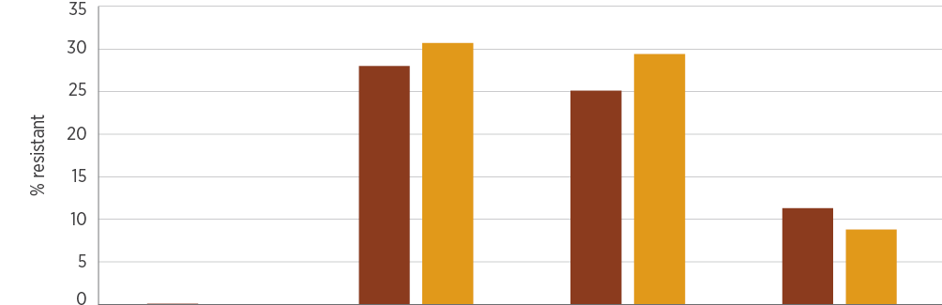
Year | Penicillin/amoxicillin | Erythromycin | Clindamycin | Trimethoprim
2016, % | 0.1 | 28.0 | 25.1 | 11.3
2017, % | 0.0 | 30.7 | 29.4 | 8.8
2016, n | 10,896 | 6,665 | 4,036 | 1,291
2017, n | 11,064 | 7,160 | 3,695 | 1,364

Sources: APAS (NSW, Vic, Qld, SA, WA, Tas, ACT); SNP (Qld, northern NSW)

4.13 Streptococcus pneumoniae
This section describes the health impact and treatment of S. pneumoniae, and the types, impact and rates of resistance in this species.

Health impact
S. pneumoniae is an important pathogen that commonly causes acute otitis media, acute sinusitis and pneumonia. It can also cause septicaemia (especially in young children), acute exacerbation of chronic obstructive pulmonary disease and bacterial meningitis. Its capacity to cause disease is linked to its polysaccharide capsule, of which there are more than 90 serotypes.
In Australia, two pneumococcal vaccines are included in the National Immunisation Program. Infants receive a conjugated vaccine that covers 13 of the most common serotypes, and older people and those with risk factors receive a polysaccharide vaccine that covers 23 of the most common serotypes. Because vaccines do not cover all serotypes, not all pneumococcal infection is vaccine-preventable.

Treatment
Otitis media and sinusitis are normally treated with oral amoxicillin, cefuroxime (in penicillin-allergic patients) or doxycycline (for people older than 8 years). Macrolides and trimethoprim–sulfamethoxazole are sometimes used for oral treatments. Pneumonia and meningitis are generally treated with benzylpenicillin if the strain is proven to be susceptible, or ceftriaxone (or cefotaxime) for penicillin-nonsusceptible strains. Strains causing pneumonia or meningitis that are non-susceptible to penicillin and ceftriaxone (rare) require treatment with reserve antimicrobials such as vancomycin or meropenem.

Types and impact of resistance
Reduced susceptibility to benzylpenicillin is common but can mostly be managed with increased dosing regimens of benzylpenicillin, or amoxicillin when oral treatment is appropriate. However, strains with reduced susceptibility causing meningitis are resistant to treatment with benzylpenicillin because of the relatively poor penetration of this antimicrobial into the subarachnoid space (where the infection is located). Meningitis caused by these strains requires treatment with ceftriaxone (or cefotaxime), unless the strains also have reduced susceptibility to these agents.
Resistance to tetracycline predicts resistance to doxycycline, the usual agent in this class used for treatment in adolescents and adults, and is a feature of multidrug-resistant strains.

Key findings: national
Resistance to benzylpenicillin was low, but overall rates of resistance to macrolides (erythromycin), tetracyclines and trimethoprim–sulfamethoxazole were all above 20–25% (Figure 4.46). Rates of resistance were somewhat lower for blood isolates than for isolates from other specimens. There were some differences in resistance rates in different clinical settings (Figure 4.47). The reasons for these differences are not obvious and will need to be explored.
Figure 4.46: Streptococcus pneumoniae resistance, by specimen source, 2016–17
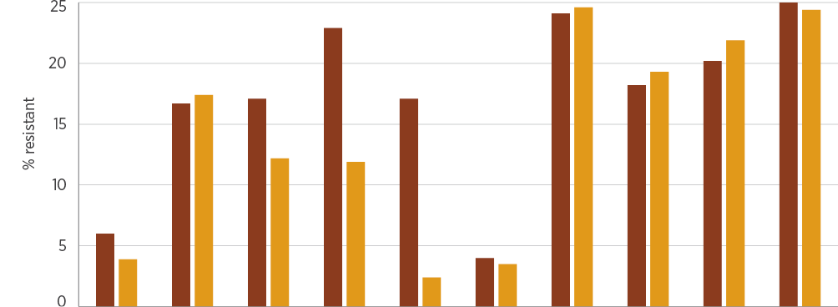
Year | PEN | ERY | CLN | TET | SXT | PEN | ERY | CLN | TET | SXT
 | Blood |  |  |  |  | Other
2016, % | 6.0 | 16.7 | 17.1 | 22.9 | 17.1 | 4.0 | 24.1 | 18.2 | 20.2 | 25.0
2017, % | 3.9 | 17.4 | 12.2 | 11.9 | 2.4 | 3.5 | 24.6 | 19.3 | 21.9 | 24.4
2016, n | 686 | 588 | 35 | 35 | 35 | 5,957 | 5,792 | 2,233 | 1,459 | 3,002
2017, n | 837 | 656 | 41 | 42 | 42 | 5,835 | 5,646 | 2,248 | 1,340 | 2,878
CLN = clindamycin; ERY = erythromycin; PEN = benzylpenicillin; SXT = trimethoprim–sulfamethoxazole; TET = tetracyclines Note: Benzylpenicillin resistance is defined as a minimum inhibitory concentration of >2 mg/L for infections other than meningitis (European Committee on Antimicrobial Susceptibility Testing).
Sources: APAS (NSW, Vic, Qld, SA, WA, Tas, ACT); SNP (Qld, northern NSW)
Figure 4.47: Streptococcus pneumoniae resistance, by clinical setting, 2016–17
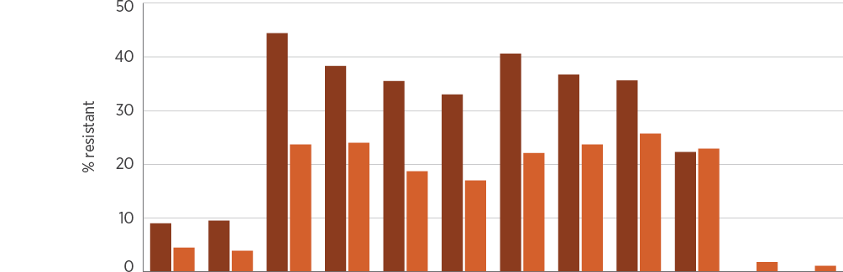
Setting | 2016 | 2017 | 2016 | 2017 | 2016 | 2017 | 2016 | 2017 | 2016 | 2017 | 2016 | 2017
 | PEN |  | ERY |  | CLN |  | TET |  | SXT |  | CTR
Private hospitals, % | 9.0 | 9.5 | 44.4 | 38.3 | 35.5 | 33.0 | 40.6 | 36.7 | 35.6 | 22.3 | nd | nd
Public hospitals, % | 4.5 | 3.9 | 23.7 | 24.0 | 18.7 | 17.0 | 22.1 | 23.7 | 25.7 | 22.9 | 1.8 | 1.1
Private hospitals, n | 178 | 179 | 133 | 94 | 93 | 88 | 96 | 90 | 132 | 94 | nd | nd
Public hospitals, n | 4,545 | 4,638 | 4,330 | 4,371 | 694 | 742 | 751 | 813 | 1,427 | 1,421 | 167 | 180
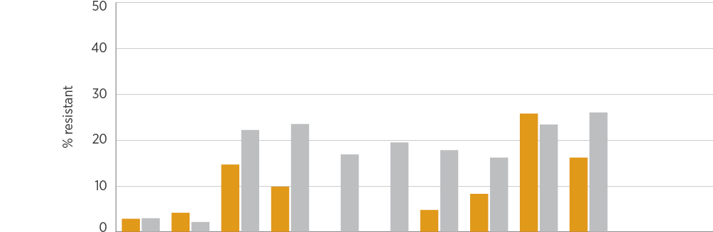
Setting | 2016 | 2017 | 2016 | 2017 | 2016 | 2017 | 2016 | 2017 | 2016 | 2017 | 2016 | 2017
 | PEN |  | ERY |  | CLN |  | TET |  | SXT |  | CTR
Multi-purpose services, % | 2.9 | 4.2 | 14.7 | 9.9 | nd | nd | 4.8 | 8.3 | 25.8 | 16.2 | nd | nd
Community, % | 3.0 | 2.2 | 22.2 | 23.5 | 16.9 | 19.5 | 17.8 | 16.2 | 23.4 | 26.0 | 0.0 | 0.0
Multi-purpose services, n | 68 | 72 | 68 | 71 | nd | nd | 62 | 60 | 62 | 68 | nd | nd
Community, n | 1,755 | 1,709 | 1,731 | 1,668 | 1,481 | 1,459 | 477 | 419 | 1,299 | 1,250 | 89 | 49
CLN = clindamycin; CTR = ceftriaxone; ERY = erythromycin; nd = no data (either not tested or tested against an inadequate number of isolates); PEN = benzylpenicillin; SXT = trimethoprim–sulfamethoxazole; TET = tetracyclines
Notes:
1. Benzylpenicillin resistance is defined as a minimum inhibitory concentration of >2 mg/L for infections other than meningitis (European Committee on Antimicrobial Susceptibility Testing).
2. Aged care homes are excluded because of an insufficient number of isolates from this setting (<30).
Sources: APAS (public hospitals); APAS (Qld, SA) and SNP (private hospitals); APAS and SNP (community); APAS (multi-purpose services)

4.14 Streptococcus pyogenes
This section describes the health impact and treatment of S. pyogenes, and the types, impact and rates of resistance in this species.

Health impact
S. pyogenes, also called group A Streptococcus, is an important human pathogen. It most commonly causes skin and soft tissue infections, and acute pharyngitis, but can cause serious and life-threatening infections such as scarlet fever, septicaemia, bone and joint infections, toxic shock syndrome, necrotising fasciitis and pneumonia. This organism is also associated with two ‘post-streptococcal’ syndromes: acute glomerulonephritis and rheumatic fever. These syndromes are now rare in most parts of Australia, but are still often seen in remote Aboriginal and Torres Strait Islander communities, contributing to substantial long-term morbidity in these populations.

Treatment
Benzylpenicillin remains the treatment of choice for S. pyogenes infections. In patients who are allergic to penicillins, macrolides such as erythromycin and first-generation cephalosporins are treatment options. Patients who have experienced one episode of acute rheumatic fever are prone to further episodes and worsening organ damage; as a consequence, they are administered long-term prophylaxis (usually over decades) with benzathine penicillin (intramuscularly) or phenoxymethylpenicillin (orally).

Types and impact of resistance
Confirmed resistance to benzylpenicillin has never been reported anywhere in the world in this species, but the consequences of its emergence would be substantial. It is expected that, based on observations of other species of Streptococcus, resistance to benzylpenicillin would also affect susceptibility to first-generation cephalosporins. In contrast, acquired resistance to macrolide antimicrobials has been present in S. pyogenes for many years, and levels of resistance seem to fluctuate in line with changes in circulating clones.

Key findings: national
Resistance to key antimicrobial agents is low, apart from tetracyclines, which are rarely used for treatment (Figure 4.48). Resistance to erythromycin (and therefore other macrolides) is low but increasing. There was some variation in macrolide resistance rates among clinical settings (Figure 4.49).
Figure 4.48: Streptococcus pyogenes resistance (all specimen sources), 2016–17
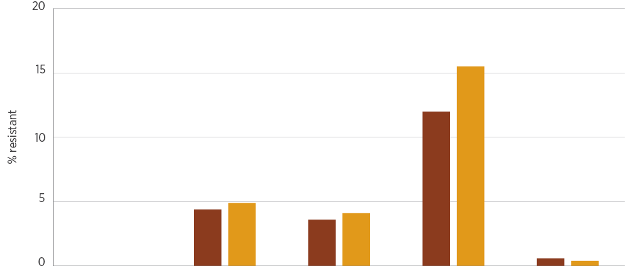
Year | Penicillin | Erythromycin | Clindamycin | Tetracycline/doxycycline | Trimethoprim–sulfamethoxazole
2016, % | 0.0 | 4.4 | 3.6 | 12.0 | 0.6
2017, % | 0.0 | 4.9 | 4.1 | 15.5 | 0.4
2016, n | 19,980 | 26,243 | 16,135 | 8,220 | 6,450
2017, n | 21,971 | 29,881 | 17,942 | 10,869 | 8,137

Sources: APAS (NSW, Vic, Qld, SA, WA, Tas, ACT); SNP (Qld, northern NSW)
Figure 4.49: Streptococcus pyogenes resistance, by clinical setting, 2016–17
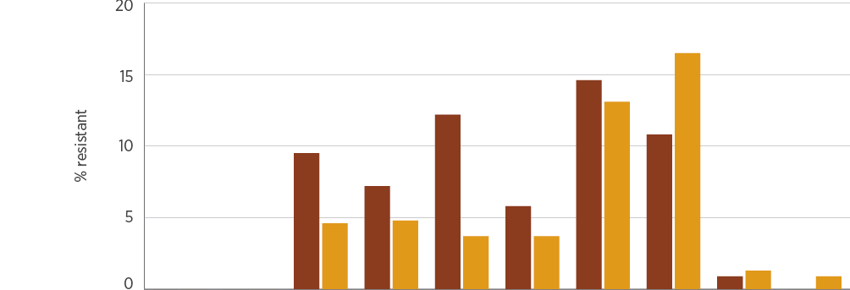
Setting | 2016 | 2017 | 2016 | 2017 | 2016 | 2017 | 2016 | 2017 | 2016 | 2017
 | Penicillin |  | Erythromycin |  | Clindamycin |  | Tetracycline/doxycycline |  | Trimethoprim–sulfamethoxazole
Private hospitals, % | 0.0 | 0.0 | 9.5 | 7.2 | 12.2 | 5.8 | 14.6 | 10.8 | 0.9 | 0.0
Public hospitals, % | 0.0 | 0.0 | 4.6 | 4.8 | 3.7 | 3.7 | 13.1 | 16.5 | 1.3 | 0.9
Private hospitals, n | 112 | 155 | 221 | 279 | 156 | 189 | 158 | 203 | 110 | 128
Public hospitals, n | 12,059 | 13,814 | 11,991 | 13,735 | 3,755 | 4,010 | 4,160 | 4,975 | 80 | 114
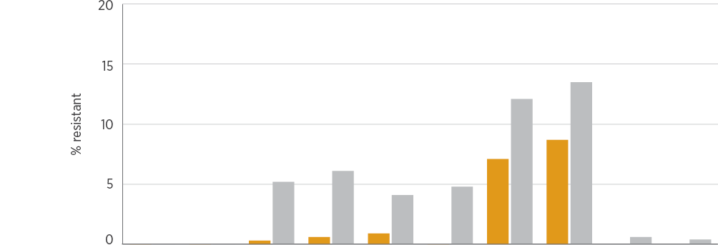
Setting | 2016 | 2017 | 2016 | 2017 | 2016 | 2017 | 2016 | 2017 | 2016 | 2017
 | Penicillin |  | Erythromycin |  | Clindamycin |  | Tetracycline/doxycycline |  | Trimethoprim–sulfamethoxazole
Multi-purpose services, % | 0.0 | 0.0 | 0.3 | 0.6 | 0.9 | 0.0 | 7.1 | 8.7 | nd | nd
Community, % | 0.0 | 0.0 | 5.2 | 6.1 | 4.1 | 4.8 | 12.1 | 13.5 | 0.6 | 0.4
Multi-purpose services, n | 1,569 | 1,721 | 1,563 | 1,715 | 235 | 195 | 1,317 | 1,478 | nd | nd
Community, n | 10,497 | 12,347 | 10,399 | 12,267 | 9,922 | 11,663 | 2,348 | 2,732 | 6,260 | 7,895

nd = no data (either not tested or tested against an inadequate number of isolates)
Note: Aged care homes are excluded because of an insufficient number of isolates from this setting (<30).
Sources: APAS (public hospitals); AGAR, APAS (Qld, SA) and SNP (private hospitals); APAS and SNP (community); APAS (multi-purpose services)

References
1. Magiorakos AP, Srinivasan A, Carey RB, Carmeli Y, Falagas ME, Giske CG, et al. Multidrug-resistant, extensively drug-resistant and pandrug-resistant bacteria: an international expert proposal for interim standard definitions for acquired resistance. Clin Microbiol Infect 2012;18(3):268–81.
2. Adeolu M, Alnajar S, Naushad S, Gupta SR. Genome-based phylogeny and taxonomy of the ‘Enterobacteriales’: proposal for Enterobacterales ord. nov. divided into the families Enterobacteriaceae, Erwiniaceae fam. nov., Pectobacteriaceae fam. nov., Yersiniaceae fam. nov., Hafniaceae fam. nov., Morganellaceae fam. nov., and Budviciaceae fam. nov. Int J Syst Evol Microbiol 2016;66(12):5575–99.
3. Antimicrobial Use and Resistance in Australia. Australian Group on Antimicrobial Resistance (AGAR) Sepsis Outcome Programs reports. Sydney: Australian Commission on Safety and Quality in Health Care; 2019 [cited 2019 Mar 6].
4. Australian Group on Antimicrobial Resistance. AGAR surveys. AGAR; 2019 [cited 2019 Mar 6].
5. National Notifiable Diseases Surveillance System. Notifications of a selected disease by state and territory and year. Canberra: Australian Government Department of Health; 2019 [cited 2019 Jan 24].
6. Australian Government Department of Health. Gonorrhoea surveillance. Canberra: DoH; 2018 [cited 2019 Jan 24].
7. Australian Government Department of Health. Meningococcal – Australian Meningococcal Surveillance Programme annual reports. Canberra: DoH; 2016 [cited 2019 Jan 14].
8. Coombs G, Bell JM, Daley D, Collignon P, Cooley L, Gottlieb T, et al. Australian Group on Antimicrobial Resistance Sepsis Outcomes Programs: 2016 report. Sydney: Australian Commission on Safety and Quality in Health Care; 2018 (accessed Feb 2019).
9. Coombs G, Bell JM, Daley D, Collignon P, Cooley L, Gottlieb T, et al. Australian Group on Antimicrobial Resistance Sepsis Outcomes Programs: 2017 report. Sydney: Australian Commission on Safety and Quality in Health Care; 2019.

Chapter 5: National Alert System for Critical Antimicrobial Resistances (CARAlert)
Key messages
- Carbapenemase-producing Enterobacterales (CPE) were the most commonly reported critical antimicrobial resistance (CAR) in 2018.
- Successful control of a local outbreak of OXA-48-like Escherichia coli in May–July 2017 highlighted the value of timely surveillance data and rapid outbreak response.
- CARs reported from aged care were predominantly CPE or daptomycin-nonsusceptible Staphylococcus aureus.
- Of CARs reported from bloodstream specimens, 81% were CPE. Oral therapies may not be available for many of these infections, and hospital-based intravenous therapy is the only treatment option.
- There were large increases in multidrug-resistant Shigella species (from 32 isolates in 2017 to 64 isolates in 2018) and ceftriaxone-nonsusceptible Salmonella species (from 38 isolates in 2017 to 51 isolates in 2018).
- The emergence of sporadic cases of ceftriaxone-nonsusceptible Neisseria gonorrhoeae (no isolates in 2017 to six isolates in 2018) indicates the need for ongoing surveillance of this CAR. Continuation of targeted prevention and control programs is also essential, given the potential implications for treatment guidelines.
- Confirmation of linezolid-nonsusceptible Enterococcus species almost tripled in 2018, with increases in both E. faecium and E. faecalis. A high proportion were from bloodstream isolates compared with other CARs.
- Of multidrug-resistant Mycobacterium tuberculosis, 15% (6 of 39 isolates) were from overseas patients.
This chapter summarises the highlights of data collected through the National Alert System for Critical Antimicrobial Resistances (CARAlert). CARAlert collects data on confirmed critical antimicrobial resistances (CARs). The chapter reports on CARs that were collected between 1 January 2017 and 31 December 2018, and had their results reported into CARAlert by 31 January 2019.

5.1 Overview of the CARAlert system
CARAlert was established by the Australian Commission on Safety and Quality in Health Care (the Commission) in March 2016 as a component of the Antimicrobial Use and Resistance in Australia (AURA) Surveillance System. Participating confirming laboratories submit data to CARAlert on priority organisms with critical resistance to last-line antimicrobial agents (Table 5.1). No patient-level data are held in the CARAlert system.
Table 5.1: Critical antimicrobial resistances included in CARAlert
Species | Critical antimicrobial resistance
Enterobacterales | Carbapenemase producing, and/or ribosomal methyltransferase producing
Enterococcus species | Linezolid-nonsusceptible
Mycobacterium tuberculosis | Multidrug-resistant – resistant to at least rifampicin and isoniazid
Neisseria gonorrhoeae | Ceftriaxone- or azithromycin-nonsusceptible
Salmonella species | Salmonella species
Shigella species | Multidrug-resistant
Staphylococcus aureus | Vancomycin-, linezolid- or daptomycin-nonsusceptible
Streptococcus pyogenes | Penicillin reduced susceptibility

Currently, 28 confirming laboratories participate in CARAlert. CARAlert generates a weekly summary email alert to report information on confirmed CARs to state and territory health authorities, the Australian Government Department of Health and confirming laboratories. See Appendix 1 for more information on CARAlert processes.
CARAlert data support timely responses to CARs by hospitals, and state and territory health departments. Some states have standalone systems for monitoring selected CARs, which complement CARAlert, but these are not widespread. Over time, CARAlert data will become increasingly useful to inform a broader range of safety and quality improvement programs.

5.2 Results from CARAlert 2017–18

Critical antimicrobial resistances overall
Between 1 January 2017 and 31 December 2018, a total of 2,979 CARs from 91 originating laboratories across Australia were entered into CARAlert (Table 5.2). There was an average of 128 entries per month in 2017, and 120 entries per month in 2018. The proportion of CARs associated with priority organisms each month is shown in Figure 5.1.

Table 5.2 Number of critical antimicrobial resistance reports, by state and territory, 1 January 2017 to 31 December 2018
CAR | NSW |  | Vic |  | Qld |  | SA |  | WA |  | Tas |  | NT |  | ACT |  | Total |  | Relative change (%)
 | 2017 | 2018 | 2017 | 2018 | 2017 | 2018 | 2017 | 2018 | 2017 | 2018 | 2017 | 2018 | 2017 | 2018 | 2017 | 2018 | 2017 | 2018
Azithromycin-nonsusceptible (LLR; MIC < 256 mg/L) Neisseria gonorrhoeae | 275 | 209^{θ} | 322 | 216^{θ} | 61 | 70^{ν} | 22 | 2^{θ} | 43 | 12^{θ} | 3 | 0† | 3 | 0† | 1 | 7† | 730 | 516^{θ} | –29.3
Carbapenemase-producing Enterobacterales | 129 | 176^{π} | 132 | 164^{π} | 200 | 180^{π} | 5 | 9† | 32 | 49^{π} | 2 | 4† | 0 | 5† | 27 | 16^{θ} | 527 | 603^{π} | 14.4
Daptomycin-nonsusceptible Staphylococcus aureus | 29 | 14^{θ} | 43 | 53^{ν} | 18 | 15^{ν} | 4 | 0† | 27 | 40^{π} | 0 | 0† | 0 | 0† | 0 | 0† | 121 | 122^{ν} | 0.8
Multidrug-resistant Shigella species | 8 | 24^{π} | 15 | 14^{ν} | 3 | 18^{π} | 2 | 4† | 1 | 3† | 1 | 0† | 1 | 0† | 1 | 1† | 32 | 64^{π} | 100.0
Ceftriaxone-nonsusceptible Salmonella species | 6 | 7† | 15 | 25^{ν} | 14 | 15^{ν} | 1 | 1† | 2 | 0† | 0 | 2† | 0 | 0† | 0 | 1† | 38 | 51^{ν} | 34.2
Carbapenemase- and ribosomal methyltransferase-producing Enterobacterales | 10 | 5^{ν} | 22 | 16^{ν} | 1 | 4† | 0 | 2† | 1 | 1† | 0 | 1† | 0 | 0† | 0 | 0† | 34 | 29^{ν} | –14.7
Multidrug-resistant Mycobacterium tuberculosis | 8 | 9† | 1 | 2† | 6 | 6† | 1 | 2† | 1 | 0† | 2 | 0† | 0 | 0† | 1 | 0† | 20 | 19^{ν} | –5.0
Ribosomal methyltransferase-producing Enterobacterales | 4 | 0† | 11 | 7^{ν} | 7 | 2† | 0 | 0† | 1 | 0† | 0 | 0† | 0 | 0† | 1 | 1† | 24 | 10^{θ} | –58.3
Linezolid-nonsusceptible Enterococcus species | 3 | 8† | 1 | 2† | 0 | 1† | 0 | 0† | 1 | 0† | 0 | 2† | 0 | 0† | 0 | 1† | 5 | 14^{π} | 180.0
Azithromycin-nonsusceptible (HLR; MIC ≥ 256 mg/L) Neisseria gonorrhoeae | 1 | 4† | 2 | 3† | 1 | 0† | 0 | 0† | 0 | 0† | 0 | 0† | 0 | 0† | 0 | 0† | 4 | 7† | 75.0
Ceftriaxone-nonsusceptible Neisseria gonorrhoeae | 0 | 0† | 0 | 2† | 0 | 1† | 0 | 0† | 0 | 0† | 0 | 0† | 0 | 0† | 0 | 0† | 0 | 3† | n/a
Ceftriaxone- and azithromycin-nonsusceptible (HLR) Neisseria gonorrhoeae | 0 | 0† | 0 | 0† | 0 | 2† | 0 | 0† | 0 | 0† | 0 | 0† | 0 | 0† | 0 | 0† | 0 | 2† | n/a
Ceftriaxone- and azithromycin-nonsusceptible (LLR) Neisseria gonorrhoeae | 0 | 0† | 0 | 1† | 0 | 0† | 0 | 0† | 0 | 0† | 0 | 0† | 0 | 0† | 0 | 0† | 0 | 1† | n/a
Daptomycin- and vancomycin-nonsusceptible Staphylococcus aureus | 0 | 0† | 0 | 1† | 0 | 0† | 0 | 0† | 0 | 0† | 0 | 0† | 0 | 0† | 0 | 0† | 0 | 1† | n/a
Linezolid-nonsusceptible Staphylococcus aureus | 0 | 1† | 0 | 0† | 1 | 0† | 0 | 0† | 0 | 0† | 0 | 0† | 0 | 0† | 0 | 0† | 1 | 1† | 0.0
Total | 473 | 457 | 564 | 506 | 312 | 314 | 35 | 20 | 109 | 105 | 8 | 9 | 4 | 5 | 31 | 27 | 1,536 | 1,443 | –6.1
HLR = high-level resistance; LLR = low-level resistance; MIC = minimum inhibitory concentration; n/a = not applicable
* Relative change is the absolute change between 2017 and 2018, expressed as a percentage of 2017 base
† Insufficient numbers (<10 in both years)
Note: A change in the proportion of each critical antimicrobial resistance in the state or territory total in 2017 compared with 2018 (Fisher’s exact test) is indicated against the 2018 total: π significant increase; θ significant decrease; ν no significant difference.
Source: CARAlert (as at 31 January 2019)

Figure 5.1: Critical antimicrobial resistances, by month of collection, 2017–18
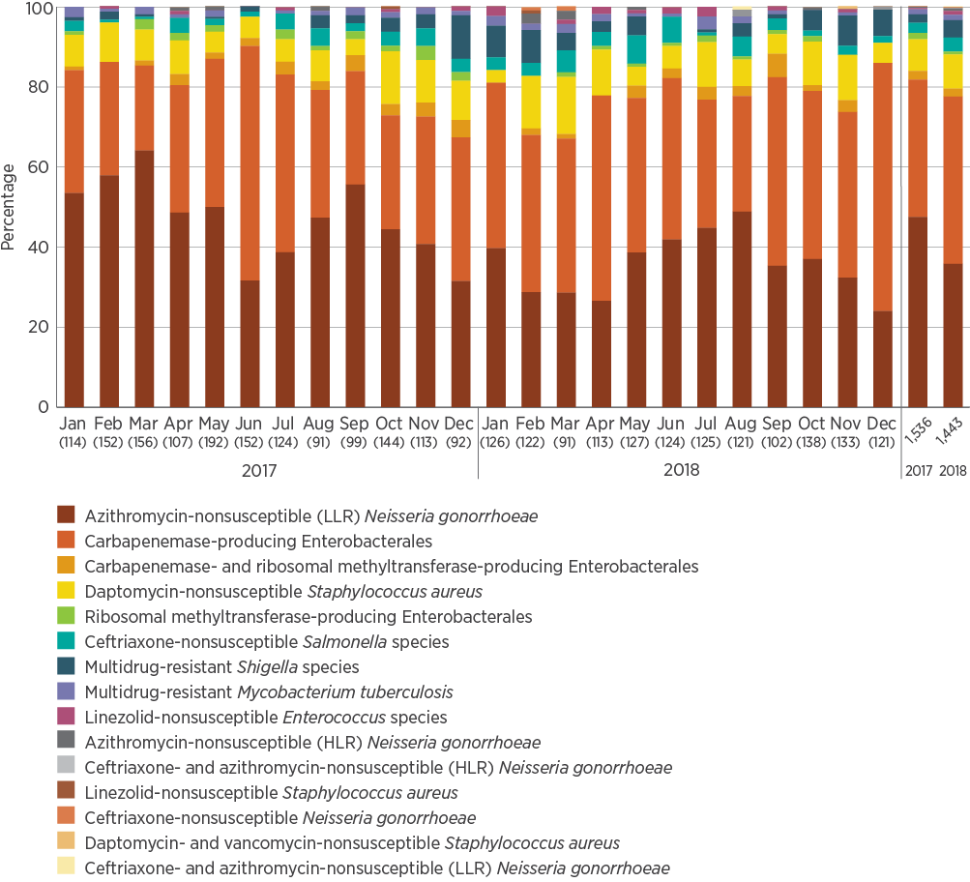
HLR = high-level resistance; LLR = low-level resistance
Notes:
1. Numbers of isolates are in brackets.
2. LLR is a minimum inhibitory concentration (MIC) < 256 mg/L; HLR is an MIC ≥ 256 mg/L.
Source: CARAlert (as at 31 January 2019)
No Streptococcus pyogenes with penicillin reduced susceptibility were submitted in the 2017–18 reporting period.
Between 1 January 2017 and 31 December 2018, a total of 2,979 critical antimicrobial resistances from 91 originating laboratories across Australia were entered into CARAlert.
Azithromycin- or ceftriaxone-nonsusceptible Neisseria gonorrhoeae was the most frequently reported CAR in 2017 (n = 734; 48%). Only four (0.5%) azithromycin-nonsusceptible N. gonorrhoeae isolates were reported to have high-level resistance (HLR) – that is, a minimum inhibitory concentration (MIC) ≥ 256 mg/L. There were no reports of ceftriaxone non-susceptibility in 2017 (Table 5.2). The total number of azithromycin- or ceftriaxone-nonsusceptible N. gonorrhoeae reported declined by 28% in 2018 (n = 529; 37%). However, reports of N. gonorrhoeae with azithromycin HLR alone increased (n = 7; 1.3%), and ceftriaxone-nonsusceptible N. gonorrhoeae (n = 6; 1.1%), with (n = 3) and without (n = 3) azithromycin non-susceptibility, were also reported (Figure 5.2).
Carbapenemase-producing Enterobacterales (CPE) were the most frequently reported CAR in 2018 (n = 632; 44%), either alone (n = 603; 42%) or in combination with production of ribosomal methyltransferases (n = 29; 2%); this is a 13% increase from 2017 (n = 561; 37%). CPE peaked during May–July 2017 because of an outbreak of OXA-48-producing Escherichia coli ST38 in Queensland, where 80 cases were reported during that period. The outbreak, which was largely confined to a single facility, was controlled within two months. Queensland Health has strategies in place to ensure early detection of CPE cases, and control and prevention of transmission.
In 2017, azithromycin- or ceftriaxone-nonsusceptible N. gonorrhoeae was the most frequently reported critical antimicrobial resistance (CAR; 48% of isolates). In 2018, carbapenemase-producing Enterobacterales were the most frequently reported CAR (44% of isolates).
Figure 5.2: Critical antimicrobial resistances, by organism and month of collection, 2017–18
Enterobacterales – carbapenemase producing
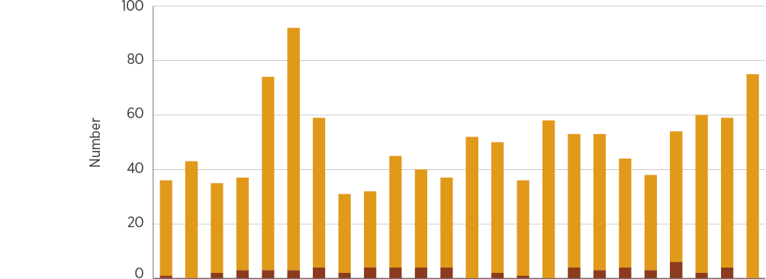
CAR | Jan | Feb | Mar | Apr | May | Jun | Jul | Aug | Sep | Oct | Nov | Dec | Jan | Feb | Mar | Apr | May | Jun | Jul | Aug | Sep | Oct | Nov | Dec
 | 2017 |  |  |  |  |  |  |  |  |  |  |  | 2018
Carbapenemase and ribosomal methyltransferase (n = 63) | 1 | 0 | 2 | 3 | 3 | 3 | 4 | 2 | 4 | 4 | 4 | 4 | 0 | 2 | 1 | 0 | 4 | 3 | 4 | 3 | 6 | 2 | 4 | 0
Carbapenemase (n = 1,130) | 35 | 43 | 33 | 34 | 71 | 89 | 55 | 29 | 28 | 41 | 36 | 33 | 52 | 48 | 35 | 58 | 49 | 50 | 40 | 35 | 48 | 58 | 55 | 75

Figure 5.2: continued
Enterobacterales – ribosomal methyltransferase producing
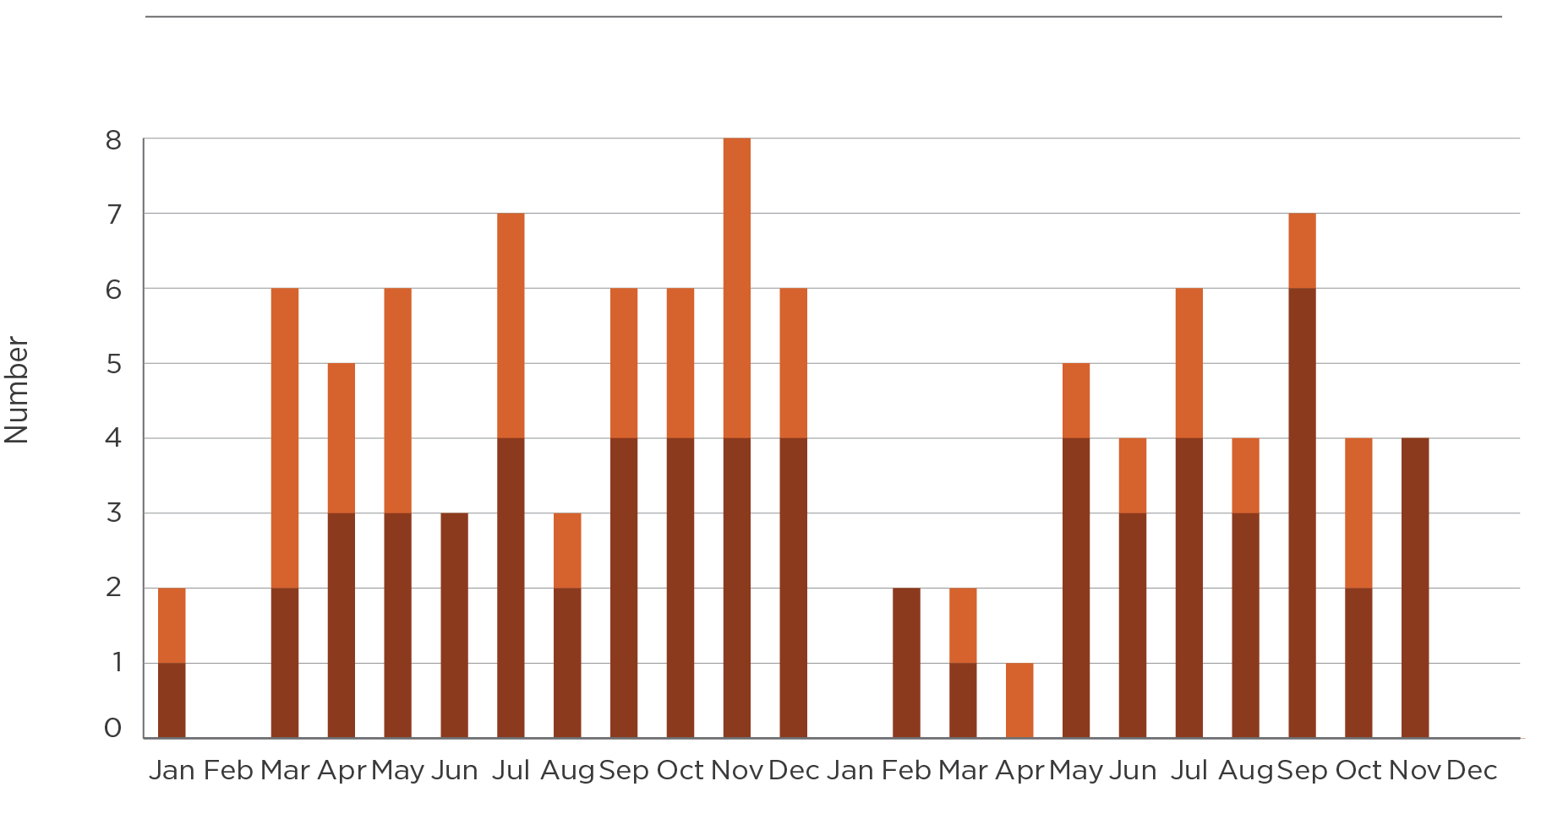
CAR | Jan | Feb | Mar | Apr | May | Jun | Jul | Aug | Sep | Oct | Nov | Dec | Jan | Feb | Mar | Apr | May | Jun | Jul | Aug | Sep | Oct | Nov | Dec
 | 2017 |  |  |  |  |  |  |  |  |  |  |  | 2018
Ribosomal methyltransferase and carbapenemase (n = 63) | 1 | 0 | 2 | 3 | 3 | 3 | 4 | 2 | 4 | 4 | 4 | 4 | 0 | 2 | 1 | 0 | 4 | 3 | 4 | 3 | 6 | 2 | 4 | 0
Ribosomal methyltransferase  (n = 34) | 1 | 0 | 4 | 2 | 3 | 0 | 3 | 1 | 2 | 2 | 4 | 2 | 0 | 0 | 1 | 1 | 1 | 1 | 2 | 1 | 1 | 2 | 0 | 0

Figure 5.2: continued
Neisseria gonorrhoeae – azithromycin-nonsusceptible (low-level resistance)
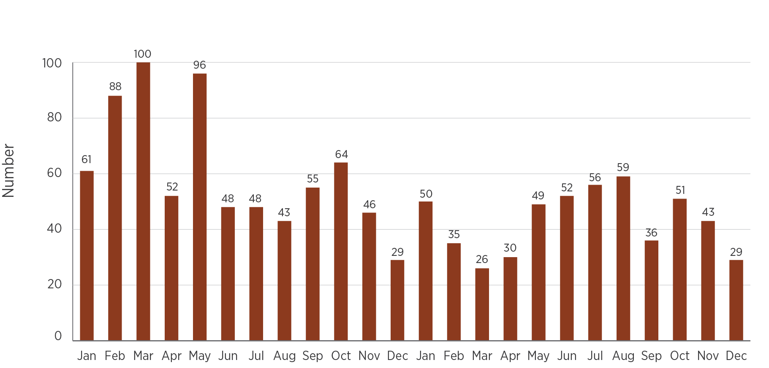

Neisseria gonorrhoeae – ceftriaxone- or azithromycin-nonsusceptible (high-level resistance)
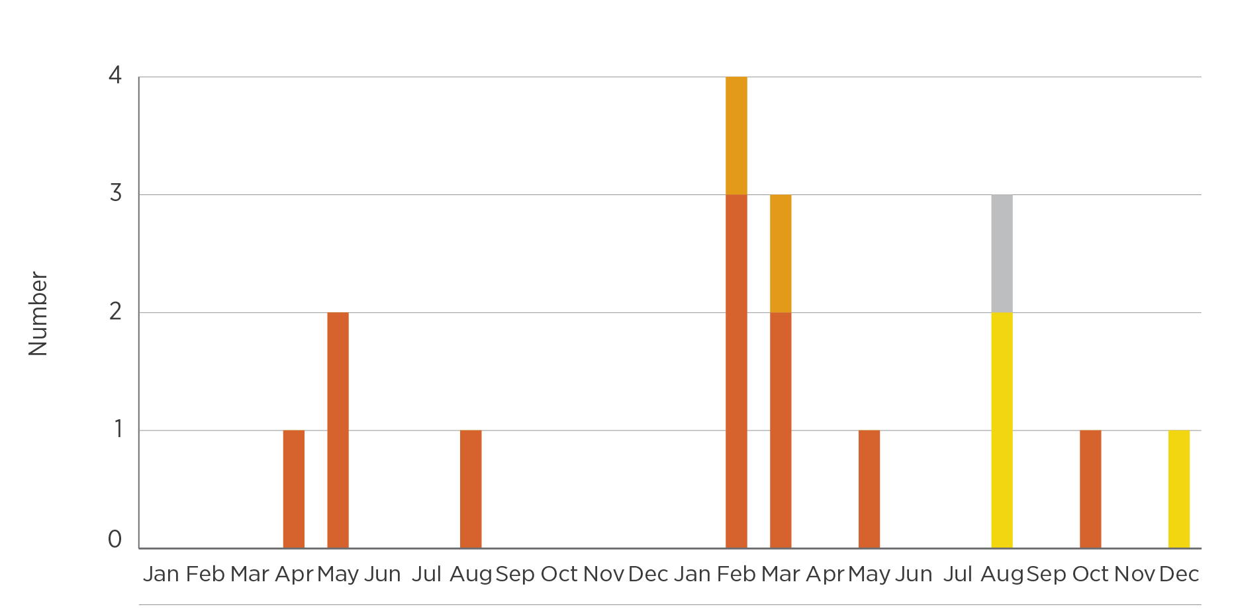
CAR | Jan | Feb | Mar | Apr | May | Jun | Jul | Aug | Sep | Oct | Nov | Dec | Jan | Feb | Mar | Apr | May | Jun | Jul | Aug | Sep | Oct | Nov | Dec
 | 2017 |  |  |  |  |  |  |  |  |  |  |  | 2018
Azithromycin- nonsusceptible (high-level resistance) (n = 11) | 0 | 0 | 0 | 1 | 2 | 0 | 0 | 1 | 0 | 0 | 0 | 0 | 0 | 3 | 2 | 0 | 1 | 0 | 0 | 0 | 0 | 1 | 0 | 0
Ceftriaxone- nonsusceptible (n = 3) | 0 | 0 | 0 | 0 | 0 | 0 | 0 | 0 | 0 | 0 | 0 | 0 | 0 | 0 | 0 | 0 | 0 | 0 | 0 | 2 | 0 | 0 | 0 | 1
Ceftriaxone- and azithromycin-nonsusceptible (high-level resistance) (n = 2) | 0 | 0 | 0 | 0 | 0 | 0 | 0 | 0 | 0 | 0 | 0 | 0 | 0 | 1 | 1 | 0 | 0 | 0 | 0 | 0 | 0 | 0 | 0 | 0
Ceftriaxone- and azithromycin- nonsusceptible (low-level resistance) (n = 1) | 0 | 0 | 0 | 0 | 0 | 0 | 0 | 0 | 0 | 0 | 0 | 0 | 0 | 0 | 0 | 0 | 0 | 0 | 0 | 1 | 0 | 0 | 0 | 0

Figure 5.2: continued
Salmonella species – ceftriaxone-nonsusceptible
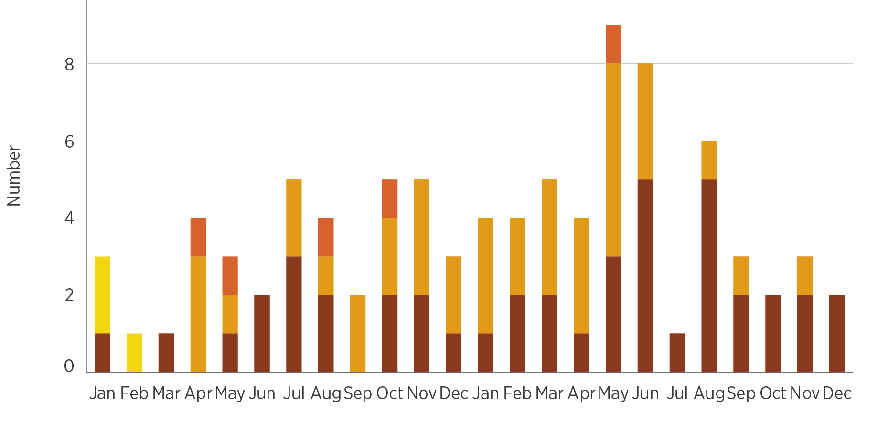
CAR | Jan | Feb | Mar | Apr | May | Jun | Jul | Aug | Sep | Oct | Nov | Dec | Jan | Feb | Mar | Apr | May | Jun | Jul | Aug | Sep | Oct | Nov | Dec
 | 2017 |  |  |  |  |  |  |  |  |  |  |  | 2018
ESBL (n = 43) | 1 | 0 | 1 | 0 | 1 | 2 | 3 | 2 | 0 | 2 | 2 | 1 | 1 | 2 | 2 | 1 | 3 | 5 | 1 | 5 | 2 | 2 | 2 | 2
AmpC (n = 38) | 0 | 0 | 0 | 3 | 1 | 0 | 2 | 1 | 2 | 2 | 3 | 2 | 3 | 2 | 3 | 3 | 5 | 3 | 0 | 1 | 1 | 0 | 1 | 0
AmpC, ESBL (n = 5) | 0 | 0 | 0 | 1 | 1 | 0 | 0 | 1 | 0 | 1 | 0 | 0 | 0 | 0 | 0 | 0 | 1 | 0 | 0 | 0 | 0 | 0 | 0 | 0
Unknown (n = 3) | 2 | 1 | 0 | 0 | 0 | 0 | 0 | 0 | 0 | 0 | 0 | 0 | 0 | 0 | 0 | 0 | 0 | 0 | 0 | 0 | 0 | 0 | 0 | 0
ESBL = extended-spectrum β-lactamase
Figure 5.2: continued
Shigella species – multidrug-resistant
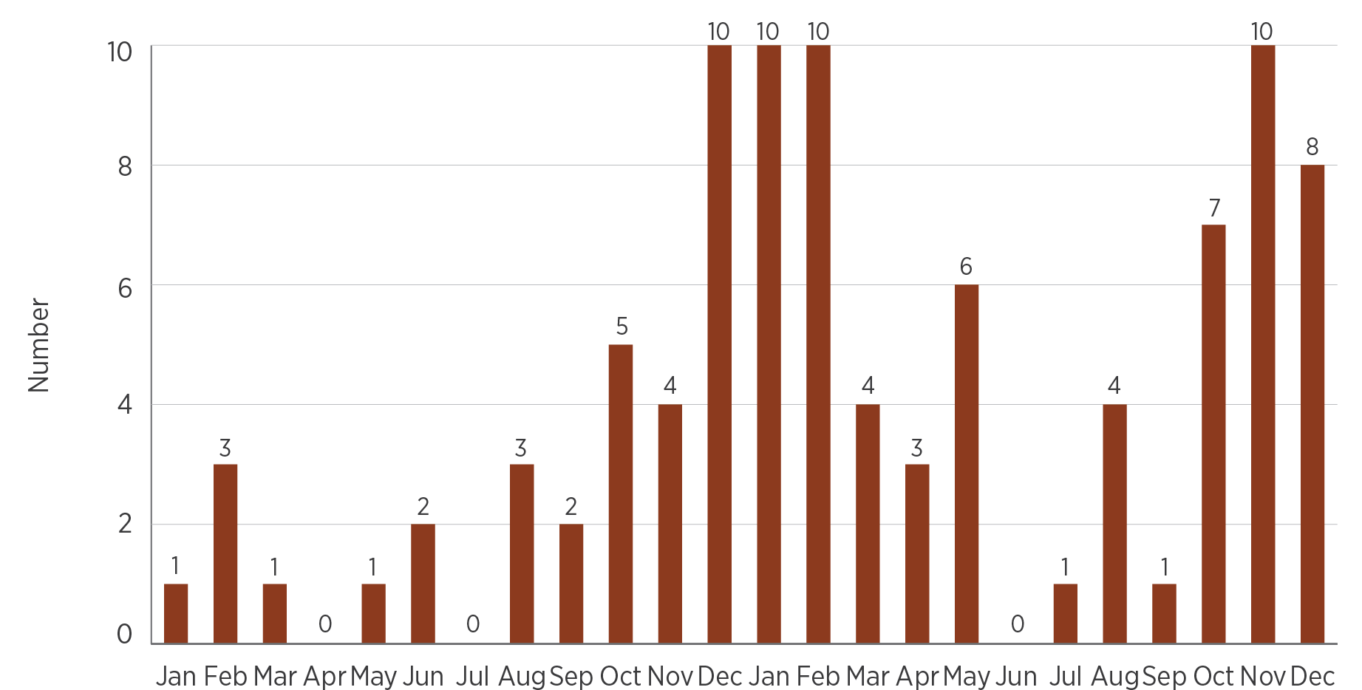
Staphylococcus aureus – daptomycin- , linezolid- or vancomycin-nonsusceptible
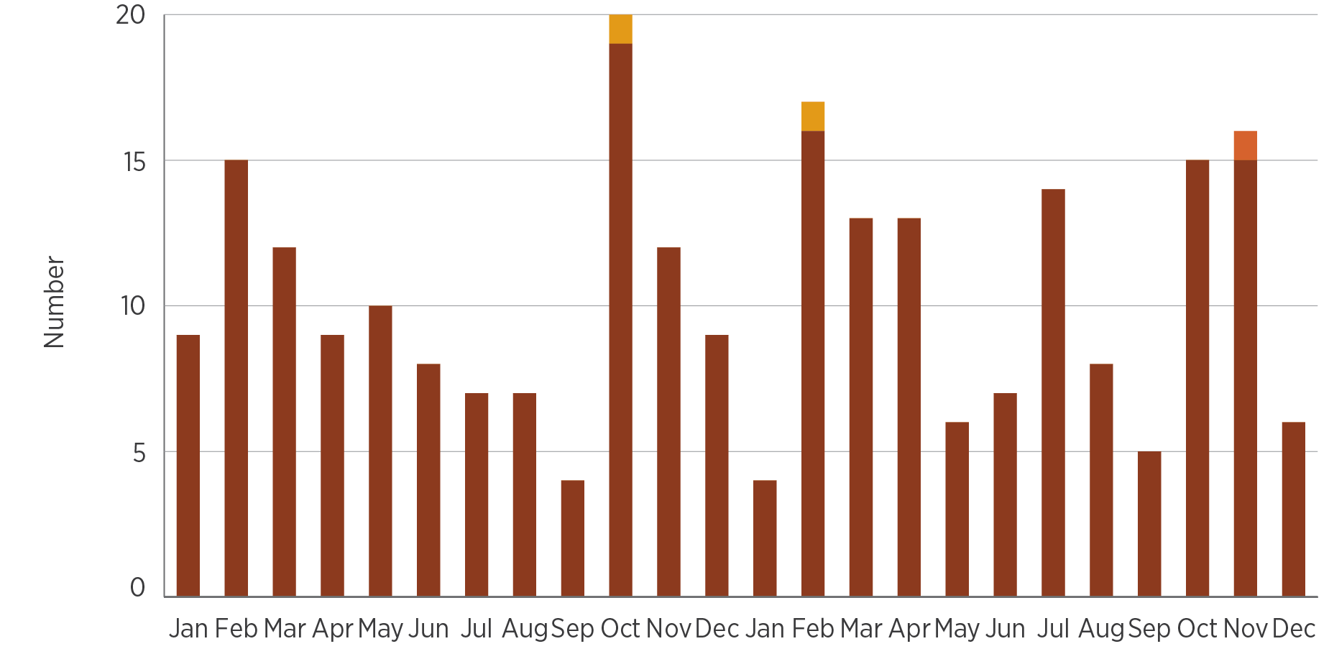
CAR | Jan | Feb | Mar | Apr | May | Jun | Jul | Aug | Sep | Oct | Nov | Dec | Jan | Feb | Mar | Apr | May | Jun | Jul | Aug | Sep | Oct | Nov | Dec
 | 2017 |  |  |  |  |  |  |  |  |  |  |  | 2018
Daptomycin (n = 243) | 9 | 15 | 12 | 9 | 10 | 8 | 7 | 7 | 4 | 19 | 12 | 9 | 4 | 16 | 13 | 13 | 6 | 7 | 14 | 8 | 5 | 15 | 15 | 6
Linezolid (n = 2) | 0 | 0 | 0 | 0 | 0 | 0 | 0 | 0 | 0 | 1 | 0 | 0 | 0 | 1 | 0 | 0 | 0 | 0 | 0 | 0 | 0 | 0 | 0 | 0
Daptomycin and vancomycin (n = 1) | 0 | 0 | 0 | 0 | 0 | 0 | 0 | 0 | 0 | 0 | 0 | 0 | 0 | 0 | 0 | 0 | 0 | 0 | 0 | 0 | 0 | 0 | 1 | 0
Figure 5.2: continued
Enterococcus species – linezolid-nonsusceptible
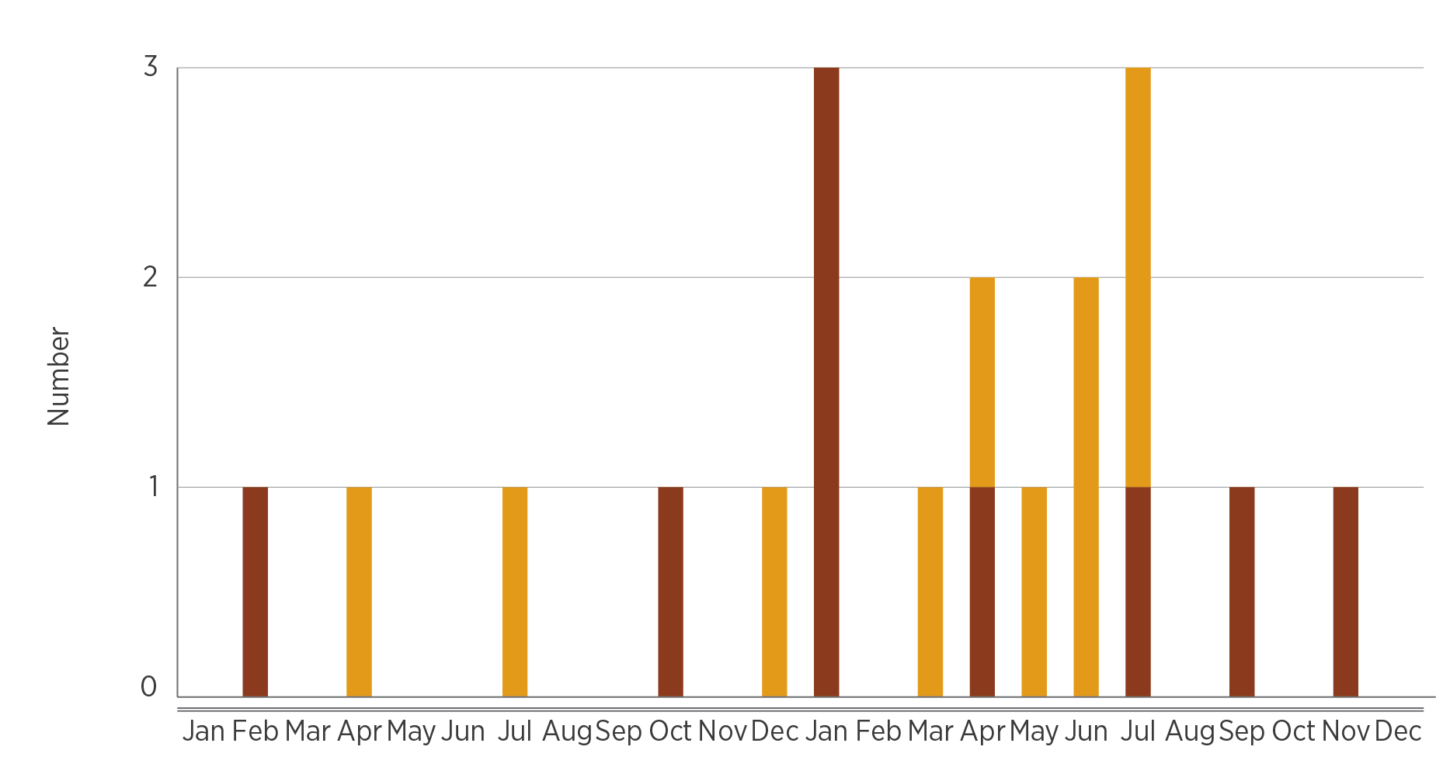
CAR | Jan | Feb | Mar | Apr | May | Jun | Jul | Aug | Sep | Oct | Nov | Dec | Jan | Feb | Mar | Apr | May | Jun | Jul | Aug | Sep | Oct | Nov | Dec
 | 2017 |  |  |  |  |  |  |  |  |  |  |  | 2018
Enterococcus faecium (n = 9) | 0 | 1 | 0 | 0 | 0 | 0 | 0 | 0 | 0 | 1 | 0 | 0 | 3 | 0 | 0 | 1 | 0 | 0 | 1 | 0 | 1 | 0 | 1 | 0
Enterococcus faecalis (n = 10) | 0 | 0 | 0 | 1 | 0 | 0 | 1 | 0 | 0 | 0 | 0 | 1 | 0 | 0 | 1 | 1 | 1 | 2 | 2 | 0 | 0 | 0 | 0 | 0
Figure 5.2: continued
Mycobacterium tuberculosis – multidrug-resistant
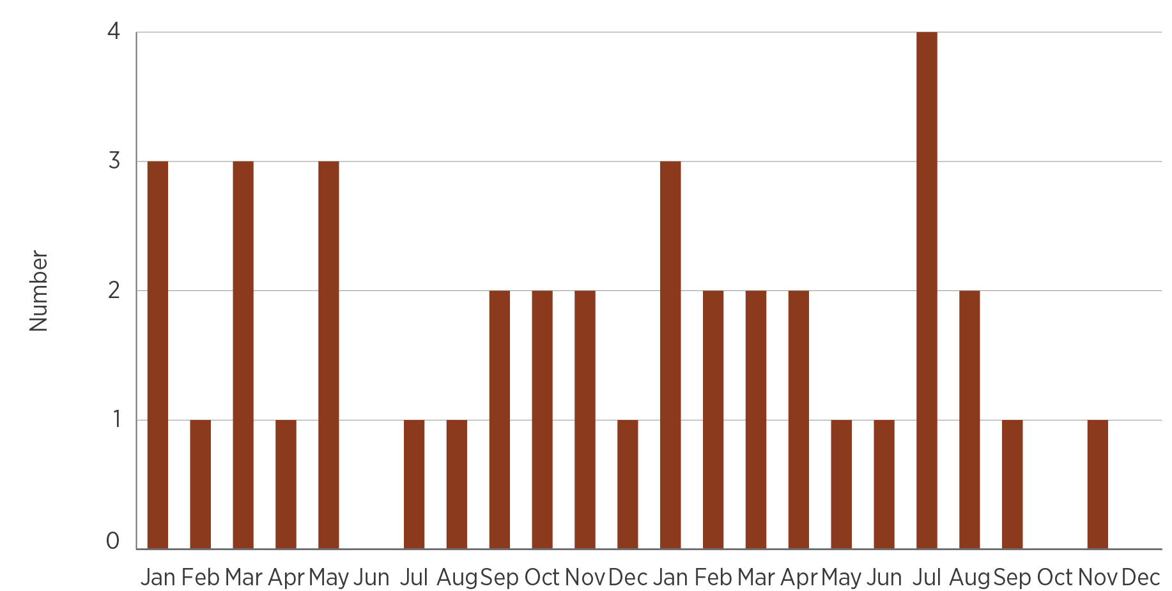
Source: CARAlert (as at 31 January 2019)

Critical antimicrobial resistances by state and territory
Most CARs (88% in 2017 and 2018) were collected from patients who lived in the most populous states: New South Wales (NSW; 31% in 2017; 32% in 2018), Victoria (37% in 2017; 35% in 2018) and Queensland (20% in 2017; 22% in 2018). There were fewer than 10 reports per year from Tasmania and the Northern Territory, and fewer than 35 reports per year from the Australian Capital Territory (ACT) and South Australia (Figure 5.3). A total of 24 reports were from overseas residents: 12 CPE, six multidrug-resistant Mycobacterium tuberculosis, five azithromycin-nonsusceptible N. gonorrhoeae (low-level resistance [LLR], MIC < 256 mg/L) and one linezolid-nonsusceptible Enterococcus species.
CPE were reported from all states and territories; however, no CPE were reported from the Northern Territory in 2017. CPE as a proportion of all reported CARs varied by state and territory, and by year. Reports of CPE as a proportion of all CARs in both 2017 and 2018 were highest for the ACT (87% and 59%) and Queensland (64% and 59%).
Daptomycin-nonsusceptible Staphylococcus aureus was reported from four states:
36–43% (43/121 in 2017; 53/122 in 2018) from Victoria
24–11% (29/121 in 2017; 14/122 in 2018) from NSW
22–33% (27/121 in 2017; 40/122 in 2018) from Western Australia
15–12% (18/121 in 2017; 15/122 in 2018) from Queensland.
Multidrug-resistant M. tuberculosis was reported from all states and territories except the Northern Territory. Six of 39 reports (three per year in 2017 and 2018) were for patients residing overseas.
There was a 29% decline in the overall number of azithromycin-nonsusceptible N. gonorrhoeae (LLR) reports in 2018 compared with 2017 (n = 730 in 2017; n = 516 in 2018). The decline was seen in all states and territories except Queensland, where there was a 15% increase (n = 61 in 2017; n = 70 in 2018), and the ACT (n = 1 in 2017; n = 7 in 2018).
Four azithromycin-nonsusceptible N. gonorrhoeae (HLR) were confirmed in 2017: one from Queensland (collected in April 2017), two from Victoria (May 2017) and one from NSW (August 2017). No ceftriaxone-nonsusceptible strains were reported in 2017. In 2018, nine azithromycin-nonsusceptible N. gonorrhoeae (HLR) strains were confirmed, two of which were also ceftriaxone-nonsusceptible (from Queensland). An additional four N. gonorrhoeae that were ceftriaxone-nonsusceptible either alone (n = 3) or with azithromycin LLR (n = 1) were reported in 2018. Of the six ceftriaxone-nonsusceptible N. gonorrhoeae, three were from NSW and three were from Victoria.
Figure 5.3: Critical antimicrobial resistances, by patient’s state or territory of residence, 2017–18
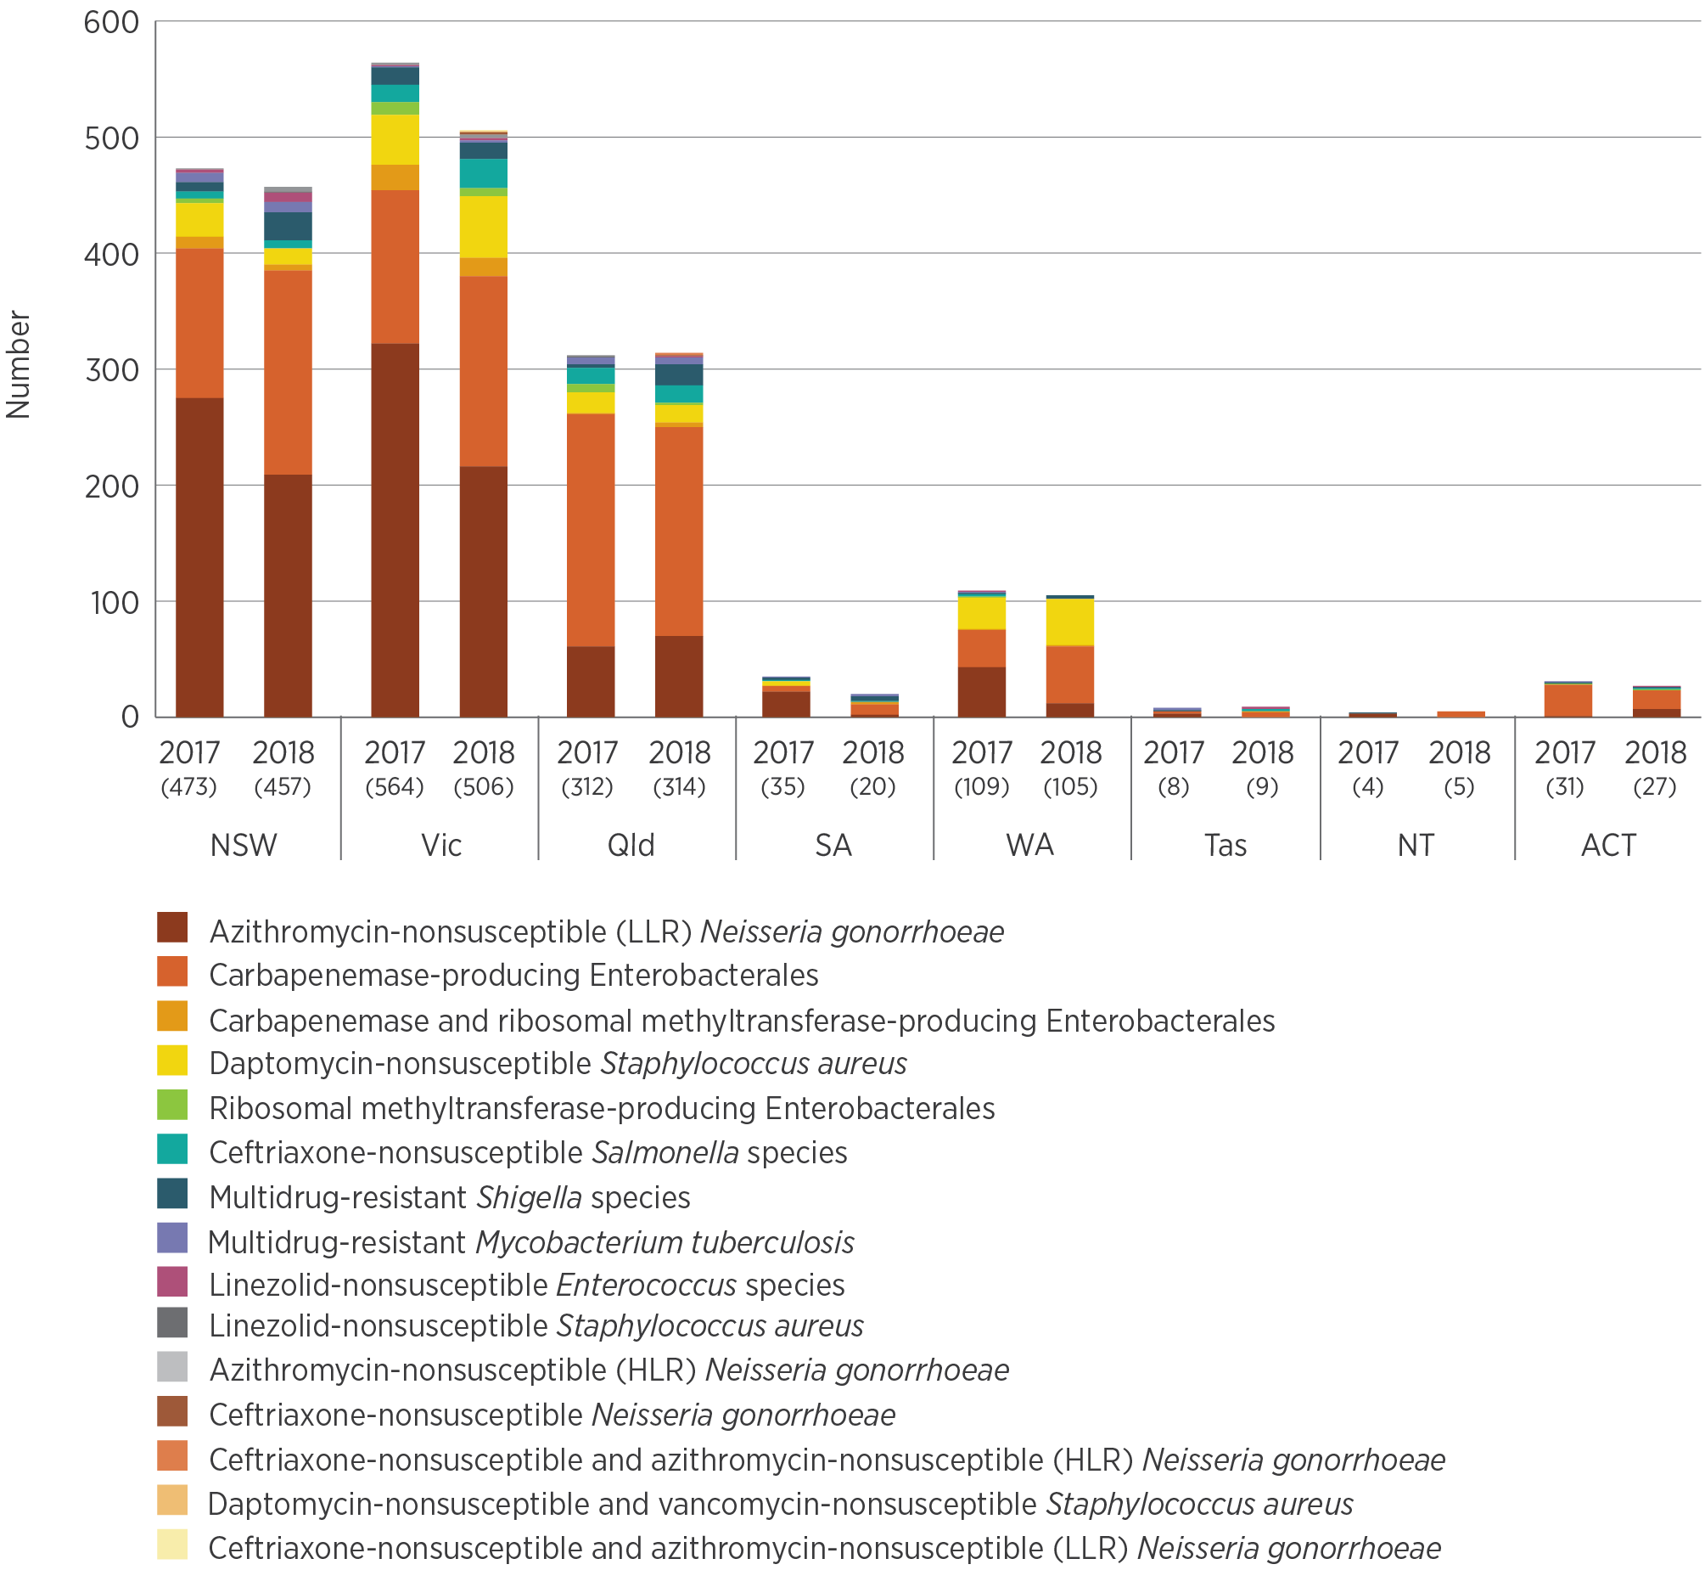
HLR = high-level resistance; LLR = low-level resistance
Notes:
1. Numbers of isolates are in brackets.
2. LLR is a minimum inhibitory concentration (MIC) of <256 mg/L; HLR is an MIC of ≥256 mg/L.
Source: CARAlert (as at 31 January 2019)

Critical antimicrobial resistances by age group
CARs were isolated from patients of all ages; the median age was 40–49 years (Figure 5.4). A total of 76–77% (427/561 in 2017; 487/632 in 2018) of CPE were isolated from people aged 50 years and older. Azithromycin-nonsusceptible N. gonorrhoeae was the predominant CAR reported for the age groups 15–19, 20–29, 30–39 and 40–49 years. Only 2.7–3.3% (42/1,536 in 2017; 47/1,413 in 2018) of all CARs were reported in children aged less than 15 years; CPE and ceftriaxone-nonsusceptible Salmonella species dominated in this age group (71% in 2017; 79% in 2018). For the 0–4-year age group, CPE was the most frequently reported CAR (32 reports in two years), followed by ceftriaxone-nonsusceptible Salmonella species (n = 16) and azithromycin-nonsusceptible N. gonorrhoeae (LLR; n = 7). In this age group, N. gonorrhoeae isolates were probably related to either local or international community-based transmission.
Figure 5.4: Critical antimicrobial resistances, by age group, 2017–18
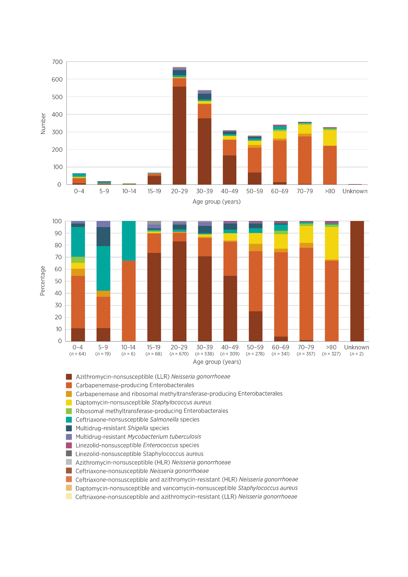
HLR = high-level resistance; LLR = low-level resistance
Note: LLR is a minimum inhibitory concentration (MIC) of <256 mg/L; HLR is an MIC of ≥256 mg/L.
Source: CARAlert (as at 31 January 2019)

Critical antimicrobial resistances by specimen type
Just over three-quarters of all CARs were from clinical specimens (81% in 2017; 75% in 2018), which are specimens collected for diagnostic purposes rather than for screening. These included urine, wound, blood and other (such as genital or respiratory) specimens (Figure 5.5).
Of CPE isolates:
More than 50% were from clinical specimens (286/561, 51.0% in 2017; 327/632, 51.7% in 2018)
60% of isolates from clinical specimens were from urine (172/286 in 2017; 197/327 in 2018)
8% of isolates from clinical specimens were from blood cultures (24/286 in 2017; 26/327 in 2018).
Figure 5.5: Critical antimicrobial resistances, by specimen type, 2017–18
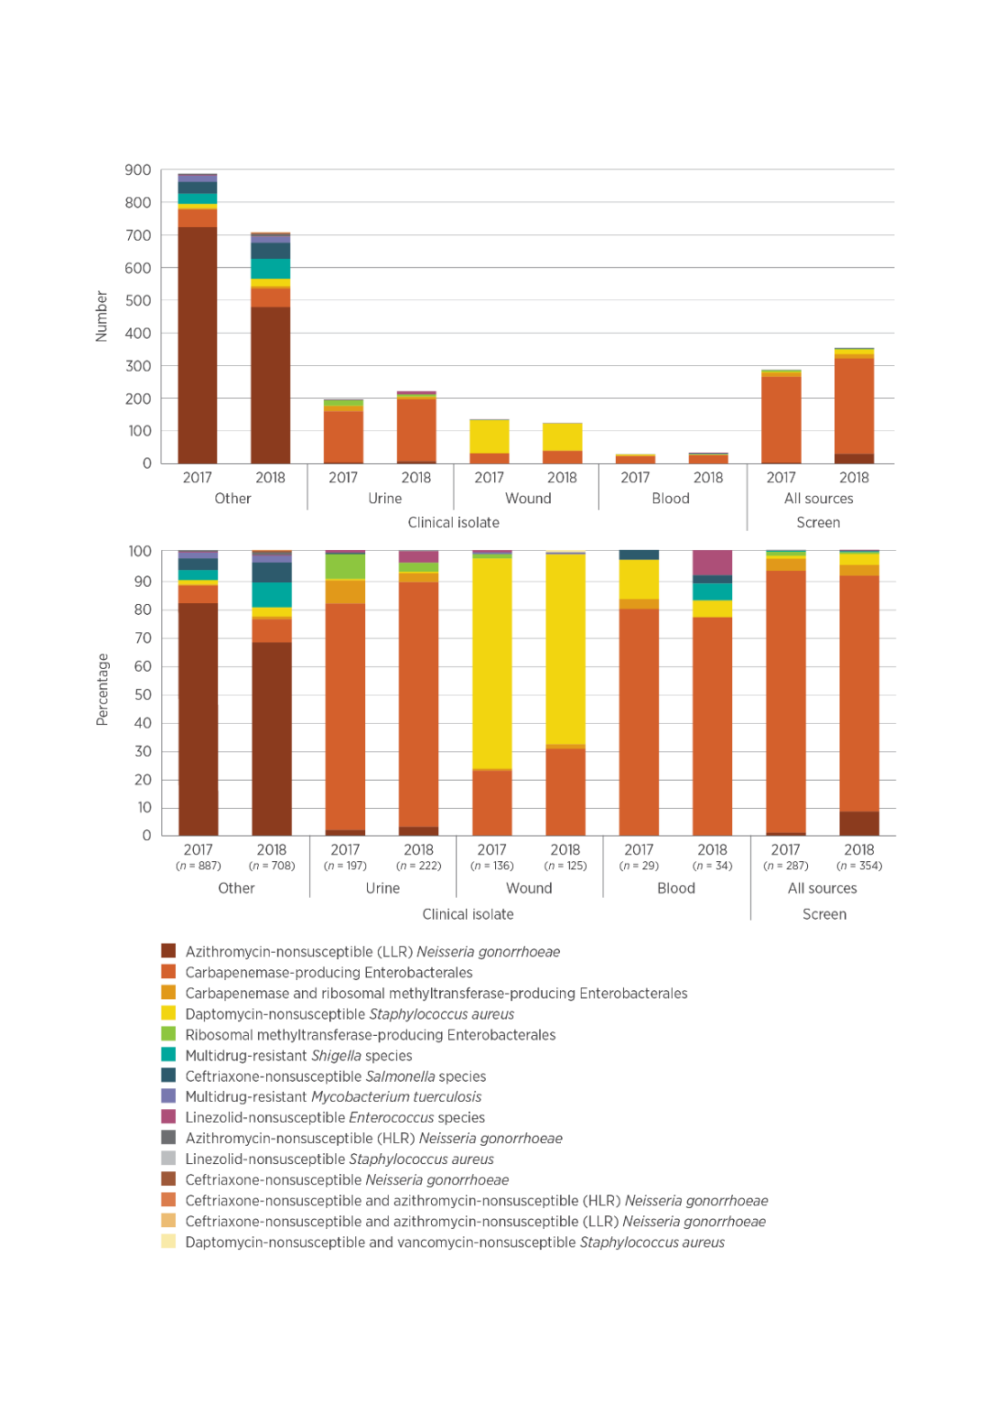

HLR = high-level resistance; LLR = low-level resistance
Notes:
1. LLR is a minimum inhibitory concentration (MIC) of <256 mg/L; HLR is an MIC of ≥256 mg/L.
2. ‘Other’ refers to specimen types other than urine, wound or blood, such as genital, faecal or respiratory tract.
Source: CARAlert (as at 31 January 2019)
CPE comprised 81% of all CARs confirmed from blood specimens, highlighting the clinical spectrum of CPE infections compared with other CARs. Reports of linezolid-nonsusceptible Enterococcus species almost tripled in 2018, with increases in both E. faecium and E. faecalis. This CAR accounted for 8.8% of all CARs reported for blood cultures in 2018; 1 in 5 reports of this CAR were from blood.
Carbapenemase-producing Enterobacterales (CPE) comprised 81% of all critical antimicrobial resistances (CARs) confirmed from blood specimens, highlighting the clinical spectrum of CPE infections compared with other CARs.
Four other CARs were also reported from blood cultures in 2017 and 2018: daptomycin-nonsusceptible S. aureus (n = 4 in 2017; n = 2 in 2018), ceftriaxone-nonsusceptible Salmonella species (n = 1 in 2017 and 2018), linezolid-nonsusceptible Enterococcus species (n = 3 in 2018) and multidrug-resistant Shigella species (n = 2 in 2018). Urine is an important specimen for certain CARs, such as CPE, because the urinary tract is a common site of infection. In addition, Shigella is responsible for sporadic outbreaks among men who have sex with men.

Critical antimicrobial resistances by facility type
Excluding azithromycin-nonsusceptible N. gonorrhoeae, which is generally isolated in the community, the majority of CARs (637/802, 79% in 2017; 701/914, 77% in 2018) were detected in either hospitalised patients or hospital outpatients. Smaller proportions were isolated in the community (106/802, 13% in 2017; 156/914, 17% in 2018) and in aged care homes (18/802, 2% in 2017; 18/914, 2% in 2018) (Figure 5.6).
Excluding azithromycin-nonsusceptible Neisseria gonorrhoeae, which is generally isolated in the community, the majority of critical antimicrobial resistances (77–79%) were detected in either hospitalised patients or hospital outpatients.
Figure 5.6: Critical antimicrobial resistances, by facility type, 2017–18
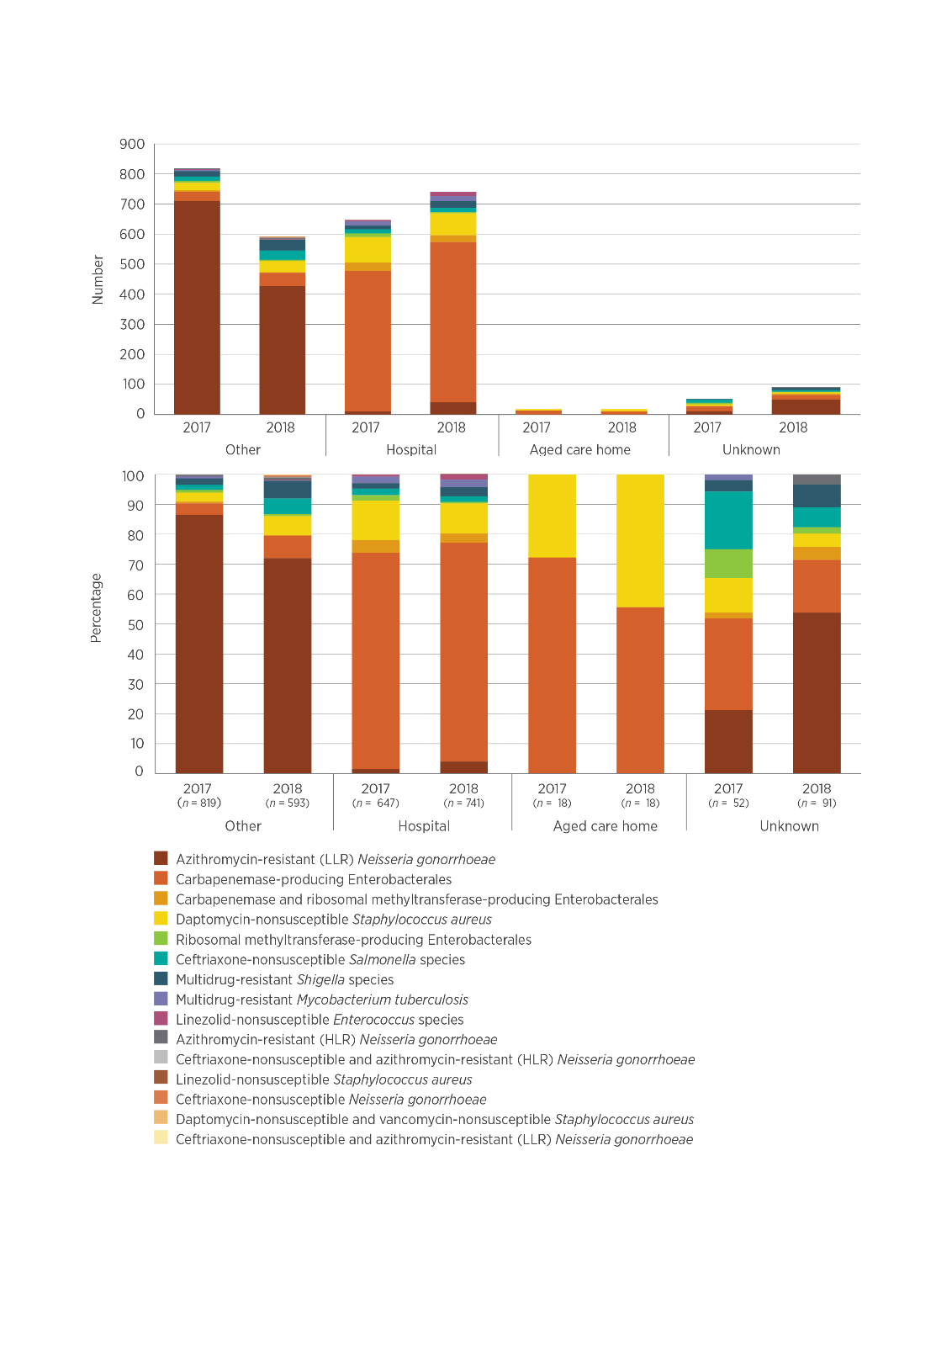
HLR = high-level resistance; LLR = low-level resistance
Notes:
1. LLR is a minimum inhibitory concentration (MIC) of <256 mg/L; HLR is an MIC of ≥256 mg/L.
2. ‘Other’ refers to community (non-hospital and non–aged care home).
Source: CARAlert (as at 31 January 2019)

Carbapenemase-producing Enterobacterales type by state and territory
Ten carbapenemase types were reported throughout Australia during 2017–18. Seven (IMP, OXA-48-like, NDM, KPC, VIM, OXA-23-like and IMI) were reported in both years, FRI was reported in 2017 only, and SME and GES were reported in 2018 only. There were notable regional differences in the distribution of the top five carbapenemases (Table 5.3).
Three carbapenemase types (IMP, NDM and OXA-48-like) accounted for 97% of all Enterobacterales with a confirmed carbapenemase, either alone or in combination, in 2017 and 2018.
IMP types increased by 29% in 2018 compared with 2017, although there was a 43% decrease in reports from the ACT. No IMP-producing Enterobacterales were reported from South Australia; however, one Enterobacter cloacae complex containing NDM+IMP was reported in 2018. All the strains that have been genetically sequenced to date (52%; 348/664) were bla_{IMP-4}. Increasing numbers of IMP-4-producing E. cloacae complex were noted in Victoria from October 2018; these were mostly confined to one institution.
NDM types, either alone or in combination, were found in all states and territories. There was a 42% increase in NDM types in 2018 compared with 2017, most notably in Queensland (12/201, 6% in 2017; 35/184, 19% in 2018). The number of NDM types reported doubled in both Western Australia (from 8 to 17) and South Australia (from 5 to 11) in 2018. Four different genes were found in the strains sequenced to date: bla_{NDM-5} (58/112; 52%), bla_{NDM-1} (43/112; 38%), bla_{NDM-4} (6/112; 5%) and bla_{NDM-7} (5/112; 4%). NDM types accounted for all types found in South Australia, 30% (25/83) of types found in Western Australia, 28% (94/334) of types found in Victoria, and 22% (69/320) of types found in NSW.
Reports of OXA-48-like CPE decreased in 2018, following control of the 2017 Queensland outbreak. There was little change in the number of isolates from clinical specimens. KPC types were mostly reported from Victoria (38/53; 72%); there were also reports from NSW (n = 11) and Queensland (n = 4).
In April 2017, IMI was detected for the first time in an E. cloacae complex isolate from a patient residing in NSW. Also reported for the first time were an FRI-producing E. cloacae complex from a patient residing in Tasmania (May 2017), and a GES-5-producing Klebsiella pneumoniae from a patient residing in Victoria (May 2018).
Co-production of CPE types was seen at low levels (23/561, 4.1% in 2017; 16/632, 2.5% in 2018). The most common co-producing genes since January 2017 were NDM+OXA-48-like (29 isolates), IMP+OXA-48-like (three isolates), IMP+NDM (two isolates), IMP+KPC (two isolates), NDM+VIM (one isolate), KPC+OXA-48-like (one isolate) and KPC+NDM (one isolate).
Table 5.3: Top five carbapenemase types, number reported by state and territory, 2017–18
Carbapenenase type | Year | NSW | Vic | Qld | SA | WA | Tas | NT | ACT | Total
IMP | Total | 215 | 126 | 238 | 1 | 46 | 1 | 1 | 36 | 664
 | 2017 | 90 | 57 | 101 | 0 | 20 | 0 | 0 | 23 | 291
 | 2018 | 125 | 69 | 137 | 1 | 26 | 1 | 1 | 13 | 373
NDM | Total | 69 | 94 | 47 | 16 | 25 | 3 | 4 | 5 | 263
 | 2017 | 36 | 46 | 12 | 5 | 8 | 0 | 0 | 2 | 109
 | 2018 | 33 | 48 | 35 | 11 | 17 | 3 | 4 | 3 | 154
OXA-48-like | Total | 42 | 70 | 97 | 3 | 14 | 4 | 0 | 2 | 232
 | 2017 | 23 | 32 | 84 | 0 | 5 | 0 | 0 | 2 | 146
 | 2018 | 19 | 38 | 13 | 3 | 9 | 4 | 0 | 0 | 86
KPC | Total | 11 | 38 | 4 | 0 | 0 | 0 | 0 | 0 | 53
 | 2017 | 5 | 19 | 2 | 0 | 0 | 0 | 0 | 0 | 26
 | 2018 | 6 | 19 | 2 | 0 | 0 | 0 | 0 | 0 | 27
VIM | Total | 1 | 2 | 3 | 0 | 1 | 2 | 0 | 0 | 9
 | 2017 | 1 | 2 | 3 | 0 | 0 | 2 | 0 | 0 | 8
 | 2018 | 0 | 0 | 0 | 0 | 1 | 0 | 0 | 0 | 1
Note: Number reported by state and territory includes genes detected alone or in combination with another type.
Source: CARAlert (as at 31 January 2019)
There were notable variations between states and territories in the carbapenemase types reported from clinical specimens. The proportions of CPE overall that were from screening cultures also differed; this may reflect differences in approaches to screening practices (Figure 5.7).
Figure 5.7: Carbapenemase types from clinical isolates, by state or territory, 2017–18
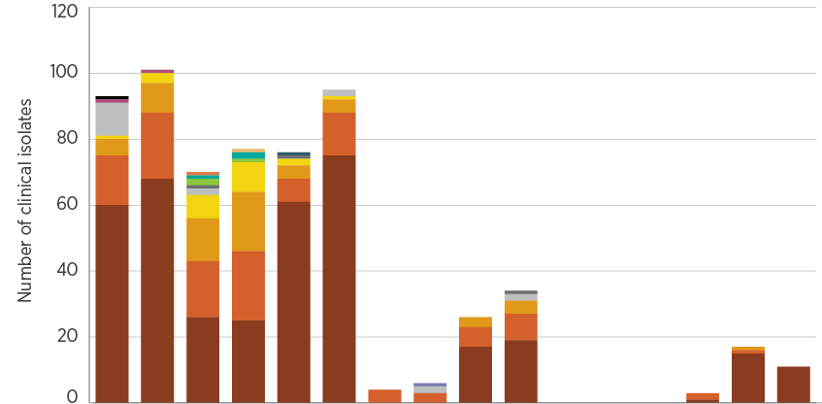
CAR | 2017 | 2018 | 2017 | 2018 | 2017 | 2018 | 2017 | 2018 | 2017 | 2018 | 2017 | 2018 | 2017 | 2018 | 2017 | 2018
 | NSW |  | Vic |  | Qld |  | SA |  | WA |  | Tas |  | NT |  | ACT
Screen, % | 33.1 | 44.2 | 54.5 | 57.2 | 62.2 | 48.4 | nd | 45.5 | 21.2 | 32.0 | nd | nd | nd | nd | 37.0 | 31.3
Clinical, n | 93 | 101 | 70 | 77 | 76 | 95 | 4 | 6 | 26 | 34 | 0 | 0 | 0 | 3 | 17 | 11
Screen, n | 46 | 80 | 84 | 103 | 125 | 89 | 1 | 5 | 7 | 16 | 2 | 5 | 0 | 2 | 10 | 5
Total | 139 | 181 | 154 | 180 | 201 | 184 | 5 | 11 | 33 | 50 | 2 | 5 | 0 | 5 | 27 | 16
nd = no data (insufficient numbers)
* Number of screening cultures as a proportion of total number of carbapenemase-producing Enterobacterales (CPE), where 10 or more CPE were reported per year
Source: CARAlert (as at 31 January 2019)

Carbapenemase-producing Enterobacterales by organism
Carbapenemases were found in 30 species (11 genera) of Enterobacterales. IMP types accounted for 51–59% (287/561 in 2017; 370/632 in 2018) of all carbapenemases, and were found in 25 different species (Figure 5.8). E. cloacae complex accounted for 49–52% (140/287 in 2017; 192/370 in 2018) of all IMP types and 25–30% (140/561 in 2017; 192/632 in 2018) of all CPE. However, in Queensland, 32–47% (64/201 in 2017; 86/184 in 2018) of all CPE reported were E. cloacae complex containing IMP types.
NDM and OXA-48-like carbapenemase types were found mainly in E. coli (61–67% for NDM; 82–52% for OXA-48-like). However, when both NDM and OXA-48-like or KPC types were found together, they were mainly in K. pneumoniae (65–58% for NDM+OXA-48-like; 88–96% for KPC).
Figure 5.8: Carbapenemase-producing Enterobacterales, 2017–18
By species and carbapenemase type
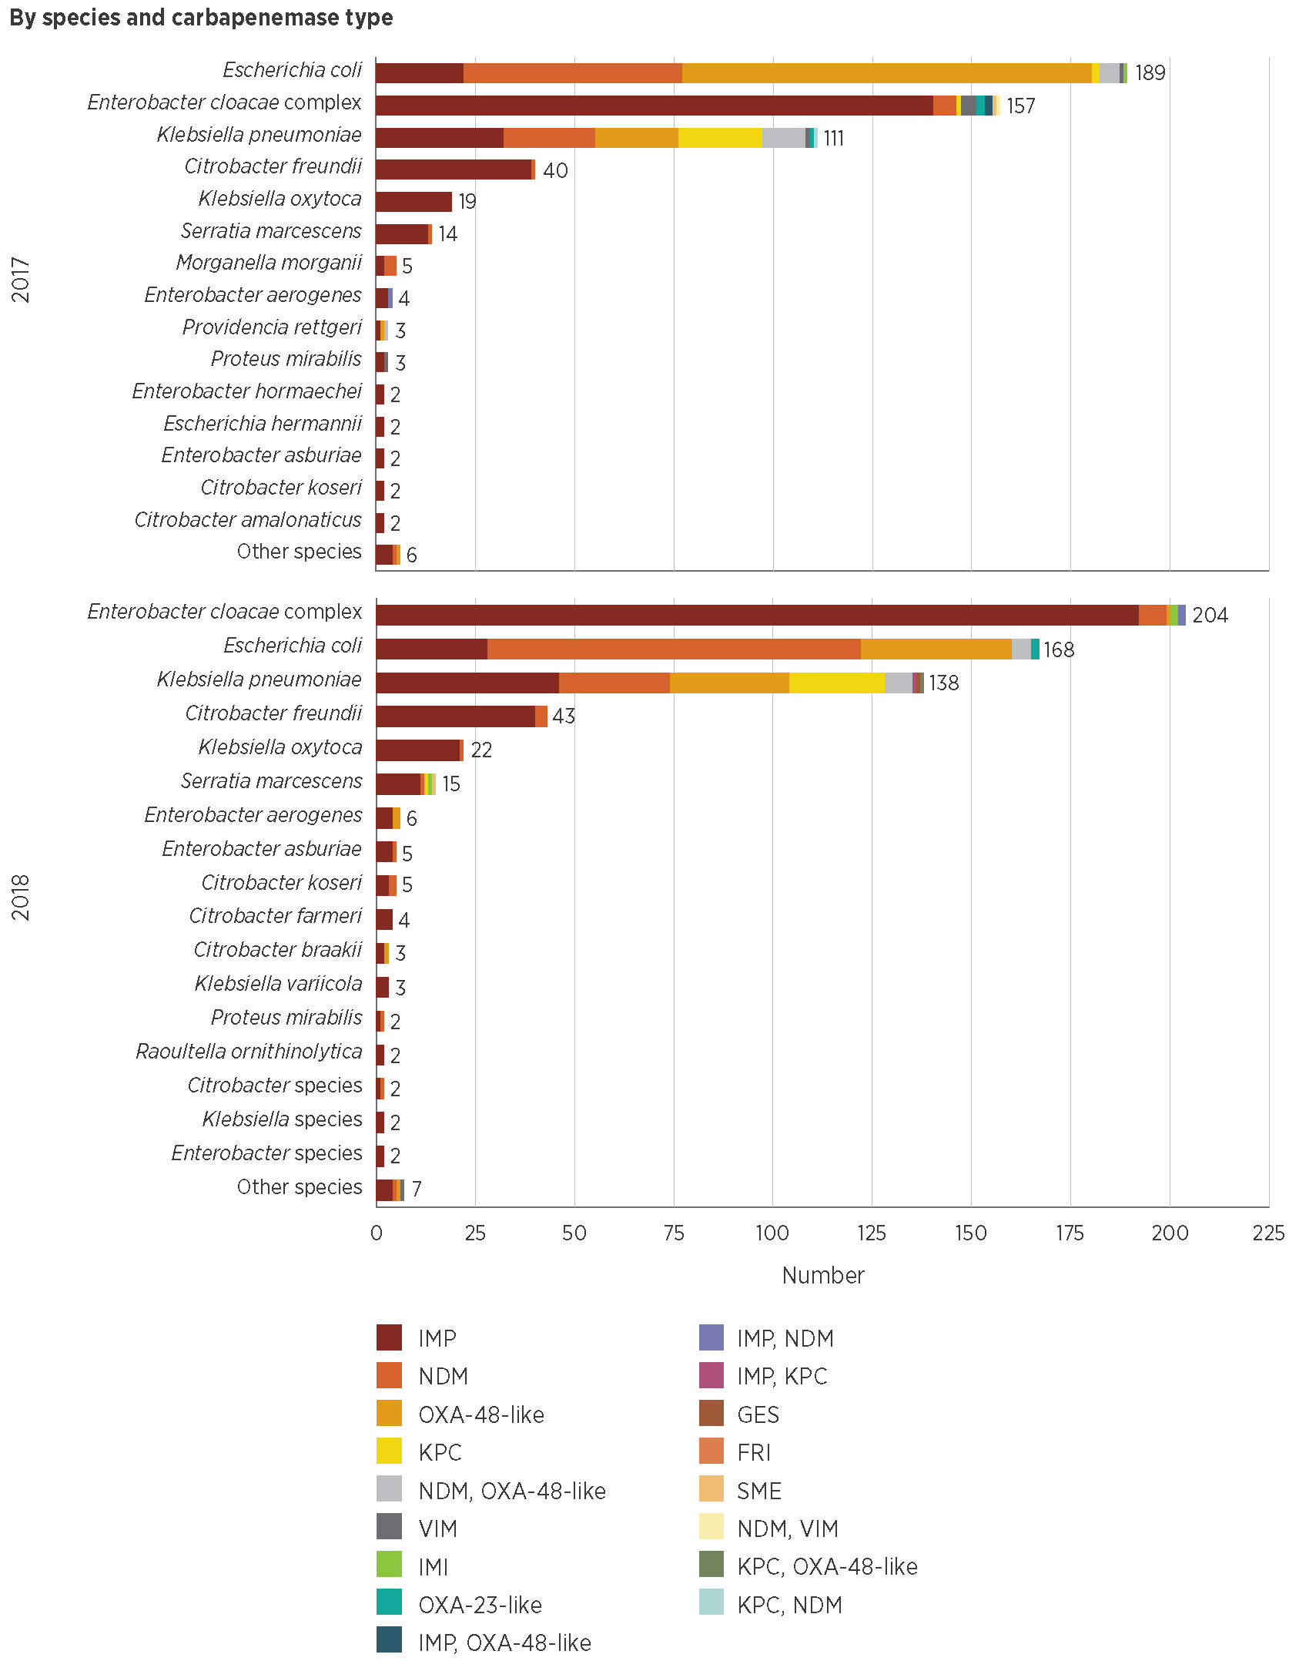
Figure 5.8: continued
By carbapenemase type and species
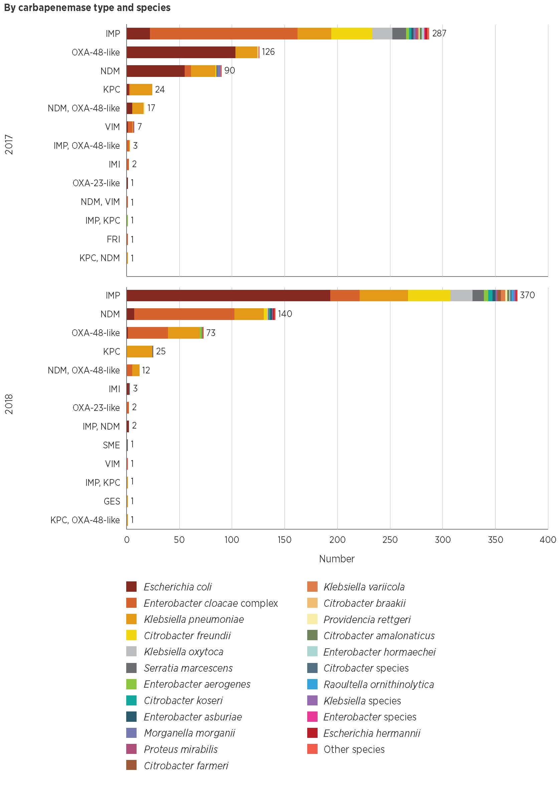
Source: CARAlert (as at 31 January 2019)

Other critical antimicrobial resistance types
Almost all (237/239; 99%) CARs reported for S. aureus were daptomycin-nonsusceptible strains. Two linezolid-nonsusceptible strains were confirmed from patients residing in Queensland (October 2017) and NSW (February 2018); one daptomycin- and vancomycin-nonsusceptible S. aureus strain was reported from a patient residing in Victoria (October 2018).
Ribosomal methyltransferases (RMTs) were detected in 97 isolates of Enterobacterales, representing nine species; 65% (63/97) of these also had a carbapenemase. The RMTs were mostly found among E. coli (39/97; 40%) and K. pneumoniae (35/97; 36%). Four RMT genes were found: rmtB (50/97; 52%), either alone (48) or in combination with rmtC (1) or armA (1); armA alone (24/97; 25%); rmtC alone (14/97; 14%); and rmtF (9/97; 9%). Multiple genes were found in one E. cloacae complex (rmtB, rmtC and NDM) and one K. pneumoniae (armA, rmtB, NDM and OXA-48-like).

5.3 Commentary
CPE continue to be dominated by those of the IMP type, found most often in the E. cloacae complex. IMP-producing Enterobacterales were reported in 87 public hospitals throughout Australia in 2017–18. NDM-producing Enterobacterales were reported from all states and territories, and reports of these increased during 2017 and 2018. Although NDM types are generally thought to be acquired overseas, identification of local transmission and appropriate control action are important priorities.
The differences between states and territories in the proportion of screening isolates may indicate local variations in surveillance, infection control and screening practices. Local outbreaks during 2017 and 2018 are likely to have required increased infection control and surveillance in affected hospitals over short periods of time. The impact of outbreaks such as these on other aspects of hospital work and patient flows is also likely to be substantial if timely control action is not taken.
The variation between states and territories in reports of CPE as a proportion of all CARs, and the frequency of reporting of CPE, indicates the need for local decisions about containment priorities. The Commission’s Recommendations for the Control of Carbapenemase-Producing Enterobacteriaceae (CPE): A guide for acute care health facilities¹ and relevant local guidance provide a framework for responding to CPE.
A total of 3% of all CPE reports (32/1,193) occurred in the 0–4-year age group. The mode of acquisition of these CARs is not known; however, CPE outbreaks can occur in the neonatal intensive care unit setting. The long-term impact of this type of resistance on neonates is unknown. Education of clinicians on the risks of neonatal acquisition of antimicrobial-resistant organisms, and review of the appropriateness of antimicrobial use and infection control in the neonatal care setting are encouraged.
There were six N. gonorrhoeae isolates with ceftriaxone non-susceptibility, two of which were also azithromycin-nonsusceptible (one HLR and one LLR). In 2017 and 2018, there were reports from five countries of N. gonorrhoeae strains with resistance to ceftriaxone, and global concerns about the ongoing efficacy of current recommended treatments.²⁻⁴ In Australia, the recommended treatment for N. gonorrhoeae is ceftriaxone in conjunction with azithromycin; this regimen was introduced to limit further development of resistance to ceftriaxone.⁵
There were six Neisseria gonorrhoeae isolates with ceftriaxone non-susceptibility, two of which were also azithromycin-nonsusceptible. In 2017 and 2018, there were reports from five countries of N. gonorrhoeae strains with resistance to ceftriaxone, and global concerns about the ongoing efficacy of current recommended treatments.
The low background rate of azithromycin-nonsusceptible N. gonorrhoeae (LLR) in Australia is now well established. Reports of this CAR remained relatively steady during 2017 and 2018. The clinical implications of this LLR are not clear. However, the reports of ceftriaxone non-susceptibility in 2018 are a concern; ongoing monitoring of azithromycin and ceftriaxone non-susceptibility is required because of the importance of emerging changes in susceptibility for treatment guidelines. Use of antibiotics such as azithromycin is also associated with increased resistance in other organisms.⁶ Given the relatively recent introduction of azithromycin for the treatment of N. gonorrhoeae, analyses and monitoring of trends in azithromycin resistance in other organisms will be considered.
Other CARs remain at very low levels; however, ongoing prevention and control strategies, and monitoring are essential to ensure that levels of these CARs continue to remain low in Australia.

5.4 Developments and future plans
The AURA National Coordination Unit reviewed CARAlert in 2018, in conjunction with relevant experts, and the states and territories. The review identified four new CARs that will be reported to CARAlert from 2019:
Transferrable resistance to colistin in Enterobacterales
Carbapenemase-producing Acinetobacter baumannii complex
Carbapenemase-producing Pseudomonas aeruginosa
Candida auris, which is a multidrug-resistant yeast that has caused outbreaks in multiple countries.
The AURA National Coordination Unit will continue to collaborate with relevant experts to enhance CARAlert as new resistances are identified.
Maintaining effective surveillance of N. gonorrhoeae resistance, continuing programs for prevention and control of sexually transmissible infections, and implementing outbreak response strategies are all essential to minimise the spread of untreatable gonorrhoea.
CARAlert data have implications for infection control and prevention programs that are implemented by health service organisations to meet the requirements of the Preventing and Controlling Healthcare-Associated Infection Standard of the National Safety and Quality Health Service Standards – for example, in relation to CPE. The Commission will work with states and territories on strategies to promote consistency of screening and infection control practices to improve CPE containment.
Maintaining effective surveillance of Neisseria gonorrhoeae resistance, continuing programs for prevention and control of sexually transmissible infections, and implementing outbreak response strategies are all essential to minimise the spread of untreatable gonorrhoea.
It is becoming increasingly important to improve surveillance processes to distinguish between local and overseas acquisition of CARs, particularly in relation to screening and management of patients who are transferred or admitted to an Australian hospital following treatment or development of an illness overseas. The Commission will work with states and territories to promote implementation of appropriate local infection control and enhanced surveillance strategies.
The Commission has been engaged by the Australian Government Department of Health to work with states and territories, and relevant experts to develop a national model for an antimicrobial resistance surveillance and outbreak response network. This work, which will be completed during 2019, complements existing state and territory roles and responsibilities in relation to leadership of effective antimicrobial resistance outbreak responses within their jurisdiction, and collaboration if a national or inter-jurisdictional response is required. The model is intended to promote alignment of state and territory protocols; avoid duplication of processes in relation to surveillance, screening, testing and outbreak response; and be adaptable to local requirements. Implementation of the model will be led by states and territories, and the Australian Government Department of Health. CARAlert and other AURA Surveillance System data will complement local surveillance data in the event of outbreaks of antimicrobial-resistant organisms.

References
1. Australian Commission on Safety and Quality in Health Care. Recommendations for the control of carbapenemase-producing Enterobacteriaceae (CPE): a guide for acute care health facilities. Sydney: ACSQHC; 2017 (accessed Feb 2019).
2. Centers for Disease Control and Prevention (US). 2016 sexually transmitted diseases surveillance. Atlanta (GA): CDC; 2017 [cited 2018 Nov 1].
3. Family Planning Association (UK). Sexually transmitted infections factsheet. FPA; 2016 [updated 2016 Nov; cited 2019 Feb 13].
4. Regan DG, Hui BB, Wood JG, Fifer H, Lahra MM, Whiley DM. Treatment for pharyngeal gonorrhoea under threat. Lancet Infect Dis 2018;18(11):1175–7.
5. Australasian Sexual Health Alliance. Australian STI management guidelines for use in primary care. Sydney: ASHA; 2017 [cited 2019 Feb 25].
6. Leach AJ, Shelby-James TM, Mayo M, Gratten M, Laming AC, Currie BJ, et al. A prospective study of the impact of community-based azithromycin treatment of trachoma on carriage and resistance of Streptococcus pneumoniae. Clin Infect Dis 1997;24(3):356–62.

Chapter 6: Focus areas
Key messages
Amoxicillin–clavulanic acid and cefalexin prescribing
- The broad-spectrum antibiotics amoxicillin–clavulanic acid and cefalexin have the potential to promote the development of antimicrobial resistance (AMR). They are prescribed in high volumes in both community and hospital settings. Prescribing of these agents is often inappropriate, and not consistent with guidelines.
- The reasons for high proportions of inappropriate prescribing are similar in community and hospital settings.
- Reducing inappropriate prescribing of these antibiotics, and promoting use of narrower-spectrum antibiotics such as amoxicillin, will reduce the volume of broad-spectrum antibiotic use in community and hospital settings, and contribute to preventing and containing AMR.
Chronic obstructive pulmonary disease
- Chronic obstructive pulmonary disease (COPD) is a common condition for which broad-spectrum antibiotics are prescribed for microbiological and/or anti-inflammatory reasons. People with COPD are prone to developing AMR in respiratory isolates.
- There is a long-term trend in hospitals of high levels of inappropriate prescribing of antibiotics for exacerbation of COPD.
- Targeted strategies and guidelines to improve the appropriateness of antibiotic prescribing for treatment of COPD in hospitals will require collaboration between clinicians involved in antimicrobial stewardship and the specialists managing patients with COPD.
Aged care homes
- There is a substantial burden of infection and colonisation with multidrug-resistant organisms among people living in aged care homes in Australia, and high levels of unnecessary antimicrobial prescribing and inappropriate antimicrobial use.
- Aged care homes are an important community setting for monitoring AMR and antimicrobial use, because of the potential for amplifying AMR as a result of the high frequency of residents moving in and out of hospitals.
- Enhanced infection prevention and control, and antimicrobial stewardship efforts in aged care homes and hospitals will help to reduce transmission between these settings and improve the safety of care provided to residents.
International comparisons in antimicrobial resistance
- Although Australia’s rates of fluoroquinolone resistance in Escherichia coli and Klebsiella pneumoniae remain very low compared with most European countries, resistance has increased when compared with some countries. Resistance rates to third-generation cephalosporins in these two species are lower than the European average.
- Compared with European countries, rates of resistance in key gram-positive pathogens are moderate to high in Australia. The prevalence of vancomycin resistance in Enterococcus faecium remains higher in Australia than in more than 30 European countries, even though rates have levelled off in recent years.
This chapter explores key issues identified through antimicrobial use (AU) and antimicrobial resistance (AMR) surveillance that highlight the importance of surveillance and responses that may be required. It also compares rates of AMR in Australia with those in other countries.

6.1 Amoxicillin–clavulanic acid and cefalexin prescribing
All AU, especially use of broad-spectrum antibiotics, has the potential to affect the progression of AMR. Therefore, use of broad-spectrum antibiotics should be reduced when clinically appropriate. In hospitals, this is facilitated in some part through restricted antimicrobial formularies and antimicrobial stewardship (AMS) programs. In the community, the Pharmaceutical Benefits Scheme (PBS)/Repatriation Pharmaceutical Benefits Scheme (RPBS) authority prescription processes help in this regard.
The broad-spectrum antibiotics amoxicillin–clavulanic acid and cefalexin have the potential to promote the development of antimicrobial resistance. They are prescribed in high volumes in both community and hospital settings. Prescribing of these agents is often inappropriate, and not consistent with guidelines.
In hospital and community settings, there is the potential to promote reduced use of two commonly used oral broad-spectrum antibiotics (amoxicillin–clavulanic acid and cefalexin) that are not generally restricted. Improved use of these agents should be considered, along with use of other broad-spectrum antimicrobials, as part of hospital AMS programs.

Frequency of prescribing
In 2017, amoxicillin–clavulanic acid and cefalexin comprised 13.2% and 4.4%, respectively, of all antibiotics (defined daily doses per 1,000 occupied bed days) prescribed in hospitals. They were the third (amoxicillin–clavulanic acid, 6.6%) and sixth (cefalexin, 5.2%) most commonly prescribed antibiotics in the 2017 Hospital National Antimicrobial Prescribing Survey (Hospital NAPS).
Amoxicillin–clavulanic acid and cefalexin were among the three most commonly prescribed antibiotics for the NPS MedicineWise MedicineInsight cohort; 14.7% of MedicineInsight patients were prescribed at least one prescription for amoxicillin–clavulanic acid or cefalexin in 2017. The frequency of prescribing for these agents varied by season. Cefalexin prescriptions were more common in the hotter months, most likely because of the increase in skin and soft tissue infections during this period. Together, amoxicillin–clavulanic acid and cefalexin comprised 37.6% of all antibiotic prescriptions dispensed in 2017 under the PBS/RPBS. In aged care homes that contributed to the Aged Care National Antimicrobial Prescribing Survey (AC NAPS) in 2017, 25.2% of prescriptions analysed were for cefalexin (19.4%) and amoxicillin–clavulanic acid (5.8%).

Indications for prescribing and compliance with guidelines
The top three indications for prescribing cefalexin in hospitals were cystitis (29.8%), surgical prophylaxis (22.5%) and cellulitis/erysipelas (9.5%). These were also the most common indications for inappropriate prescribing of cefalexin; surgical prophylaxis was disproportionately represented (41.1%) compared with cystitis (17%). Community-acquired pneumonia (CAP) (16%), cystitis (11.4%) and hospital-acquired pneumonia (10.6%) were the top three indications for prescribing amoxicillin–clavulanic acid in the 2017 Hospital NAPS. However, inappropriate prescribing of this agent occurred most often for CAP (31.4%), infective exacerbation of chronic obstructive pulmonary disease (COPD; 15.6%) and cystitis (8%).
In the 2017 Hospital NAPS, a high proportion of cefalexin and amoxicillin–clavulanic acid prescriptions were deemed to not comply with guidelines (48.2% and 34.3%, respectively). They were also the top two most inappropriately prescribed antibiotics in hospitals (cefalexin, 43.3%; amoxicillin–clavulanic acid, 29.4%). The reasons for inappropriate prescribing of these agents varied; for cefalexin, the most common reasons were the wrong dose (27.2%) or duration (32.6%), whereas, for amoxicillin–clavulanic acid, the most common reason was that the spectrum was too broad for the indication being treated (63.0%).
The NPS MedicineWise MedicineInsight data show that many prescriptions for these agents were not consistent with first-line treatment recommendations. Skin/wound infection (31.8%) was the most common indication for prescribing cefalexin (8.9% for amoxicillin–clavulanic acid), despite cefalexin not being the preferred first-line therapy in the absence of penicillin allergies.¹ Acute cystitis, or urinary tract infection (UTI)¹, was the second most common indication (21.5%) for cefalexin. Despite trimethoprim being the recommended first-line treatment for UTI¹, only 44.9% of females aged over 18 years who were prescribed antimicrobials for this indication received trimethoprim. Given the frequency of cefalexin prescriptions for UTIs, it is possible that cefalexin is being prescribed preferentially to trimethoprim for cystitis in the community, despite it being recommended as a second-line therapeutic choice.
It is possible that cefalexin is being prescribed preferentially to trimethoprim for cystitis in the community, despite it being recommended as a second-line therapeutic choice.
Sinusitis (14.0%) was the most common indication for prescribing amoxicillin–clavulanic acid in general practices that contributed to the MedicineInsight program. Amoxicillin is the recommended first-line treatment for sinus infections, if antibiotics are required.¹ The second most common indication for prescribing amoxicillin–clavulanic acid in MedicineInsight practices was upper respiratory tract infection (URTI). Antibiotics are not generally recommended to treat URTIs.¹

Reducing the use of amoxicillin–clavulanic acid and cefalexin
There are many reasons for using antibiotics that are not consistent with recommended first-line therapies. Tolerability of certain antibiotic preparations may lead to prescribing preferences – for example, avoiding flucloxacillin syrup in children in favour of more palatable paediatric formulations such as amoxicillin–clavulanic acid or cefalexin.
First-line clinical failure may be another reason for selecting broader-spectrum antibiotics. This failure may be due to AMR or other factors. If first-line clinical failure is occurring often, it may trigger a clinician to reconsider first-line recommendations to improve clinical outcomes. Clinician uncertainty following clinical failure or slow improvement may also be motivating factors.
Regardless of the reasons for deviation from treatment recommendations, narrower-spectrum antibiotics are more appropriate for most people if they are therapeutically equivalent to broad-spectrum antibiotics. When there are varying adverse effect profiles for antimicrobials, clinicians should adopt a balanced approach that includes considering individual patient needs, prescriber preference and development of resistance. When resistance begins to emerge in a particular antibiotic–organism combination, strategies are required to discourage prescription of unnecessarily broad-spectrum antibiotics.
A large reduction in amoxicillin–clavulanic acid and cefalexin use could be achieved by discouraging prescribing of antibiotics when there is minimal, if any, benefit compared with symptom management. However, alternative strategies – such as promoting the selection of narrower-spectrum antibiotics (for example, amoxicillin) for particular conditions rather than amoxicillin–clavulanic acid and cefalexin – could also significantly reduce peoples’ exposure to these antibiotics.
The reasons for prescribing amoxicillin–clavulanic acid and cefalexin for skin and soft tissue infection should be explored. Using narrower-spectrum antibiotics, such as flucloxacillin, for mild cellulitis would have a large overall effect on reducing broad-spectrum antibiotic use. Addressing prescriber concerns about adverse effects of flucloxacillin, including hepatotoxicity and non-immediate penicillin allergy, will support appropriate prescribing of narrow-spectrum antibiotics.²
Promoting the use of trimethoprim, rather than cefalexin, for cystitis could reduce cefalexin use. Improving the uptake of amoxicillin over amoxicillin–clavulanic acid for sinusitis infections, if antibiotics are clinically indicated, is another option for improving antibiotic prescribing practice.
Addressing misconceptions about the microbiological spectrum of these agents may also help to improve prescribing practice. A common example is the reliance on amoxicillin–clavulanic acid and cefalexin to treat lower respiratory tract infections, particularly in the context of antibiotic allergy or perceived treatment failure. Cefuroxime is the preferred cephalosporin for many conditions, due to several microbiological benefits.^{1,3} Adding a second agent, such as amoxicillin or doxycycline, is the suggested strategy for clinical failure in mild CAP, rather than using amoxicillin–clavulanic acid or cefalexin.¹
Despite appreciable decreases in community and hospital prescribing in the past five years, ongoing high-volume use of amoxicillin–clavulanic acid and cefalexin, rather than narrower-spectrum agents, for many conditions is a concern. Given evidence of increasing AMR in Australia, and the frequency with which these broad-spectrum agents are prescribed, more attention is required to optimise prescribing of these two antibiotics to reduce AMR progression.
Areas for action
Promoting class switches in primary care and reducing antibiotic prescriptions that will have minimal, if any, therapeutic benefits could reduce broad-spectrum antibiotic prescribing in primary care.
To achieve similar outcomes in hospitals, AMS programs should aim to improve all aspects of prescribing broad-spectrum antibiotics, including amoxicillin–clavulanic acid, cefalexin and other agents that are not on restricted formulary lists.

6.2 Chronic obstructive pulmonary disease
COPD is a chronic lung condition that is characterised by episodic worsening of lung function. These episodes are often attributed to infective complications and are called infective exacerbations of COPD. These exacerbations may be caused by viruses, bacteria or non-infective causes. Although many of these complications are managed in the community, recurrent admissions for inpatient care due to hypoxaemia and difficulty breathing are common in the latter stages of COPD. Therefore, this condition features prominently in both community and hospital AU data.

Reasons for inappropriate prescribing
Longitudinal Hospital NAPS data show high levels of inappropriate prescribing (from 36.8% in 2014 to 37.8% in 2017) for this indication. The reasons for this are multi-factorial and require careful consideration when developing responses.⁴
Diagnostic uncertainty is a common barrier to following antibiotic prescribing guidelines. When a person with COPD is assessed for hospital admission, it can be difficult to distinguish between a lower respiratory tract infection (such as pneumonia), an exacerbation without pneumonia and a non-infective presentation. Confounding this issue is the persistent colonisation of the respiratory tract with various organisms, which makes it difficult to assess whether an organism is causing an infection. For this reason, sputum culture is not recommended in acute exacerbations, except in clinical failure or when there is a high suspicion of resistant disease on presentation.¹ Broader-spectrum antibiotics are often considered a more appropriate option than targeted treatments by prescribers.
Consistent with the findings of the Hospital NAPS, compliance with guidelines has been shown to be low for COPD treatment (10–14.3%).^{5,6} Social factors, such as medical hierarchy, also contribute to compliance or noncompliance with COPD treatment guidelines in Australia.⁷ The perception that AMR is not a matter for immediate concern for some clinicians is also an issue that affects antimicrobial prescribing practice.
Another complicating factor for AU in people with COPD is the anti-inflammatory, rather than antibacterial, effects of antibiotics. Historical studies show benefits, including reduced exacerbations, with long-term low-dose macrolides, despite the development of AMR, including the loss of fluoroquinolone therapy in Pseudomonas isolates.⁸ A 2018 systematic review showed that, to save one exacerbation, eight patients needed to be treated with macrolides for 3–12 months (95% confidence interval 5–17 months).⁸ The review identified no significant benefits regarding hospital admissions, and only marginal benefits for quality-of-life measures.
Macrolides also have side effects, in addition to resistance, including cardiac dysrhythmias, tinnitus and diarrhoea. The relative benefits of their use need to be continually assessed. It is important to consider the implications for AMR of the use of macrolides for anti-inflammatory purposes. As shown in Chapter 4, erythromycin resistance in Streptococcus pneumoniae, which commonly causes infections in patients with COPD, varies by setting, and averages 17.4% overall.

Complexity of following treatment guidelines
Dosing and duration of antibiotics for COPD treatment are more complex than, for example, for CAP. To optimise AU, clinicians need to become familiar with COPD treatment guidelines. Ceftriaxone, which is recommended for severe pneumonia, is used commonly (59%) in hospital settings to treat COPD, despite not being recommended by Therapeutic Guidelines: Antibiotic¹ or the COPD-X guidelines⁹ and having no benefit in length of stay or readmission rates.⁶
The two guidelines on the treatment of COPD have minor differences, particularly regarding the use of amoxicillin–clavulanic acid and duration of antibiotics. In 2017, COPD accounted for 15.6% of all amoxicillin–clavulanic acid prescriptions assessed for the Hospital NAPS.¹⁰ COPD-X suggests that amoxicillin–clavulanic acid should be considered if there is no clinical response to initial treatment, whereas Therapeutic Guidelines: Antibiotic suggests that amoxicillin–clavulanic acid should not be given at all, as it does not have superior efficacy to the first-line treatments recommended in Therapeutic Guidelines: Antibiotic. COPD-X suggests treatment for at least five days, whereas Therapeutic Guidelines: Antibiotic recommends a five-day course only of amoxicillin or doxycycline. A review of the reasons for these differences could be an area of focus to reduce inappropriate prescribing for people with COPD.

Improving prescribing for chronic obstructive pulmonary disease
It is important for clinicians who manage COPD to endorse evidence-based guidelines locally, as their leadership can improve prescribing practices in others. AMS activities are successful when local treating clinicians promote them.¹¹
Local and national strategies are required to improve the prescribing practices for COPD. Optimising prescribing for this condition is warranted because of the burden of COPD, the frequency of inpatient care, and the spectrum and quantity of AU.
Optimising prescribing for chronic obstructive pulmonary disease (COPD) is warranted because of the burden of COPD, the frequency of inpatient care, and the spectrum and quantity of antimicrobial use.
Areas for action
The reasons driving inappropriate prescribing will be assessed, to inform strategies to improve antibiotic prescribing for COPD.
Harmonising national guidelines will help clinicians to improve their prescribing practices.
AMS experts and treating clinicians could support quality improvement actions and promote adherence to guidelines, which could lead to improved prescribing for COPD.

6.3 Aged care homes
Aged care homes play an important role in the care of older members of the community in Australia, as well as some younger people who require care. In addition, multi-purpose services in all states and the Northern Territory provide integrated health and aged care services for small regional and remote communities where a standalone aged care home or hospital would not be viable.
Aged care homes are also recognised nationally and internationally as an important community setting for monitoring AMR and AU because of the high prevalence of infections and colonisation caused by antimicrobial-resistant organisms in residents.¹²⁻¹⁵ High levels of inappropriate antimicrobial prescribing and use in aged care homes are also well documented.^{10,16,17}
Aged care homes are also recognised nationally and internationally as an important community setting for monitoring antimicrobial resistance and use because of the high prevalence of infections and colonisation caused by antimicrobial-resistant organisms in residents.
Residents of aged care homes are susceptible to infections for many reasons, including advanced age, multiple comorbidities, poor functional status, compromised immune status and the use of invasive devices such as urinary tract catheters. In addition, many residents live close together, and may have frequent contact with potentially colonised or infected staff or other residents. Some aged care home residents may also have multiple or prolonged hospitalisations for the same reasons they are susceptible to infections.

Antimicrobial use in aged care homes
As described in Chapter 3, the AC NAPS provides an indication of the appropriateness of AU in Australian aged care homes and multi-purpose services. Participation in AC NAPS is voluntary. There were concerning levels of inappropriate AU in participating facilities in 2016 and 2017, which potentially risks the safety of residents. Inappropriate use included:
Prescribing antimicrobials for unconfirmed infections
Prolonged duration of antimicrobial prescriptions
Widespread use of topical antimicrobials
Poor documentation of indication, duration, and review or stop date.

Antibiotic resistance in aged care homes
Data on AMR in residents of aged care homes are also available from the Australian Passive AMR Surveillance (APAS) system (see also Chapter 4). APAS data showed that the proportion of methicillin resistance in Staphylococcus aureus isolates is higher in aged care homes than in other settings, and increased from 25.1% in 2006 to 36.2% in 2014 for four long-term APAS contributors; the proportion was 32.1% in 2017 for all 10 contributing laboratories.¹⁵ Since 2015, the proportion of methicillin resistance in S. aureus isolates in hospitals and aged care homes has remained steady, while the upward trend in methicillin resistance in the community has continued.
However, data from the Australian Group on Antimicrobial Resistance (AGAR) show a changing underlying picture for methicillin-resistant S. aureus (MRSA) clones that is not readily apparent when reviewing the overall prevalence data. AGAR data show that the relatively stable overall prevalence of MRSA is due, in part, to a decline in the prevalence of a healthcare-associated clone of MRSA (ST239), combined with a rise in community-associated clones and in a different healthcare-associated clone (ST22) that has become prominent in aged care facilities.^{14,18}
Despite strict restriction of fluoroquinolones in hospitals and the community, APAS data show that the proportion of non-susceptibility to fluoroquinolones in Escherichia coli rose from 2% in 2006 to 11.8% in 2017. Distinct upward trends in the percentages of E. coli isolates that had fluoroquinolone non-susceptibility were observed in all settings, for both long-term APAS contributors (2005–2014) and for all APAS contributors for which data are currently available for 2015–2017. However, the proportions were highest for isolates from aged care homes for both periods. In 2017, the proportion of fluoroquinolone non-susceptibility in E. coli isolates from aged care homes was 18.1%, compared with 12.1% in hospitals and 10.2% in the community.
The prevalence of AMR in Australian aged care homes, combined with high levels of inappropriate AU, suggest that aged care homes could amplify AMR in Australia.
The prevalence of antimicrobial resistance in Australian aged care homes, combined with high levels of inappropriate antimicrobial use, suggest that aged care homes could amplify antimicrobial resistance in Australia.
Areas for action
The Australian Commission on Safety and Quality in Health Care (the Commission) has widely disseminated the 2017 AC NAPS and APAS results, to be considered in the context of the new Aged Care Quality Standards.¹⁹ All aged care homes will be assessed against these standards from 1 July 2019. The standards will require aged care homes to show practices that promote appropriate antibiotic prescribing and use to support best care, and reduce the risk of increasing resistance to antibiotics. Aged care homes began transitioning to the new Aged Care Quality Standards on 1 July 2018.
The Commission will work with the Aged Care Quality and Safety Commission to promote ongoing surveillance of AMR and AU, effective infection prevention and control programs, and the development and implementation of AMS programs in Australian aged care homes, to support safe, quality care.

6.4 International comparisons of antimicrobial resistance
Australia’s resistance rates can be compared with those of European countries for selected pathogens, because Europe is the only region that regularly releases comparable data. AGAR data can be directly compared with data from the European Antimicrobial Resistance Surveillance Network (EARS-Net) program^{20,21}, because both surveillance systems review resistance in bacterial pathogens found in blood cultures.

Fluoroquinolones and third-generation cephalosporins
Although Australia’s rates of fluoroquinolone resistance in E. coli and Klebsiella pneumoniae remain very low compared with most European countries, Figures 6.1 and 6.2 show that resistance has increased when compared with some countries. Resistance rates to third-generation cephalosporins in these two species are lower than the European average (Figures 6.3 and 6.4).
Restricting access to fluoroquinolones in both the community and hospitals is thought to have kept rates of resistance to these antimicrobials low in Australia, ensuring their ongoing value for treating infections caused by strains that are resistant to other antimicrobial classes.
However, this picture is now changing. For fluoroquinolone-resistant E. coli, Australia ranked third lowest compared with European countries in 2015 (AURA 2017 report), but rose to sixth lowest by 2017 despite increases in resistance rates in most European countries. This has occurred despite no major changes in Australian restrictions. The reasons for the increase in resistance rates are unclear, although possible contributing factors include (see Chapters 3 and 4):
Spread of specific fluoroquinolone-resistant clones
Co-selection of resistance as a result of high use of amoxicillin, amoxicillin–clavulanic acid and cefalexin in the community.
For fluoroquinolone-resistant Escherichia coli, Australia ranked third lowest compared with European countries in 2015, but rose to sixth lowest by 2017 despite increases in resistance rates in most European countries.
Rates of resistance to third-generation cephalosporins remained fairly low in Australia for some time, but have been increasing slowly (see Chapter 4). This antimicrobial class is restricted in the community, but is still widely used in hospitals – often unnecessarily, as NAPS has shown (see Chapter 3). Also, similar to fluoroquinolone resistance, resistance co-selection may be playing a role.
Rates of resistance to third-generation cephalosporins remained fairly low in Australia for some time, but have been increasing slowly.
Figure 6.1: Escherichia coli rates of resistance to fluoroquinolones* in Australia and European countries, 2016 and 2017
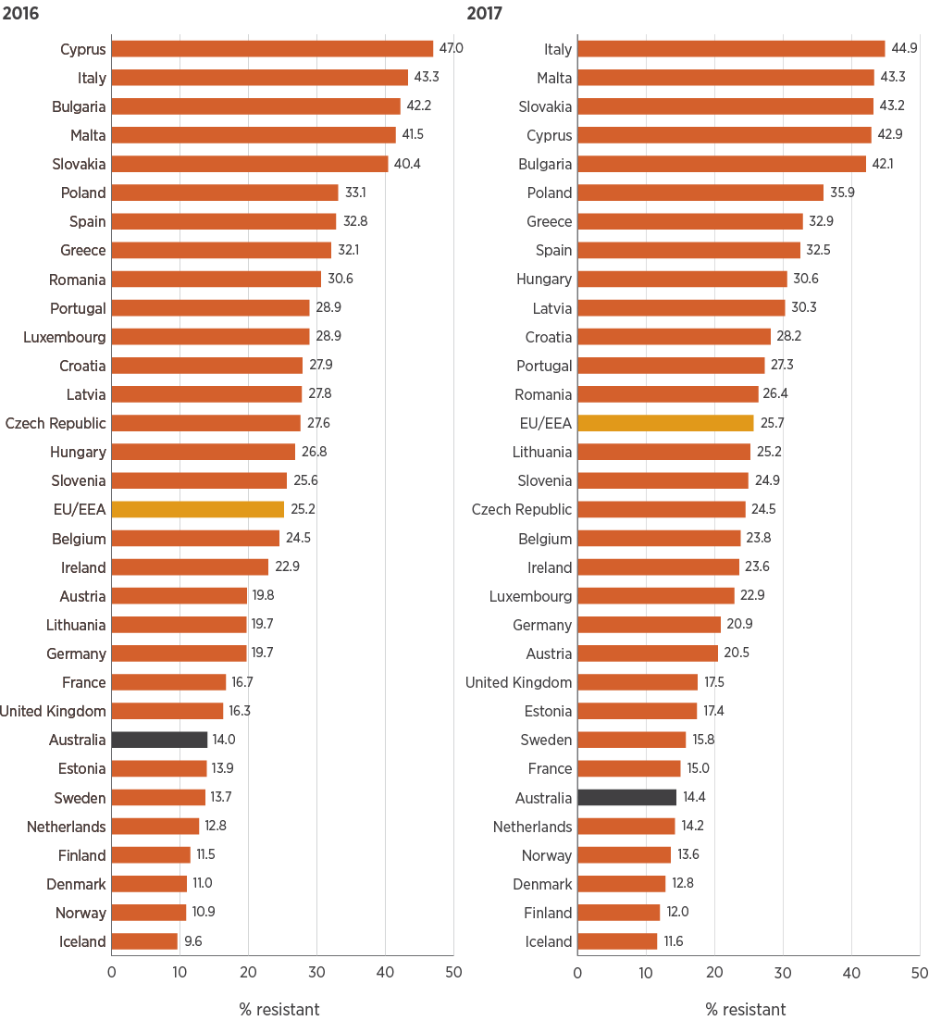
EU/EEA = European Union (EU) and European Economic Area (EEA) countries’ population-weighted mean percentages
* Represented by resistance to ciprofloxacin
Sources: AGAR (Australia); EARS-Net (Europe)
Figure 6.2: Klebsiella pneumoniae rates of resistance to fluoroquinolones* in Australia and European countries, 2016 and 2017
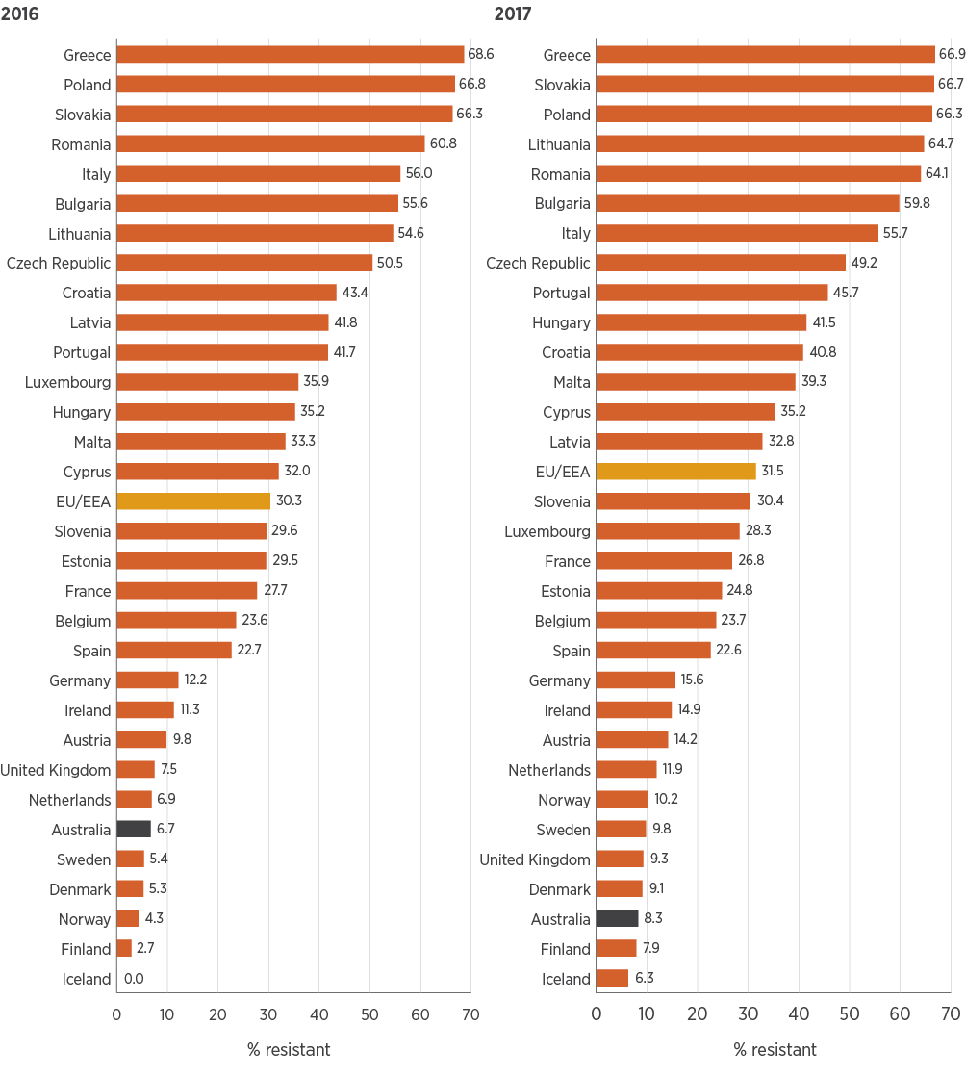
EU/EEA = European Union (EU) and European Economic Area (EEA) countries’ population-weighted mean percentages
* Represented by resistance to ciprofloxacin
Sources: AGAR (Australia); EARS-Net (Europe)
Figure 6.3: Escherichia coli rates of resistance to third-generation cephalosporins in Australia and European countries, 2016 and 2017
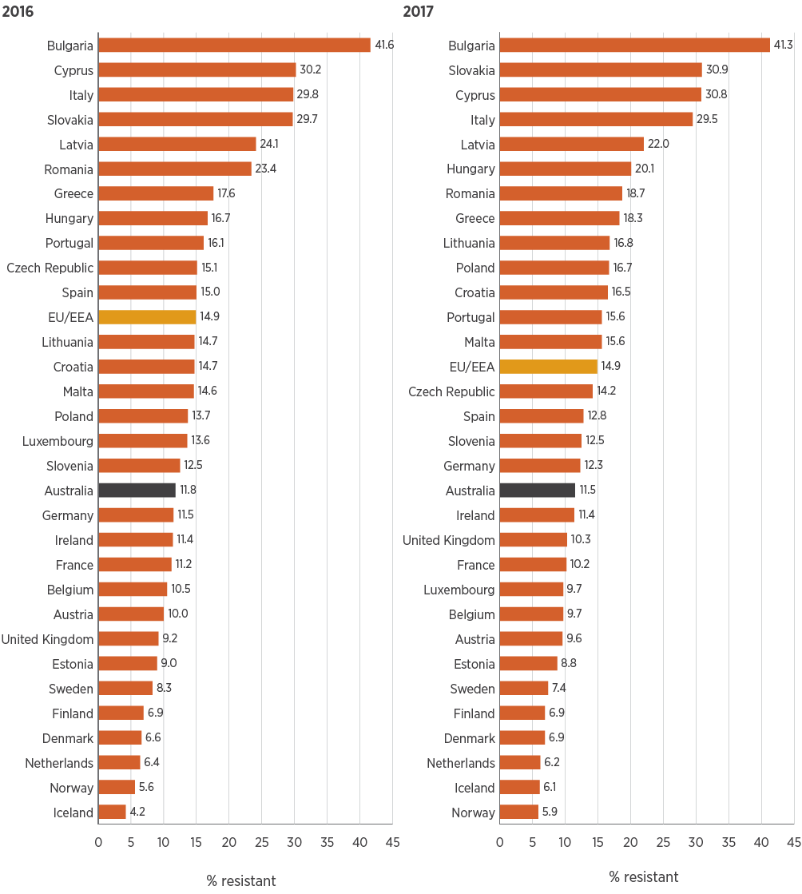
EU/EEA = European Union (EU) and European Economic Area (EEA) countries’ population-weighted mean percentages
Sources: AGAR (Australia); EARS-Net (Europe)
Figure 6.4: Klebsiella pneumoniae rates of resistance to third-generation cephalosporins in Australia and European countries, 2016 and 2017
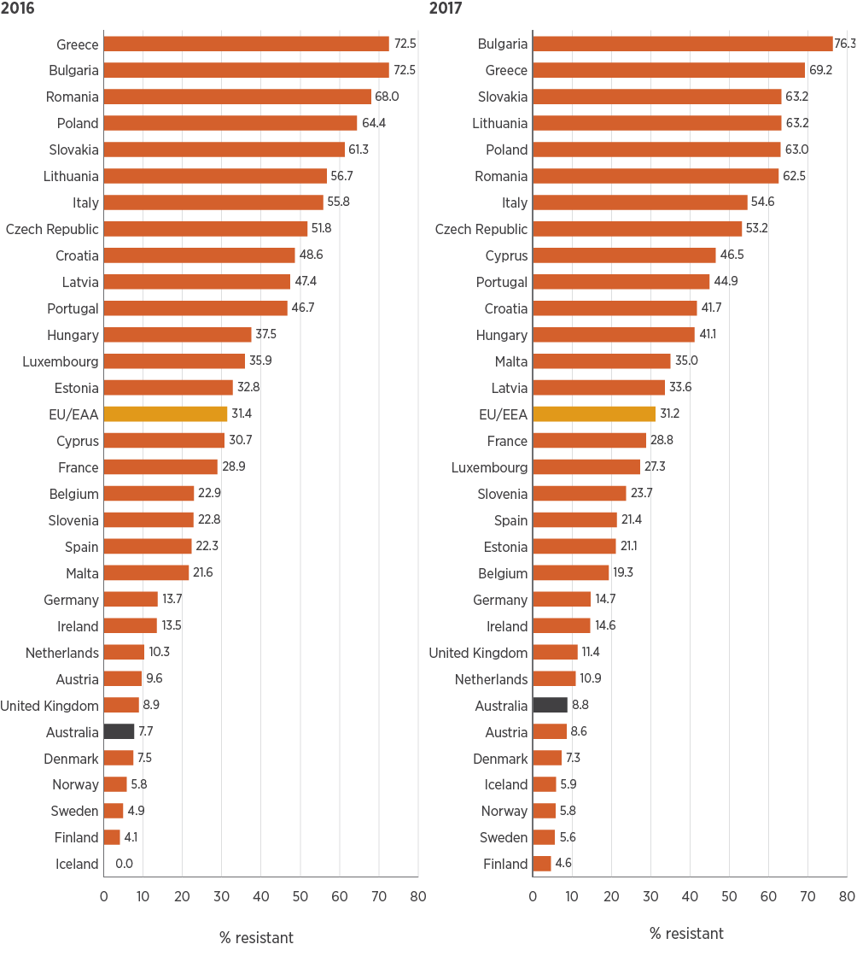
EU/EEA = European Union (EU) and European Economic Area (EEA) countries’ population-weighted mean percentages
Sources: AGAR (Australia); EARS-Net (Europe)

Piperacillin–tazobactam
This report includes rates of resistance to piperacillin–tazobactam in Pseudomonas aeruginosa for the first time (Figure 6.5). As for other gram-negative pathogens, Australian resistance rates are lower than the European average. Because P. aeruginosa is a species with a largely environmental, rather than human, reservoir, differences between countries reflect environmental factors, and infection control standards and practices.
Figure 6.5: Pseudomonas aeruginosa rates of resistance to piperacillin–tazobactam in Australia and European countries, 2016 and 2017
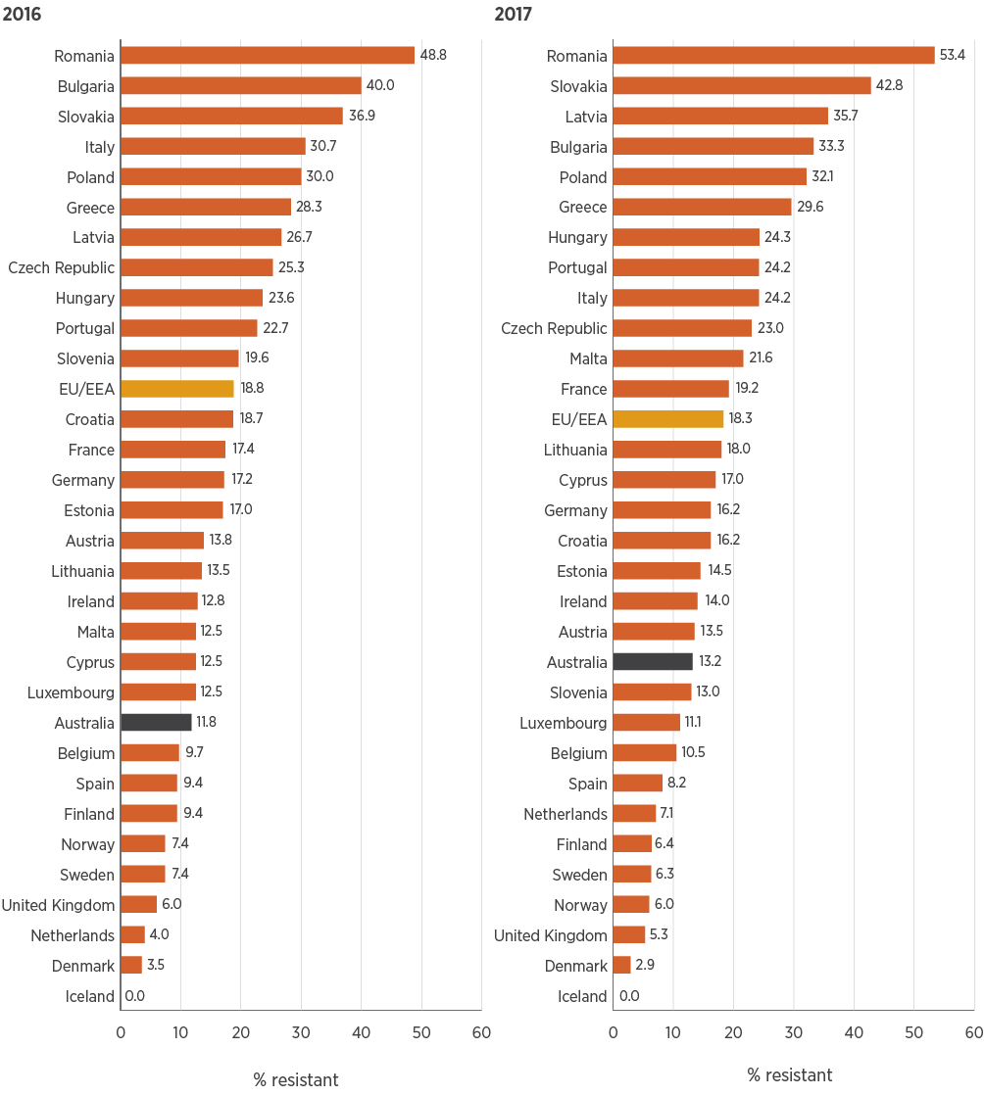
EU/EEA = European Union (EU) and European Economic Area (EEA) countries’ population-weighted mean percentages
Sources: AGAR (Australia); EARS-Net (Europe)

Methicillin and vancomycin
In contrast to the resistance rates for E. coli and K. pneumoniae, rates for S. aureus and Enterococcus faecium are not as favourable. Australia ranks just in the top half of countries for MRSA rates (Figure 6.6), and had higher rates of resistance to vancomycin in E. faecium than in 30 European countries in 2016 and 2017 (Figure 6.7), even though rates in Australia have levelled off in recent years, as described in Chapter 4.
Australia ranks just in the top half of countries for MRSA rates, and had higher rates of resistance to vancomycin in Enterococcus faecium than any European country in 2016 and 2017, even though rates in Australia have levelled off in recent years.
For MRSA, overall resistance rates have changed very little in Australia in 2016 and 2017. However, there has been a:
Rapid decline in the prevalence of the multidrug-resistant healthcare-associated clone ST239
Rise in the United Kingdom–originating EMRSA-15 healthcare-associated clone
Steady rise in the prevalence of community-associated clones.¹⁸
European surveillance data do not include clonal analyses of MRSA, so the proportions of community-associated MRSA (CA-MRSA) and healthcare-associated MRSA (HA-MRSA) in a particular country are not known. In Europe, the proportion of community-onset infections caused by MRSA clones that are usually associated with HA-MRSA has increased, indicating transfer of HA-MRSA clones into the community.²² In Australia, CA-MRSA has a similar prevalence to HA-MRSA.
Figure 6.6: Staphylococcus aureus rates of resistance to methicillin in Australia and European countries, 2016 and 2017
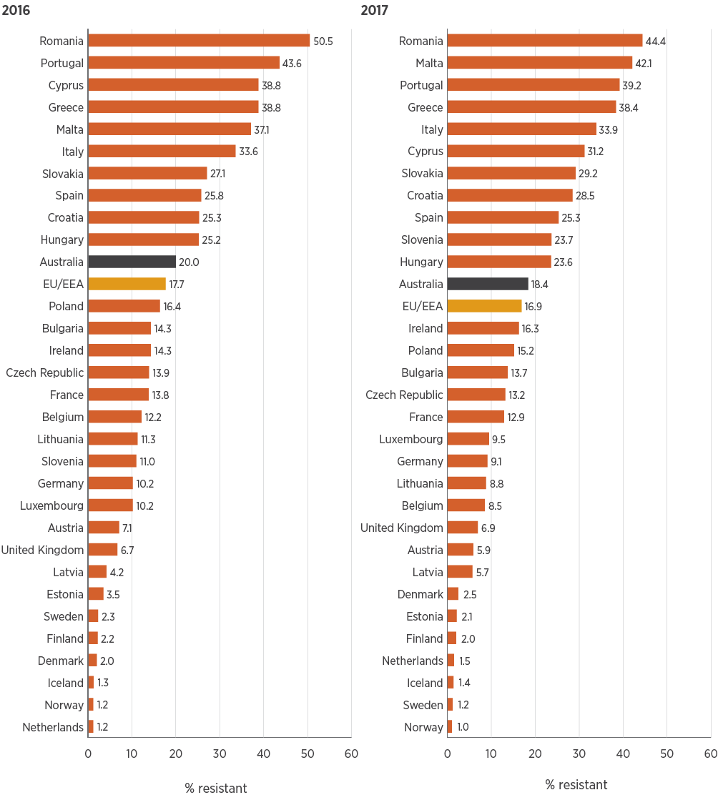
EU/EEA = European Union (EU) and European Economic Area (EEA) countries’ population-weighted mean percentages
Sources: AGAR (Australia); EARS-Net (Europe)
Figure 6.7: Enterococcus faecium rates of resistance to vancomycin in Australia and European countries, 2016 and 2017
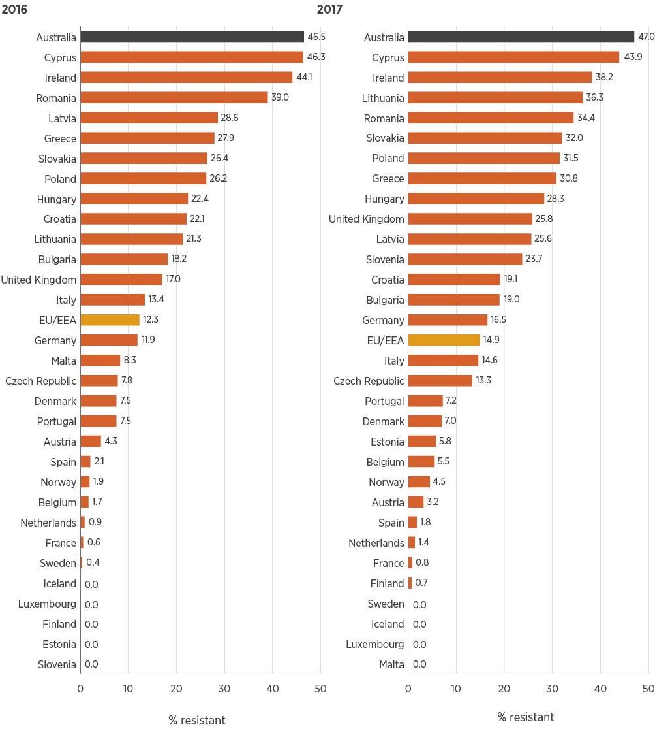
EU/EEA = European Union (EU) and European Economic Area (EEA) countries’ population-weighted mean percentages
Sources: AGAR (Australia); EARS-Net (Europe)

References
1. Antibiotic Expert Groups. Therapeutic guidelines: antibiotic. Melbourne: Therapeutic Guidelines Limited; 2014.
2. Andrade RJ, Tulkens PM. Hepatic safety of antibiotics used in primary care. J Antimicrob Chemother 2011;66(7):1431–46.
3. Sader HS, Jacobs MR, Fritsche TR. Review of the spectrum and potency of orally administered cephalosporins and amoxicillin/clavulanate. Diagn Microbiol Infect Dis 2007;57(3 Suppl):5S–12S.
4. Broom J, Broom A. Guideline relevance, diagnostic uncertainty, fear and hierarchy: intersecting barriers to antibiotic optimization in respiratory infections. Respirology 2018;23(8):733–4.
5. Fanning M, McKean M, Seymour K, Pillans P, Scott I. Adherence to guideline-based antibiotic treatment for acute exacerbations of chronic obstructive pulmonary disease in an Australian tertiary hospital. Intern Med J 2014;44(9):903–10.
6. Brownridge DJ, Zaidi ST. Retrospective audit of antimicrobial prescribing practices for acute exacerbations of chronic obstructive pulmonary diseases in a large regional hospital. J Clin Pharm Ther 2017;42(3):301–5.
7. Broom JK, Broom AF, Kirby ER, Gibson AF, Post JJ. Clinical and social barriers to antimicrobial stewardship in pulmonary medicine: a qualitative study. Am J Infect Control 2017;45(8):911–6.
8. Herath SC, Normansell R, Maisey S, Poole P. Prophylactic antibiotic therapy for chronic obstructive pulmonary disease (COPD). Cochrane Database Syst Rev 2018;(10):CD009764.
9. Lung Foundation Australia. The COPD-X Plan: Australian and New Zealand guidelines for the management of chronic obstructive pulmonary disease [PDF, 2.9MB]. Milton (Qld): Lung Foundation Australia; 2018 (accessed Feb 2019).
10. National Centre for Antimicrobial Stewardship, Australian Commission on Safety and Quality in Health Care. Antimicrobial prescribing practice in Australian hospitals: results of the 2017 Hospital National Antimicrobial Prescribing Survey [PDF, 2.7MB]. Sydney: ACSQHC; 2018 (accessed Feb 2019).
11. Wathne JS, Kleppe LK, Harthug S, Blix HS, Nilsen RM, Charani E, et al. The effect of antibiotic stewardship interventions with stakeholder involvement in hospital settings: a multicentre, cluster randomized controlled intervention study. Antimicrob Resist Infect Control 2018;7:109.
12. Suetens C, Latour K, Kärki T, Ricchizzi E, Kinross P, Moro ML, et al. Prevalence of healthcare-associated infections, estimated incidence and composite antimicrobial resistance index in acute care hospitals and long term care facilities: results from two European point prevalence surveys, 2016 to 2017. Euro Surveill 2018;23(46):pii=1800516.
13. Smith M, Atkins S, Worth L, Richards M, Bennett N. Infections and antimicrobial use in Australian residential aged care facilities: a comparison between local and international prevalence and practices. Aust Health Rev 2013;37(4):529–34.
14. Coombs G, Bell JM, Daley D, Collignon P, Cooley L, Gottlieb T, et al. Australian Group on Antimicrobial Resistance Sepsis Outcomes Programs: 2016 report [PDF, 2.6MB]. Sydney: Australian Commission on Safety and Quality in Health Care; 2018 (accessed Feb 2019).
15. Australian Commission on Safety and Quality in Health Care. Australian Passive Antimicrobial Resistance Surveillance: first report – multi-resistant organisms. Sydney: ACSQHC; 2018 (accessed Feb 2019).
16. Centers for Disease Control and Prevention. The core elements of antibiotic stewardship for nursing homes. Atlanta (GA): CDC; 2015 (accessed Feb 2019).
17. National Centre for Antimicrobial Stewardship, Australian Commission on Safety and Quality in Health Care. Aged Care National Antimicrobial Prescribing Survey 2016. Sydney: ACSQHC; 2017 (accessed Feb 2019).
18. Turnidge J, Coombs G, Daley D, Nimmo G, Australian Group on Antimicrobial Resistance (AGAR) participants. MRSA: a tale of three types – 15 years of survey data from AGAR. Sydney: Australian Commission on Safety and Quality in Health Care; 2016.
19. Aged Care Quality and Safety Commission. Aged Care Quality Standards. Sydney: ACQSC; 2019 (accessed Feb 2019).
20. European Centre for Disease Prevention and Control. Antimicrobial resistance surveillance in Europe 2016: annual report of the European Antimicrobial Resistance Surveillance Network (EARS-Net). Stockholm: ECDC; 2017.
21. European Centre for Disease Prevention and Control. Surveillance of antimicrobial resistance in Europe: annual report of the European Antimicrobial Resistance Surveillance Network (EARS-Net) 2017. Stockholm: ECDC; 2018.
22. Grundmann H, Schouls LM, Aanensen DM, Pluister GN, Tami A, Chlebowicz M, et al. The dynamic changes of dominant clones of Staphylococcus aureus causing bloodstream infections in the European region: results of a second structured survey. Euro Surveill 2014;19(49):pii=20987.

Chapter 7: Conclusions and future developments
Key messages
- Antimicrobial resistance (AMR) continues to be a substantial risk to patient safety because it reduces the range of antimicrobials available to treat infections. It also increases morbidity and mortality associated with infections caused by multidrug-resistant organisms and limits a range of other life-saving treatments such as chemotherapy and specialist surgery such as organ transplantation, because of a lack of effective antimicrobials.
- The enhanced data from the Antimicrobial Use and Resistance in Australia (AURA) Surveillance System has enabled focused reports to complement the AURA 2016, AURA 2017 and AURA 2019 reports, each providing greater detail to formulate more targeted and effective strategies to improve antimicrobial prescribing and appropriateness of use, and to prevent and contain AMR.
- Overall, AMR in Australia shows little sign of abating. Resistance rates in some gram-positive pathogens are steadily worsening, and increasing resistance in common gram-negative pathogens such as Escherichia coli is of serious concern.
- Methicillin-resistant Staphylococcus aureus (MRSA) is now predominantly a community pathogen, with community-associated clones being seen in primary care and the ST22 clone being found in aged care homes. Both are also seen in the hospital setting, but as yet there is no evidence that they have become established in this setting.
- The prevalence of vancomycin resistance in Enterococcus faecium remains high, with the emergence and expansion of vanA-harbouring strains that are resistant to teicoplanin. Very few antimicrobials remain for the treatment of infections with vanA strains, and the efficacy of these agents is uncertain.
- After many years of increasing volume of antimicrobial use (AU) in the community, 2017 showed a reduction. However, after a similarly long period of decline in hospital AU, there was an increase in 2017. The direct cause of this shift in volume is not clear; it was possibly impacted by antimicrobial shortages. The AURA National Coordination Unit (NCU) will work with relevant stakeholders to monitor further changes and develop response strategies.
- Key areas of focus for the AURA NCU in 2020 will be to support the relevant lead organisations in aged care and the primary care sector, and clinicians and carers, to understand the reasons for inappropriate prescribing and improve prescribing practice.
- AURA 2019 data provide increased capacity to identify patterns and trends in resistance in the priority organisms for Australia in acute care, aged care homes and the community. This information enables better defined responses to specific resistance in specific settings. The AURA NCU will undertake further consultation with clinical and technical experts to provide this information in the most accessible form.
- The AURA Surveillance System will provide increasing capacity to inform the National AMR Strategy, and state, territory and private sector strategies.
This chapter provides an overview of the key issues identified from analyses of data for AURA 2019, and the proposed next phases of work in the development of the Antimicrobial Use and Resistance in Australia (AURA) Surveillance System.

7.1 Conclusions from AURA findings
Antimicrobial resistance (AMR) in Australia shows little sign of abating, overall. Resistance rates in some major gram-positive pathogens are worsening steadily, and remaining stably high in others. There are some notable reductions, such as waning of the hospital-associated clone of methicillin-resistant Staphylococcus aureus (MRSA; clone ST239), which had been established in eastern Australia since the late 1970s. For other less common pathogens, such as Mycobacterium tuberculosis, resistance remains low.
Increasing resistance in common gram-negative pathogens such as Escherichia coli is of serious concern. E. coli is the most common cause of urinary tract infection and septicaemia, and as data from the Australian Group on Antimicrobial Resistance (AGAR) show, is mostly community associated. Resistance to fluoroquinolones is a marker of multi-drug resistance in this species and, despite major restriction on fluoroquinolone use in the community through authority listing on the Pharmaceutical Benefits Scheme, resistance is slowly worsening. Although the full reasons for this are not known, it is certain that high community use of other oral antimicrobials, to which fluoroquinolone-resistant strains are also resistant, is contributing to this.
The evolution of MRSA clones has been somewhat surprising. The major reduction in clone ST239 had been countered through a combination of a steady rise in community clones, and of clone ST22, a clone originally described in the United Kingdom. MRSA is now predominantly a community pathogen, with community-associated clones seen in primary care and clone ST22 found in aged care homes. Both are also seen in the hospital setting, but as yet there is no evidence that they have become established in the hospital sector.
The prevalence of vancomycin resistance in Enterococcus faecium has remained high for some years, exceeding levels detected in any European country. Although there are some early indications of a reduction in overall rates, a more troublesome picture is the emergence and expansion of vanA-harbouring strains. These strains are resistant to teicoplanin, an agent used widely to manage infections with vanB-harbouring strains that have been dominant in Australia until recently. Very few antimicrobials remain for the treatment of infections with vanA strains, and the efficacy of these agents is uncertain.
Patterns of antimicrobial use (AU) in Australian hospitals remain fairly stable. Downward trends in volume of use in hospitals, as shown through the data from the National Antimicrobial Utilisation Surveillance Program (NAUSP), have been very encouraging, but 2017 data showed increased use. This change may be due, in part, to the worldwide shortage of piperacillin–tazobactam during 2017, causing a switch to multi-drug regimens with higher defined daily doses (DDDs), and the increased use of antimicrobials such as ceftriaxone with higher resistance selection potential.
However, the piperacillin–tazobactam shortage also indicated a positive impact in the experience of the John Hunter Hospital in New South Wales, which showed a link between the shortage of piperacillin–tazobactam and a fall in rates of vancomycin-resistant enterococci. Antimicrobial shortages can result in unpredictable outcomes, and the piperacillin–tazobactam shortage has highlighted that relying on DDDs as a measure of antimicrobial exposure in hospitals may not always provide a complete picture. This is because the surveillance of total aggregate antibiotic use does not account for the ratio of broad-spectrum to narrow-spectrum use or equate to appropriateness of use.
It is of concern that overall prescribing in Australian hospitals has not improved over the five years since the National Antimicrobial Prescribing Survey (NAPS) started. Documentation, appropriateness and compliance with guidelines have remained fairly stable over the five years to 2017, and these issues remain challenges for antimicrobial stewardship programs. On a positive note, improvement has been shown in the rates of excessively long prescribing for surgical prophylaxis. The AURA National Coordination Unit (NCU) will continue to work with clinicians, states and territories, and relevant societies and colleges to improve the quality of hospital prescribing through enhanced AMS activities.
It is very encouraging to see the turnaround in the volume of prescriptions in primary care since 2015. Many organisations have made considerable efforts to reduce unnecessary prescribing in the community, particularly NPS MedicineWise. Recent strategies by the Australian Government Department of Health are also positive steps, such as the Chief Medical Officer’s direct approach to general practitioners to promote improved prescribing by providing peer data. Results from NPS MedicineWise MedicineInsight data further emphasise the decline in volume of prescriptions. While efforts to support continued decline in prescribing volume should continue, there should also be a renewed focus on strategies to improve appropriateness of prescribing, especially for upper respiratory tract infections. The AURA NCU intends to work with clinicians, state and territory governments and the Australian Government to target strategies to improve appropriateness of prescribing for respiratory tract infections, particularly as antimicrobial stewardship is enhanced in primary care.
Area for action
Improve appropriateness of prescribing in primary care
Although there has been an encouraging decrease in the volume of antimicrobial prescribing in primary care as a result of effort from many organisations, a renewed focus is required on strategies to improve the appropriateness of prescribing.
The Australian Commission on Safety and Quality in Health Care will continue to work with clinicians, state and territory governments and the Australian Government to develop targeted strategies to improve appropriateness of prescribing, particularly for upper respiratory tract infections.
Aged care homes are very important settings for care. However, they have been identified as important areas of focus for AMR due to the high levels of unnecessary antimicrobial prescribing, as reported by the Aged Care NAPS (AC NAPS), and as potential reservoirs for some multidrug-resistant pathogens.
Prescribing in the primary care sector in Australia is still very much higher than most European countries, and more than double that of benchmark countries such as the Netherlands. These comparisons should act as an incentive to intensify efforts to improve practice and to consider setting targets as part of future AMR strategies.

7.2 Future developments for the AURA Surveillance System and future AURA reports
The strategy employed by the AURA NCU has been to partner with a broad range of clinicians, health service organisations, laboratories, health departments and the private sector to increase the provision of surveillance data on AU and AMR in a way that continuously improves data representativeness. There have been considerable enhancements to AURA as a result, with all states and the Australian Capital Territory contributing resistance data through the Australian Passive AMR Surveillance (APAS) system, and all states and territories having some hospitals providing resistance data through AGAR. There have been substantial gains regarding AU and appropriateness of prescribing, with a doubling of participants in NAUSP, NAPS and AC NAPS. This has increased the value of analyses and reporting, and the AURA NCU will continue to identify target areas for improving population and geographic coverage for all aspects of surveillance. Specific areas of focus will be improved geographic coverage for APAS in the Northern Territory and Victoria, and in the private sector with regard to AU and appropriateness of prescribing. The AURA NCU will also focus on engaging smaller health services, particularly in rural and remote areas, along with aged care homes outside Victoria.
Public and private laboratories play a key role in contributing to surveillance of antimicrobial resistance. The AURA NCU will work with laboratories to harmonise susceptibility testing methods to reduce the impact that different testing methods have on reporting of resistance.
Area for action
Expand surveillance coverage to increase data representativeness
The strategic approach for the development of the AURA Surveillance System has resulted in the substantial enhancement of surveillance of antimicrobial resistance and antimicrobial use. However, some areas of surveillance require specific expansion, including:
- Smaller health services, particularly in rural and remote areas
- Aged care homes in states and territories other than Victoria
- Passive antimicrobial resistance surveillance in the Northern Territory and Victoria
- Passive antimicrobial resistance surveillance in the private sector.
The AURA National Coordination Unit will focus on engaging these areas to improve the representativeness of AURA data, within available resources.
Molecular trends in resistance are important to target treatment, infection control and outbreak response. The AURA NCU will work with laboratories to identify local capacity and opportunities to capture molecular data.
As the range of data continues to expand, future reporting will be considered in light of further consultation with end users to maximise the utility of AURA data. This work will also include more tailored communication of findings to each of the professional groups involved in the various dimensions of prevention and control of AMR. For example, this may include specific work with medical specialties such as respiratory physicians, surgeons, infectious diseases physicians and microbiologists, as well as general practitioners, pharmacists and infection control practitioners.
Area for action
Collaborate with laboratories to strengthen capacity and capability
Ongoing efforts will be made to promote harmonisation of susceptibility testing methods to reduce the impact of variance in reporting of antimicrobial resistance. As improved understanding of the molecular trends in organisms’ resistance is important for targeting of infection control efforts, the AURA National Coordination Unit will work with laboratories and the Australian Government sector to identify local capacity and opportunities to capture molecular data.
AURA 2019 further promotes the value of data from the National Alert System for Critical Antimicrobial Resistances (CARAlert) for infection prevention and control programs implemented by health service organisations to meet the requirements of the Preventing and Controlling Healthcare-Associated Infection Standard of the National Safety and Quality Health Service Standards. A review of CARAlert was conducted in 2018, resulting in additional critical antimicrobial resistances to be added to the system during 2019. Regular reports will continue to be refined to meet user requirements.
In regard to carbapenemase-producing Enterobacterales (CPE), the AURA NCU will continue to work with the states and territories on strategies to promote consistency of screening and infection control practices to improve CPE containment.
As an extension to the AURA Surveillance System, the Australian Commission on Safety and Quality in Health Care (the Commission) was engaged by the Australian Government Department of Health to develop a national framework for an outbreak response network for multidrug-resistant organisms. This work will be completed during 2019, and will complement existing state and territory roles in regards to effective resistance outbreak responses. The framework will provide a mechanism to enhance communication and collaboration between the jurisdictions if a national or inter-jurisdictional resistance outbreak response is required.
The Commission will complete this work to promote alignment of state and territory protocols; avoid duplication of processes in relation to surveillance, screening, testing and outbreak response; and be adaptable to local requirements. It is proposed that implementation of the framework will be led by states and territories, and the Australian Government Department of Health. CARAlert and other AURA Surveillance System data will complement local surveillance data in the event of outbreaks of antimicrobial-resistant organisms.
The AURA Surveillance System is focused on human health, but has been established and is operated in the One Health context. As AMR policy and programs develop further in the animal and agricultural sectors, there may be structural changes to the way that the AURA Surveillance System operates in the future. However, sustainability and continuity of data collection and reporting will be ensured if transition is required. Future AURA reports will strive to provide the highest level of utility to stakeholders and the community. To achieve this, greater emphasis will be placed on the accessibility of data and reports through web-based systems, as resources allow.

Appendix 1: Data source description
This appendix describes the data sources used for the AURA 2019 report.

A1.1 Data sources for antimicrobial use
This section provides information on the methods used by each of the sources for data on antimicrobial use (AU) in this report, including information on processes and limitations.

National Antimicrobial Prescribing Survey
The Hospital National Antimicrobial Prescribing Survey (NAPS) is a voluntary online audit performed annually by hospitals to assess antimicrobial prescribing practices and appropriateness of prescribing within the hospital. NAPS is conducted by the National Centre for Antimicrobial Stewardship (NCAS). Data from NAPS are reported annually by NCAS and the Antimicrobial Use and Resistance in Australia (AURA) National Coordination Unit. Participating hospitals can interrogate their own data and undertake benchmarking using the audit tool. The preferred methodology for the audit is a hospital-wide point prevalence survey. AURA 2019 includes highlights of analyses of 2016 and 2017 Hospital NAPS data.^{1,2}
The Surgical NAPS is an audit tool that allows facilities to review their use of procedural and post-procedural surgical antimicrobial prophylaxis. Procedural antimicrobial prophylaxis is defined as any antimicrobial administered either immediately before or during a procedure for the purpose of prophylaxis. Post-procedural antimicrobial prophylaxis is defined as any antimicrobial given immediately after a surgical procedure for the purpose of prophylaxis. In contrast to the Hospital NAPS, the Surgical NAPS captures data on duration of antimicrobial prophylaxis using a time frame of 48 hours rather than 24 hours. The preferred methodology is a retrospective audit. AURA 2019 includes analyses of 2017 Surgical NAPS data.
The Aged Care NAPS (AC NAPS) is a standardised surveillance tool that can be used to monitor AU and the prevalence of infections in Australian aged care homes. The preferred methodology for the audit is a facility-wide point prevalence survey. AURA 2019 includes highlights of analyses of 2016 and 2017 AC NAPS data.³

Participants
The number of facilities participating in the Hospital NAPS, Surgical NAPS and AC NAPS has increased each year that the surveys have been conducted, with the exception of the Hospital NAPS in 2017.
Participants in the Hospital NAPS include public and private hospitals from all states and territories, all hospital peer groups and all remoteness areas. In 2016, 325 hospitals (234 public and 91 private) contributed data. In 2017, 314 hospitals (228 public and 86 private) contributed data. Despite the 3.4% decrease in the number of facilities participating in the Hospital NAPS in 2017 compared with 2016, the number of prescriptions and patients for which data were submitted increased slightly in 2017.
In 2017, 106 hospitals contributed data to the Surgical NAPS, an increase of 39 from the 2016 pilot Surgical NAPS; the increase in participation was greater for private hospitals than for public hospitals. Public and private hospitals from all states and the Northern Territory took part in the survey in 2017. A range of hospital peer groups participated, and all remoteness areas were represented.
In 2017, 292 aged care homes submitted AC NAPS data; 287 participated in 2016. In both years, all states, remoteness areas and organisation types were represented; there were no participants from either the Australian Capital Territory or the Northern Territory. Most participating aged care homes were located in Victoria, more than 40% were classified as inner regional, and approximately 68% were state government operated.

Considerations
Issues that need to be considered when interpreting NAPS data include the following.
Participation in the Hospital NAPS, Surgical NAPS and AC NAPS is voluntary. The facilities that choose to participate are not a randomised sample, so the results may not be representative of all Australian hospitals and aged care homes.
The methodology for the NAPS audits has varied each year, so results are not directly comparable from year to year.

Hospital NAPS
For the 2016 Hospital NAPS report, analyses were included for 320 hospitals (229 public and 91 private) that contributed data during the data collection period 1 March 2016 to 2 February 2017.¹ In 2017, the Hospital NAPS data collection period was the calendar year 1 January 2017 to 31 December 2017. NCAS reanalysed data for 2016 and 2017 for the 2017 Hospital NAPS report, based on the calendar year in which the data were collected; the analyses included 325 hospitals that contributed data between 1 January 2016 and 31 December 2016 (234 public and 91 private).²
Depending on the audit method selected by sites participating in the Hospital NAPS, patients may be counted more than once. For smaller facilities that choose the option of a repeat point prevalence survey, certain patients may be counted multiple times if they are still an inpatient on a subsequent audit day. This may cause artificial inflation of the prevalence of some indications that require longer durations of treatment, or use of the antimicrobials that are used to treat these conditions.
Individual auditors at each facility are responsible for assessing antimicrobial prescribing appropriateness and compliance with guidelines. Remote expert assessments are conducted by the NAPS support team on request. Because assessments involve some degree of interpretation, standardised appropriateness definitions used by auditors help to moderate subjectivity.
Depending on local antimicrobial stewardship issues, casemix and resources, hospitals may choose to use other audit tools, such as the Surgical NAPS, the Quality Improvement NAPS or a locally designed tool. This may have affected the number of hospitals that chose to participate in the 2017 Hospital NAPS.

Surgical NAPS
For the Surgical NAPS, the impact of some of the survey limitations was reduced by data exclusion and cleaning. Specific considerations are as follows:
The flexible methodology means that the results of the 2017 Surgical NAPS are not directly comparable with any previous Surgical NAPS; comparisons should be limited to within specific surgical procedure groups for 2017 only
Each hospital could decide how they performed the survey and which patients or surgical specialties were audited; if directed surveys were performed, patient sampling may not have been random, and auditors may have targeted problem or higher-volume surgical units
During the data analysis, potential inconsistencies were identified in how some facilities completed their survey, suggesting that they may have misinterpreted some of the data-field definitions.
A validation study performed on data from the 2016 pilot Surgical NAPS showed a 6.7% rate of disagreement between assessments conducted by hospital auditors and assessments conducted by the NAPS support team.

Aged Care NAPS
For the AC NAPS, specific considerations include the following.
Most of the participating aged care homes that contributed to AC NAPS in 2016 and 2017 were located in Victoria, and were classified as inner regional and state government operated.
The 2016 data that were reanalysed with 2017 data may differ from previous reports, because of changes in data validation processes.
Signs and symptoms of infection in older residents may be atypical, so failure to meet the McGeer et al. definitions^{4,5} may not fully exclude the presence of a true infection. In addition, the McGeer et al. definitions require microbiological confirmation for some infections (for example, urinary tract infection). The McGeer et al. definitions for surveillance of infection in long-term care are largely based on signs and symptoms relating to a specific body system (gastrointestinal tract, respiratory tract, urinary tract, skin/soft tissue/mucosal and systemic). For some definitions, radiological evidence and use of devices (for example, urinary catheters) are also assessed.
The survey was conducted during winter. The results may have been different in another season. For example, certain respiratory infections are usually more frequent in winter than in other seasons.
The analysis relied on the validity of local assessments, and no additional external validation was undertaken.
Further information on NAPS can be found on the NAPS website.⁶

National Antimicrobial Utilisation Surveillance Program
The National Antimicrobial Utilisation Surveillance Program (NAUSP), which began in 2004, focuses on standardised measurement of AU in Australian adult acute public and private hospitals. NAUSP is administered by the Infection Control Service of the Communicable Disease Control Branch at SA Health. Development and implementation of NAUSP have been an ongoing collaboration between SA Health and the Australian Commission on Safety and Quality in Health Care (the Commission) since 2013.
Hospitals contribute to NAUSP on a voluntary basis. Pharmacy departments of participating hospitals use dispensing reports to supply NAUSP with aggregate monthly details of antimicrobials issued to individual inpatients and ward imprest supplies (that is, ward stock managed by the pharmacy). Hospital occupancy data are collected in the form of overnight occupied bed days (OBDs).
NAUSP assigns each contributing hospital a unique code. The code is used to report in a de-identified way on usage rates of selected antimicrobials and therapeutic groups.
NAUSP uses standardised usage density rates, based on the World Health Organization (WHO) Anatomical Therapeutic Chemical (ATC) standards for defined daily doses (DDDs). The denominator is overnight OBDs. Reporting on AU based on DDDs enables total hospital use to be assessed and compared as a rate, and also allows international comparisons.
The NAUSP annual and two-yearly reports cover total in-hospital AU data collected from participating hospitals across Australia. NAUSP also publishes a range of six-monthly reports, and participating hospitals can use the NAUSP portal to produce reports that provide benchmarking data to inform local quality improvement activities.

Participants
The number of hospitals that contribute to NAUSP has more than doubled since the endorsement of the National Safety and Quality Health Service Standards in 2011. Participation in NAUSP supports successful implementation of the Preventing and Controlling Healthcare-Associated Infection Standard.
In 2016, 169 public and private adult acute care hospitals contributed data to NAUSP. Participants included all Principal Referral Hospitals, and 88% of Public Acute Group A and Public Acute Group B Hospitals. Between 1 January and 31 December 2017, 191 acute hospitals (155 public and 36 private) contributed data that were included in NAUSP analyses. All states and territories, all Principal Referral Hospitals, and more than two-thirds of Public Acute Group A and Public Acute Group B Hospitals were represented in the program in both years. The number of private hospitals participating in NAUSP is slowly increasing.
All Australian states and territories were represented in NAUSP in 2016; 35 hospitals have contributed continuously since July 2004, and 13 South Australian hospitals have contributed continuously since the program began locally in 2001.

Considerations
The data collected by NAUSP exclude:
Most topical antimicrobial formulations (except some inhalations), antimycobacterials (except rifampicin), antivirals, antiparasitics, and infusor packs of antibacterials for use outside hospital settings
AU in paediatric hospitals, and paediatric wards and neonatal units within general hospitals; use in the paediatric population cannot easily be translated into a standard usage density rate based on the WHO definition of DDDs
AU for outpatient areas, discharge prescriptions and external services (for example, Hospital in the Home), to ensure that data reflect in-hospital AU
Antimicrobials issued by pharmacies to individuals, and wards classified as psychiatric, rehabilitation, dialysis and day-surgery units.
Data provided to NAUSP do not include the indication for which antimicrobials are used, or any patient-specific data. Although some contributing hospitals provide data on ward-by-ward antimicrobial consumption, data for specialist areas (except for intensive care units) have not generally been available.
A comprehensive list of antimicrobials for which data are collected by NAUSP, the ATC classification and the DDD for each route of administration are available from the NAUSP website.⁷
The NAUSP cohort is heavily weighted towards large public hospitals, where antimicrobial stewardship activities are generally well established. In 2015, NAUSP removed restrictions on participation that were based on minimum bed numbers. Participating hospitals are required to meet the criteria for categorisation into one of eight Australian Institute of Health and Welfare (AIHW) peer groups: Principal Referral Hospital; Specialist Women’s Hospital; Public Acute Group A, B and C Hospitals; and Private Acute Group A, B and C Hospitals. Newly established hospitals that may not have received an AIHW peer group code are unclassified in some reports.
Discrepancies between annual reports may occur because of data submitted retrospectively by contributing hospitals. Until 2016, NAUSP reports were confined to use of antibiotics in Australian hospitals.
Additional issues that need to be considered when interpreting NAUSP data include the following:
Participation is voluntary, and smaller facilities in both the public and private sectors, and private facilities generally, are under-represented
The DDD, as defined by WHO, occasionally does not match usual daily doses used in Australian hospital clinical practice
Data for 29 Queensland hospitals are not included because of inconsistent application of surveillance definitions from 2013 to 2017.
Further information on NAUSP can be found on the NAUSP website.⁷

Pharmaceutical Benefits Scheme and Repatriation Pharmaceutical Benefits Scheme
The Australian Government Department of Human Services collects data, in the Medicare pharmacy claims database, on antimicrobial dispensing in the community through the Pharmaceutical Benefits Scheme (PBS) and the Repatriation Pharmaceutical Benefits Scheme (RPBS).
The Australian Government Department of Health analyses PBS/RPBS data to inform economic analyses and policy development. Comprehensive medicine usage data are required for a number of purposes, including pharmacosurveillance and targeting, and evaluation of initiatives for quality use of medicines. The data are also needed by regulatory and financing authorities, and the pharmaceutical industry.
Data captured by the PBS/RPBS are extensive. In 2017, a little over 26.5 million prescriptions were supplied under the PBS/RPBS for all antibiotics.

Additional data and analysis
As part of the development of AURA 2019, the Commission engaged the University of South Australia to provide a report on use of antibiotics in Australia. Data were analysed for all antibiotic prescriptions supplied under the PBS/RPBS for 2013–2017.
The Department of Human Services provided a five-year extract of antibiotic prescriptions supplied under the PBS/RPBS. The extract included all antibiotics listed on the PBS/RPBS that were dispensed between 1 January 2013 and 31 December 2017. This included all prescriptions priced under the patient co-payment, which are prescriptions that do not attract a reimbursement. The data did not contain details on any prescriptions supplied privately. The data included the following fields:
Patient identifier (system-generated unique identifier)
Patient date of birth (MMYYYY)
Statistical Area Level 3 (SA3) in which the patient resided
SA3 in which the prescriber’s address was located
PBS item code
ATC code
Product form and strength
Quantity of PBS item supplied
Date of supply
Type of prescription – original, repeat, authority
Number of repeats ordered
Number of repeats supplied
Regulation 24 indicator.
The antibiotics included in the analyses presented in this report are shown in Table A1.1.
Table A1.1: Antibiotics included in the analyses of PBS/RPBS data for AURA 2019, 2013–2017
ATC codes | Description
J01 | Antibacterials for systemic use
A02BD | Combinations for eradication of Helicobacter pylori
A07AA09 | Vancomycin (intestinal anti-infectives)
A07AA11 | Rifaximin (intestinal anti-infectives)
D06AX09 | Mupirocin (cream/ointment, RPBS)
D06BA01 | Sulfadiazine silver (cream)
S01AA01, S01AA11, S01AA12 | Ophthalmological antibiotics: gentamicin, chloramphenicol, tobramycin
S01AE01, S01AE03 | Ophthalmological fluoroquinolones: ofloxacin, ciprofloxacin
S02AA01, S02AA15 | Otological anti-infectives: chloramphenicol, ciprofloxacin
S03AA | Framycetin (S01AA07 on WHO, but S03AA on www.pbs.gov.au)
ATC = Anatomical Therapeutic Chemical; WHO = World Health Organization
The following analyses were undertaken:
- Trends in antimicrobials supplied, defined as
- number of prescriptions per 1,000 inhabitants at national, state and SA3 levels, 2013–2017
- number of prescriptions per 1,000 inhabitants by class of systemic antibiotic, 2013–2017
- DDDs per 1,000 inhabitants per day by class of systemic antibiotic (ATC code J01) at national and state levels, 2013–2017
DDDs per 1,000 inhabitants per day by class of systemic antibiotic (ATC code J01), 2015–2017
Number of all antimicrobials dispensed per 1,000 inhabitants by patient age, patient SA3 and state of residence in 2017
- For the top 10 antibiotics supplied in 2017
- most commonly supplied antibiotics in 2017
rate at which original prescriptions are ordered with the maximum number of repeats, as a proportion of all original prescriptions for the top 10 antibiotics, by prescriber SA3, and by state and territory in 2017
Rate per 1,000 inhabitants of all antibiotics supplied in winter (June, July, August) 2017, by prescriber SA3, and by state and territory.
For reporting of age-standardised rates, the reference population was the Australian population in mid-2013.⁸ For analyses including population data, the mid-year (30 June) estimates for each calendar year, as provided by the Australian Bureau of Statistics, were used.

Considerations
Issues that need to be considered when interpreting PBS/RPBS data include the following:
Data include antibiotics dispensed through the PBS and the RPBS; therefore, antibiotics dispensed from some inpatient and outpatient services, and some community health services and Aboriginal and Torres Strait Islander health services may not be captured
Private prescriptions are not included in this dataset
The data do not indicate the diagnosis or condition of the patient.
Antibiotics may be dispensed from private prescriptions outside the PBS. The reasons for antibiotics being dispensed privately may include:
The prescriber wishes to prescribe an antibiotic for a non-subsidised indication
The prescriber does not seek an approval for an antibiotic that requires an authority as the antibiotic is inexpensive (for example, ciprofloxacin)
The prescriber wishes to prescribe a quantity that exceeds the PBS limit.
In addition, dispensing through the PBS/RPBS does not necessarily equate to consumption. Antibiotic consumption can be overestimated because patients may not comply with therapy recommendations.
Further information on the PBS can be found on the PBS website.⁹

NPS MedicineWise MedicineInsight program
NPS MedicineWise operates a national program called MedicineInsight, which collects longitudinal, de-identified clinical data from participating general practices across Australia.
The program aims to support quality improvement by providing local data to general practices. The data can be benchmarked at local, regional and national levels. Participating practices are offered customised quality improvement activities that support alignment with best practice and identify key areas for improvement.
MedicineInsight data include patient demographic and clinical data entered by general practitioners (GPs) and practice staff directly into the system, or collected from external sources (for example, pathology test results), and system-generated data such as antimicrobial start time and date of a patient encounter. The data can be used to analyse use of medicines, switching of medicines, indications for prescribing, adherence to guidelines, and pharmacovigilance to support post-market surveillance of medicine use in primary care.

Participants
Participation in MedicineInsight is voluntary; the general practices included are not a randomised sample. AURA 2019 includes analyses of data from general practices from all states and territories; however, the proportion of participating practices varies by state and territory.
Patients are included from the first recording of their clinical data in the participating practices’ clinical systems.

Considerations
Dispensing data can differ from prescribing data, because not all prescriptions are dispensed; therefore, these data may not correlate completely with PBS data.
Data are sourced from medical records, and rely on an appropriate level of completeness and accuracy of those records. Specialist prescriptions and samples are not included.

Changes since 2017
The program dataset is continually being enhanced to further develop capabilities and capacity in data analytics and report presentation, to support prescribers and national surveillance.
Since AURA 2017 was published, MedicineInsight data have been moved to a new, more sophisticated data warehouse. This data warehouse provides a more complete and robust view of the data, and should provide more complete reason-for-visit information than previous reports. These changes may result in differences in the number of conditions and prescriptions identified in this report compared with AURA 2017.
Repeat prescriptions are now included when calculating the numerator for monthly rates. This more accurately reflects the amount of prescribing than restricting the analysis to original prescriptions only, as was presented in AURA 2016 and AURA 2017.

Data definitions
The following definitions are used for MedicineInsight.
General practice sites: one or more practices that share the same clinical information system (CIS). For example, a site may be one organisation that consists of a number of geographically diverse general practices that share the same CIS, or a site may be a single GP practice.
Patients: patients who visited a GP at least once in the previous two years up to and including the year of analysis (2015, 2016, 2017), and were marked as active by the practices and not recorded as deceased.
Condition: conditions are described using fields in the CIS that capture the patient’s medical history, reason for encounter and reason for prescription. The CIS uses coding systems, such as Docle in Medical Director or Pyefinch in Best Practice, for data entered into the system. Medical, pharmaceutical and other experts in the MedicineInsight team develop algorithms to identify specific conditions and measures of interest in the MedicineInsight database, based on commonly accepted definitions.
Indication: indications for prescribing are described using the ‘reason for prescription’ field in the first instance. If an explicit recorded reason for the prescription is missing, an association is assumed between the antibiotic prescribed and the reason for the encounter and/or a diagnosis recorded on the same day as the prescription.
Further information about the NPS MedicineWise MedicineInsight program and associated data can be found on the MedicineInsight website.¹⁰

A1.2 Data sources for antimicrobial resistance
This section provides information on the methods used by each of the sources for data on antimicrobial resistance (AMR) in this report, including information on processes and limitations.

Australian Group on Antimicrobial Resistance
The Australian Group on Antimicrobial Resistance (AGAR) is a collaboration of clinicians and scientists, with involvement from microbiology laboratories in all Australian states and territories. AGAR has been in operation since 1985, with voluntary participation from key microbiology laboratories.
AGAR operates a series of targeted survey programs each year on the level of AMR in selected bacteria detected from blood cultures.¹¹ This provides information on AMR in serious infections, and aligns with the European Antimicrobial Resistance Surveillance Network (EARS-Net).¹² Microbiology laboratories provide laboratory data, demographic data and isolates to two central AGAR reference laboratories, which undertake molecular testing on selected isolates and prepare reports on the data for the following three programs:
Gram-negative Sepsis Outcome Program (GNSOP) (formerly the Enterobacteriaceae Sepsis Outcome Program)
Australian Staphylococcal Sepsis Outcome Program (ASSOP)
Australian Enterococcal Sepsis Outcome Program (AESOP).
In addition to susceptibility test data, most participating laboratories provide demographic and limited outcome data on each episode of bacteraemia.

Participants
In 2016, 28 laboratories that serviced 32 hospitals participated in GNSOP, ASSOP and AESOP; in 2017, 29 laboratories that serviced 36 hospitals participated in these programs. Each of the three programs includes laboratories from all states and territories. The numbers of laboratories in each state and territory varies, and they provide services for different types of hospitals. The laboratories are mostly public; a small number of private laboratories participate in each program.

Considerations
Issues that need to be considered when interpreting AGAR data include the following:
Data are not denominator controlled because there is no consensus on an appropriate denominator for these types of surveys
The surveys are voluntary; the types of resistance likely to be observed are influenced by institution size, throughput, patient complexity and local AU patterns
There is currently insufficient capacity to obtain sufficiently detailed clinical information to judge the clinical significance of resistance
Data collection requires manual data entry to a web portal, which can increase the chance of recording errors
The level of participation in each program may vary from year to year, depending on available resources.
Further information on AGAR can be found on the AGAR website.¹¹

National Neisseria Network
The National Neisseria Network (NNN) is a collaborative association of nine laboratories that contribute to passive laboratory surveillance of the pathogenic Neisseria species: N. gonorrhoeae and N. meningitidis. The NNN conducts two programs: the Australian Gonococcal Surveillance Programme (AGSP) and the Australian Meningococcal Surveillance Programme (AMSP).
Infections caused by N. gonorrhoeae and N. meningitidis are notifiable diseases under the National Notifiable Diseases Surveillance System (NNDSS). Notifications are made to state and territory health authorities under the provisions of the relevant public health legislation. Computerised, de-identified unit records of notifications are supplied to the Australian Government Department of Health daily for collation, analysis and publication on the department’s website and in the quarterly journal Communicable Diseases Intelligence.

Australian Gonococcal Surveillance Programme
The AGSP has monitored AMR in clinical isolates of N. gonorrhoeae from public and private laboratories across all Australian states and territories since 1981. It is the longest running national surveillance program for gonococcal AMR in the world.
The NNN laboratories report data on gonococcal susceptibility for an agreed core group of antibacterial agents, on a quarterly basis, to the WHO Collaborating Centre for Sexually Transmitted Infections and Antimicrobial Resistance. This laboratory is based in Sydney and publishes an annual report in Communicable Diseases Intelligence.¹³ The antibacterials that are currently routinely surveyed are azithromycin, ceftriaxone, ciprofloxacin, penicillin and spectinomycin.
Although most information gathered and reported by the AGSP is based on resistance surveillance of clinical samples, sentinel surveillance is also undertaken in a very limited number of settings in Australia. Sentinel surveillance activity involves patient follow-up and ‘test of cure’ cultures after treatment, particularly for oropharyngeal infections and in high-risk populations. This program is important in detecting treatment failure and informing therapeutic strategies.

Considerations
Relative limitations of the AGSP data relate to the decrease in numbers of isolates for antimicrobial susceptibility testing (AST) with the increased use of nucleic acid amplification tests (NAAT) either by clinician choice, or by necessity in remote settings. However, nationally, 1 of 3 notified cases have AST performed, which is higher than any other national program. The NNN has developed and implemented NAAT to detect specific AMR genes or specific N. gonorrhoeae strains of public health interest. However, at this point, NAAT cannot replace AST to detect novel resistant strains or novel mechanisms for AMR.

Australian Meningococcal Surveillance Programme
The AMSP, established in 1994, provides a national laboratory-based program for examining invasive meningococcal disease caused by N. meningitidis.
The AMSP collects data on the strain phenotype (serogroup, serotype and subserotype) and antibacterial sensitivity of invasive meningococcal isolates, as well as nonculture-based laboratory testing (nucleic acid amplification assays and serological examination). The AMSP links the laboratory information with clinical information to provide a comprehensive epidemiological survey.
The incidence of invasive meningococcal disease has significantly and sustainably decreased since 2004, following introduction to the National Immunisation Program (NIP) in 2003 of a publicly funded serogroup C meningococcal conjugate vaccine. In 2018, a quadrivalent vaccine that protects against the A, C, W and Y strains was added to the NIP, and some states and territories also implemented catch-up programs for children, adolescents and young adults who were not eligible for vaccination under the NIP. Despite this, invasive meningococcal disease remains a significant public health concern in Australia, and detailed analysis of locally circulating N. meningitidis strains continues to be a priority.

Considerations
Limitations of the AMSP data used for this report are largely process issues relating to data availability for required demographic fields, either because requesting and referring clinicians have not had information available or data not fully complying with data requirements for notification. An additional possible technical limitation is that, in a small proportion of cases, meningococcal infection is detected using only nucleic acid tests and culture is negative. Therefore, susceptibility results are not available for these cases.
Further information on the AMSP can be found on the Australian Government Department of Health website.¹⁴

National Notifiable Diseases Surveillance System
Australia has a well-established Mycobacterium tuberculosis surveillance program. Susceptibility testing is undertaken by the Australian Mycobacterium Reference Laboratory Network (AMRLN), and data on resistance are provided to the NNDSS for publication.
The AMRLN started M. tuberculosis reporting in 1986. The network comprises five state-based Mycobacterium reference laboratories, which undertake testing for all states and territories. These laboratories use nucleic acid amplification tests to detect the presence of M. tuberculosis complex.
M. tuberculosis is notifiable under the NNDSS. Notifications are made to state and territory health authorities under the provisions of the relevant public health legislation. Computerised, de-identified unit records of notifications are supplied to the Australian Government Department of Health daily for collation, analysis and publication on the department’s website and in the quarterly journal Communicable Diseases Intelligence.
Data on M. tuberculosis notifications and resistance have been publicly available since 1994. Since 2012, data on M. tuberculosis resistance and national notification data have been reported in Communicable Diseases Intelligence. The data are also reported annually to the WHO global M. tuberculosis surveillance program.

Considerations
AMRLN data included in this report are based on data from each state and territory for 2016 and 2017, provided to the Commission by the Australian Government Department of Health from NNDSS data taken from a snapshot on 31 July 2018. Totals in this report may vary slightly from the totals reported in Communicable Diseases Intelligence quarterly publications and state and territory reports.
The quality and completeness of data compiled in the NNDSS are influenced by various factors. Notifications may be required from treating clinicians, diagnostic laboratories or hospitals. In addition, the mechanism of notification varies between states and territories, and in some cases different diseases are notifiable by different mechanisms. The proportion of cases seen by healthcare providers that are the subject of notification to health authorities is not known with certainty for any disease, and may vary among diseases, between jurisdictions and over time.
Further information on the NNDSS¹⁵ and the AMRLN¹⁶ can be found on the Australian Government Department of Health website.

Australian Passive AMR Surveillance
The Australian Passive AMR Surveillance (APAS) system was established by the Commission in 2015 with the support of Queensland Health, which enabled access to the OrgTRx system as the information technology infrastructure. APAS collects, analyses and reports on de-identified patient-level AMR data contributed by 10 public and private pathology services across Australia. These laboratories detect AMR in isolates referred from public and private hospitals, aged care homes and community settings. Initially, data were captured from January 2015 from all contributing laboratories. APAS includes more than 50 million AMR records from 2006 to 2018.
The data captured by APAS enable reporting on AMR in the form of:
Longitudinal datasets for specified organism–antimicrobial combinations
Cumulative antibiograms showing rates of resistance for a range of organisms from a specified specimen type within a selected time period
Tabulations showing the resistance profiles of organism strains isolated during a selected time period
Reporting for individual units within hospitals or health services, or at a statewide level.
Comprehensive antibiogram and resistant-organism reporting from the current APAS contributors has been implemented at the local level, along with national reporting by the Commission.¹⁷

Participants
The following pathology services currently contribute data to APAS:
ACT Pathology (all public and some private Australian Capital Territory health services)
Pathology Queensland (all Queensland Health public hospitals and health services)
Mater Pathology Brisbane (Queensland public and private patients)
SA Pathology (public health catchments for South Australia)
NSW Health Pathology laboratories that provide services to Sydney, South Western Sydney, South Eastern Sydney, Illawarra Shoalhaven, Hunter New England, Mid North Coast and Northern NSW Local Health Districts (LHDs), and the Sydney Children’s Hospitals Network (Randwick)
Royal Hobart Hospital (Tasmania)
Monash Health (Victoria)
PathWest Laboratory Medicine (Western Australia).
Historical data from 2006 were available from four of these pathology services: the former Sydney South West Pathology Service that provides services to the Sydney and South Western Sydney Local Health Districts, Mater Pathology Brisbane, Pathology Queensland, and SA Pathology.

Considerations
It is important to note that, for historical data in particular, there may have been changes since 2006 in the number of facilities from which the pathology services have received isolates, and numbers are likely to have varied from year to year. In addition, a number of public laboratories have been reconfigured or renamed over time; these changes are not addressed in detail in this report.
Data from states and territories with state- or territory-wide public pathology services (Queensland, South Australia, Western Australia and the Australian Capital Territory) are most representative. Queensland, in particular, is comprehensively covered because of the involvement of Mater Pathology Brisbane. Data from Victoria are limited because there is only one contributing site, and data are not available from the Northern Territory. New South Wales has, since APAS commenced, brought together all public laboratories as the statewide service NSW Health Pathology; the laboratory names used in this report reflect naming conventions during the period 2015–2017. Some public laboratories undertake testing for private facilities and in the community.
Passive AMR surveillance involves extracting routine susceptibility testing results from laboratory information systems. Passive AMR surveillance differs in several ways from the targeted AMR surveillance conducted by AGAR for the AURA Surveillance System. These differences include the following:
The range of agents tested against any given isolate tends to be smaller than for targeted AGAR surveillance
Although there is some commonality between services, each contributor tests and reports different antimicrobials according to its local practice
Three different susceptibility testing systems are used in clinical microbiology across Australia, and test results (categorical interpretations) are not always comparable between systems; the AURA Surveillance System acknowledges the differences in the interpretation of results obtained by each method and is working with stakeholders to promote alignment with a single method in Australia
Only categorical data are available through APAS – namely, the reporting categories of ‘susceptible’, ‘intermediate’ and ‘resistant’; these categories are defined by interpretive criteria for resistance testing, commonly called breakpoints.
In addition, the results of duplicate testing are included in the data collected for APAS. Duplicate testing means that the same bacterial strain is tested and reported from repeated specimens and similar specimens from a single infection episode. This is appropriate clinical laboratory practice from a patient management perspective. The impact of these duplicates is minimised for analyses of APAS data by using algorithms based on resistance patterns, and selected time periods for which duplicates are not counted. Only the first isolate for the first specimen of each specimen type per year is included in the dataset for analyses. A repeat isolate from the same specimen type is not included.
Further information on APAS can be found on the Commission’s website.¹⁸

Sullivan Nicolaides Pathology
Sullivan Nicolaides Pathology (SNP) is one of the largest members of the Sonic Healthcare group. As part of its practice, SNP collects data on AMR identified through its laboratory network. Similar to OrgTRx, SNP’s AMR data are held centrally, and a range of filtering and reporting mechanisms allow inclusion or exclusion of multiple isolates from the same patient–site combination within a selected time period.
Similar to OrgTRx, SNP has the capacity to generate and report AMR data in the form of:
Longitudinal datasets for specified organism–antimicrobial combinations
Cumulative antibiograms showing rates of resistance for a range of organisms from a specified specimen type within a selected time period
Tabulations showing the resistance profiles of organism strains isolated during a selected time period.

Participants
SNP data presented in this report are from SNP services provided to private hospitals, aged care homes and general practices in Queensland and northern New South Wales.

Considerations
Issues that need to be considered when interpreting SNP data include the following:
Data provided through SNP for this report are from private hospitals, aged care homes and general practices based in Queensland and northern New South Wales only; these data are complemented by data from the OrgTRx system, which has provided equivalent data for Queensland public hospitals and health services
Not all antimicrobials are tested against all organisms, because different laboratories may have their own protocols and undertake selective testing of antimicrobials.
Further information on SNP can be found on the SNP website.¹⁹

National Alert System for Critical Antimicrobial Resistances
The National Alert System for Critical Antimicrobial Resistances (CARAlert) collects data on nationally agreed priority organisms that are resistant to last-line antimicrobial agents, and provides timely information to states and territories to support response action.
All of the following criteria must be met for organisms and resistances to be categorised as a critical antimicrobial resistance (CAR) for reporting to CARAlert:
Inclusion as a priority organism for national reporting as part of the AURA Surveillance System
A serious threat to last-line antimicrobial agents
Strongly associated with resistance to other antimicrobial classes
At low prevalence in, or currently absent from, Australia and potentially containable
Data not otherwise collected nationally in a timely way.
The CARAlert system is based on the following routine processes used by pathology laboratories for identifying and confirming potential CARs:
Collection and routine testing – the isolate is collected from the patient and sent to the originating laboratory for routine testing
Confirmation – if the originating laboratory suspects that the isolate is a CAR, it sends the isolate to a confirming laboratory that has the capacity to confirm the CAR
Submission to the CARAlert system – the confirming laboratory advises the originating laboratory of the result of the test, and the originating laboratory reports back to the health service that cared for the patient; the confirming laboratory then submits the details of the resistance and organism to the secure CARAlert web portal.
Generally, CARs are submitted to CARAlert within seven days of the isolate being confirmed as a CAR. However, the results are provided to the originating laboratory as soon as possible after confirmation.
CARAlert generates a weekly summary email alert to report information on confirmed CARs to state and territory health authorities, the Australian Government Department of Health and confirming laboratories.

Participants
Australian public and private laboratories that have the capacity to confirm CARs were identified through consultation with state and territory health authorities, the Public Health Laboratory Network and AGAR.
Currently, 28 confirming laboratories participate in CARAlert, and there is at least one confirming laboratory in each state and territory. The CARs that each of the confirming laboratories are able to confirm are regularly reviewed.

Considerations
Issues that need to be considered when interpreting CARAlert data include the following:
Local operating procedures for laboratories may not currently include testing for all the critical resistances included in CARAlert; however, all laboratories are encouraged to actively screen for CARs
There may be delays in confirming laboratories reporting CARs to CARAlert, which means that the data that were analysed for this report may not be complete for the 2018 calendar year.
More information about CARAlert is available on the Commission’s website.²⁰

References
1. National Centre for Antimicrobial Stewardship, Australian Commission on Safety and Quality in Health Care. Antimicrobial prescribing practice in Australian hospitals: results of the 2016 Hospital National Antimicrobial Prescribing Survey. Sydney: ACSQHC; 2018 (accessed Feb 2019).
2. National Centre for Antimicrobial Stewardship, Australian Commission on Safety and Quality in Health Care. Antimicrobial prescribing practice in Australian hospitals: results of the 2017 Hospital National Antimicrobial Prescribing Survey. Sydney: ACSQHC; 2018 (accessed Feb 2019).
3. National Centre for Antimicrobial Stewardship, Australian Commission on Safety and Quality in Health Care. Antimicrobial prescribing and infections in Australian aged care homes: results of the 2017 Aged Care National Antimicrobial Prescribing Survey. Sydney: ACSQHC; 2018 (accessed Feb 2019).
4. McGeer A, Campbell B, Emori TG, Hierholzer WJ, Jackson MM, Nicolle LE, et al. Definitions of infection for surveillance in long-term care facilities. Am J Infect Control 1991;19(1):1–7.
5. Stone ND, Ashraf MS, Calder J, Crnich CJ, Crossley K, Drinka PJ, et al. Surveillance definitions of infections in long-term care facilities: revisiting the McGeer criteria. Infect Control Hosp Epidemiol 2012;33(10):965–77.
6. National Centre for Antimicrobial Stewardship. The National Antimicrobial Prescribing Survey. Melbourne: NCAS; 2016 [cited 2019 Jan 14].
7. SA Health. National Antimicrobial Utilisation Surveillance Program (NAUSP). Adelaide: SA Health; 2019 [cited 2019 Feb 21].
8. Australian Bureau of Statistics. Australian demographic statistics, Mar 2013. Canberra: ABS; 2013 [cited 2019 Jan 14].
9. Australian Government Department of Health. Pharmaceutical Benefits Scheme. Canberra: DoH; 2019 [cited 2019 Feb 21].
10. NPS MedicineWise. MedicineInsight. Sydney: NPS MedicineWise; 2018 [cited 2019 Jan 14].
11. Australian Group on Antimicrobial Resistance. AGAR surveillance. AGAR; 2018 [cited 2019 Feb 21].
12. European Centre for Disease Prevention and Control. European Antimicrobial Resistance Surveillance Network (EARS-Net). Solna, Sweden: ECDC; 2019 [cited 2019 Jan 14].
13. Australian Government Department of Health. Gonorrhoea surveillance. Canberra: DoH; 2018 [cited 2019 Feb 21].
14. Australian Government Department of Health. Meningococcal – Australian Meningococcal Surveillance Programme annual reports. Canberra: DoH; 2016 [cited 2019 Jan 14].
15. Australian Government Department of Health. National Notifiable Diseases Surveillance System. Canberra: DoH; 2019 [cited 2019 Jan 14].
16. Australian Government Department of Health. Tuberculosis notifications in Australia annual reports. Canberra: DoH; 2018 [cited 2019 Feb 21].
17. Australian Commission on Safety and Quality in Health Care. Australian Passive Antimicrobial Resistance Surveillance: first report – multi-resistant organisms. Sydney: ACSQHC; 2018 (accessed Feb 2019).
18. Australian Commission on Safety and Quality in Health Care. Australian Passive AMR Surveillance (APAS). Sydney: ACSQHC; 2018 [cited 2019 Jan 14].
19. Sullivan Nicolaides Pathology. About Sullivan Nicolaides Pathology. Brisbane: SNP; 2019 [cited 2019 Feb 21].
20. Australian Commission on Safety and Quality in Health Care. National Alert System for Critical Antimicrobial Resistances: CARAlert. Sydney: ACSQHC; 2019 [cited 2019 Jan 14].

Appendix 2: Priority organisms
As part of the establishment of the Antimicrobial Use and Resistance in Australia (AURA) Surveillance System, the Australian Commission on Safety and Quality in Health Care worked with a range of clinical and technical experts, and the states and territories, to identify a group of organisms considered to be a priority for surveillance in Australia.
The organisms were selected on the basis of their high public health importance, and/or they were common pathogens for which the impact of resistance was substantial in both the hospital and community settings.
The resulting AURA priority organisms were grouped into four sets:
- Organisms with high public health importance and/or common pathogens for which the impact of resistance is substantial in both the hospital and community settings
- Organisms for which the impact of resistance is substantial in the hospital setting
- Organisms for which resistance is a marker of epidemiological resistance and/or antimicrobial use
- Organisms for which resistance will be monitored through passive surveillance, and prioritised for targeted surveillance if a signal emerges.
Some of these organisms were not under surveillance of any type before the priority organisms list was established. The majority of these organisms are now reported on through the AURA Surveillance System.
The list of priority organisms was used to identify resistances to be monitored through the National Alert System for Critical Antimicrobial Resistances (CARAlert), which was established by the AURA National Coordination Unit in 2016.
The development of CARAlert also involved an extensive consultation process with the states and territories, and included:
Determining the criteria for identifying a critical antimicrobial resistance of national priority
Understanding the capacity of laboratories across Australia to undertake confirmatory testing of critical antimicrobial resistances
Developing and supporting the health system to use CARAlert.
CARAlert is continually reviewed by the AURA National Coordination Unit, in collaboration with states and territories, and relevant experts, to ensure that it is meeting the needs of the population and the health system. Following the most recent review in 2018, additional resistances will be added for monitoring during 2019.
Priority set 1: Organisms with high public health importance and/or common pathogens for which the impact of resistance is substantial in both the hospital and community settings
Species | Core reportable agents
Enterobacterales (especially Escherichia coli, Klebsiella pneumoniae) | Ampicillin, piperacillin–tazobactam, cefazolin, ceftriaxone/cefotaxime, ciprofloxacin, gentamicin, meropenem
Enterococcus species | Ampicillin, vancomycin, linezolid
Mycobacterium tuberculosis | Isoniazid, ethambutol, pyrazinamide, rifampicin
Neisseria gonorrhoeae | Benzylpenicillin, ceftriaxone/cefotaxime, ciprofloxacin
Neisseria meningitidis | Benzylpenicillin, ceftriaxone/cefotaxime, ciprofloxacin, rifampicin
Salmonella species | Ampicillin, azithromycin, ceftriaxone/cefotaxime, ciprofloxacin
Shigella species | Ampicillin, ciprofloxacin, trimethoprim–sulfamethoxazole, azithromycin
Staphylococcus aureus | Oxacillin (MRSA), cefoxitin (MRSA), ciprofloxacin, clindamycin (including inducible resistance), trimethoprim–sulfamethoxazole, erythromycin, gentamicin, tetracycline, vancomycin, linezolid (if tested), daptomycin (if tested)
Streptococcus pneumoniae | Benzylpenicillin, ceftriaxone/cefotaxime, meropenem
MRSA = methicillin-resistant Staphylococcus aureus
Priority set 2: Organisms for which the impact of resistance is substantial in the hospital setting
Species | Core reportable agents
Acinetobacter baumannii complex | Meropenem
Enterobacter cloacae complex and E. aerogenes | Ceftriaxone/cefotaxime, ciprofloxacin, gentamicin, meropenem
Pseudomonas aeruginosa | Ceftazidime, ciprofloxacin, gentamicin/tobramycin, piperacillin–tazobactam

Priority set 3: Organisms for which resistance is a marker of epidemiological resistance and/or antimicrobial use
Species | Core reportable agent
Campylobacter jejuni or C. coli | Ciprofloxacin

Priority set 4: Organisms for which resistance will be monitored through passive surveillance, and prioritised for targeted surveillance if a signal emerges
Species | Core reportable agents
Clostridium difficile | Moxifloxacin
Haemophilus influenzae type b | Ampicillin, ceftriaxone/cefotaxime, ciprofloxacin
Streptococcus agalactiae | Benzylpenicillin, erythromycin, clindamycin
Streptococcus pyogenes | Benzylpenicillin, erythromycin, clindamycin

Appendix 3: Terminology

A3.1 Abbreviations
Term | Definition
ABS | Australian Bureau of Statistics
AC NAPS | Aged Care National Antimicrobial Prescribing Survey
ACH | aged care home
ACT | Australian Capital Territory
AGAR | Australian Group on Antimicrobial Resistance
AHMAC | Australian Health Ministers’ Advisory Council
AIHW | Australian Institute of Health and Welfare
AMR | antimicrobial resistance
AMRLN | Australian Mycobacterium Reference Laboratory Network
AMS | antimicrobial stewardship
APAS | Australian Passive AMR Surveillance
ATC | Anatomical Therapeutic Chemical
AU | antimicrobial use
AURA | Antimicrobial Use and Resistance in Australia
AURA NCU | AURA National Coordination Unit
AWaRe | Access, Watch and Reserve
β-lactamase inhibitors | beta-lactamase inhibitors
CA-MRSA | community-associated methicillin-resistant Staphylococcus aureus
CAP | community-acquired pneumonia
CAR | critical antimicrobial resistance
CARAlert | National Alert System for Critical Antimicrobial Resistances
CARSS | Canadian Antimicrobial Resistance Surveillance System
CDS | calibrated dichotomous sensitivity
CHC | COAG Health Council
CI | confidence interval
CIS | clinical information system
CLSI | Clinical and Laboratory Standards Institute
COAG | Council of Australian Governments
COPD | chronic obstructive pulmonary disease
CPE | carbapenemase-producing Enterobacterales
DDD | defined daily dose
EARS-Net | European Antimicrobial Resistance Surveillance Network
EEA | European Economic Area
EMM | electronic medication management
EMR | electronic medical record
ESAC-Net | European Surveillance of Antimicrobial Consumption Network
ESBL | extended-spectrum β-lactamase
EU | European Union
EUCAST | European Committee on Antimicrobial Susceptibility Testing
GLASS | Global Antimicrobial Resistance Surveillance System
GP | general practitioner
GP NAPS | General Practice National Antimicrobial Prescribing Survey
HAI | healthcare-associated infection
HA-MRSA | healthcare-associated methicillin-resistant Staphylococcus aureus
HLR | high-level resistance
ICU | intensive care unit
IV | intravenous
LIS | laboratory information system
LLR | low-level resistance
LRTI | lower respiratory tract infection
MBS | Medicare Benefits Schedule
MDR-TB | multidrug-resistant tuberculosis
MIC | minimum inhibitory concentration
MRSA | methicillin-resistant Staphylococcus aureus
NAPS | National Antimicrobial Prescribing Survey
NAUSP | National Antimicrobial Utilisation Surveillance Program
NCAS | National Centre for Antimicrobial Stewardship
NCU | National Coordination Unit
NNDSS | National Notifiable Diseases Surveillance System
NNN | National Neisseria Network
NSQHS | National Safety and Quality Health Service
NSW | New South Wales
NT | Northern Territory
OBD | occupied bed day
OECD | Organisation for Economic Co-operation and Development
pAmpCs | plasmid-borne AmpC enzymes
PBS | Pharmaceutical Benefits Scheme
QI NAPS | Quality Improvement National Antimicrobial Prescribing Survey
Qld | Queensland
QSAMSP | Queensland Statewide Antimicrobial Stewardship Program
RMT | ribosomal methyltransferase
RPBS | Repatriation Pharmaceutical Benefits Scheme
SA | South Australia
SNP | Sullivan Nicolaides Pathology
Tas | Tasmania
URTI | upper respiratory tract infection
UTI | urinary tract infection
Vic | Victoria
VICNISS | Victorian Healthcare Associated Infection Surveillance System
VRE | vancomycin-resistant enterococci
WA | Western Australia
WHO | World Health Organization
XDR-TB | extremely drug-resistant tuberculosis

A3.2 Common terms
Term | Definition
acquired resistance | Reduction in susceptibility by acquiring resistance genes from other bacteria or through mutation.
aged care home | A special-purpose facility that provides accommodation and other types of support to frail and aged residents, including assistance with day-to-day living, intensive forms of care and assistance towards independent living. In AURA 2016, aged care homes were referred to as residential aged care facilities.
Anatomical Therapeutic Chemical (ATC) classification | An internationally accepted classification system for medicines that is maintained by the World Health Organization. Active substances are divided into different groups according to the organ or system on which they act, and their therapeutic, pharmacological and chemical properties.
antimicrobial | Antimicrobials are chemical substances that inhibit the growth of, or destroy, bacteria, fungi, viruses or parasites. They can be administered therapeutically to humans or animals. In this report, ‘antimicrobial’ is used when the surveillance data include antibiotic, antifungal, antiviral and antiparasitic agents. When the surveillance data include only antibiotics, the term ‘antibiotic’ is used. The terms antibacterial and antibiotic have the same meaning.
antimicrobial resistance (AMR) | Failure of an antimicrobial to inhibit a microorganism at the antimicrobial concentrations usually achieved over time with standard dosing regimens.
antimicrobial stewardship (AMS) | An ongoing effort by a health service organisation to reduce the risks associated with increasing antimicrobial resistance and to extend the effectiveness of antimicrobial treatments. It may incorporate a broad range of strategies, including monitoring and reviewing antimicrobial use.
broad-spectrum antimicrobials | A class of antimicrobials that affects many organisms.
community onset | Description applied to an organism that is acquired by a patient at least 48 hours before they are admitted to a hospital, or to specimens collected in the community, outpatient clinics or emergency departments.
defined daily dose (DDD) | The assumed average maintenance dose per day to treat the main indication for an average adult patient, as defined by the World Health Organization. The DDD is a technical unit of measurement that is widely accepted in international surveillance programs because it enables comparison of antimicrobial use within and between countries. DDDs are only assigned for medicines given an Anatomical Therapeutic Chemical (ATC) code.
DDDs per 1,000 inhabitants per day | Sales or prescription data about medicine use in the community can be expressed as DDDs per 1,000 inhabitants per day to give a population estimate for use of a medicine (or group of medicines). For example, 10 DDDs per 1,000 inhabitants per day means that, on a given day, 1% of the population received a medicine (or group of medicines). This estimate is most useful for medicines that treat chronic illnesses for which the DDD and the average prescribed daily dose are similar.
DDDs per 1,000 occupied bed days (OBDs) | Antimicrobial use in hospitals is usually measured as a rate using OBDs. Antimicrobial use (in DDDs) is the ‘numerator’ and bed occupancy is the ‘denominator’. Bed occupancy is a measure of clinical activity in the hospital. The definition of a bed day may differ between hospitals or countries, and bed days should be adjusted for occupancy rate. In hospitals that contribute to the National Antimicrobial Utilisation Surveillance Program, occupied bed days are the total number of hospital inpatient bed days during the period of interest (for example, a month), taken from a count of hospital inpatients every day at about midnight. This measure excludes subacute bed days.
Enterobacterales | Recent taxonomic studies have narrowed the definition of the family Enterobacteriaceae. Some previous members of this family are now included in other families within the order Enterobacterales, and this term is now used across AURA publications, including AURA 2019.¹
Enterobacteriaceae | See Enterobacterales
extended-spectrum β-lactamase | An enzyme that is produced by some gram-negative bacteria. Bacteria that produce these enzymes are usually found in the bowel and urinary tract, and are considered to be multidrug-resistant organisms because they are resistant to a large number of antibiotics.
hospital | All public, private, acute and psychiatric hospitals; free-standing day hospital facilities; and alcohol and drug treatment centres. Includes hospitals specialising in dentistry, ophthalmology and other acute medical or surgical care. It may also include hospitals run by the Australian Defence Force and corrections authorities, and those in Australia’s offshore territories. It excludes outpatient clinics and emergency departments.
hospital onset | Description applied to an organism that is acquired by a patient at least 48 hours after being admitted to a hospital.
hospital peer group | Grouping of Australian public and private hospitals according to a classification system developed by the Australian Institute of Health and Welfare. Hospitals are assigned to peer groups based on the type and nature of the services they provide. Peer grouping of hospitals supports valid comparisons that reflect the purpose, resources and role of each hospital. The peer groups in the analyses for AURA 2019 are:  - Principal Referral Hospital  - Specialist Women’s Hospital  - Public Acute Group A Hospital  - Public Acute Group B Hospital  - Public Acute Group C Hospital  - Private Acute Group A Hospital  - Private Acute Group B Hospital  - Private Acute Group C Hospital.
intrinsic resistance | Natural lack of susceptibility to the antimicrobial used for treatment.
J01 | A code within the Anatomical Therapeutic Chemical (ATC) classification system that is applied to the group labelled ‘Antibacterials for systemic use’.
McGeer et al. criteria | For the Aged Care National Antimicrobial Prescribing Survey (AC NAPS), the criteria for an infection are based on the McGeer et al. infection surveillance definitions², which were revised in 2012.³ The definitions are largely based on signs and symptoms localised to a specific body system (gastrointestinal tract, respiratory tract, urinary tract, skin/soft tissue/mucosal or systemic). For some definitions, radiological evidence and use of devices (for example, urinary catheters) are also assessed.
multidrug-resistant organism | Microorganisms that are resistant to one or more classes of antimicrobial agents.
National Safety and Quality Health Service (NSQHS) Standards | Standards developed by the Australian Commission on Safety and Quality in Health Care to drive the implementation of safety and quality systems, and improve the quality of health care in Australia. The NSQHS Standards provide a nationally consistent statement about the standard of care that consumers can expect from their health service organisations.
NAUSP hospital contributor code | The National Antimicrobial Utilisation Surveillance Program (NAUSP) assigns each contributing hospital a unique code. The code is used to report peer group performance on usage rates of selected antimicrobials and therapeutic groups in a de-identified way. Each contributing hospital is able to benchmark its own usage rate to that of other hospitals.
occupied bed days (OBDs) | The total number of bed days of all admitted patients accommodated during the reporting period, taken from a count of inpatients at about midnight each day. For hospitals contributing to the National Antimicrobial Utilisation Surveillance Program, subacute beds are excluded from the calculation of OBDs.
passive surveillance | Use of data that are already collected and designed for a broader purpose, but when a subset of the data can be used for secondary analysis. In this report, it refers to broader collections from which data on antimicrobial use and resistance can be extracted.
Pharmaceutical Benefits Scheme (PBS) | An Australian Government program that subsidises medicines.
Principal Referral Hospitals | Public acute hospitals that provide a very broad range of services, have a range of highly specialised service units and have very large numbers of patients. The term ‘referral’ recognises that these hospitals have specialist facilities not usually found in smaller hospitals, such as:  - 24-hour emergency department  - Intensive care services  - All or most of the following specialised units – cardiac surgery, neurosurgery, infectious diseases, bone marrow transplant, organ (kidney, liver, heart, lung or pancreas) transplant and severe burn units.⁴
Repatriation Pharmaceutical Benefits Scheme (RPBS) | An Australian Government program that subsidises medicines for veterans.
Statistical Area Level 3 (SA3) | Geographical areas designed for the output of regional data, including 2016 Census data. SA3s create a standard framework for analysing Australian Bureau of Statistics data at the regional level by clustering groups of Statistical Areas Level 2 (SA2) that have similar regional characteristics.⁵
targeted surveillance | Data collection designed for a specific and targeted purpose. In this report, it refers to collections specifically designed for the surveillance of antimicrobial-resistant organisms.
therapeutic group or class | A category of medicines that have similar chemical structure.
topical (medication) | A medication that is applied to body surfaces such as the skin or mucous membranes; includes creams, foams, gels, lotions and ointments.

References
1. Adeolu M, Alnajar S, Naushad S, Gupta RS. Genome-based phylogeny and taxonomy of the ‘Enterobacteriales’: proposal for Enterobacterales ord. nov. divided into the families Enterobacteriaceae, Erwiniaceae fam. nov., Pectobacteriaceae fam. nov., Yersiniaceae fam. nov., Hafniaceae fam. nov., Morganellaceae fam. nov., and Budviciaceae fam. nov. Int J Syst Evol Microbiol 2016;66(12):5575–99.
2. McGeer A, Campbell B, Emori TG, Hierholzer WJ, Jackson MM, Nicolle LE, et al. Definitions of infection for surveillance in long-term care facilities. Am J Infect Control 1991;19(1):1–7.
3. Stone ND, Ashraf MS, Calder J, Crnich CJ, Crossley K, Drinka PJ, et al. Surveillance definitions of infections in long-term care facilities: revisiting the McGeer criteria. Infect Control Hosp Epidemiol 2012;33(10):965–77.
4. Australian Institute of Health and Welfare. Australian hospital peer groups. Canberra: AIHW; 2015. (AIHW Cat. No. HSE 170; Health Services Series No. 66.) (accessed Feb 2019).
5. Australian Bureau of Statistics. Australian Statistical Geography Standard (ASGS): volume 1 – main structure and greater capital city statistical areas. Canberra: ABS; 2016 (accessed Feb 2019).

Appendix 4: Key messages

Chapter 1: Introduction
Antimicrobial resistance (AMR) is a risk to patient safety because it reduces the range of antimicrobials available to treat infections. It also increases morbidity and mortality associated with infections caused by multidrug-resistant organisms. AMR may limit future capacity to perform medical procedures such as organ transplantation, cancer chemotherapy, diabetes management and major surgery, because of a lack of effective antimicrobials.
The Australian Commission on Safety and Quality in Health Care established the Antimicrobial Use and Resistance in Australia (AURA) Surveillance System in 2014. This has enabled national coordination of data collection and analyses, and an enhanced understanding of antimicrobial use (AU) and AMR across Australia, including local and national patterns and trends over time.
Comprehensive, coordinated and effective surveillance of AMR and AU enables effective strategies to be developed to prevent and control AMR.
AURA 2019 is the third report of its type on AMR and AU in Australia. It includes data about organisms that have been determined to be a priority for Australia, the volume of AU, the appropriateness of antimicrobial prescribing, key emerging issues for AMR, and a comparison of Australia’s situation with other countries.

Chapter 2: Data sources and methods
The Australian Commission on Safety and Quality in Health Care (the Commission) continues to manage the Antimicrobial Use and Resistance in Australia (AURA) Surveillance System following its establishment in 2014. The AURA Surveillance System captures data on antimicrobial use (AU) and antimicrobial resistance (AMR) from hospital and community settings using both passive and targeted systems.
Data on AU and its appropriateness are sourced from the National Antimicrobial Prescribing Survey, the National Antimicrobial Utilisation Surveillance Program, the NPS MedicineWise MedicineInsight program and the Pharmaceutical Benefits Scheme/Repatriation Pharmaceutical Benefits Scheme.
Data on AMR are sourced from the Australian Group on Antimicrobial Resistance, Australian Passive AMR Surveillance (based on the Queensland Health OrgTRx system), the National Neisseria Network, the National Notifiable Diseases Surveillance System, Sullivan Nicolaides Pathology and the National Alert System for Critical Antimicrobial Resistances.

Chapter 3: Antimicrobial use and appropriateness

Hospitals
In 2017, total-hospital antibiotic use in hospitals that participated in the National Antimicrobial Utilisation Surveillance Program (NAUSP) increased for the first time since 2013. The usage rate increased from 932.8 defined daily doses (DDDs) per 1,000 occupied bed days (OBDs) in 2016 to 956.8 DDDs per 1,000 OBDs in 2017.
Antibiotic use in NAUSP contributor hospitals varied among states and territories, and among peer groups.
Consistent with findings from 2015, the five most commonly used antibiotics in NAUSP contributor hospitals in 2017 were amoxicillin–clavulanic acid, cefazolin, flucloxacillin, doxycycline and amoxicillin.
A national shortage of piperacillin–tazobactam in 2017 had a considerable impact on patterns of antibiotic use in NAUSP contributor hospitals, including increased use of cephalosporins.
The overall rate of inappropriate prescribing in hospitals that participated in the National Antimicrobial Prescribing Survey (NAPS) has been static since 2013. In 2017, 23.5% of prescriptions assessed were found to be inappropriate.
In 2017, the most common indications for prescribing antimicrobials in NAPS contributor hospitals were surgical prophylaxis, community-acquired pneumonia, medical prophylaxis, urinary tract infections and sepsis.
The proportion of prescriptions for surgical prophylaxis that extended beyond the recommended 24 hours dropped in NAPS contributor hospitals from 41.1% in 2013 to 30.5% in 2017.
Cefalexin and amoxicillin–clavulanic acid had the highest rates of inappropriate prescribing in NAPS contributor hospitals.
Eight of the top 10 most used antimicrobials in NAPS and NAUSP contributor hospitals were also included in the top 10 antimicrobials with the highest rates of inappropriate prescribing.

Community

Primary care
In 2017, 41.5% (n = 10,215,109) of the Australian population had at least one systemic antibiotic dispensed under the Pharmaceutical Benefits Scheme (PBS) or the Repatriation Pharmaceutical Benefits Scheme (RPBS).
After a steady increase in the rate of antibiotic dispensing under the PBS/RPBS between 2013 and 2015, there was a decline in 2016, and a further decline in 2017.
The mostly commonly supplied antibiotics under the PBS/RPBS continue to be cefalexin, amoxicillin and amoxicillin–clavulanic acid.
In patients aged less than 65 years, the highest rate of dispensing was for children aged 2–4 years.
Approximately 50% of all antibiotic prescriptions were ordered with repeats; of those repeats, approximately half were filled within 10 days of the original prescription.
The rate of systemic antibiotic prescribing in participating MedicineInsight practices has steadily declined since 2010. However, antibiotics continue to be overprescribed compared with guideline recommendations.
In 2017, 26% of patients from participating MedicineInsight practices were prescribed systemic antibiotics.
A large percentage of patients from participating MedicineInsight practices were prescribed antibiotics for conditions for which there is no evidence of benefit, including influenza (52.2% of patients with this condition recorded) and acute bronchitis (92.4% of patients with this condition recorded).
Differences in prescribing by participating MedicineInsight practices were found among age groups. Children aged 0–4 years were most commonly prescribed amoxicillin, and people aged 90–94 years were most commonly prescribed cefalexin and ciprofloxacin. The most common indications for cefalexin prescribing were skin/wound infections and urinary tract infections.

Aged care homes
Almost 1 in 10 residents of aged care homes that participated in the Aged Care National Antimicrobial Prescribing Survey (AC NAPS) was prescribed at least one antimicrobial.
There is a high rate of use of antimicrobials for unconfirmed infections in aged care homes that participated in the AC NAPS. More than half of antimicrobial prescriptions were for residents who had no signs or symptoms of infection.
Approximately one-quarter of prescriptions in 2016 and 2017 in aged care homes that participated in the AC NAPS did not include the reason for prescribing antimicrobials.
In 2016 and 2017, approximately one-third of antimicrobial prescriptions in aged care homes that participated in the AC NAPS were for topical use.

Chapter 4: Antimicrobial resistance
National rates of resistance for many priority organisms have not changed substantially from those reported in AURA 2016 and AURA 2017. However, several notable upswings in resistance are important to consider in the context of infection prevention and control, and antimicrobial prescribing.
In Escherichia coli, resistances to common agents used for treatment continue to increase. Resistance to ciprofloxacin and other fluoroquinolones has continued to rise in isolates from community-onset infections, despite restriction of access to these agents on the Pharmaceutical Benefits Scheme. These changes in resistance may mean increasing treatment failures and greater reliance on last-line treatments such as carbapenems.
In Enterococcus faecium, when all specimens are considered, the overall rate of vancomycin resistance is declining nationally, although the absolute number of isolates with vancomycin resistance continues to increase.
In Neisseria gonorrhoeae, rates of azithromycin resistance initially remained low, with a slight upward trend from 2012 to 2015. There has been a sharp upward trend since 2015, with resistance in 2017 now at 9.3%. The total number of notifiable cases also continues to increase.
In Neisseria meningitidis, the number of notifiable cases increased, and reduced susceptibility to benzylpenicillin reached almost 45% in 2017. Resistance to benzylpenicillin is now almost 6%, which may affect treatment guidelines.
In Salmonella, ciprofloxacin resistance in typhoidal species (Salmonella Typhi and Salmonella Paratyphi) exceeded 60% in 2017, confirming that ciprofloxacin should no longer be relied on for empirical treatment. These high rates are partly because of recent changes to susceptibility testing breakpoints.
In Staphylococcus aureus, patterns of methicillin resistance continue to evolve. Clones that were previously dominant are being replaced by other clones, and community-associated methicillin-resistant S. aureus has become prominent in remote and very remote regions. This requires a renewed focus on infection prevention and control in community and acute settings.

Chapter 5: National Alert System for Critical Antimicrobial Resistances (CARAlert)
Carbapenemase-producing Enterobacterales (CPE) were the most commonly reported critical antimicrobial resistance (CAR) in 2018.
Successful control of a local outbreak of OXA-48-like Escherichia coli in May–July 2017 highlighted the value of timely surveillance data and rapid outbreak response.
CARs reported from aged care were predominantly CPE or daptomycin-nonsusceptible Staphylococcus aureus.
Of CARs reported from bloodstream specimens, 81% were CPE. Oral therapies may not be available for many of these infections, and hospital-based intravenous therapy is the only treatment option.
There were large increases in multidrug-resistant Shigella species (from 32 isolates in 2017 to 64 isolates in 2018) and ceftriaxone-nonsusceptible Salmonella species (from 38 isolates in 2017 to 51 isolates in 2018).
The emergence of sporadic cases of ceftriaxone-nonsusceptible Neisseria gonorrhoeae (no isolates in 2017 to six isolates in 2018) indicates the need for ongoing surveillance of this CAR. Continuation of targeted prevention and control programs is also essential, given the potential implications for treatment guidelines.
Confirmation of linezolid-nonsusceptible Enterococcus species almost tripled in 2018, with increases in both E. faecium and E. faecalis. A high proportion were from bloodstream isolates compared with other CARs.
Of multidrug-resistant Mycobacterium tuberculosis, 15% (6 of 39 isolates) were from overseas patients.

Chapter 6: Focus areas

Amoxicillin–clavulanic acid and cefalexin prescribing
The broad-spectrum antibiotics amoxicillin–clavulanic acid and cefalexin have the potential to promote the development of antimicrobial resistance (AMR). They are prescribed in high volumes in both community and hospital settings. Prescribing of these agents is often inappropriate, and not consistent with guidelines.
The reasons for high proportions of inappropriate prescribing are similar in community and hospital settings.
Reducing inappropriate prescribing of these antibiotics, and promoting use of narrower-spectrum antibiotics such as amoxicillin, will reduce the volume of broad-spectrum antibiotic use in community and hospital settings, and contribute to preventing and containing AMR.

Chronic obstructive pulmonary disease
Chronic obstructive pulmonary disease (COPD) is a common condition for which broad-spectrum antibiotics are prescribed for microbiological and/or anti-inflammatory reasons. People with COPD are prone to developing AMR in respiratory isolates.
There is a long-term trend in hospitals of high levels of inappropriate prescribing of antibiotics for exacerbation of COPD.
Targeted strategies and guidelines to improve the appropriateness of antibiotic prescribing for treatment of COPD in hospitals will require collaboration between clinicians involved in antimicrobial stewardship and the specialists managing patients with COPD.

Aged care homes
There is a substantial burden of infection and colonisation with multidrug-resistant organisms among people living in aged care homes in Australia, and high levels of unnecessary antimicrobial prescribing and inappropriate antimicrobial use.
Aged care homes are an important community setting for monitoring AMR and antimicrobial use, because of the potential for amplifying AMR as a result of the high frequency of residents moving in and out of hospitals.
Enhanced infection prevention and control, and antimicrobial stewardship efforts in aged care homes and hospitals will help to reduce transmission between these settings and improve the safety of care provided to residents.

International comparisons in antimicrobial resistance
Although Australia’s rates of fluoroquinolone resistance in Escherichia coli and Klebsiella pneumoniae remain very low compared with most European countries, resistance has increased when compared with some countries. Resistance rates to third-generation cephalosporins in these two species are lower than the European average.
Compared with European countries, rates of resistance in key gram-positive pathogens are moderate to high in Australia. The prevalence of vancomycin resistance in Enterococcus faecium remains higher in Australia than in more than 30 European countries, even though rates have levelled off in recent years.

Chapter 7: Conclusions and future developments
Antimicrobial resistance (AMR) continues to be a substantial risk to patient safety because it reduces the range of antimicrobials available to treat infections. It also increases morbidity and mortality associated with infections caused by multidrug-resistant organisms and limits a range of other life-saving treatments such as chemotherapy and specialist surgery such as organ transplantation, because of a lack of effective antimicrobials.
The enhanced data from the Antimicrobial Use and Resistance in Australia (AURA) Surveillance System has enabled focused reports to complement the AURA 2016, AURA 2017 and AURA 2019 reports, each providing greater detail to formulate more targeted and effective strategies to improve antimicrobial prescribing and appropriateness of use, and to prevent and contain AMR.
Overall, AMR in Australia shows little sign of abating. Resistance rates in some gram-positive pathogens are steadily worsening, and increasing resistance in common gram-negative pathogens such as Escherichia coli is of serious concern.
Methicillin-resistant Staphylococcus aureus (MRSA) is now predominantly a community pathogen, with community-associated clones being seen in primary care and the ST22 clone being found in aged care homes. Both are also seen in the hospital setting, but as yet there is no evidence that they have become established in this setting.
The prevalence of vancomycin resistance in Enterococcus faecium remains high, with the emergence and expansion of vanA-harbouring strains that are resistant to teicoplanin. Very few antimicrobials remain for the treatment of infections with vanA strains, and the efficacy of these agents is uncertain.
After many years of increasing volume of antimicrobial use (AU) in the community, 2017 showed a reduction. However, after a similarly long period of decline in hospital AU, there was an increase in 2017. The direct cause of this shift in volume is not clear; it was possibly impacted by antimicrobial shortages. The AURA National Coordination Unit (NCU) will work with relevant stakeholders to monitor further changes and develop response strategies.
Key areas of focus for the AURA NCU in 2020 will be to support the relevant lead organisations in aged care and the primary care sector, and clinicians and carers, to understand the reasons for inappropriate prescribing and improve prescribing practice.
AURA 2019 data provide increased capacity to identify patterns and trends in resistance in the priority organisms for Australia in acute care, aged care homes and the community. This information enables better defined responses to specific resistance in specific settings. The AURA NCU will undertake further consultation with clinical and technical experts to provide this information in the most accessible form.
The AURA Surveillance System will provide increasing capacity to inform the National AMR Strategy, alongside state, territory and private sector strategies.

