Changes to NDIS plans

What we heard from the community
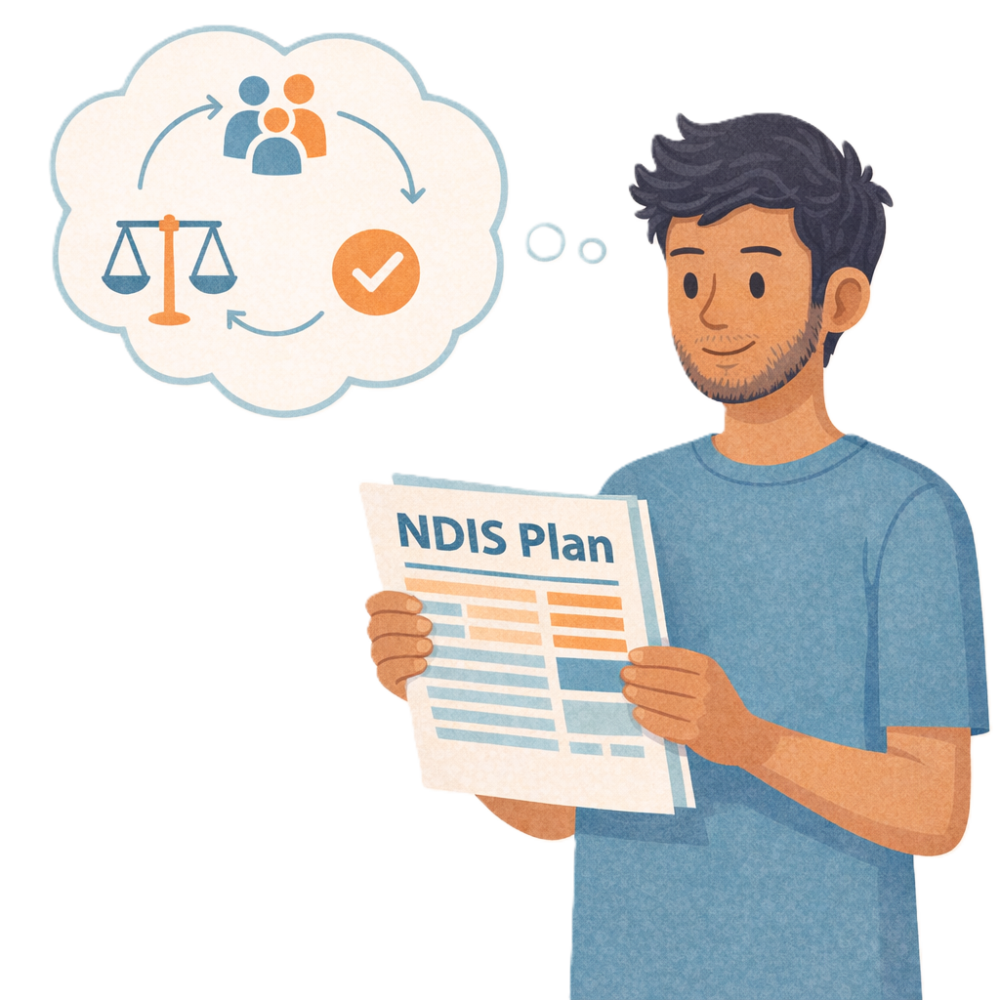

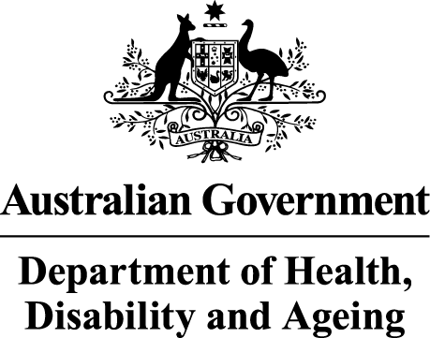 | The Australian Government Department of Health Disability and Ageing wrote this.  We say DHDA for short.  When you see the word we it means DHDA.
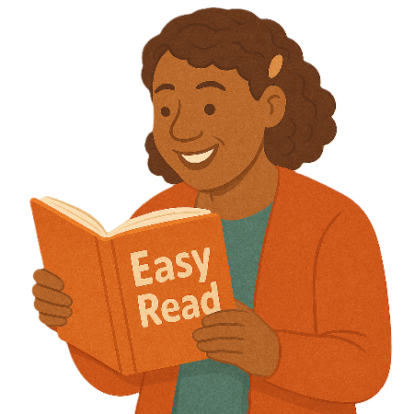 | We wrote this in an easy to read way.  We use pictures to explain some ideas.
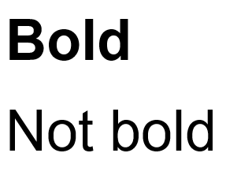 | We have some words in bold.  This means the letters are thicker and darker.  These are important words.
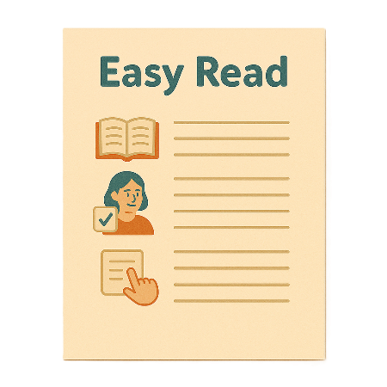 | This is an Easy Read summary of another document.  This means it has the most important ideas.
 | We can answer any questions by email.  NDISconsultations@health.gov.au
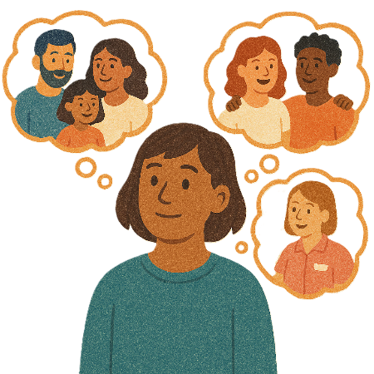 | You can ask for help to read this document.  You can ask  - A friend  - Family members  - A support person.
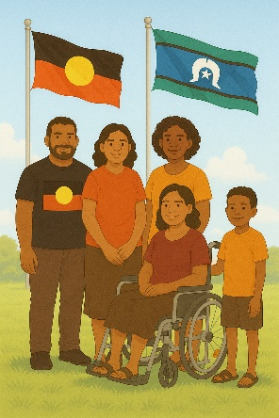 | We recognise Aboriginal and Torres Strait Islander people as the Traditional Owners of the land we live on.
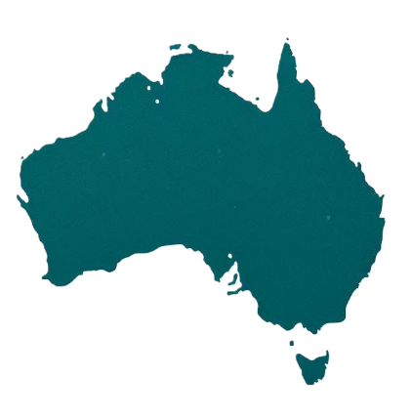 | They were the first people to live on and use the  - Land  - Waters.

Contents

About this document | 5
How we asked people what they think | 9
Who we heard from | 11
People told us about information | 12
People told us about NDIA decisions | 13
People told us about support needs assessments | 14
People told us about budgets | 18
People told us about plans | 20
Things the NDIA should do | 22
What happens next | 24
Contact us | 28

About this document

This document is about changes to how NDIS plans are made.

We call the new way to make a plan

- New framework planning.

A framework is how we will do something.
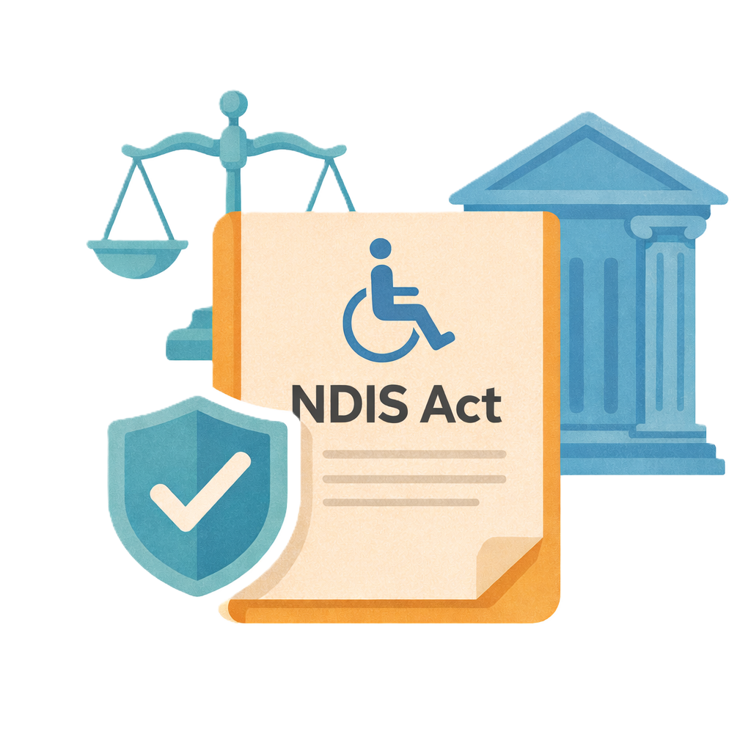 | The government changed the law about the NDIS in 2024.  Laws are rules for how we live.  This change lets us make new rules about how the NDIS works.
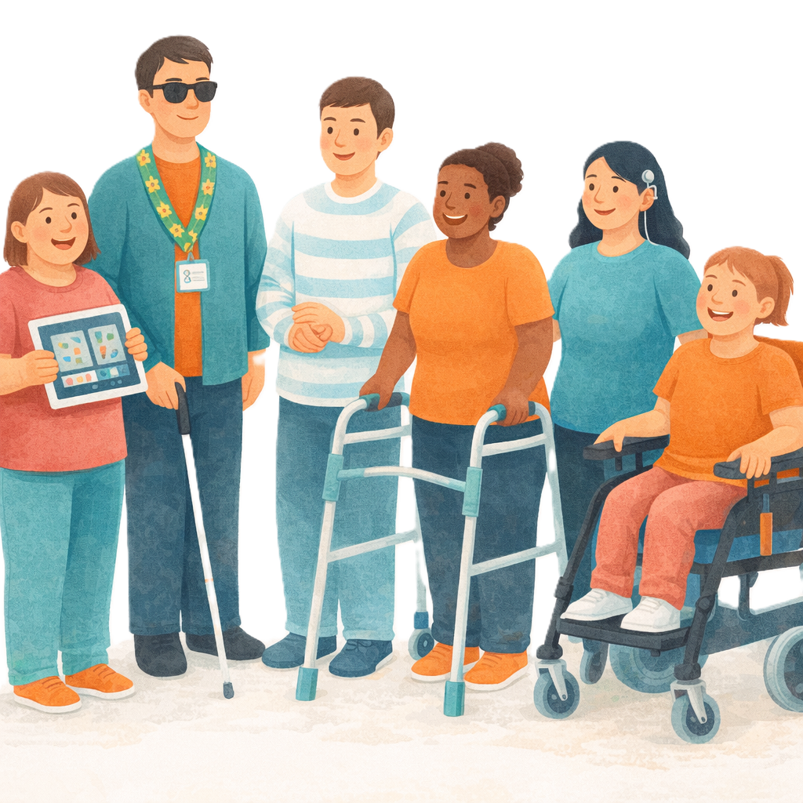 | We are making the rules with  - People with disability
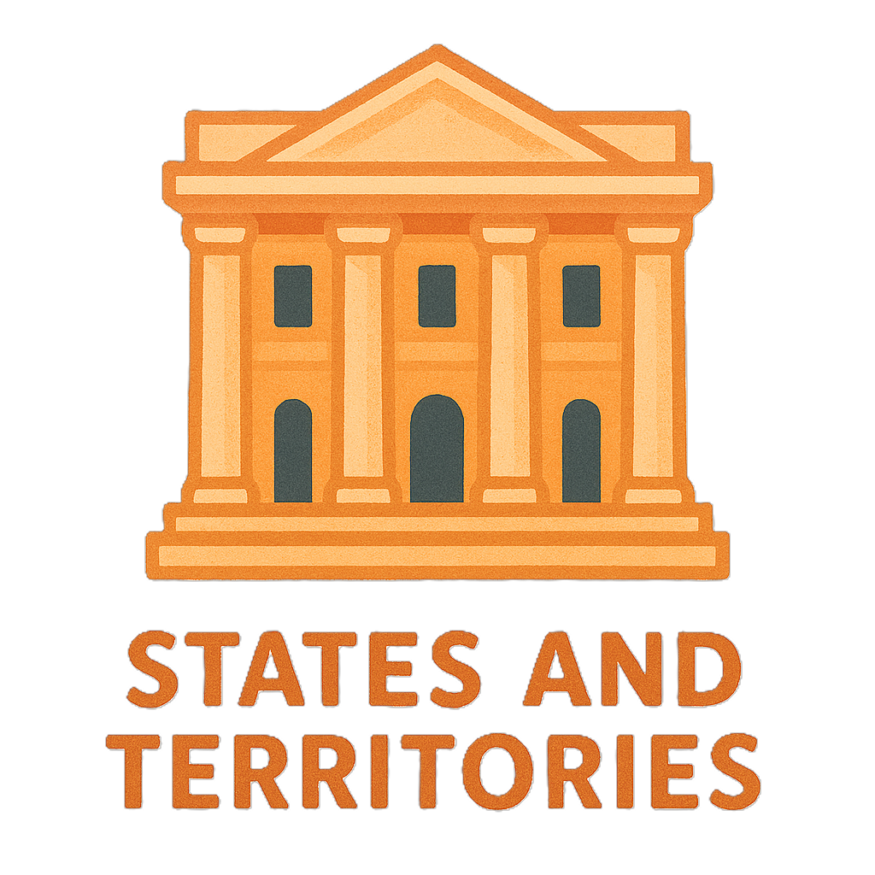 | - State and territory governments
 | - The National Disability Insurance Agency.  We call it the NDIA for short.  The NDIA looks after the NDIS.
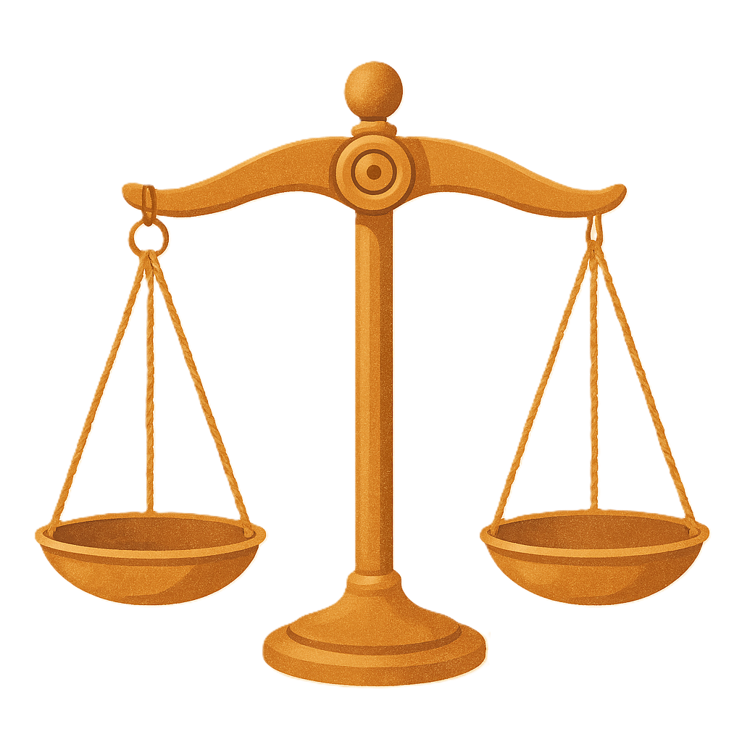 | The new rules will help make decisions fair for everyone.
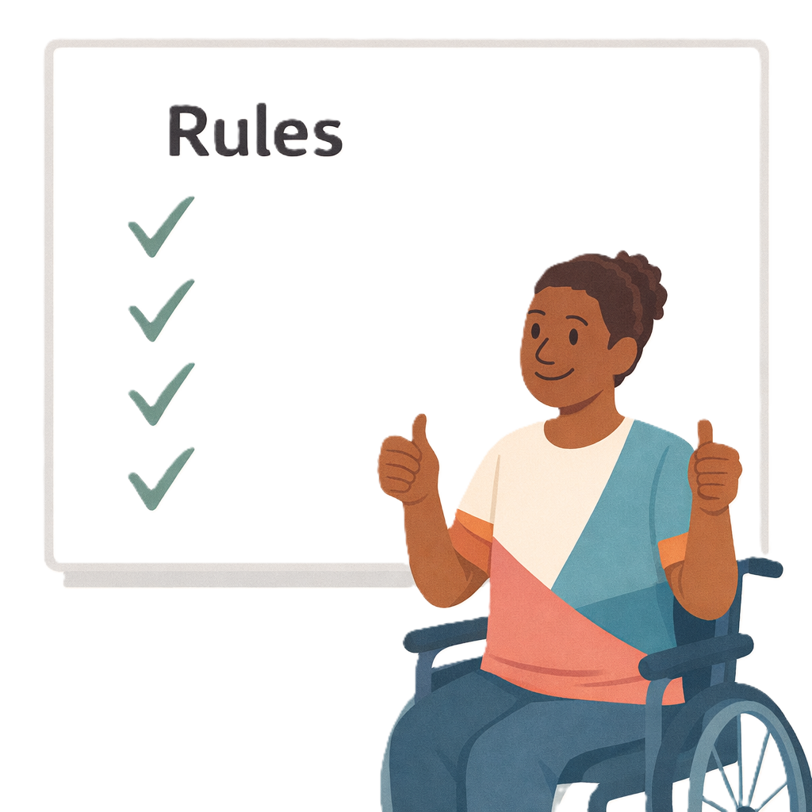 | These rules will say how  - Support needs are worked out  - Budget is worked out  A budget is the amount of money in someones plan.  - A plan can be used.
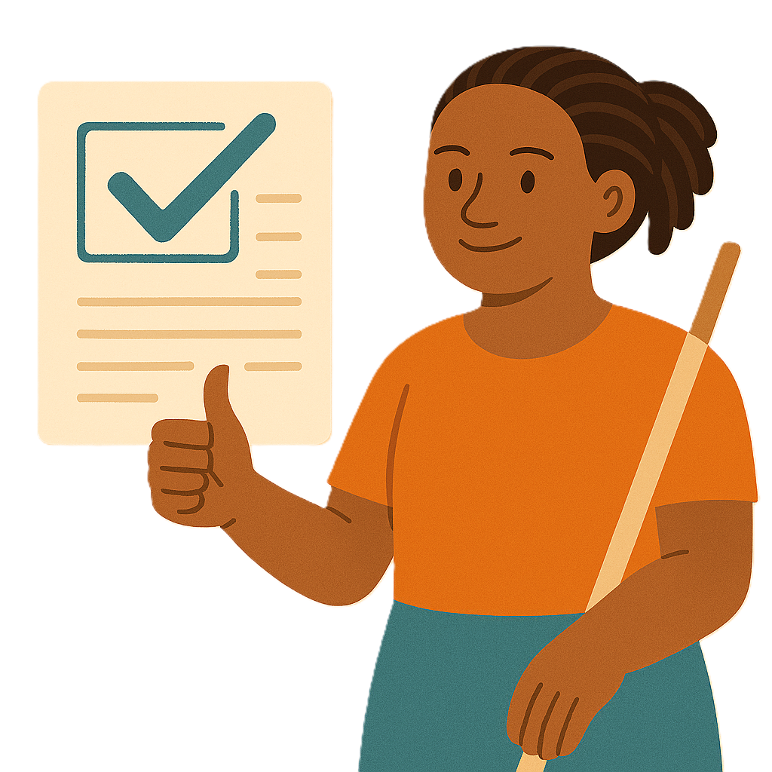 | We will  - Share clear information
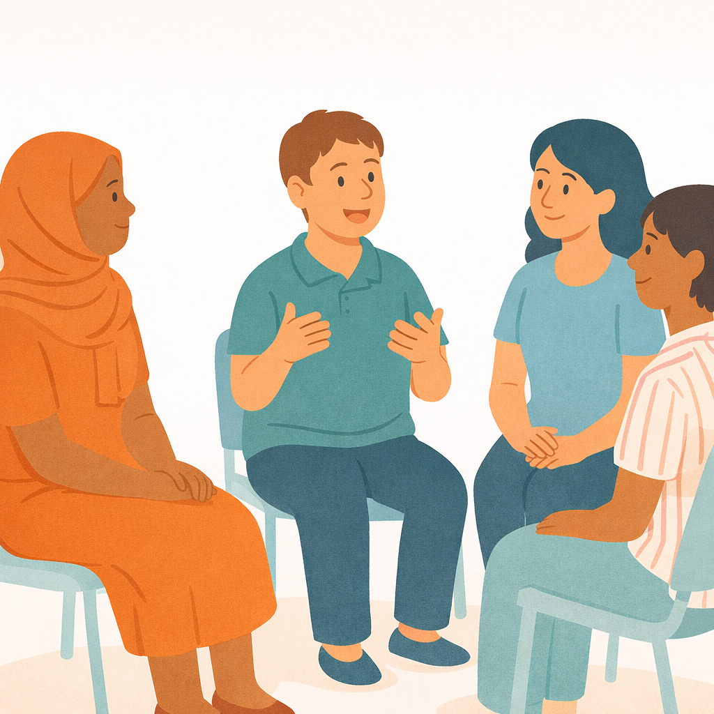 | - Keep talking to people
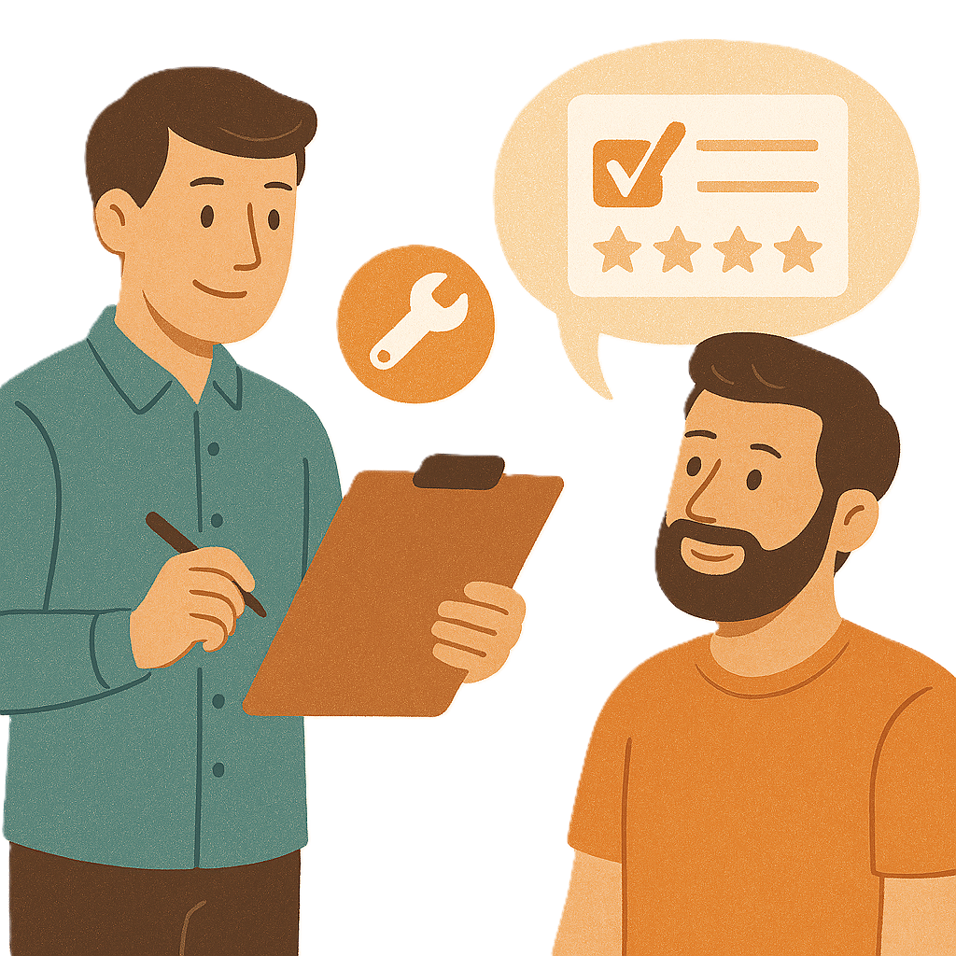 | - Keep listening to feedback  Feedback says what you think about something.  It will help  - Find problems  - Make it better in the future.
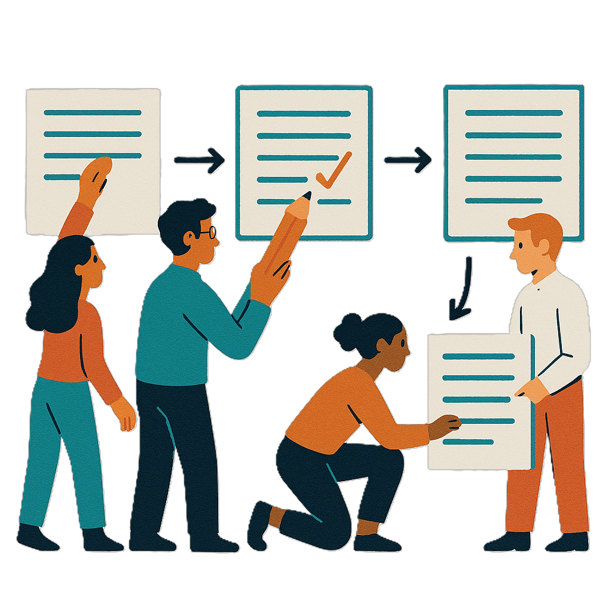 | - Use feedback to make the new rules.  We will do this as things are changing.

How we asked people what they think

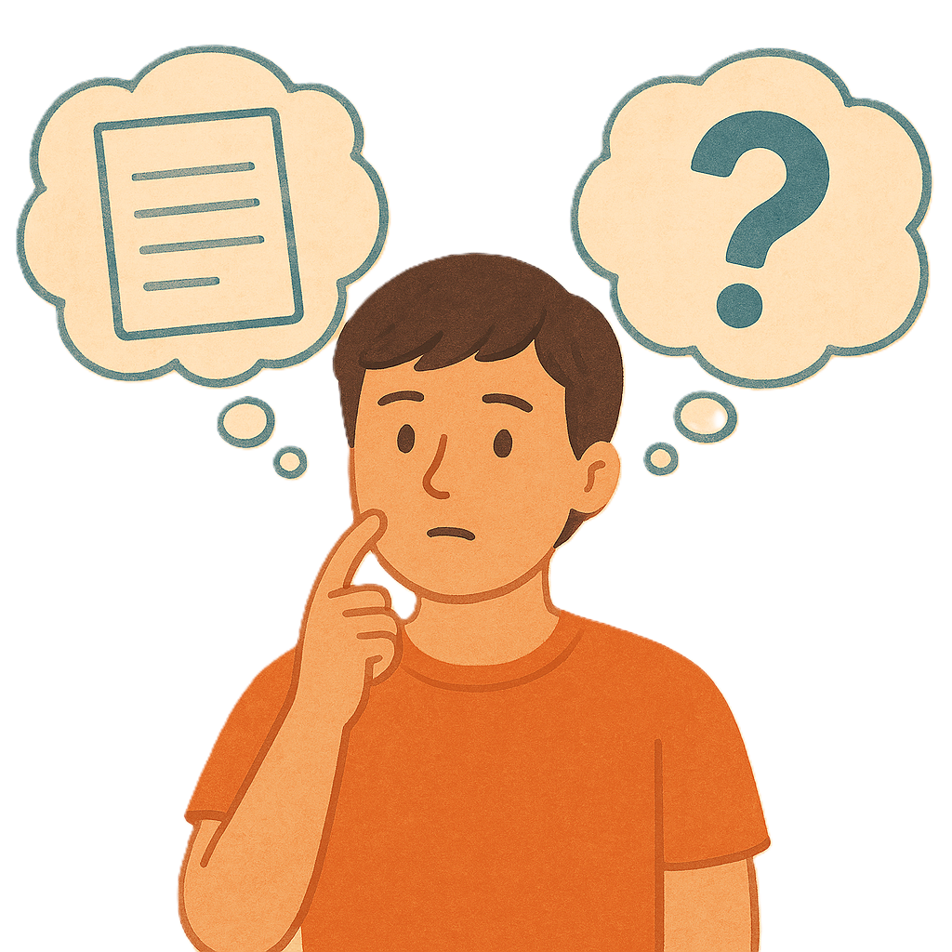 | We asked people what they think about the new way of planning.
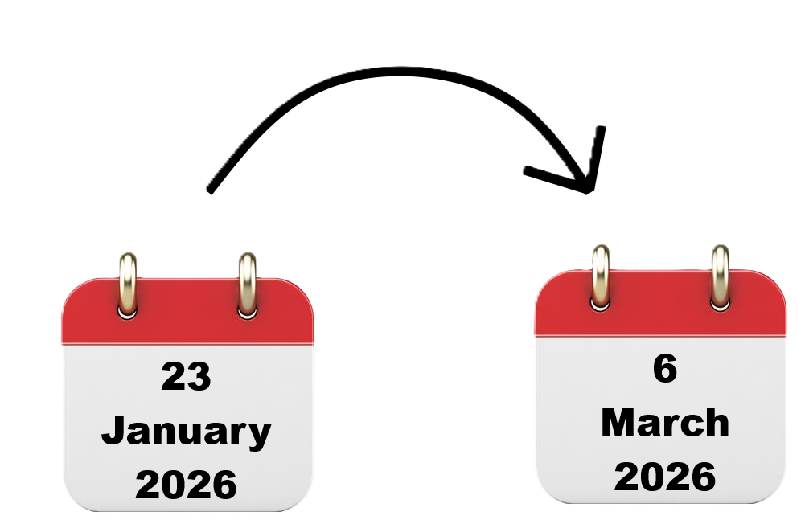 | People could tell us their ideas from  - 23 January 2026  To  - 6 March 2026.
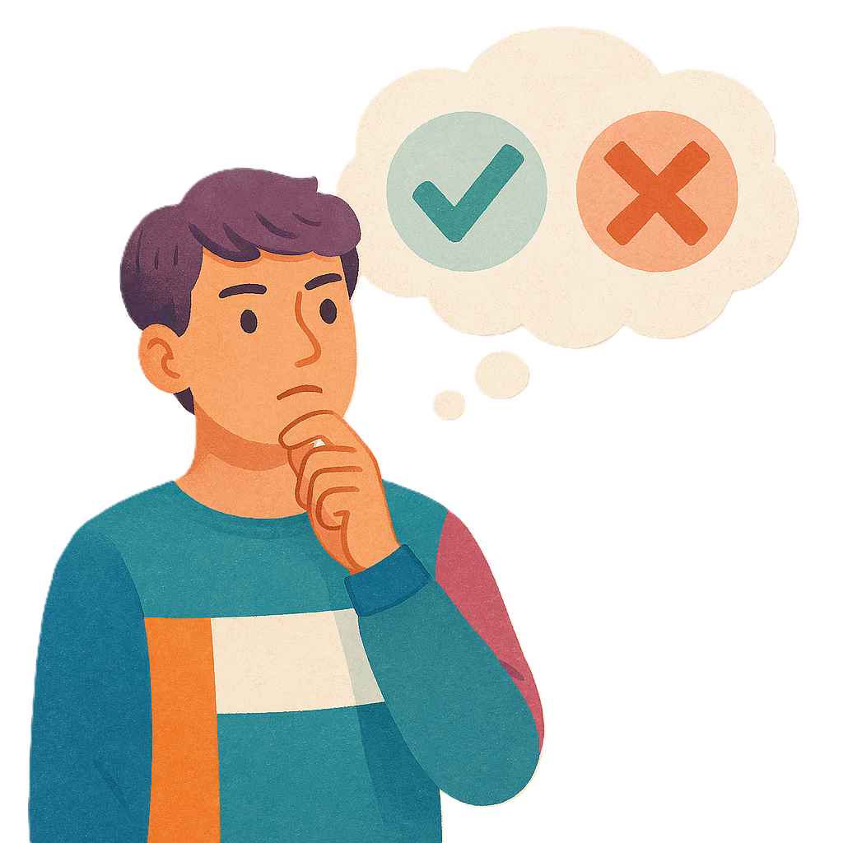 | People gave us their feedback in 3 ways.
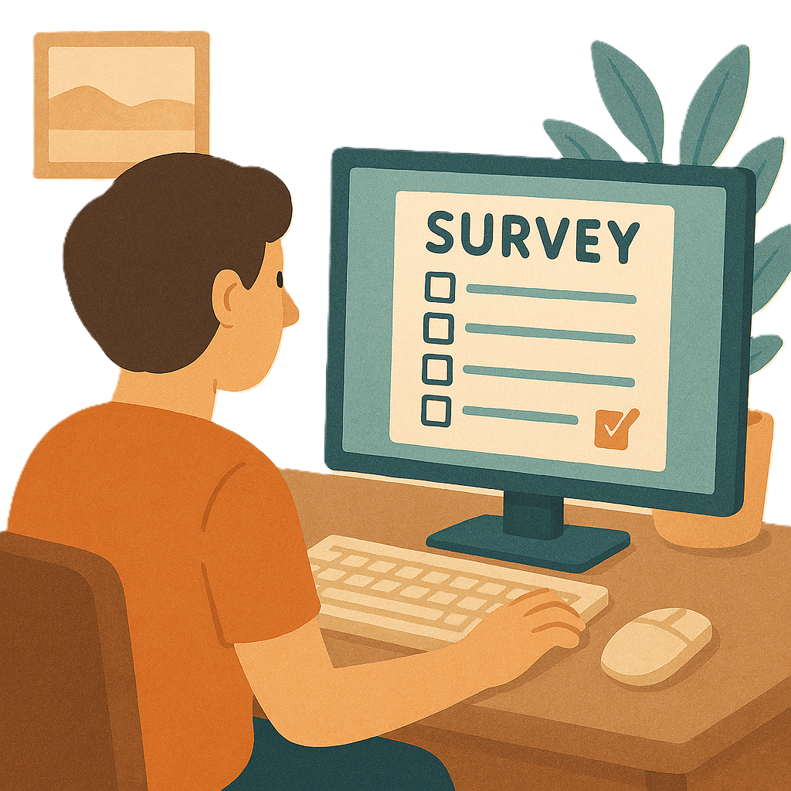 | People could  - Answer questions in a survey  Surveys have questions about your ideas.
 | - Send us an email
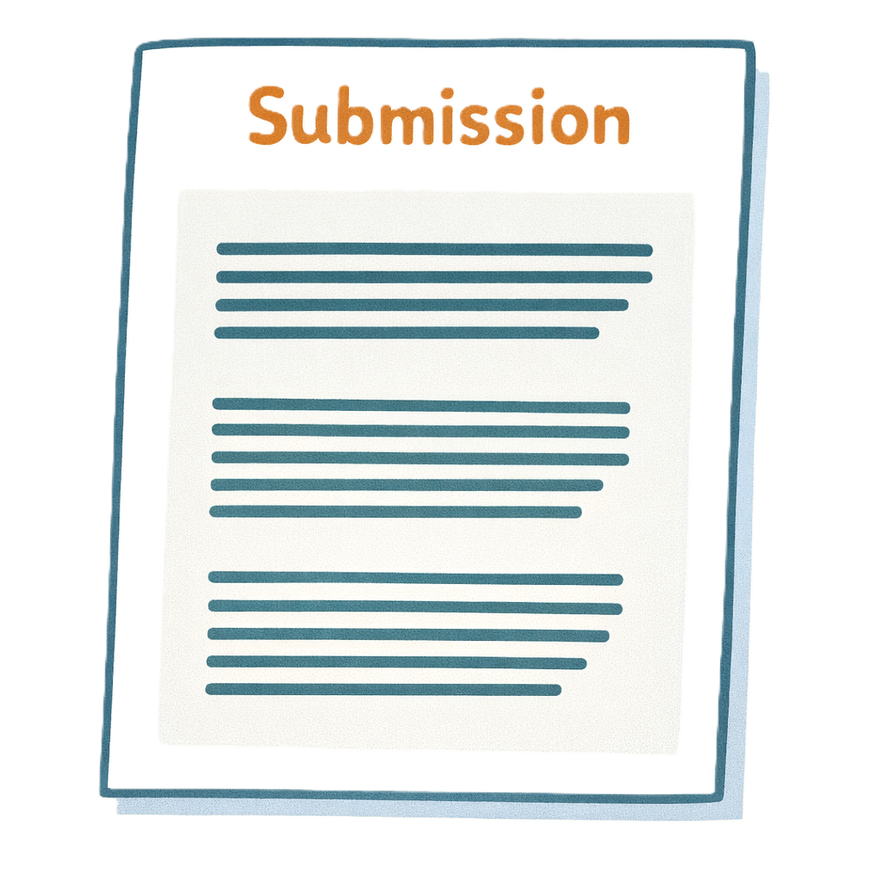 | - Send us a submission.  A submission is when you write down your ideas and send them to us.

Who we heard from

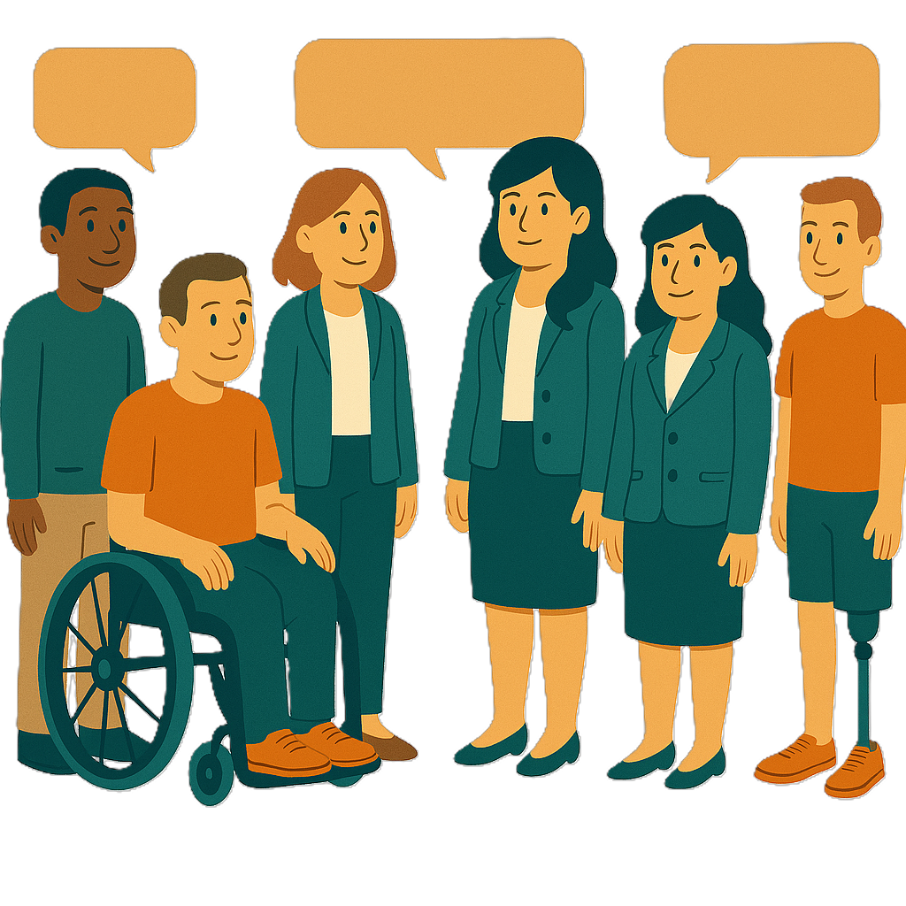 | We heard ideas from lots of people and organisations.
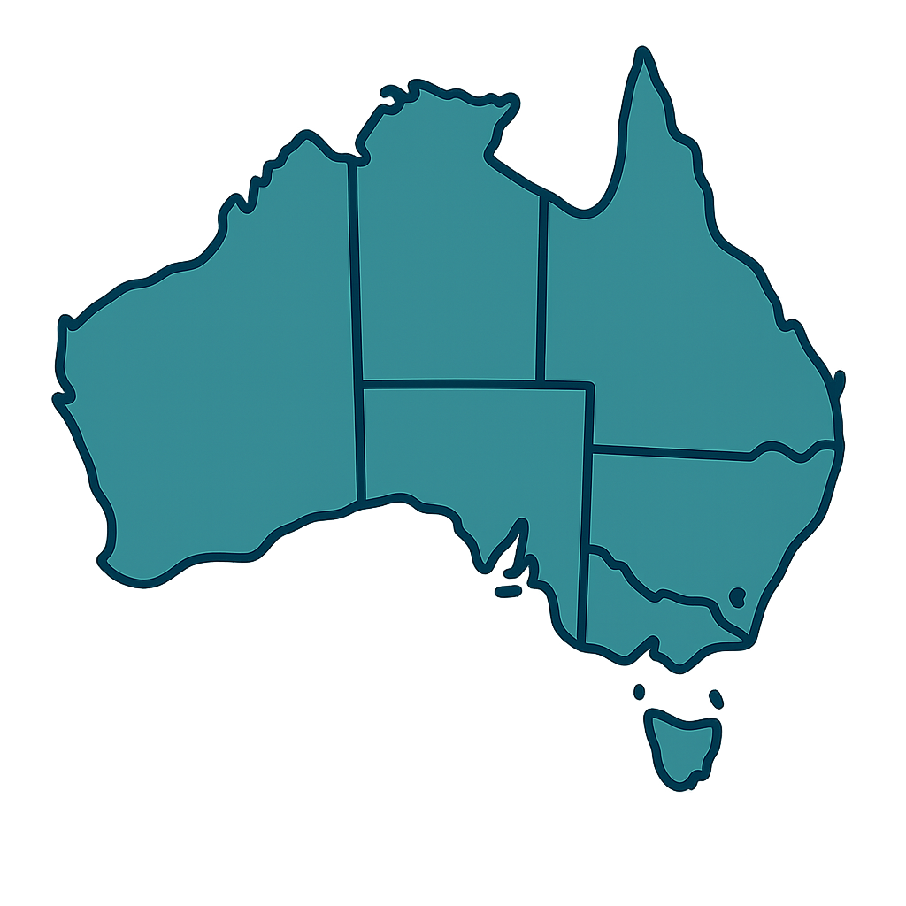 | They were from all over Australia.
Many were people

- With disability
- From different cultures.
People told us about information

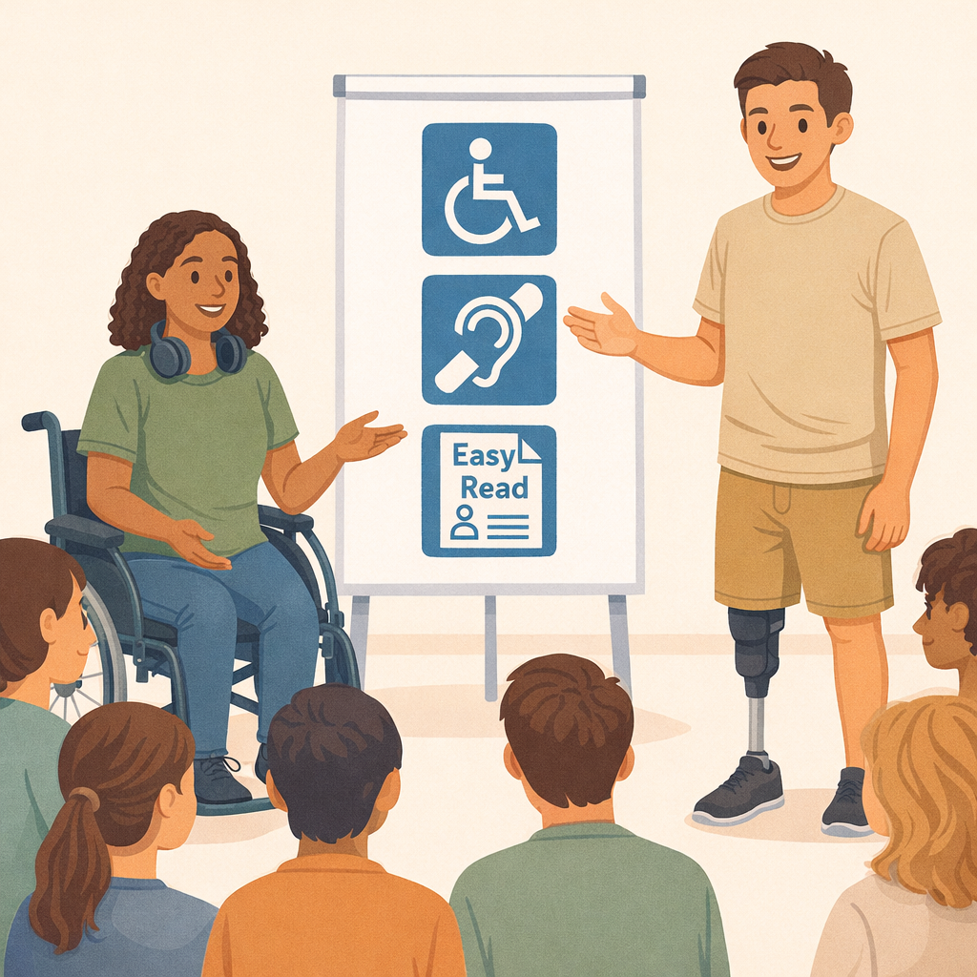 | People told us they want better information.  They said our information should  - Have more details  - Be easy to understand  - Be more accessible.
Accessible means everyone can use it.

Like Easy Read.
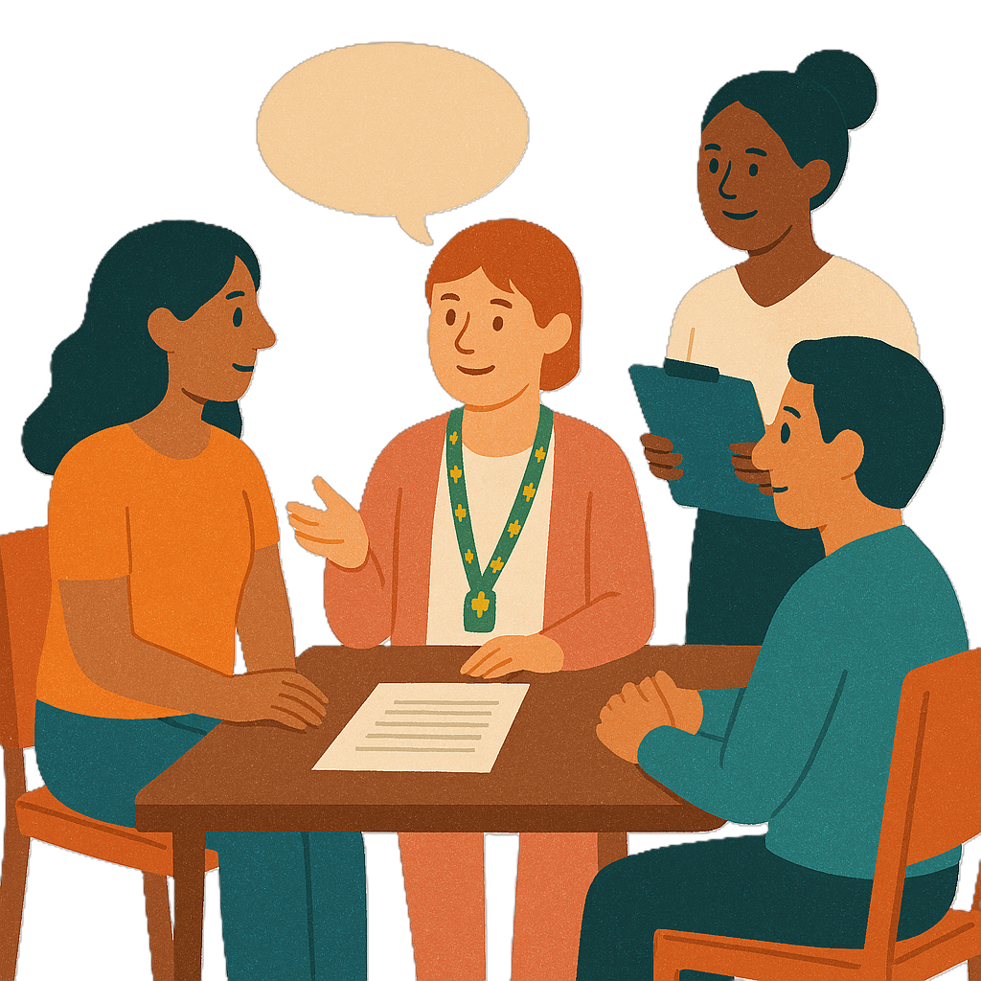 | They want us to explain  - Each step to make a new plan  - When new plans will start.

People told us about NDIA decisions

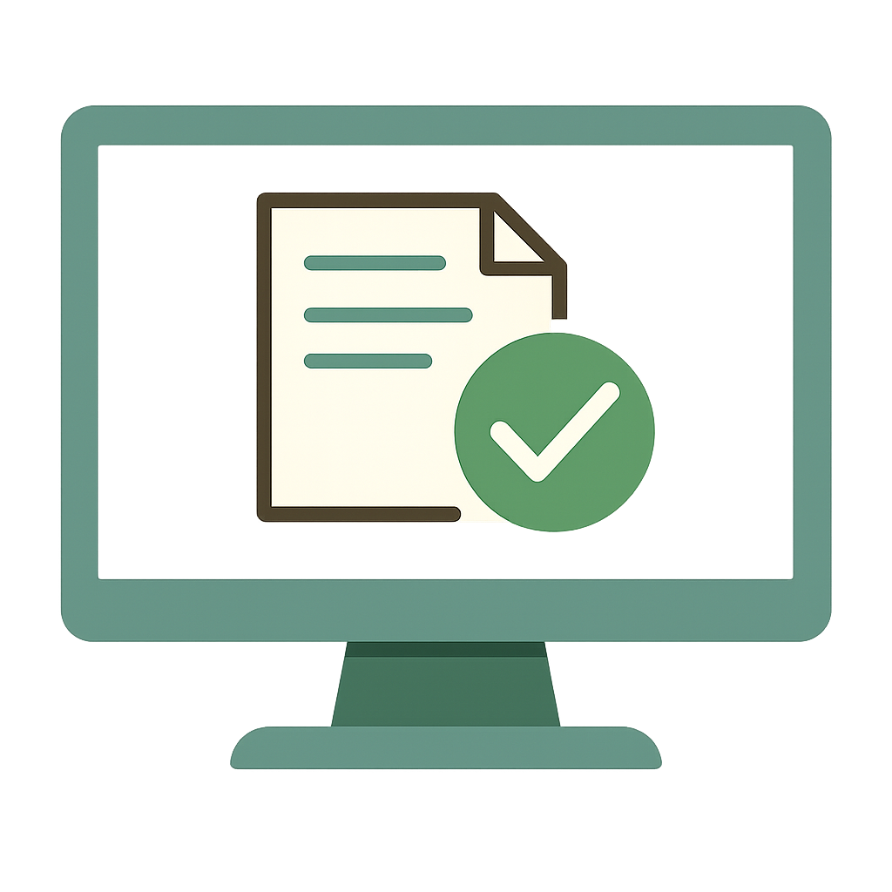 | People want more information about how the NDIA makes decisions.  They are worried the NDIA will  - Not think carefully about peoples lives  - Use computers to make decisions.
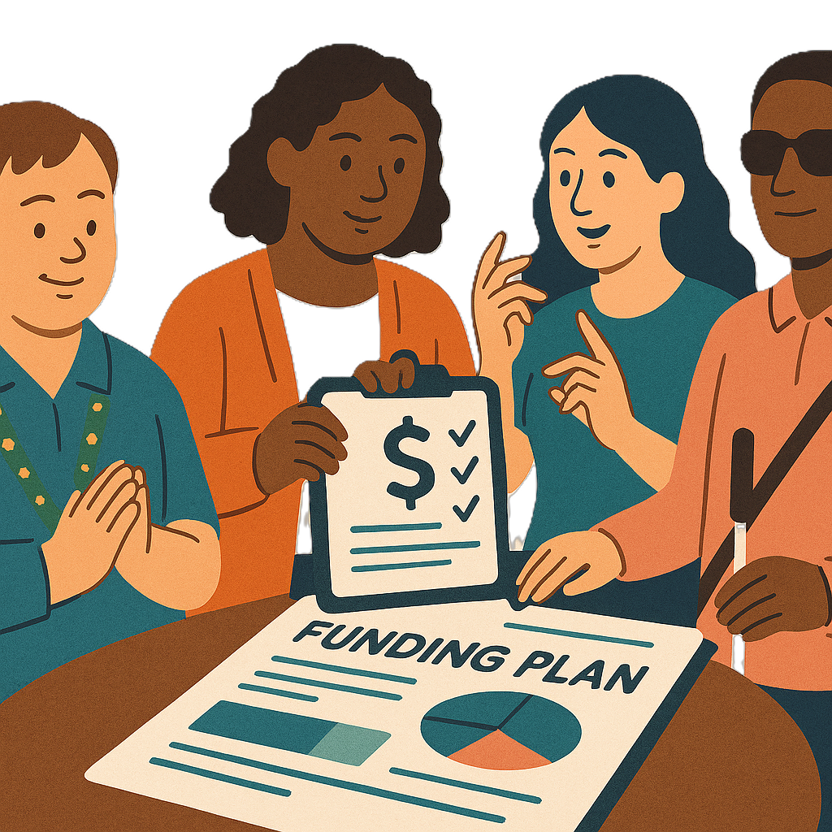 | This includes decisions about their  - Plan  - Budget.

People told us about support needs assessments

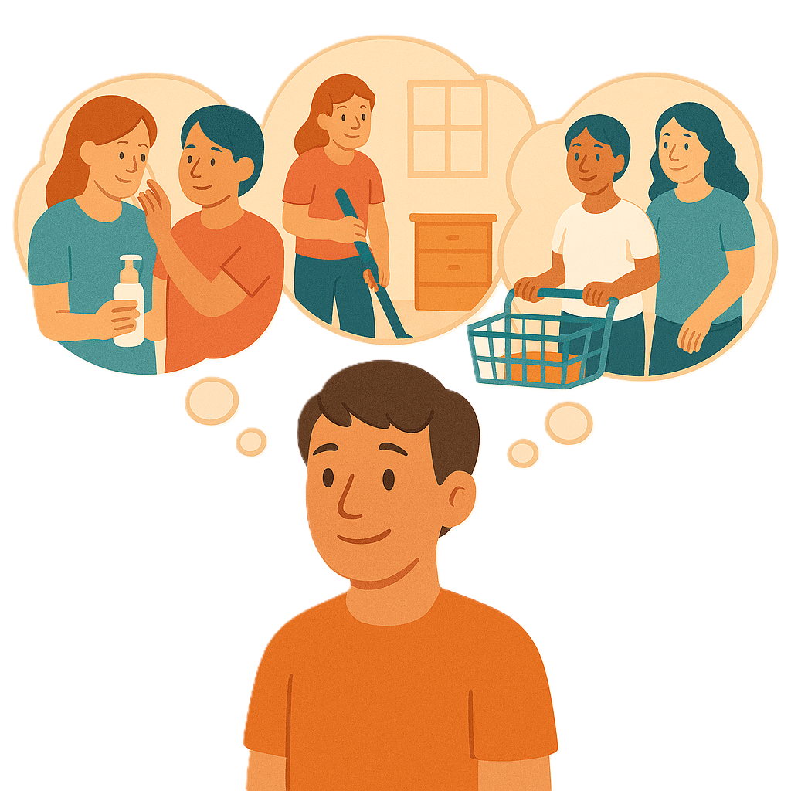 | People also told us about support needs assessments.  Support needs assessments are a way to check what supports people need.  We will call them the assessments for short.
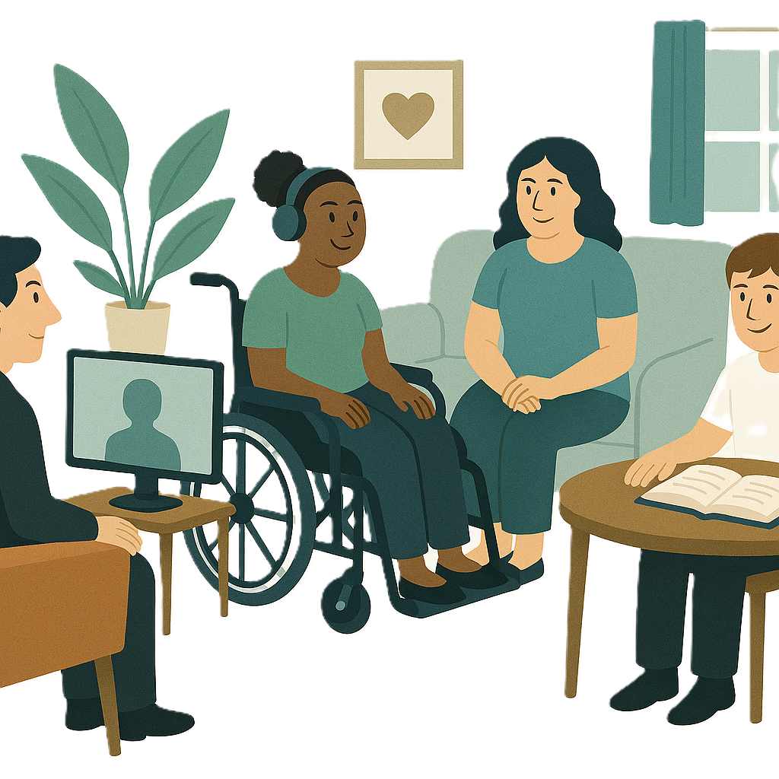 | People said it is important for the assessments to  - Feel safe  - Be fair.
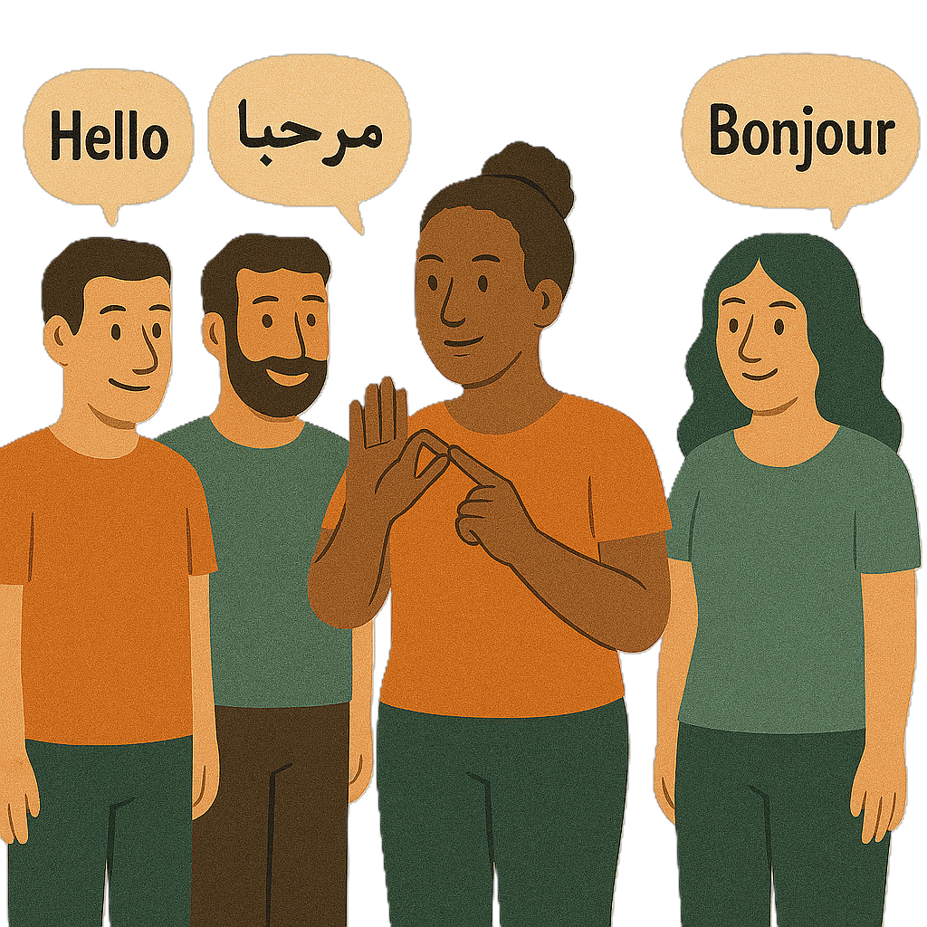 | They want  - Help from a support person  - An interpreter if they need one.  Interpreters help change words from 1 language to another like Auslan.  Auslan is Australian sign language.
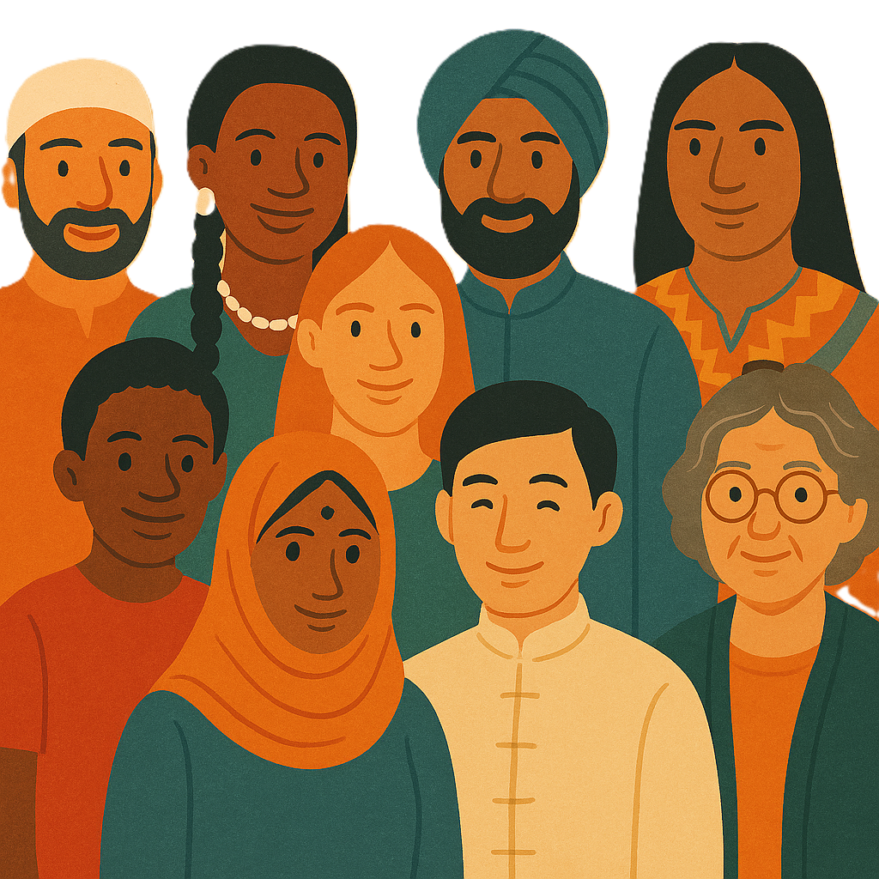 | People told us the assessments should  - Work for people from different cultures
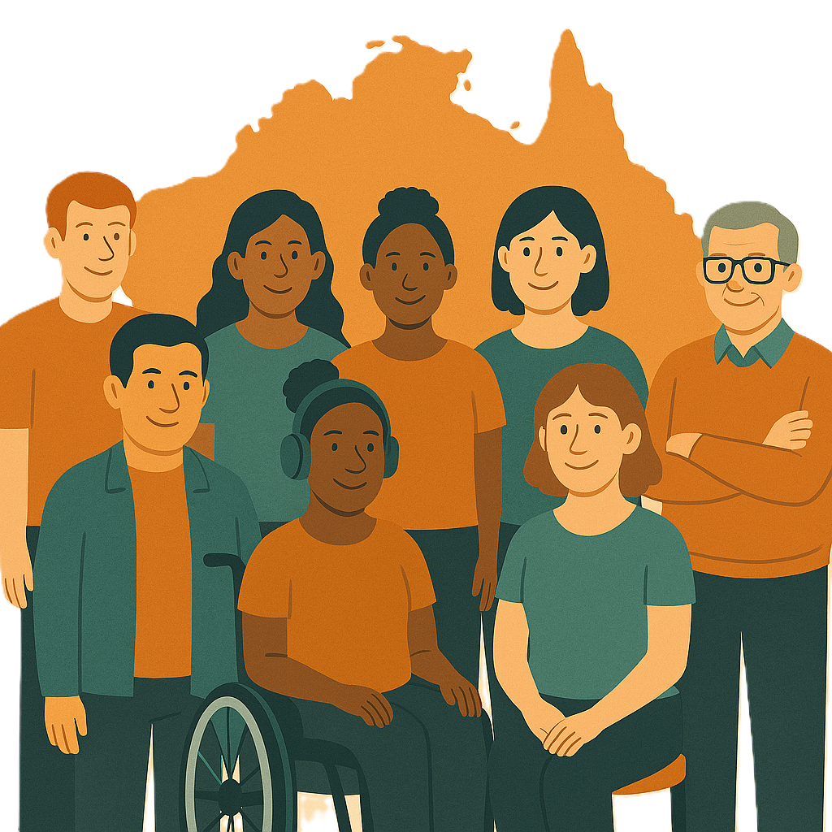 | - Focus on the person and what they need
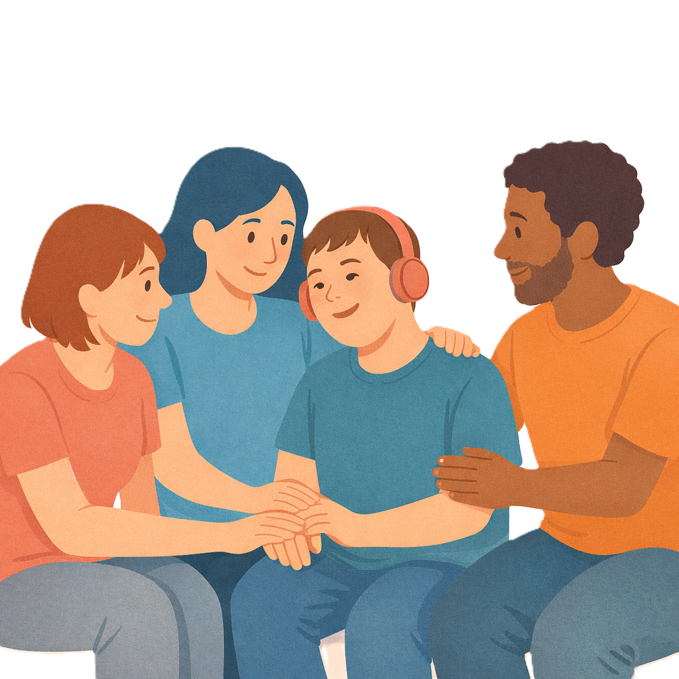 | - Listen to their family and carers.
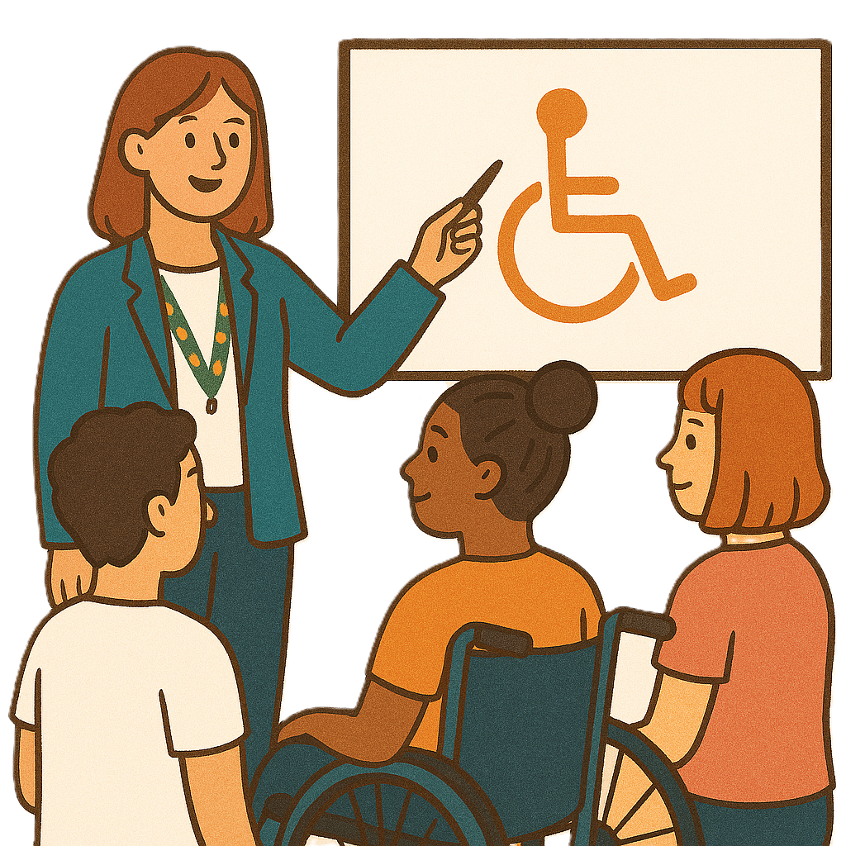 | They told us the assessments should be done by someone they choose.  The person doing the assessments needs to  - Have the right training  - Understand their disability.
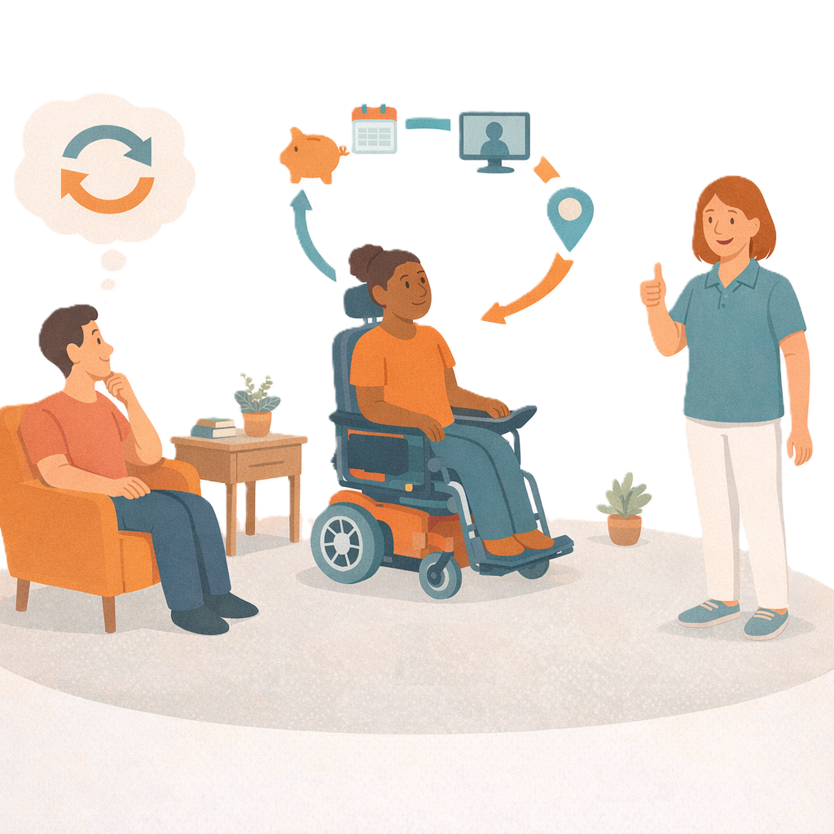 | People told us they should include information about  - Hard days  - How their needs change over time.
 | It should also include information from health workers who know them well.  Like their doctor.
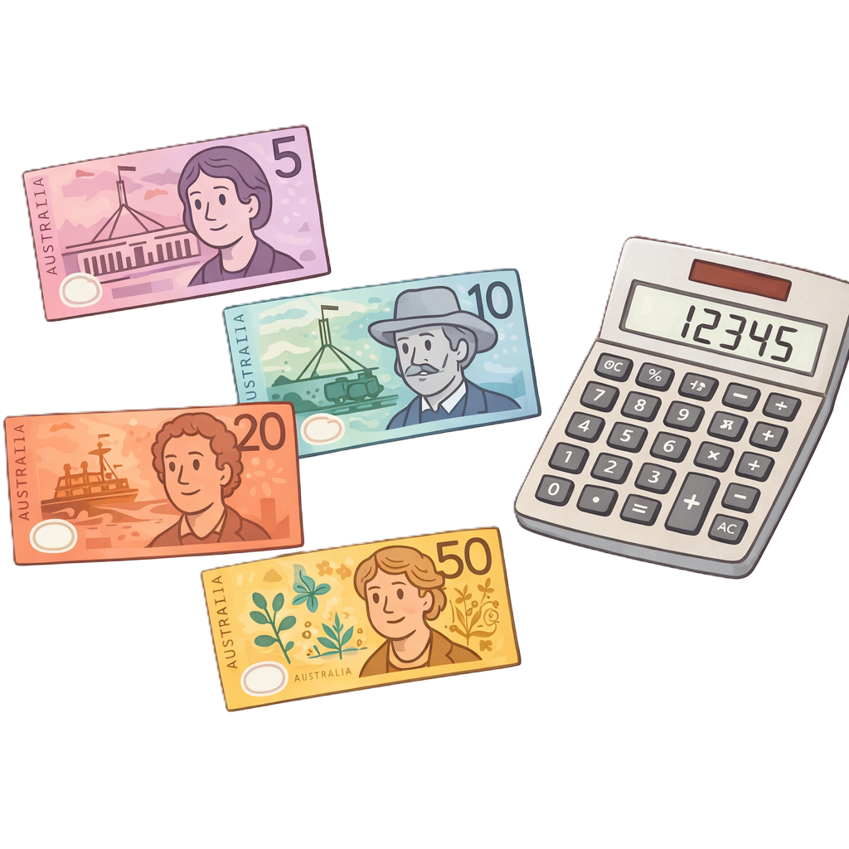 | People want to know how the NDIA will use this information to work out their budget.

People told us about budgets

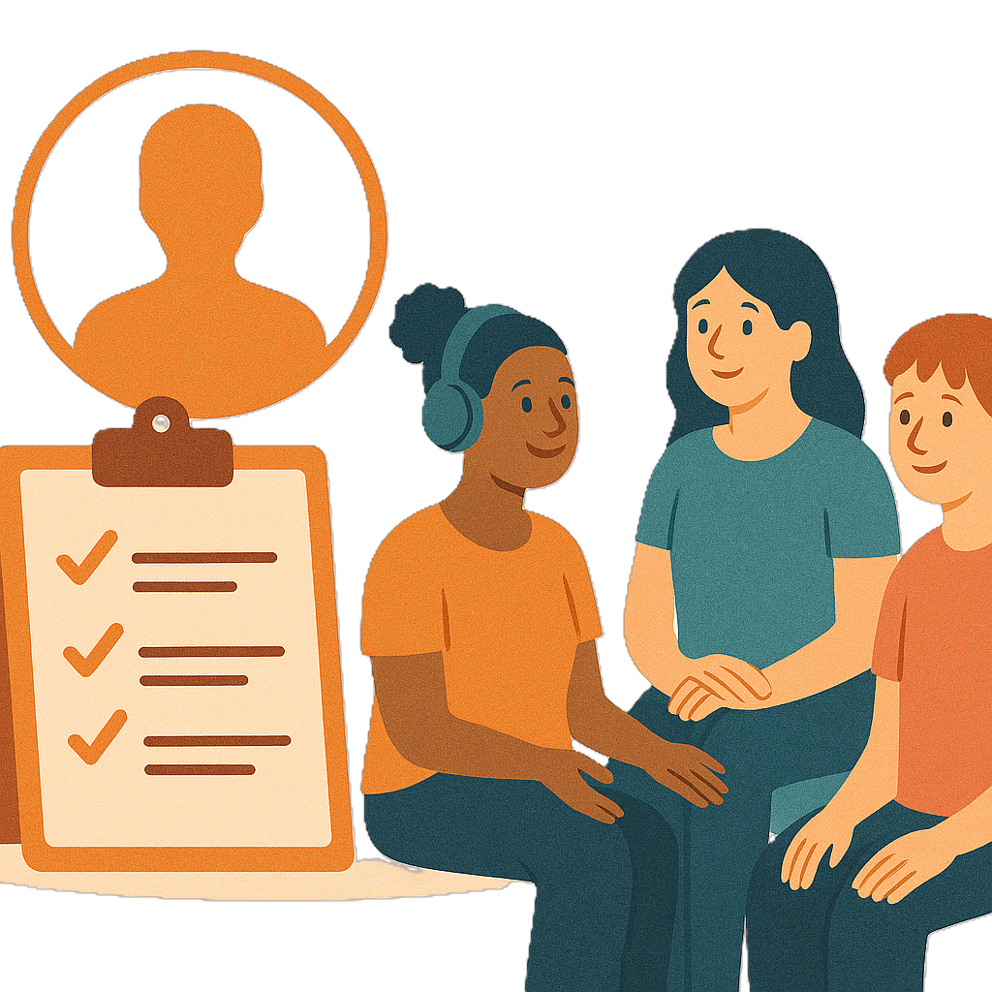 | People told us budgets should  - Explain clearly what kind of supports it says they need
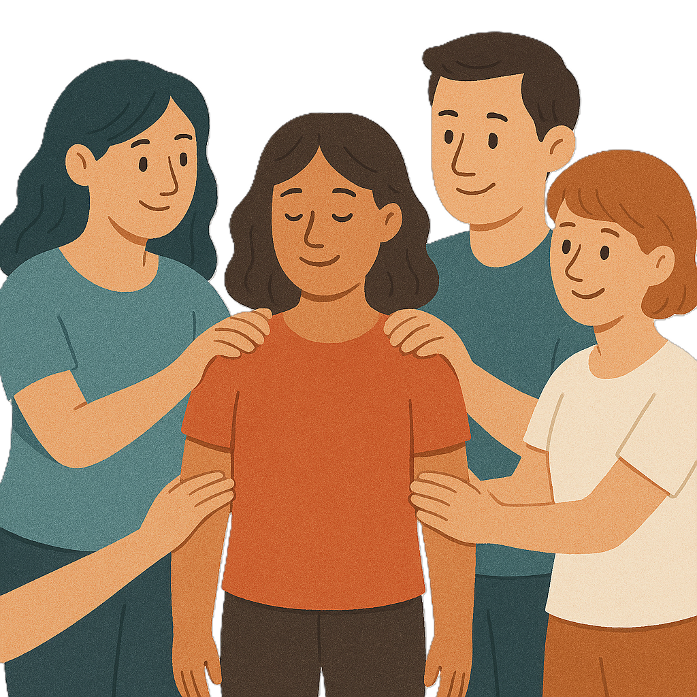 | - Include the support they get from family and friends
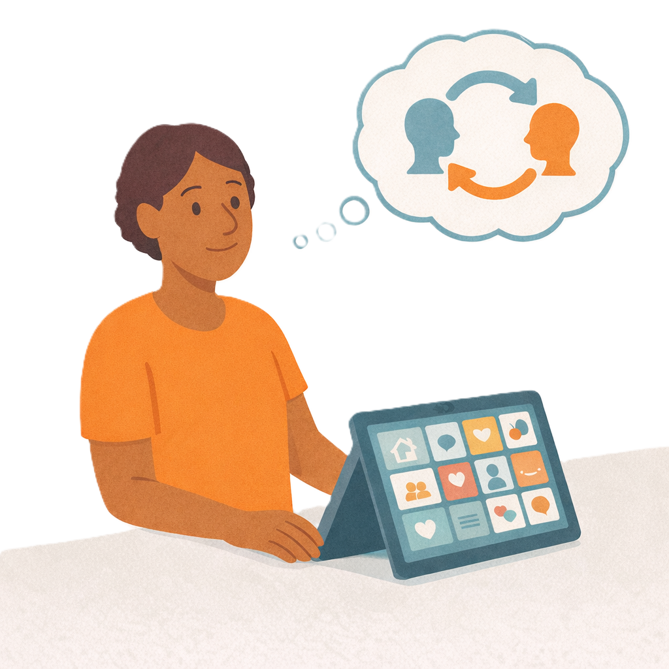 | - Not replace NDIS supports with family and friends.  Replace means change 1 thing for another.
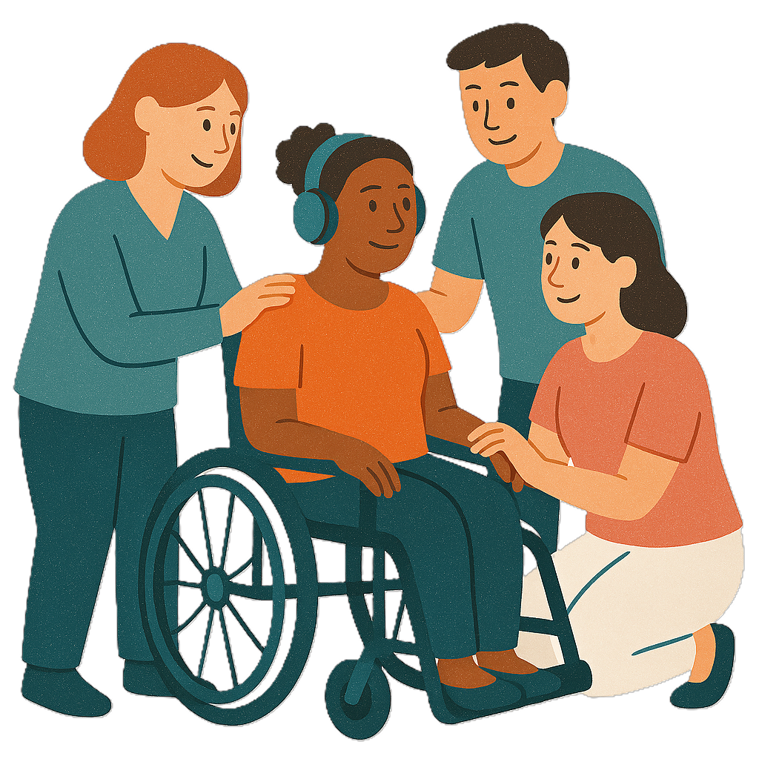 | They said their family and friends are  - Important  - Need to be looked after.
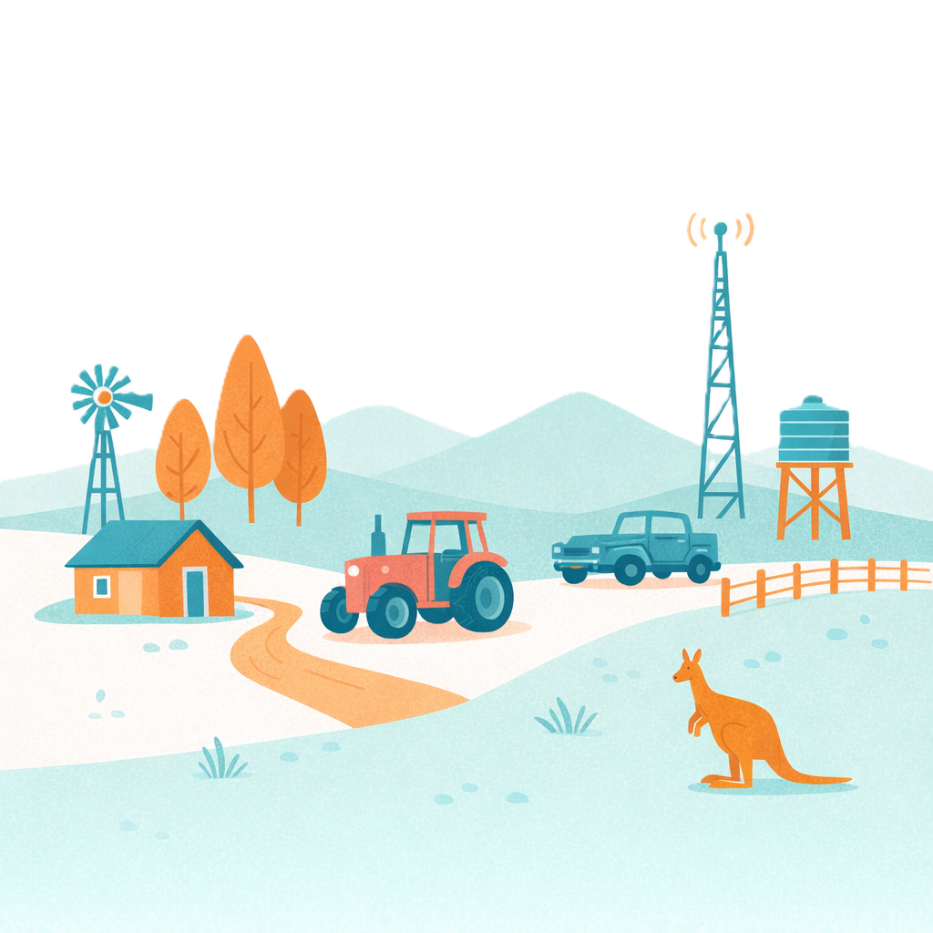 | People told us we need to think more about  - People who live outside big cities  - There are less services outside big cities  - How budgets work with less services.

People told us about plans

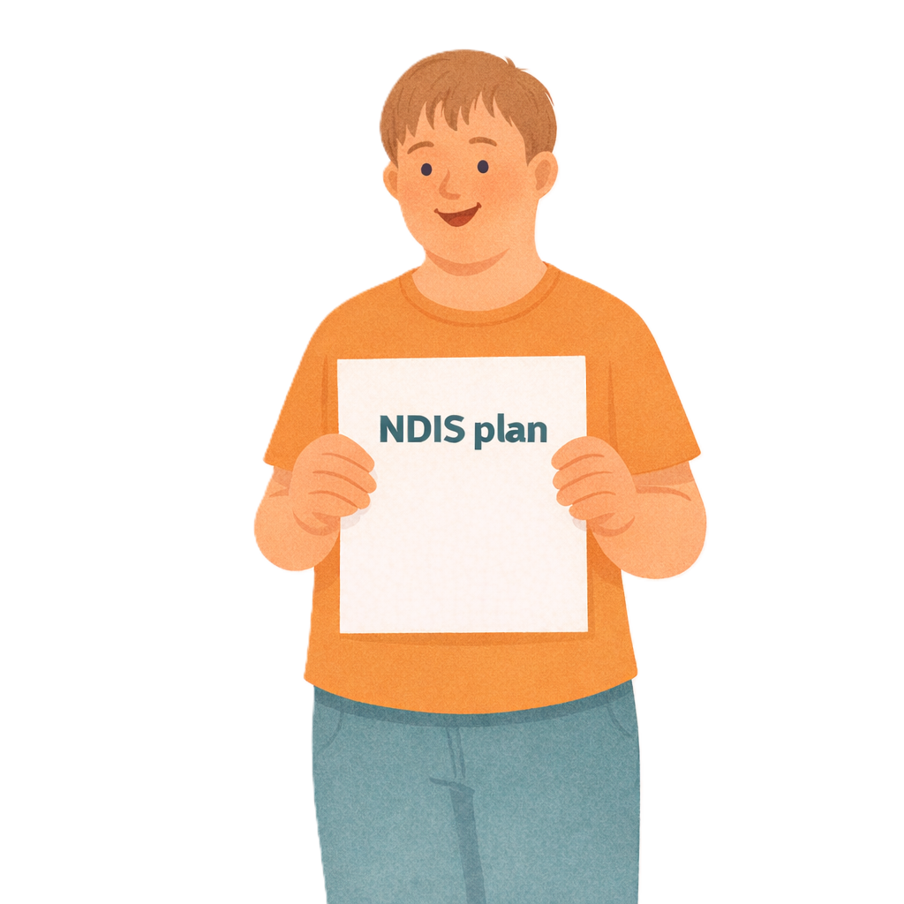 | People also want help after their plan starts.
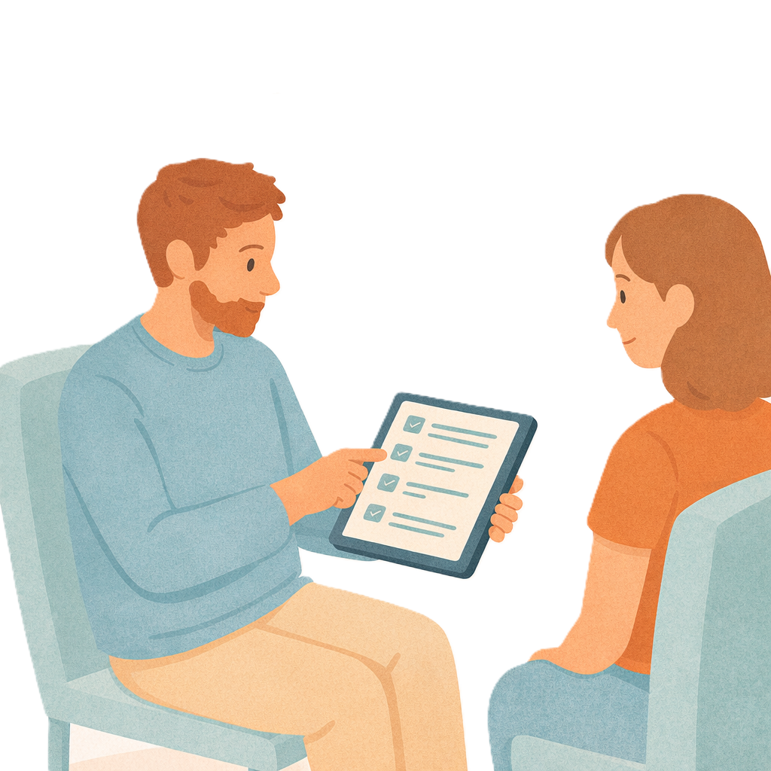 | They want clear information about how to  - Understand their plan  - Use their plan.  They want choice in how they use their plan.
 | People told us they worry about when their plan will change.
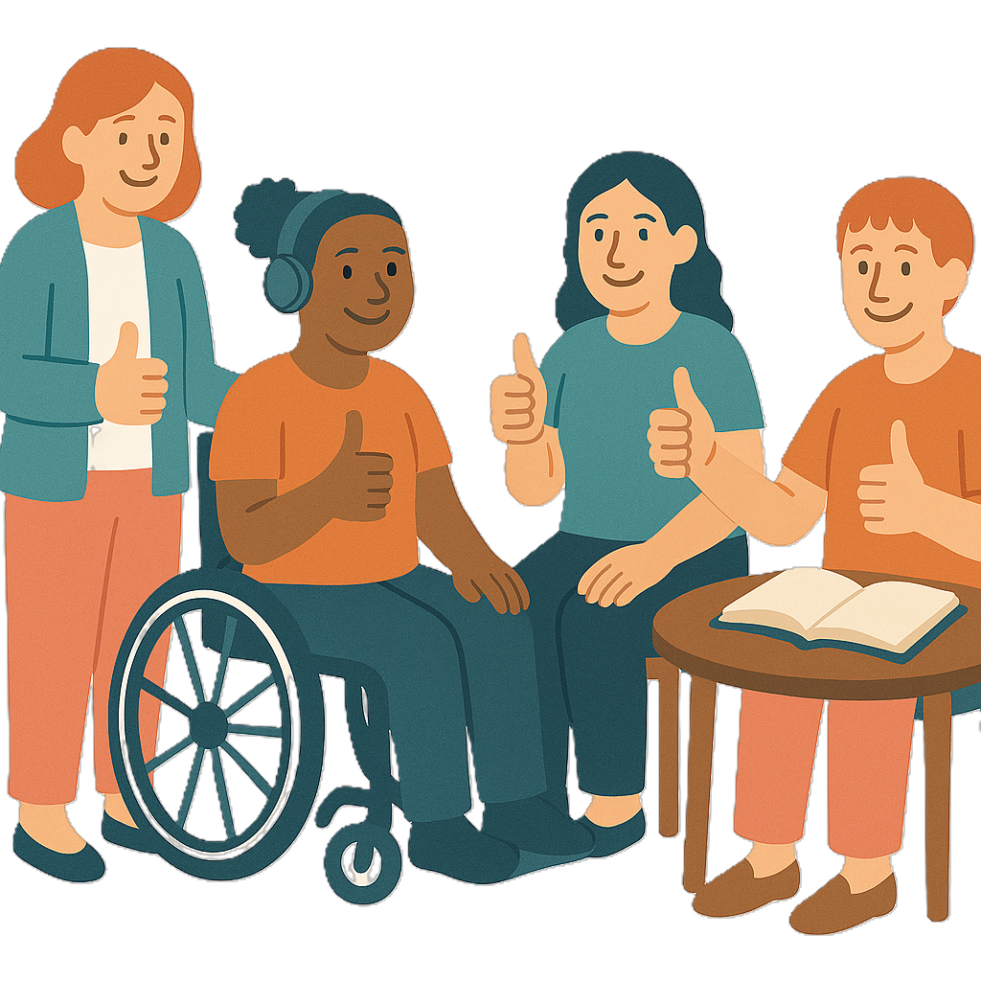 | They want to know if  - The change will be easy
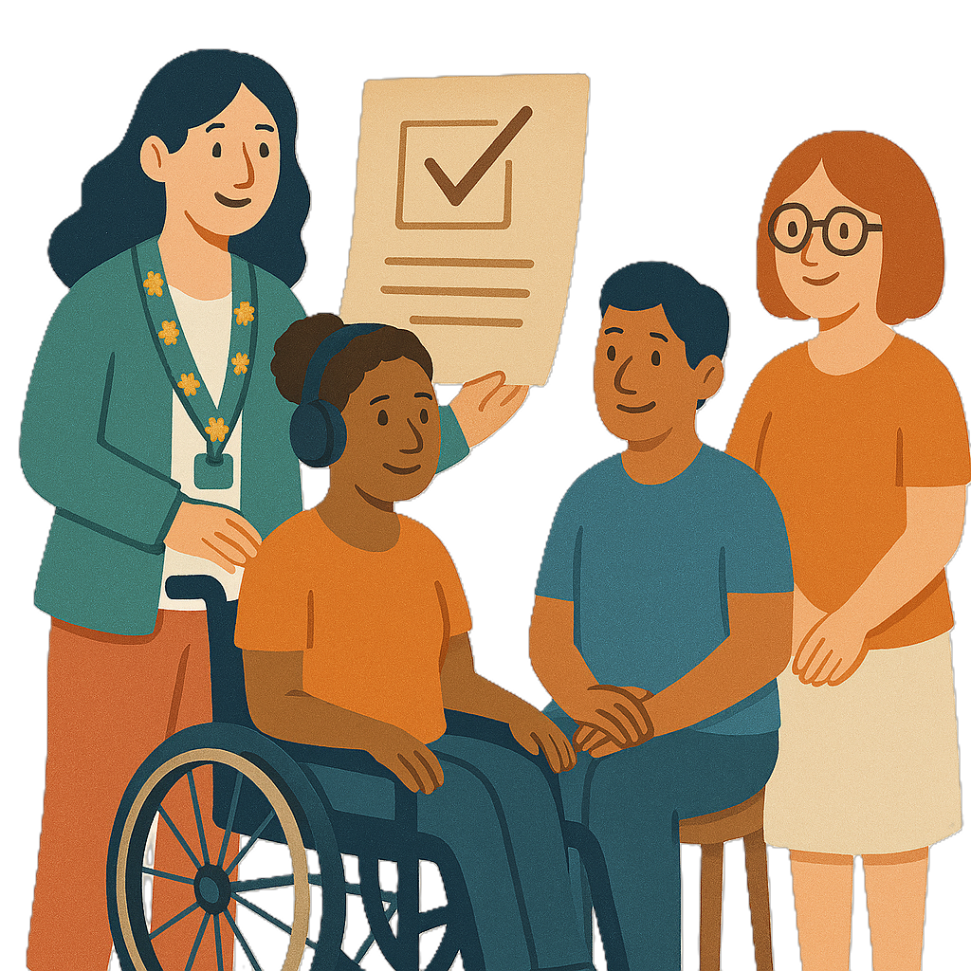 | - Their plan will keep going until new framework planning starts.

Things the NDIA should do

People told us some things the NDIA should do.

We shared them with the NDIA.
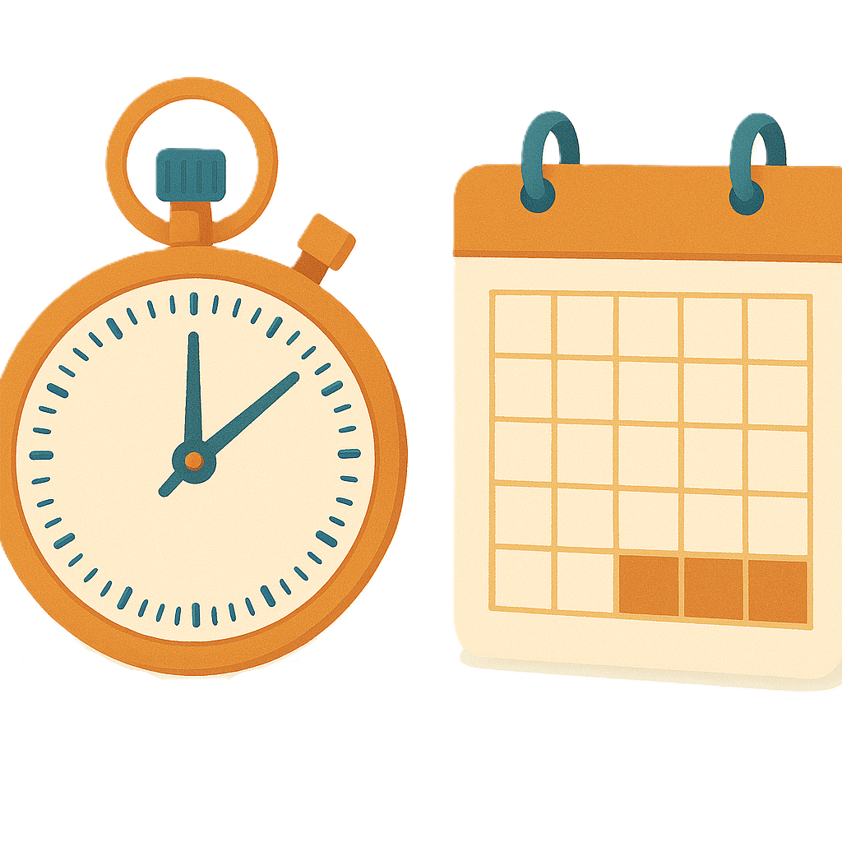 | We told the NDIA people want clear information about  - When things will happen
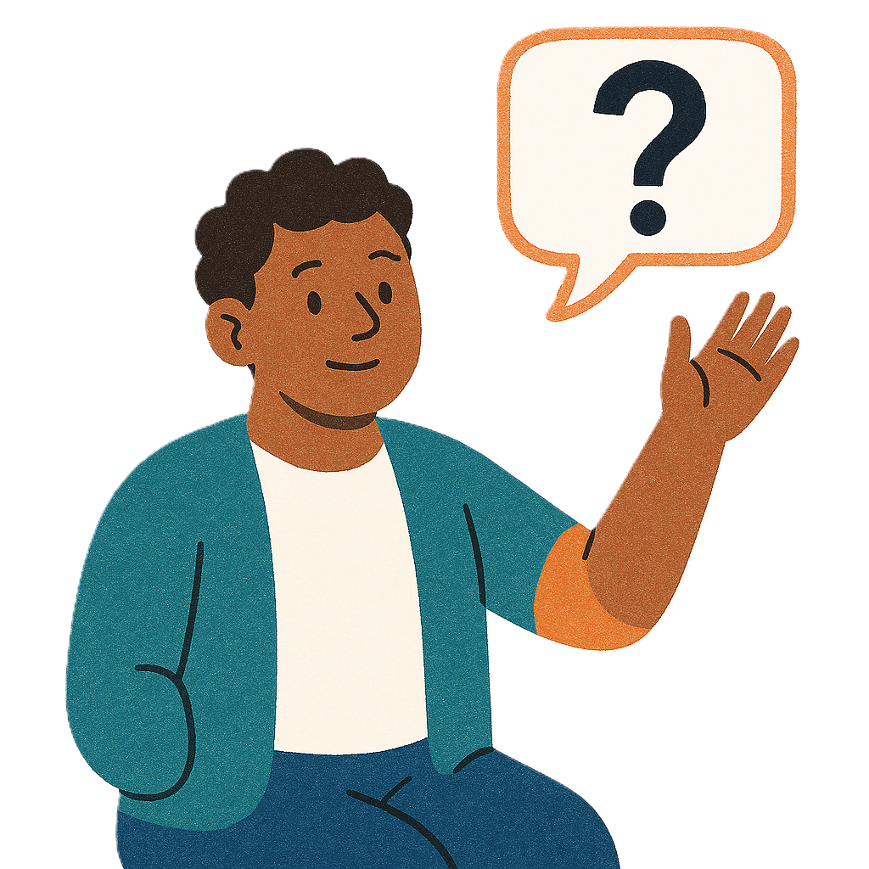 | - How to ask for a change to their plan
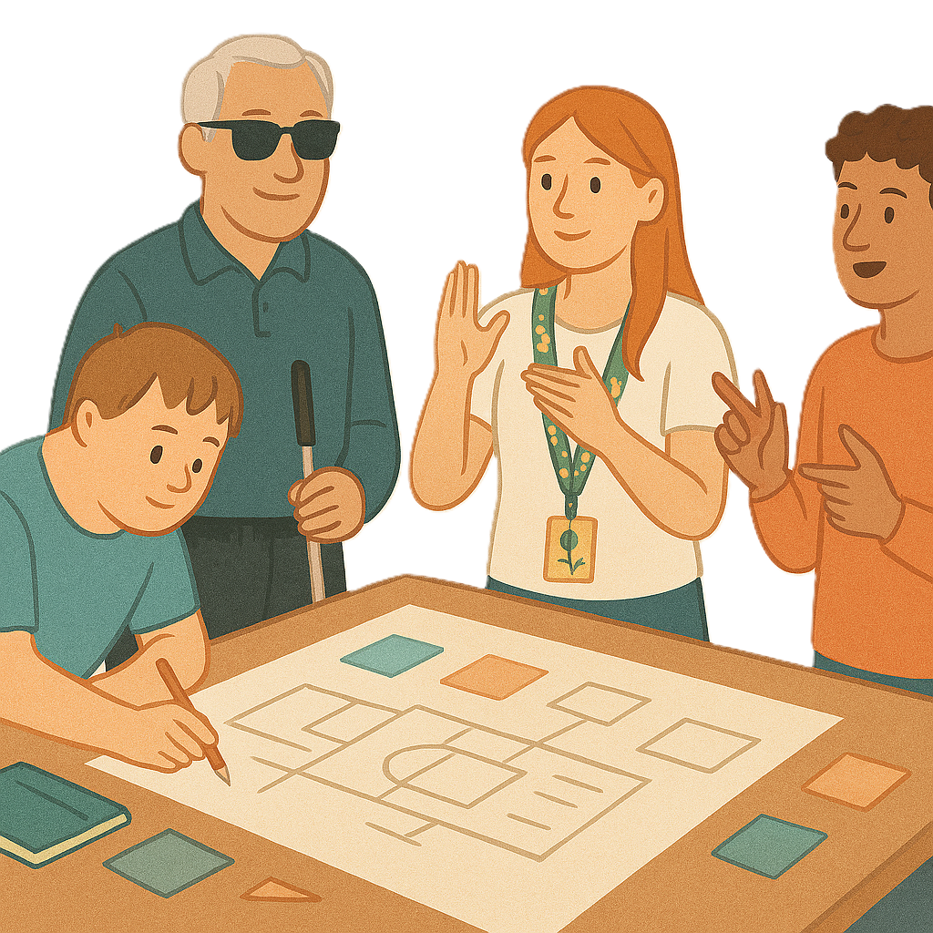 | - How they can be a part of the  co design of new framework planning.  Co design means working together to make things better.

What happens next

We listened to feedback from

- People with disability

 | - Families and carers
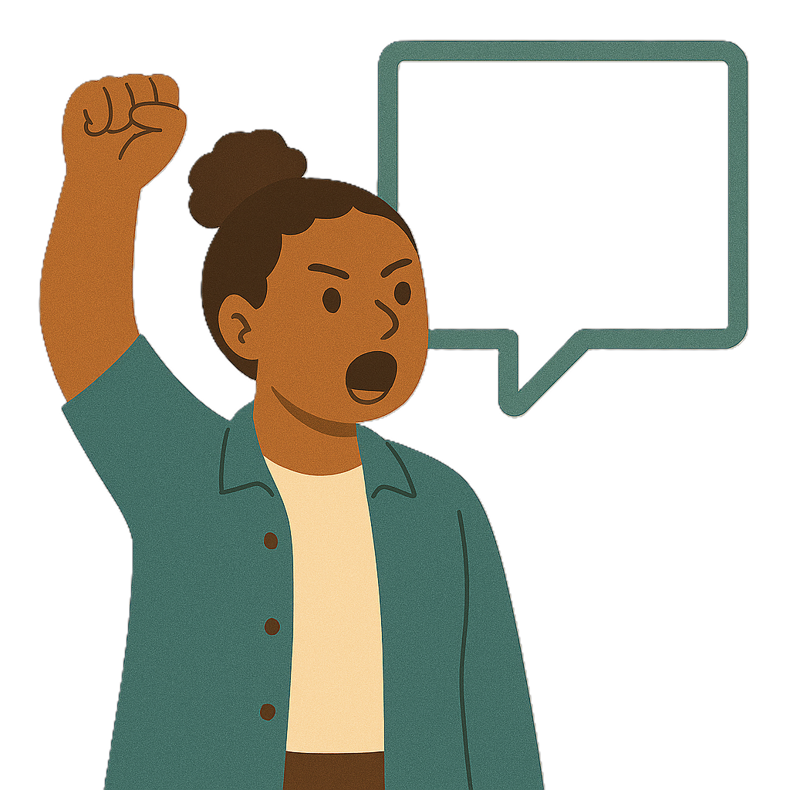 | - Advocates.  An advocate is a person who  - Stands up for people  - Helps people stand up for themselves.
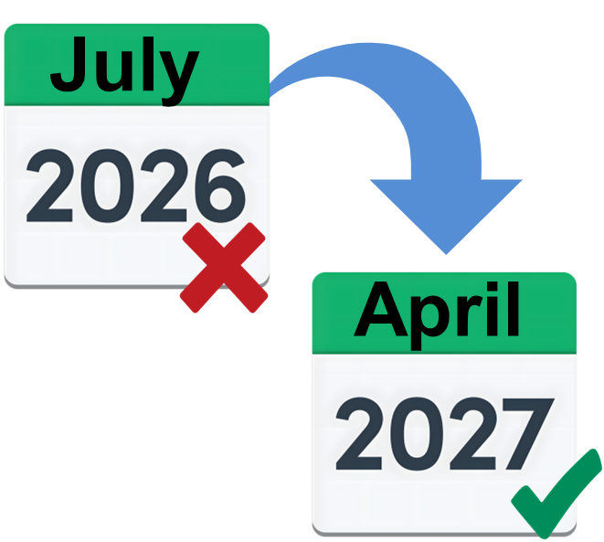 | They told us  - July 2026 is too soon for new framework planning to start.  We have changed when it will start.  Now new framework planning will start on  1 April 2027.
 | This gives us more time to  - Listen to feedback
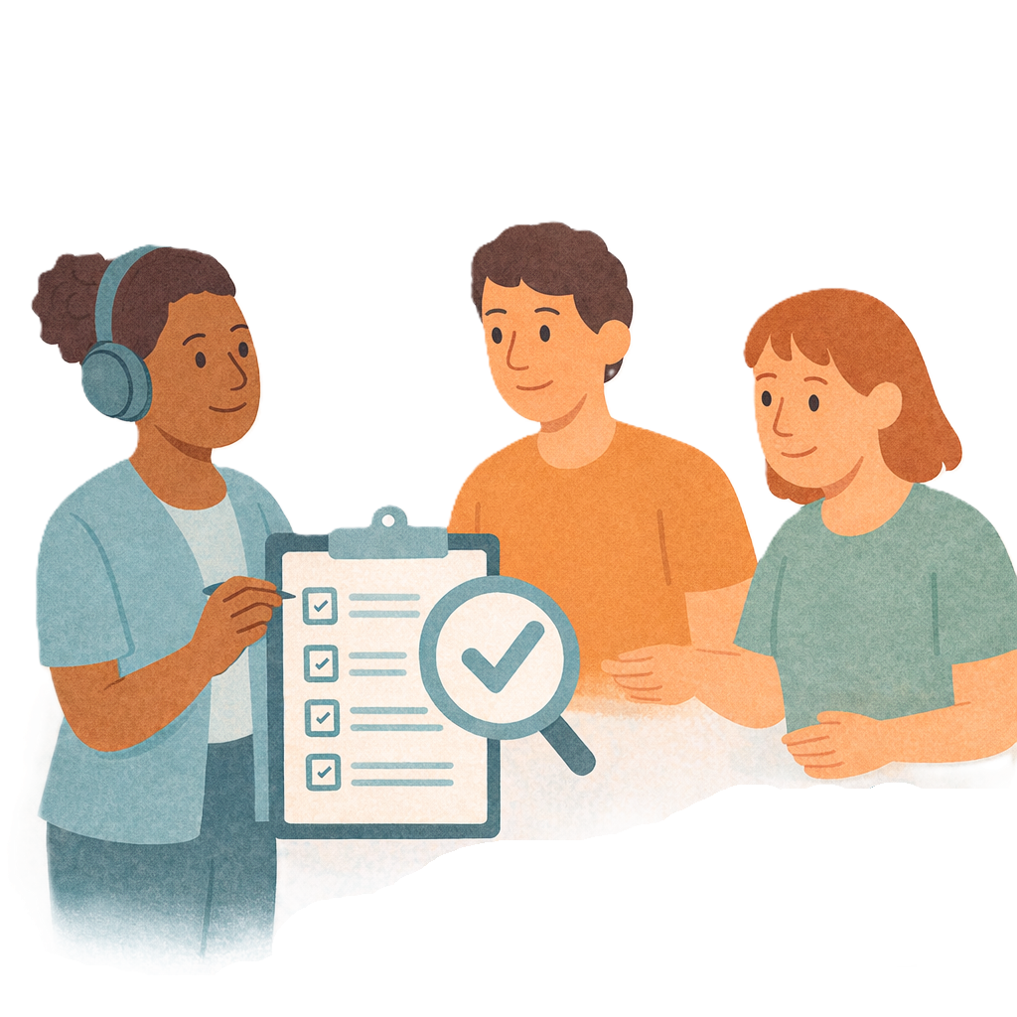 | - Check the rules are right
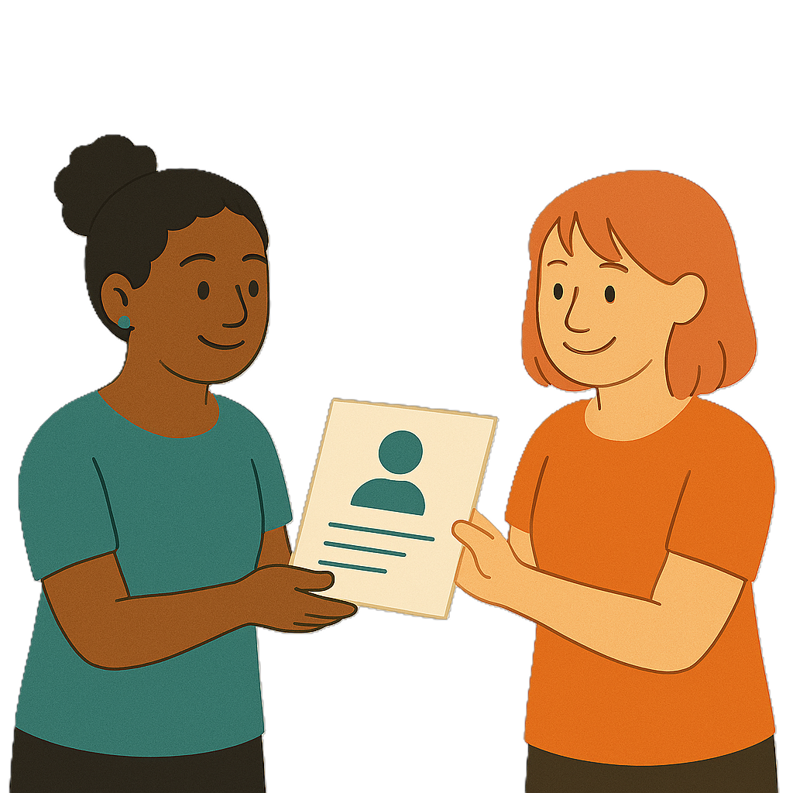 | - Share information on how the changes will happen.
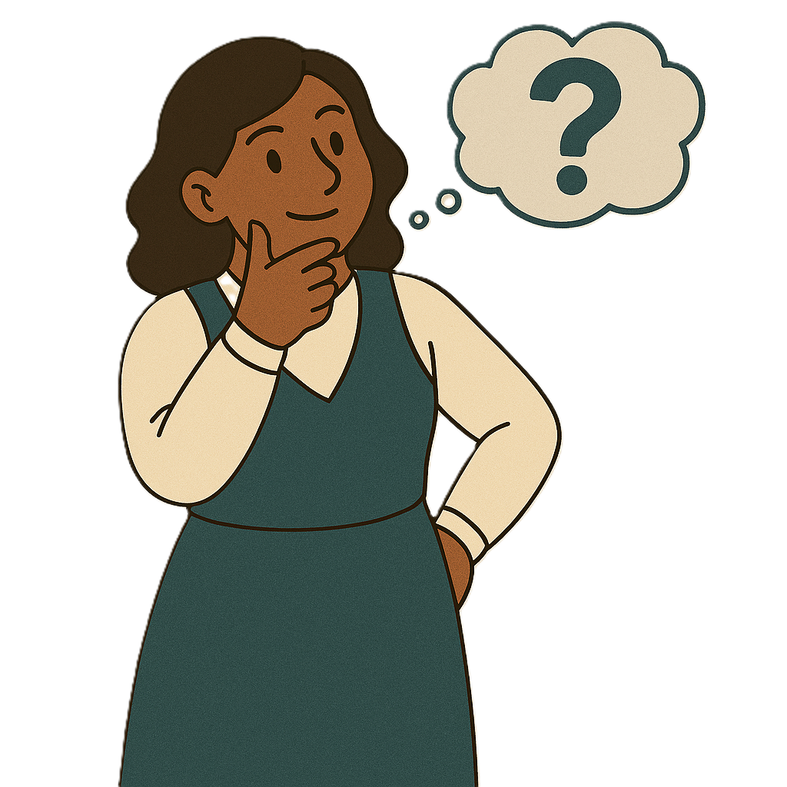 | Later this year we will  - Share more information on new framework planning  - Ask what you think about it.
This includes information about

- Support needs assessments

 | - How budgets are worked out
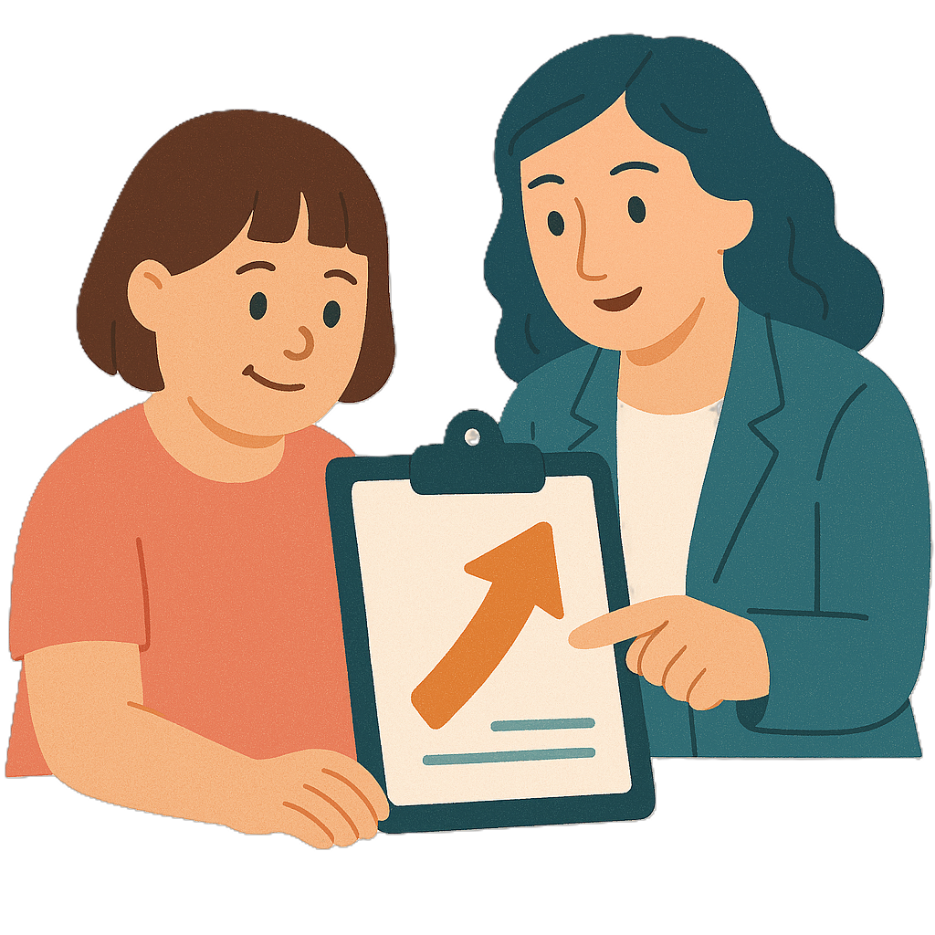 | - How NDIS supports will change
 | - When people can ask for a change in their plan.

Contact us

 | You can contact us if you need more information.
 | You can send us an email to  NDISconsultations@health.gov.au
 | You can look at our website.  www.health.gov.au/our-work/ndis-legislation-changes/rules/framework

Some images in this Easy Read were made using AI.
You must not share or copy any of the images without permission.
August 2026.

