The National Preventive Health Strategy presents a powerful opportunity for Australia to build a sustainable prevention system for the future – building on previous success and momentum, addressing the increasing burden of disease, reducing health inequity and increasing preparedness for emerging health threats.

Ensuring all Australians are living well for longer.

CONSULTATION PAPER: Development of the National Preventive Health Strategy

Contents

Introduction 3
The role of the Strategy 5
Building the Strategy 6
What will the Strategy achieve? 13
The Vision and Aims explained… 14
The Goals explained… 15
The Framework for Action: Achieving the Vision and Aims 16
1. Mobilising a Prevention System 17
2. Boosting Action in Focus Areas 19
3. Continuing Strong Foundations 20
Where to from here? 21

Please note:
- Preventive health is a key pillar of Australia’s Long Term National Health Plan.
- A 10-year National Preventive Health Strategy (the Strategy) is being developed and will be completed by March 2021.
- Significant consultation has occurred to date (see health.gov.au website for further detail) and has led to the development of this Consultation Paper.
- This Consultation Paper draws on evidence from a range of sources and sets out what the Strategy aims to achieve and conceptually, how this might be done in terms of areas of focus and ensuring Australia builds an enduring prevention system.
- The Strategy will not be disease-specific in its approach but rather, it will focus on evidence-based approaches to reducing disease and poor health.
- Feedback on this approach will be used to ensure the Strategy enables all Australians to maintain and be supported to have good health.

Introduction

Good health has intrinsic value for all Australians. The emergence of coronavirus (COVID-19) has highlighted how important health is to our quality of life and overall wellbeing. The year 2020 has required an enormous public health response to protect the lives of Australians and prevent the further spread of COVID-19. However, this response would not have been possible without the collective effort of all Australians. This collective effort has emphasised the interconnectedness of our health; the vulnerabilities of many, become the vulnerabilities of all Australians. When considering Australia’s future, the importance of an agile health system focussed on prevention and equity has proven to be vital.
Health is not just the presence or absence of disease or injury – more holistically, it is a state of wellbeing. More years of good health have significant benefit for the community, enabling all individuals to lead fulfilling and productive lives for as long as possible. In 2017, the Productivity Commission conservatively estimated that improving the health of people in fair or poor health could raise Gross Domestic Product (GDP) by over $4 billion a year.
Australians overall are among the healthiest and longest living people in the world. This is due to a health system ranked amongst the best in the world and because of many effective and sustained disease prevention programs. However, there is no room for complacency. Many Australians are living longer, but are not enjoying optimal health in their later years. Every year millions of years of healthy life are lost because of illness, injury or premature death. On average, Australians live almost eleven years in poor health, or around thirteen percent of their life.
Over the past fifty years, there has been a rise in the burden of disease due to increasing chronic conditions with heart disease, dementia and cancer accounting for the majority of avoidable illness and premature death in Australia. As the burden of disease rises so does the pressure on our health system. Infectious disease and trauma also remain significant contributors to the poor health of Australians. New threats to the health of Australians have also emerged, including an epidemic of obesity, changing weather patterns and different strains of infectious disease.
The impact of poor health is experienced unevenly in Australian communities, with many contributing factors sitting outside of the health system. It is well known that when a community flourishes, its health tends to flourish too - enabling individuals to achieve their potential. This is due to the close relationship between people’s health and the circumstances in which people grow, live, work and age. Generally, people in lower socioeconomic groups are at greater risk of poor health, have higher rates of illness, disability and death, and live shorter lives than people from higher socioeconomic groups⁴. Australia has seen, during the COVID-19 pandemic, the increased health risks of these vulnerable populations.
There are also many groups in society who have greater health needs including Aboriginal and Torres Strait Islander people; those living in rural and remote areas; people with disability; lesbian, gay, bisexual, transgender and intersex people (LGBTI); and those from culturally and linguistically diverse backgrounds. Many members of these groups experience a greater and an avoidable burden of disease compared to the rest of the population⁴.
Without continued vigilance and a sustained focus on disease prevention and health promotion, including on the influences of health, there is a risk that the advances of recent decades could be reversed.
Our health system is focussed fundamentally on the treatment of illness and disease. The National Preventive Health Strategy (the Strategy) will enhance the focus on prevention providing more balance in our health system. It will deliver structures that will greatly strengthen capacity for effective and agile prevention in our health system and beyond, recognising a whole of government response is required and at all level. The Strategy will address the third pillar of Australia’s Long Term National Health Plan and in accordance with the 2020-25 National Health Reform Agreement.
The Strategy will ensure that in Australia:
- children grow up in communities that nurture their healthy development - providing the best start to life;
- individuals are living well for longer, enjoying life as they age – adding health to life;
- those groups with more needs experience greater improvements in health – addressing inequity in health; and
- prevention is valued and viewed as a worthwhile venture – funding is rebalanced towards prevention.
Achieving this, together with other areas of reform (e.g. the Primary Health Care 10 Year Plan, Closing the Gap National Agreement), will be central to creating a healthier Australia.

The role of the Strategy

This will be a strategy for all Australians, no matter who they are or where they live.
The Strategy will provide the overarching, long-term approach to prevention in Australia by building systemic change to ensure the best outcomes for all Australians. It will identify areas of focus for the next 10 years and outline evidence-based approaches to underpin future priorities.
Prevention is complex and the causes of ill health and disease vary from person to person, community to community, health issue to health issue. For example, addressing the complex causes of obesity, reducing tobacco use, or improving mental health requires comprehensive and sustained programs. There are no simple solutions. Approaches need to be adaptable and targeted to meet the different needs of different communities, particularly those communities most at risk. The approaches should take into account the role of physical and social environments (e.g. access to green space, access to a nutritious food supply, sanitation, and supportive community networks), cultural influences (e.g. connection to Country) and emerging threats in the national and international context (e.g. changing weather patterns and infectious disease control). There will also be value in considering additional influences such as the resilience of individuals and communities, which act as protective factors against poor health and wellbeing.
The health of an individual is determined largely by the social, cultural, structural, economic and physical environments experienced throughout life, as well as various individual attributes including genetic make-up. In recognition of this, the Strategy will acknowledge that the health sector must be enabled to both lead by example and foster engagement and collaboration across many other sectors. Effective prevention requires a collective and cohesive effort across sectors to better prevent disease and to promote environments that support individuals to lead healthy lives. The responsibility for creating positive change by 2030 is shared: by all governments, the non-government sector, research and academia, private sector, industries, communities and the individual. Every Australian and every sector has a role to play in achieving the vision that we are healthy and able to lead fulfilling and productive lives for as long as possible. The Strategy will be a collective framework for action.
Ensuring the Strategy will be expert-informed
An Expert Steering Committee (the Committee) was formed in September 2019 to provide advice on the development of the Strategy. The Committee is composed of experts from a range of specialities to reflect the extensive scope of the Strategy, including experts from the public health, health promotion, medical, nursing, allied health and consumer advocacy fields. Representatives of the Committee are listed on the Department’s webpage dedicated to the Strategy at https://www1.health.gov.au/internet/main/publishing.nsf/Content/national-preventive-health-strategy.

Building the Strategy

Drawing from what we have heard, what we have learned and what we know already works.
The Strategy is being developed using the best evidence from a range of sources including:
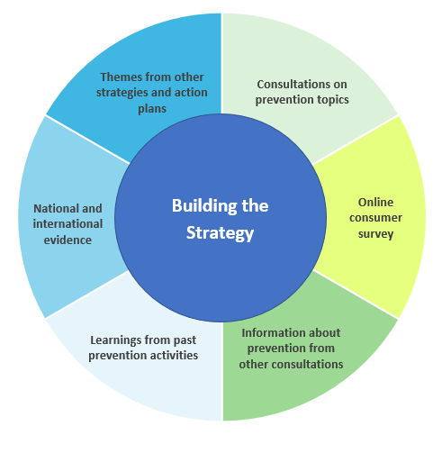
- National and international evidence about what works.
- Targeted consultations, which have provided the opportunity to hear from experts in different fields of prevention; the views of people representing consumer groups and advocacy organisations; and from the public about what is important to keep themselves, their families and their communities healthy.
- Responses from over 6,000 people through an online survey.
- The lessons learned from past prevention activities.
- Other relevant national strategies, action plans and frameworks to ensure the Strategy aligns with and builds on action in prevention.
- Relevant health consultations conducted by the Australian Government in recent years.

Australia’s Long Term National Health Plan outlines a number of areas of reform, including the development of the Primary Health Care 10 Year Plan and the National Aboriginal and Torres Strait Islander Health Plan. These strategies and plans will be considered in the development of the Strategy to ensure there is a consistent and complementary approach to reform.

Through the consultations, we have heard from thousands of Australians and experts about the barriers to staying healthy and we have heard about the possible solutions.
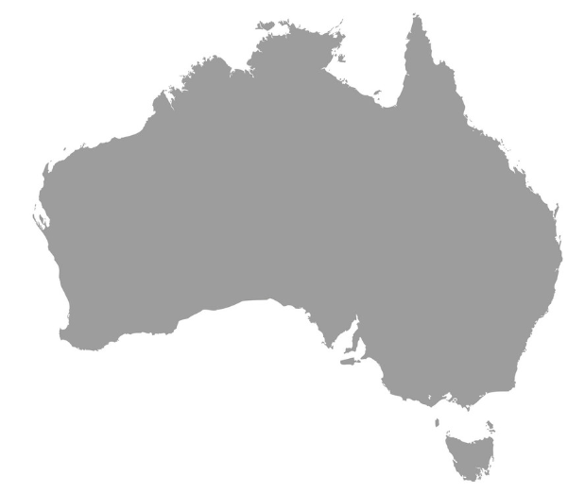
Since September 2019, we have engaged with over 6,000 people
Primary Health Networks
Researchers
Community organisations
Food industry
The public and consumers of the health system

Public health experts
Advocacy organisations

State, territory and local governments
Medical, nursing and allied health
professionals

Healthy food is expensive and there is not enough public transport in my area.
Consultation is integral to the development of the Strategy to ensure the views of public health experts, key stakeholder groups and the public are well represented in the Strategy. Organisations representing population groups who experience an unfair burden of disease attended these workshops including Aboriginal and Torres Strait Islander people. To date, consultation has consisted of a series of topic-specific workshops and a national consumer survey.
Eight topic-specific consultation workshops were held between October 2019 and January 2020, as outlined in Table 1. We heard from experts in prevention, including representatives from government, non-government organisations, research groups, medical, nursing and allied health professionals, primary health networks, professional organisations and consumer groups.
Long term funding is needed to transform the scale, scope and impact of delivering prevention in Australia. Without it, the economic burden of disease will continue to rise.
The workshops engaged with participants to share their vision for the Strategy, the important inclusions and their priorities for the future.

Table 1 - The Consultation Workshops conducted to date
Consultation Workshop topic | Date and location of workshop
Cancer screening | 14 October 2019, Sydney
Nutrition and physical activity | 30 October 2019, Sydney
Prevention, tackling risk factors | Two workshops - 6 November 2019, Melbourne
Research | 7 November 2019, Melbourne
Tobacco | 8 November 2019, Melbourne
Rural & remote health (prevention in primary care) | 19 December 2019, Adelaide
Education and health literacy | 30 January 2020, Sydney
Intervening early is a key to successfully preventing disease and we need to be better at it.
A national consumer survey “Living Well for Longer” was open to the public from 19 December 2019 to 14 February 2020. The survey asked for people’s views on their health priorities; what was important to them in being or staying healthy; and what would help them to take better care of their health.
The survey results highlighted the most important health-related priorities were mental wellbeing, maintaining physical health and independence.
Healthy food was seen as the most important influence on good health with the cost and accessibility of healthy food choices identified as the most significant barrier to good health. People participating in the survey also identified smoking as an important influence on health outcomes.
Consumers are overwhelmed and confused by the sheer volume of health information available. They do not know who to trust or where to go for information.
When considering the sources of health advice, participants indicated that doctors, pharmacists and the internet were the main sources they turned to for information. Doctors were viewed as trustworthy, while the internet was not viewed as reliable.

Australia is a world leader in prevention – we should celebrate our successes & acknowledge that improving population health is an incremental and long-term approach.
Our past success in prevention
Australia is recognised as an international leader in prevention, particularly our experience in tobacco control, our response to the HIV epidemic, our introduction of national cancer screening programs, and our innovation in immunisation.
There is much that we can learn from our past success to guide our future strategy. Success in prevention has not come by chance and there is no one solution or approach. It has involved sustained commitment by governments, passionate non-government organisations, community members and a determined response by members of the public. It has also involved sustained, multi-sector approaches to achieve long-term success.
So many factors that affect our health lie outside the health system. We need a whole-of-government approach.
Figure 1 outlines the success Australia has had in reducing tobacco use and the number of Australians smoking. This important example demonstrates the need for a continuous, comprehensive approach. Success was achieved through a range of interventions including taxation, indoor and outdoor smoking bans, and product regulation as well as support from health services and public education campaigns. The implementation of these strategies, combined with high quality evaluations and data from continuous monitoring, is widely seen as a case study for achieving sustained public health outcomes.
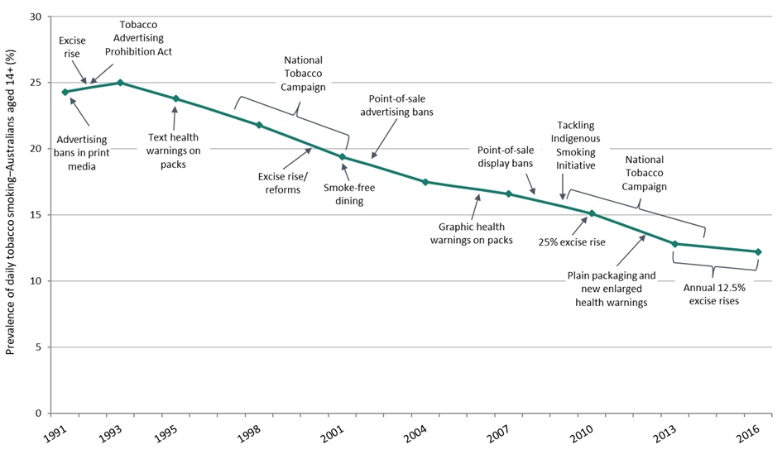
Figure 1 - Prevalence of daily tobacco smoking in Australians aged >14 years old
Source: Tobacco in Australia, Facts and Issue Introduction & Chapters 11, 11A, 13, 14 & 15 and National Drug Strategy Household Surveys, 1991 to 2016, AIHW 2017

Drawing together consultations, previous strategies and lessons from the past, we have learned
Success comes from sustained and coordinated action: Solving complex public health challenges is not easy. Our experience in reducing tobacco use, in HIV prevention and in reducing road traffic injuries has demonstrated the importance of combining different forms of government action with meaningful engagement from many sectors, to achieve incremental change. This includes non-government organisations and communities underpinned by sustained public education.

Healthy environments support healthy living: Several factors are critical to enabling people to lead healthy lives. These include: the way our cities and neighbourhoods are planned; environmental factors such as weather events and air quality; commercial influences; availability and access to healthy food choices; and safe environments for physical activity in our communities. Creating supportive and enabling environments for health is a collective responsibility of communities, individuals, organisations, governments at all levels, the private sector and industry.
We need to ensure our efforts meet the needs of those suffering the most; health inequities exist and people are being left behind.

Health is for all Australians: Some groups in our community have poorer health or particular health needs– including Aboriginal and Torres Strait Islander people, those experiencing social and economic disadvantage, those living in rural and remote areas, people with disability, LGBTI people, and those from culturally and linguistically diverse backgrounds. Responding to the needs of these groups requires whole of population initiatives, policies and programs, complemented by additional support for those with the greatest need. We have learned that a co-design approach with communities in the development, delivery and evaluation of services produces the best outcomes.

Success builds on the things that work: Prevention efforts should be based on the best available evidence and we should learn from success and failure.

The health sector is enabled to lead by example: The health sector in Australia should be enabled to make the most of every opportunity to improve prevention to create supportive and enabling environments for health. This should be done both within the health system and through partnerships with other sectors.

Data, research and evidence are important drivers: We know a great deal about what works in prevention, but still have much to learn – especially in designing effective interventions for populations with the greatest need. There is a need to develop capacity, tools and networks to support prevention research and strengthen research-policy pathways.

The Strategy can support existing national strategies and plans: There are significant commitments to prevention in existing national strategies and plans. The Strategy will focus on creating an overarching structure as well as system enablers that will achieve greater alignment to these plans – this will achieve a more sustainable and effective health system overall.
Compared to other countries, Australia does not spend enough trying to prevent disease. We need to be more proactive and develop long-term, sustainable solutions.

Adapting to the future: A long-term strategy should be adaptable and responsive to emerging issues, and the benefits and impacts of evolving technology – such as infectious diseases and personalised medicine.

The previous sections of the Consultation Paper have highlighted the key themes and learnings that have contributed to the development of the following sections. The subsequent pages outline key concepts for the National Preventive Health Strategy, and we value your feedback on these elements.

What will the Strategy achieve?

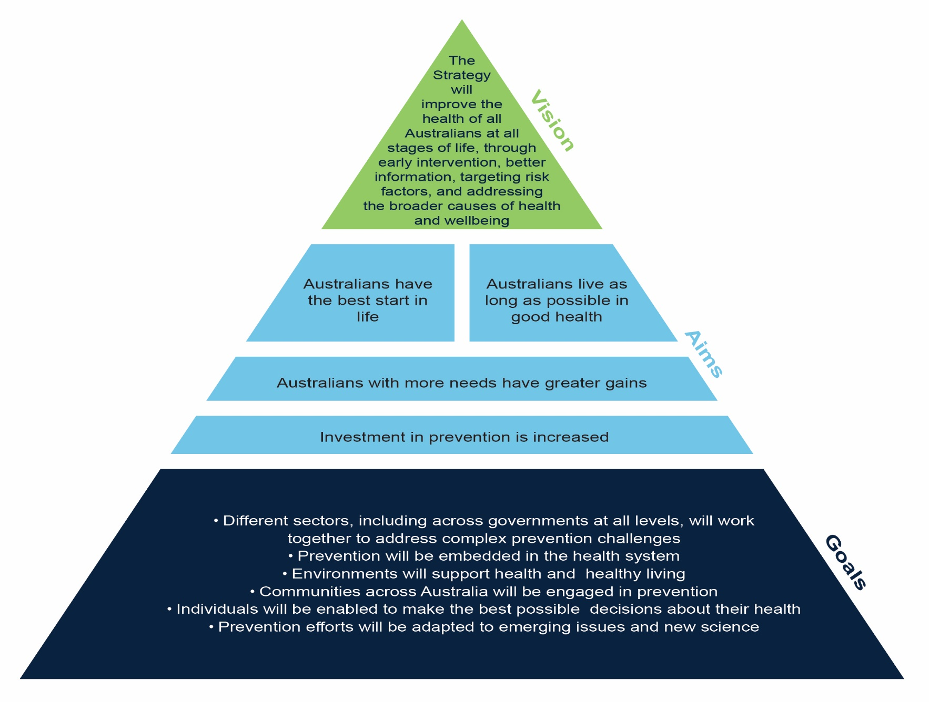
Australians are healthy, and able to lead fulfilling and productive lives for as long as possible.

Are the vision and aims appropriate for the next 10 years? Why or why not?

The Vision and Aims explained…

The Strategy will be designed to improve the health of all Australians at all stages of life, through early intervention, better information, targeting risk factors and addressing the broader causes of health and wellbeing. The Strategy will include targets for each aim, so that we can monitor our progress in improving the health of all Australians.
The Strategy will aim to ensure:
- Australians have the best start in life
The Strategy will recognise the value of a life course approach, which emphasises the significance of prevention in the early years of life. We have heard the importance of preventing infectious disease and injuries in childhood and of supporting children at risk in order to create strong foundations to prevent of chronic conditions in later life.

- Australians live as long as possible in good health
A strong focus on preventive health and health promotion can extend the quality of life and life expectancy of Australians. We have heard that opportunities for prevention change as individuals’ age and the Strategy should support action to prevent infectious disease, injuries and chronic conditions across the life-span.

- Australians with more needs have greater gains
The burden of ill health is not shared equally amongst Australians. We heard the Strategy should result in greater gains for parts of the Australian community who are burdened unfairly due to personal circumstances. Furthermore, there needs to be a focus in the Strategy on reducing inter-generational health disadvantage.

- Investment in prevention is increased
Our health dollars are spent primarily on the treatment of illness and disease. The consultations have indicated the need to significantly enhance investment in prevention in order to achieve a better balance between treatment and prevention in Australia, as outlined in Australia’s Long Term National Health Plan.

The Goals explained…

The Strategy will focus effort on the following six goals by 2030, prioritising effort for those with greater needs including in rural and remote locations.

- Different sectors, including across governments at all levels, will work together to address complex prevention challenges
Action by different sectors will be coordinated and aligned, to support integrated solutions to complex prevention challenges.
- Prevention will be embedded in the health system
Our health sector will lead by example and make the most of every opportunity to support prevention in our primary, community and acute care settings.
- Environments will support health and healthy living
The environments in which people live, work, learn and play will better enable individuals to be healthy and live productive and fulfilling lives for as long as possible.
- Communities across Australia will be engaged in prevention
Communities, including neighbourhoods, cultural and social groups, workplaces, schools and interest groups, along with non-government organisations will be engaged as partners to improve the health of Australians – this includes place-based approaches.
- Individuals will be enabled to make the best possible decisions about their health
Australians from all backgrounds will have the options, knowledge and skills to make the best decisions about their health and the health of their families.
- Prevention efforts will be adapted to emerging issues and new science
Emerging issues and new science will be reviewed continuously to ensure prevention efforts are focused on opportunities that achieve the greatest health gains.

Are these the right goals to achieve the vision and aims of the Strategy?
Why or why not? Anything missing?

The Framework for Action: Achieving the Vision and Aims

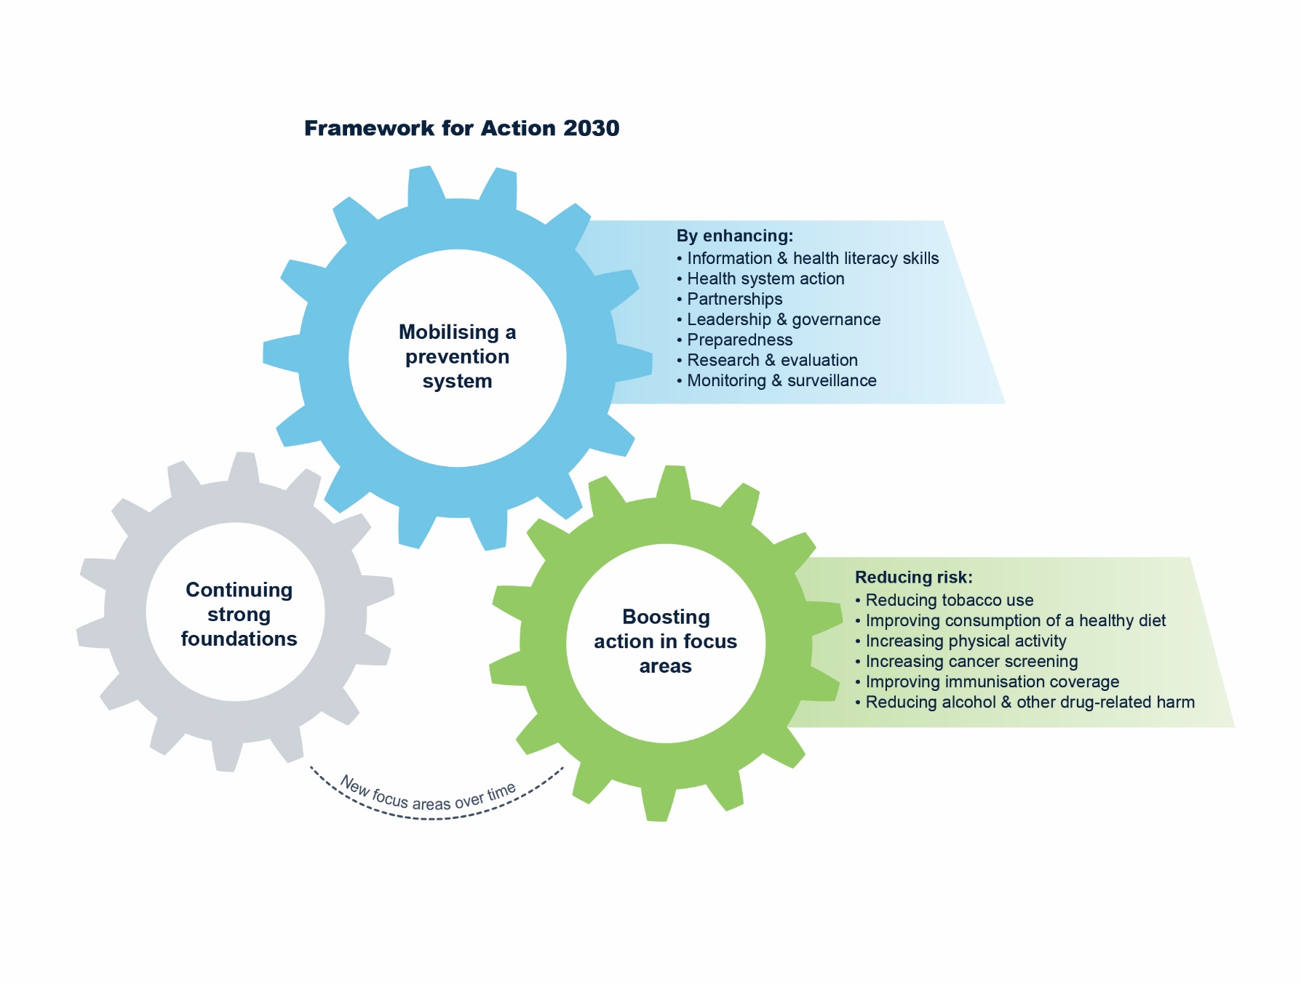
The Framework for Action (the Framework) will be the foundation of the Strategy, providing the strategic and structured approach to achieve better health by 2030. The consultations indicated the greatest benefit from this Strategy will come from connecting and integrating existing work in order to provide a more coordinated national approach. The Framework will better support work already underway across Australia to deliver outcomes in the early years and throughout life, and to those with greater health needs.
Through implementation of the Framework, the Vision, Aims and Goals of the Strategy will be achieved.

The Framework is composed of three interlinked elements:
- Mobilising a prevention system – the key driver for achieving systemic change and better health outcomes.
- Boosting action in focus areas – accelerating action in priority areas adaptable to need.
- Continuing strong foundations – acknowledges work under way and the importance of sustained action.
Currently, the Framework for Action does not include specific actions. Your feedback will be used to generate key actions in each element of the Framework.

1. Mobilising a Prevention System

One of the strongest themes from the consultations was that action is required to enhance and expand existing prevention action (the prevention system). Feedback consisted of the need for strong leadership, effective governance arrangements, mechanisms to create and sustain partnerships, drivers of action within health and other sectors, and well targeted programs to build health literacy. A high functioning prevention system is crucial and will improve partnerships; ensure our efforts are evidence-based; build capacity within communities; empower individuals; embed continuous improvement; and adapt to emerging issues. This will accelerate the health and wellbeing of Australians and create a sustainable, resilient and efficient approach for the future.
The Strategy will focus on seven enablers to create a more effective and integrated prevention system. Workforce underpins all seven enablers in mobilising a prevention system. It was highlighted during consultations that building the capacity and capability of the workforce, both current and emerging, will be integral to achieving success.
Information and literacy skills
The Strategy will enable all Australians to have access to high quality, evidence based information about how to stay healthy, in a form that is easily understood and actionable.
We have heard there is a need for high quality, credible and accessible health information that is useful to all Australians. We have also heard that populations in greatest need should be a major focus, ensuring the information is culturally appropriate and relevant to the target audience. There is also a need to help Australians acquire practical transferable skills to understand which information to trust and to improve their health literacy. There is also a need to recognise and support the role of the workforce in supporting consumer access to information and health literacy development.
Health system action
Consultations indicated a need to reorientate the health system to promote health, which includes embedding prevention as part of routine health service delivery including in primary health care, hospitals, and community health services.
Partnerships
We have heard the importance of partnerships between a range of sectors with greater cooperation between these sectors leading to more successful individual and system outcomes.

The Strategy recognises that action across many sectors will be required to improve health. The health sector must be enabled to play a lead role in building partnerships for prevention across sectors to address the social, economic, cultural and environmental influences on health.

Consistent with the WHO Global Action Plan for the Prevention and Control of Non-communicable diseases (NCD’s), public health policies, strategies and multi-sectoral action for the prevention and control of NCD’s must be protected from undue influence by any form of vested interest. Real, perceived or potential conflicts of interest must be acknowledged and managed.

Leadership and governance
The Strategy recognises the need for strong leadership across all levels of government to create an authorising and supportive environment for prevention.
In order to address the complex challenges in prevention, we have heard that the success of the Strategy will be influenced by an increased, long-term sustainable funding mechanism. Parallel to this, a structured governance approach is required to determine the priorities for action, evaluate the evidence, monitor emerging issues and enhance cross-sectoral collaboration.
Monitoring is a key component of leadership and governance. The implementation of the Strategy will require a continuous improvement approach to achieve its targets and to ensure there is a focus on what is working.
Preparedness
The emergence of COVID-19 has highlighted the importance of having an agile and flexible health system in order to enhance Australia’s response to large-scale emergencies that impact our health. Having an adaptable health system will ensure that processes and systems can continue to pivot in the face of new threats, enabling the prevention system to endure and therefore reducing the impact and burden on individuals.

The Strategy recognises that greater strategic preparedness and planning within the health system, including workforce capacity, is required. In particular, the experience of COVID-19 has also exacerbated the fact that those who are most vulnerable in society are those who feel the impact of a population-wide public health emergency the greatest. Consequently, when enhancing preparedness and preventive health efforts, a health equity lens must be applied.
Research and evaluation
Research and evaluation can help us understand future opportunities to achieve better health outcomes.

The consultation workshops highlighted the need for enhanced sharing of information on best practice interventions so we know what works and opportunities are provided to expand the intervention and its benefits to a wider population. We have heard that more localised research is needed to inform targeted approaches to prevention. There is a need for stronger partnerships between researchers and policy makers to improve the translation of evidence.
Monitoring and Surveillance
We have heard the importance of having access to key data on diseases and risk factors, which includes understanding trends in how they may be evolving over time.
To inform prevention policy and practice, it is essential to have a widely accessible health monitoring and surveillance system that is reliable and provides data in a timely manner. We have heard that studies such as the Intergenerational Health and Mental Health Study (IHMHS) will be vitally important in guiding future efforts in prevention.

Are these the right actions to mobilise a prevention system?

2. Boosting Action in Focus Areas

There are many ways to reduce risk to help Australians live longer and healthier lives. We have heard there is value in identifying a small number of national focus areas, where a stronger and better-coordinated effort will enable accelerated gains in health, particularly for communities experiencing an unfair burden of disease. We have certainly seen, during the COVID-19 pandemic, that many individuals with chronic conditions and/or other vulnerabilities become more at risk of poorer outcomes.
Six focus areas have been identified to boost prevention action in the first years of the Strategy and to impact health outcomes across all stages of life:
- Reducing tobacco use
- Improving consumption of a healthy diet
- Increasing physical activity
- Increasing cancer screening
- Improving immunisation coverage
- Reducing alcohol and other drug-related harm
Accelerated action in each of the focus areas will significantly decrease the overall burden of disease in Australia. Many of these focus areas already have national strategies and plans to guide action and the Strategy will enable, prioritise and build on these efforts. While participants in the consultations highlighted there were many opportunities to improve prevention, overall there was agreement about the importance of these specific focus areas in order to achieve the vision of the Strategy.

Where should efforts be prioritised for the focus areas?

3. Continuing Strong Foundations

During consultations, we heard about many effective and well-designed prevention-based programs and strategies developed by government, non-government organisations and communities. This element of the Framework acknowledges the immense activity that is already under way to better prevent illness and disease in Australia. The importance of continuing and building on current prevention activity, and the importance of sustained action were discussed in many consultations, in areas such as mental health and wellbeing, injuries, oral health and sexual and reproductive health.
The Strategy will include actions designed to continue and improve on the strong foundations already in place across Australia. It will enable enhanced delivery of existing strategies and plans through a stronger and better-coordinated prevention system.
The Framework has been designed to be responsive and adaptable over the 10-year period of the Strategy. The Framework allows for the creation of new focus areas to boost responses to emerging health issues.

How do we enhance current prevention action?

Where to from here?

Feedback and submissions received as part of this Consultation Paper will be collated and analysed, and used to inform the development of a draft version of the Strategy. There will be further public consultation in the coming months providing all Australians with the opportunity to comment on the draft version of the Strategy.
Updates to public consultation will be published on the National Preventive Health Strategy webpage, which can be found on the Department of Health’s website: https://www1.health.gov.au/internet/main/publishing.nsf/Content/national-preventive-health-strategy.
If you have any questions or comments about the Strategy or the consultation process, please contact nphs@health.gov.au.

Productivity Commission 2017, Impacts of Health Recommendations, Shifting the Dial: 5 year Productivity Review, Supporting Paper No. 6, Canberra
Australian Institute of Health and Welfare 2020. Australia’s health 2020: in brief. Australia’s health series no. 17 Cat. no. AUS 232. Canberra: AIHW
Productivity Commission 2017, Why a Better Health System Matters, Shifting the Dial: 5 year Productivity Review, Supporting Paper No. 4, Canberra.
Australian Institute of Health and Welfare 2019. Australian Burden of Disease Study: impact and causes of illness and death in Australia 2015. Australian Burden of Disease series no. 19. Cat. no. BOD 22. Canberra: AIHW.

