1. Purpose
The Australian Government is committed to making sure Australians have transparency, choice and affordable access to private specialist medical care. However, we know Australians are paying increasing fees to see medical specialists, and many are delaying or missing care as a result. One particular concern is the small minority of providers who may be charging excessive fees for these essential health care services.
The Department of Health, Disability and Ageing has published a detailed public consultation paper on options to address excessive specialist fee charging. The paper examines the data on specialist fee variation and presents options to protect patients from excessive fees. This executive summary provides an overview of issues discussed in that paper. This paper is not proposing regulation of fees that are not excessive.
The options outlined in this paper do not represent government policy and are provided to facilitate feedback from patients, providers, and other interested parties. Further information on other consultations being undertaken to address specialist affordability can be found on the department's website.
We invite consumers, providers and other interested parties to anonymously provide your views on addressing excessive specialist fees by completing our online survey on Consultation Hub and/or to submit any additional comments via email to specialistaffordability@health.gov.au. This consultation will close at 12pm on Monday 19 October 2026.

2. Scope of the consultation paper
In scope
For the purposes of the consultation paper unless otherwise indicated, specialist general practitioners are referred to as GPs, and non-GP specialists and consultant physicians are referred to as “specialists”. “Specialist services” as captured in the data used for the paper can sometimes also be delivered by GPs and other eligible health professionals.
Details of in scope services are provided in Appendix A of the full consultation paper.
Out of scope
Specialist affordability is a complex issue with interactions across many policy areas, including those outlined below. However, as this paper focusses only on the prevention of very excessive fees, rather than broader affordability issues, these issues are not discussed in the paper.

3. Why is Government concerned about specialist fees?
While the focus of this paper is on excessive fees, it is useful to note the broader context of concerns over specialist fees. There is significant community concern about the rising cost of health care, particularly specialist care. These concerns are reflected in Medicare data. In 2025, Australians spent $4.17 billion out-of-pocket on out-of-hospital specialist services, an increase of 75.8% since 2019. This equates to approximately $458 in out-of-pocket costs per person, among those who accessed out-of-hospital specialist services where an out-of-pocket fee was paid. In-hospital gap payments for privately insured stays increased by 72.2% in the same period, with a median medical gap of $323 per episode in 2025.
The increase in specialist out-of-pocket costs over recent years has significantly outpaced general price growth. For example, the average out-of-pocket for an initial specialist consultation increased from $94.72 in 2016 to $158.75 in 2025 (Figure 1). This equates to a 67% increase in out-of-pocket costs. By comparison, the Consumer Price Index (CPI) rose by 32% over the same period.
Figure 1. Growth in CPI compared to the average out-of-pocket costs for two specialist consultation items.
2016: $94.72
2016: $95.27
2026: $158.75
2026: $153.34
Note: MBS data shown is for item 104 (initial specialist consultation) and item 110 (initial attendance of a consultant physician), out-of-hospital, patient billed services only.
While Government is concerned about the impact of this general increase in specialist fees on affordability, the particular area of concern being considered in this paper is the charging of what may appear to be excessive fees by a small minority of providers on top of these general fee increases.

4. Defining excessive fees
Individuals’ perception of whether a fee is excessive will vary significantly. Financial circumstances, personal judgements, past comparable experiences and awareness of service input and practice overhead costs will all factor in whether a patient or provider considers a fee to be excessive. There is no agreed definition of excessive specialist fee charging.
To appropriately target an initiative to reduce excessive fees, a definition of excessive will need to be considered. Table 1 provides an overview of three potential methods for defining excessive fees. For a detailed consideration of these options see Section 4 of the full consultation paper.

Table 1. Overview of the options to define excessive specialist fees.
Definition option | Description
Reasonableness | Fees are deemed excessive based on a subjective case-by-case assessment of fee charging. Considerations may include the time required to undertake a service, input costs, relative complexity of a service or patient, or the circumstances where a service is provided.  Assessing ‘reasonableness’ in an individual case would need to be an ‘after the case’ assessment, assessed in response to a complaint or government agency review/audit activity. It would not define with certainty what is excessive but would allow flexibility in considering individual cases.  A similar approach is being used in the Support at Home aged care program.
Peer comparison – Multiple of median market fee or top X% of market fees | Fees are deemed excessive based on how far they vary from the market rate. This provides a consistent approach for defining excessive fees and accounts for the distribution of fees according to the market, providing a basis for identifying outliers. It could be based on:  - how far it varies from the median fee (e.g. if a fee is more than X times the median fee charged for that item).  - if it is among the highest fees charged for that item (e.g. the top X% of fees).  This option identifies those charging excessively compared to their peers. However, it does not take into account whether the median itself is reasonable. For example, if all or a great majority of providers are charging fees for an item which most people might consider ‘excessive’ this concern would not be addressed under this definition.
Benchmark comparison – Multiple of MBS Schedule Fee | Fees are deemed excessive based on how they vary from the MBS Schedule Fee. This provides a consistent approach for defining excessive fees and takes advantage of an existing published reference point. This reference may result in some providers being considered excessive chargers in certain cases where current market pricing is noticeably higher than the MBS Schedule Fee. Using the median market fee or percentile-based definitions discussed above to define excessive rather than the MBS Schedule Fee may better address this concern.  Assessing whether fees are excessive based on a benchmark comparison provides a clear definition of excessive. However, there may be situations where there are explanations for apparently excessive fee e.g. patient complexity in a particular case. It also does not consider whether there are market pressures which influence provider pricing decisions.  In Special treatment: Improving Australians' access to specialist care, the Grattan Institute defines three times the MBS Schedule Fee on average as excessive.

4.1 Challenges defining excessive fees
The three methods highlight some of the challenges in developing a consistent approach to defining when a fee should be deemed excessive.
- Statistically based definitions (such as comparisons to MBS or median market fees) provide a consistent way to define excessive that can be easily operationalised but could result in a fee being unfairly labelled as ‘excessive’ or some fees that may be ‘excessive’ not being defined as such.
- A reasonableness definition allows greater consideration of individual circumstances but does not apply a clear definition for patients, providers or regulators, making understanding, compliance and regulation more difficult and resource intensive.
These challenges do not mean that development of a definition should be abandoned. Rather, it demonstrates that a combination of approaches, greater nuance or additional criteria may be necessary.
5. Excessive fee charging trends, drivers and impacts
5.1 Fee variation and evidence of excessive fees
While the Government sets MBS Schedule Fees and benefits, private specialists are free to set their own fees above these amounts. Many providers recognise their ethical obligation to ensure the fees they charge are reasonable. However, analysis of the fees charged by providers indicates there are providers who are charging fees that are significantly higher than their peers.
When comparing the fees charged by specialists in 2025 against the median fees charged by all providers for the same item (Figure 2), the department found:
- More than 450,000 (1.1%) of in-hospital specialist services were charged with fees between 3 and 5 times the median total fee charged, and more than 260,000 (0.7%) were charged with fees more than 5 times the median.
- More than 1.6 million (0.7%) of out-of-hospital specialist services were charged with fees between 3 and 5 times the median total fee charged, and more than 220,000 (0.1%) were charged with fees more than 5 times the median.
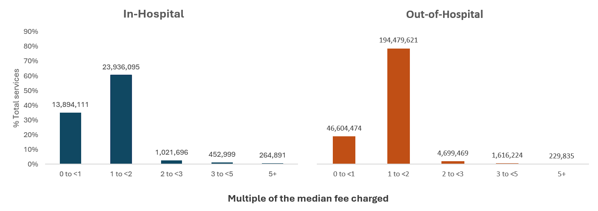
Figure 2. Specialist services charged at multiples of the median fee, in- and out-of-hospital, including bulk billed services, 2025.

This pattern of high fee charging in a small, but significant minority of services is also apparent when fees are compared to the item’s Schedule Fee rather than median fees (Figure 3). In 2025:
- More than 1.5 million (3.9%) of in-hospital specialist services were charged with fees between 3 and 5 times the Schedule Fee charged, and more than 690,000 (1.8%) were charged with fees more than 5 times the Schedule Fee.
- More than 4.5 million (1.8%) of out-of-hospital specialist services were charged with fees between 3 and 5 times the Schedule Fee charged, and more than 550,000 (0.2%) were charged with fees more than 5 times the Schedule Fee.

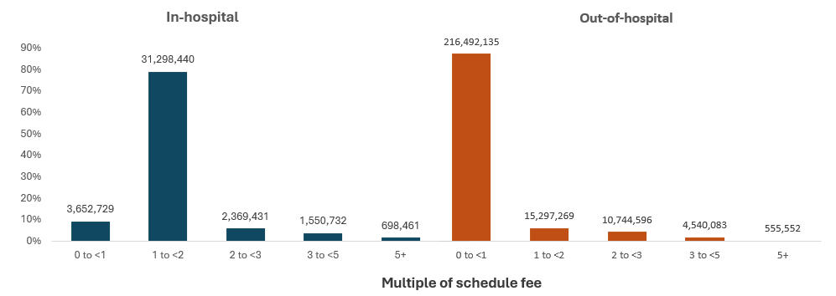
Figure 3. Specialist services charged at multiples of the Schedule Fee, in- and out-of-hospital, including bulk billed services, 2025.
Are patterns of fee charging the same across specialties?
There is substantial variation in billing behaviour both within and across specialties which can be driven by a range of factors. Figure 4 on page 8 shows that the proportion of services with greater variance from the median fee are not the same across specialties. In the detailed paper a comparison is also made to the MBS fee which shows that specialties identified as potentially high fee charging are also influenced by the choice of comparator. For example, some specialties have a low number of fees identified as excessive when compared to the median, but a high number of fees identified as excessive when compared to the Schedule Fee.
An important consideration when assessing whether fees may be excessive is the impact of MBS item modifiers on total fees. Modifiers are part of the MBS system and can be billed in conjunction with some procedural items to account for selected time or complexity factors. For example, modifier items are commonly billed in association with the administration of anaesthesia to account for certain complexities/procedure length. This practice may explain the high observed variations in median and schedule fees observed in some cases.

5.2 Impact of excessive fees on patients
Rising fees are increasingly putting specialist care out of the reach of many Australians. The Australian Bureau of Statistics (ABS) Patient Experiences Survey found 8.6% of people aged 15 years and over, more than 1.9 million people, delayed or did not see a specialist due to cost in 2024-25. Delaying specialist care may increase the risk of deterioration, crisis presentations, preventable hospitalisation, and place greater pressure on other parts of the health system.
Excessive fees can also have a cumulative financial burden on some patients, particularly those with chronic disease or those receiving an intensive course of multiple high cost treatments. In 2025:
- more than 23,000 in-hospital patients and more than 84,000 out-of-hospital patients had three or more services with fees exceeding three times the median total fee.
- more than 129,000 in-hospital patients and more than 347,000 out-of-hospital patients had three or more services with fees exceeding three times the Schedule Fee.
5.3 Factors contributing to excessive fee charging
The capacity for providers to independently set fees has facilitated the practice of price differentiation, where providers can charge varying amounts for identical services. There are benefits to this as it allows providers to adjust fees to account for genuine variation between services, however in the supply constrained specialist market it has also enabled excessive fee charging.
Factors that can contribute to fee variation are listed below, a discussion of these is in Section 5 of the full consultation paper.
- Variability in patient complexity or comorbidities.
- Variability in clinical practice between specialities.
- Variability in business operating costs including due to location of a practice.
- Prescence of local competition, including public services.
- Provider experience, especially if a provider is highly specialised within their field.
- Perceived quality or skills of a provider (by either providers or patients).
- Patient use of price as a quality signal (which can inadvertently legitimise or encourage excessive fees).
- Information asymmetry between providers and patients, particularly in deciding who to seek specialist care from.
- Private health insurance status and associated no and known gap arrangements.
- Patient eligibility for the Extended Medicare Safety Net (EMSN).
- Patient capacity to pay, where providers engage in altruistic billing (where providers bulk bill those unable to pay and cross-subsidise these fees with other patients).
- Inelastic demand for health care services, especially where patients have life limiting or time sensitive conditions.
5.4 Case for Government intervention
The combined effect of limited transparency, the imbalance of power between the provider and patient, and excessive fees is compromising the access to and affordability of specialist services. While high prices can be a natural outcome of any market with limited supply and high demand, there are significant ethical considerations which bear consideration in a market that is delivering an essential health good subsidised by the Government.
There are some risks to any Government intervention in the specialist market. However, based on the observed fee distributions the existing professional standards and frameworks for ethical billing are not preventing excessive fee billing behaviour and it can have a significant cost impact on patients.
Given the essential nature of specialist services, market features that make it unlikely to self-correct and the trajectory of current fees, there is a strong case for Government intervention on excessive fees. Curbing excessive fees will help protect patients from the minority of providers who have used the unique features of the specialist market to charge unreasonable fees.

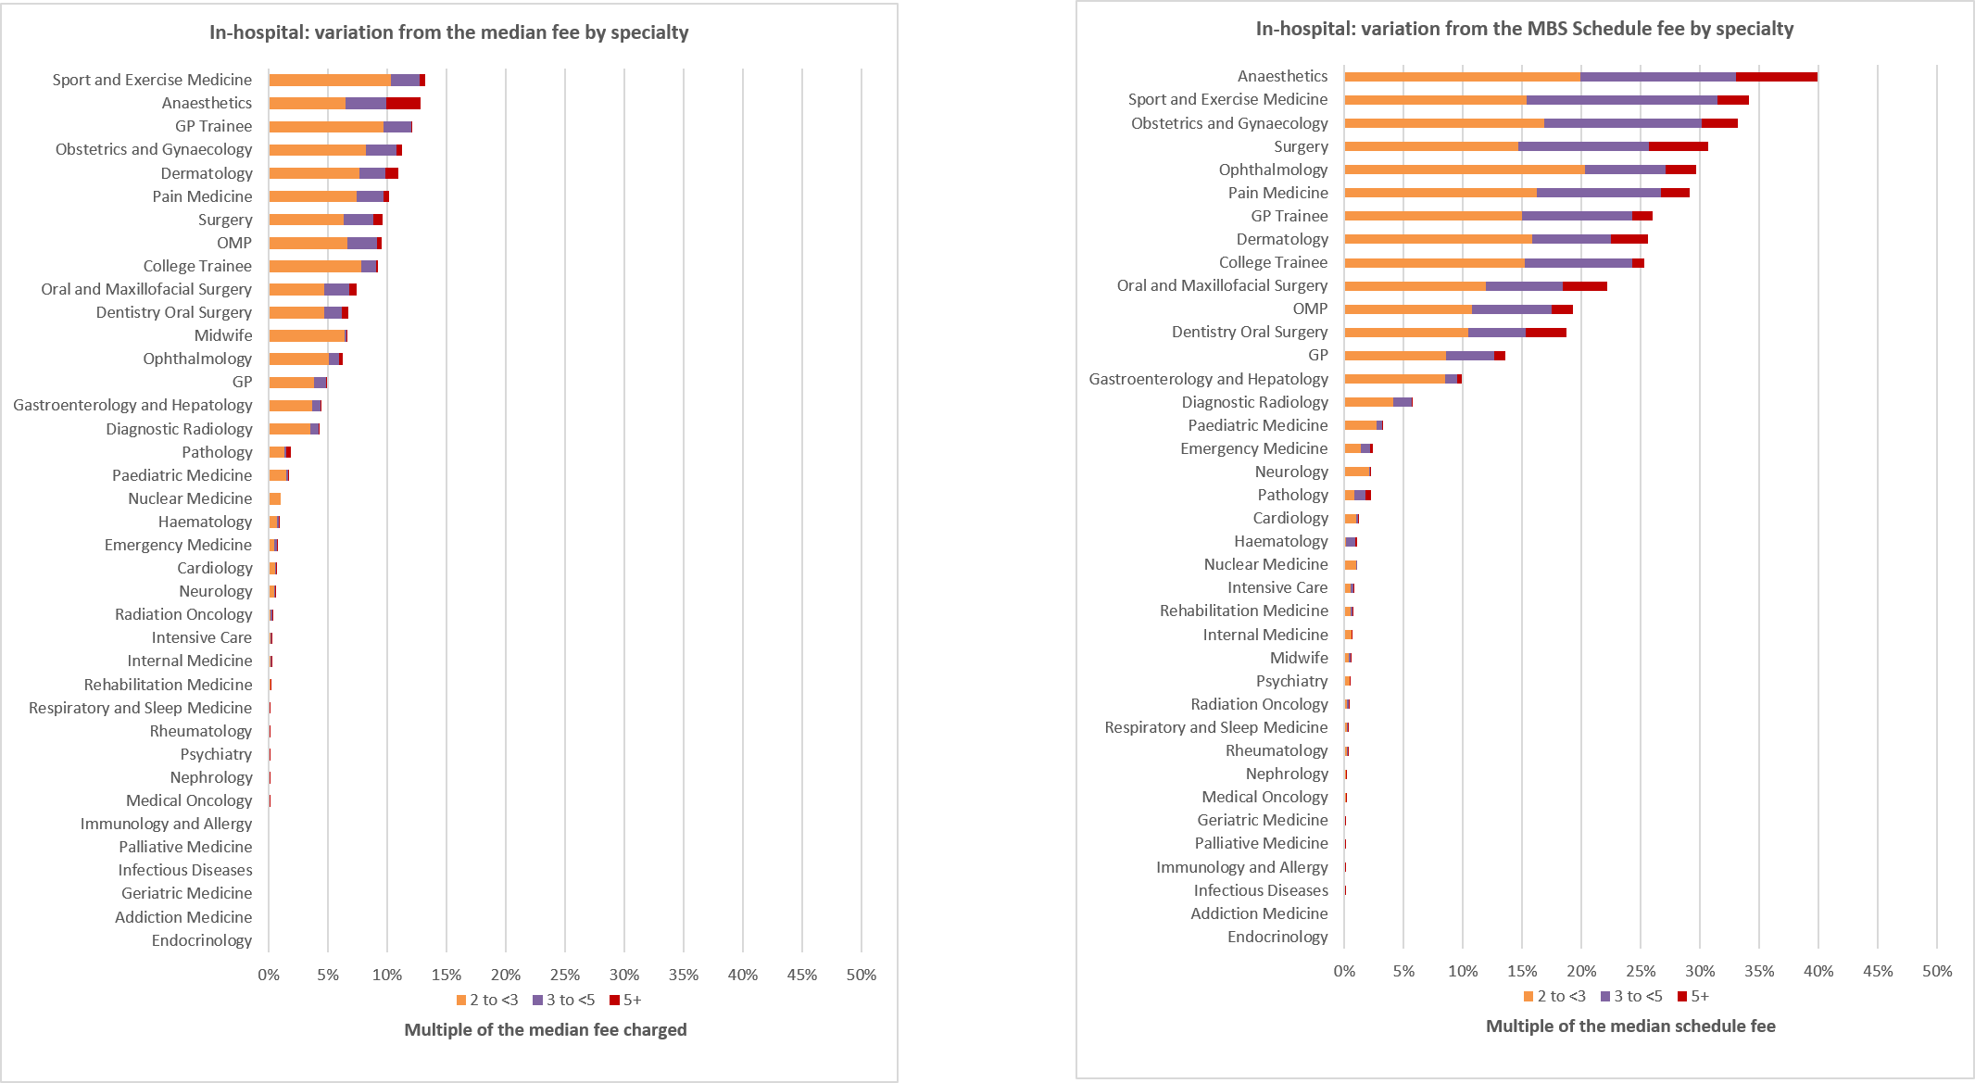
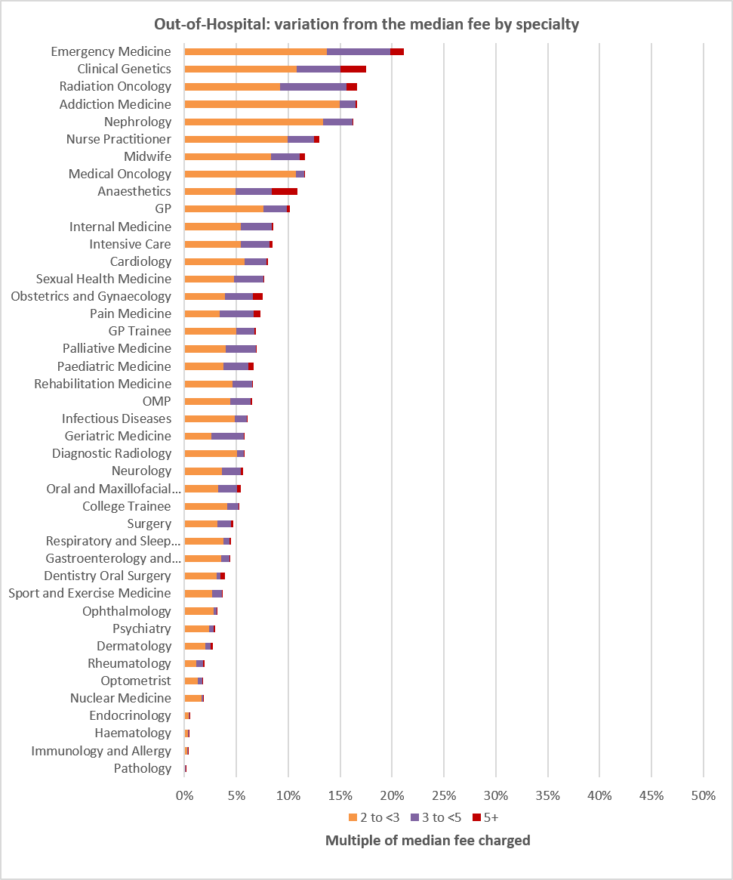
Figure 4. Percentage of in-scope specialist services where the total fee was more than 2 to <3, 3 to <5 and more than 5 times the median fee, in- and out-of-hospital, 2025.

Note: Analysis makes a peer comparison by comparing total fees charged by a specialty at the Derived Medical Specialty 2 level, for each in scope MBS item which that DMS used. For example, it compares the fee charging of all dermatologists for item 104, then item 105 separately and then aggregates these variances per DMS. Differentiating between the specialties and settings better isolates the potential variability in clinical practice, input costs etc. between professions for the relevant items. Some specialties have been excluded due to small provider volumes.

6. Options to address excessive specialist fees
Several options exist for Government to intervene and address excessive specialist fee charging. Table 2 provides an overview of potential intervention options. All the options have differing implementation requirements and challenges, which influence the complexity of delivering an intervention, particularly for interventions requiring legislative and digital changes. Further consideration of the options is in Section 6 of the full consultation paper.
The department recognises there will be challenges in implementing any measures to address excessive fees. These include that there may be reasons to explain what may otherwise look like excessive fee charging. This could include clinical complexity reasons in relation to a particular service, the way services have been billed in a particular case (eg: fees for multiple items billed against one item). This will be taken into account in considering an appropriate regulatory model and approach. There will also be further opportunity for stakeholder engagement and input on the detail of any reform option chosen by Government prior to implementation.
Table 2. Potential options for Government intervention on excessive specialist fees.
Intervention options | Methods | Current examples
Fee transparency & patient empowerment | - Publish point at which fees are deemed ‘excessive’  - Identify providers charging excessive fees  - Strengthen informed financial consent | - Medical Costs Finder (transparency of fees and out-of-pocket costs)  - Support at Home
Provider education | - Letters to providers to notify them of concerns with their billing practices and encourage them to adjust fees (nudge letters) | - Nudge campaigns targeting antibiotic prescribing
Peer assessment | - Providers referred to a third party for review when their billing practices seem excessive  - Penalties/consequences if found to be excessive | - Support at Home  - Professional Services Review
Cap fees on MBS items, for each service | - Introduce a maximum allowable fee for each MBS item – this could be relative to Schedule Fee, median fee, or percentile cut offs (top X% of fees)  - Penalties/consequences if cap breached | - Extended Medicare Safety Net caps (caps benefits, not fees charged)
Review average provider billing over a year to determine if excessive | - Consider the provider’s aggregate billing in a financial year to determine if overall average billings are ‘excessive’  - Penalties/consequences if found to be excessive | - Grattan suggested model of addressing excessive fees
Incentives for lower out-of-pocket fees | - Bulk billing incentives for specialists  - Practice incentive payments for specialists | - GP Bulk Billing Incentive  - GP Practice Incentive Payments (PIP)

7. Challenges addressing excessive fees
There are several risks associated with any government intervention to address excessive fees. Some of these risks are unique to the MBS but others have been experienced in different health, disability and ageing programs that have introduced or considered fee regulation.
Many of the risks can be mitigated through policy design, either through the definition of excessive fees or through criteria to govern exceptions to regulation or other government intervention. Other risks will require further consultation with related entities (e.g. private health impacts).
Table 3. Overview of potential risks requiring consideration in the development of policies.
Risks | Description | Mitigations
Higher “non-excessive” fees or reductions in bulk billing | Providers increase the fees charged at the bottom end of their fee range and/or reduce their bulk billing rates to counter-balance the loss of income caused by having to reduce excessive fees. | Monitor changes in pricing across sector, identify any providers significantly increasing prices. Careful setting of any excessive fee definitions/limits.
Some providers exit Medicare | Some providers may consider they are better off exiting Medicare and continue charging high prices privately. | Policy design to limit risks by targeting clearly excessive fees.
Patient impacts | In some reform options, patients may be disadvantaged if MBS benefits are denied at the point of claiming, i.e. after care delivered and patient initial payment of the excessive fee made. | Reforms should support patients facing excessive fees. Options such as withdrawing Medicare benefits should be carefully considered so as not to be implemented to detriment of patients
Price signalling | Fee regulations, particularly published prices or caps, could become a signal for providers to increase fees to the upper limits. | Monitor changes in pricing across sector, identify any providers significantly increasing prices. Careful setting of any excessive fee definition.
Disadvantage complex co-claims (i.e. multiple items in one episode of care) | Interventions may unfairly punish fees that account for multiple co-claimed items, if out-of-pocket fees are aggregated under one item. | Examine/review potentially excessive fees before taking regulatory action. Provide opportunity for provider to justify fees.
Clinical variation of the services under the same MBS item | Within an MBS item there can be clinical variation or complexity differences that lead to fee variation (e.g. various methods of skin excision captured under one item). Intervention may inappropriately disadvantage higher complexity services. | Examine/review potentially excessive fees before taking regulatory action. Consult each profession to understand what is excessive for their specialty, particularly for items that several specialties use.
Redistribution of out-of-pocket costs across MBS items | Providers may change the mix of items they claim for the same services to avoid exceeding the point of excessive. This was observed when only certain items had EMSN caps applied. | Monitor changes in pricing and claiming, identify any items with significantly changed claiming patterns post implementation.
Bill smoothing / fee splitting | Fees may be split across multiple items or attendances or attributed to ‘administration/booking fees’ in order to stay underneath an excessive threshold and avoid consequences of interventions. | Reforms to protect patients from fee splitting are being considered through the informed financial consent consultation process.

Specialist services for the purposes of this paper have been identified based on selected ‘Broad Types of Services’ (BTOS) which is a classification system used to group together MBS items generally associated with similar services or types of providers. Many items included in the in scope BTOS can be delivered by both GPs and specialists.
Department of Health, Disability and Ageing internal analysis (MBS data DOP Year: 2025).
Department of Health, Disability and Ageing internal analysis (HCP1 data 2014 to 2019).
Department of Health, Disability and Ageing internal analysis (MBS data DOS Years: 2019 to 2025) and Consumer price index (CPI) rates | Australian Taxation Office.
The MBS Schedule Fee is the official fee for a service, against which all benefits are benchmarked. The rebate/benefit is a set proportion of the Schedule Fee which the Government provides to patients to subsidise eligible MBS services. The difference between the total fee charged by a provider and the rebate is known as an out-of-pocket cost and this is paid by the patient. Total fees are set by the provider.
Department of Health, Disability and Ageing internal analysis (MBS data, DOS Year: 2025).
Department of Health, Disability and Ageing internal analysis (MBS data, DOS Year: 2025).
Department of Health, Disability and Ageing internal analysis (MBS data, DOS 2025).

