1. Purpose
The Australian Government is committed to making sure Australians have transparency, choice and affordable access to private specialist medical care. However, we know Australians are paying increasing fees to see medical specialists, and many are delaying or missing care as a result. Following recent investments in primary care, including establishing Medicare Urgent Care Clinics and increasing the Bulk Billing Incentive in general practice, the Government is now focused on practical reforms to make specialist health care more affordable and easier to navigate for patients.
This paper will examine the data on specialist fee variation and present options to protect patients from excessive fees. The paper is not proposing regulation of fees that are not excessive. It is one of a series of consultation papers published by the Department of Health, Disability and Ageing on specialist affordability which can be found on the department’s website. The options outlined in this paper do not represent government policy and are provided to facilitate feedback from patients, providers, and other interested parties.

2. Scope of this consultation paper
For the purposes of this consultation paper unless otherwise indicated, specialist general practitioners are referred to as GPs, and non-GP specialists and consultant physicians are referred to as “specialists”. “Specialist services” as captured in the data used for this paper can sometimes also be delivered by GPs and other eligible health professionals. Details of in-scope services are provided in Appendix A (page 28).
  - In scope
- Fees charged for health care services funded through the MBS: this consultation has been prompted by concerns about the rising cost of specialist services. All MBS funded specialist services (in- and out-of-hospital) are within scope.
- Factors influencing how providers set their fees: consideration of the variation in fees charged for MBS items and the factors that influence these pricing decisions.
- Patient experiences: impact of excessive specialist fees on patients.
- Options for reform: consideration of approaches to strengthen Medicare arrangements to protect patients from excessive fees, including transparency, education and regulation.
  - Out of scope
- Broader affordability concerns: this paper is specifically focussed on the prevention of very excessive fees charged by some specialists, rather than the affordability of fees charged by the majority. Improving specialist affordability is a complex challenge that requires multiple policy responses. Addressing excessive fees represents one element of that response.
- Non-MBS eligible health care services and technologies: evidence presented in this paper is based on available Medicare data, and options build upon existing Medicare arrangements.
- Private hospital and health insurance (PHI) reforms: this paper does not specifically consider reforms to PHI arrangements or private hospitals - a consultation paper on Private Health Sector Reform is available here.
- Public health systems: evidence presented in this paper is based on private specialist services, this paper does not consider the delivery of free specialist services delivered through the public system, nor does it discuss the operations of the public hospital system.
- Broader health system reforms: issues not directly related to addressing excessive specialist fees, such as workforce planning.

3. Why is Government concerned about specialist fees?

While the focus of this paper is on excessive fees, it is useful to note the broader context of concerns over specialist fees. In 2024-25 more than 224.2 million private specialist services were delivered through Medicare to over 19.1 million Australians by over 84,000 providers (approximately 38,500 specialists and 45,000 general practitioners and other eligible health professionals). There are more than 30 distinct professions who operate as specialists. These providers deliver invaluable and essential health care services.

3.1 Rising out-of-pocket costs
There is significant community concern about the rising cost of health care, particularly specialist care. These concerns are reflected in Medicare data. In 2025, Australians spent $4.17 billion out-of-pocket on out-of-hospital specialist services, an increase of 75.8% since 2019 (Figure 1). This equates to approximately $458 in out-of-pocket costs per person, among those who accessed out-of-hospital specialist services where an out-of-pocket fee was paid.
In-hospital gap payments for privately insured stays increased by 72.2% in the same period, with a median medical gap of $323 per episode in 2025.
Figure 1. Total out-of-pocket for out-of-hospital specialist versus GP non-referred services.
The growth in specialist out-of-pocket costs, compared to other healthcare specialties, is particularly evident when examining the change in average out-of-pocket costs by service type. Figure 2 shows the change in average out-of-pocket costs by Broad Type of Service (BTOS), a categorisation used in the MBS to group MBS items (further details on BTOS are provided in Appendix A). The BTOS with MBS items most commonly claimed by specialists are shaded in purple.
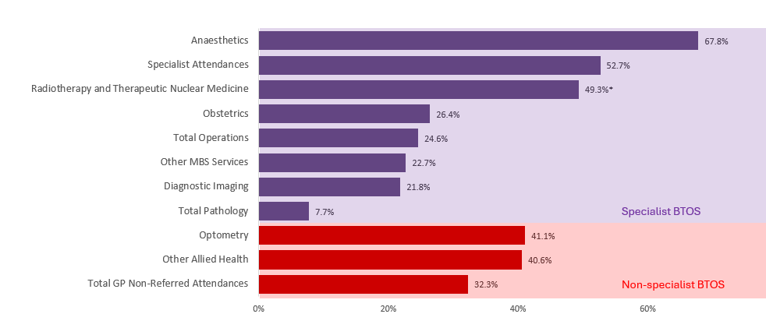
Figure 2. Change in average out-of-pocket cost per out-of-hospital service by BTOS, patient billed only, from 2019 to 2025.
Note: The Radiotherapy and Therapeutic Nuclear Medicine bar shows change from 2019 to 2024 only. From 1 July 2024, the radiotherapy schedule was replaced with a new, restructured schedule so changes in annual average out-of-pocket costs per service could not be easily compared for this analysis.
The increase in specialist out-of-pocket costs over recent years has significantly outpaced general price growth. For example, the average out-of-pocket for an initial specialist consultation increased from $94.72 in 2016 to $158.75 in 2025 (Figure 3 on page 4). This equates to a 67% increase in out-of-pocket costs. By comparison, the Consumer Price Index (CPI) rose by 32% over the same period.
Figure 3. Growth in CPI compared to the average out-of-pocket costs for two specialist consultation items.
2016: $94.72
2016: $95.27
2026: $158.75
2026: $153.34
*MBS data shown is for item 104 (initial specialist consultation) and item 110 (initial attendance of a consultant physician), out-of-hospital, patient billed services only.

4. Defining excessive fees
While Government is concerned about this general increase in specialist fees, the particular area of concern being considered in this paper is the charging of what may appear to be excessive fees by a small minority of providers on top of these general fee increases.
Individuals’ perception of whether a fee is excessive will vary significantly. Financial circumstances, personal judgements, past comparable experiences and awareness of service input and practice overhead costs all factor in whether a patient or provider considers a fee to be excessive. There is no agreed definition of excessive specialist fee charging.
While determining what makes a fee excessive is inherently subjective, if the Commonwealth is to implement options to limit or reduce excessive fees, then ‘excessive’ will need to be defined so these interventions are appropriately targeted. This section examines three methods for defining excessive fees.

4.1 Reasonableness – fees are deemed excessive based on a case-by-case assessment of fee charging
‘Reasonableness’ is one option for determining whether a fee is excessive or not without being explicit about a cutoff point. Reasonableness may be a more appropriate way to define excessive where case by case assessments are to be made, for example in a peer review model. Considerations may include the time required to undertake a service, input costs, relative complexity of a service or patient, or the circumstances where a service is provided. Fees charged by other providers for similar or identical services, where known, may also be used to inform a decision on whether a fee is reasonable or excessive.
The Council of Presidents of Medical Colleges (CPMC) Framework for Ethical Billing and Fee Transparency and the Australian Medical Association (AMA) Position Statement on Setting Medical Fees and Billing Practices outline high level principles for setting fees including a ‘reasonableness’ consideration.
The AMA state “Medical practitioners should also satisfy themselves in each individual case as to a fair and reasonable fee having regard to their own costs and the particular circumstances of the case and the patient. The AMA does not support egregious charges — fees that the majority of a practitioner’s peers would consider to be unacceptable.”
The CPMC states “Fees should reflect the context of care including time, complexity, expertise, costs of practice, and prevailing benchmarks and they should be reasonable in relation to the service provided.”
Neither statement provides examples of unreasonable fees, however the AMA does publish a fee guide for its members of recommended fees for MBS items. This fee guide is not public.
The Support at Home (SaH) aged care program also refers to prices being ‘reasonable and transparent’ and publishes a national median price alongside the upper (75th percentile – 75% of fees are below this) and lower (25th percentile – 25% of fees are below this) ranges for these prices. These are based on provider survey data and are intended to support consumers to compare the prices of different providers. While anything above the 75th percentile is not labelled as ‘excessive’, the department monitors what providers are charging for services and seeks justification from providers who appear to have unreasonable prices. Where a provider’s prices appear unreasonable or are not adequately justified, they may be referred to the Aged Care Quality and Safety Commission for compliance and/or enforcement action. There is legislative backing for this approach with the Aged Care Rules 2025, Rule 273.15, providing that the price charged by the registered provider must not be ‘unreasonable’. This term is not further defined but the Commission has issued guidance materials for setting Support at Home prices.

4.2 Peer comparison – fees are deemed excessive based on how far they deviate from the market
An alternative method for determining excessive fees is to consider how the fee charged by an individual provider compares to the fees charged by other providers claiming the same item.
A fee could be considered excessive:
- based on how far it deviates from the median fee charged for that item (e.g. if a fee is more than X times the median fee charged for that item).
- when it is among the highest fees charged for that service (e.g. the top X% of all fees).
These statistical approaches for defining excessive can be applied consistently but the approach has its limitations. For example, deviation from the median does not provide insight as to whether the median fee itself is reasonable. This is demonstrated in Figure 5 (on page 6) which provides an example for three hypothetical items.
Despite having identical highest and lowest fee charged and Schedule Fees, the variation in the fee distribution across these items produces different median values. Capping based on deviation from the median would not consider these contextual factors and may advantage or disadvantage certain items and fee charging behaviours. For example, if all or the majority of providers were charging a median fee that the public considers very high (Figure 4, Item C, on page 6) this would create a very high starting point from which to set a definition of excessive fees (e.g. 3 times this amount). That the median fee itself was very high would not be addressed in this example.
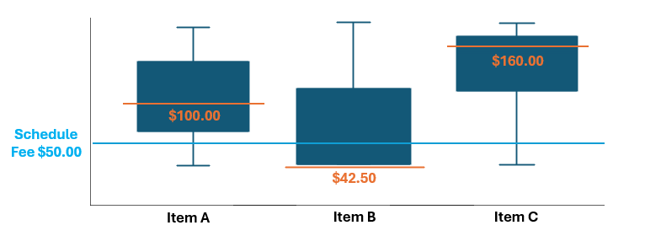
Figure 4. Variation in the median fee (in orange) for three hypothetical items with identical minimum, maximum and Schedule Fees.
Similarly, defining the top X% of all services as excessive does not take into consideration the relative value of the ‘excessive’ fee charged by a provider compared to their peers or the Schedule Fee. As an extreme example, for some items with very high rates of bulk billing, charging the full Schedule Fee would be, by definition, excessive.

4.3 Benchmark comparison – fees are deemed excessive based on how they deviate from the MBS Schedule Fee
Another method for determining whether an individual provider’s fee is excessive is to compare it to the MBS Schedule Fee set for that item. In Special treatment: Improving Australians' access to specialist care the Grattan Institute defines ‘extreme fees’ as more than triple the Schedule Fee on average (although the method could be based on any ratio). Using this definition, they identified that more than one in five Australians who saw a specialist in 2023 were charged an extreme fee at least once.
Using the Schedule Fee as the benchmark comparator provides a consistent approach for defining excessive fees and takes advantage of an existing published reference point. This approach does, however, present some limitations. There are concerns raised by some that the Schedule Fee may not always reflect costs. The relationship between the Schedule Fee and the fee charged by individual providers also varies significantly by item.
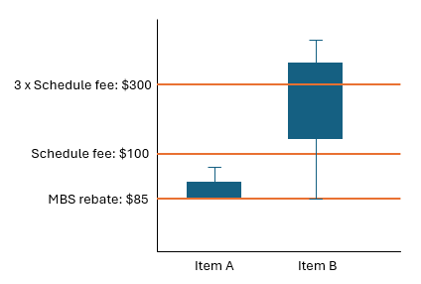
Some fee distributions have close alignment to the Schedule Fee. In these instances (Item A in Figure 5), a cap set at three times the Schedule Fee would result in a definition of excessive far above the market rate for those services. For other items, the majority of providers may charge fees close to or above three times the Schedule Fee (Item B in Figure 5). In these instances, a larger number of fees charged would be deemed excessive. Figure 5 provides a hypothetical example – the box represents the 25th to 75th percentile range (showing what the middle 50% of providers charge), the lines represent the minimum and maximum spread of fees outside this range.
Figure 5. Impact of benchmark cut offs on two hypothetical items with the same Schedule Fee but different fee distributions.
Applying a uniform definition for excessive fees based on a ratio of the fee charged to the Schedule Fee will therefore have uneven impacts across items. While in some cases it may be a broadly appropriate reflection of an ‘excessive’ fee, in other cases it may be considered too high or too low compared to the existing market. Using the median market fee or percentile-based definitions discussed above to define excessive rather the MBS Schedule Fee may better address such concerns.

4.4 Challenges defining excessive fees
The three methods highlight some of the challenges in developing a consistent approach to defining when a fee should be deemed excessive. Use of statistically based definitions provides a consistent and clear way to define excessive but could result in a fee for a service being unfairly labelled as ‘excessive’ or some fees that may be ‘excessive’ not being defined as such. Use of a ‘reasonableness’ definition allows greater consideration of individual circumstances but does not apply a clear definition for patients, providers or regulators, making understanding, compliance and regulation more difficult, noting there are over 3,000 specialist items on the MBS.
As discussed in Section 5.3 of this paper, there are many reasons why the fees a provider charges may vary, such as clinical variation in complexity, time required to deliver a service, or private health gap arrangements. There are also administrative processes which need to be considered to ensure the labelling of a fee as excessive is fair, including ensuring data entry is accurate and that out-of-pockets are assigned to the right MBS item (both in practice billing software and in Services Australia claiming processes).
These challenges do not mean that development of a definition should be abandoned. Rather, it demonstrates that a combination of approaches, greater nuance or additional criteria may be necessary.
5. Excessive fee charging trends, drivers and impacts
5.1 Fee variation and evidence of excessive fees
  - Are excessive fees common?
While the Government sets MBS Schedule Fees and benefits, private specialists are free to set their own fees above these amounts. Many providers recognise their ethical obligation to ensure the fees they charge are reasonable. The AMA’s Position Statement on Setting Medical Fees and Billing Practices notes:
The AMA does not support egregious charges — fees that the majority of a practitioner’s peers would consider to be unacceptable.
Similarly, the CPMC’s Ethical Billing Framework establishes that fees should be ‘fair, reasonable and proportionate’ and providers should ‘avoid exploitative or unjustified fees’.
Most specialists adhere to this guidance. However, analysis of the fees charged by providers compared to their peers indicates that there is a small minority of providers who are charging fees that are significantly higher than their peers.
When comparing the fees charged by specialists in 2025 against the median fees charged by all providers for the same item (Figure 6), the department found:
- More than 450,000 (1.1%) in-hospital specialist services were charged with fees between 3 and 5 times the median total fee charged, and more than 260,000 (0.7%) were charged with fees more than 5 times the median.
- More than 1.6 million (0.7%) out-of-hospital specialist services were charged with fees between 3 and 5 times the median total fee charged, and more than 220,000 (0.1%) were charged with fees more than 5 times the median.
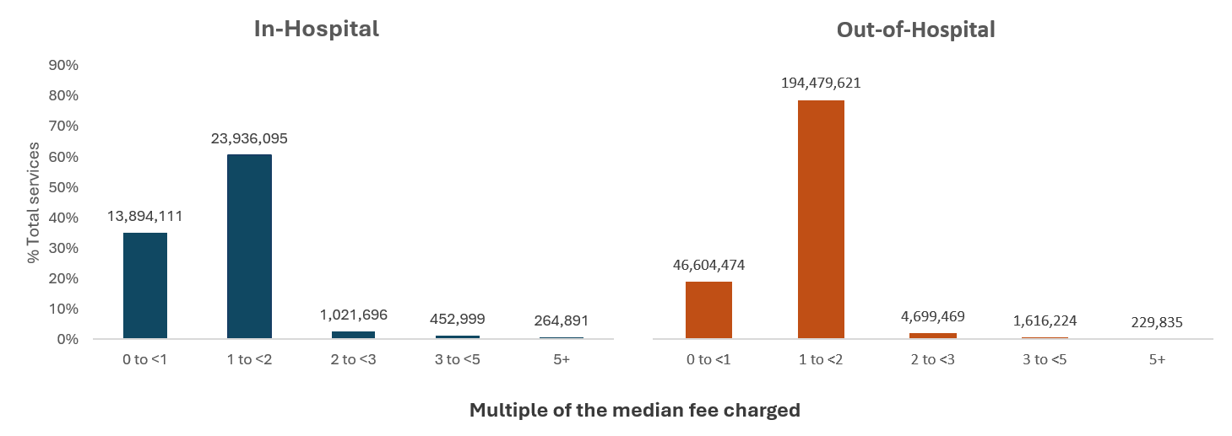
Figure 6. Specialist services charged at multiples of the median fee, in- and out-of-hospital, including bulk billed services, 2025.

This pattern of high fee charging in a small, but significant minority of services is also apparent when fees are compared to the item’s Schedule Fee rather than median fees (Figure 7). In 2025:
- More than 1.5 million (3.9%) in-hospital specialist services were charged with fees between 3 and 5 times the Schedule Fee charged, and more than 690,000 (1.8%) were charged with fees more than 5 times the Schedule Fee.
- More than 4.5 million (1.8%) out-of-hospital specialist services were charged with fees between 3 and 5 times the Schedule Fee charged, and more than 550,000 (0.2%) were charged with fees more than 5 times the Schedule Fee.

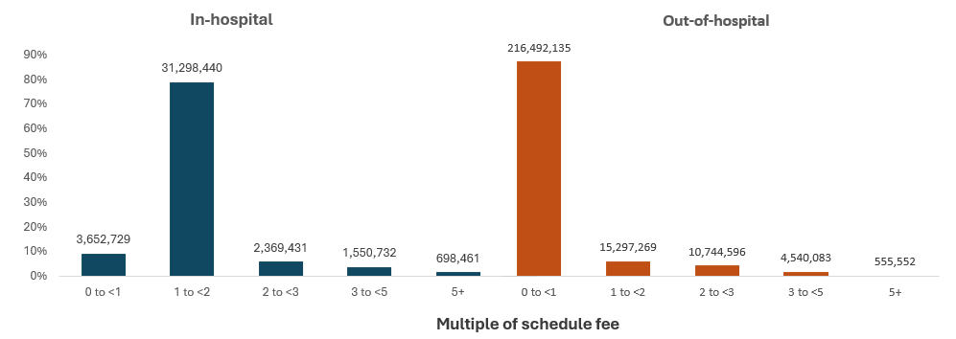
Figure 7. Specialist services charged at multiples of the Schedule Fee, in and out-of-hospital, including bulk billed services, 2025.
Fee variation within an MBS item
The variation in fees charged is most apparent when viewed at the individual item level. Figure 8 shows the different fees charged by providers for three items. The shapes of these graphs vary significantly, from distributions that appear more linear to some that are heavily skewed. Some of the factors that can contribute to this variation are discussed in Section 5.3. The large spikes at the tail of heavily skewed distributions are unlikely to be explained by differences in complexity or quality of service given the significant jump in fee (for example, from ~$400 to ~$5,400 within the same item as in the third graph).
Figure 8. Example MBS items demonstrating variability of fee distribution shapes, 2024-25.
*This MBS item data includes in-hospital and out-of-hospital services, for bulk billed and patient billed services.

Does private health insurance impact fee variation?
Australia maintains a mix of public and private health care and Australians can choose to take out private health insurance (PHI) to cover the cost of receiving care for eligible health services. Under current legislation, private health insurers are not able to pay benefits for fees charged for Medicare services provided out-of-hospital. This ensures some people are not given preferential access to necessary medical care because they hold PHI. In the context of specialist medical treatment, insurers are required to pay at minimum 25% of the MBS fee for privately insured patients admitted to hospital to receive treatment for which they are insured (this includes private services delivered at a public hospital).
Insurers determine the higher benefits to be paid to a specialist if they agree to participate in a no or known gap cover arrangement. Specialists can choose to apply an insurer’s gap cover arrangement for each MBS item billed. This means the remaining gap, if any, an insured patient is required to pay after MBS and PHI benefits are applied can vary on a case-by-case basis, and across different specialists and insurers.
The graph below shows what proportion of fees, on average, is paid by the patient (represented in light blue) and what is funded through Medicare and private insurance rebates (represented in dark blue). As specialist fees increase, the likelihood of patients needing to pay a gap for privately insured in-hospital medical services increases. Excessive fees are delivered outside of gap and known gap arrangements as by their nature they are outliers. The average medical gap payment where a gap was payable was $245.08 per episode in the March 2026 quarter. The average ratio of gap payment to Medicare and PHI benefits varies by specialty. It should be recognised that this data represents averages of a large number of services. Even within specialties where, on average, patients are paying a high proportion of fees charged there remain many providers who actively participate in known and no gap arrangements. And conversely, there are a small number of providers charging high fees where gap payments generally represent a small contribution towards the eventual fee.
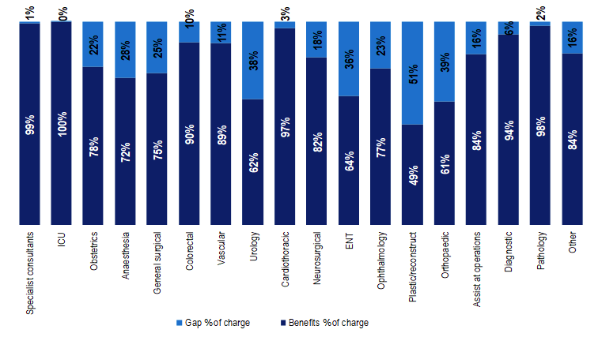
Figure 9. Average proportion of MBS and PHI benefits compared to gap amounts by specialty, in-hospital, March 2026 quarter.

When considering the proportion of services delivered well above the median fee or Schedule Fee by specialty (Figures 10 and 11 on pages 12 and 13), in-hospital settings generally have less variation from these benchmarks. This may indicate that PHI gap arrangements have assisted in constraining the incidence of excessive fees in this setting, while the out-of-hospital services have not experienced the same pressure. It may also reflect other differences between these settings.
The lower variation from benchmarks for in-hospital fees does not persist when all specialties are considered together, instead out-of-hospital fees appear to have the lower rate of variation (Figures 6 and 7, on pages 7 and 8). This may be a result of the large volume of bulk billed, out-of-hospital pathology services which may skew the proportion of services identified as high fee charging.
Are patterns of fee charging the same across specialties?
There is substantial variation in billing behaviour both within and across specialties. This can be driven by several factors, including the MBS items different professions can use, availability of workforce, settings they practice in, and the range of clinical complexity providers engage with. Therefore, it is appropriate to consider the fee distributions of each item, by specialty.
Figures 10 and 11 (on pages 12 and 13) demonstrate the proportion of services where a provider charged 2 to <3, 3 to <5, 5 or more times the median fee and Schedule Fee, by specialty. This is different to Figures 6 and 7 (on pages 7 and 8), which are not differentiated by specialty.
The proportion of services with greater variance from the median or Schedule Fee are not the same across specialties, and specialties identified as high fee charging are heavily influenced by the choice of comparator. For example, some specialties have a low number of fees identified as excessive when compared to the median, but a high number of fees identified as excessive when compared to the Schedule Fee. This might indicate the majority of that specialty are consistently charging a high fee (i.e. the median itself is high) that is well above the Schedule Fee.
An important consideration with the data presented in Figure 10 and 11 (on pages 12 and 13) is the impact of MBS item modifiers on total fees. Modifiers are part of the MBS system and can be billed in conjunction with some procedural items to account for selected time or complexity factors. For example, modifier items are commonly billed in association with the administration of anaesthesia to account for certain complexities/procedure length. This practice may explain the high observed variations in median fees observed below.

Figure 10. In hospital: Percentage of in-scope specialist services where the total fee was more than 2 to <3, 3 to <5 and more than 5 times the median and Schedule fee by specialty, 2025.
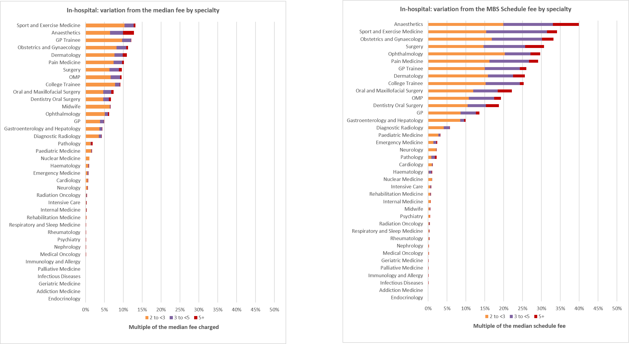
Note: Analysis makes a peer comparison by comparing total fees charged by a specialty at the Derived Medical Specialty 2 level, for each in scope MBS item which that DMS used. For example, it compares the fee charging of all dermatologists for item 104, then item 105 separately and then aggregates these variances per DMS. Differentiating between the specialties and settings better isolates the potential variability in clinical practice, input costs etc. between professions for the relevant items. Some specialties have been excluded due to small provider volumes.

Figure 11. Out-of-hospital: Percentage of in-scope services where total fee was more than 2 to <3, 3 to <5 and more than 5 times the median fee and Schedule Fee by specialty, 2025.
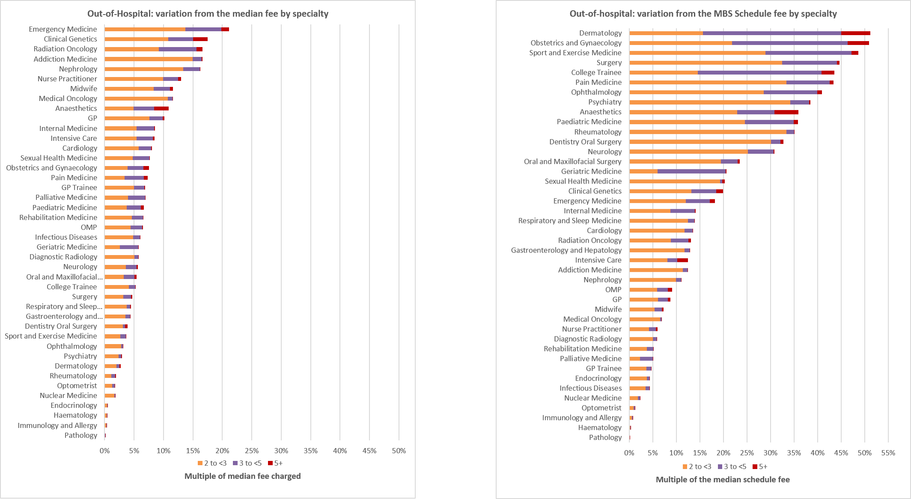
Note: Analysis makes a peer comparison by comparing total fees charged by a specialty at the Derived Medical Specialty 2 level, for each in scope MBS item which that DMS used. For example, it compares the fee charging of all dermatologists for item 104, then item 105 separately and then aggregates these variances per DMS. Differentiating between the specialties and settings better isolates the potential variability in clinical practice, input costs etc. between professions for the relevant items. Some specialties have been excluded due to small provider volumes.

5.2 Impact of excessive fees on patients
Rising fees are increasingly putting specialist care out of the reach of many Australians. The Australian Bureau of Statistics (ABS) Patient Experiences Survey found 8.6% of people aged 15 years and over, more than 1.9 million people, delayed or did not see a specialist due to cost in 2024-25 (Figure 12). The Consumers Health Forum National Consumer Sentiment Survey (2025) found similarly high numbers of Australians delaying care due to cost. Delaying specialist care may increase the risk of deterioration, crisis presentations, preventable hospitalisation, and place greater pressure on other parts of the health system.
Figure 12. Proportion of patients that delayed or did not see a GP or medical specialist due to cost on at least one occasion, 2013-14 to 2024-25.
Patient burden
Excessive fees can have a cumulative financial burden on some patients. In 2025, over 23,000 in-hospital patients and more than 84,000 out-of-hospital patients received three or more services with fees exceeding three or more times the median total fee. More than 129,000
in-hospital patients and more than 347,000 out-of-hospital patients had three or more services charged at more than three times the Schedule Fee (Figure 13).
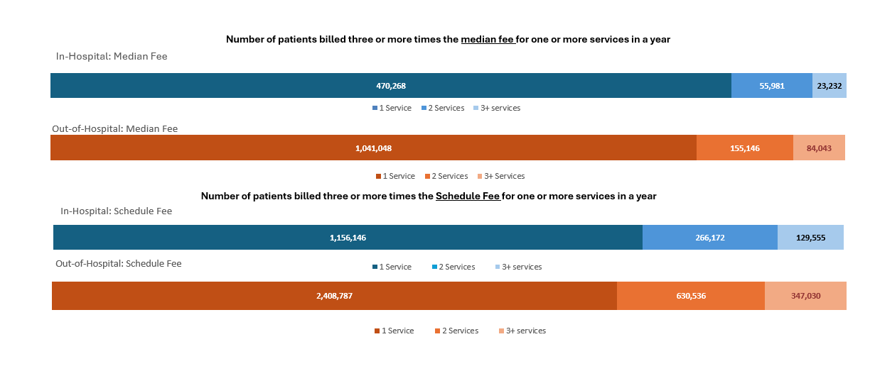
Figure 13. Number of times patients experienced fees charged at three or more times the median fee or Schedule Fee in a year, 2025.
This cumulative financial burden is likely to be most significant for patients with chronic conditions, those receiving ongoing psychiatric care, or those who need a course of treatment for an acute condition (e.g. radiation oncology) as they may return to the same high fee charging provider for multiple services. Patients who have ongoing specialist care requirements, particularly mental health care, may have limited practical ability to shop around or change providers once care has commenced.
5.3 Factors contributing to excessive fee charging
Provider factors
Specialists’ individual pricing decisions contribute to significant variation in the fees patients encounter. The capacity for providers to independently set fees has facilitated the practice of price differentiation, where providers charge varying amounts for identical services. Stakeholders in the medical sector note that this flexibility allows specialists to align fees with clinical complexity. Some further argue that charging higher fees to some cohorts enables them to bulk bill or reduce fees for patients they consider have less capacity to pay, effectively cross subsidising these fees. This places doctors in the subjective position of assessing a patient’s ability to pay.
Some variance is expected in fees for the same service, noting variability in practice operating costs including location-based costs, presence of local competition, patient complexity and specialties. Patient comorbidities and the complexity of the principal medical issue will have an impact on the way a specialist conducts an intervention, even if this intervention uses the same MBS item as a service delivered to a simpler patient with no comorbidities. For example, there are ten MBS items which relate to colonoscopy however the full clinical spectrum of possible interventions within these ten items is more granular than this. As a result, clinicians may vary the fees charged to better capture costs and time associated with patient specific complexity.
However, a 2024 study investigating drivers of fee variation for in-hospital services found patient characteristics have a limited role in determining specialist fees or out-of-pocket costs (they explain 4-6% of fee variability). Instead, fee variability was primarily attributable to specialist specific variation (65% of the total variance in total fees and 72% of out-of-pocket costs). This variation was related to experience, reputation and perceived quality or skill difference (perception of skill difference can be by the specialist themselves or by patients).
These are highly subjective factors which are difficult to consider when making a judgement about whether a fee is reasonable or excessive, and even more difficult for patients to use when making health care decisions without corresponding outcomes-based information.
In out-of-hospital settings another observed driver of fee variation is provider awareness of a patient’s eligibility for the Extended Medicare Safety Net (EMSN). A 2019 study found that when providers were aware their patients were eligible for additional Government benefits under EMSN this led to fee increases of approximately 12% on average. This fee inflation led to the Government capping some EMSN benefits to prevent excessive fee charging on those items.
Patient factors
The ABS data (Figure 12, on page 13) shows a large number of patients delaying care due to high costs. That this has not increased as both general cost of living pressures and overall specialist costs have increased over recent years may be due to the unique characteristics of the health care market. As healthcare is an essential good, patients are typically price takers and will pay higher fees to access care than they may otherwise do for non-essential goods or services. This creates inelastic demand which can enable some providers to set fees well above their peers and still have patients who are willing to bear that high cost. This may be particularly exacerbated in areas where access to equivalent public services is constrained.
Another facilitator of high fee charging is information asymmetry. Patients are typically infrequent purchasers of specialist healthcare services and may have a limited sense of what that health care service should cost. This can make their purchasing decisions reliant on the advice provided by the GP and specialist from whom they are receiving care. The Government is investing in upgrades to the Medical Costs Finder (MCF) to help patients better understand these costs and be able to compare their doctor's fees to that of other providers in their area. However there remains a risk that patients may use price data as an indicator of quality. Studies have found that higher prices have no correlation with clinical outcomes, but price may be used by consumers as a marker of quality.
There is a risk that, when consumers assume price indicates quality, that this can inadvertently legitimise excessive fees, which can in turn distort and drive-up prices across the whole market over time. Similar concerns exist regarding reform options such as fee capping. Caps may function as a price target, and their introduction may result in higher fees for patients across the market rather than acting as a targeted excessive fee reduction. This risk is likely greatest in markets or circumstances where consumers are less sensitive to price, such as high-income areas, or when patients have life limiting conditions. This may also be the case in areas of reduced competitive pressure, such as when services have limited availability in a geographical area, or can only be performed by a small cohort of highly specialised specialists.
5.4 Case for Government intervention
The combined effect of limited transparency, the imbalance of power between the provider and patient, and excessive fees is compromising access and affordability of specialist services. While high prices can be a natural outcome of any market with limited supply and high demand, there are significant ethical considerations which bear consideration in a market that is delivering an essential health good subsidised by Government. Increasing financial barriers to access undermine the universal nature of the Australian health care system and contribute to imbalances between private and public systems.
While the proportion of specialist services delivered through Medicare being charged what may be considered an excessive fee is relatively small, the cost impact on affected patients is significant. For example, while the median for one item is $595, the observed fees at the 95th percentile of that item’s distribution are $1,250 meaning some patients are being charged $655 more than the median for the same service. The department has also received complaints from patients who have been charged higher fees based on their insurance status. In one instance, a patient was quoted $900 more than the advertised price for an initial consultation because they did not hold PHI. Initial consultations are typically delivered out-of-hospital and are not eligible for PHI coverage. Under current arrangements there is nothing to protect patients from these types of fees or excessive price differentiation.
While there are some risks to any Government intervention in the specialist market, as noted in statements from the AMA and CPMC, the profession itself does not support excessive fees. However, the current opaque and unregulated fee arrangements are facilitating excessive fee charging. Based on the observed fee distributions across all specialist types, existing professional standards and frameworks for ethical billing are not preventing this behaviour. If providers are allowed to continue charging excessive fees these may become normalised.
Given the essential nature of specialist services, market features that make it unlikely to self-correct and the trajectory of current fees, there is a strong case for Government intervention on excessive fees. Curbing excessive fees will help protect patients from the minority of specialists who have used the unique features of the specialist market to charge unreasonable fees. It will also complement the MCF upgrades and proposed informed financial consent and referral reforms which aim to improve fee transparency and patient control over health care choices.

6. Options to address excessive specialist fees
Several options exist for Government to intervene and address excessive specialist fee charging. Table 2 provides an overview of potential intervention options and further explanation of the options is below. All the options have differing implementation requirements and challenges, which influence the complexity of delivering an intervention, particularly for interventions requiring legislative and digital changes.
The department recognises there will be challenges in implementing any measures to address excessive fees. These include that there may be reasons to explain what may otherwise look like excessive fee charging. This could include clinical complexity reasons in relation to a particular service, the way services have been billed in a particular case (e.g. fees for multiple items billed against one item). This will be taken into account in considering an appropriate regulatory model and approach. There will also be further opportunity for stakeholder engagement and input on the detail of any reform option chosen by Government prior to implementation.
Of note, under the majority of existing Medicare arrangements all individuals enrolled in Medicare are entitled to the same benefit for a service listed on the MBS, however there is no regulation of the total fee a provider can charge. This differs from the health insurance systems in many other countries, where fee regulation is commonly implemented when a government benefit is also provided for a service., ,
Table 2. Potential options for Government intervention on excessive specialist fees.
Intervention options | Methods | Current examples
Fee transparency & patient empowerment | - Publish point at which fees are deemed ‘excessive’  - Identify providers charging excessive fees  - Strengthen informed financial consent | - Medical Costs Finder (transparency of fees and out-of-pocket costs)  - Support at Home
Provider education | - Letters to providers would notify of concerns and encourage them to adjust fees (nudge letters) | - Nudge campaigns targeting antibiotic prescribing
Peer assessment | - Providers referred for third party review where billing practices seem excessive  - Penalties/consequences if found to be excessive | - Support at Home  - Professional Services Review
Cap fees on MBS items, for each service | - Relative to Schedule Fee, median fee, or percentile cut offs (top X% of fees)  - Penalties/consequences if cap breached | - Extended Medicare Safety Net caps (caps benefits, not fees charged)
Review average provider billing over a year to determine if excessive | - Consider the provider’s aggregate billing in a financial year to determine if overall average is ‘excessive’  - Penalties/consequences if found to be excessive | - Grattan suggested model of addressing excessive fees
Incentives for lower out-of-pocket fees | - Bulk billing incentives for specialists  - Practice incentive payments for specialists | - GP Bulk Billing Incentive  - GP Practice Incentive Payments (PIP)
6.1 Fee transparency & patient empowerment
Increasing fee transparency puts more information in a patient’s hands to guide decisions about how they receive health care and in some settings have been found to reduce out-of-pocket costs., Additional reforms being considered through the Informed Financial Consent public consultation paper aim to reduce the opacity of some of the existing billing behaviours.
The Medical Costs Finder (MCF) website provides fee transparency by publishing indicative fees charged, range of fees, and patient out-of-pocket costs for a number of common medical services by geographic region. The Government has committed to strengthening this resource by providing further clarity to people about individual provider fees (focusing on non-GP specialists at this stage) and likely out-of-pocket costs for their private healthcare experience. For common in-hospital procedures, the website is also intending to publish the out-of-pocket cost of an individual lead provider and the combined medical out-of-pocket costs of all providers involved in a separation where relevant.
The department could also explore potential opportunities to assist consumers by:
- indicating where an individual provider’s fees are excessive relative to other providers delivering the same service.
- flagging providers who have regularly charged excessive fees in a relevant reporting period.
There are several challenges that would need to be considered before implementing any of these expansions, for example how to reflect excessive fees across multiple providers, multiple MBS items (when services involve several items), and privacy obligations (excessive fees will by definition be outliers and therefore increase the risks of patient re-identification in published data).
The Support at Home (SaH) aged care program has used fee transparency to improve affordability by publishing a range of prices that providers are charging identifying the median national fee and an upper range (75th percentile) and lower range (25th percentile) which participants can use to compare fees. The published SAH prices are not a regulated fee cap, and providers may choose to charge fees above the published range where they believe it reasonable to do so. If participants believe a provider’s fees are unreasonable, they can refer providers to the Aged Care Quality and Safety Commission for investigation (see Section 6.3 for further discussion).
6.2 Provider education and awareness
Improving provider education and awareness around billing behaviour is a complementary intervention option for fee transparency and patient empowerment interventions. Fee transparency interventions, while designed for patients, also increase transparency for providers of fees charged by their peers and may lead to fee increases by currently lower charging providers. Provider education and awareness of what fees are deemed excessive may assist with mitigating this risk. This education could be delivered generally via some of the intervention options discussed in Section 6.1 or in a more targeted way directly to the relevant high fee charging providers through nudge letters.
In June 2017, the department commenced a communications campaign to reduce the over-prescription of antibiotics by GPs. This campaign sent letters to providers with high prescribing rates to advise them where their prescribing rate sat compared to their peers. Compared to GPs who did not receive a letter, the ‘nudge’ letters (nudging providers to change behaviour) caused a 9.3% to 12.4% reduction in antibiotic prescription rates.
A nudge campaign to induce a similar effect for high fee chargers would be simple to implement however, it may have a smaller benefit than observed in the antibiotic campaign. While antibiotic prescription has no particular benefit for providers, charging high fees has a direct financial benefit which may not be dissuaded by a letter alone. Nudge letters may be a good initial step for testing a chosen definition for excessive and for raising awareness among providers of their excessive billing behaviour before more formal regulation options are considered.
6.3 Peer assessment
This approach relies on the judgement of a third party to determine when a fee that is charged is reasonable and fair (i.e. not excessive). The advantage of peer assessments is that it may not require up front calculation of reasonable and excessive fees for each service. Instead, it is flexible, allowing consideration of individual circumstances that may explain variations in fees from the norm (for example, differences in technique or technology used in a procedure that is understood and supported by the patient).
However, peer assessment is based on subjective judgement. Where a fee is judged reasonable by one group it may be unreasonable for another. Establishing mechanisms to ensure assessments are fair and consistent without an upfront definition of excessive represents a challenge. Another limitation for this intervention is the potential delay between the patient being charged an excessive fee and the reasonableness of that fee being considered by a peer review body. Retrospective consideration of excessive fees by a provider’s peers offers little immediate support to those patients being asked to pay excessive fees in the moment and may not result in any patient recompense.
The SaH aged care program provides an example of how independent review could be applied to excessive provider charges. While the SaH program is considering options and systems to introduce price caps on the services it funds, the Commonwealth has authorised the Aged Care Quality and Safety Commission to order refunds where providers are found to be overcharging and take action against those who fail to meet obligations.
Peer assessment of clinical and professional standards is well established in the health system, most notably by the Medical Board of Australia (which regulates safe practice and professional standards) and the Professional Services Review (PSR) (which considers inappropriate practice related to Medicare, the Child Dental Benefits Scheme and Pharmaceutical Benefits Scheme). While the AMA, CPMC and many specialist colleges support ethical billing practices, regulators have to date considered preventing excessive fee charging as outside their scope of review.
6.4 Cap excessive fees for individual MBS items, for each service
Introducing fee capping at the MBS item and service level involves identifying a maximum allowable fee for each item based on an agreed definition of excessive, and comparing provider fees to this cap for each service delivered. Some potential methods for using statistics to determine an excessive fee for an individual MBS item are outlined in Section 4 (page 4) of this paper. These methods included providers charging multiples of the Schedule Fee, median fee, or charging fees in the top percentiles of an item’s fee distribution.
There are a broad range of actions that could be considered where providers have charged above the caps, including warning letters, monetary fines, withholding Medicare benefits/considering excessive fees to be Medicare ineligible, recovering the MBS benefit from the provider, or removing future Medicare eligibility from the provider.
The Medicare rebate is a patient benefit which is reimbursed to the patients, typically after they pay the provider the total fee. Therefore, it is challenging in existing Medicare regulatory infrastructure to prevent an excessive fee from being charged/apply fee caps before a service has been billed. This means regulatory enforcement of fee caps would likely need to occur after the patient has been charged an excessive fee. An option which has been raised in public discourse is to make excessive fees ineligible for Medicare. However, this would result in the withholding of the MBS benefit from the patient, placing them further out-of-pocket while the provider would retain the full amount of the excessive fee.
With all enforcement options, consideration needs to be given as to whether consequences for breaches of caps would only involve penalties for the provider or if there should also be remediation options for the patient. Typically, compliance through Medicare results in MBS benefits being repaid to Government rather than to patients. Mechanisms could be designed to allow providers to make a repayment to a patient (instead of the government), but such a system would be complex to design and administer.
There is a risk that some providers would amend their billing practices in response to fee caps, shifting out-of-pocket costs between MBS items or issuing a second set of non-MBS eligible fees (split billing or up-front deposits) to avoid the impact of caps. The department’s consultation paper on Informed Financial Consent considers the issue of split billing and mechanisms to prevent it. Reforms proposed in that paper would be essential enabling elements of any fee capping policy.
Care would also be required to ensure the cap for each item is set at an appropriate level to effect change for patients, while not being so low that it encourages providers to operate outside of Medicare.
6.5 Review provider billing over a year against excessive fee caps to determine if excessive
Fee capping could also be based on billing behaviour over a longer time period, rather than for each service. This approach would identify providers that routinely charge over an agreed fee cap for items, with the cap based on an agreed definition of excessive. This approach was suggested by the Grattan Institute who described excessive fees as:
…those more than triple the Medicare schedule fee, on average. For each specialist, we calculate the ratio of fee charged to the schedule fee for each service, then take the average of these ratios. We also calculate the average fee charged across all services relative to the average schedule fee. Specialists who have a ratio above 3 for either measure are designated extreme-fee chargers. The first definition captures specialists who consistently charge extreme fees, and the second captures those who charge a subset of their services at exorbitant rates.
Assessment of any measure of average billing behaviour would necessarily be retrospective. Options for remedial actions could include warning letters, monetary fines, recovering the MBS benefit from the provider, or removing future Medicare eligibility from the provider. Under this model it would be unlikely individual patients who have been charged excessive fees could be compensated due to the use of average fee ratios to identify where a provider is excessive, rather than individual services.
Under an approach which considers average fees charged rather than each service, patients may continue to be exposed to high fees due to the opportunity for providers to engage in cross subsidisation of fee charging. A provider may continue to charge a subset of excessive fees but offset these with a sufficient volume of low-fee or bulk-billed services elsewhere in their practice to not exceed the fee cap on average. As a ratio across all billings is used to determine when a provider exceeds a cap, this handful of excessive fees may not be sufficient to trigger a provider for remedial action.
To mitigate this risk when using aggregate or average billings, a lower cap may be required to generate a greater effect for more individual patients. This may, however, increase the risk of providers charging excessive fees completely outside of Medicare.
6.6 Incentives for lower out-of-pocket fees
Introducing incentives for providers to reduce fees or patient out-of-pocket costs could be designed in several ways: for example, as a bulk billing or low billing incentive or as more targeted incentive payments associated with particular services.
Significant affordability measures for GP services have been delivered, including through the $7.9 billion expansion of the bulk billing incentive, which has led to increases in GP bulk billing. GPs are also incentivised to undertake certain activities via practice incentive payments (PIP).
However, GP bulk billing rates are higher than specialists (84.1% vs 36.7% over the 12 months to the June Quarter 2026) and out-of-pocket variance above these amounts is small in comparison to out-of-pocket variance observed in non-GP specialists. This means the same incentive approach for specialists would require significantly more investment to achieve the same outcomes. PIP-style incentives are also unlikely to be high enough to prevent excessive fee charging, noting some specialist fees have been observed at more than 50 times the median.

7. Challenges addressing excessive fees
There are several risks associated with any government intervention to address excessive fees. Some of these risks are unique to the MBS but others have been experienced in different health, disability and ageing programs that have introduced or considered fee regulation.
Many of the risks can be mitigated through policy design, either through the definition of excessive fees or through criteria to govern exceptions to regulation or other government intervention. Other risks will require further consultation with related entities (e.g. private health impacts).
Table 3. Overview of potential risks requiring consideration in the development of policies.
Risks | Description | Mitigations
Higher “non-excessive” fees or reductions in bulk billing | Providers increase the fees charged at the bottom end of their fee range and/or reduce their bulk billing rates to counter-balance the loss of income caused by having to reduce excessive fees. | Monitor changes in pricing across sector, identify any providers significantly increasing prices. Careful setting of any excessive fee definitions/limits.
Some providers exit Medicare | Some providers may consider they are better off exiting Medicare and continue charging high prices privately. | Policy design to limit risks by targeting clearly excessive fees.
Patient impacts | In some reform options, patients may be disadvantaged if MBS benefits are denied at the point of claiming, i.e. after care delivered and patient initial payment of the excessive fee made. | Reforms should support patients facing excessive fees. Options such as withdrawing Medicare benefits should be carefully considered so as not to be implemented to detriment of patients
Price signalling | Fee regulations, particularly published prices or caps, could become a signal for providers to increase fees to the upper limits. | Monitor changes in pricing across sector, identify any providers significantly increasing prices. Careful setting of any excessive fee definition.
Disadvantage complex co-claims (i.e. multiple items in one episode of care) | Interventions may unfairly punish fees that account for multiple co-claimed items, if out-of-pocket fees are aggregated under one item. | Examine/review potentially excessive fees before taking regulatory action. Provide opportunity for provider to justify fees.
Clinical variation of the services under the same MBS item | Within an MBS item there can be clinical variation or complexity differences that lead to fee variation (e.g. various methods of skin excision captured under one item). Intervention may inappropriately disadvantage higher complexity services. | Examine/review potentially excessive fees before taking regulatory action. Consult each profession to understand what is excessive for their specialty, particularly for items that several specialties use.
Redistribution of out-of-pocket costs across MBS items | Providers may change the mix of items they claim for the same services to avoid exceeding the point of excessive. This was observed when only certain items had EMSN caps applied. | Monitor changes in pricing and claiming, identify any items with significantly changed claiming patterns post implementation.
Bill smoothing / fee splitting | Fees may be split across multiple items or attendances or attributed to ‘administration/booking fees’ in order to stay underneath an excessive threshold and avoid consequences of interventions. | Reforms to protect patients from fee splitting are being considered through the informed financial consent consultation process.

8. Consultation questions
This consultation paper has sought to outline current trends in specialist fees, particularly excessive fees; describe some methods for defining excessive; and put forward potential options for government intervention to address excessive fees. These changes are being considered as part of a broader plan to improve access and affordability of specialist services.
We invite you to anonymously provide your views on addressing excessive specialist fees by completing our online survey on Consultation Hub and/or to submit any additional written comments via email to specialistaffordability@health.gov.au. This consultation will close at 12pm on Monday 19 October 2026.
8.1 General public consultation questions
Multiple choice
- Which of the following frameworks do you think best captures when a fee is excessive?
  - Reasonableness (a fee is reasonable considering costs and service delivered)
  - Benchmark comparison to the Schedule Fee (a fee is similar to a fixed benchmark)
  - Peer comparison using the median fee (a fee is similar to other fees charged by peers)
  - Peer comparison using a percentile cut-off such as 90th / 95th percentile (a fee is similar to other fees charged by peers)
  - Other [free text entry].
- Have you experienced what you consider to be excessive fees? [yes/no]
- Have you ever been charged a specialist fee and not been able to claim an MBS rebate? [yes/no]
- Have you avoided, delayed going to a specialist, or ceased a course of treatment due to cost? [yes/no]
Scale of 1 to 5
- On a scale of 1-5, where 1 means you disagree completely and 5 means you strongly agree, do you think the following potential methods of fee regulation will address excessive fee charging?
  - Publishing reasonable fees or other fee transparency measures.
  - Introducing peer review of excessive fees.
  - Introducing maximum fees (price caps) providers can charge patients under Medicare.
  - Introducing an incentive payment to encourage fee reductions, or bulk billing.
- On a scale of 1-5, where 1 means you disagree completely and 5 means you strongly agree, how much do you agree with the below statements?
  - Specialist fees are too high.
  - Specialists should be allowed to charge any fee for Medicare services they personally deem acceptable.
  - When provided a fee for a service you feel comfortable determining whether it is excessive.
  - Government has a role in preventing excessive fee charging.
  - There should be consequences for specialists who charge excessive fees.
  - Specialists who charge higher fees deliver higher quality care.
Open field questions
- If relevant, please provide details of excessive fee charging you have experienced.
- Are there other policy options to address excessive fees that you would recommend which have not been discussed in this paper?
- Are there other risks related to addressing excessive fees which are not discussed in this paper?
- Do you think there are implications for private health insurance arrangements from the changes discussed in this paper?
8.2 Provider specific questions
Multiple choice questions
- Which of the following frameworks do you think best captures when a fee is excessive?
  - Reasonableness (a fee is reasonable considering costs and service delivered)
  - Benchmark comparison to the Schedule Fee (a fee is similar to a fixed benchmark)
  - Peer comparison using the median fee (a fee is similar to other fees charged by peers)
  - Peer comparison using a percentile cut-off such as 90th / 95th percentile (a fee is similar to other fees charged by peers)
  - Other [free text entry].
- In your experience as a specialist have you experienced or witnessed peers charging what you consider to be excessive fees? [yes/no]
Scale of 1-5
- On a scale of 1-5, where 1 means you disagree completely and 5 means you strongly agree, do you think the following potential methods of fee regulation will address excessive fee charging?
  - Publishing reasonable fees or other fee transparency measures.
  - Introducing peer review of excessive fees.
  - Introducing maximum fees (price caps) providers can charge patients under Medicare.
  - Introducing an incentive payment to encourage fee reductions, or bulk billing.
- On a scale of 1-5, where 1 means you disagree completely and 5 means you strongly agree, how much do you agree with the below statements?
  - Specialist fees are too high.
  - Specialists should be allowed to charge any fee for Medicare services they personally deem acceptable.
  - Government has a role in preventing excessive fee charging.
  - There should be consequences for specialists who charge excessive fees.
  - Specialists who charge higher fees deliver higher quality care.
- On a scale of 1-5, where 1 means very uncommon and 5 means very common, how common are the following billing arrangements in your practice?
  - Use of the Multiple Operation Rule (delivery of two or more surgical procedures in the same episode of care from Category 3, Group T8 of the MBS) .
  - Use of MBS item modifiers.
  - Use of an upfront fee that then covers all subsequent treatment costs.
  - Use of deposits before treatment commences.
  - Software which attributes the out-of-pocket costs from several items against only one of the MBS items on a bill (i.e. rolling up out-of-pocket costs).
Open field questions
- What factors do you consider in the setting of your fees?
- If relevant, please provide details of excessive fees you have witnessed while practicing.
- Are there other policy options to address excessive fees that you would recommend which have not been discussed in this paper?
- Do you think there are implications for private health insurance arrangements from the changes discussed in this paper?
- Are there other risks related to addressing excessive fees which are not discussed in this paper?
- Are there standard billing, operational processes which may result in out-of-pocket costs not being accurately attributed to items? For example, software that attributes all out-of-pockets to one item when multiple items are charged in one service event.

Appendix A. Medicare Data: in-scope data for this paper

What are specialist services?
The MBS does not have a distinct list of items which would be considered “specialist services”. Some MBS items can only be delivered by eligible specialists, such as initial consultations, however there are many procedural MBS items which can be delivered by several eligible specialist types, general practitioners, and other eligible health providers.
For this consultation paper, Broad Types of Service (BTOS) were used to identify “specialist services” vs “non-specialist services”. The same in-scope BTOS (table 4 on page) were used in all analysis.
This paper does provide some analysis at the speciality level, however as rules for the use of MBS items are typically applied at the item level, not at the speciality level the paper does not exclude services delivered by non-specialist professions from analysis of the in-scope items.
This high-level grouping was chosen to broadly define in-scope services for the purposes of this paper and does not necessarily reflect the items which could be in-scope for any future intervention to address excessive specialist fees.
All analysis in this paper is conducted at the MBS item level and does not account for the interaction of the Multiple Operation Rule, modifiers, or use of deposits by providers. This level of analysis will be more effectively undertaken after further consultation with the sector and Services Australia on the application of these in billing and data reporting processes.

What are Broad Types of Service (BTOS)?
BTOS is a way of categorising MBS items by grouping together items generally associated with similar services or types of providers. BTOS is a classification method only and is not used to determine whether health professionals are eligible to provide or claim a particular MBS item. A single BTOS category could contain services by multiple different professions. For example, the BTOS “Operations” includes complex surgeries potentially only able to be delivered by one speciality but also contains the MBS items for skin excisions which could be delivered by dermatologists, GPs, surgeons, or other various medical specialties. Similarly, items within the BTOS “Anaesthetics” can include anaesthesia type services not delivered by anaesthetists.
Table 4. In-scope BTOS used in analysis of “specialist services” in this paper.
BTOS | Description of services
Specialist Attendances | Consultations and attendance services provided by medical specialists, including initial and subsequent consultations.
Obstetrics | Pregnancy, childbirth and postnatal care services provided by medical practitioners.
Anaesthetics | Anaesthesia services, including consultation, initiation, time, any procedures associated with anaesthesia, or associated non-anaesthetist services.
Pathology Tests | Diagnostic laboratory testing services, including blood tests, micro-biology, histopathology and other pathology investigations.
Diagnostic Imaging | Imaging services for the diagnosis or monitoring of health conditions, including X-ray, CT, MRI, ultrasound and nuclear medicine.
Operations | Surgical and procedural services, and assistance at operations.
Radiotherapy & Therapeutic Nuclear Medicine | Radiation oncology and some therapeutic nuclear medicine treatment services.
Other MBS Services | Miscellaneous MBS services, including a broad range of diagnostic, imaging, therapeutic and administrative services.

Table 5: Out of scope BTOS which were not used to define “specialist services” in this paper.
BTOS | Description of services
Non-referred attendances - GPs or VR GPs | Non-referred or services mainly delivered by General Practitioners, including consultations, health assessments, chronic disease management.
Non-referred attendances - Other | Other non-referred medical services, including general medical attendances, and pregnancy support counselling services.
Optometry | Services provided by optometrists, including vision assessments and management of eye and vision conditions.
Non-referred attendances - Enhances Primary Care | Primary care services that support coordination and multidisciplinary care, particularly for people with chronic and complex health needs.
Non-referred attendances - Practice Nurse | Primary care services delivered by practice nurses, including consultations and management of ongoing care.
Other Allied Health | A range of services for Medicare eligible allied health professionals.

What are Derived Major Specialties (DMS)?
Derived Major Specialty (DMS) is a classification system that categorises providers using a combination of their highest professional qualification, registered Medicare specialty code(s), and claiming of MBS items. There are three DMS levels, with DMS1 being the highest. This paper uses DMS-2 data calculated for the 2024-25 financial year.
- DMS Group (DMS1): A broad descriptor that differentiates medical practitioners, and allied health professionals, for example “Specialist” or “Allied Health”. This is based on a practitioner’s highest qualification.
  - Major Specialty (DMS2): Within each DMS-1, specific medical specialties or allied health professions. For example, the DMS-1 of “Specialist” could be differentiated into “Cardiologist”, “Ophthalmologist” and “Rheumatologist” etc. Each provider’s claiming of MBS items is analysed to determine this classification.
The DMS classification of a provider can vary, as they are derived from Medicare claiming data over a selected time-period. For example, if a paediatric cardiologist claimed mostly paediatric items for the first three months of a year, and claimed cardiology items for the remaining 9 months, their DMS would reflect “Paediatrician” for the first three months of data, and “Cardiologist” if calculated from the entire year.
Inclusion of bulk billed service in fee distributions
The fee distribution data used throughout the paper includes both bulk billed and patient billed MBS eligible services in its data set. Excluding bulk billed services from the analysis would increase the proportion of services found to have charged multiples of the median and/or schedule fee. Excluding pathology services from the data set (which are predominantly bulk billed) would also result in a more varied distribution of fees charged and higher proportion of fees found to have charged multiples of the median and/or schedule fee.
Inclusion of bulk billed services in the data set would reduce the amount at which a fee is deemed excessive in any peer comparison (median and Xth percentile).

In Hospital vs. Out-of-Hospital
The MBS subsidises eligible medical services differently depending on whether they are provided as part of hospital treatment or not, known as “In-hospital” services. As medical specialists work across both settings, this paper includes data for both in-hospital and out-of-hospital services.
- In-hospital: As per Private Health Insurance Act 2007, in-hospital services include treatment in a private hospital, or treatment as a private patient in a public hospital, for in-patient and out-patient services. These services generally attract a benefit of 75% of the MBS schedule fee.
- Out-of-hospital: All MBS services that are not delivered in a hospital setting. For example, consultations with an ophthalmologist at their private clinic. These services generally attract a benefit of 85% of the MBS schedule fee.

Appendix B. Background information

What is the Medicare Benefits Schedule?
The Medicare Benefits Schedule (MBS) is a program within Medicare, Australia’s universal health care system, which provides a financial “benefit” to patients to subsidise the cost of eligible health services. MBS benefits are not a provider benefit, nor are they intended to cover the full cost of a service. A provider can choose to bulk bill (accept the benefit as payment) or charge any other amount.
The MBS is presented as an itemised list of services, with each item including the following details:
- Item Number: A unique numerical identifier assigned to each clinical service.
- Descriptor: A detailed description outlining the specific requirements for the clinical service. If all requirements are not met, an MBS benefit will not be payable.
- Schedule Fee: The official fee for the service, against which all benefits are benchmarked.
- Benefit Rate (rebate): The financial amount patients may receive, calculated as a percentage of the schedule fee. The benefit rate is dependent on how and where a service is delivered, for example in-hospital or out-of-hospital.
Out-of-pocket costs are the difference between the Medicare rebate and the total fee a provider has charged. If there is no difference, this is referred to as bulk-billing.

How are MBS items set and maintained?
The Government is responsible for adding, deleting and amending items. This is decided through Budget, often informed by advice from the Medical Services Advisory Committee (MSAC), the MBS Review Advisory Committee (MRAC) and the Department of Health, Disability and Ageing.
MSAC is an independent committee of experts in medicine, health economics, and consumer affairs. It reviews applications for public funding of new healthcare services and changes to existing ones, including technology and eligibility criteria. MRAC is an independent, clinician and consumer-led committee established to advise Government as part of the MBS Continuous Review. MSAC and MRAC recommendations to Government play a significant role in shaping MBS funding decisions.

Extended Medicare Safety Net
Extended Medicare Safety Net (EMSN) provides additional Medicare benefits once a patient or registered family reaches a specified threshold in eligible out-of-pocket costs for out-of-hospital services in a calendar year.
The out-of-hospital, out-of-pocket costs reported in this paper take into account the EMSN benefits, therefore the out-of-pocket cost is only the additional a patient paid above the rebate and any EMSN benefits they were also eligible for.

Department of Health, Disability and Ageing internal analysis (MBS data DOP Year: 2024-25).
Department of Health, Disability and Ageing internal analysis (MBS data DOP Year: 2025. Not CPI adjusted).
Department of Health, Disability and Ageing internal analysis (HCP1 data 2014 to 2019. Not CPI adjusted).
Department of Health, Disability and Ageing internal analysis (MBS data DOS Years: 2019 to 2024. Not CPI adjusted).
Department of Health, Disability and Ageing internal analysis (MBS data DOS Years: 2019 to 2025. Not CPI adjusted).
Department of Health, Disability and Ageing internal analysis (MBS data DOS Years: 2019 to 2025) and Consumer price index (CPI) rates | Australian Taxation Office.
Department of Health, Disability and Ageing internal analysis (MBS data, DOS Year: 2025).
Department of Health, Disability and Ageing internal analysis (MBS data, DOS Year: 2025).
Department of Health, Disability and Ageing internal analysis (MBS Data, DOS Years: 2024-25).
Department of Health, Disability and Ageing About private health insurance
Australian Prudential Regulation Authority. (2026). Quarterly PHI membership and benefits summary
Department of Health, Disability and Ageing internal analysis (MBS data, DOS 2025).
Department of Health, Disability and Ageing internal analysis (MBS data, DOS 2025).
Department of Health, Disability and Ageing internal analysis (MBS data, DOS 2025).
Sabanovic, H. et al. (2023). “It's not a one operation fits all”: A qualitative study exploring fee setting and participation in price transparency initiatives amongst medical specialists in the Australian private healthcare sector
Yong J, Elshaug A, Mendez S, Prang K, Scott A. (2024). Sources of specialist physician fee variation: Evidence from Australian health insurance claims data.
Yu S. et al. (2019). Physician pricing behaviour: Evidence from an Australian experiment.
See Appendix B for further details on the EMSN.
Hillis, D J. et al. (2017). Variation in the costs of surgery: seeking value
Department of Health, Disability and Ageing internal analysis (MBS Data, DOS Years: July 2024 to June 2025). In-hospital and out-of-hospital services.
Commonwealth Fund (2026). France | Commonwealth Fund
Government of Canada. About Canada's health care system - Canada.ca
Federal Ministry of Health. Statutory health insurance (SHI)
Araich, et al. (2023) 'Healthcare price transparency in North America and Europe', British Journal of Radiology, 96(1151).
Brown (2019) ‘Equilibrium effects of health care price information’ Review of Economics and Statistics, 101(4); Chen and Miraldo (2022) ‘The impact of hospital price and quality transparency tools on healthcare spending: a systematic review’, Health Economics Review, 62.
Australian Government. (2020). Nudge versus Superbugs: 12 months on
Department of Health, Disability and Ageing internal analysis. (MBS data, DOP: 1 Jun 2026.)

