11 November 2022

**Risk Equalisation Consultation – Additional Information**

The Department recently received a request concerning the Actuarial Study into Risk Equalisation (RE), specifically a more detailed calculation of the financial impacts on insurers based on the membership size of the fund.

The information in response to this request is set out below.

**********************************************************************************

Finity calculated the net RE amount paid or received by each fund under both the current RE system and the simple hybrid model. Further details on the methodology are set out in Attachment C of the RE study.

The table below can be read as follows. Suppose the average claim costs (after RE) for funds with less than 1% market share is currently $100, under the current RE model. Then under the simple hybrid model, the estimated average claim costs (after RE) reduces 0.7% to $99.30. There is a small (0.1%) average increase in costs for larger funds (>5% market share).

|  |  |
| --- | --- |
| Fund market share | Change in claims per SEU net of RE |
| <1% | -0.7% |
| 1%-5% | -0.3% |
| >5% | 0.1% |
| Overall industry result | 0.0% |

Table 3.4 of the RE study may also be of interest, which shows the same statistic for other groupings of funds.

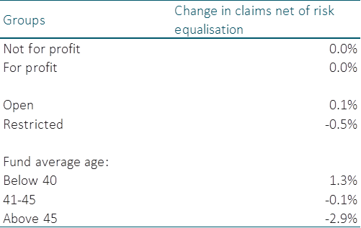

It is important to note that as part of the RE study, Finity developed a simple hybrid RE model using Australian PHI data. The purpose of developing the model was to demonstrate whether alternative RE models test better than the current model, using a comprehensive set of criteria.

The Department is consulting on the findings and recommendations of the Finity RE study, with a focus on outcomes for policyholders, and the performance of Australia’s private healthcare system. The Department is also consulting on the arrangements or mechanisms that should accompany a process to develop a detailed proposal for RE. While the Department is happy to provide the requested information, please note that the consultation is not about introducing the simple RE model from the Finity report. Any proposed RE model would only be available for consultation as part of the process for developing a detailed proposal.

**********************************************************************************