OSR and NKPI for Aboriginal and Torres Strait Islander Primary Health Care Data Framework

Contents
1. Introduction 2
2. Authority for this Framework 2
3. Definitions 3
4. Data collection and preparation 3
5. Data ownership 4
6. Access to the National Dataset 4
Department of Health 4
DSS 4
AIHW 5
Health Services 5
NACCHO and NACCHO Affiliates 5
Third parties 5
NIAA 6
Other Commonwealth agencies 6
7. Commonwealth requirements 6
8. Governance 7
Appendix A—the National Aboriginal and Torres Strait Islander Health Data Principles 8
Appendix B—HDP and EDW 10
Appendix C—summarised HDP and EDW data flows 11
Appendix D—conditions for data access through HDP 12
Appendix E—Grant Opportunity Guidelines (excerpt) 13
Appendix F—data sharing consent in the HDP 14
Appendix G—conditions for third party access to the National Dataset through AIHW 15

Introduction
Health services funded under the Indigenous Australians’ Health Programme (IAHP) collect and supply important Indigenous health data sets to the Department of Health as part of their funding agreements. These are the:
- Aboriginal and Torres Strait Islander National Key Performance Indicators (nKPI)—a set of indicators that are collected twice a year at the health service level and which aggregate information on the regular clients that a health service sees.
- Aboriginal and Torres Strait Islander health organisations: Online Services Report (OSR)—responses to an annual questionnaire that contains information about the organisations that provide primary health care services for Aboriginal and Torres Strait Islander people.
These data are the best available information relating to the primary health care services delivered to Aboriginal and Torres Strait Islander Australians by IAHP funded providers. They comprise an invaluable resource for health services and policy makers and are a strategic data asset of national significance.
This Framework articulates the roles and responsibilities of participants in the collection, use, access, privacy and security of the nKPI and OSR data (the Data). It is informed by the Australian Health Ministers’ Advisory Council endorsed National Aboriginal and Torres Strait Islander Health Data Principles (2006), and provides a culturally respectful foundation for the collection, use, access, privacy and security of the Data. Information on nKPI and OSR against these principles is provided at Appendix A.

Authority for this Framework
This Framework was developed with input from a Working Group comprising representatives of the Indigenous health sector, the Department of Health, the National Indigenous Australians Agency (NIAA), the Australian Institute of Health and Welfare (AIHW), and the Winnunga Nimmityjah Aboriginal Health Service.
The Framework was endorsed by the Aboriginal and Torres Strait Islander Health Services Data Advisory Group (HS DAG) on [insert date].

Definitions
AIHW | Australian Institute of Health and Welfare
Data | nKPI and OSR data
DSS | Department of Social Services
EDW | Enterprise Data Warehouse
HDP | Health Data Portal
health service | An Indigenous primary health care organisation funded to provide services under the IAHP and/or the IAS.
HS DAG | Aboriginal and Torres Strait Islander Health Services Data Advisory Group
IAHP | Indigenous Australians’ Health Programme
IAS | Indigenous Advancement Strategy
NACCHO | National Aboriginal Community Controlled Health Organisation
NACCHO Affiliates | The NACCHO State and Territory sector support organisations
National Dataset | Dataset used for reporting and third party access. It contains validated and finalised Data from all health services with exclusion rules applied.
NIAA | National Indigenous Australians Agency
nKPI | National Key Performance Indicators for Aboriginal and Torres Strait Islander primary health care
OSR | Aboriginal and Torres Strait Islander health organisations: Online Services Report
PM&C | Department of the Prime Minister and Cabinet
third party | All applicants requesting access to the National Dataset except health service Data Owners, the Department of Health and the AIHW.

Data collection and preparation
The nKPI and OSR data are collected by Indigenous primary health care organisations funded under the IAHP and/or the IAS (health services).
As part of the funding agreement between the Department of Health and individual health services, each health service agrees to provide Data to the Department of Health. These Data are submitted through the Department of Health’s Health Data Portal (HDP) and held in the Department’s Enterprise Data Warehouse (EDW) (see Appendices B and C). Security of, and access to, the Data in the HDP and EDW is managed by Department of Health Administrators.
The AIHW is contracted by the Department of Health to:
- assist health services to submit their Data via the HDP
- investigate and improve data quality
- analyse and report.
Conditions for access to the Data through the HDP are outlined in Appendix D. With the express permission of an individual health service, approved Department of Health and AIHW staff can access individual health service Data in the HDP to assist a health service finalise and improve the quality of their Data. These data may not be used for any other purpose.
In the HDP, Data submitted by health services are validated against predefined rules, finalised (indicated by a status of ‘processed’), and flagged by the AIHW, if needed, for exclusion from the National Dataset (if unresolved data quality issues remain). These validated and finalised Data are transferred from HDP to EDW to form the National Dataset that is used for reporting and to respond to requests for access by third parties. Only Data from the National Dataset will be available for reporting and provision to third parties.
Copies of the historic National Datasets created prior to the introduction of the EDW are held both in EDW and at the AIHW.

Data ownership
Ownership of the Data are retained by the health service that collects and provides it.
As owners of their Data, health services retain the right to grant, or refuse, consent for the use of their Data at the health service level (including for publication purposes).

Access to the National Dataset
Only data from the National Dataset will be used for reporting and for third party data requests.

Department of Health
The Department of Health may use the Data as specified in:
- the agreement between each health service and the Department, and
- the Grant Opportunity Guidelines (see Appendix E).
Approved uses are to:
- monitor the activity of health services
- identify areas of need
- inform policy development and program delivery
- support continuous quality improvement
- measure service delivery
- improve service delivery
- improve health outcomes
- support progress towards Closing the Gap targets
- reduce the burden of reporting
- inform funding allocations
- brief the responsible Minister.

Department of Social Services
DSS is contracted by the Department of Health to manage funding agreements with health services. Under delegations on behalf of the Department of Health, authorised DSS Funding Agreement Managers (FAMs) may access health service level Data from the National Dataset via the QLIK dashboards in the HDP. This arrangement was agreed at the Departmental level.

AIHW
Under agreement with the Department of Health, the AIHW may use the National Dataset to:
- analyse data quality
- develop AIHW reports
- manage third party data requests.

Health Services
Data from the National Dataset are made available to health services via QLIK dashboards in the HDP. Health services may also request data from the AIHW. If the health service no longer exists or has merged with another organisation, consultation will be undertaken with relevant parties to determine the appropriateness of access. The AIHW will make any final determination in their role as Data Custodian.

NACCHO and NACCHO Affiliates
The National Aboriginal Community Controlled Health Organisation (NACCHO) and the NACCHO State and Territory Affiliates (the Affiliates) play a key role in supporting health services and, as part of this role, may seek access to health service level Data.
When a health service submits their Data through the HDP they are asked if they wish to consent to other parties such as NACCHO, their NACCHO State or Territory Affiliate or the State or Territory Government having access (see Appendix F).
In accordance with this consent, data from the National Dataset will be provided to NACCHO and the relevant Affiliates:
- by the AIHW via the data request process, where individual health services agree to do so; or
- directly by the health service, as the Data Owner, by enabling access permissions to their Data in the HDP (which they can also revoke at any time) (see Appendix C); or
- through formal bilateral agreements made between the health service and the relevant Affiliate outside of the HDP.
The use to which the NACCHO or the Affiliate puts these Data should be negotiated and agreed with the health services concerned.

Third parties
All requests by third parties for access to National Dataset should be made through the AIHW as Data Custodian of the National dataset. The AIHW has been Data Custodian of the nKPI national dataset since 2012, and of the OSR national dataset since 2008.
Through data requests, the AIHW provides access to statistical information that governments, researchers and the community may use for purposes relating to improving the delivery of primary health care services to Aboriginal and Torres Strait Islander Australians, through research, policy development and promoting public awareness.
In determining whether access to the National Dataset can be provided to third parties, the AIHW will consider the:
- purposes for which the Data are to be used
- any conditions imposed by health services
- AIHW Ethics Committee approval for the collections
- AIHW Act 1987
- Privacy Act 1988.
The AIHW will administer access to the National Dataset in accordance with its’ Data Governance Framework, which includes policies and procedures on:
- information security and privacy (technical, physical and personnel aspects)
- data custody
- the AIHW Ethics Committee
- confidentialising data
- release of statistical information.
Release of Data at the health service level requires the permission of the health services concerned (as ‘data owners’). Health service level Data may be provided either directly by the AIHW or through access to the EDW, depending on the circumstances.
The third party request process is described in the flow chart at Appendix G.

NIAA
All requests for access to the National Dataset by the NIAA should be directed to the AIHW. This includes request for access to historical aggregate and health service level Data relating to the Social and Emotional Wellbeing and Alcohol and Substance previously funded by the PM&C.
The AIHW will consider whether relevant contracts or funding agreements specify that the health service level Data can be provided to the NIAA. In such cases, the AIHW will provide the NIAA with Data consistent with those agreements. If not, the AIHW will seek health services’ permission before it agrees to release these Data.
If the AIHW determines that the request is consistent with required permissions and agrees to release Data to the NIAA, Data will be transmitted through secure email transmission (the Australian Government’s protected security network).

Other Commonwealth agencies
The Grant Opportunity Guidelines (excerpt at Appendix D) include the Department of Health sharing the Data with other Commonwealth agencies. However, the Department of Health has determined that access will be restricted to the Department, DSS (as funding administrators) and the AIHW, and that all requests for access to the National Dataset by third parties should go through the AIHW.

Commonwealth requirements
Commonwealth agencies (including the Department of Health, AIHW, DSS, the NIAA and PM&C) may be required to release the Data on a confidential basis to the Office of the Australian Information Commissioner or the Australian National Audit Office pursuant to legislative powers.

Governance
The HS DAG, formerly the OCHREStreams Advisory Group, advises the Department of Health regarding the ongoing development of the nKPI and OSR data sets.
The HS DAG membership is comprised of a variety of expert Government and non-Government representatives, and is co-chaired by the Department of Health and NACCHO. HS DAG is an advisory body, and does not have responsibility for operational oversight of the nKPI and OSR data collections.
The HS DAG may request that this Framework be reviewed or amended as required, to ensure its currency in describing governance of the Data.

Appendix A—the National Aboriginal and Torres Strait Islander Health Data Principles

Principle 1: The management of health-related information about Aboriginal and Torres Strait Islander persons must be ethical, meaningful, and support improved health and better planning and delivery of services.
The nKPI and OSR data collections meet this principle; consent is sought for collection and the Data are primarily used to support improved health outcomes for Aboriginal and Torres Strait Islander people.

Principle 2: The analysis, interpretation and reporting of Aboriginal and Torres Strait Islander health and health-related information should, where feasible, occur collaboratively with Aboriginal and Torres Strait Islander peoples.
The nKPI an OSR data are generally collected by ACCHSs. The health services also work collaboratively with the AIHW to ensure the accuracy of the data that they provide.

Principle 3: The privacy and confidentiality of Aboriginal and Torres Strait Islander people will be protected in accordance with any relevant legislation and privacy codes.
The nKPI and OSR data collections are protected through best practice encryption and may only be accessed according to the consent that the health services have agreed to. The Data are not considered personal for the purposes of compliance with the Privacy Act.

Principle 4: Aboriginal and Torres Strait Islander peoples should be informed at the point of service that attendance/participation may contribute to administrative or mandatory data collections and that such data will be used to improve the quality, coverage and scope of health services and protect the public health. Data collection agencies and data custodians should have a policy that provides this information to people at the point of data collection and appropriate governance arrangements to review its implementation.
Aggregate data for the nKPI and OSR are collected by health services funded under the Indigenous Australians’ Health Programme. These services have the responsibility to provide information to their clients regarding how their Data will be used. The Data Custodian can provide information to services in this regard.

Principle 5: In general, free and informed consent should be obtained from Aboriginal and Torres Strait Islander peoples prior to any information management activities, except where mandatory reporting or legislative provisions apply. Otherwise, where there is a proposal to initiate an information management activity without the consent of Aboriginal and Torres Strait Islander peoples, it must be clearly demonstrated both that the activity will advance the interests of Aboriginal and Torres Strait Islander peoples and that it is impractical and infeasible to obtain further specific consent.
When Data are collected through the Health Data Portal health, services must show that they consent to the Commonwealth using their Data in specific ways. The services must ensure in turn that their clients’ consent to their Data being provided as part of an anonymised aggregated data set. The Grant Opportunity Guidelines also provide a clear statement regarding how the Commonwealth will use collected Data. For other uses the Commonwealth must seek additional consent.

Principle 6: The value of the resources required to collect and use information should be assessed in the light of the potential benefit to Aboriginal and Torres Strait Islander peoples’ health.
The nKPI and OSR collections constitute some of the richest and most accurate data relating to Indigenous health in Australia, and is critical to improving Aboriginal and Torres Strait Islander health.

Principle 7: The collection, collation and utilisation of information should be conducted in the most efficient and effective manner possible and minimise the burden on Aboriginal and Torres Strait Islander people.
The burden of collecting these Data is relatively low, relying primarily on the Clinical Information Systems used by each health service. The Department of Health is continually seeking to minimise the administrative burden on health services.

Principle 8: Systematic and ethical processes for sharing information should be encouraged to assist in policy, planning, management and delivery of health services to Aboriginal and Torres Strait Islander people.
The Commonwealth seeks to use the Data to benefit the health of Aboriginal and Torres Strait Islander people. Data will only be used according to the consent provided.

Principle 9: Aboriginal and Torres Strait Islander communities should be provided with feedback about the results and possible implications arising from data analysis.
The Data are published at an aggregate level which is freely available to services. In addition, each service can access their own Data and conduct analysis using the tools in the Health Data Portal to assess their performance and measure their activities against other services with similar characteristics.

Principle 10: Information collections require regular review and refinement in order to ensure ongoing relevance to service delivery and the potential for improved health outcomes.
The nKPI and OSR data are subject to review on submission, and have also been reviewed in detail by the AIHW to ensure that they are fit for purpose.

Principle 11: Cultural respect and security of data practices must be promoted across all collections. Aboriginal and Torres Strait Islander individuals and communities should be afforded the same ethical and legal standards of protection as are enjoyed by other Australians. This may require the development and application of methods that are different to or in addition to those in mainstream data collections.
The nKPI and OSR collections are guided by the Health Services Data Advisory Group, which provides advice to Government on all aspects of the use and collection of these Data. The consideration given to the treatment of these Data is of a higher standard than that given to other like data sets.

Appendix B—HDP and EDW

The Enterprise Data Warehouse (EDW)
The Department of Health developed the EDW in 2011. It is a system used for reporting and data analysis. The EDW is a central repository of integrated data collected from a range of disparate sources. It allows approved people and organisations to access, link and use high value data. The way that health services upload data nKPI and OSR to the EDW is through the HDP, which commenced in December 2018.
Access to the EDW is controlled by the Data Services Branch within the Department of Health. All data held in the EDW are managed in accordance with the Department of Health’s overarching Data Governance and Release Framework that requires data stewards to explicitly authorise any access to restricted or sensitive data. The Data Governance and Release Framework is managed by the Health Analytics Branch within the Department of Health.
The EDW infrastructure meets the requirements of the Australian Signals Directorate Information Security Manual. The manual is the standard which governs the security of government Information and Communication Technology (ICT) systems.

The Health Data Portal (HDP)
The HDP is a bespoke web-based solution developed within the EDW that allows health services to upload data directly, either through their Clinical Information System (Medical Director, MMEx, Communicare and Best Practice) or through a manual submission. The HDP is a safe and secure tool that allows health services to submit their nKPI or OSR report data. More information on the HDP may be found at: http://www.health.gov.au/internet/main/publishing.nsf/Content/indigenous-data-portal.
The HDP also provides health services with access to a QLIK dashboard where they are able to look at their data in real time in a variety of different ways, and to compare their data to a variety of customisable benchmarks. Individual health services will be able to access and share their data and undertake de-identified comparisons with (anonymised) health services with similar characteristics or against national trends. This empowers health services and informs and supports continuous quality improvement.
Access for any user of the HDP platform (outside of Department of Health users) requires an AUSkey credential, which authenticates both the identity and the organisation of the user. By itself, the AUSkey does not enable access to any data. After the end of March 2020 Auskey will be decommissioned and replaced with myGovID. This new system will work in the same way for the purposes of authentication. Permission to access specific data for a health service within the HDP is controlled through the allocation of a combination of roles and folders by the User Administrator (UA) in each health service:
- The UA controls access to the health service’s data for users within the health service or for users in other health services or Affiliates who may request permission through the HDP.
- The UAs for the Department of Health and the AIHW control access for staff whose roles require them to work with health services and health service data.
- The UAs must ensure that the access provided matches the requirement of the role, and must additionally revoke this access if any changes occur. The UAs are also responsible for ensuring that data accessed are commensurate with the requirement of the tasks associated with the specified role.

Appendix C—summarised HDP and EDW data flows
AIHW reporting
Third party request for aggregate data
Managed by AIHW via data request process.
AIHW quality assurance processes
Data are checked, finalised, and flagged for exclusion from National Dataset (if unresolved data quality issues remain).
A National Dataset is produced and stored in EDW.
Health service data loaded and
processed
Health Service data are checked against predefined rules on upload and error report produced. Repeated as necessary to improve quality of data.
AIHW space for file transfer
QLIK dashboard
Interactive QLIK Indigenous Health Data reports produced.
Health Data Portal (HDP)
Access managed by Health Administrators.

Health Enterprise Data Warehouse (EDW) ODS
Health service data loaded via HDP are stored in EDW. Views of the data are created. Access to, and content of, views are managed by Health Administrators.
AIHW EDW view
Authorised staff of AIHW access an approved view of the data in EDW for uses as specified in the Data Framework.
Temporary workspace for AIHW analysis (ADS)
Health EDW view
Authorised staff of Health access an approved view of the data in EDW for uses as specified in the Data Framework.
Landing space for AIHW file transfer between EDW and HDP (P Drive)
Health service (data provider)
Data files are uploaded by health services via the HDP.
Third party request for access to service level data
Managed by AIHW via data request process. If access required to EDW, permission assigned by Health Administrators.

Appendix D—conditions for data access through HDP
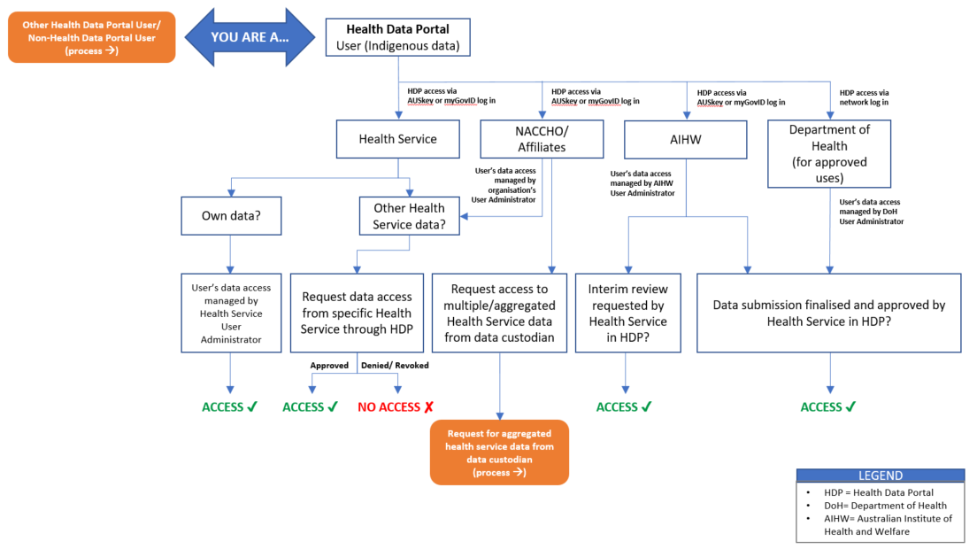

Appendix E—Grant Opportunity Guidelines (excerpt)
The Grant Opportunity Guidelines outlines how the Commonwealth may use data provided by health services. These guidelines state:
We (the Commonwealth) may reveal confidential information to:
- the committee and other Commonwealth employees and contractors to help us manage the program effectively;
- employees and contractors of our department so we can research, assess, monitor and analyse our programs and activities;
- employees and contractors of other Commonwealth agencies for any purposes, including government administration, research or service delivery;
- other Commonwealth, State, Territory or local government agencies in program reports and consultations;
- the Auditor-General, Ombudsman or Privacy Commissioner;
- the responsible Minister or Parliamentary Secretary; and
- a House or a Committee of the Australian Parliament.
We may share the information you give us with other Commonwealth agencies for any purposes including government administration, research or service delivery and according to Australian laws, including the:
- Public Service Act 1999;
- Public Service Regulations 1999;
- Public Governance, Performance and Accountability Act 2013;
- Privacy Act 1988;
- Crimes Act 1914; and
- Criminal Code Act 1995.

Appendix F—data sharing consent in the HDP

nKPI
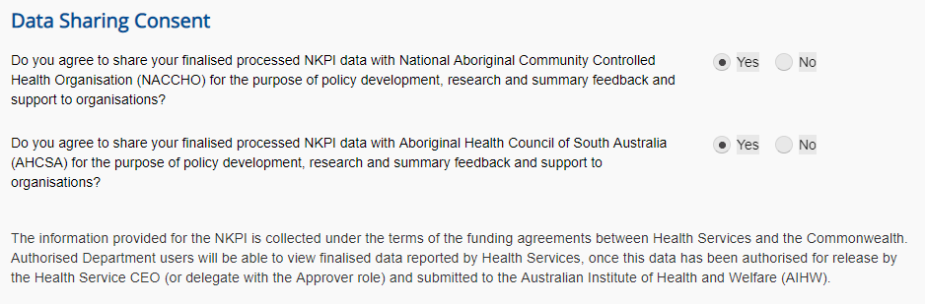

OSR
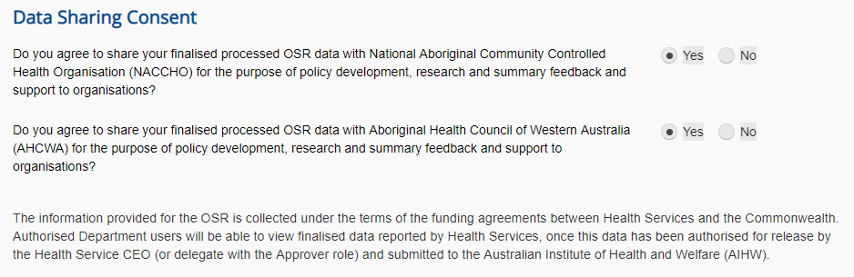

Statement of use
From July 1 2020, an additional statement will be included in the data sharing consent screen on the Health Data Portal. This statement provides an overview of the uses to which health services data may be put. It states:
The Commonwealth may use the Data as specified in the agreement between each health service and the Department of Health. Approved uses are to:
- monitor the activity of health services
- identify areas of need
- inform policy development and program delivery
- support continuous quality improvement
- measure service delivery
- improve service delivery
- improve health outcomes
- support progress towards Closing the Gap targets
- reduce the burden of reporting
- inform funding allocations
- brief the responsible Minister.

Appendix G—conditions for third party access to the National Dataset through AIHW
