Nurse Practitioner Workforce Plan

Analysis of submissions - Round Two

© Commonwealth of Australia (Department of Health and Aged Care) 2023

**Title: Nurse Practitioner Workforce Plan**

**Analysis of submissions - Round Two**

**Creative Commons Licence**

cid:image001.png@01D10CD1.33FE7F70

With the exception of the Commonwealth Coat of Arms and where otherwise noted, this product is provided under a Creative Commons Attribution 4.0 International Licence. (http://creativecommons.org/licenses/by/4.0/legalcode).

This publication is licensed under the Creative Commons Attribution 4.0 International Public License available from https://creativecommons.org/licenses/by/4.0/legalcode (“Licence”). You must read and understand the Licence before using any material from this publication.

The Licence may not give you all the permissions necessary for your intended use. For example, other rights (such as publicity, privacy and moral rights) may limit how you use the material found in this publication. The Licence does not cover, and there is no permission given for, use of any of the following material found in this publication:

* the Commonwealth Coat of Arms (by way of information, the terms under which the Coat of Arms may be used can be found on the Department of Prime Minister and Cabinet website

https://www.pmc.gov.au/government/commonwealthcoat-arms);

* any logos and trademarks;
* any photographs and images;
* any signatures; and
* any material belonging to third parties.

**Attribution:** Without limiting your obligations under the Licence, the Department of Health requests that you attribute this publication in your work. Any reasonable form of words may be used provided that you:

* include a reference to this publication and where, practicable, the relevant page numbers;
* make it clear that you have permission to use the material under the Creative Commons Attribution 4.0 International Public License;
* make it clear whether or not you have changed the material used from this publication;
* include a copyright notice in relation to the material used. In the case of no change to the material, the words “© Commonwealth of Australia (Department of Health) 2020” may be used. In the case where the material has been changed or adapted, the words: “Based on Commonwealth of Australia (Department of Health) material” may be used; and
* do not suggest that the Department of Health endorses you or your use of the material.

**Enquiries:** Any enquiries regarding any other use of this publication should be addressed to the Branch Manager, Communication Branch, Department of Health, GPO Box 9848, Canberra ACT 2601, or via e-mail to [copyright@health.gov.au](mailto:copyright@health.gov.au)

Contents

Introduction 4

Methodology 4

Key Findings 5

Aim 7

Outcomes 8

Education and lifelong learning 9

Recruitment and retention 10

Models of care 11

Health workforce planning 13

Conclusion 13

# Introduction

The Department of Health and Aged Care (Department) is currently developing a Nurse Practitioner Workforce Plan (Plan). The Plan will outline a set of actions to address nurse practitioner (NP) workforce issues of national significance and increase the accessibility and delivery of person-centred care for all Australians through a well-distributed, culturally safe NP workforce.

Key outcomes of the Plan will include:

* increase the supply of NPs
* facilitate recruitment and retention of NPs
* support the NP workforce to enhance skills and capability to address population health needs
* facilitate sustainable models of NP care that meet community needs
* build understanding of the role and contribution of NPs; and
* bolster data infrastructure and planning processes that include NPs in workforce planning.

As part of the development of the Plan, the Department sought the views of stakeholders via an initial public consultation process from 19 November 2021 to 20 December 2021. The purpose of the consultation was to collect ideas from a wide range of stakeholders on their perspectives, experiences and knowledge of NPs and to identify benefits, barriers, and workforce solutions to inform development of the Plan. Following this process, a consultation draft of the Plan was developed. The consultation draft Plan was released by the Department for stakeholder feedback through a second round of public consultation held from 19 December 2022 to 10 February 2023. Feedback received through the consultation process will be used to refine and inform the final Plan.

# Methodology

The Department held the second round of consultations via an online survey on Consultation Hub and also accepted written submissions via email. Targeted meetings were held aiming to tap into expertise from key stakeholder organisations with different perspectives. Yarning circles and a consumer focus group were held to test the actions within the draft Plan to ensure they are realistic, implementable and well received by both First Nations peoples and consumers. In total, 215 submissions were received, comprising of 172 online survey responses, 25 written submissions via email, 15 targeted stakeholder meetings, 1 consumer focus group and 2 yarning circles.

To facilitate consultation with relevant stakeholders, the Nurse Practitioner Steering Committee members were also asked to share the draft with their own stakeholder contacts and invite them to participate.

A social media campaign to raise awareness of the consultation continued throughout the second round (19 December 2022 to 10 February 2023). This included: an announcement of public consultation opening via Twitter and LinkedIn on 11 January; then another post on 24 January 2023 reminding people to participate and that the consultation would close soon. Internal promotion within the Department was also undertaken to raise awareness of the consultation with a feature on the Department’s intranet page and in internal all staff emails. Internal staff were requested to encourage their stakeholders to share their thoughts on the aim, outcomes and actions of the draft Plan via the Consultation Hub.

The average interaction rate across all Plan posts was 1.8% (these figures are for LinkedIn and Twitter only, for the month of January 2023). The posts received 5611 impressions and 101 interactions.In looking at the data, LinkedIn performed above average for interaction rate – the highest post was 6.59% (LinkedIn usually has an average of 4% for interaction across the channel and anything above this is considered high performing). While the impressions are low, the high interaction rate means this was the right channel for this content as it was highly relevant to the people that saw it. Twitter provided more awareness of the topic than action based on these results.

The Department undertook analysis of the 197 online submissions (including survey and written responses) using the Citizen Space application in February 2023. The data from online and written submissions was further analysed simultaneously with stakeholder feedback from meetings, yarning circles and focus groups in excel. This involved coding the qualitative responses for feedback on key themes and creation of analysis notes to further refine the consultation draft.

This report presents the analysis of round two consultation.

# Key Findings

The total number of submissions received was 197 with 172 online survey responses and 25 written submissions via email. The figures and tables show data reported and analysed from citizen space. The findings also include qualitative data derived from the analysis of stakeholder meetings, yarning circles focus groups and online submissions.

Demographics

**Location**

Respondents were asked to identify their location by remoteness area. There were 170 responses to this question with half being from urban areas (51%) and followed by regional (17%), rural (10%) and remote (4%) and very remote (4%). Some did not respond (14%).

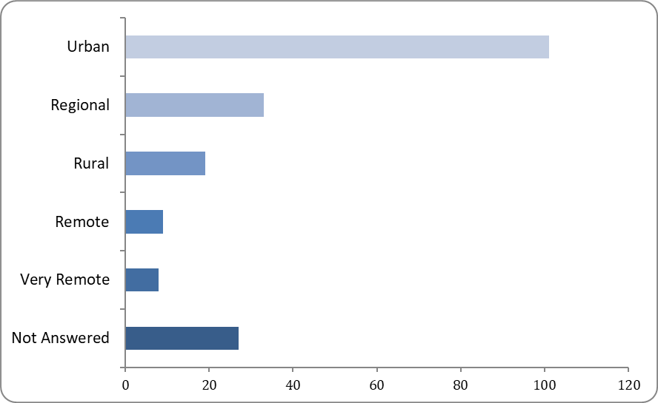

Figure 1: Question: *Please select your location.*

**Individuals or organisation status**

Respondents were asked to identify if they were answering as an individual or on behalf of an organisation There were 185 responses for this question. Of these, 139 (71%) responded as an individual and 46 (23%) responded on behalf of an organisation or institution. Twelve (6%) did not answer.

Figure 2: Question: Which describes your best response?

**Category of occupation**/Description of respondent

Respondents who identified as an individual were asked to select the category that best describes themselves. There were 149 responses to the question. Many respondents were nurse practitioners (42%) and 12% identified as registered nurses.

Figure 3 Question: *Please select the category that best describes you.*

**Category of affiliation**

Respondents were asked to identify their affiliation category. There were 58 responses to the question. Of the respondents the top three categories of affiliation included 5% from Peak/professional body – nursing, 5% State/Territory Government department/agency, and 5% University/education/research institute.

|  |  |  |
| --- | --- | --- |
| **Category of affiliation** | **Total** | **Percent** |
| Peak/professional body - nursing | 10 | 5.15% |
| Peak/professional body – medical | 3 | 1.55% |
| Peak/professional body – other | 6 | 3.09% |
| Regulatory body | 2 | 1.03% |
| Aboriginal and/or Torres Strait Islander organisation | 0 | 0.00% |
| State/Territory Government department/agency | 10 | 5.15% |
| Health service delivery organisation | 8 | 4.12% |
| Local council | 0 | 0.00% |
| Primary Health Network | 3 | 1.55% |
| University/education/research institute | 9 | 4.64% |
| Other - please specify below | 4 | 2.06% |
| Not Answered | 139 | 71.65% |

Table 1: Question: *Please select the category that best describes your organisation/institution.*

## Aim

Respondents were asked if they believed the aim of the plan is clear. There were 168 responses. Of the respondents who reported about clarity of the aim there were 155 (79%) who reported the aim to be very clear or somewhat clear, 13 (6%) were unclear, and 29 (15%) did not answer.

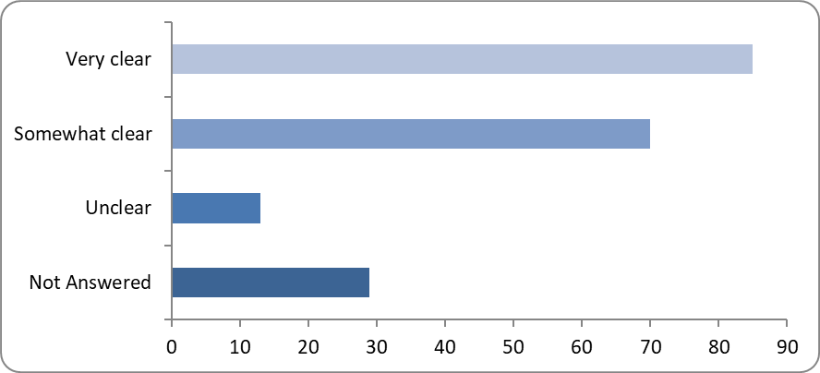

Figure 4: Question: *Do you think the aim of the plan is clear?*

## Outcomes

Respondents were asked if they believed the targeted outcomes of the Plan are appropriate for the next 10 years? 168 respondents answered the question. The majority, 155 (79%) identified they believed the outcomes were very or somewhat appropriate, whereas 10 (5%) showed they were not appropriate. 3 respondents (2%) were unsure and 29 (14%) failed to respond.

Figure 5: Question: *Are the targeted outcomes of the Plan appropriate for the next 10 years?*

Respondents were invited to provide any additional feedback or comments on the aim and outcomes. The following feedback was obtained from 118 online respondents and participants in meetings, yarning circles and focus groups.

Most respondents highlighted their opinion that nurse practitioners have an important role in health workforce to increase access to health and aged care. Many respondents expressed the need for increased nurse practitioner workforce numbers and commented that a funded plan for significant growth is long overdue. A large majority of respondents provided feedback that nurse practitioners are valuable in health care service delivery, from metropolitan to rural and remote areas. It was suggested that opportunities in the private sector could be recognised as untapped potential for employment.

A key theme that emerged from the data in this section was that despite holding the endorsed NP qualification many NPs stated they were not employed in this role. This feedback was repeated in the theme of recruitment and retention. While many respondents supported the aims and outcomes in principle, the feedback included suggestions to improve clarity in the language. Additionally, it was suggested that the Plan provide detail with more specific actions and timelines. Minor suggestions as far as consistency with terminology were identified, and to include reference to key strategies that align with the Plan.

Many respondents suggested the development of a robust Monitoring and Evaluation Framework (MEF) should be included. The need to include NPs in the models of care was highlighted. It was suggested an outcome regarding accessible and supported pathways for nurses/NPs across the career continuum be included. Incentives to increase continued learning opportunities were requested. This feedback was echoed in the education and lifelong learning section.

## Education and lifelong learning

## Respondents were asked if the actions of the Plan support the NP workforce to enhance their skills and capability to address population health needs. 168 respondents provided feedback to this question. 120 (61%) answered yes, 14 (7%) answered no, and 34 (17%) responded they were unsure. 29 (15%) respondents did not answer.

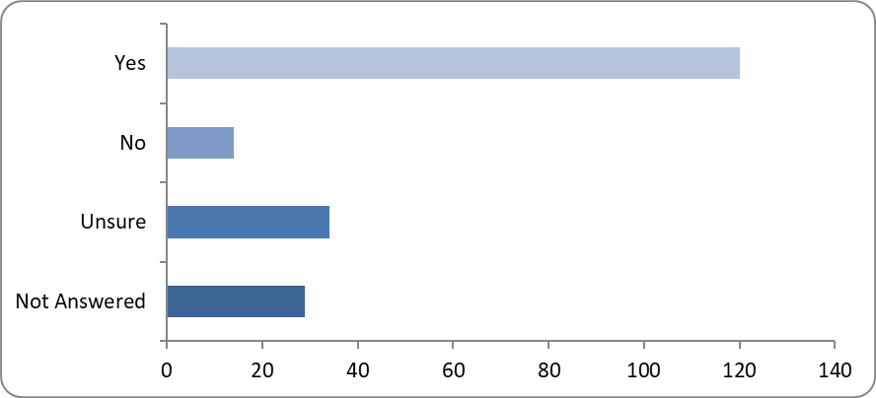

Figure 6: Question: *Will these actions support the nurse practitioner workforce to enhance their skills and capability to address population health needs?*

**Improving education and endorsement pathways for First Nations NP growth**

Respondents were asked if the actions of the Plan encourage provision and uptake of NP education and the NP endorsement pathway, including encourage the growth of First Nations NPs? There were 166 responses to the question. At least half of the respondents 100 (51 %) answered yes, whereas 8 (4%) answered no. 58 (29%) were unsure and 31 (16%) did not answer.

|  |  |  |
| --- | --- | --- |
| Option | Total | Percent |
| Yes | 100 | 50.76% |
| No | 8 | 4.06% |
| Unsure | 58 | 29.44% |
| Prefer not to say | 0 | 0.00% |
| Not Answered | 31 | 15.74% |

Table 2: Question: *Will these actions encourage provision and uptake of nurse practitioner education and the nurse practitioner endorsement pathway, including encourage the growth of First Nations nurse practitioners?*

Respondents were invited to provide any additional feedback or comments on the theme of education and lifelong learning. The following feedback was obtained from 110 online respondents and participants in meetings, yarning circles and focus groups. Many respondents commented that encouraging more nurses into educational opportunities to become NPs would contribute to the Plan’s success. Many respondents indicated the barriers to NP education include the cost of education and associated expenses such as housing and time off paid work. The removal of financial barriers was identified as being particularly important for attracting more people from First Nations and culturally and linguistically diverse communities into further educational programs to progress toward becoming a NP.

Inconsistent clinical supervision and mentoring support for NP students was a key theme commented on by several respondents. Some stakeholders felt that the Plan does not provide pathways for RNs to progress to become a NP in the primary health care space. It was identified by some respondents that there is an opportunity in this Plan to highlight the need for partnerships and collaboration with state and territory public health systems to support the development of NPs. Some respondents suggested the actions within the Plan could be improved with strengthened language to improve clarity. Many suggestions around curriculum content were provided.

## Recruitment and retention

Respondents were asked if the actions of the Plan facilitate the recruitment and retention of nurse practitioners. There were 168 responses to this question. More than half of respondents answered yes (54%, n=104) in contrast to 15 (8%) who answered no. 49 (25%) were unsure and 26 respondents (13%) did not answer the question.

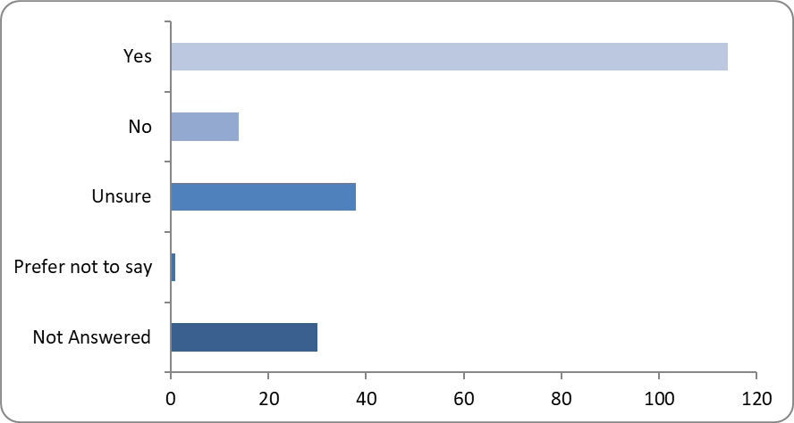

Figure 7: Question: *Will these actions facilitate the recruitment and retention of nurse practitioners?*

Respondents were invited to provide any additional feedback or comments on recruitment and retention. The following feedback was obtained from 112 online respondents and participants in meetings, yarning circles, and focus groups. Many respondents provided feedback about the negative impact financially that they experience as a result from current incentives, funding, and structures. This results in out-of-pocket expenses for the NP and their consumers.

The majority of respondents highlighted barriers to practice as a direct issue to recruit and retain NPs. Many respondents highlighted the need to review the current Medical Benefits Schedule (MBS) to improve the financial sustainability of NP services. Most respondents suggested an increase in accessible items that the NP can claim. Further feedback about barriers in practice were provided where self-employed NPs are unable to access MBS items and be renumerated for the time spent with patients. Ordering certain diagnostic tests was reported as problematic for NPs in some circumstances and may result in additional costs to the patient when the test is ordered by the NP. Another example cited was the inability to order some pathology tests that attract an MBS benefit for their patients. Many respondents suggested a review of funding arrangements including incentives in both private and public systems.

Respondents consistently agreed on the need to create opportunities to employ newly qualified NPs. There was concern from some respondents that many endorsed NPs are not appointed to the level of a NP. Furthermore, respondents provided feedback describing circumstances where NPs are employed in other job positions such as Clinical Nurse Consultants.

## Models of care

Respondents were asked if the actions in the Plan will facilitate sustainable models of nurse practitioner care that meet community needs? 167 respondents answered this question. Of the 167 respondents, over half responded yes, 114 (58%) whereas 14 (7%) did not think so and 38 (19%.) were unsure. One respondent (1%) preferred not to say and 30 (15%) did not respond.

Figure 8: Question: *Will these actions facilitate sustainable models of nurse practitioner care that meet community needs?*

**Actions to ensure national consistency of practice and enable nurse practitioners to work to their full scope of practice**

Respondents were asked if the actions in the Plan will ensure national consistency of practice and enable nurse practitioners to work to their full scope of practice? Of the 167 respondents at least half answered yes 103 (53%), 18 (9%) and 45 (22%) answered no and unsure respectively, 30 (15%) did not answer and 1 (1%) preferred not to say.

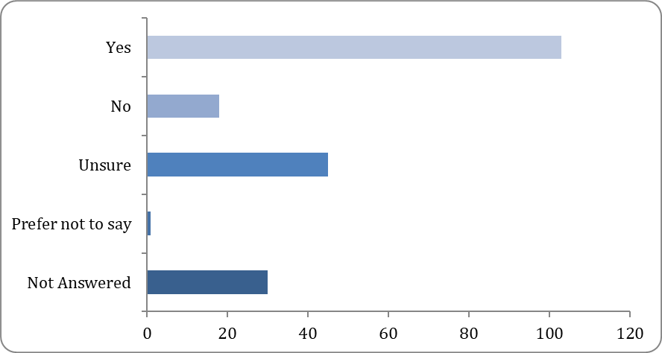

Table 3: Question: *Will these* *actions ensure national consistency of practice and enable nurse practitioners to work to their full scope of practice?*

Respondents were invited to provide any additional feedback on models of care. The following feedback was obtained from 98 online respondents and participants in meetings, yarning circles, and focus groups. This section generated the most comprehensive feedback. Some feedback was repeated in multiple themes. Similar to the feedback received in the theme recruitment and retention, there were many comments regarding the need to improve MBS rebates as this poses a significant barrier for consumers to access NP care. It was repetitively recognised that inadequate funding for models of care continue to be a significant barrier. Many respondents suggested the removal of Medicare restriction to enable NPs to work within their scope of practice. Initiatives to support Closing the Gap were highlighted. Again, PBS featured in a large amount of feedback where respondents identified the lack of prescribing authority that impedes NP scope of practice.

Many respondents provided feedback proposing the removal of collaborative arrangements because of the confusion and the lack of autonomy it causes and requested legislative reform to enable this. It was evident there was confusion with some respondents about the difference between collaborative arrangement versus working in collaboration and suggestions to clarify the differences were made. Some respondents suggested a review of funding arrangements and exploring the establishment of a roadmap for funding reforms. The need to identify clinical governance structures to support NPs was received by some respondents.

The inclusion of a clear Monitoring and Evaluation Framework (MEF) was identified by many respondents within this theme. Inclusion of telehealth and its importance in rural and remote care was a theme identified by a few respondents. Further clarity around language and some definitions were suggested.

## Health workforce planning

Respondents were asked if the actions of the Plan will bolster data infrastructure and planning processes that include NPs in health workforce planning. There were 166 responses to this question. 99 (51%) answered yes and 10 (5%) answered no. 56 (29%) were unsure, 1 (1%) preferred not to say, and 28 (14%) failed to respond.

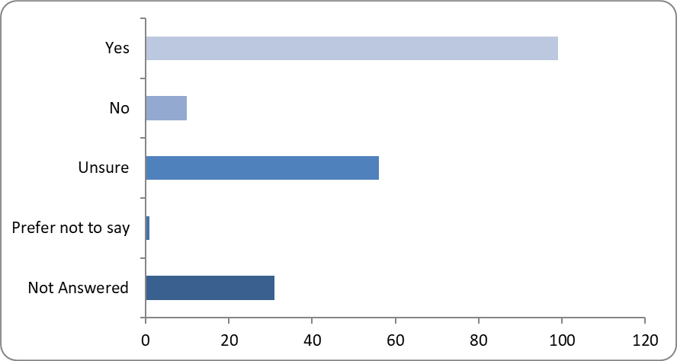

Figure 9: *Will these actions bolster data infrastructure and planning processes that include nurse practitioners in health workforce planning?*

Respondents were invited to provide any additional feedback or comments on health workforce planning theme. The following feedback was obtained from 73 online respondents and participants in meetings, yarning circles, and focus groups. Many respondents commented on the need to raise awareness about NPs regarding their knowledge, skills and the care they provide, and the potential significant benefits NPs can play in improving access to health care and patient outcomes. It was suggested by many respondents that development and implementation of a national NP awareness strategy would increase professional staff and consumer awareness of the NP role. Other respondents noted that communications and education campaigns would help to increase community uptake and service navigation.

Data collection strategies emerged as a theme, with many respondents providing the suggestion to include NPs in access to the Health Demand and Supply Utilisation Patterns Planning (HeaDS UPP) Tool. It was suggested by some respondents that increased data collection will provide further evidence about the work NPs provide and to assist towards workforce planning. It was suggested that a reference committee for oversight to provide consistency and governance be established.

# Conclusion

There was a high response rate from stakeholders from the consultation on the draft Plan. The mix of responses from consumers, NPs, health professionals and organisations provided a comprehensive picture of how the aim, outcomes and actions of the Plan were received. Feedback on improving the draft Plan was constructive. Whilst many responses were still focused on the barriers to NPs providing care, the Department received useful suggestions for refining the draft Plan. Stakeholder feedback captured in the targeted sessions will also be used to refine the Plan and ensure the actions address key NP workforce challenges. Suggestions around the refinement of concise language were identified by many respondents and a review of where some actions sit on the timeline was also highlighted. Suggestions proposed during this round of consultation will be considered by the Nurse Practitioner Steering Committee and utilised to refine a final draft of the Plan.