Consultation Paper

Developing the National Nursing Workforce Strategy
November 2023

Contents
Consultation Paper 1
Developing the National Nursing Workforce Strategy 1
Contents 2
Outline 3
Introduction 4
Why a national Strategy? 4
Scope of the Strategy 4
Process to develop the Strategy 5
Purpose of this consultation paper 5
Nursing workforce in Australia 6
Issues for consideration 8
The growing need in aged care services 8
The regional, rural and remote nursing workforce 8
Cultural safety 9
First Nations nurses 9
Career pathways and specialisation 10
Nurses’ health and wellbeing 11
Nursing leadership and management 11
Building nursing research capability 12
Recruitment and retention 12
The future of nursing in Australia 14
A workplace that thrives on a positive culture, empowered by accomplished leaders, fully supporting their nurse workforce 15
Delivering person-centred care 15
Nurses working to their optimum scope of practice 16
Technology drives a very different workforce and health service 17
Education and lifelong learning that provides high quality skills 18
Career pathways that are globally aligned, nationally recognised and provide structured progress 19
References 20

Outline
What we did yesterday will not work tomorrow.
We will need to find new and different ways to attract and retain nurses now to meet the health needs of the future.
  - Why a national strategy?
  - Purpose of this consultation paper
  - An overview of Australia’s nursing workforce
  - Issues for consideration in a National Nursing Workforce Strategy
  - The future of nursing in Australia – possible scenarios

Introduction
The Australian health, aged and disability care sectors are evolving in response to an ageing population, increases in chronic disease, and the impact of technology. Nurses are the largest health profession in Australia, comprising over 40% of the health workforce.
Nurses have a central role to ensure safe, affordable and respectful care for people. As members of multidisciplinary teams, nurses provide high-quality health, aged and disability care and coordination, and perform key functions across all service settings, in metropolitan, regional, rural and remote areas. Nurses also tend to have the highest contact rates within acute care, residential aged care and remote settings. A well supported nursing workforce is critical to effectively addressing the health, aged and disability care needs of the Australian community.

Why a national Strategy?
There has never been a national-level strategy developed to inform nursing policy and workforce planning. Australia’s first National Nursing Workforce Strategy (Strategy) will support the ongoing development of a capable, resilient nursing profession delivering person centred, evidence based compassionate care to all Australian communities.

Scope of the Strategy
The Strategy will cover Registered Nurses (RN), Enrolled Nurses (EN), Nurse Practitioners (NP), Assistants in Nursing (AIN – however named) and students of nursing. It will also consider the roles of these individuals in the broader care team of the future.

Process to develop the Strategy
The Australian Government Department of Health and Aged Care, Victorian Department of Health and Safer Care Victoria are leading the development of the Strategy, in collaboration with all states and territories and nursing stakeholders.
The Strategy will be underpinned by extensive stakeholder engagement, including through targeted consultations and broader public consultation. Consultation events are being publicly advertised and are open to anyone with an interest in the future of the nursing profession.
The Strategy will complement and inform the work of a wide range of strategies and plans to support the nursing workforce in Australia. These linkages to broader health workforce planning and strategies will be explored through a national and international environmental scan.
For more information on the structure, scope and process to develop the Strategy
visit www.health.gov.au/nnws.

Purpose of this consultation paper
This consultation paper has been developed by the Australian Government Department of Health and Aged Care, the Victorian Government Department of Health and Safer Care Victoria to provide stakeholders with information about the current issues facing the nursing workforce in Australia today.
The consultation paper also paints a picture of what the future could look like. It does not accept the status quo, embraces possibilities and suggests a range of workforce strategies that could be considered in the future.
It poses a series of questions throughout to promote different ways of thinking about the future of nursing to help inform the Strategy. These questions are put forward to stimulate your thinking as you engage with the consultation, whether that be in the workshops, the webinars, the survey or in a written submission.
We are seeking to engage with a vast and diverse range of stakeholders. Your feedback will assist us to develop a future-focussed strategy that seeks to support nurses to continue delivering high quality health care in future care environments.

Nursing workforce in Australia
Australia’s health system is complex, with nursing workforce accountabilities split between various stakeholders. The nature of federation means that decision making is distributed and reflects the different priorities of the Australian government and individual state and territories. However, at the centre of the health system is the person, the health consumer.
The Australian government is responsible for developing national health policies and funding population specific services, including health and medical research, National Disability Insurance Scheme (NDIS), Pharmaceutical Benefits Scheme (PBS), and Medicare Benefits Schedule (MBS). It contributes funds to the states and territories for public health and hospital services through the National Health Reform Agreement.
State and territories are the largest employers of the nursing workforce who fund and manage public hospitals, deliver community, preventative and ambulance services, and regulate and license private hospitals. In 2020–21 nurses accounted for 2 in 5 (41%, 175,000) full-time equivalent (FTE) staff in public hospitals. In private hospitals, nurses accounted for 52% of FTE staff in private free-standing day hospital facilities and 56% of FTE staff in other private hospitals. Figure 1 illustrates the integration of the nursing workforce in Australia’s health care system.
Nursing in Australia has always been a female dominated occupation. Of the 363,505 employed nurses in Australia in 2022, 87.8% (319,249) were recorded as female, while only 12.2% (44,231) of the workforce were male. The average annual growth rate from 2017 to 2022 for employed male nurses increased by 4.5%, while the average annual growth rate from 2017 to 2022 for employed female nurses increased by 2.6%.
There are also proportionally fewer nurses from indigenous or non-English speaking backgrounds.
In 2022, 1.5% of employed nurses in Australia reported to be Aboriginal and/or Torres Strait Islander. 40.8% of Australian nursing workforce were born outside of Australia in 2022, illustrating the diversity of the nursing workforce.
More data and information on the education and regulation of nurses is available
at www.health.gov.au/nnws.

Figure 1: Australian health care system
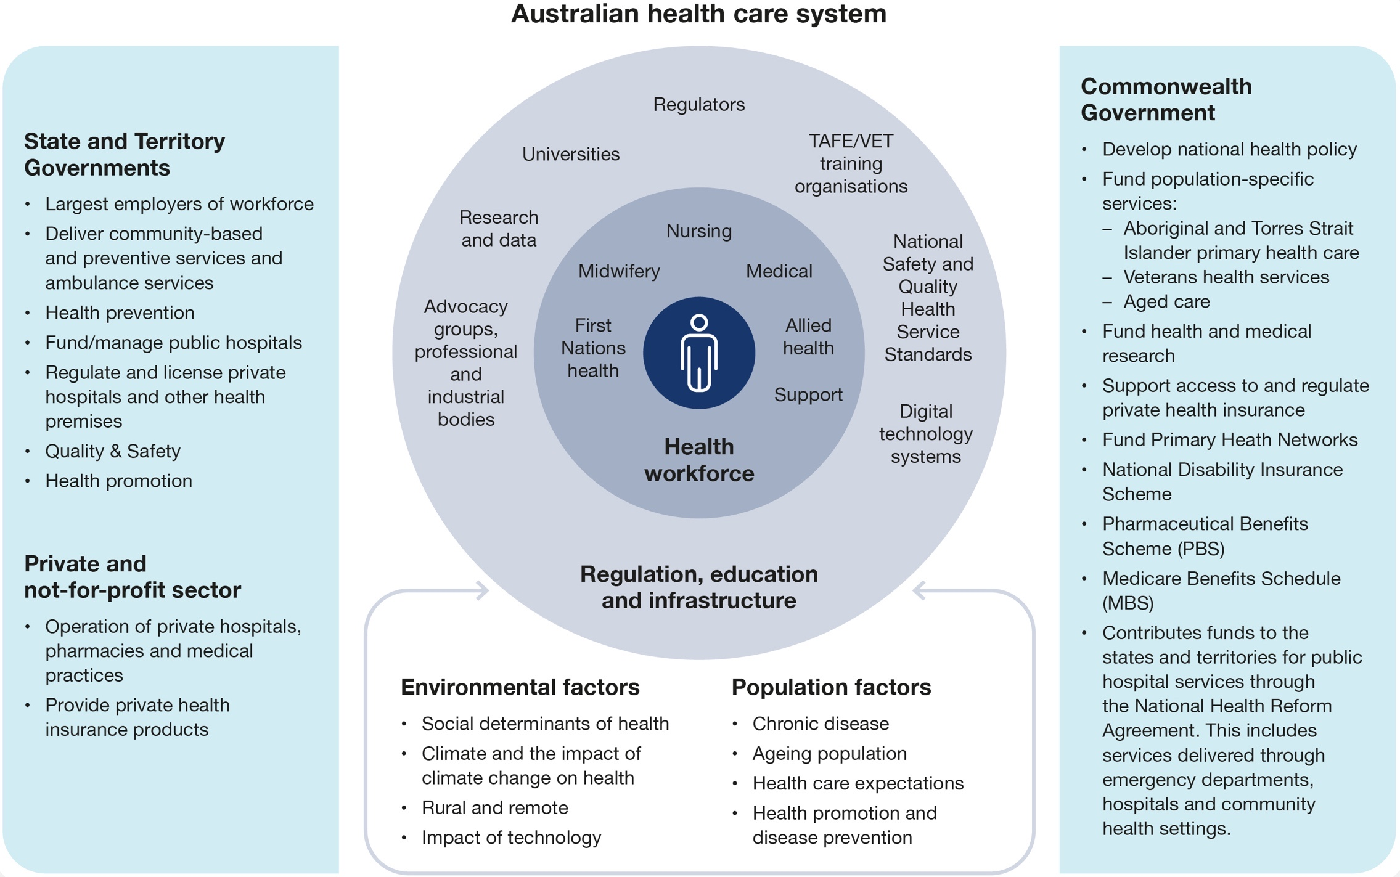

Issues for consideration

The growing need in aged care services
Australia’s changing demographics are influencing the demand for and provision of aged care. Australians are living longer than ever before. It is projected that the number of Australians aged 85 years and over will increase from 515,700 in 2018–19 (2.0% of the Australian population) to more than 1.5 million by 2058 (3.7% of the population). With advanced age comes greater frailty. Older people are more likely to have more than one health condition (comorbidity) as their life expectancy increases. As the population of older people increases, more people are expected to have memory and mobility disorders.
There is also increasing demand in other complementary sectors which are competing for the same workforce and facing a workforce that is also ageing.
Discussion question:
- What effect will the ageing population have on the nursing workforce needs of tomorrow?

The regional, rural and remote nursing workforce
Sustainability of the nursing workforce in rural areas is vital to the health outcomes of rural communities, and key to protecting the viability of health care services outside of metropolitan areas. Nursing professionals in rural/regional areas tend to be older than their metropolitan counterparts and require a broad skill base. The employment of newly registered nurses into smaller rural centres can be difficult.
Working in remote areas provides a rewarding experience for nurses but is not without its challenges. The role of the nursing workforce broadens and expands with increasing remoteness and remote area nurses are often the only health professional to which consumers have access. Nurses working in remote areas need to have broad generalist knowledge and skills as well the capacity to manage emergency situations. Workforce fatigue and professional isolation among remote area nurses is common. In addition, high staff attrition and turnover pose significant challenges to quality and increases the cost of service delivery.
Discussion questions:
- How do we grow, support and sustain the regional, rural and remote nursing workforce?
- How will nurses in regional, rural and remote areas provide care in the future?

Cultural safety
Australia is known as one of the most culturally and linguistically diverse (CALD) countries in the world. According to the 2021 Census of Population and Housing, more than 7 million people (28%) in Australia were born overseas. The number of people who reported speaking a language other than English at home increased from almost 5 million people in 2016 (22%) to around 6 million (23%). In 2021, 3.4% of the Australian population indicated they spoke English not well or not at all.
It is critical to engage with priority populations and people for whom access to health care can be challenging, to provide safe, supportive health care. This includes engaging with and providing culturally safe care to First Nations Australians, people from culturally and linguistically diverse backgrounds and people with disability.
It also includes ensuring the diversity and safety of the nursing workforce, including those who are First Nations Australians, from CALD communities, live with disability and/or identify as LGBTIQ+.
Discussion question:
- How can we ensure the healthcare environment is culturally sensitive for nurses from diverse backgrounds?

First Nations nurses
Decades of research tells us that a culturally safe holistic model of health care works best for First Nations people and that they are more likely to access care from First Nations health professionals. A key principle of the National Aboriginal and Torres Strait Islander Health Workforce Strategic Framework and Implementation Plan 2021–2031 is the importance of culture and recognising that First Nations health workforce participation is an essential element within all health workforce initiatives, settings, and strategies.
Discussion question:
- What actions should be taken to build and support the First Nations nursing workforce?

Career pathways and specialisation
Figure 2: Scotland Career Map
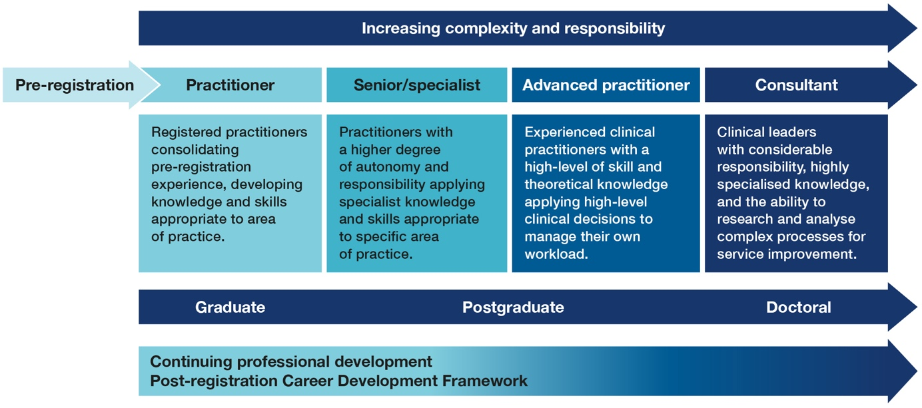
Career pathways in nursing are diverse, and mainly stem from a nurse’s development or specialisation associated with setting of practice. Specialisation is loosely defined by experience but can increase through continuing professional development (CPD) or undertaking postgraduate qualifications. The limitations of specialisation are that nationally, there are no robust methods for advanced standing/recognition of prior learning and there is a reliance on a subjective assessment by an organisation. In addition, there are no defined pathways to progression which exist in some other countries, such as in Scotland (Figure 2, above).
The collective benefits of establishing career pathways include but are not limited to continuity of performance, capacity and capability building, continuous practice improvement, creating prepared employees and contribution to the profession.
Discussion question:
- How can nursing career pathways be articulated so that the workforce understands how to navigate and build a satisfying and stimulating career in nursing?

Nurses’ health and wellbeing
The COVID-19 pandemic required transformative changes to both healthcare workplace culture and environment. Nurses were required to undertake new responsibilities and adapt significantly as a workforce.
Burnout has been identified as a factor in nurses exiting the profession with nurses reporting decreased feelings of accomplishment and increased levels of fatigue and cynicism. Those who remain at work report greater levels of stress, and an increasing propensity to consider leaving their job or profession. Prior to the COVID-19 pandemic, nurses had identified similar stressors, however the workload and pressure following the pandemic increased and therefore exacerbated factors that contributed to feelings of burnout.
For nurses deciding on career mobility or professional longevity, safety has become a key concern. The notable rise in occupational violence has become a prominent concern for the workforce and is contributing to an employee’s decision to opt for lower risk settings or leave the profession. The effective identification and investment in well‑supported nurses will be required to continue to attract and retain the best and brightest, where the nurse workforce themselves are cared for and thriving.
Discussion question:
- What are the barriers and enablers that need to be overcome to enhance workplace culture for nurses?

Nursing leadership and management
Clinical expertise is a critical component for a nurse, but it is not necessarily the most appropriate measure for nurses in leadership and management roles. Just as clinical expertise has required capabilities, leadership and management have recognised capabilities to be exercised effectively. Visible, accountable and purposeful leadership at all levels of a service is required to cultivate an inclusive and just culture. Both nursing leadership and management need to be supported by relevant education programs.
Internationally the Nursing Now Challenge is working to see greater recognition and capability of nurse leadership in contributing to health care policy. Good nursing leadership and management is also important in setting the culture and environment within which nurses work.
Effective leadership at all levels has been identified as a critical factor in supporting and sustaining the nursing workforce. This requires investment in management training, supervision and support to develop and advance new and established leaders. A critical success factor of effective leadership is positive workplace culture – from a student on placement feeling valued and supported, to the most senior administrator feeling purposeful and engaged. Setting the tone for a positive workplace culture is a key feature of highly skilled leaders today.

Building nursing research capability
Nurses are well-positioned to conduct research in Australia’s healthcare system and academia as they are employed in every healthcare setting and care for people across every stage of life. Quality nurse-led research can improve care outcomes and find efficiencies and savings for the health system. Globally and in Australia, nurses are under-represented as recipients of research funding and postgraduate scholarships, and opportunities to combine clinical practice and research at all stages in a nurse’s career are limited. In Australia, a major source of research funding comes from the National Health and Medical Research Council (NHMRC). Analysis of the 238 investigator grants awarded by NHMRC in 2020 showed only 7 (3%) were awarded to nurses, and one of the 64 (1.6%) postgraduate scholarships awarded was to a nurse. These are low numbers for Australia’s largest health workforce.
Discussion question:
- What actions/change needs to occur to build capacity and numbers of nurse researchers across whole of health?

Recruitment and retention
To support the recruitment of the domestic nursing workforce, there are numerous strategies and approaches underway. This includes raising awareness to target school students to enter the profession, building and supporting the professions’ identity as being the most ‘trusted’ profession. Focusing on school leavers alone will not address critical shortages – there will be a need to attract ‘second career-ers’ who are drawn to nursing and bring skills gained in other professions to the nurse workforce. Recruitment strategies must also encourage culturally and linguistically diverse groups to enter nursing so that the composition of the profession in Australia reflects the community it serves.
While Australia’s key workforce strategies strive to embed ongoing self-sufficiency in terms of workforce supply, the interim report of the independent Review of Overseas Health Practitioner Regulatory Settings acknowledges this is a longer term solution. Recruitment of internationally trained nurses accounts for nearly one fifth (18% in 2022 of RNs, ENs and dual registered) of the nursing workforce. From this review, a range of regulatory requirements impacting the recruitment of internationally qualified health practitioners will be addressed. These include streamlining requirements between multiple entities ranging in scope from immigration and regulation, up to employment.
There are many factors that may influence workforce retention, including the practice environment, work conditions and remuneration, opportunities for career progression, workload management, job satisfaction, and professional development opportunities. Retention can be increased for existing nurses through leadership opportunities, best use of their skill set and professional knowledge, flexibility in scope of practice and roles, as well as innovative models of care.
Workforce returners are also an important consideration given lower numbers of nurses returning to the workforce after a break for family or other reasons.
As in all professions, there will always be attrition from the nursing workforce. However there is an opportunity to consider strategies to retain nurses to meet the current and future demand for services. A supply and demand study of the nursing workforce, currently underway, will provide updated data to quantify the nursing workforce in Australia.
Discussion question:
- How can we increase the recruitment and retention of nurses to meet the current and future demand?

The future of nursing in Australia
The skills shortage means that there are more people leaving the workforce (not just the nursing workforce) than entering it and the current birth rate in Australia is not high enough to replace them. That means less people in the workforce overall, supporting an ever growing ageing population.
The nursing workforce shares many of these challenges with a range of other workforces. Many other workforces, from teachers to police, defence to hospitality share the same dilemmas as they plan for a workforce that will look very different in the future.
Discussion questions:
- What should our ambition and vision for the nursing workforce be in the future?
- What will the nursing workforce of the future look like? How will it be different? And what impact will that have on workforce planning?
- How does the system need to change to support a sustainable future fit nursing workforce?
Scenarios in blue have deliberately been prepared to provoke future thinking. They are entirely fictitious, apart from some examples that are referenced in the text. Please read them with the spirit in which they are intended – an opportunity to reframe perspective and consider “what might be, not what currently is”.

A workplace that thrives on a positive culture, empowered by accomplished leaders, fully supporting their nurse workforce
A sustainable health workforce relies on a workplace culture that is positive and supportive of all who interact with it. A key aspect of workplace culture is leaders and managers who set the tone and direction for their teams, empowering them to reach their full potential.
Effective leadership is a skill like any other, requiring skills and training, and practical application. One that embraces diversity in all its forms, and ensures that people feel valued in the roles they undertake, from a student nurse on their very first day through to a seasoned senior administrator. Ensuring a positive safe and supportive workplace culture across the health workforce is a critical success factor in retention.
Discussion question:
- What are the barriers that need to be overcome to enhance workplace culture and conditions for nurses?

Delivering person-centred care
In person-centred care, health and social care professionals work collaboratively with people who use services. Person-centred care supports people to develop the knowledge, skills and confidence they need to more effectively manage and make informed decisions about their own health and health care. It is coordinated and tailored to the needs of the individual. And, crucially, it ensures that people are always treated with dignity, compassion and respect.
Adopting person-centred care as ‘business as usual’ requires fundamental changes to how services are delivered and to roles – not only those of health care professionals, but of patients too – and the relationships between patients, health care professionals and teams.
Discussion questions:
- How do we equip nurses to deliver person‑centred care?
- What changes are required to deliver person-centred care of the future?

Nurses working to their optimum scope of practice
Scenario
Cara has been a Registered Nurse in primary care for over 10 years. She also has an endorsement for prescribing medicines and works in a designated prescribing relationship to facilitate this part of her role. It took a while for her expanded scope of practice and skills to be recognised, but now she – and many like her – are in high demand in primary health and aged care settings. The new bundled payment method (rather than fee for service) has meant she can better integrate and coordinate healthcare for people with chronic conditions.
Twenty-first century health challenges related to demographic, epidemiological and technological changes require a health workforce geared towards health promotion, disease prevention, people-centred community-based health services and personalised long‑term care.
The skillset of nurses working to their full potential and to an optimised scope of practice poses enormous benefits to healthcare systems including increased access to healthcare, reduction in waiting times, more timely assessments and referrals, and a greater focus on early intervention, to name a few.
Optimal use of the nursing skill set as part of a multidisciplinary team promotes an integrated care model and improved patient experiences.
Encouraging and enabling nurses to work at full capacity within their scope of practice will provide benefits at all levels, from individual and team, to the healthcare system nationally and most importantly to the health outcomes of the Australian community.
Discussion questions:
- Assuming a wider scope of practice for nurses in the future, what are the emerging roles nurses will need to fill?
- What are the most important skills and capabilities that will be required of nurses in the future?

Technology drives a very different workforce and health service
Scenario
Jamarra works in a remote health service and uses technology to care for a far greater number of people than he has ever been able to previously. Technology has meant he can check in on every person daily without leaving the health service; triage new patients; monitor their vital signs; deliver medication; and review their progress seamlessly alongside other integrated specialists across Australia and around the globe. He is a central part of a skilled multidisciplinary care team, where he is listened to and respected as an equal voice. Technology means he can also access further learning and specialisation remotely, to improve his experience and skillset.
Digital technology is being increasingly incorporated into healthcare to improve quality, safety and efficiency. Digital health encompasses a wide range of technologies used by consumers and healthcare providers such as digital health records, electronic prescriptions, electronic medication systems, and telehealth.
Consumers in Australia are also using digital health solutions more than ever before to help them to manage their health and make informed decisions. Research shows that digital technology solutions can improve patient care and outcomes. For example, a recent study of the impact of electronic medication systems at a large teaching hospital in Australia showed a reduction in the rate of medication administrative errors.
Technological advancements are fundamentally changing the way nursing is undertaken, with everything from drones delivering medication and life saving equipment to remote areas; to wearable healthcare that can monitor temperature, movement and even mood (including loneliness) of older Australians remotely; to a wound clinic that uses Artificial Intelligence to sift through thousands of pictures of wounds and quickly highlight those that are in need of attention, exponentially improving the productivity of nurses. In defence parlance, technology will be a ‘force multiplier’ of the greater health system – allowing health professionals to be more productive, effective, integrated and efficient than ever before.
Discussion question:
- What are the main ways technology will change the role of a nurse in the future?

Education and lifelong learning that provides high quality skills
Scenario
Having worked in administration in primary health care for 5 years Leanne decided she wanted to retrain as a Registered Nurse. She was able to find flexible training through a partnership between a University and her Primary Healthcare Network. This meant she did not have to move away from home to complete her clinical placements, was able to combine work and training, and her prior skills were recognised.
Future requirements of our health system mean there is opportunity to re-think how our nurse workforce is educated and equipped with the optimal skills to fulfil their potential and ensure the biggest impact on health outcomes. Globally, there are trials aimed at providing high quality education and a work-ready nurse workforce through initiatives such nurse apprenticeship schemes, simulation-based nurse certification and increased numbers of nursing schools, faculty, and student slots. The education system of the future could also encourage nurses to re-enter the workforce by providing nationally recognised blended short course and hands-on experience to fast track re-entry.
There is opportunity to provide tailored education for experienced individuals with an array of skills developed in other sectors or industries, who are attracted to the dynamic, professional care‑based environment of nursing. Currently barriers for people wanting to enter the health profession can be significant, including the cost of education and the need to travel to complete clinical placements.
Discussion question:
- What changes to educational opportunities and career pathways would support the future workforce?

Career pathways that are globally aligned, nationally recognised and provide structured progress
Scenario
Scott was always interested in a job helping people. He liked the idea of nursing, but he elected for an unscored ATAR when he finished school. A careers advisor suggested he become an EN which he liked the idea of, because the Pathway Planner he received from a few different private and TAFE institutions had a heavy emphasis on speed and practicality. Scott had access to a Digital Passport that outlined step by step how he could progress up to an RN and beyond, options of where he could undertake on-the-job training, competencies required and expected pay, all nationally consistent. Scott isn’t sure whether he wants to progress past EN stage, or how long he will remain interested in the job – but in the short term he really likes knowing where he could be headed.
As in many other industries and sectors, career progression will be easier with structured pathways so people can see what they need to do and how, as they progress. Nationally recognised skills will boost mobility, ensuring all of Australia can benefit from a skilled workforce, and people can experience a range of health settings in different place should they desire.
Career pathways are also available for a growing international workforce that are educated and skilled in the particular needs and requirements of the Australian health system.
Discussion question:
- How can we improve nurse career progression to ensure nurses are retained over their lifetime?

References

Department of Health and Aged Care. 2020–25 National Health Reform Agreement (NHRA). 2023 [Available from: https://www.health.gov.au/our-work/2020-25-national-health-reform-agreement-nhra]
Australian Institute of Health and Welfare. Hospital Workforce. 2022. [Available from: https://www.aihw.gov.au/reports-data/myhospitals/themes/hospital-workforce]
Department of Health and Aged Care. National Health Workforce Dataset. 2022 [Available from: https://hwd.health.gov.au/resources/information/nhwds.html]
Royal Commission into Aged Care Quality and Safety. Final Report – Executive Summary. 2021. [Available from: https://agedcare.royalcommission.gov.au/publications/final-report-executive-summary]
Health Workforce Australia. Australia’s Future Health Workforce – Nurses Overview Report. 2014 [Available from: https://www.health.gov.au/sites/default/files/documents/2021/03/nurses-australia-s-future-health-workforce-reports-overview-report.pdf]
McCullough, K., Bayes, S., Whitehead, L., Williams, A., & Cope, V. We say we are doing primary health care but we’re not: Remote area nurses’ perspectives on the challenges of providing primary health care services. Collegian. 2021.
CRANAplus. CRANAplus framework for remote and isolated practice. 2018. [Available from: https://crana.org.au/cranaplus-framework-for-remote-and-isolated-practice]
Opie, T., Dollard, M., Lenthall, S., Wakerman, J., Dunn, S., Knight, S., & Macleod, M. Levels of occupational stress in the remote area nursing workforce. Australian Journal of Rural Health. 2010.
Wakerman, J., Humphreys, J., Russell, D., Guthridge, S., Bourke, L., Dunbar, T., Zhao, Y., Ramjan, M., Murakami-Gold, L. & Jones, M. Remote health workforce turnover and retention: what are the policy and practice priorities? Human Resources for Health. 2019.
Department of Health and Aged Care. National Aboriginal and Torres Strait Islander Health Workforce Strategic Framework and Implementation Plan 2021–2031. 2022. [Available from: https://www.health.gov.au/resources/publications/national-aboriginal-and-torres-strait-islander-health-workforce-strategic-framework-and-implementation-plan-2021-2031?language=en]
National Agreement on Closing the Gap, July 2020. [Available from: https://www.closingthegap.gov.au/national-agreement/national-agreement-closing-the-gap]
Chief Nursing Officer Directorate, Scottish Government. Transforming Nursing, Midwifery And Health Profession (NMaHP) roles: review of Clinical Nurse Specialist and Nurse Practitioner roles within Scotland. 2021. [Available from: https://www.gov.scot/publications/transforming-nursing-midwifery-health-profession-nmahp-roles-review-clinical-nurse-specialist-nurse-practitioner-roles-within-scotland/pages/14]
Jenkins, D. & Spence, C. The Career Pathways How-to-Guide. Brooklyn, NY: Workforce Strategy Center. 2006.
Halcomb, E., McInnes, S., Williams, A., Ashley, C., James, S., Fernandez, R., Stephen, C., & Calma, K. The Experiences of Primary Healthcare Nurses During the COVID-19 Pandemic in Australia. Journal of Nursing Scholarship. Australia. 2020.
Galanis, P., Vraka, I., Fragkou, D., Bilali, A., & Kaitelidou, D. Nurses’ burnout and associated risk factors during the COVID-19 pandemic: A systematic review and meta-analysis. Journal of Advanced Nursing. 2021.
Nursing Now Challenge. Championing leadership development opportunities for student and early career nurses and midwives around the world. 2023. [Available from: https://www.nursingnow.org]
Medical Journal of Australia. Harnessing the nursing and midwifery workforce to boost Australia’s clinical research impact. 2022. [Available from: https://www.mja.com.au/journal/2022/217/10/harnessing-nursing-and-midwifery-workforce-boost-australias-clinical-research#16]
Department of Health and Aged Care. National Health Workforce Dataset. 2022 [Available from: https://hwd.health.gov.au/nrmw-dashboards/index.html]
Department of Health and Aged Care. Independent review of health practitioner regulatory settings. 2023. [Available from: https://regulatoryreform.gov.au/sites/default/files/FINAL%20Independent%20Review%20of%20Overseas%20Health%20Practitioner%20Regulatory%20Settings%20-%20Interim%20Report_1.pdf]
International Council of Nurses. Human resources for health. 2023. [Available from: https://www.icn.ch/membership/specialist-affiliates/nursing-policy/icn-strategic-priorities/human-resources-health]
Vaghasiya, M., Poon, S., Gunja, N., & Penm, J. The impact of an electronic medication management system on medication deviations on admission and discharge from hospital. International Journal of Environmental Research and Public Health. 2023.

