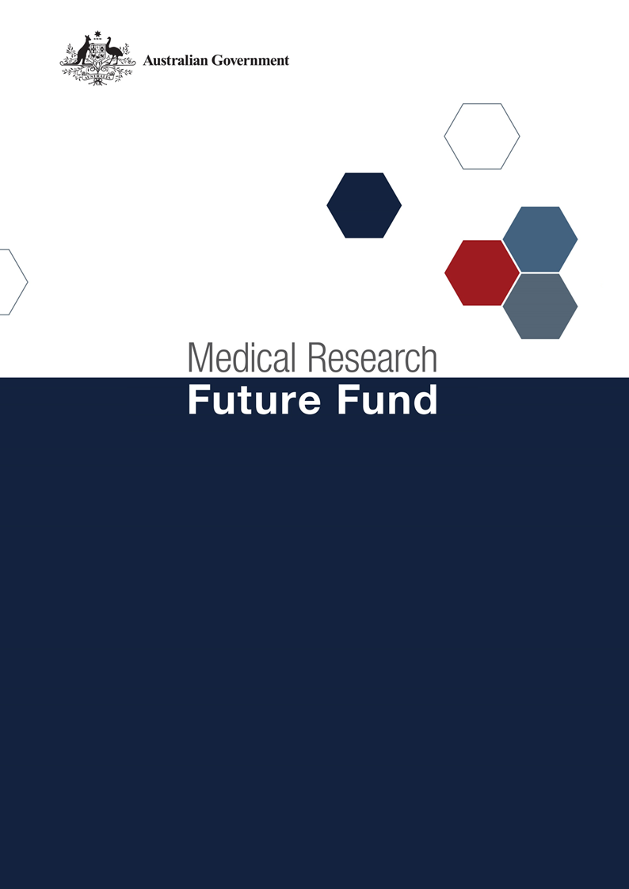

Consultation Guide for the
Australian Medical Research and Innovation Priorities 2020-2022

Table of Contents

Consultation purpose 2
Purpose of the MRFF Priorities 2
Context of the consultation 3
The 10 Year Investment Plan for the MRFF 3
Consultation approach 4
Consultation questions 4
Consultation Process 4
Public Submissions 4
Public Forums via webinar 5
Targeted Roundtable Discussions via videoconference 5
Principles of engagement 5
Further Information 7
Key Contacts 7
Staying Informed 7
References 7
Attachment A: MRFF Investment in Research to Date 8

Consultation purpose
Consistent with the Medical Research Future Fund Act 2015 (the Act), the independent Australian Medical Research Advisory Board (AMRAB) is conducting a consultation to develop the Medical Research Future Fund’s (MRFF) Australian Medical Research and Innovation Priorities 2020-22 (the Priorities). The 2020-22 Priorities must be tabled in the Australian Parliament by 6 November 2020.

The Priorities must be consistent with the Strategy that is currently in force. As the Strategy expires during the life of the next Priorities (i.e. in November 2021), this consultation will specifically focus on revisiting the Priorities in the contemporary context and seek to identify opportunities to use the next twelve months as a period of consolidation under the current Strategy.

A process for revisiting the Strategy will occur in 2021. The Priorities will also necessarily be revisited as part of that process to ensure their alignment with the next Strategy which will be in effect from 2021-2026.

Purpose of the MRFF Priorities
The Act specifies that AMRAB must determine:
- a strategy for ensuring that a coherent and consistent approach is adopted in providing financial assistance under the Act for medical research and medical innovation that is in force for 5 years – the current Australian Medical Research and Innovation Strategy 2016-21 (the Strategy) is due to expire in November 2021.
- priorities for providing financial assistance under the Act for medical research and medical innovation that are in force for 2 years – the current Australian Medical Research and Innovation Priorities 2018-20 (the Priorities) are due to expire in November 2020.

The Priorities must be consistent with the Strategy that is currently in force. Both are developed by AMRAB and informed by national consultation.

The Act requires AMRAB to take into account the following when determining the Priorities:
- the burden of disease on the Australian community
- how to deliver practical benefits from medical research and medical innovation to as many Australians as possible
- how to ensure that financial assistance provided through the MRFF provides the greatest value for all Australians
- how to ensure that financial assistance provided through the MRFF complements and enhances other financial assistance provided for medical research and innovation
- any other relevant matters.

The MRFF Priorities is a non-disallowable legislative instrument, meaning it is tabled in Parliament and is not subject to change, debate or repeal.

The Priorities are considered by the Minister for Health before the Commonwealth Government decides on the disbursement of funding from the MRFF. For these reasons it is important that the community – patients, clinicians and researchers alike – are engaged in the development of the MRFF Priorities.

We invite the Australian public, organisations with expertise in health and medical research and innovation, consumer representatives, clinicians and health services managers to contribute to this process.

The consultation process will commence in September 2020 through an online consultation hub to provide opportunities for written submissions to be considered. Targeted webinars and virtual roundtables on specific issues and themes will also provide opportunities to inform AMRAB’s deliberation on the next set of MRFF priorities.

AMRAB will consider all feedback from the consultation process, including written submissions, and utilise your contributions to refresh the Priorities for the remaining year of the Strategy.

Information about consultation activities will be provided on the MRFF Website. You can receive the latest information, by subscribing to the MRFF newsletter.

Context of the consultation
In recent times Australia has faced unprecedented challenges, including the devastating effects of bushfires and the current COVID-19 pandemic. The Australian health system and medical research sector has demonstrated its immense ability and capacity to innovate and respond to these challenges, while also continuing to progress the existing research activities and priorities that are critical to ongoing improvements in health care and health outcomes, as well as prepare for future health crises in Australia, in what have been difficult circumstances.

The current Strategy (2016-2021) and accompanying Priorities (2018-2020) have provided a wide-ranging platform that has allowed the MRFF to be responsive to the current health challenges, while continuing to funding projects that stimulate health and medical research across the entire research pipeline and achieve the MRFF’s strategic objectives. AMRAB’s objective is to continue this adaptive approach, to ensure investment in research is flexible and meets the needs of the changing health and medical landscape.

The 10 Year Investment Plan for the MRFF
As part of the 2019-20 Budget, the Government announced a $5 billion, 10-year investment plan for the MRFF that directs MRFF funding into four themes.
- Patients. Funding innovative treatments, supporting clinical trials, and delivering more advanced health care and medical technology to improve the health of all Australians.
- Researchers. Supporting our researchers to make breakthrough discoveries, develop their skills and progress their careers in Australia.
- Research missions. Helping researchers think big to tackle significant health challenges through investment, leadership and collaboration.
- Research translation. Moving research ideas from the lab to the clinic, so that medical discoveries become part of clinical practice for GPs, specialists and hospitals.

There are 20 initiatives under these themes, funded over 10 years to harness innovation, provide vital infrastructure, improve patient outcomes, and generate jobs and economic growth.

The 10 year plan provides a framework within which MRFF funding is dispersed with regard to the Strategy and Priorities. The Strategy, Priorities and the 10 Year Plan provide transparency and predictability to researchers and industry about the strategic objectives of MRFF disbursements.
A summary of the disbursement of MRFF funds from its inception to date under the MRFF themes and initiatives is included as Attachment A.

Consultation approach
AMRAB is interested in hearing your reflections on the current MRFF Priorities, the Australian Medical Research and Innovation Priorities 2018-2020, and their ongoing appropriateness to guide MRFF investments in health and medical research over the next 12 months operating under the current Strategy.

This is an opportunity to consider how the current Priorities have aligned with research needs over the last two years, as well as the opportunities for consolidation and refinement within the context of the current Strategy. It is also an opportunity to ensure that MRFF continues to fund national health priorities that improve research effectiveness, efficacy, quality and safety to deliver improved health outcomes and a sustainable health system for all Australians.

Consultation questions
Given the context of the development of the Priorities, the consultation will focus on the following questions:
- Do the current Priorities remain relevant in the contemporary environment for continuation for a further 12 months?
- Should any of the Priorities should be emphasised or de-emphasised for the next 12 month period?
- Are unaddressed gaps in knowledge, capacity and effort across the healthcare continuum and research pipeline that would warrant changes to the Priorities?
- Is there an opportunity to consolidate the Priorities for the remaining twelve months of the Strategy?

Consultation Process
AMRAB has agreed the following means will be used to conduct a national consultation on the next set of MRFF Priorities. All details and booking arrangements for the MRFF 2020-22 Priorities Consultation are available from the MRFF website. The COVID-19 pandemic and associated travel restrictions means that face to face consultation will not be possible.

Public Submissions
Online public submissions opened from 9 September 2020 on the Health Department’s Consultation Hub, which can be accessed from the MRFF website.

Submissions are to be provided using the online form on the Consultation Hub. Respondents are asked to identify themselves and if they are affiliated to an organisation. There are word limits and there is no allowance for attachments.

Those making a public submission are reminded that this is not an opportunity to submit proposals for funding. Rather, the explicit focus of the public submission opportunity is to solicit opinions and perspectives on what AMRAB should consider in determining the next set of MRFF Priorities.

Submissions will not be considered if:
- it is a proposal for a grant or a specific request for funding
- the submission does not align with the Australian Medical Research and Innovation Strategy 2016–2021 or the requirements of the Act.

AMRAB has also determined Principles of Engagement (see below) that Stakeholders are asked to have regard to in developing their submissions. Multiple submissions are welcome, however duplicates will not be considered.

Respondents will have an opportunity to indicate consent to have their submission made public on the MRFF website. The decision to post consenting public submissions on the website will be that of AMRAB. All submissions will be reviewed and analysed by the Commonwealth Department of Health’s Health and Medical Research Office (HMRO) to inform AMRAB’s considerations in developing the 2020-22 Priorities.

Public Forums via webinar
AMRAB has committed to holding a public forum(s) via webinar, providing an opportunity for attendance from stakeholders from all States and Territories during the month September 2020 with further details to be provided on the MRFF website.

At these forums stakeholders will receive a presentation from an AMRAB member about the current Priorities and AMRAB’s perspective about their appropriateness for the remaining twelve months of the Strategy. Stakeholder will also have the opportunity to ask questions to inform their approach to their written submission.

Targeted Roundtable Discussions via videoconference
AMRAB may also consider targeted roundtables to engage with specific stakeholder groups to address particular issues arising from the written submissions. Invitations will be limited and subject to the decision of AMRAB.

Principles of engagement
In conducting this third MRFF national consultation process, AMRAB has determined the following principles for engagement. Individuals, representatives and organisations are asked to respect these principles in articulating points of view and position statements on the direction of the Priorities for the remaining year of the Strategy.
- Support for research excellence is paramount, and reference should be given to the MRFF Funding Principles.
- Appreciate that the MRFF is intended to be transformational - it is a once in a generation opportunity to benefit Australians.
- Avoid duplication of priorities and effort, and where appropriate identify opportunities to leverage opportunities through collaboration with the purpose of maximising impact.
- Appreciate the focus on whole-of-system benefit, and stakeholders are encouraged to think beyond single disease or study self-interest.
- Recognise the importance of priority identification that promotes health and social justice, eliminates discrimination and protects access and equity.
- Reference the strategic platforms established in the Australian Medical Research and Innovation Strategy 2016-2021 (the Strategy).
- Focussed on the suitability of current Priorities for the next twelve months operating under the Strategy. If change to the Priorities is warranted within this period suggestions are contextualised in the context of the current priorities:
  - What priorities should be emphasised (what is missing), de-emphasised (what can be removed) or retained.
  - Identifying the contemporary drivers for change.
- Be cognisant of the Government’s $5 billion, MRFF 10-year investment plan, announced as part of the 2019–20 Budget. Submissions should focus on how the priorities may inform funding decisions within the 10-year plan themes and initiatives rather than seek to redefine them.
- Recognise that a whole-of-government approaches are needed to address some complex issues in health and medical research, including indirect costs, research quality and evaluation.
- Be respectful of other stakeholder perspectives, experiences and opinions.

IMPORTANT NOTE: This consultation process is not an opportunity for the submission of funding proposals. MRFF initiatives operate consistent with the Commonwealth Grants Rules and Guidelines and are offered in line with the Government‘s MRFF Funding Principles policy. Opportunities to submit proposals may only occur within the parameters of grant opportunities advertised via GrantConnect.

Further Information

Key Contacts
For any questions relating to this consultation please contact the Department of Health’s HMRO team via MRFF@health.gov.au.

Staying Informed
Monitor the MRFF website as it will be regularly updated with notifications of opportunities to either engage with AMRAB or reflect on the ongoing national conversation.

References
- Australian Medical Research and Innovation Strategy 2016-2021
https://beta.health.gov.au/resources/publications/australian-medical-research-and-innovation-strategy-2016-2021
- Australian Medical Research and Innovation Priorities 2018–2020 https://beta.health.gov.au/resources/publications/australian-medical-research-and-innovation-priorities-2018-2020
- Medical Research Future Fund Act 2015
https://www.legislation.gov.au/Details/C2016C00406
- MRFF 10-Year Funding Plan
https://www.health.gov.au/resources/publications/medical-research-future-fund-mrff-10-year-investment-plan
- MRFF Funding Principles
http://beta.health.gov.au/resources/publications/medical-research-future-fund-mrff-funding-principles
- MRFF Investment Initiatives
https://www.health.gov.au/initiatives-and-programs/medical-research-future-fund/all-mrff-initiatives
- AMRAB membership background
https://beta.health.gov.au/committees-and-groups/australian-medical-research-advisory-board-amrab
- Commonwealth Grants Rules and Guidelines
https://www.finance.gov.au/resource-management/grants/
- GrantConnect
https://www.grants.gov.au/
- Business Grants Hub
https://industry.gov.au/smallbusiness/Pages/Business-Grants-Hub.aspx

ATTACHMENT A

MRFF Investment in Research to Date
The Medical Research Future Fund (MRFF) has provided over $1.1 billion of funding to support Australian researchers address both national and global research challenges from its commencement in 2016 to 30 June 2020.
Over the past two years the broad platforms provided by the Australian Medical Research and Innovation Priorities 2018-2020 have guided research investment in key areas of strategic need, including in response to emerging health challenges such as the recent bushfires that devastated much of Australia and the COVID-19 pandemic which has impacted populations on a global level.
In July this year MRFF reached maturity at $20 billion with the Government’s final credit of $3.2 billion. This sustainable source of funding will continue to support important health and medical research projects over the long term, informed by the the Australian Medical Research and Innovation Strategy and Priorities.
The following table outlines the disbursement of funding from the MRFF since its inception. Further information about the themes and initiatives through which MRFF funding has been disbursed is accessible from the MRFF page of the Department of Health website.
MRFF Initiative | Total Expended and Committed (since 2016)  $m | Total Funding Agreements  (since 2016)
Patients | 461.586 | 166
Emerging Priorities and Consumer Driven Research | 281.102 | 63
Clinical Trials Activity | 164.220 | 94
Global Health | 16.264 | 9
Researchers | 110.763 | 113
Frontier Health and Medical Research | 22.895 | 16
Researcher Exchange and Development within Industry | 32.000 | 1
Clinician Researchers | 55.868 | 96
Research Missions | 257.002 | 92
Australian Brain Cancer Mission | 19.176 | 7
Million Minds Mental Health Research Mission | 37.760 | 10
Genomics Health Futures Mission | 77.028 | 22
Dementia, Ageing and Aged Care Mission | 23.122 | 16
Indigenous Health Research Fund | 49.435 | 10
Stem Cell Therapies Mission | 6.909 | 10
Cardiovascular Health Mission | 37.845 | 14
Traumatic Brain Injury Mission | 5.728 | 3
Research Translation | 275.656 | 85
Preventive and Public Health Research | 121.207 | 46
Primary Health Care Research | 6.901 | 5
Rapid Applied Research Translation | 60.880 | 26
Medical Research Commercialisation | 67.300 | 3
National Critical Research Infrastructure | 19.368 | 5
Research Data Infrastructure | - | -
TOTAL | 1,105.007 | 456
Note: Grant counts and expenditures include funding provided through the Coronavirus Research Response.

