NDIS Provider Definition

Consultation
Part 2
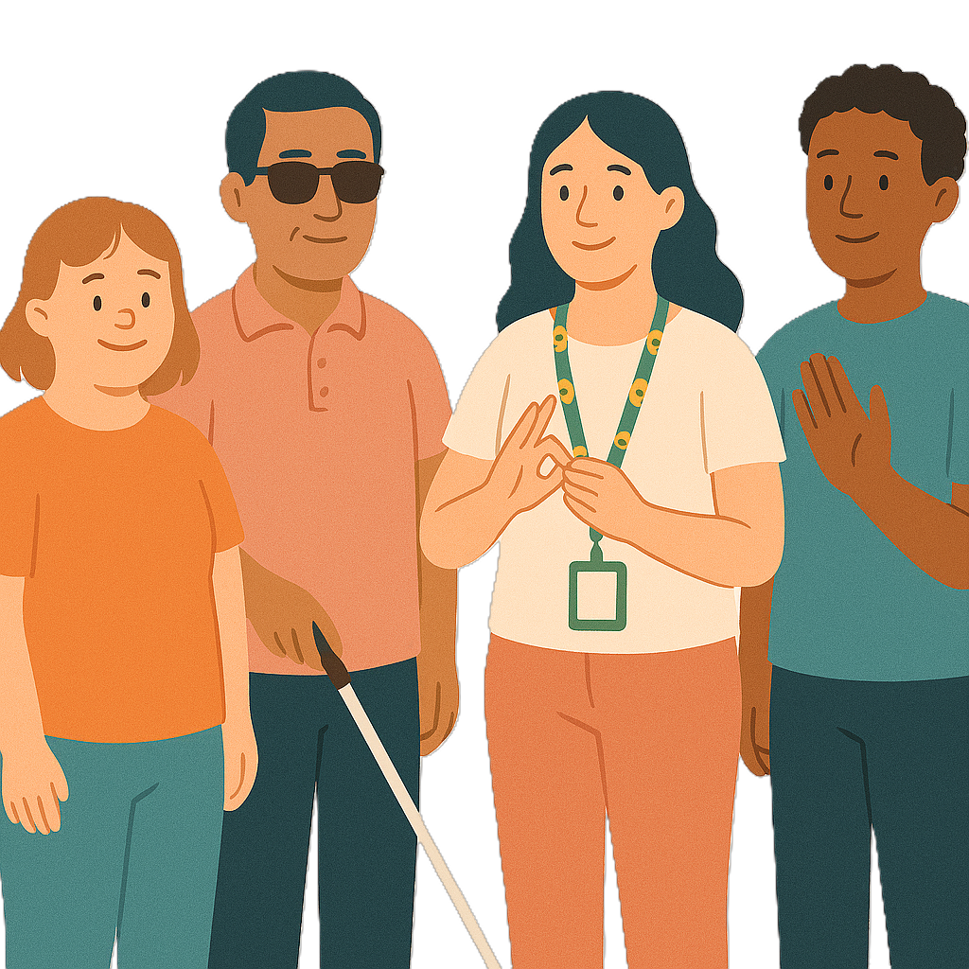
 | The Australian Government Department of Health Disability and Ageing wrote this.  We say DHDA for short.  When you see the word we it means DHDA.
 | We wrote this in an easy to read way.  We use pictures to explain some ideas.
 | We have some words in bold.  This means the letters are thicker and darker.  These are important words.
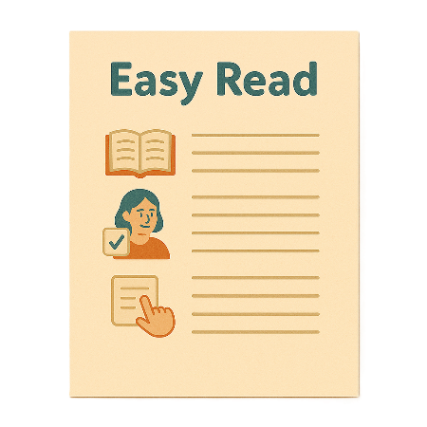 | This is an Easy Read summary of another document.  This means it has the most important ideas.
 | We can answer any questions by email.  Email us NDISRegulation@health.gov.au
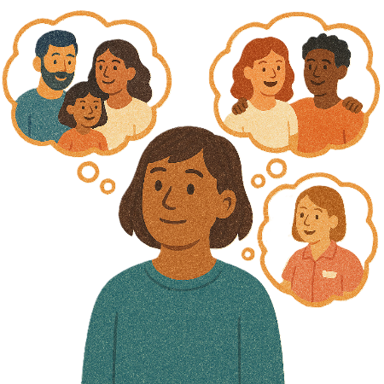 | You can ask for help to read this document.  You can ask  - A friend  - Family members  - A support person.
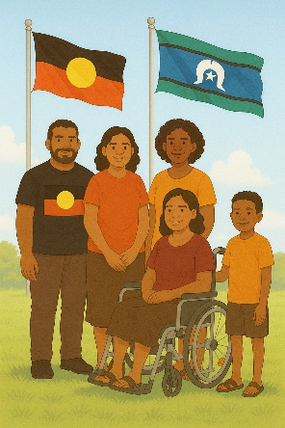 | We recognise Aboriginal and Torres Strait Islander people as the Traditional Owners of the land we live on.
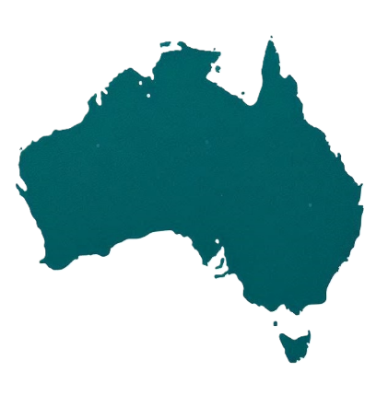 | They were the first people to live on and use the  - Land  - Waters.

Contents

About this document | 5
What to do | 7
Why is it important to share your ideas | 9
Question 1 | 10
Question 2 | 11
Question 3 | 12
Question 4 | 13
Question 5 | 14
Question 6 | 15
Thank you | 16

About this document

 | This document has 2 parts.
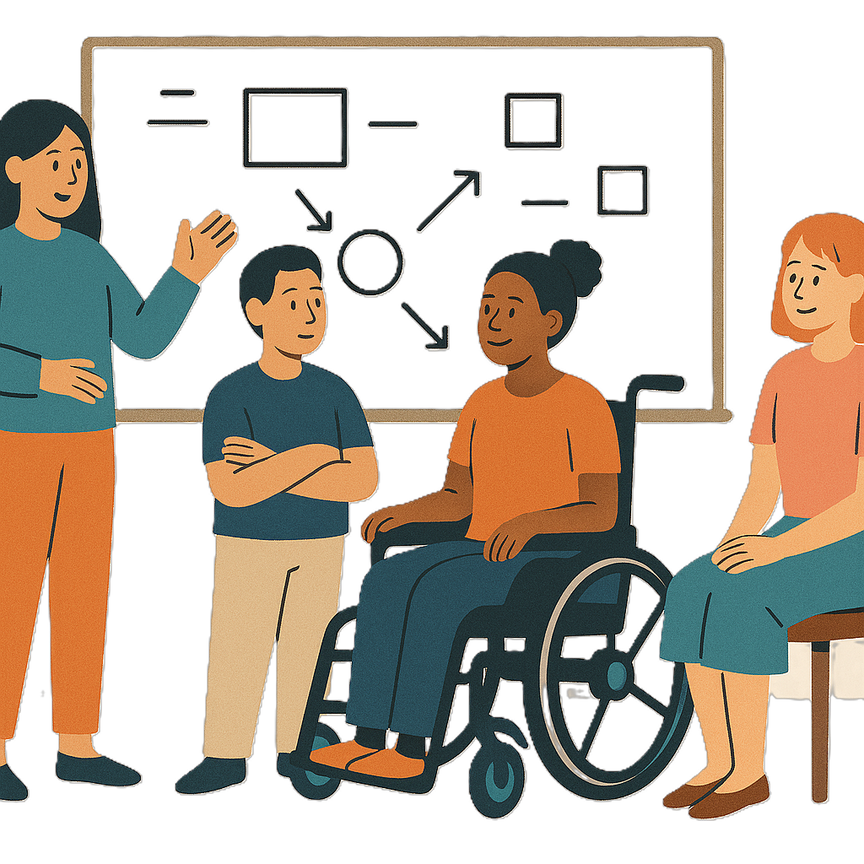 | Part 1 talks about  - What we want to do
 | - Why we want to do it
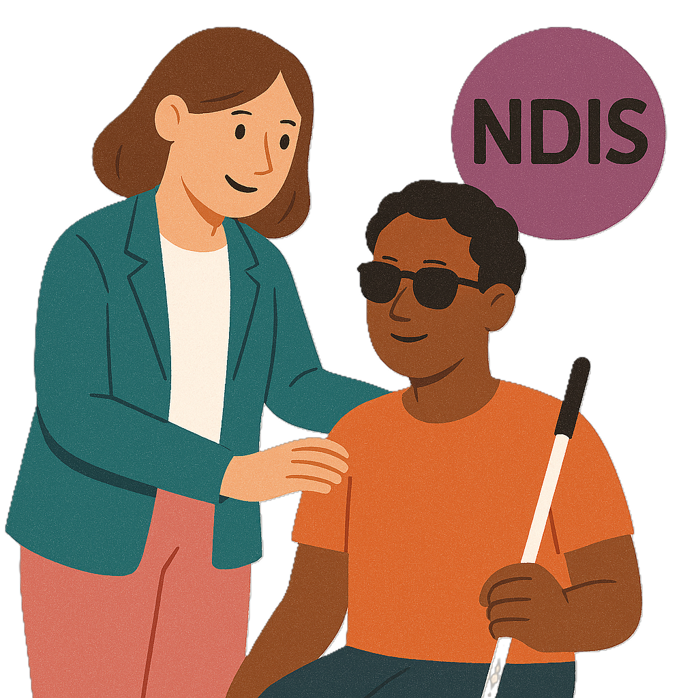 | - What the NDIS provider definition is now  NDIS providers get money from your NDIS plan to help support you.
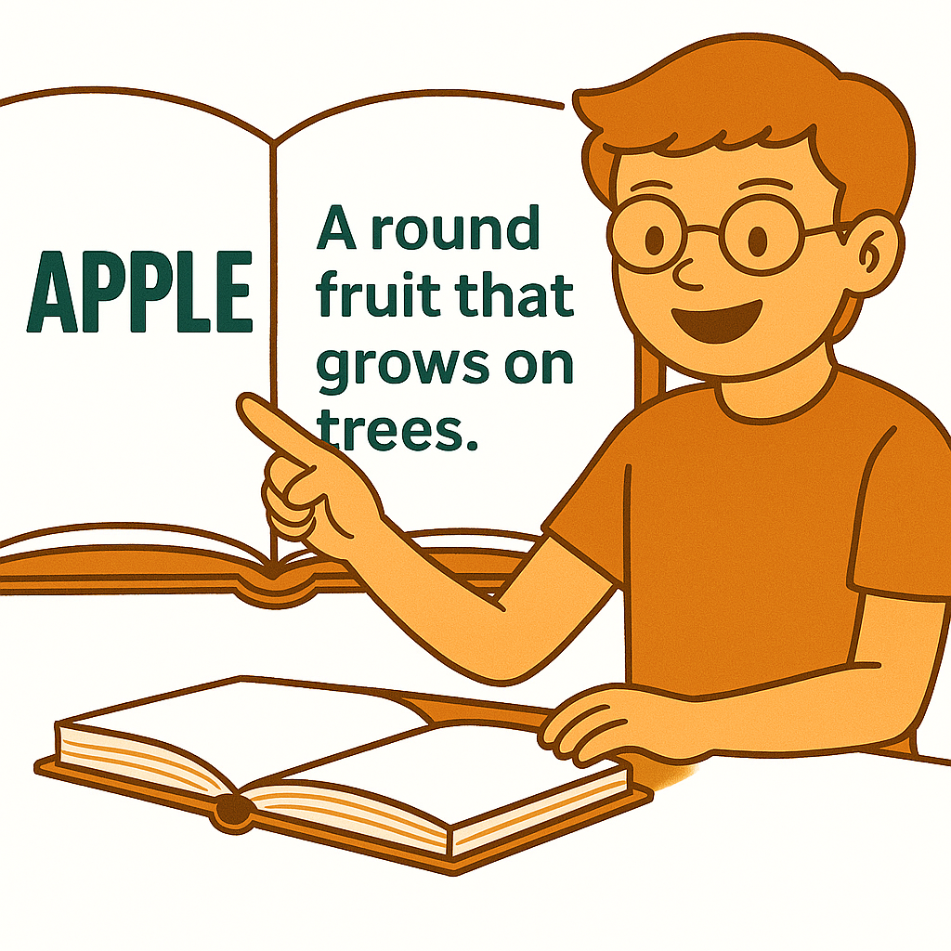 | Definitions explain what a word or idea means.
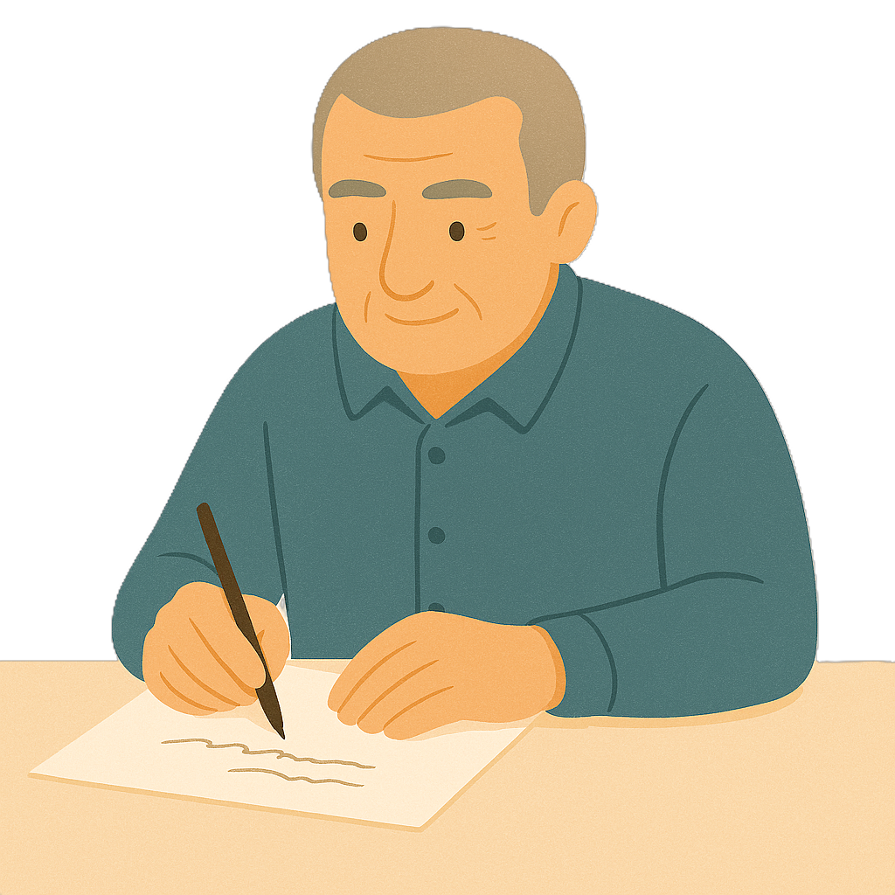 | Part 2 has  - Questions for you to answer.
 | You can read the other part on our website.

What to do

 | You need to download the questions.  You can  - Write your answers
 | - Type your answers.
 | You need to send your answers back to us by email.  NDISRegulation@health.gov.au
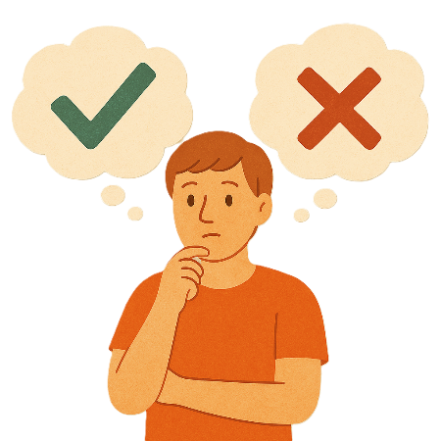 | There are no right or wrong answers.  Do your best.
 | You can choose what questions to answer.  You do not have to answer them all.

Why it is important to share your ideas

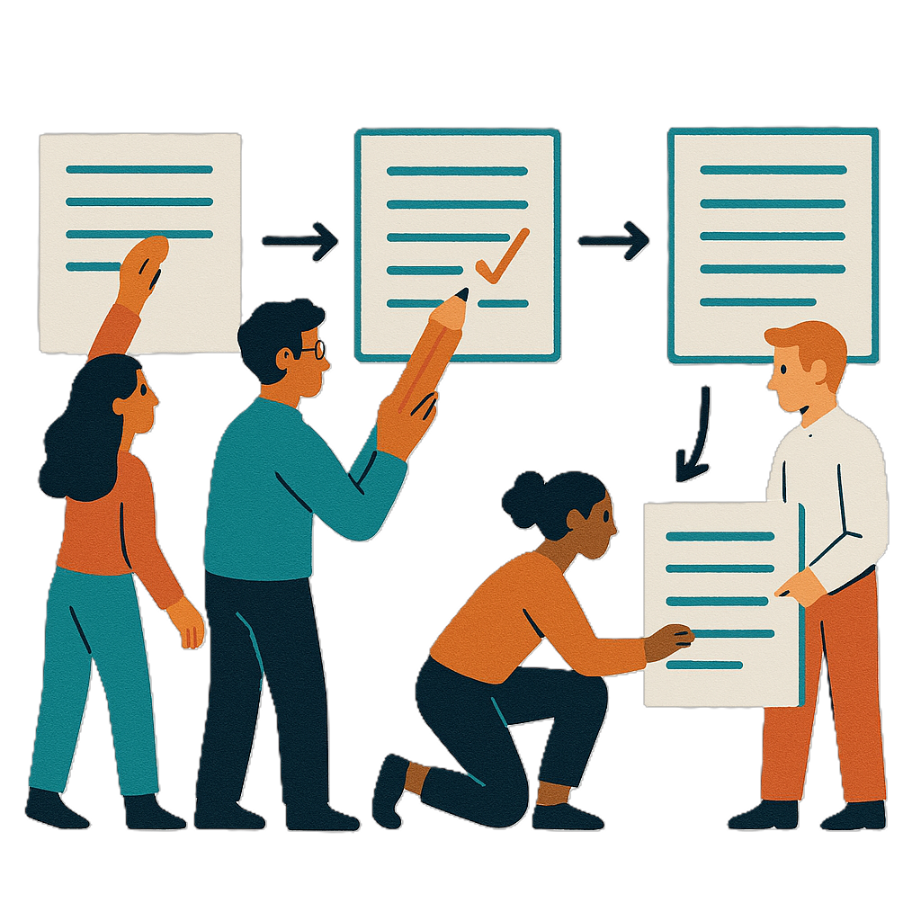 | The NDIS Taskforce said the government should change the definition for NDIS providers.
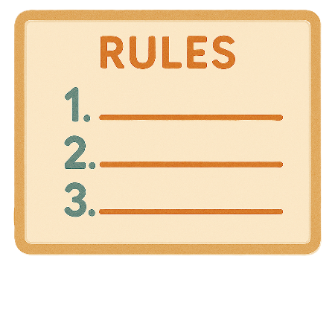 | Your ideas will help make new rules.  We want to know if the new rules will change the way you use your NDIS support.
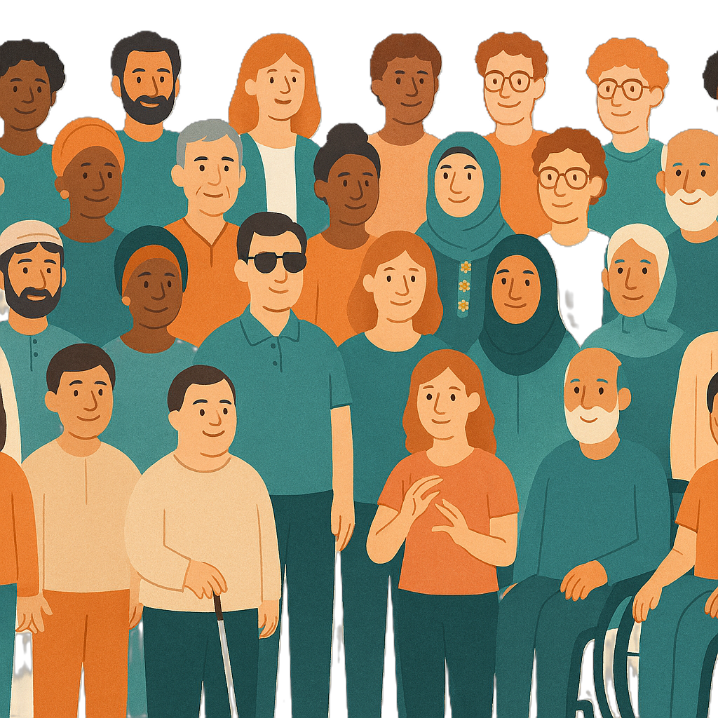 | Sharing how you use supports will help us make new rules that work for everyone.
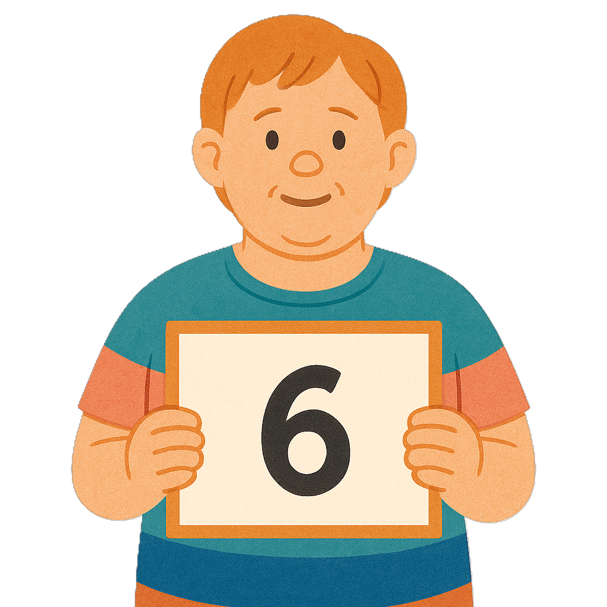 | We have 6 questions.

Question 1

 | Who needs to show the government that they are safe for people with disability to use.  Please write your answer in the box.

Question 2

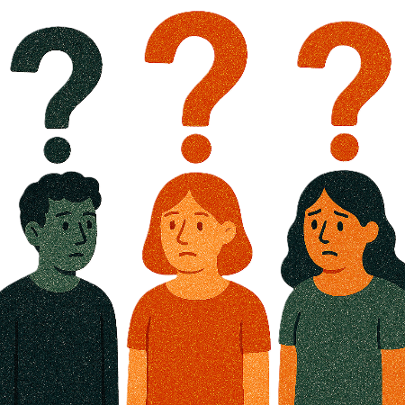 | What do you think a NDIS provider is.  Please write your answer in the box.

Question 3

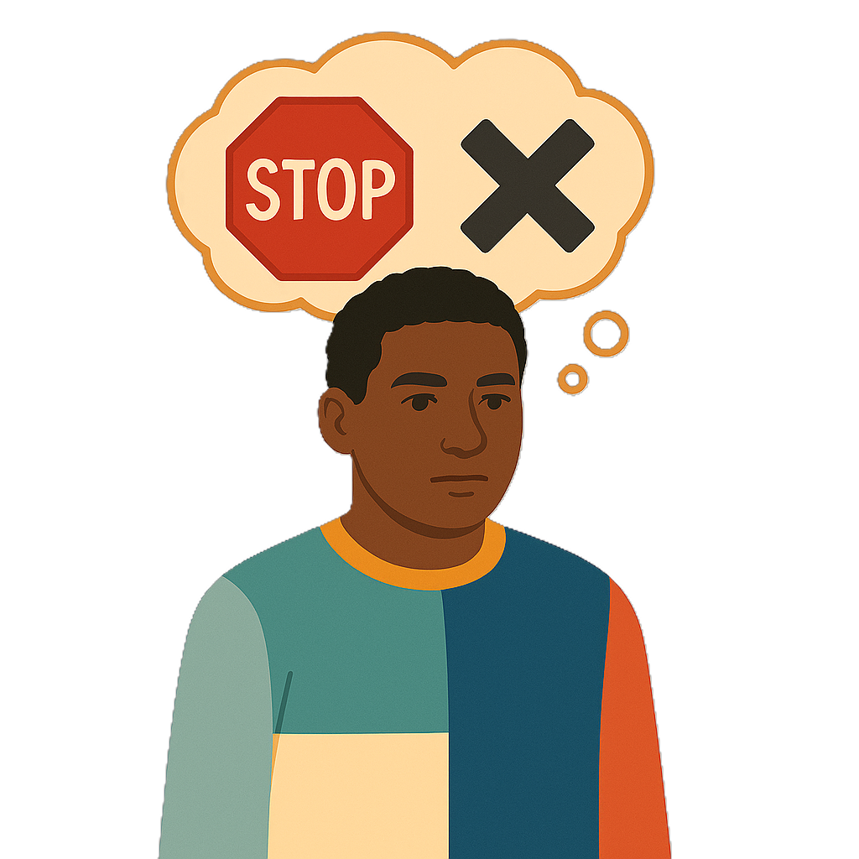 | How can the government make sure the way you use your supports does not stop.  Please write your answer in the box.

Question 4

 | How can we make sure the definition of NDIS provider meets everyones needs.  Please write your answer in the box.

Question 5

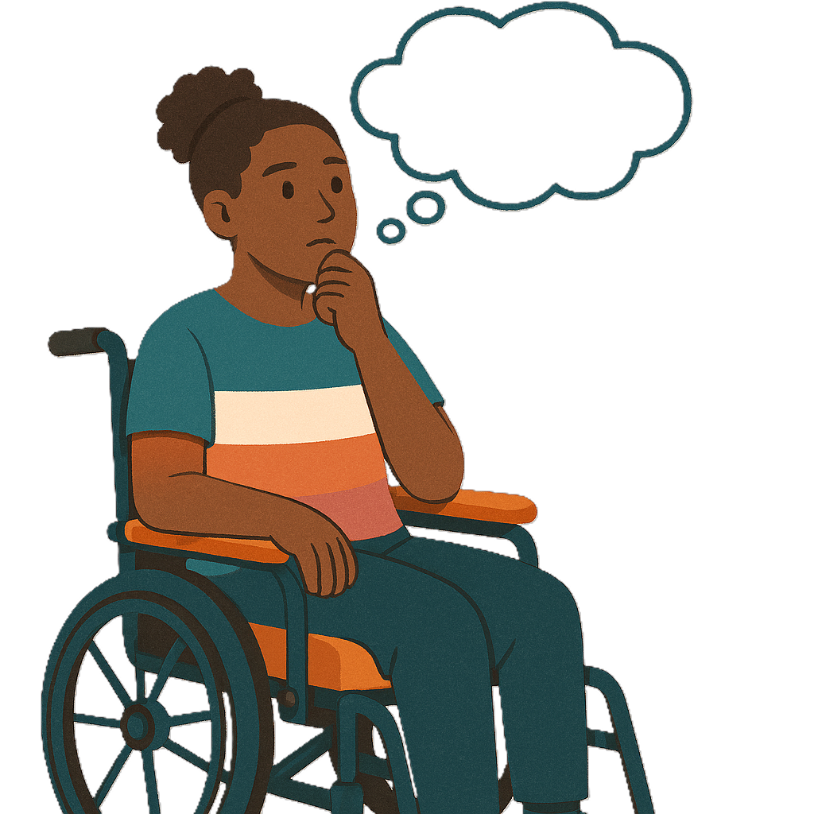 | Is there anything else we should include in the definition other than the type of support.  Please write your answer in the box.

Question 6

 | How could a new definition make supports  - Work better  - Last for a long time.  Please write your answer in the box.

Thank you

 | Thank you for answering our questions.
 | Please send your answers back by  Saturday 28 February 2026.
If you have typed your answers on the computer

- Send the survey back by email

NDISRegulation@health.gov.au
 | If you wrote your answers you can  - Email your survey back to us  - Scan your survey into the computer  - Email it back to us  NDISRegulation@health.gov.au

Images in this Easy Read must not be used or copied without permission

