NDIS Provider Definition

Consultation
Part 1
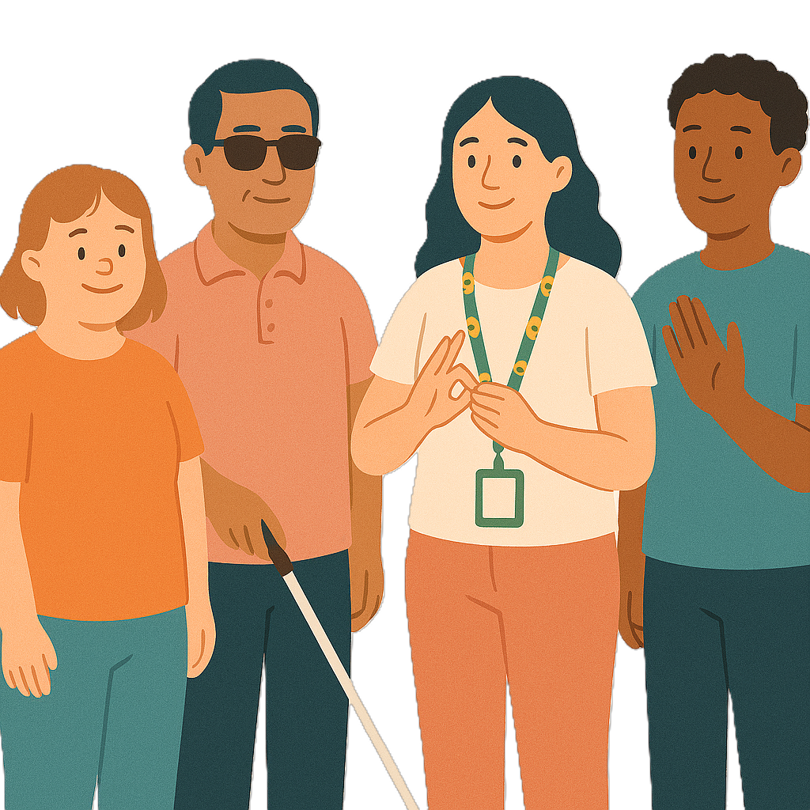
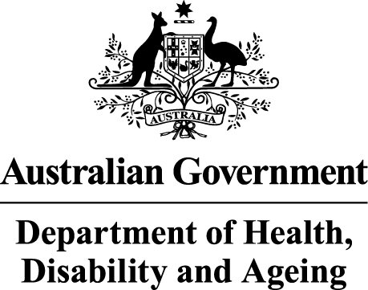 | The Australian Government Department of Health Disability and Ageing wrote this.  We say DHDA for short.  When you see the word we it means DHDA.
 | We wrote this in an easy to read way.  We use pictures to explain some ideas.
 | We have some words in bold.  This means the letters are thicker and darker.  These are important words.
 | This is an Easy Read summary of another document.  This means it has the most important ideas.
 | We can answer any questions by email.  Email us NDISRegulation@health.gov.au
 | You can ask for help to read this document.  You can ask  - A friend  - Family members  - A support person.
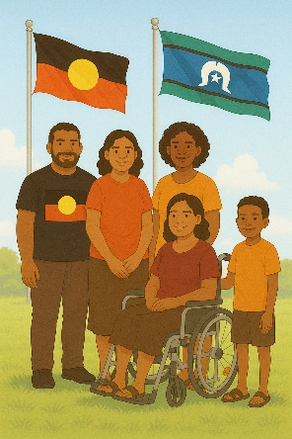 | We recognise Aboriginal and Torres Strait Islander people as the Traditional Owners of the land we live on.
 | They were the first people to live on and use the  - Land  - Waters.

Contents

About this document | 5
About our consultation | 7
Why are we doing this consultation | 9
Outcomes | 12
How to take part | 14
Consultation paper | 15
NDIS provider definition | 19
Change to registration | 22
NDIS Provider Registration | 27
List of support types | 29
Contact us | 36

About this document

 | This document has 2 parts.
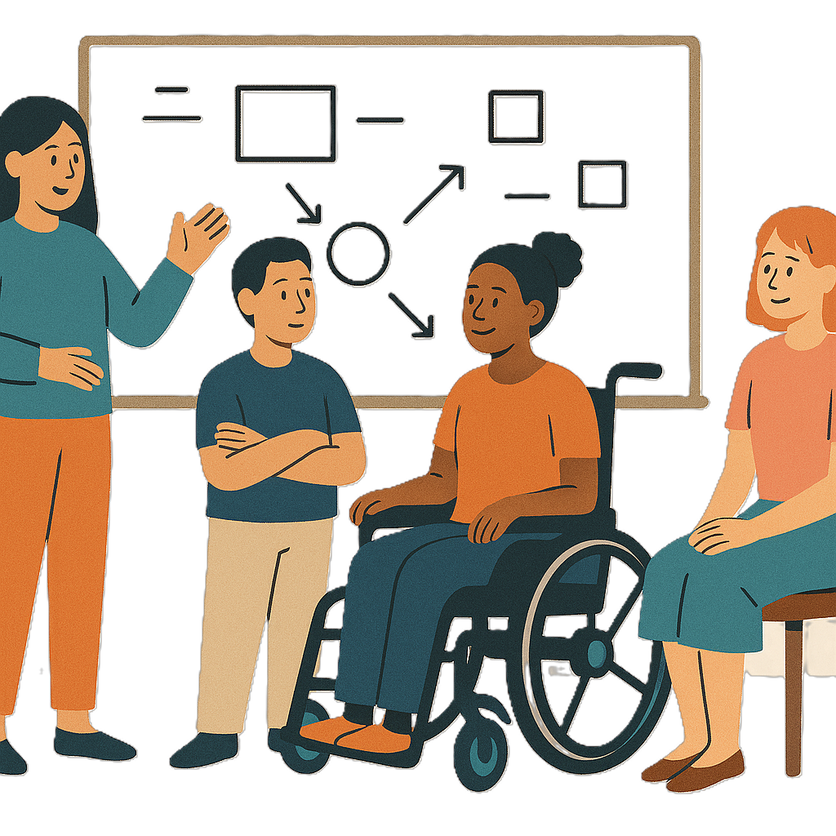 | Part 1 talks about  - What we want to do
 | - Why we want to do it
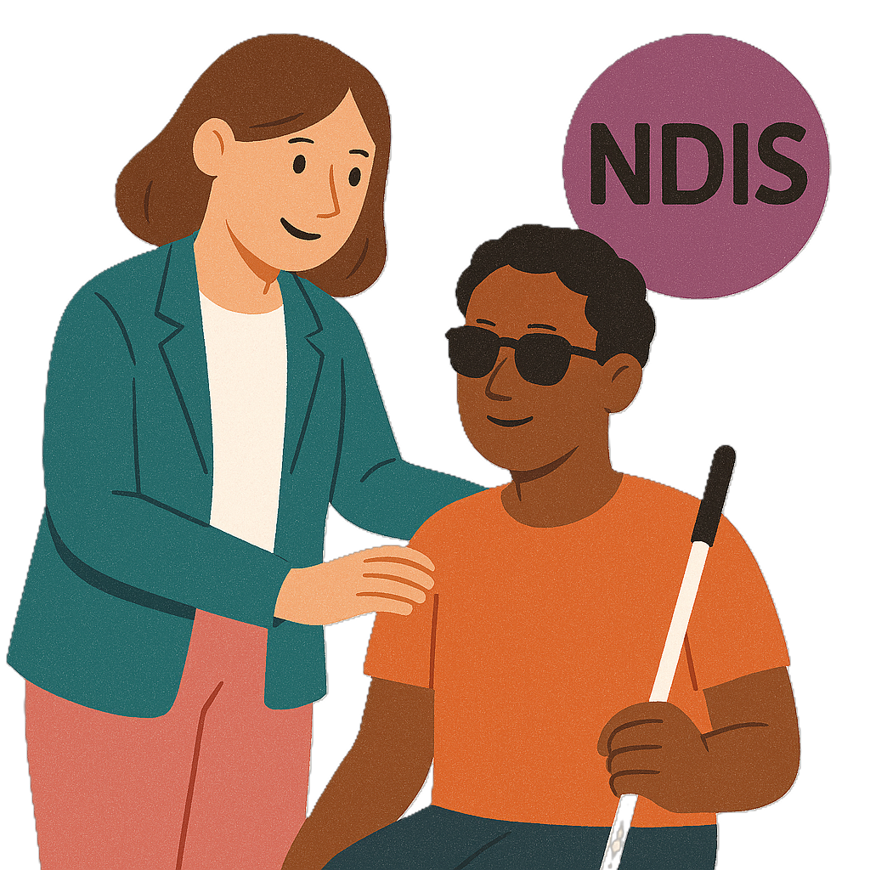 | - What the NDIS provider definition is now  NDIS providers get money from your NDIS plan to help support you.
 | Definitions explain what a word or idea means.
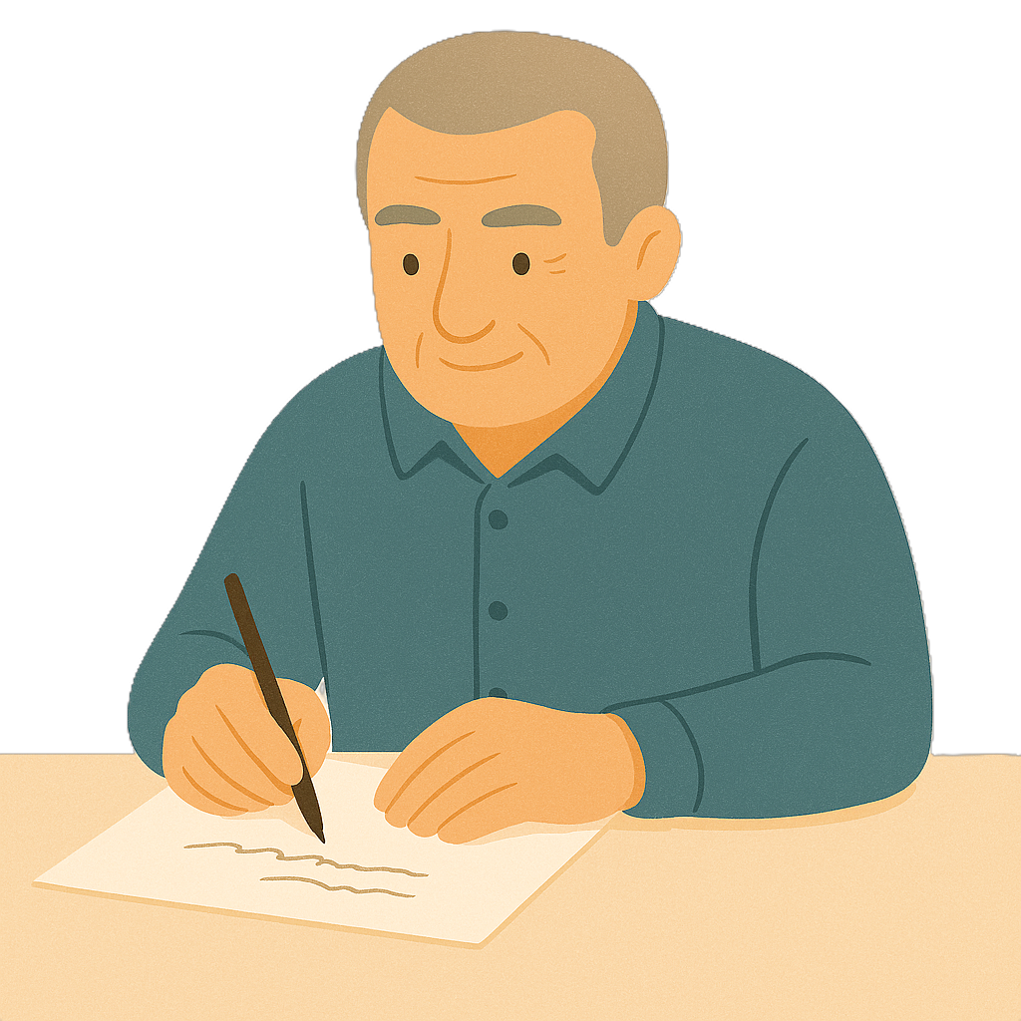 | Part 2 has  - Questions for you to answer.
 | You can read the other part on our website.

About our consultation

 | DHDA is doing a consultation.  Consultation is the governments way of working with the disability community.  It makes sure that the government is listening to communities.  This helps the government make better plans to support people with disability.
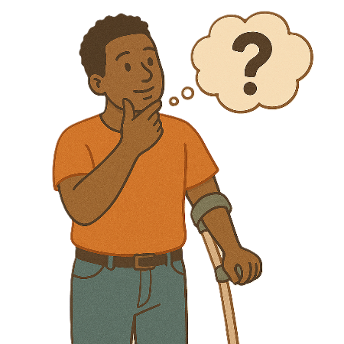 | We want to know  - What you think a NDIS provider is
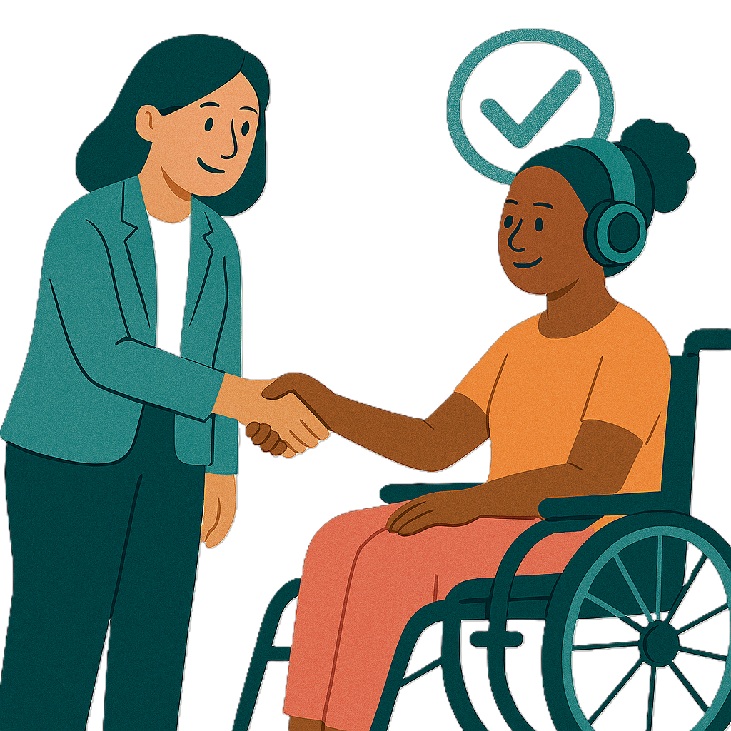 | - How supports can be better
 | - How services can be better.

Why are we doing this consultation

 | We are doing this consultation to make changes to NDIS regulation.  Regulation means making sure people follow the rules.  This keeps people with disability safe.
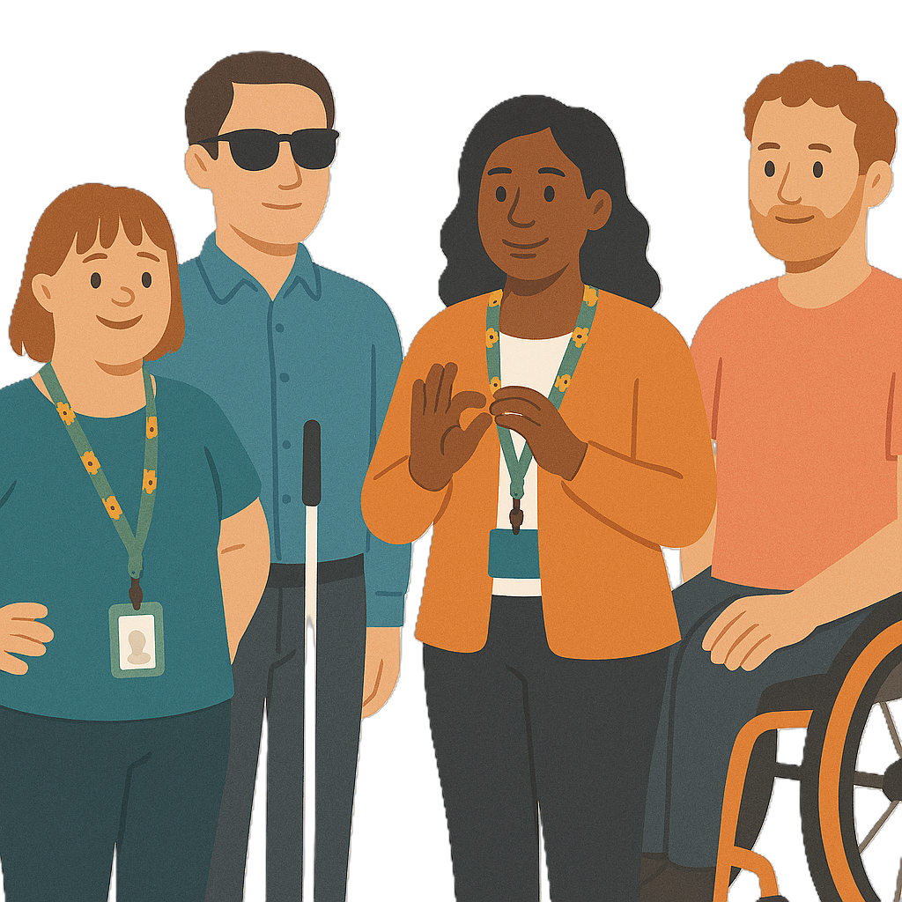 | There have been lots of ways to check if regulation is working  - NDIS Provider and Worker Registration Taskforce  We call it the NDIS Taskforce for short.
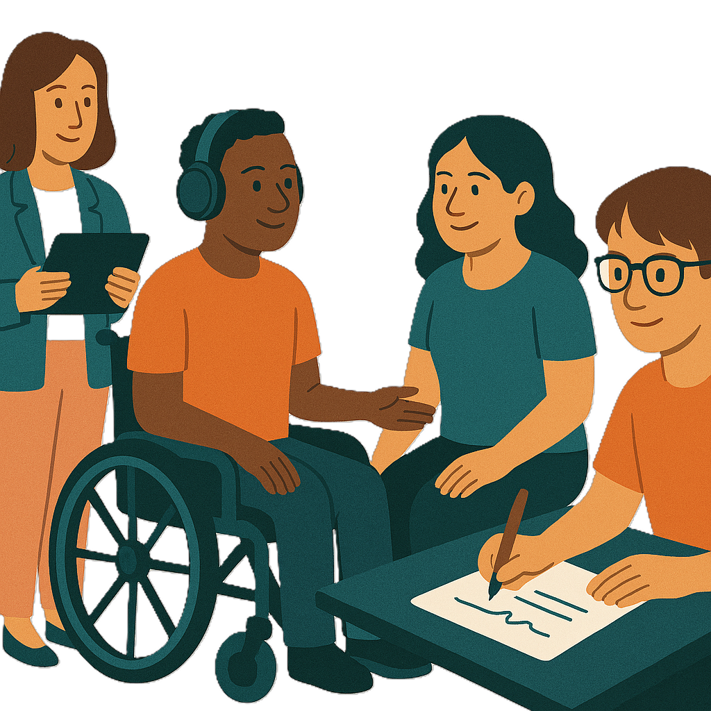 | Worker registration means the provider  - Put their name on a list  - Agree to follow the rules of the NDIS Quality and Safeguards Commission  We call it NDIS Commission for short.  We also call worker registration being registered.
 | A taskforce is a group of people who work together to  - Give ideas  - Fix problems.
 | - The NDIS Review  The government did a review of the NDIS.  A review is when you check what  - Works  - Needs to change.
 | - The Disability Royal Commission  We call it DRC for short.  DRC looked at how people with disability are treated.

Outcomes

 | We have some outcomes.  Outcomes are the things we see when our plans are working.
 | The Australian Government wants to change the NDIS provider definition.
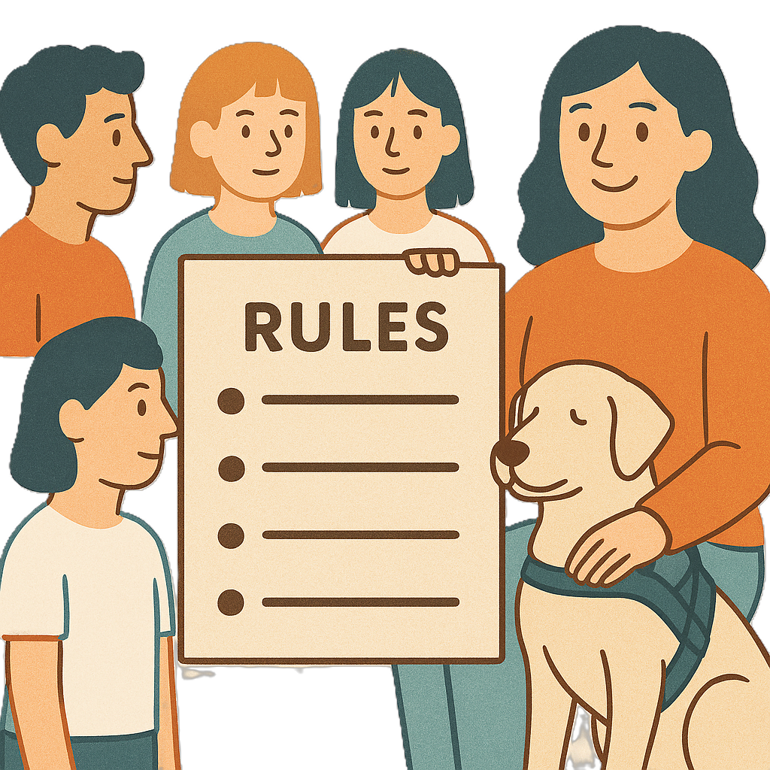 | Changing the NDIS provider definition will  - Make the rules fairer  The rules will make more sense.
 | - Help keep people with disability who get NDIS supports safe
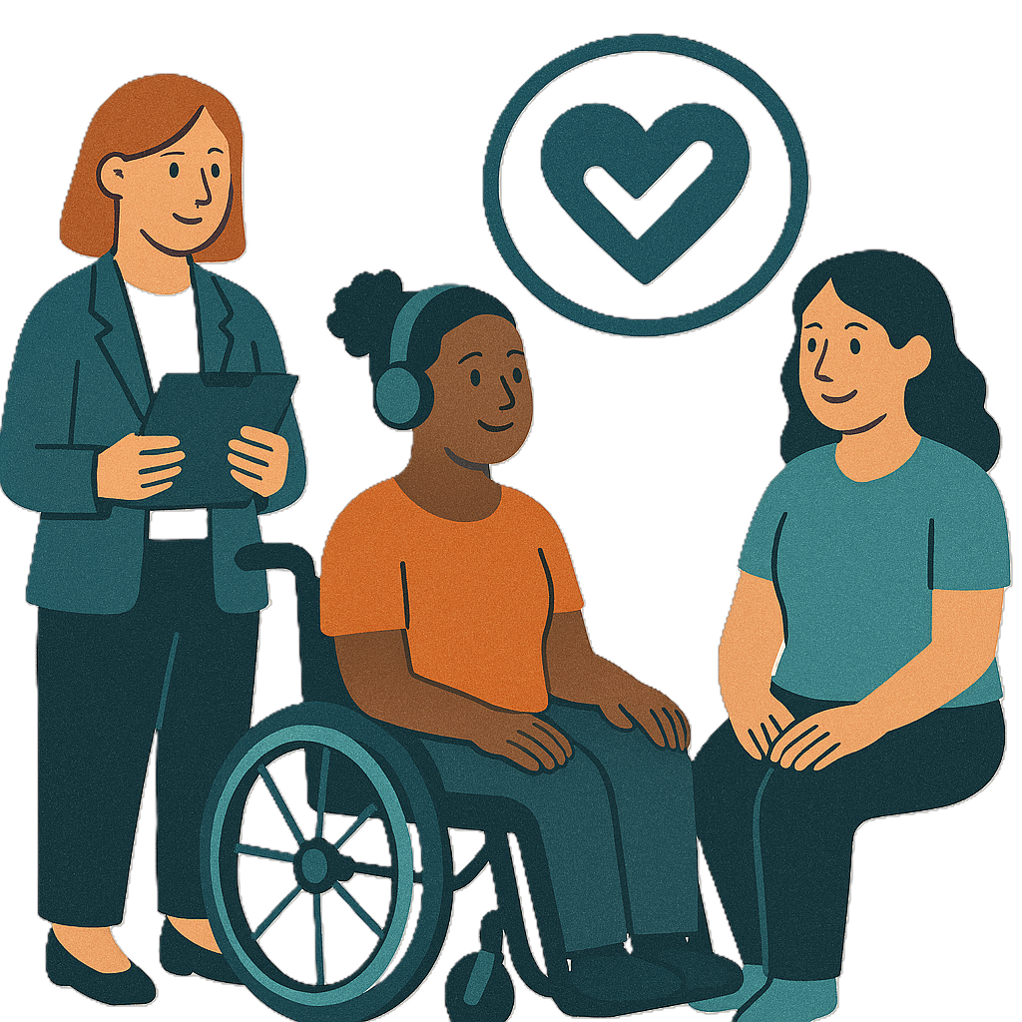 | - Have better services for people with disability who get NDIS supports.

How to take part

 | There are 2 ways you can take part  - Answer questions online
 | - Write your answers to our questions.
 | You can send us an email if you need help.  NDISRegulation@health.gov.au

Consultation paper

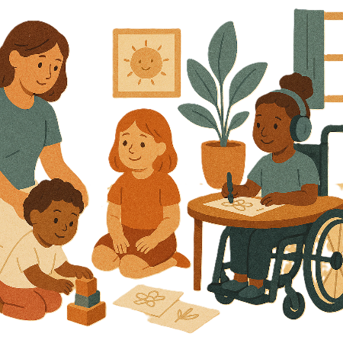 | This consultation will help the government make NDIS services better.  It will help  - Early childhood education  This is where children go to learn before they go to school.  It can be things like  - Childcare centres  - Preschools.
 | - Aged care services
 | - Disability services.
 | This consultation will look at  - What services should be in the definition
 | - How to protect the rights of everyone  Rights are rules about treating everyone  - Fair  - Equal.
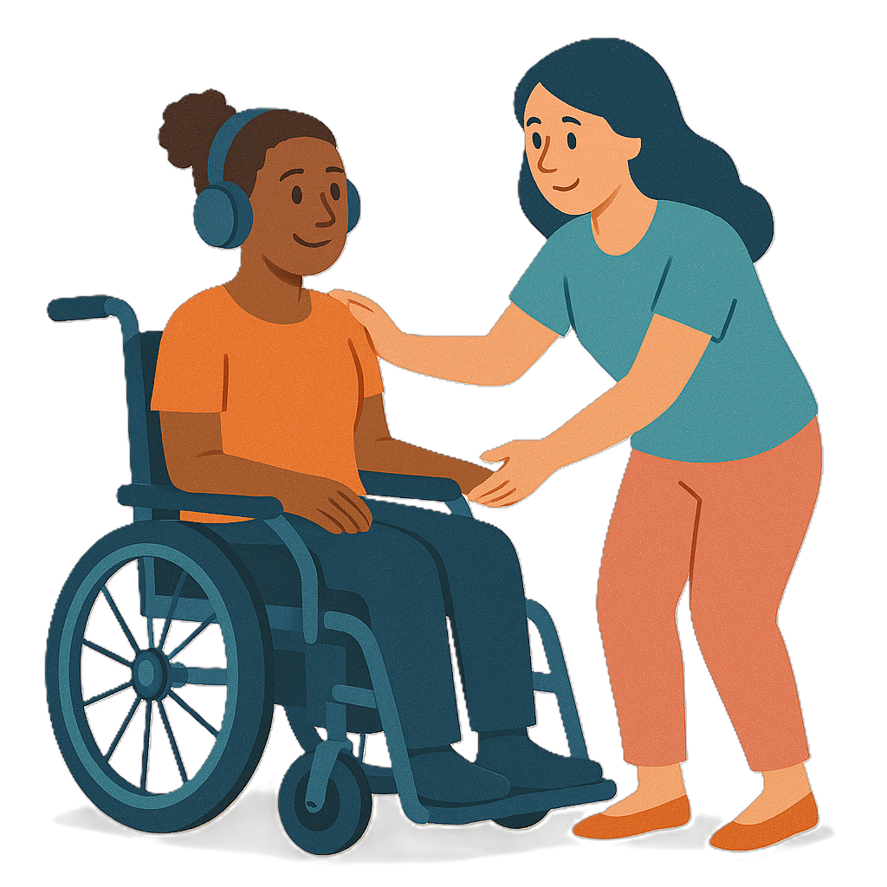 | - How to make services better
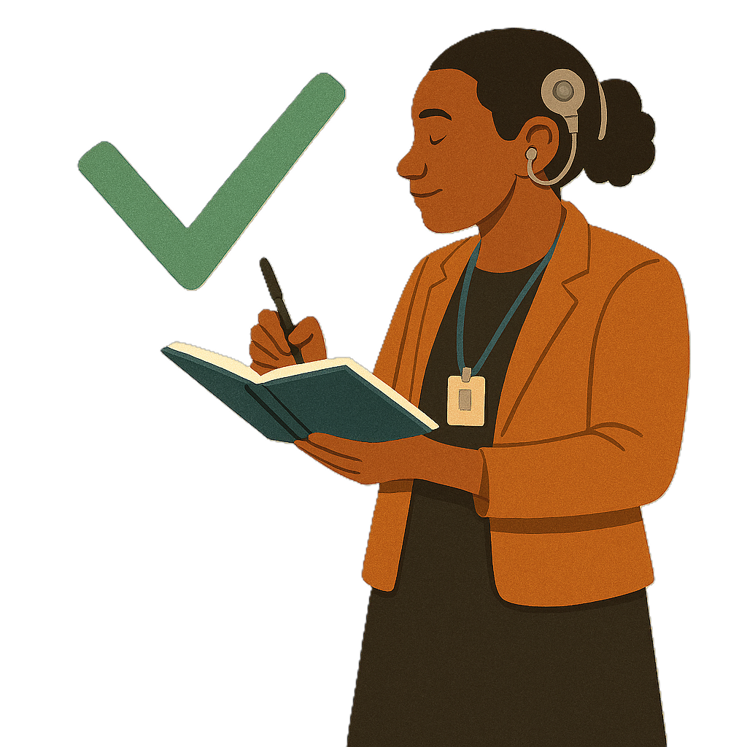 | - How to make sure services are being checked on properly.
 | The NDIS provider definition now does not have any of the changes that have been made for  - NDIS review  - Aged care reforms.  Reform means making changes to make something better.
 | The NDIS Taskforce had the idea to make the changes.  - The new definition will have the changes from the NDIS Review

NDIS provider definition

 | NDIS provider means  - A person who gets  - Funding from a NDIS plan to do supports  - NDIS money  They can not be the person with disability who gets NDIS supports.
 | Funding is money from the government to take part.
- A person or organisation that

- Gives support or services for people with disability under the NDIS
 | - Are listed in the rules.  The rules say if a person or organisation is a NDIS provider.  They must follow the NDIS rules.  Even if they do not get NDIS money.
 | The government wants to make changes to the NDIS provider definition.  The government wants to hear from the community before they make any changes.
 | The new definition will help decide  - Who needs to register
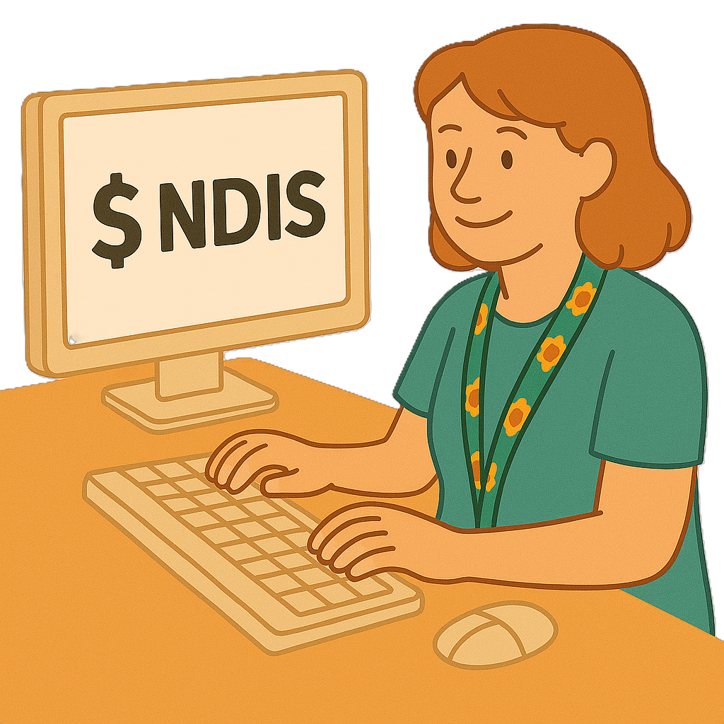 | - Which providers can be checked in the computer system when NDIS money is used.  These providers would not need to register.
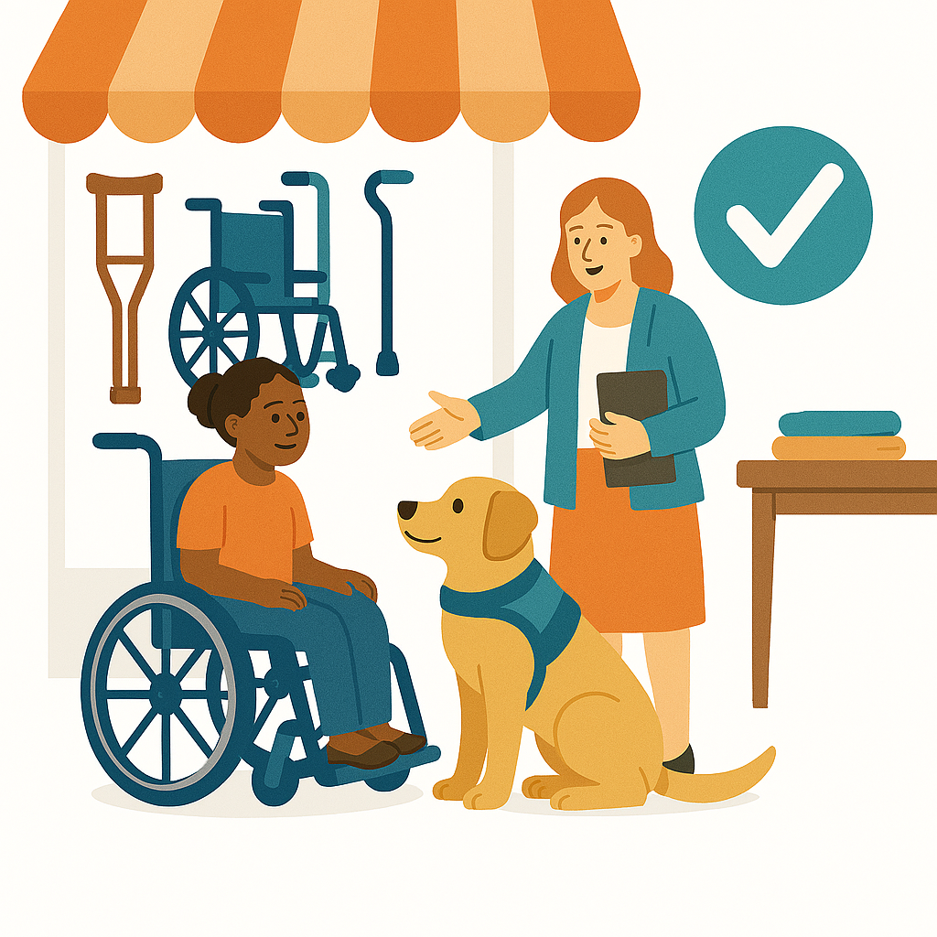 | This means you can still buy things the way you normally do.

Changes to registration

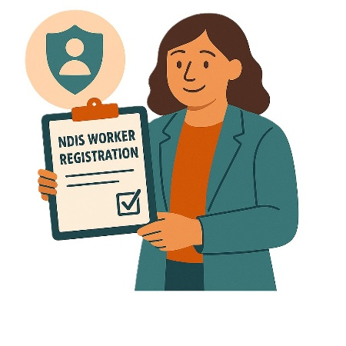 | The NDIS Review gave recommendations.  Recommendations are ideas to do things better.  1 recommendation was for all NDIS providers to be registered.  This would make it safer for people with disability.
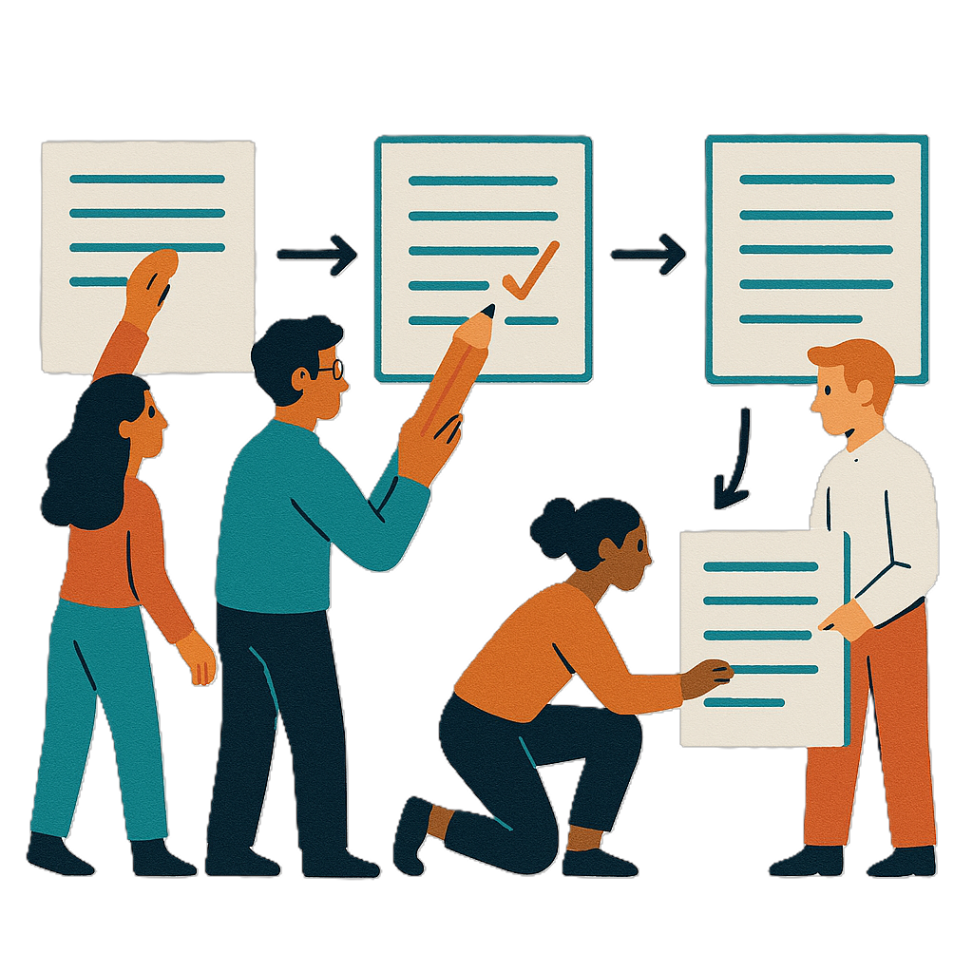 | The NDIS Taskforce said the NDIS provider definition needed to change.  This means anyone in the new definition would need to be registered.
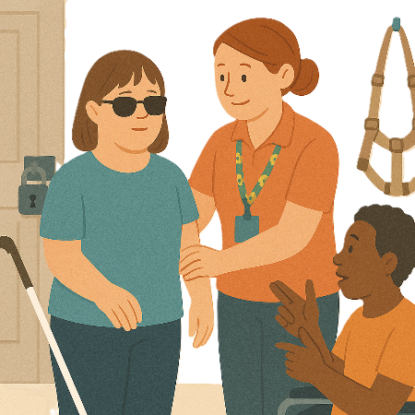 | Now who needs to be registered are NDIS providers who do  - Restrictive practices  Restrictive practices can take away your rights.  They stop you from going places and doing what you want.
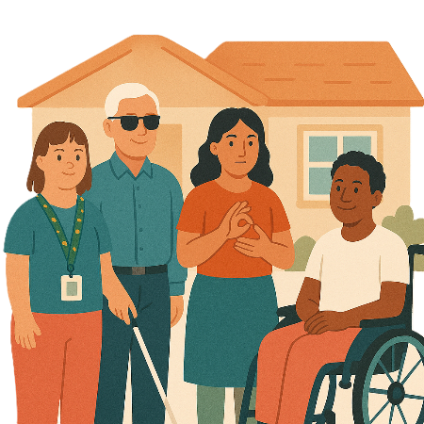 | - Specialist disability accommodation  We call it SDA for short.  People with disability can  - Live in a house paid for by the NDIS  - Get support to live in the house.
 | - Specialist behaviour support  Behaviour support helps you live a good life.
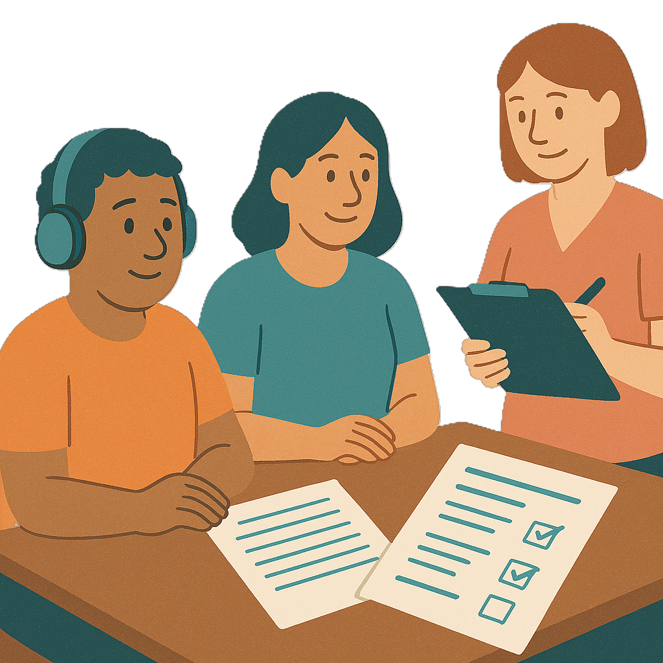 | This includes  - Doing behaviour support assessments  Assessments help us work out what support you need.
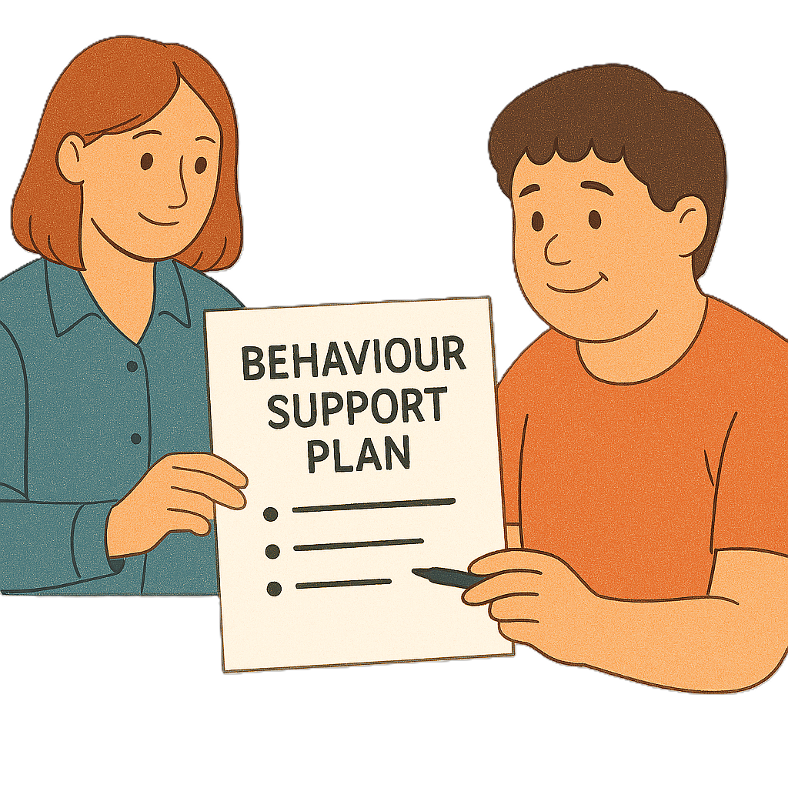 | - Making behaviour support plans.
 | If the National Disability Insurance Agency manages a NDIS plan there are rules.  They must use NDIS providers that are registered.  We call it NDIA for short.  NDIA look after the NDIS.
 | Some people were confused about what NDIS provider rules will be in the future.
 | This consultation will help the government hear your ideas.
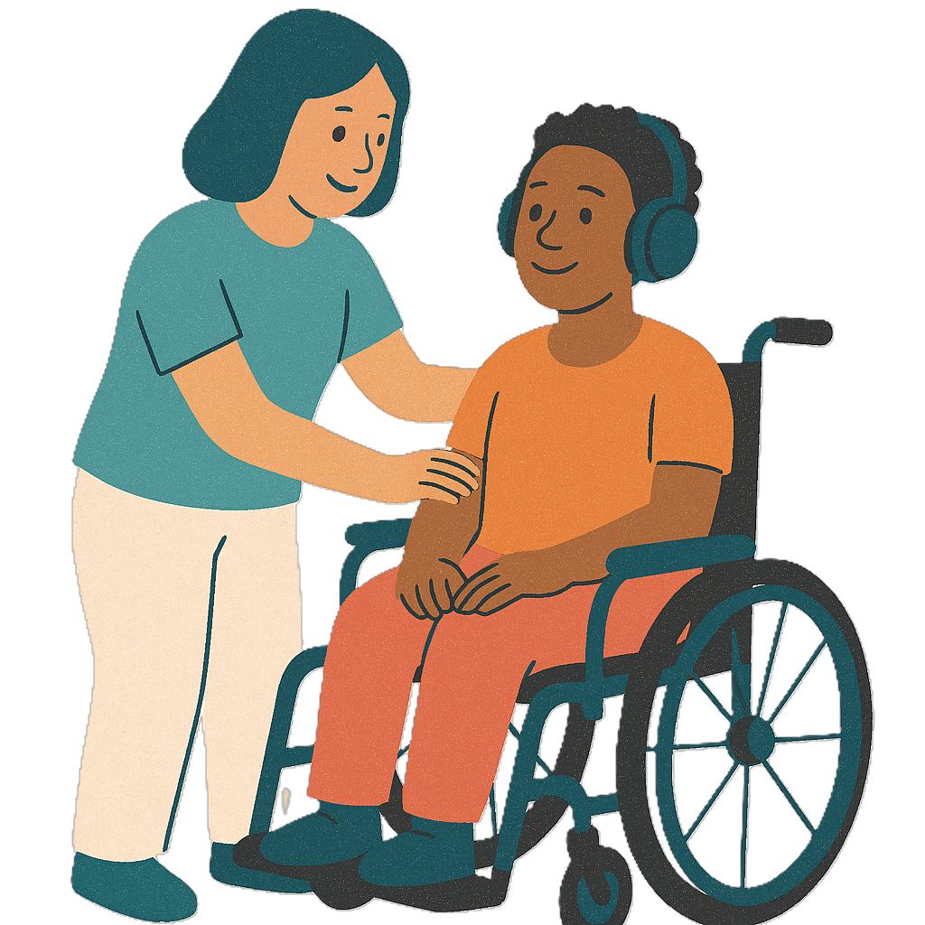 | The new definition will help  - Make it easier for low risk supports  Low risk supports are supports that are safe.  They do not need close watching to keep people safe.
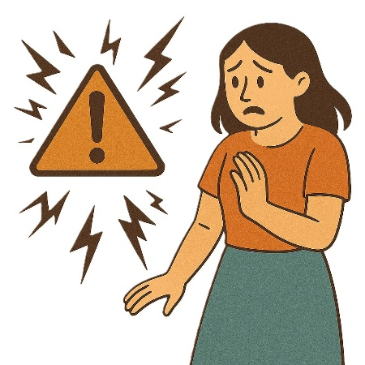 | Risks are the chance that something bad might happen to you.
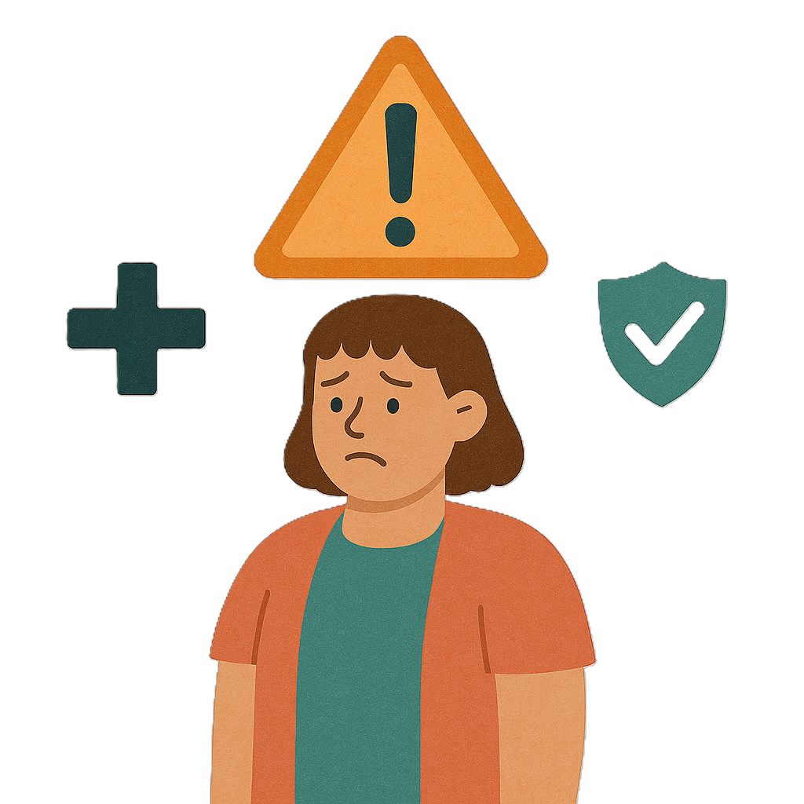 | - Check on high risk providers  High risk providers are supports that can affect someones  - Health  - Safety  - Rights.

NDIS Provider Registration

 | The NDIS Taskforce recommends 3 levels for NDIS provider registration  - High risk  - Medium risk  - Low risk.
 | High risk services are things like group homes.  They will need to share more information with the government.  This will mean the government knows they are doing the right thing.
 | Medium risk services are services that help with medicine.  They will need to share information with the government too.  They will be on a different list to the high risk services.
 | Low risk services are services that help with things like cooking.  They will need to share a bit of information.  The shop does not need to go on the list.
 | Part of this will be making sure people with disability who get NDIS supports are  - Safe  - Treated fairly.

List of support types

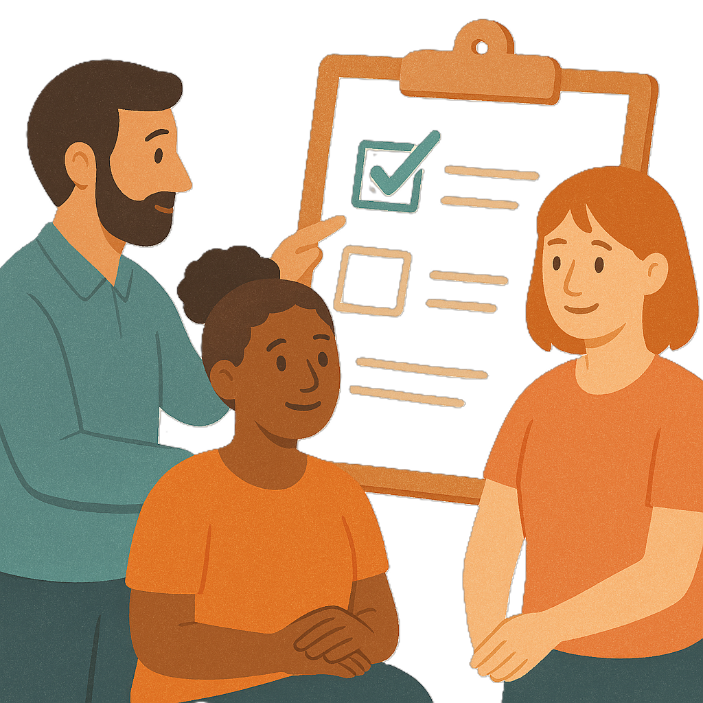 | The NDIS Taskforce think the different types could be  - Supports  - Services  That are offered to a person with disability.
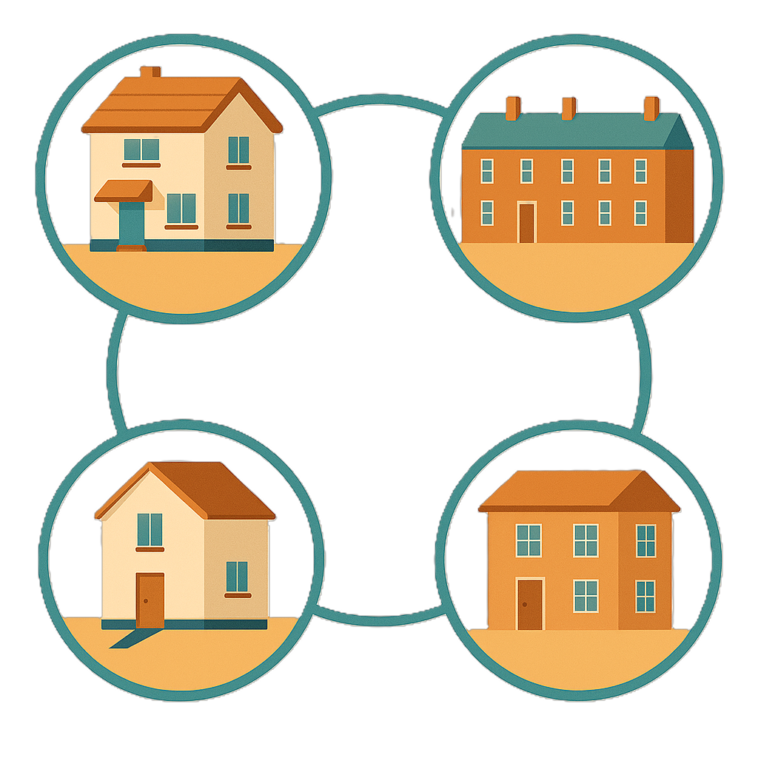 | A support that might need to be registered could be  - Help to find housing
 | - Support to live at home
 | - Live independently with support  This means being able to  - Make choices about your life  - Do things by yourself as much as you can  - Get help when you need it.
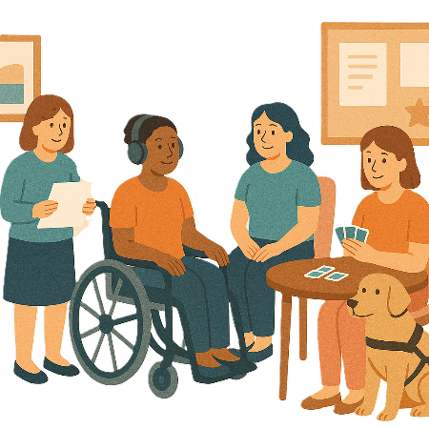 | - Day programs at community centres
 | - Help finding a job
 | - Learning new skills for work
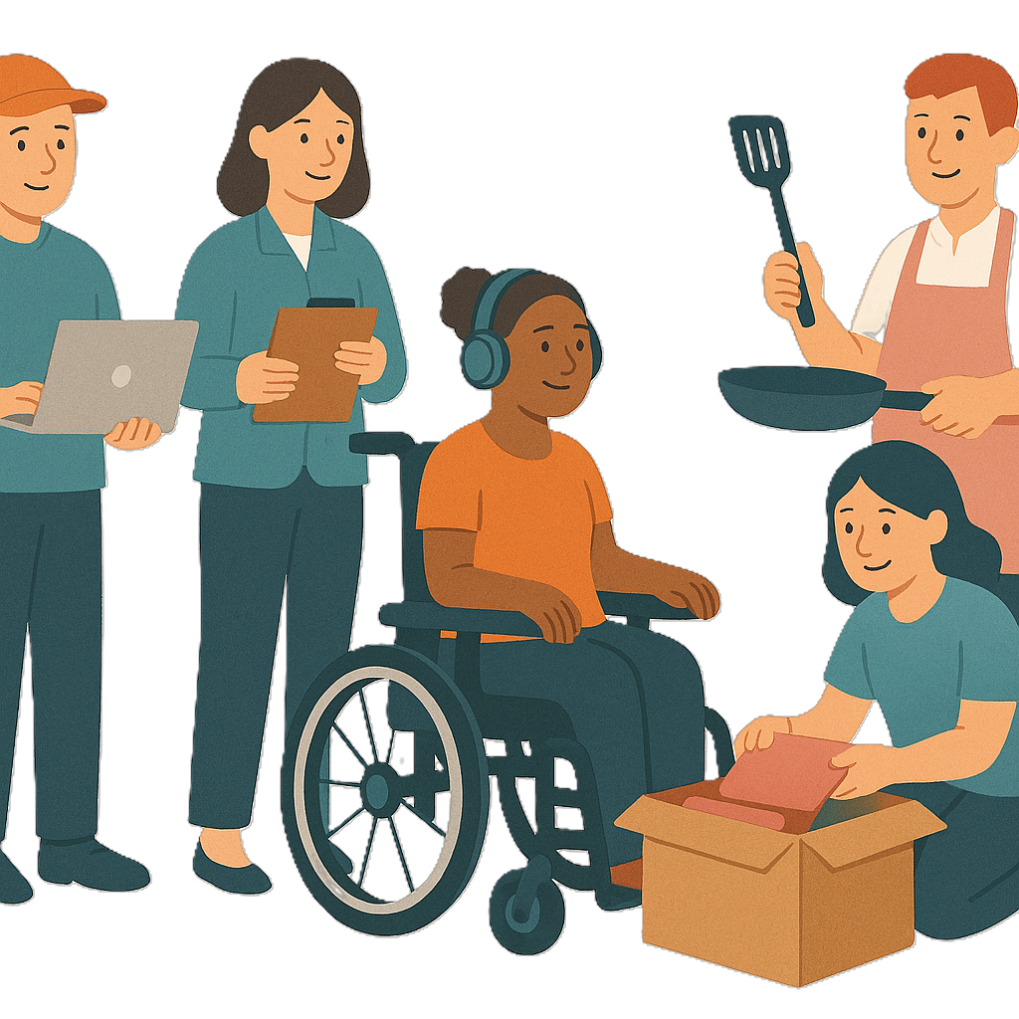 | - Supported jobs for people with disability
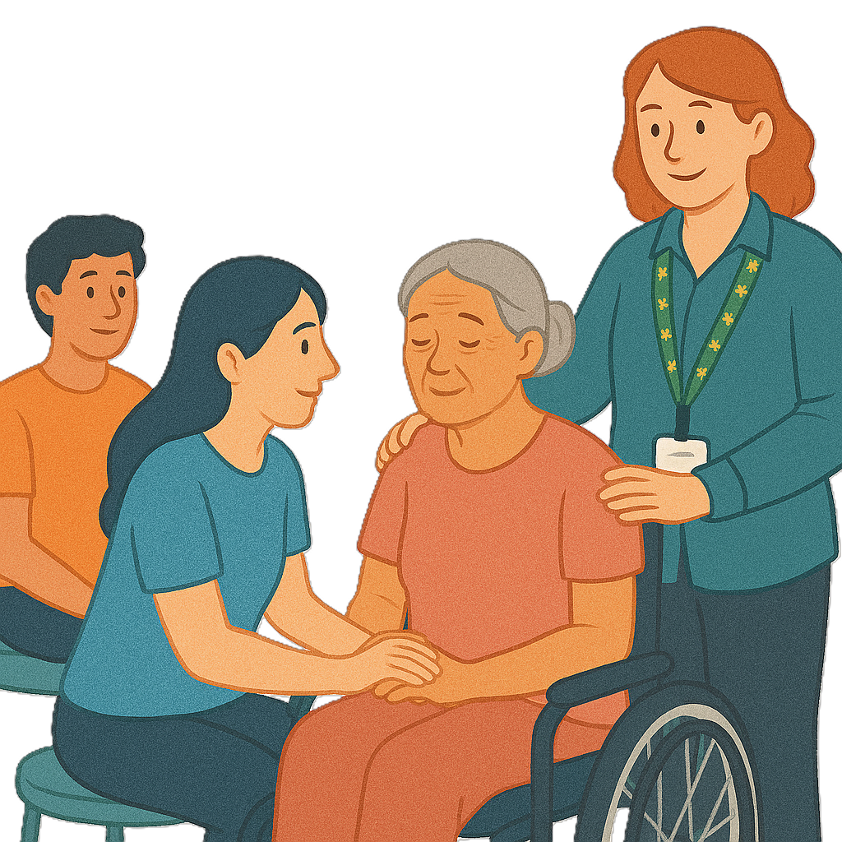 | - Short term stays  Short term stays are a break for the people who care for you.  You go and stay somewhere for a set time.  People will look after you while you are there.  It can also be called respite care.
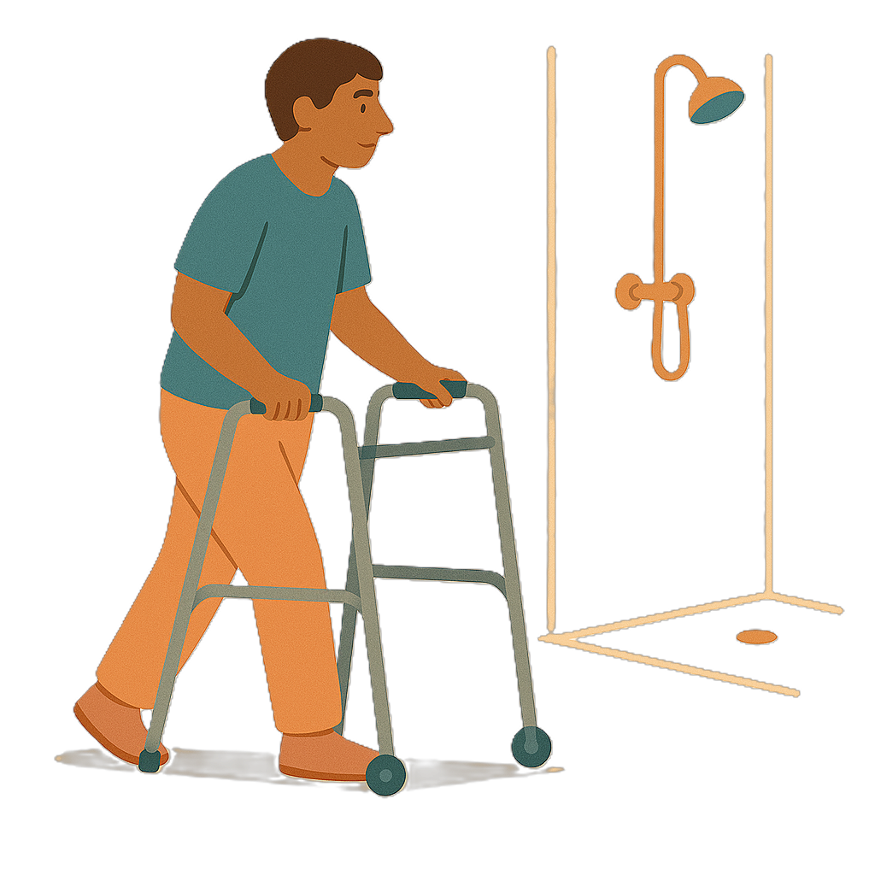 | - Help at home with things like  - Showering  - Moving around
 | - Taking part in the community
 | - Helping to look after NDIS  - Plans  - Funding
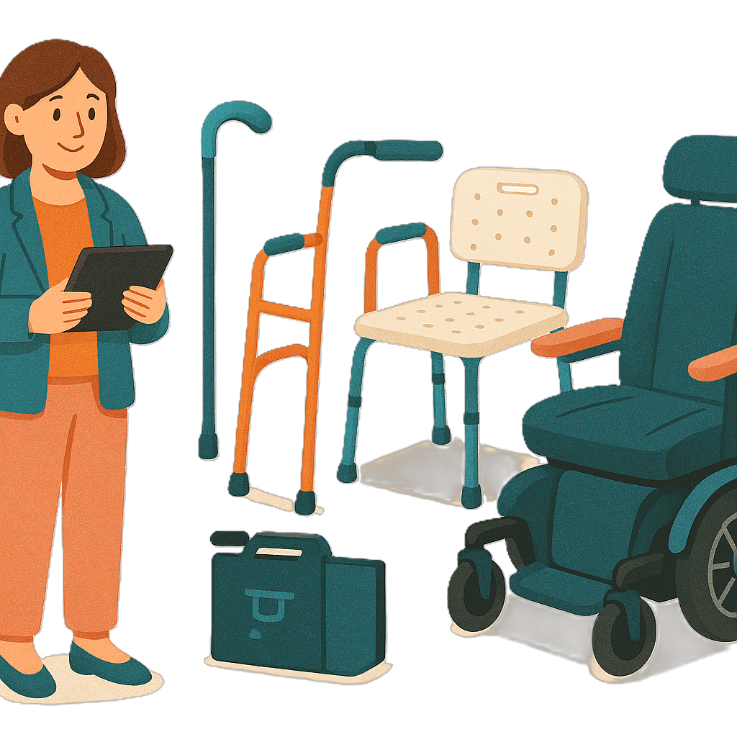 | - Making or selling equipment to help with everyday life
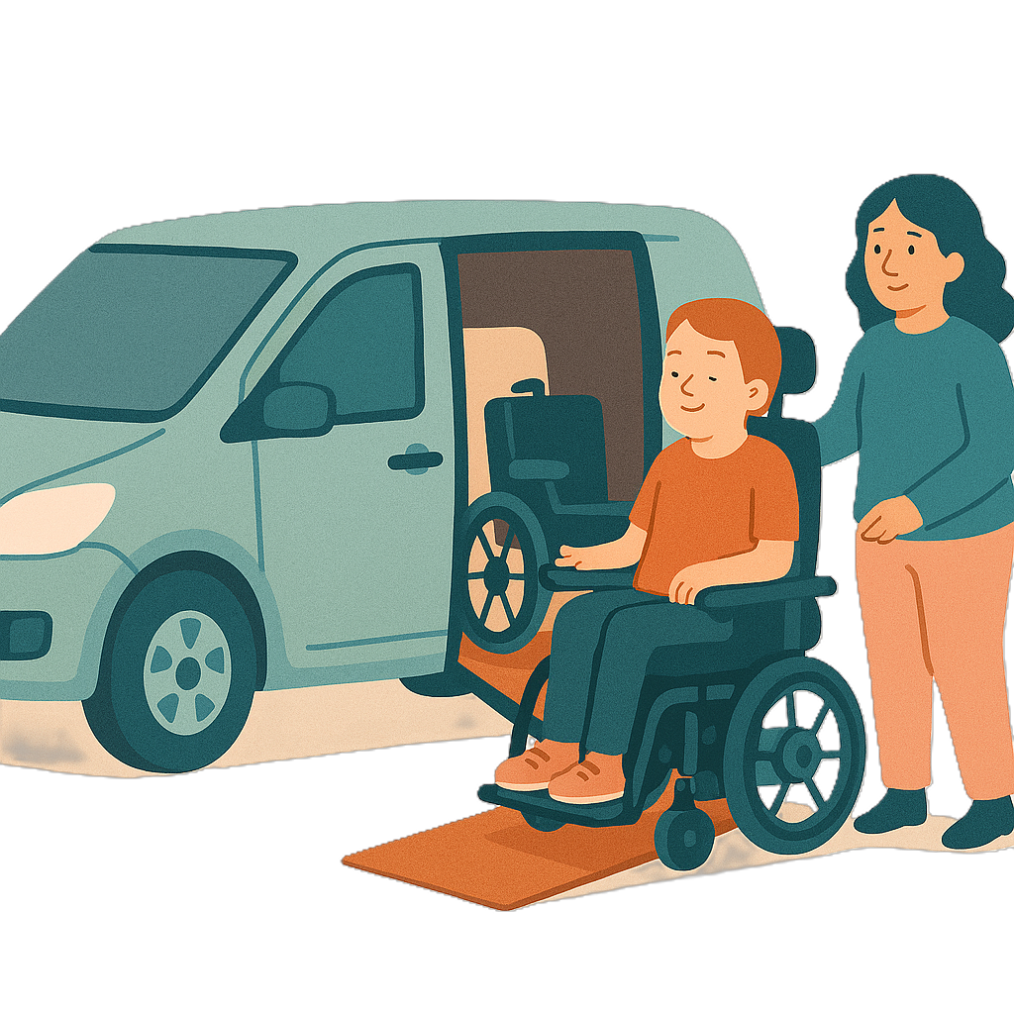 | - Transport services for people with disability  Transport is how people move from one place to another.  Like a car made for person with disability
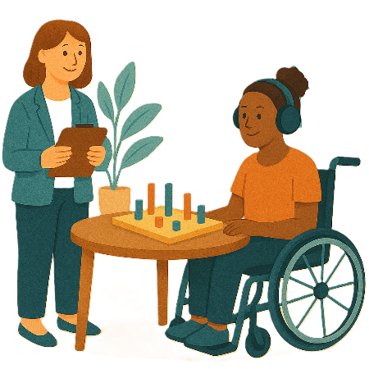 | - Therapy  Therapy is something to help you  - Feel better  - Grow stronger.  There are lots of different types of therapy.
 | - Support for young children
 | - Help with managing challenging behaviours  Challenging behaviours are actions that  - Are hard to understand  - Make it hard for people to join in everyday life  - May hurt the person  - May hurt other people.
 | - Interpreter services  Interpreters help change words from 1 language to another like Auslan.
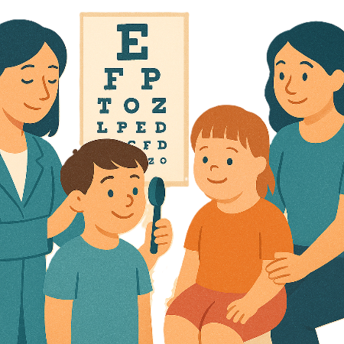 | Health services like  - Eye care  - Childrens health
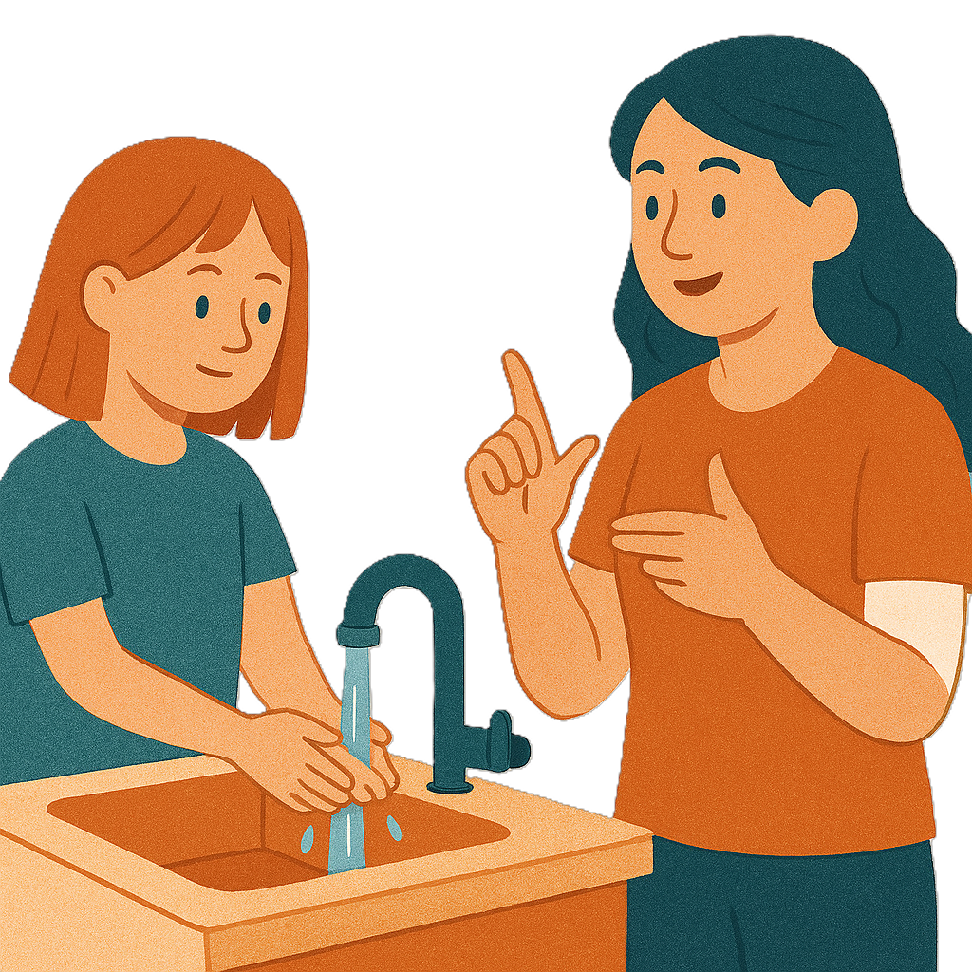 | - Supports that build skills and being independent
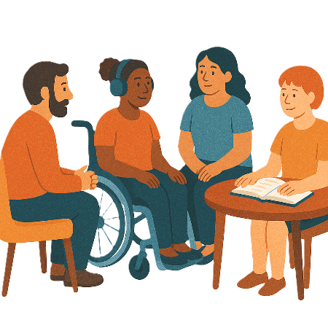 | - Peer support groups  Peer support is when people with disability give each other support and advice.
 | - Help to move around  - Safely  - With confidence  Confidence means knowing you can do something.

Contact us

 | You can contact us if you need more information.
 | You can send us an email.  NDISRegulation@health.gov.au

Images in this Easy Read must not be used or copied without permission

