Individual Disability Advocacy Program

Consultation paper
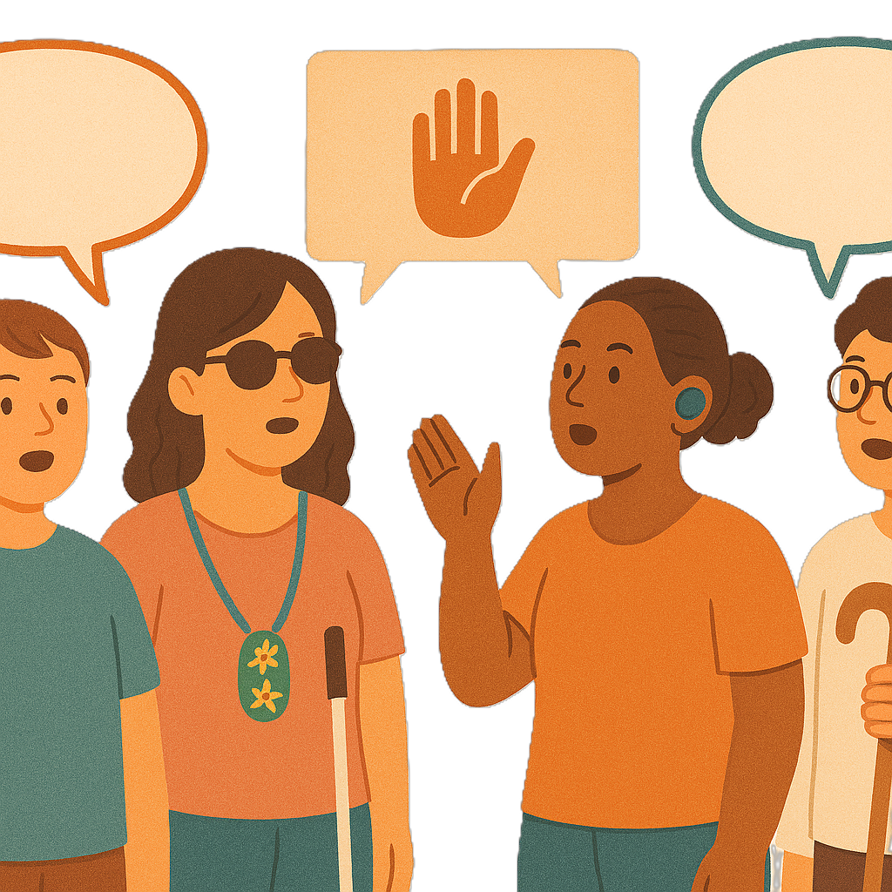
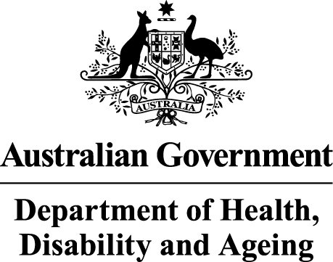 | The Australian Government Department of Health Disability and Ageing wrote this.  We say DHDA for short.  When you see the word we it means DHDA.
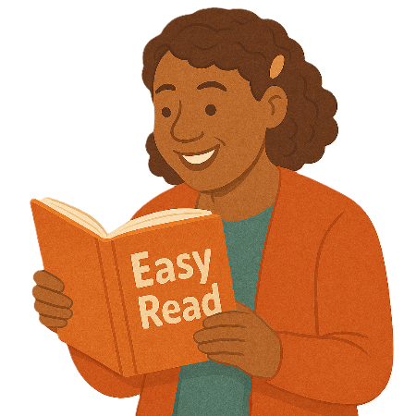 | We wrote this in an easy to read way.  We use pictures to explain some ideas.
 | We have some words in bold.  This means the letters are thicker and darker.  These are important words.
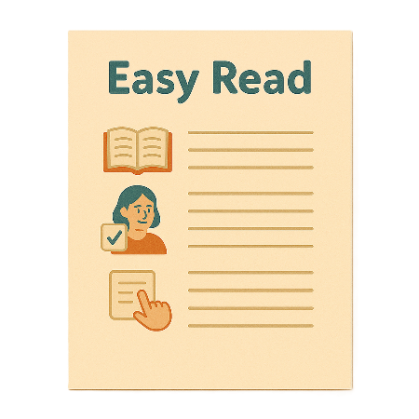 | This is an Easy Read summary of another document.  This means it has the most important ideas.
 | We can answer any questions by email.  Email us disabilityadvocacyreforms@health.gov.au
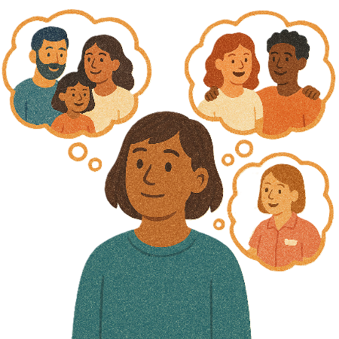 | You can ask for help to read this document.  You can ask  - A friend  - Family members  - A support person.
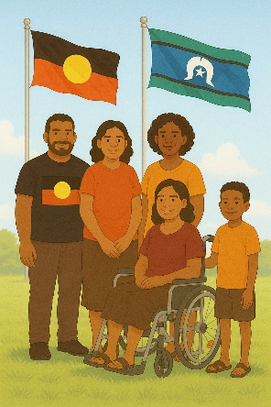 | We recognise Aboriginal and Torres Strait Islander people as the Traditional Owners of the land we live on.
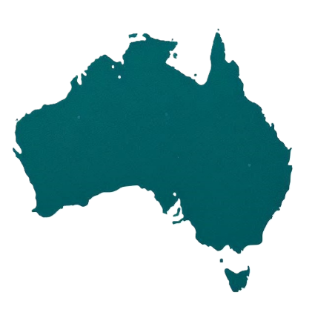 | They were the first people to live on and use the  - Land  - Waters.

Contents

New Individual Disability Advocacy Program | 5
What is individual disability advocacy | 9
What the community has told us | 11
Our plan | 15
Aims | 17
Partners | 21
Activities | 22
Outcomes | 23
How IDAP will start | 24
What do you think | 25
How to share your ideas | 27

New Individual Disability Advocacy Program

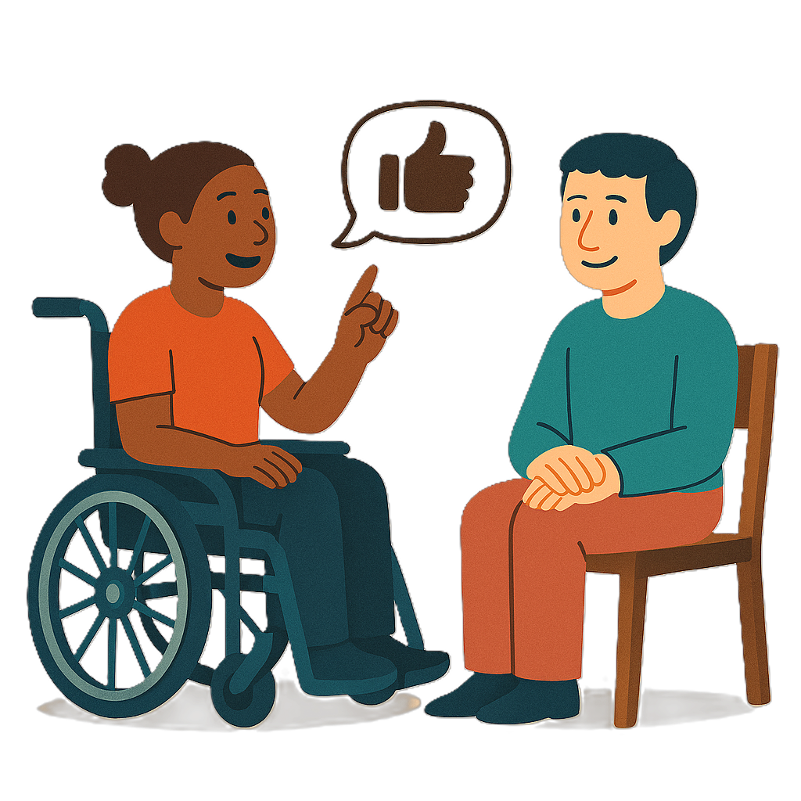 | We want your feedback on a new individual disability advocacy program.  We call it IDAP for short.
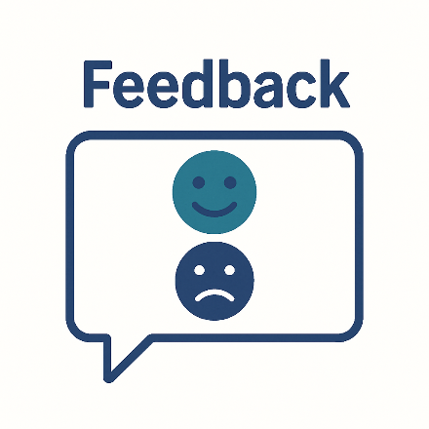 | Feedback says what you think about something.  It will help  - Find problems  - Make it better in the future.
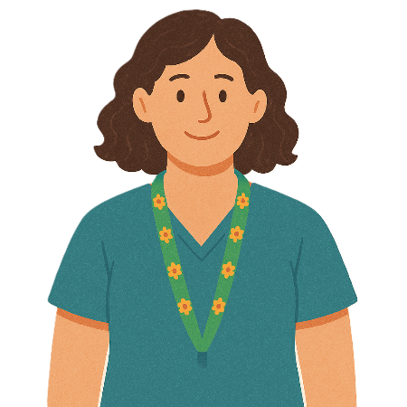 | Individual means 1 person.
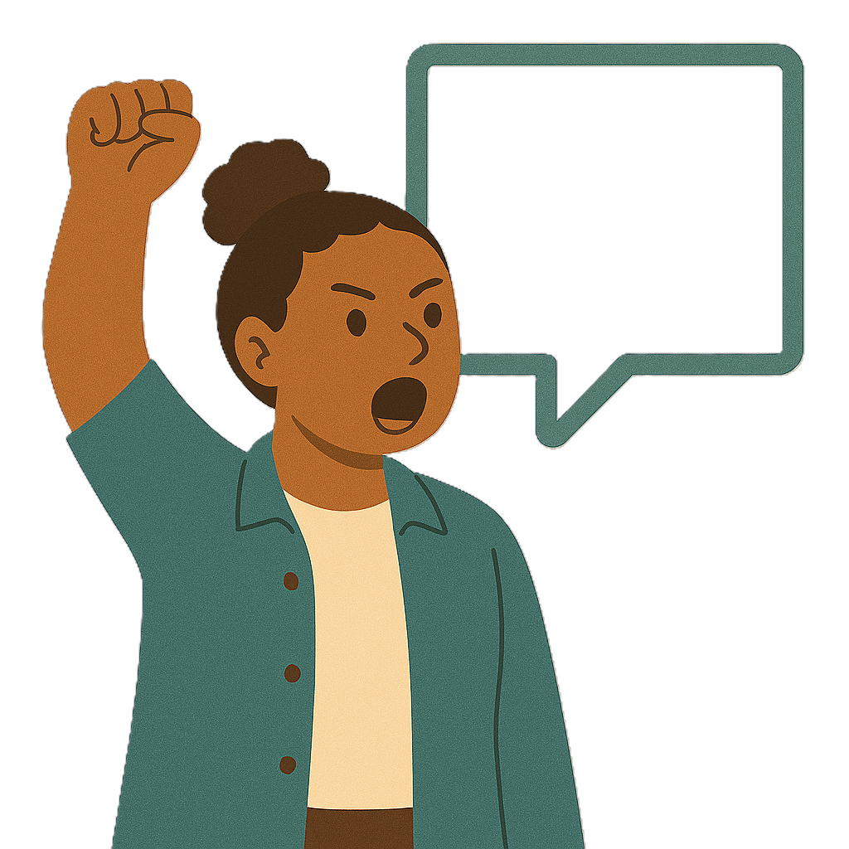 | Advocacy is when someone supports you to speak up for your rights.
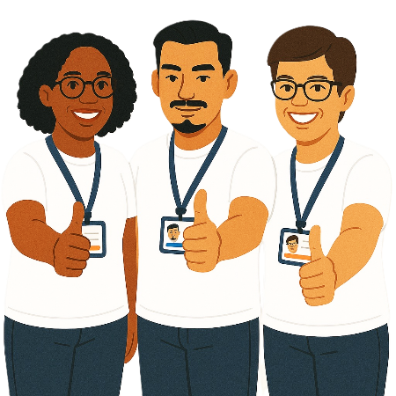 | Rights are rules about treating everyone  - Fair  - Equal.
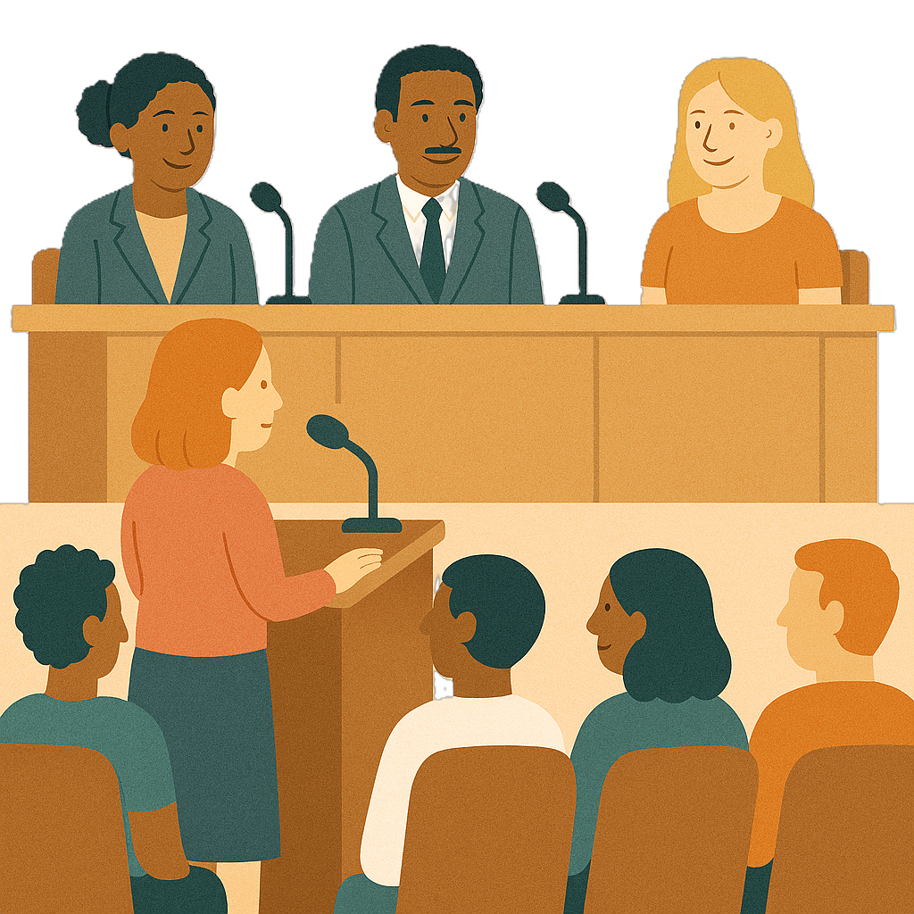 | The Disability Royal Commission looked at how people with disability are treated.  We call it DRC for short.
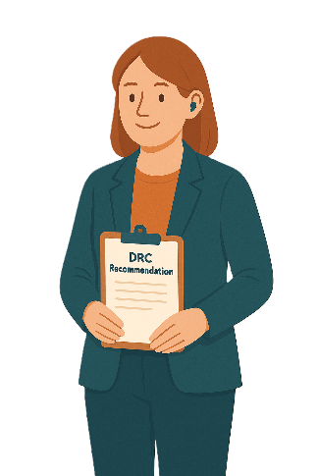 | DRC gave recommendations.  Recommendations are ideas to do things better.
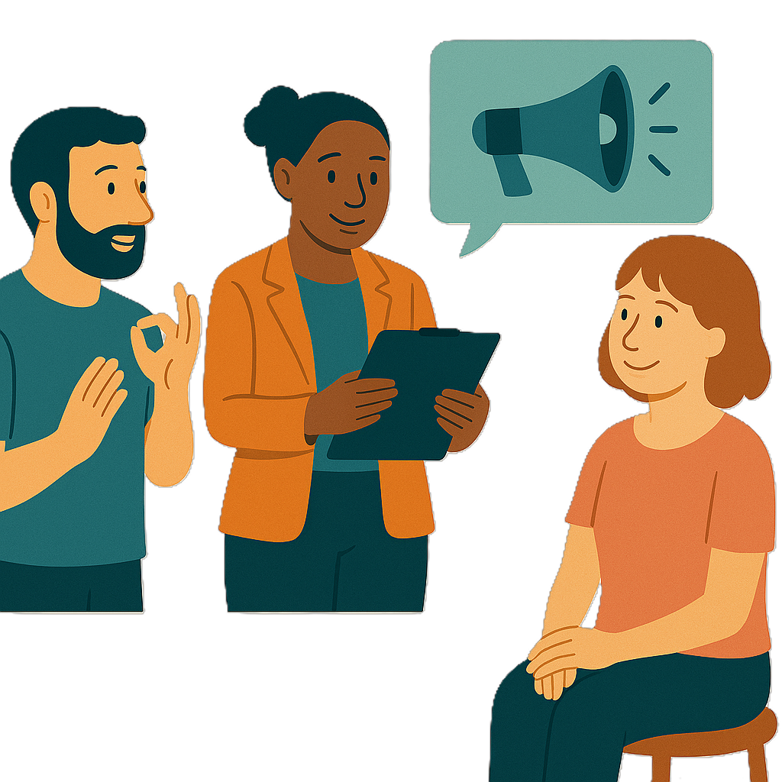 | To work on the recommendations the Australian Government said they would make IDAP.
 | You can go to the website to read more about DRC.  www.health.gov.au/resources/collections/australian-government-response-to-the-disability-royal-commission  It is in Easy Read.

What is individual disability advocacy

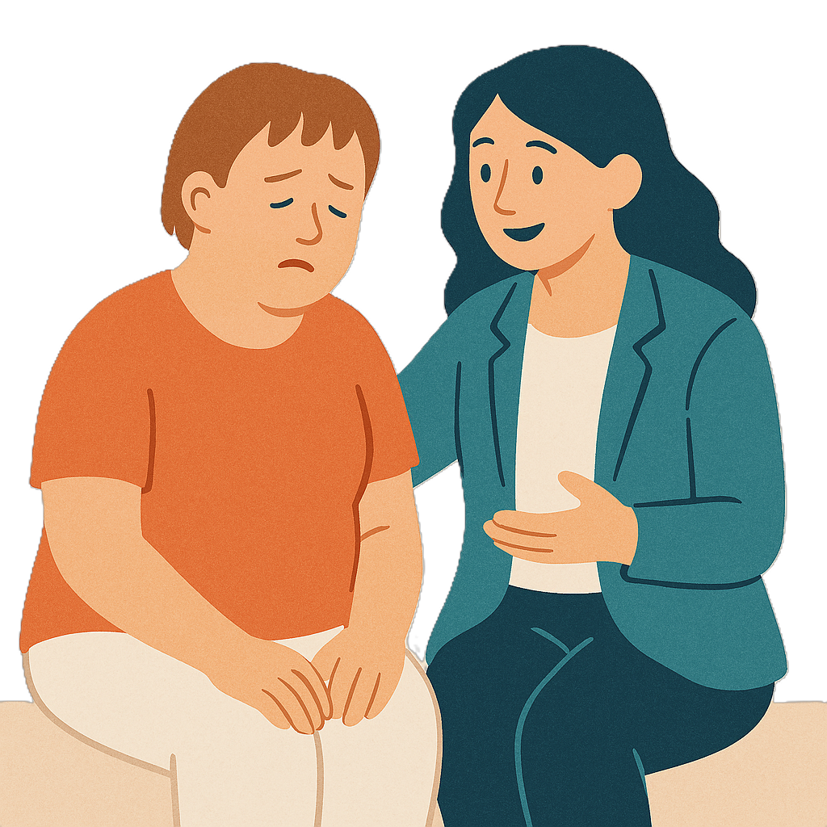 | Individual disability advocacy is when a person gets support to fix  - When they have been treated unfairly
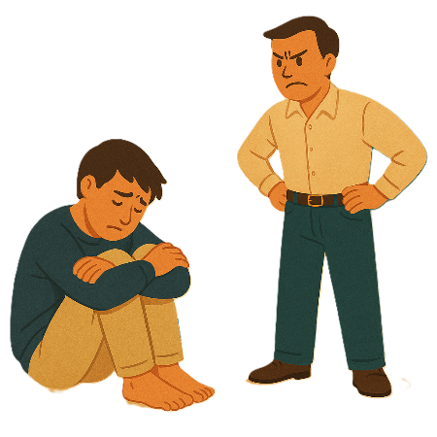 | - Abuse  Abuse is when someone treats you badly.
You can get support from

- An expert advocate

Expert is knowing a lot about something.
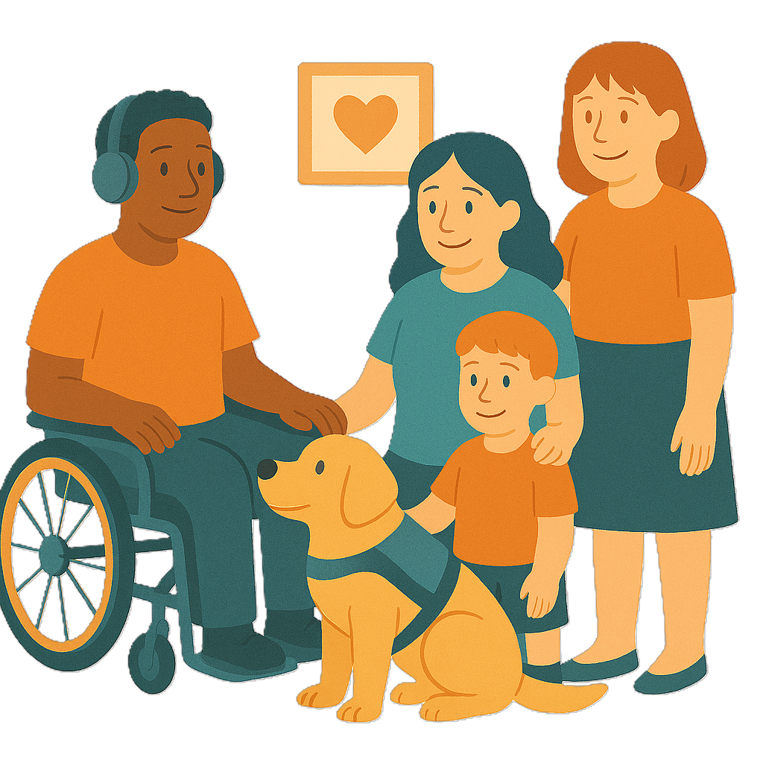 | - Family member
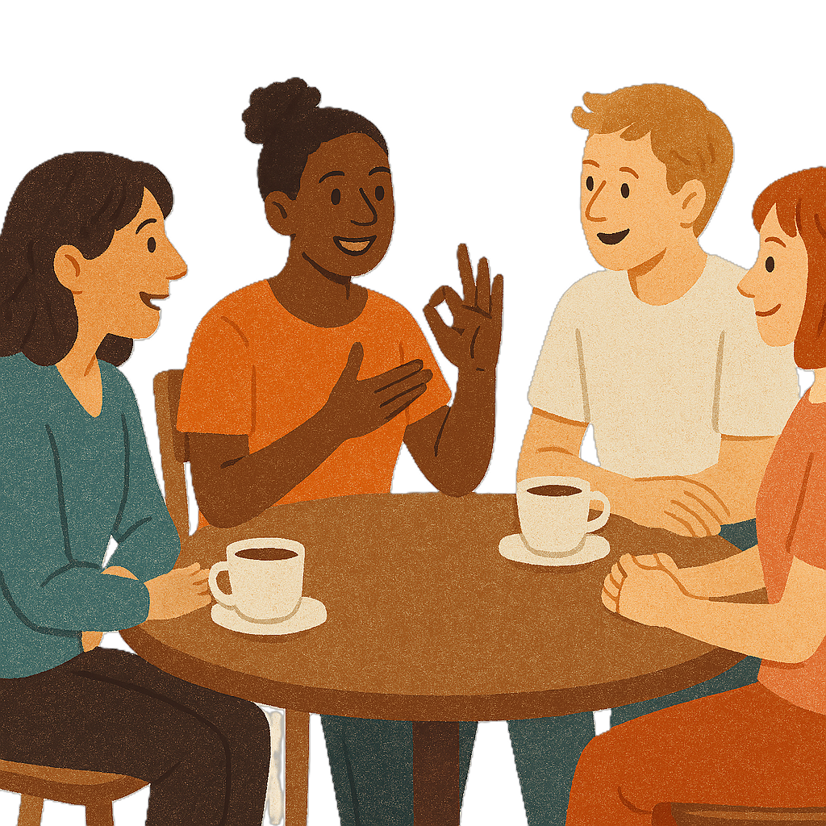 | - Friend
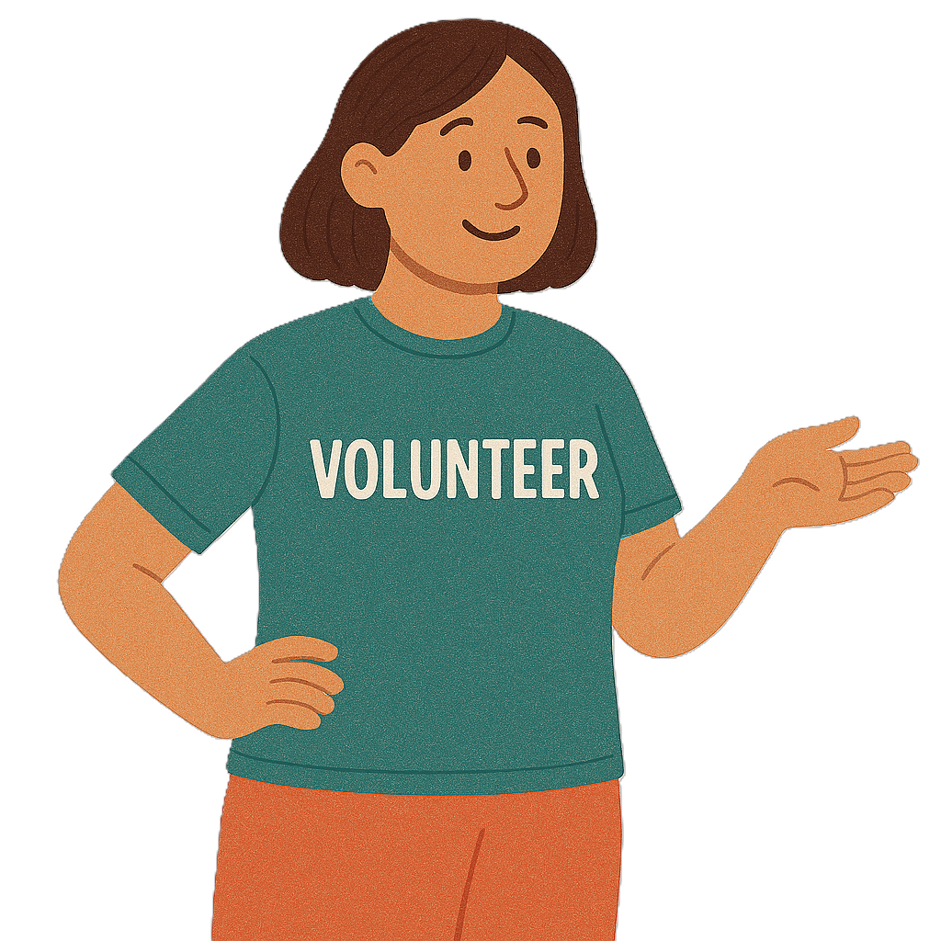 | - Volunteer from an advocacy organisation  Volunteers help someone but do not get paid.
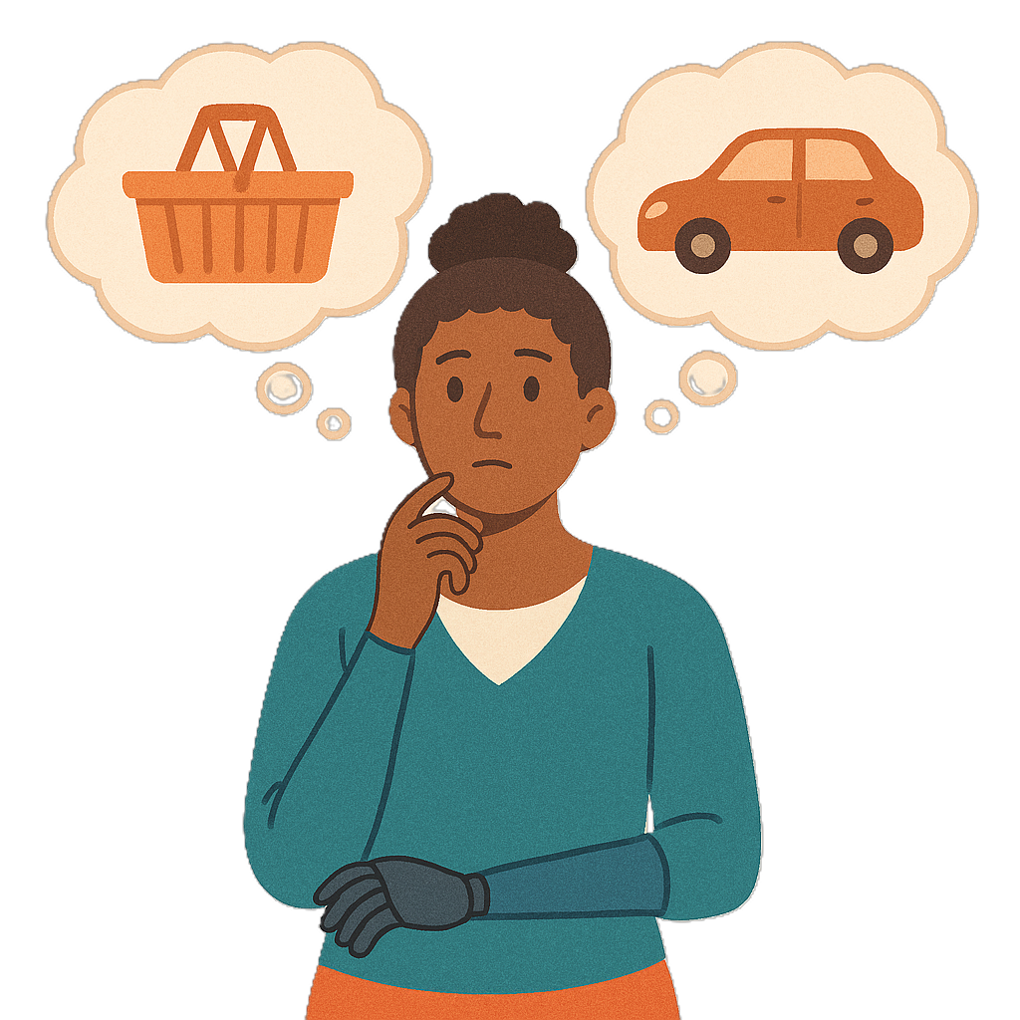 | This supports people with disability to  - Make their own choices
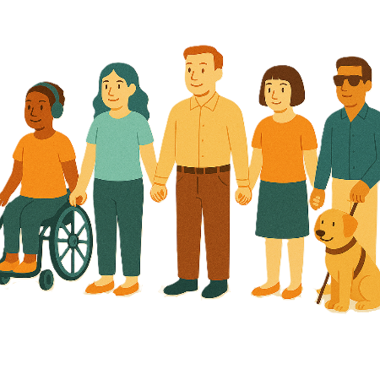 | - Have equal rights.

What the community has told us

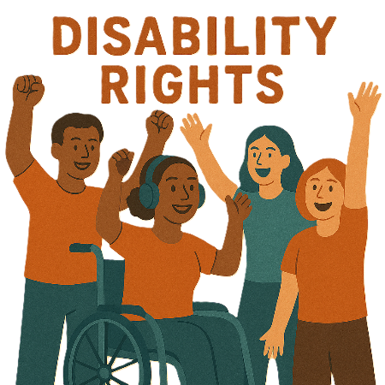 | We know disability advocacy is very important.
It supports people with disability to

- Make their own choices
 | - Have equal rights.
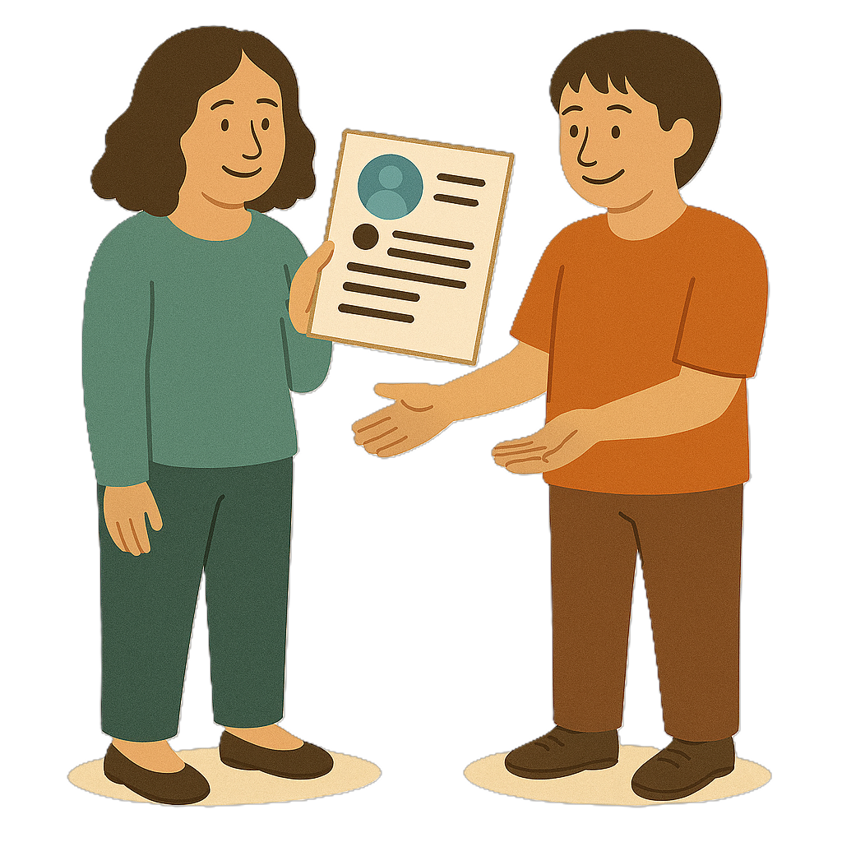 | The community has told us that individual advocacy  - Gives trusted information
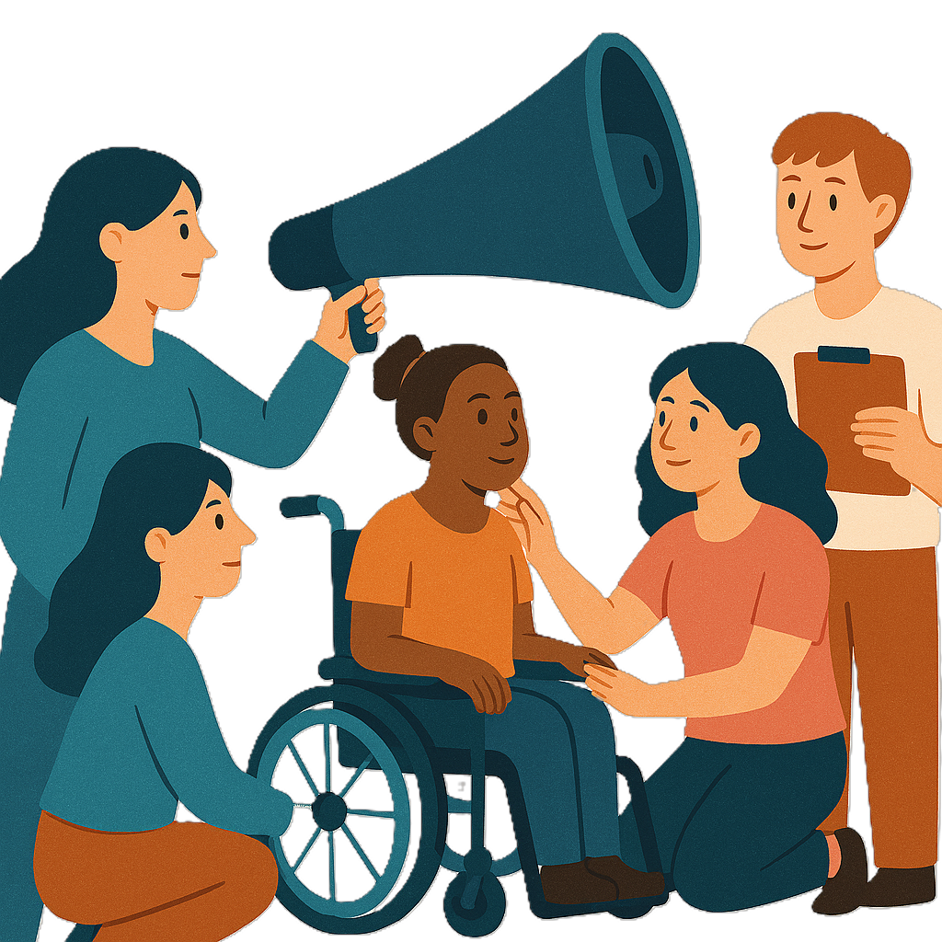 | - Helps people to build skills
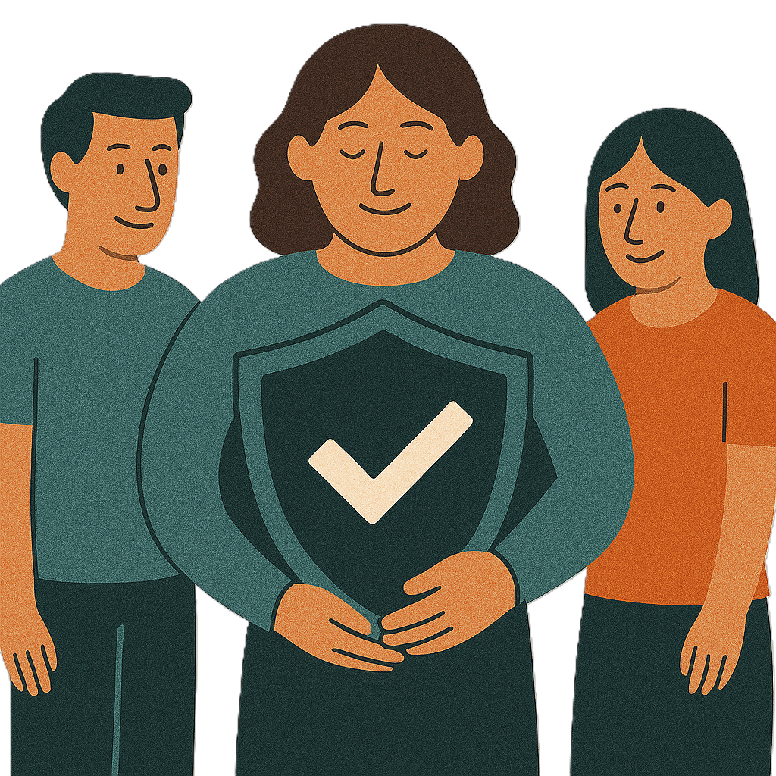 | - Is an important safeguard  Safeguard means protecting people with disability from harm.
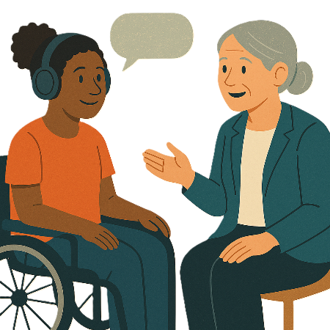 | - Helps people get the right support
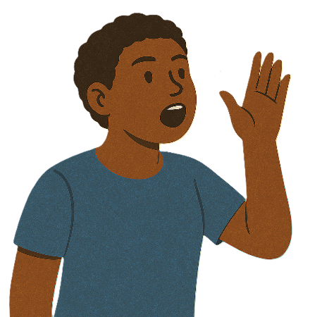 | - Helps people speak up for their rights
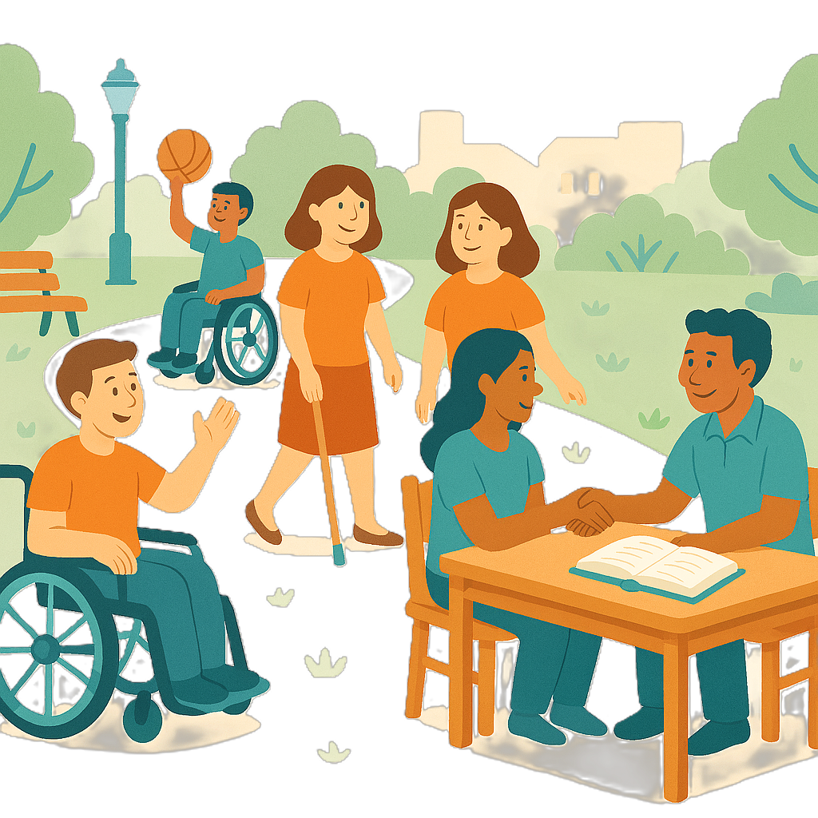 | - Helps people take part in their communities
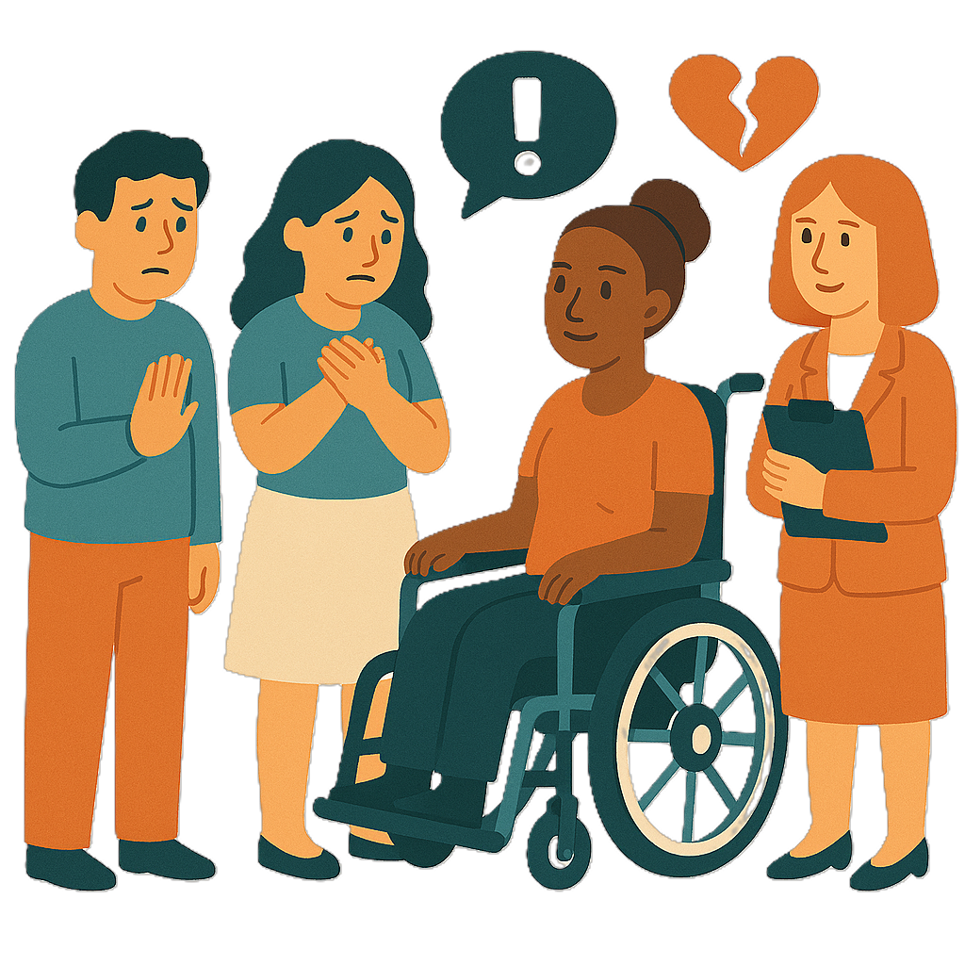 | - Is needed for different reasons
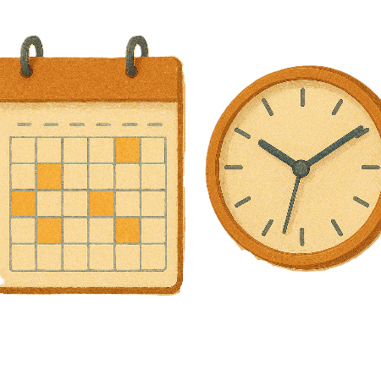 | - Needs to be done by organisations that can be around for a long time  This means people can go back to the same organisation if they have a different problem.
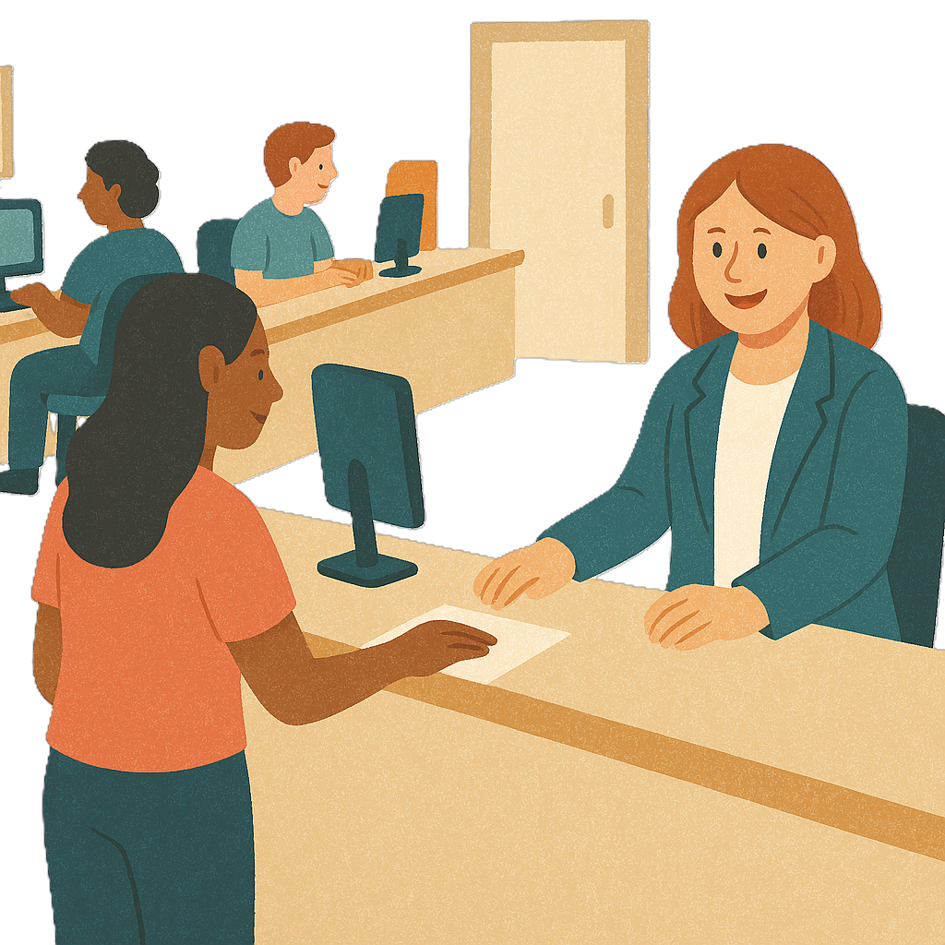 | - Be able to be done in person
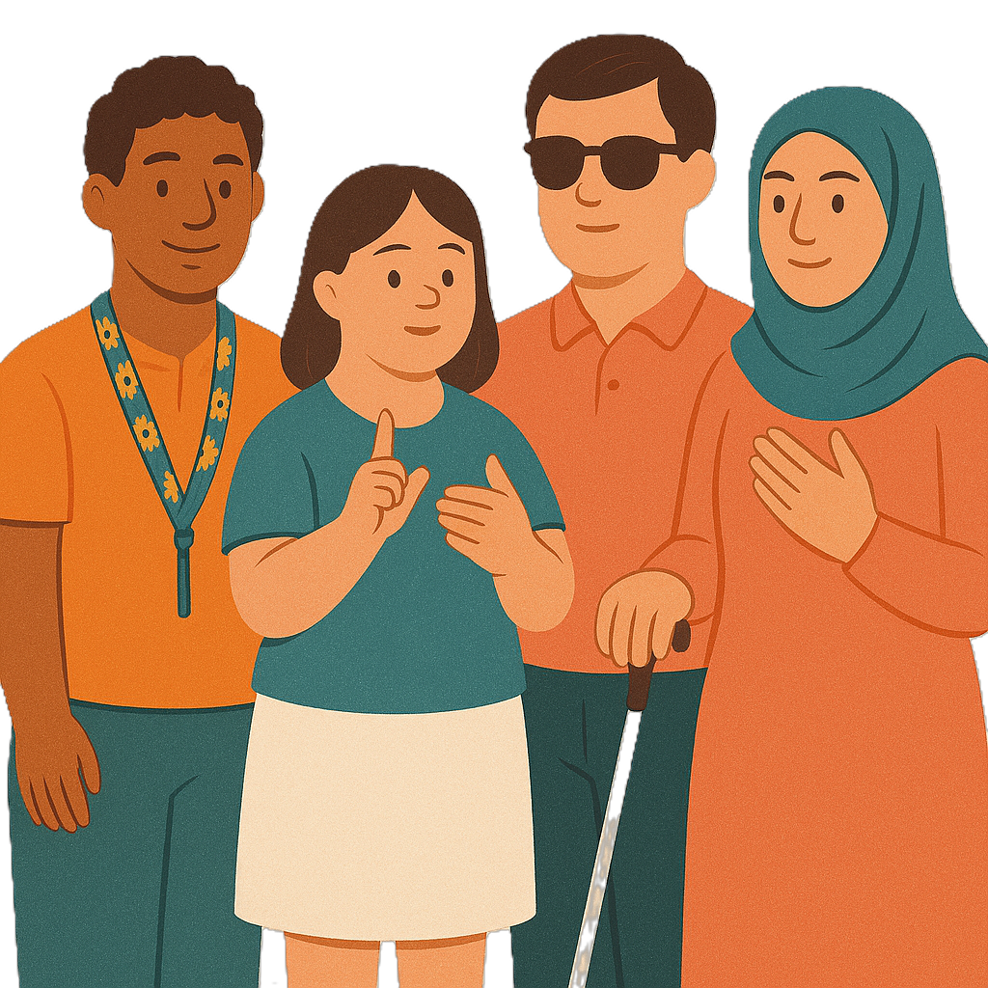 | - Needs to be culturally responsive  Culturally responsive means respecting peoples  - Rights  - Cultures  - Traditions.  This helps people feel safe to be themselves.

Our plan

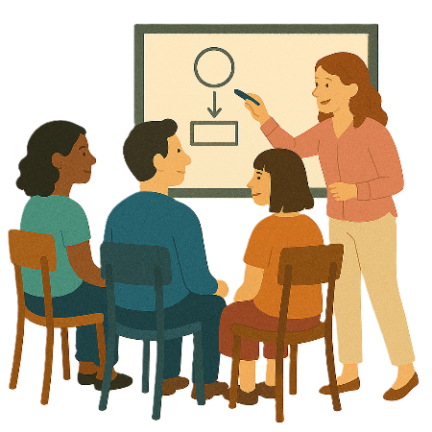 | We have made a plan from what we heard.  Our plan has
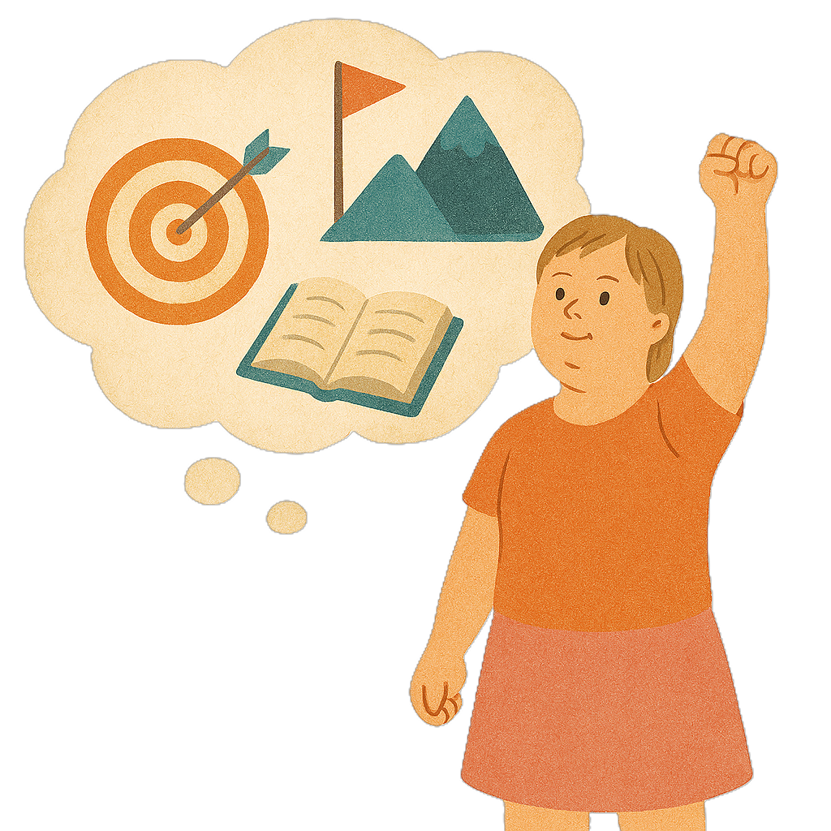 | - Aims  Aims are things you want to do.
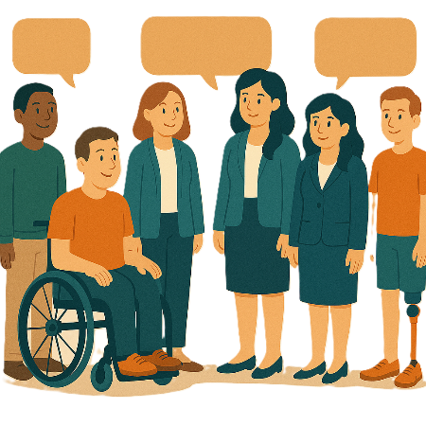 | - Who we will work with  We call them partners.
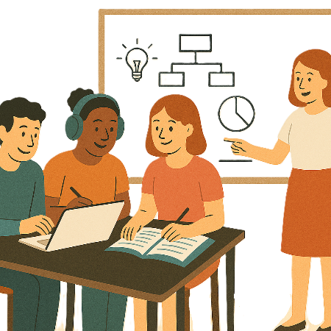 | - The things we will do  We call them activities.
 | - Outcomes  Outcomes are the things we see when our plans are working.

Aims

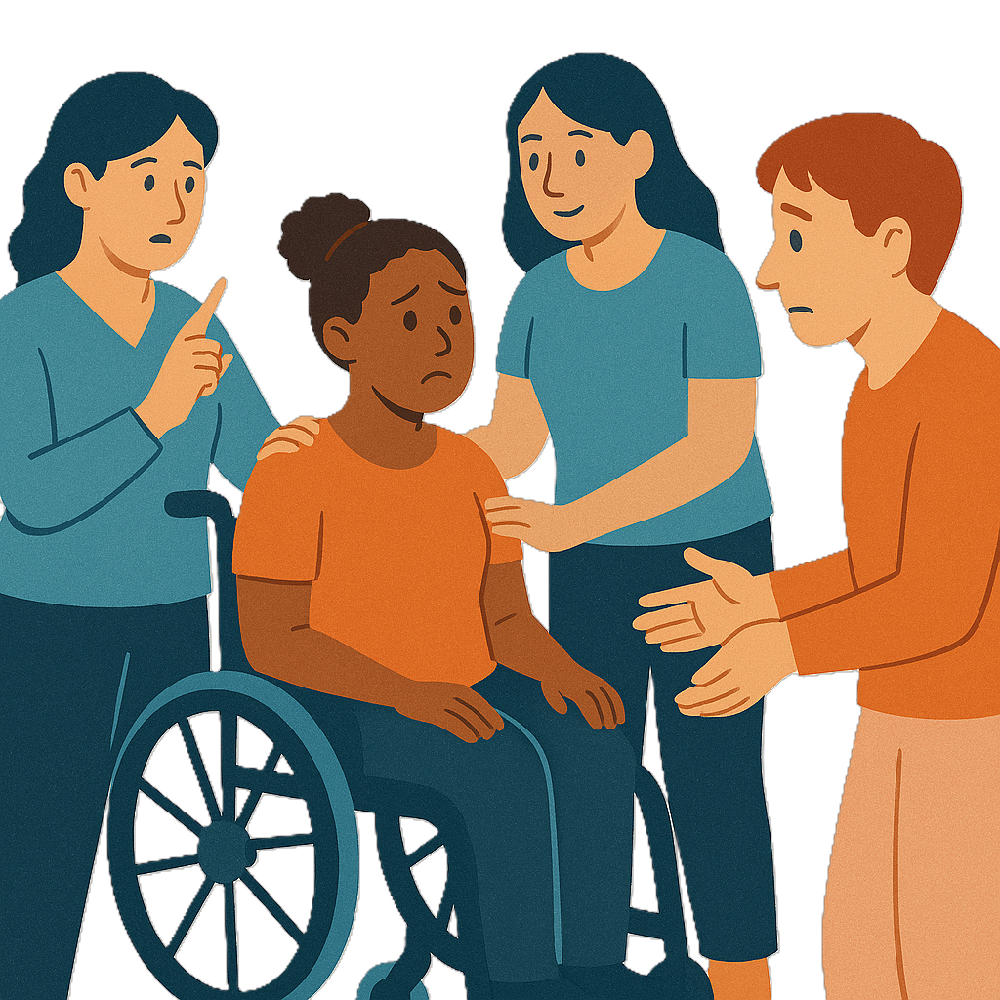 | We think IDAP should  - Support people with disability who are at risk of harm.
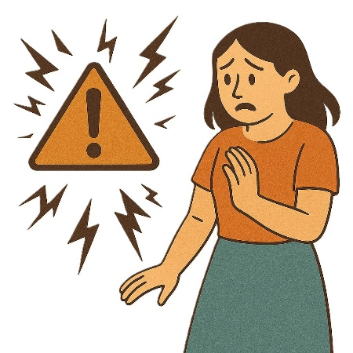 | Risks are the chance that something bad might happen to you.
This will make sure people with disability get support to

- Make their own choices
 | - Speak up for their rights.
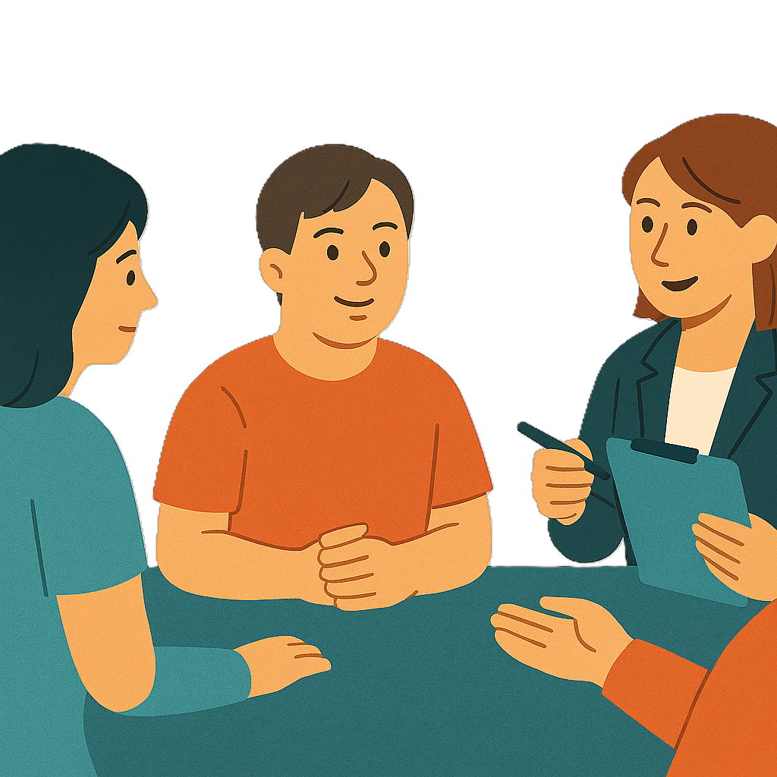 | To do this we think IDAP should  - Help people with disability and their supports to get individual disability advocacy support  They need to be able to get it when they need it.
 | - Have advocacy that is more culturally responsive
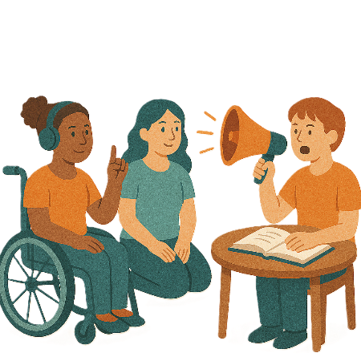 | - Help organisations build their skills  This will mean they can do more advocacy that is  - Good  - Inclusive  - Responsive.
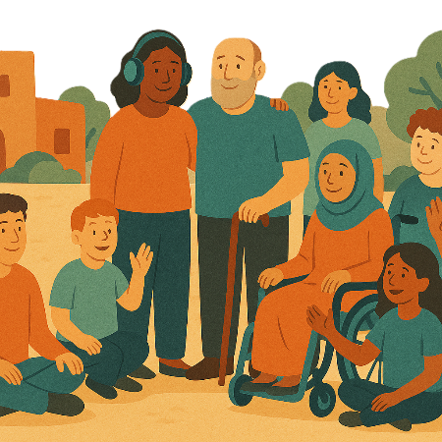 | Inclusive is when everyone  - Can take part  - Feels like they belong.
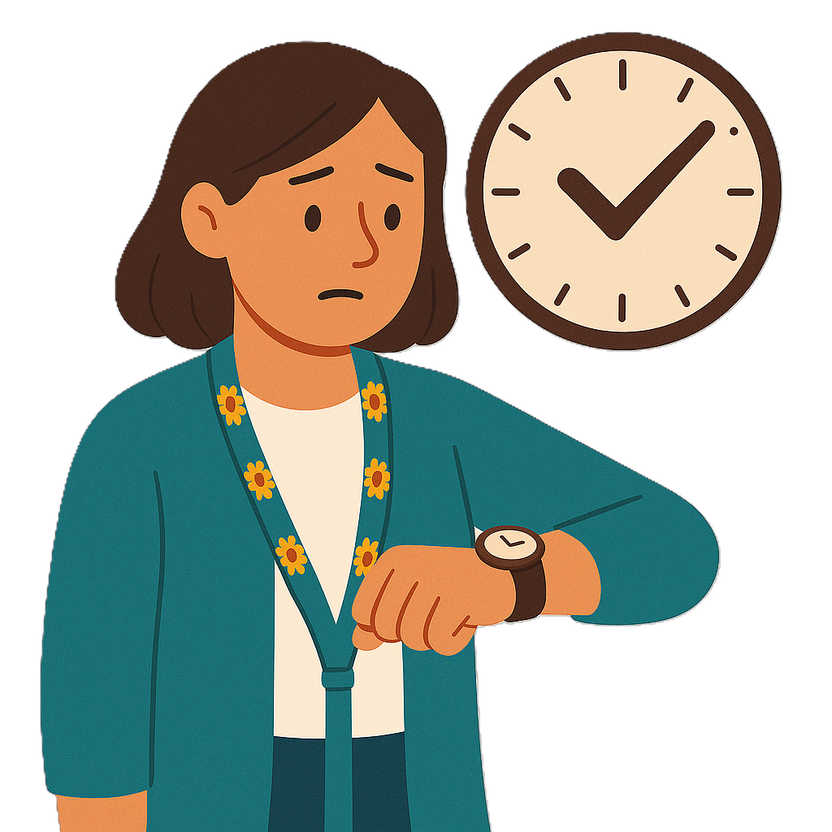 | Responsive means acting  - Quickly  - In a good way  When things need to change.
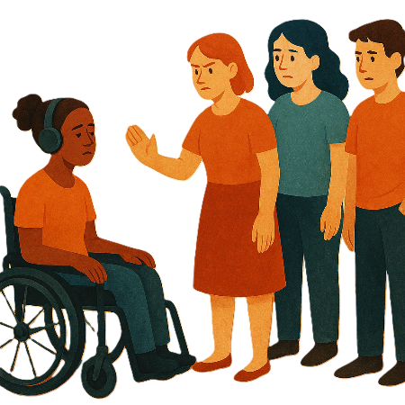 | - Supports advocacy that helps with  - Discrimination  Discrimination means treating someone unfairly because of something about them they cannot change.  Like they have a disability.
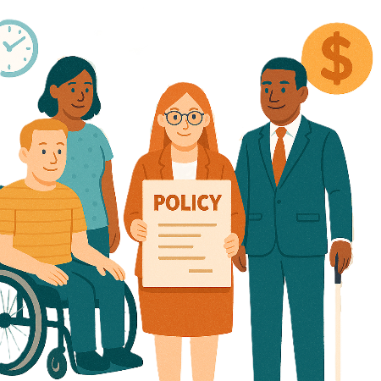 | - Making policies better  Policies are plans for how to do things.
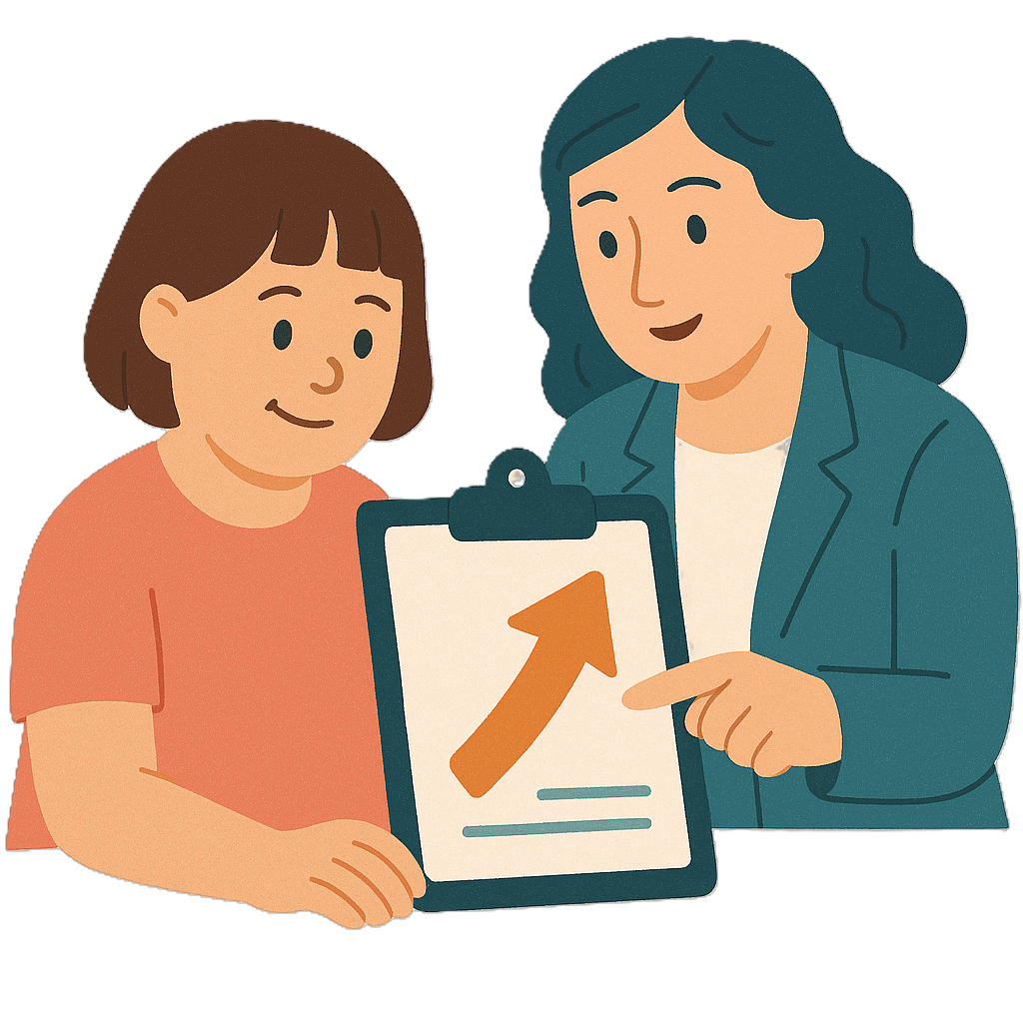 | - Making the way services do things better  This can be called improving practice.
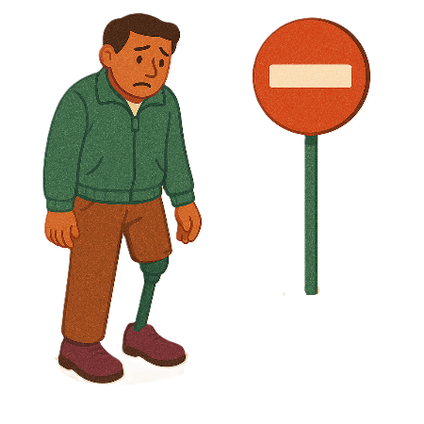 | - Having less barriers for people to be included  A barrier is something that stops you from doing what you  - Want  - Need.

Partners

 | We will work with different people to make IDAP.
 | Disability advocacy organisations will keep giving support.
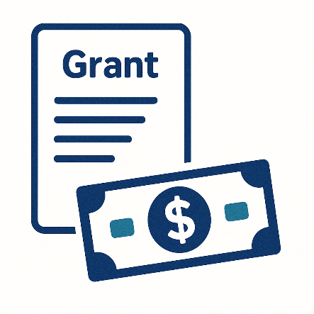 | DHDA will work with the Community Grants Hub.  Grants are when people agree to do work for the government.

Activities

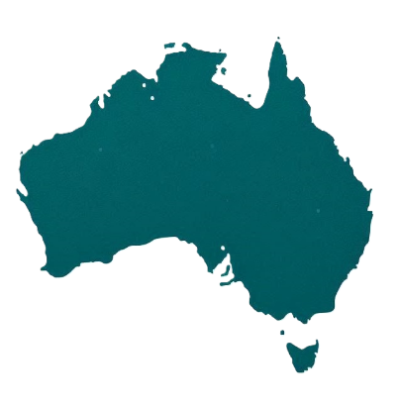 | We will need to  - Have lots of advocacy services all around Australia
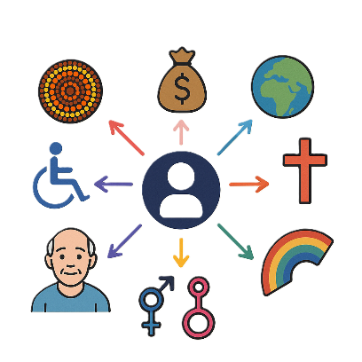 | - Support people with the different parts of who they are  This is called intersectionality.
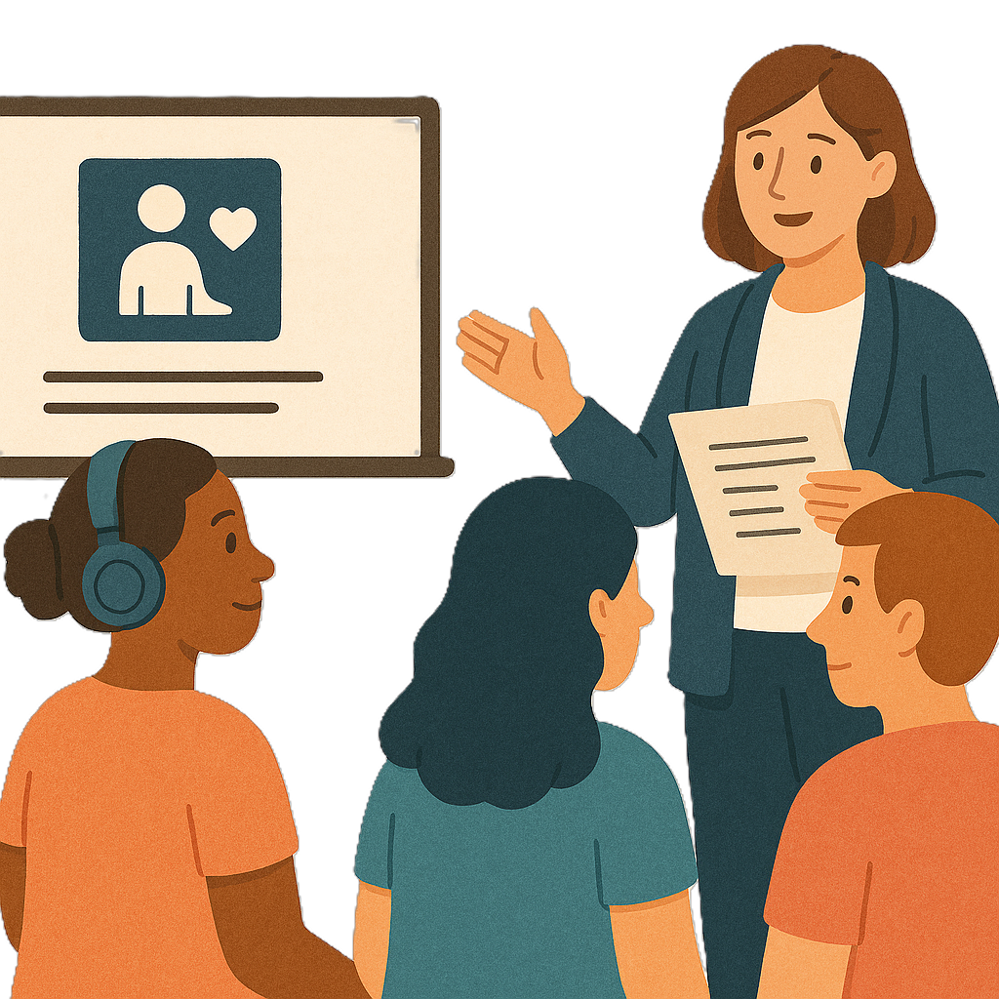 | - Have training for advocates
 | - Collect good data to check how we are going  Data is  - Facts  - Information  - Records.

Outcomes

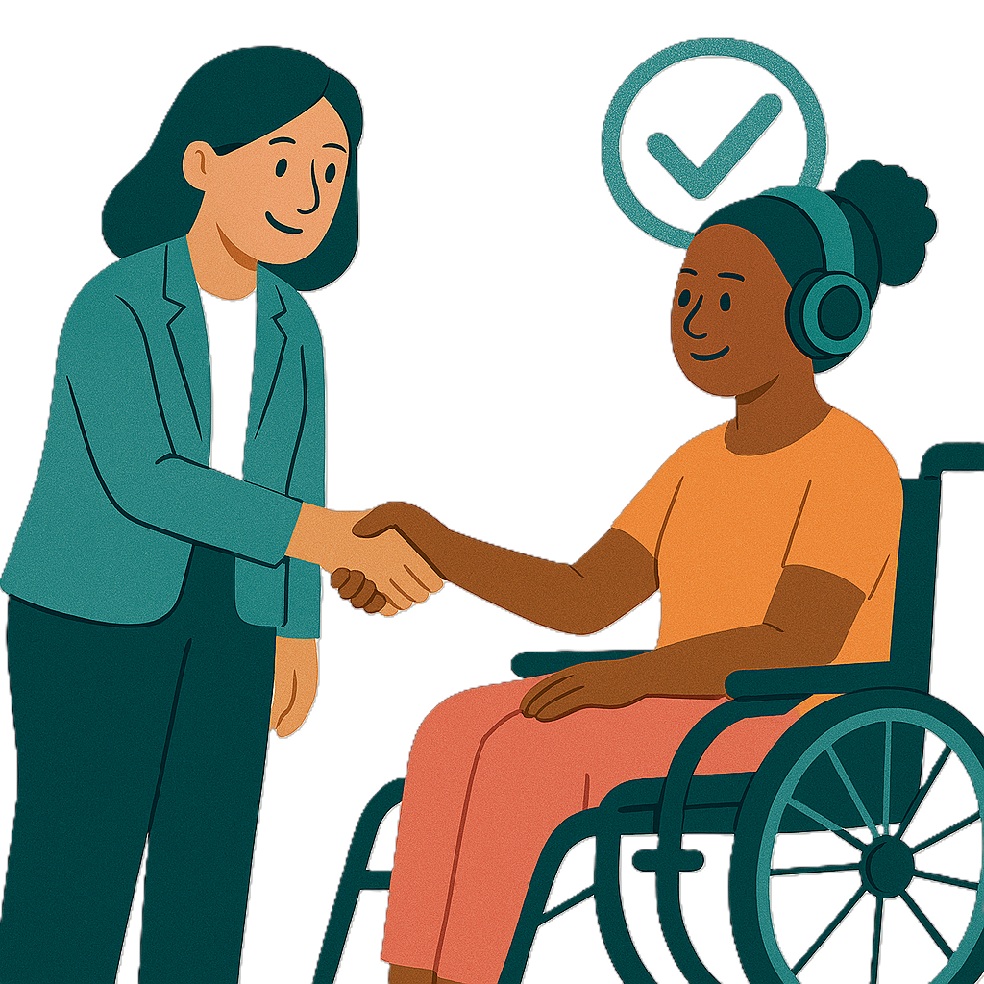 | We think we will see  - People with disability getting advocacy support more easily  They will also know more about the supports they can get.
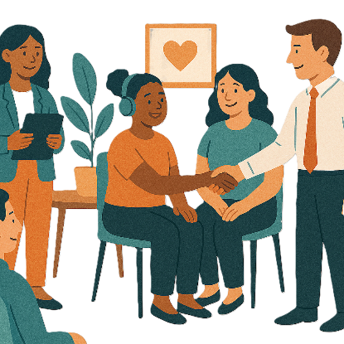 | - Advocacy organisations will be able to do a better job
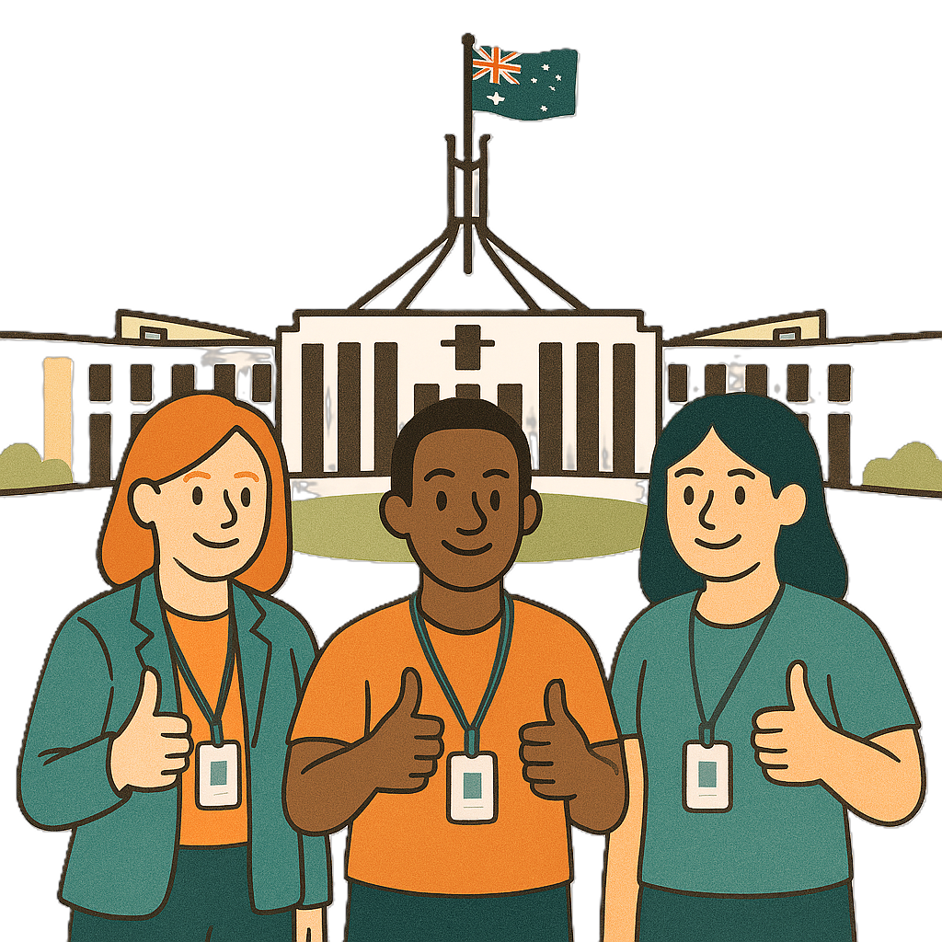 | - The government will be able to use the data to make policies better.
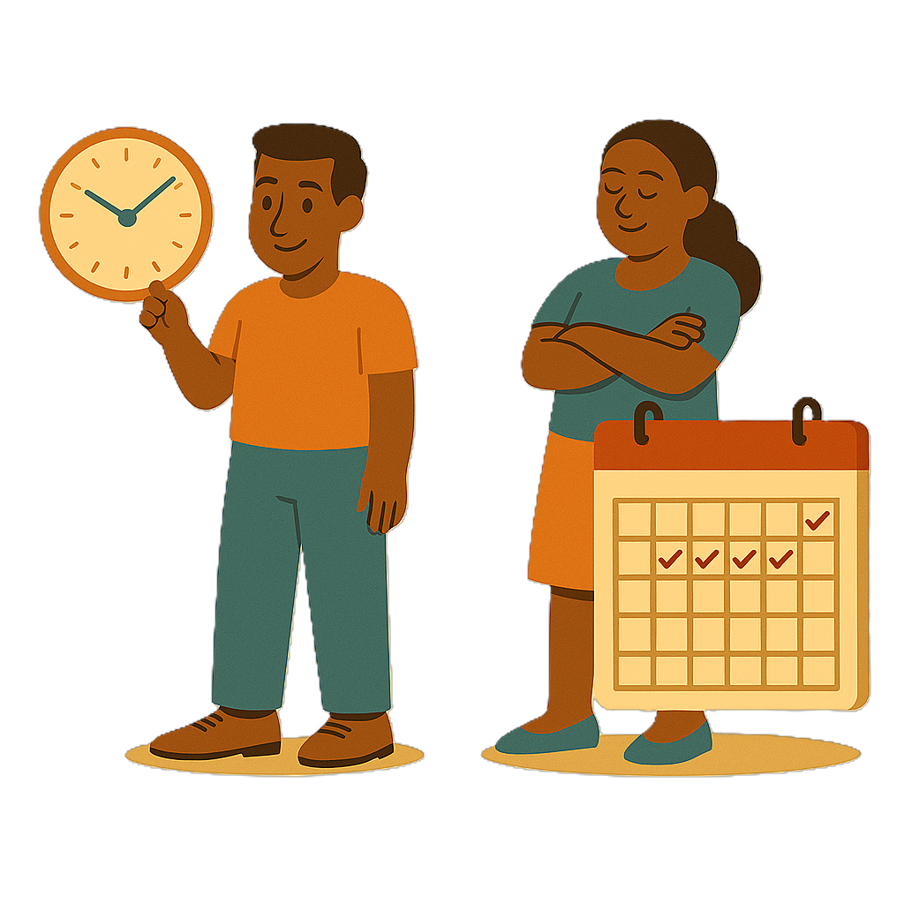 | Some outcomes will happen quickly.  Others will take longer.

How IDAP will start

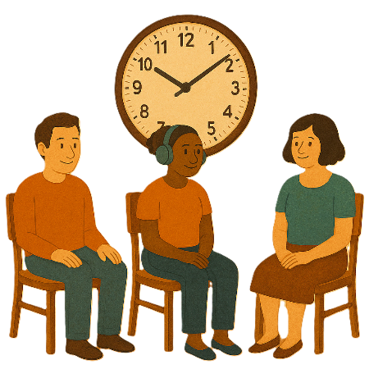 | The changes will happen over time.
We are planning carefully.

This will mean people can keep using services while we make changes.
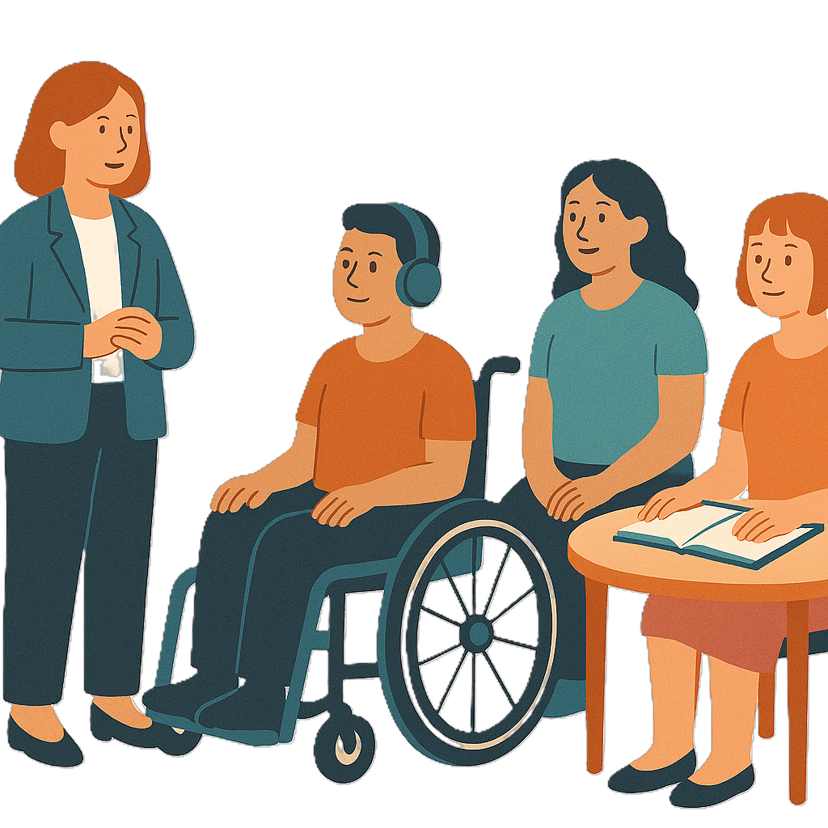 | We will give organisations time to make changes to how they  - Work
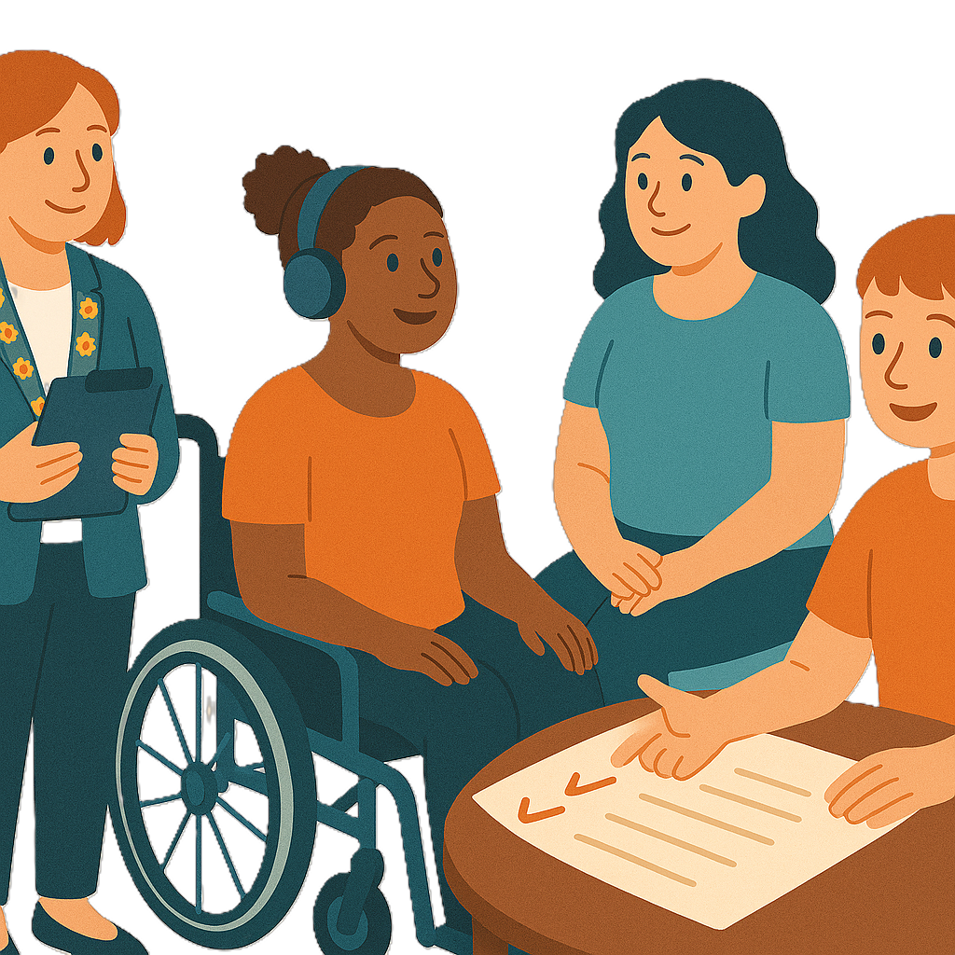 | - Help people find new advocacy services if they need.

What do you think

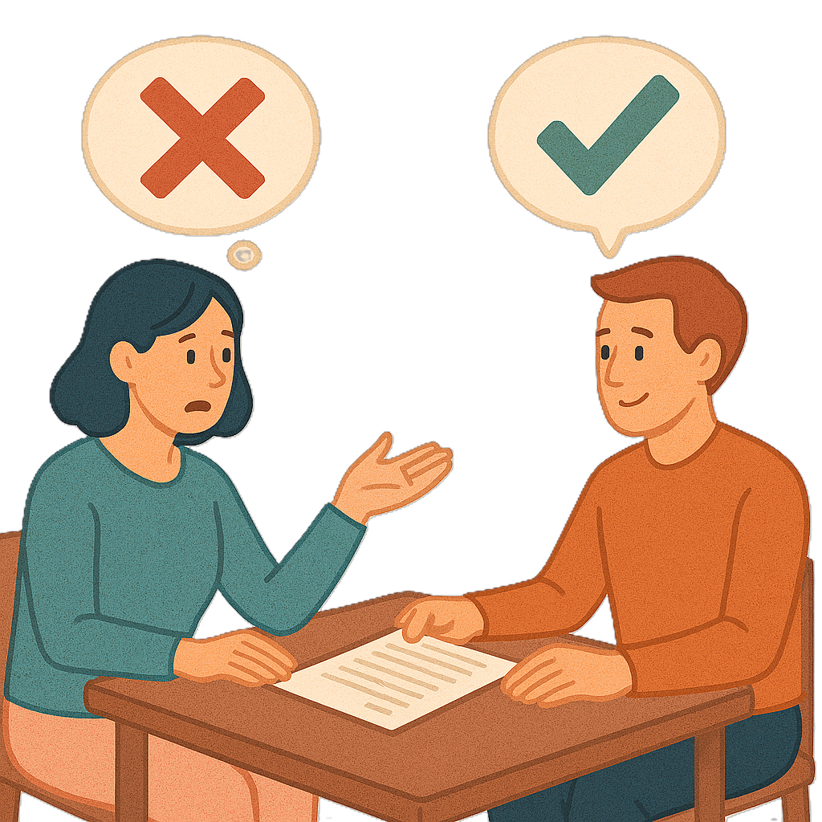 | We want to know if you  - Agree with what we have heard
 | - Think our plan will help people with disability.
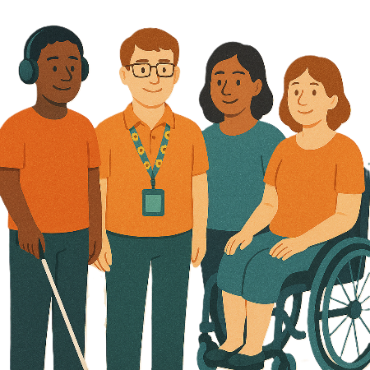 | We want to hear from  - People with disability
 | - Their families
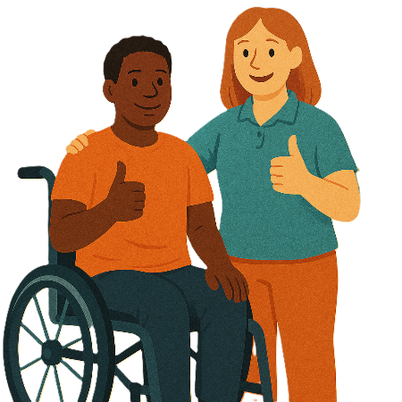 | - Carers
 | - Advocates
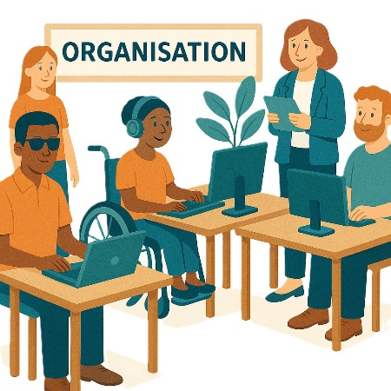 | - Disability advocacy organisations
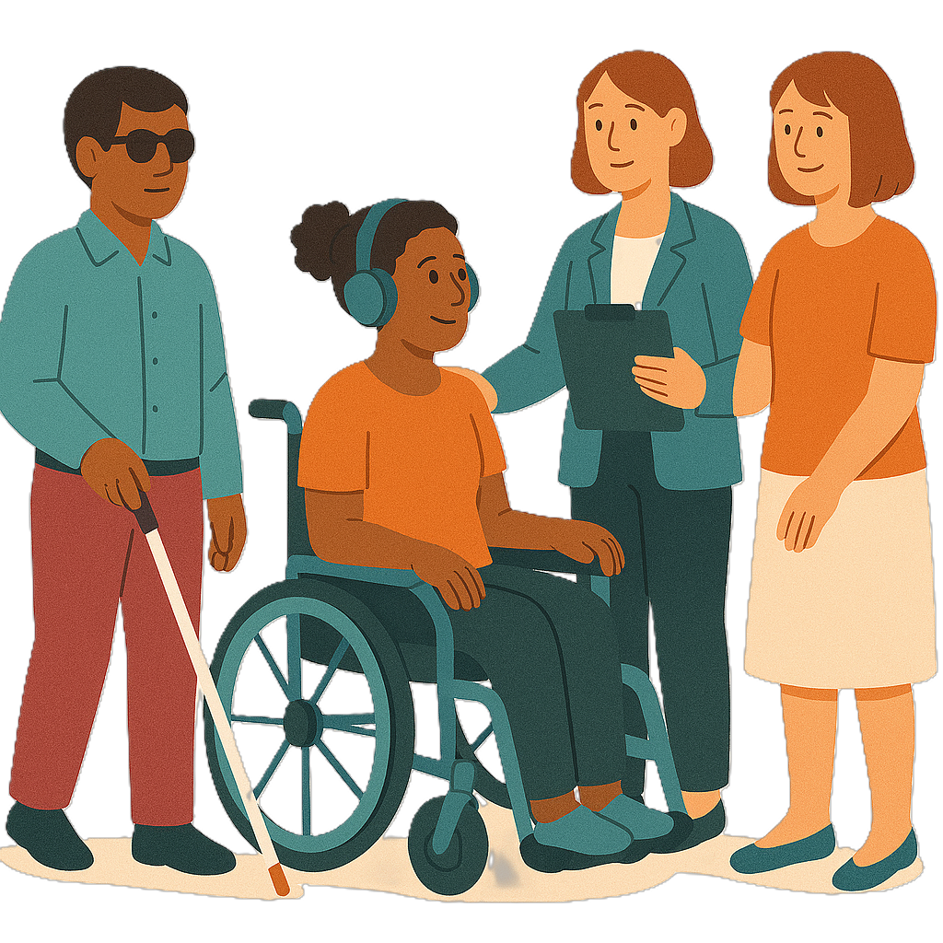 | - Disability service providers.

How to share your ideas

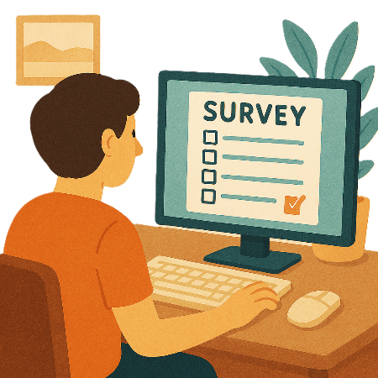 | You can take part by  - Answering questions on our website  consultations.health.gov.au/disability-and-carers-group/individual-disability-advocacy-reform  It is not in Easy Read.
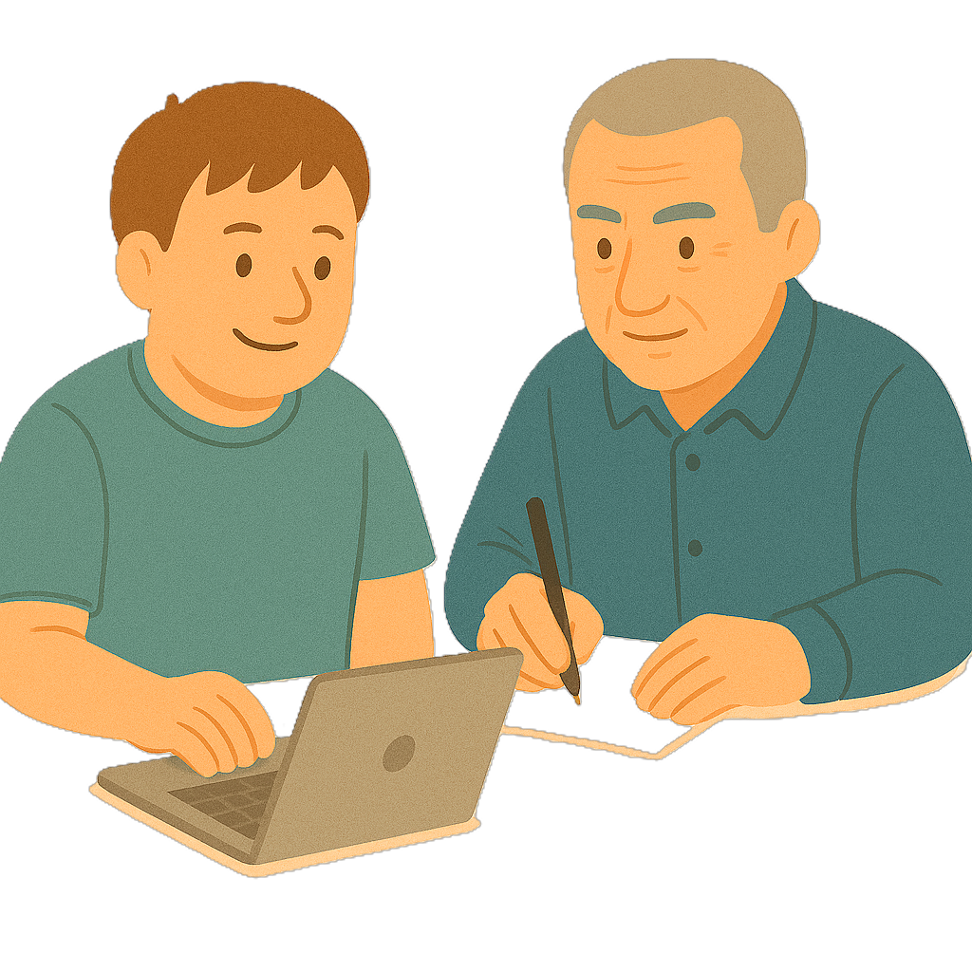 | - Sending us your answers.
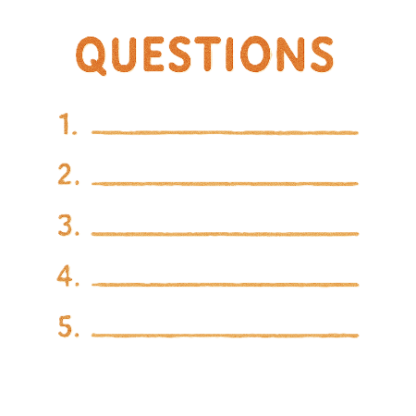 | We can send you the list of questions.  You can send us an email to ask for them.  disabilityadvocacyreforms@health.gov.au
 | You can send your answers to us by  - Email  disabilityadvocacyreforms@health.gov.au
 | - Posting a letter  Disability Advocacy and Inclusion Reforms  Advocacy and Inclusion Programs Branch  Department of Health Disability and Ageing  GPO Box 9848  Canberra ACT 2601
 | You need to send your feedback by  16 January 2026.

Images in this Easy Read must not be used or copied without permission

