Individual Disability Advocacy Program

Consultation

Final report

Part 1
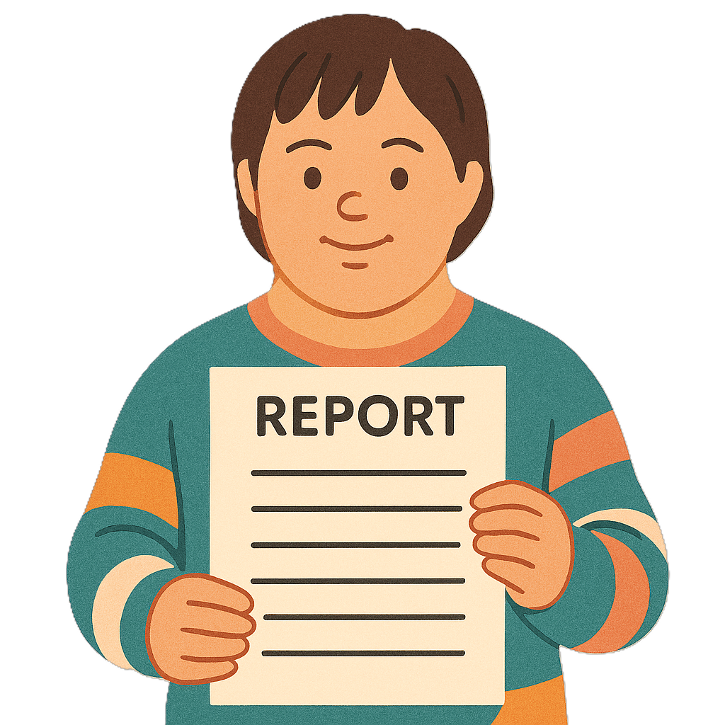
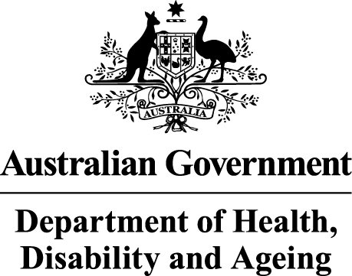 | The Australian Government Department of Health Disability and Ageing wrote this.  We say DHDA for short.  When you see the word we it means DHDA.
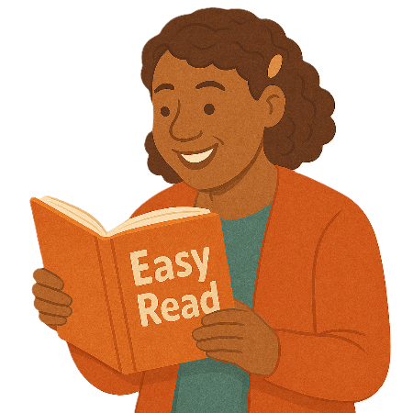 | We wrote this in an easy to read way.  We use pictures to explain some ideas.
 | We have some words in bold.  This means the letters are thicker and darker.  These are important words.
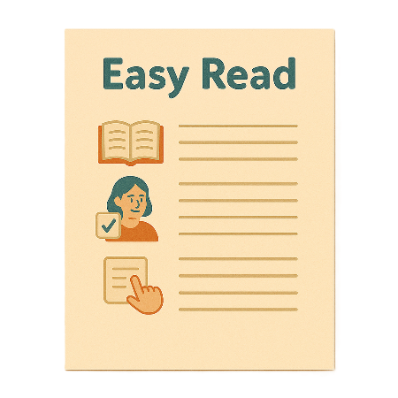 | This is an Easy Read summary of another document.  This means it has the most important ideas.
 | We can answer any questions by email.  Email us disabilityadvocacyreforms@health.gov.au
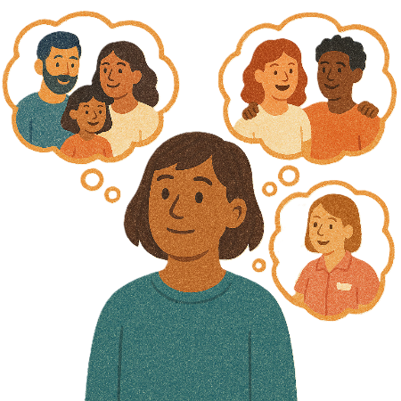 | You can ask for help to read this document.  You can ask  - A friend  - Family members  - A support person.
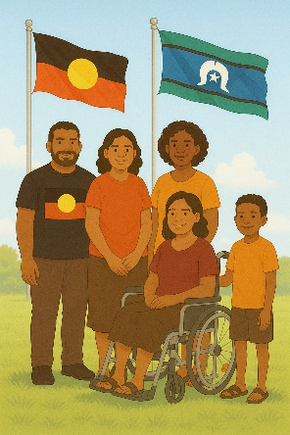 | We recognise Aboriginal and Torres Strait Islander people as the Traditional Owners of the land we live on.
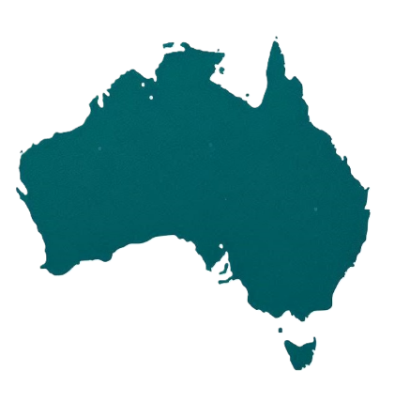 | They were the first people to live on and use the  - Land  - Waters.

Contents

About this document | 5
What is individual disability advocacy | 7
What we did | 10
Why we did it | 12
How we did it | 13
Contact us | 19

About this document

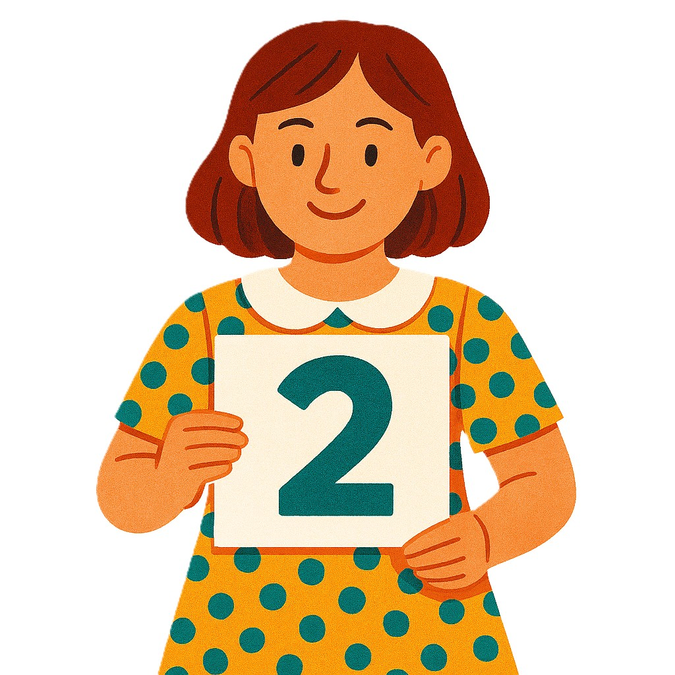 | This document is in 2 parts.
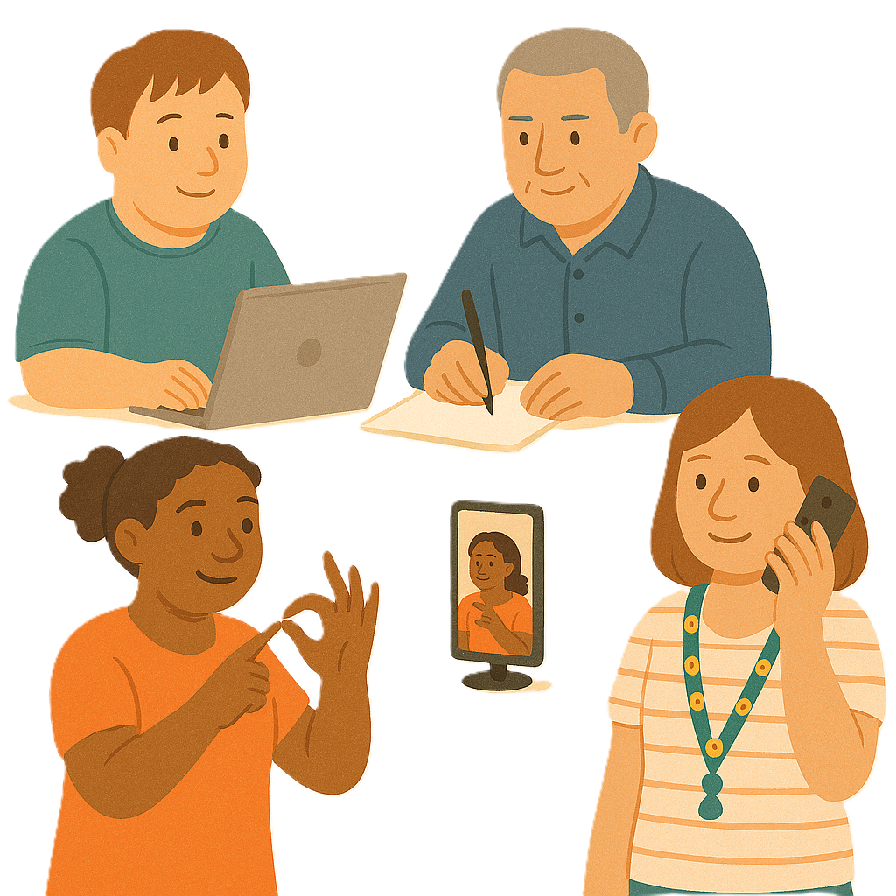 | Part 1 talks about  - Our consultation  Consultation is the governments way of working with the disability community.  It makes sure that the government is listening to communities.  This helps the government make better plans to support people with disability.
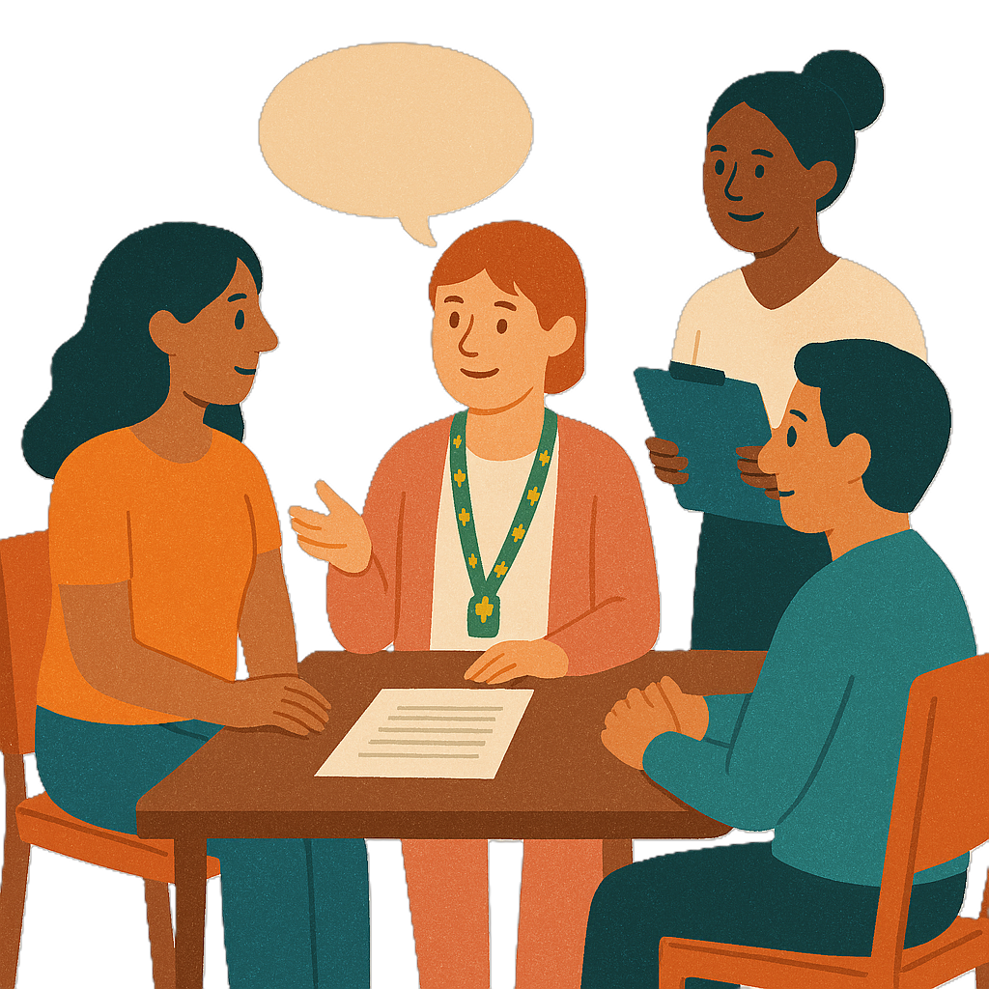 | Part 2 talks about  - What people said.
 | You can read the other part on our website.  consultations.health.gov.au/disability-and-carers-group/individual-disability-advocacy-reform/
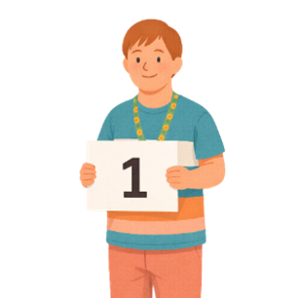 | This is part 1.

What is individual disability advocacy

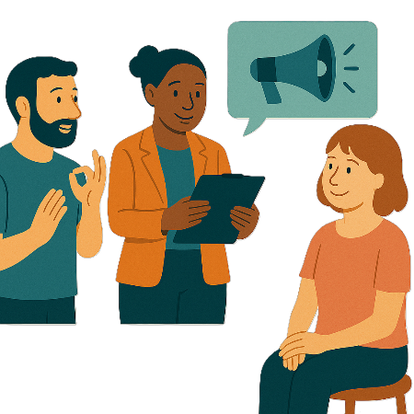 | The Australian Government is making a new individual disability advocacy program.  We call it IDAP for short.
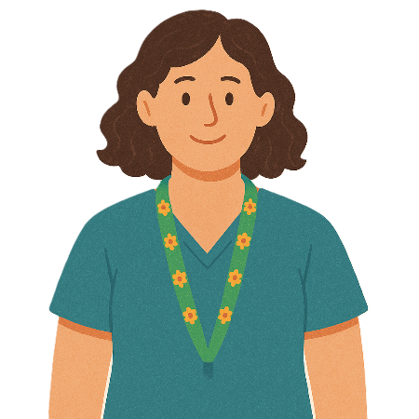 | Individual means 1 person.
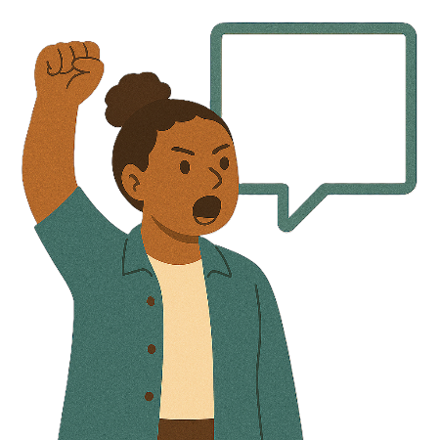 | Advocacy is when someone supports you to speak up for your rights.
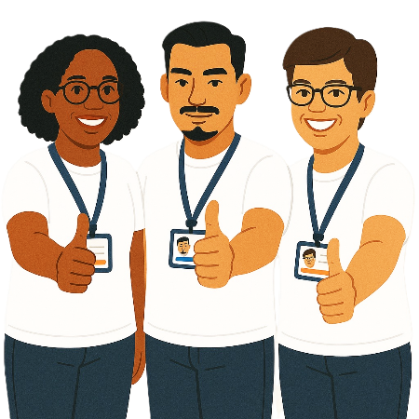 | Rights are rules about treating everyone  - Fair  - Equal.
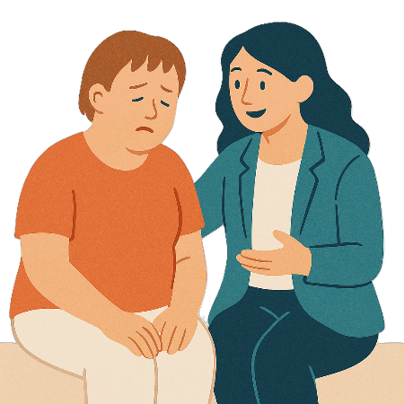 | Individual disability advocacy is when a person gets support to fix  - When they have been treated unfairly
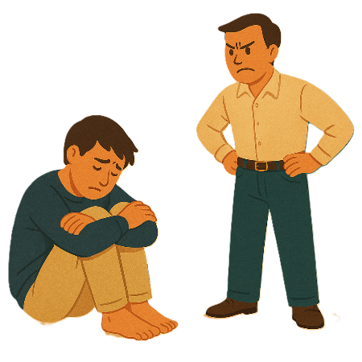 | - Abuse  Abuse is when someone treats you badly.
You can get support from

- An expert advocate

Expert is knowing a lot about something.
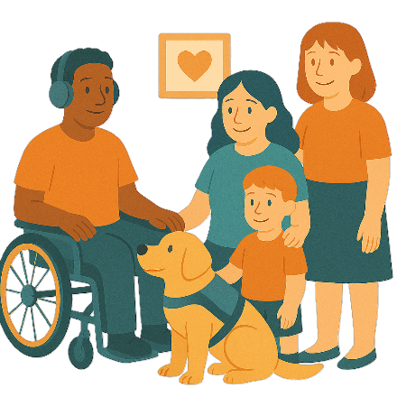 | - Family member
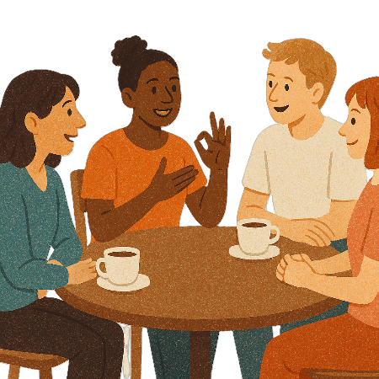 | - Friend
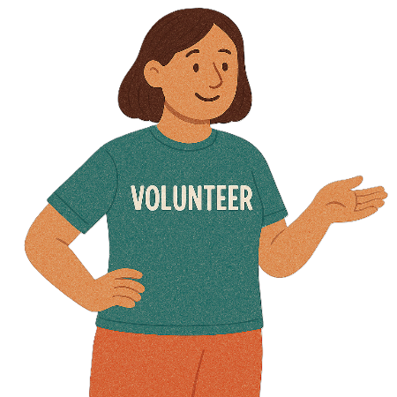 | - Volunteer from an advocacy organisation  Volunteers help someone but do not get paid.

What we did

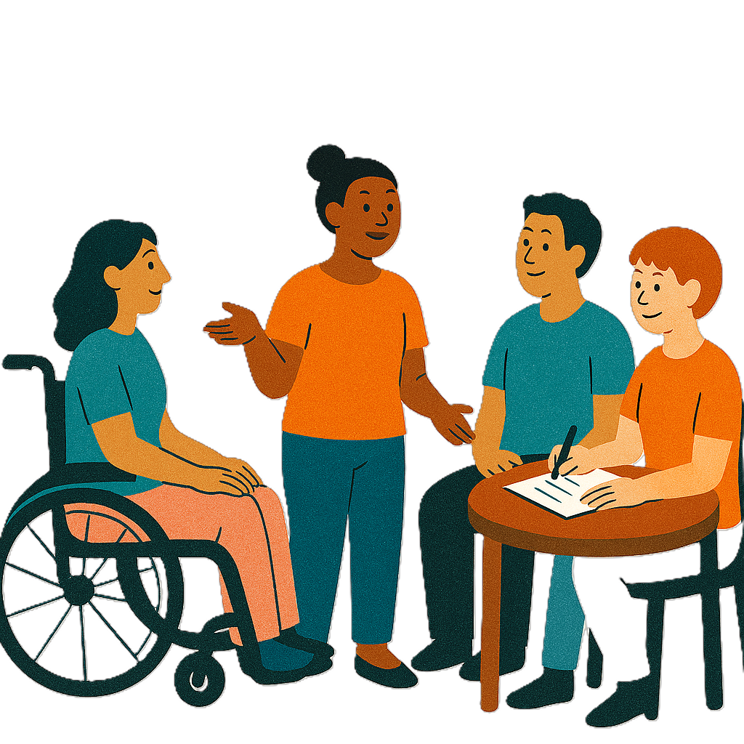 | We did a consultation on IDAP.  IDAP will replace some of the old programs.  Replace means change 1 thing for another.
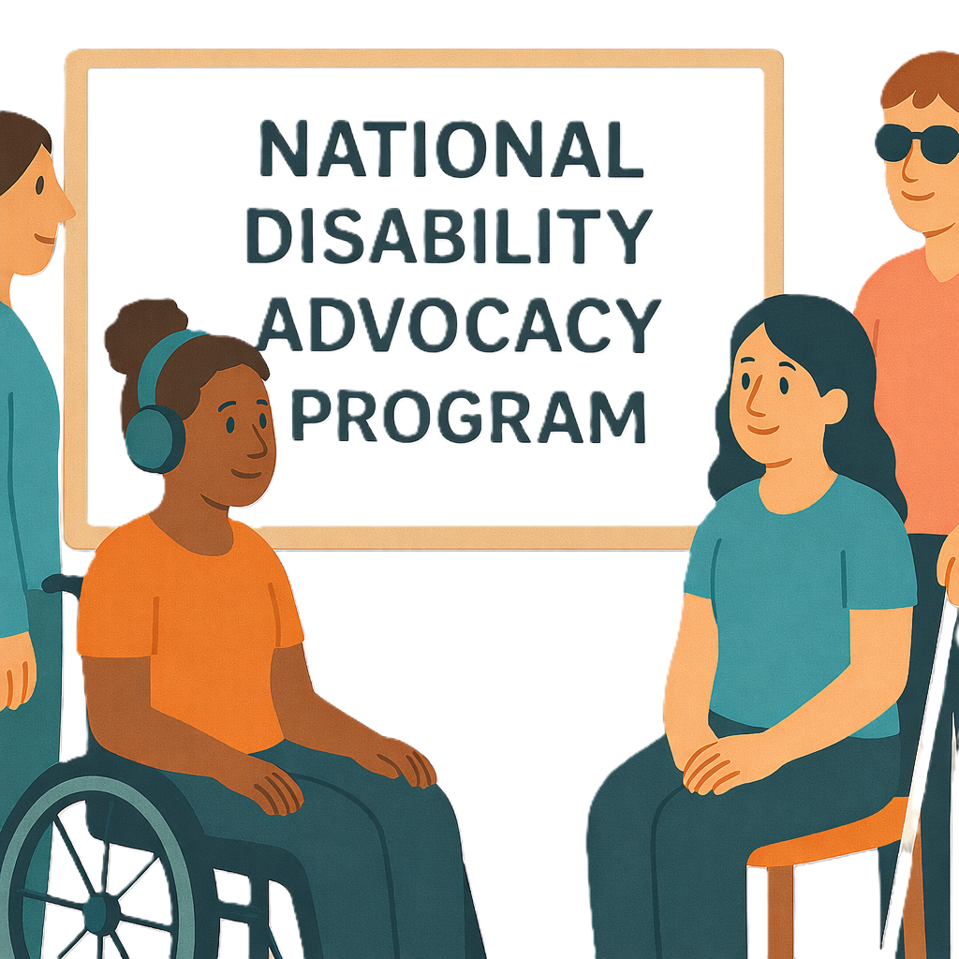 | The old programs IDAP will replace are  - National Disability Advocacy Program
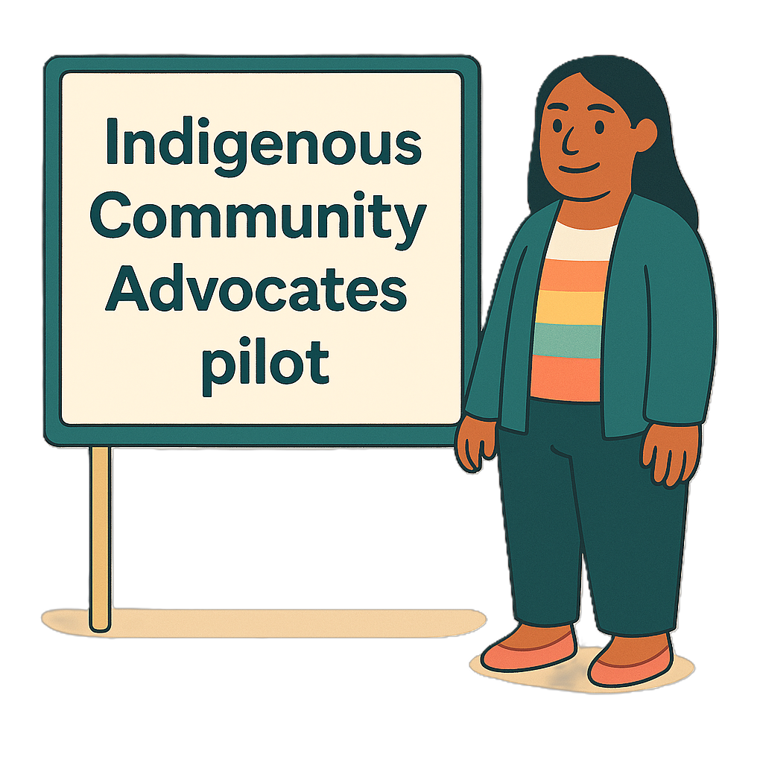 | - Indigenous Community Advocates Pilot
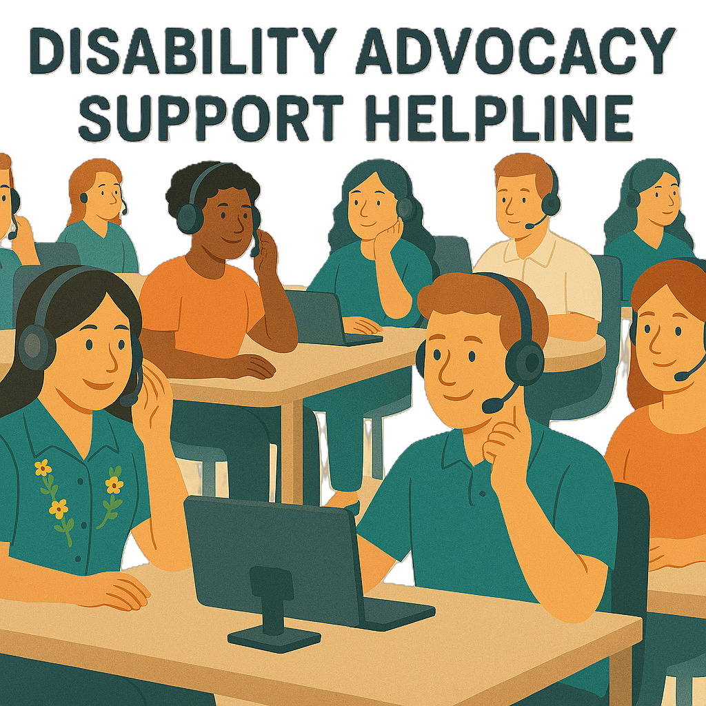 | - Disability Advocacy Support Helpline
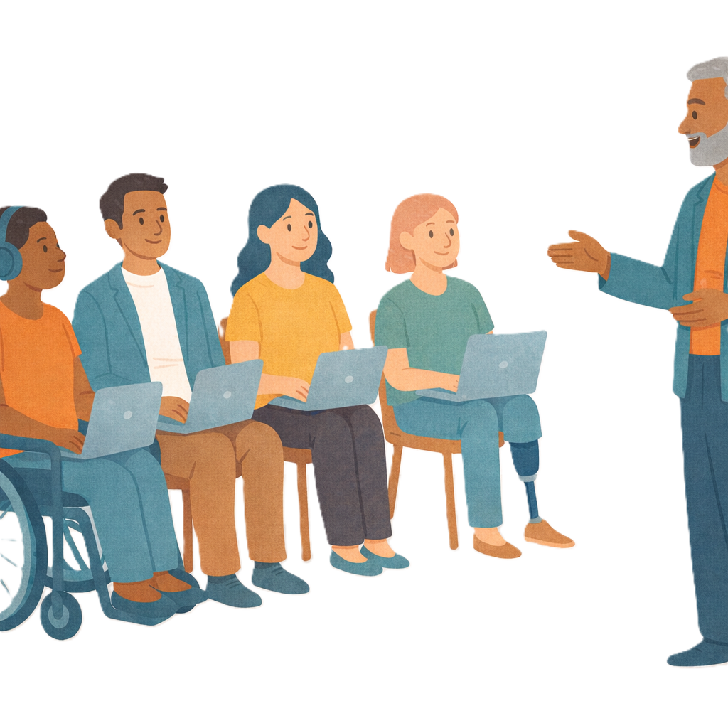 | - National Centre for Disability Advocacy.
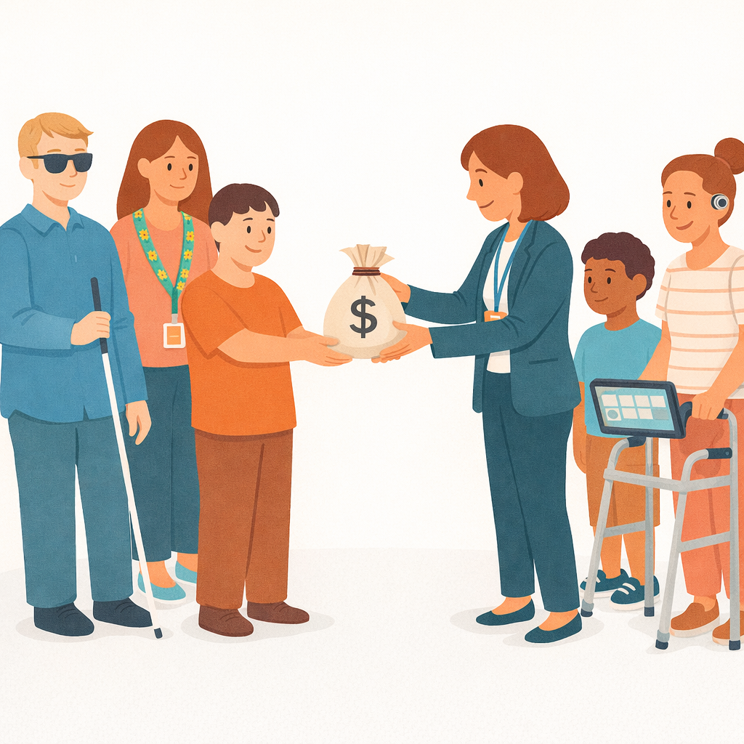 | IDAP will help how advocacy organisations get money.  This will make it easier for them to support people with disability.

Why we did it

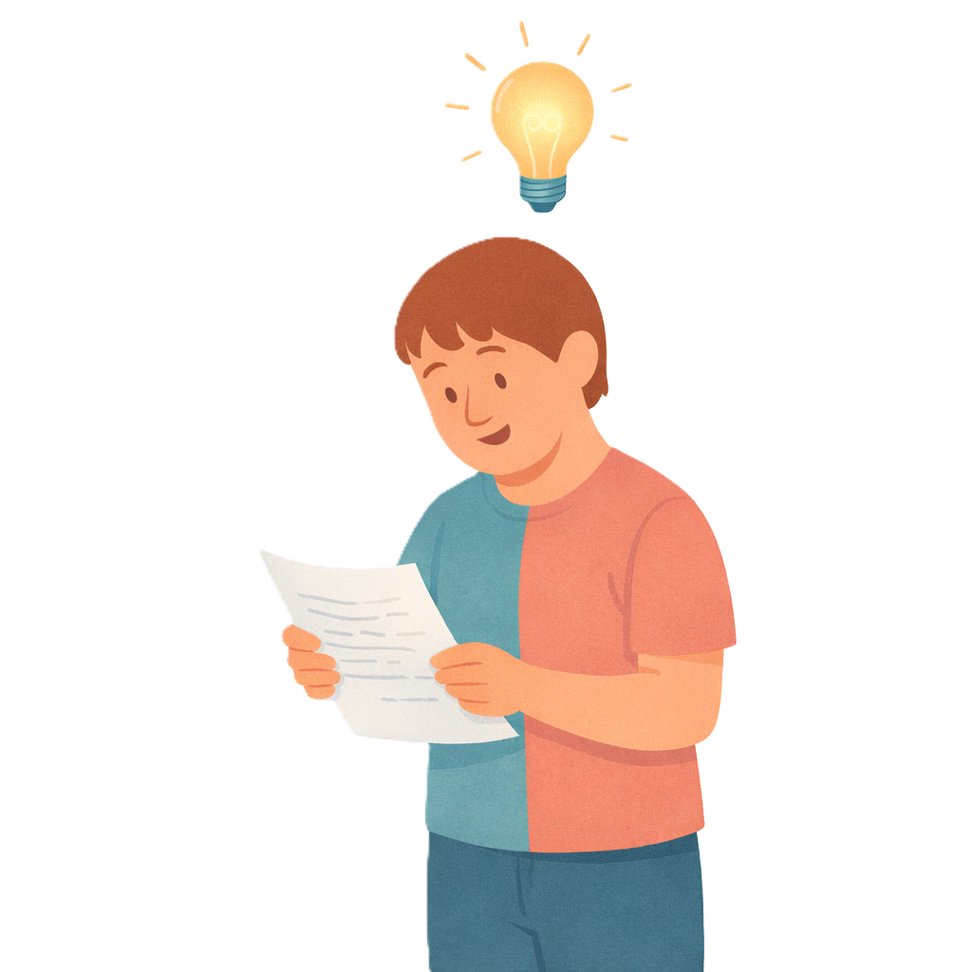 | We did a consultation so we could  - Test our ideas
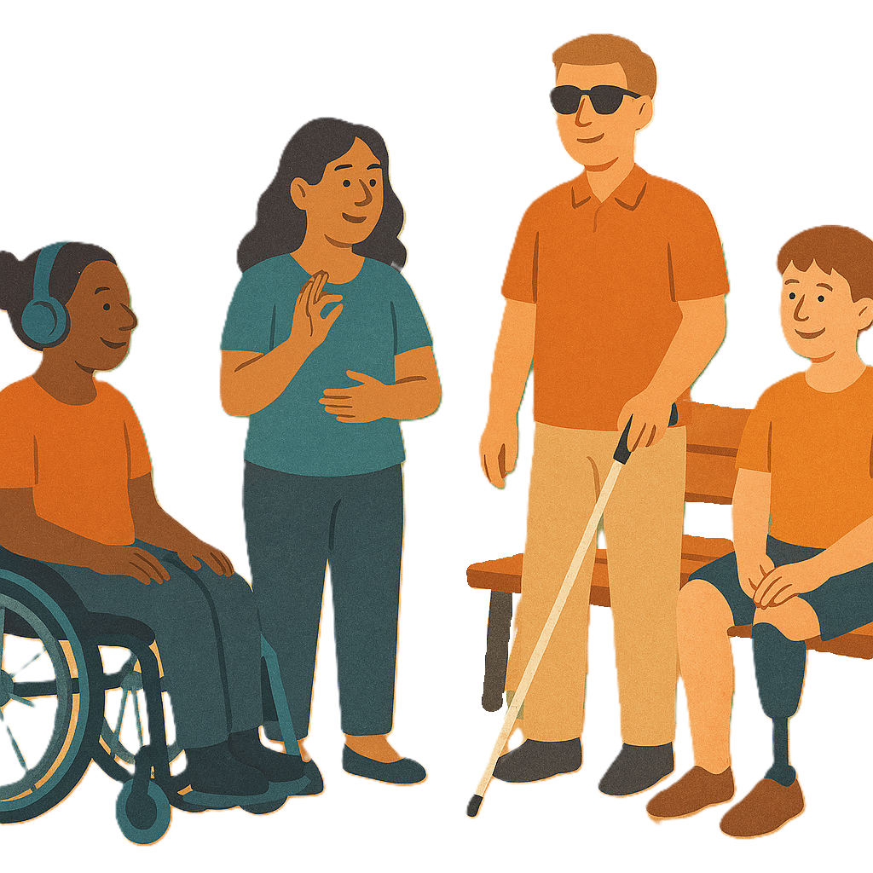 | - Hear about the experiences of people with disability
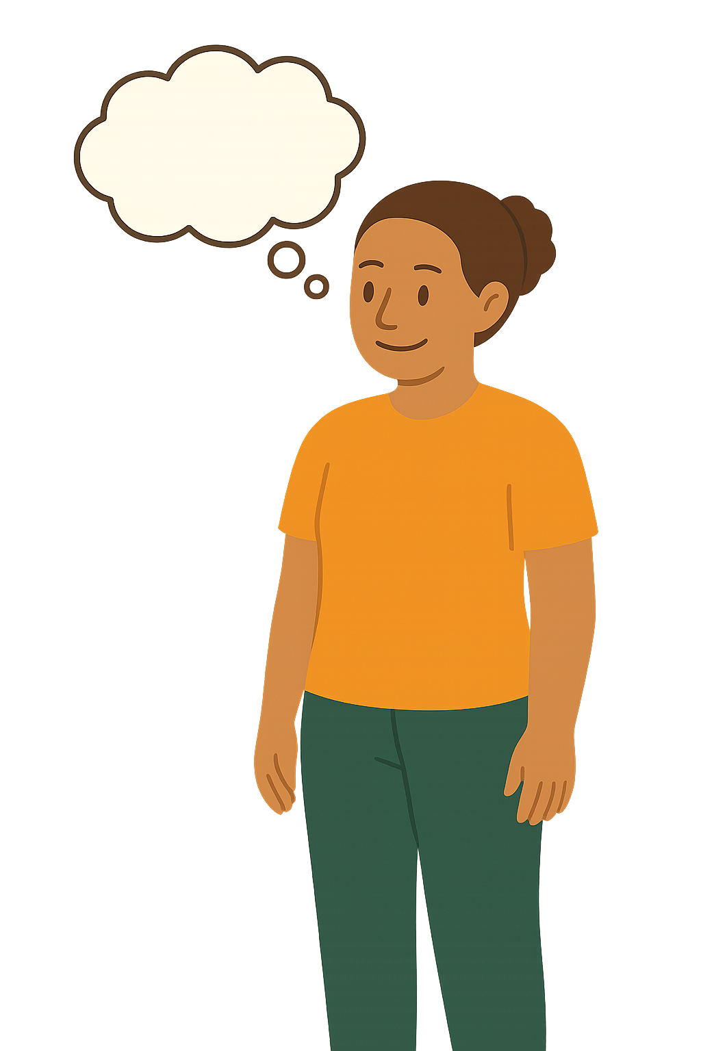 | - To find out what is important.
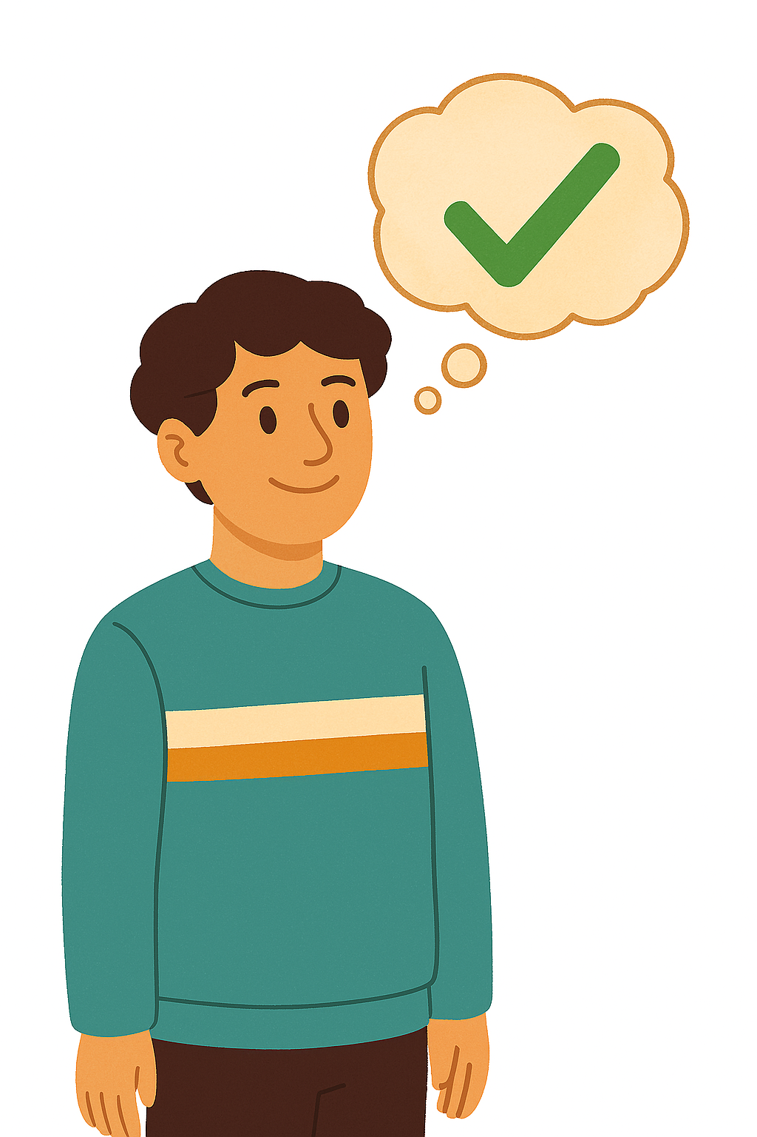 | This helps make sure we get IDAP right.

How we did it

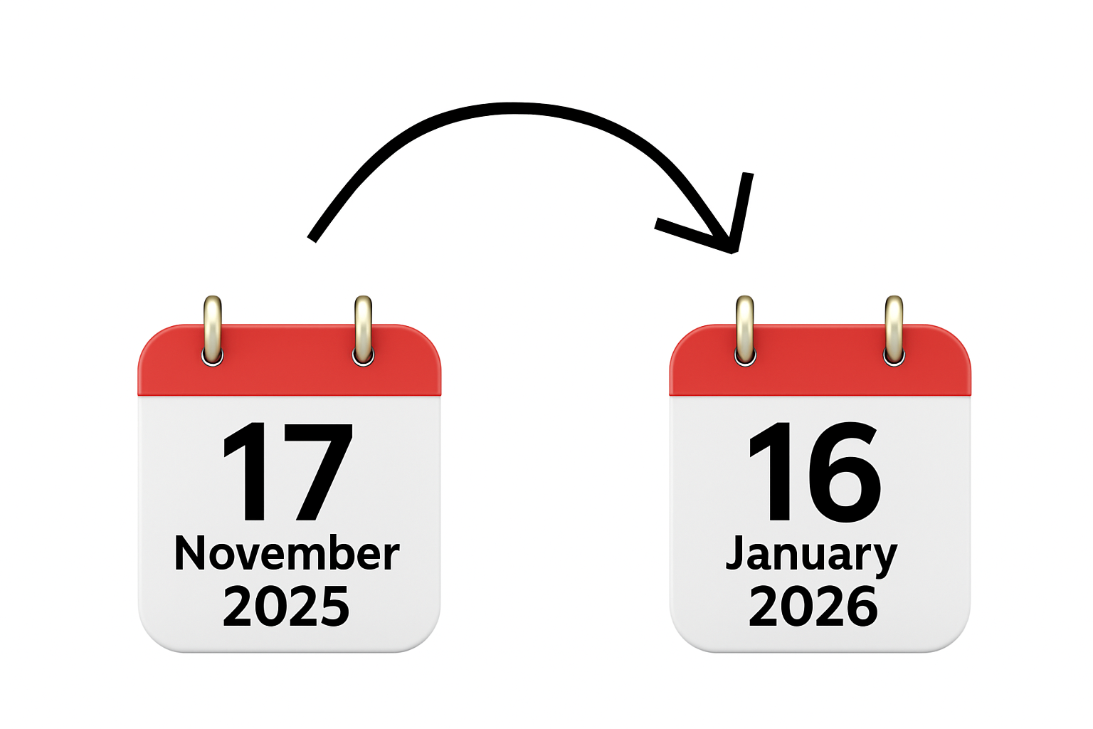 | Our consultation was open between  - 17 November 2025  - 16 January 2026.
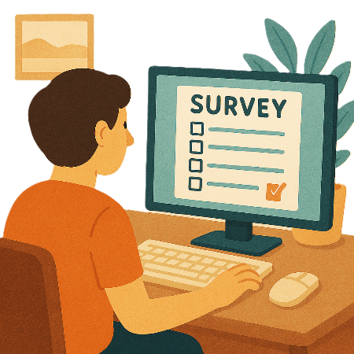 | People could share their ideas by  - Doing a survey online  Surveys have questions about your ideas.
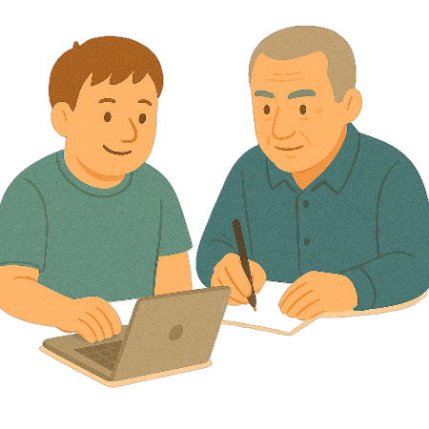 | - Sending their answers in  - An email  - A letter
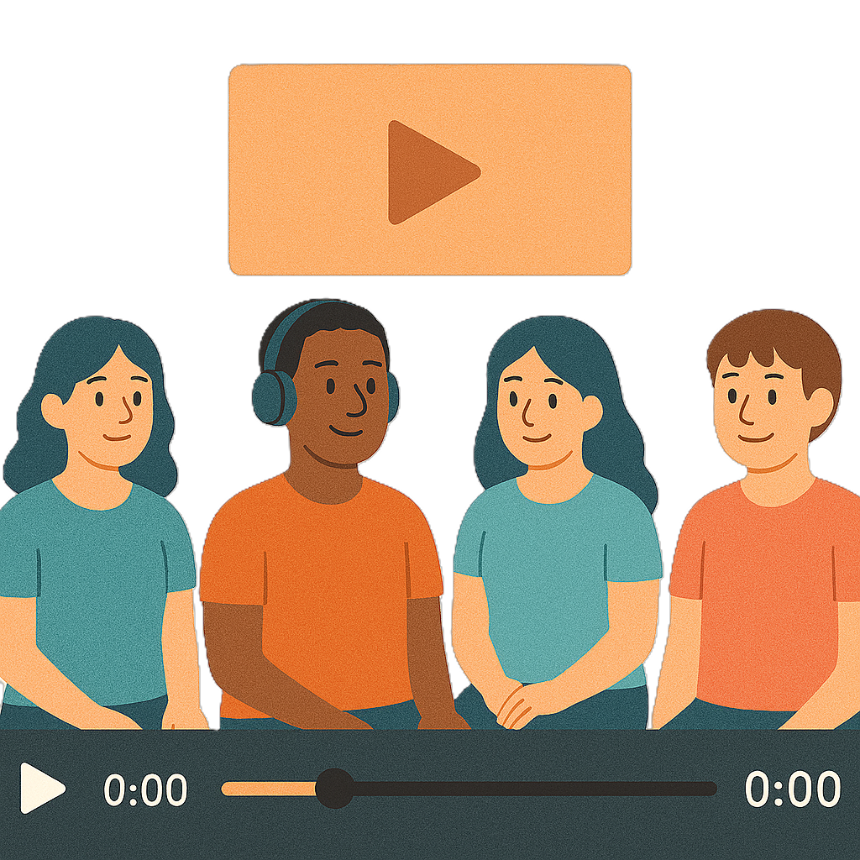 | - Making a video of their ideas
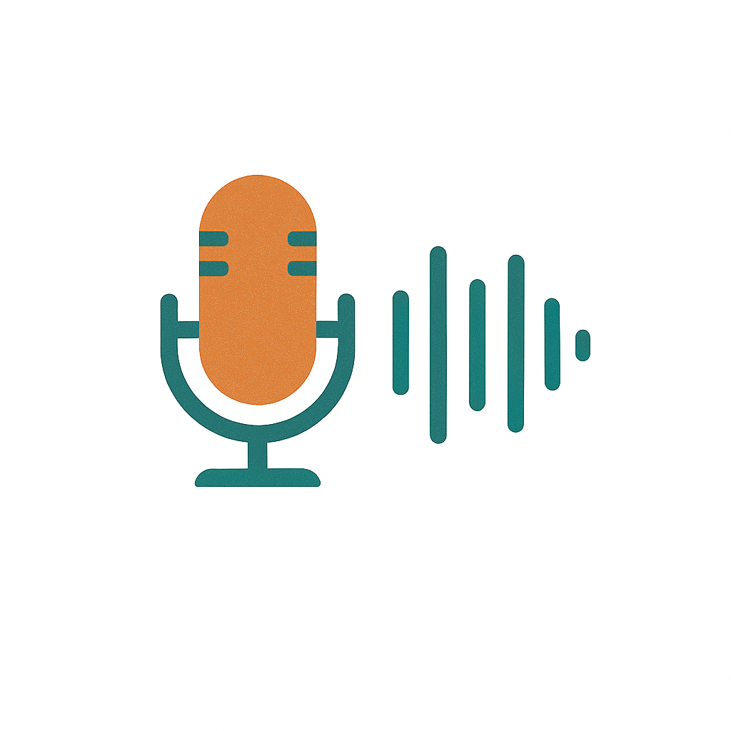 | - Making an audio file  An audio file is speaking only.
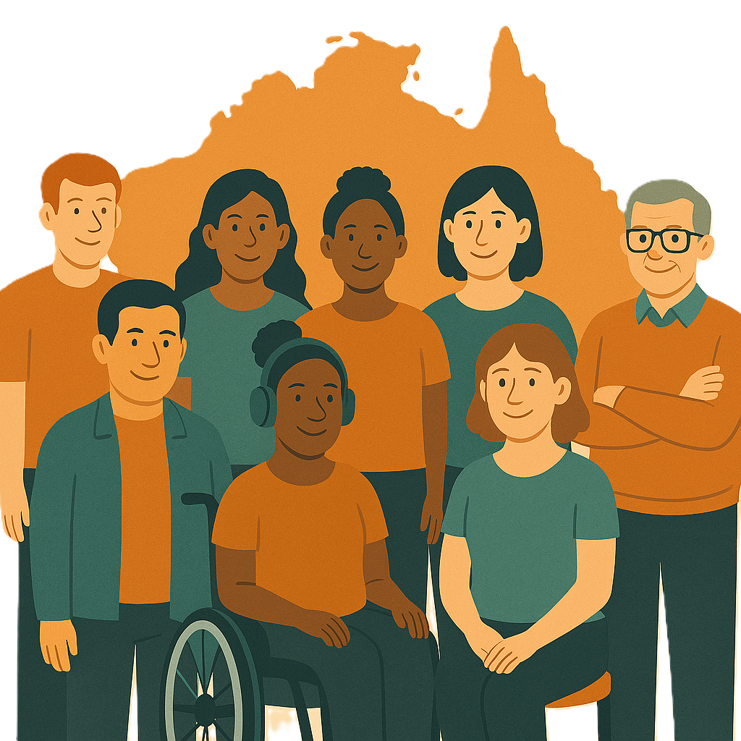 | Lots of people shared their ideas.  Like
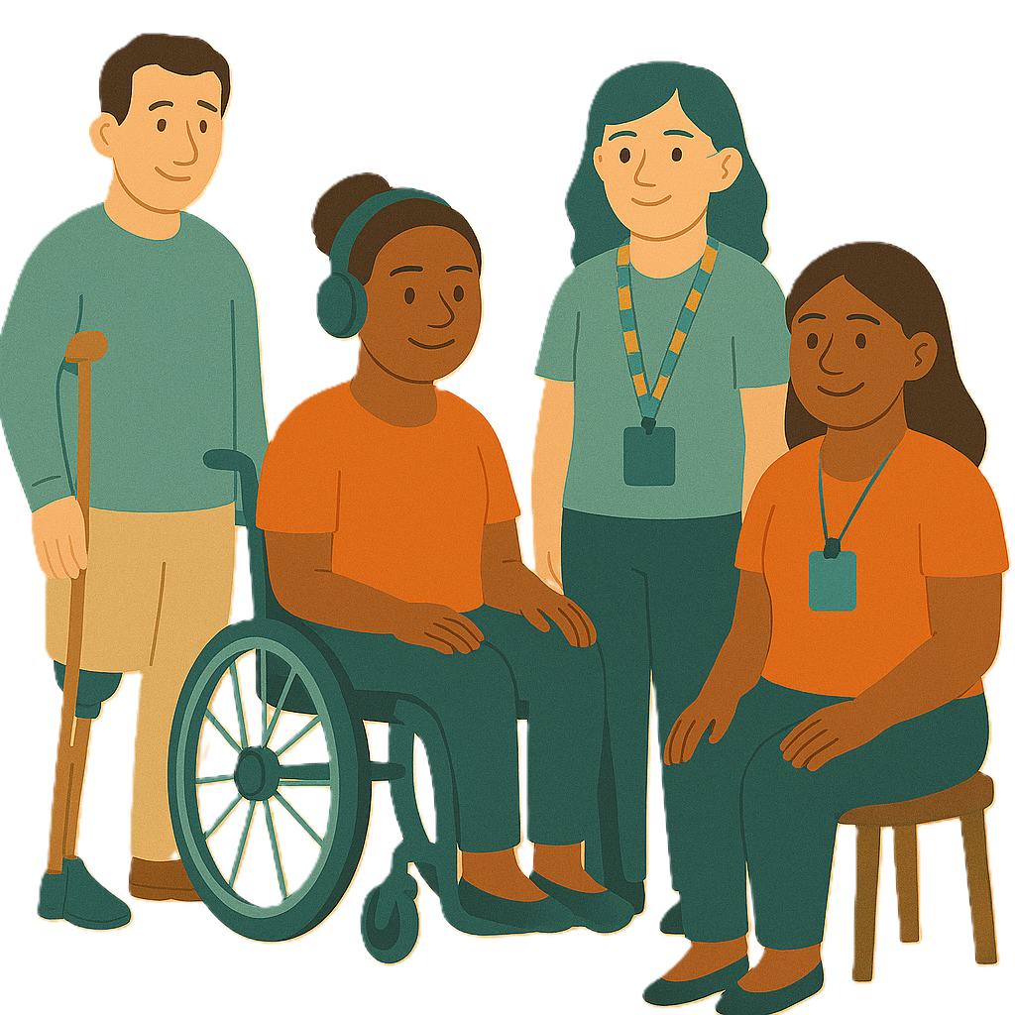 | - People with disability
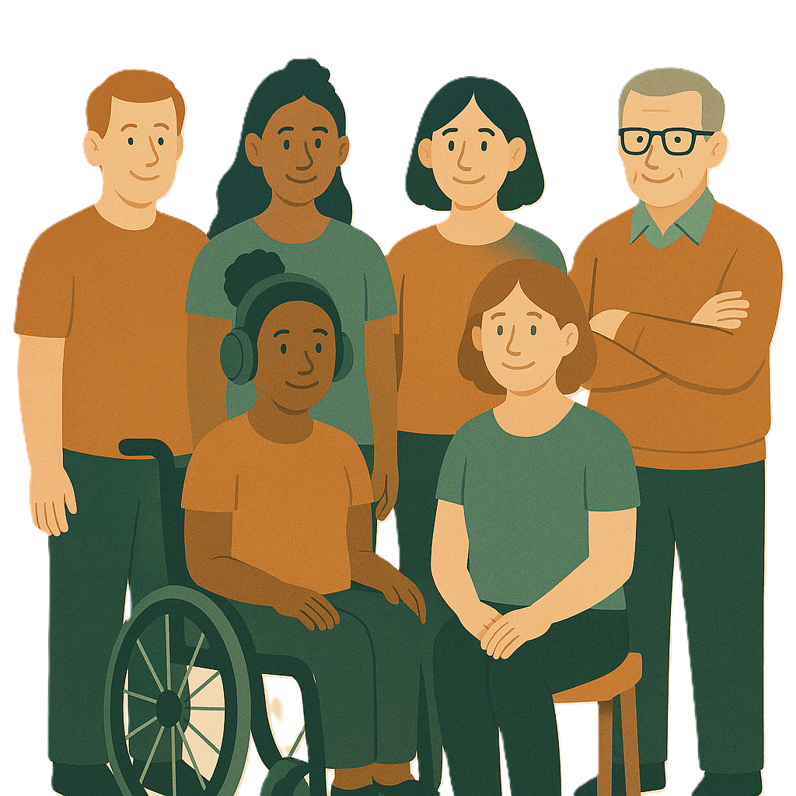 | - Families
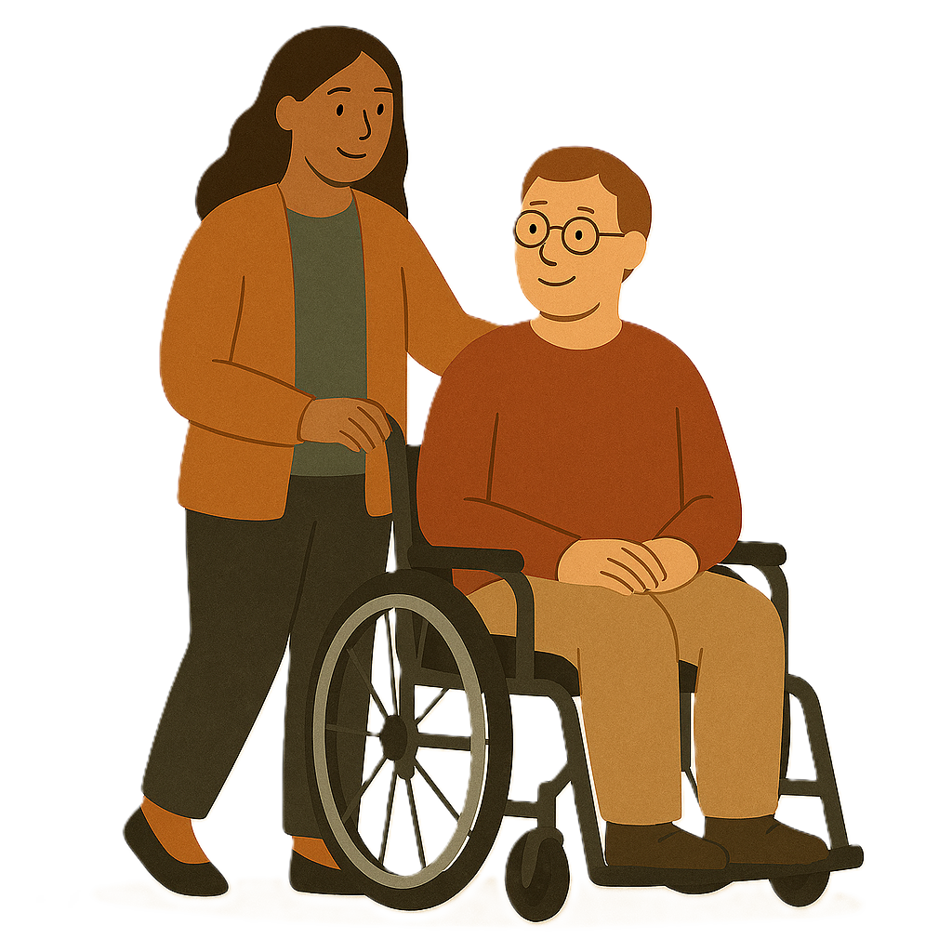 | - Carers
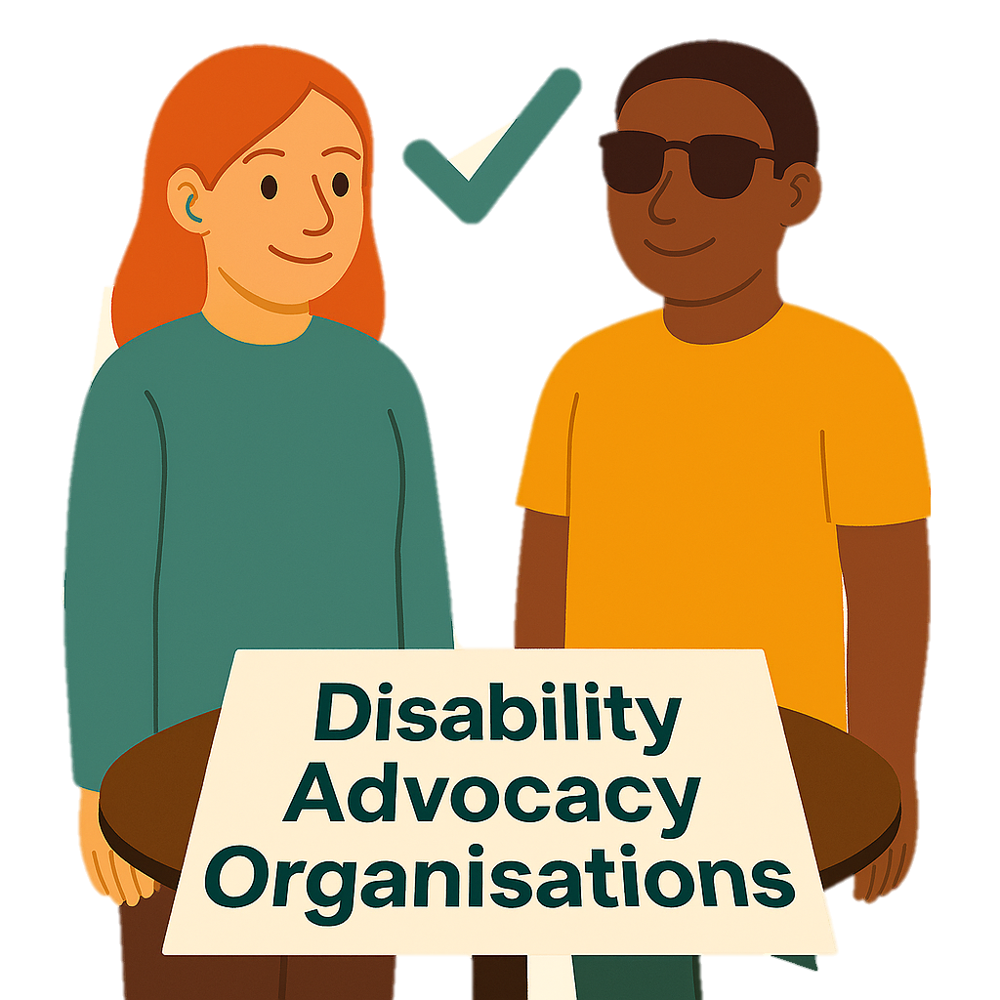 | - Disability advocacy organisations
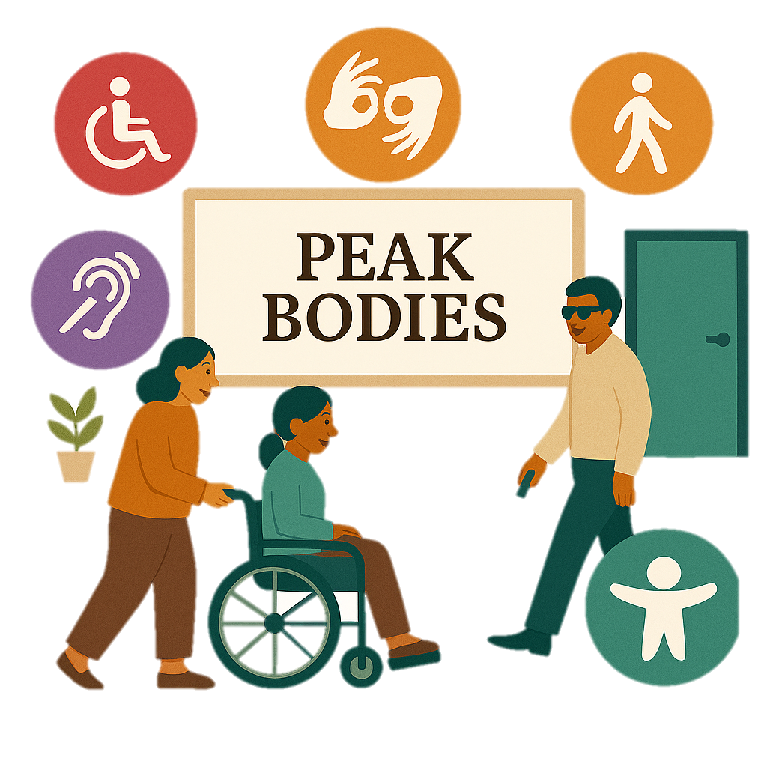 | - Organisations that do not work for the government  They can be called peak bodies.
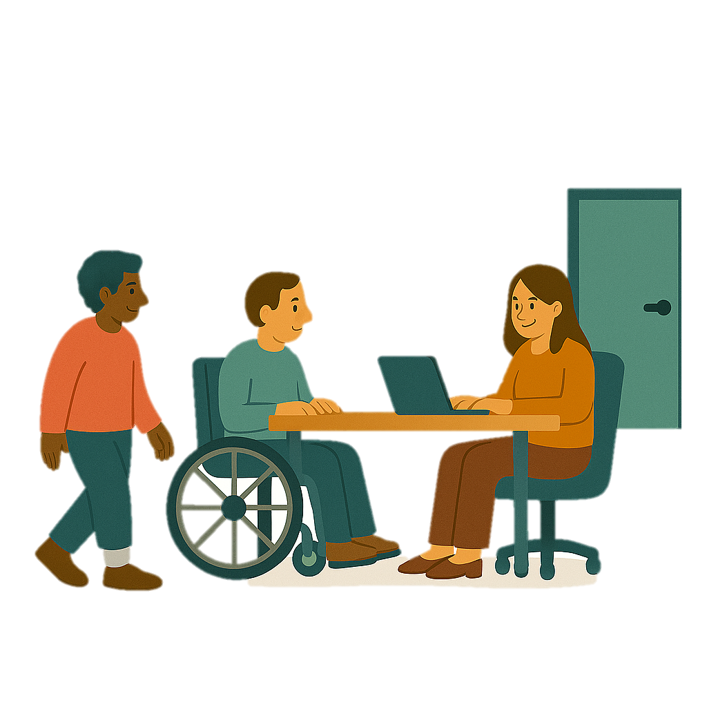 | - Community organisations
 | - Different parts of the government.
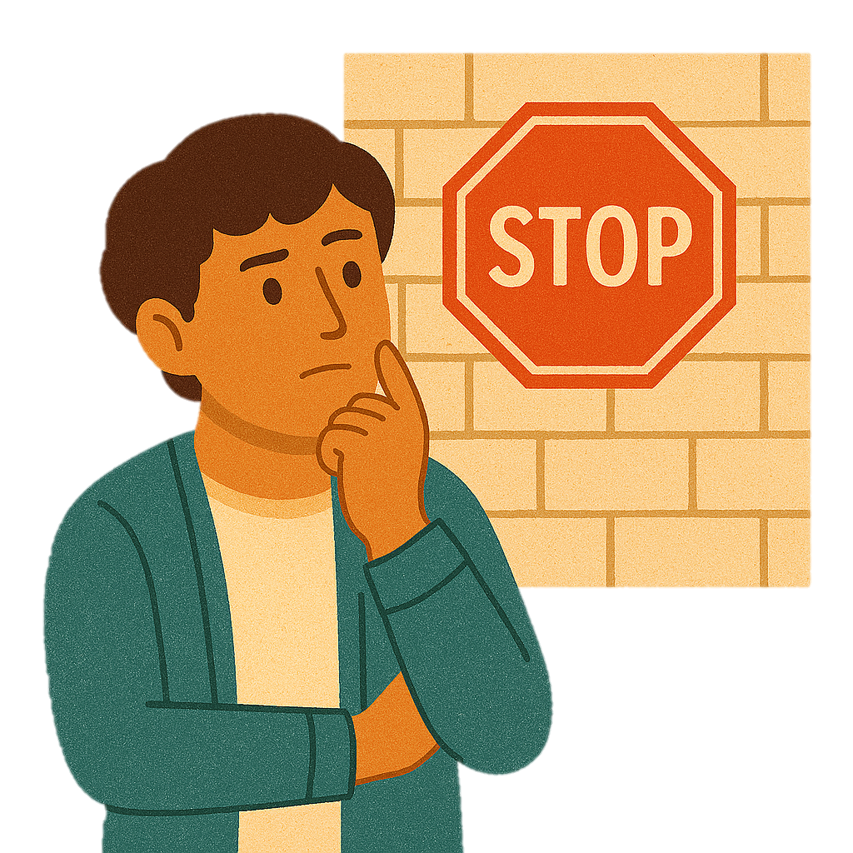 | We know that barriers can stop some people from taking part in consultation.  A barrier is something that stops you from doing what you  - Want  - Need.
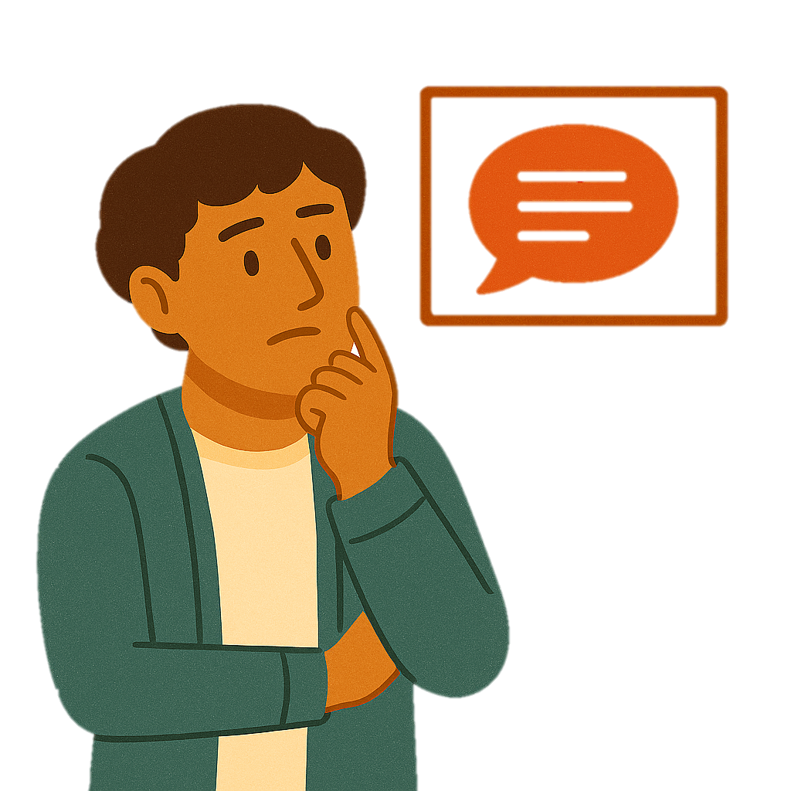 | Some barriers could be  - Ways they communicate
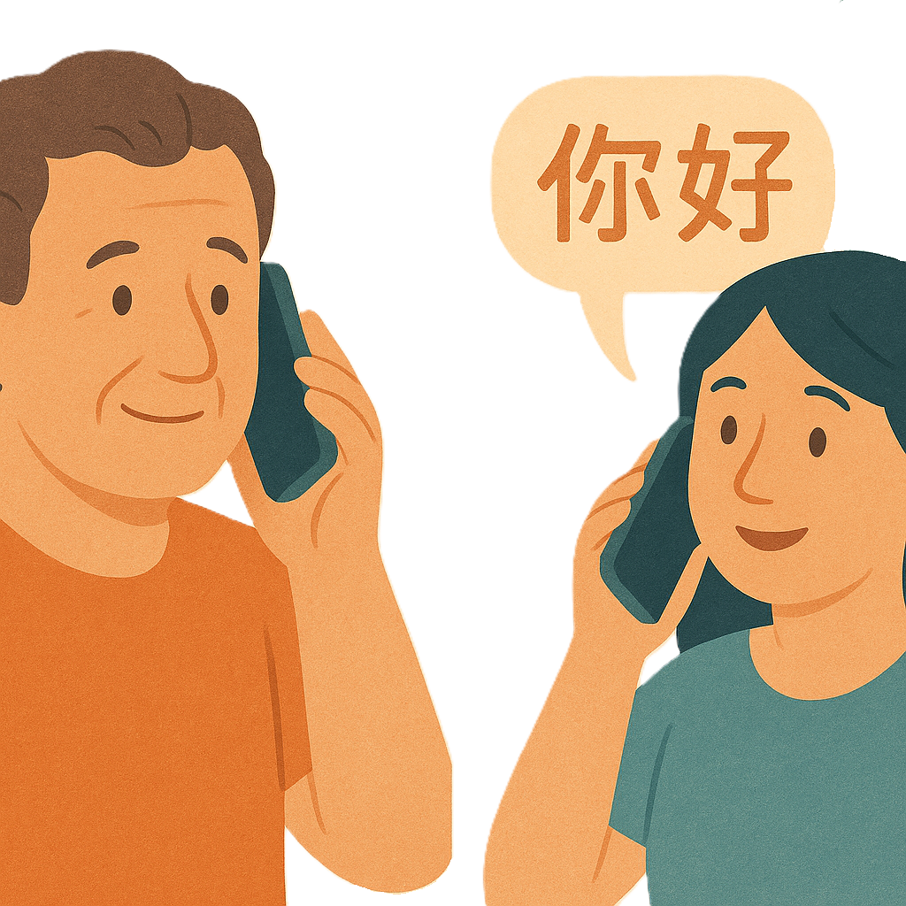 | - The language they speak
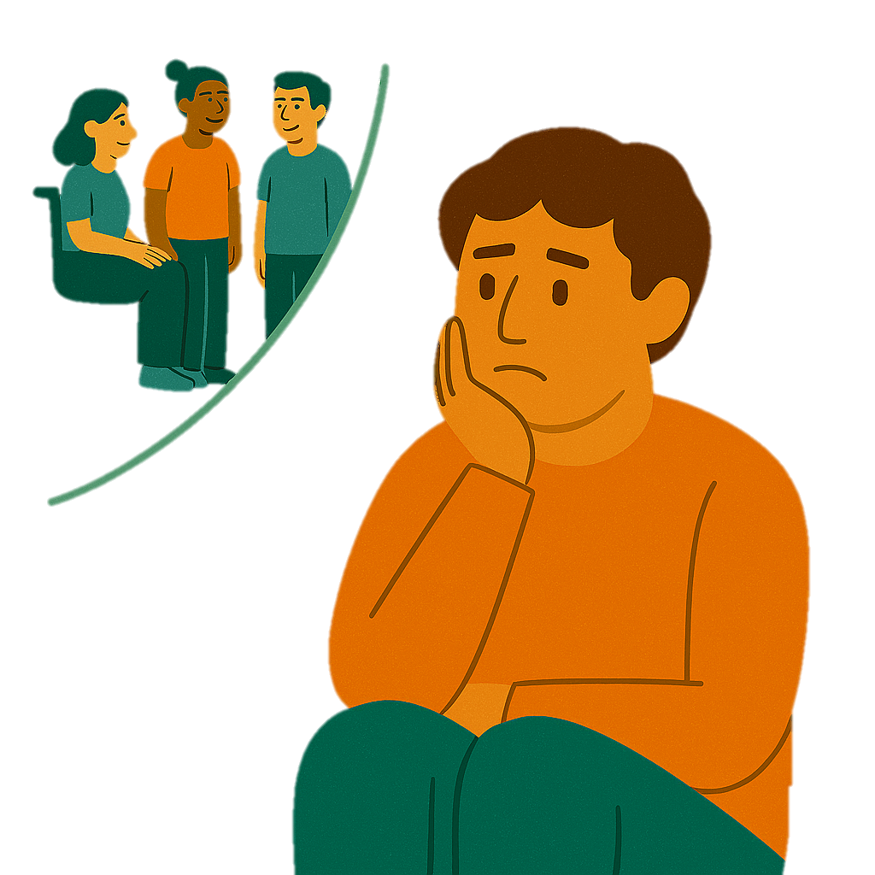 | - They are isolated  Isolated means being alone.
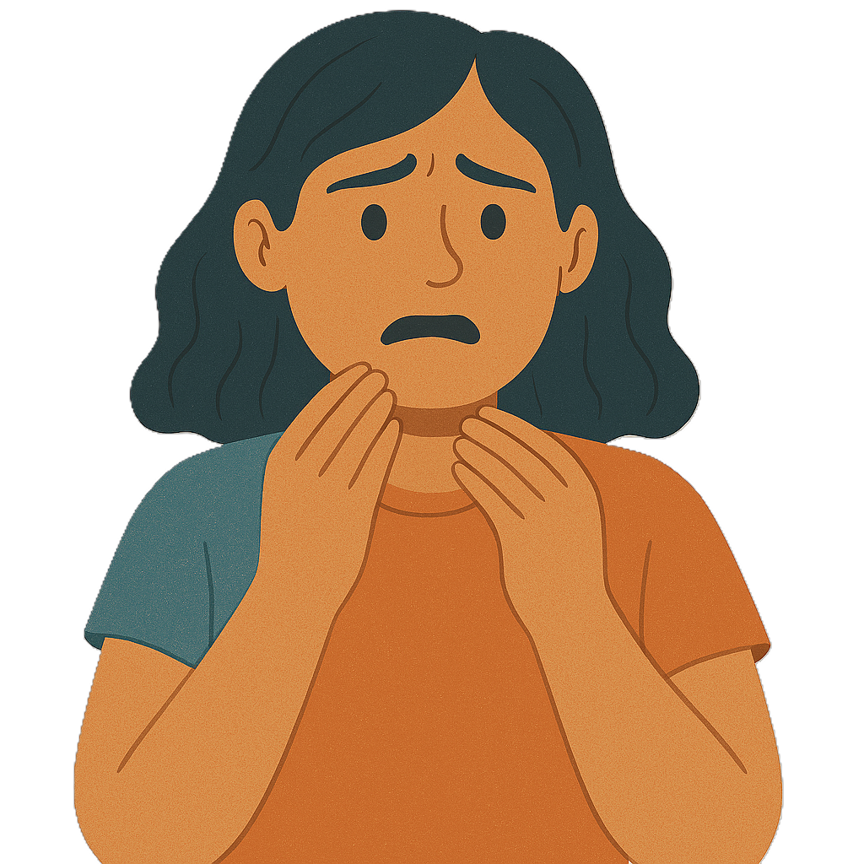 | - Being scared to speak up
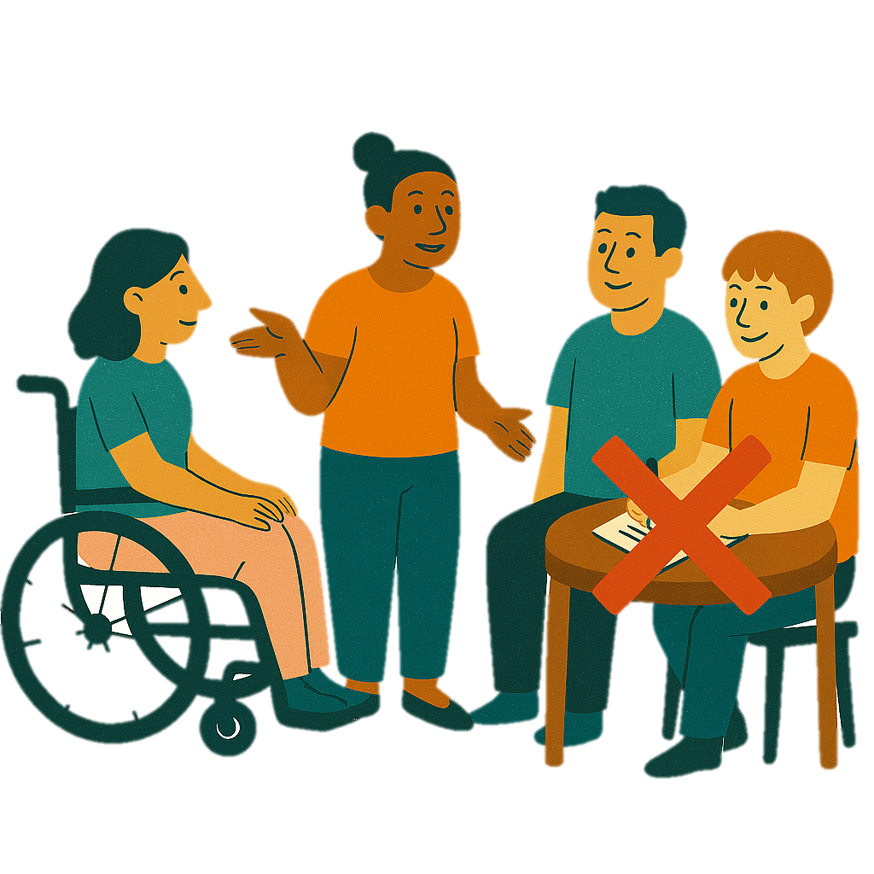 | We know some people could not take part in our consultation.

Contact us

 | You can contact us if you need more information.
 | You can send us an email.  disabilityadvocacyreforms@health.gov.au
 | You can look at our website.  consultations.health.gov.au/disability-and-carers-group/individual-disability-advocacy-reform/

Some images in this Easy Read were made using AI.
You must not share or copy any of the images without permission.
March 2026.

