# Australian and New Zealand Nutrient Reference Values for Sodium

**Support Document 2**

**Statistical Analyses**

This analysis was substantively conducted by Dorothy Mackerras for review by the Sodium Expert Working Group, with research assistance provided by Elizabeth Neale and Deborah Nolan Clark, editorial support from Linda Tapsell, Chair of the EWG.

**March 2014**

Table of contents

**Executive Summary**

**Glossary**

**1. Introduction**

**2. Methods**

2.1 Data extraction

2.2. Data preparation

2.2.1 Categorisation of studies

2.2.2 Expression of the results

2.2.3 Calculation of difference in electrolyte excretion

2.2.4 Calculations for blood pressure outcomes

2.3 Analysis

2.3.1 Exploration of the data and descriptive statistics

2.3.2 Meta-analysis to explore group differences

2.3.3 Examination of data for upper level purposes

2.3.4 Examination of data for SDT purposes

2.3.5 Statistical tests

**3. Results – systolic blood pressure**

3.1 Preliminary exploration of the data

3.2 Descriptive statistics

3.2.1 Demographic characteristics

3.2.2 Trial design descriptors

3.2.3 Electrolyte excretion and systolic blood pressure

3.3 Meta-analysis of effects of sodium excretion on systolic blood pressure

3.3.1 Use of the weights from the meta-analysis to weight other variables

3.4 Interpretation of data for UL purposes

3.5 Interpretation of data for SDT purposes

**4. Results – diastolic blood pressure**

**5. Results – cholesterol**

**6. Conclusions**

**7. References**

**8. Appendices**

**Glossary**

NT normotensive

HT hypertensive

SBP systolic blood pressure

BP blood pressure

Na sodium

K potassium

95% CI: 95% confidence interval

**Executive Summary**

Fifty-five studies yielded 66 observation groups from which 5 were excluded from analysis owing to incomplete data or extreme values.

Overall, there was a weighted average reduction in SBP in the low Na group compared to the high sodium group ( -3.9mmHg; 95%CI; -4.7 to -3.0 mm Hg). Heterogeneity among the studies was classified as medium overall (I2=72%). The impact on SBP was different in normotensives (-1.0mm Hg) and hypertensives (-4.7mm Hg). The studies included in the meta-analysis contained a much higher proportion of hypertensive groups than the prevalence in Australia or New Zealand and so the overall meta-analysis results cannot be extrapolated to the two countries. Using a prevalence of 30% (from a survey in Australia that defined hypertension based on either blood pressure measurement at interview or use of medication) to weight the category specific results for hypertensives and normotensives yields an estimated reduction of 2.1mm Hg in SBP in the adult population if mean sodium excretion decreases from abut 3500mg to about 2100mg.

The association between different measures of sodium excretion and systolic blood pressure were examined in several ways. A point at which increasing sodium excretion increased the impact on SBP could not be identified. The available data covered the range 1200-3300mg sodium and we conclude that the data are linear in this range. Therefore, if there is a point at which the impact of increases in sodium intake increases the size of the effect on SBP compared to lower intakes (i.e. a UL), it does not lie in the range of the data examined. It cannot be extrapolated from the data because the concept of a UL implies non-linearity in the data.

The same analysis does not allow identification of an SDT. One possibility for setting an SDT might be to use the result of the meta-analysis which showed a reduction in SBP when mean population excretion is lowered from about 3500mg to 2100mg/day. This would lead to an SDT of an intake that is equivalent to an excretion of 2100mg/day. Current total sodium excretions in both countries are unclear but might sufficiently similar to 3500mg/day that this result can be applied. Additional criteria are needed to define the goals for what the SDT should indicate. Analyses to ensure that the NRV for adequacy of sodium and other nutrients can also be met is needed for reality checking of any selected guidance values.

When setting NRVs, the conversion factor from the available data (24 hour sodium excretion) to a dietary intake needs to be factored in.

Time has not permitted the diastolic blood pressure data to be examined.

1. **Introduction**

For the purposes of this document, the Sodium NRVs under consideration were the Upper Level (UL) and the Suggested Dietary Target (SDT) for adults. The underlying premise when setting a UL is that there is a relationship between the nutrient and the outcome defined as the adverse effect. Along with the definition of the problem and quality review of evidence, the derivation of Upper Levels involves identifying the point at which the risk of the outcome starts to increase, i.e. it assumes that a non-linear relationship exists (e.g. a segmented linear relationship or a sigmoidal relationship). If the point at which risk of the specified adverse outcome increases cannot be identified, the Framework lists other possible guidance values which could be set instead of a UL [1].

There are a number of considerations, including that of evidence of adverse effects at high levels of consumption and of a dose response relationship.

It is well accepted that lowering sodium intakes reduces blood pressure although many reviews have limited their analyses to studies that achieved a reduction of at least 920 mg.

[2]. Whether this relationship is linear across the range of intakes or not is more debated. The evidence to support non-linearity is derived from two trials that used 3 doses of sodium (approximately 1150, 2300, 3450 mg/day) [3, 4]. In the previous iteration of the NRVs one of the justifications given for setting the UL at 2300mg (100mmol) was that the relationship was not constant and that there was a breakpoint at 2300mg [5]. The 3-dose studies [3, 4] were the main evidence for this view. However no formal analysis appears to have been done on the body of evidence which described only one study as a randomised controlled trial [6]. It is noted that in both the 3-dose trials, the higher range had a lower response per unit increase in sodium intakes than the lower range. Therefore the mid-dose in these trials does not correspond to the definition of a UL which is the point where there is an increased response per unit increase in intake.

There are numerous other RCTs that used only two doses of sodium (outlined in Support Document 1) and each of these also provides an estimate of the slope of the dose-response relationship. However these studies have used a variety of doses in the high and low sodium groups and the dose difference has also varied among studies. Previous analyses do not seem to have taken this into account when assessing whether these other studies support the linear or non-linear proposition and may not have considered whether the 2-dose studies support the results of the 3-dose studies when examining whether a breakpoint exists.

It is hypothesised that the size of the difference in blood pressure response to a given difference in sodium intake depends on the lower of the two intakes. Specifically, that the response is stronger if the lower of the two intakes is less than 2000-2300mg/day than if it is higher. One way to test this would be to test the interaction term between difference in sodium intake and lower sodium intake in a (meta-)regression. However because the sodium intakes are combinations of each other (difference in intake=high intake –low intake) the interpretation of regression results is not straight forward. Another way to deal with this problem is to divide the data into groups of low sodium intakes and examine the differences in blood pressure within the groups. Notably this hypothesis, if true, would not lead to a UL because the UL is set at the point where the response is stronger at the higher intake, not the lower intake.

The data examined in this supporting document all derived from randomised controlled trials in humans. In these trials at least two groups were given different doses of sodium either which was achieved either by advising subjects to follow different types of diet or by giving all subjects a low sodium diet and randomising to sodium or placebo pills (or, occasionally, a specific food with high and low sodium content). There were no trials in which there was an arm with zero sodium intake. As the focus of this review concerned the prevention of chronic disease, the evidence came from intervention studies involving adults.

The analysis presented here forms part of the reference framework for the NRV review for sodium. It considers the broader question of whether it is possible to set a UL and/or SDT by analytical means with reference to data from the scientific literature. Specifically the analysis aims to investigate whether there is any evidence of one or more breakpoints in the dose-response relationship using the totality of the data. That is, does the slope of the dose-response depend on the actual sodium intake or only on the difference in sodium intake?

1. **Methods**

**2.1 Data Extraction**

All articles summarised in tabular form in the evidence based review (Supporting Document 1) were considered. Briefly, these studies reported data for change in SBP and/or diastolic blood pressure between intervention and control groups. They were derived by updating the meta-analysis of Graudal et al. [7] but by placing the restriction that studies had to have a minimum duration of 4 weeks. Only studies which reported the intake (defined by 24hr urinary sodium excretion) in the low and high sodium intake groups were included in the statistical analysis described here. Studies were also excluded if they did not report variance data that could be used to calculate a standard error of the difference in blood pressure between the two sodium intake groups. In the case of studies which had more than two groups [3, 4, 8] , the low and intermediate groups (corresponding to sodium intakes of approximately 50mmol/day and 100mmol/day respectively) were selected for analysis based on consensus with the Expert Working Group that this comparison would be the most informative for current purposes.

**2.2 Data preparation**

Data from all included articles were summarised in Microsoft Excel (Microsoft Corporation, 2010, Version 14.0.7) (see Appendix 2 for data lists). Analyses were conducted using Stata 13.1 (Intercooled, College Station, TX) or Stats Direct (StatsDirect Ltd. StatsDirect statistical software. http://www.statsdirect.com. England: StatsDirect Ltd. 2013)

**2.2.1 Categorisation of studies**

Where available, data was extracted separately for sub groups based on gender, ethnicity and hypertension status. Studies were further characterised based on the hypertension status of participants.

**2.2.2 Expression of the results**

All sodium data are expressed in mg because these are the units of the NRVs. For ease of comparison with other overviews examining the relationship between sodium intake and blood pressure, the trial data was left as comparisons between the low sodium group to the high sodium intake group even though the current purpose of examining the possibility of setting a UL or SDT would suggest that the high sodium intake group should be compared to the low sodium intake group. This recognised that readers familiar with the topic area would be more accustomed to seeing the trial data presented as addressed the question of whether lower sodium intake decreased blood pressure compared to high intake and all of the meta-analyses show negative (i.e. reductions) in blood pressure. As noted above, in Alli et al. [9] , the data were reversed compared to other analyses. In this study, the group allocated to advice to reduce sodium (which the authors called the intervention group) had a higher sodium excretion at the end of the trial than the group who were not given this advice (the control group). While this might be regarded as breaking the intention to treat principle, it should be noted that in using the observed urinary sodium excretion, rather than the intended excretion, the analysis contains elements of compliance. Some previous meta-analyses have excluded studies which achieved less than a 40mmol difference in urinary Na [10, 11], and so have used compliance to select studies. This particular study [9] was one of two subsequently deleted from the main analyses because it had outlier results.

* + 1. **Calculation of difference in electrolyte excretion**

Urinary sodium and potassium data was recorded in the units reported in the paper, with all data converted to mg/24hr. Urinary excretion values in 2 papers were measured over an 8 hour period and converted to 24 hour values by multiplying by 3.8 and 4.9 for sodium and potassium respectively [12].

Mmol data in the papers were converted to mg by multiplying by 23 for sodium and 39 for potassium [5].

The difference in urinary sodium and potassium excretion between high and low sodium groups was calculated using the following equation:

|  |
| --- |
| Difference in 24 hour urinary excretion =  24 hour urinary excretion at the end of the low sodium period  - 24 hour urinary excretion at the end of the high sodium period |

* + 1. **Calculations for blood pressure outcomes**

Available data on the change in continuous health outcomes (e.g SBP) were obtained from Graudal et al. [7]. When the trial or observation group had not been included in Graudal et al. [7], data were taken from WHO [11] if it was clear that the formulas below had been used in the calculation. Otherwise, the calculations (below) were done.

All values were absolute values and there were no results expressed as %change from baseline. The low sodium group was assumed to be the ‘intervention’ group for the purpose of calculation. The following formula was used to calculate missing values for the difference in SBP (or DBP) between high and low sodium intake groups:

**Calculation of difference:**

##### For parallel trials:

##### diff_SBP = (SBPlow_Na,end - SBPlow_Na,start) - (SBPhigh_Na,end - SBPhigh_Na,start), where

SBPlow_Na,end = mean SBP at the end of study time in the low_Na group

SBPlow_Na,start  = mean SBP at the start of study time in the low_Na group

SBPhigh_Na,end  = mean SBP at the end of study time in the high_Na group

SBPhigh_Na,start = mean SBP at the start of study time in the high_Na group

##### For cross-over trials:

diff_SBP = SBPlow_Na,end - SBPhigh_Na,end , where

SBPlow_Na,end = mean SBP at the end of study time on low_Na intake phase

SBPhigh_Na,end  = mean SBP at the end of study time on high_Na intake phase

Calculation of variance:

If necessary the standard error of the mean was calculated from the standard deviation:

SE=SD/√(n)

*For parallel trials*

SEdiff_SBP = √(SE2low_Na,change +SE2high_Na,change), where

SElow_Na,change is the SE of the change in SBP from the start to the end of the study in the low_Na group

SEhigh_Na,change is the SE of the change in SBP from the start to the end of the study in the high_Na group

Additional calculations for parallel trials (where data on standard error of the change in each group was not available):):

SElow_Na,change = √ [(SE2low_Na,end + SE2low_Na,start) – 2r(SElow_Na,end)(SElow_Na,start)]

SEhigh_Na,change = √[(SE2high_Na,end + SE2high_Na,start) – 2r(SEhigh_Na,end)(SEhigh_Na,start)] where

SElow_Na,end is the SE of SBP at the end of the study period in low_Na group

SElow_Na,start is the SE of SBP at the start of the study period in low_Na group

SEhigh_Na,end is the SE of SBP at the end of the study period in high_Na group

SEhigh_Na,start  is the SE of SBP at the start of the study period in high_Na group

is the within subject correlation of two measurements of SBP; set to 0.5 in this analysis [13].

For cross-over trials:

SE2diff_SBP = √ [(SE2low_Na,end + SE2high_Na,end) – 2r(SElow_Na,end)(SEhigh_Na,end)], where

SElow_Na,end is the SB of SBP at the end of the low_Na intake phase

SE2high_Na,end is the SB of SBP at the end of the high_Na intake phase is the within subject correlation of two measurements of SBP; set to 0.5 in this analysis [13]

**Calculation of 95% Confidence Interval:**

The 95% CI for diff_SBP was calculated as:

diff_SBP + 1.96(SEdiff_SBP)

Because the difference in sodium excretion between the high and low groups varied among the studies, the difference in SBP per 500mg decrease in Na excretion between the high and low Na groups was calculated by dividing the difference in BP between the high and low group by the difference in 24 hour Na excretion between the high and low group. Because both these values are negative, their ratio is positive and therefore it was multiplied by -1 to keep the direction of the change in BP/500mg Na moving in the same direction as the change in BP.

Creation of cutpoints to dichotomise the excretion data in the low Na group.

One analysis done in the WHO report [11] was to divide all studies into two groups – those with a 24 hour urinary sodium excretion in the low sodium group below 2000mg and those with excretion greater than this. A second analysis was done on the same data using 1200mg as the cutpoint. This analysis was re-created in the current report, but the data were cut at 100mg intervals from 1100mg upwards to allow patterns to be examined which might indicate whether a change in effect on SBP occurred at any value. The range for each analysis was selected such that there were at least two studies in above and below the cutpoint. Simple averages and weighted averages (using the inverse variance weights from the meta-analysis) were calculated.

Creation of multiple categories of excretion data in the high Na group

The WHO report [11] describes making categories using the ‘baseline’ group, which is interpreted to mean the high sodium group:

Furthermore, WHO grouped studies based on baseline sodium intake level, and found a significant decrease in systolic blood pressure in all subgroups. In the four studies with a baseline sodium intake of <3 g/ day, the decrease was 1.79 mmHg (95%CI: 0.07, 3.52); in the studies with a baseline sodium intake of 3.0–3.5 g/day, the decrease was 2.97 mmHg (95%CI: 1.21, 4.73); in the studies with a baseline sodium intake of 3.5–4.0 g/day, the decrease was 3.07 mmHg (95%CI: 1.43, 4.71); in the studies with a baseline sodium intake of 4.0–4.5 g/day, the decrease was 3.91 mmHg (95%CI: 1.72,6.10); and in the studies with a baseline sodium intake of >4.5 g/day, the decrease was 5.74 mmHg (95%CI: 3.03, 8.45). The test of subgroup differences suggested no difference in the change in systolic blood pressure by subgroup (P=0.17).

Although the differences were not statistically significant among the groups, the larger change in SBP for the group with high sodium values >4500mg/day might indicate a breakpoint that needs to be considered. The report does not describe a similar analysis for DBP.

Therefore, the high Na group was broken into the following categories to conduct a similar analysis: <2999mg; 3000 to3499mg; 3500 to3999mg; 4000 to 4499mg and > 4500mg.

* 1. **Analysis**

**2.3.1 Exploration of the data and descriptive statistics**

Distributions were examined to determine whether there were studies with extreme or outlier studies, and what might explain these.

The demographic characteristics of the subjects in the studies were described (eg mean age and weight) to determine what types of populations the results related to. This was done because NRVs are often extrapolated from one group to another.

Trials were categorised according to descriptors (design, hypertension status, co-intervention, duration etc). Hypertension status both as classified by the study authors and using current criteria were examined.

Observation groups with incomplete data were excluded and graphical methods were used to identify other groups with extreme or outlier values. This is because any decision about a UL or SDT should be evident in the bulk of the data and not solely when a small number of studies are included in the analysis. Correlations were used to describe the pairwise associations between variables.

## 2.3.2 Meta-analysis to explore group differences

Although the purpose of the analysis was to assess whether there is a threshold that defines a sodium intake below which there is no effect on blood pressure, a meta-analysis was undertaken to confirm whether the inclusion and exclusion criteria used in our analysis would yield a dataset that reflected previous findings. Sub-group meta-analysis was done for factors which might be important in affecting the change in BP and which would therefore need to be taken into account before attributing effects to sodium intake. These factors were: hypertensive status of the subjects, posture of resting BP measurement (sitting versus supine because both postures were commonly classed as resting), parallel versus cross-over design and use of dietary advice to achieve the difference in intake versus placing all subjects on a low sodium diet and randomising to sodium or placebo pills (a surrogate for blinding).

A random effects meta-analysis was done. The results were graphed using a forest plot and a funnel plot was done to examine whether publication bias might be evident. 95% CI were calculated der Simonian-Laird method [14].The heterogeneity among the studies was described using I2. “I2 describes the “percentage of total variation across studies that is due to heterogeneity rather than chance” and 0%, 25%, 50% and 75% could be interpreted as indicating no, low, medium and high heterogeneity respectively [15] . In the case that there is a dose-response relationship, variation in aspects such as dose or study duration among studies may cause heterogeneity. The inverse variance weights were saved and used in subsequent analyses.

The inverse variance weights from the meta-analysis were used to weight the averages for SBP per 500mg decrease in Na and 24 hr Na excretion in the various analyses using categories of Na excretion to explore confounding by differences in the range of Na doses tested among the studies.

Random-effects meta-analyses were also conducted for total cholesterol, HDL cholesterol and LDL cholesterol data using the previously described methods.

Further statistical analysis of data on diastolic blood pressure was not done due to time constraints. The EWG prioritised the analysis if systolic blood pressure data as this has been demonstrated to be of greater clinical importance [16].

* + 1. **Examination of data for upper level purposes**

A number of approaches were taken to examine the data for the purposes of considering whether it would be possible to set a UL for sodium.

The difference in dose of sodium between the high and low arms of the studies varied greatly, and so the impact on blood pressure would also be expected to vary among the studies assuming that there is a dose-response relationship between sodium intake and blood pressure. The meta-analysis done above does not take this into account but compares all low sodium arms to all high sodium arms.

To remove confounding between studies owing to testing of different dose ranges, the change in SBP was re-expressed per 500mg increment in the difference in Na excretion between the high and low Na group in each study. The range in effect size was examined.

The simple and weighted average differences in SBP, SBP per 500mg decrease in Na and difference in Na for the groups defined by the moving dichotomous cutpoints of the low sodium group were graphed. This allowed inspection for patterns (converging or diverging lines) which might indicate that the effect was increasing with increasing excretion (i.e. a UL) or that effect was decreasing (e.g. had reached a threshold of effect, this is not a UL). The graphs were created for all studies and for the largest subgroup, hypertensives, who also show a larger response than do normotensives.

**2.3.4 Examination of data for SDT purposes**

For SDT purposes, data was considered on the range of 24-hour Na excretion in which a dose-response relationship between decrease in sodium intake and decrease in SBP could be observed. The issue of a dose response relationship was considered. The proximity of the lower end of observed data to the upper end of the AI range was another consideration, bearing in mind that at least 50% of population intakes should be above the AI.

The overall meta-analysis result is dependent of the relative proportions of normotensive and hypertensives in the studies which is not the same as in the Australian and New Zealand populations. Hence the overall meta-analysis result cannot be interpreted as the difference in SBP that would be achieved the Na intake decreased. However the separate effects estimated for normotensives and hypertensives can be extrapolated. Three weighted averages were calculated using the prevalence of high blood pressure reported in the 1999-2000 AusDiab survey (30% based on measurement at interview or medication, cited in [17]), 16% in the 2011 New Zealand Health Survey (based on a question about medication use [18]),) and the 21% from the 2012 Australian Health Survey (based on BP measurement at interview [19]).

A weighted regression was done of the relationship between difference in SBP and difference in Na excretion between the high and low Na groups.

## 2.3.5 Statistical tests

Owing to the large number of comparisons and the exploratory nature of the analysis, no statistical tests have been done.

Changes in SBP and correlations are expressed using 2 significant figures except where automatic outputs from Stata have other defaults. Sodium excretion values are expressed in whole numbers.

**3 Results – systolic blood pressure (SBP)**

**3.1 Preliminary exploration of the data**

As described in Supporting Document 1, the 56 papers that met the inclusion criteria for inclusion in the review yield 66 groups for analysis. Of these, one [20] did not report any variance data that could be used to calculate a standard error of the difference in blood pressure between the two sodium intake groups. Two studies [21, 22] reported the difference in 24-hour urinary sodium excretion but did not report data excretion data for the low and high intake groups individually. Hence these 3 studies were excluded leaving 63 observation groups with complete sodium excretion and SBP data.

Figure 1 shows the sodium excretion data for each of the 63 observations. One study [23] compared a range of 6500mg/24 hours and used both the lowest low sodium intake and the highest high sodium intake of all the observation groups. Alli et al. [9] ( had the smallest difference between the two groups, only 177mg/24 hours although it also had one of the highest sodium intakes in its low sodium group. The inverse trend (r=0.52, Table 1) between the dose in the low sodium group and the difference between the low and high sodium doses tested is seen more clearly in a scatterplot of the difference in sodium excretion versus the sodium excretion in the low group (Figure 2). There is a stronger -0.63 correlation between the between the dose in the high sodium group and the difference between the low and high sodium doses tested. Figure 2 indicates that the data are not necessarily linear and so the correlation is an imperfect measure of association.

*Table 1 Pairwise correlations between sodium excretion and SBP variables (n=63)*

|  |  |  |  |  |  |  |  |  |
| --- | --- | --- | --- | --- | --- | --- | --- | --- |
|  | |  | | 24hr Na in low Na group | | 24hr Na in high Na group | difference in urinary Na between groups | difference in SBP between groups |
|  | |  | |  | |  |  |  |
| *All 63 observations* | | | |  | |  |  |  |
|  | 24hr Na in low Na group | | | 1.00 | |  |  |  |
|  | 24hr Na in high Na group (high-low) | | | 0.33 | | 1.00 |  |  |
|  | difference in urinary Na (high-low) | | | 0.52 | | -0.63 | 1.00 |  |
|  | difference in SBP (high Na-low Na) | | | 0.19 | | -0.23 | 0.36 | 1.00 |
|  | difference in SBP per 500mg decrease in urinary Na | | | 0.23 | | 0.06 | 0.13 | 0.65 |
|  |  | | |  | |  |  |  |
| *Excluding Alli et al [**9**]* | | | |  | |  |  |  |
|  | 24hr Na in low Na group | | | 1.00 | |  |  |  |
|  | 24hr Na in high Na group | | | 0.34 | | 1.00 |  |  |
|  | difference in urinary Na (high-low) | | | 0.48 | | -0.66 | 1.00 |  |
|  | difference in SBP (high Na-low Na) | | | 0.10 | | -0.26 | 0.32 | 1.00 |
|  | difference in SBP per 500mg decrease in urinary Na | | | -0.13 | | 0.04 | -0.15 | 0.83 |
|  |  | | |  | |  |  |  |
| *Excluding Alli et al [**9**] and van Berge-Landry [**23**]* | | | | | | |  |  |
|  | 24hr Na in low Na group | | 1.00 | |  | |  |  |
|  | 24hr Na in high Na group | | 0.34 | | 1.00 | |  |  |
|  | difference in urinary Na (high-low) | | 0.48 | | -0.66 | | 1.00 |  |
|  | difference in SBP (high Na-low Na) | | 0.10 | | -0.26 | | 0.32 | 1.00 |
|  | difference in SBP per 500mg decrease in urinary Na | | -0.13 | | 0.04 | | -0.15 | 0.83 |

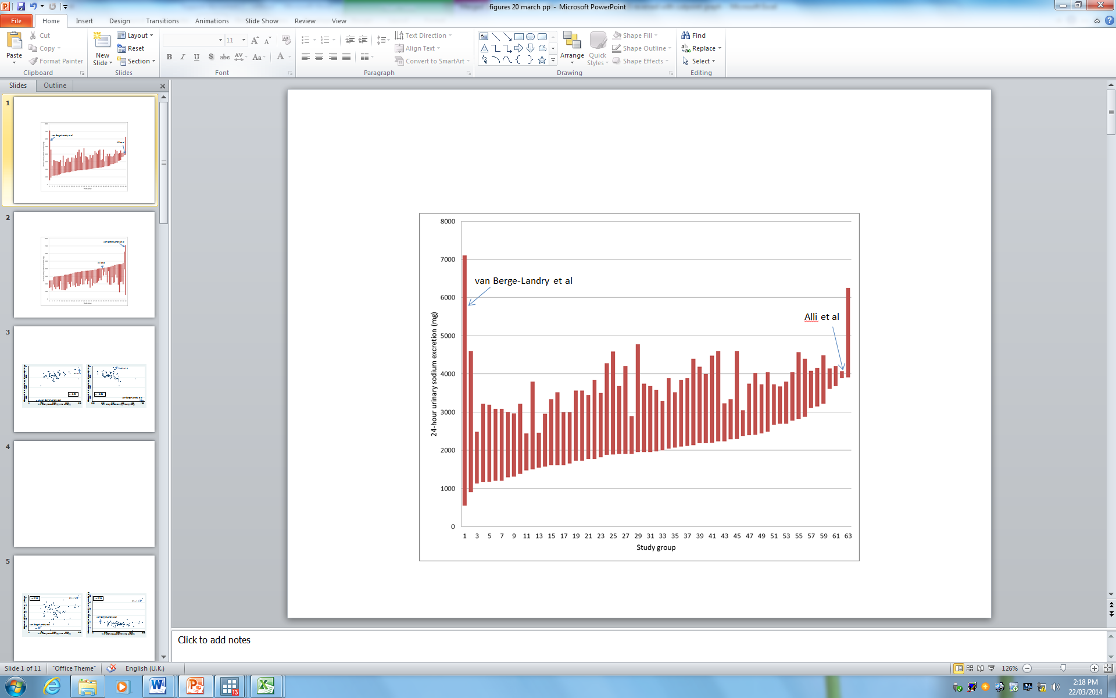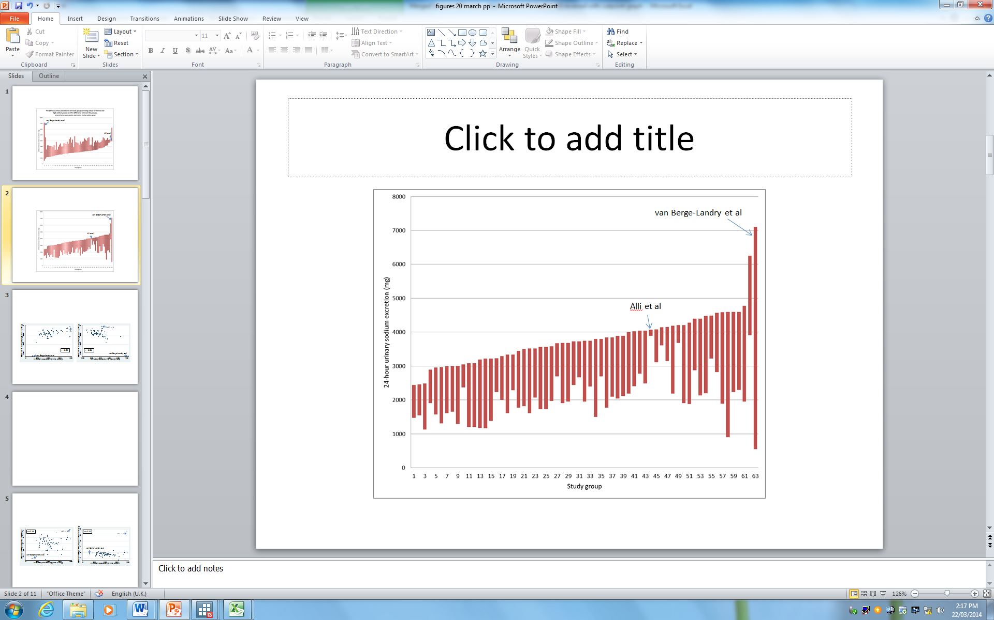

Figure 1 24-hour urinary Na excretion in 63 observation groups ordered by increasing excretion in the low Na group (top) and the high Na group (bottom) (The lower and upper bounds of each column are the excretion in the low and high Na groups respectively, the height of the column is the difference between the two groups).

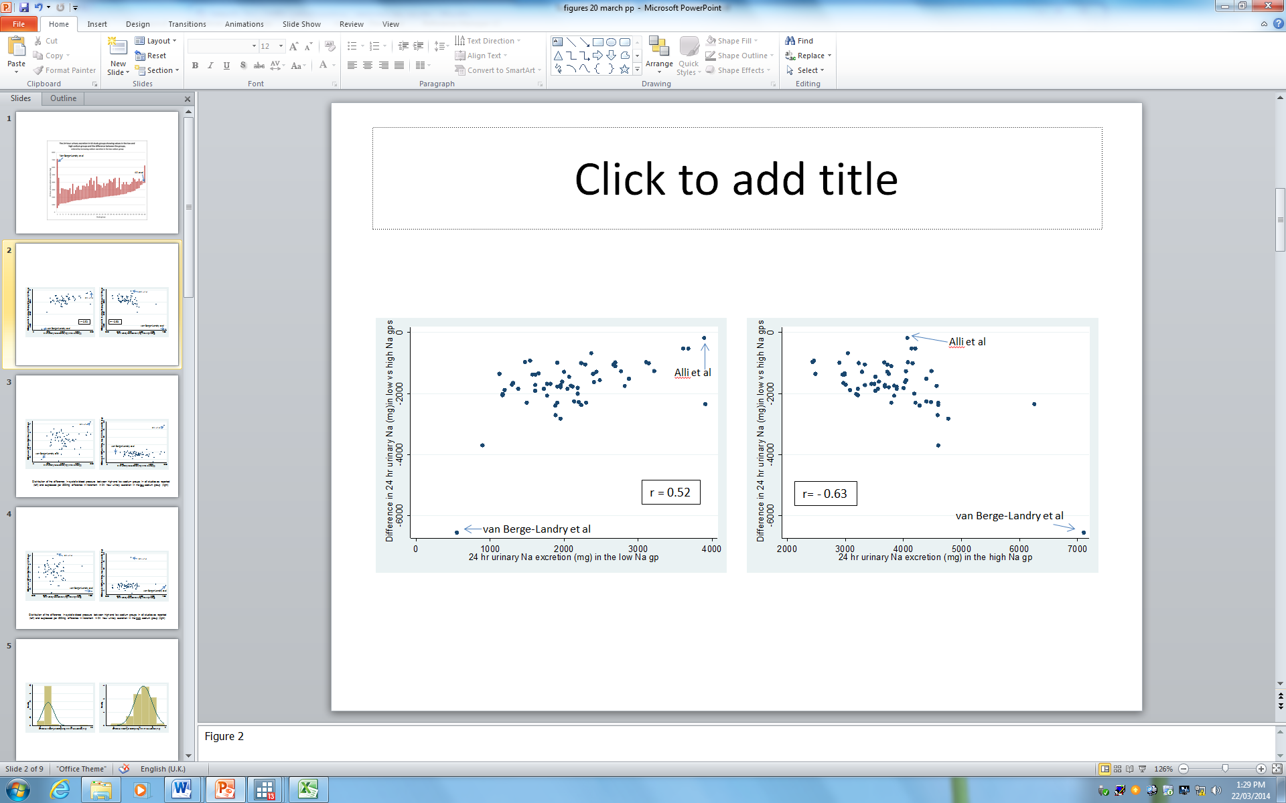

*Figure 2 Scatterplot of the difference in 24-hour sodium excretion between high and low Na intake groups versus excretion in the low intake group (left) and high excretion group (right) (NB the vertical scale in Figure 2 is inverted compared to Figure 1)*

The change in SBP was approximately normally distributed in spite of the variation in dose range tested (Figure 3(left) whereas the distribution of SBP per 500mg difference in Na excretion had a substantial outlier (Figure 4 left). Figures 5 and 6 show the relationship (Table 1) between SBP and SBP per 500mg decrease per 500mg decrease in Na plotted against Na excretion in the low Na group (Figure 5) and the high Na group (Figure 6). The result of both Alli et al. [9] nor van Berge-Landry et al. [23] are consistent with other studies for the SBP plots. For the SBP plot, the results of van Berge-Landry et al. [23] are consistent with the majority of other studies, but are at the end of the range (an extreme value but not an outlier) whereas the results of Alli et al. [9] are completely discordant with the rest of the data.

Therefore these two studies were removed from the analysis to prevent undue influence on results. If there is a threshold of effect (i.e. a sodium excretion value at which a UL and/or SDT can be defined based on data analysis), then it should be present in the majority of the data and not solely when these two studies are included. Selected analyses have been repeated which include these two studies and are presented in Appendix 3

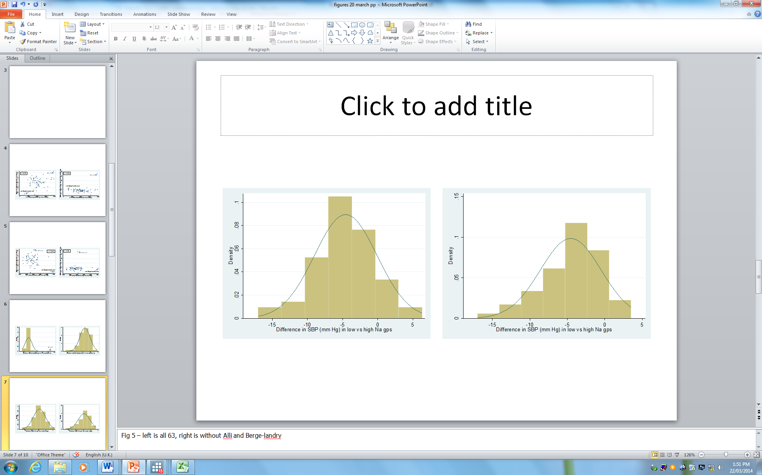

*Figure 3 Distribution of the difference in systolic blood pressure per 500mg difference between high and low sodium groups in all 63 observation groups (left) and when Alli et al. [**9**] and van Berge-Landry et al. [**23**] are deleted (right)*

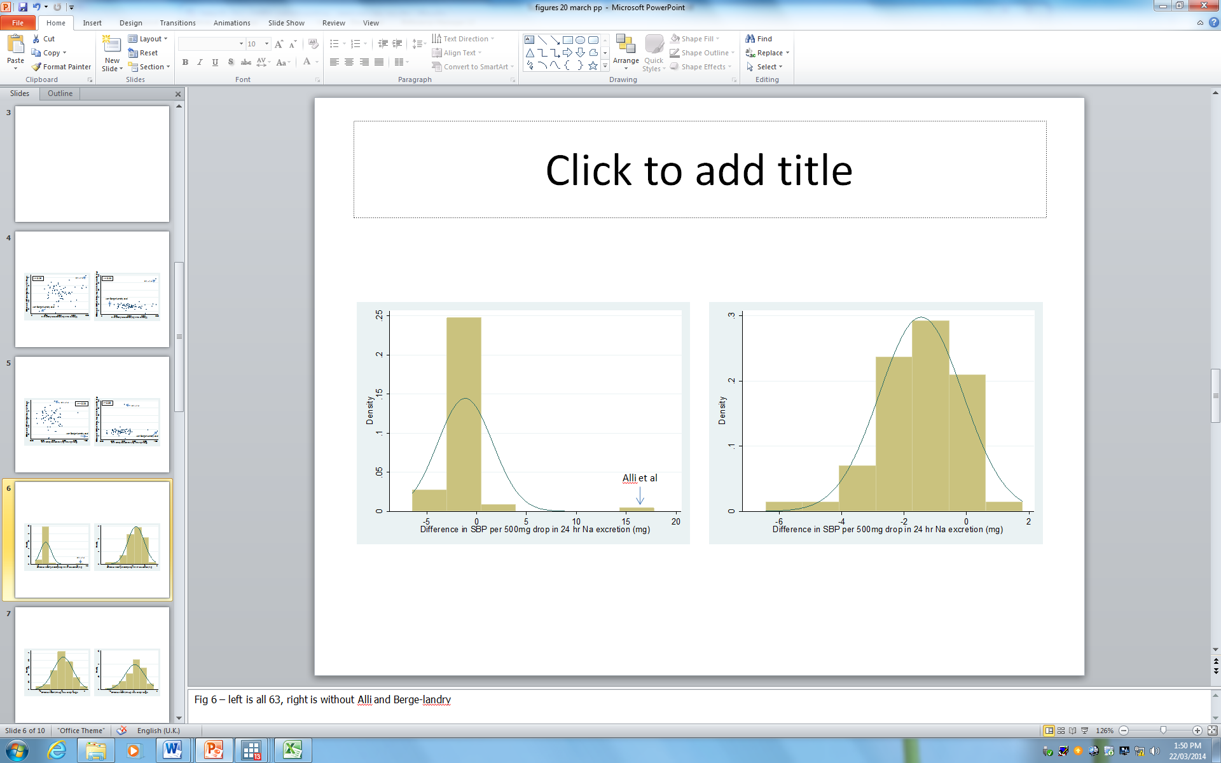

*Figure 4 Distribution of the difference in systolic blood pressure between high and low sodium groups in all 63 observation groups (left) and when Alli et al. [**9**] and van Berge-Landry et al. [**23**] are deleted (right)*

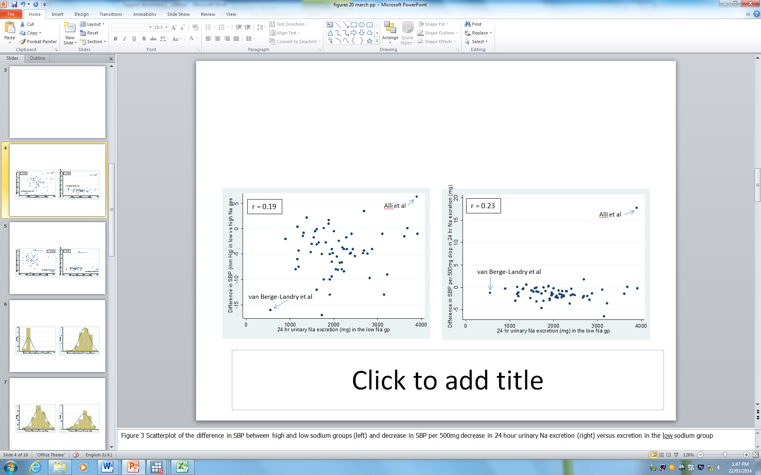

*Figure 5 Scatterplot of the decrease in SBP between high and low sodium groups (left) and decrease in SBP decrease in 24 hour urinary Na excretion (right) versus 24 hr Na excretion in the low sodium group*

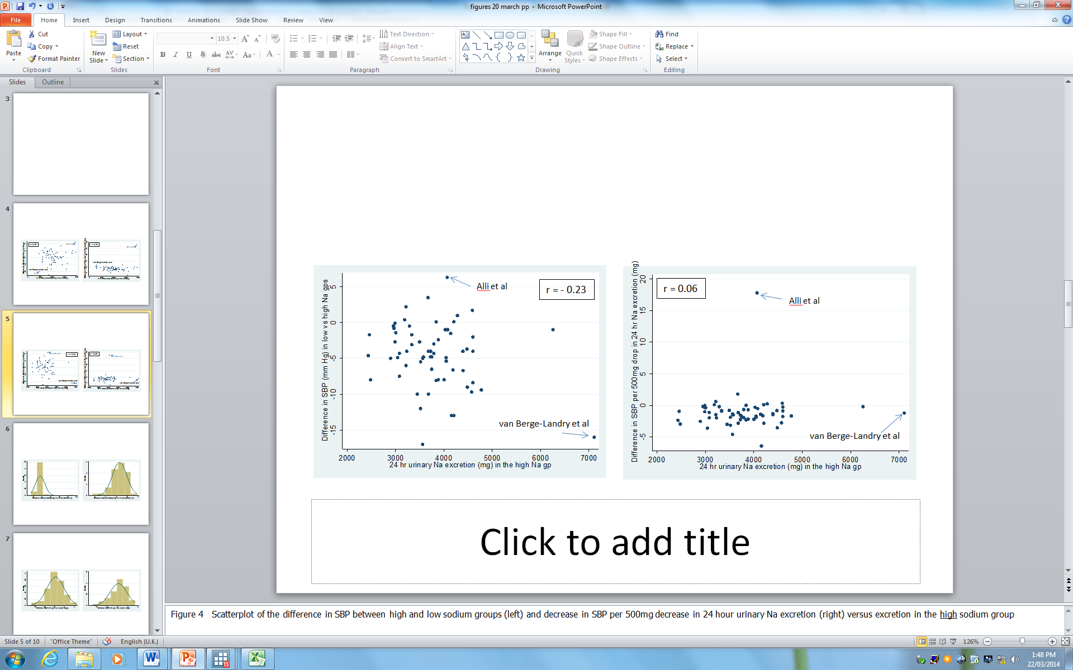

*Figure 6 Scatterplot of the difference in SBP between high and low sodium groups (left) and decrease in SBP per 500mg decrease in 24 hour urinary Na excretion (right) versus excretion in the high sodium group*

## 3.2 Descriptive statistics

### 3.2.1 Demographic characteristics

Most of the trials gave an indication of the age of the subjects which ranged from 22 to 73 years and an average of 52 (Table 2). This average is indicative only, because some studies reported ranges.

After exclusion of five studies [9, 20-23], 46 studies included both men and women. Four studies [24-27] included only men. Only one study provided data separately by sex [28].

Approximately half the trials indicated the body mass or weight of the subjects. The average body mass index was 27kg/m2 and average weight was 79-80kg both before and after the intervention.

In summary, the available data include adults of various ages from young to elderly and both sexes. On average, the subjects were heavier than the reference weights (61kg for women and 76kg for men) used to set the 2006 values [5].

##### Table 2 Age and body mass of the 63 observation groups

|  |  |  |  |  |  |  |  |  |  |  |
| --- | --- | --- | --- | --- | --- | --- | --- | --- | --- | --- |
|  | N | Mean | + | SD | Median | IQR | | | Min | Max |
| Age (years) | 60 | 52 | + | 11 | 52 | 47 | To | 59 | 22 | 73 |
| BMI intervention group - before (kg/m2) | 13 | 27 | + | 2 | 27 | 25 | To | 29 | 24 | 31 |
| BMI control group - before (kg/m2) | 13 | 27 | + | 2 | 27 | 25 | To | 29 | 24 | 31 |
| Weight intervention group - before (kg) | 33 | 80 | + | 11 | 78 | 75 | To | 86 | 64 | 117 |
| Weight control group - before (kg) | 33 | 80 | + | 11 | 78 | 73 | To | 86 | 64 | 114 |
| Weight intervention group - after (kg) | 36 | 79 | + | 9 | 77 | 74 | To | 84 | 62 | 110 |
| Weight control group - after (kg) | 36 | 79 | + | 9 | 78 | 74 | To | 84 | 64 | 110 |

### 3.2.2 Trial design descriptors

Just over half the observation groups were tested using a cross-over design and the remainder were tested in a parallel design (Table 3). However the type of intervention varied with design in that the parallel designs were more likely to use dietary advice to achieve the difference in sodium intake. The cross-over studies were more likely to advise all subjects to follow a low sodium diet then randomise them to sodium or placebo tablets to achieve the difference in sodium intake. Hence the parallel studies were generally not blinded. Few interventions lasted more than 8 weeks. Most cross-over trials did not use a washout period. Of the three that did, the washout had a shorter duration than the test periods.

There were approximately equal numbers of hypertensive and normotensive groups across the designs. Division of measurement of resting BP was in the supine or seated posture was also even across the designs.

Re-assessing the hypertensive status of subjects using current criteria did not alter the classification of participants in most observation group (Table 4). In two studies, the authors classified their subjects as normotensives whereas they would be classified as mixed under the current ANZ criteria and in two other studies, a mixed group would be classified as hypertensive now. However 6 studies did not describe their participants adequately to allow classification using current criteria.

Therefore owing to the missing information, the classification given by study authors was used in the current analysis.

##### Table 3 Cross-tabulation of design features by trial design (cross-over or parallel)

|  |  |  |  |  |
| --- | --- | --- | --- | --- |
| Variable | Group | Cross-over (n=33) | Parallel (n=28) | Total (n=63) |
| Original hypertension classification of subjects | | | | |
|  | HT | 22 | 20 | 42 |
|  | NT | 6 | 7 | 13 |
|  | Mixed | 5 | 1 | 6 |
| Revised hypertension status of subjects | | | |  |
|  | HT | 19 | 16 | 35 |
|  | NT | 5 | 5 | 10 |
|  | Mixed | 5 | 5 | 10 |
|  | inadequate information | 4 | 2 | 6 |
| Posture for resting BP measurement | | |  |  |
|  | Supine | 15 | 13 | 28 |
|  | seated | 16 | 14 | 30 |
|  | not stated/unclear | 2 | 1 | 3 |
| Type of intervention | |  |  |  |
|  | Dietary advice only | 7 | 15 | 22 |
|  | Na or placebo pills/substances | 26 | 13 | 39 |
| Co-intervention | |  |  |  |
|  | None | 27 | 13 | 40 |
|  | Drug | 4 | 2 | 6 |
|  | dietary supplement | 0 | 6 | 6 |
|  | Diet | 2 | 5 | 7 |
|  | Alcohol | 0 | 2 | 2 |
| Duration of test phase (weeks) | |  |  |  |
|  | 4 | 22 | 5 | 27 |
|  | 5 | 3 | 0 | 3 |
|  | 6 | 7 | 5 | 12 |
|  | 8 | 1 | 4 | 5 |
|  | 9 | 0 | 1 | 1 |
|  | 10 | 0 | 1 | 1 |
|  | 12 | 0 | 3 | 3 |
|  | 13 | 0 | 1 | 1 |
|  | 26 | 0 | 1 | 1 |
|  | 52 | 0 | 1 | 1 |
|  | 65.3 | 0 | 2 | 2 |
|  | 78 | 0 | 1 | 1 |
|  | 104 | 0 | 1 | 1 |
|  | 156 | 0 | 2 | 2 |
| Duration of washout (weeks) | |  |  |  |
|  | 0 | 30 | 0 | 30 |
|  | 0.57-2 | 3 | 0 | 3 |
|  | not applicable | 0 | 28 | 28 |

##### Table 4 Comparison of hypertension status of subjects classified by study authors to revised classification using current Australian definition of hypertension [29]

|  |  |  |  |  |  |  |
| --- | --- | --- | --- | --- | --- | --- |
|  |  | Revised hypertension status of subjects | | | | |
|  |  | HT | NT | mixed | inadequate information to assess | Total |
| Original hypertension classification of subjects | HT | 35 | 0 | 2 | 5 | 42 |
| NT | 0 | 10 | 2 | 1 | 13 |
| mixed | 0 | 0 | 6 | 0 | 6 |
|  | Total | 35 | 10 | 10 | 6 | 61 |

### 3.2.3 Electrolyte excretion and systolic blood pressure

Mean 24 hour sodium excretion in the low and high sodium groups was 2083mg and 3797mg respectively during or at the end of the studies (Table 5). On average, 24-hour sodium excretion was 1714mg lower in the low sodium groups than the high sodium groups.

The difference in SBP between the low and high sodium intake groups at the end of the studies was -4.6mmHg.

When expressed per 500mg difference in 24 hour sodium excretion, the mean difference in blood pressure between the low and high sodium intake groups was -1.1mmHg.

About half the studies also reported potassium excretion data. Mean 24 hour potassium excretion during or at the end of the studies was 2560mg and 2598mg respectively in the low and high sodium dose groups and the (calculated) mean difference was -38mg (Table 5). From this, it is concluded that differences in potassium intake among the observation groups are not likely to confound a relationship between SBP and sodium excretion.

*Table 4 Mean (unweighted) 24-hour excretion of sodium and potassium and SBP during or at the end of the studies (unweighted)*

|  |  |  |  |  |  |  |  |  |  |  |
| --- | --- | --- | --- | --- | --- | --- | --- | --- | --- | --- |
| Parameter | N | Mean | + | SD | Median |  | IQR |  | Min | Max |
| Na excretion in low Na group (mg/24 hr) | 61 | 2079 | + | 650 | 1973 | 1610 | to | 2392 | 897 | 3910 |
| Na excretion in high Na group (mg/24 hr) | 61 | 3739 | + | 666 | 3726 | 3232 | to | 4156 | 2438 | 6256 |
| Difference in Na excretion between high and low Na groups (mg/24 hr) | 61 | -1660 | + | 578 | -1709 | -1909 | to | -1288 | -3703 | -524 |
| Potassium excretion in low Na group (mg/24 hr) | 35 | 2635 | + | 421 | 2652 | 2418 | to | 2886 | 1638 | 3748 |
| Potassium excretion in high Na group (mg/24 hr) | 35 | 2673 | + | 363 | 2648 | 2496 | to | 2925 | 1599 | 3358 |
| Difference in potassium excretion between high and low Na groups (mg/24 hr) | 35 | -38 | + | 226 | -78 | -191 | to | 39 | -636 | 507 |
| Difference in SBP between high and low Na groups (mm Hg) | 61 | -4.5 | + | 4.1 | -4.3 | -6.7 | to | -1.5 | -17 | 3.5 |
| Difference in SBP/500mg decrease in Na between high and low groups (mm Hg) | 61 | -1.5 | + | 1.3 | -1.5 | -2.2 | to | -0.5 | -6.4 | 1.8 |

## 3.3 Meta-analysis of the effect of reduction in sodium excretion on systolic blood pressure

Figure 7 shows the forest plot for a random effects analysis of the 61 observations. Overall, there was a weighted average of -3.9mm Hg (95% CI: -4.7 to 3.0). Heterogeneity among the studies was classified as medium overall (I2=72%). This difference in SBP related to a reduction in 24 hour Na excretion from 3619mg to 2053mg (a decrease of 1566mg) after weighting the Na values using the weights generated from the meta-analysis.

The overall average of the meta-analysis which gives higher weighting to studies with smaller variance, reduced the average decrease in SBP compare to the simple average of -4.5mmHg (Table 6). The simple average reduction in SBP relates to a simple average decrease of 1660mg sodium excretion (Tables 4, 6)

*Table 5 Outcomes of the meta-analysis of the difference in SBP in the group with lower 24 hour urinary Na excretion compared to the group with higher Na excretion,*

|  |  |  |  |  |  |  |  |
| --- | --- | --- | --- | --- | --- | --- | --- |
| Hypertension status of participants |  | Mean difference in SBP (mm Hg) | | | I2** for meta-analysis | Mean difference in SBP (mm Hg) per 500mg decrease in 24 hr urinary Na excretion | |
| N | Unweighted | Meta-analysis | Weighted |  | Unweighted | Weighted |
|  |  |  |  |  |  |  |  |
| All | 61 | -4.5 | -3.9 | -3.9 | 72% | -1.5 | -1.3 |
|  |  |  |  |  |  |  |  |
| HT | 42 | -5.2 | -4.7 | -4.7 | 53% | -1.6 | -1.6 |
| NT | 13 | -2.4 | -1.0 | -1.5 | 33% | -0.8 | -0.5 |
| mixed | 6 | -4.8 | -4.4 | -4.4 | 78% | -1.6 | -1.6 |

*Table 6 24hr urinary sodium excretion in the low and high sodium groups, and difference in excretion between groups, by hypertension status*

|  |  |  |  |  |  |  |  |
| --- | --- | --- | --- | --- | --- | --- | --- |
|  |  | 24 hr Na excretion (mg) | | | |  |  |
|  | N | Low sodium group | | High sodium group | | Difference in 24 hr Na excretion (mg) | |
|  |  | Mean | Weighted mean | Mean | Weighted mean | Mean | Weighted mean |
|  |  |  |  |  |  |  |  |
| All | 61 | 2079 | 2053 | 3739 | 3619 | -1660 | -1566 |
|  |  |  |  |  |  |  |  |
| HT | 42 | 2129 | 2106 | 3846 | 3771 | -1717 | -1665 |
| NT | 13 | 2087 | 2157 | 3634 | 3575 | -1546 | -1419 |
| Mixed | 6 | 1709 | 1604 | 3212 | 2997 | -1504 | -1393 |



*Figure 7 Meta-analysis of the difference in SBP in the group with lower 24 hour urinary Na excretion compared to the group with higher Na excretion, ordered by decreasing width of 95% confidence interval*



*Figure 8 Funnel plot associated with the meta-analysis shown in Figure 7…*

The bias assessment plot (Figure 8) indicates an even spread for studies with small variance but suggests that there may be publication bias among studies with higher variance (wide confidence intervals) such that studies showing a small reduction, or an increase in SBP might be missing from the analysis due to non-publication. If the meta-analysis is redone using only studies that achieved a weighting of 1.0% or greater in Figure 7, the reduction in SBP was essentially the same (-3.7mm Hg; 95% CI: -4.7 to -2.8)

As others have reported, the effect is stronger in hypertensive groups (-4.7mm Hg) than normotensive groups (-1.0mm Hg) (Figure 9). Heterogeneity among hypertensive participant groups was classified at medium (I2=53%), low among normotensive participant groups (I2=33%) and high among groups with participants of mixed hypertension status (I2=78%) (Table 5). The reduction in Na excretion among normotensives was 200mg less than in hypertensives (Table 6). Owing to a small change in weighting, the overall effect was -4.1mm Hg when these subgroups were included as part of the calculations. This reduced back to -3.9 if the group with mixed hypertension status was grouped with the hypertensive group.

The different magnitude of response in hypertensives and normotensives (Figure 9) explains part of the heterogeneity in Figure 7. The meta-analysis does not take into account the varying difference in sodium excretion/intake in the high and low sodium groups (Figure 1), and therefore response, which would be another possible source of heterogeneity among the studies.

**3.3.1 Use of the weights from the meta-analysis to weight other variables**

Using the inverse variance weights from the meta-analysis to calculate a weighted average yields similar or identical values for the change in SBP (Table 5). Even when not identical, they are closer to the meta-analysis result than is the simple average result. Therefore, it is reasonable to use the inverse variance weights from the meta-analysis of SBP to estimate a weighted average for variables in the dataset that have no variance and cannot be subjected to meta-analysis (i.e. the sodium excretion variables and the change in SBP per 500mg decrease in Na excretion).

Possible confounding by important factors – data not shown



##### Figure 9 Meta-analysis of the difference in SBP in the group with lower 24 hour urinary Na excretion compared to the group with higher Na excretion, by hypertension status of participants at baseline, ordered by decreasing width of 95% confidence interval

## 3.4 Examination of data for UL purposes

Dichotomous cutpoints of the low Na excretion group

The above Figures and correlations suggest that any relationship between the excretion of sodium in the low sodium group and the difference in SBP between the high and low groups is at least partly due to confounding by the difference in sodium dose range tested among the observations. Another way of looking at this is to divide the studies into two groups with differring absolute sodium levels and examine whether the difference in blood pressure is the same in the two groups. This was done progressively for cutpoints by units of 100mg Na. In other words, each of the graphs in Figure 5 were divided into two parts vertically, moving from left to right. The average difference in blood pressure and blood pressure per 500mg Na desrease and difference in sodium excretion between the high and low groups was calculated for studies above and below the division. Both the simple average and a weighted average using the inverse variance weights from the meta-analysis shown in Figure 7 were calculated. The tables of data generated by these calculations and used to graph Figures 10 and 11 are given in Appendix 2.

The data are graphed in Figures 10 and 11 over the range for which there was a minimum of at least two studies in each average above and below the cutpoints. Figure 10 shows the data for all observation groups combined and is graphed over the range 1200 to 3300mg in the low sodium group. Figure 11 shows the data for the hypertensive groups only (n=42) and is graphed over 1300mg to 3300mg in the low sodium group. If the means in the observations sets above and below the cutpoints are identical, then the two lines become superimposed on each other.

When considering the difference in SBP in all observatrion groups, the below cutpoint group has a smaller mean reduction in SBP than the above cutpoint group when the cutpoint is below 2000mg. Between differences in the range 2000-3000mg, there is no clear difference. Above about 3000mg, the reduction in SBP becomes about 4mm Hg less strong in the above cutpoint group (Figure 10, top left). When the observations are weighted (Figure 10, top right) however, the reversal occurs more cleanly at 2000mg. However, at all cutpoints, the above cutopint group is tested with a smaller difference in sodium doses than the below cutpoint group (Figure 8, middle) and so a smaller decrease in SBP in the above cutpoint group than the below cutpoint group would be expected. The bottom graphs in Figure 10 show the decline in SBP after correcting for differences in the sodium ranges tested. When expressed per 500mg difference in sodium, above and below cutpoint groups have essentially the same mean difference in SPB (about 1.0 to -1.5mmHg per 500mg reduction in Na excretion among the observations) (Figure 10 bottom) although the lines cross at a cutpoint of 2700mg.

Figure 10 shows all groups and therefore includes both normotensives and hypertensives whose response to sodium reduction is of a different magnitude (Figure 9). The analyses were repeated using only the 42 hypertensive observation groups (Figure 11) to examine whether the results in Figure 10 were due to a mixture of responses. Overall, restricting the subjects to hypertensives leads to a stronger decrease in SBP in the group with low sodium values above the cutpoint than below the cutpoint but the difference in sodium range tested is also larger. However when expressed per 500mg Na decrease, there was a greater effect on SBP at all values except 1300mg and 3300mg in the above cutpoint group for both the simple and weighted averages (Figure 11, bottom). The difference ranges from about half to 1mm Hg.

It should be noted that there are only a small number of studies (2 or more) contributing to the average result for the below cutpoint group for low values and above cutpoint group for higher values and so trends at each end of these lines should not be over-interpreted (See Appendix 1 for exact numbers),

This analysis was done to mimic the type of cutpoint analysis done in the WHO report [11] in which average reduction in blood pressure was calculated for studies with means in the low sodium group above and below 1200mg and above and below 2000mg. A greater number of cutpoints were done to fill in the gaps. The same analysis for sodium excretion and SBP per 500mg Na decrease was done to highlight the correlation between excretion in the low sodium group and the difference in sodium excretion. The lines of the analysis in the left hand top and bottom Figure 10 are a different way of presenting the same data in Figure 5 (after excluding Alli et al. [9]and van Berge-Landry et al. [23]. Figure 5 (right) clearly shows that the reduction in SBP per 500mg decrease in sodium intake has essentially a constant range for all low sodium values.

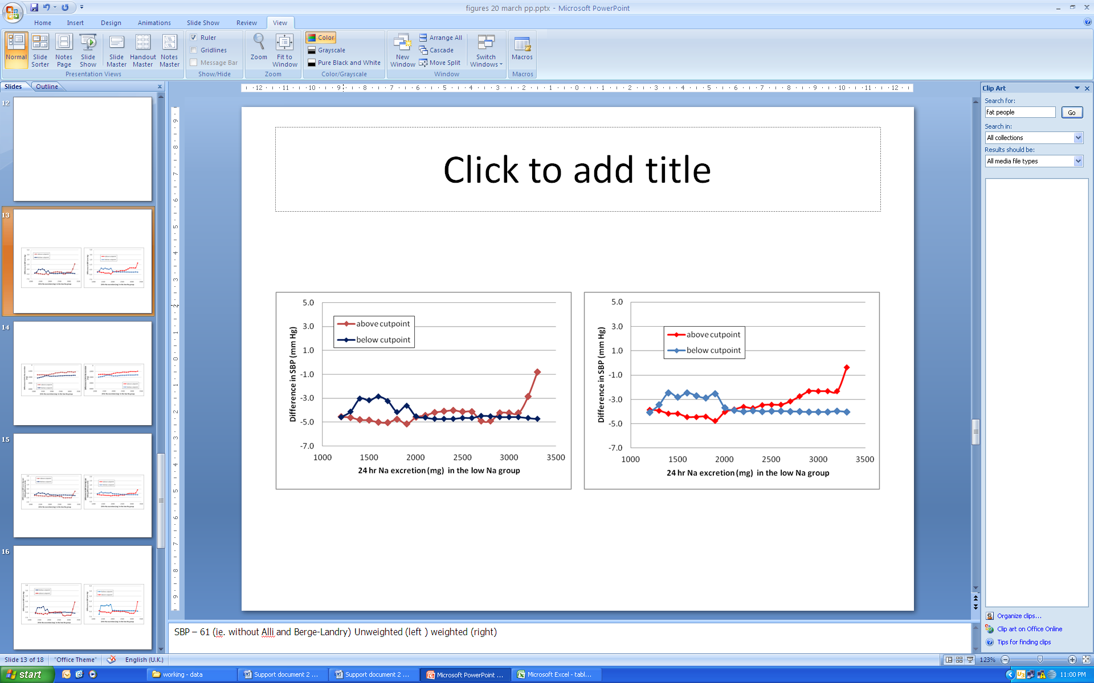

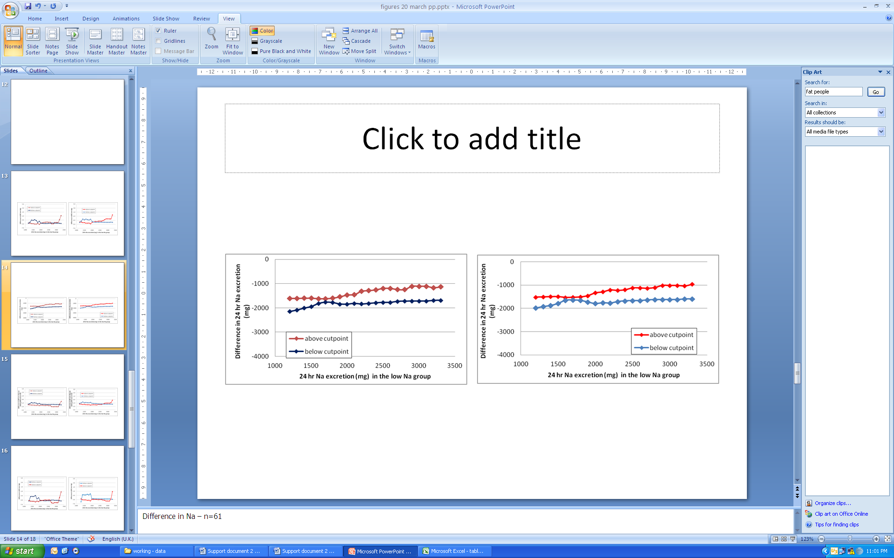

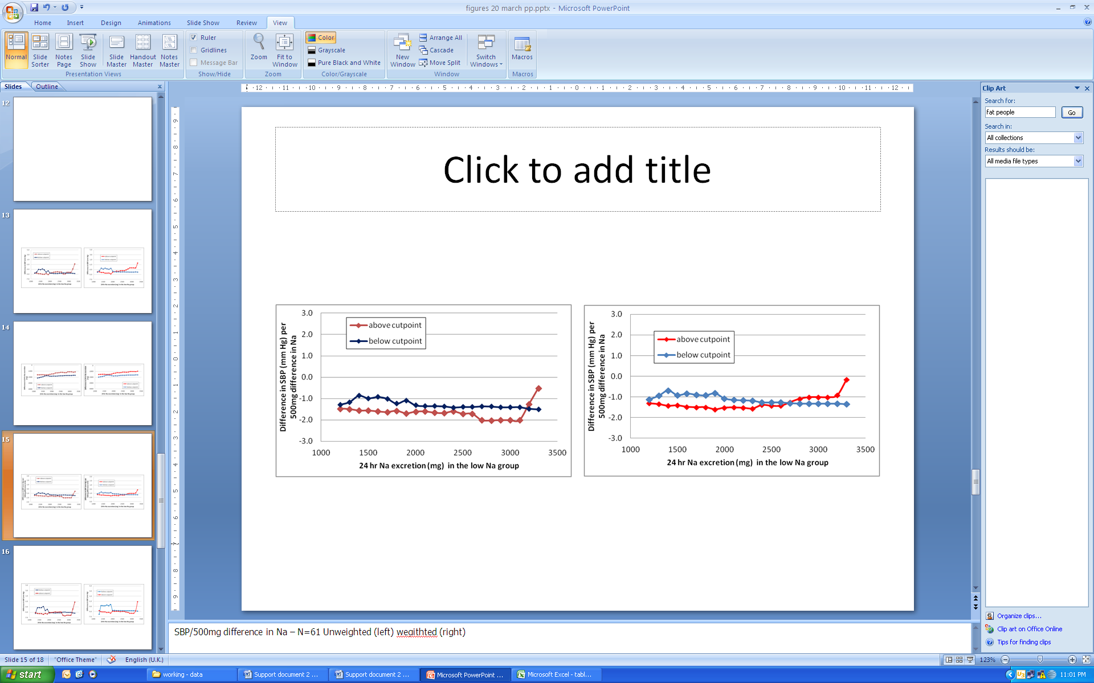

*Figure 10 Mean difference in SBP (top), 24-hour urinary Na excretion (middle) and SBP/500mg Na excretion (bottom) above and below a moving cutpoint in the low sodium group calculated using a simple average (left) or weighted using weights from the meta-analysis (right hand series), in all 61 observations*

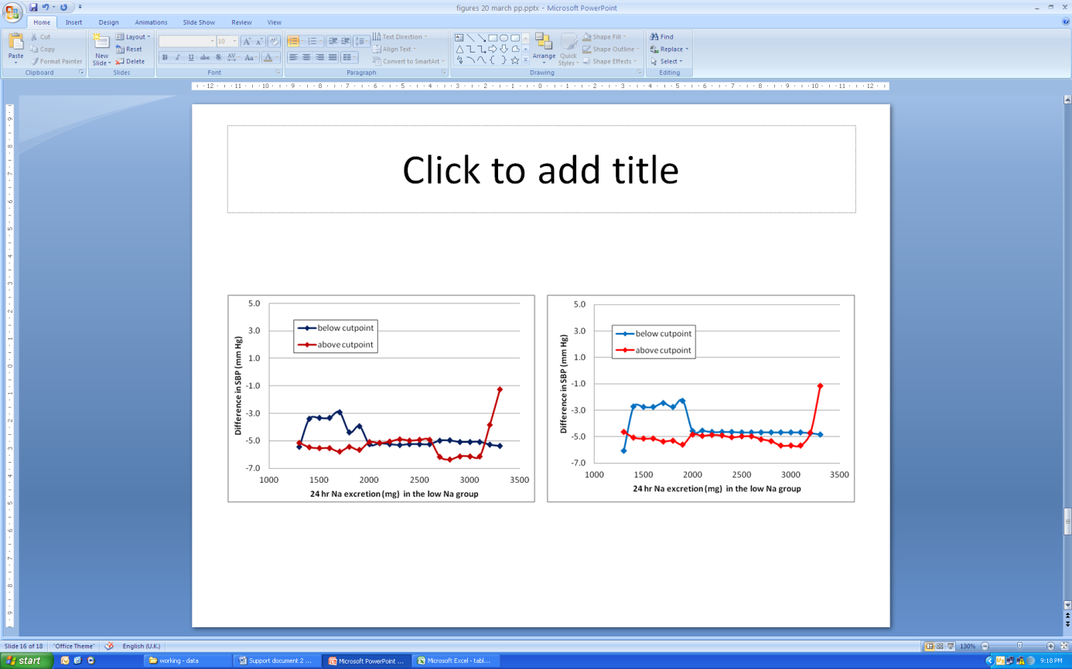

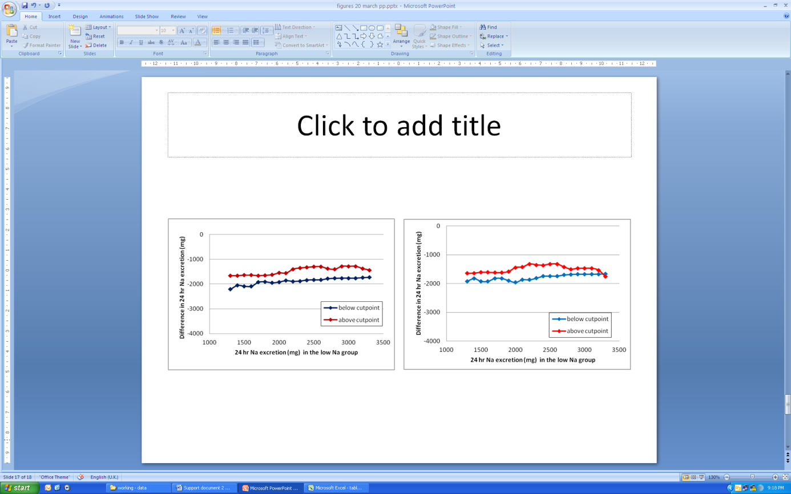

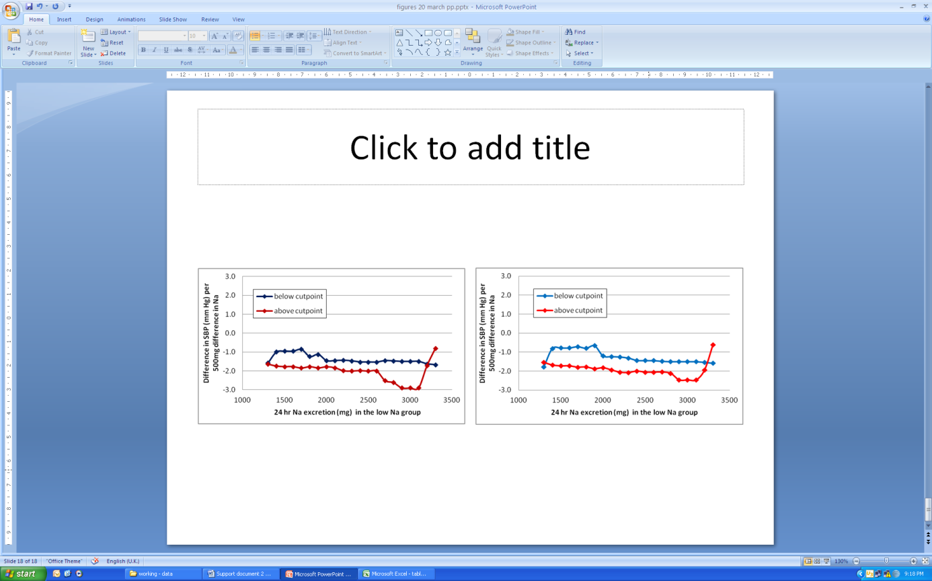

*Figure 11 Mean difference in SBP (top), 24-hour urinary Na excretion (middle) and SBP/500mg Na excretion (bottom) above and below a moving cutpoint in the low sodium group calculated using a simple average (left) or weighted using weights from the meta-analysis (right hand series), in hypertensive subjects only (n=42)*

This analysis has been done as the inverse of what might normally be done for investigation of a UL. Hence references to decreases in SBP in relation to the low sodium excretion group sodium can also be interpreted as an increase in SBP when sodium excretion increases from the value in the low sodium group. Although the lines are not superimposed on each other, there is no pattern there is no clear trend of convergence or divergence in the lines that would suggest a point at which the effect is changing in relation to the excretion in the low sodium group over the range of 1300mg to 3300mg. Although there seems to be an increasing effect of sodium values per 500mg above the cutpoint in the hypertensives, this does not incidate that a point of incresing effect is found becuase the effect is also increasing in the below cutpoint group, whereas the effect should decrease in the below cutpoint group is a UL-type of point is reached.

Categorisation of the high Na excretion group

This analysis is based on a similar categorisation in the WHO report [11] and examines whether the effect varies in groups defined on the excretion in the high Na group. As indicated in earlier Figures, the group with the highest values in the high Na group also tested the largest difference between the low and high Na groups. Among all groups, the largest decrease in SBP per 500mg Na decrease occurred in the middle group and there was a similar less pronounced inverted U-shape in the hypertensive groups (Table 7). This analysis is difficult to intrepret in the current context of setting values for a UL which needs to examine increaseing intake above the criterion value, not decreasing intakes below it. The difference between the groups has not been formally tested in this exploratory analysis. Although the average intake of Na is unclear, it is likely to be at the low end of values shown in Table 7.

*Table 7 Categorisation of differences in SBP by category of 24 hr Na excretion (mg) in the high sodium group*

|  |  |  |  |  |  |  |  |
| --- | --- | --- | --- | --- | --- | --- | --- |
|  | Category of 24 hr Na excretion (mg) in the high Na group |  | All groups (n=61) |  | Hypertensive groups only (n=42) | | |
|  | N | Mean | Weighted mean | N | Mean | Weighted mean |
| Difference in SBP | <3000 | 8 | -2.9 | -2.4 | 5 | -3.3 | -2.6 |
| 3000-3499 | 13 | -3.3 | -2.7 | 6 | -3.2 | -2.9 |
| 3500-3999 | 18 | -5.6 | -5.5 | 13 | -5.6 | -5.5 |
| 4000-4499 | 15 | -5.1 | -3.9 | 12 | -6.2 | -5.5 |
| >=4500 | 7 | -4.7 | -5.1 | 6 | -5.8 | -6.4 |
|  |  |  |  |  |  |  |  |
| Difference in Na between high and low groups | <3000 | 8 | -1248 | -1224 | 5 | -1343 | -1416 |
| 3000-3499 | 13 | -1577 | -1522 | 6 | -1430 | -1326 |
| 3500-3999 | 18 | -1636 | -1625 | 13 | -1641 | -1626 |
| 4000-4499 | 15 | -1556 | -1436 | 12 | -1684 | -1690 |
| >=4500 | 7 | -2571 | -2621 | 6 | -2549 | -2610 |
|  |  |  |  |  |  |  |  |
| Difference in SBP per 500mg decrease in Na | <3000 | 8 | -1.3 | -1.1 | 5 | -1.4 | -1.0 |
| 3000-3499 | 13 | -1.2 | -1.1 | 6 | -1.4 | -1.4 |
| 3500-3999 | 18 | -1.7 | -1.8 | 13 | -1.6 | -1.7 |
| 4000-4499 | 15 | -1.7 | -1.3 | 12 | -2.1 | -1.8 |
| >=4500 | 7 | -1.0 | -1.0 | 6 | -1.3 | -1.2 |
|  |  |  |  |  |  |  |  |
| Total |  | 61 | -1.5 | -1.3 | 42 | -1.6 | -1.6 |

Summary

Hence it is concluded that the data represent random variation around common effect over the range examined and that there is no breakpoint where the effect size increases. Therefore it is not possible to define a UL based the data analysis. If a UL is to be set, then either a different health endpoint needs to be examined, or other considerations must be articulated.

It is possible that a value at which the effect on SBP changes exists either above or below this range (e.g. the range 1300mg-3300mg might lie on the straigh mid-section of a sigmoidal curve) but this cannot be determined from the available data.

## 3.5 Examination of data for SDT purposes

The data analysis for the UL indicates no breakpoint for selecting an SDT.

Dose-response relationship

One study did not give any indication of the age of its subjects and was excluded [30]. When all studies were included (including Alli et al. [9] and van-Berge-Landry et al. [23] , the difference in Na was a significant predictor of the difference in SBP both in a univariate model and a multivariate model containing age and blood pressure status (-1.01 mm Hg per 500mg decrease in Na excretion). However when these two studies were excluded as has been done for the analysis overall, the relationship with Na was smaller (-0.42 mm Hg per 500mg decrease in Na excretion) and no longer significant. The change was specifically due to the exclusion of van Berge-Landry et al. [23] who tested a difference of 6500mg in Na excretion.

*Table 8 Weighted regression of the relationship between difference in sodium intake between the high and low groups and difference in blood pressure (NB because both difference in sodium and blood pressure are negative, i.e. going in the same direction, the regression coefficient is positive)*

|  |  |  |  |  |  |  |  |  |
| --- | --- | --- | --- | --- | --- | --- | --- | --- |
| Parameter |  | | Univariate | | | | Multivariate | |
|  |  | | Coefficient (mm Hg) | | | p | Coefficient (mm Hg) | p |
| *All studies with age data, including the two excluded studies (n=62)* | | | | | | | |  |
| Difference in Na, per 500 mg | | | | | 1.08 | <0.001 | 1.01 | <0.001 |
| Age, per year | |  | | | . | . | -0.10 | 0.02 |
| Blood pressure status | | NT vs HT | | | . | . | 1.75 | } 0.11* |
|  | | Mixed vs HT | | | . | . | -0.57 | } |
| Constant | |  | | | -0.46 | 0.63 | 3.82 | 0.11 |
|  | |  | | |  |  |  |  |
| Adjusted r2 for model | |  | | | 0.23 | . | 0.34 | . |
|  | |  | | |  |  |  |  |
| *Included studies with age data only (n=60)* | | | | | |  |  |  |
| Difference in Na, per 500 mg | | | | 0.60 | | 0.14 | 0.42 | 0.27 |
| Age, per year | |  | | . | | . | -0.09 | 0.03 |
| Blood pressure status | | NT vs HT | | . | | . | 2.20 | } 0.09* |
|  | | Mixed vs HT | | . | | . | -0.16 | } |
| Constant | |  | | -1.97 | | 0.15 | 1.23 | 0.62 |
|  | |  | |  | |  |  |  |
| Adjusted r2 for model | |  | | 0.02 | | . | 0.20 | . |

* F test for the blood pressure variable

Extrapolation of the meta-analysis results to Australia and New Zealand

In the meta-analysis, only 13 of the 61 observation groups were normotensive in whom the impact is lower than in hypertensives (Figure 9). Hence the overall meta-analysis results do not predict what the effect of sodium reduction would be in the general Australian and New Zealand population where the prevalence of normal blood pressure is much greater than in the studies included in the meta-analysis. In the 1999-2000 round of the AusDiab survey of adults 25 years and older, 30% had elevated blood pressure when measured or were on medication for high blood pressure [17] . Using this prevalence to weight the category specific results for hypertensives and normotensives yields an estimated reduction of 2.1mm Hg in SBP in the adult Australian population for a reduction of around 1700mg in sodium intake. In the 2011-12 New Zealand Health Survey of adults, 16% reported that they were taking medication for high blood pressure but blood pressure was not measured as part of the survey [18]. Using this prevalence for weighting yields an estimated effect of -1.9mmHg in SBP. To date, only the measured prevalence of high blood pressure (systolic or diastolic blood pressure equal to or greater than 140/90 mmHg) in adults aged 18 years and older has been reported for the 2012 Australian Health Survey [19]). Using this prevalence (21.5%) for weighting yields an estimated effect of -1.6mmHg in SBP. This does not take into account whether other factors that might affect the response of blood pressure to sodium reduction are the same in the study populations and the populations of New Zealand and Australia.

Summary

As shown in Table 6, the reduction in sodium excretion was similar in normotensive and hypertensive groups. Therefore it can be concluded that SBP would decrease by 2mm Hg if a population containing 30% hypertensives reduced its mean sodium excretion from about 3500mg to about 2100mg. Current total sodium intakes in both countries are unclear but might sufficiently similar to 3500mg/day that this result can be applied.

When setting an SDT, it would also be important to consider whether it is possible for a population to simultaneously achieve the NRV for adequate intake and the NRV for health status improvement (SDT). It is not clear whether the SDT is a target for the average value in the population or all of the population (note that technical specification of a performance indicator for assessing population intakes is different from the message given to individuals in a clinical situation). If the SDT is a target for all the population, then it cannot be set lower than the (unknown) 97th centile of intake that would be seen when the median Na intake is on the upper bound of the AI (920mg). This considers only adequacy of sodium intake. There are other calculations that have determined the sodium intake that must be achieved to ensure adequate intakes of all essential micronutrients. These analyses have not been done as part of this project.

**4 Results: Diastolic blood pressure**

Time did not permit examining the data for diastolic blood pressure.

**5 Results: cholesterol**

Meta-analyses for total, HDL and LDL cholesterol are shown in Appendix 4.

Pooled results for the random effects meta-analyses are shown in Table 9.

*Table 9: Pooled results for the effect of sodium reduction on total, HDL and LDL cholesterol (mmol/L)1*

|  |  |  |
| --- | --- | --- |
| Outcome | Weighted mean difference | 95% Confidence Intervals |
| Total cholesterol | 0.032 | -0.019 to 0.084 |
| HDL cholesterol | -0.006 | -0.021 to 0.009 |
| LDL cholesterol | 0.023 | -0.025 to 0.072 |

1 Studies listed in Support Document 1

**6.Conclusions**

Overall, there was a weighted average of -3.9mmHg. Heterogeneity among the studies was classified as medium overall (I2=72%). The impact on SBP was different in normotensives (-1.0mm Hg) and hypertensives (-4.7mm Hg). The studies included in the meta-analysis contained a much higher proportion of hypertensive groups than the prevalence in Australia or New Zealand and so the overall meta-analysis results cannot be extrapolated to the two countries. Using a prevalence of 30% (from a survey in Australia that defined hypertension based on either blood pressure measurement at interview or use of medication [17]) to weight the category specific results for hypertensives and normotensives yields an estimated reduction of 2.1mm Hg in SBP in the adult population mean sodium excretion from abut 3500mg to about 2100mg.

The association between different measures of sodium excretion and systolic blood pressure were examined in several ways. A point at which increasing sodium excretion increased the impact on SBP could not be identified. The available data covered the range 1200-3300mg sodium and therefore we conclude that the data are linear in this range. Therefore, if there is a UL, it does not lie in the range of the data examined. It cannot be extrapolated from the data because the concept of a UL implies non-linearity in the data.

Similarly to the UL, it is not possible to identify a point which could be used as an SDT. One possibility might be to use the result of the meta-analysis which showed a reduction in SBP when mean population excretion is lowered from about 3500mg to 2100mg/day. Current total sodium intakes in both countries are unclear but might sufficiently similar to 3500mg/day that this result can be applied. Additional criteria are needed to define the goals for what the SDT should indicate and an analysis to ensure that the NRV for adequacy can also be met is also needed.

When setting NRVs, the conversion factor from the available data (24 hour sodium excretion) to a dietary intake needs to be factored in.

1. Department of Health and Ageing, *Methodological framework for the review of Nutrient Reference Values*, 2013.

2. World Health Organization, *Guideline: Sodium intake for adults and children*, 2012, World Health Organization (WHO): Geneva.

3. Sacks, F.M., et al., *Effects on blood pressure of reduced dietary sodium and the dietary approaches to stop hypertension (DASH) diet.* New England Journal of Medicine, 2001. **344**(1): p. 3-10.

4. Macgregor, G.A., et al., *DOUBLE-BLIND-STUDY OF 3 SODIUM INTAKES AND LONG-TERM EFFECTS OF SODIUM RESTRICTION IN ESSENTIAL-HYPERTENSION.* Lancet, 1989. **2**(8674): p. 1244-1247.

5. National Health and Medical Research Council and New Zealand Ministry of Health, *Nutrient Reference Values for Australia and New Zealand including recommended dietary intakes.* 2006.

6. National Health and Medical Research Association and New Zealand Ministry of Health, *Evidence appendix for nutrient reference values for Australia and New Zealand*, 2005.

7. Graudal, N.A., T. Hubeck-Graudal, and G. Jurgens, *Effects of low sodium diet versus high sodium diet on blood pressure, renin, aldosterone, catecholamines, cholesterol, and triglyceride.* Cochrane Database of Systematic Reviews, 2011(11).

8. Kirkendall, A.M., et al., *The effect of dietary sodium chloride on blood pressure, body fluids, electrolytes, renal function, and serum lipids of normotensive man.* The Journal of laboratory and clinical medicine, 1976. **87**(3): p. 411-34.

9. Alli, C., et al., *FEASIBILITY OF A LONG-TERM LOW-SODIUM DIET IN MILD HYPERTENSION.* Journal of Human Hypertension, 1992. **6**(4): p. 281-286.

10. He, F., J. Li, and G. MacGregor, *Effect of longer-term modest salt reduction on blood pressure.* Cochrane Database of Systematic Reviews, 2013(4).

11. World Health Organisation, *Effect of reduced sodium intake on blood pressure, renal function, blood lipids and other potential adverse effects*, 2012: Geneva.

12. Hypertension Prevention Trial Research, G., *The hypertension prevention trial: Three-year effects of dietary changes on blood pressure.* Archives of Internal Medicine, 1990. **150**(1): p. 153-162.

13. Follmann, D., et al., *Variance imputation for overviews of clinical trials with continuous response.* Journal of Clinical Epidemiology, 1992. **45**(7): p. 769 - 773.

14. DerSimonian, R. and N. Laird, *Meta-analysis in clinical trials.* Controlled Clinical Trials, 1986. **7**(3): p. 177-188.

15. Higgins, J.P.T., et al., *Measuring inconsistency in meta-analyses.* BMJ, 2003. **327**(7414): p. 557-560.

16. Izzo Jr, J., D. Levy, and H. Black. *Clinical advisory statement: Importance of systolic blood pressure in older Americans*. [cited 2014; Available from: https://[www.nhlbi.nih.gov/health/prof/heart/hbp/hbpstmt/hbpstmt.htm](http://www.nhlbi.nih.gov/health/prof/heart/hbp/hbpstmt/hbpstmt.htm).

17. Australian Institute of Health and Welfare, *Australia's health 2010*, 2010: Canberra.

18. New Zealand Ministry of Health, *The Health of New Zealand Adults 2011/12: Key findings of the New Zealand Health Survey*, 2012: Wellington.

19. Australian Bureau of Statistics, *4364.0.55.001 - Australian Health Survey: First Results, 2011-12*, 2012: Canberra.

20. Arroll, B. and R. Beaglehole, *SALT RESTRICTION AND PHYSICAL-ACTIVITY IN TREATED HYPERTENSIVES.* New Zealand Medical Journal, 1995. **108**(1003): p. 266-268.

21. Dubbert, P.M., et al., *EFFECTS OF DIETARY INSTRUCTION AND SODIUM-EXCRETION FEEDBACK IN HYPERTENSION CLINIC PATIENTS.* Behavior Therapy, 1995. **26**(4): p. 721-732.

22. Mascioli, S., et al., *SODIUM-CHLORIDE RAISES BLOOD-PRESSURE IN NORMOTENSIVE SUBJECTS - THE STUDY OF SODIUM AND BLOOD-PRESSURE.* Hypertension, 1991. **17**(1): p. I21-I26.

23. van Berge-Landry, H. and G.D. James, *Serum electrolyte, serum protein, serum fat and renal responses to a dietary sodium challenge: Allostasis and allostatic load.* Annals of Human Biology, 2004. **31**(4): p. 477-487.

24. Morgan, T., et al., *HYPERTENSION TREATED BY SALT RESTRICTION.* Lancet, 1978. **1**(8058): p. 227-230.

25. Andersson, O.K., B. Fagerberg, and T. Hedner, *IMPORTANCE OF DIETARY SALT IN THE HEMODYNAMIC ADJUSTMENT TO WEIGHT-REDUCTION IN OBESE HYPERTENSIVE MEN.* Hypertension, 1984. **6**(6): p. 814-819.

26. Fagerberg, B., et al., *BLOOD-PRESSURE CONTROL DURING WEIGHT-REDUCTION IN OBESE HYPERTENSIVE MEN - SEPARATE EFFECTS OF SODIUM AND ENERGY RESTRICTION.* British Medical Journal, 1984. **288**(6410): p. 11-14.

27. Parker, M., et al., *2-WAY FACTORIAL STUDY OF ALCOHOL AND SALT RESTRICTION IN TREATED HYPERTENSIVE MEN.* Hypertension, 1990. **16**(4): p. 398-406.

28. Nestel, P.J., et al., *ENHANCED BLOOD-PRESSURE RESPONSE TO DIETARY SALT IN ELDERLY WOMEN, ESPECIALLY THOSE WITH SMALL WAIST-HIP RATIO.* Journal of Hypertension, 1993. **11**(12): p. 1387-1394.

29. National Heart Foundation of Australia (National Blood Pressure and Vascular Disease Advisory Committee), *Guide to management of hypertension*, 2008 Updated 2010, National Heart Foundation of Australia.

30. Suckling, R., et al., *MODEST SALT REDUCTION LOWERS BLOOD PRESSURE AND URINARY ALBUMIN EXCRETION IN IMPAIRED GLUCOSE TOLERANCE AND TYPE 2 DIABETES.* Journal of Hypertension, 2010. **28**: p. E219-E219.

Appendix

1 Supplementary analyse

2 Data used to generate Figures 10 and 11

3 Results of selected analyses repeated after including Alli et al and van Berge-Landry et al

4: Total, HDL and LDL cholesterol meta-analyses

## Appendix 1 – Supplementary analyses

Influence of seated or supine posture on blood pressure results

There was a notable difference (2mm Hg) in the size of effect on SBP according to whether resting blood pressure was measured supine or seated (Table A1.1). All except one of the observation groups measured in the supine posture had a blood pressure status of HT or mixed. When the effect on blood pressure was examined by groups of posture and blood pressure status (Figure A1.1), it was evident that the effect was the same in HT who were measured either seated or supine. In addition, there was a difference in effect size by blood pressure status among those measured seated. There were too few observations in the other groups to draw meaningful conclusions.

Therefore it was concluded that the difference in effect on SBP was due to confounding by blood pressure status and could be ignored in the analysis.

*Table A1.1 Difference in SBP between low and high sodium excretion groups by posture of blood pressure measurement*

|  |  |  |  |  |
| --- | --- | --- | --- | --- |
|  | Posture for measurement of resting BP | | | |
|  | supine | seated | not stated | total |
| *Effect from meta-analysis* | | *difference in SBP (mm Hg)* | | |
|  | -5.2 | -3.3 | -2.4 | -3.9 |
|  |  |  |  |  |
| *Hypertension status* | *N* | *N* | *N* | *N* |
| HT or mixed | 27 | 19 | 2 | 48 |
| NT | 1 | 11 | 1 | 13 |
|  |  |  |  |  |
| Total | 28 | 30 | 3 | 61 |

Influence of intervention type (diet or pills) on blood pressure results

Influence of design (cross-over or parallel) on blood pressure results



*Figure A1.1 Meta-analysis of the difference in SBP in the group with lower 24 hour urinary Na excretion compared to the group with higher Na excretion, by hypertension status of participants at baseline and posture when blood pressure was measured, ordered by decreasing width of 95% confidence interval*

## Appendix 2 – data used to generate Figures 10 and 11

##### Table A2.1 All included observations (n=61), simple average

|  |  |  |  |  |  |  |  |  |  |
| --- | --- | --- | --- | --- | --- | --- | --- | --- | --- |
| Cutpoint | Mean value in observation groups where 24-hour sodium excretion in the low sodium group was **below** the cutpoint | | | |  | Mean value in observation groups where 24-hour sodium excretion in the low sodium group **was greater than or equal** to the cutpoint | | | |
|  | Difference in SBP | Difference in Na excretion in the low sodium group | Difference in SBP per 500mg increment in Na excretion | N |  | Difference in SBP | Difference in Na excretion in the low sodium group | Difference in SBP per 500mg increment in Na excretion | N |
| 1200 | -4.6 | -2151 | -1.3 | 6 |  | -4.5 | -1606 | -1.5 | 55 |
| 1300 | -4.1 | -2088 | -1.2 | 7 |  | -4.6 | -1605 | -1.5 | 54 |
| 1400 | -3.0 | -2012 | -0.9 | 9 |  | -4.8 | -1599 | -1.6 | 52 |
| 1500 | -3.2 | -1943 | -1.0 | 11 |  | -4.8 | -1598 | -1.6 | 50 |
| 1600 | -2.9 | -1821 | -0.9 | 13 |  | -5.0 | -1616 | -1.6 | 48 |
| 1700 | -3.2 | -1766 | -1.0 | 17 |  | -5.0 | -1619 | -1.6 | 44 |
| 1800 | -4.1 | -1783 | -1.2 | 21 |  | -4.8 | -1595 | -1.6 | 40 |
| 1900 | -3.6 | -1843 | -1.1 | 24 |  | -5.1 | -1541 | -1.7 | 37 |
| 2000 | -4.5 | -1847 | -1.3 | 31 |  | -4.6 | -1467 | -1.6 | 30 |
| 2100 | -4.6 | -1816 | -1.4 | 35 |  | -4.4 | -1450 | -1.6 | 26 |
| 2200 | -4.7 | -1842 | -1.4 | 40 |  | -4.2 | -1313 | -1.7 | 21 |
| 2300 | -4.7 | -1817 | -1.4 | 43 |  | -4.1 | -1286 | -1.7 | 18 |
| 2400 | -4.7 | -1793 | -1.4 | 46 |  | -4.0 | -1254 | -1.6 | 15 |
| 2500 | -4.6 | -1774 | -1.4 | 49 |  | -4.1 | -1194 | -1.7 | 12 |
| 2600 | -4.6 | -1774 | -1.4 | 49 |  | -4.1 | -1194 | -1.7 | 12 |
| 2700 | -4.5 | -1732 | -1.4 | 52 |  | -4.9 | -1244 | -2.0 | 9 |
| 2800 | -4.5 | -1723 | -1.4 | 53 |  | -4.9 | -1240 | -2.0 | 8 |
| 2900 | -4.6 | -1720 | -1.4 | 55 |  | -4.2 | -1108 | -2.0 | 6 |
| 3000 | -4.6 | -1720 | -1.4 | 55 |  | -4.2 | -1108 | -2.0 | 6 |
| 3100 | -4.6 | -1720 | -1.4 | 55 |  | -4.2 | -1108 | -2.0 | 6 |
| 3200 | -4.7 | -1695 | -1.5 | 57 |  | -2.9 | -1166 | -1.3 | 4 |
| 3300 | -4.7 | -1687 | -1.5 | 58 |  | -0.8 | -1133 | -0.5 | 3 |

##### Table A2.2 All included observations (n=61), weighted average

|  |  |  |  |  |  |  |  |  |  |
| --- | --- | --- | --- | --- | --- | --- | --- | --- | --- |
| Cutpoint | Mean value in observation groups where 24-hour sodium excretion in the low sodium group was **below** the cutpoint | | | |  | Mean value in observation groups where 24-hour sodium excretion in the low sodium group **was greater than or equal** to the cutpoint | | | |
|  | Difference in SBP | Difference in Na excretion in the low sodium group | Difference in SBP per 500mg increment in Na excretion | N |  | Difference in SBP | Difference in Na excretion in the low sodium group | Difference in SBP per 500mg increment in Na excretion | N |
| 1200 | -4.1 | -1987 | -1.1 | 6 |  | -3.8 | -1518 | -1.3 | 55 |
| 1300 | -3.4 | -1922 | -1.0 | 7 |  | -3.9 | -1511 | -1.4 | 54 |
| 1400 | -2.5 | -1876 | -0.7 | 9 |  | -4.2 | -1499 | -1.4 | 52 |
| 1500 | -2.8 | -1790 | -0.9 | 11 |  | -4.2 | -1498 | -1.4 | 50 |
| 1600 | -2.5 | -1652 | -0.8 | 13 |  | -4.5 | -1529 | -1.5 | 48 |
| 1700 | -2.7 | -1642 | -0.9 | 17 |  | -4.4 | -1527 | -1.5 | 44 |
| 1800 | -2.9 | -1661 | -0.9 | 21 |  | -4.4 | -1512 | -1.5 | 40 |
| 1900 | -2.5 | -1729 | -0.8 | 24 |  | -4.8 | -1456 | -1.6 | 37 |
| 2000 | -3.7 | -1795 | -1.1 | 31 |  | -4.0 | -1336 | -1.5 | 30 |
| 2100 | -3.9 | -1759 | -1.2 | 35 |  | -3.8 | -1293 | -1.5 | 26 |
| 2200 | -4.0 | -1771 | -1.2 | 40 |  | -3.6 | -1208 | -1.5 | 21 |
| 2300 | -3.9 | -1709 | -1.2 | 43 |  | -3.7 | -1229 | -1.6 | 18 |
| 2400 | -4.0 | -1677 | -1.3 | 46 |  | -3.5 | -1201 | -1.4 | 15 |
| 2500 | -4.0 | -1668 | -1.3 | 49 |  | -3.4 | -1120 | -1.4 | 12 |
| 2600 | -4.0 | -1668 | -1.3 | 49 |  | -3.4 | -1120 | -1.4 | 12 |
| 2700 | -4.0 | -1638 | -1.3 | 52 |  | -3.2 | -1135 | -1.3 | 9 |
| 2800 | -4.0 | -1626 | -1.3 | 53 |  | -2.7 | -1103 | -1.1 | 8 |
| 2900 | -4.0 | -1625 | -1.3 | 55 |  | -2.3 | -1012 | -1.0 | 6 |
| 3000 | -4.0 | -1625 | -1.3 | 55 |  | -2.3 | -1012 | -1.0 | 6 |
| 3100 | -4.0 | -1625 | -1.3 | 55 |  | -2.3 | -1012 | -1.0 | 6 |
| 3200 | -4.0 | -1599 | -1.3 | 57 |  | -2.3 | -1033 | -0.9 | 4 |
| 3300 | -4.0 | -1595 | -1.4 | 58 |  | -0.4 | -965 | -0.2 | 3 |

##### Table A2.3 Hypertensives only (n=42), simple average

|  |  |  |  |  |  |  |  |  |  |
| --- | --- | --- | --- | --- | --- | --- | --- | --- | --- |
| Cutpoint | Mean value in observation groups where 24-hour sodium excretion in the low sodium group was **below** the cutpoint | | | |  | Mean value in observation groups where 24-hour sodium excretion in the low sodium group **was greater than or equal** to the cutpoint | | | |
|  | Difference in SBP | Difference in Na excretion in the low sodium group | Difference in SBP per 500mg increment in Na excretion | N |  | Difference in SBP | Difference in Na excretion in the low sodium group | Difference in SBP per 500mg increment in Na excretion | N |
| 1300 | -5.5 | -2208 | -1.6 | 4 |  | -5.1 | -1666 | -1.6 | 38 |
| 1400 | -3.4 | -2055 | -1.0 | 6 |  | -5.5 | -1661 | -1.7 | 36 |
| 1500 | -3.3 | -2090 | -0.9 | 7 |  | -5.5 | -1643 | -1.8 | 35 |
| 1600 | -3.3 | -2090 | -0.9 | 7 |  | -5.5 | -1643 | -1.8 | 35 |
| 1700 | -2.9 | -1927 | -0.9 | 9 |  | -5.8 | -1660 | -1.8 | 33 |
| 1800 | -4.4 | -1911 | -1.2 | 11 |  | -5.5 | -1649 | -1.8 | 31 |
| 1900 | -3.9 | -1951 | -1.1 | 12 |  | -5.7 | -1624 | -1.8 | 30 |
| 2000 | -5.3 | -1917 | -1.5 | 19 |  | -5.1 | -1552 | -1.8 | 23 |
| 2100 | -5.2 | -1864 | -1.5 | 22 |  | -5.2 | -1556 | -1.8 | 20 |
| 2200 | -5.2 | -1894 | -1.4 | 27 |  | -5.1 | -1400 | -2.0 | 15 |
| 2300 | -5.3 | -1880 | -1.5 | 29 |  | -4.9 | -1356 | -2.0 | 13 |
| 2400 | -5.2 | -1839 | -1.5 | 32 |  | -5.0 | -1329 | -2.0 | 10 |
| 2500 | -5.2 | -1830 | -1.5 | 33 |  | -4.9 | -1303 | -2.0 | 9 |
| 2600 | -5.2 | -1830 | -1.5 | 33 |  | -4.9 | -1303 | -2.0 | 9 |
| 2700 | -5.0 | -1784 | -1.5 | 35 |  | -6.2 | -1385 | -2.5 | 7 |
| 2800 | -5.0 | -1770 | -1.5 | 36 |  | -6.4 | -1403 | -2.6 | 6 |
| 2900 | -5.1 | -1763 | -1.5 | 38 |  | -6.1 | -1287 | -2.9 | 4 |
| 3000 | -5.1 | -1763 | -1.5 | 38 |  | -6.1 | -1287 | -2.9 | 4 |
| 3100 | -5.1 | -1763 | -1.5 | 38 |  | -6.1 | -1287 | -2.9 | 4 |
| 3200 | -5.3 | -1743 | -1.6 | 39 |  | -3.8 | -1380 | -1.7 | 3 |
| 3300 | -5.4 | -1732 | -1.7 | 40 |  | -1.3 | -1438 | -0.8 | 2 |

##### Table A2.4 Hypertensives only (n=42), weighted average

|  |  |  |  |  |  |  |  |  |  |
| --- | --- | --- | --- | --- | --- | --- | --- | --- | --- |
| Cutpoint | Mean value in observation groups where 24-hour sodium excretion in the low sodium group was **below** the cutpoint | | | |  | Mean value in observation groups where 24-hour sodium excretion in the low sodium group **was greater than or equal** to the cutpoint | | | |
|  | Difference in SBP | Difference in Na excretion in the low sodium group | Difference in SBP per 500mg increment in Na excretion | N |  | Difference in SBP | Difference in Na excretion in the low sodium group | Difference in SBP per 500mg increment in Na excretion | N |
| 1300 | -6.1 | -1918 | -1.8 | 4 |  | -4.6 | -1644 | -1.5 | 38 |
| 1400 | -2.7 | -1825 | -0.8 | 6 |  | -5.1 | -1637 | -1.7 | 36 |
| 1500 | -2.8 | -1921 | -0.8 | 7 |  | -5.2 | -1608 | -1.7 | 35 |
| 1600 | -2.8 | -1921 | -0.8 | 7 |  | -5.2 | -1608 | -1.7 | 35 |
| 1700 | -2.5 | -1820 | -0.7 | 9 |  | -5.4 | -1620 | -1.8 | 33 |
| 1800 | -2.8 | -1821 | -0.8 | 11 |  | -5.3 | -1617 | -1.8 | 31 |
| 1900 | -2.3 | -1896 | -0.7 | 12 |  | -5.6 | -1581 | -1.9 | 30 |
| 2000 | -4.6 | -1961 | -1.2 | 19 |  | -4.8 | -1442 | -1.8 | 23 |
| 2100 | -4.6 | -1863 | -1.2 | 22 |  | -4.9 | -1427 | -1.9 | 20 |
| 2200 | -4.7 | -1870 | -1.3 | 27 |  | -4.9 | -1323 | -2.1 | 15 |
| 2300 | -4.6 | -1812 | -1.3 | 29 |  | -4.9 | -1351 | -2.1 | 13 |
| 2400 | -4.6 | -1746 | -1.4 | 32 |  | -5.0 | -1363 | -2.0 | 10 |
| 2500 | -4.7 | -1738 | -1.4 | 33 |  | -5.0 | -1324 | -2.1 | 9 |
| 2600 | -4.7 | -1738 | -1.4 | 33 |  | -5.0 | -1324 | -2.1 | 9 |
| 2700 | -4.7 | -1700 | -1.5 | 35 |  | -5.2 | -1422 | -2.1 | 7 |
| 2800 | -4.7 | -1679 | -1.5 | 36 |  | -5.3 | -1500 | -2.1 | 6 |
| 2900 | -4.7 | -1675 | -1.5 | 38 |  | -5.7 | -1471 | -2.5 | 4 |
| 3000 | -4.7 | -1675 | -1.5 | 38 |  | -5.7 | -1471 | -2.5 | 4 |
| 3100 | -4.7 | -1675 | -1.5 | 38 |  | -5.7 | -1471 | -2.5 | 4 |
| 3200 | -4.7 | -1670 | -1.5 | 39 |  | -4.7 | -1533 | -1.9 | 3 |
| 3300 | -4.8 | -1661 | -1.6 | 40 |  | -1.2 | -1752 | -0.6 | 2 |

## Appendix 3 Results of selected analyses repeated after including Alli et al and van Berge-Landry et al

**Meta-analysis**



*Figure A3.1 Meta-analysis of the difference in SBP in the group with lower 24 hour urinary Na excretion compared to the group with higher Na excretion, by hypertension status of participants at baseline, ordered by decreasing width of 95% confidence interval (compare to Figure 9)*

**Examination of evidence for non-linear trend**

The data illustrated in Figure A3.1 are given in Tables A3.1 and A3.2

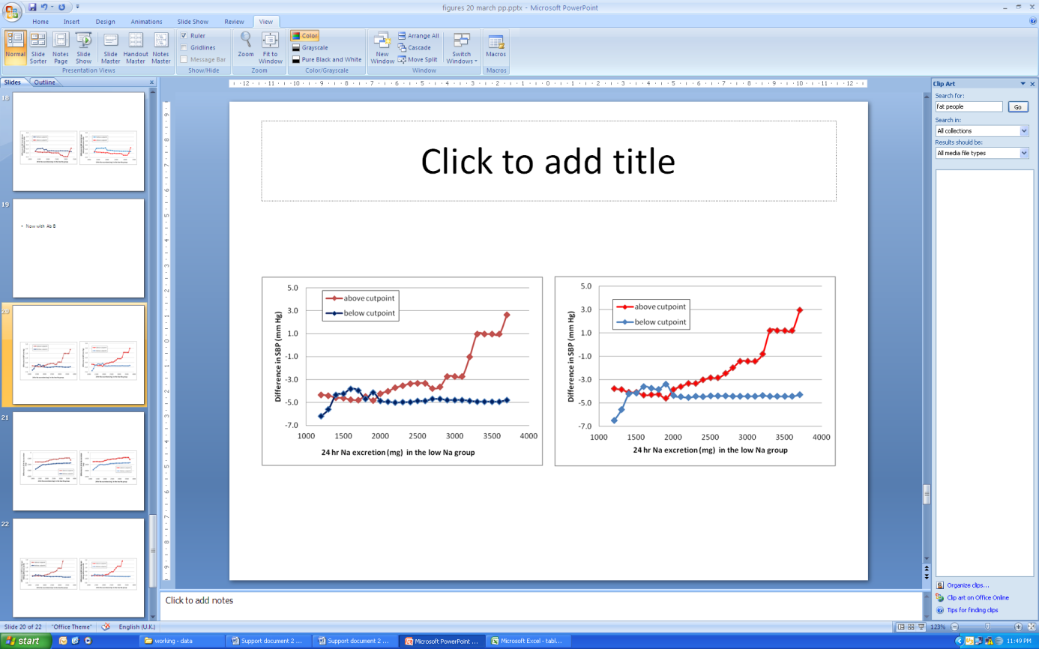

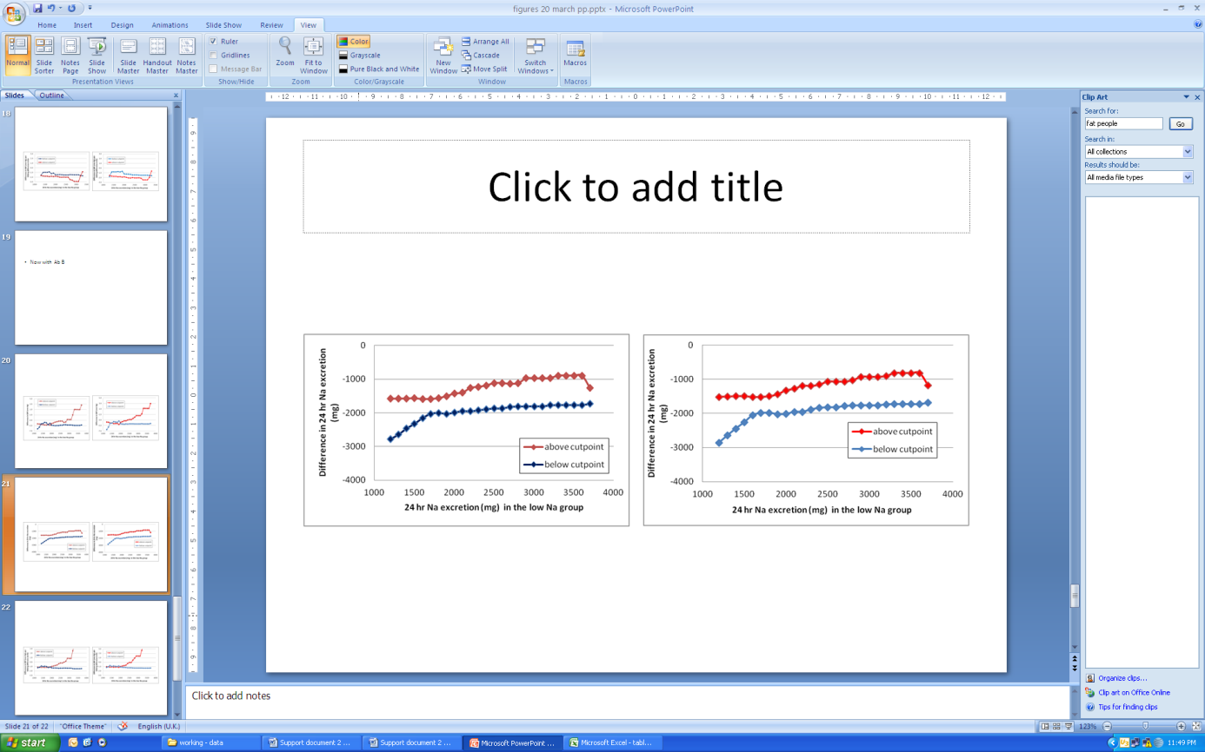

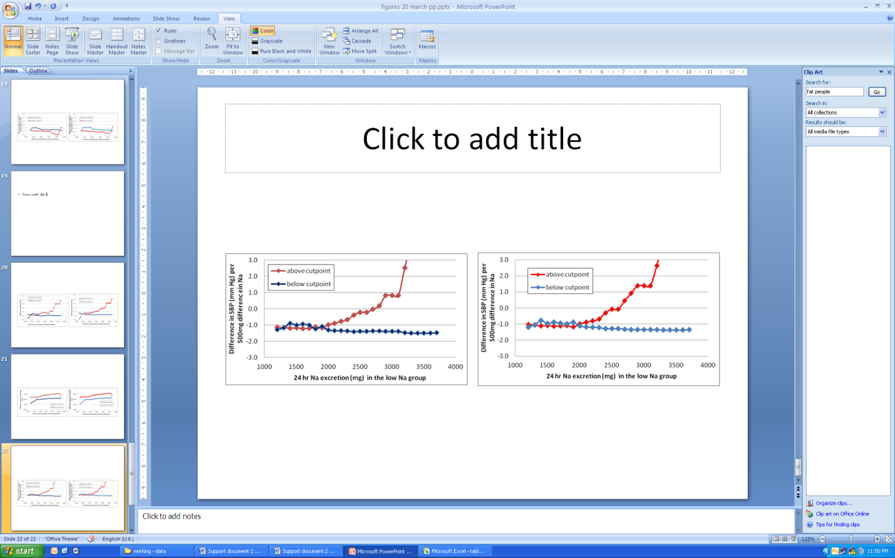

*Figure A3.2 Mean difference in SBP (top), 24-hour urinary Na excretion (middle) and SBP/500mg Na excretion (bottom) above and below a moving cutpoint in the low sodium group calculated using a simple average (left) or weighted using weights from the meta-analysis (right hand series), in 63 observations (compare to Figure 10)*

##### Table A3.1 All 63 observations, simple average

|  |  |  |  |  |  |  |  |  |  |  |
| --- | --- | --- | --- | --- | --- | --- | --- | --- | --- | --- |
| Cutpoint | Mean value in observation groups where 24-hour sodium excretion in the low sodium group was **below** the cutpoint | | | |  | Mean value in observation groups where 24-hour sodium excretion in the low sodium group **was greater than or equal** to the cutpoint | | | | |
|  | Difference in SBP | Difference in Na excretion in the low sodium group | Difference in SBP per 500mg increment in Na excretion | N | Difference in SBP | | Difference in Na excretion in the low sodium group | Difference in SBP per 500mg increment in Na excretion | N |
| 1200 | -6.2 | -2780 | -1.3 | 7 | -4.3 | | -1581 | -1.1 | 56 |
| 1300 | -5.6 | -2646 | -1.2 | 8 | -4.4 | | -1579 | -1.1 | 55 |
| 1400 | -4.3 | -2467 | -0.9 | 10 | -4.6 | | -1572 | -1.2 | 53 |
| 1500 | -4.3 | -2328 | -1.0 | 12 | -4.6 | | -1570 | -1.2 | 51 |
| 1600 | -3.8 | -2159 | -0.9 | 14 | -4.8 | | -1587 | -1.2 | 49 |
| 1700 | -4.0 | -2032 | -1.0 | 18 | -4.8 | | -1587 | -1.2 | 45 |
| 1800 | -4.7 | -2000 | -1.2 | 22 | -4.5 | | -1561 | -1.1 | 41 |
| 1900 | -4.1 | -2031 | -1.1 | 25 | -4.8 | | -1505 | -1.2 | 38 |
| 2000 | -4.9 | -1994 | -1.3 | 32 | -4.2 | | -1426 | -1.0 | 31 |
| 2100 | -4.9 | -1948 | -1.3 | 36 | -4.0 | | -1403 | -0.9 | 27 |
| 2200 | -5.0 | -1957 | -1.3 | 41 | -3.7 | | -1261 | -0.8 | 22 |
| 2300 | -5.0 | -1924 | -1.4 | 44 | -3.5 | | -1227 | -0.7 | 19 |
| 2400 | -5.0 | -1894 | -1.4 | 47 | -3.4 | | -1187 | -0.4 | 16 |
| 2500 | -4.9 | -1870 | -1.4 | 50 | -3.3 | | -1116 | -0.2 | 13 |
| 2600 | -4.9 | -1870 | -1.4 | 50 | -3.3 | | -1116 | -0.2 | 13 |
| 2700 | -4.7 | -1823 | -1.4 | 53 | -3.8 | | -1137 | 0.0 | 10 |
| 2800 | -4.7 | -1813 | -1.4 | 54 | -3.6 | | -1122 | 0.2 | 9 |
| 2900 | -4.8 | -1807 | -1.4 | 56 | -2.7 | | -975 | 0.8 | 7 |
| 3000 | -4.8 | -1807 | -1.4 | 56 | -2.7 | | -975 | 0.8 | 7 |
| 3100 | -4.8 | -1807 | -1.4 | 56 | -2.7 | | -975 | 0.8 | 7 |
| 3200 | -4.9 | -1778 | -1.5 | 58 | -1.0 | | -968 | 2.5 | 5 |
| 3300 | -4.9 | -1770 | -1.5 | 59 | 1.0 | | -894 | 4.1 | 4 |
| 3400 | -4.9 | -1770 | -1.5 | 59 | 1.0 | | -894 | 4.1 | 4 |
| 3500 | -4.9 | -1770 | -1.5 | 59 | 1.0 | | -894 | 4.1 | 4 |
| 3600 | -4.9 | -1770 | -1.5 | 59 | 1.0 | | -894 | 4.1 | 4 |
| 3700 | -4.8 | -1729 | -1.5 | 61 | 2.7 | | -1262 | 8.8 | 2 |

##### Table A3.2 All 63 observations, weighted average

|  |  |  |  |  |  |  |  |  |  |
| --- | --- | --- | --- | --- | --- | --- | --- | --- | --- |
| Cutpoint | Mean value in observation groups where 24-hour sodium excretion in the low sodium group was **below** the cutpoint | | | |  | Mean value in observation groups where 24-hour sodium excretion in the low sodium group **was greater than or equal** to the cutpoint | | | |
|  | Difference in SBP | Difference in Na excretion in the low sodium group | Difference in SBP per 500mg increment in Na excretion | N | Difference in SBP | | Difference in Na excretion in the low sodium group | Difference in SBP per 500mg increment in Na excretion | N | |
| 1200 | -6.5 | -2855 | -1.2 | 7 | -3.8 | | -1515 | -1.0 | 56 | |
| 1300 | -5.5 | -2645 | -1.0 | 8 | -3.8 | | -1509 | -1.1 | 55 | |
| 1400 | -4.2 | -2445 | -0.8 | 10 | -4.1 | | -1497 | -1.1 | 53 | |
| 1500 | -4.1 | -2262 | -1.0 | 12 | -4.1 | | -1494 | -1.1 | 51 | |
| 1600 | -3.6 | -2055 | -0.9 | 14 | -4.3 | | -1521 | -1.1 | 49 | |
| 1700 | -3.7 | -1991 | -0.9 | 18 | -4.3 | | -1518 | -1.1 | 45 | |
| 1800 | -3.8 | -1984 | -1.0 | 22 | -4.3 | | -1500 | -1.1 | 41 | |
| 1900 | -3.4 | -2021 | -0.9 | 25 | -4.6 | | -1442 | -1.2 | 38 | |
| 2000 | -4.3 | -2019 | -1.1 | 32 | -3.8 | | -1326 | -1.0 | 31 | |
| 2100 | -4.5 | -1955 | -1.2 | 36 | -3.6 | | -1282 | -0.9 | 27 | |
| 2200 | -4.5 | -1952 | -1.2 | 41 | -3.3 | | -1189 | -0.8 | 22 | |
| 2300 | -4.4 | -1884 | -1.2 | 44 | -3.3 | | -1198 | -0.7 | 19 | |
| 2400 | -4.4 | -1841 | -1.3 | 47 | -3.0 | | -1159 | -0.3 | 16 | |
| 2500 | -4.4 | -1822 | -1.3 | 50 | -2.8 | | -1070 | -0.1 | 13 | |
| 2600 | -4.4 | -1822 | -1.3 | 50 | -2.8 | | -1070 | -0.1 | 13 | |
| 2700 | -4.4 | -1785 | -1.3 | 53 | -2.5 | | -1069 | 0.4 | 10 | |
| 2800 | -4.4 | -1770 | -1.3 | 54 | -2.0 | | -1029 | 0.9 | 9 | |
| 2900 | -4.4 | -1766 | -1.3 | 56 | -1.4 | | -927 | 1.4 | 7 | |
| 3000 | -4.4 | -1766 | -1.3 | 56 | -1.4 | | -927 | 1.4 | 7 | |
| 3100 | -4.4 | -1766 | -1.3 | 56 | -1.4 | | -927 | 1.4 | 7 | |
| 3200 | -4.4 | -1738 | -1.3 | 58 | -0.8 | | -905 | 2.6 | 5 | |
| 3300 | -4.4 | -1731 | -1.4 | 59 | 1.2 | | -817 | 4.1 | 4 | |
| 3400 | -4.4 | -1731 | -1.4 | 59 | 1.2 | | -817 | 4.1 | 4 | |
| 3500 | -4.4 | -1731 | -1.4 | 59 | 1.2 | | -817 | 4.1 | 4 | |
| 3600 | -4.4 | -1731 | -1.4 | 59 | 1.2 | | -817 | 4.1 | 4 | |
| 3700 | -4.3 | -1691 | -1.3 | 61 | 2.9 | | -1176 | 9.5 | 2 | |

**Appendix 4: Total, HDL and LDL cholesterol meta-analyses**

*Meta-analysis of the difference in total cholesterol in the group with lower 24 hour urinary Na excretion compared to the group with higher Na excretion*

/h/140907/

Stratum * Difference SE Approximate 95% CI % Weight (fixed, random)

1 0.1293 0.570118 -0.988111 1.246711 0.213712 0.213712 Gates

2 0 0.360463 -0.706495 0.706495 0.534608 0.534608 Meland

3 0.1293 0.342124 -0.54125 0.79985 0.593461 0.593461 Schorr (Total Chol)

4 -0.199122 0.307819 -0.802436 0.404192 0.733107 0.733107 Fotherby

5 0 0.275515 -0.54 0.54 0.915096 0.915096 Sciarrone (Total Chol)

6 0 0.234698 -0.46 0.46 1.261068 1.261068 Ruppert

7 -0.2 0.229596 -0.65 0.25 1.317738 1.317738 Meland

8 0.1 0.219392 -0.33 0.53 1.443169 1.443169 Cappucio

9 0 0.202002 -0.395917 0.395917 1.702342 1.702342 Grobbee

10 0.07758 0.195537 -0.305665 0.460825 1.816773 1.816773 Van Berge-Landry Total Chol

11 -0.1 0.16837 -0.43 0.23 2.45034 2.45034 Sciarrone (Total Chol)

12 0 0.147711 -0.289508 0.289508 3.183717 3.183717 Kirkendall

13 0.212052 0.146323 -0.074735 0.498839 3.244397 3.244397 McCarron

14 -0.18102 0.101639 -0.380228 0.018188 6.724178 6.724178 Jablonski

15 0.04 0.043368 -0.04 0.13 36.933147 36.933147 Harsha

16 0.07 0.043368 -0.02 0.15 36.933147 36.933147 Harsha

Fixed effects (inverse variance)

Pooled * difference = 0.032685 (95% CI = -0.018972 to 0.084342)

Z (test test * difference differs from 0) = 1.240131 P = 0.2149

Non-combinability of studies

Cochran Q = 9.279721 (df = 15) P = 0.8624

Moment-based estimate of between studies variance = 0

I² (inconsistency) = 0% (95% CI = 0% to 45.4%)

Random effects (DerSimonian-Laird)

Pooled * difference = 0.032685 (95% CI = -0.018972 to 0.084342)

Z (test test * difference differs from 0) = 1.240131 P = 0.2149

Bias indicators

Begg-Mazumdar: Kendall's tau = 0 P = 0.9647

Egger: bias = -0.301363 (95% CI = -0.932576 to 0.32985) P = 0.3232



*Meta-analysis of the difference in HDL cholesterol in the group with lower 24 hour urinary Na excretion compared to the group with higher Na excretion*

Stratum * Difference SE Approximate 95% CI % Weight (fixed, random)

1 -0.049134 0.363366 -0.761318 0.66305 0.04368 0.04368 Gates

2 -0.199122 0.162683 -0.517976 0.119732 0.217912 0.217912 Fotherby

3 -0.098268 0.140781 -0.374194 0.177658 0.290991 0.290991 Meland

4 -0.05 0.102043 -0.25 0.15 0.553866 0.553866 Meland

5 -0.04 0.096941 -0.23 0.15 0.613702 0.613702 Ruppert

6 0.07758 0.078769 -0.076804 0.231964 0.929521 0.929521 Schorr (HDL-C)

7 -0.1 0.076532 -0.25 0.05 0.984651 0.984651 Sciarrone (HDL-C)

8 -0.02586 0.061773 -0.146933 0.095213 1.511377 1.511377 Jablonski

9 -0.1 0.056123 -0.21 0.01 1.830962 1.830962 Sciarrone (HDL-C)

10 0.002586 0.051325 -0.098009 0.103181 2.189316 2.189316 McCarron

11 0.01 0.012755 -0.02 0.03 35.447424 35.447424 Harsha

12 -0.01 0.010204 -0.03 0.01 55.3866 55.3866 Harsha

Fixed effects (inverse variance)

Pooled * difference = -0.005686 (95% CI = -0.020571 to 0.009198)

Z (test test * difference differs from 0) = -0.748774 P = 0.454

Non-combinability of studies

Cochran Q = 9.458242 (df = 11) P = 0.5797

Moment-based estimate of between studies variance = 0

I² (inconsistency) = 0% (95% CI = 0% to 49.8%)

Random effects (DerSimonian-Laird)

Pooled * difference = -0.005686 (95% CI = -0.020571 to 0.009198)

Z (test test * difference differs from 0) = -0.748774 P = 0.454

Bias indicators

Begg-Mazumdar: Kendall's tau = -0.151515 P = 0.459

Egger: bias = -0.559695 (95% CI = -1.27154 to 0.152151) P = 0.1103



*Meta-analysis of the difference in LDL cholesterol in the group with lower 24 hour urinary Na excretion compared to the group with higher Na excretion*

Stratum * Difference SE Approximate 95% CI % Weight (fixed, random)

1 0.209466 0.50164 -0.773731 1.192663 0.242326 0.575288 Gates

2 0.18102 0.298055 -0.403157 0.765197 0.686423 1.596019 Schorr (LDL-C)

3 0 0.274042 -0.537112 0.537112 0.811991 1.877049 Fotherby

4 0.1 0.2398 -0.37 0.57 1.060438 2.42361 Sciarrone (LDL-C)

5 -0.1 0.21429 -0.52 0.32 1.327953 2.998439 Sciarrone (LDL-C)

6 0.13 0.209188 -0.28 0.54 1.393521 3.137223 Ruppert

7 0.152574 0.135372 -0.11275 0.417898 3.327587 6.892704 McCarron

8 -0.23274 0.088078 -0.405369 -0.060111 7.860569 13.713675 Jablonski

9 0.07 0.038266 0 0.15 41.644596 33.392997 Harsha

10 0.01 0.038266 -0.06 0.09 41.644596 33.392997 Harsha

Fixed effects (inverse variance)

Pooled * difference = 0.023392 (95% CI = -0.025007 to 0.071792)

Z (test test * difference differs from 0) = 0.947282 P = 0.3435

Non-combinability of studies

Cochran Q = 12.091176 (df = 9) P = 0.2082

Moment-based estimate of between studies variance = 0.002921

I² (inconsistency) = 25.6% (95% CI = 0% to 64%)

Random effects (DerSimonian-Laird)

Pooled * difference = 0.012911 (95% CI = -0.062094 to 0.087916)

Z (test test * difference differs from 0) = 0.337389 P = 0.7358

Bias indicators

Begg-Mazumdar: Kendall's tau b = 0 P = 0.9284 (low power)

Egger: bias = -0.003875 (95% CI = -1.317828 to 1.310077) P = 0.9947

