**Modernising the Food Standards Australia New Zealand Act 1991**

Impact Analysis

25 January 2024

****Nous Group** acknowledges Aboriginal and Torres Strait Islander Peoples as the First Australians and the Traditional Custodians of country throughout Australia. We pay our respect to Elders past, present and emerging, who maintain their culture, country and spiritual connection to the land, sea and community.

This artwork was developed by Marcus Lee Design to reflect Nous Group’s Reconciliation Action Plan and our aspirations for respectful and productive engagement with Aboriginal and Torres Strait Islander Peoples and communities.

*Disclaimer:*

*Nous Group (****Nous****) has prepared this report for the benefit of The Department of Health and Aged Care (the* ***Client****).*

*The report should not be used or relied upon for any purpose other than as an expression of the conclusions and recommendations of Nous to the Client as to the matters within the scope of the report. Nous and its officers and employees expressly disclaim any liability to any person other than the Client who relies or purports to rely on the report for any other purpose.*

*Nous has prepared the report with care and diligence. The conclusions and recommendations given by Nous in the report are given in good faith and in the reasonable belief that they are correct and not misleading. The report has been prepared by Nous based on information provided by the Client and by other persons. Nous has relied on that information and has not independently verified or audited that information.*

© Nous Group

Contents

1 Executive summary 4

2 Background and context 12

2.1 The Act is only one element of the complex food regulatory system 12

2.2 This review is an exciting opportunity for modernisation 19

3 The problems to solve 20

3.1 The Terms of Reference have called for a focus on inconsistencies with ‘best practice’ 20

4 Rationale for government action 41

5 Options for reform 44

5.1 Option 1 | Retain the status quo 46

5.2 Option 2 | Modernise regulatory settings 47

6 Net Benefit 68

Option 1 | Retain the status quo 69

Option 2 | Modernise regulatory settings 72

6.1 Sensitivity analysis 78

7 Summary of stakeholder feedback 81

7.2 Reforming standard-setting 83

7.3 Efficient and effective operations 84

7.4 Improving system agility 85

7.5 Planned consultation activities 86

8 Best option and implementation 87

8.1 Extent to which options solves the policy problems 89

8.2 Delivery risks 94

8.3 Costs and benefits 103

9 Evaluation of the preferred option 104

9.1 Purpose and scope of evaluation 104

9.2 Data collection 106

10 Next steps 110

Appendix A Terms of Reference 111

Appendix B The Act Review Steering Committee members 114

Appendix C Net benefit assumptions and calculation 115

Appendix D Application of proposed risk framework 118

|  |  |
| --- | --- |
| List of acronyms used in this report | |
| ABCB | Australian Building Codes Board | |
| APVMA | Australian Pesticides and Veterinary Medicines Authority | |
| AUD | Australian Dollar | |
| BCR | Benefits Cost Ratio | |
| COAG | Council of Australian Governments | |
| DAFF | Department of Agriculture Fisheries and Forestry | |
| DHAC | Department of Health and Aged Care | |
| EFSA | European Food Safety Authority | |
| FMM | Food Ministers’ Meeting | |
| Food Treaty | Agreement between the Government of Australia and the Government of New Zealand concerning a Joint Food Standards System  ***Note:*** *Also shortened to ‘Australia-New Zealand Joint Food Treaty’ or the ‘Joint Food Treaty’* | |
| FRA | The Food Regulation Agreement | |
| FRSC | Food Regulation Sub-Committee | |
| FSANZ | Food Standards Australia New Zealand | |
| IA | Impact Analysis | |
| ISFR | Implementation Sub-Committee for Food Regulation | |
| JIFSAN | Joint Institute for Food Safety and Applied Nutrition | |
| MPI | New Zealand Ministry for Primary Industries | |
| NCC | National Construction Code | |
| NZD | New Zealand Dollar | |
| NZFSSRC | New Zealand Food Safety Science and Research Centre | |
| OIA | Office of Impact Analysis | |
| RIS | Regulatory Impact Statement | |
| TGA | Therapeutic Goods Administration | |
| ToR | Terms of Reference | |
| TTMRA | Trans-Tasman Mutual Recognition Arrangement | |
| US | The United States of America | |

# Executive summary

Access to adequate food is a basic human right.0F[1]

While ensuring a safe food supply is a significant challenge in some parts of the world, people living in Australia and New Zealand can be confident in the quality and safety of the food they eat – even if they are unaware of the significant regulatory efforts exerted to achieve this.

The joint Australia-New Zealand food standards system has an excellent reputation for safety, which also underpins the industry’s economic prosperity. The 2022 *State of the Industry Report* published by the Australian Food and Grocery Council found that the food and grocery sector (alone) injected AUD $133.6 billion into the economy in 2020-21 (despite COVID-19 pandemic disruptions) and represented 32% of all manufacturing jobs.1F[2] Likewise, New Zealand’s position is strong, with food and beverage exports in 2018 valued at NZD $29 billion, accounting for 43% of New Zealand’s total exports.2F[3]

The *Food Standards Australia New Zealand Act 1991* (the Act) is one of several foundational instruments that make up the joint food regulatory system. By empowering Food Standards Australia New Zealand (FSANZ) to set and amend food standards and undertake other core functions, the Act underpins the safety of our food supply and provides a regulatory framework for foods to enter the market in Australia and New Zealand.

The Act has been in place for over 30 years, with relatively few amendments in that time. Food Ministers have recognised the importance of the Act in within the food regulatory system and given the amount of change that the system has faced since the Act was developed, they have endorsed a holistic review to be undertaken, in line with a Terms of Reference (see Appendix A).

The Australian Government Department of Health and Aged Care (DHAC) is leading the Review in partnership with the New Zealand Ministry for Primary Industries (MPI) and Department of Agriculture, Fisheries and Forestry (DAFF), with input from the Act Review Steering Committee (members at Appendix B). Nous Group (Nous) has been commissioned to develop an Impact Analysis (IA) to support this work.

|  |
| --- |
| This Review has been ongoing since 2020. It has involved significant consultation to unpack the issues in the system, identify opportunities and increasingly refine a reform package that will lead to more efficient and effective regulatory outcomes. This includes public consultation on a scoping paper in 2020 and a draft Regulatory Impact Statement (RIS) in 2021. Significant analysis of stakeholder views has been completed, along with modelling of the costs and benefits of possible amendments.  In November 2022, Food Ministers, who set the policy direction for food regulation across Australia and New Zealand, considered a series of reform concepts and endorsed some for further consideration. Other concepts were specifically excluded from further analysis. In April 2023, Food Ministers agreed to the addition of six concepts for consideration relating to Indigenous culture and expertise.  For brevity, this IA does not present a ‘null hypothesis’ option which proposes a scenario where FSANZ and a joint food standards regulatory system does not exist. This option was canvassed in earlier consultations and ruled fundamentally unviable.  Feedback from consultation will be incorporated into a final version of the IA, which will set up Ministers across Australia and New Zealand to make decisions about the most appropriate course of action to modernise the Act and FSANZ’s operations. |

This IA is structured to answer the seven guiding questions of impact analysis, described by the Office of Impact Analysis (OIA; Figure 1), and each question is answered in detail in the body of this report.

Figure 1 | The seven guiding questions of impact analysis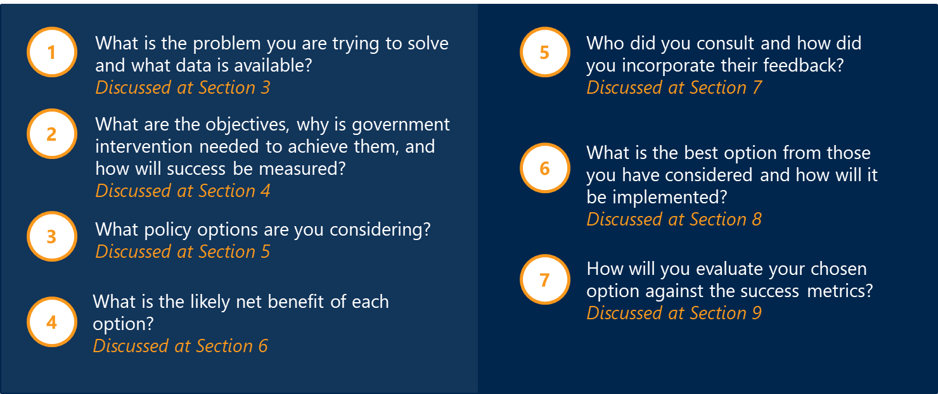

#### The problems to solve

The food standards system safeguards the safety, quality and reputation of Australian and New Zealand foods, generating significant benefits for consumers and industry. Stakeholders have been anxious to emphasise the that current regulatory system is not broken, but it could be improved Following a review of best practice, four core policy problems have been identified:

* Policy Problem 1 | The purpose and objectives of FSANZ are not clear. Inconsistencies in how key terms are defined in the Act contribute to uncertainty about the purpose of standard-setting and how regulatory measures can be used to manage short- and long-term health risks. Unlike other contemporary pieces of legislation, the Act is also silent on the particular needs and commitments of government to First Nations and Māori Peoples, which does not align with either community expectations, or requirements under commitments such as the Treaty of Waitangi.
* Policy Problem 2 | Legislated processes and decision-making arrangements for food standards are cumbersome and inflexible. The Act is highly prescriptive around how variations to food standards can be made, which can contribute to unnecessary time and cost burdens and prevent some foods from being efficiently brought to market. This approach also ties up resources and creates the environment in which FSANZ is forced to prioritise applications (which are subject to legislated timeframes) over proposals or other work.
* Policy Problem 3 | Elements of operations outlined in the FSANZ Act are inefficient. The Act sets statutory parameters around FSANZ’s board composition and nomination processes that do not reflect contemporary best practice. The organisation is also facing sustained resourcing pressures that mean some of FSANZ’s statutory functions are delayed, or not done at all.
* Policy Problem 4 | Gaps and duplication of efforts challenge system agility. While FSANZ is constituted as an independent authority, it must collaborate and coordinate with other actors across the system. Missed opportunities to deliver joined-up, high-impact policy and regulatory work create gaps and duplications in effort and undermine the overall effectiveness of the regulatory system.

For each of the problems (and the sub-problems within them), an ‘impact rating’ has been calculated to highlight which issues were most detrimental and therefore of highest priority to solve.

#### Options for reform

Two options have been presented in this IA, as summarised in Table 1.

For some of the sub-components within Option 2, there are a number of ideas presented, each of which is being openly scrutinised through the consultation process. The ‘nature of change’ column recognises whether an option is legislative (L) and/or operational (O) in nature. A small number of initiatives would only have effect in Australia.

Table 1 | Overview of the two options for reform

| Theme | OPTION 1 | Retain the status quo | OPTION 2 | Modernise regulatory settings | Nature of change |
| --- | --- | --- | --- |
| Component 1 | Purpose and objectives of FSANZ | This option assumes no changes to the Act or FSANZs operations. | The definition of ‘protection of public health and safety’ within the Act could be clarified to be in line with the current policy guidance.   * Sections 3 and 18 of the Act could be amended and aligned to give a definition of 'protecting public health and safety' that encapsulates both acute and long-term health elements. * The Act could be further clarified by making language in the legislation consistent across all documents of the bi-national food regulation system. | L |
| There could be greater clarity around how ministerial policy guidance is reflected in the development of food standards. | O |
| Language within the Act could be updated to be more culturally inclusive. | L |
| Component 2 | Reforming standard-setting | A risk-based framework and approach could be introduced to guide the development of food regulatory measures. | O |
| New pathways to amend food standards could be introduced.   * The Act could provide for FSANZ to accept risk assessments from overseas jurisdictions. * Select international standards *could* be automatically recognised. * An additional pathway to bring very low risk products to market could support greater economic opportunities for food businesses. * Principles could be embedded in legislation to allow FSANZ to create other pathways to amend food standards. | L |
| Decision-making arrangements could be streamlined.   * The FSANZ Board’s non-delegable duties (set out in Section 150) could be removed or revised. * Members of the FMM could be given the explicit ability to delegate decision-making to ratify changes to food standards to particular departmental officials. | L |
| Legislative change and greater guidance material could support bringing more traditional foods to market.   * A one-off investment of time and resources could be made to develop and publish a list of traditional foods or ingredients that have undergone safety assessments. * Further guidance material on how traditional foods can be assessed for safety could be developed. | O |
| FSANZ could be resourced to undertake more timely, holistic and regular standard reviews. | O |
| Codes of Practice and guidelines could be increasingly used to complement food standards. | O |
| Component 3 | Efficient and effective operations | Outstanding recommendations from the 2014 review of the FSANZ Board could be implemented.   * Compositional requirements of the FSANZ Board could be amended to address the need for flexibility to accommodate future work requirements. * The nomination process could be changed to be an open market process by advertising for upcoming vacancies externally, as well as seeking nominations from identified organisation. | L |
| The expedited approvals pathway could be removed to address workload prioritisation. | L |
| To generate more sustainable revenue, cost recovery could be expanded for work that benefits industry.   * An industry-wide levy could be introduced. * Compulsory fees could be implemented for all applications. * FSANZ could carry out other entrepreneurial activities. | L/O |
| Some services could also be cost recovered from government agencies.   * A food recall coordination levy could be imposed (*Australia only*). * Jurisdictions could be charged a fee to add additional proposal work to FSANZ’s workplan. | L |
| Component 4 | Improving system agility | Mechanisms to enable FSANZ and FMM to undertake periodic joint agenda-setting could be implemented. | O |
| FSANZ could engage earlier and more systematically with the Food Regulation Standing Committee (FRSC) and jurisdictions in the development of food standards. | O |
| FSANZ could take guardianship over key food safety databases (*Australia only*). | O |
| Further work could be done to establish information sharing arrangements with international partners. | O |
| Statements of Intent could be introduced into the Food Standards Code to assist with interpretation and enforcement. | O |
| FSANZ could be resourced to develop, update and maintain industry guidelines to guide interpretation of food standards.   * FSANZ could update and maintain industry guidelines which provide advice on how industry can comply with food standards. * Options to better account for the needs of First Nations and Māori Peoples could also be explored. | O |
| FSANZ could collaborate more regularly with jurisdiction enforcement agencies. | O |
|

#### Analysis to date has been informed by extensive consultation

To date, there have been three rounds of engagement through which more than 190 individuals and organisations have provided input. This input has informed assessment of the options against three evaluation criteria.

##### Criterion 1 | The extent to which the option solves policy problems

While Option 1 continues to provide significant value to the Australian and New Zealand community and successfully manages the market failures it was originally designed to address, the policy problems identified in this document are inherent to Option 1.

Option 2 represents a departure from the status quo and would result in clearer objectives and purpose for FSANZ and for the use of food regulatory measures; more risk-based and proportionate handling of applications and proposals while aligning more closely with international standards-setting counterparts; greater operational efficiency and effectiveness within FSANZ; and stronger system agility, with better consultation and cooperation between FSANZ and other system actors.

##### Criterion 2 | Delivery risks

Option 1 was deemed on average to be riskier than Option 2, and large part because it would perpetuate or exacerbate tensions and problems that are already being observed.

##### Criterion 3 | Cost and benefits

Costs and benefits have been described qualitatively and quantitatively for key stakeholder groups: industry, consumers, government (Australian and New Zealand Governments and state and territory governments) and FSANZ.

Current legislative and operational arrangements deliver many benefits to stakeholders compared to a scenario where FSANZ and the joint food standards system did not exist. These include better health outcomes for consumers, reduced barriers to market entry for industry and economic opportunities that are borne from the reputation and trust put into Australian and New Zealand regulatory system.

There are also significant costs involved however, including delay costs for industry trying to navigate regulatory processes, and for governments who are funding FSANZ.

Importantly, while the net present value for Option 1 assumes no change in existing legislative or operational settings (including funding), it has been well recognised that FSANZ is insufficiently resourced. For FSANZ to be able to deliver its full gamut of regulatory functions - even in the absence of any other changes - it would require an adjustment in its substantive funding, equating to $26 million in appropriations from the Australian and New Zealand Government with an addition of $900,000 from industry cost recovered fees for applications. This represents an additional $6.5 million relative to FSANZ’s current appropriations of $19.5 million.

The net present value and Benefits Costs Ratio (BCR) for Option 1 is shown in Table 2.

Table 2 | Distribution of present value costs and benefits for Option 1 (AUD $m) over ten years

|  |  |  |  |  |  |
| --- | --- | --- | --- | --- | --- |
|  | FSANZ | Other government entities | Industry | Consumers | Total |
| Costs | 131.5 | 15.0 | 64.0 | 7.2 | 217.7 |
| Benefits | 22.2 | - | - | 206.2 | 228.4 |
| Net benefits |  |  |  |  | 10.7 |
| Benefits Cost Ratio (BCR) |  |  |  |  | **1.05** |

The same information for Option 2 is shown in Table 3. The distribution of the costs and benefits for Option 2 reflects a greater share of food regulation costs across the system, a greater level of resourcing for FSANZ, resulting in lower industry costs and higher public health benefits. Compared to Option 1, Option 2 delivers higher net present value — $208.6 million compared to $10.7 million with a BCR of 1.63. This suggests that Option 2 is more effective than Option 1 in delivering public health benefits. Of note, there are many costs and benefits in this model that can further qualified but cannot be reliably quantified.

Table 3 | Distribution of present value costs and benefits for Option 2 (AUD $m) over ten years

|  |  |  |  |  |  |
| --- | --- | --- | --- | --- | --- |
|  | FSANZ | Other government entities | Industry | Consumers | Total |
| Costs | 166.8 | 58.6 | 29.2 | 75.2 | 329.8 |
| Benefits | 133.8 | - | 115.9 | 288.7 | 538.3 |
| Net benefits |  |  |  |  | 208.6 |
| Benefits Cost Ratio (BCR) |  |  |  |  | 1.63 |

#### Option 2 is currently the preferred option – but this round of consultation will be critical to getting the detail right

Several consultation questions have been posed through this document, focused on unpacking the strengths, limitations and opportunities associated with options to reform the Act and FSANZ’s operations.

Feedback to this IA will be received via a public consultation process, hosted on the DHAC Consultation Hub and input will be incorporated into a final version of the IA, which will ultimately be considered by Cabinet in Australia and in partnership with the New Zealand Government and course a pathway to reform.

# Background and context

Food impacts every person every day of their lives.

Across Australia and New Zealand, tens of thousands of businesses create the supply chain of processors, manufacturers, distributors, and vendors, feeding a bi-national population of more than 30 million people (as well as a much broader export market).

The most recent data from 2019 indicates than 276,000 people work in the food and grocery manufacturing sector3F[4] and countless more work in the supply, and sale of food and food-related products. Food production is particularly important in regional areas, where 40% of the food production workforce is located. In New Zealand, the food and beverage sector accounted for 46% of all goods and services exports, making it by far the most important part of the country’s trade economy.[5]

The availability of quality, safe food is something that most Australians and New Zealanders take for granted, yet it is a highly sophisticated regulatory system that creates this sense of security.

In November 2019, the Food Ministers Meeting (FMM; previously the Forum) agreed on an ambitious plan to reform the regulatory system to ensure it remains strong, robust and agile into the future.

As part of this, the Department of Health and Aged Care (DHAC) in partnership with the Ministry for Primary Industries (MPI) and the Department of the Department of Agriculture, Fisheries and Forestry (DAFF) has been charged with reviewing the *Food Standards Australia New Zealand (FSANZ) Act* 1991 (the Act) and the operations of FSANZ (the Review), in line with a Terms of Reference (see Appendix A).

Changes to regulatory requirements are subject to Impact Analysis (IA), to ensure that any proposed amendments achieve better outcomes and minimise the burden experienced across stakeholder groups.

This document constitutes the draft IA. It presents four components of change within Option 2 and provides comparisons of each against the status quo (Option 1). Further refinements will need to be made to ensure that the initiative described within each of the four components represent the best combination of amendments.

## The Act is only one element of the complex food regulatory system

There have been huge changes in the food industry over the past decades. In the early 1990s when the Act was first passed, supply chains were far less globalised, and there were fewer large, national, or multi-national companies with sophisticated food safety processes in place. In this context, robust pre-market approvals helped to ensure that the food sold in Australia and New Zealand was safe to eat.

Yet, since that time, consumer preferences, patterns, and expectations in relation to food have changed drastically. The modern consumer, for example, seeks more diverse and convenient food options, often driven by busier lifestyles. This means that individuals can be exposed to higher volumes of food additives and other ingredients compared to in the past, which can have a compounding effect on safety and long-term health outcomes.

Adding to that, the last 30 years has seen the establishment of international food conglomerates and greater food safety maturity within such organisations, borne in part from an understanding that a reputation for safety and quality is a competitive edge. Yet, more recently, the COVID-19 pandemic and other geopolitical uncertainties have disrupted food supply chains, requiring more agility from food businesses to carry out their operations.

Governments have scrambled to adapt to these evolving challenges, including to support growth and prosperity in regional and rural areas while also building stronger international trade relations; and managing the rates of illness and chronic disease our health systems must support without stymying innovation and consumer choice. These changes have created the impetus to review regulatory settings.

It is important to note from the outset however, that food is regulated through an intricate web of legislative and institutional arrangements – a snapshot of which is provided at Figure 2. To understand the opportunities to modernise food regulation via the Act, it is helpful to distinguish its scope and remit from other key documents: the Food Regulation Agreement (FRA), the Agreement between the Government of Australia and the Government of New Zealand concerning a Joint Food Standards System (also known as the ‘Australia-New Zealand Joint Food Treaty’ or the ‘Food Treaty’, in short), the Food Standards Code and jurisdictional Food Acts.

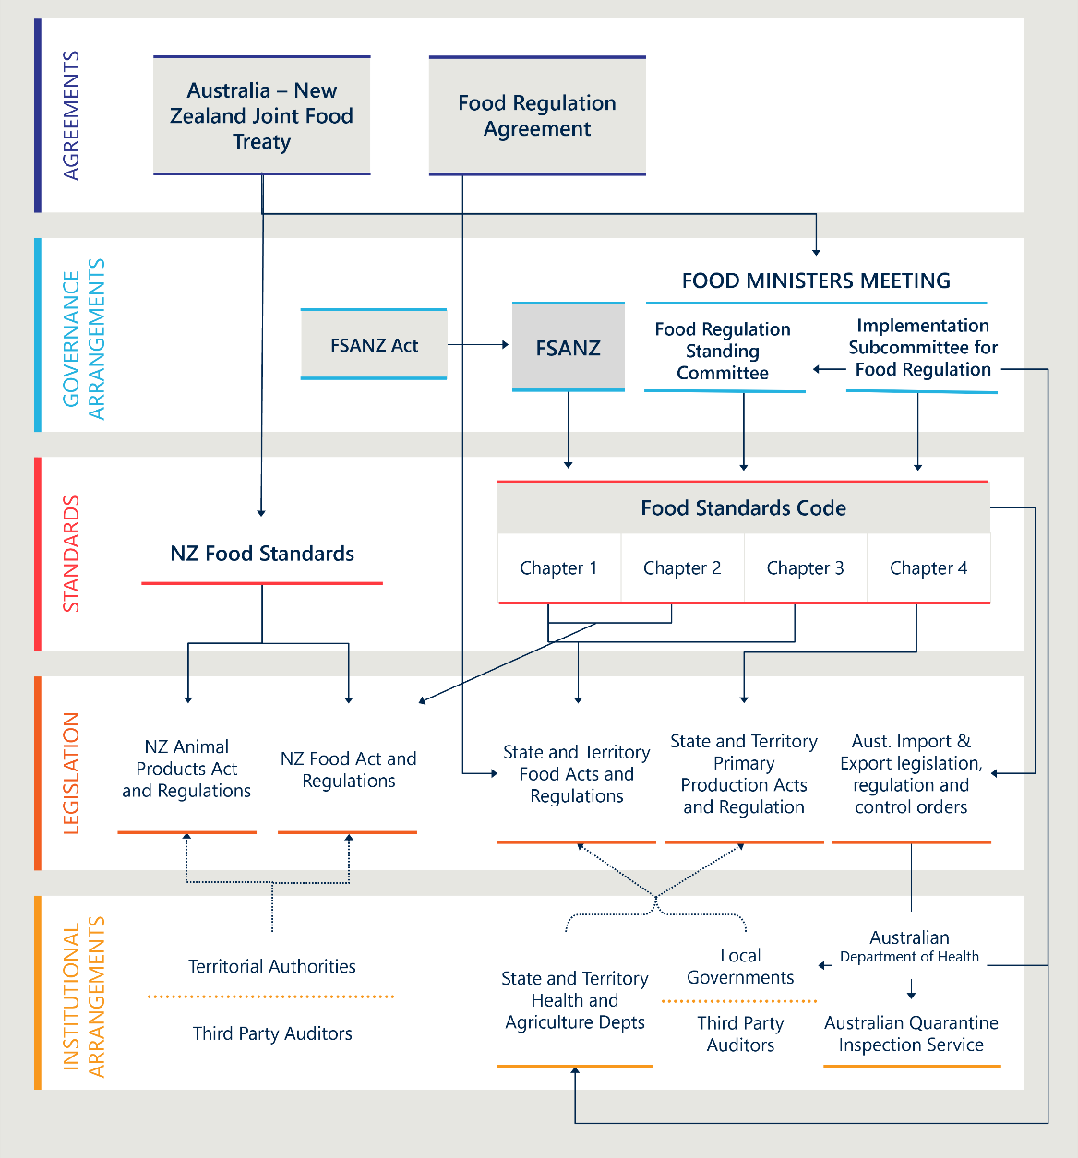Figure 2 | Snapshot of the food regulatory system

### The Food Regulation Agreement

#### The Food Regulation Agreement (FRA) is designed to promote a nationally consistent approach to food regulation within Australia

The FRA is an intergovernmental agreement that was initially signed by all Australian governments in November 2000. It was last endorsed by the Council of Australian Governments (COAG) in July 2010.

The FRA sets out:

* objectives for the food regulatory system
* the remit and powers of a ministerial council
* FSANZ’s role within the food regulatory system
* governance arrangements relating to food standards, including working arrangements with FSANZ and the legislated role of the FMM to ratify amendments
* voting arrangements for FMM decisions
* roles and responsibilities of Food Regulation Standing Committee (FRSC)
* model law provisions divided into two annexes.

While food regulation is a constitutional responsibility of states and territories (see Section 2.1.5), the FRA through the establishment of governance and process underpins a nationally consistent regulatory approach, which protects the safety and quality of all Australian foods and minimises regulatory burden for industry.

#### The FRA establishes a ministerial forum and provides a strong authorising environment for decisions about food policy

The ministerial forum for food policy issues has gone through several name changes. Listed as Australia and New Zealand Food Regulation Ministerial Council in the FRA, in 2011 the Ministerial Council was renamed as the Legislative and Governance Forum of Food Regulation. The name was further amended in 2015 to the Australia and New Zealand Ministerial Forum on Food Regulation (the Forum), and finally updated to the FMM in 2021.

The functions and powers of the FMM are set out in the FRA and provide Food Ministers (a mix of Health and Agriculture Ministers) a unique authorising environment in which to progress food policy decisions – including the ability to ratify amendments to the Food Standards Code.

FSANZ is independent of the FMM, but it must have regard to the policy guidelines developed by the Food Ministers when setting food standards. The FMM can also ask FSANZ to review its decision to approve a standard or variation to a standard.5F[6]

The FRA also establishes the Food Regulation Sub-Committee (FRSC) to coordinate policy advice to the FMM. The Implementation Sub-Committee for Food Regulation (ISFR) was then established by FRSC to ensure that Food Standards are implemented and enforced consistently.

### The Australia–New Zealand Joint Food Treaty

#### The Food Treaty establishes the bi-national food system

The Australia–New Zealand Joint Food Treaty (the Food Treaty) was first executed in 1995 and commits Australia and New Zealand to adopt and apply a shared set of Food Standards set in the Food Standards Code.

It includes information about:

* the objectives of the bi-national system
* the agreement between Australia and New Zealand regarding introducing or amending food legislation
* principles underpinning the food standards system
* joint adoption of the food standards set in the Food Standards Code
* funding arrangements for the food standards system
* the grounds on which New Zealand can opt out of a food standard.

Unlike the FRA, the Food Treaty does not attempt to align the regulatory approaches of the two countries and there are no model law provisions included.

The Food Treaty is underpinned by the *Trans-Tasman Mutual Recognition Arrangement (TTMRA)* and the *Australia-New Zealand Closer Economic Relations Trade Agreement (ANZCERTA).* The TTMRA is an agreement between the Australian Government, State and Territory Governments, and the Government of New Zealand which provides that, with a few exceptions, a good (including food products) that may be legally sold in Australia may be sold in New Zealand and vice versa. The ANZCERTA is one of the most comprehensive bilateral free trade agreements in existence. It covers substantially all trans-Tasman trade in goods, including agricultural products, and was the first to include free trade in services.

### The FSANZ Act 1991

The *FSANZ Act 1991* establishes FSANZ as a statutory body. It sets out the functions of FSANZ as well as prescriptive processes required to create and amend food regulatory measures, primarily food standards.

FSANZ develops the food standards in the Food Standards Code, with advice from other government agencies and input from stakeholders.

FSANZ also undertakes extensive surveillance activities to monitor food supply to ensure it is safe. It provides a critical coordination function to respond to a food incident, such as a foodborne illness outbreak or product recall. It works in close partnership with the DHAC, DAFF, MPI, jurisdictional food regulators and food businesses to carry out this work.

The FSANZ Act has undergone a series of only minor amendments since it came into effect in 1991.

Table 4 | Overview of legislative changes to the FSANZ Act

|  |  |
| --- | --- |
| Bill | Year |
| * Statute Update (Autumn 2018) Bill 2018 | 2018 |
| * Food Standards Australia New Zealand Amendment (Forum on Food Regulation and Other Measures) Bill 2015 * Food Standards Amendment (Fish Labelling) Bill 2015 * Food Standards Australia New Zealand Amendment Bill 2015 | 2015 |
| * Public Governance, Performance and Accountability (Consequential and Transitional Provisions) Bill 2014 * Agricultural and Veterinary Chemicals Legislation Amendment (Removing Re-approval and   Re-registration) Bill 2014 | 2014 |
| * Health and Other Legislation Amendment Bill 2012 * Statute Law Revision Bill 2012 | 2012 |
| * Acts Interpretation Amendment Bill 2011 | 2011 |
| * Food Standards Amendment (Truth in Labelling—Genetically Modified Material) Bill 2010 * Food Standards Australia New Zealand Amendment Bill 2010 * Alcohol Toll Reduction Bill 2010 * Food Standards Amendment (Truth in Labelling—Palm Oil) Bill 2010 * Food Standards Australia New Zealand Amendment Bill 2010 * Trade Practices Amendment (Australian Consumer Law) Bill (No. 2) 2010 | 2010 |
| * Food Standards Amendment (Truth in Labelling - Palm Oil) Bill 2009 * Statute Law Revision Bill 2009 * Food Standards Amendment (Truth in Labelling Laws) Bill 2009 | 2009 |
| * Alcohol Toll Reduction Bill 2007 * Food Standards Australia New Zealand Amendment Bill 2007 | 2007 |
| * Statute Law Revision Bill (No. 2) 2006 * National Health and Medical Research Council Amendment Bill 2006 | 2006 |
| * Health and Aged Care Legislation Amendment (Application of Criminal Code) Bill 2001 * Australia New Zealand Food Authority Amendment Bill 2001 | 2001 |
| * Administrative Review Tribunal (Consequential and Transitional Provisions) Bill 2000 * Gene Technology (Consequential Amendments) Bill 2000 | 2000 |
| * Australia New Zealand Food Authority Amendment Bill 1999 | 1999 |
| * Australia New Zealand Food Authority Amendment Bill (No. 2) 1997 | 1997 |
| * Audit (Transitional and Miscellaneous) Amendment Bill 1996 * Australia New Zealand Food Authority Amendment Bill 1996 | 1996 |

This IA focuses on the Act and FSANZ’s operations, with the FRA, Food Treaty and Food Standards Code (below) excluded by the Terms of Reference.

### The Food Standards Code

The Food Standards Code brings together Food Standards, which are legislative instruments under the *Legislation Act 2003.*

#### The Food Standards Code is a critical instrument for food regulation

The Food Standards Code is adopted by reference in state and territory Food Acts. It provides largely outcome-based standards that cover the entire supply chain from ‘paddock to plate’.

New Zealand has the power to opt out of individual Food Standards in certain circumstances, as granted under the Joint Food Standards Treaty. It currently does not adopt:

* Standard 1.4.2 Maximum Residue Limits
* Standard 1.6.2 Processing Requirements
* Standard 2.1.1 (4)(2) Thiamine in Bread
* Standard 2.4.2 (2)(3) Vitamin D in Margarine
* ​Standard 2.6.3 Kava standard
* Chapter 3 Food Safety Requirements
* Chapter 4 Primary Production Standards.

In New Zealand food businesses must comply with New Zealand’s *Food Act 2014* for any and all standards that are not adopted from the Food Standards Code. Where New Zealand exercises its right to opt out of a Food Standard, the *Food Act 2014* provides for the relevant Minister to issue a domestic food standard that achieves a similar outcome, but works better within New Zealand’s legislative framework.

Figure 3 | The four chapters of the Food Standards Code

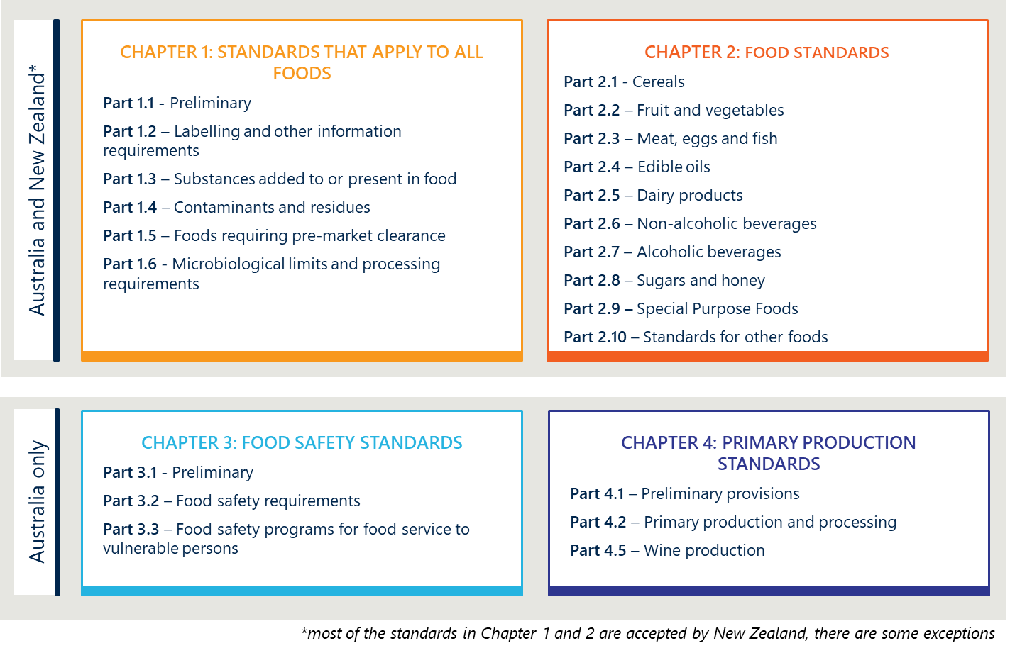

### Jurisdictional Food Acts

Each state, territory and New Zealand have their own food acts that govern regulation of food.

#### Signatories to the FRA commit to adopting Food Standards in their own food acts, and implementing other regulatory measures set out in model law

In line with the terms of the FRA, states and territories have implemented model law provisions into their own food legislation (shown at Figure 4). Importantly, the FRA does not stipulate that model law should be carried through jurisdictions’ agriculture-related legislation, which means that primary production is not explicitly recognised within the FRA as a link in the food chain.

Enforcement of food standards is carried out by jurisdictions. In Australia, this includes a mix of state and local governments, statutory regulators and private auditors, as well as DAFF for imported foods. In New Zealand, this is conducted by the MPI.

Figure 4 also shows the institutional arrangements in place to monitor and enforce food legislation that are different across the country.

Figure 4 | Relevant food related legislation in each Australia jurisdiction

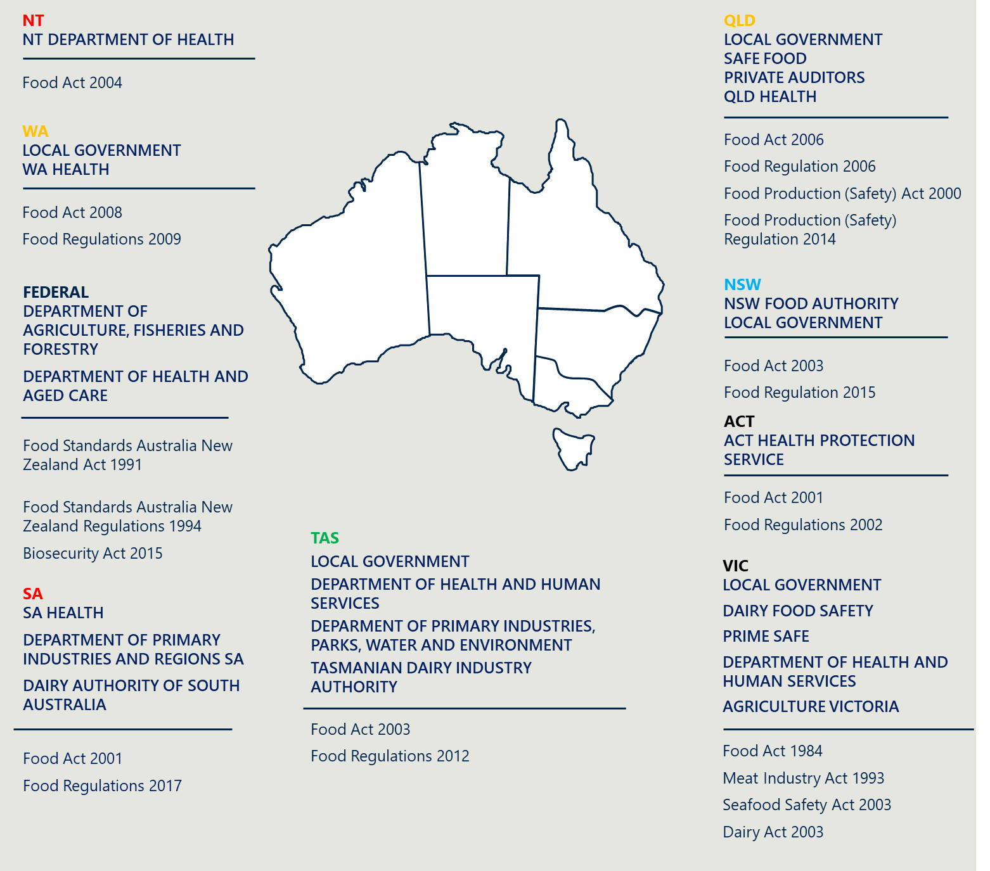

As shown in Figure 5, New Zealand applies the Food Standards to four Acts and the regulatory scheme is administered by MPI.

Figure 5 | New Zealand Acts and institutional arrangements



## This review is an exciting opportunity for modernisation

Recognising that much has changed in the last 30 years, Food Ministers have now agreed to a holistic, first principles review of the Act. This is an opportunity to consider how it can be modernised to work most effectively within a more mature and integrated joint food standards system. This includes exploring a transition to outcomes-based legislation, administered in a risk-based and proportionate manner.

# The problems to solve

|  |
| --- |
| The review of the FSANZ Act and FSANZ operations has been guided by a Terms of Reference (Appendix A).  The full scope of issues and opportunities within the Terms of Reference have been explored through the course of the Review, and stakeholders have been extensively consulted to develop, test and refine problem statements and associated options for reform.  This version of the IA focuses on issues and opportunities that have been endorsed for further consideration by the FMM. To this end, it does not cover the full gamut of topics called out in the Terms of Reference.  Section 7 does however discuss the evolution of the IA, and how changes had been made over time to respond to narrow the focus of reform options by leveraging stakeholder input. |

Government has a long-standing and widely accepted role in setting, monitoring, and enforcing standards for food. They do this to ensure that consumers can have a high degree of confidence in the integrity and safety of food produced, processed, sold, or exported from Australia or New Zealand. The Act supports these objectives by establishing FSANZ and providing for processes to set and amend food standards, as well as undertake a range of other functions. Using the language of regulation, the Act is designed to:

* protect the public good by reducing foodborne illness and promoting population health
* address negative externalities, such as where the actions of some stakeholder groups create costs or harm for other people, within these costs being paid for by the responsible parties
* address information asymmetries by ensuring that consumers have adequate information and consequently are able to make informed choices which promotes high quality production.

Stakeholders consulted to date have spoken extensively about the value of FSANZ, and its contribution to ensuring food safety as part of its broader role in supporting population health and creating a strong reputation for Australia and New Zealand’s food. Successive reviews of different aspects of the system have found that it generally functions well,6F[7] though there are opportunities for improvement, particularly in relation to responsiveness, flexibility, and efficacy.

”The system can be improved – but it is not broken.”

~ Stakeholder

## The Terms of Reference have called for a focus on inconsistencies with ‘best practice’

The Terms of Reference for the Review called for a focus on areas identified as ‘being inconsistent with best practice regulation and standard-setting’. Nous considered a number of comparable regulatory systems and identified indicators of good practice, structured under four key themes. These elements are detailed below.

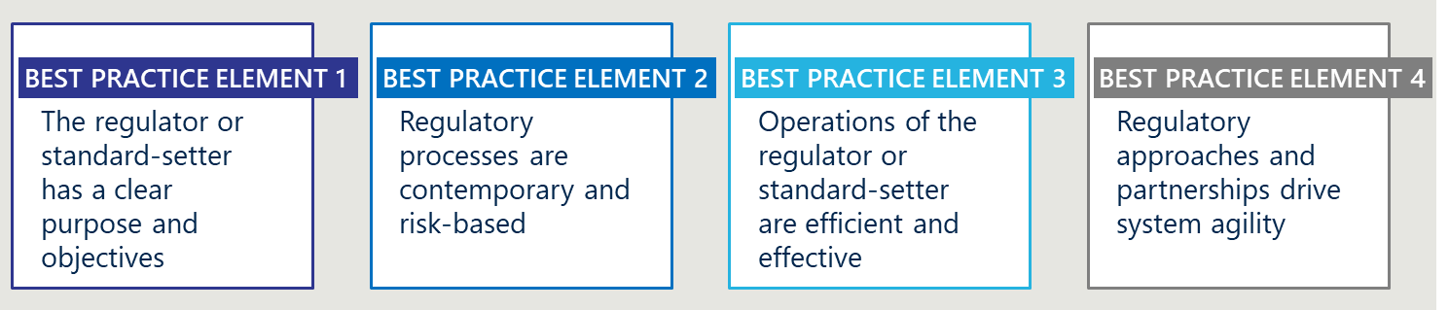

### Best Practice Element 1 | The regulator or standard-setter has a clear purpose and objectives

Objectives are clear and consistent, and factors considered by standard-setters support such objectives

International food systems generally have food safety positioned as the unequivocal priority of regulation. However, there is less consistency around how legislation picks up and balances other objectives, such as trade, consumer choice and public health. For example, the *Food Safety Authority of Ireland Act 1998* prescribes the principal function of the Authority as ‘ensuring that food produced or distributed meets the highest standards of food safety and hygiene reasonably available’7F[8].

Conversely, the general objectives of food regulation in the European Union are to:8F[9]

* Guarantee a high level of protection of human life and health and the protection of consumers’ interests.
* Guarantee fair practices in food trade, taking into account animal health and welfare, plant health and the environment.
* Ensure free movement of food and feed manufactured and marketed in the Union, in accordance with the General Food Law Regulation.
* Facilitate global trade of safe feed and safe, wholesome food by taking into account international standards and agreements when developing Union legislation, except where this might undermine the high level of consumer protection pursued by the Union.

Some jurisdictions also tactfully employ food standards as a vehicle to drive public health outcomes, such as prevention of obesity and chronic disease. For example, the Codex Alimentarius is a collection of internationally adopted food standards that are designed to protect consumers’ health (as well as ensuring fair practices in the food trade) and ‘set requirements for food aimed at ensuring food products for consumers are safe, wholesome, free from adulteration, correctly labelled and presented’.9F[10]

Regardless of the purposes stated, there is evidence that effective standard-setting schemes have clear scope and objectives and the factors that they consider in making food regulatory measures reinforce these.

#### There is a clear recognition and commitment by government to Indigenous people, and legislation is geared to support Indigenous outcomes

The New Zealand Government has a constitutional requirement to respect its obligations to Māori under the Te Tiriti o Waitangi (Treaty of Waitangi) and to deliver policy in a way that enhances Crown/Māori relations. However, celebrating and fostering Indigenous culture is a live priority for the Australian and state and territory governments as well. Our governments are joint signatories to the 2020 Indigenous Collaboration Arrangement between Australia and New Zealand.10F[11]

Several regulatory systems have tailored their language to recognise Indigenous history and expertise. For example, in New Zealand, the *Māori Fisheries Act 2004* reflects Māori cultural and historical connections to fisheries and their ongoing interests in the seafood industry. Another example is the *Resources Management Act 1991*, which is not legislation specific to Māori culture but does pick up on the principal of ‘kaitiakitanga’, which is a Māori concept relating to guardianship and sustainability and the role of communities in protecting the environment.

Other countries have taken steps to support traditional foods to enter the market. Peru, for instance, has adopted a legal framework for traditional foods designed to support cultural preservation. While such foods are required to reach the same thresholds of safety and quality, the framework provides more flexible processes for demonstrating this, including by recognising traditional methods of preparation, allowing for regional variations in traditional foods and providing for certification and labelling of traditional foods to help consumers make informed choices.

Furthermore, the Impact Assessment Agency of Canada has adopted specific guidelines for engaging with Indigenous communities. The supports meaningful consultation by adopting a flexible approach that allows Indigenous People to present evidence in culturally appropriate ways, recognising, for example oral traditions.[12]

These initiatives emphasise inclusivity and respect for Indigenous perspectives while enriching the evidence base with valuable insights and contributing to a safer, more effective and culturally sensitive regulatory system.

### Best Practice Element 2 | Regulatory processes are contemporary and risk-based

There is an emphasis on pre-market assessment  
All food regulation systems reviewed by Nous concentrate their regulatory attention at the pre-market entry point, assessing safety before foods can sold or shared. A similar approach is used in other regulatory schemes where the risk of harm involved can be high. Therapeutic goods and regulation of chemicals and pesticides in Australia and New Zealand, for example, follow a similar approach.[13] There is however a degree of risk-proportionality at play; some systems allow for less rigorous pre-market assessments for very low risk products, which helps drive innovation and economic opportunities where appropriate.

#### Standards are tailored to recognise local population characteristics such as dietary trends

Standard setters make decisions about approving substances based on an understanding of local conditions. For example, most developed countries such as the United States, Japan, and members of the European Union have their own food standard regime that is sensitive to local diets and consumption trends. These systems are not solely reliant on adoption of other jurisdictions’ standards, such as those produced by the Codex Alimentarius Commission.

Standards are regularly reviewed to consider the cumulative impact of regulatory measures

Effective schemes have established systems for triggering routine, holistic reviews of standards. This means that the cumulative effect of exposure to different substances is considered and used to revise regulatory settings. While legislative ‘sunset’ provisions are not routinely used for food, medicines, chemicals or other similar standards, responsible agencies are resourced to carry out such reviews. For example, the US Food and Drug Administration, Codex Alimentarius Commission and European Medicines Agency all conduct ongoing evaluations and revisions of existing standards to improve safety, efficacy and impact.

Statutory processes and decision-making arrangements are principles-based and designed to enable risk to drive process

Modern regulatory schemes employ risk-based decision-making approaches to ensure that rules are proportionate and minimally burdensome for all stakeholders. For example, *the New Zealand Food Act 2014* is explicitly risk-based and categorises food businesses by risk, where higher-risk businesses are subject to more stringent regulatory oversight.

Modern standard-setting bodies increasingly do the same. For example, Health Canada (the body responsible for setting health and safety standards for food) employs a proactive decision-making framework for identifying, assessing, and managing health risks.[14]

Regulatory instruments are used in a risk-based way

Standard-setting schemes are designed in a way that makes efficient and effective use of different legislative tools, with standards used to set clear, technical requirements with which entities must comply; and other instruments such as Codes of Practice or guidelines used to provide principles or other advice (often non-binding) that support achievement of those technical requirements.

For example, most developed countries including Australia and New Zealand have a food standard for eggs and egg products. The current Food Standard 2.2.2 (Australia only) sets out a series of requirements relating to sale of unacceptable eggs and traceability. The Codex Alimentarius also has a short standard for eggs and egg products14F[15], but supplements this with more detail about how to manage hygiene elements and ensure safety of such products in a Code of Practice.[16]

Instruments lower on the regulatory hierarchy can generally be developed or amended more easily than food standards. When they are used appropriately therefore, they can provide more agility to the system and be more responsive to changing risks or market forces. They should not however be used to communicate requirements that are essential to meet. For example, labelling requirements for allergenic information is generally prescribed in food standards and are binding, as are other requirements that safeguard against significant foodborne risks.

### Best Practice Element 3 | Operations of the regulator or standard-setter are efficient and effective

Legislated governance arrangements support efficient and effective decision-making

The current academic discussion[17] about best practice governance emphasises:

* Independent, skills-based boards. Independent, skills-based boards are best placed to make decisions that support the outcomes pursued by standard-setting organisations. Independence, or at least a majority composition of independence, ensures that the board makes decisions in the best interests of the organisation and its objectives, rather than those of partisan groups. In support of this, skills-based boards ensure they have the capability to effectively deliver their responsibilities. In particular, this means possessing the subject-matter expertise to make decisions in a way that is cognisant of the reality of the organisation.
* Proactive nomination and appointment processes. In keeping with best practice, modern governance committees keep a pipeline of potential candidates to fill vacancies as required. By adopting this proactive approach, modern boards reduce decision paralysis brought about by long appointment periods and ensure the organisation remains effective amidst organisational turnover.

Regulators and standard-setters are adequately resourced to deliver their remit

Comparable international bodies invest significant resources to support the work of their standard-setting bodies. There is some variation in the investment made, with the per capita investment in the Canadian food standard-setting body being $1.31 per person, per year, increasing to $3.60 per person in England; $7.00 per person per year in Ireland; and $7.76 per person, per year in Scotland. By contrast, FSANZ’s substantive funding equates to $0.70 per person per year in Australia and $0.40 per person, per year in New Zealand.[18]

Cost recovered services frequently represents a minority funding stream for standard-setters, but when they are used, they exploit the full technical capability and legislative remit of the organisation.

### Best Practice Element 4 | Regulatory approaches and partnerships drive system agility

#### There is a focus on joined-up policy and regulatory work

In strong systems, there are effective mechanisms in place to support the flow of information, enabling coordinated policy and regulatory decisions.

For example, there is strong collaboration between the DHAC, the Australian Health Practitioner Regulation Agency and National Boards[19] to consider registration and other requirements for health care practitioners in a way that safeguards quality of care, while being responsive to the need to build the health workforce and facilitate entry for internationally trained clinicians.

Some regulators and standard-setters also prioritise managing data and information and sharing this with other parties, such as with academic bodies and enforcement agencies. For example, the Food and Drug Administration in the United States maintains an Adverse Event Reporting System which records details of food related incidents, which is intended to ultimately be publicly accessible.18F[20] The European Food Safety Authority also maintains the Comprehensive European Food Consumption Database, which tracks food consumption patterns and helps inform identification of hazards in foods based on exposure over time.[21]

### The current Australia and New Zealand joint food standards system embodies some – but not all – of these best practice characteristics

When compared to the elements of best practice identified in Section 3.1, several strengths of the Australian-New Zealand joint food standards system become apparent.

Aligning with Best Practice Element 1, there is a program of work planned to enhance the recognition of Indigenous culture and expertise

In 2023, the FMM endorsed a three-tiered approach to strengthen the food regulatory system to support and celebrate the culture and expertise of First Nations and Māori People. The three tiers of work are shown in Figure 6. Importantly, Tier 1 concepts are in scope for action as part of the review of the FSANZ Act, but Tier 2 and 3 concepts are contingent on further targeted and consultation with relevant stakeholders.

Figure 6 | Program of work planned to recognise Indigenous culture and expertise

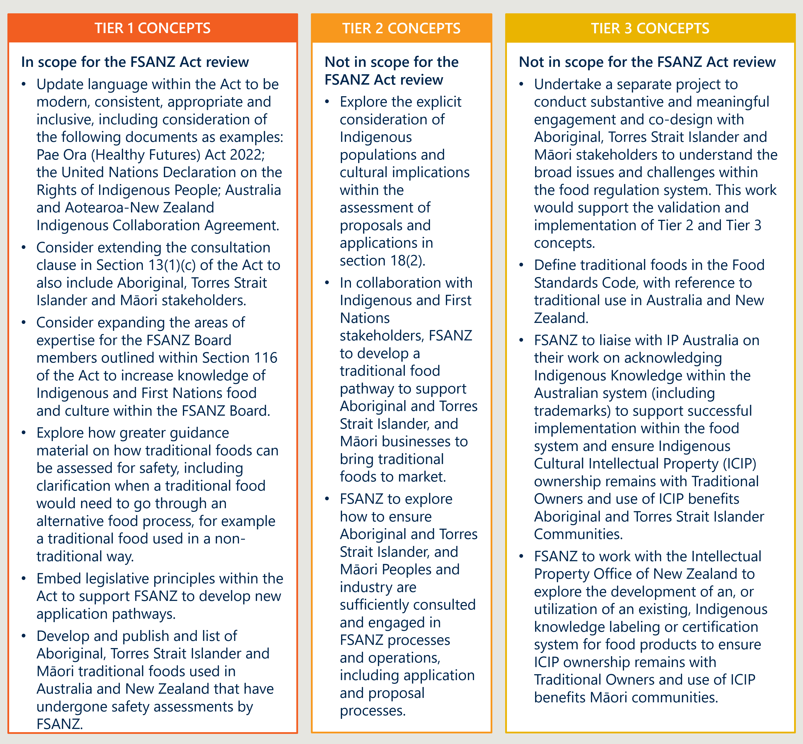

#### The Act aligns with Best Practice Element 2 in its focus on pre-market assessment

The regulatory scheme employs a rigorous pre-market assessment process where substances must be included in the Food Code before they can be shared and sold.

The Act works in complement to jurisdiction-level Food Acts in driving a preventative focus in food safety. For example, in New Zealand, food businesses must follow a program setting out how they will meet their food safety responsibilities and demonstrate to independent verifiers they are following the plan.

#### Current arrangements support the existence of a food standards system focused on the needs of Australia and New Zealand

FSANZ is specifically set up to consider the suitability of food products in the context of Australian and New Zealand diet and consumption trends.

### There are several opportunities to improve the Act

The Act is not fundamentally flawed or ill-equipped to deal with the market failures it is designed to address. However, there is evidence the Act has aged, and the broad policy problems described below reflect an accumulation of small issues where the legislation or FSANZ’s operations has not kept pace with changing industry practices and consumer expectations, or modern regulatory thinking.

Four key policies problems have been identified, summarised at Figure 7 and explored in detail below.

|  |
| --- |
| This IA seeks to characterise the relative importance of problems to solve  To do this, a ‘negative impact’ rating has been calculated for each of the ‘sub-problems’ within the four problems, which have then been aggregated up to provide a ‘problem-level’ impact rating.  The methodology for this exercise is described below.  Note: ratings have been compiled through an assessment of research and stakeholder engagement. They will be explicitly validated as part of the consultation process on the draft IA.  For each sub-problem, the level of impact was estimated, where:   * High impact (rating 3) = Aberration from best practice which has resulted in significant barriers to the achievement of efficient and effective regulation. * Moderate impact (rating 2) = Aberration from best practice which has resulted in moderate barriers to the achievement of efficient and effective regulation. * Low impact (rating 1) = Aberration from best practice which has created minor barriers to the achievement of efficient and effective regulation.   This result was multiplied by the extent of impact each sub-problem had, where:   * Large extent (rating 3) = problem has significant negative implications for Australian and/or New Zealand populations. * Moderate extent (rating 2) = problem has significant negative implications for stakeholders that engage directly with FSANZ or are subject to food standards. * Limited extent (rating 1) = problem has significant negative implications for a small cohort of stakeholders, such as just FSANZ.   The impact of sub-components was aggregated, where:  Total magnitude of the problem (for $n$ number of sub-problems) = $$\frac{\sum_{i=1}^{n}{\left(extent of sub{problem}_{i} ×impact of {subproblem}_{i}\right)}}{9n}×100$$ Ratings have then been converted to a 1-3 score, where:   * Low magnitude (rating 1) = 0-33% * Moderate magnitude (rating 2) = 34-66% * High magnitude (rating 3) = 67-100% |

Figure 7 | The four broad Policy Problems to solve

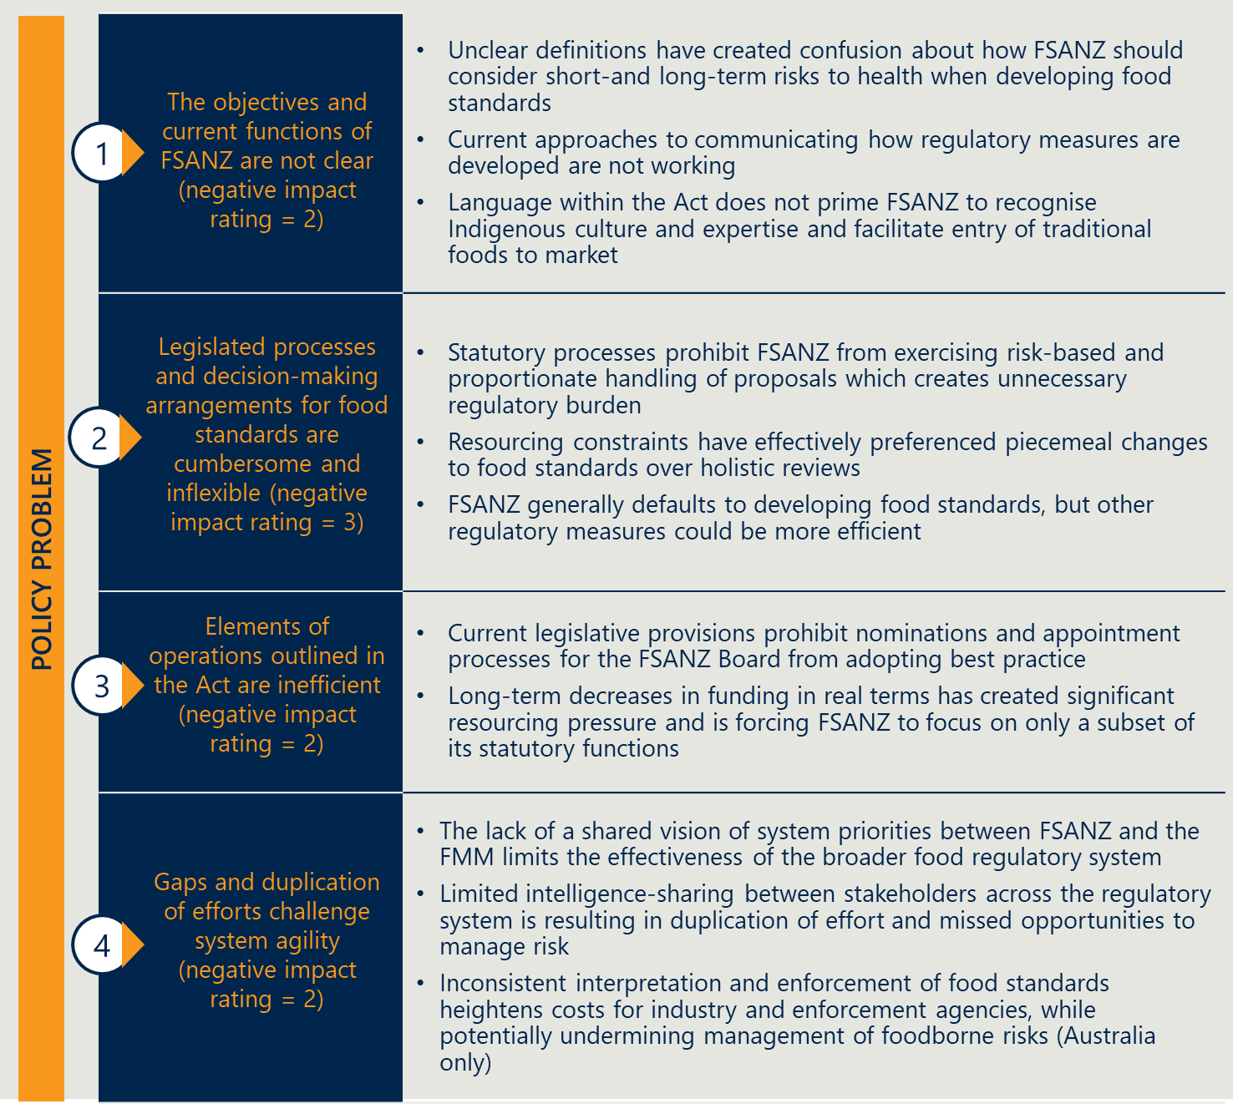



### Policy Problem 1 | The purpose and objectives of FSANZ are not clear

|  |  |
| --- | --- |
| Magnitude of problem | 2 (moderate) |

#### Sub-problem 1 | Unclear definitions have created confusion about how FSANZ should consider short-and long-term risks to health when developing food regulatory measures

|  |  |  |  |  |  |
| --- | --- | --- | --- | --- | --- |
| Level of impact | 3 | Extent of impact | 3 | Sub-problem rating | 9 |

The primary object of the Act in Section 3 is to ‘ensure a high standard of public health protection throughout Australia and New Zealand by means of the establishment and operation of FSANZ’s. This is reinforced in Section 18 where the objectives of the Authority (FSANZ) in developing or reviewing food regulatory measures are described in descending order as the ‘protection of public health and safety; the provision of adequate information relating to food to enable consumers to make informed choices; and the prevention of misleading or deceptive conduct’.

Many stakeholders have indicated that the terms ‘public health protection’ and ‘public health and safety’ are poorly defined in the legislation (and potentially incongruous), and this creates ambiguity, where they could variably refer to preventing foodborne illness or injury, primarily in the acute, post-consumption period; or long-term health, including through the prevention of obesity-related chronic disease.

This confusion has created some friction around the factors that FSANZ should be considering when developing or amending food standards, and the extent to which standards should be used to just establish a *safe* food supply, vs underpinning a food system that promotes a safe and *healthy* food supply.

In practice, food regulatory measures established by the Act are already being used to protect both short- and long-term health; in 2013, the FMM (then the Forum) issued a ministerial guideline which indicates that ‘Public health and safety in relation to food refers to all those aspects of food consumption that could adversely affect the general population or a particular community’s health either in the short term or long term, including preventable diet-related disease, illness and disability as well as acute food safety concerns.’ This definition was reaffirmed by the FMM in late 2022.

The FMM has issued several policy guidelines relating to long-term public health, including those relating to food labelling to support consumers make informed healthy choices; nutrition, health and related claims; fortification of foods with vitamins and minerals; and front of pack labelling, among others.

FSANZ has also finalised a number of amendments to food standards over the years which relate to long-term public health, including the use of additives in highly processed products such as sugar sweetened beverages and appropriate information labelling.

Clarifying the definition of ‘public health promotion and ‘public health and safety’ within the Act – and aligning this definition with other instruments such as the FRA20F[22] – may enhance clarity around the role of food standards in food regulation and policy. The factors stipulated for consideration when developing food regulatory measures (Section 18) also then need to be confirmed to ensure that they support FSANZ to develop measures that deliver to the objectives of the system.

#### Sub-problem 2 | There remains some confusion about the factors to which FSANZ has given regard in its decision-making, and how this aligns with the objectives of the Act

|  |  |  |  |  |  |
| --- | --- | --- | --- | --- | --- |
| Level of impact | 1 | Extent of impact | 2 | Sub-problem rating | 2 |

The legislation currently requires FSANZ to develop draft regulatory measures such as food standards where they align with the objectives set out in Section 18(1). As part of that process, they ‘must have regard’ to five key factors, including any written policy guidelines formulated by the FMM (Section 18(2)); see Table 5. Importantly, ministerial guidelines are not binding on FSANZ and each of the factors must be considered with equal weight.

Table 5 | Objectives of the Authority in developing, reviewing or varying food regulatory measures

|  |
| --- |
| Section 18 | Objectives of the Authority in developing or reviewing food regulatory measures and variations of food regulatory measures   1. The objectives (in descending priority order) of the Authority in developing or reviewing food regulatory measures and variations of food regulatory measures are: 2. the protection of public health and safety 3. the provision of adequate information relating to food to enable consumers to make informed choices 4. the prevention of misleading or deceptive conduct. 5. In developing or reviewing food regulatory measures and variations of food regulatory measures, the Authority must also have regard to the following: 6. the need for standards to be based on risk analysis using the best available scientific evidence 7. the promotion of consistency between domestic and international food standards 8. the desirability of an efficient and internationally competitive food industry 9. the promotion of fair trading in food 10. any written policy guidelines formulated by the Forum on Food Regulation for the purposes of this paragraph and notified to the Authority. |

Stakeholders have raised concerns that can create tensions when some of these factors may be in conflict; for example, a ministerial guideline may be at odds with the desirability of an efficient and internationally competitive food industry.

Upon drafting a regulatory measure, FSANZ refers the matter to the FMM for ratification. Some stakeholders have reported there can then be challenges in progressing an amendment where there may be a political element to the change (for example, stakeholders indicated that anything to do with infant formula often generates debate about the use and promotion of formula as a substitute to human breast milk).

Currently, the FMM may request a review of a draft standard, noting an obligation to comply with any requirements set out in the FRA or Treaty (Section 84(2)). It must inform FSANZ of its concerns with the draft (Section 86). This might include whether ministerial guidelines have been given adequate consideration.

Of note, of the 101 standards submitted for endorsement by the Food Ministers between 2017 and 2022, only one has been referred back to FSANZ due to non-compliance with existing ministerial guidance.[23] FSANZ also consults publicly on all proposed amendments to the Code, publishing all risk-assessments and supporting documents that support any decision to, or to not, amend food standards, enabling the public, industry, and food researchers to scrutinise these decisions.

These resources, however, are demonstrably either insufficient, or inaccessible. Changes to the communication approach may therefore be warranted to facilitate greater visibility around how FSANZ has balanced the different considerations and aligned with the objectives of the Act.

#### Sub-problem 3 | The Act is silent on the needs and commitments of government to First Nations and Māori Peoples

|  |  |  |  |  |  |
| --- | --- | --- | --- | --- | --- |
| Level of impact | 2 | Extent of impact | 2 | Sub-problem rating | 4 |

In referring to Indigenous culture and food expertise in this document, the Australian and New Zealand Governments both acknowledge First Nations Peoples of Australia and Māori, tangata whenua of New Zealand.

Currently, there is no explicit recognition of First Nations or Māori Peoples or how Indigenous culture and expertise could be recognised for the purpose of the Act. Furthermore, there are no operational arrangements in place that would support this ongoing dialogue, such as formal representation of Indigenous culture and expertise on the FSANZ Board.



### Policy Problem 2 | Legislated processes and decision-making arrangements for food standards are cumbersome and inflexible

|  |  |
| --- | --- |
| Magnitude of problem | 3 (high) |

#### Sub-problem 1 | Statutory processes are rules-based rather than outcomes-based

|  |  |  |  |  |  |
| --- | --- | --- | --- | --- | --- |
| Level of impact | 3 | Extent of impact | 2.5 | Sub-problem rating | 7.5 |

Current processes for changing or creating food standards present a range of issues. Approximately half of all proposals and applications made to FSANZ each year relate to minor processing aid amendments, including relating to substances that have been approved in other international food systems.[24] These processes and decision-making arrangements are enshrined in legislation and must be observed.

Currently, FSANZ is required to follow a similarly rigid process for all applications and proposals, regardless of the level of risk involved. For example, FSANZ must go through the same steps to approve low-risk food processing aids as it does to approve more complex changes, such as infant formula compositions. FSANZ also has limited ability to adjust its approach or change the procedure or timeframes after initial assessment if new information or data becomes available.

This approach represents an inefficient use of FSANZ’s limited resources and contributes to the long timeframes in progressing some applications and proposals. It also represents considerable burden on industry due to the time and costs involved in preparing detailed applications, as well as opportunity costs associated with delays to bring products to market. This barrier is particularly pronounced for smaller businesses and First Nations and Māori food enterprises, where securing funding for scientific assessments and managing delayed market access are more likely to be barriers to commercial access and success.

FSANZ completes the vast majority of its applications within the prescribed statutory timeframes. Extensive delays as a result of the intersection between the FSANZ Act requirements, Ministerial Policy guidelines, best available evidence complexities in assessment, accommodating submitter views and resources are rare for applications - for example, application A1155 was approved by the FSANZ Board, and concerned the addition of oligosaccharides from genetically modified bacteria to infant formula and formulated supplementary foods for young people. The FMM sought a review in February 2020, but was only accepted (with amendments) in late November 2020. This was despite the substances in question having already been fully approved in several comparable foreign jurisdictions.

Separately, a tailored pathway exists in the Act for introducing new high-level health claims on food labels. In recent years, this pathway has not been used at all, and stakeholders have suggested that these provisions simply add to the stock of regulations and such amendments could be made through other pathways, should they be sought in the future.

Under the current legislation, all draft standards or variations must be approved by the FSANZ Board before being ratified by the FMM. This responds to unusual arrangement where changes to the Food Code are automatically adopted into jurisdictions’ Food Acts by reference. This approach can ensure that standards ultimately represent the balanced interests of industry, consumers and other stakeholders, however, it doesn’t facilitate risk-based practices and necessarily make best use of such a high-profile and powerful forum. For example, Ministers themselves may have limited views on very minor or technical amendments to food standards (such as processing aids), although subject matter experts within their departments may be better placed to advise on relevant implications for their own regulatory environments.

#### Sub-problem 2 | Current requirements create barriers for Indigenous foods to be brought to market

|  |  |  |  |  |  |
| --- | --- | --- | --- | --- | --- |
| Level of impact | 2 | Extent of impact | 2 | Sub-problem rating | 4 |

Under current settings, particular diets and health needs of First Nations and Māori Peoples are not explicitly accounted for. Indigenous businesses may also face barriers to bringing traditional foods to market, where Indigenous businesses may not have the information or resources to navigate the current application process.

To date, limited concerted effort has been made to proactively assess common traditional foods for their safety and confirm their suitability to be introduced to Australian and New Zealand markets.

This means that FSANZ can be poorly equipped to support Indigenous food businesses to be commercially successful, even when traditional foods have been deemed ‘safe’.

#### Sub-problem 3 | Resourcing constraints have effectively preferenced piecemeal changes to food standards over holistic reviews

|  |  |  |  |  |  |
| --- | --- | --- | --- | --- | --- |
| Level of impact | 3 | Extent of impact | 3 | Sub-problem rating | 9 |

Section 55 of the Act provides for FSANZ to raise proposals to revise any or all parts of the Food Standards Code, including wholescale updates to Food Standards. Holistic reviews, however, are relatively rare and often take significant periods of time to complete.

The barriers at hand are not legislative in nature, but rather reflect the fact that FSANZ is operating in a resource constrained environment and is not able to prioritise such proposals. A consequence of this is that when a food product is assessed in isolation (e.g. pursuant to an application), they may be deemed safe and suitable for the Australian and New Zealand markets. However, individuals may consume such products in changing quantities over time, which means that an assessment made years ago may no longer be accurate. For example, various studies have linked increased exposure to food additives over time with health issues such as asthma, attention deficit hyperactivity disorder, heart difficulties, cancer and obesity.24F[25]

#### Sub-problem 4 | FSANZ generally defaults to developing food standards, but other regulatory measures could be more efficient to create

|  |  |  |  |  |  |
| --- | --- | --- | --- | --- | --- |
| Level of impact | 2 | Extent of impact | 2 | Sub-problem rating | 4 |

FSANZ has several different regulatory instruments at its disposal to achieve its objectives. The Act allows FSANZ to develop *food regulatory measures* which comprise food standards and Codes of Practice. FSANZ can also develop guidelines to assist interpretation of the Food Standards Code on its own initiative or in consultation with the Australian states and territories and other bodies (Section 13I).

Currently, FSANZ almost exclusively uses food standards as a legislative instrument. It makes available an Application Handbook which sets the mandatory requirements, including evidence, to support an application (authorised under Section 23) but does not develop Codes of Practice. FSANZ makes limited non-legally binding guidelines available on its website, including ‘User guides to the Food Standards Code’, though some stakeholders have noted this may represent a currently under-utilised resource.

Guidelines and Codes of Practice are alternative regulatory instruments that could be used to address specific issues or challenges that do not warrant the time, resources and/or rigour of processes required to develop or vary a standard. Guidelines are non-binding instruments that provide advice on how industry and other groups can meet obligations created by FSANZ. Codes of Practice similarly provide guidance on how to comply with obligations created by FSANZ.

For example, the *Food Act 1984 (Vic*), which adopts the food standards into law in Victoria, provides a defence of due diligence to industry (Section 17E) for demonstrating reasonable steps to comply (e.g. through compliance with Codes of Practice). Specifically, under this, industry can demonstrate compliance with the standards enforced by the Act in some circumstances if they ‘complied with a scheme (e.g. an industry Code of Practice) that was designed to manage food safety hazards and was based on Australian national or international standards.’

The statutory process to develop or vary a Code of Practice is shown at Figure 8. In developing a Code of Practice, the Act currently requires that FSANZ undertake all steps it would to assess an application or proposal, with the Board having final approval and notice, rather than ratification, to the FMM.

Figure 8 | Process for variation to Codes of Practices from an application or proposal

The object outlines the application and proposal process for FSANZ. It outlines a 5 step process: 1 - Approve or reject the draft variation. 2 - If another Code of practice would be superseded, revoke or vary the other code. 3 - give public notice of decision. 4 - specify date of effect and how to obtain more information. 5 - give written notice of decision to Food Ministers' Meeting.


### Policy Problem 3 | Elements of FSANZ’s operations are inefficient

|  |  |
| --- | --- |
| Magnitude of problem | 2 (moderate) |

#### Sub-problem 1 | Current legislative provisions prohibit nominations and appointment processes for the FSANZ Board from adopting best practice

|  |  |  |  |  |  |
| --- | --- | --- | --- | --- | --- |
| Level of impact | 1.5 | Extent of impact | 2 | Sub-problem rating | 3 |

The FSANZ Board comprises 12 members with a broad range of expertise, as required by the Act. Three members are nominated by the New Zealand lead minister, who sits on the FMM. Board members are appointed for a maximum of eight years, comprised of two (up to) four-year terms. The Board has specific non-delegable duties in relation to decisions about draft standards or variations (set out in Section 150).

The Board of FSANZ provides an independent collective decision-making forum for governing FSANZ and making decisions on draft standards. The FSANZ Board is *representative* in nature: more than half (7-out-of-12 members) are nominated by different organisations with specific expertise and role in the joint food standards system, including industry, public health and consumer interests. The list of organisations that can provide nominations for different Board members is prescribed in the Regulations*.*

Current legislated arrangements for the FSANZ Board raise several issues:

* Nomination and appointment processes are cumbersome and not in line with best practice. The legislated requirement25F[26] to seek input from a large number of prescribed organisations, followed by approval from the FMM, can lead to lengthy nomination and appointment processes that are resource intensive without necessarily providing additional value to member selection. These reportedly can take up to 15-18 months. For best practice, governance committees should keep a pipeline of potential candidates to fill vacancies as required.26F[27] Committees should also be majority comprised of independent candidates who can make decisions in the best interest of the organisation and its objectives, rather than on behalf of partisan groups. Board appointment processes do not reflect either feature.
* Current arrangements may not lead to an optimal skill mix.An intended strength of the FSANZ Board is breadth of expertise that spans many elements of the joint food standards system. The Act sets out an extensive list of skills that Board members have to demonstrate expertise ‘in one or more of’. However, the Act does not provide for ensuring breadth of expertise on the Board and neither the Chairperson nor the CEO currently has a formal input role to selection of new Board members. These arrangements make it difficult to address identified capability gaps in a strategic way or assemble a Board with an optimal set of capabilities.

#### Sub-problem 2 | Long-term decreases in funding has created significant resourcing pressure and is forcing FSANZ to focus on only a subset of its statutory functions

|  |  |  |  |  |  |
| --- | --- | --- | --- | --- | --- |
| Level of impact | 3 | Extent of impact | 2 | Sub-problem rating | 6 |

FSANZ is jointly funded by the Australian and New Zealand Governments on a per capita cost share basis and receives additional funding for special projects and through cost recovery. Australian states and territories do not directly contribute to FSANZ’s revenue stream.

In recent years, FSANZ’s operating budget has declined in real terms; total FSANZ resourcing has reduced from AUD $27 million in 2011-2012 to approximately AUD $22 million in 2021-2022. This is despite Health Portfolio Government Appropriations having almost doubled over the same period – moving from approximately $1 billion to approximately $2 billion per annum, and also the fact that the number of projects undertaken annually by FSANZ has increased by approximately 56% over the same period.[28]

The allocation of resources continues to present a critical challenge for FSANZ in fulfilling its functions effectively. For example, FSANZ currently invests resources into the following: Coordinating food recalls, progressing proposals to support public health outcomes, and processing applications. Due to resource constraints FSANZ has had to consciously deprioritise activities on other functions, namely contributing to international forums and standard setting committees to benefit the Australian and New Zealand industry and promote science and risk-based decision making globally; promote harmonisation across the food regulation system; develop guidance material; undertake analytics around recalls; surveillance and monitoring of the system to identify and mitigate potential risks, and so on.

The breakdown of FSANZ’s revenue sources in 2022-23 is outlined in Table 5 below.

Table 6 | Breakdown of FSANZ revenue sources in FY2022-23[29]

|  |  |
| --- | --- |
| Source | Proportion of total revenue |
| Receipts from Australian Government | 75% |
| Project revenue from Government | 10% |
| Receipts from New Zealand Government | 8% |
| Cost recovery | 4% |
| Other (e.g. interest, gains) | 3% |

As shown, only 4% of FSANZ’s revenue is generated through cost recovery. While some regulatory bodies, such as the Therapeutic Goods Administration (TGA) and Australian Pesticides and Veterinary Medicines Authority (APVMA) extensively rely on cost recovery, it is worth noting that other regulatory and standard-setting bodies do not engage in extensive cost-recovery practices.

A more comprehensive review of FSANZ’s substantive funding arrangements (such as cost sharing arrangements between the Australian and New Zealand Government and potentially Australian states and territories) is outside the scope of this Review. It could however be picked up as part of the broader work underway in relation to the joint food standards system.



### Policy Problem 4 | Gaps and duplication of efforts challenge system agility

|  |  |
| --- | --- |
| Magnitude of problem | 2 (moderate) |

#### Sub-problem 1 | The lack of a shared vision of system priorities between FSANZ and the FMM limits the effectiveness of the broader food regulatory system

|  |  |  |  |  |  |
| --- | --- | --- | --- | --- | --- |
| Level of impact | 2 | Extent of impact | 2 | Sub-problem rating | 4 |

In addition to its role as the decision-maker on all changes to food standards, the FMM often requests FSANZ to raise proposals or reviews of draft standards or variations. The responsible Minister29F[30] can also request that FSANZ take on additional project work, such as its current work relating to Health Star Ratings. It is important to note that while this practice is common, FSANZ is not legally obligated to meet the FMM’s requests.

Earlier feedback from government stakeholders has suggested that Ministers are sometimes frustrated by the time it takes for proposals to be progressed and finalised. Similarly, FSANZ has reported challenges in taking on an increasing number of FMM-directed projects, with little discussion or agreement about items that can come off its workplan.

While the FMM and FSANZ have different roles, priorities, accountabilities and operations – which may mean a shared vision of system priorities is not feasible (or necessarily desirable) – tensions at the interface between policy development and standard-setting (including through requests of reviews) can exacerbate inefficiencies within the system and contribute to significant delays in progressing changes to food standards. Furthermore, there can be a misalignment of priorities around proposals that should be progressed, as well as confusion around the intent of regulatory changes. This highlights the need for better communication between bodies so both can carry out their roles and functions appropriately and with a clear understanding of overarching priorities within the food regulatory landscape. Following on from this, there could be more systematic prioritisation between FSANZ, and FRSC to ensure that their efforts are strategically coordinated towards addressing key goals and challenges within the broader framework of food regulation.

#### Sub-problem 2 | Limited intelligence-sharing between stakeholders across the regulatory system is resulting in duplication of effort and missed opportunities to manage risk

|  |  |  |  |  |  |
| --- | --- | --- | --- | --- | --- |
| Level of impact | 2 | Extent of impact | 2 | Sub-problem rating | 4 |

FSANZ currently has extensive professional relationships with agencies involved in food policy, regulation, and research, but has no explicit legislative remit to coordinate or consolidate insights arising from this work. It maintains Memorandums of Agreement with certain bodies and participates in ad-hoc coordination efforts. However, resourcing constraints mean that limited effort is expended in establishing or administering such alliances.

As food supply chains and production methods become more complex, more data, information and intelligence could be brought to bear to inform sophisticated regulatory responses and design of regulatory systems. This includes by better understanding consumer preferences and expectations, as well as improving detection and mitigation of risks around food safety (for example, from understanding how non-compliance results in critical incidents; through to monitoring the behaviour of viruses in food).

Increasingly, the joint food standards system lags world leaders in both coordination and application of intelligence relating to food safety and composition. A number of international jurisdictions have mature systems in place to coordinate, consolidate and communicate food safety and food composition data, and deliver value to different stakeholder groups. Examples are shown in Table 7 below.

Table 7 | Examples of regulatory systems to coordinate food safety data30F[31]

New Zealand Food Safety Science and Research Centre (NZFSSRC)

The NZFSSRC, which was established following New Zealand’s Whey Protein Concentrate Inquiry, aims to promote, coordinate and deliver food safety science and help ensure New Zealand remains a world leader in food safety. Through a partnership between industry, government and research organisations, the NZFSSRC delivers high-quality science and research to assure the provision of safe food for domestic consumption and export. It also contributes to ensuring there is a strong science base for food safety decision-making. This is an effective system in New Zealand but does not extend to Australia; improved coordination and resourced collaboration between the two countries could further strengthen the joint food standards system.

Joint Institute for Food Safety and Applied Nutrition

The Joint Institute for Food Safety and Applied Nutrition is a collaboration established in 1996 that is jointly administered by the University of Maryland and the US Food and Drug Administration. It aims to provide a multi-disciplinary approach to addressing complex food safety issues by bringing together leaders in industry, government and academia to develop research, education and outreach programs. It is a significant funder of research projects, educator of university students and has trained thousands of food safety professionals from across the globe.

Campden BRI Company

Based in the UK, the Campden BRI company provides food and drink industry with practical scientific, technical, and advisory services to promote product safety and quality, process efficiency and product and process innovation. Services include analysis and testing, operational support, research and innovation support, and knowledge management. Projects are funded primarily by industry and, secondarily, through membership fees. All work has a commercial focus and clients include a broad range of food businesses from around the world, across the food supply chain.

Institute of Health Metrics and Evaluation (IHME)

Operating in the US, IHME collect and analyse extensive health-related data, including nutrition and food-related metrics. By sharing their data, findings, and health metrics through accessible platforms and publications IHME empowers policymakers, governments, and healthcare professionals to make informed decisions. This, in turn, leads to evidence-based health policies aimed at addressing nutrition and health disparities, improving public health outcomes.

Centres for Disease Control and Prevention (CDC)

Within the CDC, the Nutrition, Physical Activity, and Obesity Division plays a critical role in sharing data and driving improved public health outcomes related to nutrition and physical well-being. They collect and analyse data on nutritional status, physical activity, and obesity trends in the United States. The information is widely disseminated through publications, and online resources, enabling policymakers and public health practitioners to design and implement interventions that address nutrition-related diseases, encourage physical activity, and reduce obesity rates. Through their data-sharing efforts, the CDC's Nutrition, Physical Activity, and Obesity Division contributes to healthier eating habits, increased physical fitness, and better public health outcomes.

Currently, there are a number of highly capable organisations involved in food safety and food composition research across Australia and New Zealand. While recognising the uniqueness of their own operating imperatives – including the need to maintain independence or protect intellectual property – the duplication of effort across the system represents costs that are perhaps unnecessary. There may be economies of scale to better collaboration, combined with more strategic partnerships across the system to facilitate more data-driven, intelligence-led decision making.

#### Sub-problem 3 | Inconsistent interpretation and enforcement of food standards heightens costs for industry and enforcement agencies, while potentially undermining management of foodborne risks (Australia only)

|  |  |  |  |  |  |
| --- | --- | --- | --- | --- | --- |
| Level of impact | 3 | Extent of impact | 2 | Sub-problem rating | 6 |

Enforcement of food standards is performed through diverse institutional arrangements (seen at Figure 4 on page 18) that vary across the different jurisdictions. In Australia, these are loosely based on model law provisions set out in the FRA. Meanwhile in New Zealand, they are in the *Food Act 2014.*

The ISFR which reports through to the FRSC and in turn the FMM, has an important role to facilitate common approaches to implementing food standards through the development of guidelines. The ISFR, along with jurisdictional regulators, are reported to have invested significant resources into creating education materials for food businesses, but interpretations of how the food standards apply are varied, leading to a lack of consistency and duplication of effort. As a result, many food businesses struggle to understand what they must to do to meet their regulatory requirements. This leads to unnecessary burden associated with:

* discovery costs to understand appropriate interpretation of standards
* risk averse practices that can limit innovation
* compliance burdens to adjust practices to ensure compliance with different interpretations of standards.

This is a pronounced issue for Australian food businesses,[32] particularly those that trade across jurisdictional borders. These businesses can face additional costs in adapting their production and distribution chain to meet the most rigorous compliance requirements across the jurisdictions in which they operate. This challenge is demonstrated in the market entry requirements for egg producers (Table 8).

Table 8 | Case study: Inconsistencies across jurisdictions for Food Safety Programs[33]

|  |
| --- |
| Food Standard 3.2.1 requires certain high-risk businesses to maintain a Food Safety Program. A Food Safety Program is a written document indicating how a food business will control the food safety hazards associated with the food handling activities of the business. However, jurisdictions have varied requirements as to the applicability and contents of what must be in a Food Safety Program. In Victoria, all class 1 and most class 2 food premises need a Food Safety Program, compared with Queensland, where only licensable food businesses serving vulnerable individuals or engaged in catering are required. Each jurisdiction has its own unique template for a Food Safety Program, reflecting varied requirements and formats. These templates differ in the type and extent of information they request, leading to distinct approaches in documenting and managing food safety across different regions.  These inconsistent compliance requirements have resulted in three core issues:   * For businesses with outlets across different jurisdictions, managing varying food safety requirements leads to confusion and duplication of efforts. They must customize their Food Safety Programs to meet each jurisdiction's specific requirements and then submit these plans to multiple regulators for review, adding complexity and administrative workload. * Businesses operating across multiple states encounter challenges due to varied interpretations of Food Standards in different jurisdictions, necessitating dedicated staff for state-specific Food Safety Programs and reporting. If a single food safety plan was able to be implemented nationally, these staff could be redeployed to improving the business’ food safety management. * The inability to implement a national Food Safety Program and different reporting requirements between jurisdictions means that food safety management cannot be effectively compared between different operations, which limits business’ ability to identify areas for improvement in food safety management and adopt streamlined systems to manage food safety. |

In an environment where the duties to develop food standards and enforce them sit not only with different institutions but different levels of government, there is no foundation for FSANZ to issue binding directions around the interpretation of food standards. There is, however, an opportunity to enhance the advice and guidance FSANZ provides so shape that way that decisions are taken by both industry participants and enforcement agencies.

|  |
| --- |
| Consultation questions |
| * Does the current method used to calculate the impact of a problem provide a robust approach to identifying priority issues? * Are the ratings assigned to each of the sub-problems and ultimately the problem appropriate? If not, why? |

# Rationale for government action

Australian and New Zealand governments (at all levels) play a vital role in regulating food standards, including by providing a regulatory framework for how foods can enter the Australian and New Zealand markets.

#### While markets have changed, there is an ongoing rationale for regulating food through a standard-setting body

By establishing a standard-setting body and processes for creating and changing food standards within a bi-national framework, the Act helps to safeguard the food that Australians and New Zealanders eat. A safe food supply is a broad social good with considerable social, economic and strategic benefits. While food producers and manufacturers have a vested interest in assuring food is safe to eat, there is a clear ongoing role for government in the regulation of food. This is for a range of reasons which can be interpreted through a ‘market failure’ framework:

* Food supply chains are highly complex and increasingly integrated. This creates the potential for wide-reaching, harmful spill-over effects if the food supply is compromised or contaminated – both for consumers of food and businesses selling food products. These negative externalities, and the significant associated risks, may not be adequately insured against by individual actors in the market.
* Conversely, sustained provision of a safe food supply has positive spill-over effects for society and industry, for example for export businesses that can leverage the strong reputation that food from Australia and New Zealand has in regional and global markets. This competitive advantage is a collective good that depends on central government oversight.
* The ability for consumers to make informed decisions about the foods they eat, including avoiding certain allergens and making healthy eating decisions, is greatly supported by a common framework of standards, especially those related to information and labelling. The bi-national framework for standard-setting and development established by the Act thereby helps to address informational asymmetriesthat would likely exist in a private market.
* Meeting community expectations of a safe and well-regulated food supply chain boosts consumer confidence, making it easier for consumers to trust in the safety of food products from both Australia and New Zealand. This supports economic stability and growth in the food sector and related industries.
* Food consumption patterns are an important driver of individual wellbeing and broader public and population health. Government regulation of food can take a longer-term perspective of health and wellbeing and consider how regulation of food can promote broader social objectives, such as reduction in non-communicable food-related illnesses.

#### Only government can update the regulatory framework

The Act is Commonwealth legislation, which falls within the remit of the Australian Government to reform. Importantly though, in accordance with Article 4(4) of the Food Treaty, no amendments to the Act will be introduced without effective consultation with New Zealand.

The review of the FSANZ Act is happening as a part of the broader reform of the bi-national Food Regulation System, which includes a review of the FRA. This is an opportune time to carry out coordinated reforms across the system to ensure it remains fit for purpose as a cohesive and complementary framework.

As described earlier in Section 3, there are several limitations to the Act in its current form which hinder efficient and effective regulation, and government action is now required to effectively respond to these challenges.

#### Effective regulation of food standards will contribute to positive social outcomes

The objective of the reform is to improve the effectiveness of the Act and the associated operations and responsibilities of FSANZ. A strong regulatory framework should contribute to:

1. The maintenance of quality and safety of food available in Australia and New Zealand, while stimulating economic growth, innovation and consumer choice, indicated by:

* Stagnant or declining rates of foodborne illness
* Increasing contribution of the food and grocery sector to the Australian and New Zealand economies

1. Best use of coordinated regulatory efforts across Australian and New Zealand jurisdictions, indicated by:

* Reduced spending on interpretive advice services
* Reduced time and costs associated with standards setting processes

1. Enhanced influence by Australia and Zealand on global food policy issues, among other positive outcomes, indicated by:

* Greater alignment of international food standards systems with the Australian and New Zealand regulation.

These objectives can be achieved through a focus on:

* clarifying the purpose and objectives of FSANZ
* reforming standard-setting
* improving organisational efficiency and effectiveness
* improving system agility.

#### There are known risks or constraints to Government achieving these outcomes

Successful implementation of the preferred option will require agreement, collaboration, and adequate resourcing across the food system. Its success will be constrained if these conditions are not met.



##### Lack of stakeholder support

The Australian-New Zealand food system is comprised of an integrated network across all levels of government and industry. Stakeholder support across the system will be critical to enable reform.

* The Australian Government will be responsible for implementing legislative amendments and expanding FSANZ’s budget (in partnership with the NZ Government) to support implementation of the preferred option.
* Australian State and Territory and the New Zealand Governments will continue to be responsible for enforcement. Their active participation will also be required for components of the preferred option that facilitate greater collaboration in the food system to be a success.
* FSANZ will be responsible for the day-to-day implementation of the majority of reform options included in the preferred option, including operational changes to the process of assessing applications, pursuing greater collaboration opportunities, and stewarding additional datasets.
* Industry will be required to comply with any new requirements introduced under the preferred option and could disrupt its implementation through lobbying and public criticism if not supportive of the reforms.

##### Requirement to undertake additional, detailed work to bring policy ideas to life

A number of significant policy opportunities are proposed in this IA, such as the development of a risk-framework to drive processes and decision-making. The development of an IA can seek agreement around the principles of such changes, but there is a significant body of additional work that must be done to develop the detail around how these reforms would be operationalised. While implementation considerations have been flagged in this document, there must be real commitment by Government to undertake this work – and consult broadly on it – to ensure that the detail is right.

##### Insufficient resources

FSANZ must be adequately resourced to deliver on its current legislated responsibilities, in addition to any new functions proposed in the preferred option, to achieve the intended impact of the Review. This includes the total operating budget needed to meet operating costs, and the capabilities among staff to deliver these responsibilities effectively.

# Options for reform

|  |
| --- |
| Note: Options have been developed and iterated over time to reflect significant stakeholder input. A draft RIS was published in 2021 which proposed three options for consideration, with advice that the components presented within each of those options could be ‘mixed and matched’ as required. Feedback from this process was taken on board and in November 2022, the FMM endorsed 27 concepts for further consideration, while specifically excluding others.  Compared to the Draft RIS, Option 1 remains broadly the same (in that it represents a ‘no change’ option), but Option 2 is substantially different.  Given the volume of consultation and refinements completed to date, a third option has not been included in this IA. For example, this IA does not present a ‘null hypothesis’ option which proposes a scenario where FSANZ and a joint food standards regulatory system does not exist, as it was canvassed in earlier consultations and ruled fundamentally unviable.  Four key components of the regulatory framework have been examined: purpose and objectives, standard setting, efficient and effective operations, and system agility. Within each component, a series of ideas have been presented almost like a ‘menu’, and the purpose of the IA is to elicit feedback from stakeholders about what combination of initiatives (if any) would best reform the Act and FSANZ’s operations and deliver good outcomes.  Feedback from consultation will be incorporated into a final version of the IA, which will set up Ministers across Australia and New Zealand to make decisions about the most appropriate course of action to modernise the Act and FSANZ’s operations. |

Two reform options have been identified and developed as part of this IA: 

* OPTION 1 | Retain the status quo. It proposes that all current regulatory, operational and funding settings remain the same.
* OPTION 2 | Modernise regulatory settings. This option seeks to modernise the Act to make it agile, resilient and fit-for-purpose. This includes a regulatory framework premised on risk-proportionality, a clarified purpose and scope for FSANZ, and enabling more inclusive approaches to be developed to assess traditional foods. It also seeks to enhance FSANZ’s role to serve as a data and intelligence-led regulator that is fully integrated with food system stakeholders, including industry. FSANZ’s work would be supported through expanded cost recovery activities that apply to both industry and governments.

An option to repeal the Act has not been put forward for consideration as part of this draft IA.

In lieu of having Australia and New Zealand specific food standards (and a standard-setting body), the joint food standards system *could* promote food safety outcomes (and public health and safety more broadly) by routinely and automatically adopting food standards from other jurisdictions (e.g. Codex or other countries); relying on post-hoc penalties and sanctions to deter food businesses from engaging in conduct that compromises the safety of the food supply and/or leveraging other regulatory schemes (such as consumer law) to achieve objectives of food regulation. This would, however, have significant adverse impacts. For example, this would:

* Undermine the ability to tailor food standards and the assessment process to the Australian and New Zealand context, including dietary patterns and industry practices relevant to Trans-Tasman system.
* Compromise the competitive advantage currently enjoyed by Australian and New Zealand food businesses given reputation of the Trans-Tasman system in regional and global markets.
* Exacerbate system delays and reduce national sovereignty by placing Australia and New Zealand at the whim of developments in Codex standards and/or other jurisdictions (which would make it more difficult to progress important issues for the Trans-Tasman system in a timely manner).
* Rely more heavily on deterrence mechanisms to promote food safety (that is, sanctions of food businesses after non-compliance has occurred) and thereby reduce the ability to prevent food safety harms from occurring in the first instance.

For these reasons, repealing the Act (and FSANZ) is not a tenable reform option. This has been universally acknowledged by stakeholders consulted to date as part of this review.[34]



## Option 1 | Retain the status quo

Option 1 would maintain the Act in its current form, with no changes to either the legislation or the way that FSANZ administers it. This means:

* maintaining the current high thresholds that food products must meet before being available in the Australian and New Zealand markets
* leaving in inconsistent language around objectives and purpose, as currently set out in Section 3 and 18 of the Act
* retaining existing procedures to amend food regulatory measures using *minor, general, major, urgent,* and *high-level health claim* pathways as set out in Part 3 of the Act
* protecting the representative nature of the board and current approaches to sources nominations and appointments, as per Division 1
* leveraging existing limited cost recovery arrangements
* perpetuating ongoing shortfalls in operational budgets.

## Option 2 | Modernise regulatory settings

This option seeks to modernise the Act to make it agile, resilient and fit-for-purpose. The components that comprise Option 2 are outlined in brief in Table 9. For the purpose of undertaking an initial assessment of each option, an assumption has been made that all initiatives set out in components and subcomponents could be implemented in full. However, the purpose of consultation is to tease out which ideas meaningfully contribute to desired outcomes, so this option can be further nuanced. Detailed consultation questions are presented at the end of each component section.

Table 9 | Components of Option 2

| Theme | OPTION 2 | Modernise regulatory settings | Nature of change |
| --- | --- | --- |
| Component 1 | Purpose and objectives of FSANZ | The definition of ‘protection of public health and safety’ within the Act could be clarified to be in line with the current policy guidance.   * Sections 3 and 18 of the Act could be amended and aligned to give a definition of 'protecting public health and safety' that encapsulates both acute and long-term health elements. * The Act could be further clarified by making language in the legislation consistent across all documents of the bi-national food regulation system. | L |
| There could be greater clarity around how ministerial policy guidance is reflected in the development of food standards. | O |
| Language within the Act could be updated to be more culturally inclusive. | L |
| Component 2 | Reforming standard-setting | A risk-based framework and approach could be introduced to guide the development of food regulatory measures. | O |
| New pathways to amend food standards could be introduced.   * The Act could provide for FSANZ to accept risk assessments from overseas jurisdictions. * Select international standards *could* be automatically recognised. * An additional pathway to bring very low risk products to market could support greater economic opportunities for food businesses. * Principles could be embedded in legislation to allow FSANZ to create other pathways to amend food standards. | L |
| Decision-making arrangements could be streamlined.   * The FSANZ Board’s non-delegable duties (set out in Section 150) could be removed or revised. * Members of the FMM could be given the explicit ability to delegate decision-making to ratify changes to food standards to particular departmental officials. | L |
| Legislative change and greater guidance material could support bringing more traditional foods to market.   * A one-off investment of time and resources could be made to develop and publish a list of traditional foods or ingredients that have undergone safety assessments. * Further guidance material on how traditional foods can be assessed for safety could be developed. | O |
| FSANZ could be resourced to undertake more timely, holistic and regular reviews of standards | O |
|  | Codes of Practice and guidelines could be increasingly used to complement food standards. | O |
| Component 3 | Efficient and effective operations | Outstanding recommendations from the 2014 review of the FSANZ Board could be implemented.   * Compositional requirements of the FSANZ Board could be amended to address the need for flexibility to accommodate future work requirements. * The nomination process could be changed to be an open market process by advertising for upcoming vacancies externally. | L |
| The expedited approvals pathway could be removed to address workload prioritisation. | L |
| To generate more sustainable revenue, cost recovery could be expanded for work that benefits industry.   * An industry-wide levy could be introduced. * Compulsory fees could be implemented for all applications. * FSANZ could carry out other entrepreneurial activities. | L/O |
| Some services could also be cost recovered from government agencies.   * A food recall coordination levy could be imposed (*Australia only*). * Jurisdictions could be charged a fee to add additional proposal work to FSANZ’s workplan. | L |
| Component 4 | Improving system agility | Mechanisms to enable FSANZ and FMM to undertake periodic joint agenda-setting could be implemented. | O |
| FSANZ could engage earlier and more systematically with the Food Regulation Standing Committee (FRSC) and jurisdictions in the development of food standards. | O |
| FSANZ could take guardianship over key food safety databases (*Australia only*). | O |
| Further work could be done to establish information sharing arrangements with international partners. | O |
| Statements of Intent could be introduced into the Food Standards Code to assist with interpretation and enforcement. | O |
| FSANZ could be resourced to develop, update and maintain industry guidelines to guide interpretation of food standards.   * FSANZ could update and maintain industry guidelines which provide advice on how industry can comply with food standards. * Options to better account for the needs of First Nations and Māori Peoples could also be explored. | O |
| FSANZ could collaborate more regularly with jurisdiction enforcement agencies. | O |

### Component 2.1 | Purpose and objectives of FSANZ

#### Component 2.1.1 | The definition of ‘protection of public health and safety’ within the Act could be clarified to be in line with the current policy guidance

|  |
| --- |
| Policy problem to which this component relates:   * Problem 1.1 | Unclear definitions have created confusion about how FSANZ should consider short-and long-term risks to health when developing food regulatory measures |

##### Section 3 of the Act could be amended to include a definition of ‘protecting public health and safety' that encapsulates both acute and long-term health elements..[35]

The Ministerial Policy Statement on the Interpretation of Public Health and Safety in Developing, Reviewing and Varying Food Regulatory Measures provides one such definition of public health: *‘all those aspects of food consumption that could adversely affect the general population or a particular community’s health either in the short-term or long-term, including preventable diet-related disease, illness and disability as well as acute food safety concerns.’*

Section 18(1) could also be amended to align with such a definition and make clear that the objectives of developing food regulatory measures is to safeguard both short and long-term health.

This change aligns with a clarification provided by the FSANZ Board of its Section 18 objects. The objectives statement acknowledges the role of food standards in making a *‘positive contribution to longer term public health objectives, especially when part of a coordinated set of strategies aimed at improving diet-related contributions to public health’*.

The Act could be further clarified by making language in the legislation consistent across all documents of the bi-national food regulation system.

As outlined in Section 1 this includes:

* the FRA
* the Food Treaty.

This would support a clear, common understanding across the joint food standards system of the strategic direction and functions of FSANZ.

#### Component 2.1.2 | There could be greater clarity around how ministerial policy guidance is reflected in the development of food standards

|  |
| --- |
| Policy problem to which this component relates:   * Problem 1.2 | There remains some confusion about the factors to which FSANZ has given regard in its decision-making, and how this aligns with the objectives of the Act |

Given the ongoing confusion about how FSANZ has arrived at a draft regulatory measure, FSANZ could refresh its current communication strategies to better articulate how different factors have been considered to inform a position, with a particular focus on demonstrating how ministerial guidelines have been appraised. For example, reports could categorically explain what factors have been considered, and comment on the impacts that are anticipated by endorsing a standard, such as public health impacts.

#### Component 2.1.3 | Language within the Act could be updated to be more culturally inclusive

|  |
| --- |
| Policy problem to which this component relates:   * Problem 1.3 | The Act is silent on the needs and commitments of government to First Nations and Māori Peoples |

A general review of the language throughout the Act may provide opportunity to ensure the language is modern, consistent, appropriate and inclusive.

In undertaking a review, consideration should be given to language in other legislation and international documentation which respectfully outlines the objectives for Indigenous and First Nations Peoples. Consideration should be given to language in the:

* *Pae Ora (Healthy Futures) Act 2022*
* United Nations Declaration on the Rights of Indigenous Peoples in proposing more inclusive language
* Australia and Aotearoa-New Zealand Indigenous Collaboration Arrangement.

For example, the Pae Ora (Healthy Futures) Act specifically sets out in Section 6 how the Act is designed to give effect to the Treaty of Waitangi, beginning with an obligation on the Minister, the Ministry and all health entities to be guided by the health sector principles, which among other things, are aimed at improving the health sector for Māori and improving hauora Māori outcomes. The health sector principles themselves (set out in Section 7 on the act) commences with the premise that the health sector should be equitable, which includes ensuring Māori and other population groups have access to services in proportion to their health needs; receive equitable levels of service; and achieve equitable health outcomes.

|  |
| --- |
| Consultation questions |
| Component 2.1.1 | The definition of ‘protection of public health and safety’ within the Act could be clarified to be in line with the current policy guidance   * Would amending Section 3 and 18 of the Act to include a definition of public health and safety reduce confusion about how FSANZ considers short and long-term risks to health when developing food standards? * Do you anticipate that this clarification could materially impact the way that FSANZ approaches applications and proposals and the factors to which they give regard? * What would be the impact of clarifying the definition of ‘protection of public health and safety’ within the Act?   Component 2.1.2 | There could be greater clarity around how ministerial policy guidance is reflected in the development of food standards   * Would revising the way FSANZ communicates its consideration of Ministerial Policy Guidance in developing food regulatory measures support greater transparency in the development of food regulatory measures? * How could the consideration of Ministerial Policy Guidance in the development of food regulatory measures be effectively communicated?   Component 2.1.3 | Language within the Act could be updated to be more culturally inclusive   * Would new provisions and/or language changes in the Act better support FSANZ to recognise Indigenous culture and expertise? * What provisions or language changes could be included in the act to promote recognition of Indigenous culture and expertise? |

### Component 2.2 | Reform standard-setting

Amendments to the legislation could support more efficient and effective processes to develop food regulatory measures, with risk being the key driver of process.

#### Component 2.2.1 | A risk-based framework and approach could be introduced to guide the development of food regulatory measures

|  |
| --- |
| Policy problem to which this component relates:   * Problem 2.1 | Statutory processes are rules-based rather than outcomes-based |

Statutory processes relevant to applications and proposals could be amended to support a level of consultation and assessment commensurate with the risk involved. It could also provide sufficient flexibility to adjust the approach or procedure based on new information.

‘Risk’ might be determined through a non-legislated framework and reflect criteria such as those shown in Table 10. The framework would need to consider the shared risk appetite and preferences of New Zealand and Australian states and territories. It would need to be developed further through a consultative process with government stakeholders, industry, and public health representatives before being endorsed by the FMM.

Worked examples of how this framework may be applied are included in Appendix D.

Table 10 | Indicative risk framework

|  |  |  |
| --- | --- | --- |
| # | Criterion | Key question |
| 1 | Alignment with strategic priorities | *1. Is the application/proposal a strategic priority**(e.g. for innovation, safety, health) as determined by FMM?* |
| 2 | Subject matter/expertise | *2. What expertise**is required to make decisions? (e.g. technical scientific capability or broader policy issue)* |
| 3 | Extent of risk | *3. How significant is risk to public health or safety/how complex is the risk assessment?* |
| 4 | Scope of impact | *4. How broad reaching and immediate**are social, economic and health impacts, and are these impacts short- or long-term?* |
| 5 | Existing evidence | 5. *Is there a strong and relevant evidence-base in existence?* |

The assessment of the extent of risk will consider the potential public health impact of the regulatory measure, with measures that may contribute to adverse health outcomes being classified as ‘high risk’. This is in line with Component 2.1.1 of Option 2, with proposes that Section 18(1) could be amended to safeguard both short and long-term health. Once criteria and thresholds for risk are agreed, processes and decision-making arrangements could be aligned to the risk level (including the level of public consultation involved). For instance:

* Amendments that are considered ‘low risk’ might follow a process similar to that currently set out for minor variations. They could be subject to shorter statutory processing times (e.g. 30 days instead of the current 60 days).
* Moderate risk amendments might follow a process similar to that set out for Codes of Practice.
* High risk applications might follow a process similar to major variations.
* The pathway specific to high-level health claims would be abolished.
* Provision for urgent amendments could be retained but modified to adopt some of the risk proportionality of a non-urgent amendment.

Should a risk framework be agreed, separate work would be required to determine the decision-making arrangements for triaging applications and proposals and deciding an overall risk profile. This may need to be regularly reviewed to ensure that it remains up-to-date and fit-for-purpose, particularly as successive governments and FSANZ leadership may have different approaches or appetites to risk management.

#### Component 2.2.2 | New pathways to amend food standards could be introduced

|  |
| --- |
| Policy problem to which this component relates:   * Problem 2.1 | Statutory processes are rules-based rather than outcomes-based |

The creation of new pathways could expedite low-risk amendments to food standards. Currently regulatory measures can be developed or varied subsequent to an application or a proposal only. This approach is insensitive to the relatively minimal risk posed by substances that have been approved by comparable international regulators.

##### The Act could provide for FSANZ to accept risk assessments from overseas jurisdictions

In consultations to date, industry stakeholders spoke about the administrative burden associated compiling the required evidence base to support a comprehensive risk assessment by FSANZ.

FSANZ can currently *consider* international risk assessments that already exist but cannot *adopt* these assessments for the purposes of their review.

The Act could be amended to enable FSANZ to formally recognise and adopt the assessment and determinations of ‘overseas bodies’ (with appropriate statutory controls). This could be limited to specific international bodies (such as Codex), specific assessments (such as chemical risks assessments undertaken by the Joint Food and Agricultural Organisation of the United Nations/World Health Organisation Expert Committee on Food Additives) or could be a more general power.

Of note, this change would bring FSANZ into alignment with provisions in place in other regulatory areas (such as the TGA), which would in turn simplify the regulatory experience for businesses.

It is also consistent with the ‘Industry Innovation and Competitiveness Agenda: An Action Plan for a Stronger Australia’3[36], where the Australian Government proposed: “To reduce duplicative domestic regulation, the Government will adopt the principle that if a system, service or product has been approved under a trusted international standard or risk assessment, then Australian regulators should not impose any additional requirements, unless there is a good and demonstrable reason to do so.” This commitment informs several of the regulatory requirements set by the Australian Government Treasury.[37]

##### Select international standards *could* be automatically recognised

FSANZ could undertake an annual harmonisation process - when deemed appropriate - to adopt new standards into the Food Standard Code. For example, this could allow for the automatic adoption of new standards created for the Codex Alimentarius. Importantly, the Act could *allow* for automatic adoption, but not *compel* it. Discretion to maintain the current processes of assessment will be an important safeguard, particularly given that FSANZ’s advice to Codex is sometimes not taken on board, and therefore standards may not be suitable for Australia and New Zealand. Feedback is sought as to whether the FMM should have a role in approving any standards adopted via this pathway.

##### An additional pathway to bring very low risk products to market could support greater economic opportunities for food businesses

A minimal check pathway could also be introduced. This option would provide FSANZ a process to expedite consideration of products that have been approved by a comparable overseas regulator (for example, the Food and Drugs Administration in the United States, Food Standards Agency in the United Kingdom, Health Canada or the European Commission).36F[38] FSANZ may undertake minimal assessments of the suitability of the standards within the Australian-New Zealand context of dietary and consumption trends and/or to consider different outcomes of assessments from such regulators.

The four pathways to amend food regulatory measures are shown visually at Figure 9.

Figure 9 | Proposed pathways to amend food regulatory measures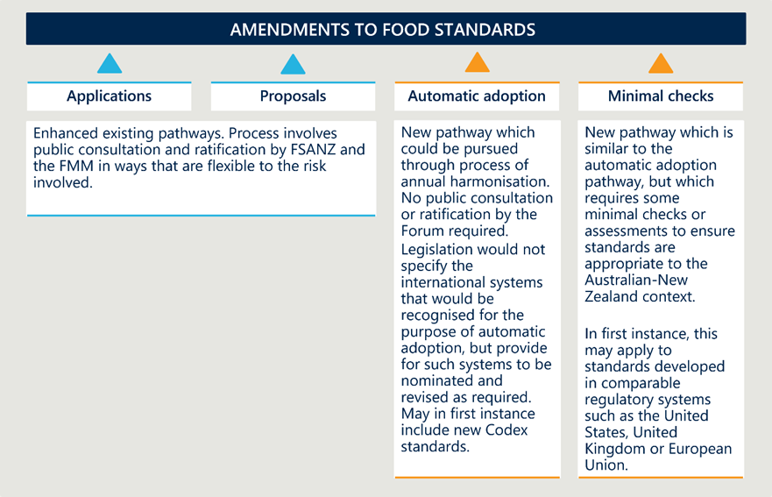

##### Principles could be embedded in legislation to allow FSANZ to create other pathways to amend food standards

Additions could be made to the Act to provide for new pathways to set or amend food standards to be established in the regulations. Legislated principles could stipulate that alternative pathways could be made available and subject to risk-proportionate requirements and decision-making arrangements.

Of note, should these provisions be exercised, work would be completed as part of amending regulations to agree exactly what these pathways would look like and how approval decisions would be made.

#### Component 2.2.3 | Decision-making arrangements could be streamlined

|  |
| --- |
| Policy problem to which this component relates:   * Problem 2.1 | Statutory processes are rules-based rather than outcomes-based |

In addition to more flexible, risk-based statutory processes, decision-making arrangements for applications and proposals could be streamlined by removing current barriers to delegation.

##### The FSANZ Board’s non-delegable duties (set out in Section 150) could be removed or revised to enable the Board to delegate decision-making responsibilities for draft standards or variations to the CEO

In the interests of transparency, if this change is adopted, internal business processes will need to ensure that the Board retains oversight over emerging risks or trends through appropriate reporting arrangements.

##### Members of the FMM could be given the explicit ability to delegate decision-making to ratify changes to food standards to particular departmental officials

This would preserve each jurisdiction’s role in having a ‘final say’ about new or amended food standards, while recognising that particular Ministers may not feel it necessary to have oversight and decision-making authority on all changes to the standards.37F[39]

This change should be accompanied by a clear and transparent decision-making process, decision tree, and evidentiary requirements. This should include seniority requirements for delegating different kinds of decisions.

Note that for existing application and proposal pathways, this would mean the current two-step decision-making arrangements were preserved. Specifically, draft standards would be developed and approved by FSANZ, before being considered and ratified by the jurisdictions. Furthermore, it is important to emphasise these proposed changes would not take away the oversight and decision-making authority of ministers or remove their ability to personally review and make final decisions.

#### Component 2.2.4 | Legislative change and greater guidance material could support bringing more traditional foods to market

|  |
| --- |
| Policy problem to which this component relates:   * Problem 2.2 | Current requirements create barriers for Indigenous foods to be brought to market |

The burden of having traditional foods listed in the Food Code could be reduced.

##### A one-off investment of time and resources to develop and publish a list of traditional foods or ingredients that have undergone safety assessments

This would support more businesses to bring traditional foods to market.

##### Further guidance material could be developed on how traditional foods can be assessed for safety

This could include clarification on when a traditional food would need to go through an alternative food process, for example a traditional food used in a non-traditional way. This would not impact the standard of safety to which foods are held.

Note: Other changes such as updates to engagement obligations with Aboriginal, Torres Strait Islander and Māori Peoples and the potential development of a traditional foods pathway are flagged as ‘Tier 2’ concepts (see Figure 6 on page 26), and are out of scope for this review.

#### Component 2.2.5 | FSANZ can be resourced to undertake more timely, holistic and regular reviews of standards

|  |
| --- |
| Policy problem to which this component relates:   * Problem 2.3 | Resourcing constraints have effectively preferenced piecemeal changes to food standards over holistic reviews |

Informed by ongoing environmental scans, consultation and data analysis, FSANZ could identify standards that require revision and dedicate resources to undertake this work in a timely way.

This reform idea could help to ensure ongoing relevance of standards, including considering the cumulative impact on health, safety, and regulatory burdens, and provide for a more systematic and strategic approach to reviewing them. This idea would leverage FSANZ’s existing coordination roles and expertise.

Reviewing the Processing Aid Standard and associated Enzymes schedule would complement a risk-proportionate approach to low-risk applications. Investigating mechanisms used by international counterparts where assessment is made on the safety of a technological function, but not restricting the foods in which it can be used, would allow industry to determine whether labelling is required via guidance in a risk proportionate way, reducing compliance burden for regulators.

#### Component 2.2.6 | Codes of Practice and guidelines could be increasingly used to complement food standards

|  |
| --- |
| Policy problem to which this component relates:   * Problem 2.4 | FSANZ generally defaults to developing food standards, but other regulatory measures could be more efficient to create |

Implementing a decision-making tool may result in greater uptake of Codes of Practice and guidelines, which can be created and amended in more agile and responsive ways. This resource could draw on the risk framework outlined in Table 10 on page 51.

Examples of low-risk issue that may be better dealt with in Codes of Practice might relate to sustainable packaging (e.g. encouraging industry to reduce the amount of plastic wrapping), nationally consistent school canteen options and placement and promotion of foods in grocery stores. On the other hand, high-risk matters, such as disclosures of allergenic information, would only be appropriate to regulate through food standards.

Codes of Practice could be developed by FSANZ, or by industry, with FSANZ’s oversight.

|  |
| --- |
| Consultation questions |
| Component 2.2.1 | A risk-based framework and approach could be introduced to guide the development of food regulatory measures   * Would the introduction of a risk-based framework support FSANZ to be flexible and proportionate in handling of changes to the Food Standards Code? * What criterion and/or evidence should be used to form the basis of a risk framework? * What would be the impact of introducing a risk-based framework to guide development of food regulatory measures for you?   Component 2.2.2 | New pathways to amend food standards could be introduced   * Would enabling FSANZ to accept risk assessments from international jurisdictions support FSANZ to exercise risk-based and proportionate handling of applications and proposals? How so? * Would enabling (but not compelling) FSANZ to automatically recognise appropriate international standards support more risk-based and proportionate handling of applications and proposals and improve efficiency and effectiveness? How so? * Would introducing a minimal check pathway for very low risk products help FSANZ exercise risk-based and proportionate handling of applications and proposals and improve efficiency and effectiveness? * Would introducing principles in legislation to allow FSANZ to create other pathways to amend food standards help FSANZ exercise risk-based and proportionate handling of applications and proposals? * What would be the impact of introducing new pathways to amend food standards for you? * Are there other opportunities relating to new pathways to amend food standards that should be considered?   Component 2.2.3 | Decision-making arrangements could be streamlined   * Would increasing opportunities for decision making arrangements to be delegated support FSANZ to be more flexible and efficient? How so?   + What factors should be considered when determining the level of risk for decision-making arrangements? * What would be the impact of streamlining decision-making arrangements for you? * What expertise should be considered when determining the delegation of decisions to an alternative person?   Component 2.2.4 | Legislative change and greater guidance material could support bringing more traditional foods to market   * Would a one-off investment of time and resources to develop and publish a list of traditional foods or ingredients that have undergone nutritional and compositional assessments facilitate entry of traditional foods to market? * Would the development of further guidance materials on how traditional foods can be assessed for safety facilitate entry of traditional foods to market? How so?   Component 2.2.5 | FSANZ can be resourced to undertake more timely, holistic and regular reviews of standards   * Would resourcing FSANZ to undertake more timely, holistic and regular reviews of standards allow FSANZ to be more strategic and consistent in changes to food standards? * Are there other initiatives that should be considered to drive more holistic consideration of food standards?   Component 2.2.6 | Codes of Practice and guidelines could be increasingly used to complement food standards   * Would the use of Codes of Practice and guidelines to better support the implementation of the Food Standards Code and help to address issues that do not warrant the time and resources required to develop or vary a standard?   + Can you provide an example of an issue that would have been/be better solved by a Code of Practice or guideline? (Free text)   + How could the decision pathway for the development of a Code of Practice of guideline be incorporated into the risk framework outlined in Component 2.2.1? * What would be the expected impact if Codes of Practice and guidelines were developed for industry, by industry?   Other   * Are there other initiatives that should be considered in this component? |

### Component 2.3 | Efficient and effective operations

This component focuses on better use of FSANZ’s limited resources through more effective governance, as well as achieving financial sustainability for the organisation.

#### Component 2.3.1 | Outstanding recommendations from the 2014 review of the FSANZ Board could be implemented

|  |
| --- |
| Policy problem to which this component relates:   * Problem 3.1 | Current legislative provisions prohibit nominations and appointments to the FSANZ Board from adopting best practice |

In 2014, the (then) Department of Health conducted a review of the FSANZ Board appointment processes..[40] The purpose of the review was to provide recommendations to better align FSANZ with contemporary approaches to governance and merit-based selection of Board members.

These recommendations were endorsed by the (then) Forum in 2015, noting that Recommendations 1 and 5 would require legislative amendment.

##### Recommendation 1 was to ‘Amend the compositional requirements of the FSANZ Board to address the need for flexibility to accommodate future work requirements’

Section 116 (2B), (2c) and (3)(a) stipulate that the Minister may appoint a person as a member of the Board only if they are satisfied that the person is suitably qualified based on expertise in one or more of a prescribed list of skills. As per the recommendations of the 2014 review, this list could be broadened to include additional skills that would support good governance and oversight, namely:

* sound judgement
* good strategic thinking
* broad understanding of FSANZ issues
* ability to challenge thoughts
* personal drive and integrity
* ability to perform publicly and be vocal when required
* ability to represent the board at different fora
* finance and governance experience, and
* regulatory experience.

Expertise in First Nations and Māori food and culture could also be included.

##### Recommendation 5 focused on ‘Amending the nomination process to be an open market process by advertising for upcoming vacancies externally’

An open market process could be achieved by amending Section 116(3)(b) of the Act to remove the requirement for nominations to be sought from organisations that are prescribed in the regulations (of which there are 43).

A new provision could be added to Section 116 requiring the Minister to consider advice from the Board Chair about the current skill mix of the Board membership and any gaps to inform appointment decisions.

#### Component 2.3.2 | The expedited approvals pathway could be removed to address workload prioritisation.[41]

|  |
| --- |
| Policy problem to which this component relates:   * Problem 3.2 | Long-term decreases in funding in real terms has created significant resourcing pressure and is forcing FSANZ to focus on only a subset of its statutory functions |

Section 146(6)(b) could be removed to revoke the option for applications to be expedited (which is subject to a fee). While this means that FSANZ would in fact forego a source of revenue, it would mean it would not be bound to commence assessment of paid applications as quickly, noting that the Act requires applications to be assessed within 12 months for a major procedure (nine months for a general or high level health claim or three months for a minor procedure), and this timeframe commences at the time the fee is paid for paid applications. This change would remove an avenue by which businesses can currently gain greater certainty as to when they can launch products and plan for the future. However, it would potentially release capacity for FSANZ to focus its resources on other initiatives, such as proposals and project work.

Note: it may not be possible to implement this change, if other changes proposed in Component 2.3.3 are also supported.

#### Component 2.3.3 | To generate more sustainable revenue, cost recovery could be expanded for work that benefits industry[42]

|  |
| --- |
| Policy problem to which this component relates:   * Problem 3.2 | Long-term decreases in funding in real terms has created significant resourcing pressure and is forcing FSANZ to focus on only a subset of its statutory functions |

Changes to the Act could enable FSANZ to cost recover for a broader range of products and services that benefit industry.

Section 146 of the Act authorises FSANZ to fix charges for services and facilities that it provides. Of note, all cost recovery arrangements that charge specific individuals (cost recovery fees) or groups of individuals/industries (cost recovery levies) must comply with the Australian Government Cost Recovery Policy[43] and the New Zealand Guidelines for Setting Charges in the Public Sector, which emphasise making decisions about when and to what degree it is appropriate to recover costs.[44]

|  |
| --- |
| There has been some literature around how cost recovery principles could be applied in the food system. For example, a review[45] focused on the NSW system (which goes beyond food standards) suggested that activities that should be funded entirely by Government include:   * Policy and Standard Setting * Enforcement * Consumer Information and Education * Government Requirements * Emergency Management Plan * Strategic Planning and Change Management * Corporate Communications   Activities that could reasonably be funded entirely by industry (i.e. subject to full cost recovery) include:   * Certification * Environmental Monitoring (routine operational only) * System Testing * Licensing * Industry Advice and Training   Overhead costs that could be jointly funded government and industry (e.g. through partial cost recovery) include   * General Management * Corporate Services * Staff Training (both Professional Development and Operational Training and Accreditation). |

Several options for cost recovery from industry are outlined below.

##### An industry-wide levy could be implemented

A levy could be placed on select food businesses to support the ongoing work of FSANZ, such as the largest 5,000 food businesses in Australia (or those generating over a certain threshold of revenue per year). This could be appropriate as standard-setting and other activities contribute to maintaining high standards of food safety and quality, reputation of the Australian and New Zealand food system and marketability of food products through a combination of rigorous pre-approvals and post-market support such as surveillance and food recall coordination.

Activities that an industry levy could support which would have direct industry-wide benefits include the production of guidance materials to assist with compliance, international harmonisation work to adopt and align with international standards expanding trade opportunities, contribute to supporting more timely consideration of standard reviews, enhanced monitoring of the food supply to identify trends and reporting on the state of the food supply. A levy could also support FSANZ to enhance and streamline its delivery of services to the industry, allowing it to undertake projects such as making the Food Standards Code more user friendly and accessible.

Should such a levy be implemented, FSANZ’s existing (and any additional industry cost recovery mechanisms proposed below) industry cost recovery mechanisms – namely, the cost to expedite applications or to capture an exclusive commercial benefit – could be discontinued.

Table 11 | Case study: The Australian Grape and Wine Authority (AGWA) Wine Grapes Levy

|  |
| --- |
| The Australian Grape and Wine Authority collects levies to support the wine grape industry in Australia. The Australian Grape and Wine Authority levy is set at $5 per tonne of wine grapes harvested by all eligible growers. The levy is charged at the point of sale of wine grapes, typically due annually. Funds collected through the AGWA levy support activities such as research, marketing, quality control, and initiatives aimed at improving the health and sustainability of the industry. This levy has had a positive impact on the wine grape industry, enabling the funding of research and marketing campaigns, resulting in improved grape quality, greater market access, and increased international competitiveness. |

##### Compulsory fees could apply to all applications

A change could be made to the Act to make all applications subject to cost-recovery. Currently, FSANZ accepts both unpaid and paid (expedited) applications from industry to make changes to the food standards. A change in this approach could provide for an increase in cost recovered revenue without necessitating significant operational changes for FSANZ. Applicants could still have the opportunity to pay for their applications to be expedited, in addition to the baseline fee. This fee could be scaled based on the estimated labour required to assess proposals, using the scale included in Part 4 of the regulations.

FSANZ could carry out other entrepreneurial activities. Section 13(1)(o) provides for FSANZ to make available its knowledge, expertise, equipment, facilities and intellectual property to other persons on a commercial basis. FSANZ could expand its activities under this remit, for example, by providing user-pays training for industry stakeholders in Australia and New Zealand to navigate and comply with the Code (a service which industry stakeholders currently procure from consultants in some cases).

#### Component 2.3.4 | Some services could also be cost recovered from government agencies

|  |
| --- |
| Policy problem to which this component relates:   * Problem 3.2 | Long-term decreases in funding have created significant resourcing pressure and is forcing FSANZ to focus on only a subset of its statutory functions |

Australian states and territories currently do not contribute to FSANZ’s substantive funding. New cost recovery activities could see some fees charged to states and territories, as well as the Australian Government and New Zealand Government.

##### A Food Recall Coordination Levy could be imposed *(Australia Only)*

FSANZ currently works with the jurisdictional enforcement agencies in Australia to coordinate an average of 90 recalls per year, primarily to address undeclared allergens and microbial contamination. This incurs an average annual cost to FSANZ of $1,190,000.

FSANZ could charge Australian States and Territories a levy, based on the number of food businesses or the average number of food recalls that are required in that jurisdiction.

##### Jurisdictions could be charged a fee to add additional proposal work to FSANZ’s workplan

FSANZ could implement a cost recovery mechanism for the FMM to request additional proposals added to FSANZ’s workplan, where these exceed the number that can be normally absorbed and agreed in the joint agenda-setting activities proposed in Component 2.4 in Section 5.2.4.

This can support FSANZ to dedicate resources to additional proposals without interrupting other initiatives on its workplan.

|  |
| --- |
| Consultation questions |
| Component 2.3.1 | Outstanding recommendations from the 2014 review of the FSANZ Board could be implemented   * Would amending the compositional requirements of the FSANZ Board increase flexibility and reflect contemporary governance processes? * Would amending the nomination process for the FSANZ Board to be an open market process increase efficiency and support a better board skill mix?   Component 2.3.2 | The expedited approvals pathway could be removed to address workload prioritisation   * What would be expected impact of removing the option for applications to be expedited?   Component 2.3.3 | To generate more sustainable revenue, cost recovery could be expanded for work that benefits industry   * What would be the expected impact of the implementation of an industry-wide levy?   + How could eligibility criteria for a levy be set so that it is fair, consistent and feasible to administer?   + What do you think could be an acceptable range for a levy rate? Please provide your response in Australian Dollars. * What would be the expected impact of compulsory fees for all applications? * Are there specific entrepreneurial activities that FSANZ should be considering charging to build up a more sustainable funding base?   Component 2.3.4 | Some services could also be cost recovered from government agencies   * Would imposing a food recall coordination levy imposition contribute to a more sustainable funding base and support FSANZ to rebalance its workload priorities by addressing resourcing pressures? How so?   + How could eligibility criteria for a levy be set so that it is fair, consistent and feasible to administer? * Would charging jurisdictions to add additional proposal or project work to FSANZ’s workplan meaningfully support FSANZ to rebalance its workload priorities by addressing resourcing pressures? How so? * What would be the expected impact of imposing a food recall coordination levy on jurisdictions?   + How would this need to be implemented to be successful?   + Would it be better to charge a levy per recall, or an annual levy? * What would be the expected impact of charging jurisdictions a fee to add additional proposal work to FSANZ’ workplan?   + How would this need to be implemented to be successful?   Other   * Are there other initiatives that should be considered in this component? | |

### Component 2.4 | Improving system agility

This component aims to make the food regulatory system better integrated, streamlined, and evidence informed. It achieves this through the creation of new collaboration mechanisms and greater data and intelligence analysis and sharing.

Several concepts focus on improving the policy/food standard interface, with greater collaboration between FSANZ, the FMM, FRSC and academics that are experts in food safety data. These are detailed below.

#### Component 2.4.1 | Mechanisms to enable FSANZ and FMM to undertake periodic joint agenda-setting could be implemented

|  |
| --- |
| Policy problem to which this component relates:   * Problem 4.1 | The lack of a shared vision of system priorities between FSANZ and the FMM limits the effectiveness of the broader food regulatory system |

##### FSANZ and the FMM could implement routine, joint priority setting mechanisms

This could, for instance, consist of annual planning days where members of FSANZ and Food Ministers come together to agree on the proposals and other project work that will be progressed as part of FSANZ’s workplan, with a view to removing or abandoning lower priority items.41F[46]

Joint priority setting could focus *solely* on the component of FSANZ’s workplan with capacity allocated to proposals and project work – it should not displace the progress of applications, which are subject to statutory timeframes.

To assist with this, FSANZ and the FMM could establish a joint prioritisation matrix by which they could assess proposals for their relative importance and resourcing demands. Such a matrix could consider factors such as:

* relative impact on public health and safety
* the current 3-year food strategic plan
* bi-national issues
* other national/international plans such as the *National Preventative Health Plan 2021-2030*
* emerging trends in food
* existing evidence base.

This would represent a joint agreement between FMM and FSANZ, not a direction from FMM to FSANZ.

#### Component 2.4.2 | FSANZ could engage earlier and more systematically with FRSC and jurisdictions in the development of food standards

|  |
| --- |
| Policy problem to which this component relates:   * Problem 4.2 | Limited intelligence-sharing between stakeholders across the regulatory system is resulting in duplication of effort and missed opportunities to manage risk |

FSANZ could involve FRSC earlier to understand the potential food safety and regulatory impact of changes to food standards. Collaborations could focus on establishing a shared understanding of the safety and regulatory impact measures that will feed into an assessment of a proposal, and the work that will be undertaken by each party at different stages of the process to identify opportunities to minimise duplication.

In practice, this component would focus on using existing FRSC processes to confirm the intent of proposals. As that there currently no formalised mechanism by which FRSC can engage with FSANZ on the development of food standards, there is scope to systematise early engagement between FSANZ and FRSC in the process to ensure that the right officials and engaged at the right time. This may also involve better use of the FMM agenda to establish a shared understanding of objectives and limitations with regard to food standards in development.

#### Component 2.4.3 | FSANZ could take guardianship over key food safety databases (Australia only)

|  |
| --- |
| Policy problem to which this component relates:   * Problem 4.2 | Limited intelligence-sharing between stakeholders across the regulatory system is resulting in duplication of effort and missed opportunities to manage risk |

FSANZ could assume a role as the custodian of a composition/nutrition/food safety data base that is used for analysis of trends and emerging issues. This could build in the first instance on the information already held by FSANZ in relation to:

* the Australia Total Diet Survey
* branded food composition and modelling work for the Health Star Rating calculator.

Positioning FSANZ’s databank to inform project work carried out by FSANZ at the request of jurisdictions would increase collaboration and contribute to greater intelligence-led decision making. FSANZ proposes that, for example, combining the branded food database with sales data could provide powerful insights into dietary management of acute and chronic population risks. This would support FSANZ to carry out project work which benefits the jurisdictions and their enforcement agencies.

#### Component 2.4.4 | Further work could be done to establish information sharing arrangements with international partners

|  |
| --- |
| Policy problem to which this component relates:   * Problem 4.2 | Limited intelligence-sharing between stakeholders across the regulatory system is resulting in duplication of effort and missed opportunities to manage risk |

Enhanced collaboration based around information sharing could also extend to international partnerships with overseas jurisdictions (including standard-setting bodies and other regulators). This could leverage FSANZ’s existing work, relationships and presence in regional and global forums.

There is some precedent for this; since 2013, FSANZ and Health Canada have been working together on the safety of genetically modified foods under a formal agreement to facilitate sharing of safety assessments of food derived from genetically modified organisms. This helps to reduce duplication and share scientific expertise between the jurisdictions.

Other ideas focus on the food standards/enforcement interface, including collaborations with industry and jurisdictional enforcement agencies, as described below.

#### Component 2.4.5 | Statements of intent could be introduced into the Food Standards Code to assist with interpretation and enforcement

|  |
| --- |
| Policy problem to which this component relates:   * Problem 4.3 | Inconsistent interpretation and enforcement of food standards heightens costs for industry and enforcement agencies, while potentially undermining management of foodborne risks (Australia only) |

FSANZ could reduce interpretive uncertainty through the provision of greater guidance on food standards. This could involve including a Statement of Intent alongside food standards in the Food Standards Code to describe what FSANZ wants to achieve in the writing of each food standard (akin to Explanatory Memoranda) which could provide basis for enforcement activities.

This could be achieved either by including the Statement of Intent as an introductory provision within each standard (like an objects clause) or including it as an editorial note and amending the current definition of a ‘standard’ (which specifically excludes text identified as an editorial note and text identified as an example) to ensure they are legally enforceable.

#### Component 2.4.6 | FSANZ could be resourced to develop, update and maintain industry guidelines to guide interpretation of food standards

|  |
| --- |
| Policy problem to which this component relates:   * Problem 4.3 | Inconsistent interpretation and enforcement of food standards heightens costs for industry and enforcement agencies, while potentially undermining management of foodborne risks (Australia only) |

##### FSANZ could update and maintain industry guidelines which provide advice on how industry can comply with food standards

This process could be triggered by industry need, established through close consultation based on specific interpretive issues and requests for clarification.

Most large food businesses engage consultants to navigate and comply with the Food Standards Code. Access to such resources can be cost prohibitive for smaller food businesses and sole traders, yet this cohort is the one that often finds it most difficult to understand their regulatory and food safety requirements.[47] These guidelines should include the specific relevant sections of the Act to provide a single source of truth.

##### Options to better account for the needs of First Nations and Māori Peoples could also be explored

For example, Section 13(1)(c) of the Act which outlines that the function of FSANZ includes developing guidelines ‘on its own initiative or in consultation with the States, the Territories and any other body or person that it considers appropriate’. This could be extended to explicitly include consultation with First Nations, or Māori Peoples.

#### Component 2.4.7 | FSANZ could collaborate more regularly with jurisdictional enforcement agencies

|  |
| --- |
| Policy problem to which this component relates:   * Problem 4.3 | Inconsistent interpretation and enforcement of food standards heightens costs for industry and enforcement agencies, while potentially undermining management of foodborne risks (Australia only) |

FSANZ could collaborate more regularly with jurisdictional enforcement agencies to identify emerging risks and activate the appropriate regulatory response. Currently, jurisdictions undertake significant work to hone a risk-based approach to regulation, based on their own perceptions of where the most pressing risks lie. FSANZ already shares intelligence with the jurisdictions to support this. To expand this collaboration, FSANZ could use its intelligence base to highlight emerging risks and position enforcement agencies to stand up a proactive response and manage issues before they arise.

|  |
| --- |
| Consultation questions |
| Component 2.4.1 | Mechanisms to enable FSANZ and FMM to undertake periodic joint agenda-setting could be implemented.   * Would establishing mechanisms to enable FSANZ and FMM to undertake periodic joint agenda setting lead to a shared vision of system priorities?   + How would this need to be implemented to be successful? * What factors should be considered as part of the joint prioritisation matrix? * In what ways could FSANZ and FMM work together in a more coordinated way?   Component 2.4.2 | FSANZ could engage earlier and more systematically with FRSC and jurisdictions in the development of food standards.   * Would more routine engagement between FSANZ and the FRSC reduce duplication of effort and missed opportunities to manage risk? How so? * What approaches could be used to improve collaboration between FSANZ, the FRSC, and the FMM?   Component 2.4.3 | FSANZ could take guardianship over key food safety databases (Australia only)   * Would FSANZ assuming a role as a database custodian for Australia meaningfully improve intelligence sharing across the regulatory system? How so? * What types of data would be most useful for FSANZ to curate?   Component 2.4.4 | Further work could be done to establish information sharing arrangements with international partners.   * Would establishing information sharing arrangements with international partners reduce duplication of effort and missed opportunities to manage risk?   + What should be the focus of such information sharing arrangements?   Component 2.4.5 | Statements of intent could be introduced into the Food Standards Code to assist with interpretation and enforcement.   * Would introducing Statements of Intent into food standards meaningfully improve consistent interpretation and enforcement of food standards? How so? * What should a Statement of Intent include to benefit industry and enforcement agencies to understand and consistently apply food standards?   Component 2.4.6 | FSANZ could be resourced to develop, update and maintain industry guidelines to guide interpretation of food standards   * Would FSANZ being resourced to develop, update and maintain industry guidelines improve consistent interpretation and enforcement of food standards? How so? * Would amending the Act to allow FSANZ to develop guidelines in consultation with First Nations or Māori peoples support cultural considerations being taken into account in the food standards process?   Component 2.4.7 | FSANZ could collaborate more regularly with jurisdictional enforcement agencies   * Would FSANZ collaborating with jurisdictional enforcement agencies improve inconsistent interpretation and enforcement of food standards?   Other   * Are there other initiatives that should be considered in this component? | |

# Net Benefit

|  |
| --- |
| This section presents an estimation of costs and benefits.  In this version of the IA, economic analysis has assumed that all initiatives currently proposed within Option 2 are implemented. The net present value will be recalculated following stakeholder feedback to reflect the final set of initiatives that comprise the preferred option.  More information about the methodology employed and key assumptions underpinning the analysis are provided at Appendix C. |

A cost benefit analysis has been conducted to identify and assess the impacts of the proposed options on key stakeholder groups. The four stakeholder groups are:

* FSANZ
* other government entities (New Zealand and jurisdictions)
* industry
* consumers.

A cost-benefit model has been designed to ensure a comprehensive and accurate assessment of the costs and benefits of all the proposed sub-components in the IA. This has required:

* identifying and defining the outcomes of each sub-component
* identifying key assumptions through literature reviews, previous consultations and FSANZ
* assessing the impact of each sub-component on the identified outcomes through literature reviews
* assigning and identifying relevant costs and benefits taking into account both tangible and intangible factors
* conducting a sensitivity analysis to evaluate the robustness of the model and assess the impacts of varying assumptions.

|  |
| --- |
| To the extent possible, the impacts have been quantified in terms of labour efficiencies and revenue (benefits) and delay and labour costs (costs). Other non-quantifiable costs have been qualified where appropriate.  The key assumptions underlying the cost benefit model are:   * Real discount rate of 7% per annum. * Delay costs to industry are AUD $40,000 (NZD $42,800) a month. * FSANZ compound wage rate is AUD $140,000 (NZD $149,800). * Public health benefits derived from one standard have been quantified to be AUD $1.33 million (NZD $1.42 million) per annum using nutrition labelling as a proxy for the public health benefits of food regulation. This is assumed to grow by the average population growth rate of 0.76% per annum. * First Nations and Māori food industry value add grows at 10% per annum.   Further details on cost benefit analysis assumptions are provided in Appendix C. |



## Option 1 | Retain the status quo

Option 1 represents the current state. That is, the FSANZ Act and operations of FSANZ as they currently are. Under Option 1, FSANZ will continue to be resourced at AUD $17.5 million (NZD $18.7 million) in appropriations from the Australian Government with an addition of AUD $2.9 million (NZD $3.1 million) in cost recovery fees and appropriations from the New Zealand Government per year.

Current revenue levels would support FSANZ to continue to generate outputs for a subset of its functions only, as per Table 12.

Table 12 | Current FSANZ functions and outputs43F[48]

|  |  |
| --- | --- |
| Workstreams | Outputs |
| 1. Develop food standards in response to applications and proposals to amend the Food Standards Code | * Assessment of 17 applications each year * Conduct 3 proposals each year * Conduct 1 standard review each year |
| 1. FSANZ Board and FMM oversight of the development of food standards | * 4 face to face meetings, 5 virtual meetings * 18 approvals * 1 request for review |
| 1. Coordinate food incident responses and food recalls | * 79 recalls * 1 incident response |
| 1. Engagement with stakeholders | * Engage with 8 forums and committees * 116 engagements with domestic and international experts * Conduct 22 joint projects * Conduct 35 interactions with FSANZ fellows * Conduct 11 meetings with FSANZ expert advisory groups |
| 1. Undertake monitoring and surveillance activities to ensure regulatory and nonregulatory activities achieve their objectives | * Conduct 2 targeted surveys * Conduct 1 surveillance activity |
| 1. Provide authoritative, evidence-based information about food risks and standards to stakeholders and consumers | * Manage 7 databases |
| 1. Engagement with stakeholders | * Deliver 7 publications * Achieve 73,800 social media reach and 2 million website visits |

|  |
| --- |
| As highlighted in Policy Problem 3.2, current funding arrangements have resulted in chronic budget shortfalls for FSANZ. Should nothing else change in the legislation or FSANZ’s operations, an additional AUD $6.5 million (NZD $7.0 million) would be required to bring total resourcing to AUD $26 million (NZD $27.8 million) per year (excluding any cost recovery revenue) to allow FSANZ to carry out its full gamut of statutory functions. |

#### Option 1 maintains high costs to industry and FSANZ to achieve public health benefits

Under Option 1, the total quantifiable cost is AUD $289.7 million (NZD $310.0 million) over ten years. A large part of costs accrues to Industry in the form of delay costs. Currently, unpaid applications take 21 months to assess while paid applications are assumed to take nine months to assess. The current assessment timeframes for both paid and unpaid applications generate delay costs of AUD $85.2 million (NZD $91.2 million) over ten years. There are further intangible costs to both industry and other government entities from a lack of certainty – the former related to interpreting food standards and the latter resulting in coordination burden between FSANZ and jurisdictions.

FSANZ, and by extension the Australian Government, also bears the majority of the costs in the development and communication of food standards.[49] Currently, FSANZ bears 86% of the total resourcing costs while other government jurisdictions contribute 10%. The remainder is borne by consumers through the flow of cost recovery of applications fees by industry.

The total quantifiable benefits of Option 1 are AUD $305.1 million (NZD $326.44 million) over ten years in the form of public health benefits. Specifically, the work FSANZ does through application assessments, standard reviews and proposal work protect a safe and nutritious supply of foods and support consumers to make informed decisions about their diets. Further unquantifiable benefits also arise from FSANZ’s role as an independent scientific agency promoting trust in the food regulatory system and harmonising standards both domestically and internationally.

The distribution of the costs and benefits of FSANZ’s current operations highlight the majority of the food safety regulation costs are borne by industry and FSANZ to achieve public health outcomes. The net benefit is AUD $15.4 million (NZD $16.4 million) over ten years with a BCR of 1.05. After applying a discount rate of 7%, the net present value of Option 1 AUD $10.7 million (NZD $11.4 million).

As Option 1 maintains the status quo, costs will remain distributed among stakeholders in Australia and New Zealand as they currently are. Some costs – such as those due to inconsistent interpretation of food standards – are experienced in higher rates by Australian stakeholders.

An overview of the distribution of costs and benefits are provided at Table 13.

Table 13 | Overview of benefits and costs by stakeholder group for Option 1

|  |  |  |
| --- | --- | --- |
| Stakeholder | Costs or Benefits | Description of costs or benefits |
| Industry | Quantified costs | * Delays in bringing products to market, due to inefficient processing of applications and proposals. (Industry stakeholders face opportunity costs amounting to AUD $40,000 (NZD $42,800) per month). Extrapolating this data leads to AUD $8.5 million (NZD $9.1 million) per year in opportunity costs. |
| Qualified costs | * Deterrent effect for prospective applicants due to time and cost of making an application (i.e. barriers to innovation). * Limited harmonisation with international standards (for exporting and importing businesses). * Increases in compliance costs as goods need further approval despite given approval in other markets. * Substantial compliance burden associated with (a) interpretive uncertainty around food standards and (b) inconsistent interpretation across jurisdictions (Australia only). * First Nations and Māori businesses cannot access food markets due to an uncertainty about how to demonstrate the safety of traditional foods. * Administrative and compliance burden to comply with cost recovery initiatives |
| Quantified benefits | * NA |
| Qualified benefits | * Regulation through food standards improves consumer confidence. By establishing and upholding safety and quality standards, regulations assure consumers of the integrity and reliability of the products they purchase. As confident consumers are more likely to engage with and invest in the market, this indirectly supports the food industry. * Improved market access to available given the bi-national nature of the food standards system. Should this not exist, jurisdictions may set their own requirements creating fragmentation in regulatory requirements. * Expedited pathways provide certainty for businesses in terms of approval timeframes. |
| Governments (Australia and New Zealand, including jurisdictions) | Quantified costs | * Funding from the New Zealand Government (AUD $2 million/NZD $2.1 million).44F[50] |
| Qualified costs | * Moderate administrative costs associated with monitoring and enforcing food standards in presence of interpretive uncertainty. This is beyond the costs incurred by jurisdictional governments to monitor and enforce compliance with food standards, which is a cost associated with jurisdiction-level food acts. |
| Qualified Benefits | * The status quo has delivered good public health and trade outcomes over many years and the joint food standards system has a strong track record and international reputation. It has effectively prevented the market failures that it was designed to address. |
| Consumers | Quantified costs | * Public health benefit from effective regulation of food standards is estimated to be AUD $1.33 million (NZD $1.42 million) per standard/review/proposal. Extrapolating this over 17 applications and 3 reviews/proposal per year gives AUD $26.5 million (NZD $28.5 million) per year in public health benefits. |
| Qualified Costs | * Small effect on consumer choice through limitation in range of food products available (due to deterrent effect, delays in processing applications). * Reduced consumption on food items due to increased costs from cost recovery initiatives |
| Qualified Benefits | * Sustained assurance around the quality and safety of the Australian – New Zealand food supply which will support confident investment into food and food businesses. |
| FSANZ | Quantified Costs | * Substantial operational costs associated with administering an outdated and inflexible Act (e.g. time involved in assessing applications and proposals through broadly one-size-fits-all approach with limited ability to draw on international evidence-base). FSANZ resourcing from the Australian government was AUD $17.5 million (NZD $18.7 million) in 2022. Assuming that FSANZ’s total funding remains stable, total funding over the next ten years from the Australian government is estimated to be AUD $175 million (NZD $187.3 million). |
| Qualified Benefits | * Public confidence in the provision of safe food. |

Table 14 | Distribution of quantified present value costs and benefits for Option 1 (AUD $m) over ten years

|  |  |  |  |  |  |
| --- | --- | --- | --- | --- | --- |
|  | FSANZ | Other government entities | Industry | Consumers | Total |
| Present costs | 131.5 | 15.0 | 64.0 | 7.2 | 217.7 |
| Present benefits | 22.2 | - | - | 206.2 | 228.4 |
| Net present benefit |  |  |  |  | 10.7 |
| Benefits Cost Ratio (BCR) |  |  |  |  | **1.05** |

## Option 2 | Modernise regulatory settings

Option 2 seeks to create a more risk-based approach to food standards assessment and regulation in line with modern regulatory approaches. Improved assessment processes are developed for Indigenous foods in addition to greater collaboration and guidance for industry and other relevant bodies.

Under this option, FSANZ would receive AUD $40 million (NZD $42.8 million) per year in funding, an increase of AUD $20.5 million (NZD $21.9 million) above Option 1. Assumptions at this stage is the funding will be comprised of:

* AUD $22.2 million (NZD $23.8 million) per year in appropriations from the Australian and New Zealand government.[51]
* AUD $10 million (NZD $10.7 million) per year cost recovered from industry.
* AUD $7.8 million (NZD $8.3 million) per year cost recovered from jurisdictions for projects (AUD $6.3 million (NZD $6.7 million)) and food recall coordination (AUD $1.5 million (NZD $1.6 million)). This cost recovery measure is only applicable to Australian jurisdictions.

#### Option 2 lowers the cost to industry while improving public health benefits and market access

The total costs and benefits of Option 2 assumes that all components of Option 2 will be implemented, although aspects of Option 2 may not be progressed to a final preferred option.

It is also assumed that, in addition to the reform components associated with this option, FSANZ’s baseline funding would be increased by AUD $2.7 million (NZD $2.9 million), to AUD $22.2 million (NZD $23.8 million) per year. This in combination with additional cost recovery measures will allow FSANZ to deliver its current legislative remit and its full suite of functions under Option 2.

The total quantifiable cost for Option 2 is AUD $438.8 million (NZD $469.5 million) over ten years. There are increased costs for FSANZ reflecting greater resourcing requirements. Compared to Option 1, FSANZ will require $400 million over ten years. The increased resourcing will provide FSANZ the resources necessary to conduct regular and holistic standard reviews, progress proposals in a timely manner, undertake risk-proportionate assessments including international best practice to support industry innovation, develop and deliver guidance and educational materials and Statements of Intent to support harmonisation, and undertake new functions such as creating and developing and publishing a list of Aboriginal, Torres Strait Islander and Māori traditional foods.

The delay costs to industry are significantly reduced. Over ten years, the introduction of a risk-based approach to application assessments will save industry AUD $46.4 million (NZD $49.7 million) in discounted delay costs relative to Option 1. It is assumed the risk-based approach will reduce assessment times by four months as shown when FSANZ adopted Canadian standards for low-risk GM applications. Industry will also save unquantified benefits from having guidance material that promotes clarity and consistency on how standards are enforced across jurisdictions. Guidance will also provide significant support to new entrants in the food sector. Increased focus on FSANZ involvement at international fora and harmonising more international standards will benefit Australian and New Zealand food businesses and open market access opportunities for food businesses looking to export or expand their export opportunities.

The total quantifiable benefit for Option 2 is AUD $726.3 million (NZD $777.2 million) over ten years and are driven by two factors: increased public health benefits and market access for Aboriginal, Torres Strait Islander and Māori foods. The increase in public health benefits is generated from more standard reviews while continuing to deliver three proposals per year. Improving market access for Aboriginal, Torres Strait Islander and Māori foods have been estimated utilising the current industry value-add of both the Australian and Māori food sector, AUD $8 million (NZD $ 8.6 million) and AUD $2.2 million (NZD $2.4 million) per year respectively.

Other government entities are also expected to accrue benefits in improved certainty between FSANZ and FMM due to greater collaboration and alignment of agendas. Further benefits to industry in the form of lower legal fees and delay costs from greater guidance materials are also expected.

The distribution of the costs and benefits for Option 2 reflects a greater share of food regulation costs across the system, a greater level of resourcing for FSANZ, resulting in lower industry costs and higher public health benefits. Compared to Option 1, Option 2 delivers higher net benefit — AUD $287.5 million (NZD $307.6 million) compared to AUD $15.4 million (NZD $16.4 million) with a BCR of 1.63. This indicates Option 2 is more cost effective than Option 1 in delivering public health benefits.

After applying a discount rate of 7%, the net present value of Option 2 over ten years is AUD $208.6 million (NZD $223.2 million), compared with the net present value of Option 1 AUD $10.7 million (NZD $11.4 million). This indicates that even where the future benefits under Option 2 are discounted, it is still more effective than Option 1.

Given the differences in the size of the food sector in Australia and New Zealand, changes to market access, such as those proposed for traditional foods will generate greater benefits for Australia than New Zealand. Analysis shows that industry value-add of the Australian traditional food sector is AUD $8 million (NZD $ 8.6 million) and of the Māori food sector is AUD $2.2 million (NZD $2.4 million) per year respectively. This means that in absolute terms, the Australian market is set to benefit more from greater access for traditional foods. An overview of the benefits and costs is provided at Table 15.

Table 15 | Overview of benefits and costs by stakeholder group for Option 2

|  |  |  |
| --- | --- | --- |
| Stakeholder | Costs or Benefits | Description of costs or benefits |
| Industry | Quantified costs | Reforming standard-setting (Component 2)   * The introduction of a risk-based framework to guide the development of food regulatory measures and new pathways to amend food standards is expected to reduce processing times for applications. At AUD $40,000 (NZD $42,800) per month, the total reduction in delay costs for industry is AUD $4.6 million (NZD $4.9 million) per year. |
| Qualified costs | Unchanged costs compared to Option 1   * Deterrent effect for prospective applicants due to time and cost of making an application (i.e. barriers to innovation).   Purpose and objective of FSANZ (Component 1)   * There is the risk that clarifying the definition of public health could inadvertently broaden FSANZ’s remit in managing public health risks, potentially creating additional administrative burdens in the preparation of applications and creating barriers to trade.   Efficient and effective operations (Component 3)   * Removing paid applications may mean that industry can no longer reliably predict when they may take a product to market. This could increase costs associated with product development, inventory management, and marketing campaigns. An unpredictable timeline might also deter potential international food companies from operating in Australia. |
| Quantified benefits | Unchanged benefits compared to Option 1   * Regulation through food standards improves consumer confidence. By establishing and upholding safety and quality standards, regulations assure consumers of the integrity and reliability of the products they purchase. As confident consumers are more likely to engage with and invest in the market, this indirectly supports the food industry. * Improved market access to available given the bi-national nature of the food standards system. Should this not exist, jurisdictions may set their own requirements creating fragmentation in regulatory requirements.   Reforming standard-setting (Component 2)   * Legislative changes to bring more traditional foods to market will improve market access for Aboriginal, Torres Strait Islander and Māori foods. These figures have been estimated using the current industry value-add of both the Australian and Māori food sector, AUD $8 million (NZD $ 8.6 million and AUD $2.2 million (NZD $2.4 million) respectively, extrapolating to an additional AUD $10.2 million (NZD $10.9 million) per annum, growing year on year at 10%. |
| Qualified benefits | Reforming standard-setting (Component 2)   * Improved harmonisation with international standards will lead to greater ease of trade and reduced barriers for international businesses looking to expand into Australia and New Zealand markets. This leads to increased competition among more diverse businesses, driving innovation.   Improving system agility (Component 4)   * Development of industry guidelines will streamline the process for businesses to comply with food standards, reducing the time and resources spent on navigating regulatory nuances. This in turn can lead to more efficient compliance processes, reduced likelihood of unintentional regulatory breaches, and a more level playing field for all industry participants. |
| Governments (Australia and New Zealand, including jurisdictions) | Quantified costs | Efficient and effective operations (Component 3)   * Cost recovery imposed on jurisdictions for food recall coordination and for adding additional items on to FSANZ’s workplan is estimated to be AUD $7.8 million (NZD $8.3 million) per year (Australia only). |
| Qualified costs | Improving system agility (Component 4)   * Jurisdictions continue to experience administrative burden associated with monitoring and enforcing food standards, albeit to a lesser degree as interpretative changes such as Statements of Intent are inserted to clarify the meaning of food standards. |
| Quantified benefits | * NA |
| Qualified benefits | Reforming standard-setting (Component 2)  Australia and New Zealand   * Harmonisation with international standards would advance the ‘Industry Innovation and Competitiveness Agenda’ proposed by the Australian Government and align with New Zealand’s Strategy Objectives in Codex 2022-2026.[52],[53] * Food Ministers would have greater capacity as decision-making to ratify certain changes to food standards could be delegated to departmental officials.   Improving system agility (Component 4)   * Improved collaboration will help jurisdictional enforcement agencies to leverage FSANZ’s intelligence base to highlight emerging risks and set up proactive responses. |
| Consumers | Quantified costs | Efficient and effective operations (Component 3)  Australia   * An industry-wide levy imposed on the largest 5,000 food businesses in Australia, at AUD $2,000 (NZD $2,140) each, would cost industry AUD $10 million (NZD $10.7 million) per annum. It is expected that industry would pass these costs on to consumers. |
| Qualified costs | Reforming standard-setting (Component 2)  Australia and New Zealand   * Introduction of low-risk pathways may lead to more unsafe foods entering the market, posing to a risk to public health and safety. |
| Quantified benefits | Reforming standard-setting (Component 2)  Australia and New Zealand   * As reforming standard-setting enables FSANZ to process more proposals and reviews, the associated public health benefit increases, extrapolating to an additional AUD $10.7 million (NZD $11.4 million) in public health benefits per year. |
| Qualified benefits | Purpose and objectives of FSANZ (Component 1) Australia and New Zealand   * Clarification of the meaning of public health will give FSANZ clear strategic mandate to consider long-term public health and food-related risks, enabling these risks to be comprehensively managed.   Reforming standard-setting (Component 2)Australia and New Zealand   * Streamlined standard-setting processes reduces barriers to entry for businesses. More businesses entering the market improves the variety of food products and consumer choice of foods. |
| FSANZ | Quantified costs | * Changes proposed under all four themes will require greater FSANZ resourcing, representing an additional AUD $20.5 million (NZD $21.9 million) per year. * Efficient and effective operations (Component 3) Removal of the expedited pathway would forego an existing source of revenue for FSANZ, representing a loss of $AUD 0.9 million (NZD $0.96 million) per year. |
| Qualified costs | * NA |
| Quantified benefits | Reforming standard-setting (Component 2)   * As streamlined standard-setting processes free up capacity and as FSANZ is resourced to undertake more reviews of standards, the number of proposals/reviews processed per year is estimated to increase by eight. * An increase in FSANZ resourcing to support the development and implementation of all its components will create more sustainable funding arrangements for FSANZ to deliver public health benefits.   Efficient and effective operations (Component 3)   * FSANZ will be able to leverage its new cost recovery channels to fund some of its own operations. Combined cost recovery across industry and jurisdictions is estimated to recover AUD $17.8 million (NZD $19.0 million) per year. * FSANZ will receive AUD $2.7 million (NZD $2.9 million) in additional funding from the Australian and New Zealand Governments, bringing total appropriations up to AUD $22.2 million (NZD $23.8 million). |
| Qualified benefits | Efficient and effective operations (Component 3)   * The FSANZ board would be sourced from broader set of nominees and assessed against a larger skill set which supports good governance, improving the capability of the board in directing FSANZ and responding to emerging food-related challenges. * More collaboration and information sharing with jurisdictional enforcement agencies and international partners will help reduce duplication and improve scientific expertise shared with FSANZ from stakeholders across the food regulatory system. |

Table 16 | Distribution of quantified present value costs and benefits for Option 2 (AUD $m) over ten years

|  |  |  |  |  |  |
| --- | --- | --- | --- | --- | --- |
|  | FSANZ | Other government entities | Industry | Consumers | Total |
| Present costs | 166.8 | 58.6 | 29.2 | 75.2 | 329.8 |
| Present benefits | 133.8 | - | 115.9 | 288.7 | 538.3 |
| Net present benefits |  |  |  |  | 208.6 |
| Benefits Cost Ratio (BCR) |  |  |  |  | 1.63 |

|  |
| --- |
| Consultation questions |
| Option 1   * Are there other costs and benefits that have not yet been qualified or quantified? * What are the growth expectations of the First Nations and Māori food sector? * What are the current delay costs to industry? * Do you have any additional data that would be useful in characterising the costs and benefits of current regulatory settings? * Any other comments regarding the Option 1 information in the Net Benefit section?   Option 2   * Are there other costs and benefits for different stakeholders that have not yet been qualified? What are they? * Do you have any additional data that would be useful to characterising the costs and benefits of proposed initiatives? * Any other comments regarding the Option 2 information in the Net Benefit section | |

## Sensitivity analysis

A sensitivity analysis is important to test the key assumptions used in the cost benefit analysis. The key drivers of benefits are the growth of Aboriginal, Torres Strait Islander and Māori food businesses as well as the accrual of public health benefits from applications/proposals/reviews processed. The discount rate has also been tested to verify the sensitivity of the cost benefit analysis to its choice.

Growth of Aboriginal, Torres Strait Islander and Māori food businesses

Based on current industry growth projections, the industry value-add for the growth of Aboriginal, Torres Strait Islander and Māori food businesses has been assumed to grow at 10% per annum.

To test the robustness of this assumption, an analysis of the net present value and BCR achieved at both no growth (pessimistic scenario) and 20% growth (optimistic scenario) was performed. The details of both analyses are described in Table 17.

Table 17 | Sensitivity analysis for growth of Aboriginal, Torres Strait Islander and Māori food businesses for Option 2 (AUD $millions)

|  |  |  |  |  |
| --- | --- | --- | --- | --- |
|  | Base case – 10% growth | Pessimistic – 0% growth | Optimistic - 20% growth | Option 1 – Status Quo |
| Net present value | 208.6 | 169.4 | 273 | 10.7 |
| BCR | 1.63 | 1.51 | 1.83 | 1.05 |

Even without any growth in Aboriginal, Torres Strait Islander and Māori food sector industry value add, there will still be overall net present benefit in Option 2, and it would still be approximately 50% more effective than the status quo.

Public health benefits

The current public health benefit per proposal/application/review is calculated to be $1.33 million, using nutrition labelling as a proxy for the public health benefits of food regulation. This is assumed to grow by the average population growth rate of 0.76% per annum.

To test the sensitivity of the model to the public health benefit figure, an analysis of the net present value and BCR achieved at both $0.67 million (pessimistic scenario) and $2.66 million (optimistic scenario) was performed. The details of both analyses are described in Table 18.

Table 18 | Sensitivity analysis for public health benefit per application/proposal/review for Options 1 and 2 (AUD $millions)

|  |  |  |  |
| --- | --- | --- | --- |
|  | Base case – $1.33 million | Pessimistic – $0.67 million | Optimistic - $2.66 million |
| Option 1 net present value (BCR) | 10.7 (1.05) | -92.4 (0.58) | 216.9 (2.00) |
| Option 2 net present value (BCR) | 208.6 (1.63) | 64.23 (1.19) | 497.3 (2.51) |

As public health represents the main driver of benefits, the net present value and BCR are both sensitive to its changes. However, even where the public health benefit is halved compared with the base case, Option 2 still yields a positive net present value.

Discount rate

In line with guidance from the Office of Impact Analysis, a real discount rate of 7% has been applied to future costs and benefits when calculating the net present value. Sensitivity analysis has also been done with real discount rates of 3% and 10% to confirm the exposure of the model to the choice of discount rates.

Table 19 | Sensitivity analysis for discount rate applied for Options 1 and 2 (AUD $millions)

|  |  |  |  |
| --- | --- | --- | --- |
|  | Base case – 7% | Low – 3% | High – 10% |
| Option 1 net present value (BCR) | 10.7 (1.05) | 13.1 (1.05) | 9.29 (1.05) |
| Option 2 net present value (BCR) | 208.6 (1.63) | 248.7 (1.65) | 184.9 (1.62) |

Even with a high discount rate, the BCR for Options 1 and 2 remain relatively consistent at 1.05 and 1.62 respectively, indicating that the choice of discount rates does not have significant impacts on the net present value and BCR.

# Summary of stakeholder feedback

Extensive consultations have occurred already to support the Review, as summarised in Figure 10. The characterisation of the policy problems, the options for reforms and the impacts these would have on different stakeholder groups has also been iterated, evolving to incorporate new feedback and other information as it became available. This version, for example, has already been informed by input from hundreds of different stakeholders.

The Review adopted a mixed mode of engagement to be inclusive of a broad range of stakeholders, gathering feedback from interviews, workshops, and submissions. Despite this, there are known limitations to the qualitative data collected. Larger businesses are better represented than smaller ones, and there is limited representation of the consumer experience (as individual consumers do not typically engage with regulatory reform). The consultation questions prompted in this version of the Impact Analysis have been designed to address these limitations.

Figure 10 | Snapshot of past consultation activities

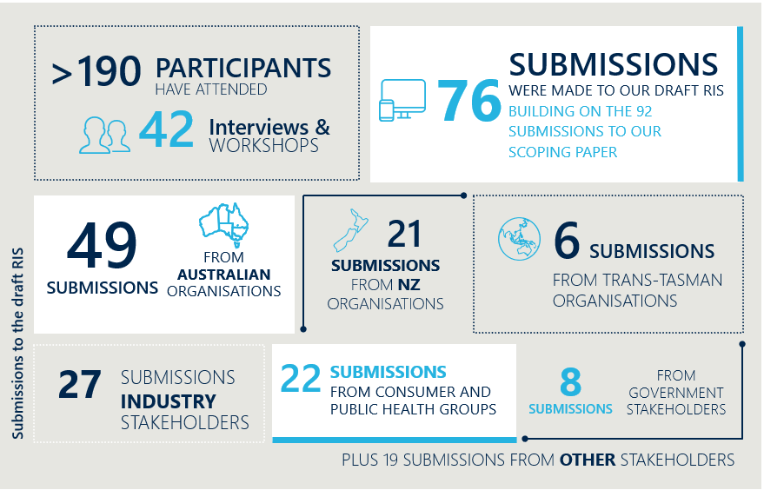

Stakeholder feedback has been themed around the four categories used to structure this IA: purpose and objectives; reforming standards-setting; efficient and effective operations; and improving system agility.

## Purpose and objectives

Stakeholders are concerned about how FSANZ’s objectives are framed and what they mean for the broader system. While unanimous in their support for ‘the protection of public health and safety’ as being the paramount objective of the Act and overarching goal for FSANZ, stakeholders reported diverse views on the interpretation and relative importance of wording in Section 3 and 18 of the Act, particularly how the concepts of ‘safety’ intersected with priorities around prevention of obesity and chronic disease, maximising trade opportunities, optimising consumer choice and managing gaps in the regulatory system, for example in the area of food fraud. Specifically:

* Australian government stakeholders were interested in the importance of the joint food standards system as an instrument to the broader food policy agenda, and the need for jurisdictions’ views and priorities to figure prominently in how regulatory measures were shaped.
* New Zealand Government stakeholders impressed the importance of aligning the Act with the objectives of the Food Treaty. They emphasised the need to empower the joint nature of the system and promote its trade focus. New Zealand stakeholders expressed support for the Act to better reflect Indigenous cultural tradition and the intent of the Treaty of Waitangi.
* Industry stakeholders stressed the importance of a strong and competitive food industry – premised on rigorous food safety standards – in which innovation was fostered, and Australian and New Zealand food businesses can genuinely compete for market share on an international stage. Industry stakeholders consistently supported the idea of including trade as an objective in the Act and did not view this inclusion as jeopardising the objective of protecting population health, recognising this drives demand for products.
* Consumer advocates emphasised the importance of informed choice and regulation to mitigate information asymmetries between businesses and consumers. Some stakeholders also cited the opportunity for the regulatory framework to more systematically consider the environmental impact and sustainability of food, and issues around food security and wastage.
* Public health stakeholders encouraged a much broader interpretation of population health which positioned the Act to use regulatory measures to promote a healthy food supply. This includes controls to minimise consumption of unhealthy foods which can lead to food-related chronic disease as well as fortify more food products with vitamins and minerals where this may lead to population-level benefits.
* There were mixed views about FSANZ’s role in combatting food fraud. While many stakeholders recognised that FSANZ had been called upon recently to assist with such matters (including in the infamous strawberry tampering incident of 2019), there was strong feedback this function sat more naturally in the remit of law enforcement bodies and did not necessarily make good use of the skills and expertise of FSANZ, which acts as an independent, scientific body.

Given this input, the IA has evolved significantly. Characterisation of the problems to solve, and the options to solve these has changed dramatically since the RIS was published for consultation in 2021. The next stage of stakeholder feedback will particularly focus on eliciting insights around a clarified definition of public health and safety; ways to better communicate how different factors have been considered in developing food regulatory measures (in a way that aligns with the objectives of the Act) and opportunities to refresh the language of the Act to better recognise Indigenous culture and expertise.

Several ideas have been explored but formally excluded from further analysis by the FMM. These include:

* The objectives of FSANZ could be expanded to recognise trade as a core goal FSANZ is designed to support.
* The objectives of FSANZ could also be extended to promote food sustainability.
* Statutory functions could be established for FSANZ in relation to food fraud.
* Criteria could be established in the Act that the FMM must meet to request a review of a draft regulatory measure.

## Reforming standard-setting

Stakeholders have been united in their call for more risk-based and proportionate processes to set and vary food regulatory measures – provided they don’t compromise on health and safety:

* There has been broad support for the implementation of a risk-based framework to guide processes and decision-making arrangements – although there has been considerable discussion about what factors must be included in a determination of ‘risk’.
* There has also been support for the uptake of the full suite of regulatory measures, including Codes of Practice as well as guidelines (noting there has been some scepticism about what legal effect these instruments would have).
* All stakeholders have indicated comfort for more expedited processes for low-risk applications and proposals and better use of international evidence, although there has been particular caution from health stakeholders to consider how Australian and New Zealand dietary patterns are considered in assessing safety information.
* The idea of introducing self-substantiation pathways for industry to bring foods to market without going through the food standards process was canvassed but generated significant pushback. Health stakeholders were particularly forceful in their views that the regulatory system should maintain a strong pre-market entry focus to assess food stuffs.
* Other mechanisms to support innovation and reduce regulatory burden were explored, such as regulatory sandboxes (which are defined as safe spaces that create an environment for businesses to test products with less risk of being ‘punished’ by the regulator for non-compliance. In return, regulators require applicants to incorporate appropriate safeguards to insulate the market from risks of their innovative business.) While many stakeholders (particularly from industry) showed some curiosity about using regulatory sandboxes to foster innovation, there was a sense this regulatory feature would be difficult and expensive to implement; potentially introduce inappropriate risk into the system; and not necessarily be taken up by food businesses.
* Industry, health, consumer and government stakeholders were all open to mechanisms to better recognise Indigenous culture and expertise. This was particularly salient among New Zealander stakeholders (noting that the New Zealand Government has more mature statutory obligations around recognising and protecting Māori culture, rooted in the principles of the Treaty of Waitangi), but there was some discussion around the most appropriate way to achieve this.
* All stakeholders were supportive of FSANZ undertaking more regular, holistic reviews of standards, noting these reviews are opportunities to consider the collective impacts of different food standards and changes to the average diets of Australians and New Zealanders. Individuals were quick to highlight however that the development and review of food standards can take significant time and resources to complete. Some stakeholders called for more certainty around the timelines for proposals, including by setting statutory timeframes, but it was largely agreed that these would be challenging given the variability of effort involved in different proposals.
* Government stakeholders in particular felt the capacity for the FMM to issue ministerial guidelines was critical to connect food standards to the broader food policy agenda. While there was recognition that FSANZ must balance several (sometimes competing) considerations when developing regulatory measures, feedback emphasised a want to ensure that ministerial guidance is given due consideration.

Given this input, the IA has evolved and currently presents a narrower set of ideas to reform standard setting. The current phase of consultation seeks to particularly surface feedback about practical ways to implement risk-based approaches (without compromising on safety).

Ideas that have been explored but ultimately excluded from further analysis by the FMM include:

* An additional industry self-substantiation pathway could be established to bring very low risk food products to market.
* Bespoke regulatory sandboxes could be enabled by legislation to work with industry and safely promote innovation.

## Efficient and effective operations

Stakeholders spoke at length about FSANZ’s operations. In relation to board nominations and appointments:

* The challenges of operating with a 12-person board were broadly recognised, but there was not a clear agreement about how this could be improved. Industry and health stakeholders, in particular, expressed strong support regarding their respective representations on the Board. They were largely unsupportive of a reduction in board size that would potentially see their interests less well reflected in board composition. New Zealander stakeholders were also anxious to ensure their interests remained heard and were clearly represented.
* There was, however, a general appreciation the Board needs a variety of skills to operate effectively, and the existing nomination and appointment process was not always sufficient for securing these. To this end, there was general support for a greater focus on skills in the appointment process.

The ability of FSANZ to manage its workload and acquit all of its functions was of key interest to stakeholders. There was universal appreciation not only of the value of the work they do, but the ongoing resourcing pressures that FSANZ has faced in recent years:

* Government and health stakeholders were particularly concerned with the effective de-prioritisation of proposals to service the growing number of applications which are subject to statutory timeframes.
* There was considerable debate about the most suitable way to address FSANZ’s workload prioritisation issues. For example, there was some debate about how to best increase FSANZ’s operating budget, through either change to substantive funding arrangements and/or expansions to cost recovery mechanisms.
* Industry stakeholders particularly spoke at length about the fragility of some parts of the food system and the potential for cost recovery activities to create undue burden on businesses trying to innovate. Others called out that the application processes are currently only accessed by a minority of (generally well resourced) food businesses who could shoulder more of the costs involved.

Given this input, the IA has evolved to:

* Nuance descriptions around how board arrangements can best be enhanced. For example, small efficiency savings such as defaulting to a virtual only mode of board meetings were abandoned relatively early in the process, given the marginal savings involved and the benefit of bringing people together in person and facilitating discussions outside of a formal agenda.
* Discontinue some ideas early in the piece due to early identification of significant unintended and negative consequences. For example, ideas to support a balance between prioritising proposals and applications, by removing statutory timeframes around applications or introducing timeframes for proposals. In this instance, feedback emphasised the complexity, broader nature and higher level of stakeholder interest and challenges in meeting a set timeframe; and the need for industry to get some value for the fees charged on most applications.
* Significantly recast options to make FSANZ more financially sustainable, including greater cost sharing considerations between jurisdictions and industry.

Some ideas were canvassed before being excluded from further consideration by the FMM, including:

* The board could shift to be explicitly skills-based and reduced in size to eight people.
* The FMM could delegate some ratification decision to the Board.
* Investment in business solutions could be made to improve the usability of existing resources.

## Improving system agility

Stakeholders were divided about how FSANZ should interact with the broader food regulatory system for best effect:

* There was general support for more joint agenda setting between FSANZ and the FMM, specifically to identify priority proposals. Many stakeholders stressed, however, the importance of FSANZ retaining its independence in the way that it then assessed proposals and carried out its other functions.
* Stakeholders – particularly from government – also were favourable about earlier and more consistent engagement between FSANZ and the FRSC to reduce duplication of effort to prepare proposals.
* Many stakeholders were supportive of FSANZ taking on guardianship of databases, noting there were different views about how this data was then used. There was a sense that informing project work was a sensible endeavour, but leveraging databases for commercial gain would create some potential issues, particularly given that most data FSANZ might collect would be provided free of charge from data custodians to be used for the public good.
* Australian stakeholders, particularly from health and industry backgrounds, saw value in someone taking on a co-ordinating function in relation to food safety research; but noted there was no inherent reason why this needed to be FSANZ. This proposition was less attractive to New Zealand stakeholders in all cases, particularly as they have their own coordinated research system.
* There was significant interest in how FSANZ could work differently with enforcement agencies to minimise issues around variable interpretation and enforcement of food standards. This was a more significant issue for Australian stakeholders than New Zealand ones given the Ministry for Primary Industry does all of the enforcement in New Zealand.
* General support from government, health and industry stakeholders was noted for standards within the Food Code to be accompanied by Statements of Intent and for FSANZ to do more to support industry through provision of guidance materials.
* The idea of FSANZ stepping into an enforcement role in Australia was discussed, but without significant enthusiasm. Stakeholders noted that the food regulatory system is complex, but roles and responsibilities are currently well defined. While industry stakeholders welcomed efforts to drive more consistency in enforcement of food standards, government stakeholders were particularly concerned with constitutional issues and the requirement to cede powers that currently sit with the jurisdictions to the Commonwealth.
* While less invasive measures such as FSANZ making binding interpretations were considered, there remained some concern about how these could be recognised by the courts in each jurisdiction giving the current legislative arrangements.
* Discussions also explored the role of the Act in improving the food-medicine interface in Australia. Consultations however highlighted this issue is largely a practice one rather than a legislative one, and there are fairly limited levers within this Review to make meaningful change on this issue.
* While there was less support for FSANZ presenting itself as a united voice for Australia and New Zealand in different environments, there was a general level of recognition of the importance of their work in international relations to influence harmonisation of food standards and to negotiate information sharing arrangements that might support more risk-proportionate processes to setting food standards locally.

This version of the IA presents a significantly narrowed set of options to improve system agility, and consultation seeks to characterise what setting would be most useful to the bring FSANZ and FMM together for joint priority setting; drive communication and collaboration with government agencies and other bodies with expertise or intelligence relating to food; and greater information and guidance to assist with interpretation and enforcement of food standards.

Concepts that were considered by the FMM and explicitly excluded from further consideration include:

* The Australian Government could be empowered to instigate food recalls
* FSANZ could be equipped to coordinate food safety research across Australia
* FSANZ could make available to the public its data and other intelligence
* FSANZ could collate and/or create consumer facing food safety education materials
* The Act could incorporate legislative changes to help clarify the food-medicine interface for Australia
* FSANZ could be empowered to make binding interpretation to drive more consistency in how food standards are enforced
* FSANZ could take on an enforcement role, focused on enforcement of health claims and novel foods
* Legislation could formalise and extend Australia and New Zealand’s role in influencing global food policy.

## Planned consultation activities

Public consultation on this version of the IA is planned for February to March 2024. The IA will be further revised and finalised after these activities, with a commitment to refining the proposed model in alignment with the valuable insights and perspectives shared by stakeholders throughout the consultation process.

# Best option and implementation

This section provides an assessment of the best option of those outlined in Section 5, Options for reform. Following the release of this IA, the best option will be selected as follows:

* Analysis of stakeholder feedback will be provided to Food Ministers and the Australian Government in mid-2024, with agreement sought to develop a final model of reform.
* Food Ministers agreement on the final model will occur in late 2024 before submission to Australian Cabinet in 2025 for final approval.

|  |
| --- |
| Option 1 and 2 have been assessed at the component level against three criteria. For the purpose of analysis, an assumption has been made that all initiatives set out in Option 2 would be implemented. This information is designed to provide a benchmark for stakeholders and stimulate thinking about how assessment against criteria might change, should the details of components within Option 2 evolve.  Three criteria were used to assess the strengths and limitations of each of the options under consideration:   * Extent to which options and their components solves policy problems * Degree to which delivery risks can be managed, and * Costs and benefits.   On each of these criteria, a higher score reflects a better outcome.  Ratings have been developed informed by all research and consultation to date. The methodology and estimates however are subject to validation through this next consultation period. The methodologies used for each criterion are summarised below.  Extent to which the options and their components solve policy problems  This criterion is assessed by multiplying the two measures:   * The impact of the policy problem (as described in Section 3) and * The degree to which a policy problem is solved by an option, should all sub-components described in this IA be implemented, where:   + No resolution (ration 0) = makes no progress in resolving the problem and bringing FSANZ and the Act in line with best practice.   + Minimal resolution (rating 1) = makes limited progress in resolving the problem and bringing FSANZ and the Act in line with best practice.   + Moderate resolution (rating 2) = Makes good progress in resolving the problem and bringing FSANZ and the Act in line with best practice.   + Majority resolution (rating 3) = largely resolves the problem and brings FSANZ and the Act in line with best practice.   Degree to which delivery risks can be managed  For each risk within a component, the negative consequence should the risk eventuate was estimated, where:   * Major consequence (rating 1) = significant impact of efficient and effective regulation of foods and/or creation of undue regulatory burden. * Moderate consequence (rating 2) = moderate impact of efficient and effective regulation of foods and/or creation of undue regulatory burden. * Minimal consequence (rating 3) = minimal impact of efficient and effective regulation of foods and/or creation of undue regulatory burden.   The result is multiplied by the likelihood of the risk occurring, where:   * Very likely (rating 1) = high likelihood of occurrence, even with suitable mitigation strategies in place. * Moderately likely (rating 2) = moderate likelihood of occurrence, with suitable mitigation strategies in place. * Unlikely (rating 3) = low likelihood of occurrence, with suitable mitigation strategies in place.   The impact of risks within the component are then aggregated, where:  Total delivery risk rating (for $n$ number of risks) = $$\frac{\sum_{i=1}^{n}{\left(Consequence of {risk}_{i} ×likelihood of {risk}_{i}\right)}}{9n}×100$$ Ratings have then been converted to a 1-3 score, where:   * High risk (rating 1) = 0-33% * Moderate risk (rating 2) = 34-66% * Low risk (rating 3) = 67-100%   Costs and benefits   * The expected impact of the reform options on FSANZ, government, industry and on consumers. The net present value and BCR calculated in Section 6 have been used here. |

At a glance, Option 2 performs best against these criteria, indicating that ‘doing something’ is better than retaining the status quo (see Table 20). Option 2 is significantly better at addressing the policy problems associated with the current state and also presents a lower risk profile and higher net benefit.

This assessment is intended to provide a benchmark against which stakeholders can consider the strengths and limitations of the components within Option 2 and make suggestions to support further refinements.

Table 20 | Summary of assessment – higher scores represent better outcomes

|  |  |  |
| --- | --- | --- |
|  | OPTION 1 | OPTION 2 |
| Criterion 1 – Policy problems | Total score = 0 | Total score = 23.5 |
| Criterion 2 – Delivery risks | Total score = 4 | Total score = 7 |
| Criterion 3 – Costs and benefits | Net present value: AUD $10.7m  NZD $11.42m  BCR: 1.05 | Net present value: AUD $208.6m NZD $223.2m BCR: 1.63 |
| Final rank | 2 | 1 |

## Extent to which options solves the policy problems

The capacity for the two options to solve policy problems is summarised in Table 21, and discussed further thereafter. Based on the combination of the negative impact of the problem (rated 1, 2 or 3) and the degree to which the option solves the problem, the maximum possible scores would be 6 for Policy Problem 1 and 4; and 9 for policy problems 2 and 3. Higher scores indicate better outcomes.

Given that the policy problems identified are inherent to the current legislative and operational arrangements, and that Option 1 assumes no changes at all, Option 1 is not configured to address any of these issues.

Table 21 | Extent to which each option solves the policy problems (weighted)

|  |  |  |  |
| --- | --- | --- | --- |
| POLICY PROBLEM | OPTION 1 | OPTION 2 | |
| Policy Problem 1 | 0 | 6 |
| Policy Problem 2 | 0 | 7.5 |
| Policy Problem 3 | 0 | 5 |
| Policy Problem 4 | 0 | 5 |
| Total | 0 | 23.5 |



### Policy Problem 1 | The objectives and current functions of FSANZ are not clear

Policy Problem 1 recognises the objectives of FSANZ are not clearly understood across the food system. The negative impact of this problem has been rated as 3 (high).

Analysis reveals that Option 1 does not address the Policy Problem in any capacity, while Option 2 significantly addresses the Problem. The corresponding scores for each are summarised in Table 22.

Table 22 | Assessment of options against Policy Problem 1

|  |  |  |
| --- | --- | --- |
|  | OPTION 1 | OPTION 2 |
| Negative impact of Policy Problem | 2 (Moderate) | 2 (Moderate) |
| Degree to which Option resolves the Policy Problem | 0 (Not at all) | 3 (High) |
| Total rating | 0 | 6 |

More detailed comparisons against sub-problems are described below.

##### Sub-problem 1 | Unclear definitions have created confusion about how FSANZ should consider short-and long-term risks to health when developing food standards

OPTION 1 makes no progress on addressing this sub-problem.

OPTION 2 addresses key issues identified by stakeholders relevant to the clarity of FSANZ’s role and functions without significantly expanding its responsibilities. Specifically, it achieves this by clarifying the definition of ‘protection of public health and safety’ within the Act to be in line with current policy guidance while also ensuring its language is culturally inclusive.

##### Sub-problem 2 | There remains some confusion about the factors to which FSANZ has given regard in its decision-making, and how this aligns with the objectives of the Act

OPTION 1 makes no progress on addressing this sub-problem.

OPTION 2 corrects the problem. If FSANZ refreshed its communication approach in a way that brought greater visibility and transparency around decision-making processes, this would address issues where stakeholders (particularly Ministers) are unclear of how different factors have been balanced and support greater confidence in the joint food standard setting system.

##### Sub-problem 3 | The Act is silent on the needs and commitments of government to First Nations and Māori Peoples

OPTION 1 makes no progress on addressing this sub-problem.

OPTION 2 could make good strides against this issue. A refresh of language within the Act could reinforce an expectation that the culture and expertise of Aboriginal, Torres Strait Islander and Māori Peoples is valued, and their population outcomes are considered in setting food regulatory measures.



### Policy Problem 2 | Legislated processes and decision-making arrangements for food standards are cumbersome and inflexible

Policy Problem 2 focuses on statutory processes to set and amend food standards, which do not align with best practice. The negative impact of this problem has been rated as 3 (high).

Analysis reveals that Option 1 does not address the Policy Problem in any capacity, while Option 2 significantly addresses the Problem. The corresponding scores for each are summarised in Table 23.

Table 23 | Assessment of options against Policy Problem 2

|  |  |  |
| --- | --- | --- |
| Option | OPTION 1 | OPTION 2 |
| Negative impact of Policy Problem | 3 (High) | 3 (High) |
| Degree to which Option resolves the Policy Problem | 0 (Not at all) | 2.5 (Moderate-high) |
| Total rating | 0 | 7.5 |

More detailed comparisons against sub-problems are described below.

##### Sub-problem 1 | Statutory processes are rules-based rather than outcomes-based

OPTION 1 makes no progress on addressing this sub-problem.

OPTION 2 represents significant improvements on this problem. Being responsive to risk would provide FSANZ and the FMM the flexibility to target resources and effort on high-risk products and important strategic priorities. This approach will maintain the necessary regulatory oversight while providing greater agility and efficiency, resulting in timelier outcomes for stakeholders. The introduction of a risk-based approach would also significantly reduce the regulatory burden on food businesses (particularly small businesses) when seeking changes to food standards.

##### Sub-problem 2 | Current requirements create barriers for Indigenous foods to be brought to market

OPTION 1 makes no progress on addressing this sub-problem.

OPTION 2 addresses this issue in part – further work is planned as part of the broader program described on page 26. Additional evidentiary support for traditional foods will better recognise Indigenous culture and food expertise and support more foods to enter the Australian and New Zealand markets.

##### Sub-problem 3 | Resourcing constraints have effectively preferenced piecemeal changes to food standards over holistic reviews

OPTION 1 makes no progress on addressing this sub-problem.

OPTION 2 would release capacity within FSANZ and bolster resourcing allocations, which help drive more regulator holistic reviews. Regular, holistic reviews of standards will benefit the community by providing an improved mechanism for Identifying and addressing internal conflicts and inconsistencies in food standards that eventuate from ad-hoc amendments over time. They would ensure that standards remain fit-for-purpose, particularly given changing dietary patterns and the accumulated impact of exposure to products in food over time.

Holistic reviews would also be an important opportunity to reflect contemporary research around population health risks, and to consider how regulatory tools might be appropriately used to mitigate obesity and food-related chronic disease.

##### Sub-problem 4 | FSANZ generally defaults to developing food standards, but other regulatory measures could be more efficient to create

OPTION 1 makes no progress on addressing this sub-problem.

OPTION 2 would lead to greater uptake of other food regulatory measures, where appropriate. The use of Codes of Practice and guidelines for low-risk matters will improve certainty about regulatory obligations and ability to seek clarity on priority issues while capitalising on more efficient statutory processes.



### Policy Problem 3 | Elements of operations outlined in the FSANZ Act are inefficient

Policy Problem 3 identifies shortcomings in the efficiency of FSANZ’s governance and operations. The negative impact of this problem has been rated as 2 (moderate).

Analysis reveals that Option 1 does not address the Policy Problem in any capacity, while Option 2 significantly address the Problem. The corresponding scores for each are summarised in Table 24.

Table 24 | Assessment of options against Policy Problem 3

|  |  |  |
| --- | --- | --- |
| Option | OPTION 1 | OPTION 2 |
| Negative impact of Policy Problem | 2 (moderate) | 2 (moderate) |
| Degree to which Option resolves the Policy Problem | 0 (Not at all) | 2.5 (Moderate-high) |
| Total rating | 0 | 5 |

More detailed comparisons against sub-problems are described below.

##### Sub-problem 1 | Current legislative provisions prohibit nominations and appointment processes for the FSANZ Boards from adopting best practice

OPTION 1 makes no progress on addressing this sub-problem.

OPTION 2 would remove legislative impediments. The suggested changes to FSANZ’s legislated governance arrangements would contribute to better, more efficient and effective decision-making. The compositional requirements of the Board would be updated to ensure it has the skills and experiences to govern over the contemporary issued faced by FSANZ.

##### Sub-problem 2 | Long-term decreases in funding have created significant resourcing pressure and is forcing FSANZ to focus on only a subset of its statutory functions

OPTION 1 makes no progress on addressing this sub-problem.

OPTION 2 would go some way in improving capacity within FSANZ. The cost recovery mechanisms proposed vary in how effectively they would sustainably mitigate resourcing pressures for FSANZ in the long-term. One-off cost recovery mechanisms like fees associated with co-ordinating food recalls and entrepreneurial activity offer less predictable funding than would be provided through an industry-wide levy. More consistent and sustainable funding would more effectively address the policy problems by enabling FSANZ to efficiently prioritise its most valuable projects based on a clear understanding of its available resources.

This option does not contemplate changes to the substantive funding arrangements for FSANZ that are currently shared between the Australian and New Zealand Governments, as this is not in scope of the FSANZ Act.



### Policy Problem 4 | Gaps and duplication of efforts challenge system agility

Policy Problem 4 focuses on siloed ways of working across the food system. The negative impact of this problem has been rated as 2 (moderate).

Analysis reveals that Option 1 does not address the Policy Problem in any capacity, while Option 2 significantly address the Problem. The corresponding scores for each are summarised in Table 25.

Table 25 | Assessment of options against Policy Problem 4

|  |  |  |
| --- | --- | --- |
| Option | OPTION 1 | OPTION 2 |
| Negative impact of Policy Problem | 2 (Moderate) | 2 (Moderate) |
| Degree to which Option resolves the Policy Problem | 0 (Not at all) | 2.5 (Moderate-high) |
| Total rating | 0 | 5 |

More detailed comparisons against sub-problems are described below.

##### Sub-problem 1 | The lack of a shared vision of system priorities between FSANZ and the FMM limits the effectiveness of the broader food regulatory system.

OPTION 1 makes no progress on addressing this sub-problem.

OPTION 2 would support better alignment of priorities. Greater coordination at standard-setting/policy development interface would improve system alignment and confidence in the regulatory system. Establishing a mechanism for regular joint-agenda setting between FSANZ and the FMM to regularly agree system goals and priority changes to food standards – in particular, proposals to prioritise in any given year – could support more aligned approaches to policy and regulation.

Agreeing items that would be de-prioritised or removed from the workplan could also promote broader confidence in the ability for the regulatory system (and FSANZ in particular) to progress issues in a timely and transparent manner.

##### Sub-problem 2 | Limited intelligence-sharing between stakeholders across the regulatory system is resulting in duplication of effort and missed opportunities to manage risk

OPTION 1 makes no progress on addressing this sub-problem.

OPTION 2 would improve intelligence sharing. Further enhancing partnerships across the system (particularly with other bodies involved in food regulation such as the FRSC and jurisdictional enforcement agencies) could better align complementary objectives and support information flows across the system where this is beneficial. It could reduce duplication of effort - particularly in research and other policy work that draws on the same evidence base - and support timelier and risk-based activities to identify and respond to food-borne risks that can have serious population health and economic consequences.

##### Sub-problem 3 | Inconsistent interpretation and enforcement of food standards heightens costs for industry and enforcement agencies, while potentially undermining management of foodborne risks (Australia only)

OPTION 1 makes no progress on addressing this sub-problem.

OPTION 2 positions FSANZ to provide more useful advice to guide interpretation and enforcement of food standards. The option still relies on this advice being taken up in a meaningful way by enforcement agencies and businesses however, therefore the sphere of influence this change can make does face some limitations.

|  |
| --- |
| Consultation questions |
| * Does the approach to assessing the degree to which an option solves a policy problem make sense? How so? * Is the rating assigned to each of the sub-problems appropriate? If not, why? |

## Delivery risks

For this criterion, possible delivery risks have been identified for the four themes: purpose and objectives; reforming standard-setting; operational efficiency and system agility. Individual risks have been identified for each theme, with a risk score calculated at an individual risk level, and then aggregated into a rating for each theme.

Table 26 | Delivery risk scores for each option

|  |  |  |
| --- | --- | --- |
| Option | OPTION 1 | OPTION 2 |
| Purpose and objectives | 1 (High risk) | 2 (Moderate risk) |
| Reforming standard-setting | 1 (High risk) | 2 (Moderate risk) |
| Efficient and effective operations | 1 (High risk) | 1 (High risk) |
| System agility | 1 (High risk) | 2 (Moderate risk) |
| Total | 4 | 7 |

### Purpose and objectives

There are several risks inherent to setting and describing the purpose and objectives of the Act and for FSANZ.

The significance of these risks for each option are summarised in Table 27.

Table 27 | Assessment of delivery risks associated with purpose and objectives

|  |  |  |
| --- | --- | --- |
|  | OPTION 1 | OPTION 2 |
| Delivery risks associated with proposals on purpose and objectives | 1 (high) | 2 (moderate) |

More detail is provided below.

#### OPTION 1 Risks

##### Confusion around the objectives and scope of FSANZ will perpetuate, meaning that risks relating to public health and safety – particularly long-term health – are not well managed

|  |  |  |  |  |  |
| --- | --- | --- | --- | --- | --- |
| Consequence | 1 | Likelihood | 1 | Risk rating | 1 |

Without clarifying the definition of the ‘public health’ in the primary legislation, the language in the Act and other key instruments will continue to be inconsistent. There will continue to be a lack of clarity in the overall strategic direction for the Act and for FSANZ.46F[54] Although FSANZ should already consider both long-term health impacts and immediate health risks in the development and review of food regulatory measures, the lack of an overarching strategic mandate risks hindering the proactive management of food-related health risks. An ambiguous mandate not only compromises the effectiveness of FSANZ in developing and reviewing food regulatory measures, but also the has major implications for the wellbeing of Australia and New Zealand populations.

##### The FSANZ Act remains out of step with contemporary expectations and obligations to recognise Indigenous culture and expertise

|  |  |  |  |  |  |
| --- | --- | --- | --- | --- | --- |
| Consequence | 2 | Likelihood | 1 | Risk rating | 2 |

Without modernising the language of the Act, it will continue to not recognise Indigenous culture and food expertise. This would be a missed opportunity to update the Act to be in line with the constitutional requirement for the New Zealand government under the Treaty of Waitangi to deliver policy in a way that enhances Crown/Māori relations, and to ensure the Act is consistent with and responds to contemporary expectations of the Australian government to celebrate and foster Indigenous culture.

#### OPTION 2 Risks

##### Alignment of definitions could inadvertently widen the scope for FSANZ and its role in managing public health risks

|  |  |  |  |  |  |
| --- | --- | --- | --- | --- | --- |
| Consequence | 2 | Likelihood | 1.5 | Risk rating | 3 |

Clarifying the definition of the ‘protection of public health and safety’ within the Act to be in line with current policy guidance could inadvertently widen the scope of FSANZ’s remit in managing public health risks.

Although FSANZ is already empowered to considered long-term food-related illnesses in developing and reviewing food standards, inserting these terms explicitly into the Act could end up expanding stakeholder expectations about FSANZ’s remit and lead to pressure for FSANZ to take on roles or consider factors outside of its current scope. This could lead to increased burden on industry, such as the requirement to present a broader range of information as part of an application to amend food standards.

##### Improving visibility of First Nations and Māori culture and expertise could draw attention to the lack of focus on other population groups

|  |  |  |  |  |  |
| --- | --- | --- | --- | --- | --- |
| Consequence | 3 | Likelihood | 2 | Risk rating | 6 |

Enhanced visibility of First Nations and Māori culture and expertise could inadvertently spotlight areas where other population groups who may feel underrepresented or overlooked. There could be unintended perceptions of partiality or bias, leading to further questions about how the Act aligns with contemporary expectations. While recognising the knowledge and culture of First Nations and Māori communities, it is crucial to ensure that language in the Act remains inclusive of the Australian and New Zealand population at large.

### Reforming standard-setting

There are several risks inherent to standard setting arrangements and the significance of these risks for each option are summarised in Table 28. The risks associated with Option 2 are deemed to be slightly lower than under Option 1.

Table 28 | Assessment of delivery risks associated with standard-setting

|  |  |  |
| --- | --- | --- |
|  | OPTION 1 | OPTION 2 |
| Delivery risks associated with standard-setting | 1 (high) | 2 (moderate) |

More detail is provided below.

#### OPTION 1 Risks

##### FSANZ’s organisational capacity will continue to be used in a way that does not make best use of its expertise, as proposals and applications will continue to be processes in a manner agnostic to risk

|  |  |  |  |  |  |
| --- | --- | --- | --- | --- | --- |
| Consequence | 1 | Likelihood | 1 | Risk rating | 1 |

By maintaining the status quo, all applications and proposals will continue to be processed using a similarly rigid method, regardless of the level of risk involved. FSANZ will continue to be compelled to go through the same procedure to approve low-risk food processing aids as it does to approve complex changes, such as infant formula compositions. This means that FSANZ will continue to use its resources in an inefficient manner, contributing to the long timeframes in progressing some applications and proposals. It also represents considerable burden on industry due to the time and costs involved in preparing detailed applications, as well as opportunity costs associated with delays to bring products to market.

This barrier is particularly pronounced for smaller businesses and First Nations and Māori food enterprises, where securing funding for scientific assessments and managing delayed market access are more likely to be barriers to commercial access and success.

##### Ongoing capacity constraints will reinforce an effective focus on processing applications, at the expense of proposals and other high-value work

|  |  |  |  |  |  |
| --- | --- | --- | --- | --- | --- |
| Consequence | 1 | Likelihood | 1 | Risk rating | 1 |

Without measures to streamline standard-setting processes, FSANZ will continue to experience ongoing capacity constraints. Given the statutory timeline imposed on applications timeframes, FSANZ will continue to focus on processing applications. Lack of capacity for proposals and reviews can lead to FSANZ being more reactive rather than proactive, limiting its ability to manage emerging food safety and public health challenges.

##### Australia and New Zealand will continue to be markets that international food companies choose not to enter, given the high regulatory burden associated with amending food standards - particularly where safety has been established elsewhere

|  |  |  |  |  |  |
| --- | --- | --- | --- | --- | --- |
| Consequence | 1 | Likelihood | 2 | Risk rating | 2 |

The current regulatory requirements around amending food standards can pose significant barriers to entry for international food companies. Extensive procedures and requirements, even for products deemed safe in other reputable jurisdictions, diminishes the appeal of the Australian and New Zealand market. The time, resources, and costs associated with navigating and complying with regulatory requirements could often outweigh the potential benefits of market entry. This not only means missed opportunities for local consumers to access a broader range of products but also potential economic repercussions in terms of investments, job opportunities, and the economic growth associated with the presence of major international brands.

#### OPTION 2 Risks

##### Applying a risk framework to guide process and decision-making may lead to unsafe foods entering the market

|  |  |  |  |  |  |
| --- | --- | --- | --- | --- | --- |
| Consequence | 1 | Likelihood | 2.5 | Risk rating | 2.5 |

Introducing a risk-based approach to developing food regulatory measures would require both significant amendments to the Act and operational changes at FSANZ.

‘Risk’ would need to be a flexible concept, with a clear framework agreed and enshrined in the appropriate regulatory instrument, but this could (and should) be updated periodically to reflect changes in industry practices, consumer expectations and political appetites for oversight. During the initial roll out phase, there may be examples where risk is not appropriately triaged up front and the food regulatory measure is not subject to the intended level of scrutiny. This could be because an insufficient breadth of risk indicators is considered, or because the right information was not accessed to make the right decision. In the worst instance, this could mean that higher risk foods are brought to market without the appropriate level of scrutiny and oversight. On the other hand, it could mean that lower risk products are subject to more robust considerations that technically required.

This risk can be managed to an extent through routine assessments of the effectiveness of the framework.

##### Establishing new pathways to amend foods standards could reduce the level of oversight and scrutiny of products in the pre-market phase, introducing higher risk to population health and safety

|  |  |  |  |  |  |
| --- | --- | --- | --- | --- | --- |
| Consequence | 1 | Likelihood | 2 | Risk rating | 2 |

Recognising international food safety assessments and providing for some foods to be included in the Food Code either through automatic adoption or via a minimal check pathway would mean some products are not subject to the same level of assessment as in the current state. Some international standards may also not be suitable for Australian and New Zealand dietary patterns.

This risk can be managed by ensuring that comparable standard-setting bodies who can issue assessments or approvals that FSANZ can recognise are carefully selected. This would require strenuous assessment of those bodies’ processes, as well as consideration about the similarities in the market and dietary trends in those countries compared to Australia and New Zealand.

##### Less direct oversight of food standards by the FMM and FSANZ Board would reduce scrutiny and diminish oversight and accountability over the standard setting system

|  |  |  |  |  |  |
| --- | --- | --- | --- | --- | --- |
| Consequence | 2.5 | Likelihood | 2 | Risk rating | 5 |

Revising FSANZ’s non-delegable duties to enable the CEO to approve draft standards or variations, or FMM members to delegate the ratification of changes to food standards would require minor legislative changes. Although these changes may reduce the number of individuals involved in decision-making, it would retain the ‘two step’ approval process (including both FSANZ and government) to amend food standards – mitigating the risk these changes would contribute to diminished oversight or accountability over the governance of the food system.

The effectiveness of these changes would be contingent on the risk framework achieving the right tolerance, ensuring that the FMM and the FSANZ Board are responsible for all higher risk decisions.

##### Increased use of Codes of Practice and guidelines could create enforcement obligations for jurisdictions to which Ministers have not agreed

|  |  |  |  |  |  |
| --- | --- | --- | --- | --- | --- |
| Consequence | 2 | Likelihood | 2 | Risk rating | 4 |

Codes of Practice and guidelines can be created using existing statutory processes, which are not required to culminate in ratification by the FMM. Yet, they could be binding upon jurisdictions because of the way that Food Acts adopt the Food Code.

To mitigate the risk that increased use of Codes of Practice and guidelines may introduce, they could be applied only for low-risk regulatory measures. Note that some of the policy and implications of a change could be factors in the risk matrix that guides consideration of guidelines and Codes of Practice.

### Efficient and effective operations

There are several risks associated with efficient and effective operations. Overall risk ratings for Option 1 and 2 are shown in Table 29. Both options have ‘high’ risk profiles that would need to be carefully managed.

Table 29 | Assessment of delivery risks associated with efficient and effective operations

|  |  |  |
| --- | --- | --- |
|  | OPTION 1 | OPTION 2 |
| Delivery risks associated with efficient and effective operations | 1 (high) | 1 (high) |

More detail is provided below.

#### OPTION 1 Risks

##### Nomination and appointment processes would continue to be relatively laborious endeavours and perpetuate the risk that the Board will not have the necessary skills to provide effective governance

|  |  |  |  |  |  |
| --- | --- | --- | --- | --- | --- |
| Consequence | 2 | Likelihood | 1 | Risk rating | 2 |

Prolonged and cumbersome nomination and appointment processes could lead to significant delays in filling board vacancies, hinder the Board's efficiency and compromise its ability to respond to pressing matters. Additionally, without a proactive and strategic pipeline of candidates, the risk of not having the right blend of expertise on the Board increases.

The current Act does not assure an optimal mix of skills, and without the direct input from key positions like the Chairperson or CEO, the Board might face capability gaps.

##### FSANZ will continue to focus on only a subset of its statutory duties, effectively creating gaps in the regulatory system where risks and opportunities are not managed as well as they could be

|  |  |  |  |  |  |
| --- | --- | --- | --- | --- | --- |
| Consequence | 1 | Likelihood | 1 | Risk rating | 1 |

FSANZ will continue to face resourcing challenges which means it will need to continue to prioritise only a subset of its functions. As the number of applications received have been trending up over time, this pressure is likely to be exacerbated, forcing FSANZ to be even more selective in the activities it pursues.

#### OPTION 2 Risks

##### The Board could be less efficient and well equipped to consider sectoral interests under new nomination arrangements

|  |  |  |  |  |  |
| --- | --- | --- | --- | --- | --- |
| Consequence | 2 | Likelihood | 2 | Risk rating | 4 |

Component 2.3 would see FSANZ moving to an open market Board nomination system, emphasising the skills and experience of applicants rather than their organisational affiliation. There is a risk that under this arrangement the organisations with specific interests or risk profiles may lose representation on the Board.

The Board nomination process may also become more resource intensive as a greater number of individuals would be eligible or consideration.

To mitigate this, the Board selection process make sure the list of skills used to assess qualifications of nominees captures the breadth of issues and needs from across the food system. Nomination forms should clearly outline these skill requirements to streamline the decision-making process.

##### Expanded cost recovery mechanisms borne by industry could create new barriers to entry for businesses seeking to vary food standards, reducing accessibility of the scheme

|  |  |  |  |  |  |
| --- | --- | --- | --- | --- | --- |
| Consequence | 2 | Likelihood | 2 | Risk rating | 4 |

New cost recovery arrangements may make it harder for businesses – particularly small businesses – to engage with FSANZ and develop applications for changes to food standards. This could stifle innovation and act as a disincentive for overseas based food businesses to invest in the Australia and New Zealand markets, leading to less choice for local consumers.

##### Application of a levy on select industry participants could contribute to financial stress in a sector that is already feeling overwhelmed

|  |  |  |  |  |  |
| --- | --- | --- | --- | --- | --- |
| Consequence | 1 | Likelihood | 2 | Risk rating | 2 |

Food businesses have been under continued stress in recent years due to severe weather events, disrupted global supply chains and other factors that have challenged profitability. A widespread levy could contribute to financial stress and potentially force some businesses to leave the market.

It would also be challenging to apply the levy in a way that is fair and ensure duplication of the levy does not occur as food products transition from the stages of production, manufacture and sale.

##### An industry-wide levy could contribute to regulatory capture

|  |  |  |  |  |  |
| --- | --- | --- | --- | --- | --- |
| Consequence | 1 | Likelihood | 2 | Risk rating | 2 |

Introducing an industry-wide levy would position food businesses as one of FSANZ’s primary funders. This could position FSANZ to benefit, or be perceived to benefit, if Australian and New Zealand food businesses are commercially successful. It could also provide greater leverage for industry stakeholders to influence FSANZ decision making.

This could incentivise more lenient or industry-interested regulatory decisions on behalf of FSANZ. There is precedent for this in the Australian regulatory system. The Recent APVMA Strategic Review highlighted material concerns in relation to regulatory capture stepping from the agency’s approach to regulation and engagement with specific stakeholders.47F[55]

##### Imposing a food recall coordination levy could increase the risk of non-engagement with FSANZ by jurisdictional enforcement agencies, resulting in less well managed foodborne risks

|  |  |  |  |  |  |
| --- | --- | --- | --- | --- | --- |
| Consequence | 1 | Likelihood | 2 | Risk rating | 2 |

Imposing a levy on jurisdictional regulators increases the risk that these regulators may become less engaged with FSANZ due to the additional financial cost. It could also hollow out the already stretched jurisdictional incident response capability. This could further lead to delayed or inadequate recalls resulting in contaminated or unsafe products remaining on shelves for longer periods, heightening the risk of public health incidents. Inefficient recalls can also generate additional costs as they may necessitate subsequent, more extensive recall actions.

### Improving system agility

There are clear risks associated with system agility. An overall risk rating for Option 1 and Option 2 is shown in Table 30. The risks associated with Option 1 are higher than for Option 2.

Table 30 | Assessment of delivery risks associated with system agility

|  |  |  |
| --- | --- | --- |
|  | OPTION 1 | OPTION 2 |
| Delivery risks associated with system agility | 1 (high) | 2 (moderate) |

More detail is provided below.

#### OPTION 1 Risks

##### Efforts to align policy and regulatory work across the system will continue to be frustrated

|  |  |  |  |  |  |
| --- | --- | --- | --- | --- | --- |
| Consequence | 2 | Likelihood | 1 | Risk rating | 2 |

Without changes to the way FSANZ works with other stakeholders across the system, there will continue to be discord around how food standards fit within and reinforce the broader efforts of the food regulatory system. Misalignment with the priorities of the FMM will continue to be a big risk, particularly as the backlog of proposals in development continues to grow.

##### Inconsistencies in interpretation and enforcement will continue to be an issue, particularly for Australian businesses and enforcement agencies, generating undue regulatory burden

|  |  |  |  |  |  |
| --- | --- | --- | --- | --- | --- |
| Consequence | 2 | Likelihood | 1 | Risk rating | 2 |

There will be no change in how interpretation of food standards is approached, continuing issues around inconsistencies. This will continue to create additional costs for both industry participants and enforcement agencies, which may be felt more acutely in the current fiscal environment.

#### OPTION 2 Risks

##### Greater collaboration across the system could put at risk FSANZ’s independence, if not done well

|  |  |  |  |  |  |
| --- | --- | --- | --- | --- | --- |
| Consequence | 2 | Likelihood | 2.5 | Risk rating | 5 |

Many stakeholders consulted have noted that FSANZ’s independence as a scientific-based standard-setting body is a key strength of current arrangements – not just for FSANZ but for the joint food standards system as a whole – and this underpins confidence and trust in the system. Stakeholders have expressed concerns that role expansions (including more collaboration with policy development entities, jurisdictional regulators and industry) could compromise FSANZ’s independence (perceived or actual) which could adversely affect allocation of effort (to serve specific stakeholder interests) or decision-making.

Mitigating this risk will require FSANZ to establish a clear delineation of roles between itself and partners, and strong governance to ensure integrity and independence is not eroded.

##### Systematising data collection and curation of databases work could actually create perverse incentives for data custodians to share their data

|  |  |  |  |  |  |
| --- | --- | --- | --- | --- | --- |
| Consequence | 2 | Likelihood | 2.5 | Risk rating | 5 |

Better data availability and quality could drive stronger decision making related to FSANZ’s functions and contribute, more broadly, to better outcomes for Australia and New Zealand. FSANZ currently relies on data being shared in without direct benefit to providers, with the implicit assumption that it will be used for the public good.

Should the use of data start contributing to disadvantageous outcomes for providers (e.g. through policy decisions regarding standards or other project work FSANZ conducts) custodians may be disincentivised from sharing. Mitigating this risk will require clear communications regarding collection and use of data, and the ongoing need of FSANZ to consider a broad range of factors when developing food regulatory measures.

|  |
| --- |
| Consultation questions |
| * Do you think the delivery risks have been appropriately identified and categorised within the Impact Analysis? * Are the delivery risk ratings assigned to each of the sub-problems appropriate? |

## Costs and benefits

The third criterion assesses the balance of costs and benefits and how these are distributed across stakeholder groups. Drawing directly from the analysis in Section 6, the net present value and BCR for the two options is summarised in Table 31.

This analysis shows the net present value of Option 2 is significantly higher for Option 2 compared to Option 1, corresponding to a BCR that is approximately 75% higher than the other options.

Table 31 | Present value costs and benefits over 10 years ($m)

|  |  |  |
| --- | --- | --- |
| Option | Net present value | Benefit Cost Ratio (BCR) |
| OPTION 1 | $10.7 | 1.05 |
| OPTION 2 | $208.6 | 1.63 |

# Evaluation of the preferred option

## Purpose and scope of evaluation

The impact of the preferred option will be evaluated following its implementation. It should be conducted by an expert evaluation body that is independent of FSANZ and DHAC. Findings should be reported to the Australian Government to provide accountability and drive ongoing improvement to the Act and the operations of FSANZ.

It should be evaluated through two lenses, process and outcomes:

* The process component of the evaluation will consider the validity of the theory of change and evidence underpinning the preferred option, how successfully it has been implemented, and any factors that contributed to this success.
* The outcomes component of the evaluation will consider the contribution of the preferred option to achieving the intended outcomes and sought system-level impact of the FSANZ Review.

These components of the evaluation may be evaluated jointed or separately, with the process evaluation conducted soon (6 to 12 months) after the implementation of the preferred option, and the outcomes evaluation conducted with enough time elapsed for the preferred option to contribute to system-level change (3 to 5 years). Both components of the evaluation should consider and make recommendations on ways in which the Act and the operations of FSANZ could be improved.

The evaluation should triangulate findings from consultations with stakeholders in FSANZ, government, and industry; quantitative data analysis; and a desktop review of literature and administrative documentation. It should be structured as a response to an agreed set of Key Evaluation Questions (KEQs) and be informed by a set of agreed indicators of success.

The proposed conceptual approach for the evaluation is outlined in Figure 11.

Figure 11 | Conceptual approach for the evaluation of the preferred option

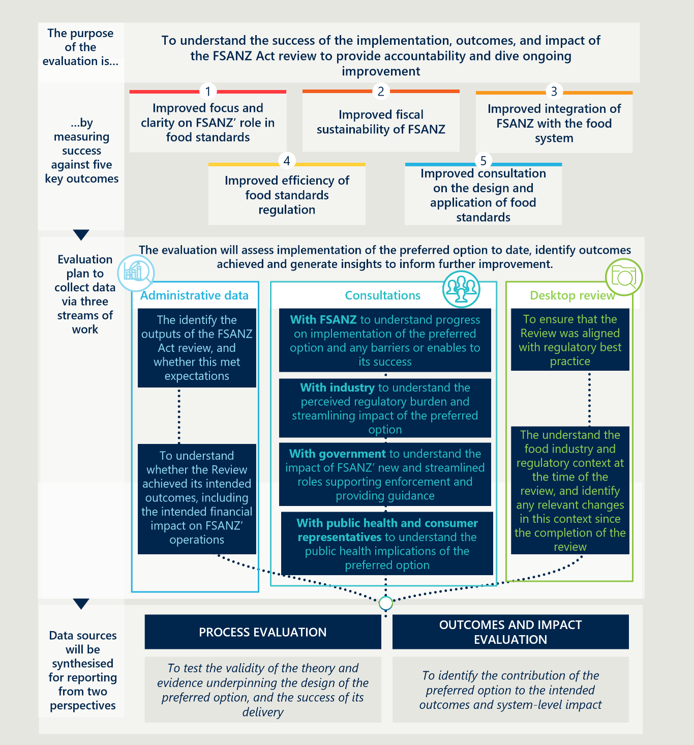

The program logic underpinning the preferred option, demonstrating the alignment between sub-components and intended outcomes of the preferred option, is displayed in Figure 12 overleaf.

Figure 12 | Program logic for the Act Review

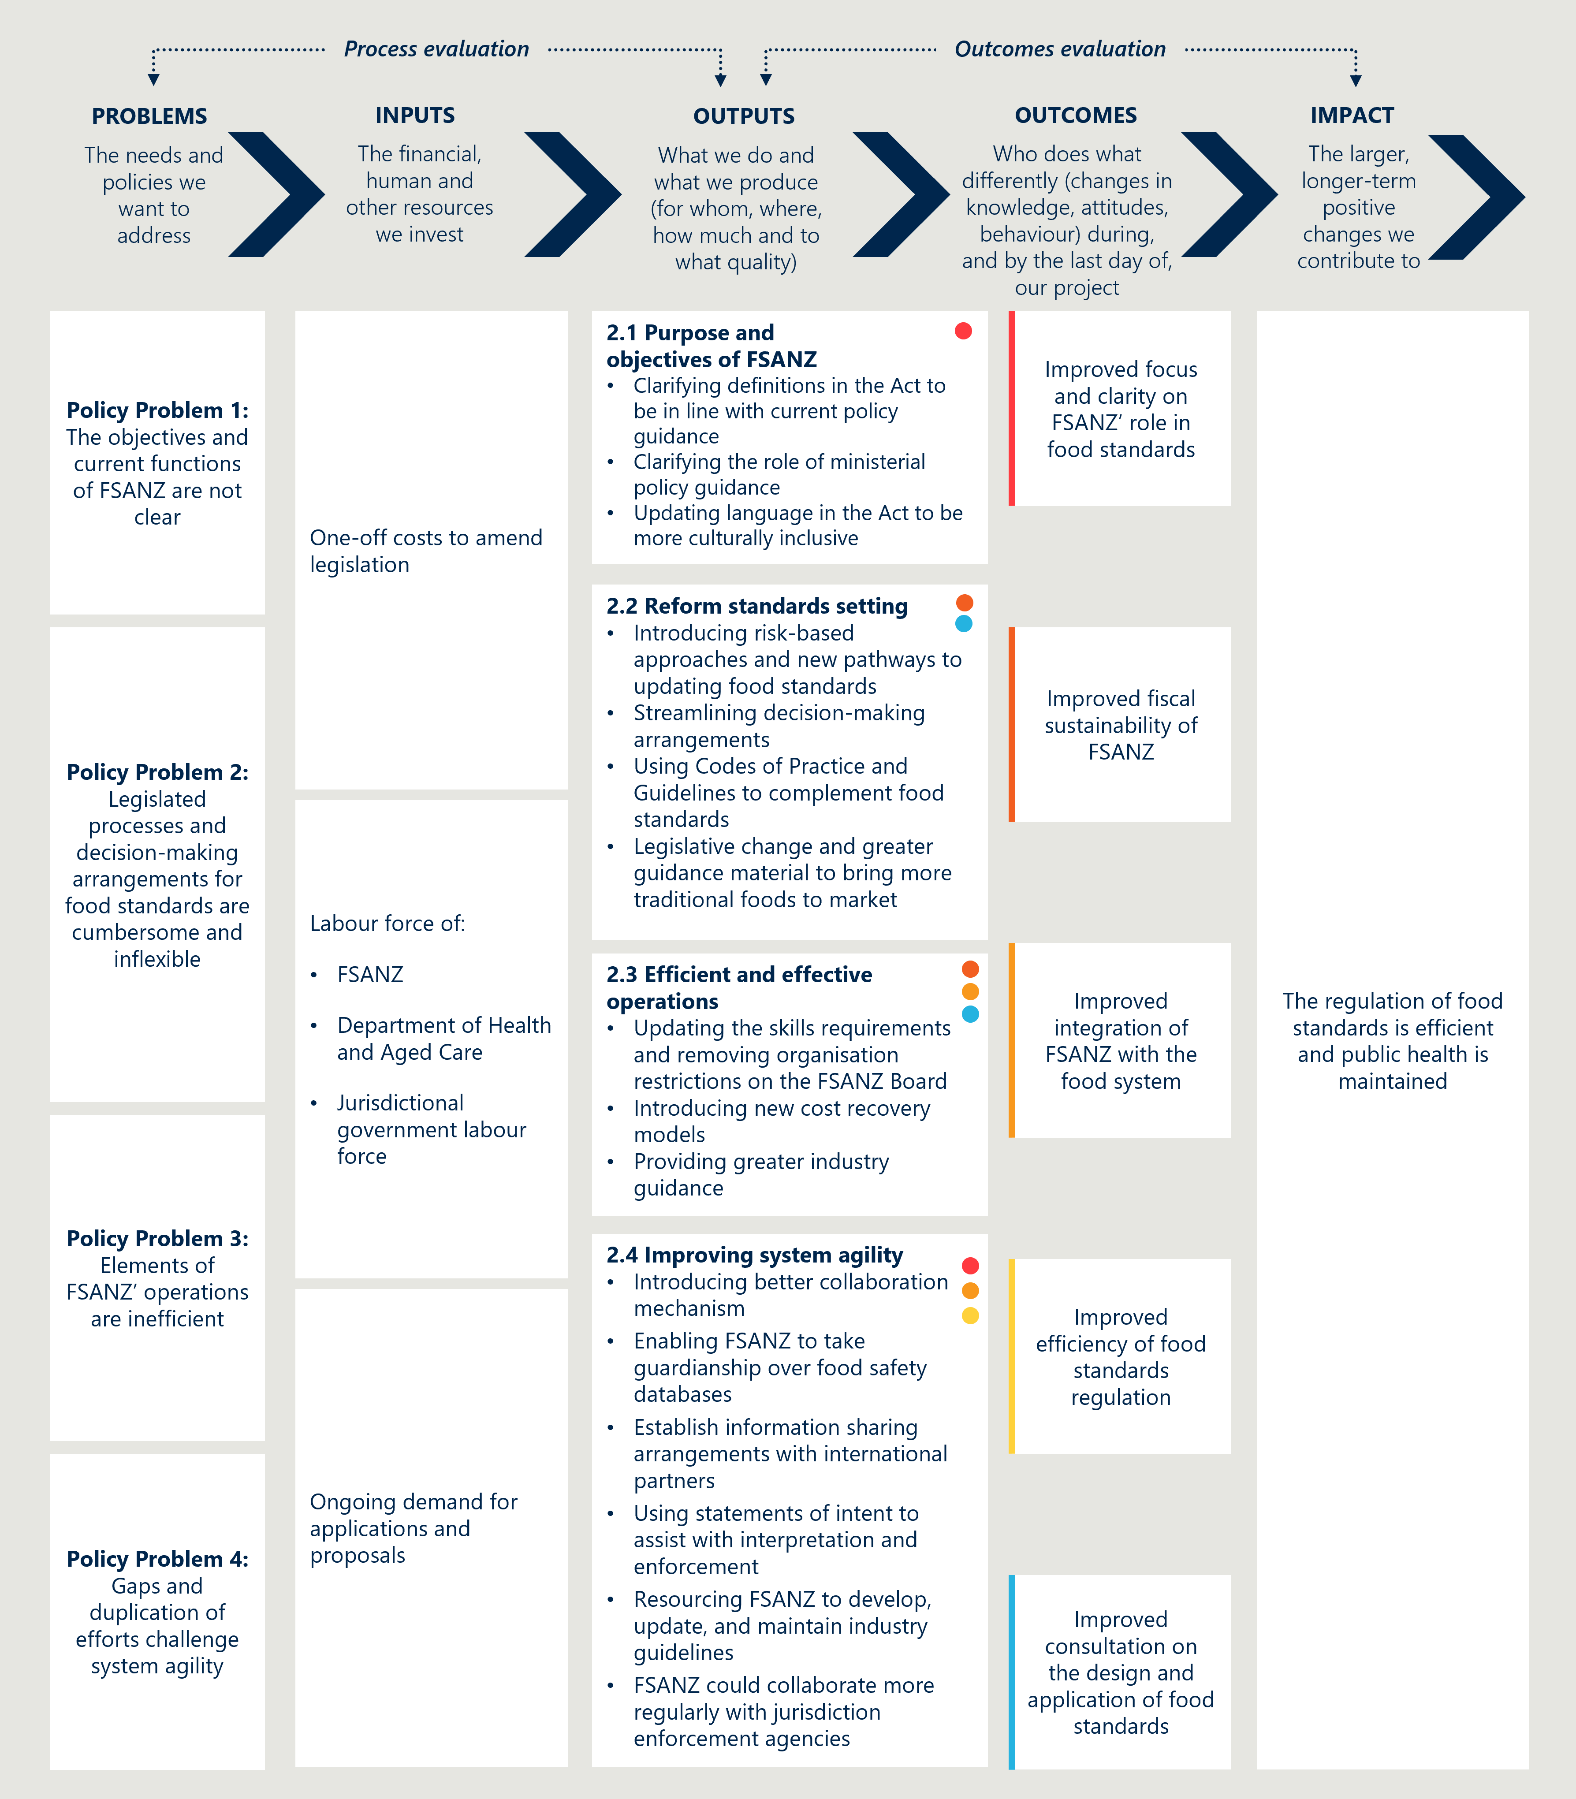

## Data collection

The evaluation of the preferred option should be structured as a response to an agreed set of KEQs. An indicative list of KEQs and suggested approach to gathering relevant data are displayed in Table 32 below. The suggested data collection approaches are aligned with the streams of work displayed in the overarching evaluation conceptual approach.

Table 32 | Indicative Key Evaluation Questions and data collection approach for the evaluation of the preferred option

|  |  |  |  |
| --- | --- | --- | --- |
| Key Evaluation Question | Research Question | | Data collection approach |
| PROCESS EVALUATION | |  | |
| To what extent is the preferred option appropriate to address the policy problems? | * Were the right problems identified? * How have the food and regulatory conditions changed since the implementation of the preferred option? * How well does the preferred option align with best practice regulation? | | Stakeholder engagement   * Engage with FSANZ staff to understand current state and identify operational and legislative issues.   Desktop review   * Literature review of regulatory best practice and food industry trends. |
| To what extent has the preferred option been implemented as intended? | * What outputs have been delivered to date? * Have these outputs been as expected? To what extent do they meet the expected reach and scale (e.g. has cost recovered revenue significantly increased; has time to assess applications significantly decreased)? | | Stakeholder engagement   * Engage with FSANZ staff to understand implementation of the preferred option and identify barriers and enablers to its success.   Quantitative analysis   * Analyse administrative data to understand outputs (e.g. number of applications assessed, time to assess applications, cost recovered revenue). |
| What factors have shaped the implementation? | * What factors are considered to have enabled or constrained the progress and quality of implementation of the preferred option? * What ongoing or emerging opportunities and risks exist that should inform decisions and future implementation? | | Stakeholder engagement   * Engage with FSANZ staff to understand implementation and opportunities for improvement. * Engage with industry to contextualise implementation data and understand how it has impacted perceptions and behaviour. * Engage with governments to contextualise implementation data and understand how it has impacted perceptions and behaviour. |
| OUTCOMES EVALUATION | |  | |
| To what extent are the intended outcomes being achieved? | * What outcomes have been achieved to date? * Have these outcomes been as expected? Why or why not? | | Stakeholder engagement   * Engage with FSANZ, government, and industry staff to understand perspectives on the success and contribution to achieving outcomes of the components of the preferred option.   Quantitative analysis   * See Table 33, indicators of success against the outcomes of the Act Review. |
| What factors have shaped the outcomes and impact? | * What factors (e.g. contextual factors, resourcing, capacity) have affected the size and value of the impacts? * What opportunities exist to further strengthen the Act? | | Stakeholder engagement   * Engage with FSANZ, government, and industry staff to understand why or why not components of the preferred option achieved their intended outcomes.   Quantitative analysis   * See Table 33, indicators of success against the outcomes of the Act Review. |

Table 33 below outlines indicators of success aligned with the intended outcomes of the preferred option. These indicators are categorised as follows:

* Actions describe the key activities that should be undertaken by FSANZ to implement the preferred option.
* Quantitative data should be drawn from administrative databases collected by FSANZ and partners.

Table 33 | Indicators aligned with outcomes of the Act Review

|  |  |
| --- | --- |
| Outcome | Indicators |
| Improved focus and clarity on FSANZ’s role in food standards | Actions   * The Act is amended for clarity and to reflect current priorities   Quantitative data   * Number of reviews of existing standards conducted by FSANZ * Number of food safety databases managed by FSANZ |
| Improved fiscal sustainability of FSANZ | Quantitative data   * Proportion of FSANZ revenue that is cost recovered, by cost recovery type |
| Improved integration of FSANZ with the food system | Actions   * Established mechanism for regular joint-agenda setting between FSANZ and the FMM * Established mechanism to involve FRSC earlier to understand food safety and regulatory impact of changes to food standards * Established mechanism for collaboration with enforcement agencies to identify emerging risks and activate appropriate regulatory response * Established mechanism for collaboration based on information sharing with overseas jurisdictions   Quantitative data   * Number of consumer-facing food safety education materials developed by FSANZ * Number of Statements of Intent on food standards published by FSANZ * Number of times that interpretive guidance on food standards is accessed by industry * Number of enforcement-aligned activities on FSANZ’s workplan |
| Improved efficiency of food standards regulation | Actions   * Establishment of a risk framework   Quantitative data   * Number of applications assessed, by application type (including low-risk applications) * Time for FSANZ to assess applications, by application type (including low-risk applications) * Time between the submission of applications by industry to the reception of a result, by application type * Number of decisions delegated from the FSANZ Board to the FSANZ CEO * Number of decisions delegated from the FMM to departmental officials * Number of risk assessments accepted from comparable overseas jurisdictions |
| Improved consultation on the design and application of food standards | Quantitative data   * Proportion of skills identified on the FSANZ Board skills matrix that are held by Board members |

|  |
| --- |
| Consultation questions |
| * Are there any other factors that should be captured in a future evaluation? * Is there anything else you want to share with us on the Impact Analysis |

# Next steps

This draft IA will be open for public submissions over January and February 2024. Submissions received will be considered and thematically analysed to further refine the IA and ensure the most appropriate elements and included in the final, preferred reform option.

DHAC, in collaboration with MPI will lead the legislative amendment process.

1. Terms of Reference

|  |
| --- |
| Review into the Food Standards Australia New Zealand Act 1991  TERMS OF REFERENCE   1. The review will include a comprehensive examination of the effectiveness of the Food Standards Australia New Zealand Act 1991 (FSANZ Act) and the associated operations and responsibilities of Food Standards Australia New Zealand (FSANZ). It will include consideration of the economic efficiency of regulation, recognising the importance of the food industry to regional communities and the broader economies of both Australia and New Zealand. The review will include findings and recommendations for any reforms. The final report from the review will be provided to the Australian minister responsible for FSANZ, who will consider the report/review in partnership with the New Zealand Minister for Food Safety and consult with state and territory food ministers through the Australia and New Zealand Ministerial Forum on Food Regulation (the Forum).   Scope   1. The Review will include the FSANZ Act and FSANZ operations, with a focus on areas identified as being inconsistent with best practice regulation and standard-setting. The Review should consider and make recommendations on the appropriateness of the FSANZ Act legislation, in particular: 2. The FSANZ assessment process to ensure it is fit for purpose and outcomes based and promotes an efficient and internationally competitive food industry. This work should include:  * ensuring any proposed changes to the regulatory system imposes the least burden on business to achieve the stated objectives of the regulation and specific consideration is given to the impact on small businesses * revision of the interface between the regulator and business, i.e. the digital or paper systems used to support the assessment.  1. An optimal operating model for FSANZ, the roles and functions of FSANZ including consideration of FSANZ undertaking a greater role as a regulator. 2. Cost recovery models for industry-initiated work. 3. Decision making processes, including the role of the CEO, FSANZ Board and Ministers. 4. Best practice board appointment processes. 5. The Review should consider and make recommendations on the operational functions of FSANZ, in particular: 6. The timeliness of work undertaken and relative priority of the FSANZ workplan including consideration of the Risk proportionality and international harmonisation of Risk assessments and standards. 7. The operation and effectiveness of the Food-Medicine Interface, including the effectiveness of regulation around nutrition supplements. 8. FSANZ as an independent agency and appropriate resourcing. 9. The Review should also consider what wider role FSANZ as a joint body could take across Australia and New Zealand and in Australia only, by considering issues and making recommendations in relation to FSANZ’s potential role including (but not limited to): 10. Enforcement of food standards – noting concerns around a lack of consistent implementation of standards across jurisdictions. 11. Emerging issues – such as food fraud and food crime. 12. Food safety – noting consumers’ and industry’s desire for one ‘Face of Food Safety’ that produces a unified national approach to raising awareness and responding to food safety issues (Australian context only). 13. Food safety research – including facilitating collaboration on research relating to food safety. 14. Communication of food standards to industry and consumers – including a greater role in providing advice on interpretation of food standards. 15. Undertaking education campaigns – in alignment with Priority 1 and Priority 2 of the Food Regulation system.   The Review will provide an indication of the potential role of FSANZ in both Australia and New Zealand and relative impact of the recommendations for Australia and New Zealand.  Out of scope   1. The Review will not include other food legislation and agreements, such as the Food Regulation Agreement, the Food Treaty, or the Model Food Act. However, should issues with these instruments be identified, they may be considered separately.   Process  Stakeholder engagement   1. Wide consultation will be undertaken as part of the Review, including with government, consumer, public health, and industry stakeholders along the supply chain.   Legislative amendments   1. In accordance with Article 4(4) of the Treaty, no amendments to the Act will be introduced without effective consultation with New Zealand.   Principles  Alignment with Priority 3 of the food regulation system   1. The Review will complement the objectives of Priority 3 of the food regulation system, as agreed by the Forum in April 2017: to maintain a strong, robust, and agile food regulation system. The central focus of this work is applying best practice regulatory approaches, with the objectives of improving timeliness, ensuring the food regulation system is responsive, and provides a unified voice regarding food safety and applying processes proportional to Risk. Under the Priority 3 program of work, the Food Regulation Standing Committee is concurrently considering wider reforms to the food regulatory system (including the Food Regulation Agreement and the Model Food Act). This review will aim to align with and complement the broader Priority 3 work.   Management   1. The Australian Government Department of Health in consultation with the Australian Government Department of Agriculture, Water and the Environment will manage the Review through an independent consultant, in partnership with the New Zealand Government and in consultation with FSANZ, and Australian states and territories. |

1. The Act Review Steering Committee members

Table 34 | The Act Review Steering Committee members

|  |
| --- |
| Organisation |
| Australian Government Department of Health and Aged Care |
| Australian Government Department of Agriculture, Fisheries and Forestry |
| New Zealand Ministry for Primary Industries |
| Food Standards Australia New Zealand |
| Department of the Prime Minister and Cabinet |
| Australian Government Department of Industry, Science and Resources |
| Australian Government Department of Foreign Affairs and Trade |

1. Net benefit assumptions and calculation

#### Key drivers

This section outlines the key drivers of cost and benefits in the cost benefit analysis and their underlying methodology.

###### Delay to industry

$$Cost of delay to industry=number of applications × delay cost per month ×processing time$$

Applications are further broken down into paid and unpaid applications. Number applications per year is based on an average of five unpaid applications from an average of 17 total applications, over the last seven years.48F[56] A growth rate of zero is presumed for applications, resulting in a constant 17 applications year over the projected ten years to calculate the net present value. The composition of applications is presumed to change with the introduction of new pathways under Option 2.

Delay cost per month has been sourced from industry consultations to date.

Processing time varies depending on the type of application. As majority of current applications are general procedures, their statutory timeframe of nine months is assumed to be the processing time.

###### Public health benefit

$$Public health benefit=\left(number of applications+number of proposals and reviews\right)× public health benefit per application/proposal/review$$

Number of proposals is based on an average of 3.5 per year over the past seven years. Baseline assumption is that FSANZ completes 3 proposals/reviews per year.

Public health benefit per application/proposal/review was calculated for one FSANZ review, ‘Review of the regulatory management of food allergens’ and generalised across reviews, proposals and applications. This is a broad generalisation given the diversity of proposals and applications processed by FSANZ, however the nature of FSANZ being a standard setting body means it is difficult in practice to attribute public health benefits/costs directly to FSANZ’s operations. Nous would be pleased to iterate this approach if more reliable methodologies and data exist.

###### FSANZ resourcing

$$Cost FSANZ resourcing=addtional FTE required × FSANZ compound wage rate+addtional funding required$$

Cost of FSANZ resourcing has been informed by the estimated funding/additional FTEs required to resource each sub-component. Based on FSANZ estimates, 140 additional ongoing FTE will be required to implement all components under Option 2.

FSANZ compound wage rate based on average annual employment cost of all FSANZ staff excluding the CEO as $144,914.

#### Assumptions

This section outlines the key assumptions to the cost benefit analysis. Monetary values in millions AUD.

General assumptions

|  |  |  |
| --- | --- | --- |
| Parameters | Value ($m) | Notes |
| Real discount rate | 7% | In line with Office of Impact Analysis guidance |
| Public health benefit per proposal/review/application | $1.33 | Annual Medicare cost of $28.9749F[57]. 5% attributable to food labelling standards50F[58] |
| Population growth rate | 0.76% |  |
| Delay cost for industry per month/per application | $0.04 | Sourced from industry consultations |
| Application growth rate | Nil |  |
| Proposal/review growth rate | Nil |  |
| FSANZ compound wage rate | $0.14 | Sourced from FSANZ[59] |

Option 1 assumptions

|  |  |  |
| --- | --- | --- |
| Parameters | Value | Notes |
| Number of paid applications | 12 | Average number of paid applications per year is 12 |
| Number of unpaid applications | 5 | Average number of unpaid applications per year is 5 |
| Processing time – paid | 9 months | Statutory timeframe of 9 months for 80% of applications |
| Processing time – unpaid | 21 months | Additional wait time of 12 months for unpaid applications |
| Number of proposals/reviews | 3 | Base case assumed 3 proposals and reviews per year |

Option 2 assumptions

|  |  |  |
| --- | --- | --- |
| Parameters | Value | Notes |
| Number of low-risk applications | 14 | Assume 80% of total (17) applications are low risk based on historical proportion of applications deemed to be low-risk |
| Number of other (higher risk) applications | 3 |  |
| Processing time for low-risk applications | 5 months | Reduction of 4 months in processing time drawn from FSANZ pilot with Health Canada on two-way assessment sharing for low-risk GM applications. There was a reduction of 4 months in assessment of an application where Health Canada provided their risk assessment to FSANZ compared to the standard 9-month process |
| Processing time for other applications | 9 months |  |
| Number of proposals/reviews | 11 | Additional 8 more standards and proposals reviewed a year |
| Benefit from publishing a list of Aboriginal, Torres Strait Islander and Māori traditional foods used in Australia and New Zealand that have undergone safety assessments | $10.2 | Industry value add of Australian and Māori native food sector is $8m and $2.2m respectively51F[60]52F[61] |
| Growth rate of Aboriginal, Torres Strait Islander and Māori traditional foods industry | 10% | Market value projected to double from 2020 to 2025 with a growth rate of 16% per annum. Assumed lower bound growth rate of 10% per annum |
| Cost recovery levy | 10 | Assume there are 5000 large businesses captured by a FSANZ levy, $2,000 each would generate $10 million |
| Cost recovery from jurisdictions for projects | 6.3 |  |
| Cost recovery from jurisdictions from food recall coordination | 1.5 |  |

1. Application of proposed risk framework

This section considers how three examples of applications or proposals could be assessed using the framework above. The application of the criteria to the examples is indicative only.

|  |
| --- |
| **Case study 1 (Low risk) |** An application to allow an existing enzyme processing aid to be produced from a new microbial source. The enzyme has a long history of safe use and is already approved to be sourced from other micro-organisms.53F[62] |

This example could be subject to the following risk assessment:

* The application is not aligned to FMM strategic priorities related to food safety, public health, innovation and/or economic activity *(criterion 1: low strategic alignment).*
* The application requires technical expertise to assess any health or safety issues related to the new microbial source for the enzyme processing aid. There are no broader policy imperatives or considerations that this application would impact *(criterion 2: technical expertise only required).*
* The enzyme strain is neither toxigenic nor pathogenic and there are no identified public health and safety concerns based on initial assessment *(criterion 3: low extent of risk).*
* The application primarily seeks to reduce industry confusion and provide greater regulatory certainty – since approval of previous microbial source for enzyme in the Code, it has been re-classified in the microbiological literature as a different species. Likely to be limited positive impact for industry and no material social or health impacts *(criterion 4: limited scope of impacts).*
* The enzyme meets international purity specifications and is permitted for use in food production in the USA, France, Canada and Japan (*criterion 5: strong existing evidence base).*

Based on this assessment, the application would be classified as low (or very low) risk and could be subject to truncated decision-making arrangements enabled by proposed reforms to Part 3 of the Act.

|  |
| --- |
| **Case study 2 (Moderate risk) |** An application to vary Standard 1.5.2 of the Code to permit the sale and use of a food derived from a new food produced using gene technology. The food has been genetically modified for protection from insect pests.54F[63] |

This example could be subject to the following risk assessment:

* The application is not closely aligned to current FMM strategic priorities, however genetically modified foods are a politically sensitive issue for some groups in Australia and New Zealand *(criterion 1: moderate strategic alignment).*
* The application requires technical expertise to assess food safety and nutritional issues in relation to the new genetically modified foods. Risks to environment and non-human animals of cultivating the new food in Australia or New Zealand would be considered separately55F[64] and not as part of this application. This application could potentially require the development of community communications strategy to address public concern *(criterion 2: technical expertise mainly required).*
* The application is likely to require a GM food assessment of less than average complexity. Existing data and evidence suggest no public health and safety issues relating to the new food, and that it is as safe for human consumption as food derived from non-GM sources *(criterion 3: moderate extent of risk; less than average complexity of risk assessment).*
* The application would permit sale and use of a new food which would impact many consumers that consume maize products (increasing choice). The application would have some impacts for industry (by enhancing market opportunities) and would likely have limited impact on international trade *(criterion 4: moderate scope of impacts).*
* The application is being considered and/or has been approved in other jurisdictions and there is a reasonable existing evidence base (provided as part of the application) regarding the food safety impacts of the GM food *(criterion 5: moderate existing evidence base).*

Based on this assessment, the application would be classified as moderate risk and could be subject to truncated decision-making arrangements enabled by proposed reforms to Part 3 of the Act based on a case-by-case assessment by the FSANZ Board and the FMM.

|  |
| --- |
| **Case study 3 (High risk) |** A proposal to revise and clarify standard relating to infant formula (for use from birth to 12 months of age), including category definitions, composition, labelling and representation of products. This includes all products regulated by Standard 2.9.1 of the Code, including infant formula, follow-on formula and infant formula for special dietary use.56F[65] |

This example could be subject to the following risk assessment:

* This proposal is a holistic review of the standard for infant formula and involves developing new principles to guide and underpin the framework for regulating composition, use and access to infant formula products. There are considerable likely economic and health impacts (see criterion 3 below) and alignment with FMM strategic priorities. There is an existing Ministerial Policy Guideline on the *Regulation of Infant Formula Products (criterion 1: high strategic alignment).*
* This proposal covers all aspects of Standard 2.9.1 – including category definitions, composition, labelling and representation of products – and includes interface with other standards. This involves technical assessment (e.g. for compositional requirements) and broader social science and policy expertise (e.g. for labelling and information for parents/carers to make informed choice) *(criterion 2: broad technical and policy expertise required).*
* The proposal considers all infant formula products regulated by Standard 2.9.1 of the Code and all aspects of the standard, including category definitions, composition, labelling and representation of products. It is recognised that regulation of breastmilk substitutes, such as infant formula, has implications for health outcomes for all infants *(criterion 3: complex risk assessment with significant potential risks to public health and safety).*
* The proposal considers all regulated infant formula products, including infant formula (for newborns), follow-on formula (for use from 6-12 month of age) and infant formula for special dietary use. Changes to composition and labelling requirements would impact industry costs and practices *(criterion 4: broad reaching social, health and economic impacts).*
* FSANZ has previously identified there is a limited evidence base on some aspects of this proposal, e.g. limited published literature on infant feeding practice and use of infant formula. Internationally, requirements for infant formula product vary significantly *(criterion 5: limited existing evidence base).*

Based on this assessment, the application would be classified as high (or very high) risk and would likely be subject to rigorous consideration and decision-making arrangements by the FSANZ Board and the FMM.

#### Implications for decision-making arrangements

The decision-making arrangements for development and variation of food regulatory measures would vary based on the risk level through a graduated, risk-tiered approach. This would be enabled by other reforms proposed as part of the Review, namely those that provide for:

* the FSANZ Board to delegate decision-making responsibilities to the FSANZ CEO
* the FMM to delegate decision-making responsibilities to departmental officials.

These reforms would be supplemented by other legislative changes that would streamline the processes for assessing applications and proposals where there is a low risk. This includes enabling FSANZ to accept risk assessments from comparable overseas jurisdictions and creating a new minimal check pathway for low-risk applications.

The intention of these reforms is to provide flexibility regarding the decision-making arrangements and processes for applications and proposals to create or vary food regulatory measures. This recognises that different stakeholders may have different risk appetites and/or different perspectives about the level of risk involved in an application or proposal.

Under a risk-tiered approach, the following decision-making arrangements could apply (subject to the determination of Ministers and the FSANZ Board about whether to delegate decision making authority):

* For low-risk applications and proposals, the default approach could be for the FSANZ Board to delegate decision-making responsibility to the FSANZ CEO and for FMM Ministers to delegate to departmental officials.
* For moderate-risk applications and proposals, the default approach could be a case-by-case assessment by the FSANZ Board and FMM about whether delegation of decision-making would be appropriate.
* For high-risk applications and proposals, the default approach could be that the FSANZ Board and the FMM would continue to ratify changes to food regulatory measures (as under the current framework).

*Note that while the dot points above refer to a ‘default approach’ for each risk-tier, the FSANZ Board and Ministers would always retain the prerogative to make the decision whether to approve, amend or reject a draft standard or draft variation.*

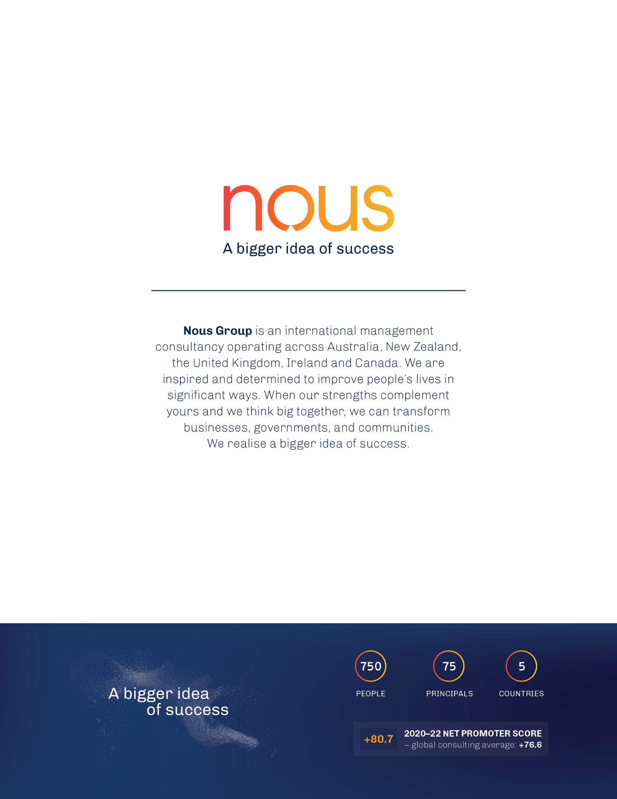

1. Attorney General Department 2020, available at: [<https://www.ag.gov.au/rights-and-protections/human-rights-and-anti-discrimination/human-rights-scrutiny/public-sector-guidance-sheets/right-adequate-standard-living-including-food-water-and-housing#what-is-the-right-to-an-adequate-standard-of-living>](https://www.ag.gov.au/rights-and-protections/human-rights-and-anti-discrimination/human-rights-scrutiny/public-sector-guidance-sheets/right-adequate-standard-living-including-food-water-and-housing%23what-is-the-right-to-an-adequate-standard-of-living)
2. Australian Food and Grocery Council 2022, *AFGC 2020-21 9 State of the Industry,* available at: < https://www.afgc.org.au/industry-resources/state-of-the-industry>
3. Ministry of Business, Innovation & Employment 2018, *Emerging growth opportunities in New Zealand Food & Beverage,* available at: <<https://www.mbie.govt.nz/dmsdocument/2209-emerging-growth-opportunities-nz-food-beverage-pdf>>
4. Sustaining Australia: Food and Grocery Manufacturing 2030. Available at:  [https://www.afgc.org.au/industry-resources/sustaining-australia-food-and-grocery-manufacturing-2030](https:/www.afgc.org.au/industry-resources/sustaining-australia-food-and-grocery-manufacturing-2030)
5. Growing the food and beverage sector, New Zealand Ministry of Business, Innovation, and Employment. Available at <https://www.mbie.govt.nz/business-and-employment/economic-development/growing-the-food-and-beverage-sector/>
6. FSANZ. The FMM (2021). Available at: <https://www.foodstandards.gov.au/code/fofr/pages/default.aspx#:~:text=The%20Food%20Ministers'%20Meeting%20(the,of%20the%20implementation%20of%20standards>
7. For example, a 2005 Review of the Food Regulation Agreement found that the Agreement has made a positive contribution to the development of a national approach to food regulation within Australia, including through its co-operative structure, improved communications between portfolios and clearer administrative arrangements. A 2006 review of the Food Treaty found that most stakeholders consider the Food Treaty has been successful in reducing barriers to trade. A 2018 Food Export Review found ‘the Australian food system is performing reasonably well’ and ‘has to date been reasonably well-functioning and have provided a competitive advantage to Australia’s food exports.’
8. Section 11. Food Safety Authority of Ireland Act 1991. Available online at <https://www.irishstatutebook.ie/eli/1998/act/29/enacted/en/pdf>
9. Food Law General Principles, European Commission. Available at: <https://ec.europa.eu/food/safety/general_food_law/principles_en>
10. Food and Agriculture Organization of the United Nations. Codex Alimentarius: About Codex Alimentarius. Available online at: [https://www.fao.org/fao-who-codexalimentarius/about-codex/en/#c453333](https://www.fao.org/fao-who-codexalimentarius/about-codex/en/%23c453333)
11. Australia and Aotearoa-New Zealand Indigenous Collaboration Arrangement (2020). Available online at: <https://www.niaa.gov.au/resource-centre/indigenous-affairs/australia-and-aotearoa-new-zealand-indigenous-collaboration-arrangement>
12. Guidance: Indigenous Knowledge under the *Impact Assessment Act.* Government of Canada. Available online at: <https://www.canada.ca/en/impact-assessment-agency/services/policy-guidance/practitioners-guide-impact-assessment-act/indigenous-knowledge-under-the-impact-assessment-act.html>
13. For example, see the *Therapeutic Goods Act 1989* and the *Agricultural and Veterinary Chemicals (Administration) Act 1992* in Australia, and the *Medicines Act 1981* and the *Hazardous Substances and New Organisms Act 1996* for New Zealand.
14. Health Canada Decision-Making Framework for Identifying, Assessing, and Managing Health Risks, August 2000, Health Canada. Available at:

    <https://www.canada.ca/en/health-canada/corporate/about-health-canada/reports-publications/health-products-food-branch/health-canada-decision-making-framework-identifying-assessing-managing-health-risks.html>
15. Working Party on Standardization of Perishable Produce (1986). UNECE Standard concerning the marketing and commercial quality control of Hens egg products for use in the food industry. Available at: <https://unece.org/DAM/trade/agr/standard/eggs/e/63produc.pdf>
16. CAC/RCP (1976) Code of Hygienic practice for eggs and egg products. Available at: [https://www.fao.org/fao-who-codexalimentarius/sh-proxy/en/?lnk=1&url=https%253A%252F%252Fworkspace.fao.org%252Fsites%252Fcodex%252FStandards%252FCXC%2B15-1976%252FCXP_015e.pdf](https:/www.fao.org/fao-who-codexalimentarius/sh-proxy/en/?lnk=1&url=https%253A%252F%252Fworkspace.fao.org%252Fsites%252Fcodex%252FStandards%252FCXC%2B15-1976%252FCXP_015e.pdf)
17. For example, Mangalam, S., Hodges, C., & Sharpington, L (2020). Theory Paper on Contemporary Regulatory Models’ prepared by PIAM Institute for Safe Food Production Queensland. This paper has been developed as part of the jurisdictional consistency project being undertaken as part of the P3 reform program. It was provided to Nous by the Australian Department of Health.
18. Food Standards Australia and New Zealand, July 2021. Overview paper on all 4 Core Areas.
19. The National Boards are responsible for setting the standards that all registered health professionals in the 16 registered health professions must meet.
20. Food and Drug Administration (2021). FDA Adverse Event reporting System (FAERS) Public Dashboard. Available at: <https://www.fda.gov/drugs/questions-and-answers-fdas-adverse-event-reporting-system-faers/fda-adverse-event-reporting-system-faers-public-dashboard>
21. European Food Safety Authority (2022). Food consumption data. Available at: [https://www.efsa.europa.eu/en/data-report/food-consumption-data](https:/www.efsa.europa.eu/en/data-report/food-consumption-data)
22. Work to develop a vision for the system (and its overarching objectives) is currently underway and changes will be ultimately captured in a revised Food Regulation Agreement.
23. It should be acknowledged that, although the ultimate decision by Ministers is usually not to review, there is often significant pre-work, discussion, and debate at FRSC level prior to this occurring.
24. FSANZ 2020, *A position paper on FSANZ’s resourcing.* Unpublished position paper.
25. Sambu, S., Hemaram, U., Murugan, R., & Alsofi, A. (2022). Toxicological and Teratogenic Effects of Various Food Additives: An Updated Review. *Biomed Research International*. Published online at: [https://www.ncbi.nlm.nih.gov/pmc/articles/PMC9249520/#:~:text=According%20to%20several%20studies%2C%20health,and%20influences%20growth%20and%20development.](https://www.ncbi.nlm.nih.gov/pmc/articles/PMC9249520/%23:~:text=According%20to%20several%20studies%2C%20health,and%20influences%20growth%20and%20development.)
26. Per s 116(1)(f) and (g), the Minister must seek appointment nominations from certain organisations and public bodies prescribed in the Regulations to determine if the person is suitably qualified for the appointment.
27. Mangalam, S, Hodges, C & Sharpington, L 2020 ‘Theory Paper on Contemporary Regulatory Models’ prepared by PRISM Institute, Canada for Safe Food Production Queensland. This paper has been developed as part of the jurisdictional consistency project being undertaken as part of the P3 reform program. It was provided to Nous by the Australian Department of Health and Aged Care.
28. Position paper on FSANZ resourcing, The FSANZ Act Review, FSANZ, 2021. (Not public).
29. FSANZ Annual Report 2022-23. Total cost recovery fees = $909,000; Total revenue = $23,600,000; therefore cost recovery represents 4% of total revenue.
30. Currently the Australian Minister for Health as set out in the Common of Australia Administrative Arrangements Order.
31. Food Safety Alliance Concept note (prepared by Dr Anne Astin PSM), provided by FSANZ.
32. This is less of an issue for New Zealand as all food businesses are regulated by a single institution, the Ministry for Primary Industries. Food that is manufactured in New Zealand and meets New Zealand requirements can be legally sold in Australia under the Trans-Tasman Mutual Agreement (and vice versa).

    While inconsistency between Australia and New Zealand are not explicitly barriers to economic opportunities, it represents an important fragmentation of the joint food standards system.
33. Adapted from MP Consulting, ‘Key areas of inconsistency in food regulation’, 26 February 2021.
34. The scoping paper published as part of this review (from 5 October to 16 November 2020) asked stakeholders whether there was still a case for regulating food. Responses from 92 submissions universally acknowledged there was still a relevant case for regulating food.
35. Currently the Act, the Food Regulation Agreement, and the Food Treaty use different wording around the objectives of food regulation. Once clarifications are made to the Act, these changes may also be carried through to these other foundational documents.
36. Australian Government, Department of Prime Minister and Cabinet (2014). *Industry Innovation and Competitiveness Agenda: An Action Plan for a Stronger Australia.* Available online at: <https://webarchive.nla.gov.au/awa/20151020202248/http://www.dpmc.gov.au/pmc/publication/industry-innovation-and-competitiveness-agenda-report-action-plan-stronger-australia>
37. Australian Government, the Treasury (2019). *Aligning with international standards and risk assessments.* Available online at: <https://treasury.gov.au/the-department/accountability-reporting/aligning-with-international-standards>
38. Note that ‘Generally Regarded as Safe’ (GRAS) Affirmations and GRAS Notifications do not constitute approval by the USFDA
39. This arrangement could also be achieved by amending the Food Regulation Agreement to include the ability to delegate.
40. Food Standards Australia New Zealand Regulations 1994 (Compilation date 1 July 2019). Part 3, 6A Organisations and public bodies from which nominations for Board members may be sought.
41. At FMM04 on 25 November 2022, Ministers agreed to further examination of the removal of expedited applications to address workload prioritisation.
42. At FMM04 on 25 November 2022, Ministers agreed to further consider cost recovery models for FSANZ for industry-initiated work.
43. Australian Government, Department of Finance (2021). *Australian Government Cost Recovery Policy.* Available online at: <https://www.finance.gov.au/government/managing-commonwealth-resources/implementing-charging-framework-rmg-302/australian-government-cost-recovery-policy> <https://www.finance.gov.au/government/managing-commonwealth-resources/implementing-charging-framework-rmg-302/australian-government-cost-recovery-policy>
44. New Zealand Government, The Treasury (2017). *Guidelines for Setting Charges in the Public Sector*. Available online at: <https://www.treasury.govt.nz/publications/guide/guidelines-setting-charges-public-sector>
45. Kerin, J. (2001). SafeFood NSW Kerin Funding Review Final Report. Available online at: https://www.foodauthority.nsw.gov.au/sites/default/files/_Documents/corporate/kerin_funding_review.pdf
46. This would align with the October 2020 Review of COAG Councils and Ministerial Forums which has recommended that the FMM (then the Forum) maintains a workplan of actions that sunset after 12 months.
47. FSANZ Position – Core Area 3
48. FSANZ, FSANZ *Annual Report 2021-22,* [*https://www.foodstandards.gov.au/publications/Documents/FSANZ%20Annual%20Report%202021-22.pdf*](https://www.foodstandards.gov.au/publications/Documents/FSANZ%20Annual%20Report%202021-22.pdf)
49. Regulation of food standards is carried out at a jurisdictional level with the costs borne by jurisdictional governments.
50. FSANZ resourcing from the Australian Government was AUD $17.5 million in 2022. For the purposes of the cost-benefit analysis, this has been included as cost to FSANZ itself, recognising the resource requirements of all FSANZ’s operations.
51. This is a working assumption. Actual changes to government contributions would need to be explored and agreed as part of broader negotiations for the food regulatory system
52. Australian Government, *Industry Innovation and Competitiveness Agenda: An action plan for a stronger Australia*, <https://www.dewr.gov.au/download/2913/competitiveness-agenda/4035/document/pdf>
53. Ministry for Primary Industries, *New Zealand’s Strategic Objectives in Codex 2022-2026*, <https://www.mpi.govt.nz/dmsdocument/9596/direct#:~:text=The%20SPS%20Agreement%20provides%20a,to%20the%20maximum%20extent%20possible>.
54. The objectives of the Act should harmonise with the overarching objectives of the food system. Work to develop a vision for the system (and its overarching objectives) is currently underway and changes will be ultimately captured in a revised Food Regulation Agreement.
55. Australian Pesticides and Veterinary Medicines Authority, Strategic Review Report – July 2023, Clayton UTZ. Available online at: <https://www.agriculture.gov.au/sites/default/files/documents/APVMA%20-%20Strategic%20Review%20Report.PDF>
56. FSANZ response to Nous data request.
57. Hua et al, ‘Out-of-hospital health care costs of childhood food allergy in Australia: A population-based longitudinal study’, *Paediatric Allergy Immunology*, 33, 2022. Figure adjusted for population growth. [[Link]](https://doi.org/10.1111/pai.13883)
58. FSANZ, ‘Review of the regulatory management of food allergens,’ 2010. [[Link]](https://www.foodstandards.gov.au/publications/Documents/Review%20of%20the%20regulatory%20management%20of%20food%20allergens.pdf)
59. The compound wage rate excludes the CEO’s wage. Where initiatives require CEO time, the CEO wage rate of $320,000
60. Australian Native Food & Botanicals, ‘*Australian native food and botanicals,’* 2020 [[Link]](https://anfab.org.au/edit/research_projects/ANFAB_2020_Market%20Study.pdf)
61. New Zealand Ministry of Primary Industries, ‘*The future of Aotearoa New Zealand’s Food Sector’*
62. This case study is based on *A1212 – Beta-fructofuranosidase enzyme from Aspergillus fijensis.* Documents available at:   
    [<https://www.foodstandards.gov.au/code/applications/Pages/a1212.aspx>](https://nousgroup.sharepoint.com/sites/TS17256/Shared%20Documents/General/F.%20Deliverables/Draft%20IA%20for%20early%20assessment%20(v2%20-%20post%20OIA%20feedback)/November%202023%20version/%3chttps:/www.foodstandards.gov.au/code/applications/Pages/a1212.aspx%3e)
63. This case study is based on *A1226 – Food derived from insect-protected corn line MON95379,* Documents available at:<https://www.foodstandards.gov.au/code/applications/Pages/A1226%20-%20Food%20derived%20from%20insect-protecte%20corn%20line%20MON95379.aspx>
64. This assessment would be by the Gene Technology Regulator in Australia and the Environmental Protection Authority in New Zealand.
65. This case study is based on *P1028 – Infant Formula.* Information available at:   
    <https://www.foodstandards.gov.au/code/applications/Documents/02%20A1226%20CFS.pdf>   
    <https://www.foodstandards.gov.au/code/proposals/Pages/P1028.aspx>