AUSTRALIA AND NEW ZEALAND MINISTERIAL FORUM ON FOOD REGULATION
POLICY GUIDELINE ON FOOD LABELLING TO SUPPORT CONSUMERS TO MAKE INFORMED HEALTHY FOOD CHOICES
November 2019

AIM
The Australia and New Zealand Ministerial Forum on Food Regulation (Forum) intends to take a whole-of-diet approach to food labelling. The Forum expects food labels to present information that provides consumers the opportunity to make informed choices that support dietary patterns aligned with the Dietary Guidelines.
Poor diet is a leading risk factor for chronic disease in Australia and New Zealand. Dietary Guidelines provide recommendations for healthy food choices to reduce the risk of chronic diseases.
The food regulation system and food labelling play a role in enabling consumers to make healthier food choices. This Policy Guideline outlines how food labels can present information to provide consumers the opportunity to apply the recommendations in the Dietary Guidelines.
It is recognised that food labels provide information about a specific foods and nutrients while Dietary Guidelines provide whole-of-diet recommendations about food groups and dietary patterns.
POLICY PRINCIPLES
- Food labels, on the physical product, should include information to provide consumers the opportunity to identify foods that contribute to healthy dietary patterns aligned with the recommendations of the Dietary Guidelines.
- Information that provides consumers the opportunity to identify foods that contribute to healthy dietary patterns aligned with the recommendations of the Dietary Guidelines sits at the mandatory end of the ‘dominant intervention mode’ within the preventive health section of the Food Labelling Hierarchy (see Appendix), unless there is an effective co-regulatory measure to achieve the aim and policy principles in this document.
- Food labels should provide information about a foods’ energy (kilojoule) content to support consumers to monitor energy intakes and assist with achieving and maintaining a healthy body weight.
- Information about nutrients identified in the recommendations in Dietary Guidelines should be presented on food labels:
  - in a manner which is easily understood by consumers,
  - on a consistent basis to support consumers to compare food products, and monitor consumption, within and across categories,
  - in a manner such that information about one nutrient should not be emphasised above others, except in food categories where predominantly energy or a single nutrient is present,
  - in a manner which does not promote foods, food groups or dietary patterns that are not aligned with recommendations in the Dietary Guidelines.

SCOPE
- This Policy Guideline focusses on healthy eating (energy balance and nutrition) recommendations in the Dietary Guidelines. Recommendations about sustainability, food safety and breastfeeding in the Dietary Guidelines is out of scope.
- This Policy Guideline applies to any foods which are required to bear a label under the Australia New Zealand Food Standards Code.
- This Policy Guideline does not apply to special purpose foods (i.e. Part 2.9 of the Australia New Zealand Food Standards Code).
- This is an overarching guideline for food labelling which captures all nutrition information on products within scope, including labelling for which specific policy guidance may be available, such as for nutrition, health and related claims and front-of-pack labelling. In these instances, both Policy Guidelines/ Policy Statement may be considered together when developing or reviewing food regulatory measures or variations of food regulatory measures.

DEFINITIONS
For the purpose of this Policy Guideline:
- Dietary Guidelines – refers to the Australian Dietary Guidelines, New Zealand Eating and Activity Guidelines and New Zealand Food and Nutrition Guidelines for other specified age and stage groups, or future iterations thereof.
- Food - refers to foods and beverages, including alcoholic beverages.
- Nutrient - refers to nutritionally important components (including protective or harmful) referred to in the Dietary Guidelines.
- Recommendations - refers to the key overarching recommendations/statements in the Dietary Guidelines.

CONTEXT
Dietary guidelines
- The Dietary Guidelines provide guidance on foods, food groups and dietary patterns that provide the nutrients required for optimal health and wellbeing and reduce the risk of chronic disease.
- Dietary Guidelines make food-based recommendations (i.e. referring to foods and food groups such as fruit; vegetables and legumes/beans; and, grain foods, mostly whole grains; etc), but in some instances the Dietary Guidelines make recommendations about foods based to the nutrients they contain (e.g. ‘limit intake of foods containing saturated fat, added salt, added sugars’ or ‘choose and/or prepare foods and drinks that are low in salt etc.).
- The dietary patterns of the majority of Australians and New Zealanders are not aligned with the recommendations in the Dietary Guidelines
- Consumer awareness of Dietary Guidelines is poor and as a result it may be difficult for consumers to understand how some foods relate to the recommendations in the Dietary Guidelines. To support work on food labelling, there is a role for education and promotion of the Dietary Guidelines to raise consumers’ awareness.
Food labels
- Consumers choose foods for a variety of reasons, most of which are not health related. Food labels are one of many sources of information available to support consumers to make informed choices when selecting foods to eat. However, when consumers attempt to make healthier choices some find it difficult to use information on food labels to apply the recommendations of the Dietary Guidelines.
- The provision of adequate information relating to food to enable consumers to make informed choices is the second priority objective of Food Standards Australia New Zealand when developing or reviewing food regulatory measures and variations of food regulatory measures.
- It is recognised that food labelling can also facilitate food reformulation which can have widespread population health benefits, including for consumers who do not read food labels.

REVIEWS AND UPDATES
These Policy Guidelines should be reviewed every 5 years to assess whether they continue to reflect the Dietary Guidelines and other relevant advice, and be updated if necessary.

Appendix
Food Labelling Hierarchy
This version of the Food Labelling Hierarchy was agreed to by the Forum on 9 December 2011 and is included in the Overarching Strategic Statement for the Food Regulation System.

The Food Labelling Hierarchy prioritises information on a food label as food safety, preventative health, and, consumer values. The ‘dominant mode of intervention’ within the hierarchy outlines how these pieces of information should be regulated.

In relation to preventive health, this includes the indirect, long term impacts on health and particularly includes chronic disease. Labelling in relation to preventative health may be initiated by government or in tandem with stakeholders, including industry. The level of intervention will be informed by governments’ health priorities, public health research and the effectiveness or otherwise of co-regulatory measures.

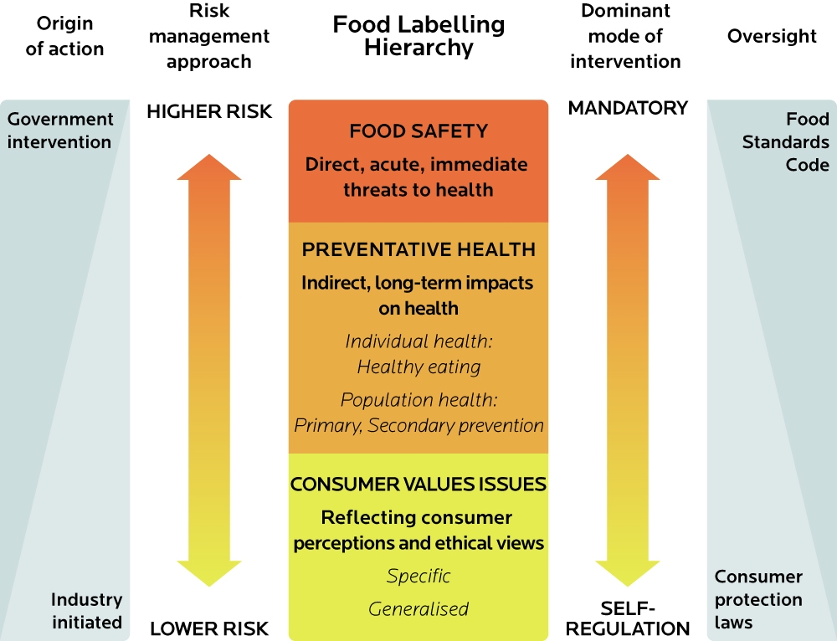

Institute of Health Metrics and Evaluation 2018. Global Burden of Disease Study.
Dietary patterns are types, combinations and amounts of foods eaten over a period of time.
i.e. consumers should not be required to access this information online via a link from a food label.
Drawn from the Forum’s Response to the Food Labelling Law and Policy Review and Overarching Strategic Statement for the Food Regulation System
As per Standard 1.1.2-2.
Australian National Health and Medical Research Council 2013.
New Zealand Ministry of Health 2015.
see New Zealand Ministry of Health Current Food and Nutrition Guidelines
for example “limit intake of foods and drinks containing added sugars” (recommendation 3.3 of the Australian Dietary Guidelines) or “choose and/or prepare foods and drinks with unsaturated fats instead of saturated fats” (Guideline 2.1 of the New Zealand Eating and Activity Guidelines)
Australian National Health and Medical Research Council 2013.
New Zealand Ministry of Health 2015.
Australian Bureau of Statistics 2016. Australian Health Survey: Consumption of Food Groups from the Australian Dietary Guidelines, 2011-12.
Kantar Public 2017. Healthy Weight and Lifestyle: Exploratory Research Report (pending publication).
Grunert, K. G., & Wills, J. M. (2007). A review of European research on consumer response to nutrition information on food labels. Journal of Public Health, 15(5), 385–399.
FSANZ (2016) Consumer Label Survey 2015 Food Labelling Use and Understanding in Australia and New Zealand. Food Standards Australia New Zealand, Canberra.
Food Standards Australia New Zealand (FSANZ) Act 1991.
Drawn from the Forum’s Response to the Food Labelling Law and Policy Review and Overarching Strategic Statement for the Food Regulation System

