

|  |
| --- |
| **EXPOSURE DRAFT** |

Public Health (Tobacco and Other Products) Amendment (On‑Product Health Messages and Other Measures) Regulations 2024

I, the Honourable Sam Mostyn AC, Governor‑General of the Commonwealth of Australia, acting with the advice of the Federal Executive Council, make the following regulations.

Dated 2024

Sam Mostyn AC

Governor‑General

By Her Excellency’s Command

Mark Butler **[DRAFT ONLY—NOT FOR SIGNATURE]**

Minister for Health and Aged Care

Contents

1 Name 1

2 Commencement 1

3 Authority 1

4 Schedules 1

Schedule 1—Amendments 2

Public Health (Tobacco and Other Products) Regulations 2024 2

1 Name

This instrument is the *Public Health (Tobacco and Other Products) Amendment (On-Product Health Messages and Other Measures) Regulations 2024*.

2 Commencement

(1) Each provision of this instrument specified in column 1 of the table commences, or is taken to have commenced, in accordance with column 2 of the table. Any other statement in column 2 has effect according to its terms.

| Commencement information | | |
| --- | --- | --- |
| Column 1 | Column 2 | Column 3 |
| Provisions | Commencement | Date/Details |
| 1. The whole of this instrument | The day after this instrument is registered. |  |

Note: This table relates only to the provisions of this instrument as originally made. It will not be amended to deal with any later amendments of this instrument.

(2) Any information in column 3 of the table is not part of this instrument. Information may be inserted in this column, or information in it may be edited, in any published version of this instrument.

3 Authority

This instrument is made under the *Public Health (Tobacco and Other Products) Act 2023*.

4 Schedules

Each instrument that is specified in a Schedule to this instrument is amended or repealed as set out in the applicable items in the Schedule concerned, and any other item in a Schedule to this instrument has effect according to its terms.

Schedule 1—Amendments

Public Health (Tobacco and Other Products) Regulations 2024

1 Section 4 (paragraph beginning “Chapter 3”)

Omit “and the health promotion inserts in Schedule 8,”, substitute “the health promotion inserts in Schedule 8, and the on‑product health messages in Schedule 8A,”.

2 Section 5

Insert:

***on‑product health message***: see subsection 114A(2).

3 Paragraph 20(2)(c)

Omit “or a health promotion insert”, substitute “, a health promotion insert or an on‑product health message”.

4 Section 30 (at the end of paragraph (f))

Add “(including the display of on‑product health messages on cigarettes)”.

5 Part 3.12 (heading)

After “**Tobacco products**”, insert “**and tobacco product accessories**”.

6 Section 113

Omit “This Division”, substitute “Unless otherwise stated, this Division”.

7 After section 114

Insert:

114A On‑product health messages on certain cigarettes

(1) A cigarette that contains a filter must display one on‑product health message, in full, in accordance with this section.

Note: The on‑product health message must be duplicated on opposite sides of the filter: see paragraph (5)(b).

(2) An ***on‑product health*** ***message*** is a message set out between quotation marks in a paragraph of clause 1 of Schedule 8A.

Location and dimensions

(3) The full on‑product health message must appear, as set out in clause 2 of Schedule 8A, within a white rectangular background:

(a) located on the imitation cork tip of the paper casing of the cigarette; and

(b) the dimensions of which comply with the following requirements:

(i) height—be 5.9 mm;

(ii) length—be 26 mm; and

(c) the right border of which is the same distance from the end of the cigarette that is not designed to be lit as the left border is from the filter tip end of the tobacco column.

Note: If the paper casing covering the filter is 26 mm in length, the distance mentioned in paragraph (c) of this subsection will be 0 mm.

(4) The text of the on‑product health message must appear such that, as set out in clause 2 of Schedule 8A:

(a) each row of text:

(i) is 2.1 mm in height; and

(ii) does not exceed 25 mm in length; and

(b) the left margin of the text is 0.5 mm from the left border; and

(c) the right margin of the text is at least 0.5 mm from the right border; and

(d) the top margin of the text is at least 0.7 mm from the top border; and

(e) the bottom margin of the text is equal to the top margin.

Orientation

(5) The on‑product health message must, as set out in subclause 3(1) of Schedule 8A:

(a) be oriented perpendicular to the end of the cigarette; and

(b) be duplicated on directly opposite sides of the filter.

(6) When the on‑product health message on one side of the filter is upright and readable, it must be upside down on the opposite side.

Note: Figure 8A.2 in subclause 3(1) of Schedule 8A shows the left‑side view and right‑side view of a cigarette that complies with this subsection. Figure 8A.3 in subclause 3(2) of that Schedule shows how the paper casing of such a cigarette would appear if it were unrolled.

Application

(7) The on‑product health message must:

(a) be printed in black directly onto the paper casing covering the filter using a matt finish; and

(b) be plainly visible and readable.

(8) The on‑product health message must not:

(a) be distorted in any way; or

(b) be obscured or obliterated in any way, or obscure or obliterate any other mark required or permitted under this Part; or

(c) be etched, embossed, debossed or applied otherwise than in accordance with paragraph (7)(a); or

(d) be removable; or

(e) be likely to be erased or damaged when the cigarette is handled.

Meaning of terms used in this section

(9) For the purposes of this section, when a cigarette is oriented such that the on‑product health message is upright and readable:

(a) the leftmost border of the white rectangular background in which the on‑product health message is displayed is the ***left border***; and

(b) the rightmost border of that background is the ***right border***; and

(c) the upper border of that background is the ***top border***; and

(d) the lower border of that background is the ***bottom border***.

Note: For an example image of a cigarette oriented in accordance with this subsection, see Figure 8A.1 in clause 2 of Schedule 8A.

114B Secretary may approve file containing on‑product health messages

(1) The Secretary may approve one or more electronic files containing images for use in applying on‑product health messages to cigarettes for the purposes of this Part.

(2) If such a file has been approved, the on‑product health message displayed on a cigarette must:

(a) be sourced from the file; and

(b) use the same resolution as the file.

(3) The Secretary must make a file approved under subsection (1) available to a person on request, free of charge, if the Secretary is reasonably satisfied that the person is involved in manufacturing cigarettes.

114C On‑product health messages to be displayed equally

(1) In a cigarette pack of cigarettes containing a filter, the cigarettes must all display the same on‑product health message.

(2) On‑product health messages are to be displayed on such cigarettes as nearly as possible in equal numbers.

(3) Without limiting subsection (2), cigarettes are taken to comply with subsection (2) if, in any random sample of 4 cigarette cartons, the same on‑product health message appears on the cigarettes in no more than 2 cigarette packs in any carton.

8 Subsection 120(3)

Omit “A filter tip”, substitute “For the purposes of paragraph 124(1)(c) of the Act, a filter tip”.

9 Section 121 (table item 5, column headed “Ingredient”, after paragraph (b))

Insert:

(ba) for cigarettes—apply the on‑product health message required by section 114A; or

10 After Schedule 8

Insert:

Schedule 8A—On‑product health messages for certain cigarettes

Note: See section 114A.

1 Text of on‑product health messages

The on‑product health messages are as follows:

(a) ‘TOXIC ADDICTION’;

(b) ‘POISONS IN EVERY PUFF’;

(c) ‘CAUSES 16 CANCERS’;

(d) ‘DAMAGES YOUR LUNGS’;

(e) ‘DAMAGES DNA’;

(f) ‘WHO IS THIS HARMING?’;

(g) ‘WHAT IS THIS COSTING YOU?’;

(h) ‘SHORTENS YOUR LIFE’.

Note: In this clause, each on‑product health message is set out between quotation marks: see subsection 114A(2).

2 Location and dimensions of on‑product health message

Figure 8A.1 shows the location and dimensions of the white rectangular background and text of the message.

Figure 8A.1: Location and dimensions of on‑product health message—general

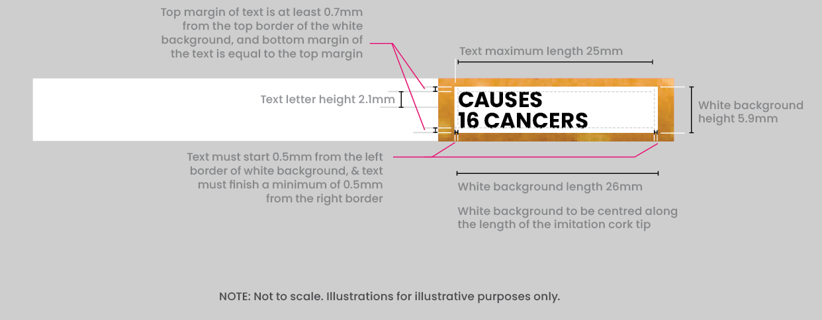

3 Orientation of on‑product health message

(1) Figure 8A.2 shows the orientation of the on‑product health message on the cigarette.

Figure 8A.2: Orientation of on‑product health message



(2) The paper casing of the cigarette would, if it were unrolled, appear as shown in figure 8A.3.

Figure 8A.3: Orientation of on‑product health message—appearance of unrolled paper casing of cigarette

