# **Consultation Paper – Exposure Draft Public Health (Tobacco and Other Products) Amendment (On-Product Health Messages and Other Measures) Regulations 2024**

## **Overview**

The *Public Health (Tobacco and Other Products) Act 2023* (the **Act**)commenced 1 April 2024. The objects of the Act are to: improve public health by discouraging smoking and the use of regulated tobacco items, and encouraging people to give up smoking and to stop using regulated tobacco items; give effect to certain obligations that Australia has as a party to the World Health Organization Framework Convention on Tobacco Control (WHO FCTC); and address public health risks posed by vaping and e-cigarette products.

The Act provides for the implementation of dissuasive measures on tobacco products such as on-product health messages through regulations. The Public Health (Tobacco and Other Products) Regulations 2024 commenced on 1 April 2024 and prescribe requirements for the purposes of the Act.

Following public communications announcing the intention to implement dissuasive measures on individual cigarettes in [November 2022](https://www.health.gov.au/ministers/the-hon-mark-butler-mp/media/ten-years-of-world-leading-reforms-and-reigniting-the-fight-against-tobacco-addiction?language=en) and [December 2023](https://www.health.gov.au/ministers/the-hon-mark-butler-mp/media/laws-begin-a-new-era-of-tobacco-control?language=en), public feedback is now sought on the exposure draft amendment Regulations regarding on‑product health messages. Comments are sought on the provisions and images for the purpose of the on‑product health messages, as outlined in this consultation paper and the following attachment:

* Exposure Draft Public Health (Tobacco and Other Products) Amendment (On‑Product Health Messages and Other Measures) Regulations 2024

The content of the exposure draft amendment Regulations should be considered in conjunction with this paper. Please note that changes may be made to the final Regulations following this consultation process; the contents of the exposure draft amendment Regulations will not necessarily reflect the final Regulations and should not be relied upon.

The Review of Tobacco Control Legislative Framework Impact Analysis (the **Impact Analysis**) provides detailed discussion of the policy objectives and evidence base for on‑product health messages (referred to as ‘on‑product health warnings’, which are one of the features described under ‘Measure 12: Require dissuasive measures on tobacco products’ in the Impact Analysis). The full version of the Impact Analysis is available on the Office of Impact Analysis website here: [Review of Tobacco Control Legislative Framework (Thematic Review) 2023 | The Office of Impact Analysis (pmc.gov.au)](https://oia.pmc.gov.au/published-impact-analyses-and-reports/review-tobacco-control-legislative-framework-thematic-review)

The introduction of on-product health messages is in line with the Guidelines for implementation of Article 11 of the WHO FCTC, which states that parties should consider requiring health warnings and messages to be printed on individual cigarettes.

## **Previous public consultation**

Between 31 May and 14 July 2023, public comment was invited on exposure drafts of the:

* Public Health (Tobacco and Other Products) Bill 2023
* Public Health (Tobacco and Other Products) (Consequential Amendments and Transitional Provisions) Bill 2023
* Public Health (Tobacco and Other Products) Regulations 2023
* Public Health (Tobacco and Other Products) (Consequential Amendments and Transitional Provisions) Regulations 2023.

Following consultation revisions were made to the Bills before consideration by the Parliament and the Act came into effect on 1 April 2024.

From 11 December 2023 to 8 January 2024, supplementary public consultation was invited on the Public Health (Tobacco and Other Products) Regulations 2023 to include changes relating to requirements for health warnings and health promotion inserts.

## **Consultation process**

Public consultation is now open on the requirements for on‑product health messages. Public comment on the exposure draft amendment Regulations and this consultation paper is sought **until 8 November 2024**.

Submissions are invited in response to the specific consultation questions. If you made a submission during the previous consultation processes between May – July 2023, or December 2023 – January 2024, it is not necessary to repeat the content of that submission.

The Department of Health and Aged Care (the **department**) intends to publish submissions received through this consultation process. Direct contact details such as phone numbers and email addresses will be redacted. By providing a submission through this process, you are consenting to having your submission published by the department in full. The department retains the right to leave unpublished any submission, or part thereof, including any that contain offensive or defamatory comments, or which are outside the scope of the consultation.

When making your submission, please indicate if you do not want your submission published or if you would prefer to make an anonymous submission. Submissions which are published on the department’s website can be accessed by the public, including people overseas. Ordinarily, where the department discloses personal information to an overseas recipient, *Australian Privacy Principle* (APP) 8.1 requires the department to take reasonable steps to ensure that the overseas recipients do not breach the APPs. If you consent to the publication of your submission, APP 8.1 will not apply to this disclosure and the department will not be accountable under the *Privacy Act 1988* (Cth) for any subsequent use or disclosure of the submission by an overseas recipient, and you will not be able to seek redress under that Act.

Submissions may be subject to freedom of information requests, or requests from the Parliament, which the department will consider and respond to in line with procedural and legal requirements.

This consultation process is undertaken in accordance with Australia’s obligations under Article 5.3 of the WHO FCTC. Article 5.3 of the WHO FCTC obliges Australia to take steps to protect its tobacco control policy setting and implementation from interference from the tobacco industry and its interests. This also extends to the e-cigarette industry. Consistent with Australia’s obligations under Article 5.3 of the WHO FCTC, consultation with tobacco and e‑cigarette industry and individuals and organisations whose interests may be aligned with the tobacco industry will be limited to what is necessary to enact effective tobacco control measures and will be undertaken in a transparent and accountable manner. Written submissions received from individuals or organisations associated with the tobacco or e‑cigarette industry will be deemed to have a conflict of interest (whether actual or perceived).

## **Exposure draft amendment Regulations - areas now subject to consultation: on‑product health messages**

The Act requires that the appearance and physical features of a tobacco product must comply with any requirements prescribed by the Regulations. Before Regulations are made that prescribe an image or text to appear on, or form part of, a tobacco product, the Commonwealth Chief Medical Officer must have recommended that the image or text be prescribed.

The exposure draft amendment Regulations would require that a cigarette that contains a filter must display an on‑product health message. The on-product health messages are proposed to be provided to manufacturers as a file containing the image of the on-product health message. This will aid accurate printing and ensure consistency of size, font and format. The department will make available, free of charge, electronic files containing the images to apply on‑product health messages for use by tobacco manufacturers.

The proposed on-product health messages and policy approach have been informed by an iterative program of research and market testing, and with input provided by technical experts including in tobacco control, behavioural change and health communication.

Key changes to the Regulations

In relation to on‑product health messages, the following changes are proposed in the exposure draft amendment Regulations:

* The detailed requirements for on‑product health messages would be contained in Chapter 3.
* A series of eight on‑product health messages would be prescribed.
* A prescribed message must be printed on the tipping/filter paper of individual cigarettes that have a filter and duplicated on directly opposite sides of the cigarette.
* Each of the prescribed messages should be included as nearly as possible in equal numbers, with compliance to be assessed over a random sample of four cartons.
* The messages are defined within Schedule 8A as text, to display the content of the messages, but the messages may be set out in a different format in the final Schedule, for example as images.

**Examples of how on-product health messages could appear**

For paper casing covering the filter that is greater than 26mm in length:

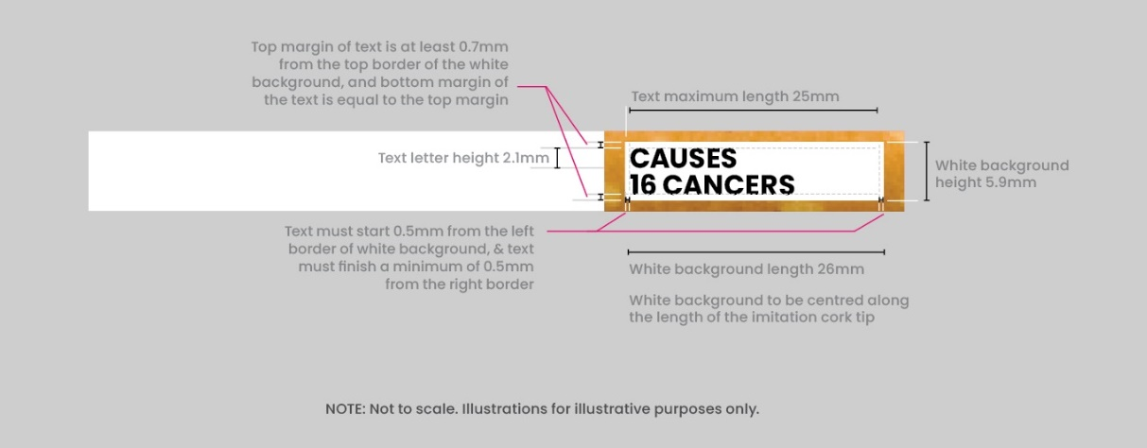

For paper casing covering the filter that is 26mm in length:

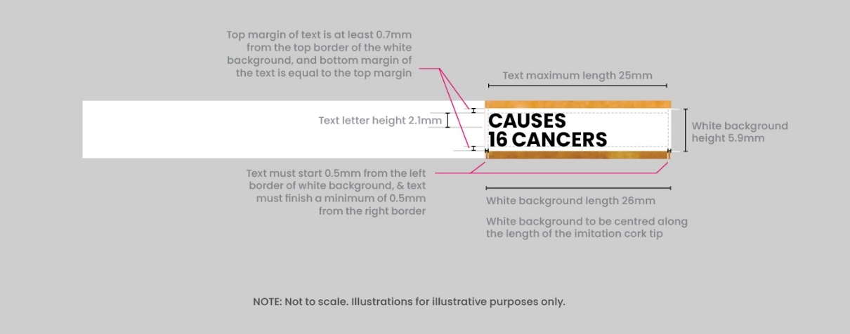

Implementation timeframes

The exposure draft amendment Regulations would prescribe the proposed requirements for on‑product health messages, and a phase-in transition period for manufacturers and retailers to become compliant with the new Regulations. The prescribed on‑product health messages would be permitted to be in use from the date the Regulations commence and must be in use from the end of the proposed transition period (1 July 2025). There will be a transition period for manufacturers to become compliant, and a further 3-month sell‑through period for retailers to sell old stock as set out below.

|  |  |  |  |
| --- | --- | --- | --- |
| **Commencement of Regulations (proposed)** | **Transitional period for manufacturer compliance** | **Sell-through period for retailers  (3 months)** | **On‑product health messages required in retail settings** |
| Late 2024 | Late 2024 –  31 March 2025 | 1 April 2025 –  30 June 2025 | 1 July 2025 |

The Government may in the future consider changes to the on‑product health messages. As prescribed in the Act, before the Governor-General makes Regulations prescribing new on‑product health messages after the first series, the Commonwealth Chief Medical Officer must have recommended that the on‑product health messages be prescribed. Where there is to be a change in on‑product health messages prescribed after the first series, there will be a 6-month minimum period before the new Regulations take effect.

## **5. Consultation questions**

Questions

1. Do you have any comments on the proposed on‑product health messages as a policy measure, including as set out in the exposure draft amendment Regulations?

2. Do you have any feedback relating to compliance with, or implementation of the on‑product health messages as defined within the exposure draft amendment Regulations?