

Proposal for a new residential aged care funding model

**Consultation Paper**

**March 2019**

Contents

Abbreviations 3

Foreword 4

Section 1 – Purpose of this paper 5

Section 2 – How to make a submission 5

Section 3 – Structure of this paper 6

Section 4 – Background 8

Part A – The need for funding reform 8

Part B – The Resource Utilisation and Classification Study 9

Section 5 – Introduction to the AN-ACC 10

Section 6 – The three components of funding under the proposed model 11

Section 7 – How residents would be assessed and classified into classes for the variable payment 14

Section 8 –National Weighted Activity Units (NWAUs): How Do They Work? 16

Section 9 - Other Supplements and Subsidies 19

Section 10 – Implementation and Transition Issues 21

Section 11 – Implications for care delivery and planning 22

Attachment A – Background – the Aged Care Funding Instrument (ACFI) 23

Attachment B – Summary of the RUCS 26

Attachment C – The RUCS Reports 27

Attachment D – The AN-ACC Assessment Tool 29

Attachment E – AHSRI’s consolidated recommendations 33

# Abbreviations

| **Abbreviation** | **Description** |
| --- | --- |
| ACAR | Aged Care Approvals Round |
| ACAT | Aged Care Assessment Team |
| ACFA | Aged Care Financing Authority |
| ACFI | Aged Care Funding Instrument |
| ADL | Activities of Daily Living |
| AHSRI | Australian Health Services Research Institute |
| AN-ACC | Australian National Aged Care Classification |
| BEH | Behaviour |
| CHC | Complex Health Care |
| RUCS | Resource Utilisation and Classification Study |
| RAS | Regional Assessment Service |
| MMM | Modified Monash Model |
| NWAU | National Weighted Activity Unit |
| RCS | Resident Classification Scale |

# Foreword

I am very excited by the results of the University of Wollongong’s Resource Utilisation and Classification Study (RUCS) and the proposed new funding model Australian National Aged Care Classification (AN-ACC).

When I announced this study in August 2017 I noted that it would be the first study of relative costs in the aged care sector since the 1990s. The university has delivered a very comprehensive study, and I would like to personally thank everyone who has been involved, including the research team at the university and each one of the residential aged care facilities and individual residents who agreed to participate. I strongly believe that this research will be a “game changer” for aged care, much as the introduction of activity-based funding was for the hospital system more than twenty years ago.

The AN-ACC is potentially a completely different way of allocating funding for residential aged care, which will remove flaws in the Aged Care Funding Instrument, including the complex and time consuming assessment process and perverse incentives.

I appreciate that we – the aged care sector and the Government – still have a lot of hard work to do before the AN-ACC can be implemented. But there is no doubt in my mind that implementing the AN-ACC would better identify the needs of individuals in residential aged care and better allocate resources to meet their needs.

Earlier this month I announced funding of $4.6 million for a trial of the new assessment tool developed as part of this study. I have been personally committed to the development of the RUCS and I am delighted to be able to present the findings of the University of Wollongong to the sector.

The Hon KEN WYATT AM, MP

Minister for Senior Australians and Aged Care

Minister for Indigenous Health

14 March 2019

# Section 1 – Purpose of this paper

This consultation paper has been developed to seek feedback and views from the residential aged care sector and broader community on the new residential aged care funding model and system that has been developed by the Australian Health Services Research Institute (AHSRI) at the University of Wollongong.

AHSRI has recommended a new model and funding system, referred to as the Australian National – Aged Care Classification (AN-ACC). This follows from completion of its analysis of relative cost drivers in the sector and development of a new tool for assessing resident funding needs as part of its Resource Utilisation and Classification Study (RUCS) which AHSRI undertook throughout the course of 2018.

The Department of Health (the Department) invites submissions from all interested parties on the AHSRI’s recommended funding model and system.

# Section 2 – How to make a submission

Submissions are due by Friday 31 May 2019 and can be provided using the Department of Health’s [Consultation Hub](https://consultations.health.gov.au/) (https://consultations.health.gov.au/).

In addition to the summary of AHSRI’s proposed new model contained in this discussion paper and the particular issues identified in this paper you may also wish to consider the AHSRI’s seven detailed reports from their RUCS study, available at the [department’s website](http://sharepoint.central.health/divisions/RFACD/teams/acfi/Shared%20Documents/BRIEFING%20PAPERS%202019%20LIVE/department's%20website) (https://agedcare.health.gov.au/reform/resource-utilisation-and-classification-study). In particular, Report 6 from AHSRI summarises the findings from the RUCS and the detail of the recommendations.

Your feedback will help inform Government consideration around residential care funding reform and the design elements of a possible new funding model and system.

You are invited to provide feedback on any aspect of the proposed model and recommendations. In particular, this paper seeks your views and feedback on:

* The findings of the RUCS and the structure of the proposed AN-ACC funding model;
* the potential impacts (benefits, costs, risks) of the adoption of the AN-ACC funding model;
* potential flow on effects and linkages with other programs or reforms in aged care; and
* potential implementation and transition considerations associated with the AN-ACC model.

Specific questions are included throughout the discussion paper. These are intended as a guide to stimulate your thinking but do not limit the feedback that you may provide.

# Section 3 – Structure of this paper

The remainder of this consultation paper is structured as follows:

**‘Section 4 – Background’** Outlines the rationale for residential aged care funding reform, and provides a summary of the RUCS.

**‘Section 5 – Introduction to the AN-ACC’** provides an overview of the key design elements of the new assessment and funding model developed as part of the RUCS, which has been termed the AN-ACC.

**‘Section 6 – The three components of funding under the proposed new model’** discusses the AN-ACC in more depth, including an explanation of the fixed payment for shared costs, the variable payment for individual resident costs, and the adjustment payment for entry costs.

**‘Section 7 – How residents would be assessed and classified into classes for the variable payment’** introduces the casemix classification system developed as a part of the RUCS.

**‘Section 8 – Relative weightings given to different facilities for the fixed payment and different resident classes for the variable payment – National Weighted Activity Units (NWAUs)’** introduces the concept of an NWAU and describes the NWAUs recommended by AHSRI, with an example.

**‘Section 9 – Other Supplements and Subsidies’** addresses several key care supplements and considerations in relation to the proposed new funding model.

**‘Section 10 – Implementation and Transition Issues’** discusses options and implications for transition if the new funding model is to be adopted.

**‘Section 11 – Implications for care delivery and planning’** outlines the relationship between new proposed funding model and care delivery.

**‘Section 12 – Other issues’**

**‘Attachment A – Background – the Aged Care Funding Instrument (ACFI)’** explains the current care funding model, which is underpinned by the ACFI.

**‘Attachment B – Summary of the RUCS’** provides a summary of each of the four sub-studies of the RUCS.

**‘Attachment C – Summary of the RUCS Reports’** provides an overview of the contents of the seven reports which address the key elements and results of the RUCS.

**‘Attachment D – The AN-ACC Assessment Tool’** shows the assessment tool developed during the RUCS.

**‘Attachment E – AHSRI’s consolidated recommendations’** is an extract of RUCS Report 6, listing all AHSRI’s recommendations.

# Section 4 – Background

## Part A – The need for funding reform

Australian Government expenditure on residential aged care subsidies and supplements totalled $12.2 billion dollars in 2017/18 of which $11.3 billion dollars were payments made under the Aged Care Funding Instrument (ACFI). The residual amounts represent accommodation support for low means residents and a range of other smaller subsidies and supplements.

The Government has been examining options for a new funding tool and system to replace the ACFI. The arguments for a new funding tool and system were summarised in the independent Aged Care Financing Authority’s 2018 Annual Report which stated:

*“there is a need for a more stable, more contemporary, more efficient and more effective funding tool and system which provides greater financial stability to both the residential aged care sector and the Government*

*ACFA considers the current ACFI tool may also suffer from no longer being contemporary (such as incentivising certain, sometimes outdated, types and modes of care delivery), it could encourage inefficiencies (through providers focusing limited resources on ACFI claiming) and appears to lack stability (with a history of cycles of high growth followed by low or no growth as higher than expected provider claiming leads to Government taking measures to reduce funding growth rates back to estimated levels).*

*ACFA considers that a key element of any reform package should be a tool that accurately and objectively assesses the funding needs of residents.*

*A more efficient Government funding system would allow provider assessment resources to be devoted to assessment for care planning purposes. A more contemporary system would support delivery of the right types of care. A more stable system would provide greater certainty on funding levels for government, providers and investors, establishing a system that encourages investment in the sector to meet future demographic challenges as demand for aged care grows.”*

The Government commissioned two reports to help inform deliberations on what a revised funding model could look like. A report by the University of Wollongong *Alternative Aged Care Assessment, Classification Systems and Funding Models* provided recommendations on options for long term reform of residential care funding arrangements. The follow up Resource Utilisation and Classification Study has led to the proposed model described in this paper.

A report by Applied Aged Care Solutions *Review of the Aged Care Funding Instrument* looked at options for retaining but amending ACFI. After considering these options the Government’s focus has been on the model proposed by the University of Wollongong outlined in this consultation paper. Both of those earlier reports are available on the Department’s website at

[www.agedcare.health.gov.au/reform/residential-aged-care-reform](https://agedcare.health.gov.au/reform/residential-aged-care-reform).

A summary of how the current ACFI model works is at Attachment A.

## Part B – The Resource Utilisation and Classification Study

The Department subsequently commissioned Australian Health Services Research Institute (AHSRI) at the University of Wollongong to undertake the RUCS to identify and measure the drivers of resource/cost utilisation in residential aged care and develop and test a fixed variable funding model. This study was essential to developing a sound empirical evidence base on what drives relative care costs in residential aged care, both at the resident and facility level, to help inform Government consideration of reform options and in the development and design of a new funding model.

The overall aims of the RUCS were to:

* Identify those clinical and need characteristics of aged care residents that influence the cost of care (cost drivers);
* Identify the proportion of care costs that are shared across residents (shared costs) relative to those costs related to an individuals' needs (variable costs);
* Develop a casemix classification based on identified costs drivers that can underpin a funding model that recognises both shared and variable costs; and
* Undertake an initial test of the feasibility of implementing the recommended classification and funding model across the Australian residential aged care sector.

The RUCS is comprised of four studies and seven reports.

The four studies were:

1. Service utilisation and classification development study
2. Fixed and variable cost analysis study
3. Casemix profiling study
4. Reassessment study

The seven reports are:

1. The Australian National Aged Care Classification (AN-ACC)
2. The AN-ACC assessment model
3. Structural and individual costs of residential aged care services
4. Modelling the impact of the AN-ACC
5. AN-ACC: A funding model for the residential aged care sector
6. AN-ACC: Synthesis and consolidated recommendations
7. AN-ACC: Technical appendices

The seven reports can be found on the Department’s website at [www.health.gov.au/reform/resource-utilisation-and-classification-study](https://agedcare.health.gov.au/reform/resource-utilisation-and-classification-study).

A summary of each of the studies is at Attachment B

A summary of each of the seven reports is at Attachment C.

# Section 5 – Introduction to the AN-ACC

The new assessment and funding model developed as part of the RUCS has been termed the Australian National Aged Care Classification (AN-ACC) system. The AN-ACC assessment and funding model is based on six key design elements:

1. Resident assessment for funding to be separate from resident assessment for care planning purposes;
2. Assessment for funding purposes to be undertaken by external assessors capturing the information necessary to assign a resident to a payment class;
3. Assessment related to care planning to be undertaken by the residential aged care facility based on resident needs and underpinned by consumer directed care principles;
4. Provision of a one off adjustment payment for each new resident that recognises additional, but time-limited, resource requirements when someone initially enters residential care;
5. A fixed price per day for the costs of care that are shared equally by all residents. This may vary by location and other factors;
6. A variable price per day for the costs of individualised care for each resident based on their AN-ACC casemix class.

# Section 6 – The three components of funding under the proposed model

There are three components to AHSRI’s proposed funding model:

* 1. a fixed payment for shared costs,
  2. a variable payment for individual resident costs; and
  3. an adjustment payment for entry costs.

Under the AN-ACC the subsidy paid to the provider would consist of a fixed component and a variable component for each resident. Providers would also be paid an adjustment payment on a time-limited basis when a new resident enters the facility.

The staff time data collected in the RUCS indicated that close to 50% of staff time was spent delivering care tailored to the specific needs of the resident, while the remaining 50% was spent delivering shared care across all residents. This supports a payment model that includes a fixed per diem price for the costs of shared care and a variable price per day for the costs of individual resident care.

**Fixed Component**  
The fixed component reflects the costs of shared care for residents and includes costs of care that all residents generally benefit from equally. The fixed cost is the same for all residents in a particular facility.

Separating the funding in this way has two benefits:

1. Fixed care recognises that a large proportion of care costs within a facility are driven not by the individual care needs of the residents but by the care delivered equally to all residents.
2. Fixed care provides stability to the funding model as a large portion of the facility’s funding is fixed regardless of changes in individual resident care needs.

Examples of fixed care include general supervision in common areas and night supervision. These costs are considered ‘fixed’ as they are not affected significantly by changes in individual resident care need.

Aged care homes will receive a per diem base care tariff (for fixed care) for all resident care days within the funding period. This fixed care tariff will vary between certain classes of facilities. For example, it will be higher in very remote facilities and for services catering for the homeless in recognition of their higher fixed costs. Base care tariffs are mutually exclusive and each facility can only qualify for payment under a single tariff (Table 1).

The factors that were found by the RUCS to be associated with an increase in fixed care costs per day were:

* remote and very remote facilities that provide Indigenous care services;
* non-Indigenous remote services that have less than 30 beds;
* non-Indigenous remote services that have less than 30 beds; and
* specialised services to homeless people.

Remoteness here is defined using the Modified Monash Model (MMM), with MMM 6-7 defined as remote and very remote.

**Variable component**

The variablecomponent is the casemix classification portion of the subsidy. Each resident is allocated a class based on their characteristics. This component will be different for different residents in a facility (Figure 1). The classification system is a branching model which enables the factors that drive care cost to be addressed interactively rather than operate in isolation. For example, two residents have cognitive impairment but one is mobile and the other is not. In the current ACFI system, cognition and mobility are each considered separately. In the AN-ACC, they are considered in combination.

The factors found to drive individual care were associated with end of life needs, frailty, functional decline, cognition, behaviour and technical nursing needs. The most costly residents (on a daily basis) are those who either enter the facility specifically for palliative care or are in a class that are not mobile, have lower levels of function, higher risk of pressure sores and other compounding factors such as behavioural issues. The least costly residents are those who are independently mobile without compounding factors. This is discussed further in Section 7.

Figure 1: An illustration of a fixed and variable payment mode for four residents in the same facility. All residents attract the same fixed payment. Resident 1 and resident 3 are allocated to the same class and therefore attract the same variable payment, while the payment for resident 2 is higher reflecting increased care costs for that individual.

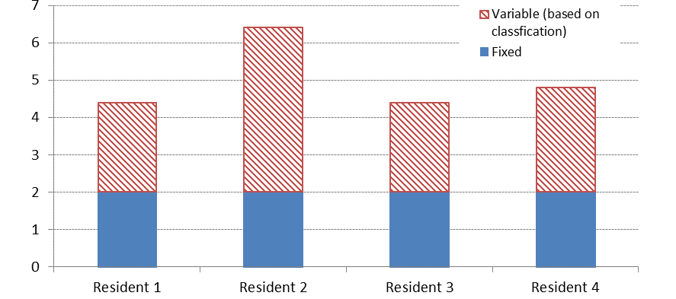

**Adjustment payment**

This payment recognises the additional, but time-limited, resource requirements when someone initially enters care. The time-limited additional costs cover the following activities:

* Time spent getting to know the resident and their family
* Individualised care planning
* Behaviour management
* Health care assessments
* Facilitating health care arising from assessment e.g. pain management
* Developing an advanced care directive in partnership with the resident and their family

This one-off payment relates only to an initial admission into residential aged care. The adjustment payment is not payable if a resident transfers between homes.

**Questions**

1. Are there any risks or benefits of the proposed funding model that have not been identified?

# Section 7 – How residents would be assessed and classified into classes for the variable payment

**The proposed classification system**

Based on a new funding assessment tool purposefully developed as part of the RUCS, a casemix classification termed the Australian National Aged Care Classification (AN-ACC) has been developed.

AN-ACC Version 1.0 comprises 13 classes and explains 50% of the variance in the cost of individual resident care. There is a fivefold variation in cost between the least and most expensive AN-ACC class.

**Figure 2: AN-ACC Version 1.0 casemix classification**

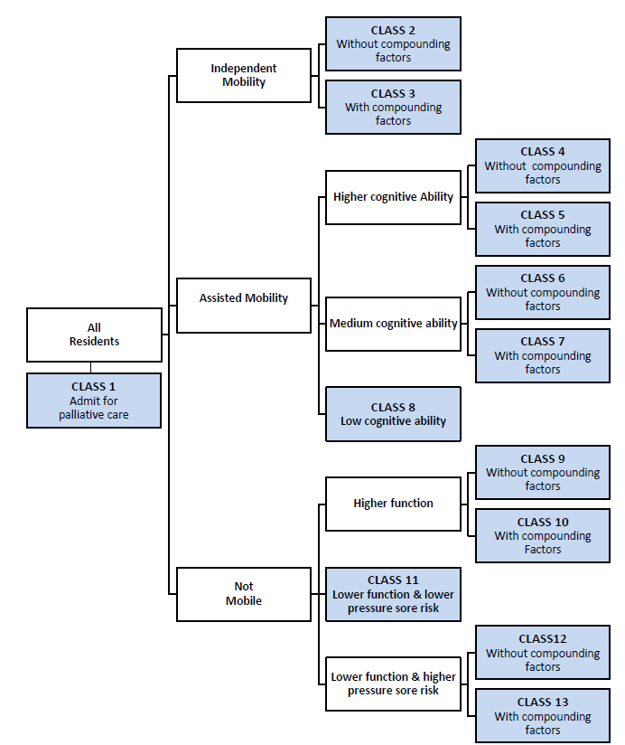

**The proposed classification assessment tool and process**

Under the AN-ACC model, care planning is still undertaken by the facility but the assessment for funding is undertaken by an external and independent assessor.

Residents will be classified into classes using the AN-ACC Assessment Tool (Attachment D) developed during the RUCS by the AHSRI. This assessed the resident using a series of questions and tools to determine the resident’s classification. The tool has been designed to capture the core attributes that drive care costs in residential aged care. It is designed to be robust and concise and is able to be undertaken by an external expert clinician who is not familiar with the resident.

AHSRI have suggested that the assessment should be undertaken within four weeks of entry into care. Given the high degree of professional judgement required to make clinical judgements in a relatively short period of time, assessors will need to have expert clinical skills in aged care assessment, sophisticated professional and organisational capabilities and be provided with comprehensive training and ongoing clinical and operational support to ensure consistency in assessment.

AHSRI have recommended that external assessors should be credentialed registered nurses, occupational therapists or physiotherapists who have experience in aged care and have completed approved assessment training.

The AN-ACC assessment tool is suitable for both the initial assessment and re‑assessment of a resident as needed.

**Re-assessment**

AHSRI identified three grounds for re-assessment:

1. Significant hospitalisation: resident is hospitalised for five or more days or resident has a general anaesthetic and is in hospital for two or more days.
2. Significant change in mobility: a resident’s mobility capacity has changed such that they move between the three mobility branches in the AN-ACC.
3. A standard time period for re-assessment: a facility may request a reassessment after a specified period of time if believed needed.

There is no requirement in the new model for a re-assessment to be requested by a provider. This is designed to provide an explicit incentive for high quality services to focus on restorative care and reablement.

**Questions**

2. Are the proposed resident assessment and classification processes appropriate? If not, why not?

3. Are the proposed reassessment triggers appropriate? If not, why not?

4. Are there other factors that should be considered for inclusion as reassessment triggers?

5. Should the Commonwealth consider the introduction of reassessment charges for services that trigger unnecessary reassessments?

6. Should there be a requirement for reassessment in the proposed funding model?

# Section 8 –National Weighted Activity Units (NWAUs): How Do They Work?

The total funding for each facility is calculated based on the relative costs of providing care (both individual care and shared care) expressed in terms of the National Weighted Activity Unit or NWAU. The NWAU is the ‘currency’ used to express the price weights for each classification category (both fixed and variable). It represents cost relativities between classes and allows a single price to be set across all care activities.

For example if, for the individual resident flexible care payment, Class A has an NWAU of 0.25 and Class B an NWAU of 0.5, then Class B is twice as costly as A and will receive twice the funding.

Government will determine the price for an NWAU of 1. This price is expressed in terms of $ per resident per day. So, in the above example, if the Government set the NWAU of 1 at a price of $1 per day then Class A would receive $0.25c per day and Class B $0.50c per day. If it set the NWAU of 1 at a price of $2 per day then Class A would receive $0.50c per day and Class B $1 per day.

The total weighted care day per resident comprises three components:

1. The total **base care tariff** (fixed component) NWAU: This is the standard daily bed day tariff determined for each different type of facility related to fixed (shared) care costs. This tariff is paid for every resident bed day in the funding period.
2. The total **variable component** NWAU: This is the variable component based on the AN-ACC class for each resident in care. This accounts for the variable care costs for residents with different individual care needs. An AN-ACC NWAU is assigned for each resident bed day based on the resident AN-ACC class. The total AN-ACC NWAU for the facility is the sum of NWAU across all residents for their total days of stay within the funding period.
3. The total **entry adjustment period** NWAU: This is an additional payment set at a standard rate per new resident admitted for the first time during the funding period.

**Total Payment = Price x**

{ Base care tariff (total NWAU) + AN-ACC variable component (total NWAU) + Adjustment payment (NWAU) }

**NWAUs recommended by AHSRI**

The NWAUs recommended by the AHSRI based on the findings from the RUCS are as follows.

Table 1: Base Care Tariffs and AN-ACC classes NWAUs

|  |  |  |
| --- | --- | --- |
| **Base care tariff** | **Facility description** | **Base care tariff NWAU** |
| Tariff 1 | Indigenous, MMM=7 | 1.80 |
| Tariff 2 | Indigenous, MMM=6 | 0.78 |
| Tariff 3 | Non-indigenous, MMM=6-7, < 30 beds | 0.68 |
| Tariff 4 | Non-indigenous, MMM=6-7, 30+ beds | 0.52 |
| Tariff 5 | Specialised homeless | 0.92 |
| Tariff 6 | All other RACFs | 0.49 |
| **AN-ACC class** | **Resident description** | **AN-ACC NWAU** |
| Class 1 | Admit for palliative care | 0.96 |
| Class 2 | Independent without CF | 0.18 |
| Class 3 | Independent with CF | 0.30 |
| Class 4 | Assisted mobility, high cognition, without CF | 0.20 |
| Class 5 | Assisted mobility, high cognition, with CF | 0.36 |
| Class 6 | Assisted mobility, medium cognition, without CF | 0.34 |
| Class 7 | Assisted mobility, medium cognition, with CF | 0.47 |
| Class 8 | Assisted mobility, low cognition | 0.51 |
| Class 9 | Not mobile, higher function, without CF | 0.52 |
| Class 10 | Not mobile, higher function, with CF | 0.83 |
| Class 11 | Not mobile, lower function, lower pressure sore risk | 0.80 |
| Class 12 | Not mobile, lower function, higher pressure sore risk, without CF | 0.78 |
| Class 13 | Not mobile, lower function, higher pressure sore risk, with CF | 0.96 |
| **Other payments** | **Payment description** | **One-off NWAU** |
| Adjustment payment | Payment on entry into residential aged care | 5.28 |

CF = Compounding factor NWAU = National Weighted Activity Unit

**Example**

An Indigenous facility in MMM7 with 20 operational beds that was caring for ten residents assessed as being in Class 7 and five residents assessed as being in Class 10, would be paid as follows if the NWAU was set at $100 per day:

* Fixed component – 1.8 NWAU x 20 approved beds* x $100 per day = $3,600 per day; plus
* Variable component – 0.47 NWAU x 10 residents in Class 7 x $100 = $470 per day; plus
* Variable component – 0.83 NWAU x 5 residents in Class 10 x $100 = $415 per day; plus
* One off adjustment payment of 5.28 NWAU x $100 = $528 for each new resident that has entered care for the first time.

* Note that AHSRI proposes that the base care tariffs be paid **per occupied bed day** for non-remote facilities (Tariffs 5 and 6). Remote facilities (Tariffs 1 to 4) would be paid for each **approved bed day**. In this example the facility attracts base care tariff 1, and hence is funded on the number of approved bed days (20) not the number of occupied bed days (15).

**Annual costing study to inform price**

Under the proposed new funding model, the Government makes an annual determination about the price of an NWAU of 1.00. This price is standard across the fixed, variable and one-off adjustment payment. All prices in the funding model are then set relative to this annually determined price.

In its report AHSRI notes how in the national hospital funding model, this price is termed the National Efficient Price (NEP) and an annual costing study is undertaken which is used to inform the setting of the price in the following year.  They recommend a similar approach apply in residential aged care to help inform the setting of the price for an NWAU of 1.00.  The Department or the Independent Hospital Pricing Authority (IHPA) could be tasked with undertaking or commissioning a national residential aged care costing study each year to help inform the price for the following year.

**Questions**

7. What are your views on an annual costing study to inform price?

# Section 9 - Other Supplements and Subsidies

The cost of care for people living in residential aged care was the primary focus of RUCS, broadly aiming to fund the same care services as ACFI.

However, there are currently a range of other subsidies and supplements that are payable to residential care providers and how they interact with and are affected by the proposed new AN-ACC model needs to be considered.

**Viability Supplement**

The viability supplement is currently paid to eligible services in rural and remote areas and to homeless and indigenous providers. It is paid in general recognition of higher costs, which may apply in respect of both delivery of care as well as delivery of other ‘hotel type’ services, and recognises that ACFI does not specifically recognise these costs.

To the extent there are higher care costs these should now be reflected in the higher fixed payment that would apply under AN-ACC to certain remote and homeless services and hence, to that extent, that component of the Viability Supplement would no longer be needed. However, the AN-ACC model as proposed does not specifically adjust for higher ‘hotel type’ costs that might also apply to facilities currently receiving the Viability Supplement. The model proposed by AHSRI would not make any additional payment to small facilities in MMM 4 and 5 locations who may currently receive some viability supplement. Options to address this could include building in some additional allowance for these costs into the AN-ACC model or maintaining in some form a payment similar to the current viability supplement (but adjusted in recognition that the higher care costs would now already be factored into the AN-ACC model).

The Department has commissioned an additional study on the costs of facilities in MMM regions 3 to 5, to report by 30 June 2019, which will assist in developing options for the viability supplement.

There are also currently a number of grand-parented versions of the Viability Supplement. There would be benefit in moving to one new model in the future.

**Homeless Supplement**

The AN-ACC model proposes a higher fixed payment for homeless services. In light of this AHSRI proposes the existing homeless supplement would be discontinued. Homeless providers also receive the Viability Supplement. To the extent the new model provides sufficient adjustment for homeless providers the need for an additional viability supplement component could also be discontinued. This is a matter that would require careful consideration to ensure additional costs and challenges these providers face are fully addressed.

**Resident Classification System (RCS) payments**

Some residents are still paid under the precursor to ACFI, the RCS. These payments would be transitioned out under AHSRI’s proposal.

**Accommodation supplements**

Accommodation costs were not part of the RUCS study. No changes to accommodation supplements are proposed.

**Other subsidies and supplements**

AHSRI recommends that the daily residential respite subsidy, oxygen supplement, enteral feeding supplement and veterans supplement be the subject of supplementary studies similar to RUCS with current recipients grandfathered until the results of such studies are available.

**Questions**

8. What are the risks and benefits of rolling viability supplement into the fixed payment NWAUs?

9. What are the risks and benefits of rolling homeless supplement into the fixed payment NWAUs?

# Section 10 – Implementation and Transition Issues

**Transition options for existing residents**

AHSRI recommends a transition strategy whereby the ACFI and AN-ACC run concurrently for two years after AN-ACC is implemented.

All new residents and residents requiring re-assessment would be assessed using the AN-ACC assessment tool and funded using the new model. ACFI payment rates would be frozen for existing residents for the two years during transition.

An alternative option to AHSRI’s proposal would be for all residents, new and existing, to switch to the new AN-ACC model from a set date. Under this option all existing residents would be assessed under the AN-ACC over a set period leading up to the commencement date. All residents would then be under the AN-ACC system from that date and ACFI and any associated ACFI processes would cease immediately.

**Proposed stop-loss threshold during transition**

AHSRI has noted that the new AN-ACC model would involve some redistribution of funding between providers as a result of the new classification system. A stop-loss arrangement has been proposed by AHSRI whereby if the impact of the shift to the AN-ACC was a more than 5% reduction in a home’s funding then the Government would make a payment to the home to limit the reduction to 5%. This would apply over a 2 year period. At least 25% of residents in a facility need to have transitioned to AN-ACC for the stop-loss to be applied.

**Other implementation considerations and timing**

Implementation of the model would require legislative change and development of new or revised IT systems for Government and providers. The new external workforce will need to be trained. Providers would no longer need to devote resources to undertaking and administration of ACFI assessments and associated tasks, freeing up resources for use in care delivery.

To test the impacts and processes the Government has announced a trial to commence in the second half of 2019 of AN-ACC.

No date has been set for when AN-ACC may be implemented but views of the sector are sought on this issue.

10. Which transition option do you prefer? Why?

11. Are there any other approaches that should be considered?

# Section 11 – Implications for care delivery and planning

The AN-ACC classification is a core building block to better measure, resource and report on the inputs, outputs and outcomes of the aged care system. Better data based on objective measures of the needs of residents is essential to describe and to predict the changing needs and costs of the aged care sector into the future.

The system builds in explicit incentives for the quality of care. There is no requirement for residents' care needs to be reassessed, meaning that providers who invest to improve the capacities of their residents will continue to be paid at the initial, higher funding level.

Recognising that facilities may currently be using the ACFI as a quasi-care planning tool, AHSRI recommends that a best practice needs identification and care planning assessment tool be developed for use by residential facilities. They also propose that each resident undergo a care planning assessment at least annually with outcomes discussed with residents and carers.

The AN-ACC classification groups residents with similar care needs together into thirteen distinct classes. The homogeneity of individuals within these classes will allow the development of meaningful and reliable comparisons of care outcomes between facilities, and will provide indicators of both high quality and low quality care. For example, measures of hospitalisation, falls, pressure sores and mortality will be able to be adjusted for the profile of residents and directly compared between facilities. Over time, a clear picture of the normal journey of residents through the residential aged care system will emerge and research into divergences from the standard pathway could identify beneficial care practices that improve resident outcomes as well as flagging potential quality concerns.

12. What are the implications of ceasing ACFI assessments in relation to care planning activities?

13. Do you support the development of a best practice needs identification and care planning assessment tool for use by residential facilities?

14. Do you support a requirement for care planning assessments to be undertaken at least once a year for all residents, with outcomes discussed with residents and carers?

# Attachment A – Background – the Aged Care Funding Instrument (ACFI)

The ACFI assesses the relative care needs of residents and is the mechanism for allocating the Government subsidy to aged care providers for delivering care to residents. The ACFI replaced the former Resident Classification Scale on 20 March 2008.

The instrument consists of 12 care needs questions, some of which have specified assessment tools The questions are rated by the aged care home on a scale of A, B, C, or D then used to determine an individual’s ‘ACFI rating’ across three funding categories or domains: Activities of Daily Living (ADL), Behaviour (BEH) and Complex Health Care (CHC). Funding in each of these domains is based on the resident’s ACFI rating and is provided at High, Medium, Low or Nil. The total daily subsidy rate paid for the care component of each resident is the sum of the three daily subsidies, with the maximum daily rate currently set at $216.59. Table 2 below shows the daily ACFI subsidy rates based on a resident’s score or rating in each funding domain from 20 September 2018.

**Table 2: Daily ACFI subsidy rates from 20 September 2018**

| Level | Activities of Daily Living (ADL) | Behaviour (BEH) | Complex Health Care (CHC) |
| --- | --- | --- | --- |
| Nil | $0.00 | $0.00 | $0.00 |
| Low | $37.16 | $8.49 | $16.48 |
| Medium | $80.92 | $17.60 | $46.95 |
| High | $112.10 | $36.70 | $67.79 |

The ADL questions are focused on nutrition, mobility, personal hygiene, toileting and continence. The BEH questions are focused on cognitive skills, wandering, verbal behaviour, physical behaviour and depression. CHC questions are on medication and complex health, with complex health care captured through 18 sub questions.

Figure 3 below shows the interaction between the ACFI and the current residential aged care funding model

**Figure 3: Interaction of the ACFI and the funding model**

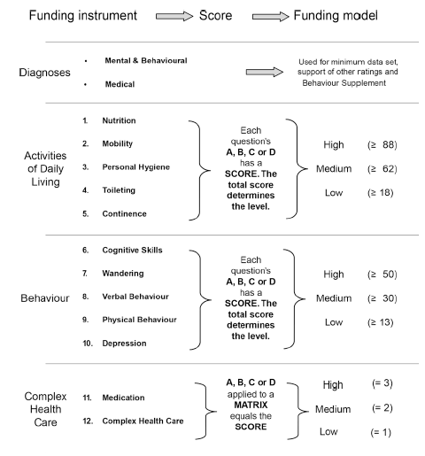

Residential care subsidy is paid monthly and is calculated by adding the amounts due for each resident for each day of the month. A provider’s residential subsidy amount for the claim period (month) is calculated as:

1. the basic subsidy amount (Aged Care Funding Instrument (ACFI)), for each eligible permanent resident based on their classification under the ACFI. The amount payable for the ACFI depends on the ratings determined for each ACFI question claimed by the approved provider;
2. **plus** any primary supplements for each eligible care recipient (oxygen supplement, enteral feeding supplement);
3. **less** any reductions in subsidy (means testing, compensation recovery and adjusted subsidy reduction for state government homes);
4. **plus** any other supplements for each eligible care recipient (accommodation supplement, hardship supplement, viability supplement, veterans’ supplement, homeless supplement).

Assessments for ACFI are currently undertaken by a residential aged care provider after the seventh day of continuous care to allow a settling in period for the resident prior to assessing the care and funding needs of the resident.

The Department has an ACFI Review Program which regulates ACFI claims made by approved providers under the *Aged Care Act 1997*, Principles and the ACFI User Guide. Reviews are undertaken by review officers who may upgrade, downgrade or validate a claim. Facilities are selected for ACFI reviews based on their review history and claiming patterns.

# Attachment B – Summary of the RUCS

The RUCS comprised four separate but closely related studies. Each study included separate data collection and analysis elements that have been synthesised to produce a classification and associated funding model that is suitable for implementation across the Australian residential aged care sector.

***Study One – Service utilisation and classification development study***

Study One involved a prospective and comprehensive collection of resident assessment, service utilisation and financial data which were analysed to develop a casemix classification. Study One involved 30 facilities clustered in three geographic regions in Queensland, New South Wales and Victoria. Study One was completed between October 2017 and October 2018.

***Study Two – Fixed and variable cost analysis study***

Study Two involved a larger nationally representative sample of 110 facilities. The purpose of this study was to understand differences in cost drivers between different types of facilities (including facility size and location) as well as differences that may result from seasonal effects. This analysis informed the design of the funding model. Study Two examined facility, rather than resident, level costs. Study Two was completed between November 2017 and October 2018.

***Study Three – Casemix profiling study***

Study Three involved the collection of variables included in the classification from an additional nationally representative sample of 69 facilities. In combination with the data from Study One, the primary purpose of Study Three was to develop a national casemix profile of residents in aged care in Australia. Study Three was completed between September 2018 and December 2018.

***Study Four – Reassessment study***

Study Four was added to the RUCS work program in mid-2018 in recognition of value that could be added by collecting additional information about the rate and extent of change in residents’ care needs over time. Study Four involved conducting re-assessments of approximately half of the residents assessed as part of Study One four to six months after their initial assessment. Study Four was completed between August 2018 and December 2018.

# Attachment C – The RUCS Reports

AHSRI have produced a suite of seven reports on the key elements of the RUCS

**Report 1: The Australian National Aged Care Classification (AN-ACC)**

Report 1 covers the design and conduct of the study undertaken to develop the Australian National Aged Care Classification (AN-ACC) Version 1.0 (Study One). It covers the design and use of the AN-ACC assessment tool and the resource utilisation study undertaken to develop AN-ACC Version 1.0, including the preparation and analysis of the data collection. It discusses the results, the classification development process and key outcomes including the statistical analysis and clinical validation.

**Report 2: The AN-ACC assessment model**

Report 2 presents detailed findings relating to the external assessment tool and assessment process (informed by Studies One, Three and Four). This includes the development of the assessment tool using expert clinical panels and a summary of feedback from assessors regarding the use of the tool and the suitability of individual instruments. The skills and competencies required for the assessment workforce and other implications for implementation of the external assessment model are considered as well as triggers and protocols for reassessment.

**Report 3: Structural and individual costs of residential aged care services in Australia**

Report 3 presents the analysis and findings of Study Two which identified the proportions of total care costs that are fixed (including shared care) and variable (relating to individualised resident care). The analysis focused on the differences in fixed costs between different types of facilities, characterised by ownership, size, remoteness and service specialisation. It includes an analysis of the drivers of fixed care costs.

**Report 4: Modelling the impact of the AN-ACC in Australia**

Report 4 presents an analysis of modelling the introduction of the AN-ACC across Australia. This is based on the findings of Study Three. The sampling and assessment data collection process and the casemix of residents in aged care across Australia are described. The focus of this report is on modelling the introduction of the AN-ACC to replace the ACFI.

**Report 5: AN-ACC: A funding model for the residential aged care sector**

Report 5 presents the design of a new funding model based on the AN-ACC. It includes a consideration of other payment issues such as existing payment supplements, a discussion of incentives in funding model design and key issues in implementing the new model.

**Report 6: AN-ACC: A national classification and funding model for residential aged care: synthesis and consolidated recommendations**

This report syntheses and consolidates the findings presented in other reports and provides a consolidated set of recommendations.

**Report 7: AN-ACC Technical appendices**

This report is a series of technical appendices that contain detailed data for reference purposes.

# Attachment D – The AN-ACC Assessment Tool

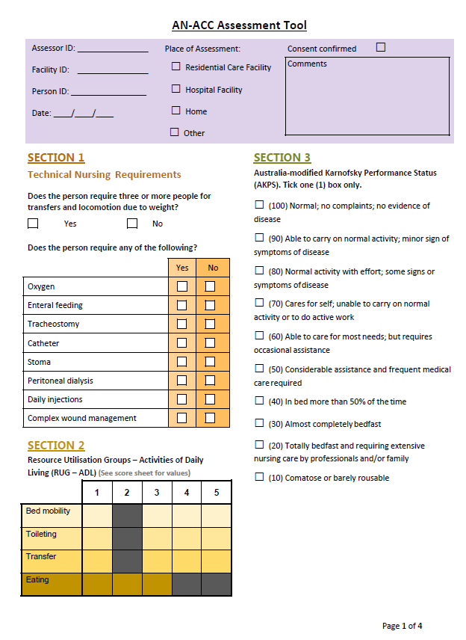

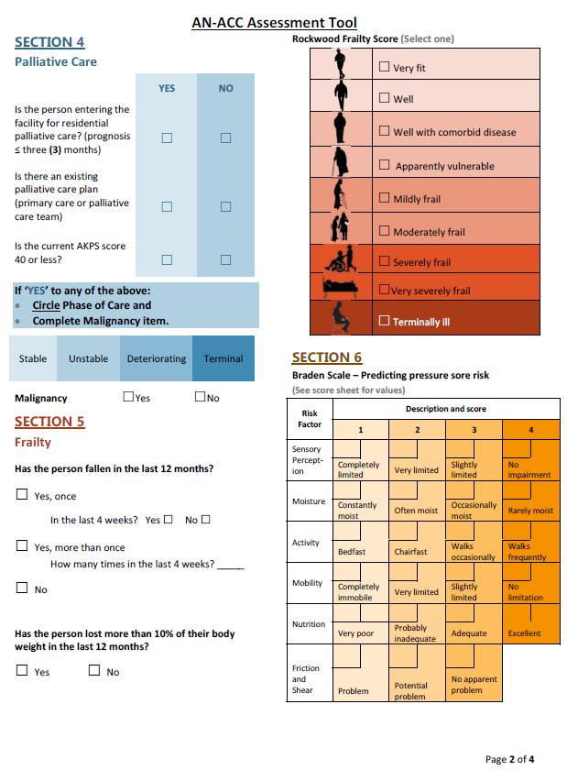 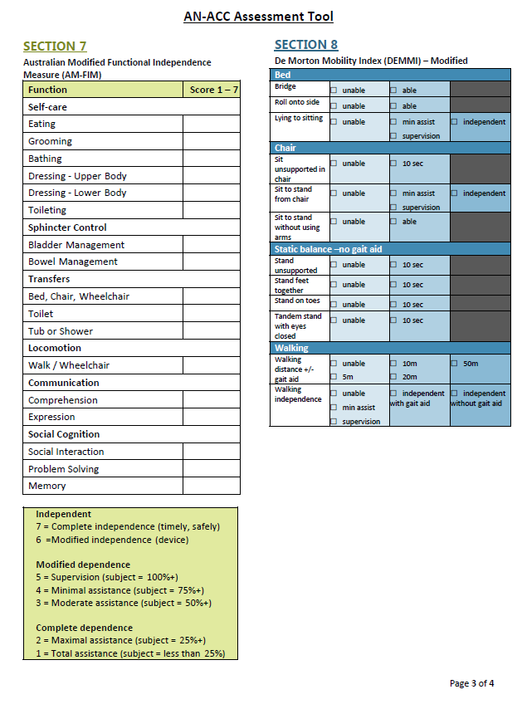 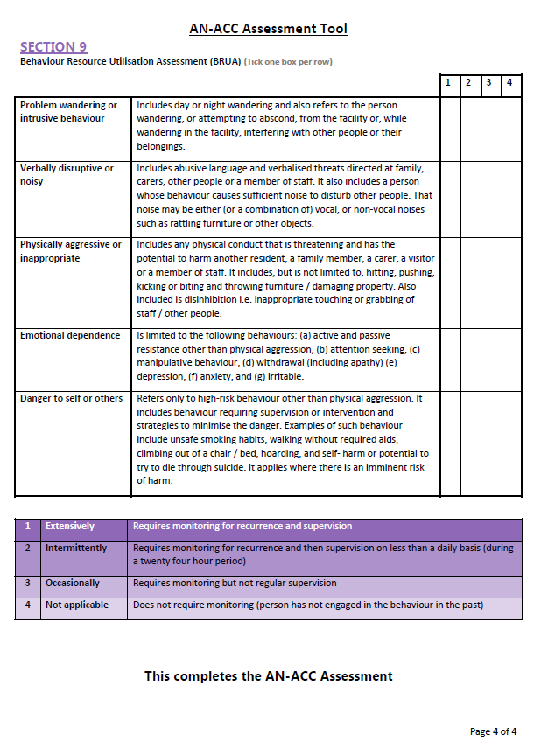

# Attachment E – AHSRI’s consolidated recommendations

**Recommendation 1**

That the Australian National Aged Care Classification (AN-ACC) Version 1.0 be adopted as the national standard classification for residential aged care.

**Recommendation 2**

That the Australian National Aged Care Classification (AN-ACC) Version 1.0 Assessment Tool be adopted as the national standard funding assessment for residential aged care.

**Recommendation 3**

That all new residents be assessed by an independent assessor using the AN-ACC Assessment Tool within four weeks of entering residential aged care.

**Recommendation 4**

That residents requiring reassessment be assessed by an independent assessor using the AN-ACC Assessment Tool.

**Recommendation 5**

That aggregate de-identified data captured in the AN-ACC assessment be released in the form of an annual public report on the needs of residents in the residential aged care sector.

**Recommendation 6**

That the new AN-ACC funding model allow for reassessment based on significantly increased needs as indicated by (1) a significant hospitalisation (2) a significant change in mobility and/or (3) a standard time period; twelve months for Classes 2 to 8 (those classes with lower mortality rate) and six months for Classes 9 to 12 (classes for people who are not mobile and are expected to deteriorate at a higher rate).

**Recommendation 7**

That the Commonwealth consider the introduction of reassessment charges for any home that routinely triggers unnecessary reassessments.

**Recommendation 8**

There be no requirement for reassessment in the AN-ACC funding model

**Recommendation 9**

That a best practice needs identification and care planning assessment tool be developed for use by residential aged care facilities.

**Recommendation 10**

That, as a condition of subsidy, each resident undergo a care planning assessment at least annually and that the outcomes of this assessment be discussed with residents and carers and be used as the basis of an annual care plan.

**Recommendation 11**

That the subsidies payable to homes for the care of residents consist of three components (base care tariff, AN-ACC payment and adjustment payment), each of which is expressed for funding purposes as a National Weighted Activity Unit (NWAU).

**Recommendation 12**

That there be a specified table of base care tariffs reflecting the structural costs of delivering care in different types of facilities.

**Recommendation 13**

That, in residential care facilities in remote areas (MMM 6 or MMM 7), the base tariff be based on approved beds (capacity) with all other base tariffs being based on occupancy.

**Recommendation 14**

That, in addition to the base tariff, homes receive a daily subsidy for each resident based on their AN-ACC class.

**Recommendation 15**

That the tariffs, classes and NWAUs set out in Report 6 be adopted in the first version of the AN-ACC funding model for residential aged care.

**Recommendation 16**

That residential aged care facilities not be advised of the resident’s exact AN-ACC class until after the person is in care.

**Recommendation 17**

That the default payment class at entry be Class 2. Payments are retrospectively adjusted to the date of entry once the assessment is undertaken.

**Recommendation 18**

That the one-off adjustment payment be set at 5.28 NWAUs.

**Recommendation 19**

That the Commonwealth, working through the Department of Health and the Aged Care Quality and Safety Commission, build strong accountability into the system to ensure that the adjustment payment be used for the intended purpose, not added to the bottom line and not contracted out to third party providers.

**Recommendation 20**

That existing Commonwealth subsidies be addressed in three different ways:

1. The homeless supplement and the adjusted subsidy reduction be discontinued once the AN-ACC model is introduced.

2. RCS payments for grandparented residents be progressively phased out with all current RCS recipients to transition to the AN-ACC within two years.

3. The daily residential respite subsidy, the oxygen supplement, the enteral feeding supplement and the veterans supplement be the subject of supplementary RUCS studies with current recipients being grandfathered until the results of the supplementary study are available.

**Recommendation 21**

That the Commonwealth develop a national transition strategy with progressive implementation of the AN-ACC over two years.

**Recommendation 22**

That the Commonwealth adopt a stop-loss policy for any home that would experience a significant funding decrease under the AN-ACC model with an initial stop-loss threshold of 5% and transition payments payable for up to two years from the date of transition.

**Recommendation 23**

That a national implementation plan with indicative time lines, costs, consultation strategy and communication plan be developed by the Department of Health.

**Recommendation 24**

That the Commonwealth undertake an annual residential aged care costing study and, informed by that, determine the dollar value of an NWAU each financial year.

**Recommendation 25**

That, in the context of broader reform proposed for aged care assessment, the Commonwealth adopt a national networked external assessment model for the AN-ACC funding assessment.

**Recommendation 26**

Irrespective of the broader organisational aspects, external assessment be undertaken by credentialed registered nurses, occupational therapists and physiotherapists who have experience in aged care, complete approved AN-ACC assessment training and comply with continuing professional development requirements.

**Recommendation 27**

That the Commonwealth develop an Information Technology strategy for the progressive implementation of the AN-ACC funding model.

**Recommendation 28**

That the Commonwealth work with peak bodies to develop and implement a change management strategy.

**Recommendation 29**

That Government commit to an ongoing aged care research and development agenda that builds on the work of the RUCS and that includes assessment, classification, costing and outcome studies.

**Recommendation 30**

That a study equivalent to RUCS be undertaken in the community aged care sector with a view to expanding AN-ACC so that it includes aged care delivered in all settings.