**Online public survey to inform the development of the next National Oral Health Plan (2025-2034)**

Contents

Purpose and scope of this paper 1

Draft framework for consultation 4

The Vision: Better oral health 5

The Principles explained… 5

Focus areas – 7 focus areas set out objectives of the plan 5

Outcomes for 2034 6

How will we achieve the outcomes for 2034? 6

Focus Area 1: Reduce Australia’s oral disease burden 6

Focus Area 2: Improve the effectiveness of oral health prevention and promotion 7

Focus Area 3: Improve health outcomes and reduce the impact of poor oral health for Aboriginal and Torres Strait Islander people 8

Focus Area 4: Improve equity of oral health access 8

Focus Area 5: Align and integrate oral health across the health system 9

Focus area 6: Support a sustainable and skilled oral health workforce 10

Focus area 7: Improve oral health research, and the collection, reporting and use of oral health data 10

# Purpose and scope of this paper

This paper describes a draft framework that will form the building blocks for a new National Oral health Plan (2025-2034). This framework is based on consultations with a diverse range of stakeholders and consumers, and examination of the existing National Oral Health Plan (2015-2024) and related strategies.

The aim of this public consultation is to gather your views on the draft framework, to inform the development of the new Plan. We value your feedback on this framework.

**What is this consultation for?** The federal, state and territory government Health Ministers have agreed that a new national plan should be developed for oral health, for the period 2025-2034. We want your feedback on the draft framework for the new plan, to help us get the new Plan right.

**Do we have a national oral health plan?** Yes, the current national oral health plan can be read here: [Australia's National oral Health Plan 2015-2024](http://www.health.gov.au/resources/publications/healthy-mouths-healthy-lives-australias-national-oral-health-plan-2015-2024?language=en)

**Why do we need a new plan?** Although most oral disease is preventable, many Australians continue to have poor oral health outcomes.

In 2021 and 2022, Australia entered into two international agreements relevant to national oral health planning:

* [World Health Organization Global Strategy and Action Plan on Oral Health](https://www.who.int/publications/i/item/9789240090538)
* [United Nations Minamata Convention on Mercury](https://minamataconvention.org/en/documents/minamata-convention-mercury-text-and-annexes)

**What is in the survey?** The survey asks a series of questions including:

* Some questions about you – this will guide the questions you are asked later and help us understand your answers.
* Your views on oral health in Australia - strengths, weaknesses and changes you would like.
* Your views on the vision statement and principles that underpin the framework.
* Your views on each of the 7 focus areas and their outcomes.

**How has the draft framework for the new plan been developed?** All governments are partners in developing the new plan. The Australian Government Department of Health, Disability and Ageing is leading consultations.

The Plan is being developed in two phases:

* Phase 1 consulted key stakeholders, as well as an examination of the current National Oral Health Plan, to develop a framework for the Plan.
* Phase 2 will result in a fully developed Plan, incorporating feedback from this consultation process.

The Plan is being developed using feedback and guidance from a range of sources, including:

**Focus groups with Aboriginal and Torres Strait Islander consumers and oral health providers** about what’s important for First Nations oral health and what should be in the Plan. These consultations are underway, conducted by an independent facilitator, First Nations Health Consulting.

**Targeted consultations with a diverse range of stakeholders** including:

* Peak bodies for dental practitioners (dentists, dental hygienists, dental therapists, oral health therapists, and dental prosthetists), dental assistants and dental technicians.
* Special needs dentistry workforce.
* First Nations oral health workforce and First Nations health organisations.
* The dental manufacturing industry.
* Dental and oral health education, training and research.
* Health care consumers.
* Regulatory and accreditation bodies.
* General practice.
* Rural and remote Australia oral health stakeholders.

**Advice from the Governance Group** overseeing the Plan’s development. Health Ministers set up a Governance Group to oversee and direct the Plan’s development. The Governance Group includes officials from the Australian Government Department of Health, Disability and Ageing, state and territory government health departments, and the Australian Institute of Health and Welfare.

**Analysis of relevant strategies, action plans and framewo**rks to ensure the Plan aligns with and builds on action in oral health. This includes Australia’s international oral health commitments through the [World Health Organization Global Strategy and Action Plan on Oral Health](https://www.who.int/publications/i/item/9789240090538) and the [United Nations Minamata Convention on Mercury](https://minamataconvention.org/en/documents/minamata-convention-mercury-text-and-annexes), examples at state and national level in Australia, as well as at the local level.

# Draft framework for consultation

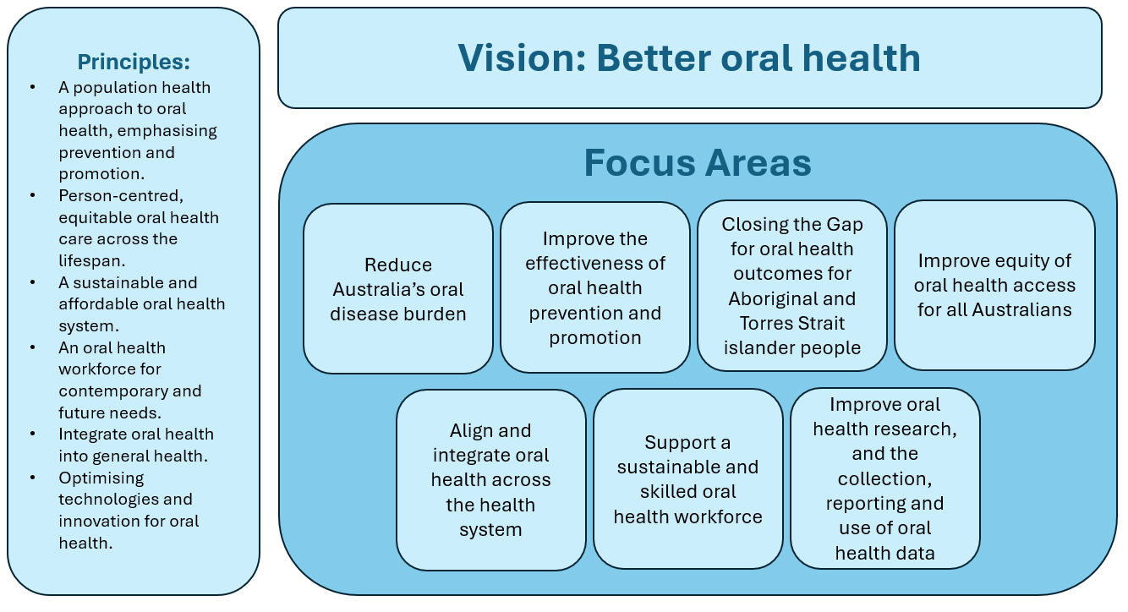

# The Vision: Better oral health

Looking into the future, the new National Oral Health Plan will describe critical outcomes to improve oral health. The draft vision, “Better oral health”, includes all aspects of oral health.

The draft vision will be realised through the principles and focus areas described below.

# The Principles explained…

The principles below are the overarching aims for the plan, and provide the foundations for the plan’s focus areas and outcomes. Each principle is relevant to the whole plan.

* **A population health approach to oral health, emphasising prevention and promotion**. A population health approach focuses on improving the effectiveness of oral health prevention and promotion within the socio-economic and cultural determinants of health.
* **Person-centred, equitable oral health care across the lifespan**. Oral health needs to be considered part of a holistic, person-centred approach to healthcare.
* **A sustainable and affordable oral health system**. The oral health sector is supported to provide sustainable and cost-effective oral health care.
* **An oral health workforce for contemporary and future needs**. Workforce models should be responsive to oral health needs.
* **Integrate oral health into general health**. Oral health is part of overall health and should be integrated into the general health system.
* **Optimising technologies and innovation for oral health**. Technologies and innovation can be used strategically for oral health at different levels, including for improving oral health literacy, service delivery and data collection.

# Focus areas – 7 focus areas set out objectives of the plan

4 goal-focused focus areas:

* Reduce Australia’s oral disease burden.
* Improve the effectiveness of oral health prevention and promotion.
* Closing the Gap for oral health outcomes for Aboriginal and Torres Strait Islander people.
* Improve equity of oral health access for all Australians.

Supported by 3 enabling focus areas:

* Align and integrate oral health across the health system.
* Support a sustainable and skilled oral health workforce.
* Improve oral health research, and the collection, reporting and use of oral health data.

Each focus area has key outcomes for Australia to aim for during 2025-2034, described below.

# Outcomes for 2034

For each of the 7 focus areas set out in the framework, outcomes are set out below. The survey will ask your opinion on these and any suggestions you may have for improvement.

We heard that fewer, better targeted strategies are needed for 2025-2034. We heard the new Plan should align with contemporary needs.

## How will we achieve the outcomes for 2034?

We heard that the new plan should give local communities and governments the freedom to adapt it to their population needs and monitor progress over time. Example actions may be useful, noting there can be many different ways to achieve outcomes. A monitoring and evaluation framework will be developed to enable evaluation of the plan.

## Focus Area 1: Reduce Australia’s oral disease burden

Many people in Australia have poor oral health, including gum disease, decayed teeth and other conditions.

|  |  |
| --- | --- |
| **2034 outcomes** | |
| 1.1 Reduced prevalence of oral diseases. | Our examination of the current Plan and its key performance indicators showed the importance of an outcome devoted to reducing the prevalence of the main oral diseases in Australia. |
| 1.2 Potentially preventable hospitalisations for oral conditions are reduced. | We heard that there are a high number of people in hospital for oral conditions, where going to the hospital could have been avoided if the person’s condition had been managed better, earlier. |

## Focus Area 2: Improve the effectiveness of oral health prevention and promotion

Oral health prevention and promotion can reduce the risk of oral disease. This in turn reduces the need for costly treatment. The outcomes below were identified by stakeholders as critical goals for 2025-2034.

|  |  |
| --- | --- |
| **2034 outcomes** | |
| 2.1 Healthy behaviours that improve oral health outcomes are promoted. | We heard that most oral diseases and conditions are preventable and can have modifiable risk factors. These include tobacco use, alcohol consumption, and nutrition. Mouth and tooth injury may be reduced through modifiable behaviours such as wearing mouthguards for contact sports.  Human papillomavirus (HPV) vaccination and sunscreen use may help reduce the risk of oral cancers. |
| 2.2 Extend oral health promoting environments in key settings. | We heard there is a need for settings outside oral health providers to promote oral health. For example: within early learning and education settings, within general practice, within community pharmacy and the community sector. |
| 2.3 Improved oral health literacy. | We heard that there are low levels of consumer understanding of oral health and the connection between a healthy mouth and a healthy body. |
| 2.4 Access to fluoridated water is increased. | Community water fluoridation is a safe, cost-effective and equitable initiative to help prevent tooth decay. |
| 2.5 Fluoride and fluoride programs are promoted. | We heard that fluoride varnish, silver diamine fluoride, and fluoride toothpaste can improve oral health, in addition to community water fluoridation. |
| 2.6 Extend policies and practices that reduce intake of sugar. | We heard that too many people consume more than the recommended amount of sugar.  Sugar attracts bacteria that damage teeth. This can cause tooth decay.  This includes sugar added to foods by manufacturers, cooks, or consumers, as well as sugars naturally present in honey, syrups and fruit juices and fruit juice concentrates. |

## Focus Area 3: Improve health outcomes and reduce the impact of poor oral health for Aboriginal and Torres Strait Islander people

Text from the current (2015-2024) National Oral Health Plan has been included. Content for this focus area will be informed by First Nations engagement currently underway.

|  |
| --- |
| **Key strategies (**2015-2024 National Oral Health Plan) |
| 1. Increase community engagement in the planning and delivery of oral health services. |
| 2. Promote the incorporation of cultural competency across training, education and assessment, clinical management protocols and guidelines. |
| 3. Develop integrated models of care that incorporate oral health education, prevention and screening with other primary care services. |
| 4. Increase the representation and engagement of Aboriginal and Torres Strait Islander people in the oral health workforce. |
| 5. Expand existing primary health practice incentives and funding adjustments for oral health services for Aboriginal and Torres Strait Islander people. |

## Focus Area 4: Improve equity of oral health access

In Australia, socio-economic factors are the greatest cause of inequity for consumer oral health access and outcomes.

|  |  |
| --- | --- |
| **2034 outcomes** | |
| 4.1 Reduced disparity of oral health care access due to geographical location. | We heard that people in regional, rural and remote Australia have poorer access to oral health care than people living in metropolitan areas. |
| 4.2 Improved sustainability and availability of resources to address oral health access inequalities. | We heard that there is a need to ensure programs that progress equitable and affordable access to oral health care are implemented, promoted and maintained. |
| 4.3 Reduced waiting times for public dental programs. | Stakeholder consultations noted that waiting times for public oral health services can be long. |
| 4.4 Improved oral health outcomes for groups with higher burden of disease and more difficulty accessing oral health care, for example older people and people with disability. | We heard that some groups of people can have worse oral health and have a harder time accessing oral health care. |

## Focus Area 5: Align and integrate oral health across the health system

Consultations identified this focus area as a key enabler for the plan. It sets out system-wide outcomes that will mobilise other aspects of the plan.

|  |  |
| --- | --- |
| **2034 outcomes** | |
| 5.1 National and jurisdictional leadership drives oral health reform. | Consultations identified clear needs for strengthened leadership and recognition of shared responsibilities. |
| 5.2 Improved public and private sector partnerships. | The private oral health sector provides most oral health services for consumers. Consultations called for better partnerships between public and private oral health sectors to reduce oral health inequity. |
| 5.3 Oral health care is integrated into primary health care. | We heard there is a need to improve connections between general practice and dentistry, because poor oral health can be a result or a cause of other illness. |
| 5.4 Digital technology improves oral health systems integration. | We heard that better use of technology could improve both the design and delivery of clinical services, person-centred care across the health system, and monitoring of health outcomes. |
| 5.5 Enhanced safety and quality through voluntary oral health practice accreditation. | Private oral health practice voluntary accreditation can help improve the safety and quality of services provided to consumers. |
| 5.6 Environmentally sustainable oral health care is promoted. | We heard that measures are needed to reduce the environmental impact of oral health services, including the reduction of waste and the use of mercury. |

## Focus area 6: Support a sustainable and skilled oral health workforce

Consultations identified this focus area as a key enabler for the plan. The oral health workforce is integral to the success of the plan.

|  |  |
| --- | --- |
| **2034 outcomes** | |
| 6.1 A future-focused oral health workforce strategy proactively plans for training, retention and distribution to build a capable and sustainable oral health workforce addressing evolving oral health needs. | We heard that a planned approach is needed to ensure that Australia has the right oral health workforce. |
| 6.2 Enhanced safety and quality in oral health care delivery. | We heard that improving the safety and quality of oral health care can improve consumer experience and outcomes. |
| 6.3 Support for all parts of the oral health workforce to work to full scope of practice. | We heard that cultural, structural and funding change is needed to support some parts of the oral health workforce to practise to the full scope of practice they are registered for. |

## Focus area 7: Improve oral health research, and the collection, reporting and use of oral health data

Consultations identified this focus area as a key enabler for the plan. Improving data availability and reporting and oral health research underpins all focus areas in the plan.

|  |  |
| --- | --- |
| **2034 outcomes** | |
| 7.1 An oral health research and comprehensive data strategy underpins timely and reliable oral health information to inform the strategic planning, funding and evaluation of oral health across the healthcare system. | We heard that a planned approach to data collection and oral health research is needed. |
| 7.2 Data collection supports an improved evidence base for an effective oral healthcare system. | We heard that better evidence is needed on how oral health care works in Australia. |
| 7.3 Research informs best-practice in oral health care. | Consultations advised that evidence-based guidelines are needed to support the delivery of oral health care. |