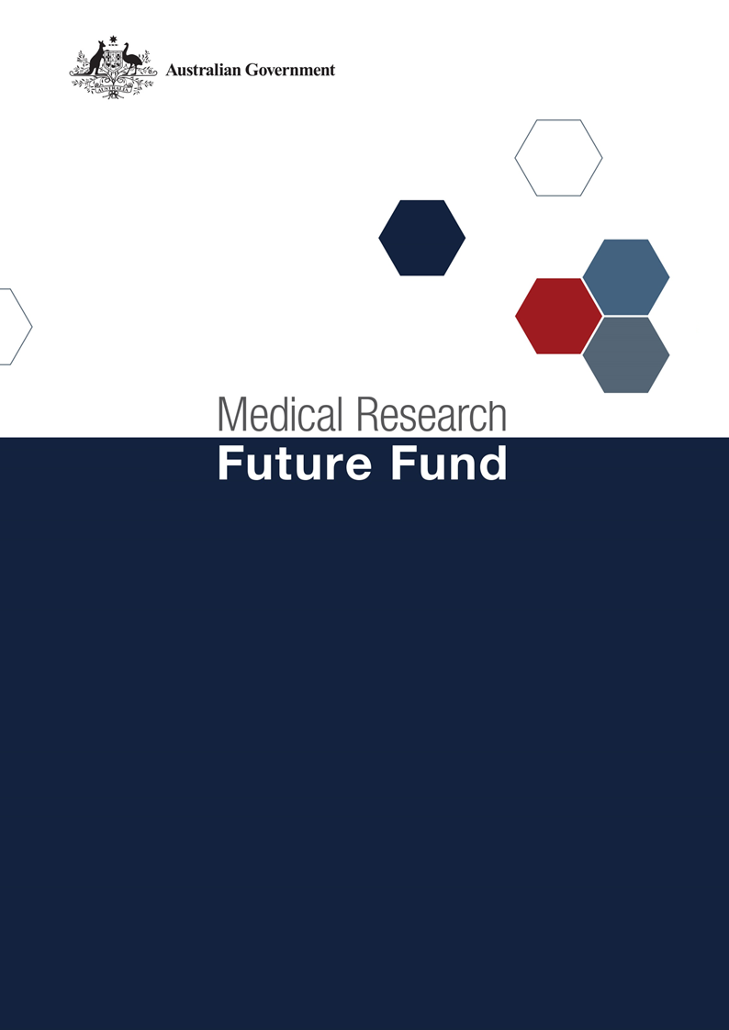

**MRFF Australian Brain Cancer Mission Roadmap and Implementation Plan Refresh National Consultation Report  
  
February 2025**

Table of Contents

Introduction 2

Community participation and submissions 3

Responses to national consultation submissions 4

# Introduction

The Medical Research Future Fund (MRFF) is a $22 billion long-term investment supporting Australian health and medical research. The MRFF aims to transform health and medical research and innovation to improve lives, build the economy and contribute to health system sustainability. The Australian Brain Cancer Mission (ABCM) was established by the Australian Government in 2017, with a $126.4 million commitment ($50 million from MRFF and $76.4 million to date from Funding Partners) over 10 years. The ABCM’s goal is for transformative improvement to the quality and length of life of people with brain cancer, with the longer-term aim of defeating brain cancer.

An Expert Advisory Panel was appointed in April 2024 to provide advice to the Minister for Health and Aged Care on the strategic priorities for research investment through the ABCM. As per the [MRFF Mission Governance document](https://www.health.gov.au/resources/publications/mrff-mission-governance), the Expert Advisory Panel provides advice on strategic priorities for research investment through the ABCM by refreshing the existing Roadmap and creating a new Implementation Plan.

The ABCM’s Roadmap is a high-level strategic document that includes the aim, vision, goal and priorities for investment for the ABCM. To support the Roadmap, the Implementation Plan outlines the priorities for investment (short, medium and long term), evaluation approaches and measures, supporting activities, and collaborative opportunities. The Roadmap and Implementation Plan will be used by the Department of Health and Aged Care to design and implement ABCM’s investments via Grant Opportunities promoted through GrantConnect ([grants.gov.au](https://www.grants.gov.au/)).

A draft refreshed Roadmap and the new Implementation Plan developed by the Expert Advisory Panel underwent national public consultation review which opened on 8 November 2024 and closed on 20 December 2024, during which time submissions were accepted through the Department’s [consultation hub](https://consultations.health.gov.au/health-economics-and-research-division/mrff-ghfm/). This national consultation sought feedback from the community on the ABCM’s draft refreshed Roadmap and the new Implementation Plan. Cancer Australia also collated feedback on the documents from the Mission funding partners.

The Chair of the Expert Advisory Panel hosted a webinar on 5 December 2024 to provide an opportunity for the community to gain a greater understanding of the purpose of the Roadmap and Implementation Plan and ask questions, prior to providing written submissions to the consultation.

The following questions were provided on the consultation hub to guide submissions:

1. Are the priority areas for investment identified in the Implementation Plan the most effective way for delivering on the Australian Brain Cancer Mission’s goal and aims?
2. Are there existing research activities which could be utilised to contribute to the Australian Brain Cancer Mission Roadmap and/or Implementation Plan aims and priority areas for investment? How can these be leveraged?
3. Are the ‘Evaluation approach and measures’ appropriate for assessing and monitoring progress towards the Australian Brain Cancer Mission’s goal and aims?

This report summarises the national consultation through webinar participation and written submissions.

## Community participation and submissions

The webinar was attended by 46 stakeholders from across Australia. A diverse range of stakeholders participated, including those from research organisations (universities and medical research institutes), industry, consumer advocacy groups, state government (health) departments, and individual community members.

At the close of the consultation period, 16 written submissions were received via the consultation hub, representing universities, medical research institutes, and national and state-based consumer organisations.

The Expert Advisory Panel considered all responses from the national consultation and the Mission funding partners, and where relevant, revised the Roadmap and Implementation Plan. A summary of the feedback from the submissions and the Expert Advisory Panel’s responses are outlined below.

# Responses to national consultation submissions

| **Consultation Question** | **Submission Feedback / Themes** | **Action by Expert Advisory Panel (The Panel)** |
| --- | --- | --- |
| **Are the priority areas for investment identified in the implementation plan the most effective way for delivering on the Australian Brain Cancer Mission’s goal and aims?** | The Implementation Plan should include a mix of large program style grants and smaller high risk short-term projects (1-2 years). | The appropriate mix of grant sizes and lengths was considered by the EAP. Funding from the MRFF only represents part of the overall funding for ABCM due to the contributions of the Funding Partners. EAP members noted that shorter high-risk studies tend to be more attractive to philanthropic investors so chose to focus on larger grants that could enable interdisciplinary collaborations, in the Implementation Plan. |
| The Implementation Plan should prioritise capacity building. | This was considered by the EAP. The upcoming grant calls under the Mission will require 30% or more of the Chief Investigator team to be Early to Mid-Career researchers, ensuring capacity building. |
| The Implementation Plan should prioritise equitable access research (rural and remote access, first nation participation in clinical trials). | Equitable access was considered when setting the priorities for investment.  For the upcoming grant calls the objectives have been amended to ask applicants to include Aboriginal and Torres strait islander community controlled organisations and regional, rural and remote health care services where possible.  All MRFF grant opportunities and the associated scoring criteria strongly encourage consideration of priority populations as identified by the Australian Medical Research Advisory Board (AMRAB). |
| The Implementation Plan should prioritise sustaining and expanding infrastructure for brain cancer research. | Applicants may seek funding to use established infrastructure in their studies via applications to the upcoming grant calls.  MRFF provides support for research infrastructure via a number of initiatives (eg. National Critical Research Infrastructure, Research Data Infrastructure).  For the upcoming grant calls the objectives have been amended to ask applicants to leverage existing research initiatives and infrastructure where possible.  The supporting activities list in the Implementation Plan has been amended to include ongoing support for research infrastructure and platforms, and examples. |
| Attention should be given to the specific features of childhood brain cancer. | The unique differences between adult and paediatric brain cancer and data on previous investments were broadly discussed at the EAP meetings. The EAP’s decision was to keep the grant calls open without restricting to adult versus paediatric brain cancer studies, and for the investment priorities to cover both brain cancer types. |
| Concerns were raised regarding the lack of investments for the upcoming years for aim 2. | Most ABCM funded studies to date fall under aim 2. The upcoming grant calls are opportunities to address the remaining priority areas identified by the EAP to achieve the Mission’s goals and aims. |
|  | Involve consumers and communities in research planning and project development to align with patients’ priorities and expectations. | When designing grant opportunities, the MRFF follows the Principles for Consumer Involvement in Research Funded by the Medical Research Future Fund. Furthermore, assessment of MRFF grants considers consumer involvement. |
|  | | |
| **Are there existing research activities which could be utilised to contribute to the Australian Brain Cancer Mission’s Roadmap and/or Implementation Plan aims and priority areas for investment? How can these be leveraged?** | Leverage existing models including the Australian Teletrial Program which uses telehealth to connect people in rural, regional and remote areas. | Specific reference to models that connect to people in regional, rural, and remote areas has been added to the Implementation Plan. |
| Leverage research into models of care and that supports implementation into community and health services. | Specific reference to models that support translation of findings to clinical practise and equitable access by all Australians has been added to the Implementation Plan. |
| The importance of Indigenous people’s participation in research should be recognised. | Specific reference to models that include Aboriginal and Torres Strait Islander people has been added to the Implementation Plan. |
| Collaborations with international consortia. | Specific reference to models that support opportunities to collaborate with other international neuro-oncology consortia has been added to the Implementation Plan. |
| Support additional projects within existing ABCM funded projects to ensure collaborations, immediate patient outcome delivery and knowledge gain. | For the upcoming grant calls the objectives have been amended to ask applicants to leverage existing research initiatives and infrastructure where possible. |
|  | | |
| **Are the ‘Evaluation approach and measures’ appropriate for assessing and monitoring progress towards the Australian Brain Cancer Mission’s goal and aims?** | Conduct annual meetings for all brain cancer stakeholders to discuss new ideas and improve collaborations. | This would be beneficial for brain cancer stakeholders and research, so should be actioned if possible. However MRFF funding cannot be used for such activities as MRFF funding can only be used for research activities. |
| Evaluation should use well defined metrics that are directly linked to the Mission's goals (quantitative and qualitative measures). | The EAP acknowledges the need for evaluation of defined metrics but agreed that appropriate data to measure improved quality of life and survival rates is complex, not always easy to gather and requires longer timelines. They therefore opted for higher level evaluation measures which were considered more attainable with the timeframes and current resources. |
| The evaluation approach should include regular monitoring intervals, incorporate feedback mechanisms, data governance and assess the impact of initiatives on patient outcomes. The evaluation framework should be adaptable to new evidence and changing circumstances. | Included in the MRFF Monitoring, Evaluation and Learning strategy. |
| The evaluation process should involve consumers and government policymakers. | The MRFF Monitoring, Evaluation and Learning strategy states that monitoring and evaluation of funded projects, programs and initiatives within the MRFF will be inclusive of consumers and stakeholders. |
| Evaluation should consider the location of clinical trial patients and the proportion of Indigenous and CALD patients in clinical trials. | The Implementation Plan includes the measurement of the proportion of people from regional, rural and remote areas with access to effective brain cancer care as an evaluation measure. |
| Evaluation should consider the use of existing infrastructure. | The Implementation Plan includes the measurement of national resources (including but not limited to research platforms and technologies) that facilitate brain cancer research are expanded, accessible and well supported as an evaluation measure. |